TURF CLASH CHAMPIONSHIP SEASON -1
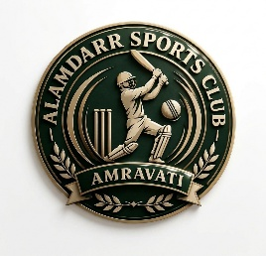
Organized by
ALAMDARR SPORTS CLUB AMRAVATI
SPONSORED BY
LUCKY HARDWARE CENTER

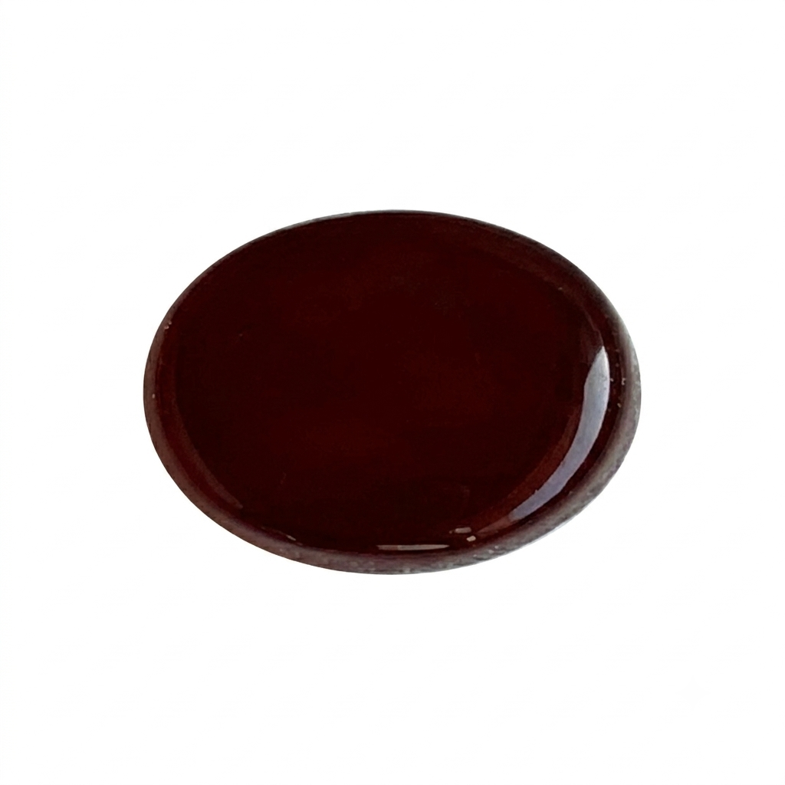
SET 1 : AQEEQ (AGATE)

P. No | Player Name | Age | Bat Style | Bowl Style | Mob
19 | BURHANUDDIN BADAWALA | 36 | RHB | RHB | 9028437074
31 | HAMZA KOTHAWALA | 33 | RHB | RHB | 9405352586
35 | SHABBIR BURHANPURWALA | 23 | RHB | RHB | 9168358852
38 | TAHA FAKHRI | 31 | RHB | RHB | 8554944552
43 | MURTAZA PRESSWALA | 22 | RHB | RHB | 9028783776
46 | ABBAS GONDIAWALA | 27 | RHB | RHB | 8459418953
52 | ALIASGAR BABBAR | 31 | RHB | RHB | 8421714717
53 | AMMAR MIZWAN | 23 | RHB | RHB | 8484944753
57 | HUSSAIN CHANDAWALA | 34 | RHB | LHB | 9850578157
79 | QAID HUSSAIN | 28 | RHB | RHB | 7276885253
83 | ABBAS ALI HAJI | 39 | RHB | RHB | 9764064144
85 | BURHANUDDIN HUSSAIN  (CAPT - FATEMI FALCONS) | 28 | RHB | LHB | 9595675756

TURF CLASH CHAMPIONSHIP SEASON -1
Organized by
ALAMDARR SPORTS CLUB AMRAVATI
SPONSORED BY
LUCKY HARDWARE CENTER

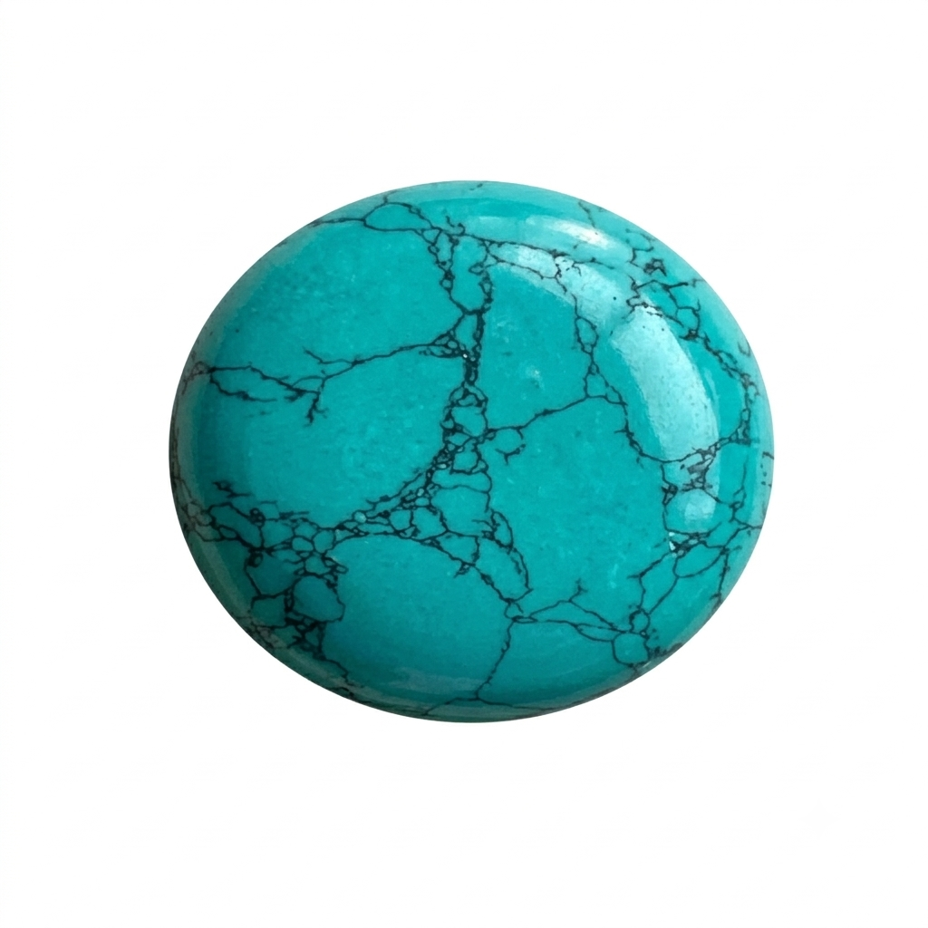
SET 2 : FIROZA (TURQUOISE)

P. No | Player Name | Age | Bat Style | Bowl Style | Mob
4 | AZIZ GHADIYALI | 43 | RHB | RHB | 8446262195
8 | TAHA BHANPURAWALA | 25 | RHB | RHB | 7038001752
14 | HATIM KALAWADWALA | 19 | RHB | RHB | 7721057252
22 | HUSSAIN KOTHAWALA | 23 | RHB | RHB | 9172880918
40 | AAUN BANDOOKWALA | 37 | RHB | RHB | 9970182152
58 | ALI ASGAR ALI | 20 | RHB | RHB | 9325704560
63 | TAHA BARAMATIWALA | 25 | RHB | RHB | 9175804462
75 | AZIZ NAGPURWALA | 32 | RHB | RHB | 7276319080
78 | HATIM HUSSAIN | 31 | RHB | RHB | 7798872772
80 | BURHAN DHORAJIWALA | 27 | RHB | RHB | 9604036204
86 | MUSTAFA AKOLAWALA  (CAPT - GALAXY TITANS) | 35 | RHB | RHB | 9970044620
87 | ABDUL QADIR KOTHAWALA  (CAPT - LUCKY LEGENDS) | - | RHB | RHB | -

TURF CLASH CHAMPIONSHIP SEASON -1
Organized by
ALAMDARR SPORTS CLUB AMRAVATI
SPONSORED BY
LUCKY HARDWARE CENTER

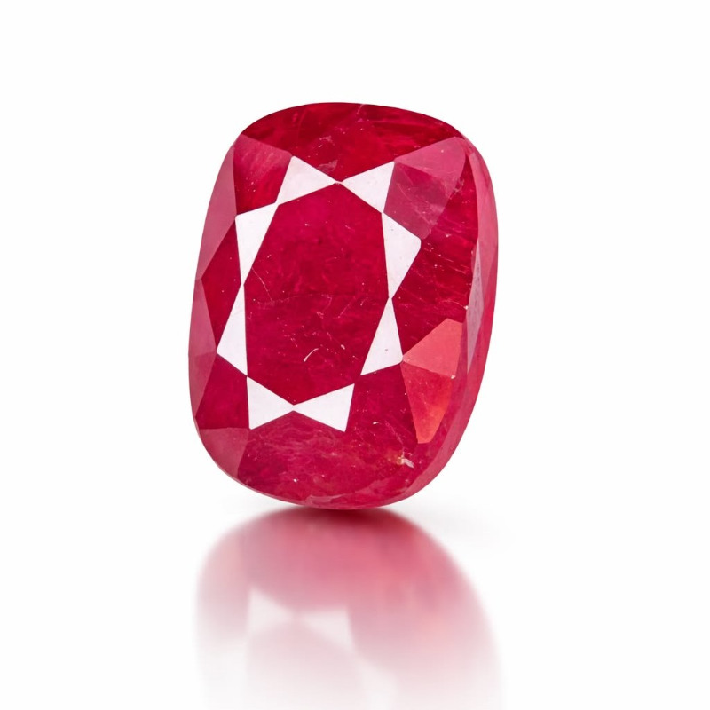
SET 3 : YAQOOT (RUBY)

P. No | Player Name | Age | Bat Style | Bowl Style | Mob
6 | TAHER DAWAWALA | 38 | RHB | RHB | 9822708633
10 | HUSAIN MIZWAN | 33 | RHB | RHB | 9175098552
34 | ALI ASGAR ATTARWALA | 25 | RHB | RHB | 8624998352
37 | HUSSAIN BOHRA | 24 | RHB | RHB | 7769061782
45 | YUSUF DARWAWALA | 17 | RHB | RHB | 9922193877
47 | MUFFADAL RAMPURAWALA | 37 | RHB | RHB | 9923521100
51 | ABBAS CHANDAWALA | 37 | RHB | RHB | 9860053552
54 | ZOHAIR CHANDURWALA | 18 | RHB | RHB | 9146889572
62 | HASAN ALI | 32 | RHB | RHB | 8087248352
76 | MOIZ JAMNAGARWALA | 26 | RHB | RHB | 7057157452
88 | TAHA SAJID HUSAIN KANCHWALA (CAPT - KANCHWALA KNIGHT RIDERS) | 27 | RHB | RHB | 9028752753
92 | ALI CHANDURWALA  (CAPT - RAJ STRIKERS) | 34 | RHB | RHB | 8793335457

TURF CLASH CHAMPIONSHIP SEASON -1
Organized by
ALAMDARR SPORTS CLUB AMRAVATI
SPONSORED BY
LUCKY HARDWARE CENTER

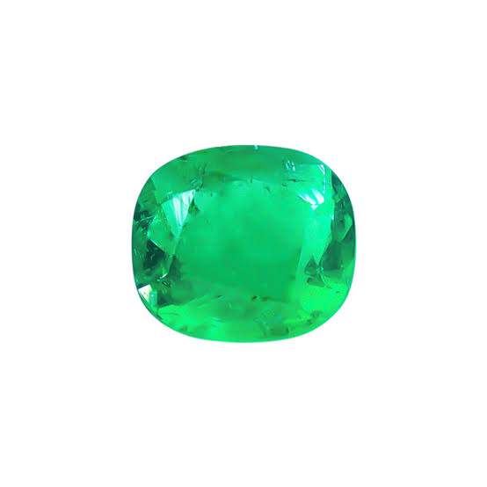
SET 4 : ZUMURRUD (EMERALD)

P. No | Player Name | Age | Bat Style | Bowl Style | Mob
15 | ADNAN DAWAWALA | 41 | RHB | RHB | 9527977552
21 | ABBAS BAGICHAWALA | 42 | RHB | RHB | 9766317524
23 | MURTAZA KOTHAWALA | 38 | RHB | RHB | 7841897252
24 | HATIM DHORAJIWALA | 33 | RHB | RHB | 9765179791
33 | KUMAIL HOLAWALA | 35 | RHB | RHB | 8275217591
49 | YUSUF ABDUL TAYYEB MALKAPURWALA | 36 | LHB | LHB | 8956903236
68 | ALI KAUSER AMEEN | 43 | RHB | RHB | 9420523010
77 | MOHOMMAD BADNERAWALA | 33 | RHB | RHB | 8983085567
81 | HUZAIFA BAGICHAWALA | 48 | RHB | RHB | 9371139352
82 | MURTAZA HOLAWALA | 50 | RHB | RHB | 9156725352
89 | SHABBIR MURTAZAPURWALA  (CAPT - SUPREME SQUAD) | 34 | RHB | RHB | 8975797870
90 | ZOEB CHAPPALWALA  (CAPT - BURHANPURWALA DOMINATORS) | 40 | RHB | RHB | 7841891212

TURF CLASH CHAMPIONSHIP SEASON -1
Organized by
ALAMDARR SPORTS CLUB AMRAVATI
SPONSORED BY
LUCKY HARDWARE CENTER

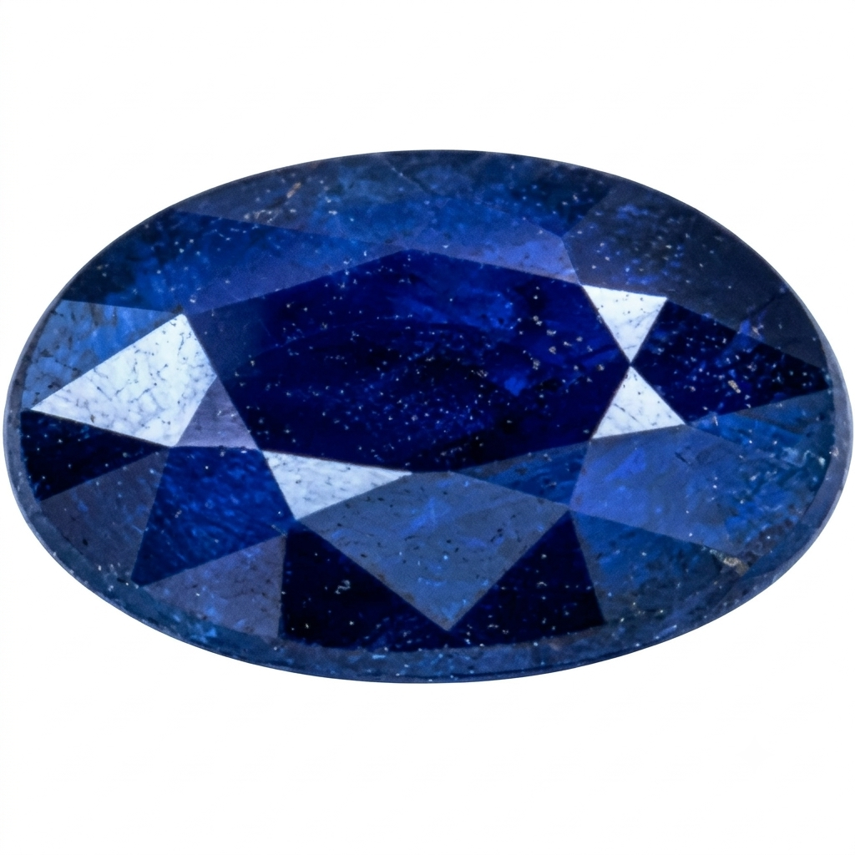
SET 5 : NEELAM (SAPPHIRE)

P. No | Player Name | Age | Bat Style | Bowl Style | Mob
1 | SHABBIR TELWALA | 17 | RHB | LHB | 7385182153
9 | BURHANUDDIN QAYAMWALA | 19 | RHB | RHB | 9421750253
20 | HUSSAIN MUNIM | 29 | RHB | RHB | 7276225352
29 | ALIASGAR KAIZAR CHOUDHARY | 16 | RHB | RHB | 9359410352
30 | SHAMOIL KOTHAWALA | 25 | RHB | RHB | 9322766632
41 | QAINAN SHAKIR | 19 | RHB | RHB | 8788859052
48 | MUSTAFA JALAL | 23 | RHB | RHB | 8855017253
70 | TAIKHOOM JAMALI | 18 | RHB | RHB | 9371348369
72 | MUSTAFA BURHANUDDIN ALI | 20 | RHB | RHB | 7020115920
73 | ADNAN NASIRABADWALA | 25 | RHB | RHB | 7559271452
84 | TAHER BABBAR | 38 | RHB | RHB | 9673738504
91 | ABDUL TAIYEB TELWALA  (CAPT - TELWALA CHALLENGERS) | 19 | RHB | LHB | 8767835509

TURF CLASH CHAMPIONSHIP SEASON -1
Organized by
ALAMDARR SPORTS CLUB AMRAVATI
SPONSORED BY
LUCKY HARDWARE CENTER

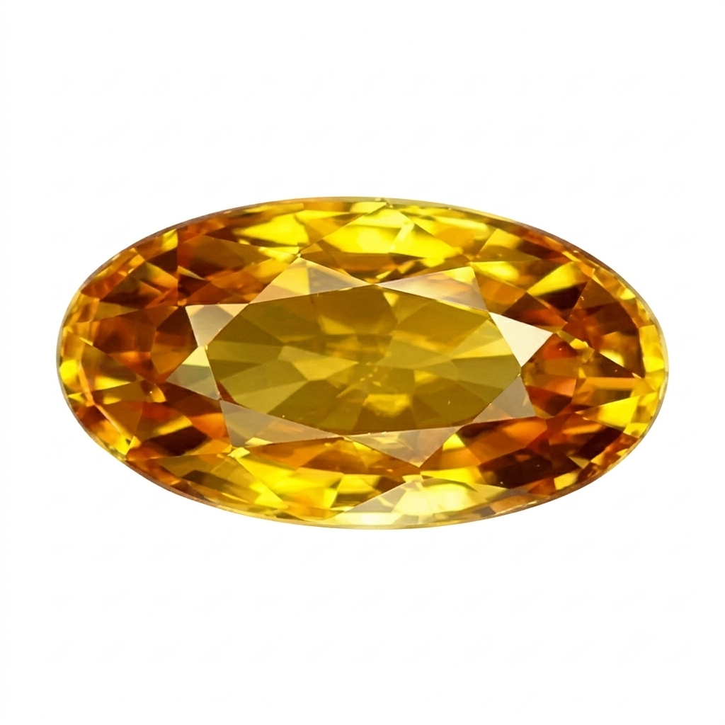
SET 6 : PUKHRAJ (YELLOW SAPPHIRE)

P. No | Player Name | Age | Bat Style | Bowl Style | Mob
2 | BURHANUDDIN JAMNAGARWALA | 16 | RHB | RHB | 9834085310
5 | MOIZ KALAWADWALA | 16 | RHB | RHB | 7721057252
7 | MURTAZA MIZWAN | 16 | RHB | RHB | 7020665872
11 | MOIZ ATTARWALA | 17 | RHB | RHB | 7517882553
13 | ABDEALI SAIFEE | 16 | RHB | RHB | 7588680153
16 | AADAM BAGICHAWALA | 17 | RHB | RHB | 8530930470
25 | HUSSAIN DAWAWALA | 16 | RHB | LHB | 9730530292
60 | SAIFUDDIN ALI | 18 | RHB | RHB | 9405804560
64 | MOHAMMED SAIFUDDIN SANJEETWALA | 16 | RHB | LHB | 7083405452
65 | HASAN ALI | 18 | RHB | RHB | 7218600053
66 | MOIZ BURHANPURWALA | 18 | RHB | RHB | 7517865387
93 | SHABBIR BAGICHAWALA  (CAPT - BAGICHAWALA BLASTERS) | 18 | RHB | RHB | 8530039352

TURF CLASH CHAMPIONSHIP SEASON -1
Organized by
ALAMDARR SPORTS CLUB AMRAVATI
SPONSORED BY
LUCKY HARDWARE CENTER

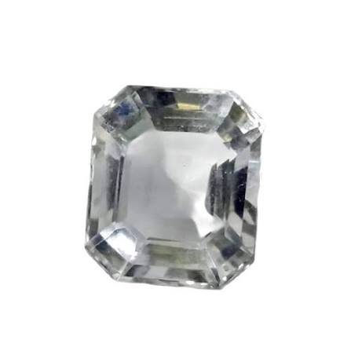
SET 7 : DUR-E-NAJAF (QUARTZ)

P. No | Player Name | Age | Bat Style | Bowl Style | Mob
3 | MUSTAFA JAGIRDAR | 19 | RHB | RHB | 9326821970
17 | MURTUZA UJJAINWALA | 19 | RHB | RHB | 9325734837
18 | SHABBIR MAHUWALA | 19 | RHB | RHB | 7038281521
32 | MUFADDAL HUSSAIN | 30 | RHB | RHB | 7020811074
39 | HAKIMUDDIN IDRIS BHANPURAWALA | 21 | RHB | RHB | 9422874905
42 | QUSAI MAHUWALA | 19 | RHB | RHB | 9322585172
44 | ALAQMAR SAFDAR BARAMATIWALA | 23 | RHB | RHB | 8855017253
52 | SHABBIR AMIN | 18 | RHB | RHB | 9975153552
55 | QUSAI MIZWAN | 19 | RHB | RHB | 8237215352
71 | HUZEFA SAIFEE | 23 | RHB | RHB | 9307860372
74 | ALIASGAR SAIFY | 26 | RHB | RHB | 9665693966
94 | BURHANUDDIN HUSAIN RAMPURAWALA  (CAPT - HUSSAINI STRIKERS) | 27 | RHB | RHB | 8208334865

TURF CLASH CHAMPIONSHIP SEASON -1
Organized by
ALAMDARR SPORTS CLUB AMRAVATI
SPONSORED BY
LUCKY HARDWARE CENTER

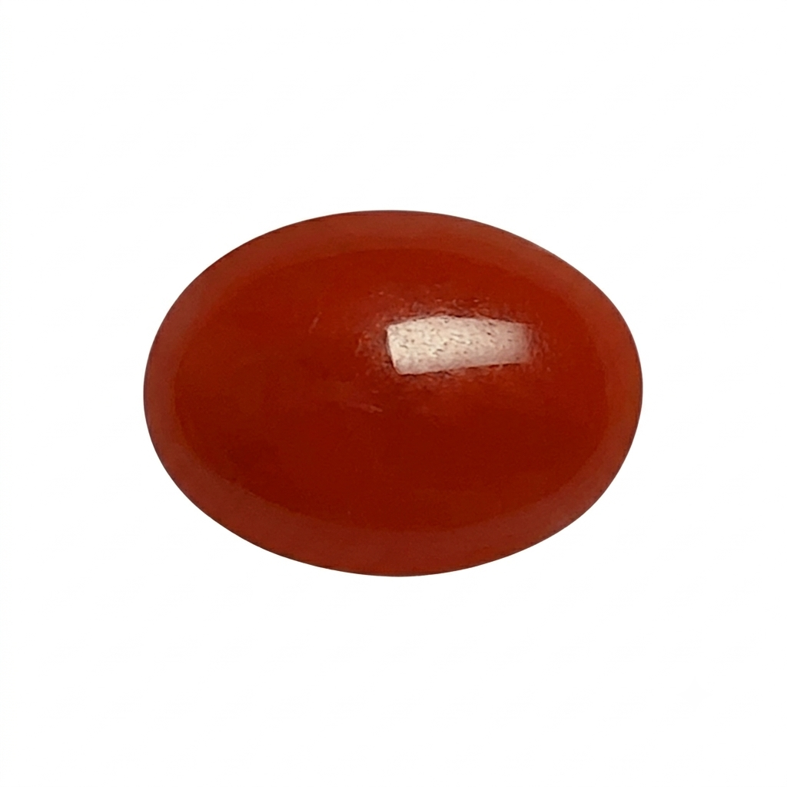
SET 8 : MARJAN (CORAL)

P. No | Player Name | Age | Bat Style | Bowl Style | Mob
12 | HUSAIN TELWALA | 46 | RHB | RHB | 9370155241
26 | AMMAR KOTHAWALA | 52 | RHB | RHB | 7776986153
27 | MUSTAFA BURHANI | 47 | RHB | RHB | 9422855044
28 | AMMAR HUSAIN | 46 | RHB | RHB | 7020535952
36 | JABIR ALI FAKHRI | 60 | RHB | RHB | 9637009009
56 | SHABBIR CHANDURWALA | 51 | RHB | RHB | 9763765052
59 | HUSAIN MIZWAN | 57 | RHB | RHB | 9665399432
61 | MUSTAFA ATTARWALA | 51 | RHB | LHB | 9604857052
67 | HUZAIFA SAIFEE | 52 | RHB | RHB | 8007873953
69 | IDRIS SAIFEE | 50 | RHB | RHB | 9665779110
95 | MURTAZA ALI JAMNAGARWALA  (CAPT - EZZY STARS) | 44 | RHB | RHB | 9511876609
96 | MURTAZA SHAKIRALI SAIFEE  (CAPT - CHOUDHARY THUNDERBOLTS) | 48 | RHB | RHB | 9422159115

