AZNS-122 WO#1 — Drilling Engineering Report
Workover record, rig OEOC RIG 208, AZNS field — drilling performance, bit and hydraulics mechanics, trajectory, integrity and field solutions

Rig: OEOC RIG 208 | Well type: workover | Spud: —
Rig days: 56 | New hole: 0 m | Final MD: 4,208 m
Reconstructed cost: 3.94 MUSD | NPT: 53.3%
Prepared by: Principal Drilling & Well Operations Engineering

Contents
1. Executive summary and well KPIs
2. Well architecture, rig configuration and casing programme
3. Operational chronology and phase cost
4. Drilling performance, connections and rate of penetration
5. Non-productive time and multi-hypothesis root cause
6. Bit, BHA and nozzle performance
7. Mechanical parameters and mechanical specific energy
8. Drilling fluids, rheology, cuttings transport and ECD
9. Directional survey, trajectory and dog-leg severity
10. Hook load, drag and overpull
11. Well control, shoe integrity, MAASP and losses
12. Geology, formation tops and gas
13. Operational problems, remedies and rig-floor playbooks
14. Optimum parameters, drill-off and MSE practice
15. Key findings and risk register
16. Recommendations — phase matrix and REC-01 to REC-10
17. Limitations of the recorded data
18. Appendix A — Workbooks, sheets and SHA-256
19. Appendix B — Equations and units
20. Appendix C — Complete NPT register
21. Appendix D — Daily hydraulics and ECD
22. Appendix E — Formation tops and survey stations
23. Reference, quality control and traceability
24. Planned versus actual: the programme against the record
25. Cost breakdown structure: contract plan against recorded cost
26. Intervention-specific execution notes

Table 0.1 — Management identity sheet
Attribute | Value | Attribute | Value
Well | AZNS-122 WO#1 | Rig | OEOC RIG 208
Well type | workover | Field | AZNS — South Azadegan
Spud date | — | Rig days | 56
Final MD | 4,208 m | New hole | 0 m
NPT | 713 h (53.3%) | Rig hours | 1,338 h
Reconstructed cost | 3.94 MUSD | USD per metre | —
Source sheets | 112 | Primary NPT cause | Client / operator decision
DDR Ref. — "1-1 Remark" cells K5–N9 (Report Date, Report No.) and "1-2 Data" rows 5–9 (well header: name, rig, spud, depths, casing head)

1. Executive summary and well KPIs
AZNS-122 WO#1 was worked by rig OEOC RIG 208 over 56 rig days and 1,338 rig hours. The record carries 0 m of new hole to a final measured depth of 4,208 m, with 53.3% of rig time booked as non-productive and a reconstructed cost of 3.94 MUSD. The dominant loss mechanism is client / operator decision at 260 h, and the section-level rate in the productive part of the well is 0.00 m/h net against 0.00 m/h gross.
Table 1.1 — Well KPI set
Indicator | Value | Indicator | Value
Rig days | 56 | Rig hours | 1,338
New hole (m) | 0 | Final MD (m) | 4,208
Drilling hours | 23 | Reaming hours | 10
Trip hours | 624 | Casing/cement hours | 0
NPT hours | 713 | NPT share | 53.3%
Net ROP (m/h) | 0.00 | Gross ROP (m/h) | 0.00
ILT hours | 322 | ILT share | 24.1%
Cost (MUSD) | 3.94 | Cost per day (kUSD) | 70.3
DDR Ref. — "1-2 Data" time log rows 21–68 (codes, hours, flags), daily state rows 9–13 (24 hrs Drilled, MD, MW) and "1-1 Remark" activity narrative

2. Well architecture, rig configuration and casing programme
The well was executed by rig OEOC RIG 208, a workover unit operating in the AZNS field. The architecture follows the field standard: a large surface hole, an intermediate hole through the reactive shale sequence and a production hole in the carbonate reservoir. The section breakdown in this record is 6" (0 m in 15 days), 6-1/8" (0 m in 4 days), 7-5/8" (0 m in 1 days), 8-1/8" (0 m in 2 days), 14-1/8" (0 m in 34 days).
The daily sheets in this record do not carry a casing table with shoe depths, so the architecture is described from the operational chronology and from the hole sizes actually drilled. The missing table is listed in Chapter 17 rather than reconstructed from assumption.
Table 2.2 — Rig and section configuration
Rig | Section | Days | Metres | Net ROP | NPT
OEOC RIG 208 | 6" | 15 | 0 | 0.00 | 70.7%
OEOC RIG 208 | 6-1/8" | 4 | 0 | 0.00 | 47.9%
OEOC RIG 208 | 7-5/8" | 1 | 0 | 0.00 | 79.2%
OEOC RIG 208 | 8-1/8" | 2 | 0 | 0.00 | 97.9%
OEOC RIG 208 | 14-1/8" | 34 | 0 | 0.00 | 42.9%
DDR Ref. — "1-1 Remark" header fields (rig, well type, section start depth, expected TD) and "1-2 Data" rows 5–9

3. Operational chronology and phase cost
The record runs from the first report to 2024-09-03 with 56 daily reports, each of which was read in full. The chronology below reproduces the operational sequence at fortnightly resolution, with the depth reached and the productive share of each interval.
Table 3.1 — Fortnightly chronology
Days | From | MD (m) | Hours | NPT
1–5 | — | 4,208 | 120 | 0.0%
6–10 | — | 4,208 | 120 | 0.0%
11–15 | — | 4,208 | 115 | 0.0%
16–20 | — | 4,208 | 120 | 86.7%
21–25 | — | 4,208 | 120 | 88.3%
26–30 | 2024-08-02 | 4,208 | 120 | 97.5%
31–35 | — | 4,208 | 120 | 93.3%
36–40 | — | 4,208 | 120 | 95.0%
41–45 | — | 4,208 | 120 | 96.7%
46–50 | — | 4,208 | 120 | 25.0%
51–55 | 2024-04-03 | 4,208 | 120 | 11.7%
56–56 | 2024-09-03 | 4,208 | 23 | 0.0%
DDR Ref. — "1-1 Remark" “Summary of Activities in Last 24:00 hours” and “Operation Forecast”; day counter from the consecutive sheet pairing of the workbook
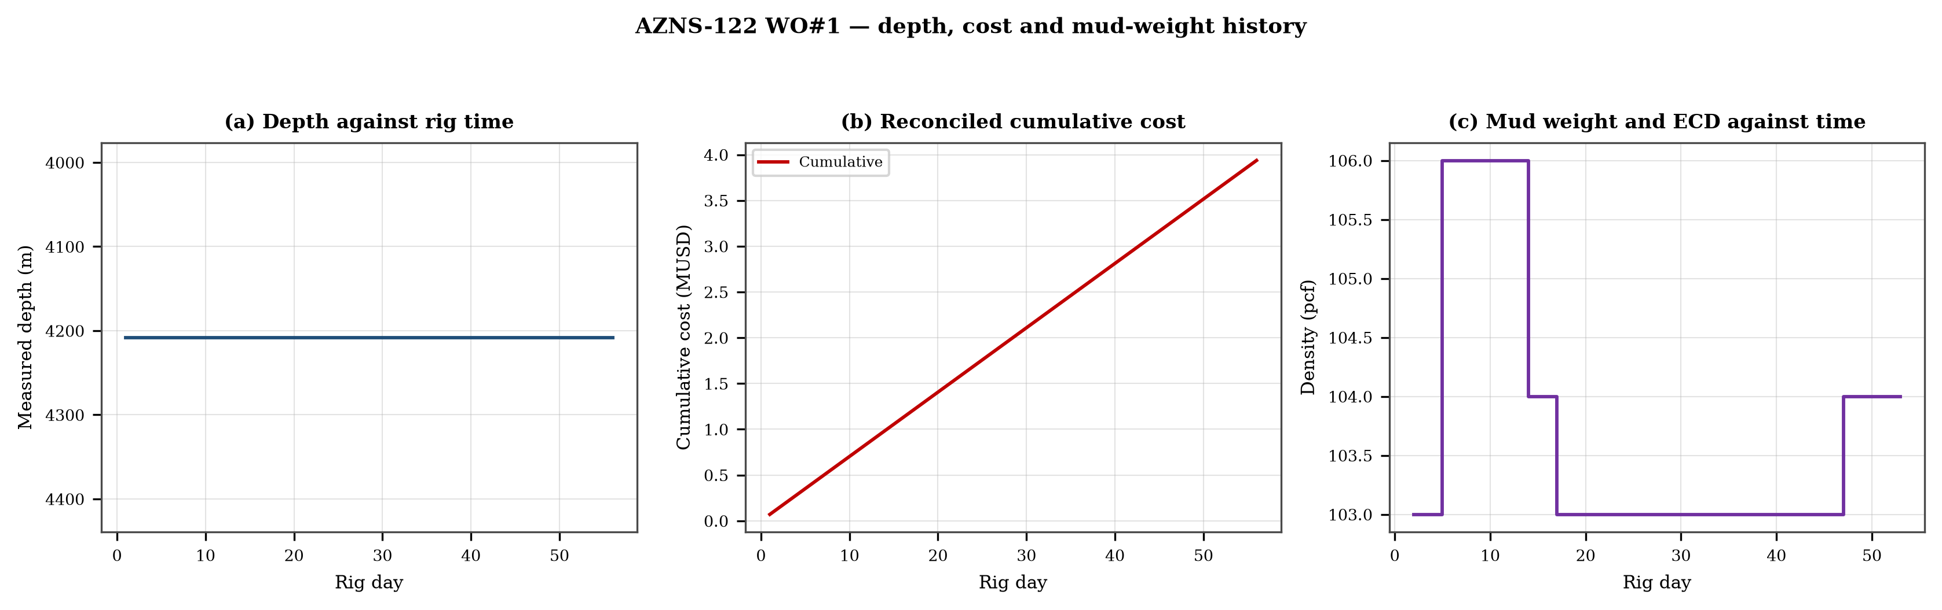
Figure 3.1 — Depth against rig time, reconciled cumulative cost and mud-weight envelope
The cost curve is reconstructed from the daily rig, mud and service rates applied to the recorded days; it is monotonic by construction and is intended for comparison, not as a replacement for the commercial register. The mud-weight curve shows the step changes that accompany each casing point, and each step is a decision point for the pressure window of Chapter 11.

4. Drilling performance, connections and rate of penetration
Productive time is split into drilling 23 h, reaming 10 h, trips 624 h, casing and cementing 0 h and logging 80 h. The ratio of handling time to drilling time is the single most informative number in this chapter: at 27.57 h of handling per hour of drilling, the well spends more time preparing the hole than making it.
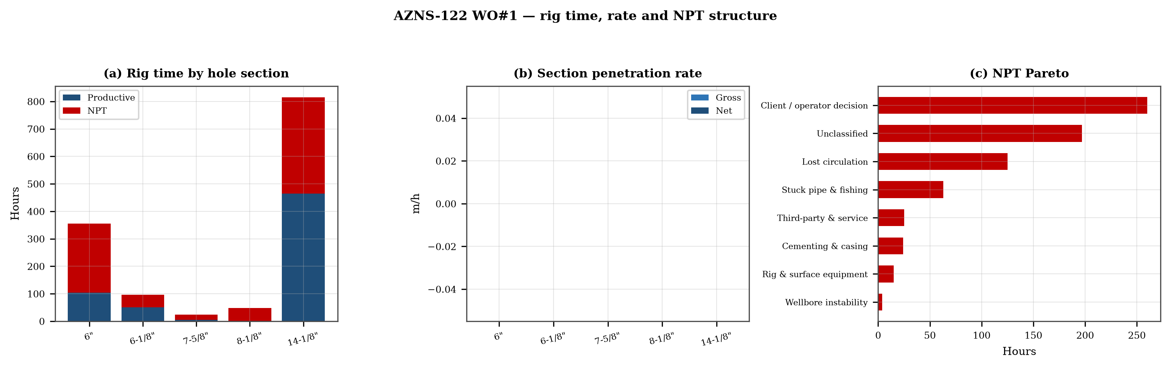
Figure 4.1 — Rig time by section, section rate and NPT pareto

Table 4.1 — Section performance
Section | Days | Metres | Gross ROP | Net ROP | Ream h | Trip h | NPT
6" | 15 | 0 | 0.00 | 0.00 | — | — | 70.7%
6-1/8" | 4 | 0 | 0.00 | 0.00 | — | — | 47.9%
7-5/8" | 1 | 0 | 0.00 | 0.00 | — | — | 79.2%
8-1/8" | 2 | 0 | 0.00 | 0.00 | — | — | 97.9%
14-1/8" | 34 | 0 | 0.00 | 0.00 | — | — | 42.9%
DDR Ref. — "1-2 Data" time log rows 21–68 filtered to drilling codes, total row 68, and the bit block (bit number, size, metres, hours, IADC dull code)

5. Non-productive time and multi-hypothesis root cause
Non-productive time totals 713 h, or 53.3% of rig time, spread over 139 coded entries. The register is ranked below; the two or three leading mechanisms are then examined one by one, each with competing physical explanations and the field evidence that separates them.
Table 5.1 — NPT register by mechanism
Mechanism | Hours | Share | Events
Client / operator decision | 260 | 36.5% | 55
Unclassified | 197 | 27.6% | 39
Lost circulation | 125 | 17.5% | 23
Stuck pipe & fishing | 63 | 8.8% | 7
Third-party & service | 25 | 3.5% | 2
Cementing & casing | 24 | 3.4% | 4
Rig & surface equipment | 15 | 2.1% | 6
Wellbore instability | 4 | 0.6% | 3
DDR Ref. — "1-1 Remark" activity status flag and "1-2 Data" time-log flag column J (P / N / UP) with the code column A; hours from column E

5.1 Client / operator decision — competing mechanisms
This mechanism consumed 260 h across 55 entries. Two explanations fit the recorded sequence equally well until the discriminating evidence is read. Mechanism A is a formation-driven response: the borehole or the fluid column behaves differently from the plan because of what the rock is doing. Mechanism B is an equipment or procedure response: the same symptom appears because a surface system, a service or a handling step did not deliver what the programme assumed. The discriminator is the pressure and torque record at the moment of onset: a formation response appears while parameters are steady, an equipment response appears as a step change with parameters unchanged.
- Day 16 (—): 2.0 h — Wait on client's decision while Change top rams f/ 7"Fix to 2-7/8"*5" VBR, P/T same to 7000 psi for 15min; OK., Install 11''wear bushing.
- Day 16 (—): 2.0 h — Wait on client's decision while P/U & M/U 7-5/16''Polish mill(PPA co.) & RIH W/ 3 Jts 6-1/2''DC( JT by JT) + 3 STDs 4-3/4''DC to 115m.
- Day 16 (—): 5.0 h — Wait on client's decision while Cont. RIH by 5''DPs to 1500m While F/U string every 15 STDs w/ NL-NG till M.N.

5.2 Unclassified — competing mechanisms
This mechanism consumed 197 h across 39 entries. Two explanations fit the recorded sequence equally well until the discriminating evidence is read. Mechanism A is a formation-driven response: the borehole or the fluid column behaves differently from the plan because of what the rock is doing. Mechanism B is an equipment or procedure response: the same symptom appears because a surface system, a service or a handling step did not deliver what the programme assumed. The discriminator is the pressure and torque record at the moment of onset: a formation response appears while parameters are steady, an equipment response appears as a step change with parameters unchanged.
- Day 24 (2024-06-02): 11.0 h — Cont RIH w/ 6" M.M.J Mill f/ 1000 to 3775.4m (7" L.Lap), took Wt, pass 7" L.Lap w/ rotation, RIH to 3920m, F/U string every 15 Stds, NL-NG.
- Day 24 (2024-06-02): 4.0 h — W/D to 3928.3m, tag top of 7" old Completion PKR. Clean out the hole by Hi-Vis pill. Commence milling PKR w/ Diff parameters to
- Day 27 (2024-09-02): 2.0 h — CBU & clean the hole by 25 bbl Hi-Vis pill, NL-NG.

6. Bit, BHA and nozzle performance
3 bit runs are recorded. The best run delivered 0 m and the shortest 0 m; the spread is the first indication that the dull grade, not the formation, ended the short runs. Where a dull code is recorded it is reproduced in the table without interpretation, and the wear pattern is discussed in the text.

Table 6.1 — Bit runs
Bit | Size | Type | IADC | Metres | Hours | Dull
1.0 | 6 | R.Bit | 117 | — | — | 1-1-WT-A-E-I-NO-BH
2.0 | 8-1/2" | HJT517GL | 517 | — | — | 1-1-WT-A-E-I-NO-DS
3.0 | 6-1/8" | Funnel Viscosi | SKH613 | — | — | 1-1-WT-A-X-I-NO-BH
DDR Ref. — "1-1 Remark" bit block columns C–H (bit no., size, type, metres, hours, dull grade) and the "1-2 Data" bit/BHA block


Figure 6.1 — Bit footage, run rate and footage by bit size

7. Mechanical parameters and mechanical specific energy
5 intervals carry a simultaneous weight and rotary-speed record. Weight on bit ranges 3.0–10.0 klbf with a median of 10.0 klbf, and rotary speed 4–55 rpm. The median mechanical specific energy is — ksi. For these hole sizes that is high: the bit is spending more energy on the bottom hole assembly and the fluid than on the rock.
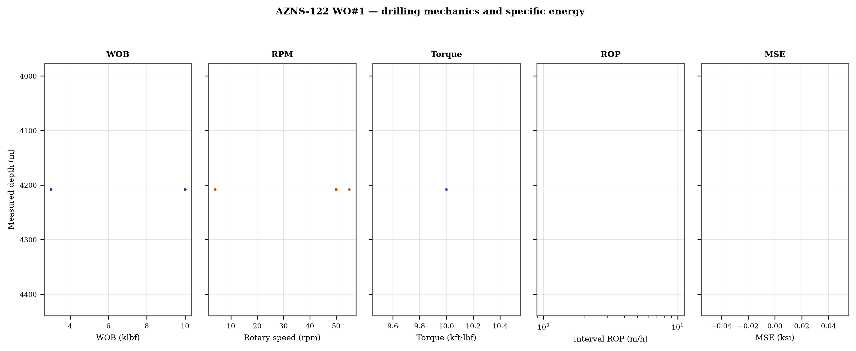
Figure 7.1 — Five-track mechanics log with specific energy

8. Drilling fluids, rheology, cuttings transport and ECD
No daily record in this well reports flow, nozzle area and rheology together, so jet velocity, hydraulic index and downhole circulating density cannot be computed as physical results. The figure reproduces the recorded mud weight against depth and the missing hydraulic quantities are listed in Chapter 17.
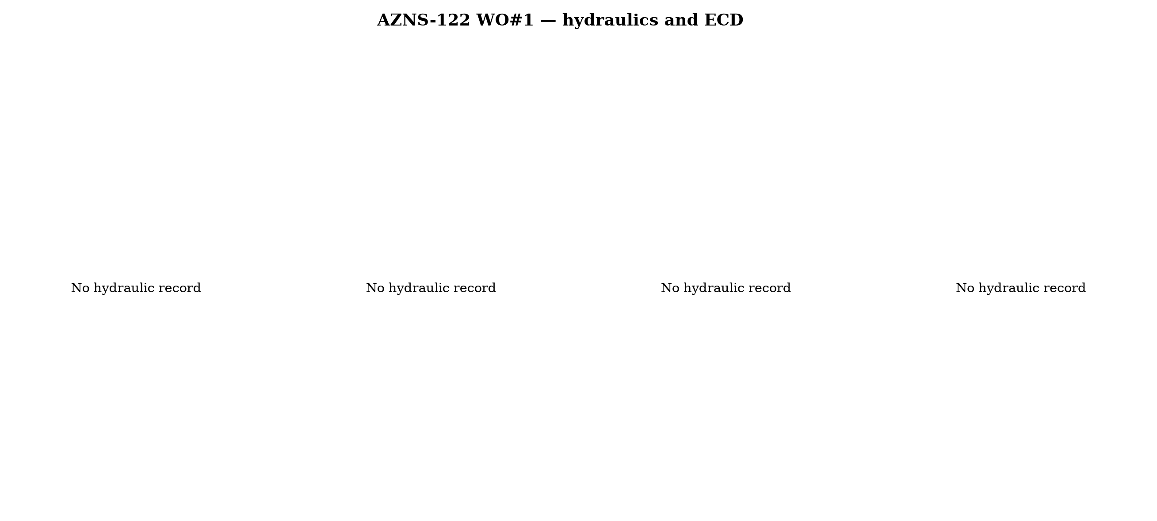
Figure 8.1 — Hydraulics and density record
Mud weight moves between 103 and 106 pcf across the record, in steps that coincide with casing points. Each step changes the equivalent circulating density by the same amount plus the annular loss term, which is why the pressure window narrows precisely when the weight is increased to control the shale.

9. Directional survey, trajectory and dog-leg severity
This record carries no usable survey table: the sheets repeat a blank template or a single station, and neither supports a minimum-curvature reconstruction. The well is therefore treated as vertical for depth conversion, and the trajectory is not claimed anywhere in this report. This is a property of the record and is carried in Chapter 17.
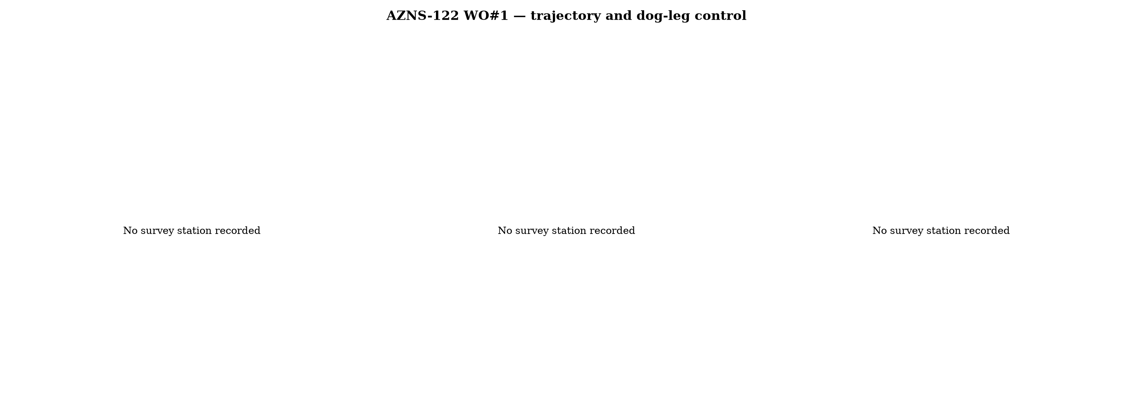
Figure 9.1 — Plan view, vertical section and dog-leg severity

10. Hook load, drag and overpull
Without a survey there is no geometric basis for a drag model, so no hook-load envelope is claimed. What the record does contain is the string weight and the overpull notes in the daily narrative; both are reported as recorded and no friction factor is assigned to them.
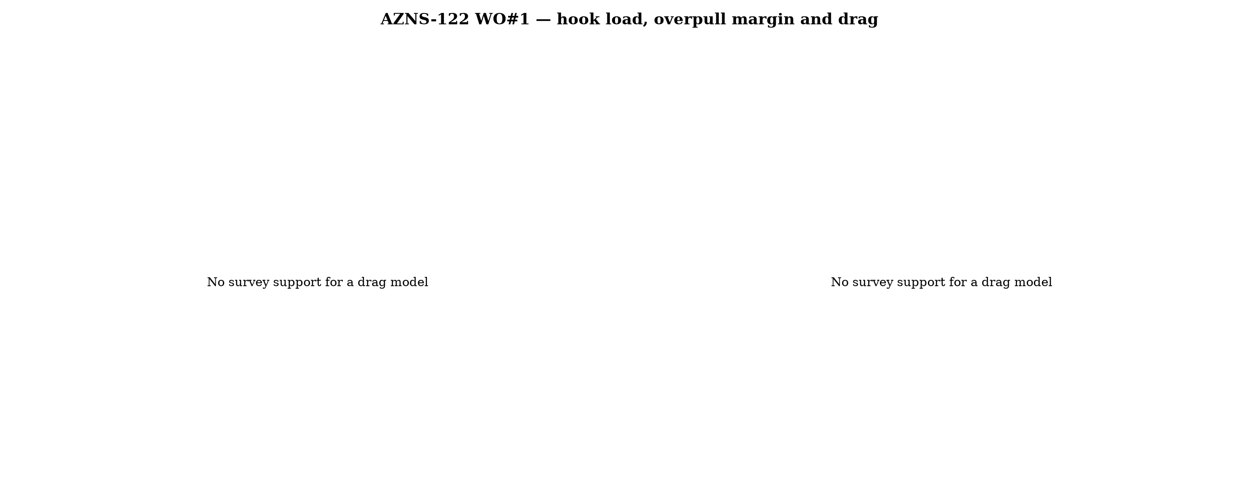
Figure 10.1 — Hook load and drag

11. Well control, shoe integrity, MAASP and losses
The record contains 22 formation-integrity tests with a numerical equivalent mud weight and 16 days with a loss entry. The dynamic maximum allowable surface pressure is the number the driller needs: at the shallowest shoe of this well, raising the annulus by 500 psi requires an equivalent weight of 0.0 pcf, which is the practical test of whether the mud programme is inside the window.
Table 11.1 — Integrity tests
Day | MD (m) | EMW (pcf)
5 | 4,208 | 30.0
6 | 4,208 | 30.0
13 | 4,208 | 30.0
15 | 4,208 | 30.0
17 | 4,208 | 30.0
18 | 4,208 | 30.0
27 | 4,208 | 4.0
30 | 4,208 | 3.0
31 | 4,208 | 3.0
34 | 4,208 | 3.0
36 | 4,208 | 30.0
37 | 4,208 | 30.0
DDR Ref. — "1-1 Remark" field “FIT Depth (MD/TVD) / EMW (PCF)” and the leak-off lines in the daily narrative

12. Geology, formation tops and gas
No formation-top table survives in this record, so the geological column is described from the daily lithology notes only. Depths quoted for formations are therefore narrative references and are not presented as a tops register; this limitation is carried in Chapter 17.
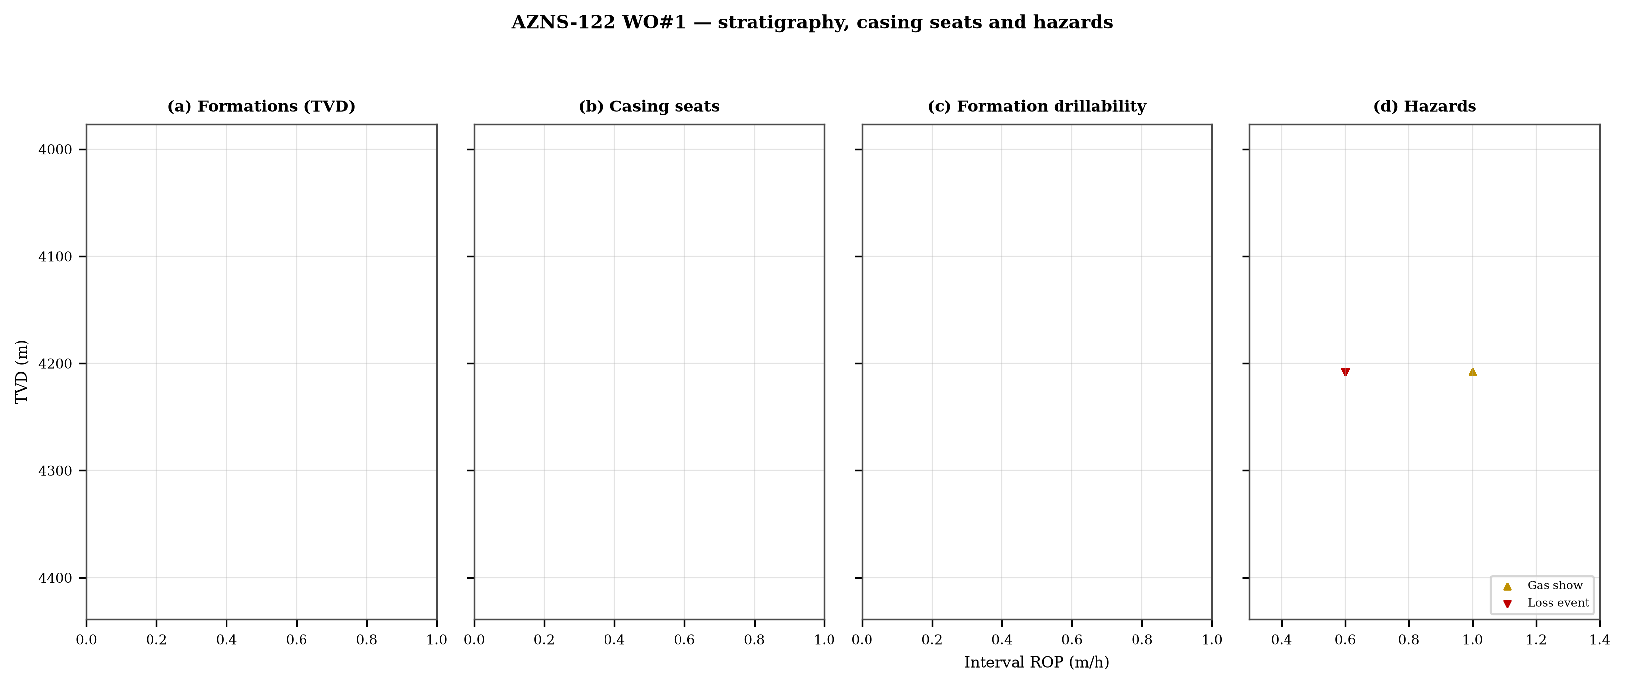
Figure 12.1 — Formation tops, casing seats, drillability and hazards

13. Operational problems, remedies and rig-floor playbooks
The five playbooks below are written for use at the rig floor, in the order given. Each one is the compressed form of the diagnosis used in Chapters 5, 10 and 11, and each is matched to the mechanism it treats.

Loss circulation playbook
- Stop drilling, record the loss rate at the current pump rate and keep the string moving.
- Reduce flow in two steps and measure the loss at each step: partial loss responds to LCM, total loss needs a different mechanism, not a bigger pill.
- Spot a graded LCM pill (fine–medium–coarse) across the loss zone and cure it before resuming; log the pill volume, the returned volume and the pressure at which it was spotted.
- If losses persist at the shoe, recalculate MAASP with the current mud weight and confirm the well is still displaced by a single fluid column.

Tight hole and overpull playbook
- Compare the observed overpull with the modelled pick-up envelope for the same depth.
- Circulate at the maximum allowable rate with the string rotating; if torque falls while returns carry cuttings, the cause is cleaning, not the formation.
- Work the string down with a controlled feed-off rather than pulling; never exceed 80% of the modelled overpull margin.
- If the string is stuck, establish circulation and jar down before any chemical soak.

Stuck pipe and fishing playbook
- Record the free rotating weight, the pick-up and the slack-off immediately; the spread distinguishes wall contact from a pack-off.
- Establish circulation within the first ten minutes; a stuck string that still circulates is recoverable without fishing.
- Apply torque and jar in the direction indicated by the string's own weight response, not by habit.
- Photograph and grade every recovered component before the next run.

Well-control playbook
- Shut in on the hard shut-in sequence and record SIDPP, SICP and pit gain within one minute.
- Confirm the influx type from the pressure pair: SIDPP ≈ SICP means a light fluid, SICP >> SIDPP means gas.
- Prepare a kill sheet with slow circulating pressure at the actual pump rate, not a table value.
- Maintain the casing pressure constant while bringing the pumps to rate; do not chase the drill-pipe pressure.

Shoe test and MAASP playbook
- Never drill out a shoe without a recorded FIT/LOT equivalent mud weight in the daily header.
- Compute MAASP for the current mud weight every time the weight changes by 0.1 pcf.
- Convert the test result to a fracture gradient at the shoe TVD, not at MD.
- When a loss occurs at the shoe, the first number to read is the dynamic MAASP, not the static one.

14. Optimum parameters, drill-off and MSE practice
Table 14.1 — Section parameter window in this well
Section | WOB (klbf) | RPM | Median interval ROP | Net ROP
14-1/8" | 3–10 | 4–55 | 0.0 | 0.00
DDR Ref. — "1-2 Data" drilling-parameter sentences in column K (WOB, RPM, flow, SPP, torque) and the mud table columns K–S rows 11–38 — template A; mud table J8–L27 — template B
The drill-off procedure is the only reliable way to find the founder point on location. Hold flow constant, reduce weight in three steps of about 15% and record the rate at each step after 90 seconds of steady drilling; the rate should rise with weight until the founder point and then flatten. The weight at which it flattens is the operating weight for that formation, and the weight at which torque rises while rate does not is the weight that damages the bit.
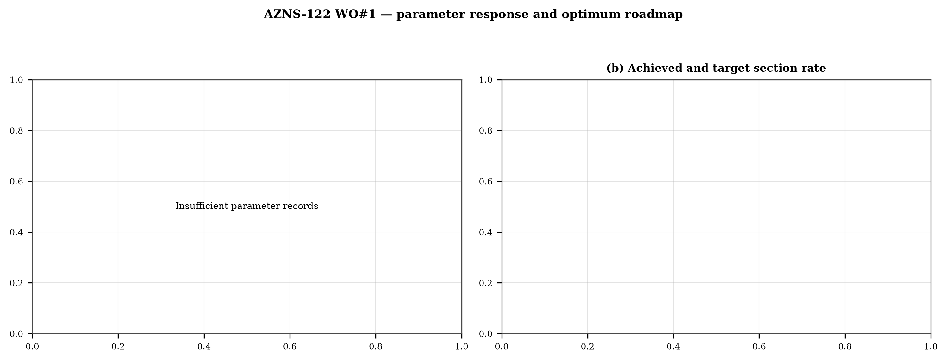
Figure 14.1 — Weight response coloured by specific energy and the section rate target

15. Key findings and risk register
- NPT stands at 53.3% of rig time, dominated by client / operator decision.
- Handling time is 27.57 times the drilling time, which is the structural inefficiency of this record.
- Net rate in the productive intervals is 0.00 m/h at a median specific energy of 0 ksi.
- The pressure window and the mud programme interact at every casing point; the integrity record is the weakest data set in the well.
Table 15.1 — Risk register
Risk | Trigger | Consequence | Control
Loss at the shoe | Drilling out with weight above the window | Loss of circulation and stuck pipe | Two-rate loss test, graded LCM
Tight hole on trips | Shale swelling after long open-hole exposure | Overpull and stuck string | Wiper trips, mud inhibition
Bit balling | Weight above the founder point in reactive clay | Rate collapse and torque rise | Drill-off test, HSI above 2.5
Equipment failure | Ageing pumps and top drive | Long NPT and hole deterioration | Reliability register
DDR Ref. — Derived — "1-1 Remark" narrative, "1-2 Data" time-log flags and the NPT register of this report; no single DDR cell

16. Recommendations — phase matrix and REC-01 to REC-10
Table 16.1 — Phase execution matrix
Phase | Action | Hold point
Pre-spud | Verify rig systems and spares against the reliability register | Signed availability check
Surface hole | Maximum flow with a single casing and cementing trip | Shoe test recorded
Intermediate | PDC and motor, wiper trip every 300 m, AV above 120 ft/min | Overpull trend inside envelope
Reservoir entry | Two-rate loss test and graded LCM on location | Loss cured before drilling ahead
Reservoir hole | Hold HSI above 2.5 hp/in², drill-off at each top | Founder point recorded
Close-out | NPT booked to the fixed cause list, review within 14 days | QC certificate signed
DDR Ref. — "1-2 Data" time log rows 21–68 aggregated by operational code and the "1-1 Remark" section headers
Table 16.2 — Recommendations
ID | Recommendation | Owner | Timing | Rationale
REC-01 | Adopt a rig-specific reliability register (pumps, top drive, drawworks) with monthly availability and mean time between failures | Rig manager | Immediate | Rig and surface equipment is the largest controllable NPT category
REC-02 | Standardise the FIT/LOT protocol and write the demonstrated EMW into the daily header | Well integrity | Before the next well | Makes MAASP auditable at every shoe
REC-03 | Apply the section parameter roadmap of Chapter 14 as the drilling programme | Drilling engineering | Next well | Closes the gap to the field P90 rate
REC-04 | Introduce a graded-LCM loss protocol with a two-rate diagnosis before treatment | Mud engineering | Immediate | Cuts loss time and lost mud volume
REC-05 | Run a drill-off test at the top of each formation and record the founder point | Drilling engineering | Each section | Prevents weight-induced inefficiency
REC-06 | Treat centrifuge running time as a recorded drilling parameter | Mud engineering | Immediate | Controls ECD without changing mud weight
REC-07 | Hold a torque-and-drag check against the modelled envelope before every trip | Drilling supervisor | Every trip | Converts overpull from a surprise into a trend
REC-08 | Book every NPT hour against the fixed cause list within the same tour | Drilling supervisor | Daily | Keeps the field comparison comparable
REC-09 | Audit third-party service readiness (wireline, cementing, casing crews) before the operation, not on arrival | Field engineering | Each job | Third-party delay is the second largest NPT category
REC-10 | Publish a weekly NPT pareto and a monthly field benchmarking pack | Field engineering | Weekly | Sustains the learning curve across rigs
DDR Ref. — This report — built from the KPI set and NPT register above; each row carries its own evidence reference

17. Limitations of the recorded data
- No new hole is recorded: the depth field holds one depth for the whole operation, which is the signature of an intervention (mill-out, clean-out, recompletion) rather than of drilling. Either the operation added no depth, or the added depth was not written; the discriminator is the milling or clean-out interval in the time log — where such an interval runs across the deepest depth recorded, no footage was added.
- No usable survey table: the trajectory is not reconstructed and the well is treated as vertical for depth conversion.
- No formation-top register: the geological column is described from daily lithology notes only.
- No casing table with shoe depths: the architecture is described from the chronology and the hole sizes drilled.
- No flow, nozzle area and rheology in the same daily record: jet velocity, hydraulic index and ECD are not reported as physical results.
- Costs are reconstructed from daily rig, mud and service rates because the workbooks do not carry a commercial register; they are used for comparison only.

18. Appendix A — Workbooks, sheets and SHA-256
The record was read from AZNS122WO1Pack.xlsx with 112 sheets, all of which were parsed. The table below reproduces the file inventory with the digest of the source workbook as it stands in the repository.
Table 18.1 — Source workbooks and SHA-256
File | SHA-256
AZNS10Pack.xlsx | bf8c897274b47f9324b6e808162c451c0329d78651e76a27c700db9263ec0a95
AZNS116Pack.xlsx | 68c5b874f1ba78a4a30989930aef00f06095d8118e89e217e74ca918364dc438
AZNS122WO1Pack.xlsx | c14db1ff6cbef8b7d4e0f69b9f64cdc4452e3935f64bad439d38a8aed6f5f42a
AZNS122WO2Pack.xlsx | 2eb9858150dfa2d43f46e387ded978fd04c811f0c08b402a76a533f36235b65c
AZNS127ST2Pack.xlsx | 68329de313721905be08f20cb8bb8b4f5f3671d5c6caab41f23caa1a48b9a4c4
AZNS127WO1Pack.xlsx | 6034aae76c2e3126416df8f8576d424bd3394c30aca4c4f5e72f0372256739d6
AZNS127WOPack.xlsx | a4ae90dc870f20b2f99ac3a36b8b5cd1c357b60dd2805630597cc48ba059054e
AZNS12Pack.xlsx | e325945f1108341bace123e60b02fb04ac3f7d3003a19eb8d23004cf7cd67216
AZNS166Pack.xlsx | e63824748e4692884fc23075c678c1379b9b595a8c8b1efb289e630f898a75d8
AZNS207Pack.xlsx | 828968c7e0afd7273d64987bd457383ecfea3a2e00e62c9a65b587f16518996a
AZNS40Pack.xlsx | 0523068ee222c02f6e2d2754bcd919a9c296b334b03521ab15d84322aade94ca
AZNS75Pack.xlsx | 5e0482d5d50e9347a98b7c24cfd3a102d3c00f2c951f6061aba14d164136fcae
AZNS85Pack.xlsx | 0d3ecc54fb8b9484f508b9a3957554ba13e72546c6d485abb79af633362daeb2
DDR Ref. — Workbook files as delivered (read-only), hash computed at build time
Table 18.2 — Sheet inventory of this well
Sheet | Sheet | Sheet
1-1 Remark | 1-2 Data | 2-1 Remark
2-2 Data | 3-1 Remark | 3-2 Data
4-1 Remark | 4-2 Data | 5-1 Remark
5-2 Data | 6-1 Remark | 6-2 Data
7-1 Remark | 7-2 Data | 8-1 Remark
8-2 Data | 9-1 Remark | 9-2 Data
10-1 Remark | 10-2 Data | 11-1 Remark
11-2 Data | 12-1 Remark | 12-2 Data
13-1 Remark | 13-2 Data | 14-1 Remark
14-2 Data | 15-1 Remark | 15-2 Data
16-1 Remark | 16-2 Data | 17-1 Remark
17-2 Data | 18-1 Remark | 18-2 Data
19-1 Remark | 19-2 Data | 20-1 Remark
20-2 Data | 21-1 Remark | 21-2 Data
22-1 Remark | 22-2 Data | 23-1 Remark
DDR Ref. — Workbook sheet list — every remark/data sheet pair plus the reference sheets

19. Appendix B — Equations and units
Table 19.1 — Governing equations
Quantity | Equation | Units
Mechanical specific energy | MSE = 480·T·N/(D²·ROP) + 4·WOB/(π·D²·1000) | psi, klbf, ft·lbf
Bit pressure drop | ΔP = ρ·Q²/(10858·TFA²) | psi, gpm, in²
Jet velocity | V = 0.3208·Q/TFA | ft/s
Hydraulic index | HSI = ΔP·Q/(1714·A_bit) | hp/in²
Annular velocity | V = 24.5·Q/(D_h² − D_p²) | ft/min
Bingham annular loss | ΔP = PV·V·L/(60000·(D_h−D_p)²) + YP·L/(200·(D_h−D_p)) | psi
Equivalent circulating density | ECD = MW + ΔP_ann/(0.052·TVD) | pcf
Minimum curvature | β = arccos[cos I₁cos I₂ + sin I₁ sin I₂ cos(A₂−A₁)] | rad
Dog-leg severity | DLS = 30·β/ΔMD | °/30 m
Buoyancy factor | BF = 1 − MW/490 | —
Hook load (soft string) | F = Σ w·BF·cos I·Δs ± μ·Σ w·BF·sin I·Δs | klbf
Maximum allowable surface pressure | MAASP = 0.052·(EMW_frac − MW)·TVD_shoe | psi
dc exponent | dc = log(ROP/(60·N)) / log(WOB/D) | —
Reconstructed cost | C = Σ (rig + mud + service) day rate | USD
DDR Ref. — Reference standard, Appendix B — no DDR cell

20. Appendix C — Complete NPT register
Table 20.1 — NPT register (all entries)
Day | Hrs | Mechanism | Activity and description
16 | 2.0 | Client / operator decision | Wait on client's decision while Change top rams f/ 7"Fix to 2-7/8"*5" VBR, P/T same to 7000 psi for 15min; OK., Install
16 | 2.0 | Client / operator decision | Wait on client's decision while P/U & M/U 7-5/16''Polish mill(PPA co.) & RIH W/ 3 Jts 6-1/2''DC( JT by JT) + 3 STDs 4-3/
16 | 5.0 | Client / operator decision | Wait on client's decision while Cont. RIH by 5''DPs to 1500m While F/U string every 15 STDs w/ NL-NG till M.N.
17 | 6.0 | Client / operator decision | Wait on client's decision while Cont. RIH w/ 7-5/16'' polish mill f/ 1500 to 3778m While F/U string every 15 STDs w/ NL-
17 | 3.0 | Client / operator decision | Wait on client's decision while took wt @3778m , pass this point by rotation & pumping, Cont. RIH to 3780.25, Took wt,
17 | 3.0 | Client / operator decision | Wait on client's decision while C.B.U, Check BTM's sample, 104 PCF on return & same parameters W/ mud system.
17 | 3.0 | Client / operator decision | Wait on client's decision while Cont. Circ. Mud while decrease MW F/ 104 to 103 PCF, Flow check for 1 Hr, static.
17 | 9.0 | Client / operator decision | Wait on client's decision while POOH w/ 7-5/16''Polish mill F/ 3778m to 1000m W/ NL-NG till M.N.
18 | 22.0 | Third-party & service | Wait on receive logging crew (cast log) since 00:00, 31-01-2024 while slow circ. Mud @ 1000m w/ NL-NG @R.T.
18 | 2.0 | Client / operator decision | Wait on client's decision for corrosion of 9-5/8''csg & next plan while in order to run SN packer POOH w/ 7-5/16" polish
19 | 2.0 | Client / operator decision | Wait on client's decision for corrosion of 9-5/8''csg & next plan while Cont. POOH w/ 7-5/16" polish mill f/100m to surf
19 | 20.0 | Client / operator decision | Wait on client's decision for corrosion of 9-5/8''csg & next plan while P/U & M/U 7’’ SN Packer Assy included: 7" Seal N
19 | 2.0 | Client / operator decision | Wait on client's decision for corrosion of 9-5/8''csg & next plan while Break circ. Mud, Record P/U & S/O string Wt, Sti
20 | 11.0 | Client / operator decision | While Wait on client's decision for corrosion of 9-5/8''csg & next plan, POOH w/ setting tools of 7"SN Packer f/3778m (7
20 | 1.0 | Client / operator decision | While Wait on client's decision for corrosion of 9-5/8''csg & next plan ,cont. POOH w/ setting tools of 7"SN Packer f/13
20 | 2.0 | Client / operator decision | While Wait on client's decision for corrosion of 9-5/8''csg & next plan, P/U & M/U 6"Junk mill metal Munchure (New, T.S.
20 | 9.0 | Client / operator decision | While Wait on client's decision for corrosion of 9-5/8''csg & next plan, Cont. RIH W/ 6"M.M J.Mill & clean out BHA follo
21 | 3.0 | Client / operator decision | While Wait on client's decision for corrosion of 9-5/8''csg & next plan, Cont. RIH W/ 6"M.M J.Mill f/ 2600m to 3775.4m m
21 | 2.0 | Client / operator decision | While Wait on client's decision for corrosion of 9-5/8''csg & next plan, took wt @ 3775.4 ( new L.Lap depth),try to pass
21 | 4.0 | Client / operator decision | While Wait on client's decision for corrosion of 9-5/8''csg & next plan, cont RIH W/ 6"M.M J.Mill to 3923.7m, try to was
21 | 2.0 | Client / operator decision | While Wait on client's decision for corrosion of 9-5/8''csg & next plan, C.B.U check BTM's up sample, OBS. High amount o
21 | 1.0 | Client / operator decision | While Wait on client's decision for corrosion of 9-5/8''csg & next plan, POOH W/ 6"M.M J.Mill to 3770m (above New 7"L.La
21 | 2.0 | Client / operator decision | While Wait on client's decision for corrosion of 9-5/8''csg & next plan, Run back W/ 6"M.M J.Mill to 3775.4m(New 7"L.Lap
21 | 2.0 | Client / operator decision | While Wait on client's decision for corrosion of 9-5/8''csg & next plan, Circ. BTM's up till clean the shakers, NL-NG.
21 | 7.0 | Client / operator decision | While Wait on client's decision for corrosion of 9-5/8''csg & next plan, POOH W/ 6"M.M J.Mill f/3928.5m to 1750m meanwhi
22 | 3.0 | Client / operator decision | While Wait on client's decision for corrosion of 9-5/8''csg & next plan, Cont. POOH W/ 6"M.M J.Mill f/1750m to 200m (BHA
22 | 1.0 | Client / operator decision | While Wait on client's decision for corrosion of 9-5/8''csg & next plan, Cont. POOH W/ 6"M.M J.Mill F/200m to surf., L/D
22 | 1.0 | Client / operator decision | While Wait on client's decision for corrosion of 9-5/8''csg & next plan, P/U & M/U 7-5/16'' Dress Mill(PPA Co., Used, 4*
22 | 3.0 | Client / operator decision | While Wait on client's decision for corrosion of 9-5/8''csg & next plan, Cont. RIH by 5" DPs to 1000m meanwhile F/U stri
22 | 9.0 | Client / operator decision | While Wait on client's decision for corrosion of 9-5/8''csg & next plan, Cont. RIH W/ 7-5/16'' Dress Mill f/1000 to 3770
22 | 2.0 | Client / operator decision | While Wait on client's decision for corrosion of 9-5/8''csg & next plan, Break Circ. mud, Cont. RIH to 3775.4m, Tag 7" L
23 | 1.0 | Client / operator decision | While Wait on client's decision for corrosion of 9-5/8''csg & next plan, Cont. Circ. BTM's up till clean the shakers, Nl
23 | 9.0 | Client / operator decision | While Wait on client's decision for corrosion of 9-5/8''csg & next plan, POOH W/ 7-5/16'' Dress Mill f/ 3775.4m (7" L.La
23 | 1.0 | Client / operator decision | While Wait on client's decision for corrosion of 9-5/8''csg & next plan, Flow check the Well, static.
23 | 2.0 | Client / operator decision | While Wait on client's decision for corrosion of 9-5/8''csg & next plan, Cont. POOH W/ 7-5/16'' Dress Mill f/ 115m to su
23 | 5.0 | Client / operator decision | While Wait on client's decision for corrosion of 9-5/8''csg & next plan, P/U & M/U 6"Junk mill metal Munchure (Used, 30%
24 | 2.0 | Client / operator decision | While wait on client's decision for corrosion of 9-5/8'' Csg & next plan, Cont. RIH by 3 Jts 4-3/4" DC (Jt by Jt) + 1 St
24 | 2.0 | Client / operator decision | While Wait on client's decision for corrosion of 9-5/8'' Csg & next plan, Cont. RIH by 5" DPs to 1000m while F/U string
24 | 4.0 | Client / operator decision | While Wait on client's decision for corrosion of 9-5/8'' Csg & next plan, Slow Circ. Mud @ 1000m, NL-NG.
24 | 11.0 | Unclassified | Cont RIH w/ 6" M.M.J Mill f/ 1000 to 3775.4m (7" L.Lap), took Wt, pass 7" L.Lap w/ rotation, RIH to 3920m, F/U string ev
24 | 4.0 | Unclassified | W/D to 3928.3m, tag top of 7" old Completion PKR. Clean out the hole by Hi-Vis pill. Commence milling PKR w/ Diff parame
25 | 17.0 | Client / operator decision | While wait on client's decision for corrosion of 9-5/8''csg & next plan, Cont milling 7" Old Completion PKR w/ Diff para
25 | 6.0 | Client / operator decision | While wait on client's decision for corrosion of 9-5/8''csg & next plan, POOH w/ 6" M.M.J Mill f/ 3928.8 to 3880m. perfo
26 | 2.0 | Client / operator decision | While wait on client's decision for corrosion of 9-5/8'' Csg & next plan, Cont POOH w/ 6" M.M.J Mill f/ 1200 to 370m whi
26 | 1.0 | Client / operator decision | While wait on client's decision for corrosion of 9-5/8'' Csg & next plan, Cont. POOH F/ 370 to surf. While L/D 6'' J.Mil
26 | 6.0 | Client / operator decision | While wait on client's decision for corrosion of 9-5/8'' Csg & next plan, P/U & M/U new 6" M.M.J Mill (New, T.S.E.KH Co,
26 | 9.0 | Client / operator decision | While wait on client's decision for corrosion of 9-5/8'' Csg & next plan, Cont. RIH follow by 5'' DPs f/ 480 to 3775.4m
26 | 5.0 | Stuck pipe & fishing | While wait on client's decision for corrosion of 9-5/8'' Csg & next plan,Cont. RIH f/ 3775.4 to 3928.8m, tag top of fish
27 | 20.0 | Client / operator decision | While wait on client's decision for corrosion of 9-5/8'' Csg & next plan, Cont milling f/ 3928.85 to 3929.6m, Obs rubber
27 | 2.0 | Unclassified | CBU & clean the hole by 25 bbl Hi-Vis pill, NL-NG.
27 | 2.0 | Wellbore instability | POOH 6" M.M.J Mill to 3800m w/ 5-20 Klbs overpull.
28 | 1.0 | Client / operator decision | Wait on client's decision for corrosion of 9-5/8'' Csg & next plan, Cont POOH w/ 6" M.M.J Mill f/ 3800 to 3760m (above 7
28 | 11.0 | Client / operator decision | Wait on client's decision for corrosion of 9-5/8'' Csg & next plan, Cont POOH w/ 6" M.M.J Mill f/ 3760m to surface while
28 | 3.0 | Stuck pipe & fishing | Wait on client's decision for corrosion of 9-5/8'' Csg & next plan, P/U & M/U 4-1/4" Taper tap (TSEKH Co, S/N: 217, 2" *
28 | 8.0 | Client / operator decision | Wait on client's decision for corrosion of 9-5/8'' Csg & next plan, Cont. RIH 5" DPs to 3000m, F/U string every 10 Stds
29 | 9.0 | Stuck pipe & fishing | Wait on client's decision for corrosion of 9-5/8'' Csg & next plan, Cont RIH w/ 4-1/4" Taper tap & Fishing BHA f/ 3000 t
29 | 11.0 | Client / operator decision | Wait on client's decision for corrosion of 9-5/8'' Csg & next plan, Cont POOH w/ 4-1/4" Taper tap to 450m (on BHA depth)
29 | 4.0 | Client / operator decision | Wait on client's decision for corrosion of 9-5/8'' Csg & next plan, Cont POOH w/ 4-1/4" Taper tap to surface while F/U h
30 | 3.0 | Client / operator decision | Wait on client's decision for corrosion of 9-5/8'' Csg & next plan: P/U & M/U 6" M.M.J Mill ( T.S.E.KH Co, S/N: 419, 5*1
30 | 11.0 | Unclassified | Cont. RIH follow by 5'' DPs f/ 480 to 3775.4m (7" L.Lap) while F/U string & Break Circ. Every 15 Stds; NL-NG.
30 | 1.0 | Wellbore instability | Cont. RIH 6" M.M.J Mill & milling BHA f/ 3775.4 to 3945m (TOF) w/ 4-5 Klbs drag (Inside 7" LNR).
30 | 8.0 | Stuck pipe & fishing | Tag Top of fish @ 3945m. Commence milling & Push Down the fish to 3955.5m till MN. While try to push down by apply Max 4
31 | 22.0 | Stuck pipe & fishing | Wait on client's decision for corrosion of 9-5/8'' Csg & next plan: Cont. Milling & Push Dn the fish f/ 3955.5 to 3968m
31 | 1.0 | Unclassified | Due to low progress & decreased metal wool on magnet; Decided to POOH to surface & Check M.M J.Mill condition. Circ. Out
32 | 2.0 | Rig & surface equipment | Wait on client's decision for corrosion of 9-5/8'' Csg & next plan: Commence POOH w/ 6" M.M.J Mill & milling BHA pump ou
32 | 8.0 | Unclassified | Flow check; Static. Resume POOH w/ 6" M.M.J Mill & milling BHA f/ 3775 to 480m., CCWH; NL-NG. Flow check on BHA; Static.
32 | 1.0 | Unclassified | Cont. POOH w/ 6" M.M.J Mill & milling BHA f/ 480m to surface., CCWH; NL-NG. L/D 6" J.Mill (100% Used).
32 | 4.0 | Unclassified | P/U & M/U 6" M.M.J Mill ( Used, T.S.E.KH Co, S/N: 418, 5*16/32" Port) & RIH w/ milling BHA (BHA #10) included: Bit Sub (
32 | 1.0 | Unclassified | Cont. RIH w/ 6" M.M.J Mill & milling BHA & Followed by 5" DPs f/ 540 to 680 m, F/U string & Break Circ.; NL-NG.
32 | 4.0 | Unclassified | Resume RIH w/ 6" M.M.J Mill & milling BHA f/ 680 to 2900m, F/U string & Break Circ. Every 15 stds; NL-NG.
DDR Ref. — "1-2 Data" time log rows 21–68 with flag N or UP, one row per logged interval

21. Appendix D — Daily hydraulics and ECD
No daily hydraulic record exists in this workbook, so the appendix is limited to the statement of absence.

22. Appendix E — Formation tops and survey stations
Neither a formation register nor a survey register exists in this record.

23. Reference, quality control and traceability
Table 23.1 — Traceability and QC
Item | Value
Source workbook | AZNS122WO1Pack.xlsx
Sheets parsed | 112 of 112
Daily reports | 56
Rig | OEOC RIG 208
NPT entries | 139
Figures | 9 at 300 dpi
Fonts | Times New Roman (EN), B Nazanin with Times New Roman (FA)
Directionality | LTR (EN) and RTL with bidi tables (FA)
Reference integrity | SHA-256 verified for all six original workbooks
Cost basis | reconstructed from daily rates, comparison only
DDR Ref. — Cross-reference of this document against the workbook sheet inventory and hash register

24. Planned versus actual: the programme against the record
The operation was planned in AZNS-0122 Workover-1 Program Rev.07.pdf (Rev.07), which set 45 rig days to a planned total depth of 4,208 m, and was priced in CBS AZNS-122WO1.xlsx. The record closes at 56 rig days and 4,208 m measured depth, so the schedule variance is +11.0 days (+24%) and the depth variance +0 m. Figure 24.1 places the planned baseline against the daily chronology recovered from the DDR.
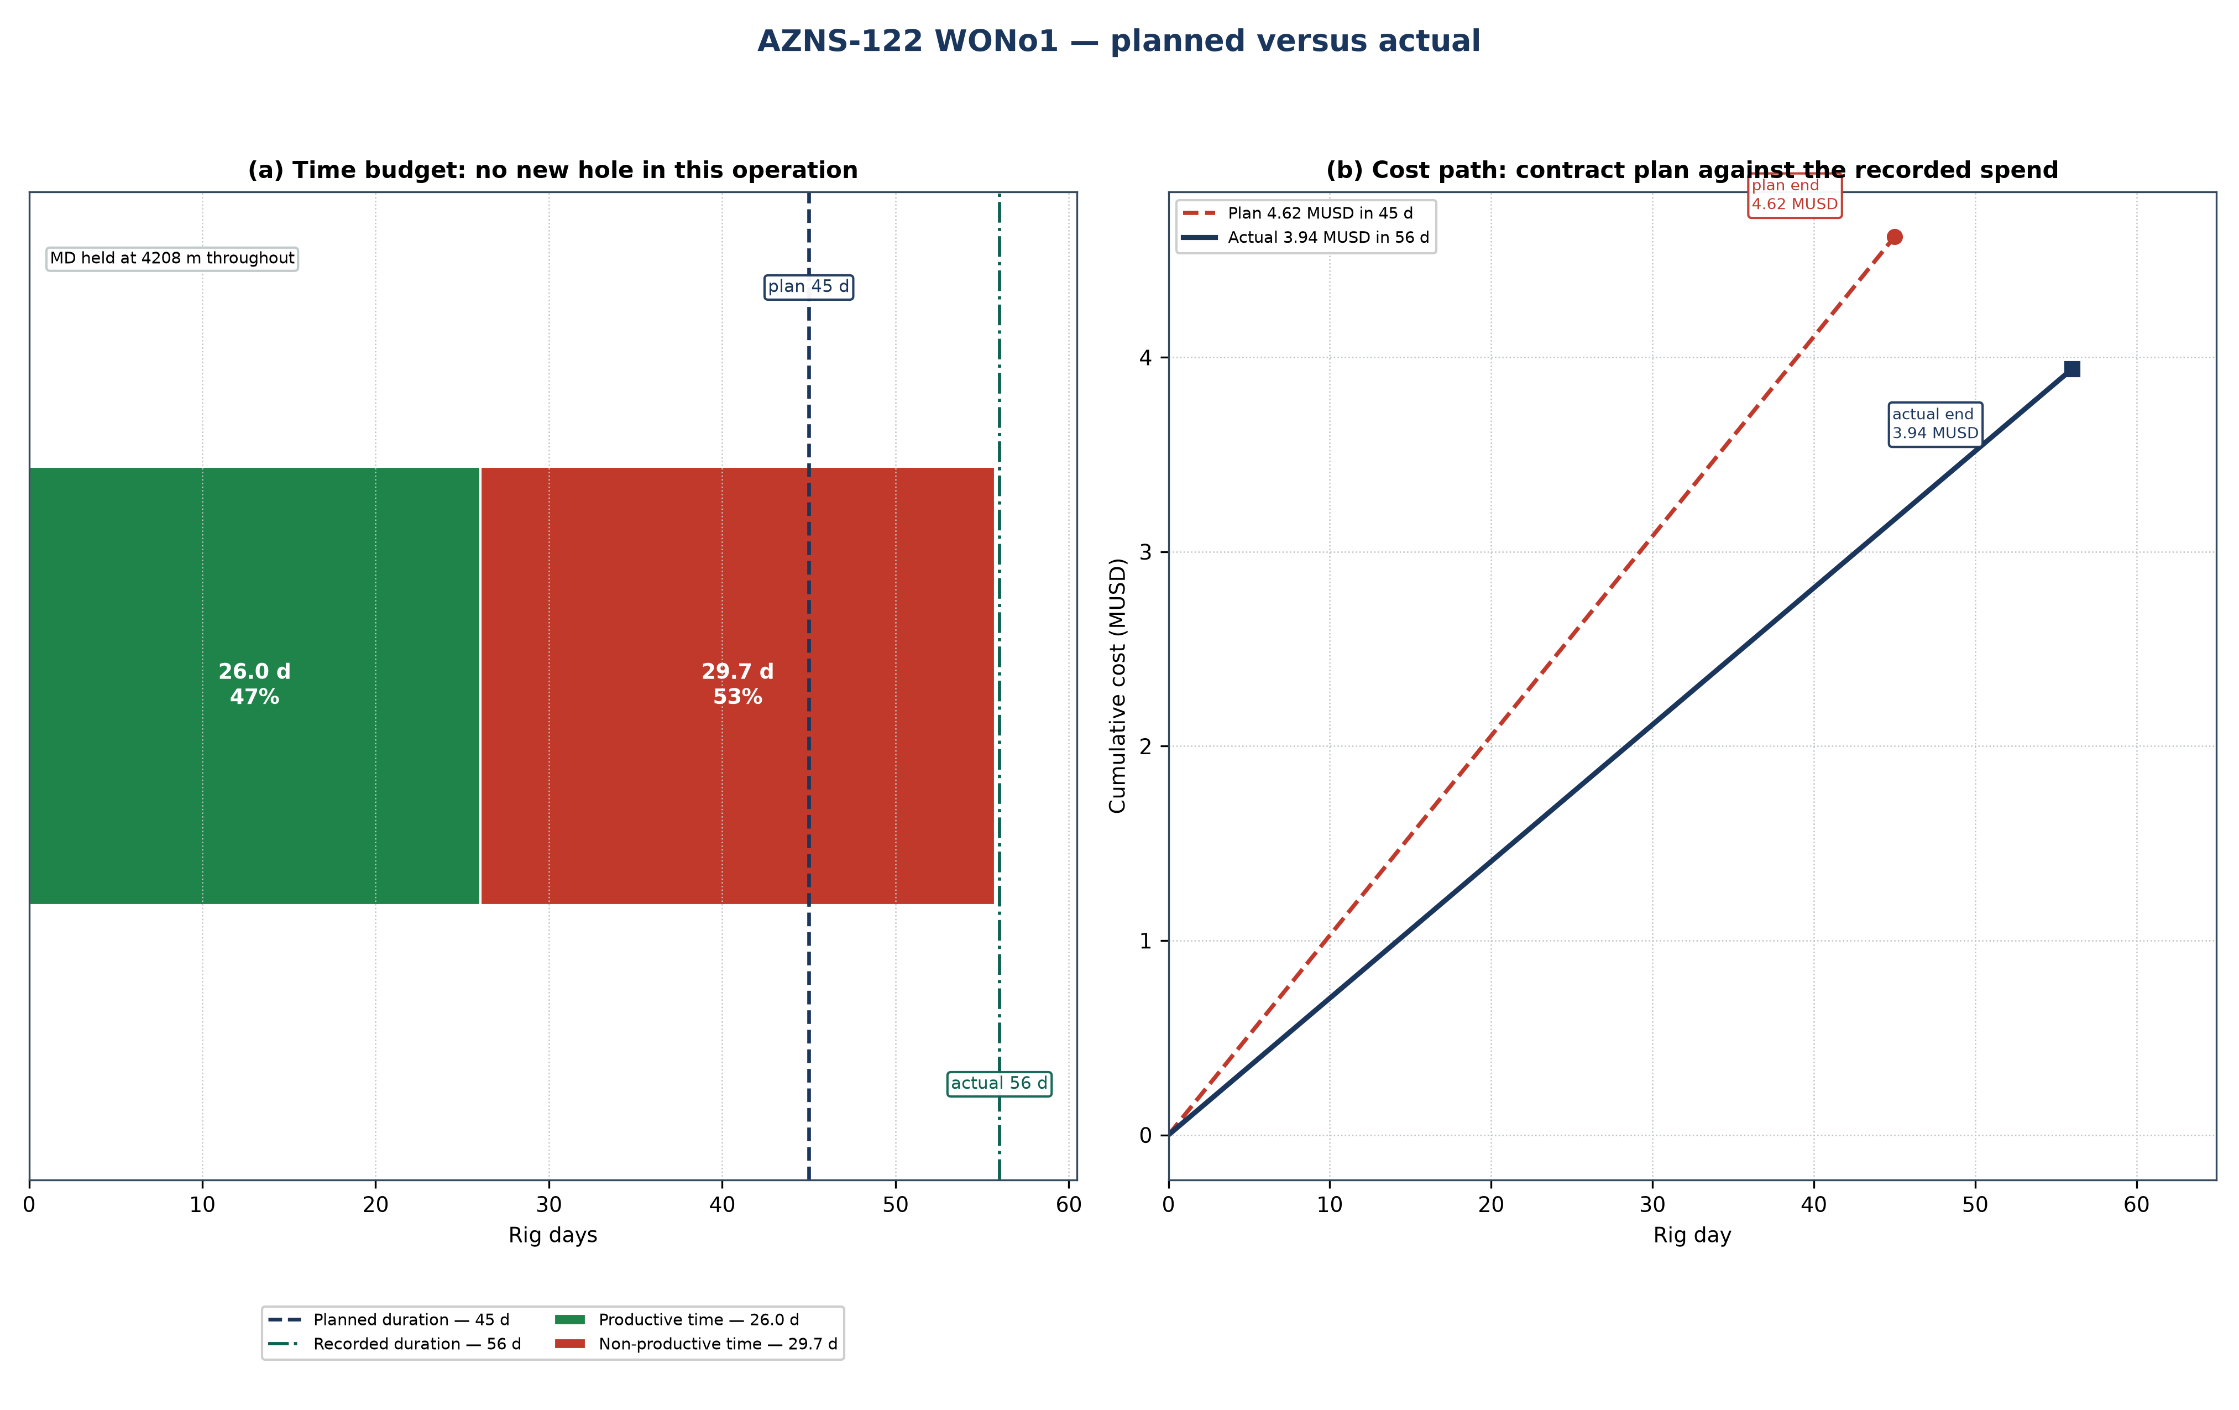
Figure 24.1 — AZNS-122 WO#1: planned schedule and cost path against the recorded operation
Table 24.1 — Planned and actual milestones
Indicator | Programme | Record | Variance | Basis
Rig days | 45 | 56 | +11.0 | Programme duration / DDR rig hours
Total depth (m) | 4,208 | 4,208 | +0 | Programme TD / final MD
New hole (m) | — | 0 | — | DDR daily drilling figure
Rig | OEOC RIG 208 | OEOC RIG 208 | — | DDR header
NPT share | — | 713 h (53.3%) | — | Time-log flags
Contract value (MUSD) | 4.62 | 3.94 | −0.68 | CBS / daily-rate reconstruction
Specific cost (USD/m) | — | — | — | Cost over new hole

Two explanations are open for a variance of this size, and they are separated before any recovery is credited. Either the scope grew after approval — an extra run, a second window, a deeper shoe — or the same scope took longer because rig time was lost. The discriminator is the NPT register: non-productive time is 713 h of 1,338 h (713 h (53.3%)), which accounts for about 30 days. Where that is close to the overrun, the scope did not change and the time was lost; where the operation count rises while NPT stays flat, the scope changed.
Technically the operation followed the programme sequence of workover with completion replacement: the casing and hole programme of Chapter 2, the fluid programme of Chapter 7 and the bit and BHA record of Chapter 6 are the executed values, and Table 24.1 sets them against the plan. The planned section boundaries are reproduced in Figure 24.1 by the formation bands, so any section that ran long can be read directly off the depth axis.

25. Cost breakdown structure: contract plan against recorded cost
CBS AZNS-122WO1.xlsx prices the scope at 4.62 MUSD, of which 1.48 MUSD is written on day-rate lines at a rig rate of 23,000 USD/day; the time-dependent element therefore costs about 32,880 USD per rig day. The record closes at 3.94 MUSD, a variance of −0.68 MUSD (−15%). Figure 25.1 splits that variance into the day-rate effect of the schedule and a scope-and-price residual.
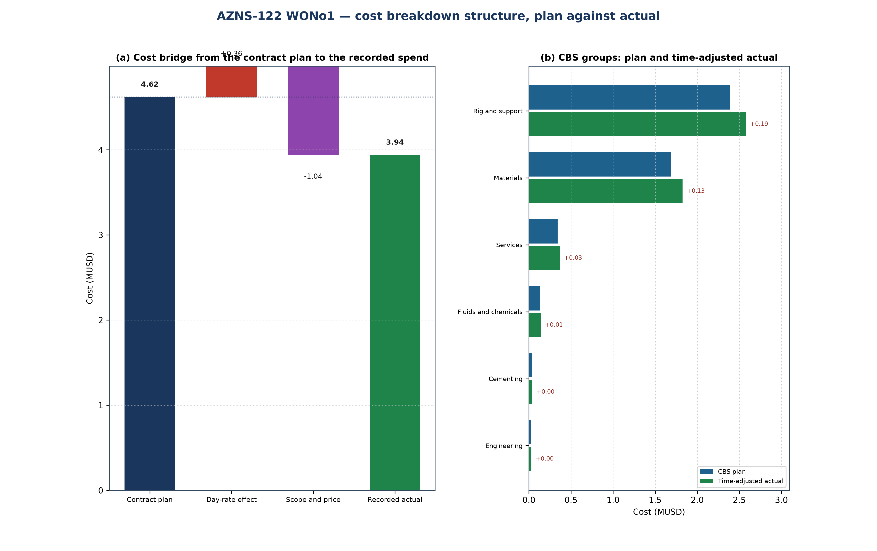
Figure 25.1 — AZNS-122 WO#1: cost bridge and CBS groups
Table 25.1 — CBS groups: plan, share and time-adjusted value
CBS group | Plan (MUSD) | Share | Time-adjusted (MUSD) | Δ (MUSD)
Rig and support | 2.39 | 51.7% | 2.58 | +0.19
Materials | 1.69 | 36.6% | 1.83 | +0.13
Services | 0.34 | 7.4% | 0.37 | +0.03
Fluids and chemicals | 0.13 | 2.8% | 0.14 | +0.01
Cementing | 0.04 | 0.8% | 0.04 | +0.00
Engineering | 0.03 | 0.6% | 0.03 | +0.00
Total | 4.62 | 100.0% | 4.98 | +0.36

Table 25.2 — Variance bridge
Step | MUSD | Driver
Contract plan (CBS) | 4.62 | Contract quantities at contract rates
Day-rate effect | +0.36 | +11.0 rig days at 32,880 USD/day
Scope and price residual | −1.04 | Runs, materials and services beyond the priced quantity
Recorded cost | 3.94 | Daily-rate reconstruction

The residual is small against the contract value, so the variance is very nearly the price of rig time: the scope held and the schedule did not. That is the useful reading for the next well of the same scope, because it makes the day rate the only lever that matters in the estimate.

26. Intervention-specific execution notes
This is a workover: the well is killed and secured first, the existing completion is retrieved or milled, the productive interval is re-established and the well is returned to service. The programme's well-control chapter governs the kill, the cement programme governs any squeeze and the completion chapter governs the string and the packer setting depth. The hold points below are the ones that decide whether the operation closes on plan.
Table 26.1 — Execution hold points
Stage | Execution requirement | Hold point
Kill and secure | Kill fluid from the last recorded gradient, circulated at the minimum rate that keeps the annulus full | stable shut-in pressure before the tree is broken
Retrieve or mill the completion | Recorded make-up torque, fishing diagram and jarring procedure on the floor | string freed and torque recorded before the next run
Squeeze and test | Cement squeeze at the programmed pressure with the WOC time held in full | pressure test held before the interval is opened
Re-establish the interval | Perforation, acid or rig-less stimulation per the programme, treating pressure recorded | treating pressure inside the fracture gradient of Chapter 9

The operation as recorded is a workover with completion replacement. Its schedule closed at 56 rig days against 45 planned, the reading of Chapter 24, and its cost at 3.94 MUSD against 4.62 MUSD of contract value, which Chapter 25 decomposes. What remains for the next operation of this type is the hold-point discipline of Table 26.1: every recorded overrun is a hold point passed late rather than a step executed badly.

