AZNS-127-ST #2 — Drilling Engineering Report
Sidetrack record, rig OEOC RIG 201, AZNS field — drilling performance, bit and hydraulics mechanics, trajectory, integrity and field solutions

Rig: OEOC RIG 201 | Well type: sidetrack | Spud: —
Rig days: 106 | New hole: 1,081 m | Final MD: 4,150 m
Reconstructed cost: 7.45 MUSD | NPT: 15.5%
Prepared by: Principal Drilling & Well Operations Engineering

Contents
1. Executive summary and well KPIs
2. Well architecture, rig configuration and casing programme
3. Operational chronology and phase cost
4. Drilling performance, connections and rate of penetration
5. Non-productive time and multi-hypothesis root cause
6. Bit, BHA and nozzle performance
7. Mechanical parameters and mechanical specific energy
8. Drilling fluids, rheology, cuttings transport and ECD
9. Directional survey, trajectory and dog-leg severity
10. Hook load, drag and overpull
11. Well control, shoe integrity, MAASP and losses
12. Geology, formation tops and gas
13. Operational problems, remedies and rig-floor playbooks
14. Optimum parameters, drill-off and MSE practice
15. Key findings and risk register
16. Recommendations — phase matrix and REC-01 to REC-10
17. Limitations of the recorded data
18. Appendix A — Workbooks, sheets and SHA-256
19. Appendix B — Equations and units
20. Appendix C — Complete NPT register
21. Appendix D — Daily hydraulics and ECD
22. Appendix E — Formation tops and survey stations
23. Reference, quality control and traceability
24. Planned versus actual: the programme against the record
25. Cost breakdown structure: contract plan against recorded cost
26. Intervention-specific execution notes

Table 0.1 — Management identity sheet
Attribute | Value | Attribute | Value
Well | AZNS-127-ST #2 | Rig | OEOC RIG 201
Well type | sidetrack | Field | AZNS — South Azadegan
Spud date | — | Rig days | 106
Final MD | 4,150 m | New hole | 1,081 m
NPT | 394 h (15.5%) | Rig hours | 2,544 h
Reconstructed cost | 7.45 MUSD | USD per metre | 6,893
Source sheets | 212 | Primary NPT cause | Unclassified
DDR Ref. — "1-1 DDR Remark" cells K5–N9 (Report Date, Report No.) and "1-2 DDR Data" rows 5–9 (well header: name, rig, spud, depths, casing head)

1. Executive summary and well KPIs
AZNS-127-ST #2 was worked by rig OEOC RIG 201 over 106 rig days and 2,544 rig hours. The record carries 1,081 m of new hole to a final measured depth of 4,150 m, with 15.5% of rig time booked as non-productive and a reconstructed cost of 7.45 MUSD. The dominant loss mechanism is unclassified at 186 h, and the section-level rate in the productive part of the well is 1.89 m/h net against 0.43 m/h gross.
Table 1.1 — Well KPI set
Indicator | Value | Indicator | Value
Rig days | 106 | Rig hours | 2,544
New hole (m) | 1,081 | Final MD (m) | 4,150
Drilling hours | 573 | Reaming hours | 149
Trip hours | 1,232 | Casing/cement hours | 51
NPT hours | 394 | NPT share | 15.5%
Net ROP (m/h) | 1.89 | Gross ROP (m/h) | 0.43
ILT hours | 765 | ILT share | 30.1%
Cost (MUSD) | 7.45 | Cost per day (kUSD) | 70.3
DDR Ref. — "1-2 DDR Data" time log rows 21–68 (codes, hours, flags), daily state rows 9–13 (24 hrs Drilled, MD, MW) and "1-1 DDR Remark" activity narrative

2. Well architecture, rig configuration and casing programme
The well was executed by rig OEOC RIG 201, a sidetrack unit operating in the AZNS field. The architecture follows the field standard: a large surface hole, an intermediate hole through the reactive shale sequence and a production hole in the carbonate reservoir. The section breakdown in this record is 4-1/8" (0 m in 3 days), 5-7/8" (0 m in 4 days), 6-1/8" (262 m in 47 days), 8-1/8" (827 m in 37 days).
The daily sheets in this record do not carry a casing table with shoe depths, so the architecture is described from the operational chronology and from the hole sizes actually drilled. The missing table is listed in Chapter 17 rather than reconstructed from assumption.
Table 2.2 — Rig and section configuration
Rig | Section | Days | Metres | Net ROP | NPT
OEOC RIG 201 | 4-1/8" | 3 | 0 | 0.00 | 0.0%
OEOC RIG 201 | 5-7/8" | 4 | 0 | 0.00 | 0.0%
OEOC RIG 201 | 6-1/8" | 47 | 262 | 0.84 | 14.9%
OEOC RIG 201 | 8-1/8" | 37 | 827 | 0.98 | 15.8%
DDR Ref. — "1-1 DDR Remark" header fields (rig, well type, section start depth, expected TD) and "1-2 DDR Data" rows 5–9

3. Operational chronology and phase cost
The record runs from the first report to the last report with 106 daily reports, each of which was read in full. The chronology below reproduces the operational sequence at fortnightly resolution, with the depth reached and the productive share of each interval.
Table 3.1 — Fortnightly chronology
Days | From | MD (m) | Hours | NPT
1–10 | — | 4,140 | 240 | 16.9%
11–20 | — | 4,140 | 240 | 24.8%
21–30 | — | 4,140 | 240 | 18.3%
31–40 | — | 4,140 | 240 | 31.7%
41–50 | — | 4,140 | 240 | 25.4%
51–60 | — | 4,150 | 240 | 2.5%
61–70 | — | 4,150 | 240 | 1.0%
71–80 | — | 4,150 | 240 | 2.5%
81–90 | — | 4,150 | 240 | 22.5%
91–100 | — | 4,150 | 240 | 18.8%
101–106 | — | 4,150 | 144 | 0.0%
DDR Ref. — "1-1 DDR Remark" “Summary of Activities in Last 24:00 hours” and “Operation Forecast”; day counter from the consecutive sheet pairing of the workbook
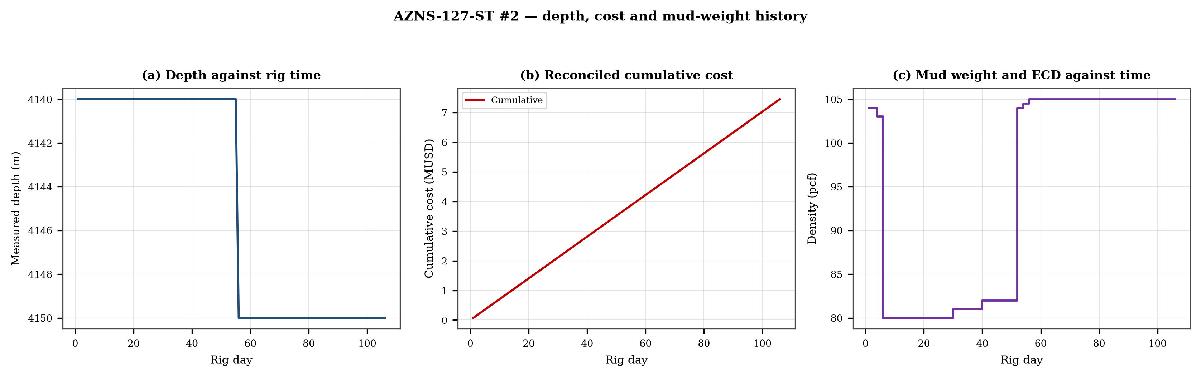
Figure 3.1 — Depth against rig time, reconciled cumulative cost and mud-weight envelope
The cost curve is reconstructed from the daily rig, mud and service rates applied to the recorded days; it is monotonic by construction and is intended for comparison, not as a replacement for the commercial register. The mud-weight curve shows the step changes that accompany each casing point, and each step is a decision point for the pressure window of Chapter 11.

4. Drilling performance, connections and rate of penetration
Productive time is split into drilling 573 h, reaming 149 h, trips 1,232 h, casing and cementing 51 h and logging 188 h. The ratio of handling time to drilling time is the single most informative number in this chapter: at 2.41 h of handling per hour of drilling, the well spends more time preparing the hole than making it.
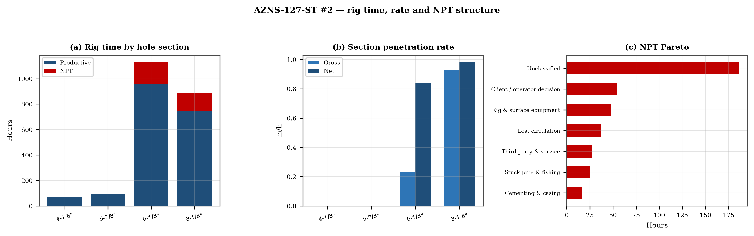
Figure 4.1 — Rig time by section, section rate and NPT pareto

Table 4.1 — Section performance
Section | Days | Metres | Gross ROP | Net ROP | Ream h | Trip h | NPT
4-1/8" | 3 | 0 | 0.00 | 0.00 | — | — | 0.0%
5-7/8" | 4 | 0 | 0.00 | 0.00 | — | — | 0.0%
6-1/8" | 47 | 262 | 0.23 | 0.84 | — | — | 14.9%
8-1/8" | 37 | 827 | 0.93 | 0.98 | — | — | 15.8%
DDR Ref. — "1-2 DDR Data" time log rows 21–68 filtered to drilling codes, total row 68, and the bit block (bit number, size, metres, hours, IADC dull code)

5. Non-productive time and multi-hypothesis root cause
Non-productive time totals 394 h, or 15.5% of rig time, spread over 107 coded entries. The register is ranked below; the two or three leading mechanisms are then examined one by one, each with competing physical explanations and the field evidence that separates them.
Table 5.1 — NPT register by mechanism
Mechanism | Hours | Share | Events
Unclassified | 186 | 47.2% | 61
Client / operator decision | 54 | 13.7% | 3
Rig & surface equipment | 48 | 12.2% | 18
Lost circulation | 38 | 9.5% | 8
Third-party & service | 27 | 6.9% | 10
Stuck pipe & fishing | 25 | 6.3% | 5
Cementing & casing | 17 | 4.3% | 2
DDR Ref. — "1-1 DDR Remark" activity status flag and "1-2 DDR Data" time-log flag column J (P / N / UP) with the code column A; hours from column E

5.1 Unclassified — competing mechanisms
This mechanism consumed 186 h across 61 entries. Two explanations fit the recorded sequence equally well until the discriminating evidence is read. Mechanism A is a formation-driven response: the borehole or the fluid column behaves differently from the plan because of what the rock is doing. Mechanism B is an equipment or procedure response: the same symptom appears because a surface system, a service or a handling step did not deliver what the programme assumed. The discriminator is the pressure and torque record at the moment of onset: a formation response appears while parameters are steady, an equipment response appears as a step change with parameters unchanged.
- Day 6 (—): 4.5 h — 4.5Hrs. NPT For OEOC Rig 201, Stop Op. & Slow Circ. @ 1225m, While Monitor the Well, NL-NG.
- Day 10 (—): 5.5 h — 5.5Hrs. NPT for HPOGC, Cont. RIH w/ 8-1/2" Cased-Hole Sidetrack BHA F/ 951 To 3042m On Elevator, While F/U Strg & Break Circ.
- Day 10 (—): 1.0 h — 1Hr. NPT for OEOC Rig 201 due to delay in RIH Operation.

5.2 Client / operator decision — competing mechanisms
This mechanism consumed 54 h across 3 entries. Two explanations fit the recorded sequence equally well until the discriminating evidence is read. Mechanism A is a formation-driven response: the borehole or the fluid column behaves differently from the plan because of what the rock is doing. Mechanism B is an equipment or procedure response: the same symptom appears because a surface system, a service or a handling step did not deliver what the programme assumed. The discriminator is the pressure and torque record at the moment of onset: a formation response appears while parameters are steady, an equipment response appears as a step change with parameters unchanged.
- Day 46 (—): 18.0 h — The continuation of operations is not possible due to the Client’s omission to notify regarding the contract, failure to introduce and register
- Day 47 (—): 24.0 h — Cont. Slow Circ. Thru string and wait on client; The continuation of operations is not possible due to the Client’s omission to notify regarding
- Day 48 (—): 12.0 h — Cont. Slow Circ. Thru string and wait on client; The continuation of operations is not possible due to the Client’s omission to notify regarding

6. Bit, BHA and nozzle performance
6 bit runs are recorded. The best run delivered 40 m and the shortest 2 m; the spread is the first indication that the dull grade, not the formation, ended the short runs. Where a dull code is recorded it is reproduced in the table without interpretation, and the wear pattern is discussed in the text.

Table 6.1 — Bit runs
Bit | Size | Type | IADC | Metres | Hours | Dull
2.0 | 8-1/2 | Insert | 517 | — | — | —
3.0 | 8-1/2" | PDC | M1665 | — | — | —
4.0 | 8-1/2" | PDC | M1662 | — | — | 1-1-BT-N-X-I-NO-BH
5.0 | 6-1/8" | TCI Bit | 517 | 2.0 | 6.0 | 1-1-WT-A-E-I-NO-BH
6.0 | 6-1/8" | PDC Bit | M1665 | 9.0 | 8.0 | —
7.0 | 5-7/8" | TCI Bit | HJT537GK | 40.0 | 11.5 | —
DDR Ref. — "1-1 DDR Remark" bit block columns C–H (bit no., size, type, metres, hours, dull grade) and the "1-2 DDR Data" bit/BHA block

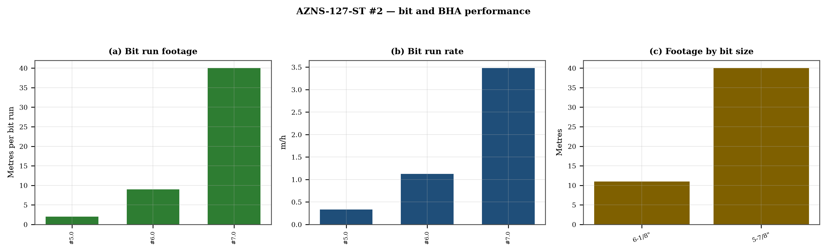
Figure 6.1 — Bit footage, run rate and footage by bit size

7. Mechanical parameters and mechanical specific energy
47 intervals carry a simultaneous weight and rotary-speed record. Weight on bit ranges 1.0–18.0 klbf with a median of 6.0 klbf, and rotary speed 20–3,893 rpm. The median mechanical specific energy is 228 ksi. For these hole sizes that is high: the bit is spending more energy on the bottom hole assembly and the fluid than on the rock.
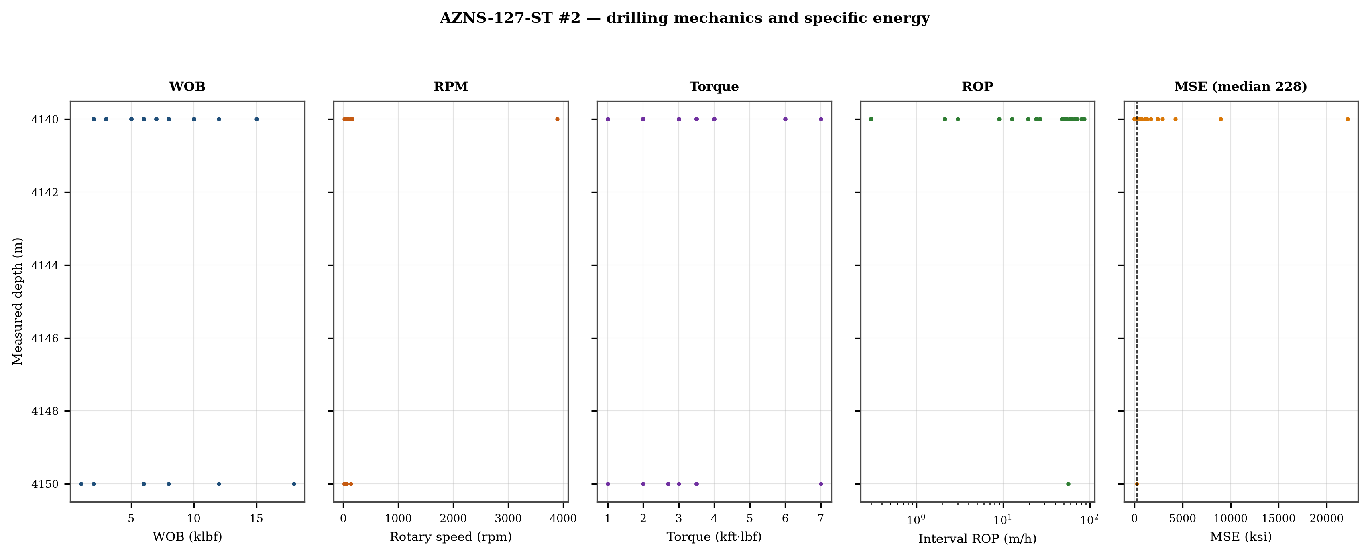
Figure 7.1 — Five-track mechanics log with specific energy

8. Drilling fluids, rheology, cuttings transport and ECD
The hydraulics record covers 35 days. Flow ranges 1–3,762 gpm, bit pressure drop 0–6,750 psi and the hydraulic index 0.0–286.1 hp/in². Annular velocity is computed for the recorded hole and pipe sizes; the 120 ft/min line on the figure is the field threshold for cuttings transport, not a regulatory limit.
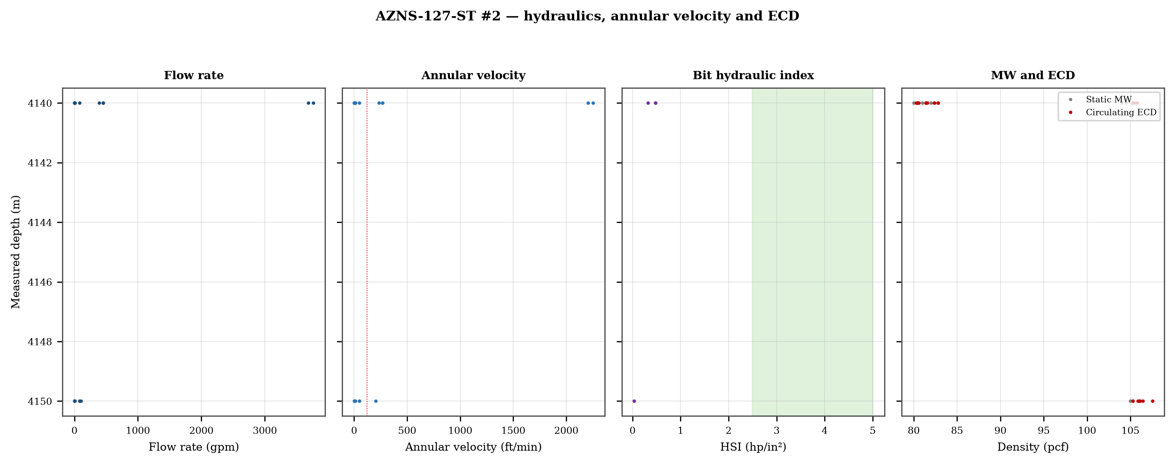
Figure 8.1 — Flow, annular velocity, hydraulic index and the ECD window
Mud weight moves between 80 and 105 pcf across the record, in steps that coincide with casing points. Each step changes the equivalent circulating density by the same amount plus the annular loss term, which is why the pressure window narrows precisely when the weight is increased to control the shale.

9. Directional survey, trajectory and dog-leg severity
The trajectory was rebuilt from 36 survey stations with the minimum-curvature method. The well reaches a maximum inclination of 11.8°, a maximum dog-leg of 11.97°/30 m and a final TVD of 3,759 m at 3,760 m MD, with a bottom-hole closure of 31 m. Dog-legs stay inside the drilling limit throughout, so the directional programme did not create the drag that Chapter 10 measures.
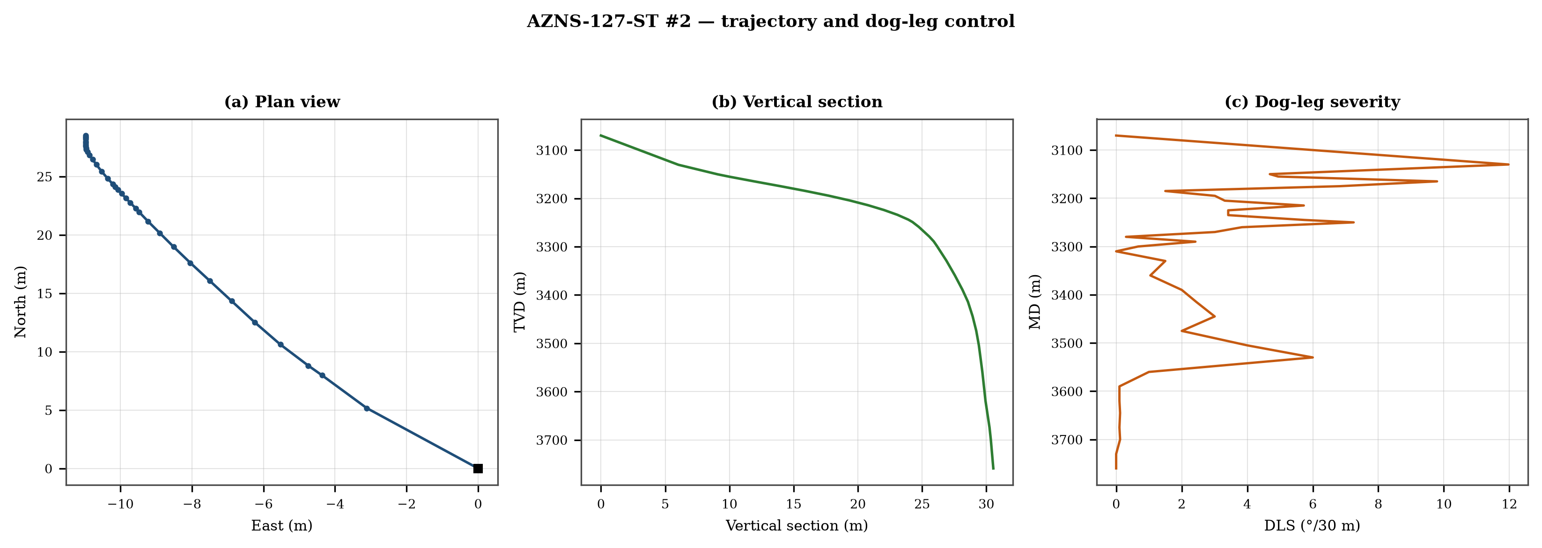
Figure 9.1 — Plan view, vertical section and dog-leg severity

Table 9.1 — Survey stations
MD | Inc | Azi | TVD | N | E | DLS
3,070.0 | 4.00 | 313.3 | 3,070.0 | 0.0 | 0.0 | 0.00
3,130.0 | 7.60 | 337.1 | 3,130.5 | 5.2 | -3.1 | 11.97
3,150.0 | 10.10 | 335.2 | 3,150.3 | 8.0 | -4.4 | 4.69
3,155.0 | 10.90 | 335.0 | 3,155.2 | 8.8 | -4.7 | 4.94
3,165.0 | 11.80 | 338.2 | 3,165.0 | 10.6 | -5.5 | 9.79
3,175.0 | 11.50 | 340.5 | 3,174.8 | 12.5 | -6.2 | 6.82
3,185.0 | 11.00 | 340.5 | 3,184.6 | 14.3 | -6.9 | 1.50
3,195.0 | 10.00 | 340.6 | 3,194.5 | 16.1 | -7.5 | 3.01
3,205.0 | 8.90 | 340.5 | 3,204.3 | 17.6 | -8.0 | 3.31
3,215.0 | 7.70 | 342.0 | 3,214.2 | 19.0 | -8.5 | 5.73
3,225.0 | 6.60 | 341.7 | 3,224.1 | 20.2 | -8.9 | 3.42
3,235.0 | 5.50 | 342.0 | 3,234.1 | 21.2 | -9.2 | 3.42
3,245.0 | 4.30 | 343.5 | 3,244.1 | 22.0 | -9.5 | 5.75
3,250.0 | 3.20 | 343.0 | 3,249.0 | 22.3 | -9.6 | 7.25
3,260.0 | 2.40 | 342.0 | 3,259.0 | 22.7 | -9.7 | 3.84
3,270.0 | 2.30 | 343.0 | 3,269.0 | 23.1 | -9.8 | 3.01
3,280.0 | 2.40 | 343.0 | 3,279.0 | 23.5 | -10.0 | 0.30
3,290.0 | 1.60 | 343.1 | 3,289.0 | 23.9 | -10.1 | 2.42
3,300.0 | 1.40 | 343.0 | 3,299.0 | 24.1 | -10.1 | 0.67
3,310.0 | 1.40 | 343.0 | 3,309.0 | 24.4 | -10.2 | 0.00
3,330.0 | 1.40 | 344.0 | 3,329.0 | 24.8 | -10.4 | 1.50
3,360.0 | 1.10 | 345.0 | 3,359.0 | 25.4 | -10.5 | 1.04
3,390.0 | 1.20 | 347.0 | 3,389.0 | 26.0 | -10.7 | 2.00
3,415.0 | 0.80 | 345.0 | 3,414.0 | 26.5 | -10.8 | 2.45
3,445.0 | 0.60 | 348.0 | 3,444.0 | 26.8 | -10.9 | 3.01
3,475.0 | 0.50 | 350.0 | 3,474.0 | 27.1 | -10.9 | 2.00
3,505.0 | 0.30 | 354.0 | 3,504.0 | 27.3 | -10.9 | 4.00
3,530.0 | 0.30 | 359.0 | 3,529.0 | 27.4 | -11.0 | 6.00
3,560.0 | 0.30 | 358.0 | 3,559.0 | 27.6 | -11.0 | 1.00
3,590.0 | 0.20 | 0.0 | 3,589.0 | 27.7 | -11.0 | 0.10
3,620.0 | 0.30 | 0.0 | 3,619.0 | 27.9 | -11.0 | 0.10
3,645.0 | 0.40 | 0.0 | 3,644.0 | 28.0 | -11.0 | 0.12
3,675.0 | 0.30 | 0.0 | 3,674.0 | 28.2 | -11.0 | 0.10
3,700.0 | 0.20 | 0.0 | 3,699.0 | 28.3 | -11.0 | 0.12
3,730.0 | 0.20 | 0.0 | 3,729.0 | 28.4 | -11.0 | 0.00
3,760.0 | 0.20 | 0.0 | 3,759.0 | 28.5 | -11.0 | 0.00
DDR Ref. — "1-2 DDR Data" survey table from header row 115 (MD, inclination, azimuth, TVD) — template A; "1-2 DDR Data" survey block J50+ — template B

10. Hook load, drag and overpull
A soft-string model was built on the recomputed survey with the buoyancy factor of the recorded mud weight and a tripping friction factor of 0.28. At 3,760 m the model gives a pick-up load of 18.1 klbf, a rotating load of 17.7 klbf and a slack-off of 17.6 klbf. The spread between pick-up and slack-off is 0.4 klbf; that is the friction the string actually carries, and it is the margin that must not be spent on a single pull.
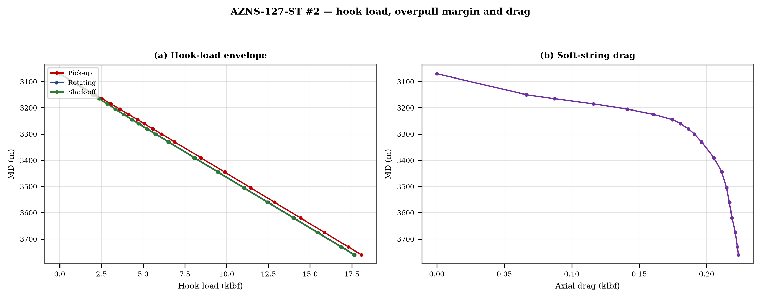
Figure 10.1 — Hook-load envelope and axial drag

11. Well control, shoe integrity, MAASP and losses
The record contains 0 formation-integrity tests with a numerical equivalent mud weight and 22 days with a loss entry. The dynamic maximum allowable surface pressure is the number the driller needs: at the shallowest shoe of this well, raising the annulus by 500 psi requires an equivalent weight of 0.0 pcf, which is the practical test of whether the mud programme is inside the window.

12. Geology, formation tops and gas
5 formation tops are recorded between 3,060 m and 3,937 m MD. The sequence and the depth of each top are reproduced below with the minimum-curvature TVD where a survey exists; the drillability of each interval is discussed against the rate record rather than against a general lithology table.
Table 12.1 — Formation tops
Formation | MD (m) | TVD (m)
Sarvak | 3,060 | 3,070
Kazhdumi | 3,272 | 3,269
Dariyan | 3,476 | 3,474
Gadvan | 3,648 | 3,644
Fahliyan | 3,937 | 3,937
DDR Ref. — "1-2 DDR Data" rows 110–131: K = formation, L/M = forecast MD and TVD, O/Q = actual TVD
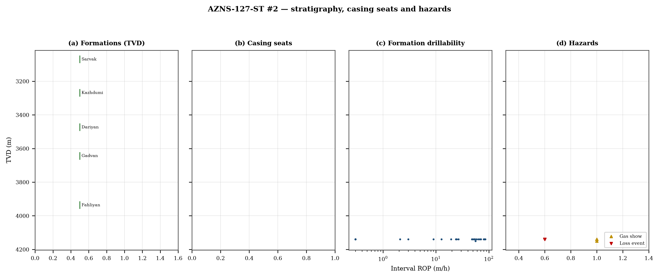
Figure 12.1 — Formation tops, casing seats, drillability and hazards

13. Operational problems, remedies and rig-floor playbooks
The five playbooks below are written for use at the rig floor, in the order given. Each one is the compressed form of the diagnosis used in Chapters 5, 10 and 11, and each is matched to the mechanism it treats.

Loss circulation playbook
- Stop drilling, record the loss rate at the current pump rate and keep the string moving.
- Reduce flow in two steps and measure the loss at each step: partial loss responds to LCM, total loss needs a different mechanism, not a bigger pill.
- Spot a graded LCM pill (fine–medium–coarse) across the loss zone and cure it before resuming; log the pill volume, the returned volume and the pressure at which it was spotted.
- If losses persist at the shoe, recalculate MAASP with the current mud weight and confirm the well is still displaced by a single fluid column.

Tight hole and overpull playbook
- Compare the observed overpull with the modelled pick-up envelope for the same depth.
- Circulate at the maximum allowable rate with the string rotating; if torque falls while returns carry cuttings, the cause is cleaning, not the formation.
- Work the string down with a controlled feed-off rather than pulling; never exceed 80% of the modelled overpull margin.
- If the string is stuck, establish circulation and jar down before any chemical soak.

Stuck pipe and fishing playbook
- Record the free rotating weight, the pick-up and the slack-off immediately; the spread distinguishes wall contact from a pack-off.
- Establish circulation within the first ten minutes; a stuck string that still circulates is recoverable without fishing.
- Apply torque and jar in the direction indicated by the string's own weight response, not by habit.
- Photograph and grade every recovered component before the next run.

Well-control playbook
- Shut in on the hard shut-in sequence and record SIDPP, SICP and pit gain within one minute.
- Confirm the influx type from the pressure pair: SIDPP ≈ SICP means a light fluid, SICP >> SIDPP means gas.
- Prepare a kill sheet with slow circulating pressure at the actual pump rate, not a table value.
- Maintain the casing pressure constant while bringing the pumps to rate; do not chase the drill-pipe pressure.

Shoe test and MAASP playbook
- Never drill out a shoe without a recorded FIT/LOT equivalent mud weight in the daily header.
- Compute MAASP for the current mud weight every time the weight changes by 0.1 pcf.
- Convert the test result to a fracture gradient at the shoe TVD, not at MD.
- When a loss occurs at the shoe, the first number to read is the dynamic MAASP, not the static one.

14. Optimum parameters, drill-off and MSE practice
Table 14.1 — Section parameter window in this well
Section | WOB (klbf) | RPM | Median interval ROP | Net ROP
4-1/8" | 1–6 | 35–35 | 0.0 | 0.00
5-7/8" | 8–8 | 60–60 | 0.0 | 0.00
6-1/8" | 2–18 | 20–3,893 | 31.5 | 0.84
8-1/8" | 2–15 | 30–130 | 26.6 | 0.98
DDR Ref. — "1-2 DDR Data" drilling-parameter sentences in column K (WOB, RPM, flow, SPP, torque) and the mud table columns K–S rows 11–38 — template A; mud table J8–L27 — template B
The drill-off procedure is the only reliable way to find the founder point on location. Hold flow constant, reduce weight in three steps of about 15% and record the rate at each step after 90 seconds of steady drilling; the rate should rise with weight until the founder point and then flatten. The weight at which it flattens is the operating weight for that formation, and the weight at which torque rises while rate does not is the weight that damages the bit.
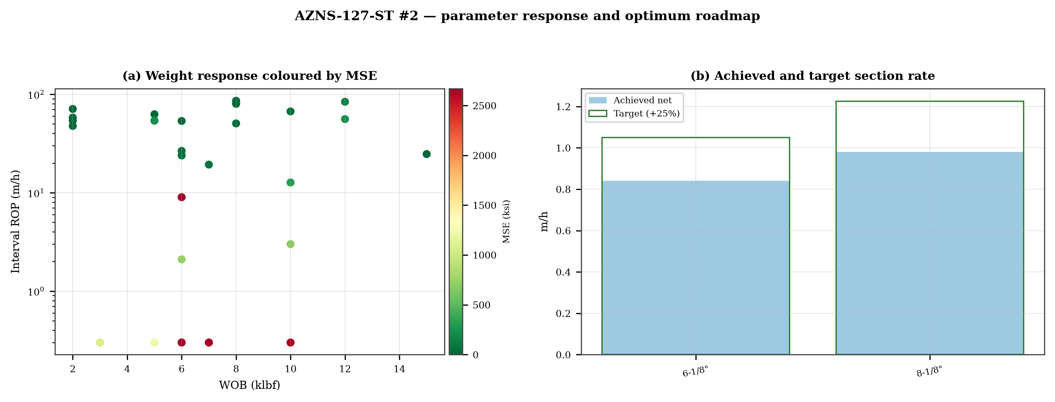
Figure 14.1 — Weight response coloured by specific energy and the section rate target

15. Key findings and risk register
- NPT stands at 15.5% of rig time, dominated by unclassified.
- Handling time is 2.41 times the drilling time, which is the structural inefficiency of this record.
- Net rate in the productive intervals is 1.89 m/h at a median specific energy of 228 ksi.
- The pressure window and the mud programme interact at every casing point; the integrity record is the weakest data set in the well.
Table 15.1 — Risk register
Risk | Trigger | Consequence | Control
Loss at the shoe | Drilling out with weight above the window | Loss of circulation and stuck pipe | Two-rate loss test, graded LCM
Tight hole on trips | Shale swelling after long open-hole exposure | Overpull and stuck string | Wiper trips, mud inhibition
Bit balling | Weight above the founder point in reactive clay | Rate collapse and torque rise | Drill-off test, HSI above 2.5
Equipment failure | Ageing pumps and top drive | Long NPT and hole deterioration | Reliability register
DDR Ref. — Derived — "1-1 DDR Remark" narrative, "1-2 DDR Data" time-log flags and the NPT register of this report; no single DDR cell

16. Recommendations — phase matrix and REC-01 to REC-10
Table 16.1 — Phase execution matrix
Phase | Action | Hold point
Pre-spud | Verify rig systems and spares against the reliability register | Signed availability check
Surface hole | Maximum flow with a single casing and cementing trip | Shoe test recorded
Intermediate | PDC and motor, wiper trip every 300 m, AV above 120 ft/min | Overpull trend inside envelope
Reservoir entry | Two-rate loss test and graded LCM on location | Loss cured before drilling ahead
Reservoir hole | Hold HSI above 2.5 hp/in², drill-off at each top | Founder point recorded
Close-out | NPT booked to the fixed cause list, review within 14 days | QC certificate signed
DDR Ref. — "1-2 DDR Data" time log rows 21–68 aggregated by operational code and the "1-1 DDR Remark" section headers
Table 16.2 — Recommendations
ID | Recommendation | Owner | Timing | Rationale
REC-01 | Adopt a rig-specific reliability register (pumps, top drive, drawworks) with monthly availability and mean time between failures | Rig manager | Immediate | Rig and surface equipment is the largest controllable NPT category
REC-02 | Standardise the FIT/LOT protocol and write the demonstrated EMW into the daily header | Well integrity | Before the next well | Makes MAASP auditable at every shoe
REC-03 | Apply the section parameter roadmap of Chapter 14 as the drilling programme | Drilling engineering | Next well | Closes the gap to the field P90 rate
REC-04 | Introduce a graded-LCM loss protocol with a two-rate diagnosis before treatment | Mud engineering | Immediate | Cuts loss time and lost mud volume
REC-05 | Run a drill-off test at the top of each formation and record the founder point | Drilling engineering | Each section | Prevents weight-induced inefficiency
REC-06 | Treat centrifuge running time as a recorded drilling parameter | Mud engineering | Immediate | Controls ECD without changing mud weight
REC-07 | Hold a torque-and-drag check against the modelled envelope before every trip | Drilling supervisor | Every trip | Converts overpull from a surprise into a trend
REC-08 | Book every NPT hour against the fixed cause list within the same tour | Drilling supervisor | Daily | Keeps the field comparison comparable
REC-09 | Audit third-party service readiness (wireline, cementing, casing crews) before the operation, not on arrival | Field engineering | Each job | Third-party delay is the second largest NPT category
REC-10 | Publish a weekly NPT pareto and a monthly field benchmarking pack | Field engineering | Weekly | Sustains the learning curve across rigs
DDR Ref. — This report — built from the KPI set and NPT register above; each row carries its own evidence reference

17. Limitations of the recorded data
- No casing table with shoe depths: the architecture is described from the chronology and the hole sizes drilled.
- No formation-integrity test with a numerical equivalent mud weight: MAASP is reported as a sensitivity, not as a measured value.
- Costs are reconstructed from daily rig, mud and service rates because the workbooks do not carry a commercial register; they are used for comparison only.

18. Appendix A — Workbooks, sheets and SHA-256
The record was read from AZNS127ST2Pack.xlsx with 212 sheets, all of which were parsed. The table below reproduces the file inventory with the digest of the source workbook as it stands in the repository.
Table 18.1 — Source workbooks and SHA-256
File | SHA-256
AZNS10Pack.xlsx | bf8c897274b47f9324b6e808162c451c0329d78651e76a27c700db9263ec0a95
AZNS116Pack.xlsx | 68c5b874f1ba78a4a30989930aef00f06095d8118e89e217e74ca918364dc438
AZNS122WO1Pack.xlsx | c14db1ff6cbef8b7d4e0f69b9f64cdc4452e3935f64bad439d38a8aed6f5f42a
AZNS122WO2Pack.xlsx | 2eb9858150dfa2d43f46e387ded978fd04c811f0c08b402a76a533f36235b65c
AZNS127ST2Pack.xlsx | 68329de313721905be08f20cb8bb8b4f5f3671d5c6caab41f23caa1a48b9a4c4
AZNS127WO1Pack.xlsx | 6034aae76c2e3126416df8f8576d424bd3394c30aca4c4f5e72f0372256739d6
AZNS127WOPack.xlsx | a4ae90dc870f20b2f99ac3a36b8b5cd1c357b60dd2805630597cc48ba059054e
AZNS12Pack.xlsx | e325945f1108341bace123e60b02fb04ac3f7d3003a19eb8d23004cf7cd67216
AZNS166Pack.xlsx | e63824748e4692884fc23075c678c1379b9b595a8c8b1efb289e630f898a75d8
AZNS207Pack.xlsx | 828968c7e0afd7273d64987bd457383ecfea3a2e00e62c9a65b587f16518996a
AZNS40Pack.xlsx | 0523068ee222c02f6e2d2754bcd919a9c296b334b03521ab15d84322aade94ca
AZNS75Pack.xlsx | 5e0482d5d50e9347a98b7c24cfd3a102d3c00f2c951f6061aba14d164136fcae
AZNS85Pack.xlsx | 0d3ecc54fb8b9484f508b9a3957554ba13e72546c6d485abb79af633362daeb2
DDR Ref. — Workbook files as delivered (read-only), hash computed at build time
Table 18.2 — Sheet inventory of this well
Sheet | Sheet | Sheet
1-1 DDR Remark | 1-2 DDR Data | 2-1 DDR Remark
2-2 DDR Data | 3-1 DDR Remark | 3-2 DDR Data
4-1 DDR Remark | 4-2 DDR Data | 5-1 DDR Remark
5-2 DDR Data | 6-1 DDR Remark | 6-2 DDR Data
7-1 DDR Remark | 7-2 DDR Data | 8-1 DDR Remark
8-2 DDR Data | 9-1 DDR Remark | 9-2 DDR Data
10-1 DDR Remark | 10-2 DDR Data | 11-1 DDR Remark
11-2 DDR Data | 12-1 DDR Remark | 12-2 DDR Data
13-1 DDR Remark | 13-2 DDR Data | 14-1 DDR Remark
14-2 DDR Data | 15-1 DDR Remark | 15-2 DDR Data
16-1 DDR Remark | 16-2 DDR Data | 17-1 DDR Remark
17-2 DDR Data | 18-1 DDR Remark | 18-2 DDR Data
19-1 DDR Remark | 19-2 DDR Data | 20-1 DDR Remark
20-2 DDR Data | 21-1 DDR Remark | 21-2 DDR Data
22-1 DDR Remark | 22-2 DDR Data | 23-1 DDR Remark
DDR Ref. — Workbook sheet list — every remark/data sheet pair plus the reference sheets

19. Appendix B — Equations and units
Table 19.1 — Governing equations
Quantity | Equation | Units
Mechanical specific energy | MSE = 480·T·N/(D²·ROP) + 4·WOB/(π·D²·1000) | psi, klbf, ft·lbf
Bit pressure drop | ΔP = ρ·Q²/(10858·TFA²) | psi, gpm, in²
Jet velocity | V = 0.3208·Q/TFA | ft/s
Hydraulic index | HSI = ΔP·Q/(1714·A_bit) | hp/in²
Annular velocity | V = 24.5·Q/(D_h² − D_p²) | ft/min
Bingham annular loss | ΔP = PV·V·L/(60000·(D_h−D_p)²) + YP·L/(200·(D_h−D_p)) | psi
Equivalent circulating density | ECD = MW + ΔP_ann/(0.052·TVD) | pcf
Minimum curvature | β = arccos[cos I₁cos I₂ + sin I₁ sin I₂ cos(A₂−A₁)] | rad
Dog-leg severity | DLS = 30·β/ΔMD | °/30 m
Buoyancy factor | BF = 1 − MW/490 | —
Hook load (soft string) | F = Σ w·BF·cos I·Δs ± μ·Σ w·BF·sin I·Δs | klbf
Maximum allowable surface pressure | MAASP = 0.052·(EMW_frac − MW)·TVD_shoe | psi
dc exponent | dc = log(ROP/(60·N)) / log(WOB/D) | —
Reconstructed cost | C = Σ (rig + mud + service) day rate | USD
DDR Ref. — Reference standard, Appendix B — no DDR cell

20. Appendix C — Complete NPT register
Table 20.1 — NPT register (all entries)
Day | Hrs | Mechanism | Activity and description
1 | 12.0 | Cementing & casing | Since 28-Feb-2026 Wait on client for next plan; Suspended the well as per client instruction w/ CMT Balance plug @ 2 sta
6 | 4.5 | Unclassified | 4.5Hrs. NPT For OEOC Rig 201, Stop Op. & Slow Circ. @ 1225m, While Monitor the Well, NL-NG.
10 | 5.5 | Unclassified | 5.5Hrs. NPT for HPOGC, Cont. RIH w/ 8-1/2" Cased-Hole Sidetrack BHA F/ 951 To 3042m On Elevator, While F/U Strg & Break
10 | 1.0 | Unclassified | 1Hr. NPT for OEOC Rig 201 due to delay in RIH Operation.
10 | 14.5 | Rig & surface equipment | 14.5Hrs. NPT for HPOGC, Conn. TDS & Cont. RIH w/ 8-1/2" Cased-Hole Sidetrack BHA w/ pump out F/ 3042 To 3054m, Hold up
10 | 1.0 | Unclassified | 1Hrs. NPT for HPOGC, CBU @ 3056.4m to sweep the Well, while perform Mud Treatment to optimize Rheological
10 | 2.0 | Unclassified | 2Hrs. NPT for HPOGC, Cont. POOH 8-1/2" Cased-hole Sidetrack BHA F/ 3056.4 To 2322m On Elevator, While Circ. C.W.H, NL-NG
11 | 3.0 | Unclassified | 3Hrs. NPT for HPOGC, Cont. POOH 8-1/2" Cased-hole Sidetrack BHA F/ 2322 To 1000m On Elevator, While Circ. C.W.H, NL-NG.
11 | 1.5 | Unclassified | 1.5Hrs. NPT for HPOGC, Obs. The Well & Static Flow Check @ 1000m for 1Hr. ; CBU for a while and monitor the Well,
11 | 5.0 | Unclassified | 5Hrs. NPT for HPOGC, Cont. POOH 8-1/2" Cased-hole Sidetrack BHA F/ 1000m To Surface On Elevator; Obs. Strg is twisted of
11 | 5.0 | Cementing & casing | 5Hrs. NPT for HPOGC, P/U, M/U, and Set 11" Plug Tester in T.H.S Bowl; Perform BOP Test as per NIOC Policy:
11 | 1.5 | Stuck pipe & fishing | 1.5Hrs. NPT for HPOGC, P/U and M/U 4-3/4" Fishing BHA including: [1-9/16" × 2-11/16" Taper Tap (New, S/N: 1017031004,
11 | 8.0 | Stuck pipe & fishing | 8Hrs. NPT for HPOGC, Cont. RIH w/ 1-9/16" × 2-11/16" Taper Tap & 4-3/4" Fishing BHA F/ 96 To 2730m Followed by 5" DPs On
12 | 2.0 | Stuck pipe & fishing | 2Hrs. NPT for HPOGC, Cont. RIH w/ 1-9/16" × 2-11/16" Taper Tap & 4-3/4" Fishing BHA F/ 2730 To 3044m Followed by 5" DPs
12 | 1.0 | Stuck pipe & fishing | 1Hr. NPT for HPOGC, Record Up & Dn ward Strg Wt. W/ & W/O Flow Rate & Rotation; Lower Strg & Engage W/ Fish &
12 | 12.5 | Stuck pipe & fishing | 12.5Hrs. NPT for HPOGC, POOH 1-9/16" × 2-11/16" Taper Tap & 4-3/4" Fishing BHA To Surface On Elevator to check string,
12 | 1.0 | Rig & surface equipment | 1Hr. NPT For OEOC Rig 201, Work on Drawworks, While Circ. C.W.H & Monitor the Well, NL-NG.
12 | 2.5 | Unclassified | 2.5Hrs. NPT for HPOGC, P/U & M/U 8-1/2" Cased-hole Sidetrack BHA including [8-1/2" Spiral Tri-Mill (Lead + Follow + Wate
12 | 5.0 | Unclassified | 5Hrs. NPT for HPOGC, Cont. RIH w/ 8-1/2" Cased-Hole Sidetrack BHA F/ 236 To 1950m On Elevator, While F/U Strg & Break Ci
13 | 2.5 | Unclassified | 2.5Hrs. NPT for HPOGC, Cont. RIH w/ 8-1/2" Cased-Hole Sidetrack BHA F/ 1950 To 3042m On Elevator, While F/U Strg & Break
14 | 2.0 | Third-party & service | M/U Gyro Sub; Failure it. Wait on Rec. Another Gyro Sub, While slow Circ. Mud thru string; NL-NG.
14 | 1.0 | Third-party & service | P/U & M/U New Gyro Sub, Align key of sleeve Gyro sub with the bent sub-scribe.
14 | 1.0 | Unclassified | 1 Hrs NPT for OEOC Rig 201 due to delay in BHA RIH operation.
18 | 0.5 | Unclassified | 0.5Hrs. NPT For OEOC Rig 201 due to work on SCR sys. malfunction and electrical problem.
18 | 0.5 | Rig & surface equipment | 0.5 Hrs. NPT For OEOC Rig 201 due to Leakage Conn. Std. & L/D 2Joints 5" DP, work on mud pump sever times & fault in gam
18 | 1.0 | Unclassified | 1Hrs. NPT For OEOC Rig 201, due to poor phone & internet connection.
19 | 1.0 | Unclassified | 1Hrs. NPT For OEOC Rig 201, due to poor phone & internet connection.
20 | 1.0 | Unclassified | 1Hrs. NPT For OEOC Rig 201, due to poor phone & internet connection.
20 | 1.0 | Unclassified | 1Hrs. NPT For OEOC Rig 201, due to insufficient welfare service provision.
21 | 1.0 | Unclassified | 1Hrs. NPT For OEOC Rig 201, due to poor phone & internet connection.
22 | 1.0 | Unclassified | 1Hrs. NPT For OEOC Rig 201, due to poor phone & internet connection.
23 | 1.0 | Unclassified | 1Hrs. NPT For OEOC Rig 201, due to poor communication service provided by contractor while B/R & R/D drilled stand, Conn
23 | 2.0 | Unclassified | 2Hrs. NPT For OEOC Rig 201, due to weakness of welfare and camp services while Resume Performance Drlg 8-1/2" H.S F/ 340
24 | 2.0 | Unclassified | 2Hrs. NPT For OEOC Rig 201, due to poor communication service provided by contractor Resume Performance Drlg 8-1/2" H.S
24 | 2.0 | Unclassified | 2Hrs. NPT For OEOC Rig 201, due to poor welfare service and the camp services are not acceptable Resume Performance Drlg
26 | 2.0 | Unclassified | 2Hrs. NPT For OEOC Rig 201, due to poor communication service provided by contractor while Cont. POOH on elevator to 305
27 | 1.0 | Unclassified | 1Hrs. NPT For OEOC Rig 201, due to delay in POOH operation.
27 | 1.0 | Unclassified | 1Hrs. Delay in slip & cut operation for OEOC rig 201.
28 | 2.0 | Unclassified | 2Hrs. NPT For OEOC Rig 201 due to Delay in RIH Op.
29 | 1.5 | Unclassified | 1.5 Hrs. NPT on OEOC Rig 201 due to obs. Washout on Strg, At 3738m, Obs. gradual decrease in SPP during Drlg by approxim
29 | 1.0 | Unclassified | 1 Hr. NPT on OEOC Rig 201 due to obs. Washout on Strg, To check for potential washout, POOH 8-1/2" Dir. Drlg F/ 3738 To
29 | 4.0 | Rig & surface equipment | 4 Hrs. NPT on OEOC Rig 201 due to obs. Washout on Strg, Cont. POOH 8-1/2" Dir. Drlg BHA F/ 3680 To 3500m W/ Pump out & S
29 | 7.0 | Unclassified | 7 Hrs. NPT on OEOC Rig 201 due to obs. Washout on Strg, Cont. POOH 8-1/2" Dir. Drlg BHA F/ 3500 To 1625m On Elevator,
30 | 3.0 | Unclassified | 3 Hrs. NPT on OEOC Rig 201 due to obs. Washout on Strg, Cont. POOH 8-1/2" Dir. Drlg BHA F/ 1625 To 660m On Elevator,
30 | 1.0 | Rig & surface equipment | 1 Hr. NPT on OEOC Rig 201 due to obs. Washout on Strg, Obs. Washout at 3078m F/ Rotary Table (Std#15, 1St Jt);
30 | 6.5 | Unclassified | 6.5 Hrs. NPT on OEOC Rig 201 due to obs. Washout on Strg, RIH back W/ 8-1/2" Dir. Drlg BHA F/ 660 To 3055m (KOP Depth -
30 | 3.5 | Unclassified | 3.5 Hrs. NPT on OEOC Rig 201 due to obs. Washout on Strg, Cont. RIH W/ 8-1/2" Dir. Drlg BHA F/ 3055 To 3656m (Open Hole)
30 | 1.5 | Unclassified | 1.5 Hrs. NPT on OEOC Rig 201 due to obs. Washout on Strg, Conn. TDS & F/U Strg; Cont. RIH W/ 8-1/2" Dir. Drlg W/ Wash &
31 | 2.0 | Rig & surface equipment | 2 Hrs. NPT For OEOC Rig 201 due to TDS Gooseneck Leakage, To Fix Goosneck Leakage, POOH 8-1/2" Dir. Drlg BHA F/ 3768 To
31 | 2.0 | Rig & surface equipment | 2 Hr. NPT For OEOC Rig 201 due to TDS Gooseneck Leakage, Work on Goosneck Leakage, While Circ. at 3685m Thru. Strg,
31 | 1.0 | Rig & surface equipment | 1 Hr. NPT For OEOC Rig 201 due to TDS Gooseneck Leakage, Fix TDS Gooseneck Leakage and RIH W/ 8-1/2" Dir. Drlg W/ Wash &
31 | 2.0 | Rig & surface equipment | 2 Hrs. NPT For OEOC Rig 201 due to TDS Gooseneck Leakage, To Fix Goosneck Leakage, POOH 8-1/2" Dir. Drlg BHA F/ 3788.9 T
31 | 0.5 | Rig & surface equipment | 0.5 Hr. NPT For OEOC Rig 201 due to TDS Gooseneck Leakage, Work on Goosneck Leakage, While Circ. at 3743.5m Thru. Strg,
32 | 1.5 | Rig & surface equipment | 1.5 Hrs. NPT For OEOC Rig 201 due to TDS Gooseneck Leakage, Cont. Work on Goosneck Leakage, While Circ. at 3743.5m Thru.
32 | 1.0 | Rig & surface equipment | 1 Hr. NPT For OEOC Rig 201 due to TDS Gooseneck Leakage, Fix TDS Gooseneck Leakage and RIH W/ 8-1/2" Dir. Drlg W/ Wash &
32 | 2.0 | Lost circulation | 2 Hrs. NPT For Hana Energy Co. due to MWD signal & DHM Diff. Press. loss, At 3791m, Obs. gradual decrease in SPP during
32 | 5.0 | Lost circulation | 5 Hrs. NPT For Hana Energy Co. due to MWD signal & DHM Diff. Press. loss, POOH 8-1/2" Dir. Drlg BHA F/ 3791 To 3428m W/
32 | 13.0 | Lost circulation | 13 Hrs. NPT For Hana Energy Co. due to MWD signal & DHM Diff. Press. loss, POOH 8-1/2" Dir. Drlg BHA F/ 3428m To Surface
33 | 1.5 | Lost circulation | 1.5Hrs. NPT for Hana Energy Co. due to MWD signal & DHM Diff. Press. loss, Cont. B/O & L/D 8-1/2" PDC Bit (D.G: 1-1-WT-A
33 | 3.5 | Lost circulation | 3.5Hrs. NPT for Hana Energy Co. due to MWD signal & DHM Diff. Press. loss, Prepare Rig Floor to P/U & M/U 8-1/2" Dir. Dr
33 | 9.0 | Lost circulation | 9Hrs. NPT for Hana Energy Co. due to MWD signal & DHM Diff. Press. loss, Cont. RIH w/ 8-1/2" Dir. Drlg BHA F/ 249 To 306
33 | 3.0 | Lost circulation | 3Hrs. NPT for Hana Energy Co. due to MWD signal & DHM Diff. Press. loss, Cont. RIH W/ 8-1/2" Dir. Drlg BHA F/ 3060 To 37
33 | 0.5 | Lost circulation | 0.5Hr. NPT for Hana Energy Co. due to MWD signal & DHM Diff. Press. loss, Conn. TDS Cont. RIH W/ 8-1/2" Dir. Drlg W/ Was
33 | 1.0 | Rig & surface equipment | 1Hr. NPT for OEOC Rig 201 due to Mud pump failure and work on the same.
34 | 3.0 | Unclassified | 3Hrs. NPT for Hana Energy Co. due to DHM Malfunction, While Dir. Drlg at 3810.3m, Obs. gradual decrease in SPP during Dr
34 | 5.5 | Unclassified | 5.5Hrs. NPT for Hana Energy Co. due to DHM Malfunction, To check for potential washout or DHM failure,
34 | 1.5 | Unclassified | 1.5Hrs. NPT for Hana Energy Co. due to DHM Malfunction, Cont. POOH 8-1/2" Dir. Drlg BHA F/ 3350 To 3050 (Open Hole) On E
34 | 7.5 | Unclassified | 7.5Hrs. NPT for Hana Energy Co. due to DHM Malfunction, Cont. POOH 8-1/2" Dir. Drlg BHA F/ 3350 To 250m (Cased Hole) On
34 | 4.0 | Unclassified | 4Hrs. NPT for Hana Energy Co. due to DHM Malfunction, Cont. POOH 8-1/2" Dir. Drlg BHA F/ 250m To Surface,
35 | 4.0 | Rig & surface equipment | 4Hrs. NPT for OEOC Rig 201 due to Bonnet Seal, Test pump & Choke Manifold Valves Leakage, Att. to BOP Test; while Press.
DDR Ref. — "1-2 DDR Data" time log rows 21–68 with flag N or UP, one row per logged interval

21. Appendix D — Daily hydraulics and ECD

Table 21.1 — Hydraulics and ECD register
Day | MD | Q | MW | TFA | ΔP bit | HSI | AV | ECD
19 | 4,140 | 2 | 80 | 0.902 | 0 | 0.0 | 1 | 80.3
20 | 4,140 | 2 | 80 | 0.902 | 0 | 0.0 | 1 | 80.4
21 | 4,140 | 3 | 80 | 0.902 | 0 | 0.0 | 2 | 80.4
22 | 4,140 | 450 | 80 | 0.902 | 95 | 0.5 | 269 | 80.5
23 | 4,140 | 3 | 80 | 0.902 | 0 | 0.0 | 2 | 80.4
24 | 4,140 | 3 | 80 | 0.902 | 0 | 0.0 | 2 | 80.4
25 | 4,140 | 3 | 80 | 0.902 | 0 | 0.0 | 2 | 80.4
26 | 4,140 | 3 | 80 | 0.902 | 0 | 0.0 | 2 | 80.5
27 | 4,140 | 450 | 80 | 0.902 | 95 | 0.5 | 269 | 80.6
28 | 4,140 | 450 | 80 | 0.902 | 95 | 0.5 | 269 | 80.5
29 | 4,140 | 3,685 | 80 | 0.902 | 6,395 | 265.5 | 2,205 | 81.5
30 | 4,140 | 390 | 81 | 0.902 | 72 | 0.3 | 233 | 81.6
31 | 4,140 | 3,762 | 81 | 0.902 | 6,750 | 286.1 | 2,252 | 82.4
32 | 4,140 | 4 | 81 | 0.902 | 0 | 0.0 | 2 | 81.4
33 | 4,140 | 4 | 81 | 0.902 | 0 | 0.0 | 2 | 81.4
35 | 4,140 | 4 | 81 | 0.902 | 0 | 0.0 | 2 | 81.4
36 | 4,140 | 4 | 81 | 0.902 | 0 | 0.0 | 2 | 81.4
37 | 4,140 | 80 | 81 | 0.902 | 3 | 0.0 | 48 | 81.4
41 | 4,140 | 2 | 82 | 0.920 | 0 | 0.0 | 1 | 82.3
42 | 4,140 | 2 | 82 | 0.589 | 0 | 0.0 | 4 | 82.8
48 | 4,140 | 3 | 82 | 0.589 | 0 | 0.0 | 6 | 82.8
49 | 4,140 | 3 | 82 | 0.589 | 0 | 0.0 | 6 | 82.8
52 | 4,140 | 4 | 104 | 0.589 | 0 | 0.0 | 8 | 105.2
53 | 4,140 | 6 | 104 | 0.589 | 0 | 0.0 | 12 | 105.3
54 | 4,140 | 6 | 104 | 0.589 | 0 | 0.0 | 12 | 105.8
55 | 4,140 | 7 | 104 | 0.589 | 0 | 0.0 | 14 | 105.6
56 | 4,150 | 6 | 105 | 0.589 | 0 | 0.0 | 12 | 106.1
57 | 4,150 | 104 | 105 | 0.589 | 16 | 0.0 | 205 | 107.5
65 | 4,150 | 5 | 105 | 0.589 | 0 | 0.0 | 10 | 106.1
66 | 4,150 | 1 | 105 | 0.589 | 0 | 0.0 | 2 | 106.0
74 | 4,150 | 80 | 105 | 0.920 | 4 | 0.0 | 48 | 105.3
75 | 4,150 | 80 | 105 | 0.920 | 4 | 0.0 | 48 | 105.3
76 | 4,150 | 1 | 105 | 0.746 | 0 | 0.0 | 3 | 106.5
83 | 4,150 | 1 | 105 | 0.746 | 0 | 0.0 | 2 | 106.0
84 | 4,150 | 1 | 105 | 0.746 | 0 | 0.0 | 2 | 105.9
DDR Ref. — "1-2 DDR Data" mud table columns K–S rows 11–38 (density, FV, PV, YP, solids, chlorides, ECD) — template A; J8–L27 — template B

22. Appendix E — Formation tops and survey stations
Table 22.1 — Formation register
Formation | MD | TVD
Sarvak | 3,060 | 3,070
Kazhdumi | 3,272 | 3,269
Dariyan | 3,476 | 3,474
Gadvan | 3,648 | 3,644
Fahliyan | 3,937 | 3,937
DDR Ref. — "1-2 DDR Data" rows 110–131, one row per top with forecast and actual TVD
Table 22.2 — Survey register
MD | Inc | Azi | TVD | DLS
3,070.0 | 4.00 | 313.3 | 3,070.0 | 0.00
3,130.0 | 7.60 | 337.1 | 3,130.5 | 11.97
3,150.0 | 10.10 | 335.2 | 3,150.3 | 4.69
3,155.0 | 10.90 | 335.0 | 3,155.2 | 4.94
3,165.0 | 11.80 | 338.2 | 3,165.0 | 9.79
3,175.0 | 11.50 | 340.5 | 3,174.8 | 6.82
3,185.0 | 11.00 | 340.5 | 3,184.6 | 1.50
3,195.0 | 10.00 | 340.6 | 3,194.5 | 3.01
3,205.0 | 8.90 | 340.5 | 3,204.3 | 3.31
3,215.0 | 7.70 | 342.0 | 3,214.2 | 5.73
3,225.0 | 6.60 | 341.7 | 3,224.1 | 3.42
3,235.0 | 5.50 | 342.0 | 3,234.1 | 3.42
3,245.0 | 4.30 | 343.5 | 3,244.1 | 5.75
3,250.0 | 3.20 | 343.0 | 3,249.0 | 7.25
3,260.0 | 2.40 | 342.0 | 3,259.0 | 3.84
3,270.0 | 2.30 | 343.0 | 3,269.0 | 3.01
3,280.0 | 2.40 | 343.0 | 3,279.0 | 0.30
3,290.0 | 1.60 | 343.1 | 3,289.0 | 2.42
3,300.0 | 1.40 | 343.0 | 3,299.0 | 0.67
3,310.0 | 1.40 | 343.0 | 3,309.0 | 0.00
3,330.0 | 1.40 | 344.0 | 3,329.0 | 1.50
3,360.0 | 1.10 | 345.0 | 3,359.0 | 1.04
3,390.0 | 1.20 | 347.0 | 3,389.0 | 2.00
3,415.0 | 0.80 | 345.0 | 3,414.0 | 2.45
3,445.0 | 0.60 | 348.0 | 3,444.0 | 3.01
3,475.0 | 0.50 | 350.0 | 3,474.0 | 2.00
3,505.0 | 0.30 | 354.0 | 3,504.0 | 4.00
3,530.0 | 0.30 | 359.0 | 3,529.0 | 6.00
3,560.0 | 0.30 | 358.0 | 3,559.0 | 1.00
3,590.0 | 0.20 | 0.0 | 3,589.0 | 0.10
3,620.0 | 0.30 | 0.0 | 3,619.0 | 0.10
3,645.0 | 0.40 | 0.0 | 3,644.0 | 0.12
3,675.0 | 0.30 | 0.0 | 3,674.0 | 0.10
3,700.0 | 0.20 | 0.0 | 3,699.0 | 0.12
3,730.0 | 0.20 | 0.0 | 3,729.0 | 0.00
3,760.0 | 0.20 | 0.0 | 3,759.0 | 0.00
DDR Ref. — "1-2 DDR Data" survey header row 115 onwards — template A; J50+ — template B

23. Reference, quality control and traceability
Table 23.1 — Traceability and QC
Item | Value
Source workbook | AZNS127ST2Pack.xlsx
Sheets parsed | 212 of 212
Daily reports | 106
Rig | OEOC RIG 201
NPT entries | 107
Figures | 9 at 300 dpi
Fonts | Times New Roman (EN), B Nazanin with Times New Roman (FA)
Directionality | LTR (EN) and RTL with bidi tables (FA)
Reference integrity | SHA-256 verified for all six original workbooks
Cost basis | reconstructed from daily rates, comparison only
DDR Ref. — Cross-reference of this document against the workbook sheet inventory and hash register

24. Planned versus actual: the programme against the record
The operation was planned in AZNS -127 Side Track-2 Program Rev.01.pdf (Rev.01), which set 115 rig days to a planned total depth of 4,150 m, and was priced in CBS AZNS-127 ST 2.xlsx. The record closes at 106 rig days and 4,150 m measured depth, so the schedule variance is −9.4 days (−8%) and the depth variance +0 m. Figure 24.1 places the planned baseline against the daily chronology recovered from the DDR.
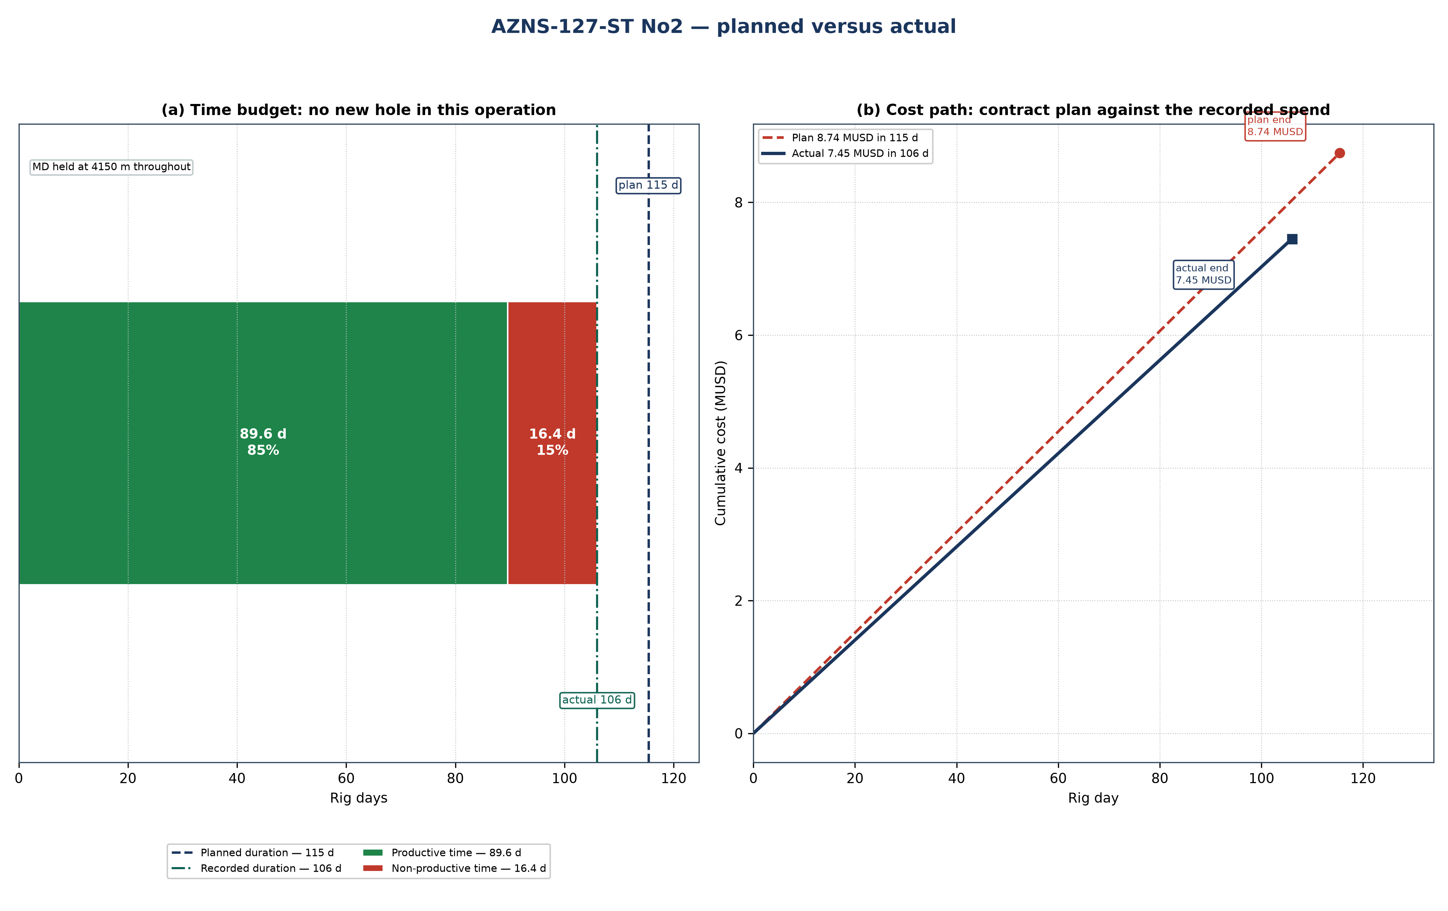
Figure 24.1 — AZNS-127-ST #2: planned schedule and cost path against the recorded operation
Table 24.1 — Planned and actual milestones
Indicator | Programme | Record | Variance | Basis
Rig days | 115 | 106 | −9.4 | Programme duration / DDR rig hours
Total depth (m) | 4,150 | 4,150 | +0 | Programme TD / final MD
New hole (m) | — | 1,081 | — | DDR daily drilling figure
Rig | OEOC RIG 201 | OEOC RIG 201 | — | DDR header
NPT share | — | 394 h (15.5%) | — | Time-log flags
Contract value (MUSD) | 8.74 | 7.45 | −1.29 | CBS / daily-rate reconstruction
Specific cost (USD/m) | 8,088 | 6,892 | — | Cost over new hole

Two explanations are open for a variance of this size, and they are separated before any recovery is credited. Either the scope grew after approval — an extra run, a second window, a deeper shoe — or the same scope took longer because rig time was lost. The discriminator is the NPT register: non-productive time is 394 h of 2,544 h (394 h (15.5%)), which accounts for about 16 days. The operation closed inside its duration, so the programme was either achievable as written or the scope was reduced; the depth variance above is the test.
Technically the operation followed the programme sequence of window milling and side-track: the casing and hole programme of Chapter 2, the fluid programme of Chapter 7 and the bit and BHA record of Chapter 6 are the executed values, and Table 24.1 sets them against the plan. The planned section boundaries are reproduced in Figure 24.1 by the formation bands, so any section that ran long can be read directly off the depth axis.

25. Cost breakdown structure: contract plan against recorded cost
CBS AZNS-127 ST 2.xlsx prices the scope at 8.74 MUSD, of which 3.79 MUSD is written on day-rate lines at a rig rate of 23,000 USD/day; the time-dependent element therefore costs about 32,811 USD per rig day. The record closes at 7.45 MUSD, a variance of −1.29 MUSD (−15%). Figure 25.1 splits that variance into the day-rate effect of the schedule and a scope-and-price residual.
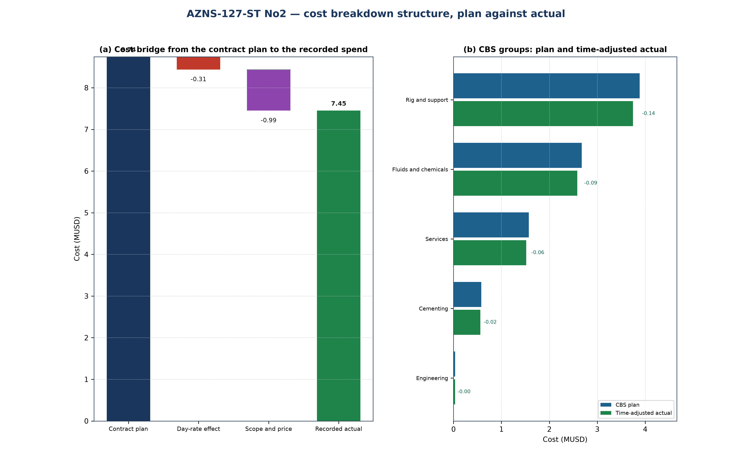
Figure 25.1 — AZNS-127-ST #2: cost bridge and CBS groups
Table 25.1 — CBS groups: plan, share and time-adjusted value
CBS group | Plan (MUSD) | Share | Time-adjusted (MUSD) | Δ (MUSD)
Rig and support | 3.88 | 44.4% | 3.75 | −0.14
Fluids and chemicals | 2.68 | 30.6% | 2.58 | −0.09
Services | 1.57 | 18.0% | 1.52 | −0.06
Cementing | 0.58 | 6.6% | 0.56 | −0.02
Engineering | 0.03 | 0.4% | 0.03 | −0.00
Total | 8.74 | 100.0% | 8.44 | −0.31

Table 25.2 — Variance bridge
Step | MUSD | Driver
Contract plan (CBS) | 8.74 | Contract quantities at contract rates
Day-rate effect | −0.31 | −9.4 rig days at 32,811 USD/day
Scope and price residual | −0.99 | Runs, materials and services beyond the priced quantity
Recorded cost | 7.45 | Daily-rate reconstruction

The residual is small against the contract value, so the variance is very nearly the price of rig time: the scope held and the schedule did not. That is the useful reading for the next well of the same scope, because it makes the day rate the only lever that matters in the estimate.

26. Intervention-specific execution notes
This is a side-track or re-entry: a window is milled in the existing casing, the whipstock is oriented and set, and the new hole is drilled directionally to the target before a liner is run and cemented. The window-milling chapter of the programme governs the exit, the directional plan governs the build, and the liner and cement chapters govern the close.
Table 26.1 — Execution hold points
Stage | Execution requirement | Hold point
Window milling | Mill length and orientation checked against the survey at the window depth | window dressed and reamed before the whipstock is pulled
Whipstock set and oriented | Orientation verified against the gyro or MWD azimuth | tool face confirmed before the first metre of new hole
Directional drilling | Build rate against the plan with the dog-leg inside the limit of Chapter 9 | survey at the end of the build before the tangent
Liner and cement | Liner shoe at the programmed depth and cement volume with the programme excess | top of liner confirmed before the tie-back

The operation as recorded is a window milling and side-track. Its schedule closed at 106 rig days against 115 planned, the reading of Chapter 24, and its cost at 7.45 MUSD against 8.74 MUSD of contract value, which Chapter 25 decomposes. What remains for the next operation of this type is the hold-point discipline of Table 26.1: every recorded overrun is a hold point passed late rather than a step executed badly.

