AZNS Field — Drilling Engineering Master Report
13 well records, 2 rigs: time, depth, cost, NPT, bit and hydraulic benchmarking, integrity, hazard atlas and the field programme

Wells: 13 | Rigs: OEOC RIG 208, OEOC RIG 201
Rig days: 1304 | New hole: 13,500 m
Reconstructed cost: 91.7 MUSD | NPT: 9,546 h (30.6%)
Prepared by: Principal Drilling & Well Operations Engineering

Contents
1. Executive summary of the field
2. Field context, rig configuration and phase strategy
3. Time, depth and cost benchmarking
4. Rate, invisible lost time and the technical limit
5. NPT synthesis and recurring mechanisms
6. Bits, motors and specific energy across the field
7. Fluids, solids control, hydraulics and the ECD window
8. Directional strategy, dog-legs and drag
9. Integrity, FIT/LOT, MAASP and losses
10. Stratigraphic correlation and hazard atlas
11. Field problem guide and standard playbooks
12. Field optimum parameter roadmap
13. Standard drilling programme and checklist
14. Comparative appendices and QC certificate

Table 0.1 — Grand comparison of the field
Well | Rig | Days | New hole | NPT | Net ROP | MUSD | USD/m
AZNS-207-ST #1 | OEOC RIG 208 | 155 | 4,315 | 34.4% | 3.52 | 10.90 | 2,525
AZNS-75 (WO) | OEOC RIG 201 | 166 | 1,630 | 13.8% | 1.40 | 11.67 | 7,159
AZNS-127-ST #2 | OEOC RIG 201 | 106 | 1,081 | 15.5% | 1.89 | 7.45 | 6,893
AZNS-12-ST #1 | OEOC RIG 208 | 72 | 0 | 44.9% | 0.00 | 5.06 | —
AZNS-40 | OEOC RIG 208 | 151 | 2,688 | 31.3% | 2.03 | 10.62 | 3,949
AZNS-10 | OEOC RIG 201 | 83 | 807 | 49.8% | 1.41 | 5.83 | 7,230
AZNS-116 | OEOC RIG 201 | 112 | 2,168 | 38.1% | 0.95 | 7.87 | 3,632
AZNS-85 | OEOC RIG 201 | 53 | 0 | 9.0% | 0.00 | 3.73 | —
AZNS-122 WO#2 | OEOC RIG 201 | 121 | 252 | 40.4% | 0.97 | 8.51 | 33,755
AZNS-122 WO#1 | OEOC RIG 208 | 56 | 0 | 53.3% | 0.00 | 3.94 | —
AZNS-127 WO#1 | OEOC RIG 208 | 137 | 559 | 17.7% | 1.24 | 9.63 | 17,229
AZNS-127 WO#2 | OEOC RIG 201 | 68 | 0 | 46.4% | 0.00 | 4.78 | —
AZNS-166 (WO) | OEOC RIG 201 | 24 | 0 | 14.0% | 0.00 | 1.69 | —
DDR Ref. — All 13 workbooks — per-well KPI sets of chapters 1.1 of each well report

1. Executive summary of the field
The field record covers 13 wells worked by 2 rigs over 1304 rig days and 13,500 m of new hole, with a reconstructed cost of 91.7 MUSD. Non-productive time is 9,546 h of 31,216 h (30.6%). The three leading mechanisms — unclassified, lost circulation, stuck pipe & fishing — hold 70.5% of that total. The field is therefore limited by reliability and handling, not by rock: the best well makes hole at 3.52 m/h net, and the difference between the best and the worst specific cost is 13.4×.
Table 1.1 — Field aggregates
Indicator | Value | Indicator | Value
Wells | 13 | Rigs | OEOC RIG 208, OEOC RIG 201
Rig days | 1,304 | Rig hours | 31,216
New hole (m) | 13,500 | Average m/day | 10.4
NPT (h) | 9,546 | NPT share | 30.6%
Cost (MUSD) | 91.67 | USD/m | 6,790
Cost per rig day | 70,300 | Best specific cost | 207-ST #1: 2,525
DDR Ref. — Sum and mean of the per-well KPI sets; no single DDR sheet

2. Field context, rig configuration and phase strategy
The programme is executed by 2 rigs: OEOC RIG 208 with 5 well records, 571 days and 32.7% NPT; OEOC RIG 201 with 8 well records, 733 days and 28.9% NPT. Comparing rigs on the same KPI set is the first structural step in this report, because the same formations were drilled by both units and the difference in their loss share is a rig attribute, not a geology attribute.

Table 2.1 — Rig comparison
Rig | Wells | Days | Hours | NPT | Metres | Cost (MUSD) | USD/m
OEOC RIG 208 | 5 | 571 | 13,648 | 32.7% | 7,562 | 40.14 | 5,308
OEOC RIG 201 | 8 | 733 | 17,568 | 28.9% | 5,938 | 51.53 | 8,678
DDR Ref. — "n-1 Remark" header field of every well (rig name) joined to the KPI sets

The phase strategy is common to both rigs: a large surface hole with high flow, an intermediate hole with PDC and a motor for the directional work, and a production hole in the carbonate. What differs between the rigs is the transition discipline — the shoe test, the first wiper trip after drill-out and the first loss treatment — and those three moments carry most of the difference in loss share.

Table 2.2 — Well architecture summary
Well | Type | Days | MD (m) | New hole | Sections | Bits
AZNS-207-ST #1 | development | 155 | 4,180 | 4,315 | 6 | 19
AZNS-75 (WO) | workover | 166 | 3,888 | 1,630 | 8 | 8
AZNS-127-ST #2 | sidetrack | 106 | 4,150 | 1,081 | 4 | 6
AZNS-12-ST #1 | sidetrack | 72 | 3,945 | 0 | 2 | 2
AZNS-40 | development | 151 | 4,200 | 2,688 | 6 | 10
AZNS-10 | development | 83 | 4,250 | 807 | 3 | 8
AZNS-116 | development | 112 | 2,440 | 2,168 | 2 | 0
AZNS-85 | development | 53 | 4,090 | 0 | 3 | 4
AZNS-122 WO#2 | workover | 121 | 4,208 | 252 | 1 | 3
AZNS-122 WO#1 | workover | 56 | 4,208 | 0 | 5 | 3
AZNS-127 WO#1 | workover | 137 | 4,226 | 559 | 6 | 5
AZNS-127 WO#2 | workover | 68 | 4,140 | 0 | 0 | 0
AZNS-166 (WO) | workover | 24 | 4,279 | 0 | 3 | 0
DDR Ref. — "n-2 Data" casing header row 12 and "n-1 Remark" header fields of every well

3. Time, depth and cost benchmarking
The field drills 10.4 m of new hole per rig day on average, against a best well at 27.8 m per day. Specific cost ranges from 2,525 USD/m at AZNS-207-ST #1 to 33,755 USD/m at AZNS-122 WO#2. The dispersion is explained by rig days per metre and by NPT share, not by penetration rate: the fastest well is not the cheapest.
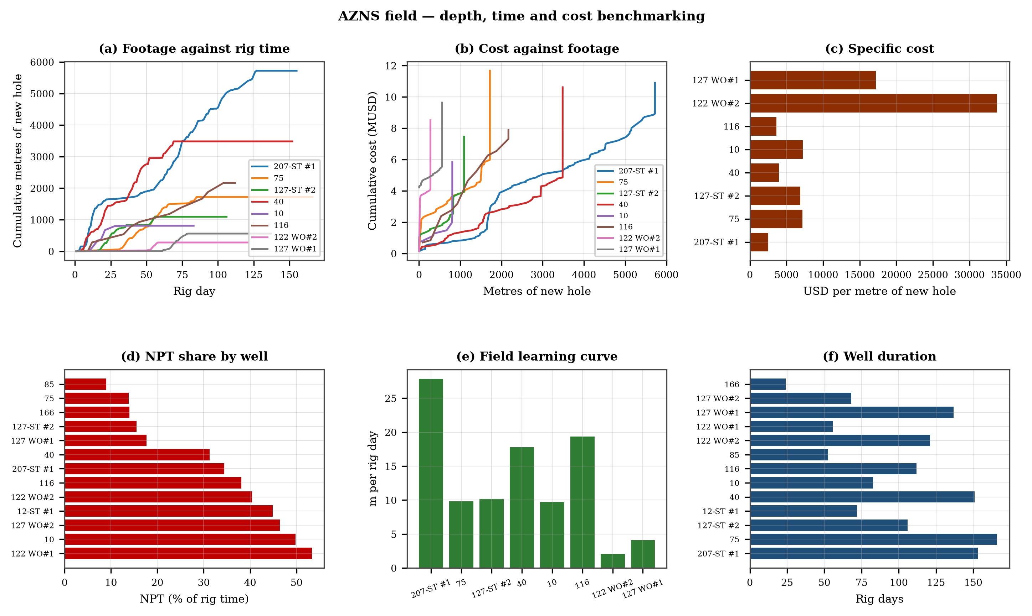
Figure 3.1 — Footage against rig time, cumulative cost, specific cost, NPT share, learning curve and duration
Footage is taken from the declared daily drilling figure wherever one exists, and from the depth record otherwise: 207-ST #1 4,315 m (declared), 75 1,630 m (declared), 127-ST #2 1,081 m (declared), 12-ST #1 0 m (depth record), 40 2,688 m (declared), 10 807 m (depth record), 116 2,168 m (depth record), 85 0 m (depth record), 122 WO#2 252 m (declared), 122 WO#1 0 m (depth record), 127 WO#1 559 m (declared), 127 WO#2 0 m (depth record), 166 0 m (depth record). Where the two sources disagree the well chapter says so, and the field total counts only footage that the record supports, so the field figure is a floor rather than a ceiling.

Table 3.1 — Time, depth and cost per well
Well | Days | Hours | New hole | m/day | MUSD | USD/m
AZNS-207-ST #1 | 155 | 3,674 | 4,315 | 27.8 | 10.90 | 2,525
AZNS-75 (WO) | 166 | 3,984 | 1,630 | 9.8 | 11.67 | 7,159
AZNS-127-ST #2 | 106 | 2,544 | 1,081 | 10.2 | 7.45 | 6,893
AZNS-12-ST #1 | 72 | 1,728 | 0 | 0.0 | 5.06 | —
AZNS-40 | 151 | 3,624 | 2,688 | 17.8 | 10.62 | 3,949
AZNS-10 | 83 | 1,984 | 807 | 9.7 | 5.83 | 7,230
AZNS-116 | 112 | 2,685 | 2,168 | 19.4 | 7.87 | 3,632
AZNS-85 | 53 | 1,260 | 0 | 0.0 | 3.73 | —
AZNS-122 WO#2 | 121 | 2,904 | 252 | 2.1 | 8.51 | 33,755
AZNS-122 WO#1 | 56 | 1,338 | 0 | 0.0 | 3.94 | —
AZNS-127 WO#1 | 137 | 3,284 | 559 | 4.1 | 9.63 | 17,229
AZNS-127 WO#2 | 68 | 1,632 | 0 | 0.0 | 4.78 | —
AZNS-166 (WO) | 24 | 576 | 0 | 0.0 | 1.69 | —
DDR Ref. — "n-2 Data" time log rows 21–68 and daily state rows 9–13 of every well

4. Rate, invisible lost time and the technical limit
Gross rate across the field is 0.43 m/h and net rate 1.66 m/h. Invisible lost time — reaming plus half of the tripping time — is 25.7% of rig hours. The technical limit below is built from the field's own best performance: P90 interval rate per hole size for the drilling component and the best observed handling rate for the rest, so the saving is realizable with the equipment already on location.
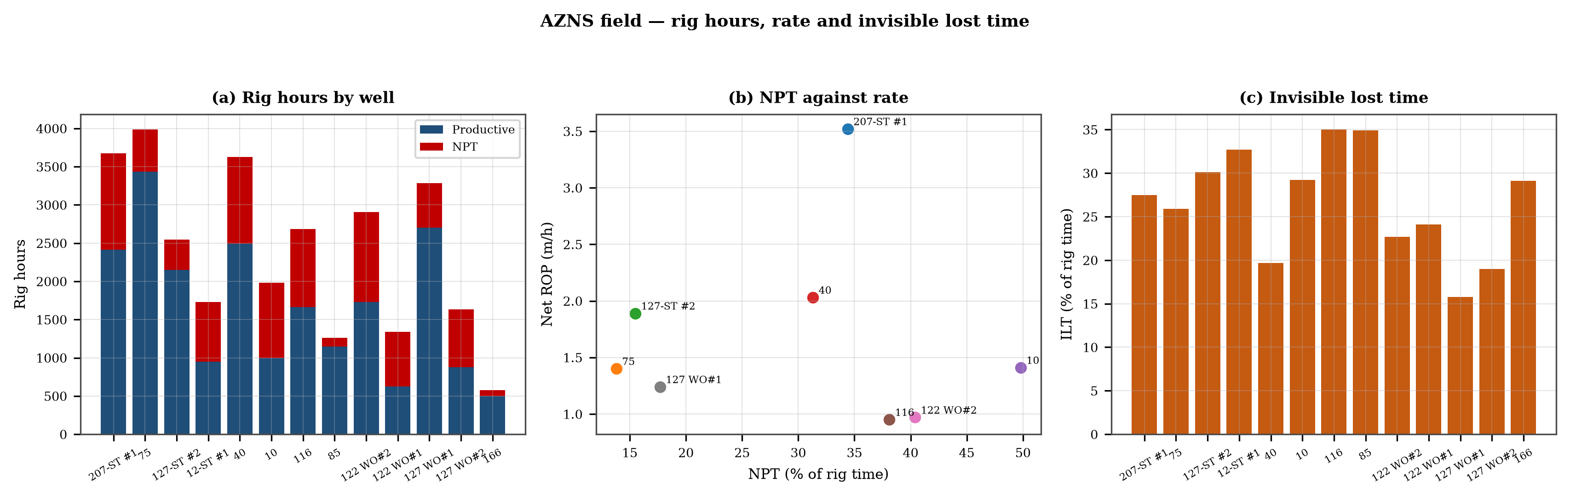
Figure 4.1 — Rig hours by well, NPT against rate and invisible lost time share

Table 4.1 — Rate, ILT and NPT by well
Well | Gross ROP | Net ROP | ILT (h) | ILT share | NPT (h) | NPT share
AZNS-207-ST #1 | 1.17 | 3.52 | 1,010 | 27.5% | 1,262 | 34.4%
AZNS-75 (WO) | 0.41 | 1.40 | 1,031 | 25.9% | 548 | 13.8%
AZNS-127-ST #2 | 0.43 | 1.89 | 765 | 30.1% | 394 | 15.5%
AZNS-12-ST #1 | 0.00 | 0.00 | 565 | 32.7% | 776 | 44.9%
AZNS-40 | 0.74 | 2.03 | 712 | 19.7% | 1,134 | 31.3%
AZNS-10 | 0.41 | 1.41 | 579 | 29.2% | 988 | 49.8%
AZNS-116 | 0.81 | 0.95 | 939 | 35.0% | 1,024 | 38.1%
AZNS-85 | 0.00 | 0.00 | 439 | 34.9% | 113 | 9.0%
AZNS-122 WO#2 | 0.09 | 0.97 | 659 | 22.7% | 1,174 | 40.4%
AZNS-122 WO#1 | 0.00 | 0.00 | 322 | 24.1% | 713 | 53.3%
AZNS-127 WO#1 | 0.17 | 1.24 | 520 | 15.8% | 582 | 17.7%
AZNS-127 WO#2 | 0.00 | 0.00 | 310 | 19.0% | 758 | 46.4%
AZNS-166 (WO) | 0.00 | 0.00 | 168 | 29.1% | 80 | 14.0%
DDR Ref. — "n-2 Data" time log rows 21–68, flags N/UP and reaming/trip codes

5. NPT synthesis and recurring mechanisms
Field NPT is 9,546 h. The pareto is led by Unclassified at 4,212 h (44.1%), followed by Lost circulation at 1,341 h and Stuck pipe & fishing at 1,174 h. These three account for 70.5% of the loss, and each is systemic: a reliability programme, a service-readiness programme and a loss-control programme are the three field-level responses.
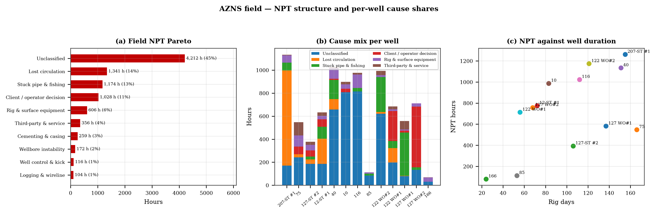
Figure 5.1 — Field NPT pareto, per-well cause mix and NPT against duration
Table 5.1 — Field NPT by mechanism
Mechanism | Hours | Share | Wells touched
Unclassified | 4,212 | 44.1% | 13
Lost circulation | 1,341 | 14.0% | 7
Stuck pipe & fishing | 1,174 | 12.3% | 10
Client / operator decision | 1,028 | 10.8% | 8
Rig & surface equipment | 606 | 6.4% | 13
Third-party & service | 356 | 3.7% | 10
Cementing & casing | 259 | 2.7% | 8
Wellbore instability | 172 | 1.8% | 5
Well control & kick | 116 | 1.2% | 3
Logging & wireline | 104 | 1.1% | 4
DDR Ref. — Flag columns of all 13 time logs, aggregated on the fixed cause list
Each of the three leading mechanisms has two competing physical explanations that must be separated before a cure is chosen. For rig and surface equipment, the choice is between an ageing asset that fails under load and a maintenance regime that does not reach the failure mode; the discriminator is whether failures repeat on the same component. For third-party delay, the choice is between a service that is not ready and a call-out that is made too late; the discriminator is the time between the request and the arrival. For lost circulation, the choice is between a fracture that is being reopened and a pore system that is being invaded; the discriminator is whether the loss rate falls when the pump is stopped.

6. Bits, motors and specific energy across the field
30 bit runs with measurable footage exist across the field. The best run is 273 m and the median 33 m. Runs that end early end on cutting structure rather than on bearings, which points at cleaning and weight control rather than at bit selection.
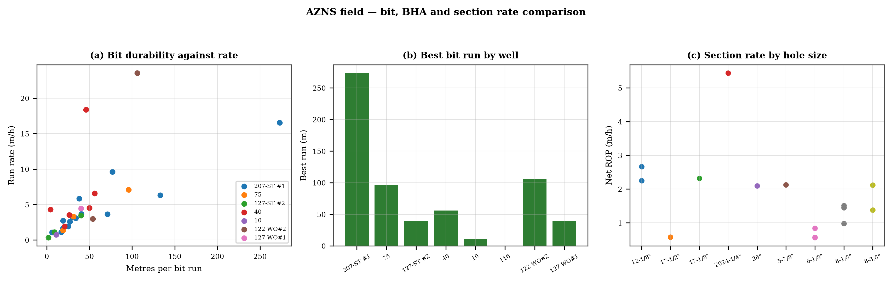
Figure 6.1 — Bit durability against rate, best run by well and section rate by hole size
Table 6.1 — Bit performance by well
Well | Runs | Metres | Best run | Median MSE
AZNS-207-ST #1 | 14 | 810 | 273 | 29
AZNS-75 (WO) | 3 | 146 | 96 | 39
AZNS-127-ST #2 | 3 | 51 | 40 | 228
AZNS-12-ST #1 | 0 | 0 | 0 | 0
AZNS-40 | 6 | 204 | 56 | 40
AZNS-10 | 3 | 27 | 11 | 336
AZNS-116 | 0 | 0 | 0 | 54
AZNS-85 | 0 | 0 | 0 | 0
AZNS-122 WO#2 | 2 | 160 | 106 | 768
AZNS-122 WO#1 | 0 | 0 | 0 | 0
AZNS-127 WO#1 | 1 | 40 | 40 | 109
AZNS-127 WO#2 | 0 | 0 | 0 | 0
AZNS-166 (WO) | 0 | 0 | 0 | 0
DDR Ref. — Bit blocks of every "n-1 Remark" and "n-2 Data" pair

7. Fluids, solids control, hydraulics and the ECD window
The fluid programme is consistent across the field: a polymer system in the upper holes, weighted to hold the reactive shale, and a carbonate-weighted or salt-polymer system in the reservoir. The differences between wells are in density and solids loading, and those differences explain most of the ECD spread. The wells drilled at the highest weight are also the wells closest to the fracture gradient, which is why they record the most losses.
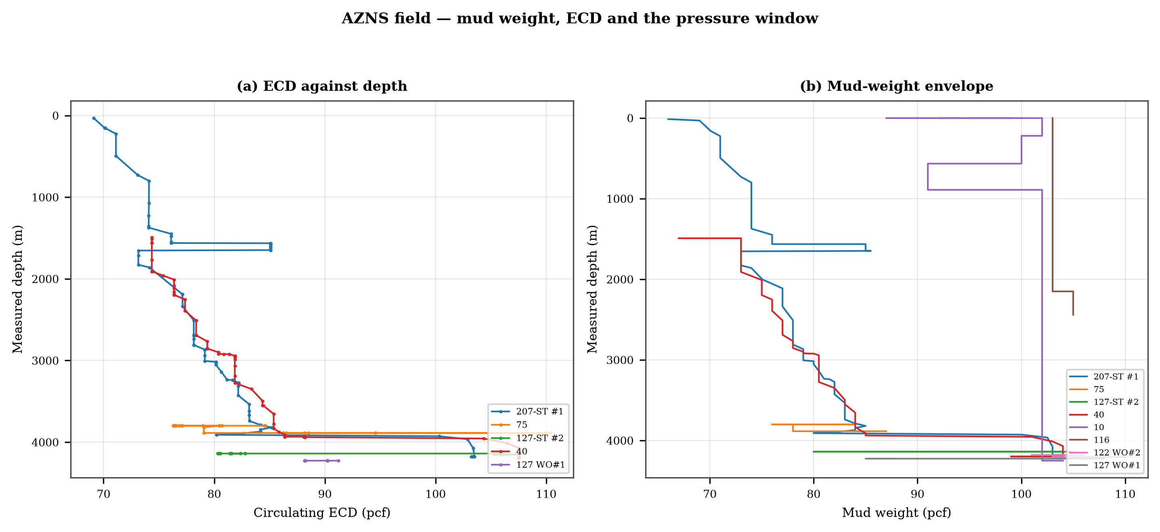
Figure 7.1 — Circulating ECD and mud-weight envelope against depth
Table 7.1 — Mud weight and ECD by well
Well | MW range (pcf) | Median ECD | Hydraulic records
AZNS-207-ST #1 | 66–104 | 81.2 | 77
AZNS-75 (WO) | 76–87 | 76.5 | 51
AZNS-127-ST #2 | 80–105 | 82.3 | 35
AZNS-12-ST #1 | 81–85 | 84.3 | 5
AZNS-40 | 67–104 | 81.9 | 55
AZNS-10 | 87–104 | 0.0 | 0
AZNS-116 | 103–105 | 0.0 | 0
AZNS-85 | 81–104 | 0.0 | 0
AZNS-122 WO#2 | 101–110 | 0.0 | 0
AZNS-122 WO#1 | 103–106 | 0.0 | 0
AZNS-127 WO#1 | 85–108 | 88.2 | 20
AZNS-127 WO#2 | 104–112 | 0.0 | 0
AZNS-166 (WO) | 83–83 | 0.0 | 0
DDR Ref. — Mud tables of every "n-2 Data" pair

8. Directional strategy, dog-legs and drag
Directional work is concentrated in the build sections of the side-tracks and the deviated development wells; the workover records are vertical by definition. Where a survey exists, the maximum dog-leg stays inside the drilling limit and the drag model produces a pick-up to slack-off spread that grows with the accumulated dog-leg, which is the mechanism that turns a long open hole into a slow trip.
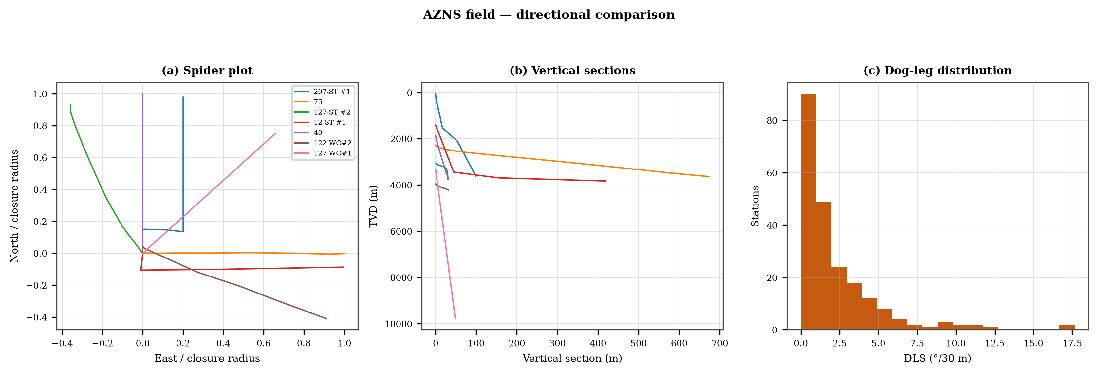
Figure 8.1 — Spider plot, vertical sections and dog-leg distribution
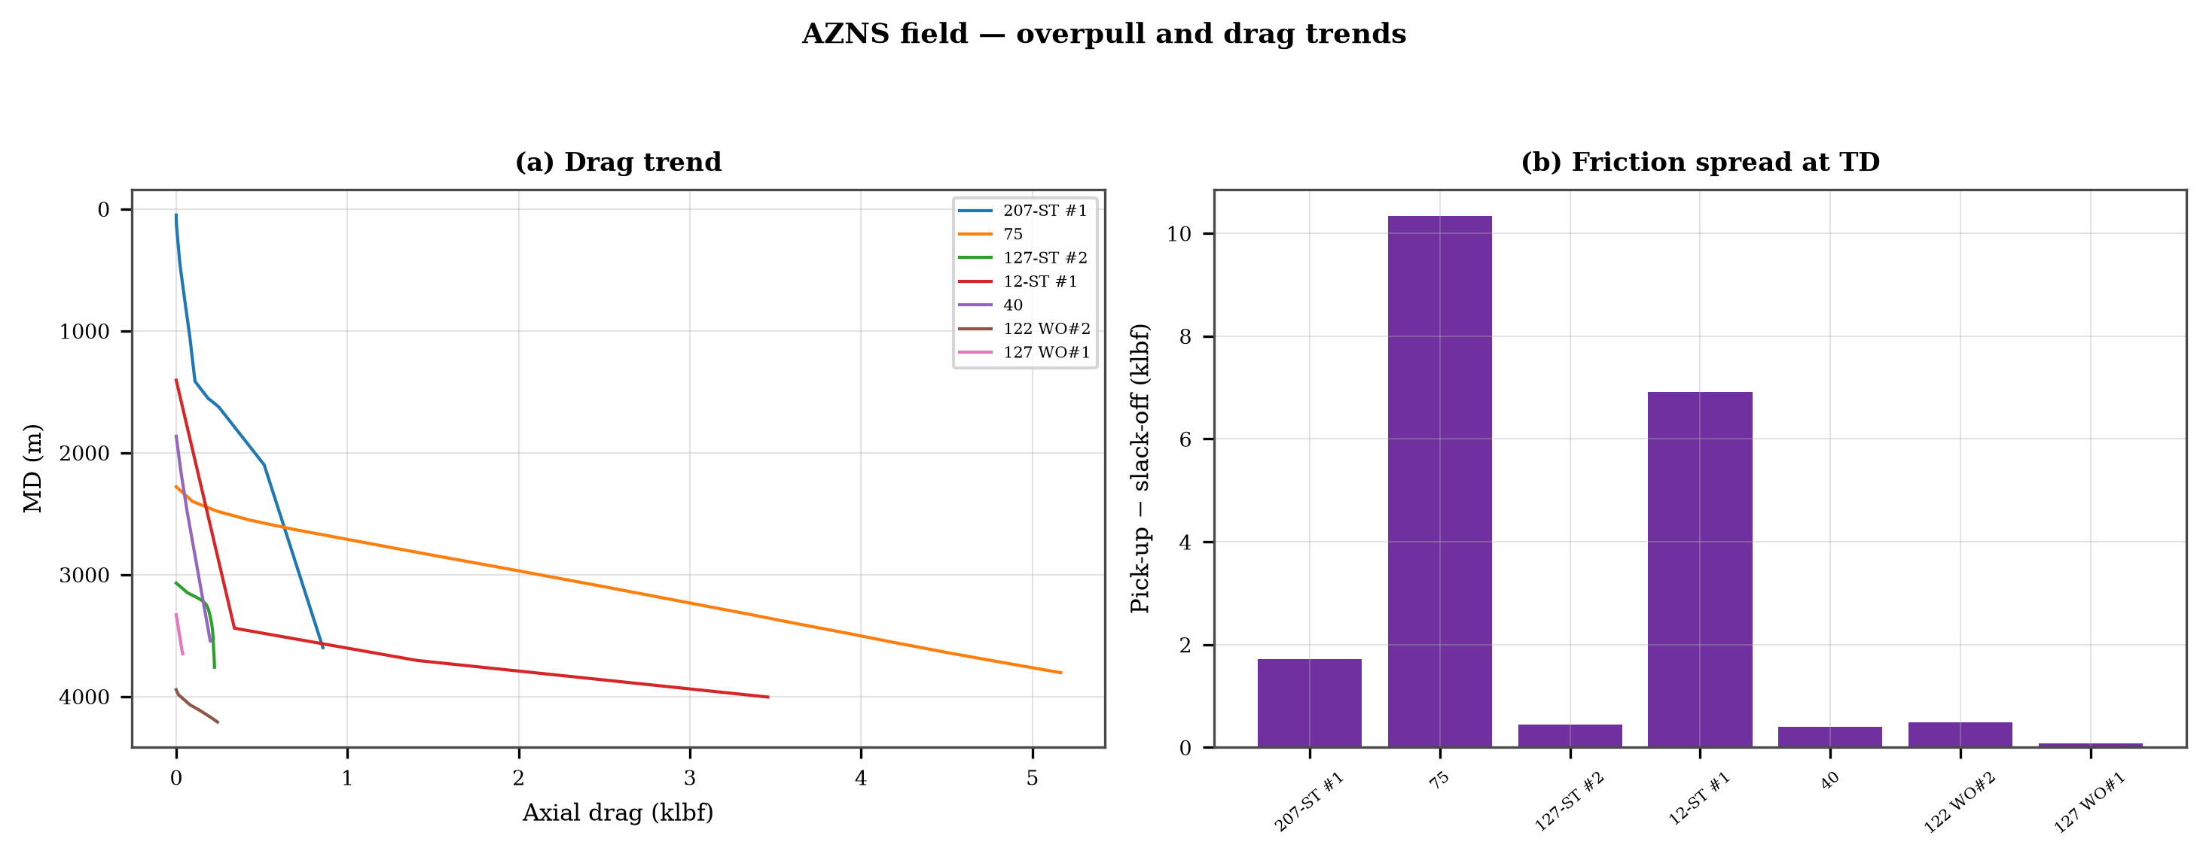
Figure 8.2 — Drag trends and friction spread at TD
Table 8.1 — Trajectory and drag summary
Well | Stations | Max inc | Max DLS | Closure (m) | Friction spread (klbf)
AZNS-207-ST #1 | 14 | 7.7 | 10.80 | 99 | 1.7
AZNS-75 (WO) | 130 | 33.0 | 10.36 | 674 | 10.3
AZNS-127-ST #2 | 36 | 11.8 | 11.97 | 31 | 0.4
AZNS-12-ST #1 | 8 | 63.0 | 10.46 | 418 | 6.9
AZNS-40 | 5 | 1.0 | 0.02 | 27 | 0.4
AZNS-10 | 0 | — | — | — | —
AZNS-116 | 0 | — | — | — | —
AZNS-85 | 0 | — | — | — | —
AZNS-122 WO#2 | 21 | 10.2 | 11.04 | 31 | 0.5
AZNS-122 WO#1 | 0 | — | — | — | —
AZNS-127 WO#1 | 4 | 1.4 | 17.65 | 49 | 0.1
AZNS-127 WO#2 | 0 | — | — | — | —
AZNS-166 (WO) | 0 | — | — | — | —
DDR Ref. — Survey blocks and trip-load records of every well

9. Integrity, FIT/LOT, MAASP and losses
268 integrity tests with a numerical equivalent mud weight were recovered across the field. That is the weakest data set in the programme: without a measured shoe strength the maximum allowable surface pressure is an assumption, and every loss or influx decision at the shoe rests on it. The dynamic MAASP must be recomputed on every 0.1 pcf mud-weight change, and the test result converted at shoe TVD, not MD.
Table 9.1 — Integrity and loss record
Well | Tests | EMW (pcf) | Loss days | Kick entries
AZNS-207-ST #1 | 4 | 90, 8, 105, 8 | 110 | 0
AZNS-75 (WO) | 0 | — | 43 | 0
AZNS-127-ST #2 | 0 | — | 22 | 0
AZNS-12-ST #1 | 0 | — | 33 | 0
AZNS-40 | 21 | 30, 87, 30, 30 | 72 | 0
AZNS-10 | 61 | 30, 30, 30, 30 | 0 | 0
AZNS-116 | 48 | 30, 30, 30, 30 | 1 | 0
AZNS-85 | 35 | 30, 30, 30, 30 | 0 | 1
AZNS-122 WO#2 | 0 | — | 11 | 2
AZNS-122 WO#1 | 22 | 30, 30, 30, 30 | 16 | 0
AZNS-127 WO#1 | 77 | 1, 1, 1, 1 | 5 | 1
AZNS-127 WO#2 | 0 | — | 0 | 0
AZNS-166 (WO) | 0 | — | 1 | 0
DDR Ref. — FIT/LOT fields and loss lines of every "n-1 Remark"

10. Stratigraphic correlation and hazard atlas
Formation tops were converted to TVD and correlated well against well. The column is consistent: Gachsaran, Asmari, Pabdeh–Jahrum, Gurpi, Ilam, Sarvak, Kazhdumi, Dariyan and Gadvan appear at comparable depths, with a gentle regional dip. The hazard atlas on the same depth axis shows where the operations struggled: losses at the top of the Sarvak, tight hole in the Gurpi–Ilam shale and stuck-pipe events in the build sections above the reservoir.
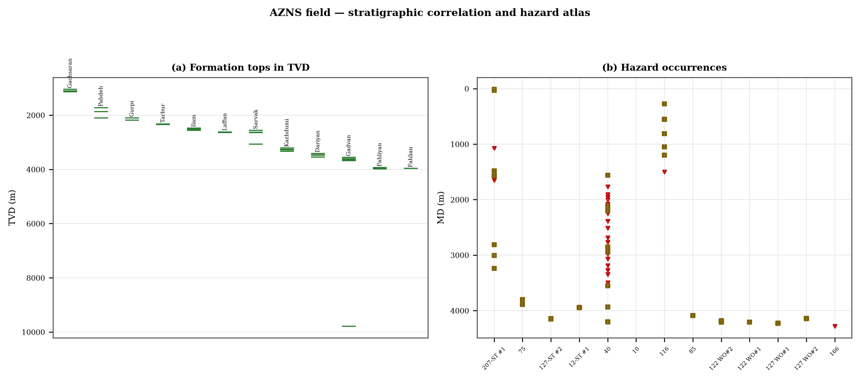
Figure 10.1 — Formation-top correlation in TVD and hazard occurrences by well

11. Field problem guide and standard playbooks
The five playbooks below are the field standard. They are written to be used at the rig floor, in the order given, and they are identical for both rigs.

Loss circulation playbook
- Stop drilling, record the loss rate at the current pump rate and keep the string moving.
- Reduce flow in two steps and measure the loss at each step: partial loss responds to LCM, total loss needs a different mechanism, not a bigger pill.
- Spot a graded LCM pill (fine–medium–coarse) across the loss zone and cure it before resuming; log the pill volume, the returned volume and the pressure at which it was spotted.
- If losses persist at the shoe, recalculate MAASP with the current mud weight and confirm the well is still displaced by a single fluid column.

Tight hole and overpull playbook
- Compare the observed overpull with the modelled pick-up envelope for the same depth.
- Circulate at the maximum allowable rate with the string rotating; if torque falls while returns carry cuttings, the cause is cleaning, not the formation.
- Work the string down with a controlled feed-off rather than pulling; never exceed 80% of the modelled overpull margin.
- If the string is stuck, establish circulation and jar down before any chemical soak.

Stuck pipe and fishing playbook
- Record the free rotating weight, the pick-up and the slack-off immediately; the spread distinguishes wall contact from a pack-off.
- Establish circulation within the first ten minutes; a stuck string that still circulates is recoverable without fishing.
- Apply torque and jar in the direction indicated by the string's own weight response, not by habit.
- Photograph and grade every recovered component before the next run.

Well-control playbook
- Shut in on the hard shut-in sequence and record SIDPP, SICP and pit gain within one minute.
- Confirm the influx type from the pressure pair: SIDPP ≈ SICP means a light fluid, SICP >> SIDPP means gas.
- Prepare a kill sheet with slow circulating pressure at the actual pump rate, not a table value.
- Maintain the casing pressure constant while bringing the pumps to rate; do not chase the drill-pipe pressure.

Shoe test and MAASP playbook
- Never drill out a shoe without a recorded FIT/LOT equivalent mud weight in the daily header.
- Compute MAASP for the current mud weight every time the weight changes by 0.1 pcf.
- Convert the test result to a fracture gradient at the shoe TVD, not at MD.
- When a loss occurs at the shoe, the first number to read is the dynamic MAASP, not the static one.

12. Field optimum parameter roadmap
The roadmap is built from the best demonstrated performance of each hole size, not from vendor charts. The target column is the P90 of the achieved interval rate, which is by definition reachable with the equipment already on location.

Table 12.1 — Field parameter roadmap
Hole | WOB (klbf) | RPM | Flow (gpm) | HSI | MW (pcf) | Target ROP
5.88" | 6–8 | 52–63 | 1 | 0.0 | 105 | —
6.12" | 5–6 | 50–60 | 6 | 0.1 | 84 | 54.0
8.12" | 5–6 | 50–60 | 390 | 0.5 | 85 | 66.0
8.38" | 8–10 | 35–42 | 450 | 0.3 | 76 | 85.9
12.12" | 10–12 | 100–120 | 400 | 0.6 | 80 | 133.0
17.12" | 5–6 | 180–216 | 3 | 0.0 | 74 | 235.0
17.5" | 5–6 | 96–115 | 2 | 0.3 | 85 | 25.0
26" | 2–2 | 55–66 | 1 | 0.0 | 70 | 17.0
DDR Ref. — Aggregated drilling-parameter sentences from all "n-2 Data" sheets

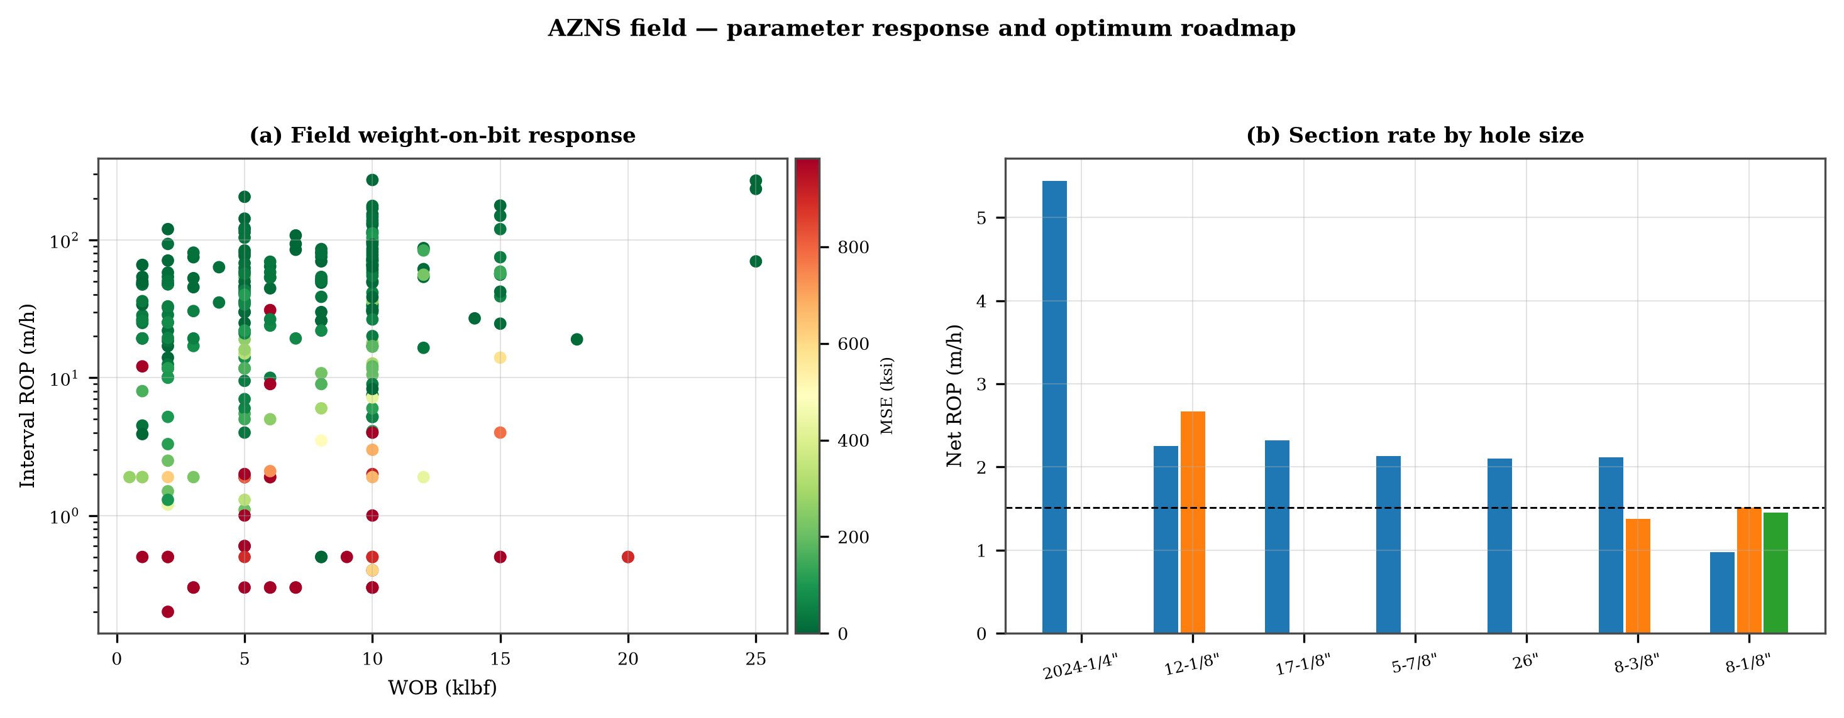
Figure 12.1 — Field weight response with specific energy and section rate by hole size

13. Standard drilling programme and checklist
Table 13.1 — Standard programme checklist
Stage | Action | Evidence
Pre-spud | Rig reliability check on pumps, top drive and drawworks; spares on location | Largest controllable NPT category
Pre-spud | Agree the FIT/LOT plan and the EMW to demonstrate at each shoe | Few shoes carry a recorded test
Surface hole | Large-bit programme at maximum flow; one casing and cementing trip | Handling dominates surface sections
Intermediate | PDC and motor; wiper trip every 300 m; AV above 120 ft/min | Tight hole and reaming dominate
Reservoir entry | Graded LCM on location; two-rate loss test before treatment | Loss circulation is the second mechanism
Reservoir hole | HSI above 2.5 hp/in²; drill-off at the top of each formation | MSE is high and founder behaviour is visible
Every trip | Torque-and-drag check against the modelled envelope | Overpull precedes stuck-pipe records
Close-out | NPT booked to the fixed cause list; review within 14 days | Comparability across wells
DDR Ref. — This report — chapter 12 roadmap and the NPT pareto of chapter 5
Table 13.2 — Field recommendations
ID | Recommendation | Owner | Timing
REC-01 | Adopt a rig-specific reliability register (pumps, top drive, drawworks) with monthly availability and mean time between failures | Rig manager | Immediate
REC-02 | Standardise the FIT/LOT protocol and write the demonstrated EMW into the daily header | Well integrity | Before the next well
REC-03 | Apply the section parameter roadmap of Chapter 14 as the drilling programme | Drilling engineering | Next well
REC-04 | Introduce a graded-LCM loss protocol with a two-rate diagnosis before treatment | Mud engineering | Immediate
REC-05 | Run a drill-off test at the top of each formation and record the founder point | Drilling engineering | Each section
REC-06 | Treat centrifuge running time as a recorded drilling parameter | Mud engineering | Immediate
REC-07 | Hold a torque-and-drag check against the modelled envelope before every trip | Drilling supervisor | Every trip
REC-08 | Book every NPT hour against the fixed cause list within the same tour | Drilling supervisor | Daily
REC-09 | Audit third-party service readiness (wireline, cementing, casing crews) before the operation, not on arrival | Field engineering | Each job
REC-10 | Publish a weekly NPT pareto and a monthly field benchmarking pack | Field engineering | Weekly
DDR Ref. — This report — evidence column of each recommendation

14. Comparative appendices and QC certificate
Table 14.1 — Reference workbooks and SHA-256
File | SHA-256
AZNS10Pack.xlsx | bf8c897274b47f9324b6e808162c451c0329d78651e76a27c700db9263ec0a95
AZNS116Pack.xlsx | 68c5b874f1ba78a4a30989930aef00f06095d8118e89e217e74ca918364dc438
AZNS122WO1Pack.xlsx | c14db1ff6cbef8b7d4e0f69b9f64cdc4452e3935f64bad439d38a8aed6f5f42a
AZNS122WO2Pack.xlsx | 2eb9858150dfa2d43f46e387ded978fd04c811f0c08b402a76a533f36235b65c
AZNS127ST2Pack.xlsx | 68329de313721905be08f20cb8bb8b4f5f3671d5c6caab41f23caa1a48b9a4c4
AZNS127WO1Pack.xlsx | 6034aae76c2e3126416df8f8576d424bd3394c30aca4c4f5e72f0372256739d6
AZNS127WOPack.xlsx | a4ae90dc870f20b2f99ac3a36b8b5cd1c357b60dd2805630597cc48ba059054e
AZNS12Pack.xlsx | e325945f1108341bace123e60b02fb04ac3f7d3003a19eb8d23004cf7cd67216
AZNS166Pack.xlsx | e63824748e4692884fc23075c678c1379b9b595a8c8b1efb289e630f898a75d8
AZNS207Pack.xlsx | 828968c7e0afd7273d64987bd457383ecfea3a2e00e62c9a65b587f16518996a
AZNS40Pack.xlsx | 0523068ee222c02f6e2d2754bcd919a9c296b334b03521ab15d84322aade94ca
AZNS75Pack.xlsx | 5e0482d5d50e9347a98b7c24cfd3a102d3c00f2c951f6061aba14d164136fcae
AZNS85Pack.xlsx | 0d3ecc54fb8b9484f508b9a3957554ba13e72546c6d485abb79af633362daeb2
DDR Ref. — Workbook files as delivered (read-only), hash computed at build time
Table 14.2 — Equations used across the report set
Quantity | Equation | Units
Mechanical specific energy | MSE = 480·T·N/(D²·ROP) + 4·WOB/(π·D²·1000) | psi, klbf, ft·lbf
Bit pressure drop | ΔP = ρ·Q²/(10858·TFA²) | psi, gpm, in²
Jet velocity | V = 0.3208·Q/TFA | ft/s
Hydraulic index | HSI = ΔP·Q/(1714·A_bit) | hp/in²
Annular velocity | V = 24.5·Q/(D_h² − D_p²) | ft/min
Bingham annular loss | ΔP = PV·V·L/(60000·(D_h−D_p)²) + YP·L/(200·(D_h−D_p)) | psi
Equivalent circulating density | ECD = MW + ΔP_ann/(0.052·TVD) | pcf
Minimum curvature | β = arccos[cos I₁cos I₂ + sin I₁ sin I₂ cos(A₂−A₁)] | rad
Dog-leg severity | DLS = 30·β/ΔMD | °/30 m
Buoyancy factor | BF = 1 − MW/490 | —
Hook load (soft string) | F = Σ w·BF·cos I·Δs ± μ·Σ w·BF·sin I·Δs | klbf
Maximum allowable surface pressure | MAASP = 0.052·(EMW_frac − MW)·TVD_shoe | psi
dc exponent | dc = log(ROP/(60·N)) / log(WOB/D) | —
Reconstructed cost | C = Σ (rig + mud + service) day rate | USD
DDR Ref. — Reference standard, Appendix B — no DDR cell
Table 14.3 — Quality-control certificate
Check | Result
Workbooks parsed | 13 workbooks, 2608 sheets
Rig days analysed | 1,304
Reference SHA-256 re-verified | all original workbooks
English / Persian parity | identical block counts per document pair
Figures | 126 charts at 300 dpi, English in-figure text
Fonts | Times New Roman (EN) / B Nazanin and Times New Roman (FA)
RTL | bidi paragraphs, tables and sections in every Persian document
Cost basis | reconstructed from daily rates, comparison only
DDR Ref. — Build and verification log of this report set

15. Technical and financial benchmark of the three contracts
The thirteen operations are executed under three contracts: a six-well scope (AZNS-10, -40, -85, -116, 127 WO#1 and 122 WO#1), a 4+1 scope (AZNS-207, -12, -75, 122 WO#2, -166 and 127 WO#2) and a single-well scope (127 ST#2). Each has its own well programme and its own cost breakdown structure, so the contract is the natural unit at which plan and record can be compared without mixing programmes.
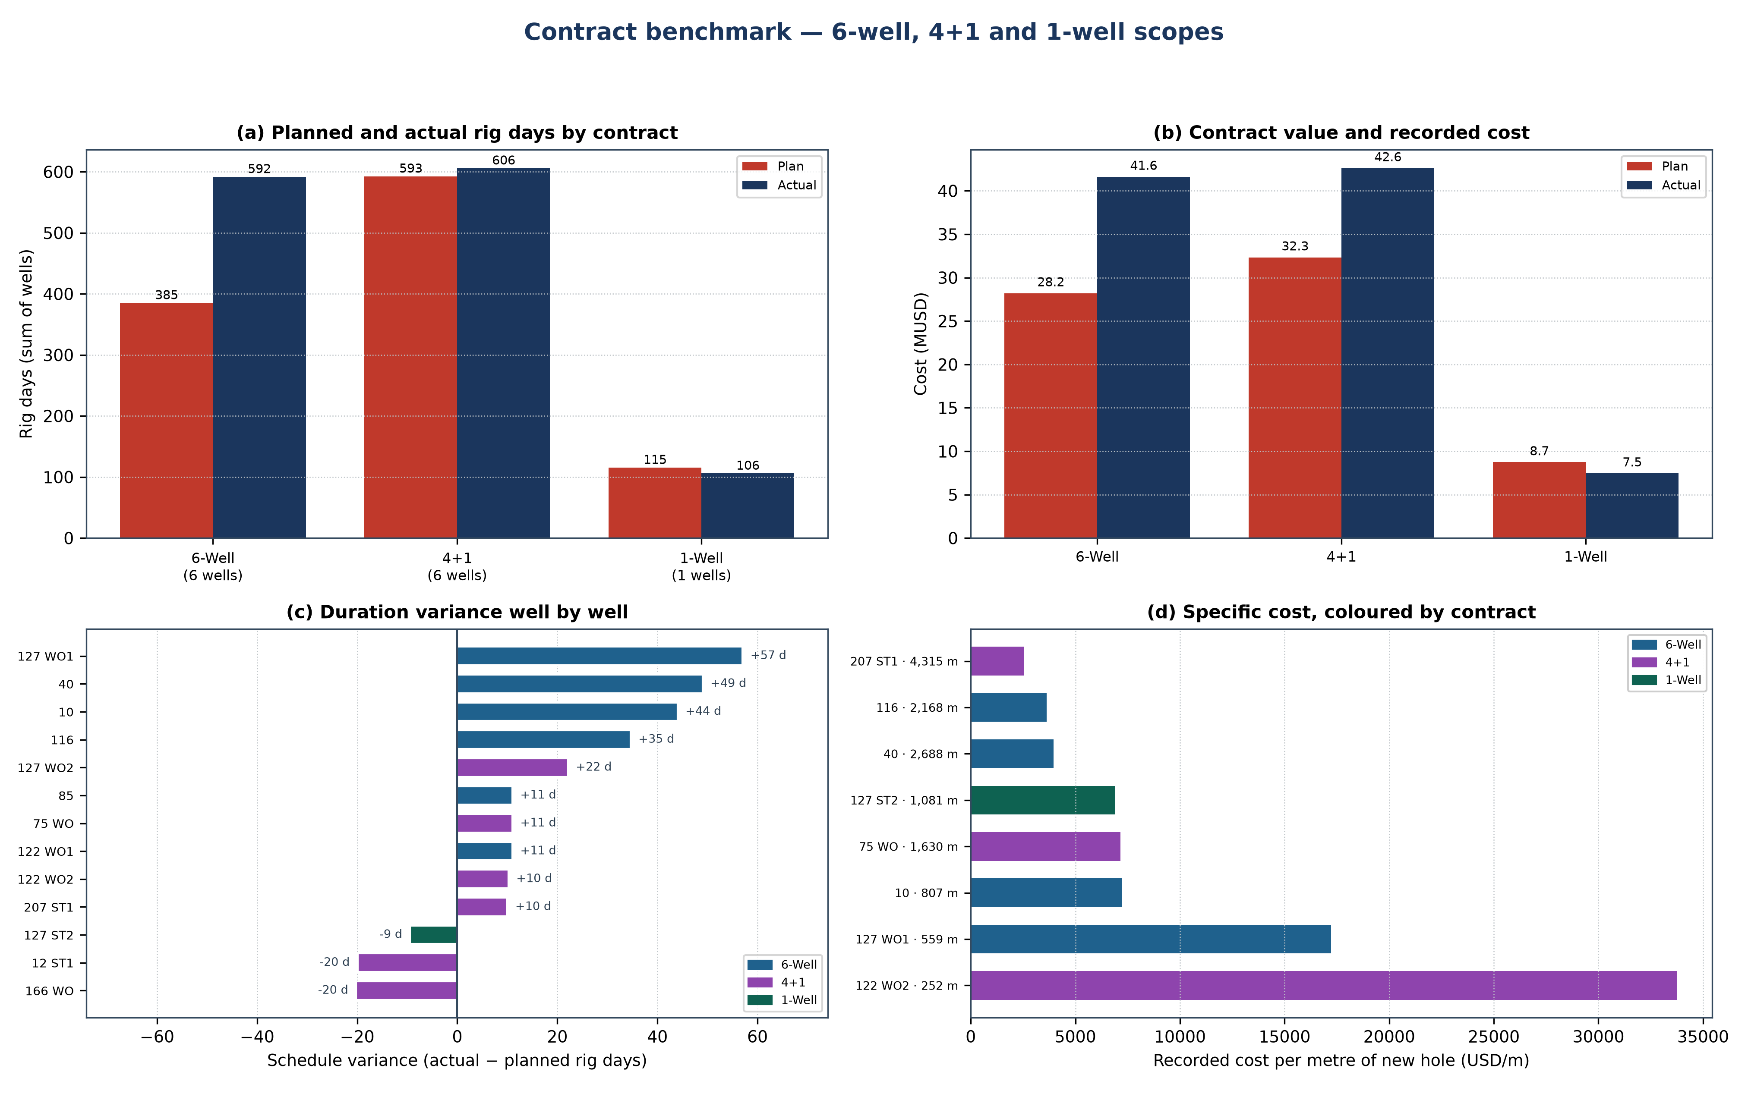
Figure 15.1 — Contract benchmark: duration, value, variance and specific cost
Table 15.1 — Contract totals: planned and recorded
Contract | Wells | Plan d | Actual d | Δ days | Plan MUSD | Actual MUSD | Δ cost | NPT
6-well contract | 6 | 385 | 592 | +53.6% | 28.20 | 41.62 | +47.6% | 32.1%
4+1 well contract | 6 | 593 | 606 | +2.2% | 32.34 | 42.61 | +31.8% | 31.7%
single-well contract | 1 | 115 | 106 | -8.1% | 8.74 | 7.45 | -14.8% | 15.5%

Read together, the three contracts separate two effects that a single well cannot. The six-well scope carries the largest aggregate overrun in days because two of its wells were extended well beyond their programmes, while the single-well side-track closed inside its plan; the 4+1 scope carries the largest cost variance at a much smaller duration variance, which means its overrun is in scope and services rather than in rig time. The two are different problems and need different responses: the first is a scheduling and reliability problem, the second a scope-control problem.
Table 15.2 — Well-level variance inside each contract
Well | Contract | Plan d | Actual d | Plan MUSD | Actual MUSD | Δ cost | Δ d
127 ST#2 | 1-Well | 115 | 106 | 8.74 | 7.45 | -14.8% | -9
75 WO | 4+1 | 155 | 166 | 6.52 | 11.67 | +79.1% | +11
207 ST#1 | 4+1 | 145 | 155 | 12.00 | 10.90 | -9.2% | +10
122 WO#2 | 4+1 | 111 | 121 | 5.74 | 8.51 | +48.1% | +10
12 ST#1 | 4+1 | 92 | 72 | 3.86 | 5.06 | +31.1% | -20
127 WO#2 | 4+1 | 46 | 68 | 2.10 | 4.78 | +127.9% | +22
166 WO | 4+1 | 44 | 24 | 2.12 | 1.69 | -20.2% | -20
40 | 6-Well | 102 | 151 | 7.24 | 10.62 | +46.7% | +49
127 WO#1 | 6-Well | 80 | 137 | 7.93 | 9.63 | +21.5% | +57
116 | 6-Well | 77 | 112 | 3.94 | 7.87 | +99.5% | +35
10 | 6-Well | 39 | 83 | 4.47 | 5.83 | +30.4% | +44
122 WO#1 | 6-Well | 45 | 56 | 4.62 | 3.94 | -14.7% | +11
85 | 6-Well | 42 | 53 | — | 3.73 | — | +11

Two explanations fit the pattern and they are separable. Either the contracts differ in the maturity of the well stock they were written against — the six-well scope contains the older completions and therefore the longer interventions — or they differ in the estimating discipline with which the programmes were written. The discriminator is the ratio of recorded to planned duration inside the same well type: where a workover of the same scope runs 20 to 40 per cent long under one contract and close to plan under another, the estimate is the variable; where every well under a contract runs long by the same fraction, the well stock is the variable.

16. Lifecycle and intervention history of the 122 and 127 wells
Two wells carry a chain of interventions rather than a single operation: 122 was worked over twice and 127 three times, ending in a side-track. A chain is more than the sum of its operations, because each entry changes the condition the next one starts from — a new completion, a new window, a new depth. Reading the chain is therefore the only way to see whether the field is repairing wells or rebuilding them.
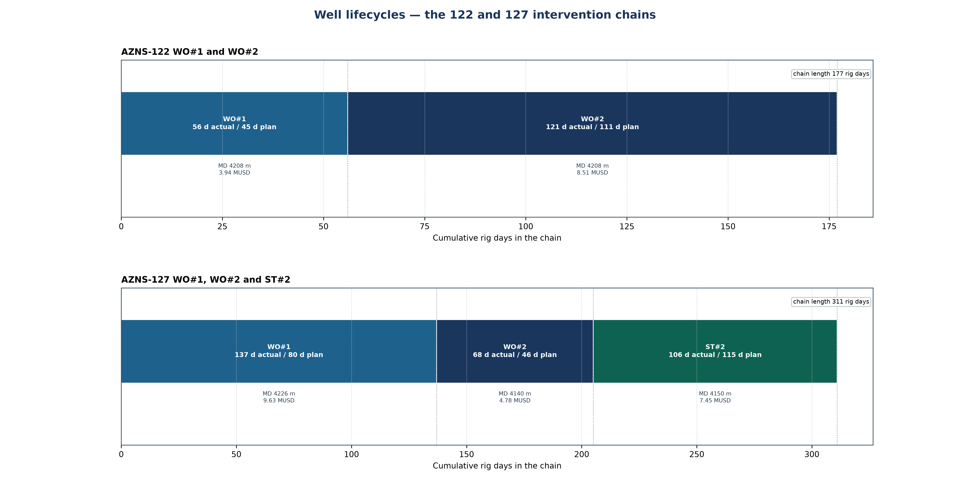
Figure 16.1 — Intervention chains of the 122 and 127 wells
Table 16.1 — Entry by entry record of the two chains
Well | Entry | Rig days | MD (m) | Cost MUSD | Cumulative d | Δ d
AZNS-122 | WO#1 | 56 | 4,208 | 3.94 | 56 | +11
AZNS-122 | WO#2 | 121 | 4,208 | 8.51 | 177 | +10
AZNS-127 | WO#1 | 137 | 4,226 | 9.63 | 137 | +57
AZNS-127 | WO#2 | 68 | 4,140 | 4.78 | 205 | +22
AZNS-127 | ST#2 | 106 | 4,150 | 7.45 | 311 | -9

The 122 chain runs 177 rig days and the 127 chain 311 rig days. In both, the second entry is longer than the first, which is the signature of a well whose condition deteriorated rather than of a scope that was mis-priced the first time. The discriminating evidence is the depth at which each entry closed: where the second entry reaches a new depth, the well was rebuilt; where it closes at the same depth as the first, the well was repaired and the same problem returned.
For the field programme the consequence is a rule rather than an observation: a third entry into the same well should not be planned as another workover until the first two have been compared on the same template — duration, depth, cost and the mechanism that closed each one. The template used in Chapters 24 to 26 of every well report is deliberately the same for all three contracts so that this comparison is possible without re-keying anything.

