SOURCE CORRECTION: CBS AZNS-122WO1, Cost Breakdown-122, G190 and H190 show USD 4,587,374.50 plan and USD 1,304,440.02 extra work. Their arithmetic sum is USD 5,891,814.52, not necessarily an approved budget comparable with actual expenditure. CBS AZNS-85, AZNS-085 WO. Extra Work, K54 and O54 show 48.07 and 51.89 days. Rig-less activities in rows 41–49 have zero time in this rig schedule, not necessarily zero elapsed duration or cost.
ENGINEERING REVIEW WARNING — This report is provisional. Source-coded coverage and selected source observations do not establish total schedule, actual expenditure, risk severity, event causation or contractor liability. Full reconciliation and page-rendered review are pending.
Board of Directors
Executive Management Report
South Azadegan Field Development — Source evidence review
Prepared from the consolidated daily drilling record, cost breakdown structures and well programmes

Measure | Value | Interpretation
Daily packs | 13 | Coverage varies
Well programmes | 14 | Includes two distinct 127 sidetracks
Recognized status pages | 1,301 | Not operation duration
Actual expenditure | Not established | Reconciliation pending
Cause and liability | Not established | Event and contract review required

Portfolio expenditure, budget variance and financial liability are not established until records and scopes are reconciled.

The Six Messages of This Report
- Portfolio actual spending and budget variance remain unverified; CBS cached values are not invoices or approved comparable budgets.
- Status codes cover recognized complete daily records only; NPT, unplanned and mixed codes remain distinct and cannot be priced without verified scope and rates.
- Technical causes, contractor liability and proposed commercial remedies require incident reconstruction and contract review.
- Rig comparison is not established by the current source coverage; recognize missing pages and reconcile assignments and time bases first.
- Programme references for wells 122 and 127 describe distinct proposed phases; they do not establish execution or a single campaign saving.
- Selected fluid loss and depth entries require unit, reporting-basis and event-depth review; the current exhibits do not establish formation causes.

1. What the Portfolio Delivered
The chart compares the main-plan or estimated well duration stated in each of 14 programmes. Moving and contingency figures are not added; these are neither verified actual durations nor a fleet timeline. Scope and phase boundaries differ.
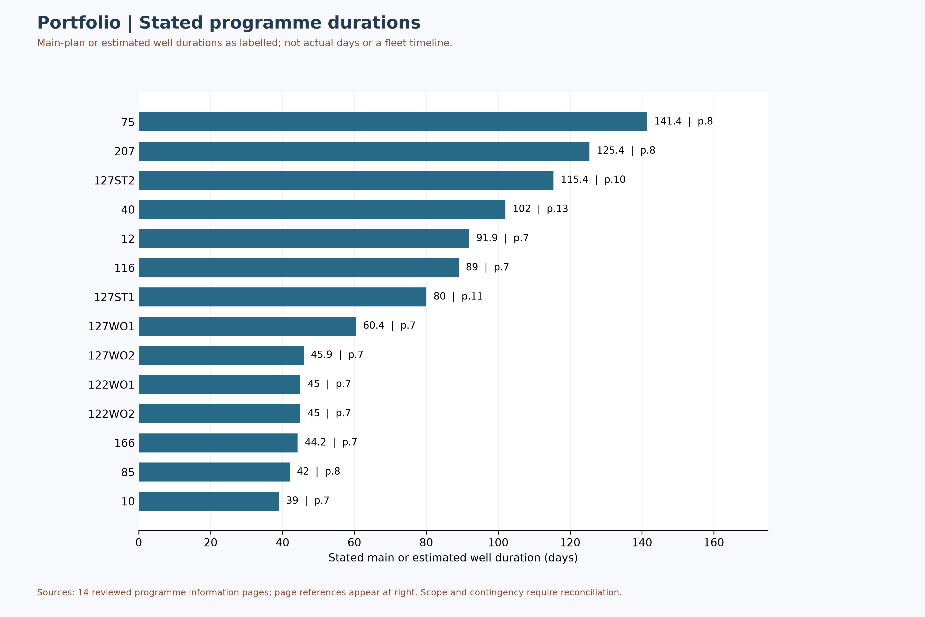
Figure M1 — Programme-stated main/estimated durations, not actual time

2. The Financial Position, Read Honestly
This figure shows the status of financial source review, not actual portfolio spend or savings. A cost worksheet alone does not prove an approved budget; scope, formulas and cost records require reconciliation.
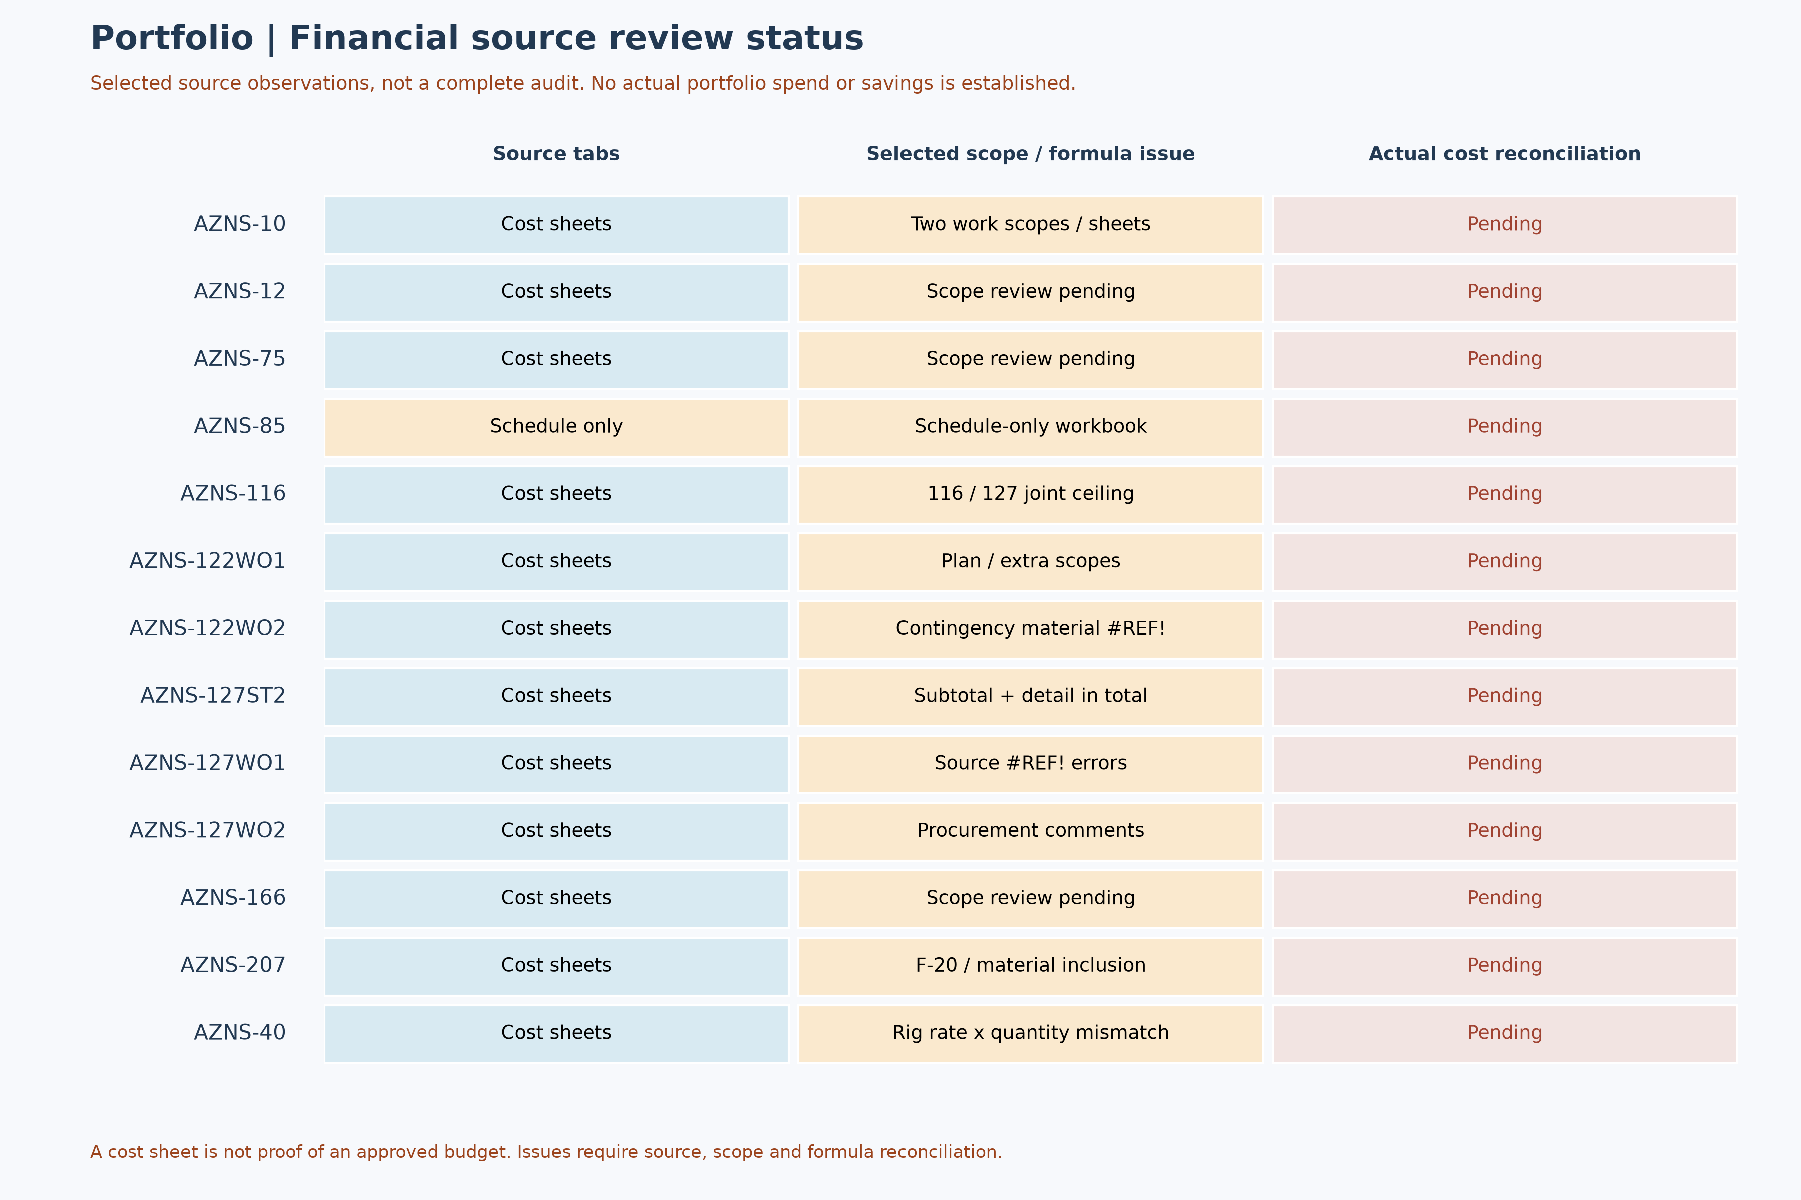
Figure M3 — Portfolio financial source review status

3. Source-coded time categories
This figure shows source-code hours only for fully classified 24-hour reports. Status pages are identified independently of data pages; unknown days are not zero. NPT and unplanned codes remain distinct, and the figure does not determine cause, contractual liability or cost.
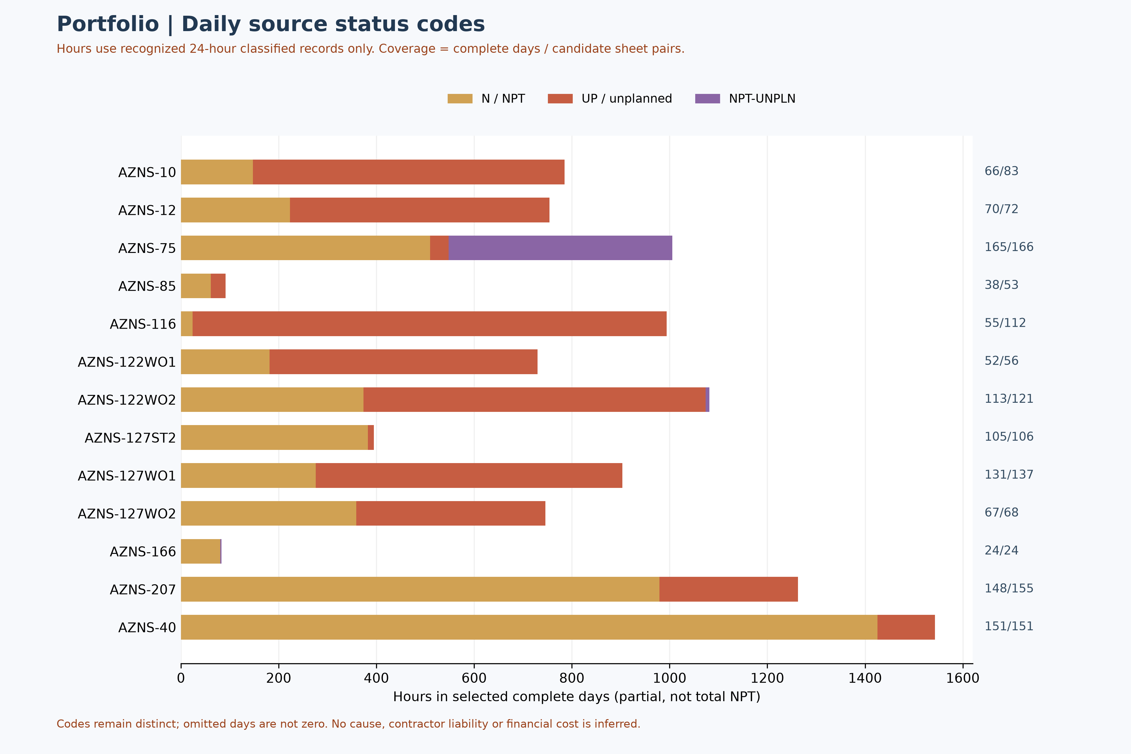
Figure M6 — Source-coded time in partially classified daily records

4. Source field coverage and economics gate
The figure shows selected field recognition within the identified data pages, not service prices or expenditure. An unrecognized field is not evidence of zero loss, no equipment or a missing physical event.
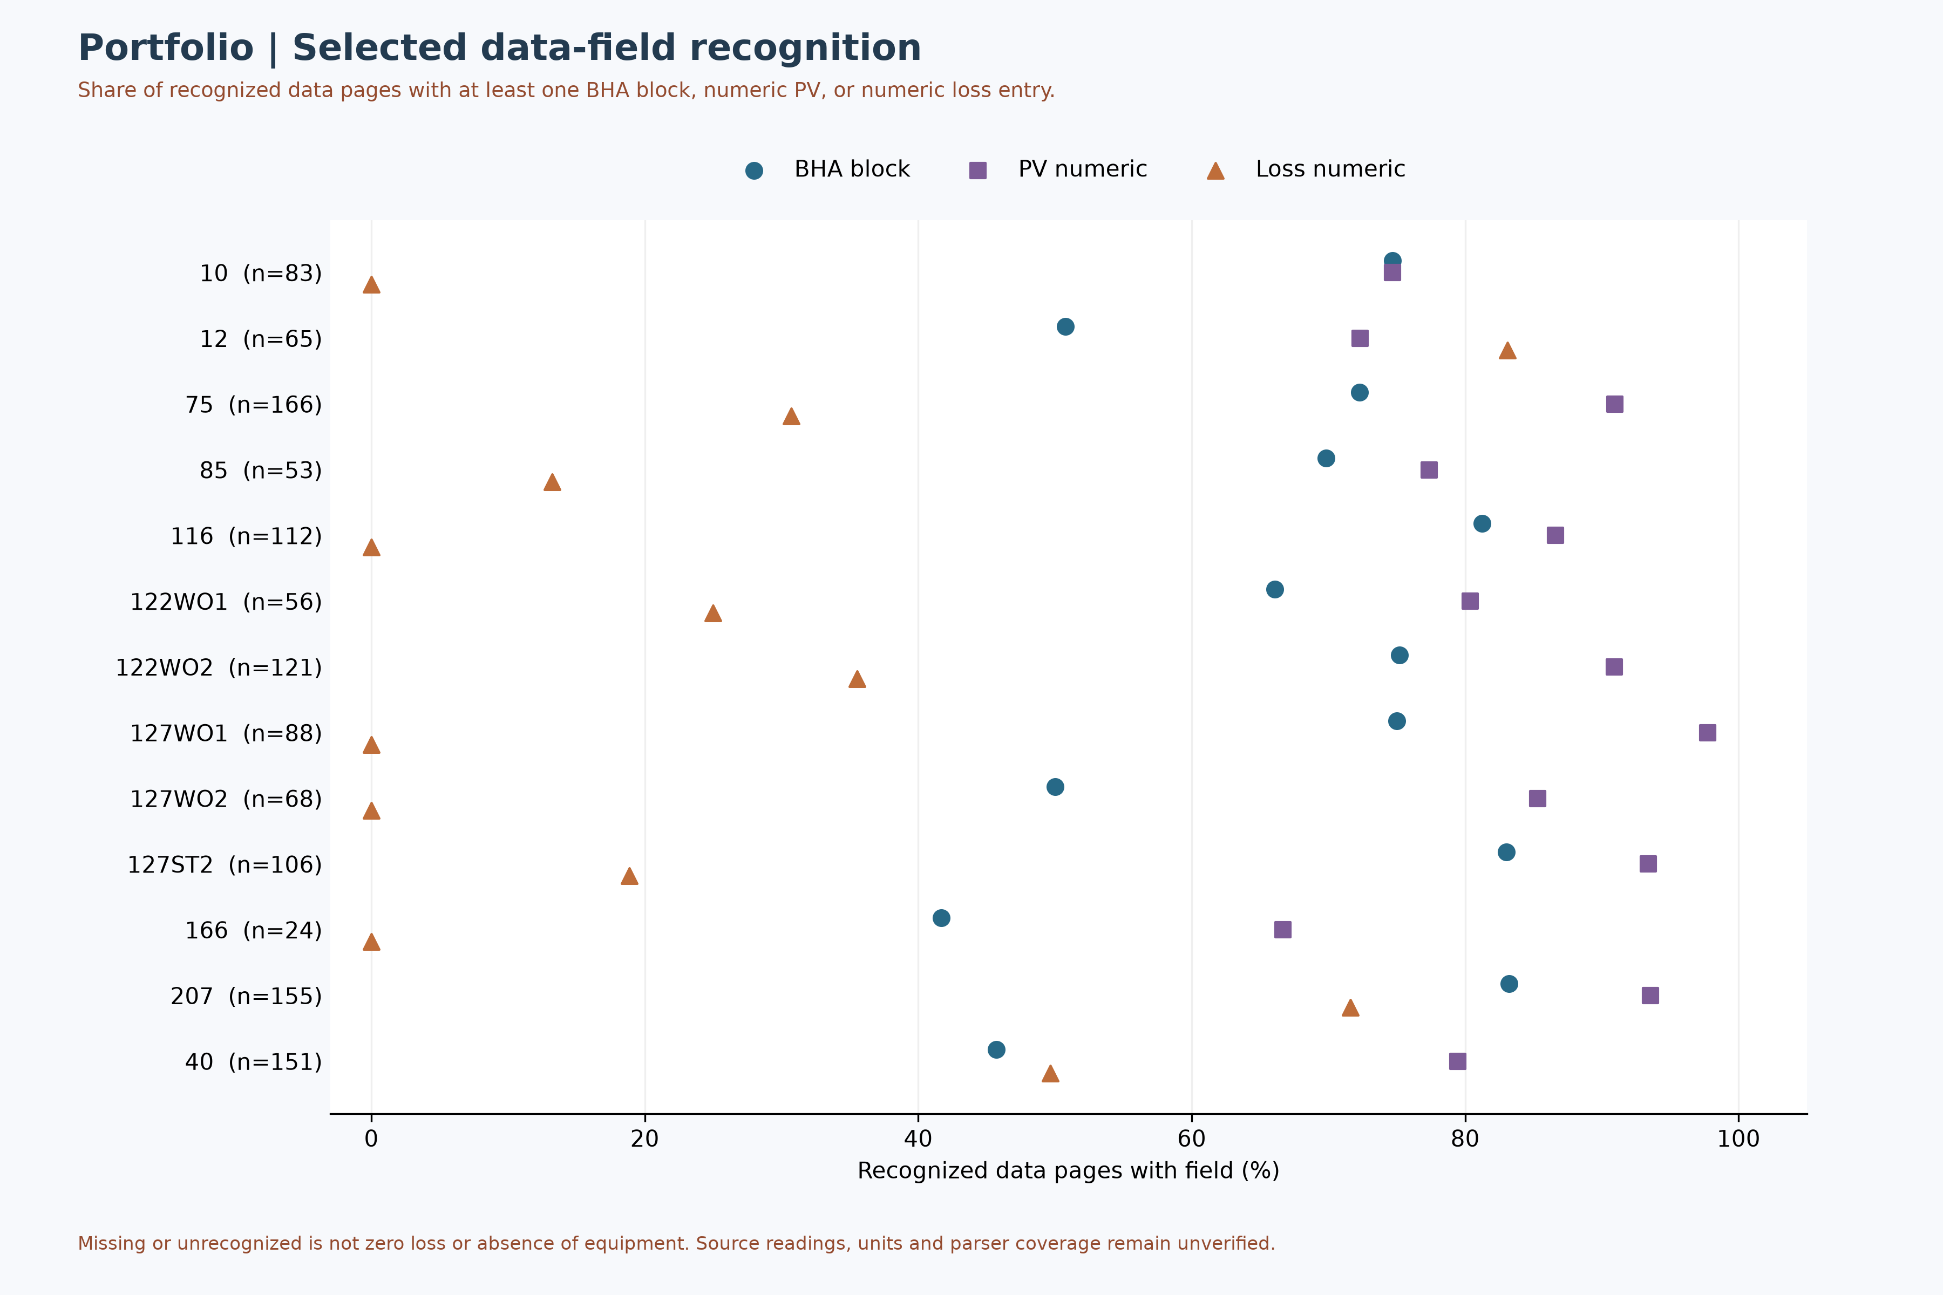
Figure M5 — Recognized BHA, viscosity and loss fields

5. Daily-record coverage
The chart distinguishes independently recognized status pages, complete classified status pages and recognized data pages. It is a coverage view, not a comparison of rig availability, efficiency, responsibility or cost.
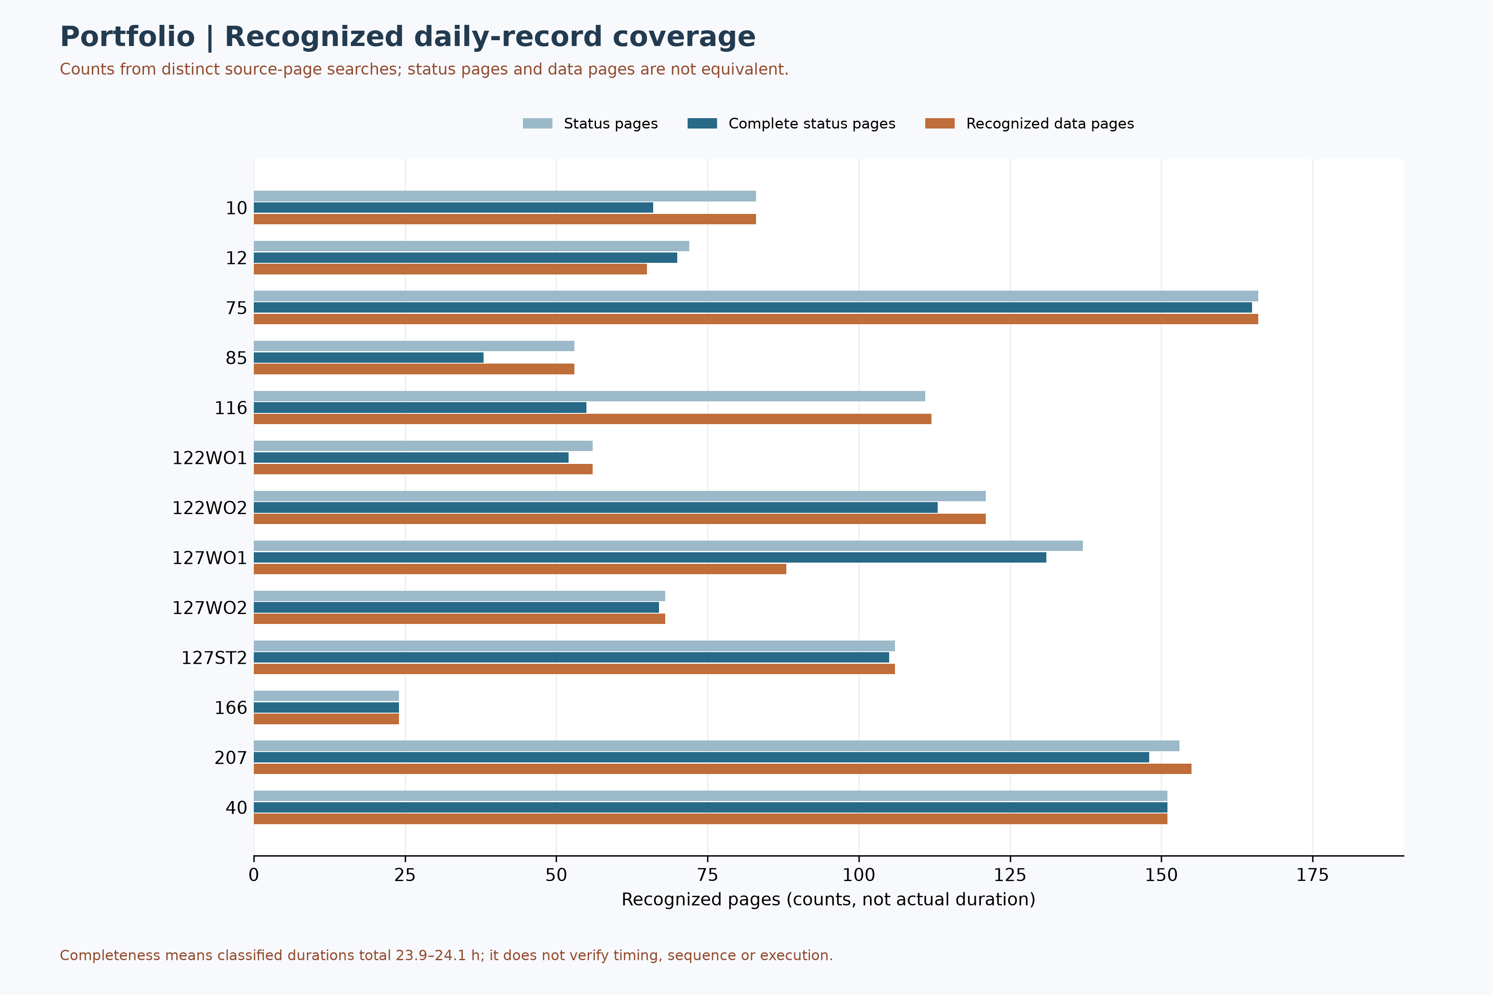
Figure M4 — Recognized source-page coverage, not rig performance

6. Programme phases for wells 122 and 127
Selected phases from six distinct programmes for wells 122 and 127 are shown with physical-page anchors. These are plans, not confirmed execution, a complete lifecycle or a cost comparison; the first and second sidetrack programmes remain distinct.
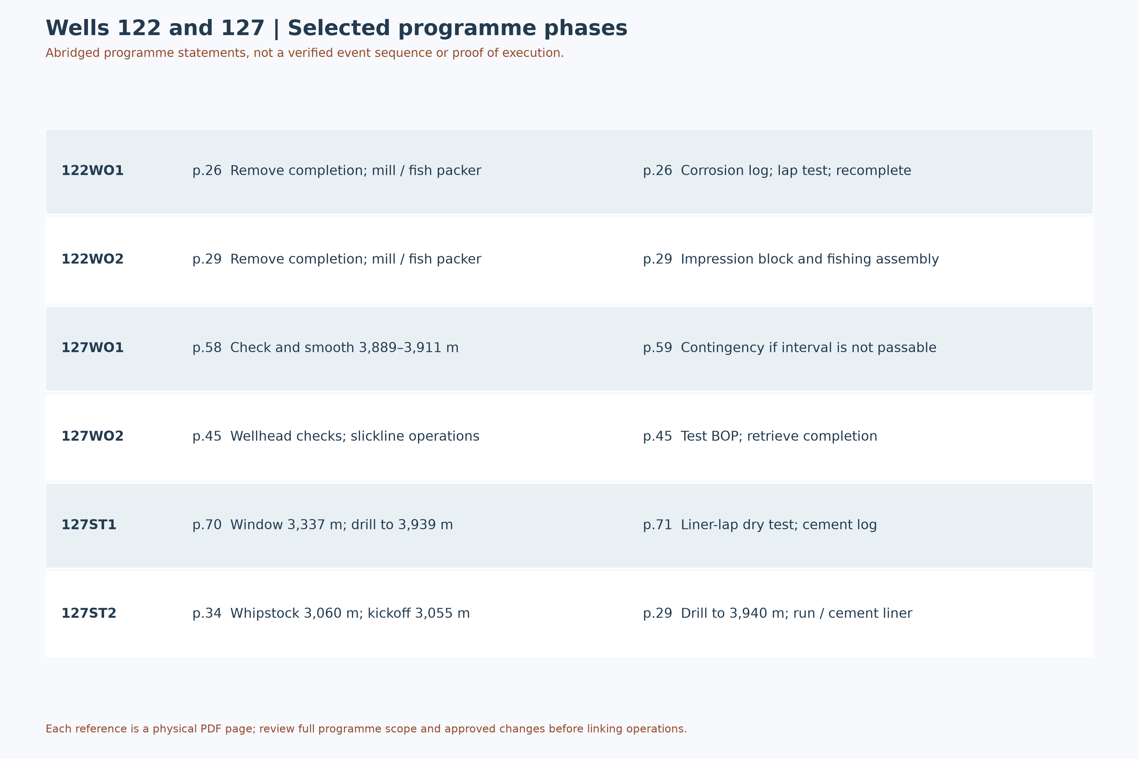
Figure M8 — Selected programme phases for wells 122 and 127

7. Source reconciliation examples
The figure lists selected source differences and scope cautions for review, not a ranked risk matrix. Resolve well identity, datum, reporting basis and approvals before design or attribution.
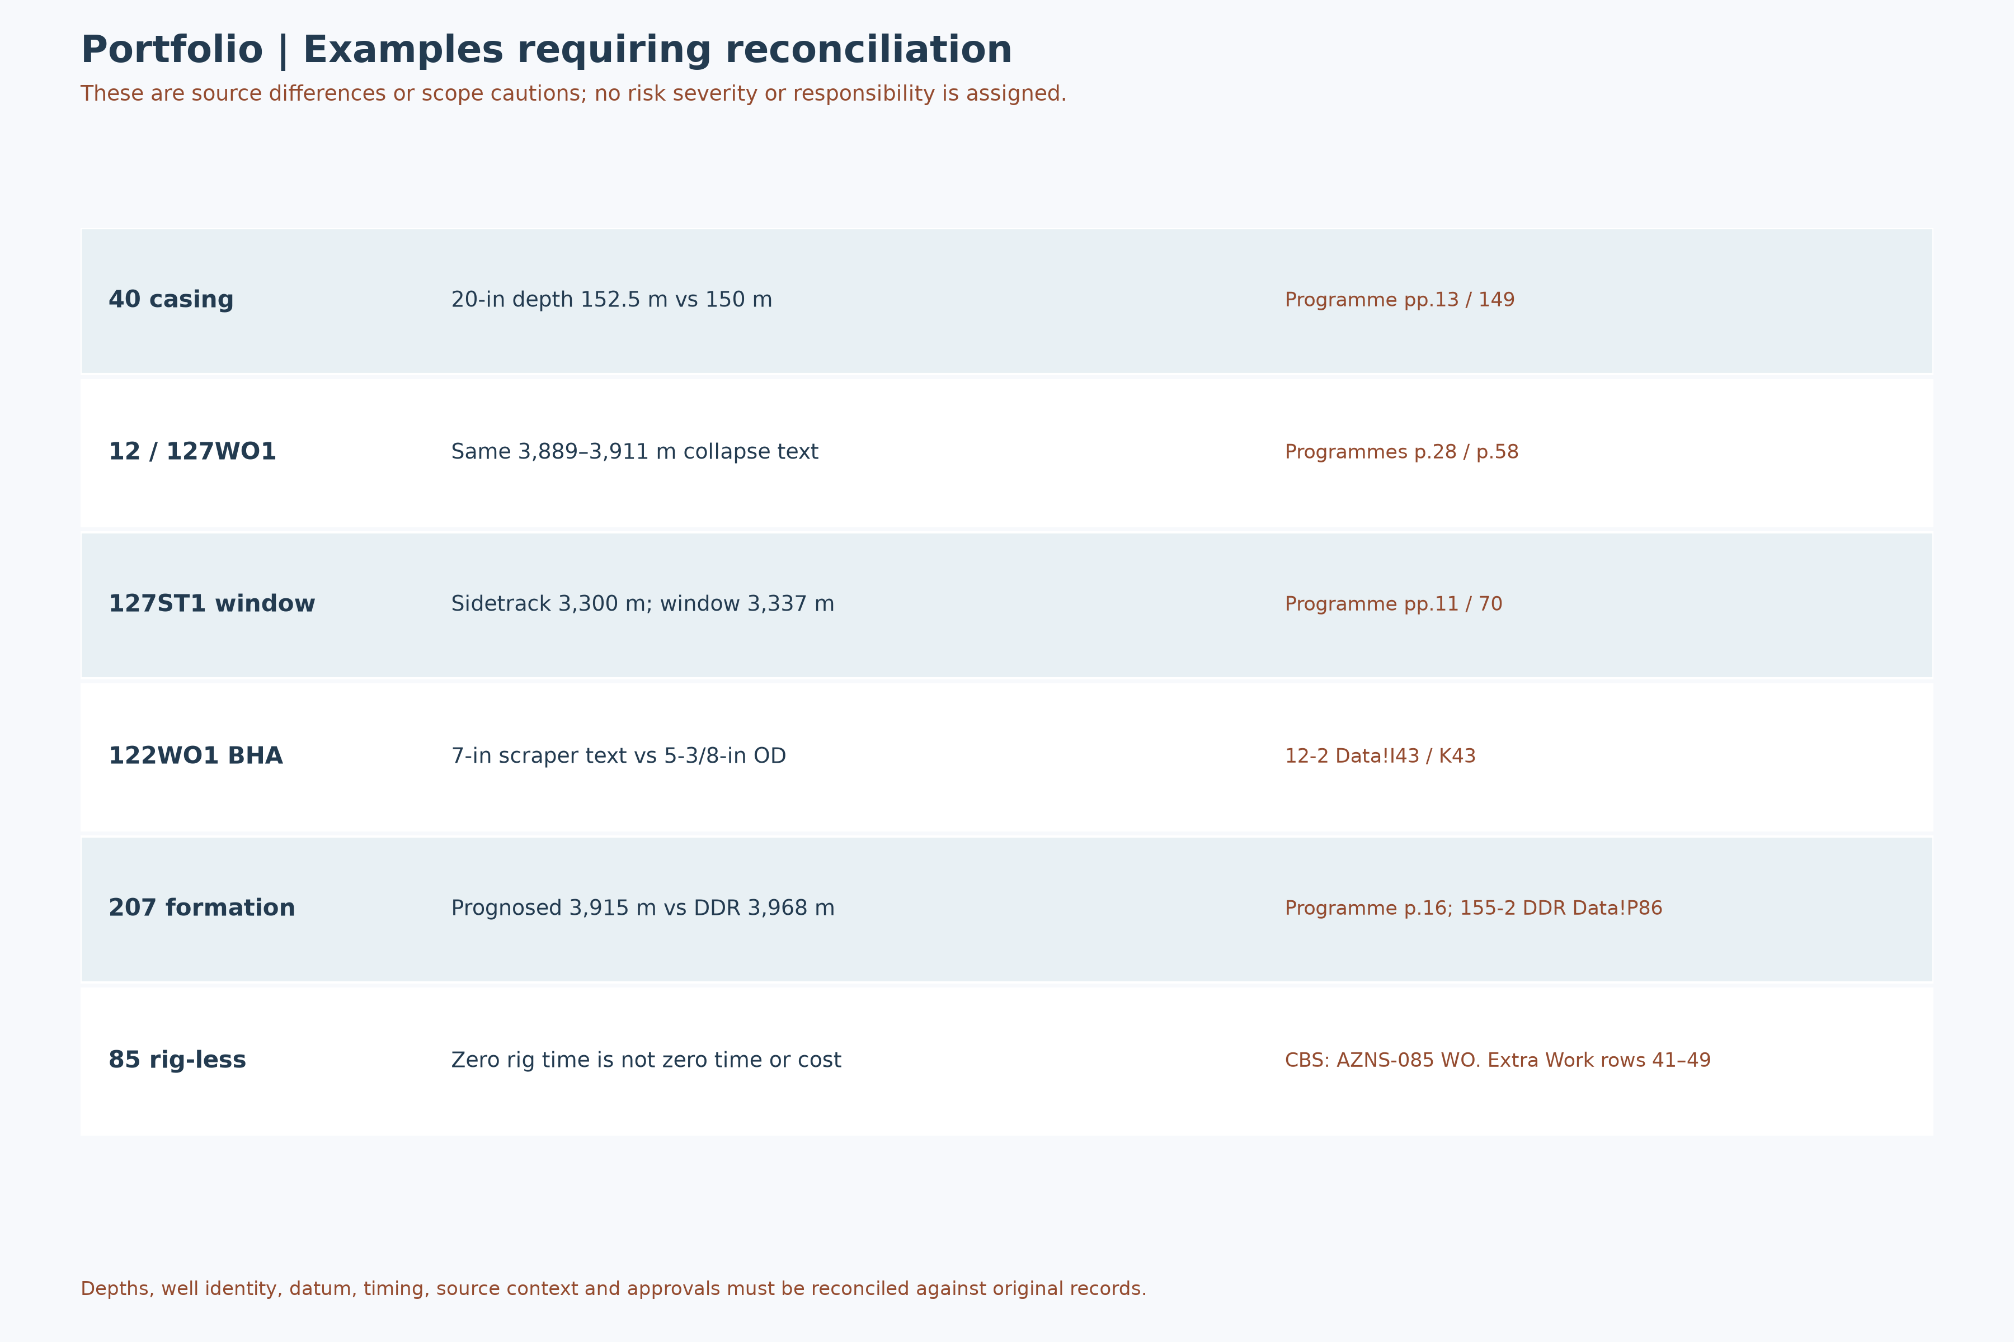
Figure M9 — Examples of unresolved source reconciliation

8. Decisions and evidence gates
Topic | Required evidence | Gate | Timing
Time and performance | Daily reports and rig assignment | Coverage and sequence review | Before assessment
Budget and cost | Approvals, formulas, scope and invoices | Financial reconciliation | Before comparison
Cause and liability | Event narrative and contract | Independent review | Before attribution
Well plan | Programme, as-built and barriers | Engineering review | Before decision
Table 7-1 — Proposed evidence-review gates, not approved actions.

9. Financial and technical exposure
The financial cost of nonproductive or unplanned time is not established. Quantification requires complete time records, contract terms, invoices, approval and a consistent cost scope; no annual projection is supported by the available review.
Operation | Source | Issue | Review gate
40 | Programme pp.13 / 149 | 20-inch casing depth 152.5 / 150 m | Reconcile depth and approved design
12 / 127WO1 | Programme p.28 / p.58 | Identical 3,889–3,911 m collapse wording | Verify well-specific source and event
127ST1 | Programme pp.11 / 70 | Sidetrack 3,300 m; window 3,337 m | Reconcile definitions and approved design
122WO1 | 12-2 Data!I43 / K43 | 7-inch scraper description / 5-3/8-inch OD | Verify component specification
207 | Programme p.16; 155-2 DDR Data!P86 | Prognosed 3,915 m / DDR 3,968 m | Verify datum and actual/predicted status
85 | CBS: AZNS-085 WO. Extra Work rows 41–49 | Rig-less steps excluded from rig schedule | Reconcile elapsed time and costs
Table 8-1 — Selected review issues and evidence gates.

10. Evidence needed for management decisions
Review approved scope changes, complete daily reports, source classification and contract terms, plus validated invoices and equipment records. Only then evaluate performance, causation, cost, liability and any proposed contractual remedy.

11. Annexes, Evidence and Contract Detail

11.1 Source inventory and loss/depth evidence
The inventory figure counts workbook sheets, not data completeness. The loss figure pairs numeric source observations with report-end depths, not event depths or formations; missing entries are not zero.
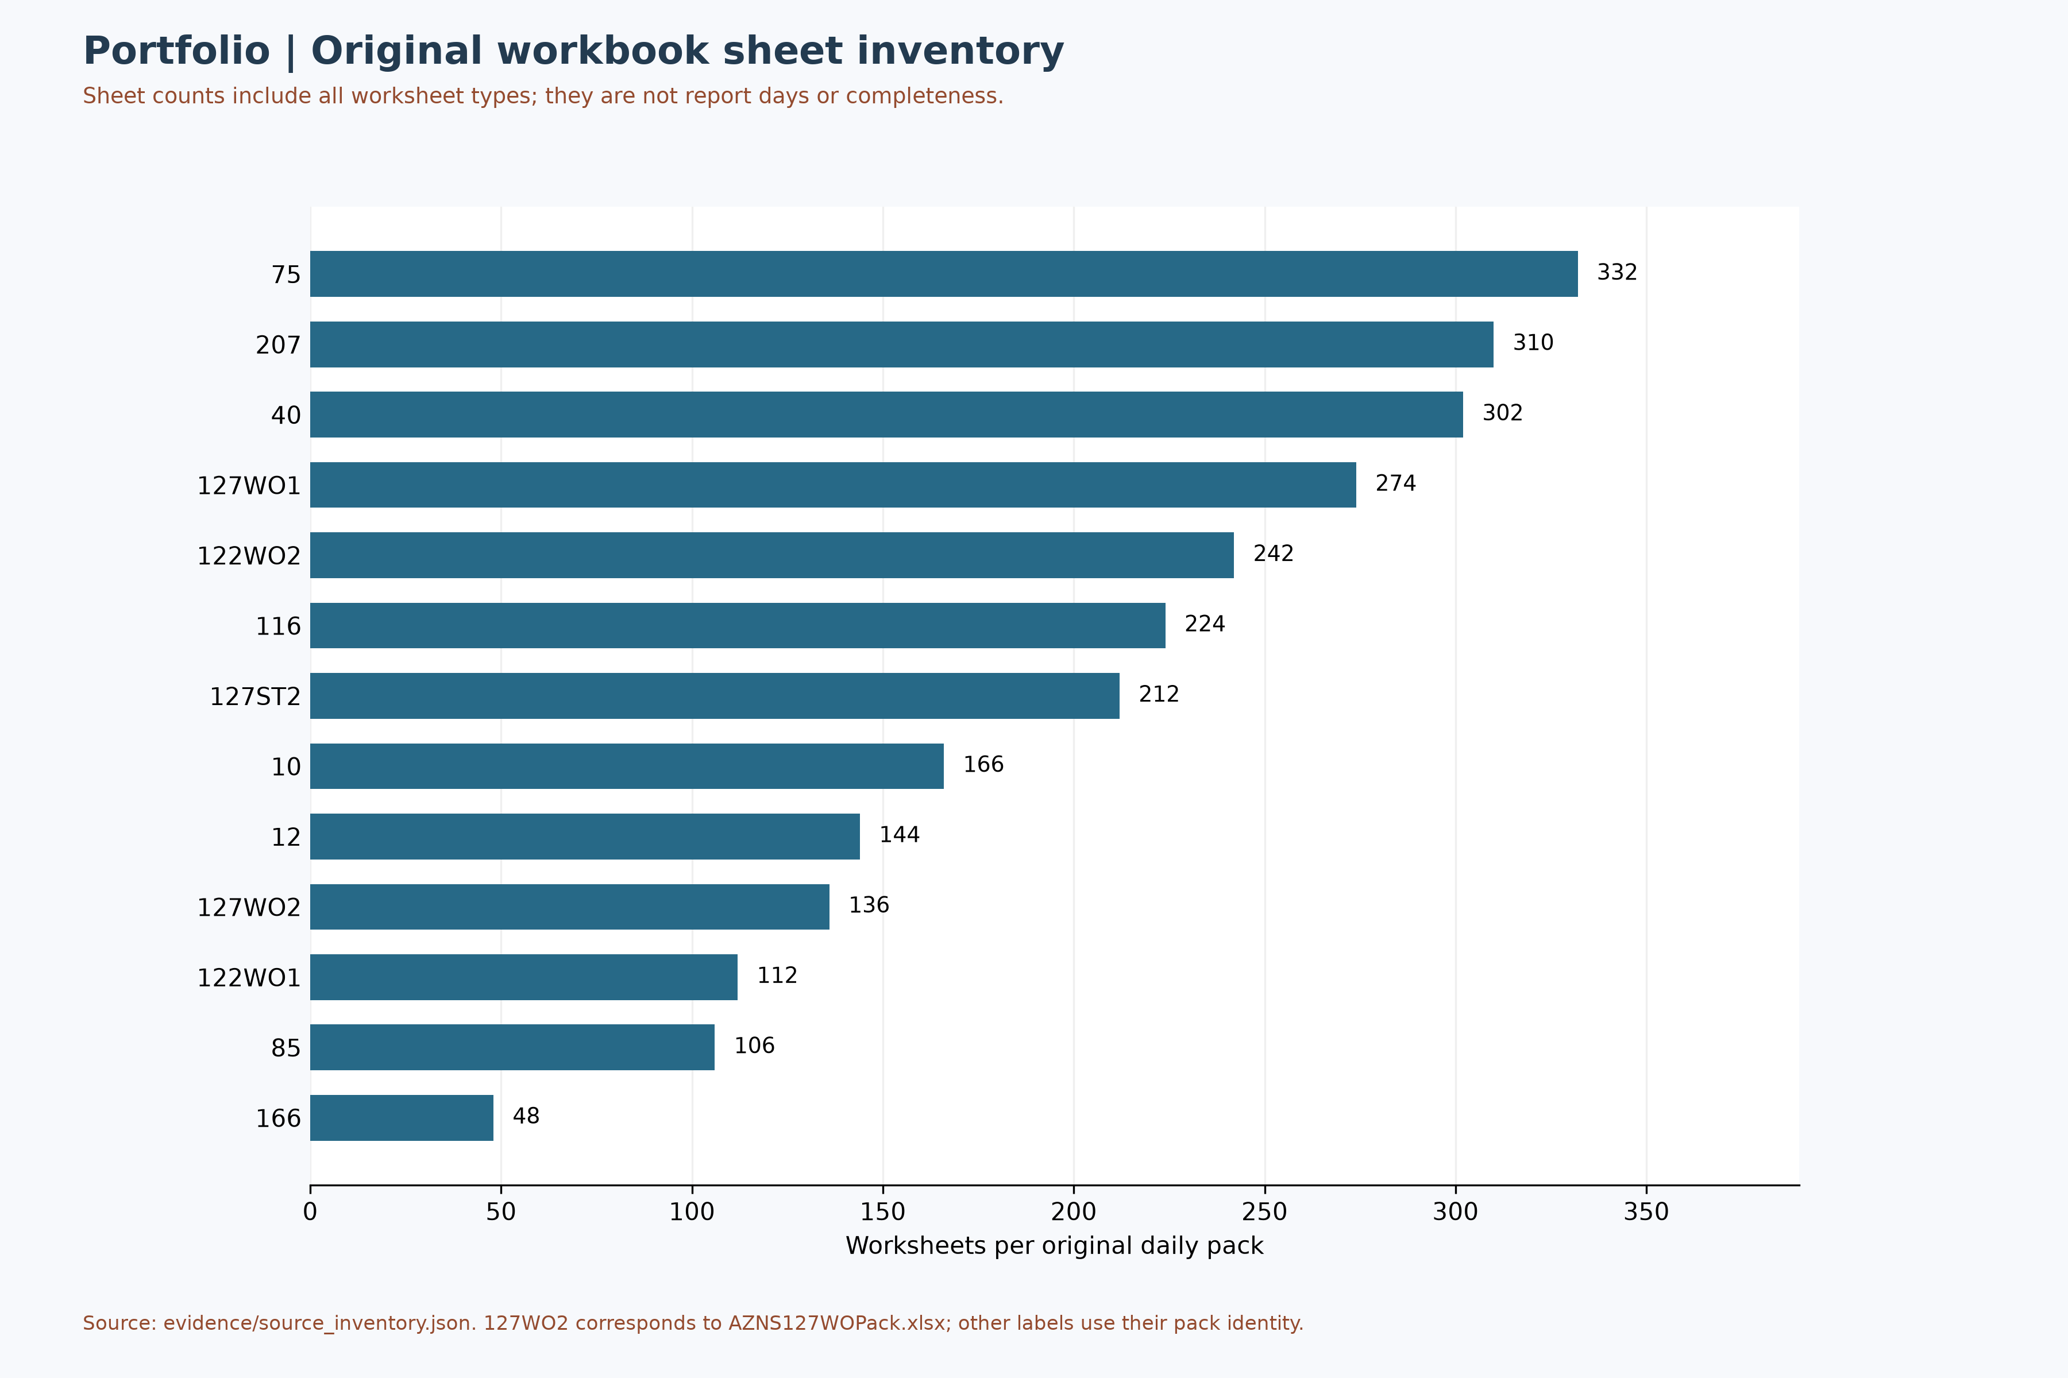
Figure M2 — Original pack worksheet inventory, not completeness
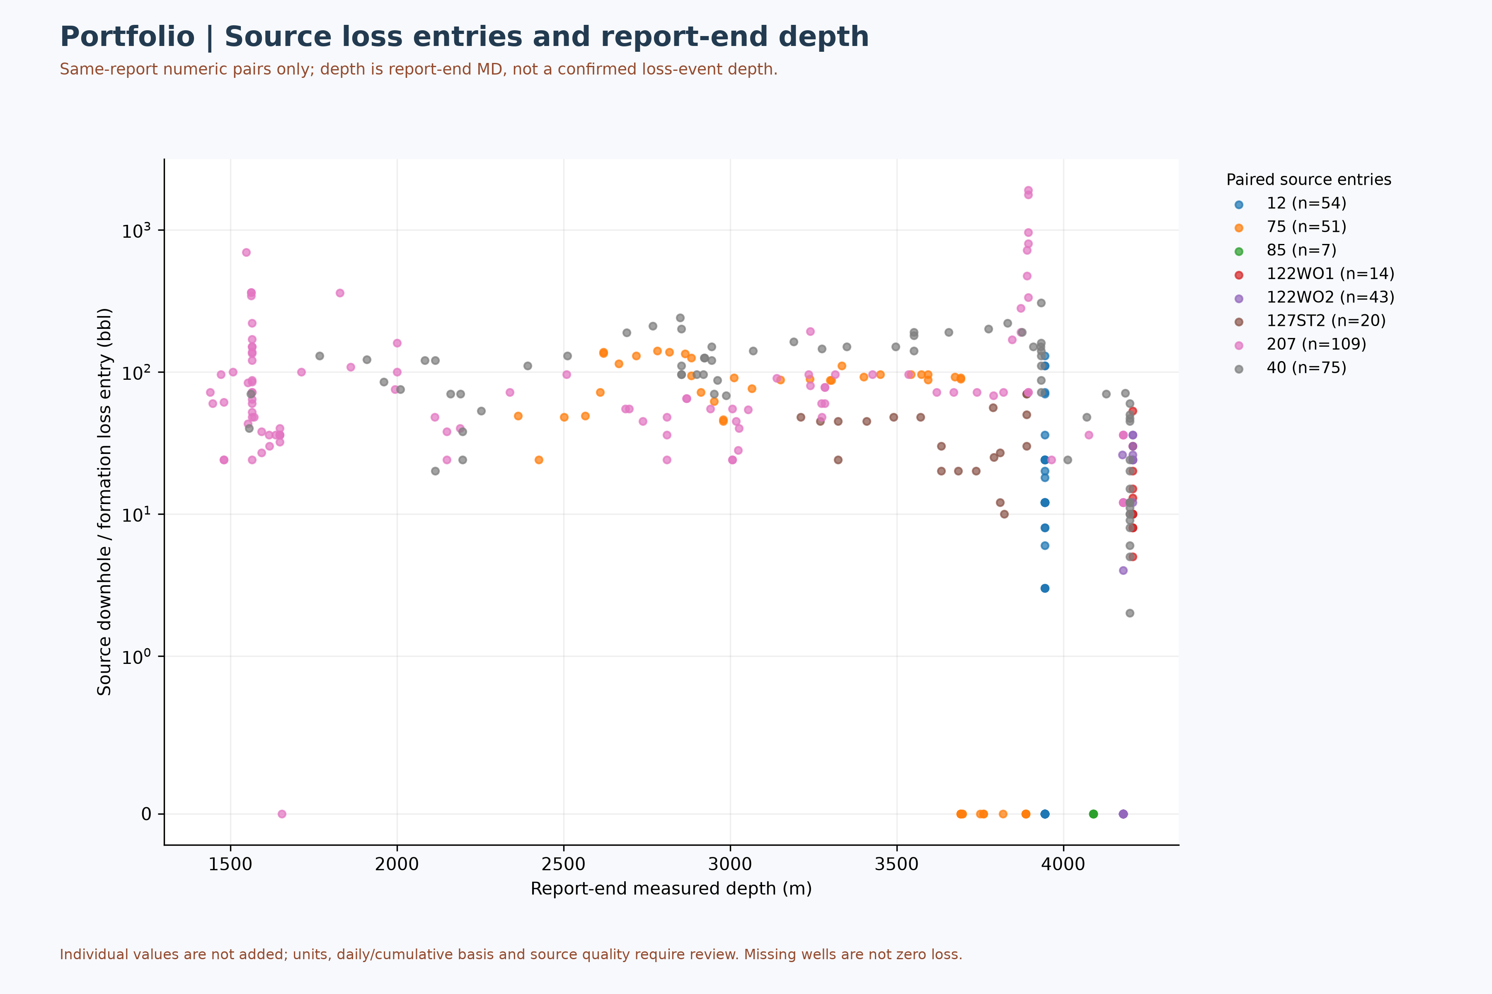
Figure M10 — Loss entries against report-end depth, not event or formation attribution

Appendix A. Financial source gates
Operation | Source sheet / cell | Cached value | Limitation
122WO1 | CBS AZNS-122WO1.xlsx / Cost Breakdown-122!G190 | 4,587,374.50 USD | Plan label; approval and scope pending
122WO1 | CBS AZNS-122WO1.xlsx / Cost Breakdown-122!H190 | 1,304,440.016 USD | Extra work; not automatically additive
85 | CBS AZNS-85.xlsx / AZNS-085 WO. Extra Work!K54 | 48.0729167 days | Rig schedule; rig-less work separate
85 | CBS AZNS-85.xlsx / AZNS-085 WO. Extra Work!O54 | 51.8895833 days | With contingency; scope pending
116 / 127WO1 | CBS AZNS-127WO1 and 116.xlsx / Total Cost-EPD & Rigless!C5 | 13,909,986.21 USD | Joint scope; do not allocate without evidence
Table A-1 — Selected CBS source values and unresolved scope.
Cached values and source labels alone do not establish actual spending, approved budget, allocation or savings. Recalculate formulas and reconcile invoices and scope before comparison.

Appendix. Portfolio KPI Table
Operation | Status pages | Complete pages | Data pages
10 | 83 | 66 | 83
12 | 72 | 70 | 65
75 | 166 | 165 | 166
85 | 53 | 38 | 53
116 | 111 | 55 | 112
122WO1 | 56 | 52 | 56
122WO2 | 121 | 113 | 121
127WO1 | 137 | 131 | 88
127WO2 | 68 | 67 | 68
127ST2 | 106 | 105 | 106
166 | 24 | 24 | 24
207 | 153 | 148 | 155
40 | 151 | 151 | 151
Table A-2 — Source-page recognition by operation.

Method and sources
The evidence index preserves original file hashes, spreadsheet cells and physical PDF pages. Status-page and data-page extractions are separate; chart inputs and limitations are recorded in the evidence directory. Formula caches are not recalculated. Further reconciliation and page-level visual QA are necessary.

Supplement: source evidence and decision gates
Decision gate — The existing portfolio financial totals and attribution are provisional. Reconcile scope, approved contract variations, rig-less services, invoices and daily reports before approving a budget or allocating contractor responsibility. This note is a limited source check, not a replacement for full reconciliation.
122WO1 — CBS AZNS-122WO1.xlsx, Cost Breakdown-122, G190 and H190 show USD 4,587,374.50 plan and USD 1,304,440.016 extra work. They cannot be combined as a like-for-like approved budget without reconciling scope and approvals.
85 — CBS AZNS-85.xlsx, AZNS-085 WO. Extra Work, K54 and O54 provide 48.07 and 51.89 days respectively; rows 41–49 classify subsequent steps as rig-less. Row 44 proposes at least 96 hours of post-acid flow and makes rig-less acidizing/cleanup subject to contractor and client approval. Exclusion from rig time is not zero elapsed time or zero cost.
207 — AZNS-207 Program.pdf, physical page 16, gives a prognosed Fahliyan top of 3,915 m MD; AZNS207Pack.xlsx, 155-2 DDR Data, P86 lists 3,968 m MD. The 53 m arithmetic difference requires confirmation of datums and whether the DDR value is an actual top before it is used as a geological deviation. Page 12 reports Fahliyan water salinity of 143,000 ppm as NaCl; it is programme information, not proof of current fluid properties.
10 and 75 — AZNS-010 Workover Program Rev.06.pdf pages 6 and 17 describe prior abandonment and cement plugs. AZNS-075 Workover-1 Program Rev.05.pdf page 86 labels a first-run Weqixin completion string as failed but its text does not establish the failure mechanism. The 10 pack shows a potential formation-table row shift between 1-2 Data and 83-2 Data; reconcile before use.
Well-report W4 plots shares of recognized complete-day source status codes, not verified technical causes; formation-table snapshots likewise require depth and row reconciliation.

Fourteen source programmes: reviewed well-information pages
The table identifies programme revision and physical page, duration with source labels and the depth stated on that page. It includes 127 ST1 as distinct from ST2. These figures do not establish execution or achieved depth; contingency values are not added without scope and time-basis reconciliation.
Operation | Programme duration (days) | Stated MD (m) | Programme file / physical page
127ST1 | 80 main | 4150 | AZNS -127 Side Track#01 Program Rev.03.pdf / 11
127ST2 | 115.4 main; 6.0 contingency | 4150 | AZNS -127 Side Track-2 Program Rev.01.pdf / 10
10 | 39 main; 9 contingency | 5340 | AZNS-010 Workover Program Rev.06.pdf / 7
12 | 91.9 main; 136.2 contingency | 3945 | AZNS-012 Workover Program Rev02.pdf / 7
122WO1 | 45 main; 7 contingency | 4208 | AZNS-0122 Workover-1 Program Rev.07.pdf / 7
122WO2 | 45 main; 7 contingency | 4208 | AZNS-0122 Workover-2 Program Rev.00.pdf / 7
40 | 102 estimated well duration; 10 estimated moving | 4200 | AZNS-040 RE-Entry Well Program Rev.03.pdf / 13
75 | 141.4 main; 149.2 with contingency | 3888.5 | AZNS-075 Workover-1 Program Rev.05.pdf / 8
116 | 89 main; 45.2 contingency | 4150 | AZNS-116 Workover Program Rev.04.pdf / 7
127WO2 | 45.9 main; 110.8 contingency | 4140 | AZNS-127 Workover #2 Program Rev.03.pdf / 7
127WO1 | 60.4 main; 58.9 contingency | 4226 | AZNS-127 Workover1 Program Rev.01.pdf / 7
166 | 44.2 main; 95 contingency | 4280 | AZNS-166 Workover-1 Program Rev.05.pdf / 7
207 | 125.4 estimated well duration; 10 estimated moving | 4180 | AZNS-207 Program.pdf / 8
85 | 42 main; 5.5 contingency | 4090 | AZNS-85 Workover Program Rev.02.pdf / 8
The 127 ST1 programme is distinct from ST2: physical page 11 of AZNS -127 Side Track#01 Program Rev.03.pdf states a window and sidetrack from 3,300 m MD, 8½- and 5⅞-inch holes, completion and an 80-day main plan. The programme alone does not establish execution or a separate daily-report record.
Additional ST1 phase references: Plan a cased-hole window at 3,337 m and drill the 8½-inch section to 3,939 m, then run and cement a 7-inch liner. [AZNS -127 Side Track#01 Program Rev.03.pdf, physical p. 70] After the liner, the programme describes a liner-lap dry test and cement-quality logging. [physical p. 71]. Page 11 states a sidetrack from 3,300 m; reconcile its definition against the window position on p. 70 and the approved design. These statements do not prove actual ST1 execution.
Programme source discrepancies: physical p. 13 of the well 40 programme gives 152.5 m for the 20-inch casing, whereas p. 149 gives 150 m. Identical wording about a 3,889–3,911 m collapse interval also occurs on p. 28 of the well 12 programme and p. 58 of the 127 WO1 programme. Neither the interval attribution nor actual casing depth is resolved without approved well-specific records.
207 programme Pabdeh thickness discrepancy: AZNS-207 Program.pdf physical page 14 states the Pabdeh interval as 1,994–2,178 m with a thickness of 165 m, while the table on page 17 gives 184 m, equal to the arithmetic endpoint difference. Both source values are retained pending review.
ST1 pre-operation casing reference: physical p. 58 of the 127 ST1 programme lists 20-, 13⅜- and 9⅝-inch casing to 146, 1,441 and 3,909 m, respectively, and a 7-inch liner from 3,777 to 4,226 m; it does not verify the final post-sidetrack configuration.

Well 127 formation-top source distinctions
The ST2 programme p.25 reproduces original-well tops with separate forecast, sample and log columns; the same source image occurs in the ST1 programme p.62. For Gachsaran these columns are 1,107, 1,105 and 1,084 m, respectively. The workover schematics show 1,105 m; this must not be silently identified as the log value. WO1 p.51 and WO2 p.38 also show different Dariyan (3,478.62 / 3,479.14 m), Gadvan (3,650.57 / 3,667 m) and Fahliyan (3,937.73 / 3,938.87 m) entries. These are source differences, not automatically geological movement or a validated sidetrack correlation.

Selected AZNS-122 workover 1 campaign evidence
The 122 WO1 daily pack records rig spud on 14 January 2024 at 15:00 and rig release on 9 March 2024 at 18:00, 55 days and 3 hours apart. Programme p.7 prints 45 main-plan days plus 7 contingency-plan days. Neither difference establishes a contractual overrun without matched time boundaries, approved scope and service records. [AZNS122WO1Pack.xlsx, 1-1 Remark!K34 and 56-1 Remark!K30; AZNS-0122 Workover-1 Program Rev.07.pdf, p.7]
Report 29 gives conflicting fish-depth entries; report 34 states the fish tail was completely milled, not that the complete fish was independently recovered. Reports 41–42 refer to a deep liner-lap reference at 3,775.4 m and a new liner lap at 1,998 m; they are distinct references. Report 56 describes a coiled-tubing brine displacement, not confirmation of the separate rig-less acid wash on programme p.27. [AZNS122WO1Pack.xlsx, 29-1 Remark!K22:K29, 34-1 Remark!K24:K25, 41-1 Remark!K22, 42-1 Remark!K24, 56-1 Remark!K22:K27]

Worksheet prefix versus report number
A header review of 1,301 status pages found 447 where the numeric report header differs from the worksheet prefix, plus one unreadable numeric header. In well 116, sheets 102-1 and 103-1 carry reports 117 and 118, whereas sheets 104-1 to 112-1 carry reports 108–116. Its start note states 8 June 2024 while the final header states 7 June. Sheet order is not chronology or operating duration; headers themselves must be reconciled to signed records. [AZNS116Pack.xlsx, 1-1 Remark!K22, sheets 101-1 through 112-1 cell S5 and 103-1 Remark!N6; evidence/sheet_report_number_audit.json]

Date-header and volatile-formula audit
Of 1,301 status pages in 13 packs, 1,042 header dates were readable under narrow rules; 259 including ambiguous formats or volatile formulas remain uninterpreted. In well 85, thirteen N5 cells contain =TODAY()-1; the cached result is not a dependable historical date and can change on recalculation. Wells 116 and 40 each show a backward step between adjacent prefix-ordered readable headers. These comparisons do not identify every discrepancy, and a readable date is not necessarily correct. [evidence/status_report_date_audit.json; AZNS85Pack.xlsx, 1-1 Remark!N5]

Selected AZNS-116 campaign review
Programme p.7 states 89 main-plan days and 45.2 contingency days; an actual-duration variance is not calculated because the start date and scope boundaries conflict. Among selected operational reports, 40-1 Remark!K29:K30 describes no fish recovered and approximately 12 cm of broken taper tap left in the well; 68-1 Remark!K26:K33 records cement-bond log acquisition, not validated interpretation; 91-1 Remark!K27:K30 reports perforating 3,979–3,975 m, not interval productivity. 103-1 Remark!K24 records rig release on 2 October 2024 at 06:00. These are selected historical source accounts, not present barrier status, contractual liability or proof that every activity was completed. [AZNS-116 Workover Program Rev.04.pdf, p.7; AZNS116Pack.xlsx; evidence/116_campaign_review.json]

Selected AZNS-85 campaign review
Selected AZNS-85 reports describe dry-test packer component failure and the loss of a drag block; later entries say a magnet did not recover it and milling began. The 61, 85 and 92-hour source notes are running figures and must not be added together or treated alone as contractual liability. 39-1 Remark records two perforating runs and describes a broader interval as approved; it does not prove continuous perforation across the whole span or productivity. The final recognized page records release of some services, not rig-release time or execution of planned rig-less acidizing. Thirteen header dates use volatile formulas and require signed-record reconciliation. [AZNS85Pack.xlsx, 18-1 Remark!K25:K30, 20-1 Remark!K30, 21-1 Remark!K23:K30, 23-1 Remark!K24:K44, 24-1 Remark!K25, 39-1 Remark!K24:K39, 53-1 Remark!K48:K50; evidence/85_campaign_review.json]

