ENGINEERING REVIEW WARNING — This legacy report is not validated for operational or financial decisions. The former linear cumulative-cost chart was removed; a verified daily cost series is not yet available; other charts, budgets and cause/formation attribution require reconstruction and reconciliation to source records. See the repository review note for the limited corrections made.
AZNS-127 WO1
Drilling, Workover and Well-Intervention Engineering Report
Technical, Operational, Contractual and Financial Analysis
Interim source review for South Azadegan; engineering approval pending

Item | Value
Well / operation | 127WO1
Daily-report pack | AZNS127WO1Pack.xlsx
Cost workbook | CBS AZNS-127 WO1.xlsx
Well programme | AZNS-127 Workover1 Program Rev.01.pdf
Status | Interim draft; source reconciliation and engineering approval required

Document control | Status
Official document code | Not established
Revision / status | Interim draft; not issued or approved
Official issue date | Not established
Preparation | Automated analytical draft
Specialist review | Completion and approval not established
Approval and distribution | Not established
Table 0-1 — Document control and review status.
This interim report compiles available records; its legacy analyses are not independently validated.

Executive KPI Summary
KPI | Value and scope
Programme-stated duration | 60.4 main; 58.9 contingency [physical p.7]
Recognized status pages | 137
Status pages with approximately 24 h classified | 131
Recognized data pages | 88
Numeric downhole-loss entries | 0
Maximum single source loss entry, bbl | No numeric entry recognized
Actual duration, total loss and actual cost | Not reconciled; not inferred from these observations

Legacy duration and NPT figures in this report remain subject to source reconciliation. Actual expenditure is not established.

Contents
No. | Section
1 | Well Identity, Rig Assignment and Data Inventory
2 | Planned versus Actual Execution Reconciliation
3 | Selected daily-report observations
4 | Performance and Parameter Analysis
5 | Drilling Fluid Engineering and Loss Accounting
6 | Completion, Casing and Service-Module Findings
7 | Source-coded non-planned time and partial coverage
8 | CBS Financial Analysis and Provisional Cost Categories
9 | Operational observations and engineering decision gates
10 | Risk-review checklist; ownership and severity not assigned
11 | Data Provenance and Cell-Level Traceability
12 | Appendix: source formation-table snapshot (unverified)
13 | Programme source summary and comparison limitations

Figures and tables are numbered by section and are listed in place.

Well Identity, Rig Assignment and Data Inventory
This interim report references AZNS127WO1Pack.xlsx and AZNS-127 Workover1 Program Rev.01.pdf. The archive was indexed, but semantic extraction and verification remain incomplete; see the evidence notes and source inventory. Static identity and rig assignments below are legacy-compiled and require verification against cited source cells and approved records.

Static identity
Field | Recorded value
Well name in daily report | AZNS-127, PAD-54
Well type declaration | IIF Vertical Well
Field | South Azadegan
Client | PPL/PEDEC
Drilling contractor | OEOC
Rig | 208 OEOC
Operation classification | Workover / Completion
Hole section / scope declaration | De-Complete, Re-Complete Operation
Spud / first report date | 2024-08-05
Release / last report date | 2024-12-19
Table 1-1 Static well identity.

Data inventory discovered for this operation
Source / extraction | Recognition and limitation
Daily pack | AZNS127WO1Pack.xlsx
Status pages | 137 recognized; 131 with approximately 24 classified hours
Data pages | 88 of 137 candidate pairs
CBS workbook | CBS AZNS-127 WO1.xlsx; cached values and scope require reconciliation
Programme PDF | AZNS-127 Workover1 Program Rev.01.pdf; information page 7
Limitation | Recognition or absence in an extraction does not establish complete archive coverage
Table 1-2 Core and auto-discovered bonus modules.
The legacy module inventory requires review; absence from an extraction does not establish absence from the entire archive.

Planned versus Actual Execution Reconciliation
The programme AZNS-127 Workover1 Program Rev.01.pdf, physical page 7, states the following objective: Remove and rerun completion, identify and remedy the annulus leak, and check/smooth the stated 3,889–3,911 m collapse interval. The stated duration in days is 60.4 main; 58.9 contingency. Contingency figures retain the source labels and should not be added or compared with execution without reconciliation.
Reconciliation metric | Planned | Actual | Variance
Programme-stated duration (days) | 60.4 main; 58.9 contingency | Not reconciled | Not reconciled
Depth reached / target (m MD) | Not reconciled | Not reconciled | Not reconciled
Cost (USD) | Not reconciled | Not reconciled | Not reconciled
Cost per rig day (USD) | Not reconciled | Not reconciled | Not reconciled
NPT share of rig time (%) | Not reconciled | Not reconciled | Not reconciled
Table 2-1 Planned versus actual reconciliation.
A planned-versus-actual duration comparison is not established until revision, scope, daily reports and time boundaries are reconciled; the previous ratio and causal attribution are withdrawn.
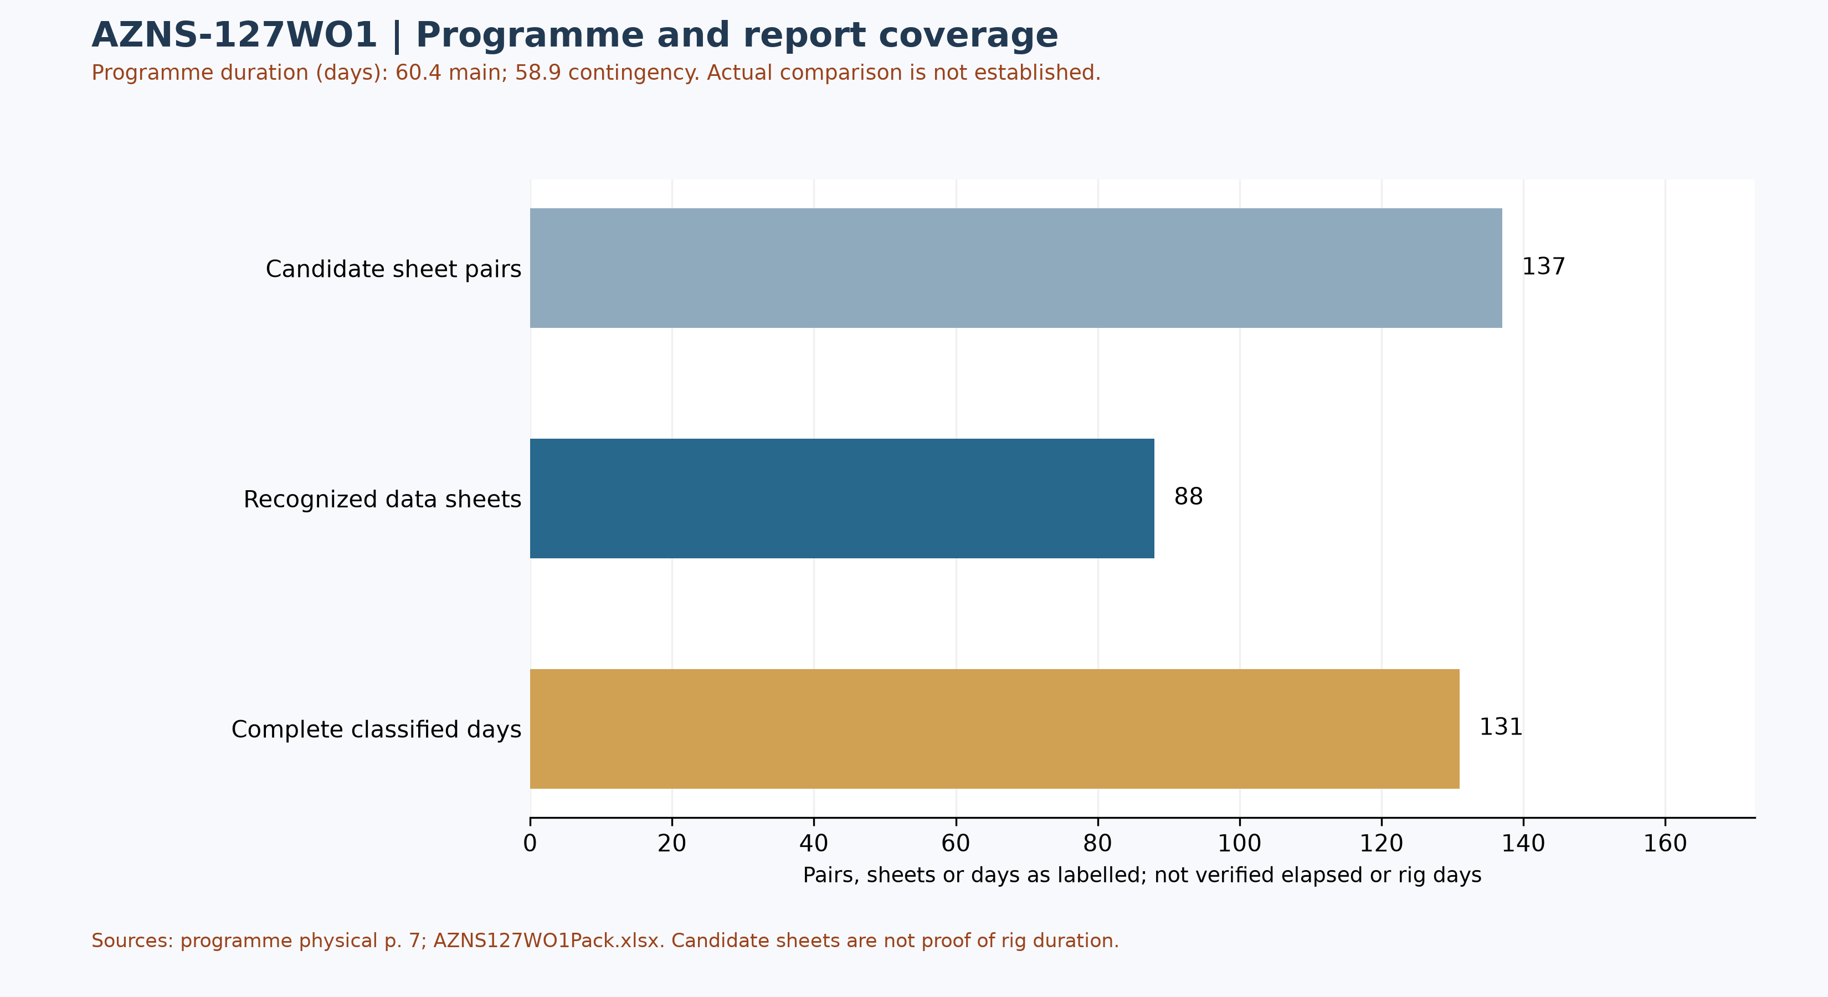
Figure W1 — Daily-record coverage and stated programme duration; actual comparison unverified
Status-page coverage is assessed independently: 137 status pages and 88 data sheets were recognized; 131 status pages contain classified durations totalling approximately 24 hours. Some reports have a status page but an absent or differently formatted data page. These counts are not verified rig duration.

Selected programme phases and limited execution evidence
The phases below are selected programme statements, not proof of execution or of the final approved revision. The selected daily observations are quoted separately; a similar topic alone does not establish phase timing, completion or deviation.
Programme — The programme identifies an interval at 3,889–3,911 m to check and smooth, and plans completion removal and recompletion. [AZNS-127 Workover1 Program Rev.01.pdf, physical p. 58]
Programme — The planned clean-out includes a contingency if the stated interval cannot be passed; prior client approval is mentioned for certain remedial work. [AZNS-127 Workover1 Program Rev.01.pdf, physical p. 59]
Daily report 39 — The report describes pulling the overshot and retrieving 21.1 m of 4½-inch tubing; the individual cell continues into subsequent text. [AZNS127WO1Pack.xlsx, 39-1 Remark!K26]
Daily report 130 — A later report records work to rectify leakage in surface lines of the pump truck; the original contains an NPT party label that is not adopted here as contractual liability. [AZNS127WO1Pack.xlsx, 130-2 Remark!K22]
Services listed in the programme: drilling and completion fluids: VIRA; waste management: Pars Hafaran Arvand; electrical logging and perforation: SEALAND; mud logging: MAPSA KISH. [AZNS-127 Workover1 Program Rev.01.pdf, physical p. 55] These are programme assignments, not evidence of actual deployment, contractual award, cost or incident liability.

Selected daily-report observations
Of 137 recognized status pages, 131 contain classified durations totalling approximately 24 hours. Planned, NPT and unplanned labels are source classifications; they do not independently establish cause, liability or total operation duration. The following examples are selective; complete extracted detail cells are retained in evidence/activity_observations.json.
Report 39 — The report describes pulling the overshot and retrieving 21.1 m of 4½-inch tubing; the individual cell continues into subsequent text. [AZNS127WO1Pack.xlsx, 39-1 Remark!K26]
Report 130 — A later report records work to rectify leakage in surface lines of the pump truck; the original contains an NPT party label that is not adopted here as contractual liability. [AZNS127WO1Pack.xlsx, 130-2 Remark!K22]
These are source statements, not independent verification of a test, failure mechanism, current well condition or an operating instruction. A description may continue into the next cell; reconcile the complete row and time before making decisions.

Additional selected daily-report evidence
These three entries are ordered by report number; sheet order alone does not establish event time, complete chronology, operational completion or current well condition. Test outcomes are source labels and require reconciliation with signed charts and the tested scope.
Report 26 — The report states that attempts to free the fish were unsuccessful and circulation was established; the cell does not establish the cause of sticking. [AZNS127WO1Pack.xlsx, 26-1 Remark!K22]
Report 42 — The cell gives the top of fish as 3,270.77 m alongside recovered tubing details; the depth reference and full assembly need reconciliation. [AZNS127WO1Pack.xlsx, 42-1 Remark!K23]
Report 60 — The cement line pressure test is recorded at 3,500 psi with result “OK”; the entry also refers to a whipstock packer at 3,339.08 m. [AZNS127WO1Pack.xlsx, 60-1 Remark!K23]
These fragments cover fish work, a depth entry and a line test; they do not prove a continuous sequence, final recovery, well status or sidetrack execution without the full records.
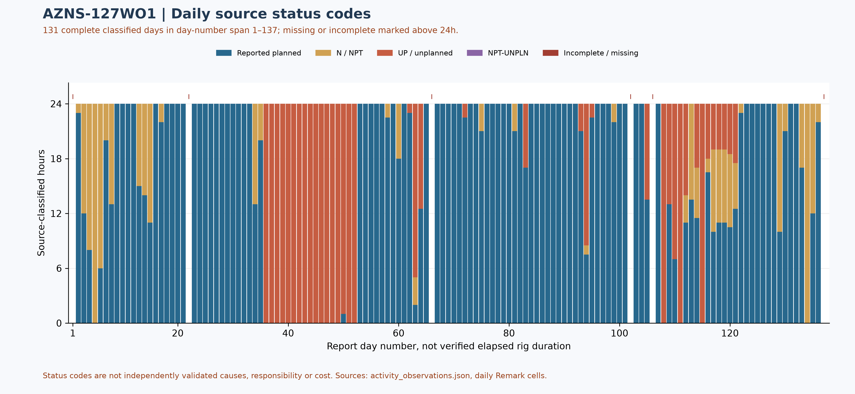
Figure W2 — Daily source-code composition in complete reports, with partial coverage

Performance and Parameter Analysis
Performance coverage: 131 status pages with classified durations totalling approximately 24 hours are used, out of 137 recognized status pages. Planned does not prove productive time; NPT, unplanned and mixed codes are distinct. Omitted hours are not zero; activity families, causes and total operation duration are not established by this table.
Source status code | Hours in complete reports | Share of classified hours
Reported planned | 2,240.50 | 71.3%
N / NPT | 276.00 | 8.8%
UP / unplanned | 627.50 | 20.0%
NPT-UNPLN (mixed) | 0.00 | 0.0%
Table 4-1 — Source status codes in recognized complete reports, not causal categories
Progress and phase-rate comparisons require reconciliation of scope, time and activity. Report-end depth is not tool depth or instantaneous rate.
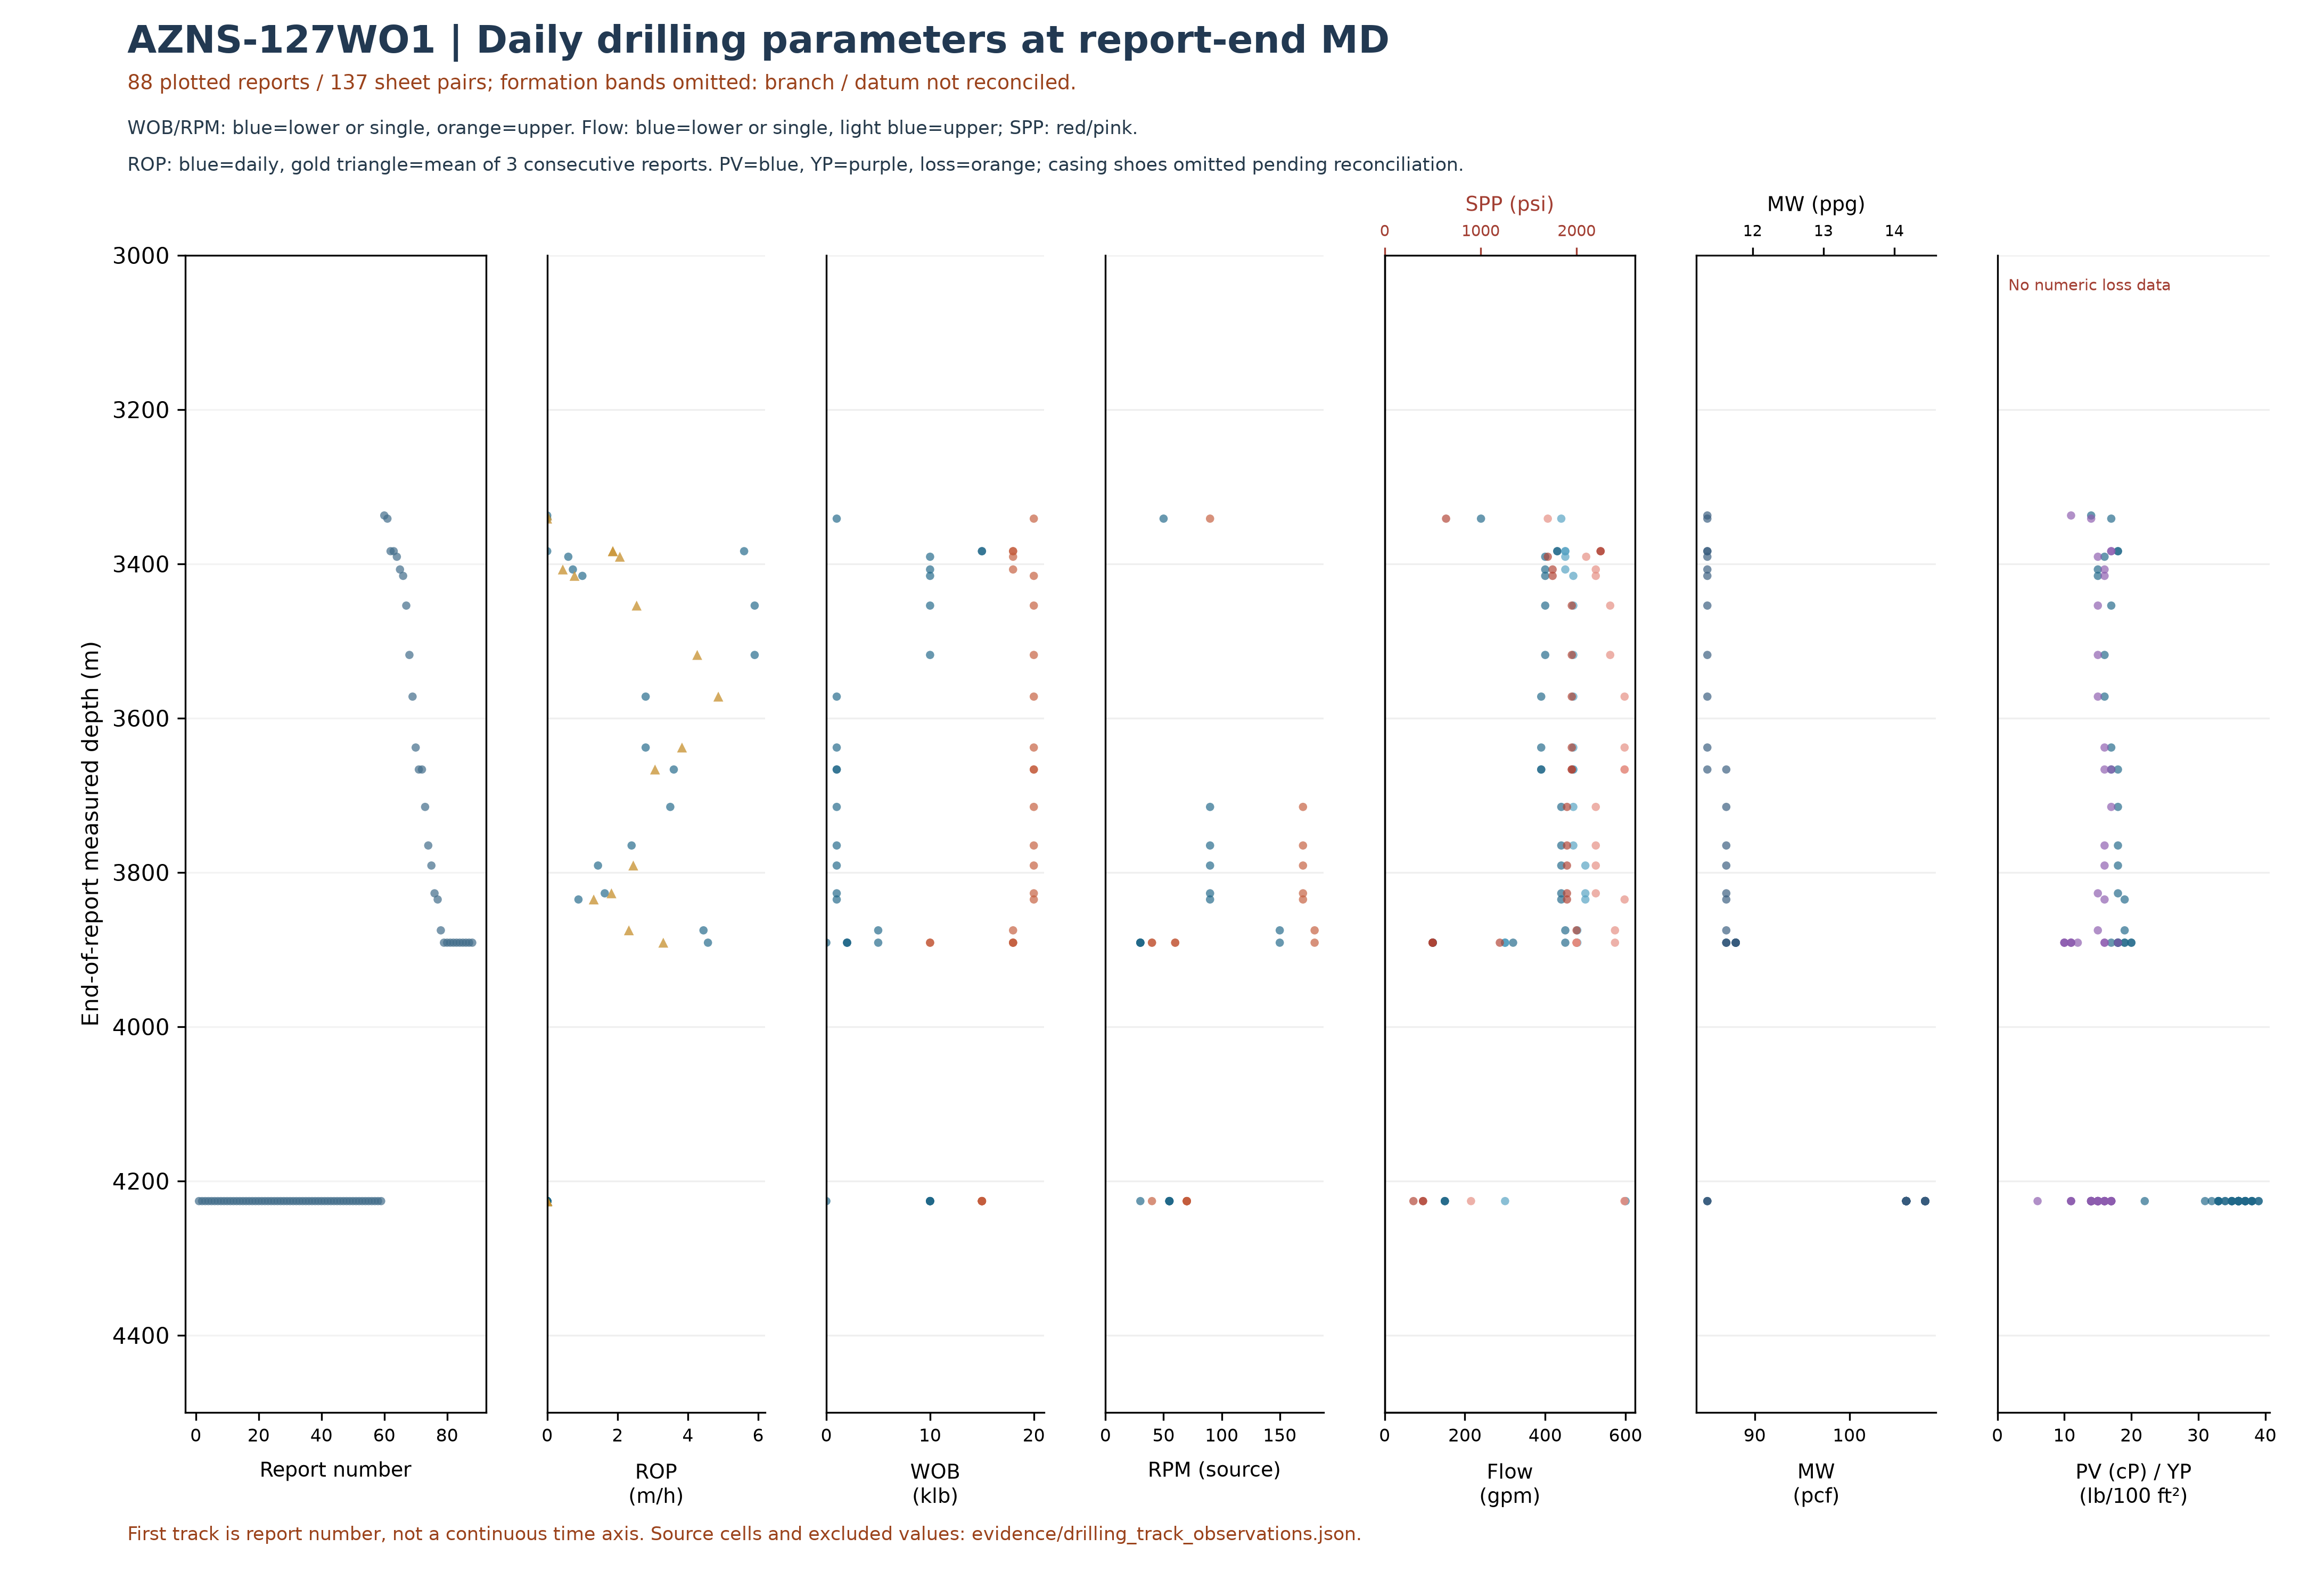
Figure W3 — Daily parameter samples at report-end depth; unverified formation bands omitted
W3 uses the data-linked extraction: its coverage and hours may be smaller than W2 and W4, which assess status pages independently of data sheets. Missing or unrecognized data sheets are not added as W3 observations.
Points are daily entries at report-end depth, not tool/event depth or a continuous log. The first track is report number, not a continuous time axis. Formation bands and shoes are omitted until branch, depth datum and configuration are reconciled. Minima and maxima are source observations, not an operating window; legacy RPM may include motor RPM. Triangles average three consecutive reports with ROP values.
Bit | Rerun | Type / size | Max cumulative m / source | Max cumulative h / source | Dull in sheet order
1 | Unknown | TCI Bit (HJT517GL); Tri Mill; 8-1/2"; 8-1/2"Tri Mill; CONFLICT | — | — | —
1 | 1 | TCI Bit (HJT517GL); VTD616DGX; 8-1/2"; 8-1/2"PDC Bit; CONFLICT | 554.2 [71-2 Data!K26] | 178 [71-2 Data!K28] | 1-2-BT-A-X-I-WT-BHA [71-2 Data!K33]
1 | 2 | VTD616DGX; 8-1/2"PDC Bit | 678.7 [75-2 Data!K26] | 231 [75-2 Data!K28] | 1-2-BT-A-X-I-WT-BHA [75-2 Data!K33]
2 | 3 | HJT517GL; VTD616DGX; 8-1/2"B. Bit; 8-1/2"PDC Bit; CONFLICT | 722.7 [77-2 Data!K26] | 262 [77-2 Data!K28] | 2-5-BT-N-X-1/32"-CT-PR [77-2 Data!K33]
3 | 2 | TCI Bit(HJT517GL); 8-1/2" | — | — | 1-1-WT-A-E-I-No-BHA [82-2 Data!K33]
5 | Unknown | MT Bit (HAT217G); 6-1/8" | — | — | 7-2-BT-(N,M)-E-I-ER-BHA. [86-2 Data!K33]
5 | 2 | MT Bit (HAT217G); 6-1/8" | — | — | —
Table 4-2 — Identified bit observations and cumulative-counter sources.
Unassigned tool observations — grouped only by identical text, not verified runs.
Unassigned raw ID | Reported size / type | Entries | First source
J.Mill#02 | 8-3/8" / M.M | 2 | 40-2 Data!K11,K12,K13
J.Mill#03 | 8-3/8" / M.M | 4 | 42-2 Data!K11,K12,K13
#04 R1 | 8-1/2"PDC Bit / M1665 | 3 | 77-2 Data!M11,M12,M13
Bit evidence is preliminary: source AZNS127WO1Pack.xlsx; 88 data sheets were recognized from 137 candidate sheet pairs. 9 tool-column entries lack an unambiguous numeric bit ID. A cumulative-counter maximum is not necessarily incremental run performance; bit-number reuse, rerun, metadata conflicts and dull reports require reconciliation. Workbook order does not prove chronology; the displayed dull observation is not necessarily final. Missing values are not zero.
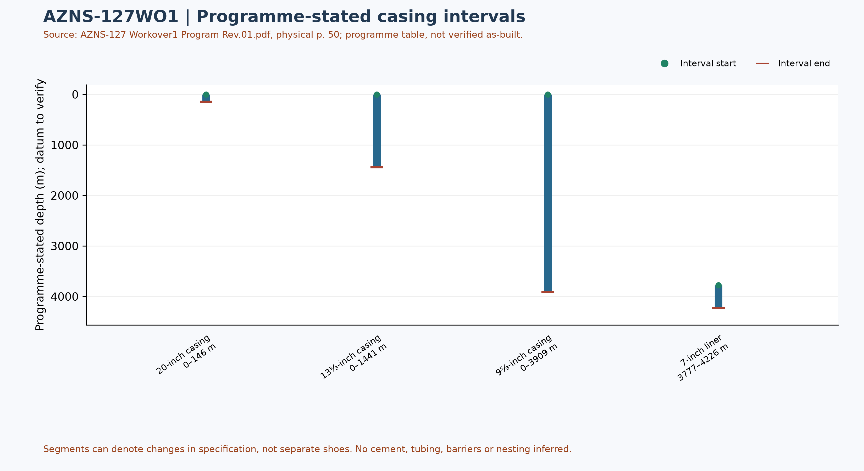
Figure W6 — Programme-stated casing intervals; not a verified as-built schematic

Drilling Fluid Engineering and Loss Accounting
This table summarizes numeric entries recovered from 88 recognized data sheets out of 137 candidate pairs. Each extreme has a source-cell example; coverage, simultaneity, units and test quality require verification. Minima and maxima are not a design window or current fluid condition.
Source observation | Numeric entries | Minimum and cell | Maximum and cell
Mud weight (pcf) | 87 | 85 [57-2 Data!R12] | 108 [39-2 Data!R12]
Plastic viscosity (cP) | 86 | 14 [57-2 Data!R18] | 39 [39-2 Data!R18]
Yield point (lb/100 ft²) | 86 | 6 [56-2 Data!R19] | 18 [81-2 Data!R19]
Source downhole loss (bbl) | 0 | No numeric entry recognized | No numeric entry recognized
Table 5-1 — Partial source-cell fluid and loss observations
A blank or nonnumeric entry is not zero. The source loss field is labelled downhole or formation loss volume; no sum or formation attribution is calculated until reporting basis, cumulative versus daily treatment and duplication are reconciled. Reconcile cell values with operational remarks and materials use separately.

Selected mud-material source entries
Table 5-2 selects source-used entries from two sheets of AZNS127WO1Pack.xlsx. Recognizable materials headers were found in 88 of 88 data sheets; this count does not validate completeness or correctness of inventory or usage. Used-column header cells and row units are retained in the evidence file.
Selected sheet | Material and cell | Used value and cell | Source unit and cell
2-2 Data | Caustic Soda [A41] | 3 [F41] | 25 kg [C41]
2-2 Data | Soda Ash (25 kg) [A42] | 3 [F42] | 25 kg [C42]
2-2 Data | Salt [A44] | 18 [F44] | 1 MT [C44]
3-2 Data | Soda Ash (25 kg) [A42] | 5 [F42] | 25 kg [C42]
3-2 Data | Salt [A44] | 20 [F44] | 1 MT [C44]
3-2 Data | Starch LV (Green) [A45] | 120 [F45] | 55 lbs [C45]
Table 5-2 — Selected mud-material used-column entries; units as printed
The used column is distinct from received, cumulative received and stock. Repeated material or values across sheets are not necessarily independent consumption; blanks and errors are not zero. Verify package size, unit abbreviation, reporting period, opening and closing balance, receipts, usage and mixing records before totals or conversion. These entries alone do not establish downhole use, treatment of losses or causality with fluid properties.

Completion, Casing and Service-Module Findings
Programme element | Interval start, m | Interval end, m | Source specification
20-inch casing | 0 | 146 | K-55, 94#, BTC
13⅜-inch casing | 0 | 1441 | N-80, 68#, BTC
9⅝-inch casing | 0 | 3909 | T-95, 53.5#, TSH Blue / TPCQ
7-inch liner | 3777 | 4226 | 110 S, 29#, TPCQ
Table 6-1 — Casing and liner intervals in AZNS-127 Workover1 Program Rev.01.pdf, physical p. 50
Programme casing scope: these values transcribe the programme table and describe historical or pre-operation conditions, not a verified final wellbore. Endpoints of specification segments are not necessarily shoes or hangers; datum, actual configuration, tally and barrier integrity require approved records. The programme gives the 20-inch casing depth as 146 m; the legacy table stated 155 m, requiring separate reconciliation.
The legacy directional survey statistics and trajectory have not been independently reconciled; W7 now shows bit/tool evidence, not a trajectory.
Personnel-on-board averages and peaks in the legacy report are withdrawn pending reconciliation of daily role-level counts, totals, missing entries and personnel scope.
The next figure displays only recognized bit and tool evidence; casing and cost evidence are presented in their respective sections. This is not a verified run count or continuous log.
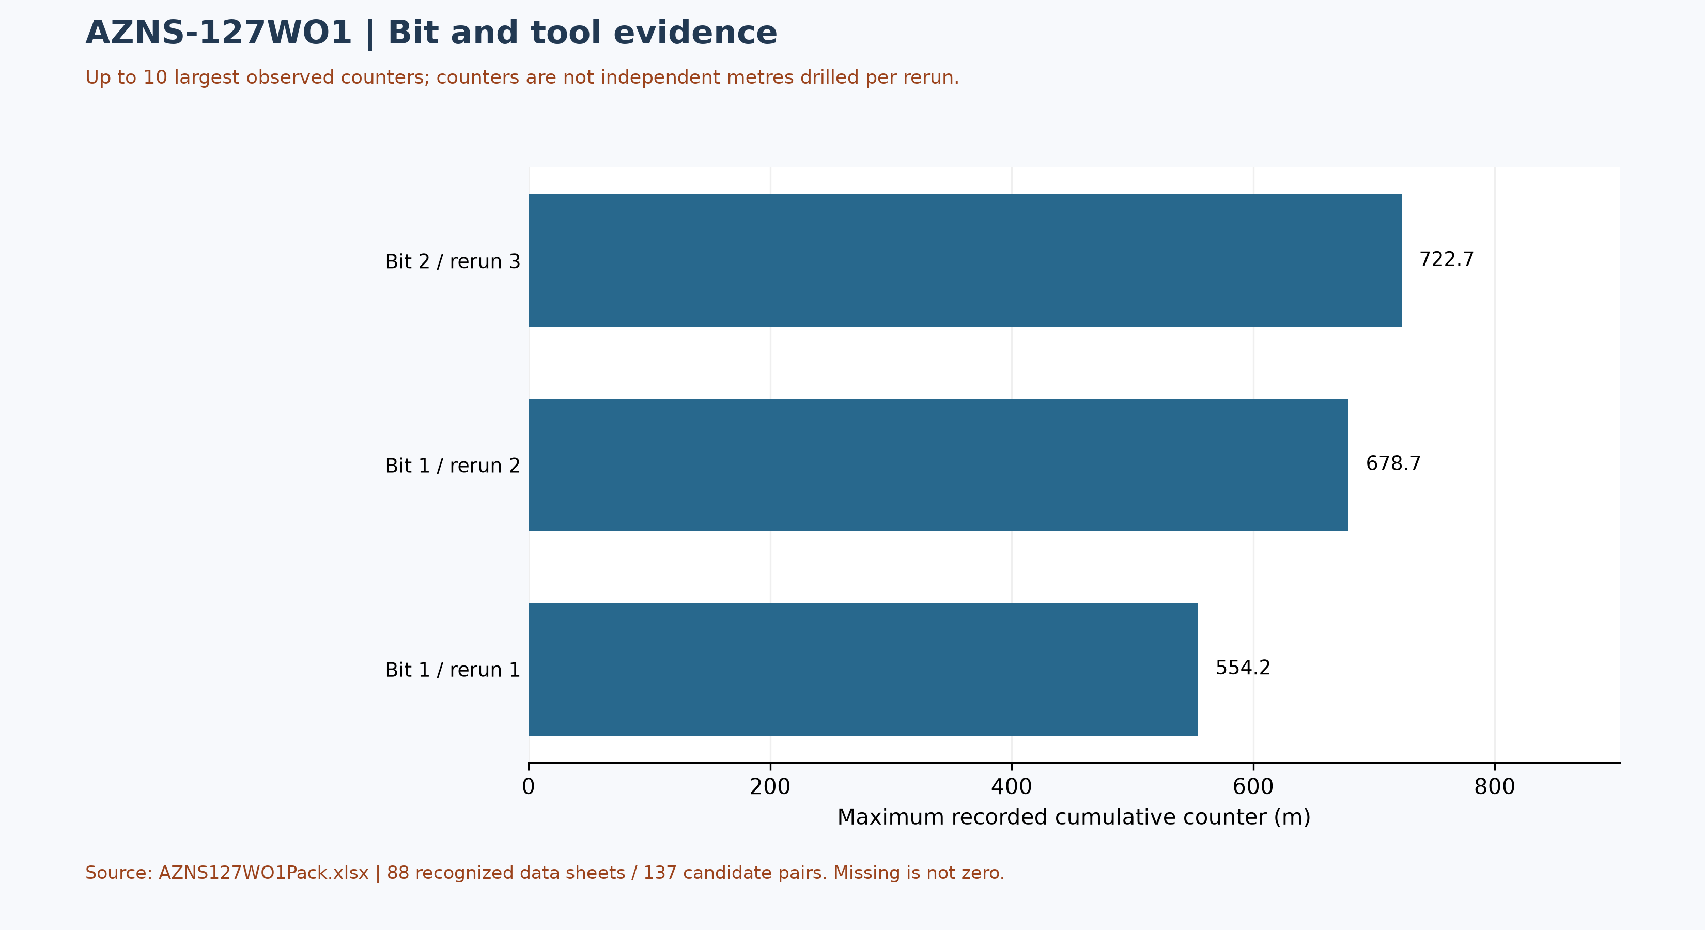
Figure W7 — Maximum source cumulative counters, not incremental run performance

Selected daily BHA components and hydraulic review
At least one nonempty recognized-format block was recovered in 66 of 88 data sheets. The table selects four rows from one block in AZNS127WO1Pack.xlsx, sheet 52-2 Data; it is not the entire string, all runs, or the current well condition. A repeated identifier or parallel columns do not establish the number of runs.
Selected component and cell | Recorded outside diameter and cell | Evidence scope
8-3/8" M.M J.Mill [I42] | 8-3/8" [K42] | Source observation
6-5/8" Junk Sub [I43] | 6-5/8" [K43] | Source observation
7" Junk Sub [I44] | 7" [K44] | Source observation
6-1/2" D.Pin [I45] | 6-1/2" [K45] | Source observation
Table 6-2 — Selected source block components and recorded dimensions
Physical programme page 62 is a navigation anchor for the planned BHA discussion; matching phase or agreement with this daily example is not established. Reconcile stated dimensions with the component name, count, length, inside diameter, connection limits, sequence, run record and manufacturer data. Hydraulic review requires verified inside and outside diameters and annular geometry for each section, simultaneous flow and fluid properties, nozzle and surface-loss information and pressure calibration. Without these inputs, pressure loss, annular velocity, hole cleaning and a reliable operating window cannot be calculated; W3 alone is not a design.

Source-coded non-planned time and partial coverage
Only 131 daily reports with classified durations totalling approximately 24 hours were included out of 137 candidate sheet pairs. These are source-code hours, not a verified total for the operation; incomplete or unrecognized days are not zero. Status pages are recognized independently of data pages; row-level cells are retained in evidence/activity_observations.json.
Table 7-1 — Source-code hours in complete reports; references are examples.
Source code | Hours in coverage | Example status and duration cells
N / NPT | 276.00 | 2-1 Remark!J37,H37 ; 3-1 Remark!J25,H25
UP / unplanned | 627.50 | 36-1 Remark!J22,H22 ; 36-1 Remark!J23,H23
NPT-UNPLN | 0.00 | None in included complete days
Activity codes alone do not establish root cause or contractual responsibility. Legacy mechanism claims, contractor attribution and financial exposure are withdrawn pending review of actual daily narrative, contracts and event evidence. Different source codes must not be presented as a single NPT definition.
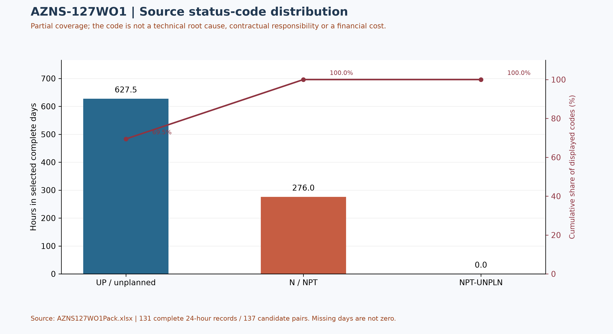
Figure W4 — Pareto of source status codes in complete days, not technical causes

CBS Financial Analysis and Provisional Cost Categories
Table 8-2 source: CBS AZNS-127 WO1.xlsx / Cost Breakdown-127. These cached source amounts are not actual expenditure or an approved comparable budget. Missing or erroneous values are not zeros; rates, scope, formulas and approvals require reconciliation. No daily expenditure series has been verified.
Source / scope | Cached value | Cell / sheet
Cached main-sheet total; scope unverified | 7,928,464.55 | F199 / Cost Breakdown-127
Table 8-1 Source financial and schedule anchors (unreconciled).
Source category | Source amount (USD) | Amount cell
Rig service | 2,479,354.17 | F5
Drilling fluids | 1,305,851.25 | F6
Cementing | 807,187.50 | F13
Mud logging | 125,127.41 | F20
Wireline logging | 444,972.50 | F24
Drilling waste management | 201,575.63 | F66
Directional drilling | 468,979.00 | F78
Casing running | 33,859.70 | F91
Temporary well suspension | 0.00 | F99
Slickline | 17,918.60 | F103
Completion running | 21,000.00 | F106
Liner hanger running | 10,920.00 | F118
H2S service | 66,382.71 | F127
Perforation | 225,098.80 | F130
Wellhead services | 12,600.00 | F135
Dry test services | 19,425.00 | F140
Rig / completion services | 207,146.04 | F143
Other services | 55,985.42 | F153
Cleanup services | 0.00 | F157
Drilling materials | 885,297.50 | F164
Project management | 447,883.33 | F175
Engineering | 81,900.00 | F178
Tubing inspection | 0.00 | F189
Wellhead / tree inspection | 5,000.00 | F197
Downhole completion inspection | 5,000.00 | F198
Table 8-2 CBS source categories and cell references (unreconciled).
Topic | Observation | Source reference | Action
Scope / actuals | Values are not actual invoices or an approved comparable ceiling. | Source sheet and formulas | Reconcile
Reference errors | Multiple cells contain reference errors; cached total is not reliable. | F30, F41, F199 | Repair / recalculate
Table 8-3 CBS reconciliation checks.
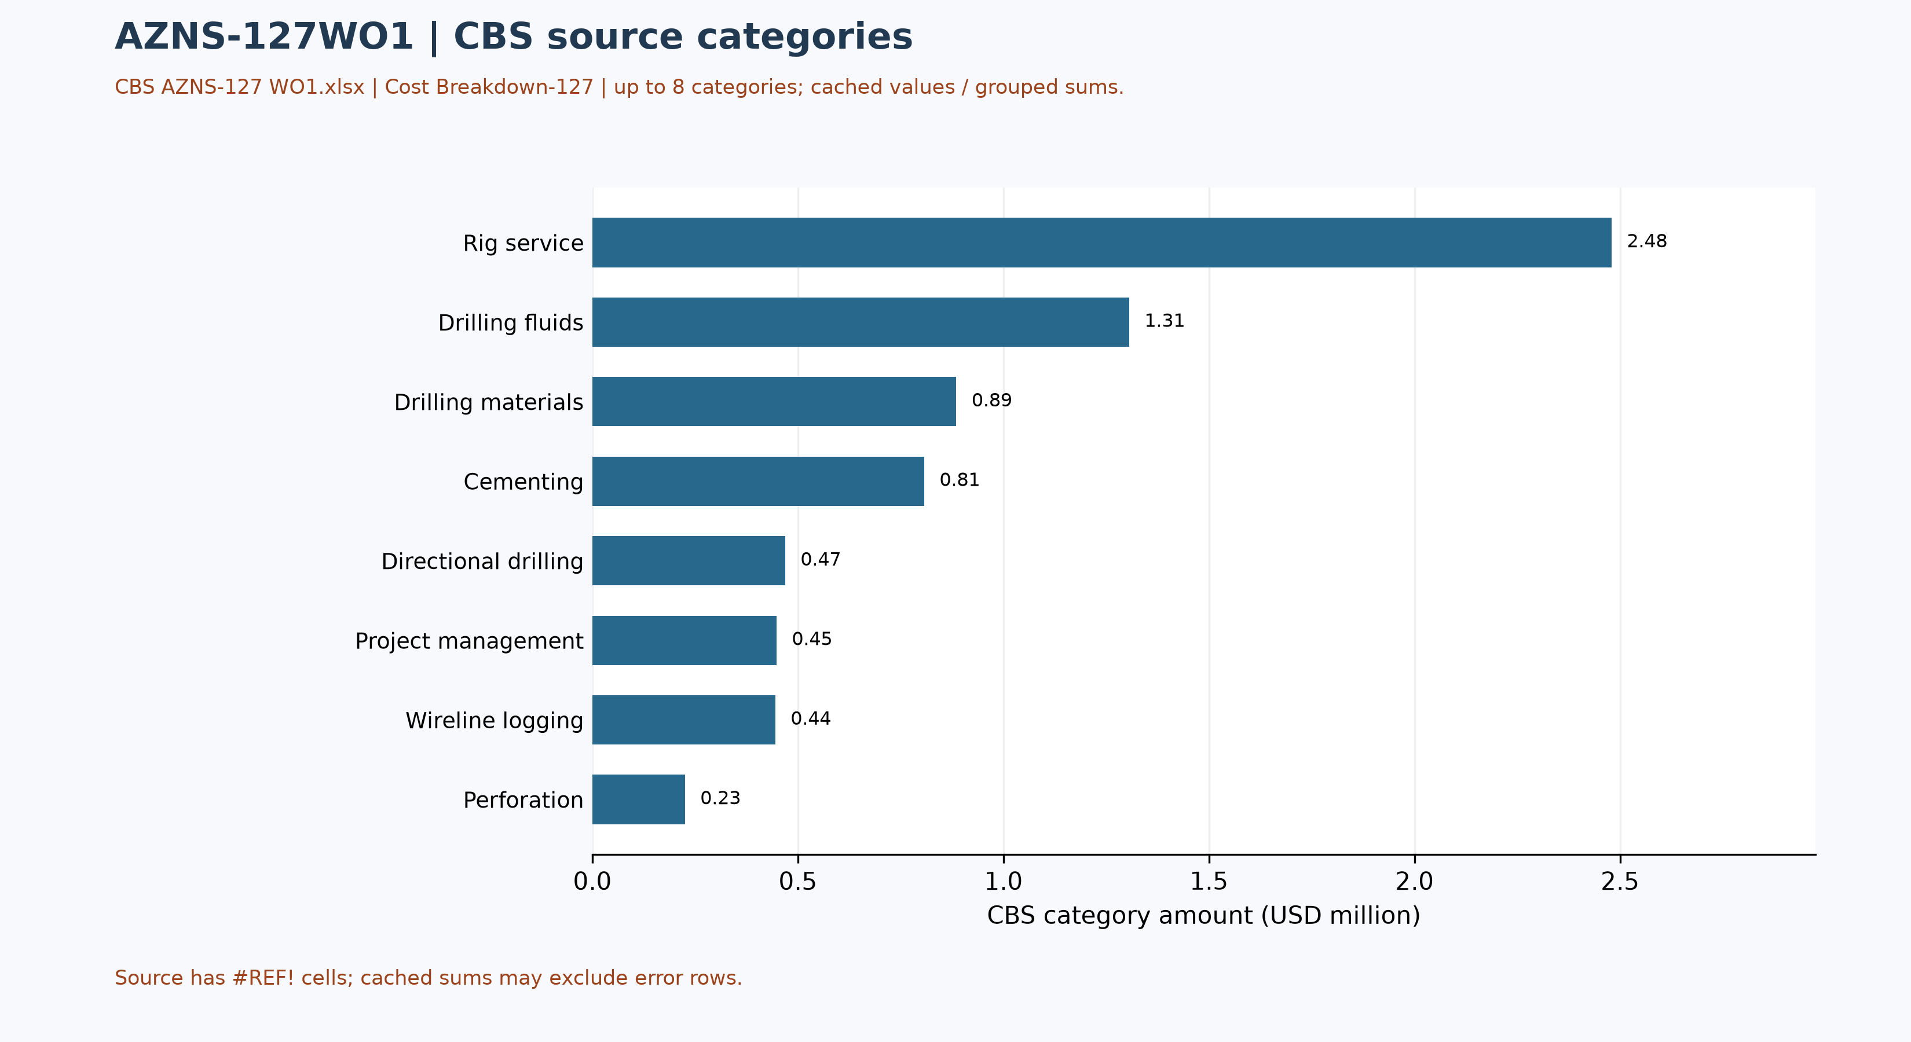
Figure W5 — CBS source cost categories, AZNS-127WO1 (unreconciled)

Selected CBS service-sheet checks
In CBS AZNS-127 WO1.xlsx, AZNS-127 WO (Side Tracking) !B2 and R2, the source labels a workover/side-tracking schedule and a cumulative duration with contingency. The formula at R23 contains a broken reference and its cached value is #REF!; subsequent cached errors occur in the same column. This schedule must not be used as a validated duration until repaired and reconciled with the separate programme.
The sheet name and workbook do not by themselves prove that the proposed side track was executed or establish a mapping to the distinct ST1 or ST2 programmes.

Operational observations and engineering decision gates
Previous numerical operating envelopes were not validated and have been withdrawn. The entries below are examples of raw daily records only; tool location, phase, units and measurement validity require review. These observations are not safe limits, optimum windows or operating instructions.
Table 9-1 — Example recorded cells; units and measurement basis require verification.
Raw field | Example recorded value | Sheet and cell
Mud weight | 106 | 2-2 Data!R12
Bit load / WOB | 10-15 | 40-2 Data!K18
RPM | 55-70 | 40-2 Data!K19
Flow | 150-300 | 56-2 Data!K23
Standpipe pressure | 300-900 | 56-2 Data!K24

Recommendations and review requirements
- Reconcile the programme revision, scope, start/end boundaries and rig/service time against daily reports and approved schedules before reporting a variance.
- Have responsible specialists verify well barriers and formation, casing and equipment limits against current approved records; no numerical design setpoint is established by this report.
- Reconcile bit identifiers, cumulative counters, tool assembly and failure evidence with original field and vendor records before selecting future equipment or diagnosing a mechanism.
- Reconcile costs with signed contracts, approved scope and invoices; do not convert source status-code hours into financial liability without a contractual assessment.

Risk-review checklist; ownership and severity not assigned
Review topic | Available evidence | Required follow-up
Well integrity and pressure | Programme objective and stated background, not proof of current condition | Reconcile tests, barriers and current approved limits
Incidents and recorded time | Partial source-code coverage in table 7-1 | Review event narrative, duration, cause and contract without presumed attribution
Equipment and operations | Example cells in table 9-1 and tool observations in table 4-2 | Verify units, calibration, tool identity and vendor records
Schedule and cost | Programme page and cost-breakdown evidence | Reconcile scope, invoices, time basis and approved revision

Data Provenance and Cell-Level Traceability
The table lists selected source anchors only. Other entries and interpretations still require independent cell/page checks, unit and scope review; the current report is not fully reconciled or reproducible without engineering interpretation.
Data element | Archive anchor (file -> sheet!cell)
well_name | 1-1 Remark!C5
client | 1-1 Remark!H5
rig | 1-1 Remark!C6
field | 1-1 Remark!C7
hole_section | 1-1 Remark!C8
well_type | 1-1 Remark!C9
report_date | 1-1 Remark!N5
spud_date | 1-1 Remark!N6
est_days | 1-1 Remark!N8
act_days | 1-1 Remark!N9
depth:project_md | 1-2 Data!D15
depth:morning_depth | 1-2 Data!D16
depth:midnight_depth | 1-2 Data!D17
depth:prev_depth | 1-2 Data!D18
CBS cost breakdown | CBS AZNS-127WO1 and 116.xlsx -> sheet "Cost Breakdown-127"
Well programme | AZNS-127 Workover1 Program Rev.01.pdf
Table 11-1 Provenance anchors.

Appendix: source formation-table snapshot (unverified)
Source: AZNS127WO1Pack.xlsx, sheet 88-2 Data. Selected as the last sheet in workbook order with a recognized formation table containing a numeric depth; if none, the last table with formation names. This is not necessarily the latest dated report.
Column roles follow the source labels, not independent confirmation of prognosis or measurement. Unlabelled populated cells are shown separately; missing cells are unknown, not zero. Values are rounded to four decimals for display. Verify row alignment, depth datum, possible inconsistencies and lithology against the programme and geological report; this table alone does not establish event attribution or operating instructions.
Source table and anchor: Formation Geology Data / N109
Formation / cell | Source values / cell
Aghajari / K111 | Forc. MD (m.): Surface [L111]  Forc. TVD (m.): Surface [M111]
Gachsaran / K112 | Forc. MD (m.): 1105 [L112]  Forc. TVD (m.): 1105 [M112]  Act. MD (m.): 1105 [O112]  Act. TVD (m.): 1105 [Q112]
Asmari / K113 | Forc. MD (m.): 1451 [L113]  Forc. TVD (m.): 1451 [M113]  Act. MD (m.): 1451 [O113]  Act. TVD (m.): 1451 [Q113]
Pabdeh / K114 | Forc. MD (m.): 1724 [L114]  Forc. TVD (m.): 1724 [M114]  Act. MD (m.): 1724 [O114]  Act. TVD (m.): 1724 [Q114]
Gurpi / K115 | Forc. MD (m.): 2189 [L115]  Forc. TVD (m.): 2189 [M115]  Act. MD (m.): 2189 [O115]  Act. TVD (m.): 2189 [Q115]
Ilam / K116 | Forc. MD (m.): 2519 [L116]  Forc. TVD (m.): 2519 [M116]  Act. MD (m.): 2519 [O116]  Act. TVD (m.): 2519 [Q116]
Laffan / K117 | Forc. MD (m.): 2617 [L117]  Forc. TVD (m.): 2617 [M117]  Act. MD (m.): 2617 [O117]  Act. TVD (m.): 2617 [Q117]
Sarvak / K118 | Forc. MD (m.): 2627 [L118]  Forc. TVD (m.): 2627 [M118]  Act. MD (m.): 2627 [O118]  Act. TVD (m.): 2627 [Q118]
Kazhdumi / K119 | Forc. MD (m.): 3273 [L119]  Forc. TVD (m.): 3273 [M119]  Act. MD (m.): 3273 [O119]  Act. TVD (m.): 3273 [Q119]
Dariyan / K120 | Forc. MD (m.): 3476 [L120]  Forc. TVD (m.): 3476 [M120]  Act. MD (m.): 3479 [O120]
Gadvan / K121 | Forc. MD (m.): 3647 [L121]  Forc. TVD (m.): 3647 [M121]  Act. MD (m.): 3652 [O121]
Fahliyan / K122 | Forc. MD (m.): 3934 [L122]  Forc. TVD (m.): 3934 [M122]

Selected tops from the programme schematic or image
Source: AZNS-127 Workover1 Program Rev.01.pdf, physical page 51. These values were transcribed from a schematic labelled before the workover, not independently confirmed current tops or as-built status. Names and depths were visually paired; event attribution requires reconciliation of the event depth, branch and datum.
Formation / member | Source depth, m MD
Gachsaran | 1105
Pabdeh | 1740.68
U. Gurpi | 2182.49
Tarbur | 2310.38
L. Gurpi | 2390.33
Laffan | 2618.34
Sarvak | 2624.7
Kazhdumi | 3273.82
Dariyan | 3478.62
Gadvan | 3650.57
Fahliyan | 3937.73
Table — Selected formation tops as printed in the source schematic or image; see text for well and stage
The ST2 programme p.25 reproduces original-well tops with separate forecast, sample and log columns; the same source image occurs in the ST1 programme p.62. For Gachsaran these columns are 1,107, 1,105 and 1,084 m, respectively. The workover schematics show 1,105 m; this must not be silently identified as the log value. WO1 p.51 and WO2 p.38 also show different Dariyan (3,478.62 / 3,479.14 m), Gadvan (3,650.57 / 3,667 m) and Fahliyan (3,937.73 / 3,938.87 m) entries. These are source differences, not automatically geological movement or a validated sidetrack correlation.

Programme source summary and comparison limitations
Source: AZNS-127 Workover1 Program Rev.01.pdf, physical page 7. Programme objective: Remove and rerun completion, identify and remedy the annulus leak, and check/smooth the stated 3,889–3,911 m collapse interval. Stated programme duration, in days: 60.4 main; 58.9 contingency. The programme states measured depth 4226 m and producer/reservoir formation Fahliyan; these do not by themselves establish achieved depth or current condition. Time boundaries, scope and contingency interpretation require reconciliation.

