ENGINEERING REVIEW WARNING — This legacy report is not validated for operational or financial decisions. The former linear cumulative-cost chart was removed; a verified daily cost series is not yet available; other charts, budgets and cause/formation attribution require reconstruction and reconciliation to source records. See the repository review note for the limited corrections made.
AZNS-116
Drilling, Workover and Well-Intervention Engineering Report
Technical, Operational, Contractual and Financial Analysis
Interim source review for South Azadegan; engineering approval pending

Item | Value
Well / operation | 116
Daily-report pack | AZNS116Pack.xlsx
Cost workbook | CBS AZNS-127WO1 and 116.xlsx
Well programme | AZNS-116 Workover Program Rev.04.pdf
Status | Interim draft; source reconciliation and engineering approval required

Document control | Status
Official document code | Not established
Revision / status | Interim draft; not issued or approved
Official issue date | Not established
Preparation | Automated analytical draft
Specialist review | Completion and approval not established
Approval and distribution | Not established
Table 0-1 — Document control and review status.
This interim report compiles available records; its legacy analyses are not independently validated.

Executive KPI Summary
KPI | Value and scope
Programme-stated duration | 89 main; 45.2 contingency [physical p.7]
Recognized status pages | 111
Status pages with approximately 24 h classified | 55
Recognized data pages | 112
Numeric downhole-loss entries | 0
Maximum single source loss entry, bbl | No numeric entry recognized
Actual duration, total loss and actual cost | Not reconciled; not inferred from these observations

Legacy duration and NPT figures in this report remain subject to source reconciliation. Actual expenditure is not established.

Contents
No. | Section
1 | Well Identity, Rig Assignment and Data Inventory
2 | Planned versus Actual Execution Reconciliation
3 | Selected daily-report observations
4 | Performance and Parameter Analysis
5 | Drilling Fluid Engineering and Loss Accounting
6 | Completion, Casing and Service-Module Findings
7 | Source-coded non-planned time and partial coverage
8 | CBS Financial Analysis and Provisional Cost Categories
9 | Operational observations and engineering decision gates
10 | Risk-review checklist; ownership and severity not assigned
11 | Data Provenance and Cell-Level Traceability
12 | Appendix: source formation-table snapshot (unverified)
13 | Programme source summary and comparison limitations

Figures and tables are numbered by section and are listed in place.

Well Identity, Rig Assignment and Data Inventory
This interim report references AZNS116Pack.xlsx and AZNS-116 Workover Program Rev.04.pdf. The archive was indexed, but semantic extraction and verification remain incomplete; see the evidence notes and source inventory. Static identity and rig assignments below are legacy-compiled and require verification against cited source cells and approved records.

Static identity
Field | Recorded value
Well name in daily report | AZNS-116, PAD-81
Well type declaration | Workover - Vertical - IIIF 116
Field | South Azadegan
Client | PPL/PEDEC
Drilling contractor | OEOC
Rig | 201 OEOC
Operation classification | Workover / Completion
Hole section / scope declaration | De-Complete, Re-Complete Operation
Spud / first report date | 2024-08-06
Release / last report date | 2024-11-25
Table 1-1 Static well identity.

Data inventory discovered for this operation
Source / extraction | Recognition and limitation
Daily pack | AZNS116Pack.xlsx
Status pages | 111 recognized; 55 with approximately 24 classified hours
Data pages | 112 of 112 candidate pairs
CBS workbook | CBS AZNS-127WO1 and 116.xlsx; cached values and scope require reconciliation
Programme PDF | AZNS-116 Workover Program Rev.04.pdf; information page 7
Limitation | Recognition or absence in an extraction does not establish complete archive coverage
Table 1-2 Core and auto-discovered bonus modules.
The legacy module inventory requires review; absence from an extraction does not establish absence from the entire archive.

Planned versus Actual Execution Reconciliation
The programme AZNS-116 Workover Program Rev.04.pdf, physical page 7, states the following objective: After unsuccessful fishing described in the programme, remove completion, perforate new intervals, change the completion string and recomplete. The stated duration in days is 89 main; 45.2 contingency. Contingency figures retain the source labels and should not be added or compared with execution without reconciliation.
Reconciliation metric | Planned | Actual | Variance
Programme-stated duration (days) | 89 main; 45.2 contingency | Not reconciled | Not reconciled
Depth reached / target (m MD) | Not reconciled | Not reconciled | Not reconciled
Cost (USD) | Not reconciled | Not reconciled | Not reconciled
Cost per rig day (USD) | Not reconciled | Not reconciled | Not reconciled
NPT share of rig time (%) | Not reconciled | Not reconciled | Not reconciled
Table 2-1 Planned versus actual reconciliation.
A planned-versus-actual duration comparison is not established until revision, scope, daily reports and time boundaries are reconciled; the previous ratio and causal attribution are withdrawn.
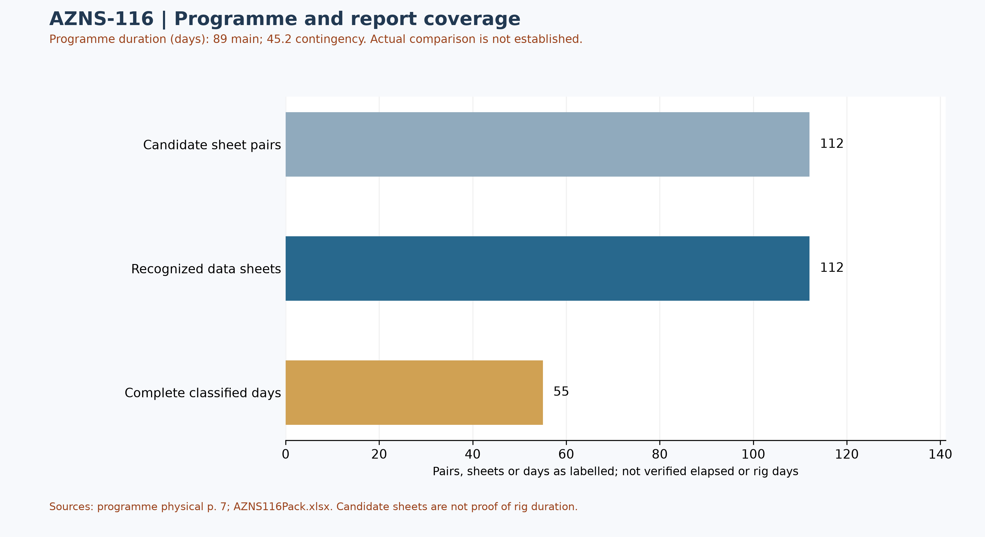
Figure W1 — Daily-record coverage and stated programme duration; actual comparison unverified
Status-page coverage is assessed independently: 111 status pages and 112 data sheets were recognized; 55 status pages contain classified durations totalling approximately 24 hours. Some reports have a status page but an absent or differently formatted data page. These counts are not verified rig duration.

Selected programme phases and limited execution evidence
The phases below are selected programme statements, not proof of execution or of the final approved revision. The selected daily observations are quoted separately; a similar topic alone does not establish phase timing, completion or deviation.
Programme — The plan describes milling a coiled-tubing fish and permanent packer, followed by a fishing attempt. [AZNS-116 Workover Program Rev.04.pdf, physical p. 46]
Programme — The programme identifies low-clearance metal-to-metal sticking risk during clean-out inside the 4½-inch liner. [AZNS-116 Workover Program Rev.04.pdf, physical p. 46]
Source worksheet 2 — The report records continuing work on leakage at the BX-152 ring gasket and says the gasket was changed with an OK result. [AZNS116Pack.xlsx, 2-1 Remark!K22]
Source worksheet 98 — The report describes continuing milling and smoothing in the 3,947–3,969 m interval, with no loss or gain reported. [AZNS116Pack.xlsx, 98-1 Remark!K22]
Services listed in the programme: drilling and completion fluids: VIRA; waste management: Pars Hafaran Arvand; electrical logging and perforation: SEALAND; mud logging: MAPSA KISH. [AZNS-116 Workover Program Rev.04.pdf, physical p. 42] These are programme assignments, not evidence of actual deployment, contractual award, cost or incident liability.

Worksheet-prefix and report-header reconciliation
Of 111 recognized status pages, the reported header number differs from the worksheet-name prefix on 107 pages; 0 headers have no readable numeric value. Axes based on worksheet prefix are not official report numbers or chronologies. Reconcile each entry's number, date and time with the header and signed records. Cell-level details are in evidence/sheet_report_number_audit.json.
In 101-1 Remark, S5/N5 show report 107 dated 21 September 2024; sheets 102-1 and 103-1 show reports 117 and 118 dated 1 and 2 October, while sheets 104-1 to 112-1 carry reports 108–116. Thus late workbook sheet order is not chronological. The first-sheet spud note 1-1 Remark!K22 states 8 June 2024, whereas the 103-1 Remark!N6 header states 7 June; reconcile the basis with signed records.

Status-page header-date audit
Of 111 recognized status pages, 111 header dates were readable under narrow rules; 0 remain uninterpreted because of ambiguous format, missing data or volatile formula. Among adjacent recognized worksheets with readable dates in prefix order, 1 go backwards and 3 repeat a date. These counts alone do not prove an error, operating days or true sequence. Volatile date formulas occur on 0 pages. Even readable Excel dates can be wrong in the source or locale; reconcile against signed records. [evidence/status_report_date_audit.json]

Selected daily-report observations
Of 111 recognized status pages, 55 contain classified durations totalling approximately 24 hours. Planned, NPT and unplanned labels are source classifications; they do not independently establish cause, liability or total operation duration. The following examples are selective; complete extracted detail cells are retained in evidence/activity_observations.json.
Source worksheet 2 — The report records continuing work on leakage at the BX-152 ring gasket and says the gasket was changed with an OK result. [AZNS116Pack.xlsx, 2-1 Remark!K22]
Source worksheet 98 — The report describes continuing milling and smoothing in the 3,947–3,969 m interval, with no loss or gain reported. [AZNS116Pack.xlsx, 98-1 Remark!K22]
These are source statements, not independent verification of a test, failure mechanism, current well condition or an operating instruction. A description may continue into the next cell; reconcile the complete row and time before making decisions.

Additional selected daily-report evidence
These three entries are ordered by worksheet prefix, not necessarily report number; sheet order alone does not establish event time, complete chronology, operational completion or current well condition. Test outcomes are source labels and require reconciliation with signed charts and the tested scope.
Source worksheet 33 — The cell describes pushing the fish from 3,846.1 to 3,876.1 m and resuming milling; it does not independently prove the fish was recovered. [AZNS116Pack.xlsx, 33-1 Remark!K24]
Source worksheet 51 — The report states that the fish was caught, worked on and released while pulling out; reconcile the surrounding entries before establishing the final outcome. [AZNS116Pack.xlsx, 51-1 Remark!K24]
Source worksheet 91 — The report records a pressure test of the 7-inch shooting nipple and wireline blowout preventer at 1,200 psi for 15 minutes, result “OK”. [AZNS116Pack.xlsx, 91-1 Remark!K23]
Fish movements do not establish final recovery. Review the fishing tally, full sequence, test record and approved barrier diagram before drawing an operational conclusion.
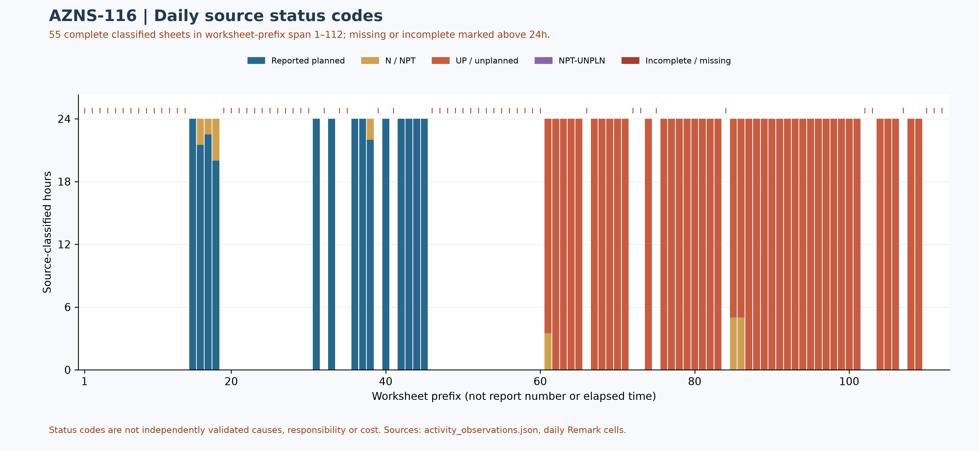
Figure W2 — Daily source-code composition in complete reports, with partial coverage

Selected AZNS-116 workover campaign reconstruction
These 16 selected entries are ordered by the source header report number, not worksheet prefix; order and dates still require reconciliation against signed records. This is not a complete hour-by-hour reconstruction or evidence of current barriers.
Worksheet 1, header report 1 — The first page records rig spud on 8 June 2024 at 18:00 and repeated unsuccessful testing while leakage was observed at a BX-152 annulus flange ring gasket. The subsequent report and signed pressure records are needed before establishing final test scope or cause. [AZNS116Pack.xlsx, 1-1 Remark!K22, K23, K24]
Worksheet 2, header report 2 — The second page reports repeated gasket replacement with a source-labelled OK result, an annulus pressure of 2,400 psi reduced to zero and later pressure increase; subsequent tubing and annulus observations are separately recorded. These are reported snapshots, not proof of a current barrier or leakage path. [AZNS116Pack.xlsx, 2-1 Remark!K22, K23, K24, K27, K28]
Worksheet 8, header report 9 — The page records pulling 4½-inch tubing and describes corrosion-damaged couplings, difficult breakouts and a coiled and cut control line. The extent and mechanism require the recovered-item tally and inspection; the entry is not a quantified corrosion assessment. [AZNS116Pack.xlsx, 8-1 Remark!K22, K23, K27, K28, K29, K30]
Worksheet 14, header report 18 — The source reports 4 lb of debris recovered in junk subs after an 8⅜-inch milling assembly, then a fishing BHA run. It separately records 1 hour labelled NPT and a hoisting-system failure entry written as 3/5 hours; the latter notation and classification must be reconciled rather than converted silently. [AZNS116Pack.xlsx, 14-1 Remark!K22, K23, K24, K25, K26, K29, K30]
Worksheet 27, header report 31 — The page records a liner-lap reference at 3,802.7 m and a client-confirmed top-of-fish reference at 3,831 m during a milling assembly run. It also records 2 hours waiting attributed in the source to delayed pulling. The stated references and attribution are not independent confirmation of geometry or contractual responsibility. [AZNS116Pack.xlsx, 27-1 Remark!K22, K23, K24, K25, K26]
Worksheet 33, header report 37 — The page describes milling to 3,846.1 m, pushing the fish to 3,876.1 m and resuming milling with no progress reported. The parameters are historical source observations, not a recommended operating window; no complete recovery is established here. [AZNS116Pack.xlsx, 33-1 Remark!K22, K23, K24, K25, K26]
Worksheet 40, header report 45 — After a taper-tap attempt near the stated 3,926.5 m top of fish, the source says no fish part was recovered and approximately 12 cm of taper tap broke and remained in the well. It also records BOP tests separately; the exact status of all downhole objects needs the final fish tally. [AZNS116Pack.xlsx, 40-1 Remark!K22, K23, K24, K25, K26, K27, K28, K29, K30]
Worksheet 51, header report 56 — The page describes catching the fish, releasing it while pulling and repeated recatching before a decision to pull the string. This selected entry does not establish final recovery; it must be read with later source pages and the final tally. [AZNS116Pack.xlsx, 51-1 Remark!K22, K23, K24, K25, K26]
Worksheet 57, header report 62 — The source records a confirmed top-of-fish reference at 3,939.3 m, a 30 bbl high-viscosity pill and an overshot attempt described as unsuccessful. The depth is a reported operational reference, not a verified final fish position. [AZNS116Pack.xlsx, 57-1 Remark!K22, K26, K27, K28, K29, K30]
Worksheet 62, header report 67 — The page reports clean-out to 3,951.75 m and records a note that operations were off plan after an obstruction was observed. This is the source's stated account; the obstruction's cause, approved scope change and contractual consequences are not resolved by the note. [AZNS116Pack.xlsx, 62-1 Remark!K22, K23, K24, K25, K35, K36, K37, K38]
Worksheet 68, header report 73 — The page records CBIL-CDR-GR-CCL runs over reported 7-inch liner and 9⅝-inch casing intervals. It describes acquisition and witness presence; it does not provide a validated cement-bond interpretation or establish isolation. [AZNS116Pack.xlsx, 68-1 Remark!K22, K23, K24, K25, K26, K27, K28, K29, K30, K31, K32, K33]
Worksheet 82, header report 87 — The source describes polishing the PBR entry profile at 3,967.84 m and reports the retrieved mill ⅛ inch under gauge, without an observed ring mark. Its waiting entries attribute 21 hours to nonreceipt of liner and 3 hours to drawworks; they are source labels, not independently established liability. [AZNS116Pack.xlsx, 82-1 Remark!K22, K23, K24, K25, K26, K32, K33, K40, K41]
Worksheet 91, header report 96 — The page records a 1,200 psi, 15-minute shooting-nipple and wireline BOP test labelled OK, followed by reported perforating over 3,979–3,975 m and source observations of successful gun firing. The excerpt does not establish interval productivity or present well integrity. [AZNS116Pack.xlsx, 91-1 Remark!K22, K23, K24, K25, K27, K28, K29, K30]
Worksheet 98, header report 103 — The page describes milling and smoothing from 3,947 to 3,969 m, followed by source-labelled static flow check and the start of a 4½-inch liner tie-back assembly. Equipment acceptance, final setting and isolation need the complete tally and signed tests. [AZNS116Pack.xlsx, 98-1 Remark!K22, K23, K24, K28, K29, K30, K31, K32, K33]
Worksheet 102, header report 117 — The page records several seal, control-line and tree pressure tests with source-labelled OK results, and a stop described in the source as force majeure due to strong wind. This description does not itself determine contractual force majeure, test acceptance or current integrity. [AZNS116Pack.xlsx, 102-1 Remark!K22, K23, K24, K25, K26, K27, K28]
Worksheet 103, header report 118 — The page reports retrieval of plug and protection sleeve, setting a back-pressure valve and rig release at 06:00 on 2 October 2024. A conflicting start-date header is documented separately; no definitive campaign duration or current barrier condition is inferred. [AZNS116Pack.xlsx, 103-1 Remark!K22, K23, K24, K25, K26]
Programme p.7 lists 89 main-plan days and 45.2 contingency days. These are planned values, not independently verified actual duration; the start-date conflict and programme scope and boundaries must be reconciled before calculating a variance. [AZNS-116 Workover Program Rev.04.pdf, p.7]

Performance and Parameter Analysis
Performance coverage: 55 status pages with classified durations totalling approximately 24 hours are used, out of 111 recognized status pages. Planned does not prove productive time; NPT, unplanned and mixed codes are distinct. Omitted hours are not zero; activity families, causes and total operation duration are not established by this table.
Source status code | Hours in complete reports | Share of classified hours
Reported planned | 326.00 | 24.7%
N / NPT | 23.50 | 1.8%
UP / unplanned | 970.50 | 73.5%
NPT-UNPLN (mixed) | 0.00 | 0.0%
Table 4-1 — Source status codes in recognized complete reports, not causal categories
Progress and phase-rate comparisons require reconciliation of scope, time and activity. Report-end depth is not tool depth or instantaneous rate.
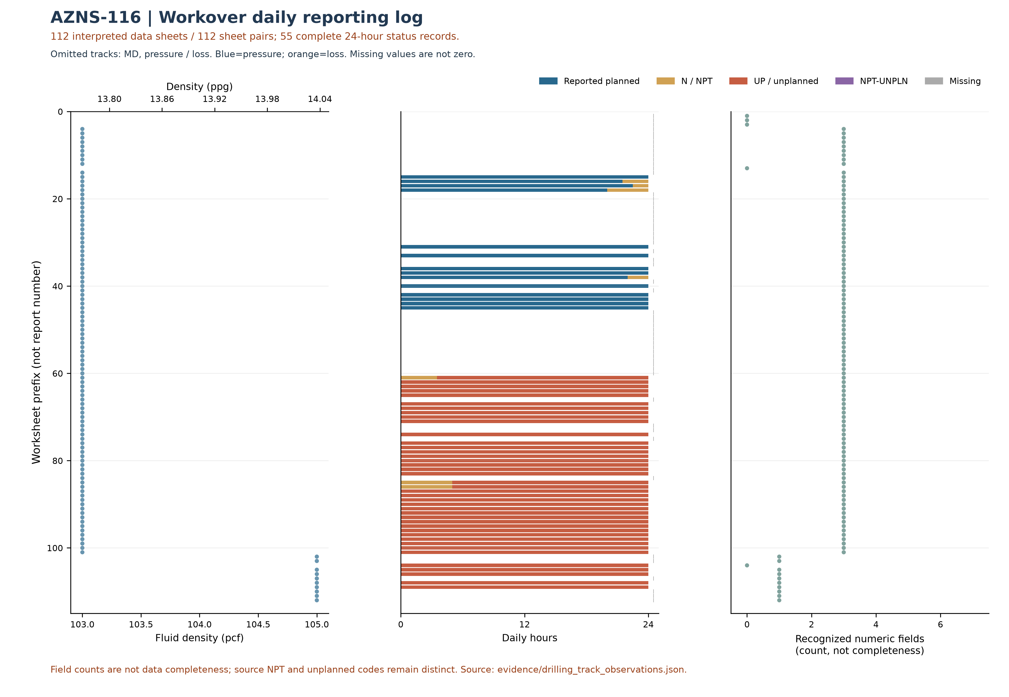
Figure W3 — Workover source observations by worksheet prefix, AZNS-116
W3 uses the data-linked extraction: its coverage and hours may be smaller than W2 and W4, which assess status pages independently of data sheets. Missing or unrecognized data sheets are not added as W3 observations.
This plot uses 112 recognized data sheets and 55 pages with classified durations totaling approximately 24 hours. Its axis is worksheet prefix, not report number or continuous time; for some workbooks sheet order is not chronological. Numeric-field counts are not data completeness. NPT and unplanned codes remain distinct; missing is not zero and report-end depth is not necessarily tool or event depth.
Bit | Rerun | Type / size | Max cumulative m / source | Max cumulative h / source | Dull in sheet order
— | — | No numeric bit ID recognized | — | — | —
Table 4-2 — Identified bit observations and cumulative-counter sources.
Bit evidence is preliminary: source AZNS116Pack.xlsx; 111 data sheets were recognized from 112 candidate sheet pairs. 0 tool-column entries lack an unambiguous numeric bit ID. A cumulative-counter maximum is not necessarily incremental run performance; bit-number reuse, rerun, metadata conflicts and dull reports require reconciliation. Workbook order does not prove chronology; the displayed dull observation is not necessarily final. Missing values are not zero.
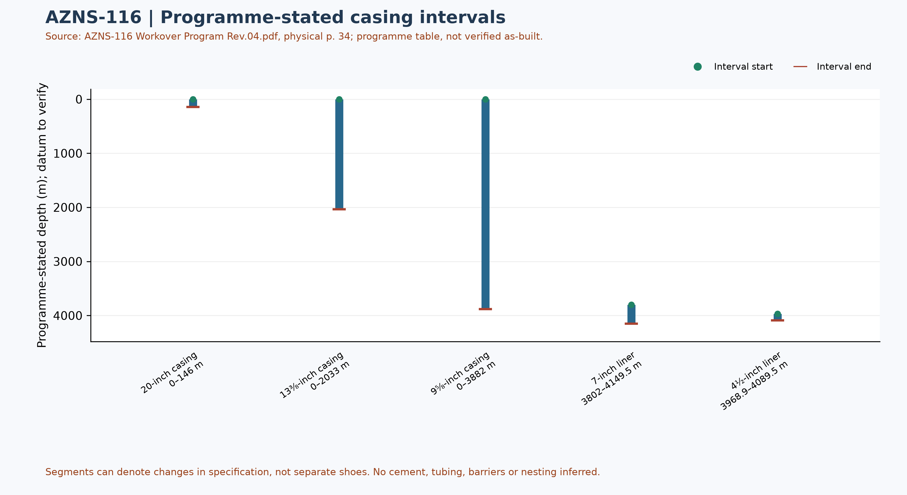
Figure W6 — Programme-stated casing intervals; not a verified as-built schematic

Drilling Fluid Engineering and Loss Accounting
This table summarizes numeric entries recovered from 112 recognized data sheets out of 112 candidate pairs. Each extreme has a source-cell example; coverage, simultaneity, units and test quality require verification. Minima and maxima are not a design window or current fluid condition.
Source observation | Numeric entries | Minimum and cell | Maximum and cell
Mud weight (pcf) | 107 | 103 [4-2 Data!R12] | 105 [102-2 Data!R12]
Plastic viscosity (cP) | 97 | 10 [85-2 Data!R18] | 38 [4-2 Data!R18]
Yield point (lb/100 ft²) | 97 | 5 [18-2 Data!R19] | 54 [85-2 Data!R19]
Source downhole loss (bbl) | 0 | No numeric entry recognized | No numeric entry recognized
Table 5-1 — Partial source-cell fluid and loss observations
A blank or nonnumeric entry is not zero. The source loss field is labelled downhole or formation loss volume; no sum or formation attribution is calculated until reporting basis, cumulative versus daily treatment and duplication are reconciled. Reconcile cell values with operational remarks and materials use separately.

Selected mud-material source entries
Table 5-2 selects source-used entries from two sheets of AZNS116Pack.xlsx. Recognizable materials headers were found in 112 of 112 data sheets; this count does not validate completeness or correctness of inventory or usage. Used-column header cells and row units are retained in the evidence file.
Selected sheet | Material and cell | Used value and cell | Source unit and cell
2-2 Data | Caustic Soda [A41] | 6 [F41] | 25 kg [C41]
2-2 Data | Soda Ash (25 kg) [A42] | 6 [F42] | 25 kg [C42]
2-2 Data | Salt [A44] | 28 [F44] | 1 MT [C44]
13-2 Sheet1 | Caustic Soda [A41] | 2 [L41] | 25 kg [E41]
13-2 Sheet1 | Xanthan Gum (XC Pol.) [A47] | 1 [L47] | 25 kg [E47]
Table 5-2 — Selected mud-material used-column entries; units as printed
The used column is distinct from received, cumulative received and stock. Repeated material or values across sheets are not necessarily independent consumption; blanks and errors are not zero. Verify package size, unit abbreviation, reporting period, opening and closing balance, receipts, usage and mixing records before totals or conversion. These entries alone do not establish downhole use, treatment of losses or causality with fluid properties.

Completion, Casing and Service-Module Findings
Programme element | Interval start, m | Interval end, m | Source specification
20-inch casing | 0 | 146 | K-55, 94#, BTC
13⅜-inch casing | 0 | 2033 | N-80, 68#, BTC
9⅝-inch casing | 0 | 3882 | T-95, 53.5#, TSH Blue
7-inch liner | 3802 | 4149.5 | S-110, 29#, TPCQ
4½-inch liner | 3968.9 | 4089.5 | T-95, 13.5#, Tenaris
Table 6-1 — Casing and liner intervals in AZNS-116 Workover Program Rev.04.pdf, physical p. 34
Programme casing scope: these values transcribe the programme table and describe historical or pre-operation conditions, not a verified final wellbore. Endpoints of specification segments are not necessarily shoes or hangers; datum, actual configuration, tally and barrier integrity require approved records.
Personnel-on-board averages and peaks in the legacy report are withdrawn pending reconciliation of daily role-level counts, totals, missing entries and personnel scope.
The next figure displays only recognized bit and tool evidence; casing and cost evidence are presented in their respective sections. This is not a verified run count or continuous log.
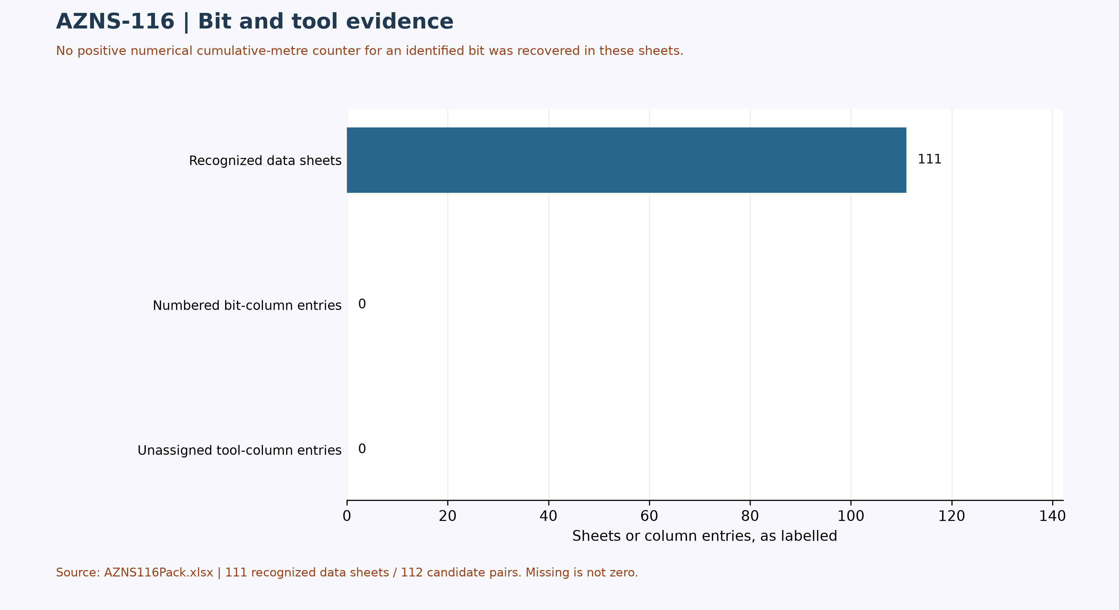
Figure W7 — Bit/tool evidence coverage, not a run count

Selected daily BHA components and hydraulic review
At least one nonempty recognized-format block was recovered in 91 of 112 data sheets. The table selects four rows from one block in AZNS116Pack.xlsx, sheet 10-2 Data; it is not the entire string, all runs, or the current well condition. A repeated identifier or parallel columns do not establish the number of runs.
Selected component and cell | Recorded outside diameter and cell | Evidence scope
Mill [I42] | 8-3/8 [K42] | Source observation
Junk Sub [I43] | 6-15/16 [K43] | Source observation
Double Pin [I44] | Not recorded | Source observation
Junk Sub [I45] | 6-15/16 [K45] | Source observation
Table 6-2 — Selected source block components and recorded dimensions
Physical programme page 50 is a navigation anchor for the planned BHA discussion; matching phase or agreement with this daily example is not established. Reconcile stated dimensions with the component name, count, length, inside diameter, connection limits, sequence, run record and manufacturer data. Hydraulic review requires verified inside and outside diameters and annular geometry for each section, simultaneous flow and fluid properties, nozzle and surface-loss information and pressure calibration. Without these inputs, pressure loss, annular velocity, hole cleaning and a reliable operating window cannot be calculated; W3 alone is not a design.

Source-coded non-planned time and partial coverage
Only 55 daily reports with classified durations totalling approximately 24 hours were included out of 112 candidate sheet pairs. These are source-code hours, not a verified total for the operation; incomplete or unrecognized days are not zero. Status pages are recognized independently of data pages; row-level cells are retained in evidence/activity_observations.json.
Table 7-1 — Source-code hours in complete reports; references are examples.
Source code | Hours in coverage | Example status and duration cells
N / NPT | 23.50 | 16-1 Remark!J26,H26 ; 17-1 Remark!J28,H28
UP / unplanned | 970.50 | 61-1 Remark!J22,H22 ; 61-1 Remark!J24,H24
NPT-UNPLN | 0.00 | None in included complete days
Activity codes alone do not establish root cause or contractual responsibility. Legacy mechanism claims, contractor attribution and financial exposure are withdrawn pending review of actual daily narrative, contracts and event evidence. Different source codes must not be presented as a single NPT definition.
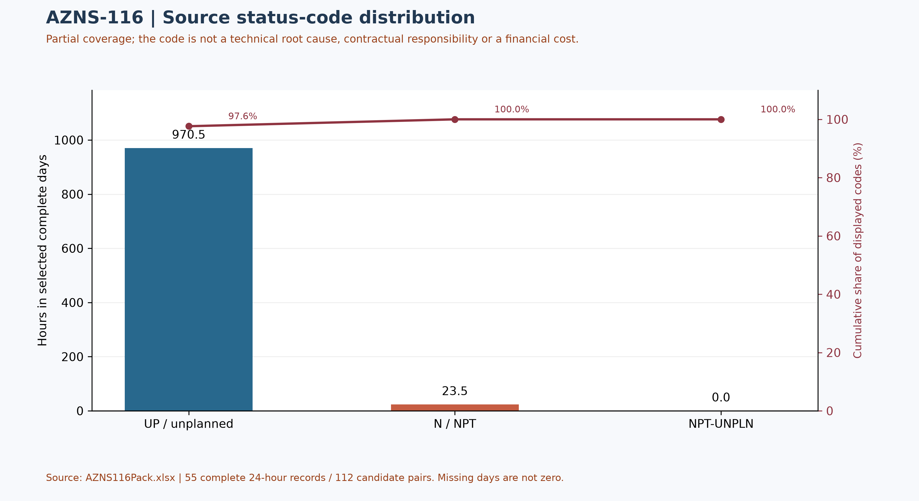
Figure W4 — Pareto of source status codes in complete days, not technical causes

CBS Financial Analysis and Provisional Cost Categories
Table 8-2 source: CBS AZNS-127WO1 and 116.xlsx / Cost Breakdown-116. Categories are derived by summing numeric cached values within each cited row range; scope and formulas remain unverified. These cached source amounts are not actual expenditure or an approved comparable budget. Missing or erroneous values are not zeros; rates, scope, formulas and approvals require reconciliation. No daily expenditure series has been verified.
Source / scope | Cached value | Cell / sheet
Cached main-sheet total; scope unverified | 4,265,143.46 | F197 / Cost Breakdown-116
Source ceiling, joint for two wells | 13,909,986.21 | C5 / Total Cost-EPD & Rigless
Table 8-1 Source financial and schedule anchors (unreconciled).
Source category | Source amount (USD) | Amount cell
Rig service | 1,780,200.00 | F5:F5
Drilling fluids | 151,498.46 | F6:F12
Cementing | 0.00 | F13:F19
Mud logging | 86,494.50 | F20:F23
Wireline logging | 112,872.50 | F24:F65
Drilling waste management | 110,310.00 | F66:F77
Directional drilling | 0.00 | F78:F90
Casing running | 27,300.00 | F91:F98
Temporary well suspension | 0.00 | F99:F102
Slickline | 12,799.00 | F103:F105
Completion running | 15,000.00 | F106:F117
Liner hanger running | 0.00 | F118:F126
H2S service | 16,254.00 | F127:F129
Perforation | 320,925.00 | F130:F134
Wellhead services | 9,000.00 | F135:F139
Dry test services | 0.00 | F140:F142
Rig / completion services | 1,235,690.00 | F143:F152
Other services | 38,700.00 | F153:F156
Cleanup services | 0.00 | F157:F163
Drilling materials | 0.00 | F164:F172
Project management | 309,600.00 | F173:F175
Engineering | 28,500.00 | F176:F186
Tubing inspection | 0.00 | F187:F194
Wellhead / tree inspection | 5,000.00 | F195:F195
Downhole completion inspection | 5,000.00 | F196:F196
Table 8-2 CBS source categories and cell references (unreconciled).
Topic | Observation | Source reference | Action
Scope / actuals | Values are not actual invoices or an approved comparable ceiling. | Source sheet and formulas | Reconcile
Joint scope | Summary ceiling covers 116 and 127; standalone allocation is not established. | B3:B14, G23 / Total Cost-EPD | Do not allocate
Table 8-3 CBS reconciliation checks.
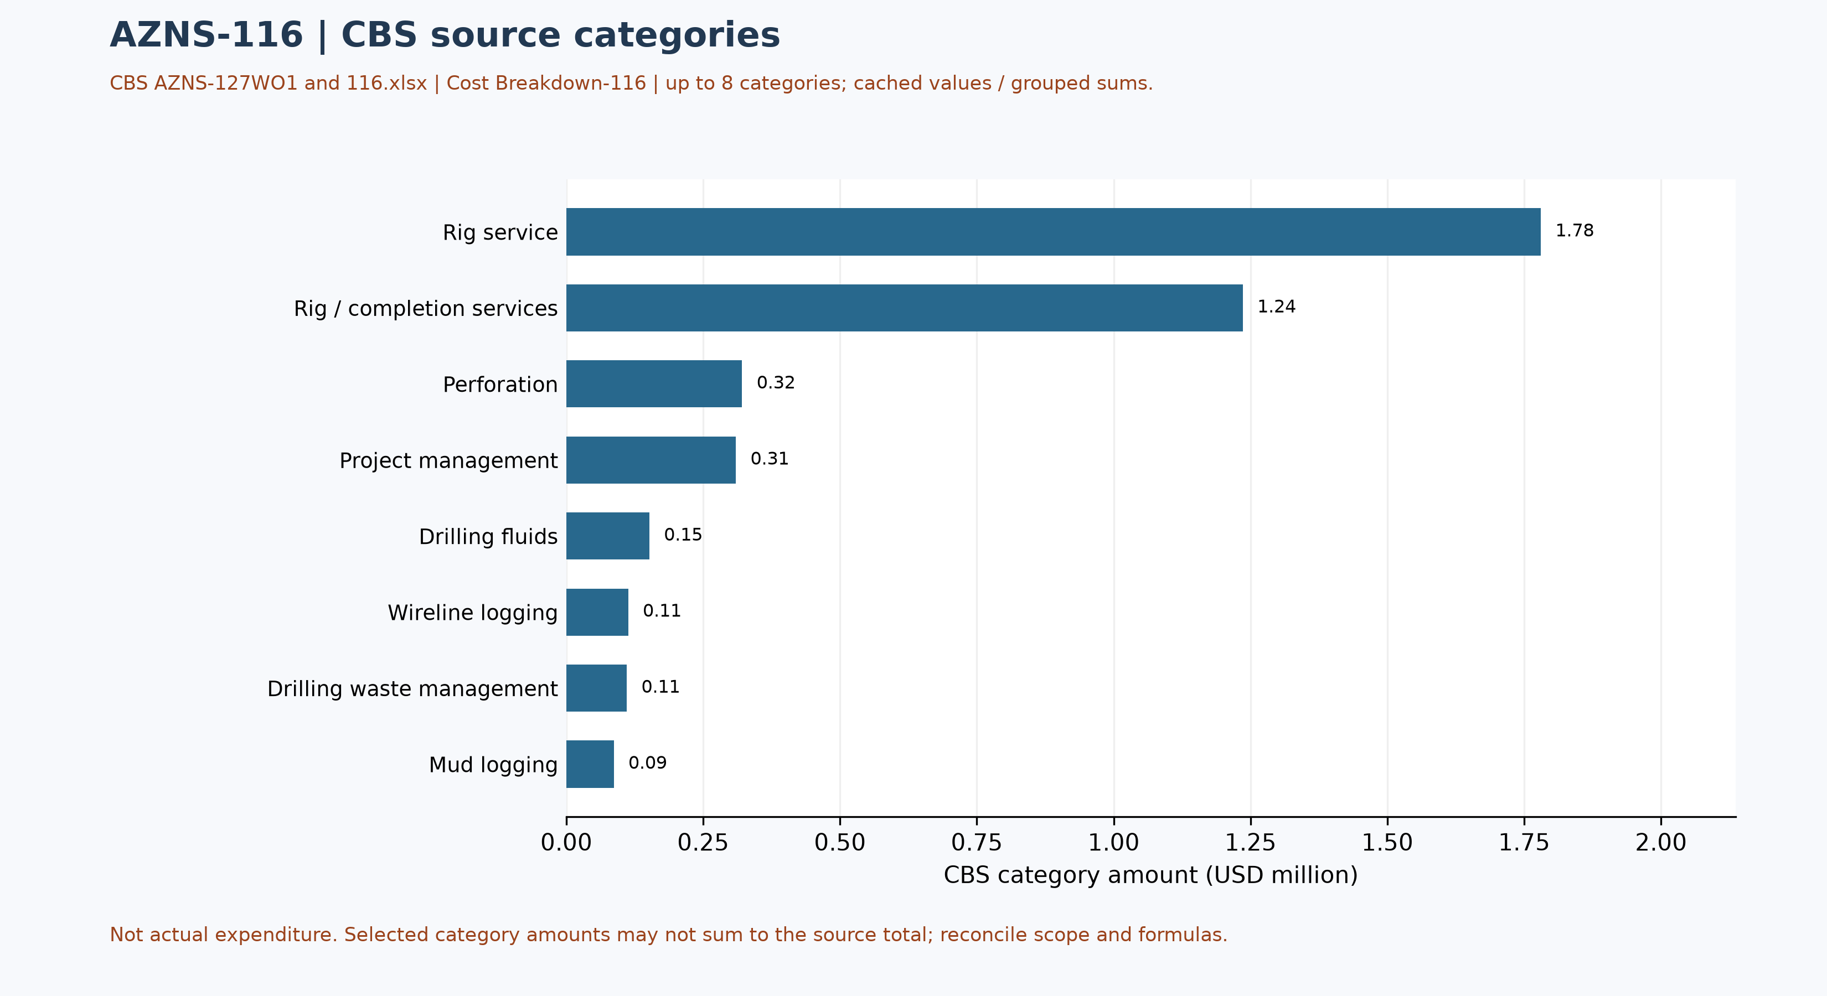
Figure W5 — CBS source cost categories, AZNS-116 (unreconciled)

Selected CBS service-sheet checks
The coiled-tubing service sheet in CBS AZNS-127WO1 and 116.xlsx, Coil Tubing Service-116!B3:H3, lists one 1½-inch coiled-tubing unit, 3 standby days and 5 operating days, with both day rates at USD 4,800 and a cached line amount of USD 38,400. The source formula multiplies each day count by its corresponding rate. This is a selected estimated service line, not a verified operational record or invoice.
This sample is not an additional cost to be added to the main breakdown or ceiling: the roll-up, contingencies, units, contract scope and service execution must first be traced and reconciled. A repeated template line across workbooks is not independent evidence of repeated deployment.

Operational observations and engineering decision gates
Previous numerical operating envelopes were not validated and have been withdrawn. The entries below are examples of raw daily records only; tool location, phase, units and measurement validity require review. These observations are not safe limits, optimum windows or operating instructions.
Table 9-1 — Example recorded cells; units and measurement basis require verification.
Raw field | Example recorded value | Sheet and cell
Mud weight | 103 | 4-2 Data!R12
Bit load / WOB | No interpretable numeric sample | —
RPM | No interpretable numeric sample | —
Flow | No interpretable numeric sample | —
Standpipe pressure | No interpretable numeric sample | —

Recommendations and review requirements
- Reconcile the programme revision, scope, start/end boundaries and rig/service time against daily reports and approved schedules before reporting a variance.
- Have responsible specialists verify well barriers and formation, casing and equipment limits against current approved records; no numerical design setpoint is established by this report.
- Reconcile bit identifiers, cumulative counters, tool assembly and failure evidence with original field and vendor records before selecting future equipment or diagnosing a mechanism.
- Reconcile costs with signed contracts, approved scope and invoices; do not convert source status-code hours into financial liability without a contractual assessment.

Risk-review checklist; ownership and severity not assigned
Review topic | Available evidence | Required follow-up
Well integrity and pressure | Programme objective and stated background, not proof of current condition | Reconcile tests, barriers and current approved limits
Incidents and recorded time | Partial source-code coverage in table 7-1 | Review event narrative, duration, cause and contract without presumed attribution
Equipment and operations | Example cells in table 9-1 and tool observations in table 4-2 | Verify units, calibration, tool identity and vendor records
Schedule and cost | Programme page and cost-breakdown evidence | Reconcile scope, invoices, time basis and approved revision

Data Provenance and Cell-Level Traceability
The table lists selected source anchors only. Other entries and interpretations still require independent cell/page checks, unit and scope review; the current report is not fully reconciled or reproducible without engineering interpretation.
Data element | Archive anchor (file -> sheet!cell)
well_name | 1-1 Remark!C5
client | 1-1 Remark!H5
rig | 1-1 Remark!C6
field | 1-1 Remark!C7
hole_section | 1-1 Remark!C8
well_type | 1-1 Remark!C9
report_date | 1-1 Remark!N5
spud_date | 1-1 Remark!N6
est_days | 1-1 Remark!N8
act_days | 1-1 Remark!N9
CBS cost breakdown | CBS AZNS-127WO1 and 116.xlsx -> sheet "Cost Breakdown-116"
Well programme | AZNS-116 Workover Program Rev.04.pdf
Table 11-1 Provenance anchors.

Appendix: source formation-table snapshot (unverified)
Source: AZNS116Pack.xlsx, sheet 112-2 Data. Selected as the last sheet in workbook order with a recognized formation table containing a numeric depth; if none, the last table with formation names. This is not necessarily the latest dated report.
Column roles follow the source labels, not independent confirmation of prognosis or measurement. Unlabelled populated cells are shown separately; missing cells are unknown, not zero. Values are rounded to four decimals for display. Verify row alignment, depth datum, possible inconsistencies and lithology against the programme and geological report; this table alone does not establish event attribution or operating instructions.
Source table and anchor: Formation Geology Data / K109
Formation / cell | Source values / cell
Aghajari / K111 | Not recorded
Gachsaran / K112 | Not recorded
Asmari / K113 | Not recorded
Pabdeh / K114 | Not recorded
Gurpi / K115 | Not recorded
Ilam / K116 | Not recorded
Laffan / K117 | Not recorded
Sarvak / K118 | Not recorded
Kazhdumi / K119 | Not recorded
Dariyan / K120 | Not recorded
Gadvan / K121 | Not recorded
Fahliyan / K122 | Not recorded

Selected formation tops from programme page
Source: AZNS-116 Workover Program Rev.04.pdf, physical page 40. The programme labels the table actual; values below are the MD (log) column, not the forecast or sample column. Depth reference: RTE 14.45 m. Event-to-formation attribution requires a reconciled event depth and datum.
Formation / member | Source top, m MD
Gachsaran | 902
Asmari | 1201
Pabdeh/Jahrum | 1377
Jahrum | 1506
Pabdeh | 1714
U. Gurpi | 2027
Tarbur | 2232
L. Gurpi | 2339
Ilam | 2482
Laffan | 2558
Sarvak | 2566
Kazhdumi | 3202
Dariyan | 3401
U. Gadvan | 3557
Khalij Mbr | 3628
L. Gadvan | 3635
Fahliyan | 3900

Programme source summary and comparison limitations
Source: AZNS-116 Workover Program Rev.04.pdf, physical page 7. Programme objective: After unsuccessful fishing described in the programme, remove completion, perforate new intervals, change the completion string and recomplete. Stated programme duration, in days: 89 main; 45.2 contingency. The programme states measured depth 4150 m and producer/reservoir formation Fahliyan; these do not by themselves establish achieved depth or current condition. Time boundaries, scope and contingency interpretation require reconciliation.

