AZNS-127 WO#2 — Drilling Engineering Report
Daily drilling report analytics, drilling mechanics, hydraulics, well integrity and performance optimisation
————————————————————————————
Field: AZNS | Rig: OEOC
Well: AZNS-127 WO#2 | Report days: 68 | Final MD: 4,140 m
Report period: 29.12.2025 to 06.03.2026
Prepared by: Principal Drilling & Well Operations Engineering
Document class: full engineering report — English (LTR)
Document control
Item | Value
Well | AZNS-127 WO#2
Reference workbook | AZNS127WOPack.xlsx
Worksheets parsed | 136
Rig days analysed | 68
Final measured depth | 4,140 m
Total rig time | 1,632 h
Engineering basis | Daily report time log, bit/BHA, mud, survey and formation records
Calculation basis | Minimum curvature, Teale MSE, API RP 13D Bingham, soft-string torque and drag

1. Executive summary and well KPIs
AZNS-127 WO#2 was reported over 68 rig days and 1,632 h of rig time. The well reached 4,140 m measured depth (— m TVD at the last survey) and added 4,140 m of new hole with 0 m of gross footage including re-drilled fill. Non-productive time absorbed 758 h (46.4% of the rig calendar); invisible lost time in drilling and handling adds a further 22 h (1.4%). The reconstructed, rate-based cost is 3.87 MUSD — 935 USD per metre of new hole and 56,945 USD per rig day.
The workbook documents a re-entry and intervention campaign rather than new hole making: 0 m of new hole were added and the recorded activity is dominated by completion work, milling, fishing and pressure testing. Metre-based indicators such as ROP and USD/m are therefore not meaningful for this well, and the performance discussion is built on rig-day efficiency, NPT structure and operation cycle time.

1.1 Key performance indicators
Table 1.1 — Well KPIs
Indicator | Value | Unit
Rig days analysed | 68 | day
Total rig time | 1,632 | h
Net new hole | 4,140 | m
Gross footage | 0 | m
Final measured depth | 4,140 | m
Drilling hours | 0 | h
Reaming hours | 36 | h
Circulating and conditioning | 45 | h
Trip hours | 332 | h
Casing, cement and WOC | 64 | h
Logging hours | 58 | h
Non-productive time | 758 | h
NPT share | 46.4% | %
Invisible lost time | 22 | h
Gross ROP | 0.00 | m/h
Net ROP | 0.00 | m/h
Best interval ROP (P90) | 0.00 | m/h
Reconstructed cost | 3.87 | MUSD
Specific cost | 935 | USD/m
Cost per rig day | 56,945 | USD/day
Bit runs analysed | 0 | run
Survey stations | 0 | station

1.2 Headline findings
- The largest NPT category is “Client / operator decision” with 540 h (71.3% of NPT); the three leading categories absorb 90.0%, so a compact set of controls addresses most of the loss.
- No formation-integrity test with a numerical equivalent mud weight was recorded; Chapter 11 states the value that must be demonstrated at each shoe instead of assuming a result.
- Numeric drilling parameters are present on 11 of 68 days and numeric flow rate on 0, which bounds how far the mechanical analysis can be pushed (Chapter 17).

2. Hole, casing and cement architecture
The well was executed in 1 operational phases. Table 2.1 gives the phase geometry with footage, rig time and recorded rate; Table 2.2 reproduces the casing and liner record from the daily report header, including grade, weight, thread, shoe depth and the recorded burst and collapse ratings.
Table 2.1 — Operational phases
Phase | MD interval (m) | Footage (m) | Days | Hours | Gross ROP | Net ROP | NPT | Period
De-completion / workover | 4,140–4,140 | 0 | 68 | 1,632 | 0.00 | 0.00 | 46% | 29.12.2025 – 06.03.2026
Table 2.2 — Casing and liner programme
Size (in) | From | To (m) | Grade | Weight (lb/ft) | Thread | Shoe TVD (m) | Burst (psi) | Collapse (psi)
20" | Surface | 146 | K-55 | 94.0 | BTC | 146.0 | 2110.0 | 520.0
20" | Surface | 155 | K-55 | 94.0 | BTC | 155.0 | 2110.0 | 520.0
13-3/8" | Surface | 1,441 | N-80 | 68.0 | BTC | 1,441.0 | 5020.0 | 2260.0
9-5/8" | Surface | 2,733 | T-95 | 53.5 | TPCQ | 2,732.6 | 9680.0 | 7340.0
7" Liner | 3147 | 3,891 | 110 SS | 29.0 | TPCQ | 3,891.0 | 11220.0 | 8530.0
9-5/8" | 2732.64 | 3,909 | T-95 | 53.5 | TSH BLUE | 3,909.0 | 9680.0 | 7340.0
4-1/2" Liner | 3780.4 | 4,140 | 110 S | 13.5 | TPG2 | 4,139.5 | 12410.0 | 10680.0
The De-completion / workover phase (from 29.12.2025 to 06.03.2026) made no new hole: 1,632 h were spent on completion, intervention and testing with 758 h of NPT.
Cementing design follows the standard two-slurry practice of this field: a lead slurry weighted to the mud weight plus a margin for the open hole, a tail slurry across the shoe and the previous casing shoe, and a spacer sized for the contact time. Where the record shows a shoe test immediately after the WOC, the test pressure and the equivalent mud weight are reproduced in Chapter 11; where it does not, the seat is treated as unverified.

3. Day-by-day chronology and phase cost
Every worksheet was read and reconciled against the 24-hour time log of its day. The chronology below condenses the daily summaries into the operational sequence that governs the well outcome; Table 3.1 allocates the reconstructed cost to each phase on the basis of the rig time consumed and the materials, casing, cement and bits actually booked on those days.
29.12.2025 — start of the De-completion / workover phase at 4,140 m:
30.12.2025 — 24.0 h of client / operator decision at 4,140 m: Operations remain suspended pending the client's clarification regarding well No.122. the well was completed and handed over
31.12.2025 — 24.0 h of client / operator decision at 4,140 m: Operations remain suspended pending the client's clarification regarding well No.122. the well was completed and handed over
01.01.2026 — 24.0 h of client / operator decision at 4,140 m: Operations remain suspended pending the client's clarification regarding well No.122. the well was completed and handed over
Table 3.1 — Reconstructed cost by phase
Phase | Days | Hours | Cost (kUSD) | USD/m | Share
De-completion / workover | 68 | 1,632 | 3,872 | — | 100.0%
Total | 68 | 1,632 | 3,872 | 935 | 100.0
Cost is reconstructed from a deterministic rate model (rig, services, materials consumed, casing/cement/bit items); the rate table is given in Appendix B of the field report.
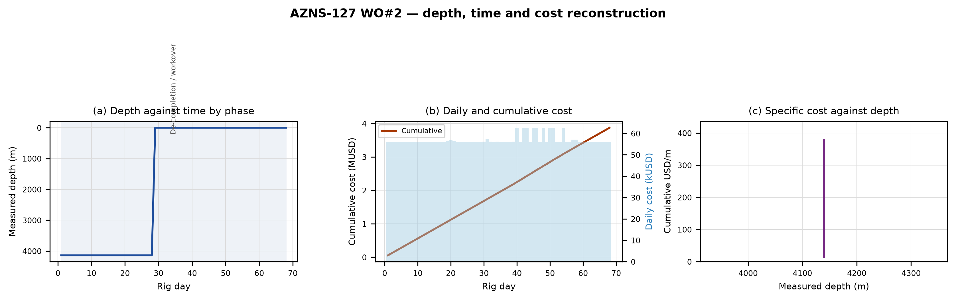
Figure 3.1 — Depth against time with daily, cumulative and specific cost

4. Drilling performance, connections and ROP
Handling overhead was measured from the time log: 0 connections were implied by the stands drilled (0 stands) and absorbed 0.0 h, at 30 minutes per connection. Against a five-minute benchmark the connection component of invisible lost time is 0.0 h; the larger component is circulation and conditioning at 22.5 h, which is the signature of a well kept open by circulation rather than drilled to its limit.
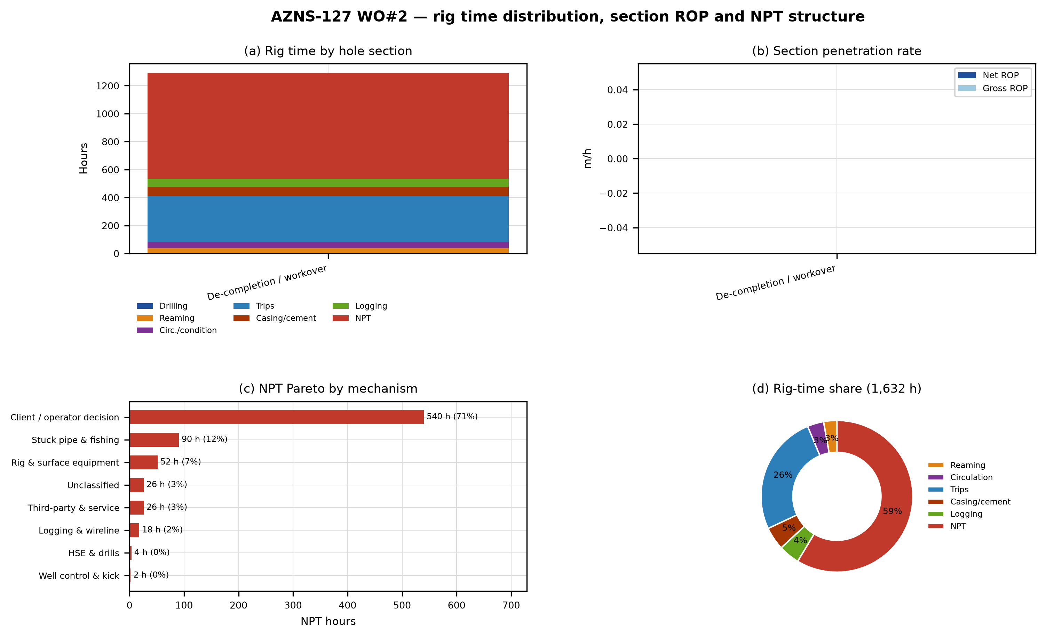
Figure 4.1 — Rig time distribution, section penetration rate and NPT Pareto

5. NPT analysis and multi-hypothesis root cause
758 h of NPT were recorded — 46.4% of rig time or 31.6 rig days. Table 5.1 aggregates the loss by physical mechanism and Table 5.2 lists the individual events above one hour. The contractual attribution column is preserved, but the engineering classification follows the activity text because charging practice reflects contract allocation rather than physical cause.
Table 5.1 — NPT by mechanism
Mechanism | Hours | Share | Rig days
تصمیم کارفرما / بهره‌بردار | 540 | 71.3% | 22.5
گیر لوله و ماهیگیری | 90 | 11.9% | 3.8
تجهیزات دکل و سطحی | 52 | 6.8% | 2.1
طبقه‌بندی‌نشده | 26 | 3.4% | 1.1
شخص ثالث و خدمات | 26 | 3.4% | 1.1
نمودارگیری و وایرلاین | 18 | 2.4% | 0.8
ایمنی، بهداشت و مانورها | 4 | 0.5% | 0.1
کنترل چاه و فوران | 2 | 0.3% | 0.1
Table 5.2 — Largest individual NPT events
Day | Date | Hours | Mechanism | Charged to | Activity (extract)
2 | 30.12.2025 | 24.0 | تصمیم کارفرما / بهره‌بردار | PEDEC/PPL | Operations remain suspended pending the client's clarification regarding well No.122. the well was completed and handed over
3 | 31.12.2025 | 24.0 | تصمیم کارفرما / بهره‌بردار | PEDEC/PPL | Operations remain suspended pending the client's clarification regarding well No.122. the well was completed and handed over
4 | 01.01.2026 | 24.0 | تصمیم کارفرما / بهره‌بردار | PEDEC/PPL | Operations remain suspended pending the client's clarification regarding well No.122. the well was completed and handed over
5 | 02.01.2026 | 24.0 | تصمیم کارفرما / بهره‌بردار | PEDEC/PPL | Operations remain suspended pending the client's clarification regarding well No.122. the well was completed and handed over
6 | 03.01.2026 | 24.0 | تصمیم کارفرما / بهره‌بردار | PEDEC/PPL | Operations remain suspended pending the client's clarification regarding well No.122. the well was completed and handed over
7 | 04.01.2026 | 24.0 | تصمیم کارفرما / بهره‌بردار | PEDEC/PPL | Operations remain suspended pending the client's clarification regarding well No.122. the well was completed and handed over
8 | 05.01.2026 | 24.0 | تصمیم کارفرما / بهره‌بردار | PEDEC/PPL | Operations remain suspended pending the client's clarification regarding well No.122. the well was completed and handed over
9 | 06.01.2026 | 24.0 | تصمیم کارفرما / بهره‌بردار | PEDEC/PPL | Operations remain suspended pending the client's clarification regarding well No.122. the well was completed and handed over
10 | 07.01.2026 | 24.0 | تصمیم کارفرما / بهره‌بردار | PEDEC/PPL | Operations remain suspended pending the client's clarification regarding well No.122. the well was completed and handed over
29 | 26.01.2026 | 24.0 | تصمیم کارفرما / بهره‌بردار | PPL/PEDEC | Cont. wait on client to receive explosive material (Totally 36Hrs), Meanwhile try to unlatch Comp. Strg. from anchor seal w/ different
61 | 27.02.2026 | 24.0 | شخص ثالث و خدمات | CLIENT | While wait on decision, Cont. RIH w/ 3Stds 3-1/8" DC (Totally 8 Stds, Jt By Jt), 5 Stds 2-7/8" DP (Jt By Jt), 4-3/4" XOS, 1 Jt 3-1/2" DP "S",
64 | 02.03.2026 | 24.0 | تصمیم کارفرما / بهره‌بردار | CLIENT | Since 28-Feb-2026 Wait on client for next plan (Suspended or remedial plan for the well), due to war & unplan well condition; Decided
The complete register of all rows is given in Appendix C.

5.1 Root-cause investigation of the dominant events

5.1.1 Day 2 (30.12.2025) — 24.0 h, Client / operator decision
Recorded activity: “Operations remain suspended pending the client's clarification regarding well No.122. the well was completed and handed over”. The event occurred at 4,140 m with a mud weight of — pcf in the — in hole.
Two mechanisms are consistent with the client / operator decision loss recorded at 4,140 m: a readiness delay of the rig or a service provider (equipment or crew not available when required, the rig is mechanically ready and waiting) and an information or decision delay (the operation is gated by an approval, a programme change or a waiting-on-instruction). The field criterion is the rig state at the start of the event: a rig that is ready and idle identifies the decision mechanism, while a rig working on its own equipment identifies the readiness mechanism. The mitigation differs accordingly — a permitting and decision calendar in the first case, a service-level agreement with standby equipment in the second.
Whichever mechanism dominates on this occasion, the record shows the event cost 24.0 h to resolve. The action that would have shortened it is the discriminating test itself: it takes under an hour and it separates two treatments whose cost differs by an order of magnitude — a chemical or density intervention against a mechanical or fishing operation.

5.1.2 Day 3 (31.12.2025) — 24.0 h, Client / operator decision
Recorded activity: “Operations remain suspended pending the client's clarification regarding well No.122. the well was completed and handed over”. The event occurred at 4,140 m with a mud weight of — pcf in the — in hole.
Two mechanisms are consistent with the client / operator decision loss recorded at 4,140 m: a readiness delay of the rig or a service provider (equipment or crew not available when required, the rig is mechanically ready and waiting) and an information or decision delay (the operation is gated by an approval, a programme change or a waiting-on-instruction). The field criterion is the rig state at the start of the event: a rig that is ready and idle identifies the decision mechanism, while a rig working on its own equipment identifies the readiness mechanism. The mitigation differs accordingly — a permitting and decision calendar in the first case, a service-level agreement with standby equipment in the second.
Whichever mechanism dominates on this occasion, the record shows the event cost 24.0 h to resolve. The action that would have shortened it is the discriminating test itself: it takes under an hour and it separates two treatments whose cost differs by an order of magnitude — a chemical or density intervention against a mechanical or fishing operation.

5.1.3 Day 4 (01.01.2026) — 24.0 h, Client / operator decision
Recorded activity: “Operations remain suspended pending the client's clarification regarding well No.122. the well was completed and handed over”. The event occurred at 4,140 m with a mud weight of — pcf in the — in hole.
Two mechanisms are consistent with the client / operator decision loss recorded at 4,140 m: a readiness delay of the rig or a service provider (equipment or crew not available when required, the rig is mechanically ready and waiting) and an information or decision delay (the operation is gated by an approval, a programme change or a waiting-on-instruction). The field criterion is the rig state at the start of the event: a rig that is ready and idle identifies the decision mechanism, while a rig working on its own equipment identifies the readiness mechanism. The mitigation differs accordingly — a permitting and decision calendar in the first case, a service-level agreement with standby equipment in the second.
Whichever mechanism dominates on this occasion, the record shows the event cost 24.0 h to resolve. The action that would have shortened it is the discriminating test itself: it takes under an hour and it separates two treatments whose cost differs by an order of magnitude — a chemical or density intervention against a mechanical or fishing operation.

6. Bit, BHA and nozzle performance (TFA, jet velocity, HSI, IADC wear)
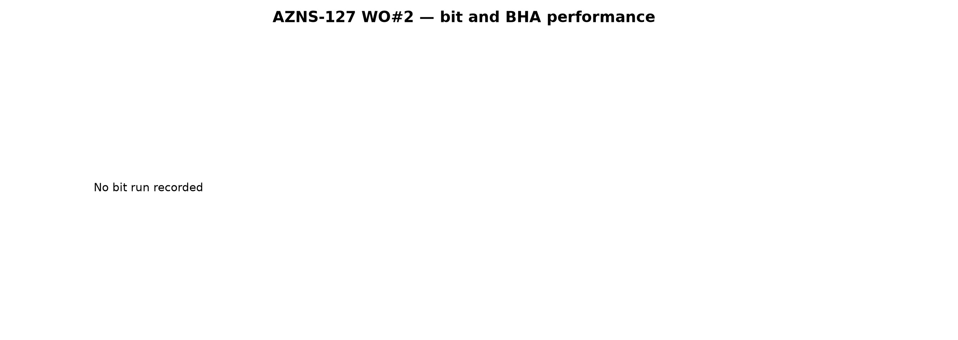
Figure 6.1 — Bit runs, metres per run and nozzle-area/hydraulic-index envelope

7. Mechanical parameters and MSE log
This well carries no interval with a complete simultaneous record of weight, rotary speed and rate of penetration, so a specific energy cannot be computed without inventing one of the three inputs. The mechanics log below reproduces the recorded torque, standpipe pressure and mud weight against depth, and the missing energy calculation is listed in Chapter 17 rather than filled with an assumption.
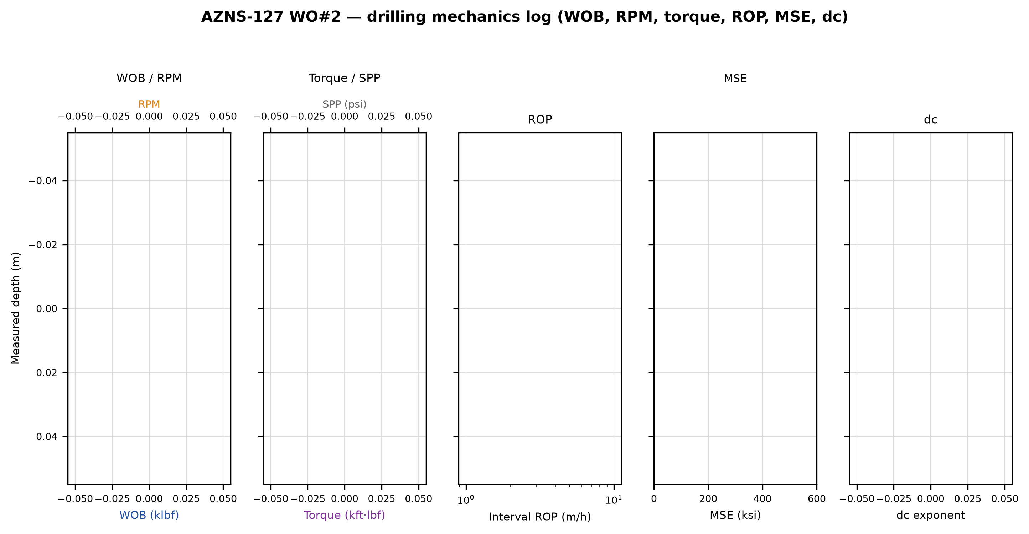
Figure 7.1 — Five-track drilling mechanics log with mechanical specific energy

8. Drilling fluids, rheology, cuttings transport and ECD
Table 8.1 — Mud properties by section
Section | MW (pcf) | PV median (cP) | YP median | PV max (cP) | Lost (bbl) | Days
De-completion / workover | 20–334 | — | — | — | 0 | 68
The fluid programme is a polymer system in the upper sections and a salt-polymer or CaCO₃-weighted system in the reservoir section, which matches the reactivity of the Gachsaran–Gurpi shale and the need to protect the Sarvak–Kazhdumi carbonates. PV and YP were not filed every day; the values used for the annular pressure loss are the recorded ones and never an interpolated substitute.
No daily record in this well reports flow rate, nozzle configuration and rheology together, so jet velocity, hydraulic index and downhole circulating density cannot be computed as physical results. The figure below reproduces the recorded mud weight and the circulating pressure against depth; the missing hydraulic quantities are carried in Chapter 17.
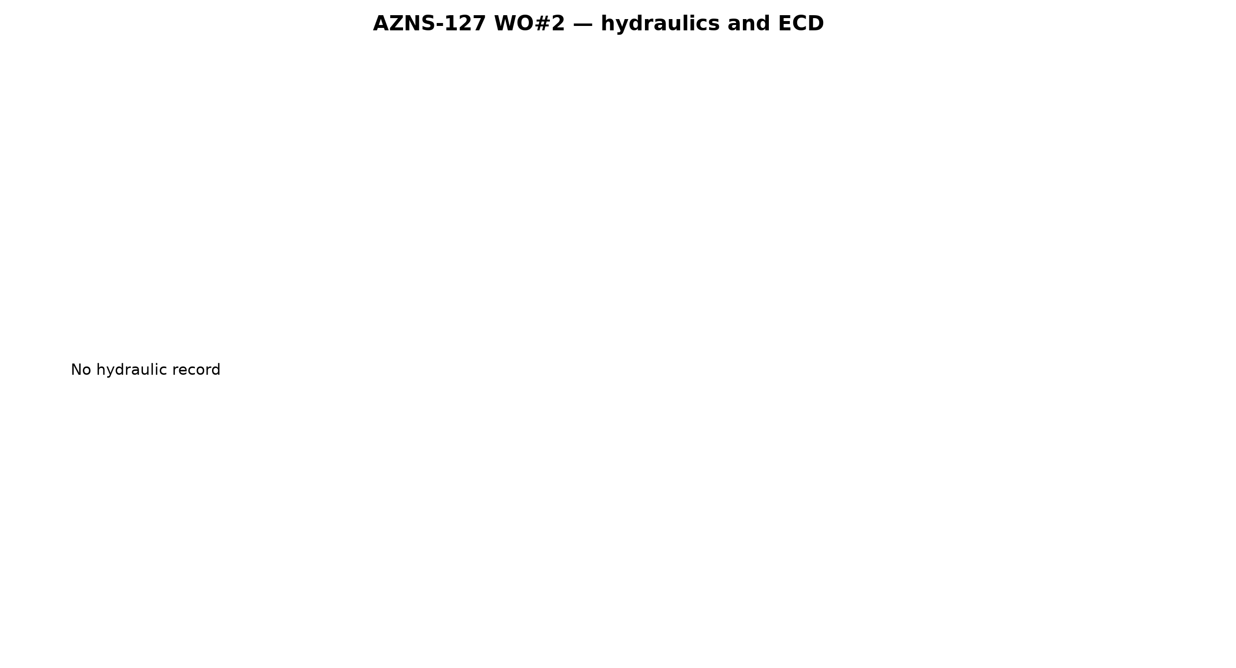
Figure 8.1 — Flow rate, annular velocity, hydraulic index and the MW/ECD window

9. Directional survey, trajectory and dog-leg severity
The workbook carries no usable survey station, so the trajectory could not be rebuilt; the well is treated as vertical for depth conversion and this limitation is carried through the report.
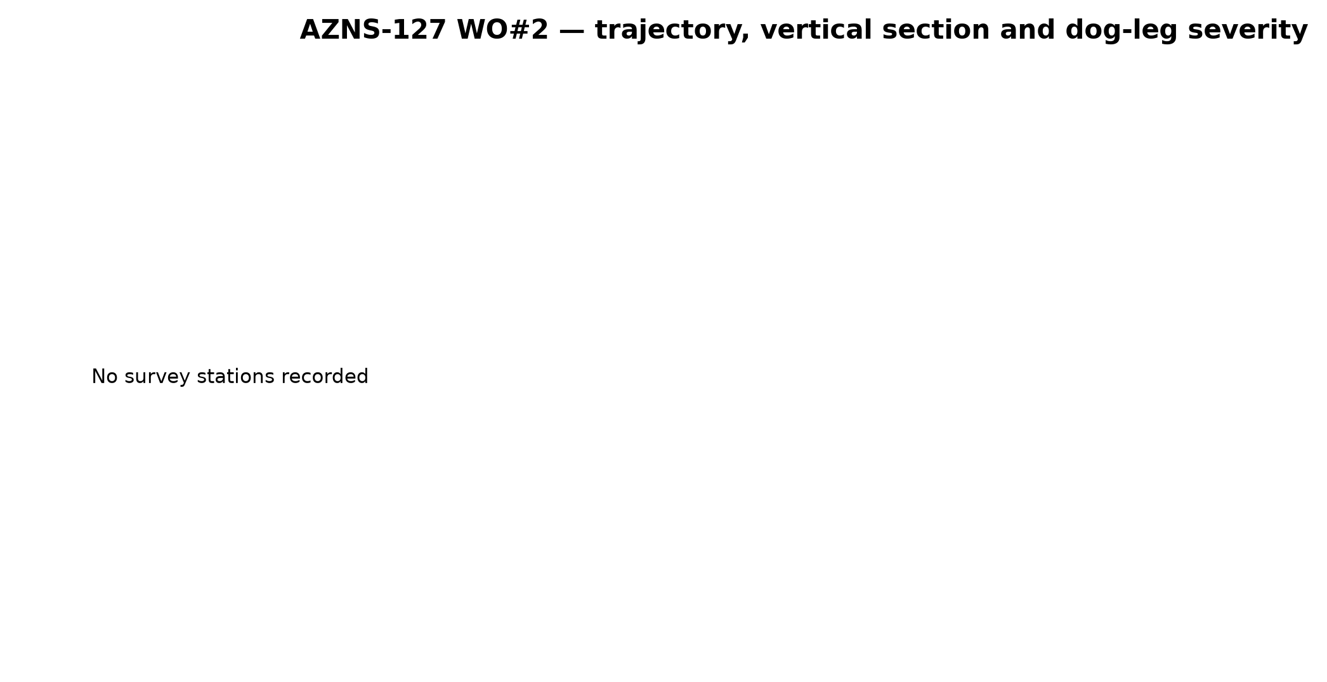
Figure 9.1 — Plan view, vertical section and dog-leg severity

10. Hook load, drag and overpull
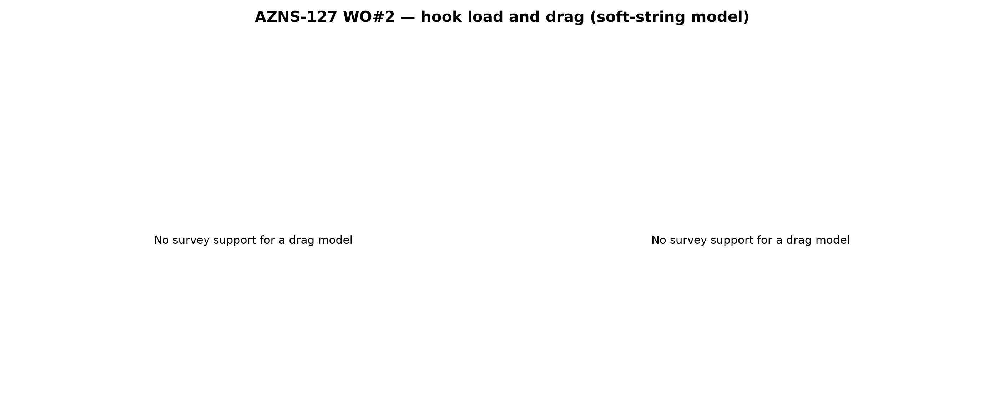
Figure 10.1 — Hook-load envelope and drag trend

11. Well control, FIT/LOT, MAASP and losses
No formation-integrity test carrying a numerical equivalent mud weight was recorded in this workbook. That is a material gap: without a measured shoe strength the maximum allowable annular surface pressure cannot be derived, and the margin against the fracture gradient stays unverified at every seat. Table 11.1 therefore states the equivalent mud weight that has to be demonstrated at each shoe to support a 500 psi MAASP at the operating mud weight, which is the value the next well should be designed against.
Table 11.2 — MAASP sensitivity with mud weight (psi)
Casing (in) | Shoe TVD (m) | MAASP @80 pcf | MAASP @90 pcf | MAASP @100 pcf | MAASP @110 pcf | EMW for 500 psi
20" | 146 | — | — | — | — | 146
20" | 155 | — | — | — | — | 142
13-3/8" | 1,441 | — | — | — | — | 87
9-5/8" | 2,733 | — | — | — | — | 84
7" Liner | 3,891 | — | — | — | — | 82
9-5/8" | 3,909 | — | — | — | — | 82
4-1/2" Liner | 4,140 | — | — | — | — | 82
MAASP = (EMW_test − MW)·0.052·shoe TVD. A dash means that no test result is available in the record for that seat.
Downhole losses were recorded on 0 days for a cumulative 0 bbl. That figure is a lower bound: the daily sheet books only the volume the mud engineer charged as lost downhole, and volume regained through LCM treatments or recovered at the shakers does not appear in the same column. The mechanism in this field is a combination of natural fracture loss in the carbonates and induced loss at the shoe when the ECD margin is consumed by cuttings loading.

12. Geology, formation tops, dc exponent and gas
The dc exponent was recomputed from recorded weight, rotary speed and rate, and corrected for the mud-weight offset (dcs). The well median is —. It is used as a trend indicator and not as a pore-pressure measurement: the departure from the normal trend in the reactive shale is consistent with the tight-hole record, while the flat response through the massive carbonates shows the matrix-controlled behaviour expected there.
0 gas mentions were extracted from the activity text. Gas behaviour of this kind is the signature of connection gas and of marginal overbalance during trips; it belongs in the trip-sheet controls of the next well rather than in a pore-pressure interpretation.
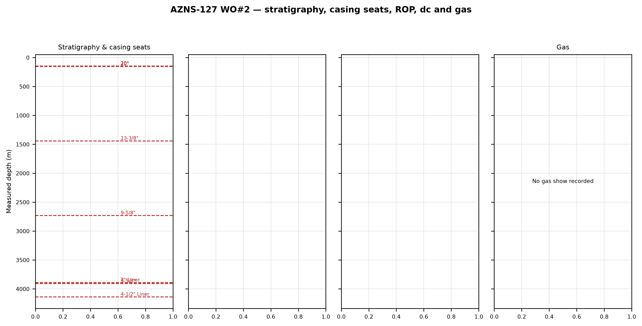
Figure 12.1 — Stratigraphy, casing seats, formation ROP, dc and gas

13. Operational problems and rig-floor playbooks
The five playbooks below are written for the rig floor. Each gives the immediate action, the two rival mechanisms that must be separated before a treatment is chosen and the field measurement that separates them. They are deliberately short enough to be read at the shaker while the string is still moving.

Playbook 1 — Stuck pipe and excessive overpull
- Stop rotating, set the string down and record free-hanging weight, pick-up and slack-off before any jarring.
- Circulate at the maximum allowable rate with the string stationary and compare return rate with pump rate: a loss with a pressure drop means the annulus is packed off, not differentially stuck.
- Mechanism A — differential sticking across a permeable bed: no movement in either direction, unrestricted circulation, sticking force proportional to overbalance.
- Mechanism B — mechanical or cuttings-bed sticking in a washed-out or high-dog-leg interval: restricted circulation, torque rise before the event, movement in one direction only.
- Discrimination: a 20 bbl low-density spot at the stuck point changes the free weight within 30 minutes in A and does nothing in B; cavings at the shaker and a pumps-off flow check complete the diagnosis.
- Only then apply the jar with the overpull that the torque-and-drag model allows, and log every pull as a fishing decision point.

Playbook 2 — Lost circulation
- Stop drilling, keep the string moving and reduce the pump rate in 50 gpm steps, recording the rate at which returns are lost and the corresponding ECD.
- Classify the loss as seepage (<10 bbl/h), partial (10–50 bbl/h) or severe (>50 bbl/h): the LCM size distribution and the treatment volume are different for each.
- Mechanism A — natural fissure or vugular loss in the carbonate: abrupt onset at a drilling break, independent of pump rate, permanent at any rate.
- Mechanism B — induced loss at the shoe or in a weak shale: progressive, appears only above a threshold ECD and partially heals when the rate is cut.
- Discrimination: repeat the condition at two flow rates; the loss that follows the ECD is induced, the loss that does not is natural.
- First action is a 20–30 bbl graded LCM pill (fine, medium, coarse) spotted at the loss zone; squeeze only if the pill fails, keeping the squeeze pressure below the break-down pressure of the open hole.

Playbook 3 — Kick or influx indication
- On a pit gain, flow with pumps off or a gas increase: stop, pick up off bottom, shut in and read SIDPP and SICP once stable.
- Record pit gain, shut-in pressures, mud weight in and out and gas; do not circulate the influx before the pressures are read.
- Mechanism A — true influx: SIDPP rises, SICP exceeds SIDPP and the pit gain is sustained.
- Mechanism B — ballooning or a false gain in a well drilled at the loss threshold: the pit gains while circulating and bleeds back when the pumps stop, with SIDPP near zero.
- Discrimination: bleed-back behaviour, the SIDPP/SICP split and repeatability over two pump cycles.
- Kill with the driller's method, holding casing pressure constant and never exceeding the dynamic MAASP of Chapter 11.

Playbook 4 — Tight hole, reaming and fill
- At the first tight spot, stop and ream down with pumps on at 40–60 rpm and low weight; never pull into a tight spot with the pumps off.
- Record the depth of the tight spot, the torque at which it appears and the fill volume on bottom after the next trip.
- Mechanism A — swelling or plastic shale: develops over hours, depth-stable, correlates with chloride dilution and MBT.
- Mechanism B — cuttings bed in a deviated or washed-out interval: migrates shallower with time, correlates with low annular velocity and is relieved by high-viscosity sweeps.
- Discrimination: a 30 bbl high-viscosity sweep followed by a wiper trip — torque collapses and fill falls in B, nothing changes in A.
- Prevention: documented wiper trip every 300 m of new hole in build sections and a minimum annular velocity of 120 ft/min in hole larger than 12-1/4 in.

Playbook 5 — Cementing or shoe-test failure
- If the shoe test fails, stop; repeat the test after a minimum 12-hour WOC and record the pressure–volume behaviour of every stage.
- Mechanism A — lead-slurry contamination by mud: the pressure bleeds off slowly and the CBL shows a low-amplitude interval at the shoe.
- Mechanism B — channel or incomplete displacement: pressure holds but leaks at a discrete rate and the CBL shows a channel rather than a general low bond.
- Discrimination: shape of the pressure-decay curve, CBL/VDL response and cement returned against cement pumped.
- Treatment is a squeeze with a fine-particle system behind a spacer designed for the mud and cement in contact, with the squeeze pressure kept below the formation break-down.

14. Optimum parameters, drill-off and MSE practice
The drill-off test is the only way to find the founder point of the bit–formation couple without relying on vendor curves. The procedure is: clean the hole for one full circulation at the target rate, hold rotary speed constant and step weight from 60 % to 130 % of the current value in five equal increments, allow two metres of penetration at each step and record rate, torque and MSE. The founder point is the weight at which the incremental rate falls below one third of the initial slope of rate against weight; beyond it, additional weight buys torque and heat only.
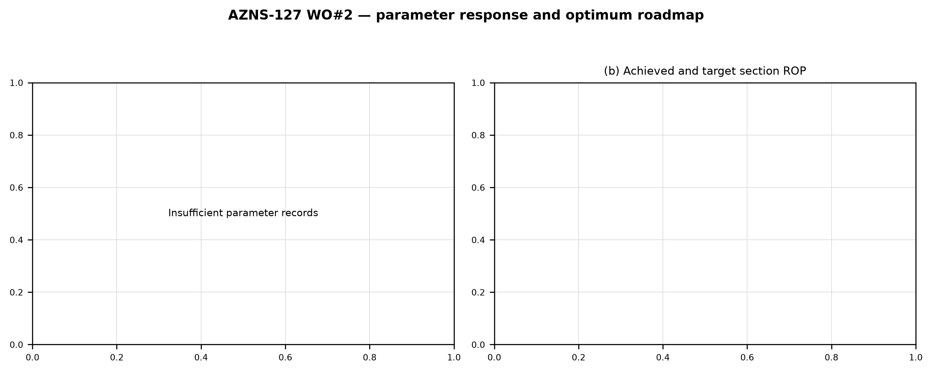
Figure 14.1 — Parameter response and optimum roadmap

15. Key findings and risk register

Table 15.1 — Findings and risks
ID | Finding | Evidence | Risk if repeated | Severity
F-01 | “Client / operator decision” is the first-order NPT mechanism | 540 h, 71.3% of NPT | Repeat of the same cost order on the next well | High
F-02 | Invisible lost time is larger than the trip time it is usually blamed on | 22 h ILT against 332 h of trips | Cost with no visible failure event | Medium
F-03 | Formation integrity is verified at only part of the casing seats | 0 FIT/LOT rows with a numerical EMW | MAASP not defensible at the untested seats | High
F-04 | Drilling parameters are only partially recorded | Numeric WOB on 11 days, flow on 0 days | Optimisation rests on interval reconstruction | Medium
F-05 | Wellbore events (stuck pipe, tight hole) are present | 8 day-level mentions | Escalation to a fishing operation | High

16. Recommendations — phase matrix and REC-01 to REC-10

Table 16.1 — Phase-by-phase rig matrix
Phase | Before spud | While drilling | Before casing | After cementing
De-completion / workover | Verify BHA, bit, nozzles and mud programme; confirm previous shoe test | Hold the Table 14.1 window; watch torque and MSE trend; sweep every 300 m in build sections | Circulate two bottoms-up, wiper trip, check the tight-spot register | Pressure test, CBL where required, record shoe integrity before drilling out

Table 16.2 — Structured recommendations
ID | Recommendation | Owner | Timing | Expected effect
REC-01 | Establish a reliability routine for the “Client / operator decision” subsystem with a 250-hour inspection interval and a spare-parts kit on location | Rig manager | Before next spud | Removes the largest NPT category
REC-02 | Issue a wiper-trip and sweep policy every 300 m of new hole in build sections with a minimum annular velocity of 120 ft/min above 12-1/4 in | Drilling supervisor | While drilling | Cuts reaming and tight-hole time
REC-03 | Run FIT/LOT at every shoe, record the EMW in the header and compute the dynamic MAASP before drilling out | Well integrity engineer | Each casing point | Makes MAASP auditable
REC-04 | Adopt the Table 14.1 window as the programme and document a drill-off test at the top of each formation | Drilling engineer | Each section | Raises ROP toward the P90 rate
REC-05 | Record WOB, RPM, flow, SPP and torque numerically every day | Drilling engineer | Immediately | Enables continuous MSE monitoring
REC-06 | Hold HSI at 2.5 hp/in² or more and jet velocity above 200 ft/s in the production hole | Drilling engineer | Each bit change | Improves cleaning, reduces balling
REC-07 | Book NPT against a fixed cause list so the pareto is comparable between wells | Drilling superintendent | Next well | Makes the learning curve measurable
REC-08 | Pre-position one low-density pill and one LCM pill before entering the reservoir | Mud engineer | Before reservoir entry | Cuts reaction time
REC-09 | Check available overpull against the torque-and-drag model before every trip | Drilling supervisor | Each trip | Avoids pulling into a stuck string
REC-10 | Hold a post-well review within 14 days on the same KPI set | Field engineering | After release | Closes the learning loop

17. Limitations of the recorded data
This report is built only from what the daily reports contain. Where a value was not recorded it is stated as not recorded, and no value has been invented. Table 17.1 quantifies the completeness of each data category so the reader can judge how far each conclusion is supported.
Table 17.1 — Data completeness
Category | Days with a value | Coverage | Consequence
Time log | 68.0 | 100.0% | Full time decomposition
Mud weight | 58.0 | 85.3% | MW/ECD window partly reconstructed
Numeric WOB | 11.0 | 16.2% | MSE limited to recorded days
Numeric flow | 0.0 | 0.0% | Hydraulics where present
Survey | 0.0 | — | Trajectory recomputed
Formation tops | 0.0 | — | Stratigraphy from the log
FIT/LOT with EMW | 0.0 | — | MAASP only where present
Bit identification | 0.0 | 0.0% | Bit runs from the record
Two further limitations follow from the source rather than from the analysis. The first is that costs are not filed in the daily reports; the cost curves in this document are therefore a deterministic reconstruction from a published rate set (rig day rate, service day rates, material consumption and casing/cement/bit items) and represent the cost structure of the operation, not an invoice. The second is that the report describes the well as recorded: where the operation text and the parameter fields disagree, both are reported and the engineering interpretation is stated explicitly.

18. Appendix A — Workbooks, sheets and SHA-256
The source workbook is AZNS127WOPack.xlsx with 136 worksheets, all read. Every worksheet is a report part (daily remark, daily technical data or look-ahead) and none was skipped. The checksums below were taken before extraction and re-verified after the documents were generated; the source files were not modified.
Table 18.1 — SHA-256 of the reference workbooks
File | SHA-256
AZNS127ST2Pack.xlsx | 68329de313721905be08f20cb8bb8b4f5f3671d5c6caab41f23caa1a48b9a4c4
AZNS127WOPack.xlsx | a4ae90dc870f20b2f99ac3a36b8b5cd1c357b60dd2805630597cc48ba059054e
AZNS12Pack.xlsx | e325945f1108341bace123e60b02fb04ac3f7d3003a19eb8d23004cf7cd67216
AZNS166Pack.xlsx | e63824748e4692884fc23075c678c1379b9b595a8c8b1efb289e630f898a75d8
AZNS207Pack.xlsx | 828968c7e0afd7273d64987bd457383ecfea3a2e00e62c9a65b587f16518996a
AZNS75Pack.xlsx | 5e0482d5d50e9347a98b7c24cfd3a102d3c00f2c951f6061aba14d164136fcae
This workbook alone contributes 136 worksheets and 68 reconciled rig days to the analysis.

19. Appendix B — Equations and units

Table 19.1 — Equations used
Quantity | Equation | Units
Minimum curvature | β = arccos[cos I₂cos I₁ + sin I₂sin I₁cos(A₂−A₁)]; RF = (2/β)tan(β/2) | degrees
Dog-leg severity | DLS = β·(30/ΔMD) | °/30 m
Teale MSE | MSE = WOB/A + 120π·N·T/(A·ROP) | psi
dc exponent | dc = log(ROP/60N)/log(12W/(1000D)) | dimensionless
Corrected dc | dcs = dc·(MW/ECD) | dimensionless
Bit pressure drop | ΔP = ρQ²/(10858·A²) | psi
Jet velocity | v = 0.3208·Q/A | ft/s
Bit hydraulic index | HSI = (ΔP·Q/1714)/(πD²/4) | hp/in²
Annular velocity | AV = 24.5·Q/(Dh²−Dp²) | ft/min
Bingham annular loss | ΔP = PV·V·L/(60000(Dh−Dp)²) + YP·L/(200(Dh−Dp)) | psi
ECD | ECD = MW + ΔP/(0.052·TVD) | pcf
MAASP | MAASP = (EMW_test − MW)·0.052·Shoe TVD | psi
Buoyancy factor | BF = 1 − MW/490 | —
Hook load | F = Σ(ΔMD·w·BF·cos I) ± Σ(μ·ΔMD·w·BF·sin I) | klbf
Specific cost | USD/m = total cost / net new hole | USD/m

20. Appendix C — Complete NPT register
The complete register of 92 rows is reproduced below, ordered by descending duration so that it can be used as an action list. The activity text is reproduced as recorded.

Table 20.1 — Complete NPT register
Day | Date | Hours | Mechanism | Charged | Activity as recorded
2 | 30.12.2025 | 24.0 | تصمیم کارفرما / بهره‌بردار | PEDEC/PPL | Operations remain suspended pending the client's clarification regarding well No.122. the well was completed and handed over
3 | 31.12.2025 | 24.0 | تصمیم کارفرما / بهره‌بردار | PEDEC/PPL | Operations remain suspended pending the client's clarification regarding well No.122. the well was completed and handed over
4 | 01.01.2026 | 24.0 | تصمیم کارفرما / بهره‌بردار | PEDEC/PPL | Operations remain suspended pending the client's clarification regarding well No.122. the well was completed and handed over
5 | 02.01.2026 | 24.0 | تصمیم کارفرما / بهره‌بردار | PEDEC/PPL | Operations remain suspended pending the client's clarification regarding well No.122. the well was completed and handed over
6 | 03.01.2026 | 24.0 | تصمیم کارفرما / بهره‌بردار | PEDEC/PPL | Operations remain suspended pending the client's clarification regarding well No.122. the well was completed and handed over
7 | 04.01.2026 | 24.0 | تصمیم کارفرما / بهره‌بردار | PEDEC/PPL | Operations remain suspended pending the client's clarification regarding well No.122. the well was completed and handed over
8 | 05.01.2026 | 24.0 | تصمیم کارفرما / بهره‌بردار | PEDEC/PPL | Operations remain suspended pending the client's clarification regarding well No.122. the well was completed and handed over
9 | 06.01.2026 | 24.0 | تصمیم کارفرما / بهره‌بردار | PEDEC/PPL | Operations remain suspended pending the client's clarification regarding well No.122. the well was completed and handed over
10 | 07.01.2026 | 24.0 | تصمیم کارفرما / بهره‌بردار | PEDEC/PPL | Operations remain suspended pending the client's clarification regarding well No.122. the well was completed and handed over
29 | 26.01.2026 | 24.0 | تصمیم کارفرما / بهره‌بردار | PPL/PEDEC | Cont. wait on client to receive explosive material (Totally 36Hrs), Meanwhile try to unlatch Comp. Strg. from anchor seal w/ different
61 | 27.02.2026 | 24.0 | شخص ثالث و خدمات | CLIENT | While wait on decision, Cont. RIH w/ 3Stds 3-1/8" DC (Totally 8 Stds, Jt By Jt), 5 Stds 2-7/8" DP (Jt By Jt), 4-3/4" XOS, 1 Jt 3-1/2" DP "S",
64 | 02.03.2026 | 24.0 | تصمیم کارفرما / بهره‌بردار | CLIENT | Since 28-Feb-2026 Wait on client for next plan (Suspended or remedial plan for the well), due to war & unplan well condition; Decided
68 | 06.03.2026 | 24.0 | تصمیم کارفرما / بهره‌بردار | CLIENT | Since 28-Feb-2026 Wait on client for next plan ; Suspended the well as per client instruction with CMT Balance plug @ 2 stage (Due to
22 | 19.01.2026 | 22.5 | تصمیم کارفرما / بهره‌بردار | — | While wait on Client to make decision, Cont. CBU Thru. Comp. Strg, Confirm Uniform 112 pcf In / Out MW, NL-NG.
59 | 25.02.2026 | 22.0 | گیر لوله و ماهیگیری | CLIENT | While wait on decision, RIH w/ 5-7/8" M.M.J.Mill to 3147m. Meanwhile F/U String & Break Circ. Every 10Stds, Conn. TDS and Cont. RIH
65 | 03.03.2026 | 22.0 | تصمیم کارفرما / بهره‌بردار | CLIENT | Since 28-Feb-2026 Wait on client for next plan (Suspended or remedial plan for the well), due to war & unplan well condition; Decided
30 | 27.01.2026 | 21.0 | تصمیم کارفرما / بهره‌بردار | PPL/PEDEC | Cont. wait on client to receive explosive material (Totally 57Hrs), Meanwhile try to unlatch Comp. Strg. from anchor seal w/ different
63 | 01.03.2026 | 20.0 | تصمیم کارفرما / بهره‌بردار | CLIENT | Since 28-Feb-2026 Wait on client for next plan (Suspended or remedial plan for the well), due to war & unplan well condition; Decided
23 | 20.01.2026 | 18.0 | تصمیم کارفرما / بهره‌بردار | — | Extra work — Change next plan at the request of Client to perform Comp. Strg Integrity Test against 2.75" Check Valve for SSD
62 | 28.02.2026 | 15.0 | گیر لوله و ماهیگیری | CLIENT | Commence POOH w/ 3-1/2" J.Mill & Clean out BHA f/ 4134 to 250m. B/O & L/D 10 Jts 2-7/8" DP, While F/U the well; NL-NG.
67 | 05.03.2026 | 14.0 | تصمیم کارفرما / بهره‌بردار | CLIENT | Since 28-Feb-2026 Wait on client for next plan ; Suspended the well as per client instruction with CMT Balance plug @ 2 stage (Due to
24 | 21.01.2026 | 12.5 | تصمیم کارفرما / بهره‌بردار | — | While wait on Rec. Coil Tubing requested by client, CBU Thru. Comp. Strg, Confirm Uniform 112 pcf In / Out MW, NL-NG.
1 | 29.12.2025 | 12.0 | تصمیم کارفرما / بهره‌بردار | PEDEC/PPL | Spud the rig 201 OEOC as per spud check list @ 1404.10.08 - 12:00.Operations remain suspended pending the client's clarification
25 | 22.01.2026 | 12.0 | تجهیزات دکل و سطحی | — | P/U & assemble 2.75" SB running + check valve as C.T BHA, RIH Set to NO-GO while circ. w/F.R: 0.3 BPM, pump unit Press. : 1500psi,
28 | 25.01.2026 | 12.0 | تصمیم کارفرما / بهره‌بردار | PPL/PEDEC | While wait on client to receive Explosive material, Try to unlatch Comp. Strg. from anchor seal w/ different parameters,
25 | 22.01.2026 | 11.0 | تصمیم کارفرما / بهره‌بردار | — | Extra work — Change next plan at the request of Client to perform Comp. Strg. Integrity test against 2.75" check valve for SSD
60 | 26.02.2026 | 11.0 | گیر لوله و ماهیگیری | CLIENT | While wait on decision, Commence POOH w/ 5-7/8" J.Mill f/ 3780.4 to 1500m, While F/U the well; NL-NG.
66 | 04.03.2026 | 11.0 | تصمیم کارفرما / بهره‌بردار | CLIENT | Circ. Thru string; NL-NG Till M.N.
42 | 08.02.2026 | 10.5 | طبقه‌بندی‌نشده | — | Contingency Plan #5 was activated and execution commenced at 22:00, 31 Jan 2026 and is currently ongoing.
42 | 08.02.2026 | 9.5 | گیر لوله و ماهیگیری | — | Cont. RIH W/ 5-5/8" Fishing BHA F/ 148 To 3147m On Elevator, While Pass Drift Thru. all Stds & Break Circ. at 30-Std interval, NL-NG.
26 | 23.01.2026 | 8.5 | تجهیزات دکل و سطحی | — | POOH C.T BHA f/ 3324 to surf., B/O & L/D C.T BHA & C.T Surf. Equip. ( 4-1/16" 10k C.T BOP, injector head connections.)
26 | 23.01.2026 | 8.5 | نمودارگیری و وایرلاین | — | R/U Slick line Equip. install slick line BOP. M/U & assemble 2.75" SB running tools + check valve RIH to set NO-GO, took weight @
67 | 05.03.2026 | 8.0 | تصمیم کارفرما / بهره‌بردار | CLIENT | Start pooh F/2750 to surf. While circ. X-well head w/nl-ng.
24 | 21.01.2026 | 7.5 | نمودارگیری و وایرلاین | — | R/D Slickline Eqps. ; Prepare Rig To Set Behtash Sanat Co. Coiled Tubing Truck & Pump Unit; R/U Coiled Tubing Facilities
26 | 23.01.2026 | 7.0 | تصمیم کارفرما / بهره‌بردار | — | Extra work Totally:(90Hrs) — Change next plan at the request of client to perform comp. Strg Integrity Test against 2.75"
60 | 26.02.2026 | 7.0 | گیر لوله و ماهیگیری | CLIENT | Resume POOH w/ 5-7/8" J.Mill BHA f/ 1500 to surface, B/O & L/D Same them, while F/U the well; NL-NG.
23 | 20.01.2026 | 6.0 | تصمیم کارفرما / بهره‌بردار | — | While wait on Client to make decision, Cont. CBU Thru. Comp. Strg, Confirm Uniform 112 pcf In / Out MW, NL-NG.
27 | 24.01.2026 | 6.0 | تصمیم کارفرما / بهره‌بردار | PPL/PEDEC | Extra work Totally:(114Hrs) — Change next plan at the request of client to perform comp. Strg Integrity Test against 2.75"
27 | 24.01.2026 | 6.0 | طبقه‌بندی‌نشده | — | Circ. Thru Comp. Strg,; NL-NG.
15 | 12.01.2026 | 5.0 | تجهیزات دکل و سطحی | — | 5Hrs. NPT for OEOC Rig 201, Change Choke manifold valve
18 | 15.01.2026 | 5.0 | تصمیم کارفرما / بهره‌بردار | — | Extra work — Change next plan at the request of Client to perform Comp. Strg Integrity Test against 2.75" Check Valve for
19 | 16.01.2026 | 5.0 | تصمیم کارفرما / بهره‌بردار | — | Extra work — Change next plan at the request of Client to perform Comp. Strg Integrity Test against 2.75" Check Valve for SSD
62 | 28.02.2026 | 5.0 | تجهیزات دکل و سطحی | CLIENT | Pump & Circ. Out 30 bbl Hi-Vis Pill, Over Circ. Till Clean shakers; NL-NG.
27 | 24.01.2026 | 4.0 | تصمیم کارفرما / بهره‌بردار | PPL/PEDEC | Circ. Thru Comp. strg,; NL-NG. Till M.N.
58 | 24.02.2026 | 4.0 | گیر لوله و ماهیگیری | CLIENT | While wait on decisions P/U & M/U 5-7/8" M.M.J.Mill (Used,T.S.E.KH Co, w/ 5 No 18/32"Nozzle Port) w/ Previous BHA to 550m While F/U
60 | 26.02.2026 | 4.0 | گیر لوله و ماهیگیری | CLIENT | P/U & M/U 3-1/2" New M.M.J.Mill (T.S.E.KH, S/N : 085 ) RIH w/ 3-1/8" B.Sub, 5 Stds 3-1/8" DC (Jt By Jt) to 140m, F/U String & Berak Circ;
62 | 28.02.2026 | 4.0 | گیر لوله و ماهیگیری | CLIENT | While wait on decision, Cont. RIH By 3-1/2" J.Mill & Clean out BHA w/ wash down f/ 3700 to 3975m, Soft wash & ream down to 4134m
63 | 01.03.2026 | 4.0 | گیر لوله و ماهیگیری | CLIENT | While wait on decision, Cont. POOH w/ 3-1/2" J.Mill & Clean out BHA f/ 250m to surface. B/O & L/D 5 Jts 2-7/8" (Totally 15 Jts), 24 Jts
66 | 04.03.2026 | 4.0 | تصمیم کارفرما / بهره‌بردار | CLIENT | POOH 8 Stds 5" DP f/ 3197 to 2900m, Flush the string. POOH to 2700m, CBU; NL-NG.
41 | 07.02.2026 | 3.5 | گیر لوله و ماهیگیری | — | Conn. TDS and Attempt To Cont. RIH W/ 5-5/8" Fishing BHA @ 3249m W/ Wash Dn, Obs. Pressure shoot up, Confirm Strg is plugged;
66 | 04.03.2026 | 3.5 | تصمیم کارفرما / بهره‌بردار | CLIENT | POOH 8 Stds 5" DP f/ 3780 (4-1/2" L.Lap) to 3552m, Flush the string. POOH to 3147m, CBU; NL-NG.
18 | 15.01.2026 | 3.0 | تصمیم کارفرما / بهره‌بردار | — | Extra work — Change next plan at the request of Client to perform Comp. Strg Integrity Test against 2.75" Check Valve for SSD
19 | 16.01.2026 | 3.0 | طبقه‌بندی‌نشده | — | Set TWCV in TBG HGR; Pressure Test TWCV @ 7000psi, Ok.
24 | 21.01.2026 | 3.0 | تصمیم کارفرما / بهره‌بردار | — | Extra work — Change next plan at the request of Client to perform Comp. Strg Integrity Test against 2.75" Check Valve for SSD
27 | 24.01.2026 | 3.0 | تصمیم کارفرما / بهره‌بردار | PPL/PEDEC | Circ. Thru Comp strg,; NL-NG.
27 | 24.01.2026 | 3.0 | تصمیم کارفرما / بهره‌بردار | PPL/PEDEC | M/U & assemble 2.75" plug for NO-GO, RIH to 3089m, took weight, try to pass this point Sev.Times, No Succ. POOH to Surf. L/D 2.75"
28 | 25.01.2026 | 3.0 | تصمیم کارفرما / بهره‌بردار | PPL/PEDEC | Extra work Totally:(126Hrs) — Change next plan at the request of client to perform comp. Strg Integrity Test against 2.75"
28 | 25.01.2026 | 3.0 | تصمیم کارفرما / بهره‌بردار | PPL/PEDEC | Circ. Thru Comp. strg.; NL-NG.
42 | 08.02.2026 | 2.5 | گیر لوله و ماهیگیری | — | P/U & M/U 5-5/8" Overshot (Dressed with 3-3/8" Basket Grapple and Mill Control & Extension sub) &
15 | 12.01.2026 | 2.0 | تجهیزات دکل و سطحی | — | 2Hrs. NPT for OEOC Rig 201, Change Choke manifold valve
17 | 14.01.2026 | 2.0 | تصمیم کارفرما / بهره‌بردار | — | Extra work — Change next plan at the request of Client to perform Comp. Strg Integrity Test against 2.75" Check Valve for
27 | 24.01.2026 | 2.0 | تصمیم کارفرما / بهره‌بردار | PPL/PEDEC | M/U & assemble 2.75" check valve for SSD, RIH to 3089m, took weight, try to pass this point Sev.Times, No Succ. POOH to Surf.
28 | 25.01.2026 | 2.0 | تصمیم کارفرما / بهره‌بردار | PPL/PEDEC | M/U & assemble 2.75" plug for NO-GO, RIH to 3089m, took weight, try to pass this point Sev. Times, No Succ. POOH to Surf. L/D 2.75"
28 | 25.01.2026 | 2.0 | نمودارگیری و وایرلاین | PPL/PEDEC | Due to change client program to strg. integrity test, L/D slick line Equip. & Golpa FLG. P/U & M/U Running tools HGR ( ACME * TPCQ )
33 | 30.01.2026 | 2.0 | شخص ثالث و خدمات | OEOC | wait on OEOC due to insufficient welfare service provision, POOH completion string f/ 1220 to 1072m while L/D 16 Jts 4-1/2"
36 | 02.02.2026 | 2.0 | تجهیزات دکل و سطحی | OEOC | 2 HRs NPT for OEOC Rig 201 Due to Delay in RIH Operation.
37 | 03.02.2026 | 2.0 | تجهیزات دکل و سطحی | OEOC | 2 HRs NPT for OEOC Rig 201 Due to Delay in POOH Operation.
43 | 09.02.2026 | 2.0 | گیر لوله و ماهیگیری | — | 2Hrs. NPT for OEOC Rig 201 due to delay in assembling Overshot.
58 | 24.02.2026 | 2.0 | تجهیزات دکل و سطحی | OEOC | 2Hrs. NPT For OEOC Rig 201 due to insufficient welfare service provision, meanwhile POOH w/ 4-1/2" CBIL, CDR, GR, CCL log as run #2
59 | 25.02.2026 | 2.0 | تجهیزات دکل و سطحی | OEOC | 2Hrs. NPT For OEOC Rig 201 due to insufficient welfare service provision.
65 | 03.03.2026 | 2.0 | تجهیزات دکل و سطحی | CLIENT | L/U Surface CMT line to string, Press test to 500/3000 psi for 15 min; Ok. & Prepare CMT Slurry solution Till M.N
66 | 04.03.2026 | 2.0 | تجهیزات دکل و سطحی | CLIENT | Resume RIH w/ OEDPs f/ 3147 to 3197m ( 50m Inside to 7" LNR). L/U Surface CMT line to string, Press test to 500/3000 psi for 15 min;
66 | 04.03.2026 | 2.0 | تجهیزات دکل و سطحی | CLIENT | Pump 20bbl fresh water as spacer ahead. Mix & Pump 80 sxs CMT "G" Delijan (SV: 19.9 bbl, SW: 118 Pcf), Pump 2.54 bbl fresh water as
67 | 05.03.2026 | 2.0 | کنترل چاه و فوران | CLIENT | Static flow check the well were static Till M.N.
28 | 25.01.2026 | 1.5 | تصمیم کارفرما / بهره‌بردار | PPL/PEDEC | M/U & assemble 2.75" plug for SSD, RIH to 3089m, took weight, try to pass this point Sev. Times, No Succ. POOH to Surf. L/D 2.75"
37 | 03.02.2026 | 1.5 | طبقه‌بندی‌نشده | — | Stop operation due to wind speed meanwhile Circ. C.W.H; NL-NG.
41 | 07.02.2026 | 1.5 | ایمنی، بهداشت و مانورها | — | Stop Op. @ 418m due to Windy Weather at the request of OEOC HSE Officer, While Slow Circ. Thru. Strg, NL-NG
41 | 07.02.2026 | 1.5 | طبقه‌بندی‌نشده | — | 1.5Hrs. NPT For OEOC Rig 201 due to delay in POOH Operation.
44 | 10.02.2026 | 1.5 | طبقه‌بندی‌نشده | — | 1.5 Hrs. NPT for OEOC Rig 201, Work on TDS, While Slow Circ. Thru. Strg @ 3190m, NL-NG.
66 | 04.03.2026 | 1.5 | تصمیم کارفرما / بهره‌بردار | CLIENT | Since 28-Feb-2026 Wait on client for next plan (Suspended or remedial plan for the well), due to war & unplan well condition; Decided
24 | 21.01.2026 | 1.0 | تجهیزات دکل و سطحی | — | RIH W/ 1-11/16" C.T BHA To 120m, While Circ. @ F.R: 0.3BPM & Pump unit Press. : 1500psi, NL-NG @ M.N.
25 | 22.01.2026 | 1.0 | تجهیزات دکل و سطحی | — | P/U C.T BHA (2-1/8" wash nozzle + 1-1/2" double flapper check valve), RIH To 800m while Circ. w/ F.R: 0.6 BPM pump unit
35 | 01.02.2026 | 1.0 | تجهیزات دکل و سطحی | OEOC | 1 HRs NPT for OEOC Due to Delay in RIH operation.
37 | 03.02.2026 | 1.0 | طبقه‌بندی‌نشده | — | Stop operation due to wind speed meanwhile Circ. C.W.H. NL-NG.
41 | 07.02.2026 | 1.0 | ایمنی، بهداشت و مانورها | — | Stop Op. @ Surface due to Windy Weather at the request of OEOC HSE Officer, While Slow Circ. Thru. Strg, NL-NG
41 | 07.02.2026 | 1.0 | ایمنی، بهداشت و مانورها | — | Stop Op. @ 785m due to Windy Weather at the request of OEOC HSE Officer, While Slow Circ. Thru. Strg, NL-NG
41 | 07.02.2026 | 1.0 | گیر لوله و ماهیگیری | — | POOH 5-5/8" Fishing BHA To 3144m On Elevator, While Circ. C.W.H, NL-NG.
42 | 08.02.2026 | 1.0 | گیر لوله و ماهیگیری | — | Conn. TDS and Attempt To Cont. RIH W/ 5-5/8" Fishing BHA F/ 3147 (7" L.Lap Depth) To 3258m W/ Wash Dn, NL-NG.
45 | 11.02.2026 | 1.0 | طبقه‌بندی‌نشده | — | 1Hr. NPT for OEOC Rig 201, Work on TDS, while Circ. Thru. Strg @ 3254m, NL-NG.
46 | 12.02.2026 | 1.0 | تجهیزات دکل و سطحی | — | 1 Hr. NPT for OEOC Rig 201, Work on mud pumps#1&3, while Slow Circ. Thru. Strg, NL-NG.
53 | 19.02.2026 | 1.0 | تجهیزات دکل و سطحی | OEOC | 1Hrs. NPT For OEOC Rig 201, Due to the constant internet and phone outage.
28 | 25.01.2026 | 0.5 | تصمیم کارفرما / بهره‌بردار | PPL/PEDEC | Circ. Thru Comp. strg.; NL-NG.
Activity text is reproduced in the language of the original record.

21. Appendix D — Daily hydraulics and ECD

Table 21.1 — Daily hydraulics and ECD
Day | Date | MD (m) | Hole | Q (gpm) | MW | TFA | ΔP bit | V jet | HSI | AV | PV | YP | ECD

22. Appendix E — Formation tops and survey stations

23. Reference, quality control and traceability
The document was generated from the structured extraction of the workbook and passed the automated checks listed below. The English and Persian versions carry the same chapters, the same tables, the same figures and the same number of content blocks, so the two documents are directly comparable page by page.
Table 23.1 — Quality-control record
Check | Result
Worksheets parsed | 136 of 136
Rig days reconciled to a 24-hour log | 68 of 68
Reference SHA-256 unchanged | verified
Minimum-curvature trajectory | 0 stations
MSE, dc, hydraulics and ECD | recomputed from the record
Cost model | deterministic rate set (field report, Appendix B)
English / Persian block parity | identical
Fonts, centring and bidi | verified by the OOXML QC script
Figures | 9 at 300 dpi
Wide tables | landscape sections

