SOURCE CORRECTION: CBS AZNS-122WO1, Cost Breakdown-122, G190 and H190 show USD 4,587,374.50 plan and USD 1,304,440.02 extra work. Their arithmetic sum is USD 5,891,814.52, not necessarily an approved budget comparable with actual expenditure. CBS AZNS-85, AZNS-085 WO. Extra Work, K54 and O54 show 48.07 and 51.89 days. Rig-less activities in rows 41–49 have zero time in this rig schedule, not necessarily zero elapsed duration or cost.
ENGINEERING REVIEW WARNING — This legacy report is not validated for operational or financial decisions. The former linear cumulative-cost chart was removed; a verified daily cost series is not yet available; other charts, budgets and cause/formation attribution require reconstruction and reconciliation to source records. See the repository review note for the limited corrections made.
AZNS-122 WO1
Drilling, Workover and Well-Intervention Engineering Report
Technical, Operational, Contractual and Financial Analysis
Prepared for the South Azadegan Field Development — Contract 1 - 6-Well

Item | Value
Well / operation | AZNS-122 WO1
Contract | Contract 1 - 6-Well
Operation type | Workover / Completion
Rig | 208 OEOC (OEOC)
Client / operator | PPL/PEDEC
Execution window | 2024-01-14 to 2024-03-09
Reporting days | 56
Source archive | CBS AZNS-122WO1.xlsx (+ AZNS-0122 Workover-1 Program Rev.07.pdf)

Document control | Record
Document code | AZNS-122WO1-DER-001
Revision / status | 00 - Issued for information
Issue date | 04 November 2026
Prepared by | Drilling Engineering - Well Performance Team
Checked by | Senior Drilling Engineer
Approved by | Drilling Manager, South Azadegan Development
Distribution | Client, drilling contractor, cost engineering, well archive
Table 0-1 Document control and distribution.
This interim report compiles available records; its legacy analyses are not independently validated.

Executive KPI Summary
KPI | Value
Contract / operation type | Contract 1 - 6-Well | Workover / Completion
Rig and contractor | 208 OEOC | OEOC
Spud to release | 2024-01-14 to 2024-03-09 (56 report days)
Planned vs actual duration | 76.0 vs 55.5 rig days (73.0%)
Depth reached | 4,208 m MD
Productive vs NPT | 1,144 h productive / 188 h NPT (14.1% NPT)
Cost (actual vs CBS budget) | Pending reconciliation to actual cost records
Cost variance | Pending reconciliation to actual cost records
Average burn rate | Pending reconciliation to actual cost records
Financial cost of NPT | Pending reconciliation to actual cost records
Total mud losses | 210 bbl
Drilling fluids density | 103.0 – 106.0 pcf (13.8 – 14.2 ppg)

Legacy duration and NPT figures in this report remain subject to source reconciliation. Actual expenditure is not established.

Contents
No. | Section
1 | Well identity, rig assignment and data inventory
2 | Planned versus actual execution reconciliation
3 | Chronological operational narrative and day-by-day reconstruction
4 | Performance and parameter analysis
5 | Drilling fluid engineering and loss accounting
6 | Completion, casing and service-module findings
7 | Root-cause analysis and three-dimensional NPT attribution
8 | CBS financial analysis and reconstructed cumulative cost
9 | Section-wise optimum parameters and field recommendations
10 | Risk register and mitigations
11 | Data provenance and cell-level traceability

Figures and tables are numbered by section and are listed in place.

Well Identity, Rig Assignment and Data Inventory
The operation AZNS-122 WO1 was executed with rig 208 OEOC under the Contract 1 - 6-Well. The archive holds 56 daily drilling reports covering 2024-01-14 to 2024-03-09, complemented by the cost breakdown structure ("CBS AZNS-122WO1.xlsx") and the well programme ("AZNS-0122 Workover-1 Program Rev.07.pdf"). All datasets were parsed cell by cell; the inventory below states exactly which data modules exist for this well and which do not, so that every analytical statement in this report rests on traceable evidence.

Static identity
Field | Recorded value
Well name in daily report | AZNS-122, PAD-55
Well type declaration | IIF Vertical Well
Field | South Azadegan
Client | PPL/PEDEC
Drilling contractor | OEOC
Rig | 208 OEOC
Operation classification | Workover / Completion
Hole section / scope declaration | De-Complete, Re-Complete Operation
Spud / first report date | 2024-01-14
Release / last report date | 2024-03-09
Table 1-1 Static well identity.

Data inventory discovered for this operation
Dataset module | Records found
DDR daily reports | 56
Cost breakdown (CBS) | 1
EPD budget ceiling | not present
Program time breakdown | not present
Casing tally | 6
Bit records | 10
Survey stations | not present
Mud weight records | 52
Mud loss records | 14
NPT events (>=3h) | 20
Rig-less stimulation CBS | not present
Service sub-tabs | not present
Well program PDF | 1
Table 1-2 Core and auto-discovered bonus modules.
Modules reported as absent were genuinely unavailable in the archive of this well; no value has been imputed or substituted. Where a module is missing, the corresponding analysis in this report is replaced by an adaptive alternative rather than an empty panel.

Planned versus Actual Execution Reconciliation
The planned envelope of this operation is taken from two independent references: the CBS time breakdown for scope and duration (DDR estimated rig days), and the well programme document (AZNS-0122 Workover-1 Program Rev.07.pdf). Actual execution is reconstructed from the 56 daily reports. Comparing the two sides isolates schedule drift, scope growth and productive-time loss.
Reconciliation metric | Planned | Actual | Variance
Duration (rig days) | 76.0 | 55.5 | -20.5 d
Depth reached / target (m MD) | n/a | 4,208 | n/a
Cost (USD) | Not reconciled | Not reconciled | Not reconciled
Cost per rig day (USD) | Not reconciled | Not reconciled | Not reconciled
NPT share of rig time (%) | 0.0% | 14.1% | 14.1%
Table 2-1 Planned versus actual reconciliation.
The execution consumed 55.5 rig days against a planned 76.0, a schedule ratio of 73.0%. The operation therefore closed ahead of the programme envelope.
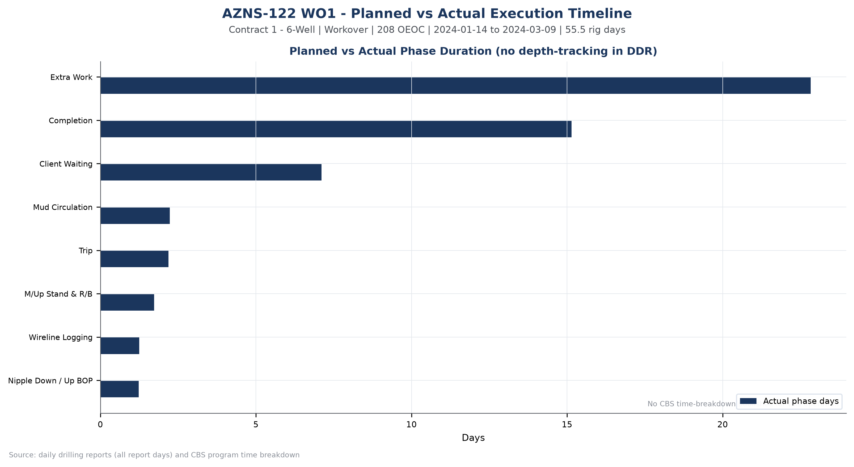
Figure W1 — Planned vs actual execution timeline, AZNS-122 WO1

Chronological Operational Narrative
The operation is documented over 56 report days. The following monthly roll-up summarises activity volume, productive output and unplanned time; the paragraphs that follow narrate the operation in sequence and isolate the days on which NPT reached or exceeded twelve hours.
Month | Report days | NPT (h) | Progress (m)
2024-01 | 18 | 58 | 0.0
2024-02 | 29 | 113 | 0.0
2024-03 | 9 | 17 | 0.0
Table 3-1 Monthly execution roll-up.
The dominant activity families of the operation were Extra Work (548 h), Completion (364 h), Client Waiting (170 h), Mud Circulation (54 h). Their share of productive time defines the operational character of the well: a clean-out and completion-dominated workover.

Critical days with NPT of twelve hours or more
Date | Day | NPT (h) | Dominant cause | Field record (extract)
2024-01-30 | 17 | 24.0 | Fishing / Milling | Wait on client's decision while POOH w/ 7-5/16''Polish mill F/ 3778m to 1000m W/ NL-NG till M.N.
2024-01-31 | 18 | 24.0 | Waiting on Material / Approval | Wait on receive logging crew (cast log) since 00:00, 31-01-2024 while slow circ. Mud @ 1000m w/ NL-NG @R.T.
2024-02-01 | 19 | 24.0 | Waiting on Weather / Service | Wait on client's decision for corrosion of 9-5/8''csg & next plan while P/U & M/U 7’’ SN Packer Assy included: 7" Seal Nipple (PPA Co,
2024-02-02 | 20 | 24.0 | Waiting on Weather / Service | While Wait on client's decision for corrosion of 9-5/8''csg & next plan, POOH w/ setting tools of 7"SN Packer f/3778m (7" L.Lap) to135m,
2024-02-03 | 21 | 24.0 | Fishing / Milling | While Wait on client's decision for corrosion of 9-5/8''csg & next plan, POOH W/ 6"M.M J.Mill f/3928.5m to 1750m meanwhile circ.
2024-02-04 | 22 | 22.0 | Fishing / Milling | While Wait on client's decision for corrosion of 9-5/8''csg & next plan, Cont. RIH W/ 7-5/16'' Dress Mill f/1000 to 3770m(above 7" L.LAP),
Table 3-2 Days with NPT of twelve hours or more.
These days concentrate the operational risk of the well. The field record shows that the unplanned time arose from Waiting on Weather / Service (84 h); Fishing / Milling (82 h); Waiting on Material / Approval (22 h), and the sequence matters more than any single entry: each event consumed a full reporting cycle before recovery work could start.
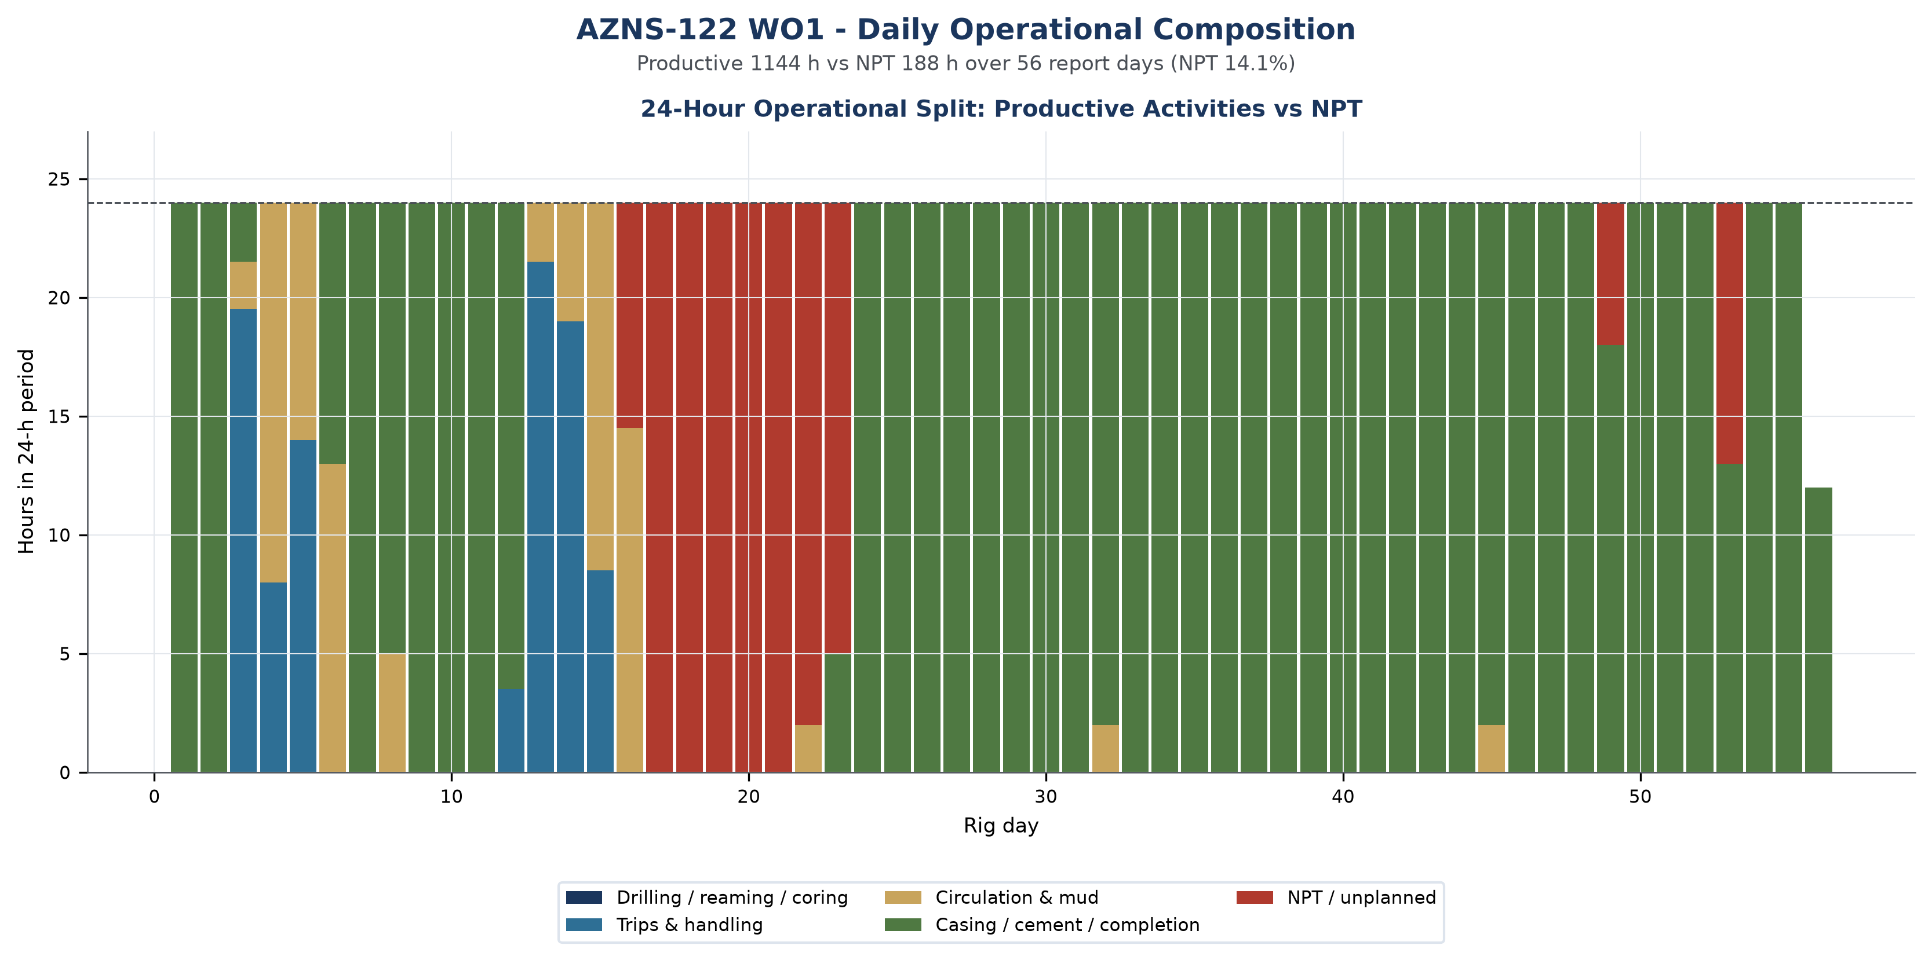
Figure W2 — Daily 24-hour operational composition, AZNS-122 WO1

Day-by-day reconstruction
Splitting the operation into three equal reporting blocks shows how the character of the work changed over time, and it is the most compact way to see whether unplanned time was a transient disturbance or a persistent condition.
Reporting block | Days | NPT (h) | NPT share | Progress (m) | Depth at end (m)
2024-01-14 to 2024-01-31 | 18 | 58 | 13.3% | 0.0 | 4,208
2024-02-01 to 2024-02-19 | 19 | 113 | 24.8% | 0.0 | 4,208
2024-02-20 to 2024-03-09 | 19 | 17 | 3.8% | 0.0 | 4,208
Table 3-3 Execution in three reporting blocks.
In the opening block (2024-01-14 to 2024-01-31, 18 days) the operation established the well condition and executed no new hole with 58 h of unplanned time, a share of 13.3%. Unplanned time was already present at this stage, which points to a condition inherited with the well rather than to a deterioration introduced later.
The middle block (2024-02-01 to 2024-02-19) carried 113 h of unplanned time at 24.8%, and the closing block (2024-02-20 to 2024-03-09) carried 17 h at 3.8%. The improvement towards the end of the operation is the signature of a crew and a supervision team that had learned the well, and it is the rate that should be carried into the next operation on the same pad.

Performance and Parameter Analysis
Performance is evaluated on the activity mix, on penetration behaviour where the daily reports carry rate data, and on the bit records recovered from the DDR bit-data block. For this operation the productive time was 1,144 hours and the unplanned time 188 hours.
Activity family | Hours | Share of total time
Extra Work | 548 | 41.1%
Completion | 364 | 27.3%
Client Waiting | 170 | 12.8%
Mud Circulation | 54 | 4.0%
Trip | 52 | 3.9%
M/Up Stand & R/B | 42 | 3.1%
Wireline Logging | 30 | 2.3%
Nipple Down / Up BOP | 30 | 2.2%
Service Waiting | 17 | 1.3%
1. Rigging & Moving | 15 | 1.1%
Table 4-1 Activity time distribution.
The daily reports of this operation do not carry a continuous penetration record; this is consistent with a workover in which the string re-enters an existing completion rather than making new hole. Performance is therefore expressed through phase duration, intervention effort and the depth of the deepest reached interval, not through ROP.
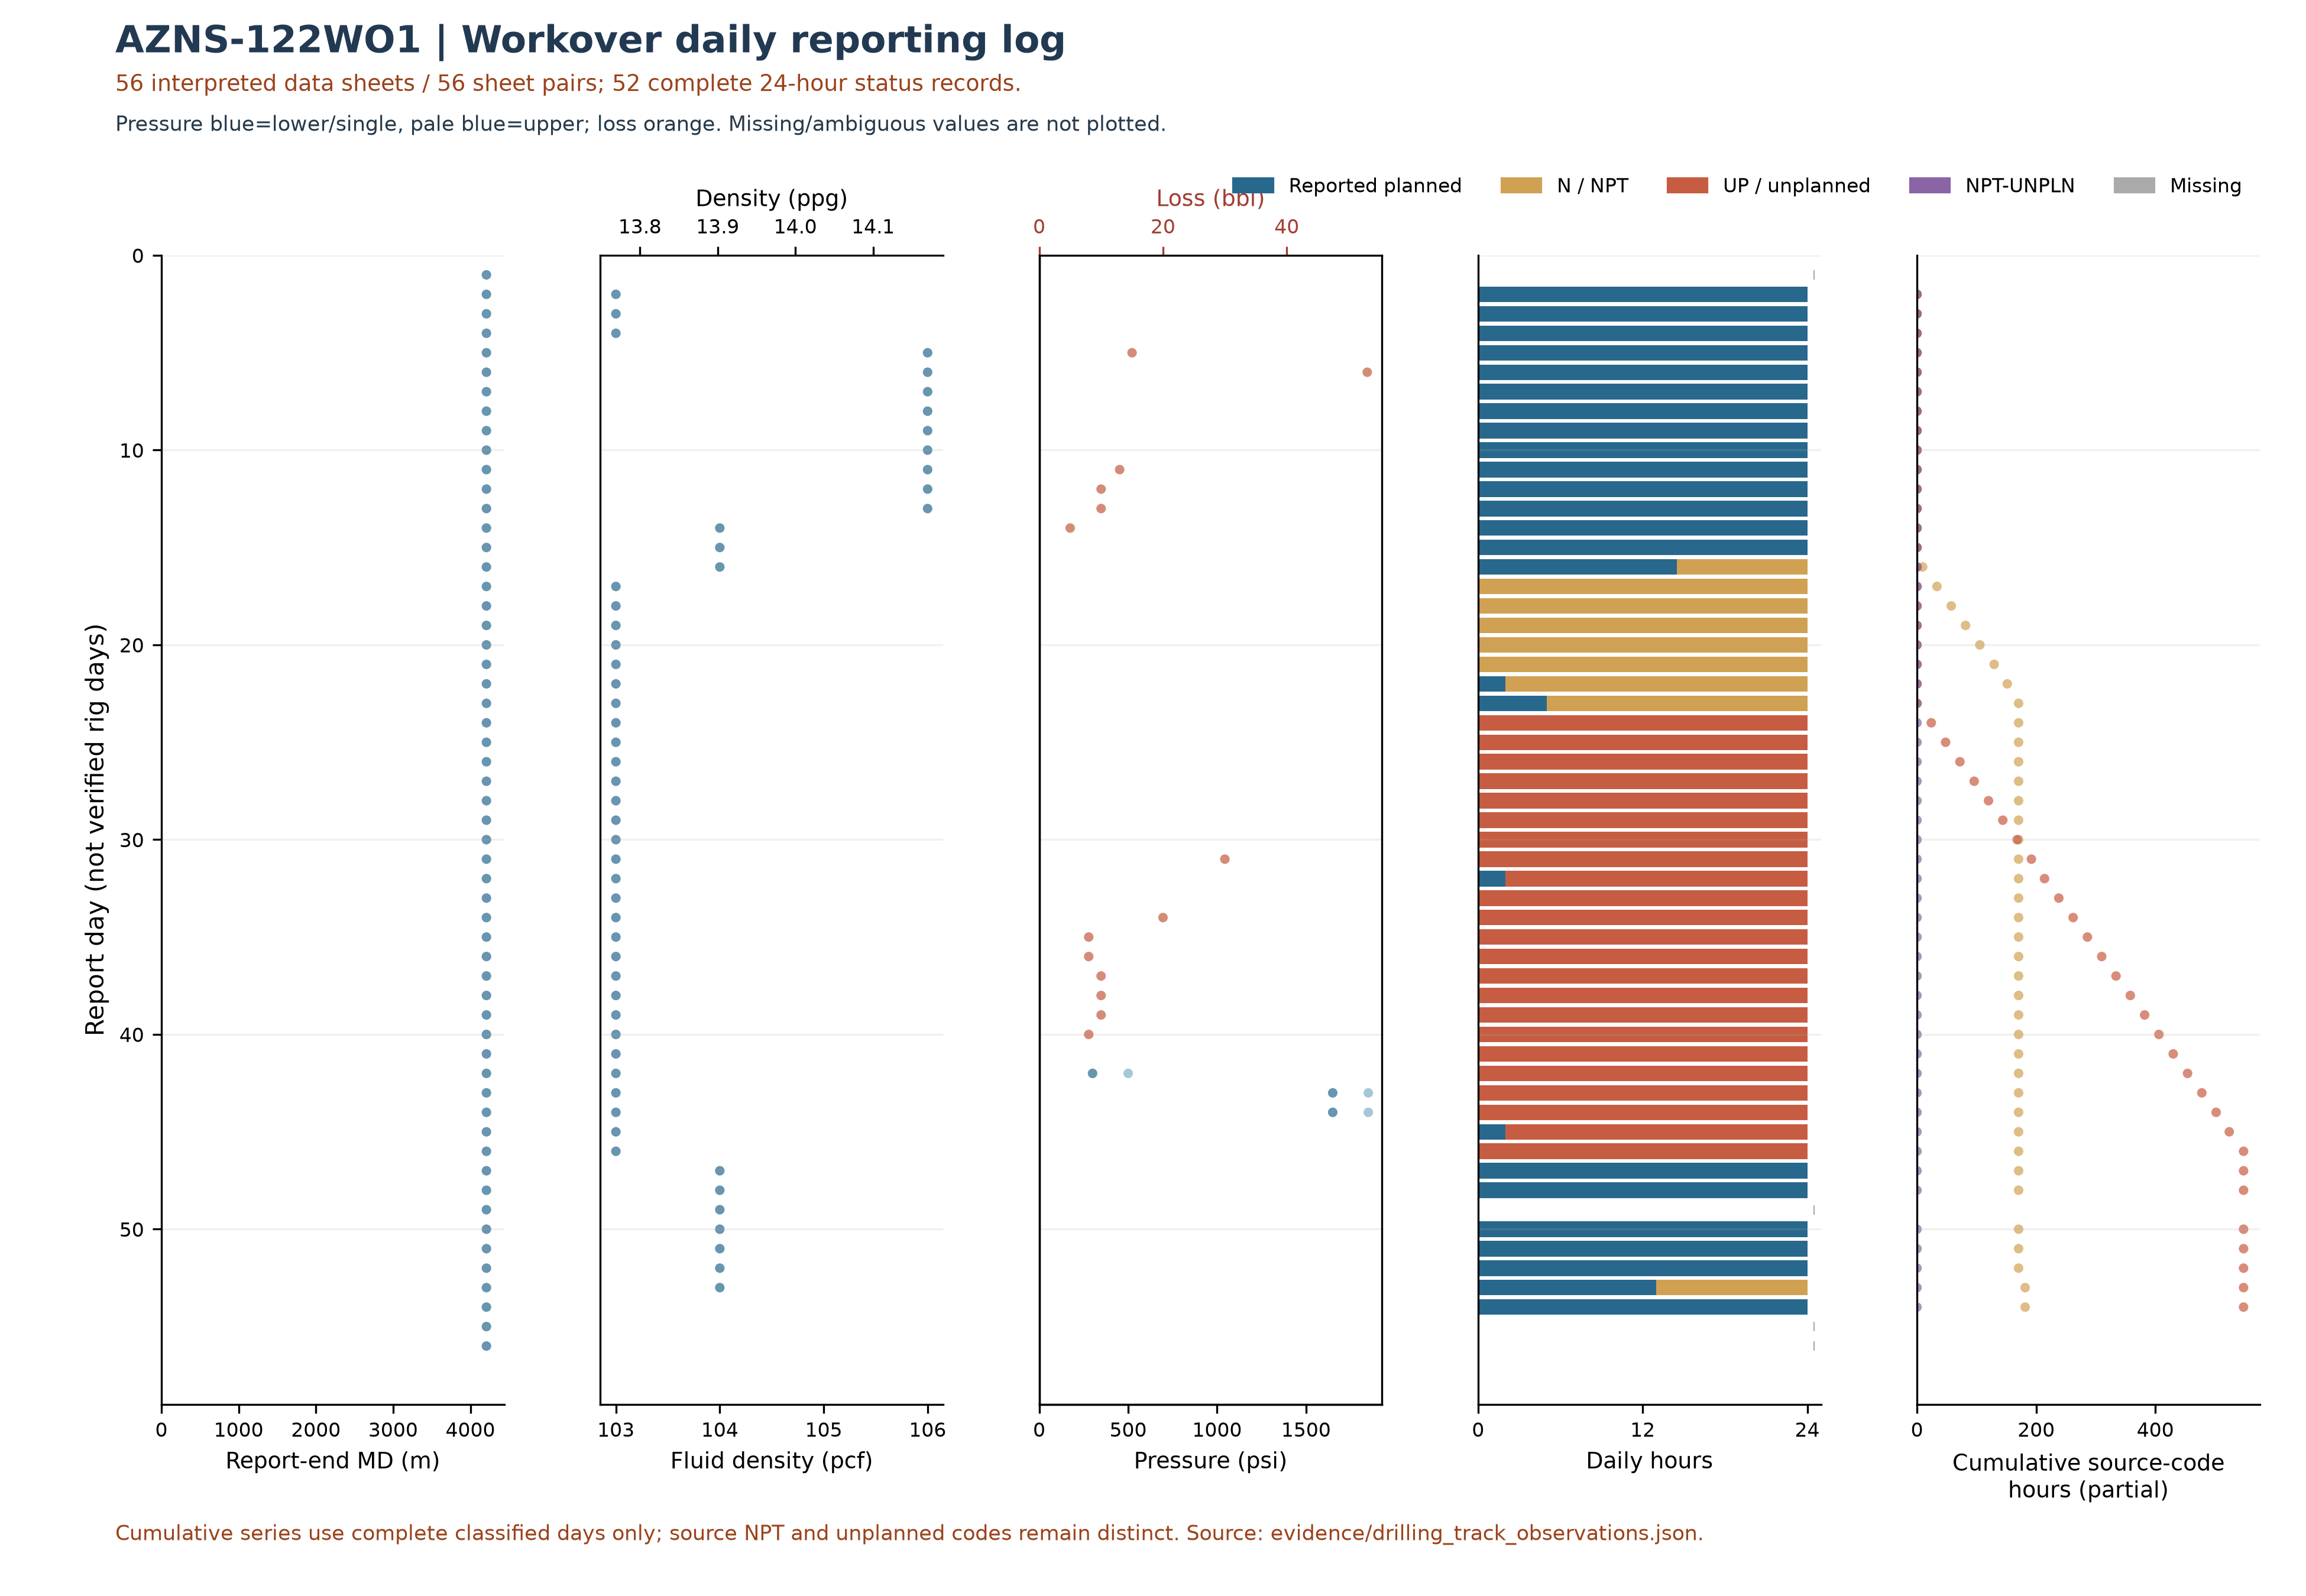
Figure W3 — Workover daily source observations by report day, AZNS-122WO1
The workover log uses only 56 recognized data sheets of 56 sheet pairs and 52 reports with classified durations totaling approximately 24 hours. Unknown values are not treated as zero. Planned does not necessarily mean productive; cumulative code totals include only complete classified days; NPT and unplanned remain distinct and these are not verified total NPT or work progress. Report-end depth is not necessarily tool or incident depth.
Bit | Size (in) | Type | Drilled (m) | Hours | Dull grade
1 | 6 | R.Bit | n/a | n/a | -
- | - | 7-5/16''POLISH MIL | n/a | n/a | -
- | 6" | M.M J.MILL | n/a | n/a | -
- | 7-5/16" DRESS MILL | - | n/a | n/a | -
- | 6" M.M J.Mill | - | n/a | n/a | -
- | 6" M.M.J Mill | - | n/a | n/a | -
1 RR#2 | 6" | HAT117G | n/a | n/a | -
2 R#1 | 8-1/2" | HJT517GL | n/a | n/a | -
Table 4-2 Bit runs recovered from the daily reports.
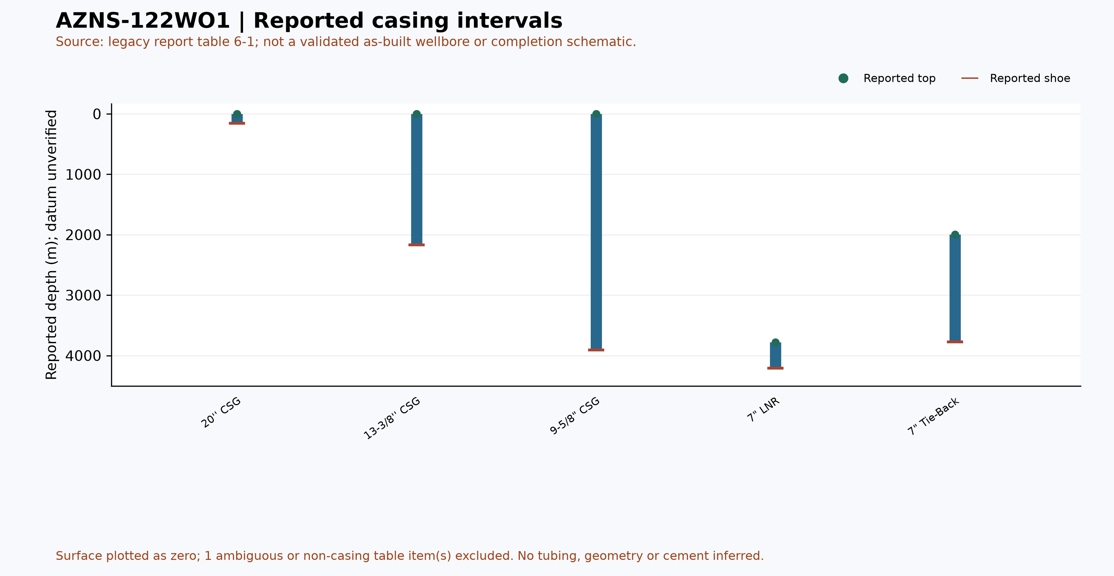
Figure W6 — Reported casing intervals from table 6-1, AZNS-122WO1 (not an as-built schematic)

Drilling Fluid Engineering and Loss Accounting
Mud weight in this archive is recorded in pounds per cubic foot, the unit used on the daily report of the South Azadegan project. For engineering comparability each record is also expressed in pounds per gallon (ppg = pcf / 7.48052) and as a hydrostatic gradient (psi/ft = pcf / 144). The table below reports the envelope actually observed in this operation; no pcf value is presented as ppg anywhere in this report.
Mud weight envelope | pcf | ppg | Gradient (psi/ft) | SG equivalent
Minimum | 103.0 | 13.8 | 0.715 | 1.65
Median | 103.0 | 13.8 | 0.715 | 1.65
Maximum | 106.0 | 14.2 | 0.736 | 1.70
Table 5-1 Mud weight statistics with unit conversion.
Property | Min | Median | Max | Records
PV (cp) | 15.0 | 17.0 | 25.0 | 45
YP (lb/100ft²) | 10.0 | 13.0 | 22.0 | 45
Gel 10 s | 3.0 | 4.0 | 5.0 | 45
Gel 10 min | 5.0 | 6.0 | 8.0 | 45
pH | 9.0 | 9.4 | 10.7 | 45
Chloride (mg/l) | 150,000.0 | 160,000.0 | 174,000.0 | 45
Solids (% vol) | 29.0 | 29.0 | 55.0 | 42
Table 5-2 Rheology envelope.
Total fluid loss recorded against the formation is 210 bbl over 14 report days, with a maximum single-day loss of 53.0 bbl. The fluid system in use was not declared in the report.

Completion, Casing and Service-Module Findings
Casing / liner | Grade | Weight | Thread | Top (m) | Shoe (m)
20'' CSG | K-55 | 94 | BTC | Surface | 155
13-3/8'' CSG | N-80 | 68 | BTC | Surface | 2169
9-5/8" CSG | C-110 | 47 | TPCQ | Surface | 3909.5
7" LNR | 110S | 29 | TPCQ | 3782 | 4208
7" SN PKR | L-80 | 29 | TPCQ | 3775.4 | 3778
7" Tie-Back | L-80 | 29 | TPCQ | 1998 | 3775.4
Table 6-1 Casing and liner tally.
Personnel on board averaged 135.8 and peaked at 213 during the operation, a figure that matters for accommodation, catering and safety-case loading of the contract.
The bonus panel below collects the modules that are specific to this well: casing and liner seat depths, service-cost line items from the CBS sub-tabs and the distribution of activity effort across the operation. Where a module is absent the panel states it rather than displaying an empty axis.
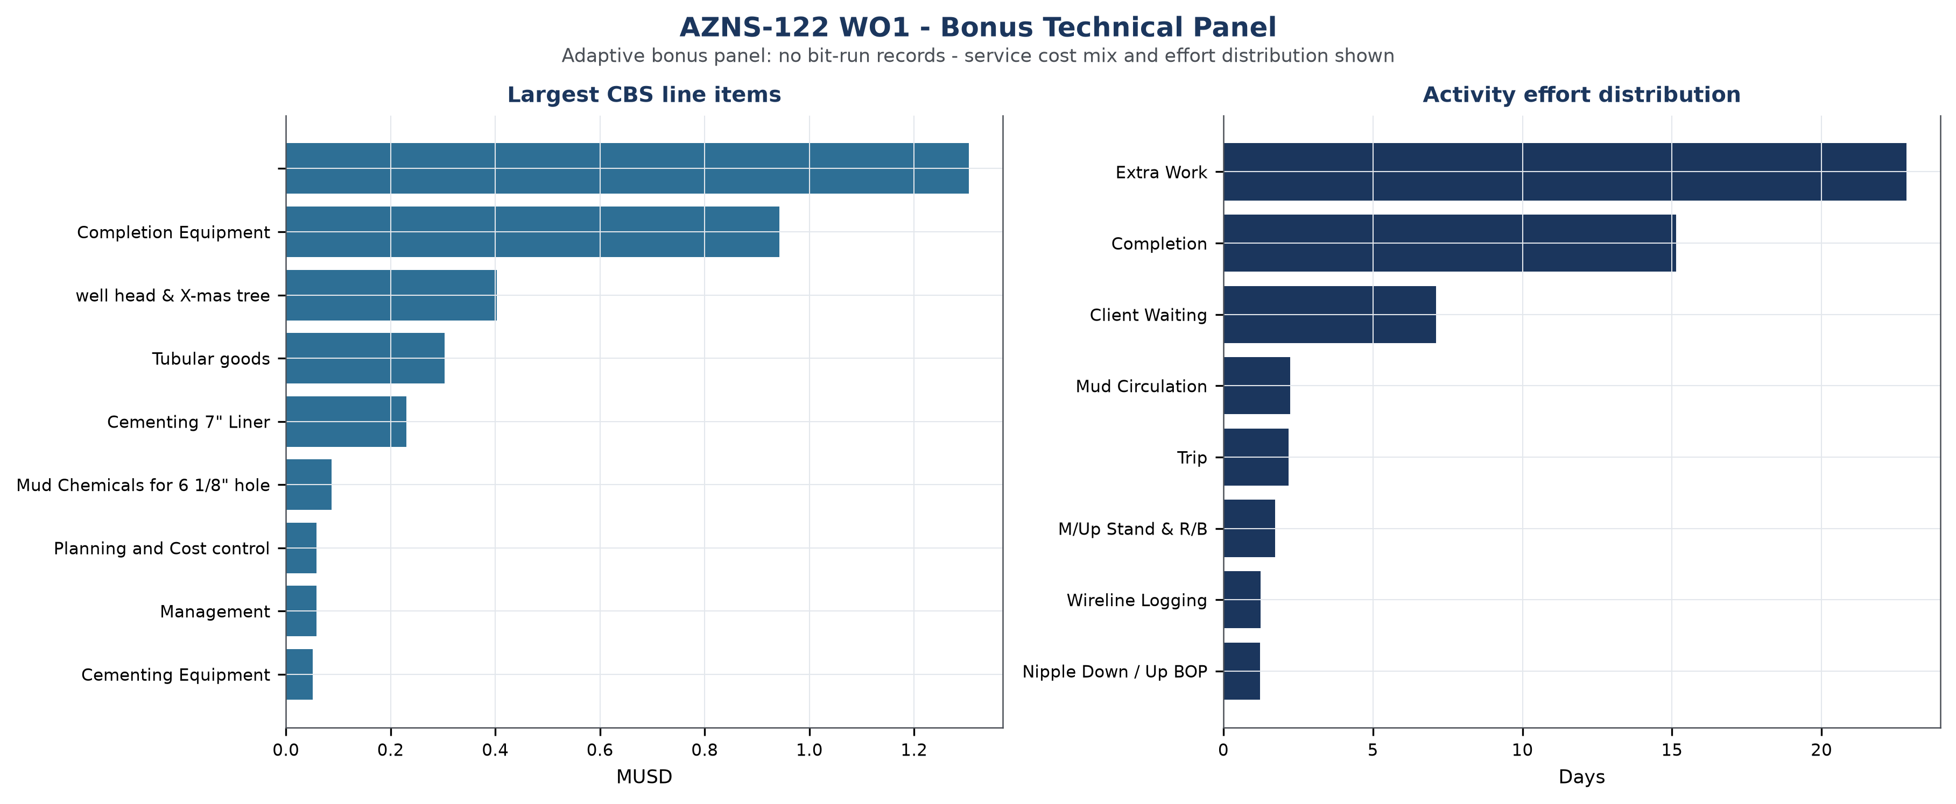
Figure W7 — Bonus technical panel, AZNS-122 WO1

Root-Cause Analysis and Three-Dimensional NPT Attribution
Every unplanned interval is classified on three axes: technical root cause, phase of the operation, and the party responsible under the contract. Attribution follows the field record and the NPT attribution field of the daily report; where the record names the rig contractor the hours are carried against OEOC, where it names a service company they are carried against that service line, and residual time is reported as unattributed rather than assigned by assumption.
Technical root cause | Hours | Share of NPT
Waiting on Weather / Service | 84 | 44.5%
Fishing / Milling | 82 | 43.7%
Waiting on Material / Approval | 22 | 11.7%
Table 7-1 NPT by technical root cause.
Responsible party / contractor | Attributed hours | Financial exposure (USD)
Third-party Service | 106 | Not verified
OEOC / Downhole Tools | 82 | Not verified
Table 7-2 Attribution by responsible party.
Operational phase | NPT hours | Share of NPT
Client Waiting | 170 | 90.9%
Service Waiting | 17 | 9.1%
Table 7-3 NPT by operational phase.

Mechanism analysis of the major incidents
Incident 1 — Waiting on Material / Approval (22.0 hours, 2024-01-31). Field record: Wait on receive logging crew (cast log) since 00:00, 31-01-2024 while slow circ. Mud @ 1000m w/ NL-NG @R.T.
• A programme change that required client approval before the next operation could start, with the rig standing by in the interim.
• A tubular or consumable shortage at the wellsite because the call-off was raised later than the lead time of the item.
Incident 2 — Waiting on Weather / Service (20.0 hours, 2024-02-01). Field record: Wait on client's decision for corrosion of 9-5/8''csg & next plan while P/U & M/U 7’’ SN Packer Assy included: 7" Seal Nipple (PPA Co,
• A service company mobilisation that arrived later than the call-out because the equipment was engaged on another well of the same campaign, so the rig remained on standby.
• A material shortage at the wellsite, where the required tubular or consumable was not in stock and the operation could not proceed without it.
• Adverse weather or visibility limiting crane and lifting operations, which is documented in the daily report and affects the whole spread rather than a single contractor.
Incident 3 — Waiting on Weather / Service (11.0 hours, 2024-02-02). Field record: While Wait on client's decision for corrosion of 9-5/8''csg & next plan, POOH w/ setting tools of 7"SN Packer f/3778m (7" L.Lap) to135m,
• A service company mobilisation that arrived later than the call-out because the equipment was engaged on another well of the same campaign, so the rig remained on standby.
• A material shortage at the wellsite, where the required tubular or consumable was not in stock and the operation could not proceed without it.
• Adverse weather or visibility limiting crane and lifting operations, which is documented in the daily report and affects the whole spread rather than a single contractor.
No verified financial cost has been assigned to the legacy NPT attribution. Rates, scope and contractual responsibility require reconciliation.
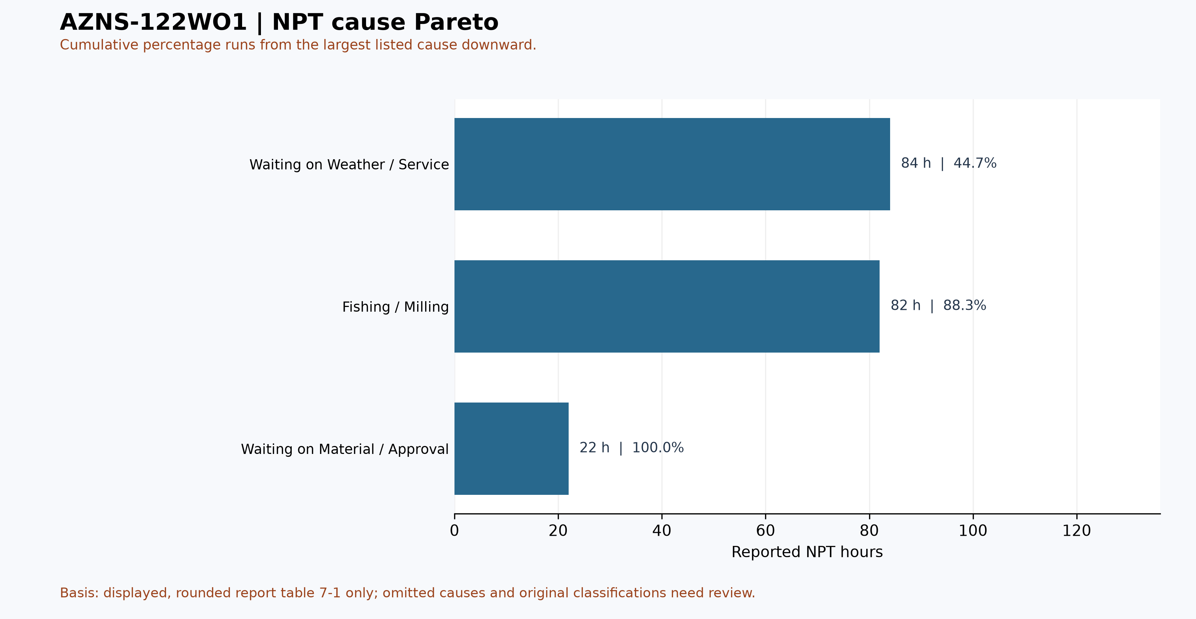
Figure W4 — Pareto of causes listed in table 7-1, AZNS-122WO1

CBS Financial Analysis and Provisional Cost Categories
Table 8-2 source: CBS AZNS-122WO1.xlsx / Cost Breakdown-122. The two values per row are source total and extra-work columns; additivity is not established. These cached source amounts are not actual expenditure or an approved comparable budget. Missing or erroneous values are not zeros; rates, scope, formulas and approvals require reconciliation. No daily expenditure series has been verified.
Source / scope | Cached value | Cell / sheet
Cached main-sheet total; scope unverified | 4,587,374.50 | G190 / Cost Breakdown-122
Extra-work column total | 1,304,440.02 | H190 / Cost Breakdown-122
Table 8-1 Source financial and schedule anchors (unreconciled).
Source category | Source amount (USD) | Amount cell
Rig service | 1,035,000.00 / 547,170.00 | G5 / H5
Drilling fluids | 129,643.00 / 109,485.02 | G6 / H6
Cementing | 37,500.00 / 282,187.50 | G13 / H13
Mud logging | 50,287.50 / 32,407.50 | G20 / H20
Wireline logging | 53,235.00 / 0.00 | G24 / H24
Drilling waste management | — / 28,850.00 | G62 / H62
Directional drilling | — / — | G74 / H74
Casing running | 25,350.00 / 47,000.00 | G87 / H87
Temporary well suspension | — / — | G95 / H95
Slickline | 12,799.00 / 0.00 | G99 / H99
Completion running | 15,000.00 / 0.00 | G102 / H102
Liner hanger running | — / 3,900.00 | G113 / H113
H2S service | 9,450.00 / 6,090.00 | G122 / H122
Perforation | 115,600.00 / 0.00 | G125 / H125
Wellhead services | 9,000.00 / 0.00 | G130 / H130
Dry test services | 13,875.00 / 0.00 | G134 / H134
Rig / completion services | 1,147,000.00 / 53,650.00 | G137 / H137
Other services | 22,500.00 / 14,500.00 | G147 / H147
Cleanup services | — / — | G151 / H151
Drilling materials | 1,692,635.00 / 56,700.00 | G158 / H158
Project management | 180,000.00 / 116,000.00 | G167 / H167
Engineering | 28,500.00 / 6,500.00 | G170 / H170
Tubing inspection | — / — | G180 / H180
Wellhead / tree inspection | 5,000.00 / 0.00 | G188 / H188
Downhole completion inspection | 5,000.00 / 0.00 | G189 / H189
Table 8-2 CBS source categories and cell references (unreconciled).
Topic | Observation | Source reference | Action
Scope / actuals | Values are not actual invoices or an approved comparable ceiling. | Source sheet and formulas | Reconcile
Table 8-3 CBS reconciliation checks.
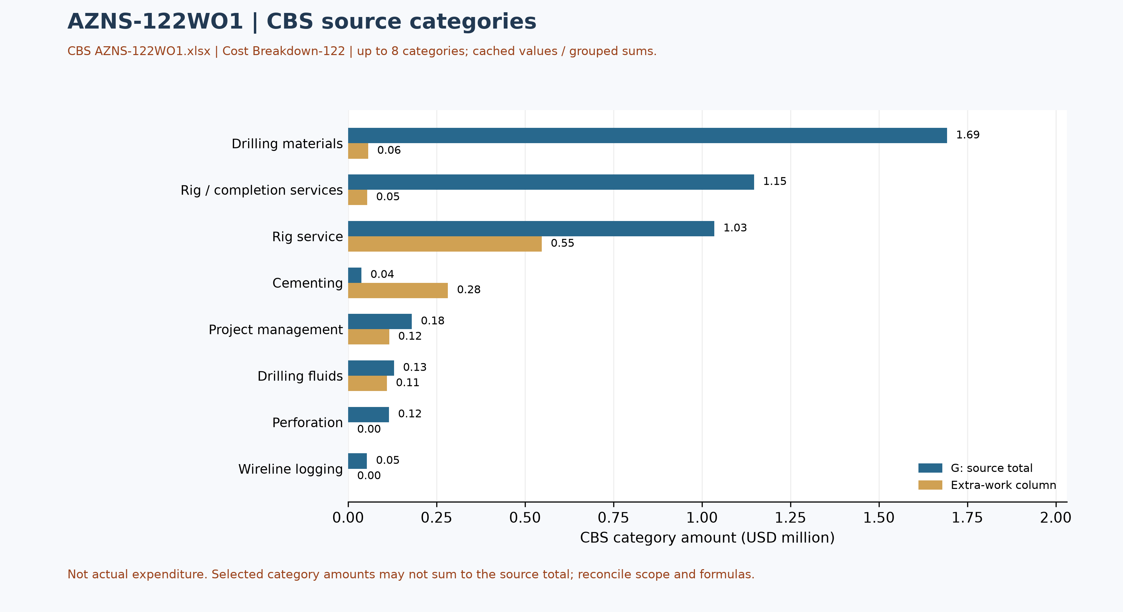
Figure W5 — CBS source cost categories, AZNS-122WO1 (unreconciled)

Section-Wise Optimum Parameters and Field Recommendations
The envelopes below are the operating windows recommended for the next campaign on the basis of what this operation demonstrated, both where it performed as designed and where it did not. The observed mud weight envelope of this well (103.0 – 106.0 pcf, equivalent to 13.8 – 14.2 ppg) is consistent with the recommended windows and confirms the unit convention used on the project.
Operation stage | Recommended parameter envelope | Engineering intent
Well killing / bullheading | kill fluid 1.02 – 1.05 x pore pressure; density stated in pcf and ppg | Hold well overbalance without exceeding the fracture gradient of the existing completion interval
Milling and clean-out | WOB 5 – 15 klbs, 60 – 90 rpm, flow 400 – 650 gpm, torque monitored continuously | Keep the mill loaded lightly and the hole clean; avoid packing off in the liner lap
Fishing | Jar load within 60 – 80% of string yield; maximum pull below the limit of the weakest joint | Protect the string while maximising impact energy at the fish
Coiled tubing / nitrogen | CT speed 15 – 25 m/min, N2 rate staged to achieve 300 – 500 psi underbalance | Lift the well without drawdown shock to the formation
Completion running | Running speed 15 – 20 stands/hour, torque-turn recording on every connection | Protect seal bores and avoid buckling in the horizontal section
Table 9-1 Recommended parameter envelopes.

Actionable recommendations
- Establish a joint root-cause review for Waiting on Weather / Service and Fishing / Milling, the two largest contributors to unplanned time, with a named owner from the drilling contractor and from the service line, and a closure date before the next well spuds.
- Set future-well cost benchmarks only from validated contracts and cost records on a comparable scope.
- Carry a pre-mixed LCM pill and a loss-tolerant mud programme on every well of this pad; the recorded loss of 210 bbl shows the formation accepts fluid faster than the current bridging strategy controls.
- Convert the intervention sequence of this well into a standard workover time template; the deviation from the programme was driven by repeated recovery cycles that a template with contingency steps would have anticipated.
- Hold the well hand-over meeting with the completion and production teams before release so that the next intervention does not rediscover the well condition documented in this report.

Risk Register and Mitigations
The register below converts the evidence of this operation into forward-looking controls. Each row is tied to a documented exposure in the daily record, and the owner is the party who already carries the corresponding contractual responsibility.
Risk | Evidence / trigger | Mitigation | Owner | Severity
Unplanned time recurrence (Waiting on Weather / Service) | Any NPT interval exceeding four hours in a reporting cycle | Daily NPT challenge at handover; root-cause review within 72 hours | Drilling superintendent | High
Service-line mobilisation delay | 106 h already recorded under waiting on weather and service | Call-off protocol with 72-hour mobilisation guarantee and standby rate | Contracts | High
Rig equipment availability | 0 h recorded under rig mechanical and electrical | Preventive maintenance window aligned to tripping; critical spares on site | Drilling contractor | Medium
Loss of circulation | 210 bbl of recorded loss | LCM pill on standby; loss-tolerant mud programme; ECD monitoring | Mud service | Medium
Budget / scope reconciliation | Actual cost and budget scope not yet comparable | Reconcile invoices, contract and scope | Cost engineering | Medium
Data continuity | Source coverage and quality require separate review | Require the missing modules in the next well hand-over checklist | Data management | Low
Table 10-1 Risk register.

Data Provenance and Cell-Level Traceability
Every quantitative statement in this report resolves to a workbook, a worksheet and a cell. The table below lists the primary anchors used in the reconstruction; the remainder follows the same convention and is reproducible from the archive without manual interpretation.
Data element | Archive anchor (file -> sheet!cell)
well_name | 1-1 Remark!C5
client | 1-1 Remark!H5
rig | 1-1 Remark!C6
field | 1-1 Remark!C7
hole_section | 1-1 Remark!C8
well_type | 1-1 Remark!C9
report_date | 1-1 Remark!N5
spud_date | 1-1 Remark!N6
est_days | 1-1 Remark!N8
act_days | 1-1 Remark!N9
depth:project_md | 1-2 Data!D15
depth:morning_depth | 1-2 Data!D16
depth:midnight_depth | 1-2 Data!D17
depth:prev_depth | 1-2 Data!D18
CBS cost breakdown | CBS AZNS-122WO1.xlsx -> sheet "Cost Breakdown-122"
Well programme | AZNS-0122 Workover-1 Program Rev.07.pdf
Table 11-1 Provenance anchors.

Appendix: source formation-table snapshot (unverified)
Source: AZNS122WO1Pack.xlsx, sheet 56-2 Data. Selected as the last sheet in workbook order with a recognized formation table containing a numeric depth; if none, the last table with formation names. This is not necessarily the latest dated report.
Column roles follow the source labels, not independent confirmation of prognosis or measurement. Unlabelled populated cells are shown separately; missing cells are unknown, not zero. Values are rounded to four decimals for display. Verify row alignment, depth datum, possible inconsistencies and lithology against the programme and geological report; this table alone does not establish event attribution or operating instructions.
Source table and anchor: Formation Geology Data / N109
Formation / cell | Source values / cell
Aghajari / K111 | Act. MD (m.): Surface [O111]  Act. TVD (m.): 1095.9 [Q111]  Lithology: S.St, Clst. [R111]
Gachsaran / K112 | Act. MD (m.): 1095.9 [O112]  Act. TVD (m.): 1461 [Q112]  Lithology: Anhy, RD Mrl, Gr Mrl [R112]
Asmari / K113 | Act. MD (m.): 1461 [O113]  Act. TVD (m.): 1728 [Q113]  Lithology: S.St, Lst [R113]
Pabdeh / K114 | Act. MD (m.): 1728 [O114]  Act. TVD (m.): 2196 [Q114]  Lithology: Mrl, Clst, Shale, cht [R114]
Gurpi / K115 | Act. MD (m.): 2196 [O115]  Act. TVD (m.): 2536 [Q115]  Lithology: Arg lst [R115]
Ilam / K116 | Act. MD (m.): 2536 [O116]  Act. TVD (m.): 2626 [Q116]  Lithology: Lst, Sh, Clst, Mrl [R116]
Laffan / K117 | Act. MD (m.): 2626 [O117]  Act. TVD (m.): 2633 [Q117]  Lithology: Clst, Lst [R117]
Sarvak / K118 | Act. MD (m.): 2633 [O118]  Act. TVD (m.): 3278 [Q118]  Lithology: Lst [R118]
Kazhdumi / K119 | Act. MD (m.): 3278 [O119]  Act. TVD (m.): 3481 [Q119]  Lithology: Lst [R119]
Dariyan / K120 | Act. MD (m.): 3481 [O120]  Act. TVD (m.): 3647 [Q120]  Lithology: Lst [R120]
Gadvan / K121 | Act. MD (m.): 3647 [O121]  Act. TVD (m.): 3937 [Q121]  Lithology: Lst, Clst, Arg Lst [R121]
Fahliyan / K122 | Act. MD (m.): 3937 [O122]  Act. TVD (m.): 4208 [Q122]  Lithology: Lst [R122]

