ENGINEERING REVIEW WARNING — This legacy report is not validated for operational or financial decisions. The former linear cumulative-cost chart was removed; a verified daily cost series is not yet available; other charts, budgets and cause/formation attribution require reconstruction and reconciliation to source records. See the repository review note for the limited corrections made.
AZNS-122 WO2
Drilling, Workover and Well-Intervention Engineering Report
Technical, Operational, Contractual and Financial Analysis
Prepared for the South Azadegan Field Development — Contract 2 - 4+1 Well

Item | Value
Well / operation | AZNS-122 WO2
Contract | Contract 2 - 4+1 Well
Operation type | Workover / Completion
Rig | 201 OEOC (OEOC)
Client / operator | PPL
Execution window | 2024-10-25 to 2025-02-24
Reporting days | 121
Source archive | CBS AZNS-122WO2.xlsx (+ AZNS-0122 Workover-2 Program Rev.00.pdf)

Document control | Record
Document code | AZNS-122WO2-DER-001
Revision / status | 00 - Issued for information
Issue date | 04 November 2026
Prepared by | Drilling Engineering - Well Performance Team
Checked by | Senior Drilling Engineer
Approved by | Drilling Manager, South Azadegan Development
Distribution | Client, drilling contractor, cost engineering, well archive
Table 0-1 Document control and distribution.
This interim report compiles available records; its legacy analyses are not independently validated.

Executive KPI Summary
KPI | Value
Contract / operation type | Contract 2 - 4+1 Well | Workover / Completion
Rig and contractor | 201 OEOC | OEOC
Spud to release | 2024-10-25 to 2025-02-24 (121 report days)
Planned vs actual duration | 97.5 vs 121.0 rig days (124.0%)
Depth reached | 4,208 m MD
Productive vs NPT | 2,505 h productive / 400 h NPT (13.8% NPT)
Cost (actual vs CBS budget) | Pending reconciliation to actual cost records
Cost variance | Pending reconciliation to actual cost records
Average burn rate | Pending reconciliation to actual cost records
Financial cost of NPT | Pending reconciliation to actual cost records
Total mud losses | 314 bbl
Drilling fluids density | 101.0 – 110.0 pcf (13.5 – 14.7 ppg)

Legacy duration and NPT figures in this report remain subject to source reconciliation. Actual expenditure is not established.

Contents
No. | Section
1 | Well identity, rig assignment and data inventory
2 | Planned versus actual execution reconciliation
3 | Chronological operational narrative and day-by-day reconstruction
4 | Performance and parameter analysis
5 | Drilling fluid engineering and loss accounting
6 | Completion, casing and service-module findings
7 | Root-cause analysis and three-dimensional NPT attribution
8 | CBS financial analysis and reconstructed cumulative cost
9 | Section-wise optimum parameters and field recommendations
10 | Risk register and mitigations
11 | Data provenance and cell-level traceability

Figures and tables are numbered by section and are listed in place.

Well Identity, Rig Assignment and Data Inventory
The operation AZNS-122 WO2 was executed with rig 201 OEOC under the Contract 2 - 4+1 Well. The archive holds 121 daily drilling reports covering 2024-10-25 to 2025-02-24, complemented by the cost breakdown structure ("CBS AZNS-122WO2.xlsx") and the well programme ("AZNS-0122 Workover-2 Program Rev.00.pdf"). All datasets were parsed cell by cell; the inventory below states exactly which data modules exist for this well and which do not, so that every analytical statement in this report rests on traceable evidence.

Static identity
Field | Recorded value
Well name in daily report | Work over#2, AZNS-122
Well type declaration | Development
Field | AZNS
Client | PPL
Drilling contractor | OEOC
Rig | 201 OEOC
Operation classification | Workover / Completion
Hole section / scope declaration | as per programme
Spud / first report date | 2024-10-25
Release / last report date | 2025-02-24
Table 1-1 Static well identity.

Data inventory discovered for this operation
Dataset module | Records found
DDR daily reports | 121
Cost breakdown (CBS) | 1
EPD budget ceiling | 1
Program time breakdown | 1
Casing tally | 6
Bit records | 18
Survey stations | 26
Mud weight records | 121
Mud loss records | 13
NPT events (>=3h) | 27
Rig-less stimulation CBS | 1
Service sub-tabs | 10
Well program PDF | 1
Table 1-2 Core and auto-discovered bonus modules.
Modules reported as absent were genuinely unavailable in the archive of this well; no value has been imputed or substituted. Where a module is missing, the corresponding analysis in this report is replaced by an adaptive alternative rather than an empty panel.

Planned versus Actual Execution Reconciliation
The planned envelope of this operation is taken from two independent references: the CBS time breakdown for scope and duration (CBS time-breakdown "AZNS-122 WO"), and the well programme document (AZNS-0122 Workover-2 Program Rev.00.pdf). Actual execution is reconstructed from the 121 daily reports. Comparing the two sides isolates schedule drift, scope growth and productive-time loss.
Reconciliation metric | Planned | Actual | Variance
Duration (rig days) | 97.5 | 121.0 | +23.5 d
Depth reached / target (m MD) | n/a | 4,208 | n/a
Cost (USD) | Not reconciled | Not reconciled | Not reconciled
Cost per rig day (USD) | Not reconciled | Not reconciled | Not reconciled
NPT share of rig time (%) | 0.0% | 13.8% | 13.8%
Table 2-1 Planned versus actual reconciliation.
The execution consumed 121.0 rig days against a planned 97.5, a schedule ratio of 124.0%. The operation therefore overran the programme envelope, and the causes are traced in the NPT chapter rather than attributed to a single event.
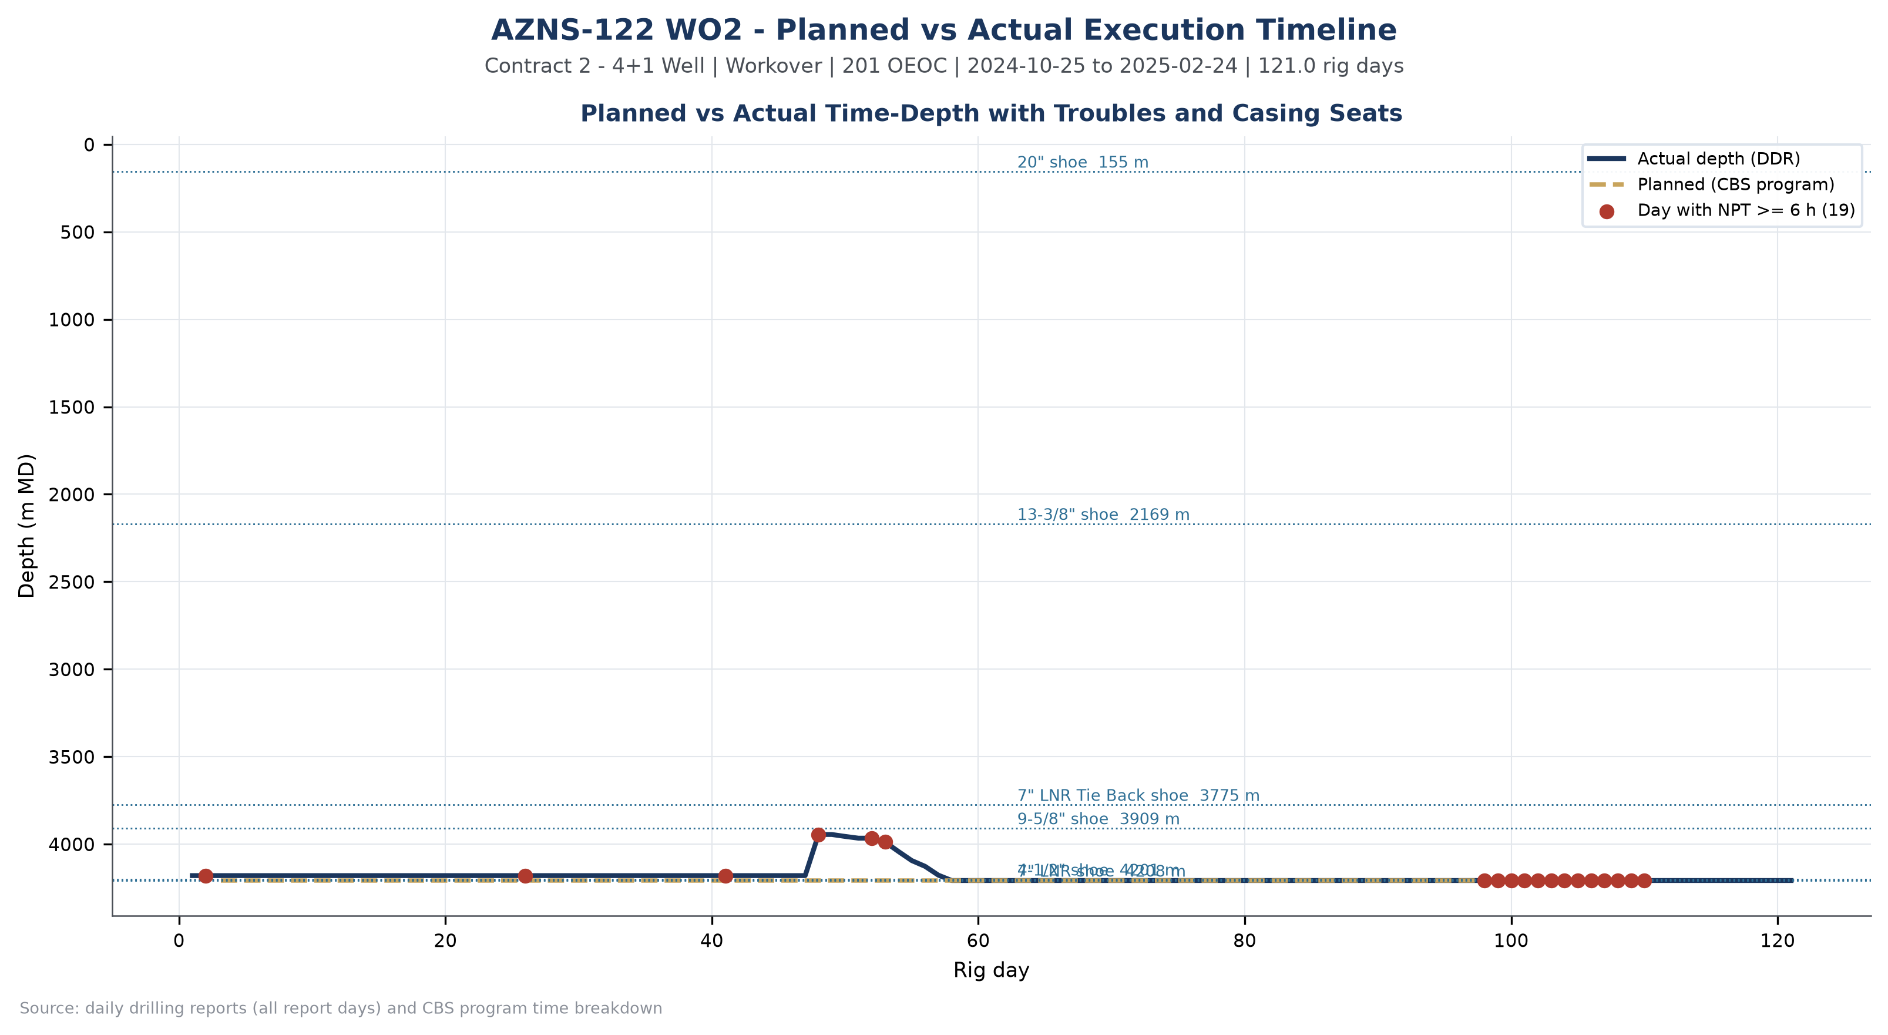
Figure W1 — Planned vs actual execution timeline, AZNS-122 WO2

Chronological Operational Narrative
The operation is documented over 121 report days. The following monthly roll-up summarises activity volume, productive output and unplanned time; the paragraphs that follow narrate the operation in sequence and isolate the days on which NPT reached or exceeded twelve hours.
Month | Report days | NPT (h) | Progress (m)
2024-10 | 6 | 12 | 0.0
2024-11 | 30 | 10 | 0.0
2024-12 | 30 | 67 | 263.0
2025-01 | 31 | 3 | 0.0
2025-02 | 24 | 308 | 0.0
Table 3-1 Monthly execution roll-up.
The dominant activity families of the operation were Trips (716 h), Fishing (492 h), Operation Status (Waiting) (474 h), Completion / XMT (284 h). Their share of productive time defines the operational character of the well: a clean-out and completion-dominated workover.

Critical days with NPT of twelve hours or more
Date | Day | NPT (h) | Dominant cause | Field record (extract)
2024-12-17 | 52 | 24.0 | Waiting on Weather / Service | P/U 6-1/8" Back-up DHM + 4-3/4" F.Sub + 4-3/4" UBHO + 4-3/4" NFMDC, Perform Shallow Test w/ 200GPM, got 1200psi Diff. Pressure, R/D
2025-02-02 | 99 | 24.0 | Waiting on Material / Approval | While wait on Received Completion String & Completion Fluid, Continue making total 700 bbl 105 pcf Mud & Circulate 105 pcf mud
2025-02-03 | 100 | 24.0 | Waiting on Material / Approval | While wait on Received Completion String & Completion Fluid, Cont Circ mud Till M.N.
2025-02-04 | 101 | 24.0 | Waiting on Material / Approval | While wait on Received Completion String & Completion Fluid, Cont Circ mud Till M.N.
2025-02-05 | 102 | 24.0 | Waiting on Material / Approval | While wait on Received Completion String & Completion Fluid, Cont Circ mud with F.Rate: 220 GPM, SPP: 2150Psi, NL.NG Till M.N.
2025-02-06 | 103 | 24.0 | Waiting on Material / Approval | While wait on Received Completion String & Completion Fluid, Cont. Circ. Mud W/ F.Rate: 220 GPM, SPP: 2150Psi, NL.NG Till M.N.
Table 3-2 Days with NPT of twelve hours or more.
These days concentrate the operational risk of the well. The field record shows that the unplanned time arose from Waiting on Material / Approval (298 h); Waiting on Weather / Service (74 h); Rig Mechanical / Electrical (21 h), and the sequence matters more than any single entry: each event consumed a full reporting cycle before recovery work could start.
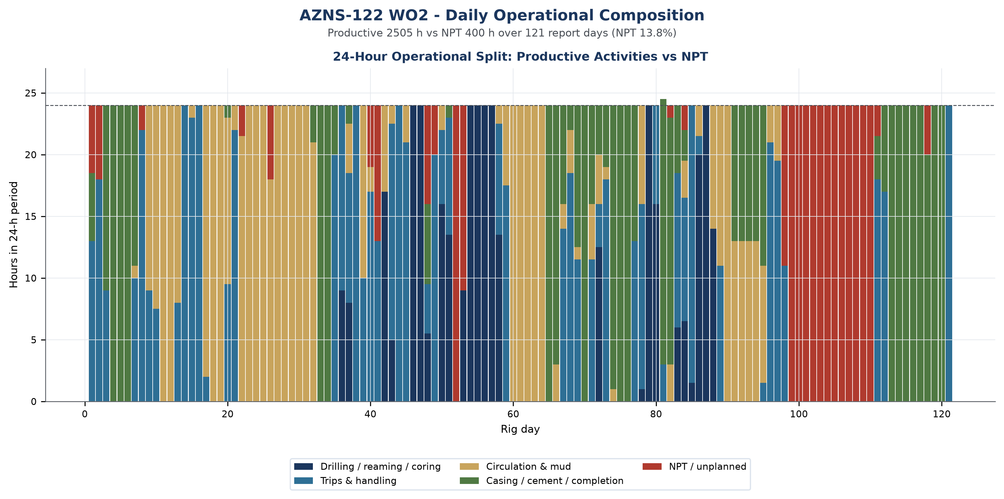
Figure W2 — Daily 24-hour operational composition, AZNS-122 WO2

Day-by-day reconstruction
Splitting the operation into three equal reporting blocks shows how the character of the work changed over time, and it is the most compact way to see whether unplanned time was a transient disturbance or a persistent condition.
Reporting block | Days | NPT (h) | NPT share | Progress (m) | Depth at end (m)
2024-10-25 to 2024-12-04 | 40 | 27 | 2.8% | 0.0 | 4,180
2024-12-05 to 2025-01-14 | 40 | 62 | 6.5% | 263.0 | 4,208
2025-01-15 to 2025-02-24 | 41 | 310 | 31.5% | 0.0 | 4,208
Table 3-3 Execution in three reporting blocks.
In the opening block (2024-10-25 to 2024-12-04, 40 days) the operation established the well condition and executed no new hole with 27 h of unplanned time, a share of 2.8%. This block was the cleanest of the three and establishes the achievable rate against which the rest of the operation should be judged.
The middle block (2024-12-05 to 2025-01-14) carried 62 h of unplanned time at 6.5%, and the closing block (2025-01-15 to 2025-02-24) carried 310 h at 31.5%. The deterioration towards the end of the operation coincides with the completion and recovery work, where each intervention carries a fixed mobilisation penalty that the daily report registers as waiting rather than as execution.

Performance and Parameter Analysis
Performance is evaluated on the activity mix, on penetration behaviour where the daily reports carry rate data, and on the bit records recovered from the DDR bit-data block. For this operation the productive time was 2,505 hours and the unplanned time 400 hours.
Activity family | Hours | Share of total time
Trips | 716 | 24.7%
Fishing | 492 | 16.9%
Operation Status (Waiting) | 474 | 16.3%
Completion / XMT | 284 | 9.8%
Drilling | 164 | 5.6%
Run Casing / Liner | 154 | 5.3%
Reaming | 142 | 4.9%
Circulate & Condition | 108 | 3.7%
Well Control | 82 | 2.8%
Specialised Directional Work | 60 | 2.0%
Table 4-1 Activity time distribution.
Recorded progress totals 263 m of interval work, giving an effective rate of 2.2 m per rig day across the operation. Where the daily reports record instantaneous ROP, the distribution is plotted on the multi-track log below together with mud weight, mud loss and cumulative unplanned time against depth.
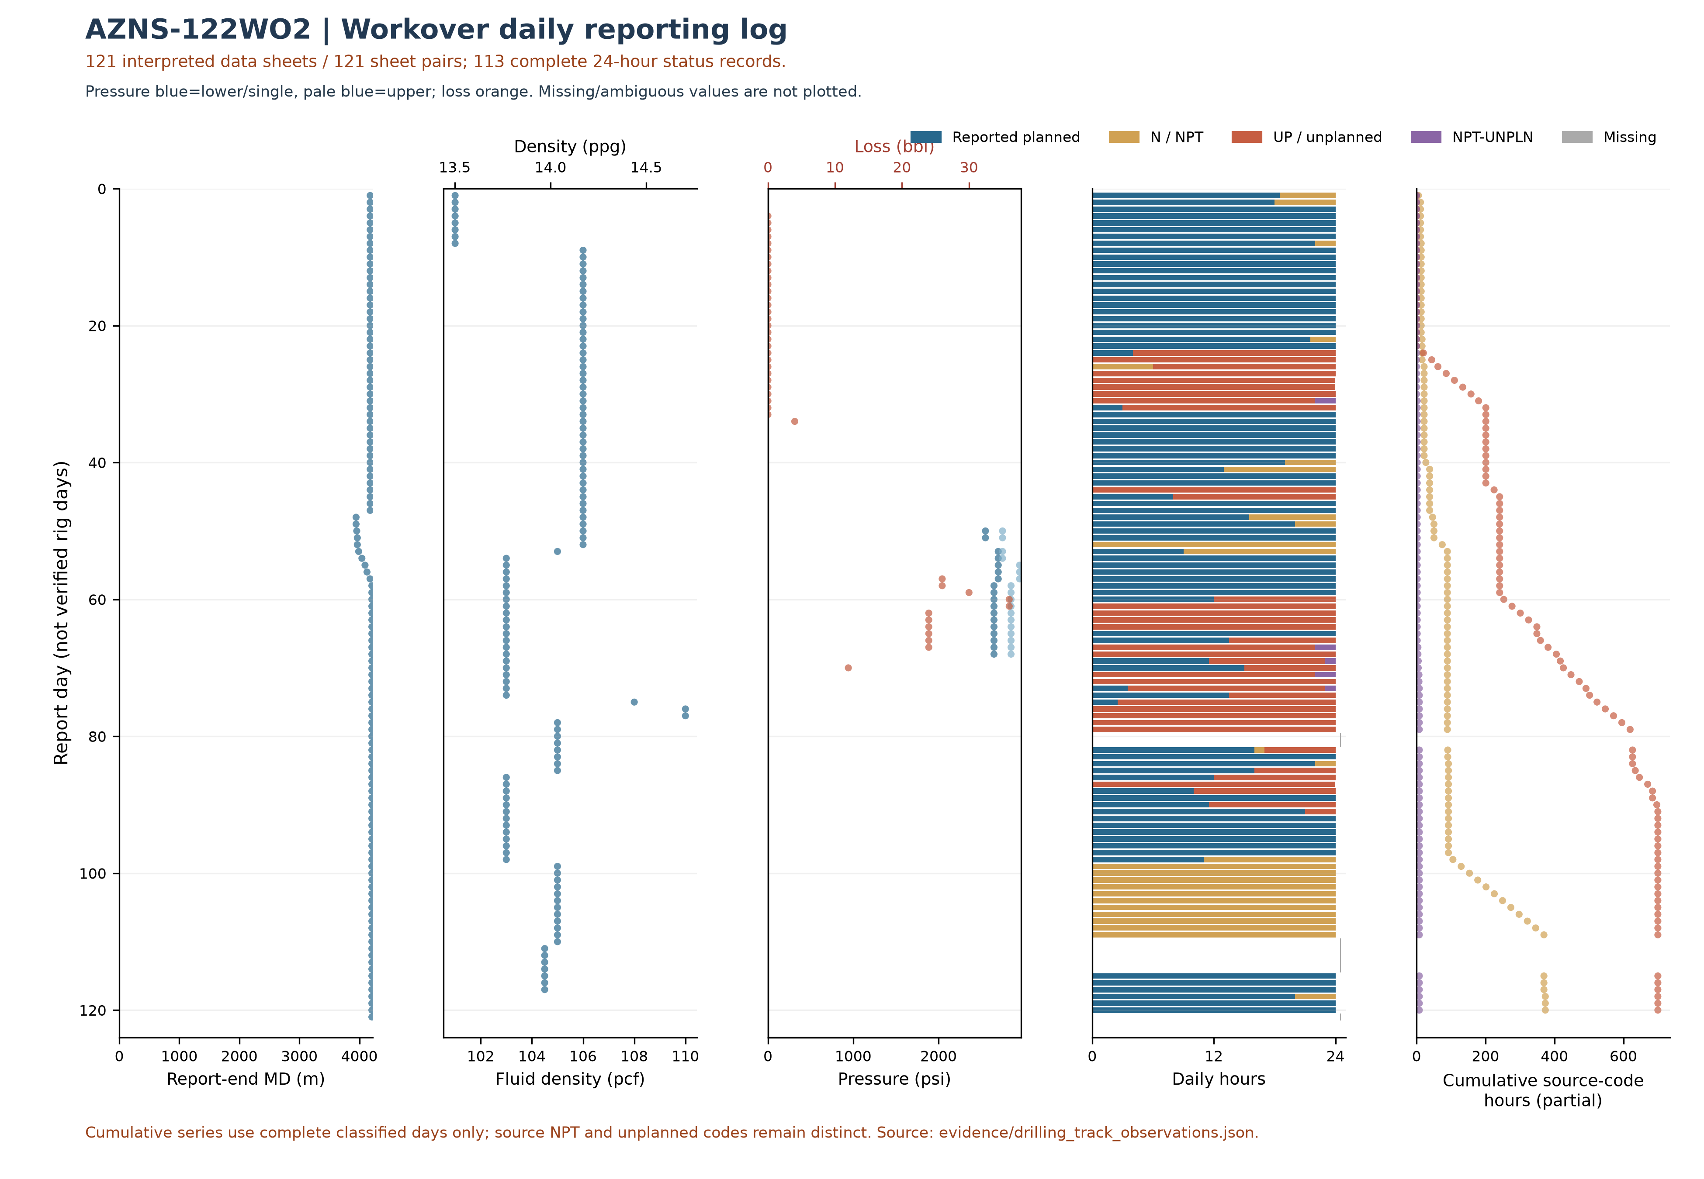
Figure W3 — Workover daily source observations by report day, AZNS-122WO2
The workover log uses only 121 recognized data sheets of 121 sheet pairs and 113 reports with classified durations totaling approximately 24 hours. Unknown values are not treated as zero. Planned does not necessarily mean productive; cumulative code totals include only complete classified days; NPT and unplanned remain distinct and these are not verified total NPT or work progress. Report-end depth is not necessarily tool or incident depth.
Bit | Size (in) | Type | Drilled (m) | Hours | Dull grade
Nozzle No | - | - | n/a | n/a | -
1.0 | 6-1/8" | R.Bit | n/a | n/a | -
1.0 | 6-1/8" | R.Bit | n/a | n/a | 8.4.BT.A.E.1/8
1.0 | 6-1/8 | Tri-Cone | n/a | n/a | -
Nozzle No | 6-1/8 | Tri-Cone | n/a | n/a | 2-2-WT-G-E-I-B
Nozzle No | 6-1/8 | PDC | 22.0 | 9.0 | -
3.0 | 6-1/8 | PDC | 54.0 | 18.0 | -
3.0 | 6-1/8 | PDC | n/a | n/a | 1-1-WT-A-X-I-N
Table 4-2 Bit runs recovered from the daily reports.
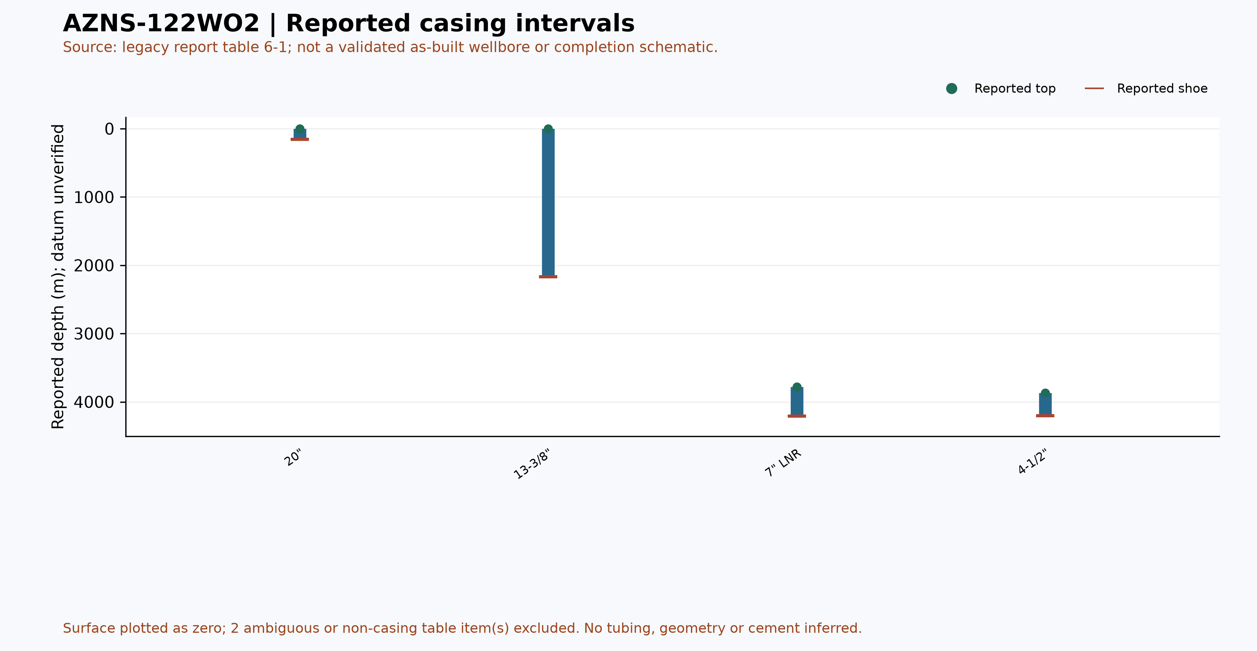
Figure W6 — Reported casing intervals from table 6-1, AZNS-122WO2 (not an as-built schematic)

Drilling Fluid Engineering and Loss Accounting
Mud weight in this archive is recorded in pounds per cubic foot, the unit used on the daily report of the South Azadegan project. For engineering comparability each record is also expressed in pounds per gallon (ppg = pcf / 7.48052) and as a hydrostatic gradient (psi/ft = pcf / 144). The table below reports the envelope actually observed in this operation; no pcf value is presented as ppg anywhere in this report.
Mud weight envelope | pcf | ppg | Gradient (psi/ft) | SG equivalent
Minimum | 101.0 | 13.5 | 0.701 | 1.62
Median | 105.0 | 14.0 | 0.729 | 1.68
Maximum | 110.0 | 14.7 | 0.764 | 1.76
Table 5-1 Mud weight statistics with unit conversion.
Property | Min | Median | Max | Records
PV (cp) | 22.0 | 32.0 | 58.0 | 110
YP (lb/100ft²) | 10.0 | 15.0 | 26.0 | 110
Gel 10 s | 2.0 | 2.0 | 5.0 | 110
Gel 10 min | 2.0 | 3.0 | 7.0 | 110
API fluid loss (cc/30 min) | 2.5 | 2.8 | 2.9 | 32
pH | 8.5 | 9.5 | 11.3 | 110
Chloride (mg/l) | 170,000.0 | 175,000.0 | 185,000.0 | 110
Solids (% vol) | 24.0 | 29.0 | 32.0 | 105
Table 5-2 Rheology envelope.
Total fluid loss recorded against the formation is 314 bbl over 13 report days, with a maximum single-day loss of 36.0 bbl. The fluid system in use was not declared in the report.

Completion, Casing and Service-Module Findings
Casing / liner | Grade | Weight | Thread | Top (m) | Shoe (m)
20" | K-55 | 94 | BTC | Surface | 155
13-3/8" | N-80 | 68 | BTC | Surface | 2169
9-5/8" | C-110 | 47 | TPCQ | Surface | 3909/5
7" LNR | S-110 | 29 | TPCQ | 3782 | 4208
7" LNR Tie Back | L-80 | 29 | TPCQ | 1998 | 3775/4
4-1/2" | T-95 | 15.2 | TPCQ | 3871.3 | 4201.5
Table 6-1 Casing and liner tally.
The directional record of this operation reaches a maximum inclination of 10.2 degrees with a peak dog-leg severity of 2.4 degrees per thirty metres across 26 survey stations. The trajectory panel below places these stations against measured depth.
Personnel on board averaged 7.5 and peaked at 23 during the operation, a figure that matters for accommodation, catering and safety-case loading of the contract.
The bonus panel below collects the modules that are specific to this well: casing and liner seat depths, service-cost line items from the CBS sub-tabs and the distribution of activity effort across the operation. Where a module is absent the panel states it rather than displaying an empty axis.
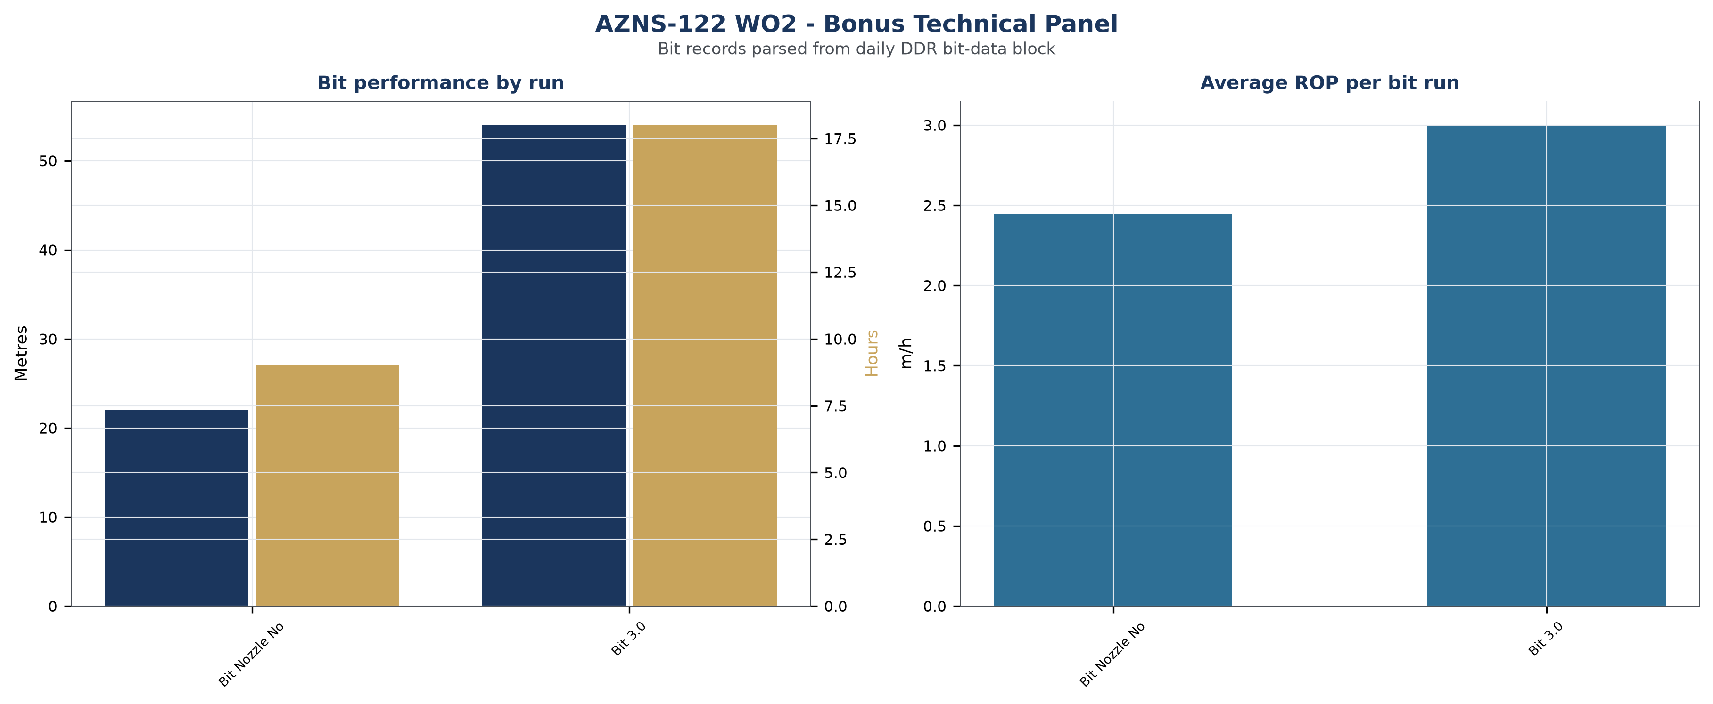
Figure W7 — Bonus technical panel, AZNS-122 WO2

Root-Cause Analysis and Three-Dimensional NPT Attribution
Every unplanned interval is classified on three axes: technical root cause, phase of the operation, and the party responsible under the contract. Attribution follows the field record and the NPT attribution field of the daily report; where the record names the rig contractor the hours are carried against OEOC, where it names a service company they are carried against that service line, and residual time is reported as unattributed rather than assigned by assumption.
Technical root cause | Hours | Share of NPT
Waiting on Material / Approval | 298 | 74.7%
Waiting on Weather / Service | 74 | 18.5%
Rig Mechanical / Electrical | 21 | 5.3%
Fishing / Milling | 3 | 0.8%
Stuck Pipe | 3 | 0.8%
Table 7-1 NPT by technical root cause.
Responsible party / contractor | Attributed hours | Financial exposure (USD)
Mud Service | 302 | Not verified
Third-party Service | 65 | Not verified
OEOC (Drilling Contractor) | 30 | Not verified
OEOC / Downhole Tools | 3 | Not verified
Table 7-2 Attribution by responsible party.
Operational phase | NPT hours | Share of NPT
Operation Status (Waiting) | 384 | 96.0%
Trips | 16 | 4.0%
Table 7-3 NPT by operational phase.

Mechanism analysis of the major incidents
Incident 1 — Waiting on Material / Approval (24.0 hours, 2025-02-02). Field record: While wait on Received Completion String & Completion Fluid, Continue making total 700 bbl 105 pcf Mud & Circulate 105 pcf mud
• A programme change that required client approval before the next operation could start, with the rig standing by in the interim.
• A tubular or consumable shortage at the wellsite because the call-off was raised later than the lead time of the item.
Incident 2 — Waiting on Material / Approval (24.0 hours, 2025-02-04). Field record: While wait on Received Completion String & Completion Fluid, Cont Circ mud Till M.N.
• A programme change that required client approval before the next operation could start, with the rig standing by in the interim.
• A tubular or consumable shortage at the wellsite because the call-off was raised later than the lead time of the item.
Incident 3 — Waiting on Material / Approval (24.0 hours, 2025-02-05). Field record: While wait on Received Completion String & Completion Fluid, Cont Circ mud with F.Rate: 220 GPM, SPP: 2150Psi, NL.NG Till M.N.
• A programme change that required client approval before the next operation could start, with the rig standing by in the interim.
• A tubular or consumable shortage at the wellsite because the call-off was raised later than the lead time of the item.
No verified financial cost has been assigned to the legacy NPT attribution. Rates, scope and contractual responsibility require reconciliation.
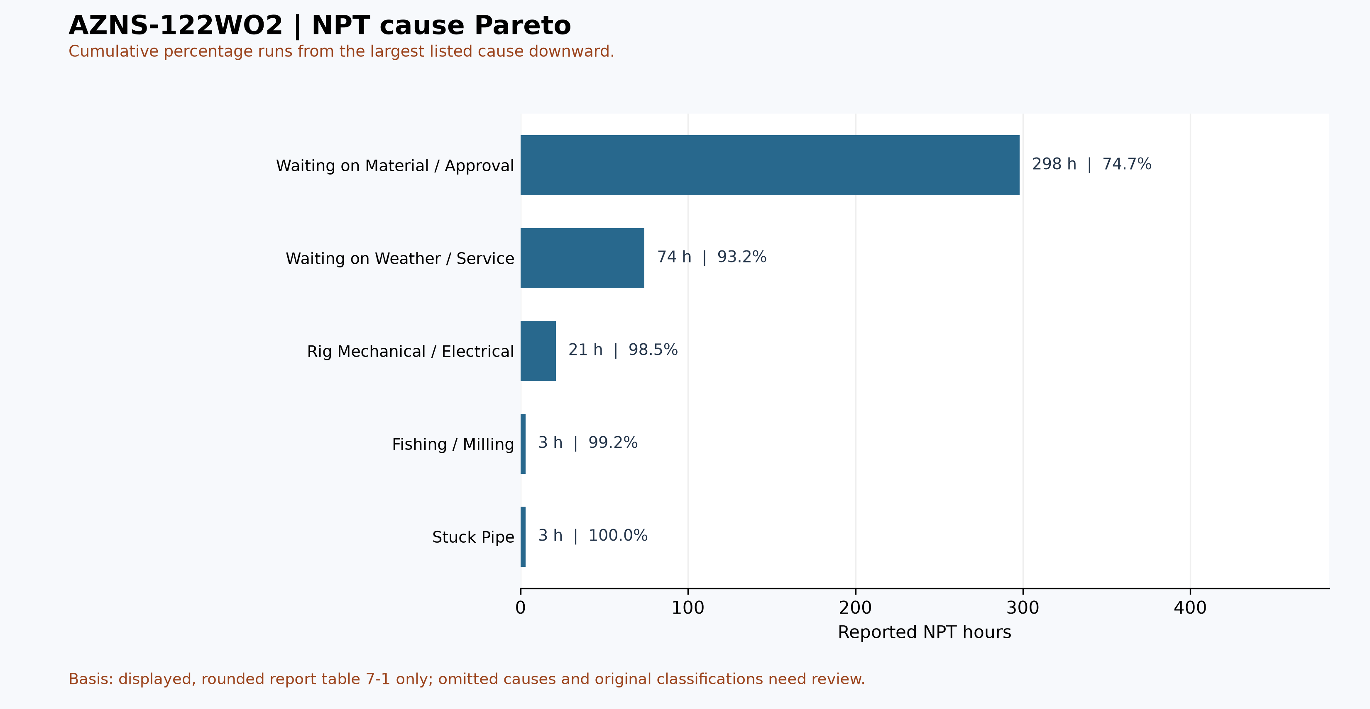
Figure W4 — Pareto of causes listed in table 7-1, AZNS-122WO2

CBS Financial Analysis and Provisional Cost Categories
Table 8-2 source: CBS AZNS-122WO2.xlsx / Cost Breakdown-122. These cached source amounts are not actual expenditure or an approved comparable budget. Missing or erroneous values are not zeros; rates, scope, formulas and approvals require reconciliation. No daily expenditure series has been verified.
Source / scope | Cached value | Cell / sheet
Cached main-sheet total; scope unverified | 4,646,112.10 | F189 / Cost Breakdown-122
Source ceiling; scope to reconcile | 7,280,632.64 | C5 / Total Cost-EPD & Rigless
Table 8-1 Source financial and schedule anchors (unreconciled).
Source category | Source amount (USD) | Amount cell
Rig service | 2,548,579.69 | F5
Drilling fluids | 452,249.24 | F6
Cementing | 70,312.50 | F13
Mud logging | 50,287.50 | F20
Wireline logging | 145,110.00 | F24
Drilling waste management | 132,025.08 | F64
Directional drilling | — | F76
Casing running | 51,870.00 | F89
Temporary well suspension | 75,722.00 | F97
Slickline | 25,598.00 | F101
Completion running | 30,000.00 | F104
Liner hanger running | 3,900.00 | F115
H2S service | 23,269.64 | F124
Perforation | 115,600.00 | F127
Wellhead services | 18,000.00 | F132
Dry test services | 0.00 | F136
Rig / completion services | 204,994.45 | F139
Other services | 55,403.91 | F147
Cleanup services | 159,458.84 | F151
Drilling materials | 1,098,275.00 | F158
Project management | 443,231.25 | F167
Engineering | 30,500.00 | F170
Tubing inspection | — | F179
Wellhead / tree inspection | 5,000.00 | F187
Downhole completion inspection | 5,000.00 | F188
Table 8-2 CBS source categories and cell references (unreconciled).
Topic | Observation | Source reference | Action
Scope / actuals | Values are not actual invoices or an approved comparable ceiling. | Source sheet and formulas | Reconcile
Reference errors | Contingency-material H column contains errors; scope effect is unresolved. | H5, H6, H249 / Material-Conting | Investigate impact
Table 8-3 CBS reconciliation checks.
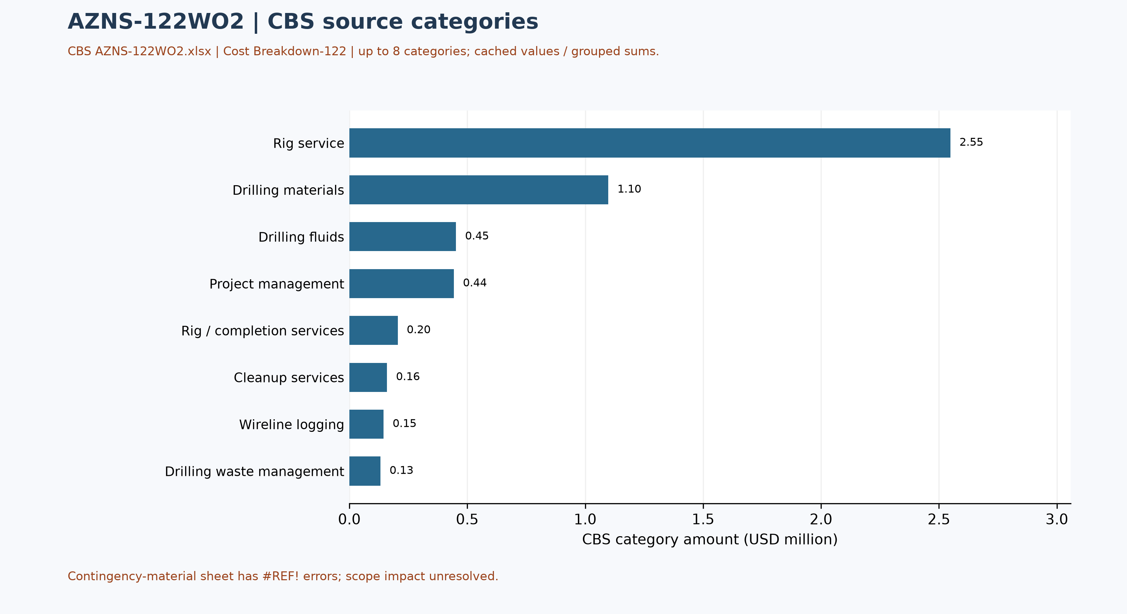
Figure W5 — CBS source cost categories, AZNS-122WO2 (unreconciled)

Section-Wise Optimum Parameters and Field Recommendations
The envelopes below are the operating windows recommended for the next campaign on the basis of what this operation demonstrated, both where it performed as designed and where it did not. The observed mud weight envelope of this well (101.0 – 110.0 pcf, equivalent to 13.5 – 14.7 ppg) is consistent with the recommended windows and confirms the unit convention used on the project.
Operation stage | Recommended parameter envelope | Engineering intent
Well killing / bullheading | kill fluid 1.02 – 1.05 x pore pressure; density stated in pcf and ppg | Hold well overbalance without exceeding the fracture gradient of the existing completion interval
Milling and clean-out | WOB 5 – 15 klbs, 60 – 90 rpm, flow 400 – 650 gpm, torque monitored continuously | Keep the mill loaded lightly and the hole clean; avoid packing off in the liner lap
Fishing | Jar load within 60 – 80% of string yield; maximum pull below the limit of the weakest joint | Protect the string while maximising impact energy at the fish
Coiled tubing / nitrogen | CT speed 15 – 25 m/min, N2 rate staged to achieve 300 – 500 psi underbalance | Lift the well without drawdown shock to the formation
Completion running | Running speed 15 – 20 stands/hour, torque-turn recording on every connection | Protect seal bores and avoid buckling in the horizontal section
Table 9-1 Recommended parameter envelopes.

Actionable recommendations
- Establish a joint root-cause review for Waiting on Material / Approval and Waiting on Weather / Service, the two largest contributors to unplanned time, with a named owner from the drilling contractor and from the service line, and a closure date before the next well spuds.
- Set future-well cost benchmarks only from validated contracts and cost records on a comparable scope.
- Carry a pre-mixed LCM pill and a loss-tolerant mud programme on every well of this pad; the recorded loss of 314 bbl shows the formation accepts fluid faster than the current bridging strategy controls.
- Convert the intervention sequence of this well into a standard workover time template; the deviation from the programme was driven by repeated recovery cycles that a template with contingency steps would have anticipated.
- Hold the well hand-over meeting with the completion and production teams before release so that the next intervention does not rediscover the well condition documented in this report.

Risk Register and Mitigations
The register below converts the evidence of this operation into forward-looking controls. Each row is tied to a documented exposure in the daily record, and the owner is the party who already carries the corresponding contractual responsibility.
Risk | Evidence / trigger | Mitigation | Owner | Severity
Unplanned time recurrence (Waiting on Material / Approval) | Any NPT interval exceeding four hours in a reporting cycle | Daily NPT challenge at handover; root-cause review within 72 hours | Drilling superintendent | High
Service-line mobilisation delay | 65 h already recorded under waiting on weather and service | Call-off protocol with 72-hour mobilisation guarantee and standby rate | Contracts | High
Rig equipment availability | 21 h recorded under rig mechanical and electrical | Preventive maintenance window aligned to tripping; critical spares on site | Drilling contractor | Medium
Loss of circulation | 314 bbl of recorded loss | LCM pill on standby; loss-tolerant mud programme; ECD monitoring | Mud service | Medium
Budget / scope reconciliation | Actual cost and budget scope not yet comparable | Reconcile invoices, contract and scope | Cost engineering | Medium
Data continuity | Source coverage and quality require separate review | Require the missing modules in the next well hand-over checklist | Data management | Low
Table 10-1 Risk register.

Data Provenance and Cell-Level Traceability
Every quantitative statement in this report resolves to a workbook, a worksheet and a cell. The table below lists the primary anchors used in the reconstruction; the remainder follows the same convention and is reproducible from the archive without manual interpretation.
Data element | Archive anchor (file -> sheet!cell)
rig | 1-1 DDR Remark!AB4
contractor | 1-1 DDR Remark!AB5
project | 1-1 DDR Remark!AB3
report_no | 1-1 DDR Remark!AL5
act_days | 1-1 DDR Remark!AL4
lta | 1-1 DDR Remark!AL3
depth:md_0000 | 1-1 DDR Remark!R9
depth:md_2400 | 1-1 DDR Remark!R10
depth:md_0600 | 1-1 DDR Remark!R11
depth:section_start | 1-1 DDR Remark!R15
mud:mud_type | 1-2 DDR Data!R8C12
mud:mw | 1-2 DDR Data!R9C12
mud:funnel_visc | 1-2 DDR Data!R11C12
mud:pv | 1-2 DDR Data!R12C12
CBS cost breakdown | CBS AZNS-122WO2.xlsx -> sheet "Cost Breakdown-122"
Planned duration | CBS AZNS-122WO2.xlsx -> CBS time-breakdown "AZNS-122 WO"
Well programme | AZNS-0122 Workover-2 Program Rev.00.pdf
Table 11-1 Provenance anchors.

Appendix: source formation-table snapshot (unverified)
Source: AZNS122WO2Pack.xlsx, sheet 121-2 DDR Data. Selected as the last sheet in workbook order with a recognized formation table containing a numeric depth; if none, the last table with formation names. This is not necessarily the latest dated report.
Column roles follow the source labels, not independent confirmation of prognosis or measurement. Unlabelled populated cells are shown separately; missing cells are unknown, not zero. Values are rounded to four decimals for display. Verify row alignment, depth datum, possible inconsistencies and lithology against the programme and geological report; this table alone does not establish event attribution or operating instructions.
Source table and anchor: Formation Top Data / N80
Formation / cell | Source values / cell
Fahlian / N82 | m MD: 3963 [P82]  m TVD: 3963 [Q82]  Lithology: Arg Lst [R82]
Fahlian / N83 | m MD: 3982 [P83]  m TVD: 3982 [Q83]  Lithology: Lst [R83]

