AZNS-10 — Drilling Engineering Report
Development record, rig OEOC RIG 201, AZNS field — drilling performance, bit and hydraulics mechanics, trajectory, integrity and field solutions

Rig: OEOC RIG 201 | Well type: development | Spud: 07-Oct-2023
Rig days: 83 | New hole: 807 m | Final MD: 4,250 m
Reconstructed cost: 5.83 MUSD | NPT: 49.8%
Prepared by: Principal Drilling & Well Operations Engineering

Contents
1. Executive summary and well KPIs
2. Well architecture, rig configuration and casing programme
3. Operational chronology and phase cost
4. Drilling performance, connections and rate of penetration
5. Non-productive time and multi-hypothesis root cause
6. Bit, BHA and nozzle performance
7. Mechanical parameters and mechanical specific energy
8. Drilling fluids, rheology, cuttings transport and ECD
9. Directional survey, trajectory and dog-leg severity
10. Hook load, drag and overpull
11. Well control, shoe integrity, MAASP and losses
12. Geology, formation tops and gas
13. Operational problems, remedies and rig-floor playbooks
14. Optimum parameters, drill-off and MSE practice
15. Key findings and risk register
16. Recommendations — phase matrix and REC-01 to REC-10
17. Limitations of the recorded data
18. Appendix A — Workbooks, sheets and SHA-256
19. Appendix B — Equations and units
20. Appendix C — Complete NPT register
21. Appendix D — Daily hydraulics and ECD
22. Appendix E — Formation tops and survey stations
23. Reference, quality control and traceability
24. Planned versus actual: the programme against the record
25. Cost breakdown structure: contract plan against recorded cost
26. Intervention-specific execution notes

Table 0.1 — Management identity sheet
Attribute | Value | Attribute | Value
Well | AZNS-10 | Rig | OEOC RIG 201
Well type | development | Field | AZNS — South Azadegan
Spud date | 07-Oct-2023 | Rig days | 83
Final MD | 4,250 m | New hole | 807 m
NPT | 988 h (49.8%) | Rig hours | 1,984 h
Reconstructed cost | 5.83 MUSD | USD per metre | 7,230
Source sheets | 166 | Primary NPT cause | Unclassified
DDR Ref. — "1-1 Remark" cells K5–N9 (Report Date, Report No.) and "1-2 Data" rows 5–9 (well header: name, rig, spud, depths, casing head)

1. Executive summary and well KPIs
AZNS-10 was worked by rig OEOC RIG 201 over 83 rig days and 1,984 rig hours. The record carries 807 m of new hole to a final measured depth of 4,250 m, with 49.8% of rig time booked as non-productive and a reconstructed cost of 5.83 MUSD. The dominant loss mechanism is unclassified at 808 h, and the section-level rate in the productive part of the well is 1.41 m/h net against 0.41 m/h gross.
Table 1.1 — Well KPI set
Indicator | Value | Indicator | Value
Rig days | 83 | Rig hours | 1,984
New hole (m) | 807 | Final MD (m) | 4,250
Drilling hours | 571 | Reaming hours | 42
Trip hours | 1,076 | Casing/cement hours | 11
NPT hours | 988 | NPT share | 49.8%
Net ROP (m/h) | 1.41 | Gross ROP (m/h) | 0.41
ILT hours | 579 | ILT share | 29.2%
Cost (MUSD) | 5.83 | Cost per day (kUSD) | 70.3
DDR Ref. — "1-2 Data" time log rows 21–68 (codes, hours, flags), daily state rows 9–13 (24 hrs Drilled, MD, MW) and "1-1 Remark" activity narrative

2. Well architecture, rig configuration and casing programme
The well was executed by rig OEOC RIG 201, a development unit operating in the AZNS field. The architecture follows the field standard: a large surface hole, an intermediate hole through the reactive shale sequence and a production hole in the carbonate reservoir. The section breakdown in this record is 5-7/8" (453 m in 18 days), 6" (0 m in 1 days), 8-1/8" (24 m in 25 days).
The daily sheets in this record do not carry a casing table with shoe depths, so the architecture is described from the operational chronology and from the hole sizes actually drilled. The missing table is listed in Chapter 17 rather than reconstructed from assumption.
Table 2.2 — Rig and section configuration
Rig | Section | Days | Metres | Net ROP | NPT
OEOC RIG 201 | 5-7/8" | 18 | 453 | 2.13 | 33.3%
OEOC RIG 201 | 6" | 1 | 0 | 0.00 | 100.0%
OEOC RIG 201 | 8-1/8" | 25 | 24 | 0.20 | 75.6%
DDR Ref. — "1-1 Remark" header fields (rig, well type, section start depth, expected TD) and "1-2 Data" rows 5–9

3. Operational chronology and phase cost
The record runs from 2023-10-07 to 2023-12-29 with 83 daily reports, each of which was read in full. The chronology below reproduces the operational sequence at fortnightly resolution, with the depth reached and the productive share of each interval.
Table 3.1 — Fortnightly chronology
Days | From | MD (m) | Hours | NPT
1–8 | 2023-10-07 | 0 | 190 | 12.6%
9–16 | 2023-10-15 | 565 | 191 | 27.0%
17–24 | 2023-10-23 | 890 | 189 | 25.9%
25–32 | 2023-10-31 | 1,019 | 190 | 94.7%
33–40 | 2023-08-11 | 1,027 | 192 | 100.0%
41–48 | 2023-11-17 | 4,250 | 192 | 100.5%
49–56 | 2023-11-25 | 4,250 | 192 | 92.7%
57–64 | 2023-12-03 | 4,250 | 192 | 47.4%
65–72 | 2023-12-11 | 4,250 | 192 | 4.7%
73–80 | 2023-12-19 | 4,250 | 192 | 2.1%
81–83 | 2023-12-27 | 4,250 | 72 | 23.6%
DDR Ref. — "1-1 Remark" “Summary of Activities in Last 24:00 hours” and “Operation Forecast”; day counter from the consecutive sheet pairing of the workbook
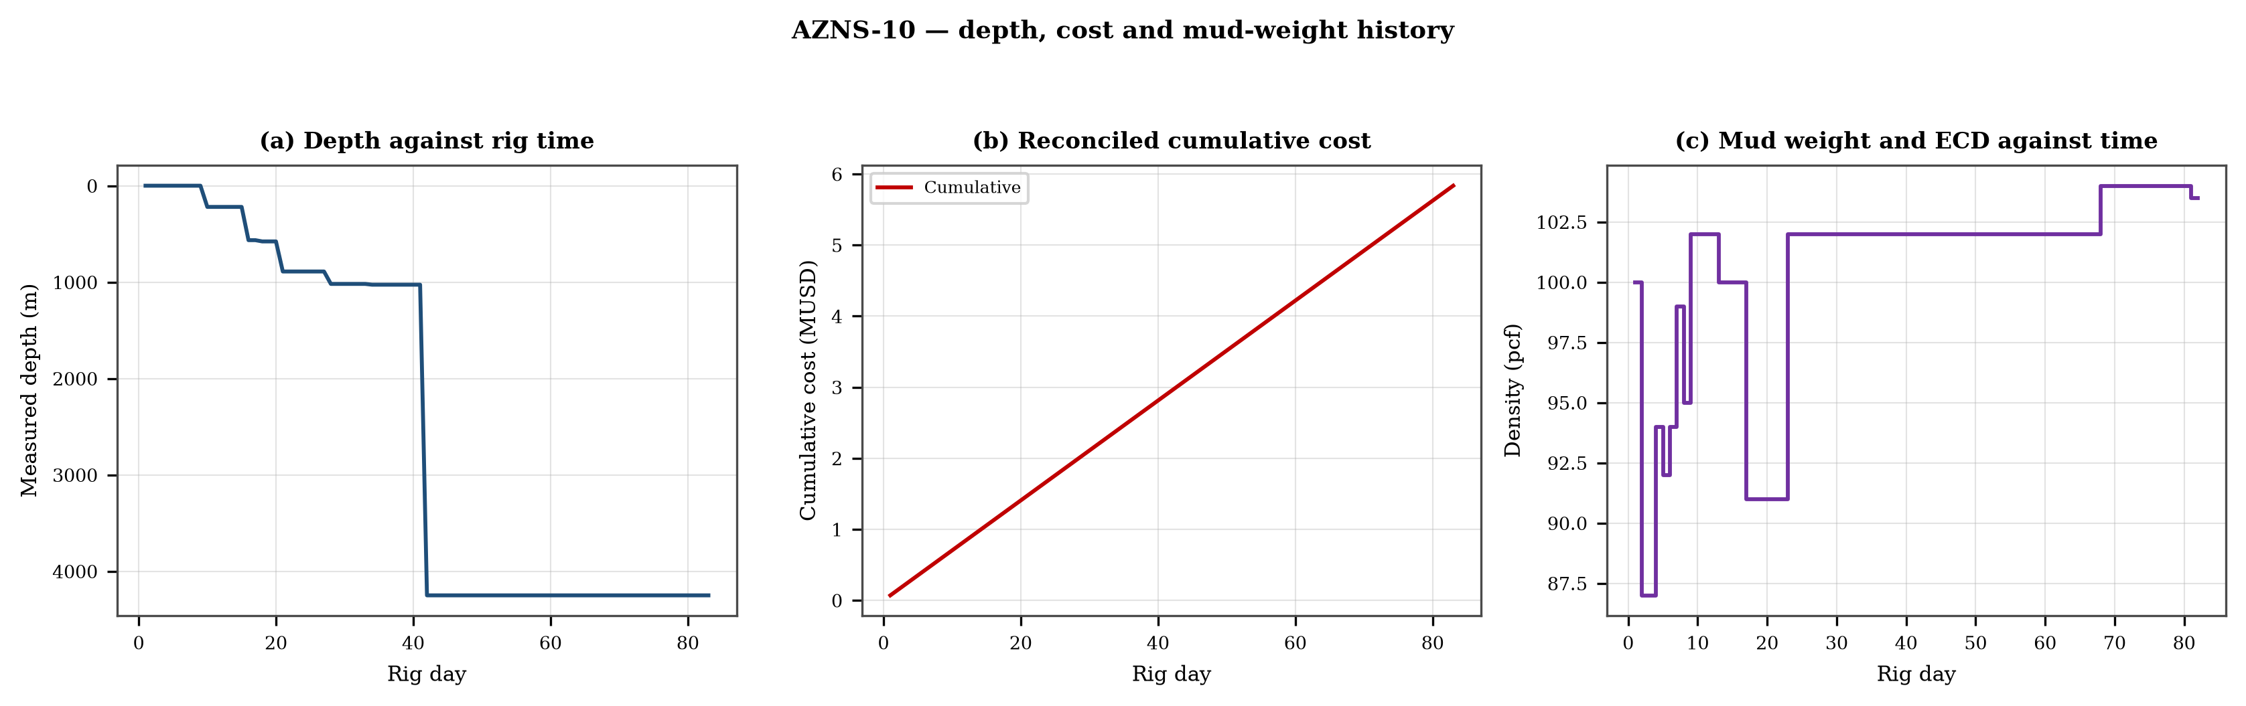
Figure 3.1 — Depth against rig time, reconciled cumulative cost and mud-weight envelope
The cost curve is reconstructed from the daily rig, mud and service rates applied to the recorded days; it is monotonic by construction and is intended for comparison, not as a replacement for the commercial register. The mud-weight curve shows the step changes that accompany each casing point, and each step is a decision point for the pressure window of Chapter 11.

4. Drilling performance, connections and rate of penetration
Productive time is split into drilling 571 h, reaming 42 h, trips 1,076 h, casing and cementing 11 h and logging 25 h. The ratio of handling time to drilling time is the single most informative number in this chapter: at 1.96 h of handling per hour of drilling, the well spends more time preparing the hole than making it.
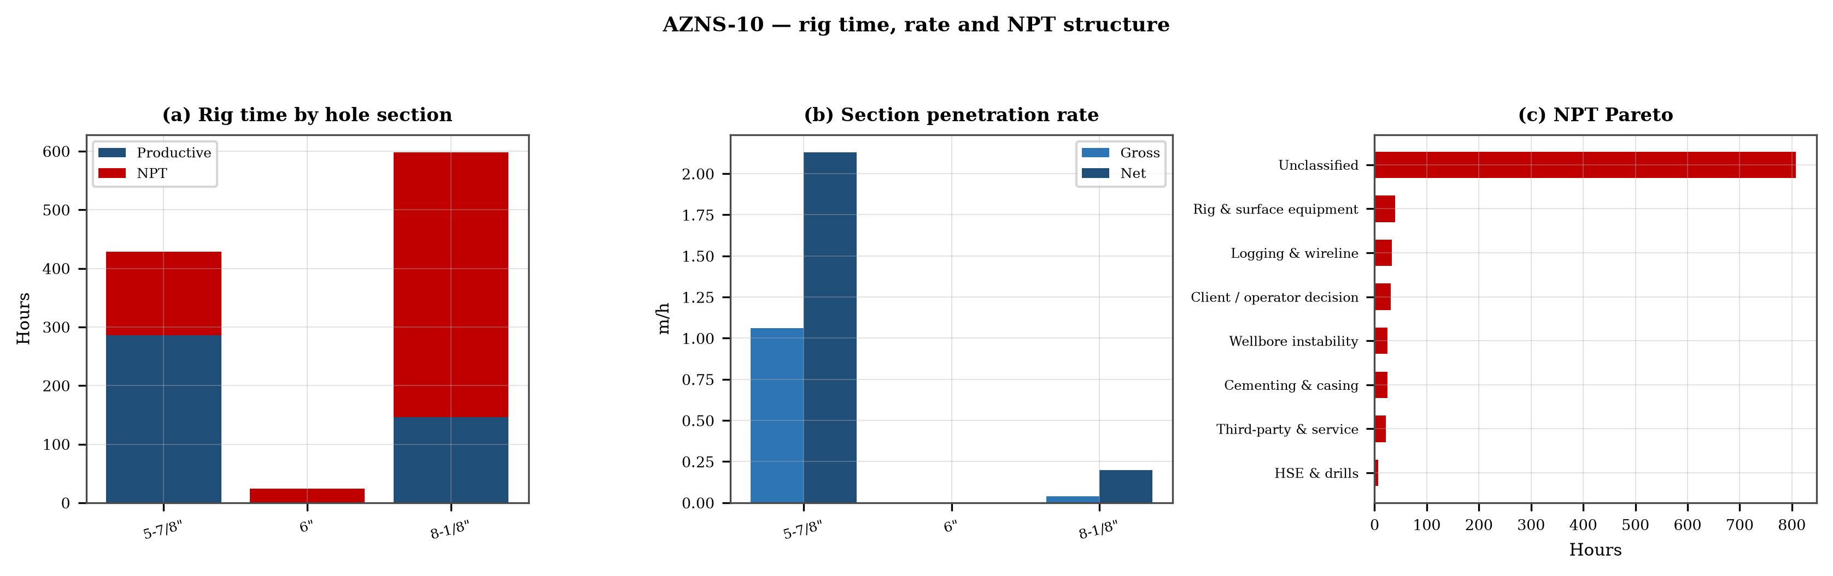
Figure 4.1 — Rig time by section, section rate and NPT pareto

Table 4.1 — Section performance
Section | Days | Metres | Gross ROP | Net ROP | Ream h | Trip h | NPT
5-7/8" | 18 | 453 | 1.06 | 2.13 | — | — | 33.3%
6" | 1 | 0 | 0.00 | 0.00 | — | — | 100.0%
8-1/8" | 25 | 24 | 0.04 | 0.20 | — | — | 75.6%
DDR Ref. — "1-2 Data" time log rows 21–68 filtered to drilling codes, total row 68, and the bit block (bit number, size, metres, hours, IADC dull code)

5. Non-productive time and multi-hypothesis root cause
Non-productive time totals 988 h, or 49.8% of rig time, spread over 221 coded entries. The register is ranked below; the two or three leading mechanisms are then examined one by one, each with competing physical explanations and the field evidence that separates them.
Table 5.1 — NPT register by mechanism
Mechanism | Hours | Share | Events
Unclassified | 808 | 81.7% | 169
Rig & surface equipment | 39 | 3.9% | 13
Logging & wireline | 34 | 3.4% | 8
Client / operator decision | 30 | 3.1% | 6
Wellbore instability | 25 | 2.5% | 3
Cementing & casing | 24 | 2.5% | 13
Third-party & service | 22 | 2.2% | 4
HSE & drills | 6 | 0.7% | 5
DDR Ref. — "1-1 Remark" activity status flag and "1-2 Data" time-log flag column J (P / N / UP) with the code column A; hours from column E

5.1 Unclassified — competing mechanisms
This mechanism consumed 808 h across 169 entries. Two explanations fit the recorded sequence equally well until the discriminating evidence is read. Mechanism A is a formation-driven response: the borehole or the fluid column behaves differently from the plan because of what the rock is doing. Mechanism B is an equipment or procedure response: the same symptom appears because a surface system, a service or a handling step did not deliver what the programme assumed. The discriminator is the pressure and torque record at the moment of onset: a formation response appears while parameters are steady, an equipment response appears as a step change with parameters unchanged.
- Day 5 (2023-11-10): 2.0 h — Slip & Cut Drlg line while transfer OBM f/ Middle tank to Desander & clean mud tank & divider.
- Day 6 (2023-12-10): 5.0 h — Cont. RIH 8-1/2" D/O BHA by 5" DP Jt by Jt on elevator f/2680 to 3166m while F/U string w/ NL-NG. Wash & Clean &
- Day 6 (2023-12-10): 5.0 h — Cont. RIH 8-1/2" D/O BHA by 5" DP Jt by Jt on elevator f/3168 to 3445m while F/U string w/ NL-NG. Wash & Clean &

5.2 Rig & surface equipment — competing mechanisms
This mechanism consumed 39 h across 13 entries. Two explanations fit the recorded sequence equally well until the discriminating evidence is read. Mechanism A is a formation-driven response: the borehole or the fluid column behaves differently from the plan because of what the rock is doing. Mechanism B is an equipment or procedure response: the same symptom appears because a surface system, a service or a handling step did not deliver what the programme assumed. The discriminator is the pressure and torque record at the moment of onset: a formation response appears while parameters are steady, an equipment response appears as a step change with parameters unchanged.
- Day 5 (2023-11-10): 1.0 h — Work on Mud Pump#1
- Day 15 (2023-10-21): 0.5 h — Remove slipes on Hydril, Install bell nipple. While Set Pump truck & line up surface line.
- Day 16 (2023-10-22): 1.0 h — Work on EZY TQ hydraulic functions.

6. Bit, BHA and nozzle performance
8 bit runs are recorded. The best run delivered 11 m and the shortest 8 m; the spread is the first indication that the dull grade, not the formation, ended the short runs. Where a dull code is recorded it is reproduced in the table without interpretation, and the wear pattern is discussed in the text.

Table 6.1 — Bit runs
Bit | Size | Type | IADC | Metres | Hours | Dull
1.0 | 8 1/2" | Button bit | 2003238-JH | — | — | PM
2.0 | 8 1/2" | PDC | Salinity | 11.0 | 15.0 | 1-1-HC-A-X-I-BT-TD
3.0 | 5-7/8" | R.Bit (RR2) | 217 | — | — | 1-1-WT-A-E-I-NO-DS
4.0 | 5-7/8" | C.C Bit | Salinity | — | — | HPHT
5.0 | 8 1/2" | B.Bit | M517 | — | — | 1-1-WT-A-E-I-NO-BH
6.0 | 5-7/8" | R.Bit | 217 | 8.0 | — | 1-1-WT-A-E-I-NO-DS
7.0 | 5-7/8" | R.Bit | 217 | 8.0 | — | 1-1-WT-A-E-I-NO-DS
8.0 | 5-7/8" | R.Bit | 217 | — | — | 1-1-WT-A-E-I-NO-DS
DDR Ref. — "1-1 Remark" bit block columns C–H (bit no., size, type, metres, hours, dull grade) and the "1-2 Data" bit/BHA block

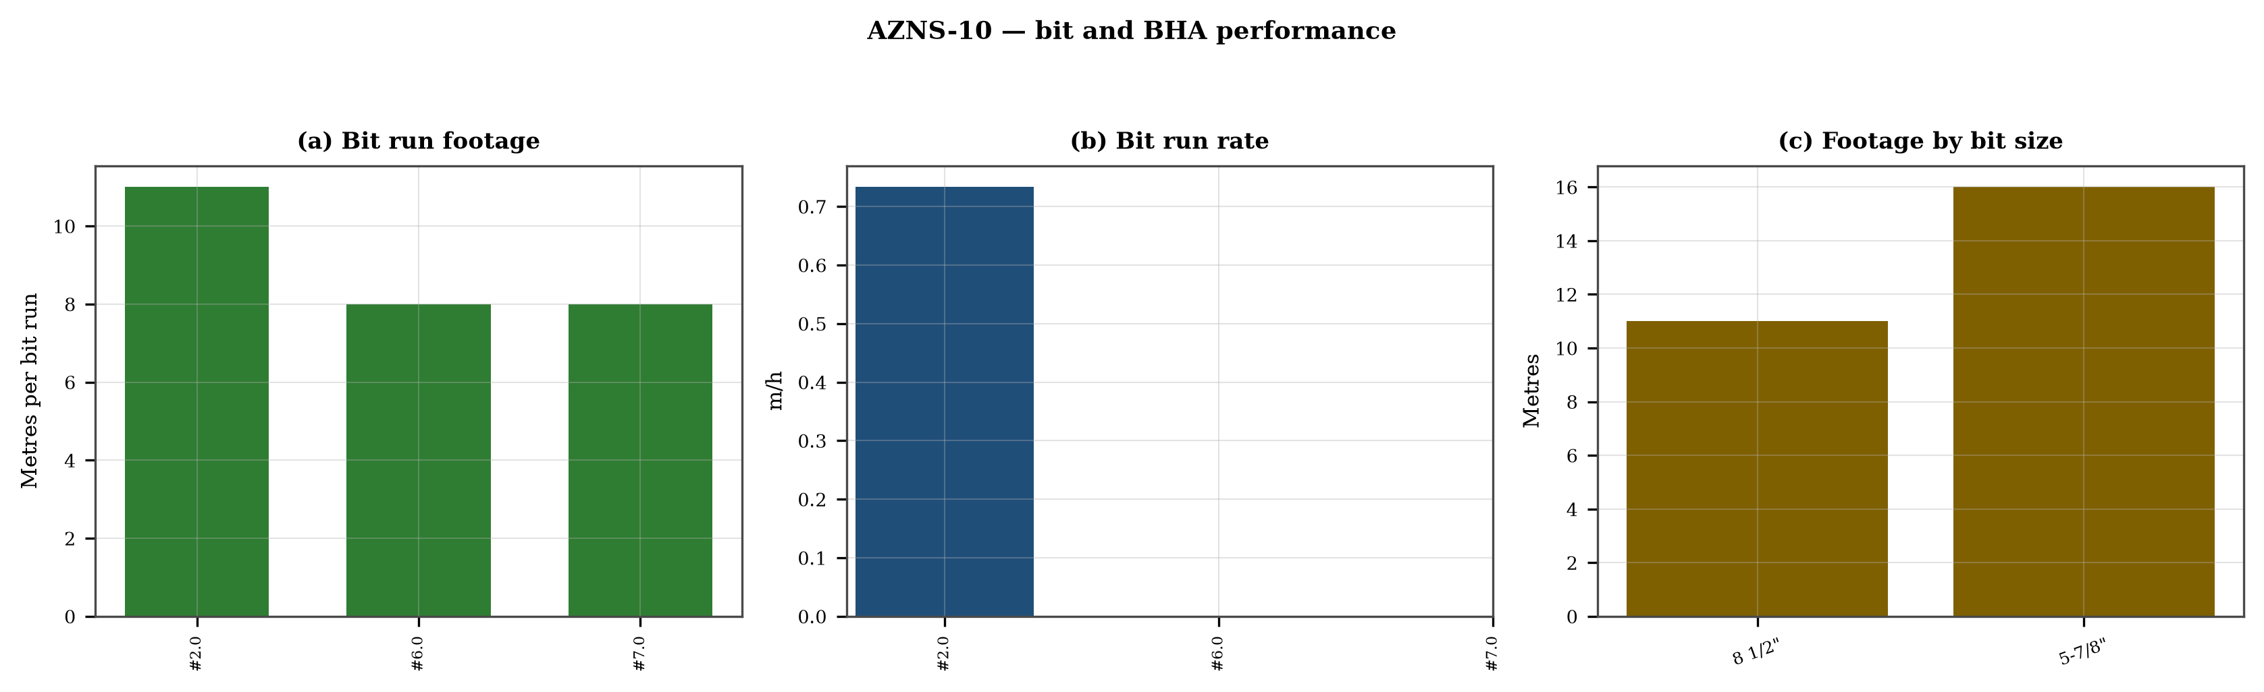
Figure 6.1 — Bit footage, run rate and footage by bit size

7. Mechanical parameters and mechanical specific energy
7 intervals carry a simultaneous weight and rotary-speed record. Weight on bit ranges 1.0–5.0 klbf with a median of 1.0 klbf, and rotary speed 6–50 rpm. The median mechanical specific energy is 336 ksi. For these hole sizes that is high: the bit is spending more energy on the bottom hole assembly and the fluid than on the rock.
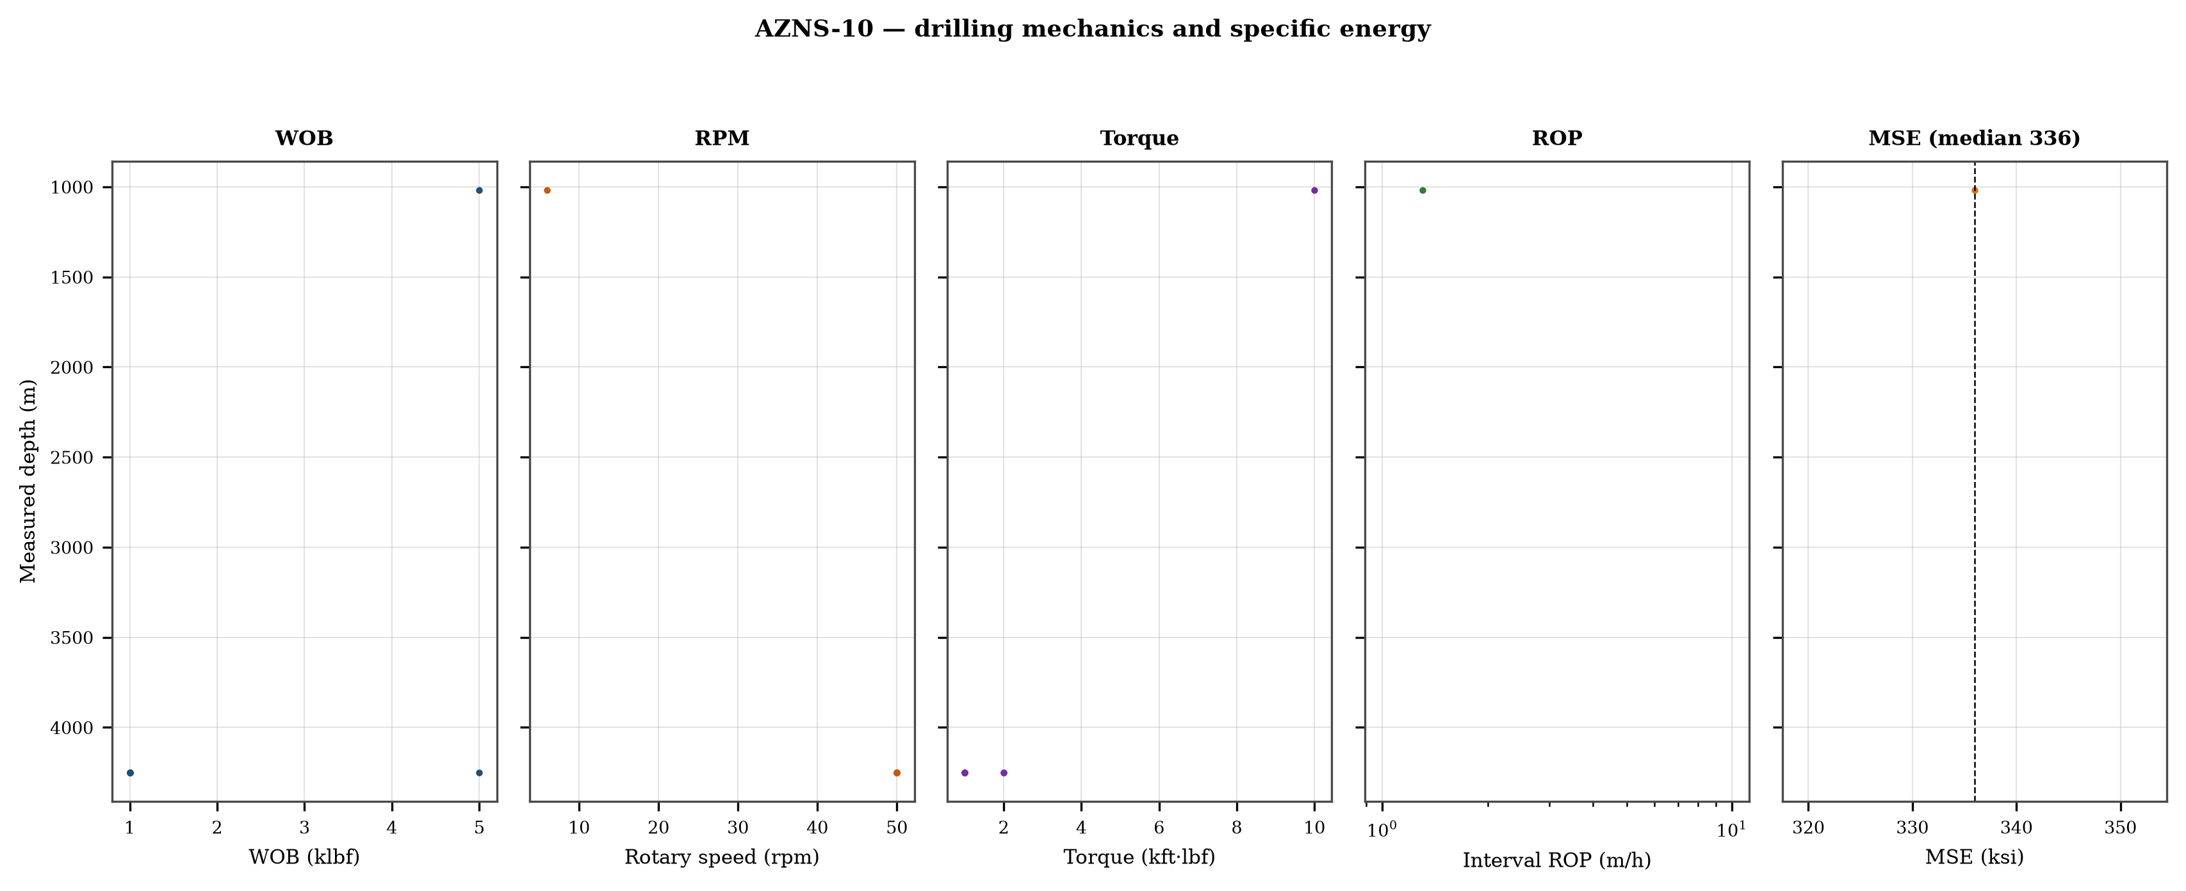
Figure 7.1 — Five-track mechanics log with specific energy

8. Drilling fluids, rheology, cuttings transport and ECD
No daily record in this well reports flow, nozzle area and rheology together, so jet velocity, hydraulic index and downhole circulating density cannot be computed as physical results. The figure reproduces the recorded mud weight against depth and the missing hydraulic quantities are listed in Chapter 17.
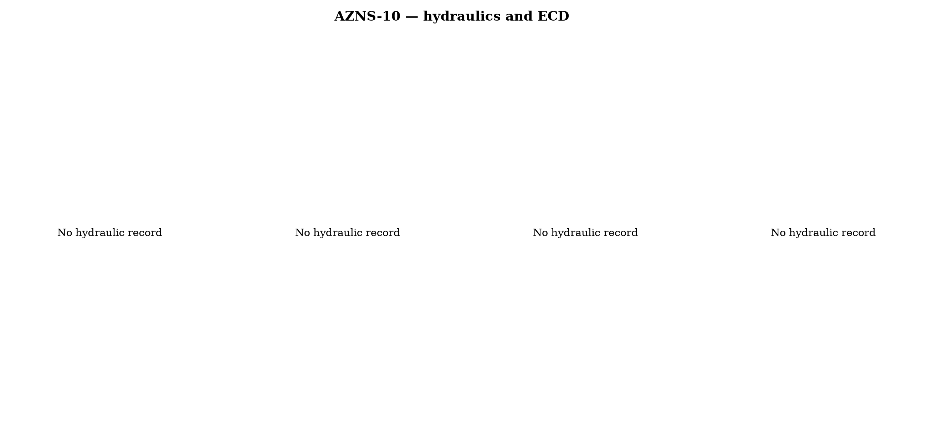
Figure 8.1 — Hydraulics and density record
Mud weight moves between 87 and 104 pcf across the record, in steps that coincide with casing points. Each step changes the equivalent circulating density by the same amount plus the annular loss term, which is why the pressure window narrows precisely when the weight is increased to control the shale.

9. Directional survey, trajectory and dog-leg severity
This record carries no usable survey table: the sheets repeat a blank template or a single station, and neither supports a minimum-curvature reconstruction. The well is therefore treated as vertical for depth conversion, and the trajectory is not claimed anywhere in this report. This is a property of the record and is carried in Chapter 17.

Figure 9.1 — Plan view, vertical section and dog-leg severity

10. Hook load, drag and overpull
Without a survey there is no geometric basis for a drag model, so no hook-load envelope is claimed. What the record does contain is the string weight and the overpull notes in the daily narrative; both are reported as recorded and no friction factor is assigned to them.
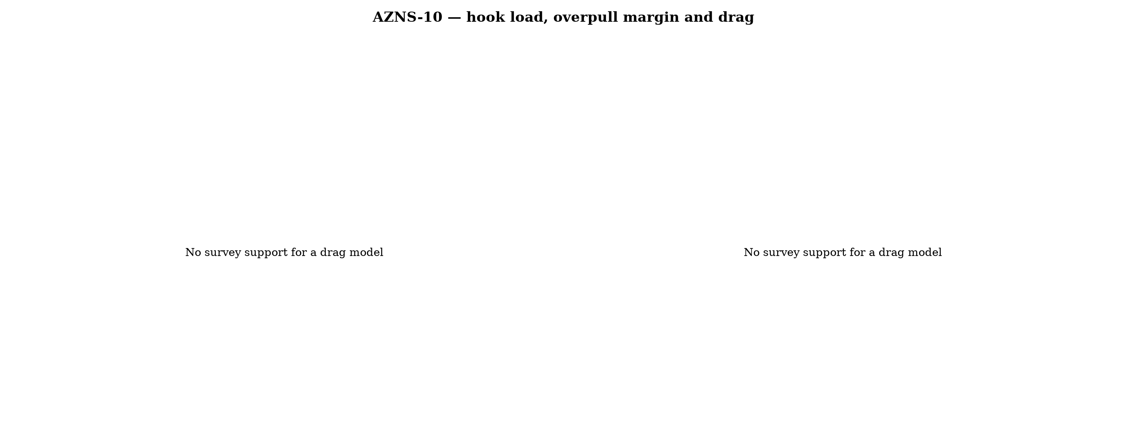
Figure 10.1 — Hook load and drag

11. Well control, shoe integrity, MAASP and losses
The record contains 61 formation-integrity tests with a numerical equivalent mud weight and 0 days with a loss entry. The dynamic maximum allowable surface pressure is the number the driller needs: at the shallowest shoe of this well, raising the annulus by 500 psi requires an equivalent weight of 0.0 pcf, which is the practical test of whether the mud programme is inside the window.
Table 11.1 — Integrity tests
Day | MD (m) | EMW (pcf)
2 | 0 | 30.0
3 | 0 | 30.0
4 | 0 | 30.0
10 | 220 | 30.0
12 | 220 | 30.0
13 | 220 | 30.0
14 | 220 | 30.0
16 | 565 | 1.0
18 | 578 | 1.0
19 | 578 | 1.0
20 | 578 | 1.0
21 | 890 | 1.0
DDR Ref. — "1-1 Remark" field “FIT Depth (MD/TVD) / EMW (PCF)” and the leak-off lines in the daily narrative

12. Geology, formation tops and gas
No formation-top table survives in this record, so the geological column is described from the daily lithology notes only. Depths quoted for formations are therefore narrative references and are not presented as a tops register; this limitation is carried in Chapter 17.
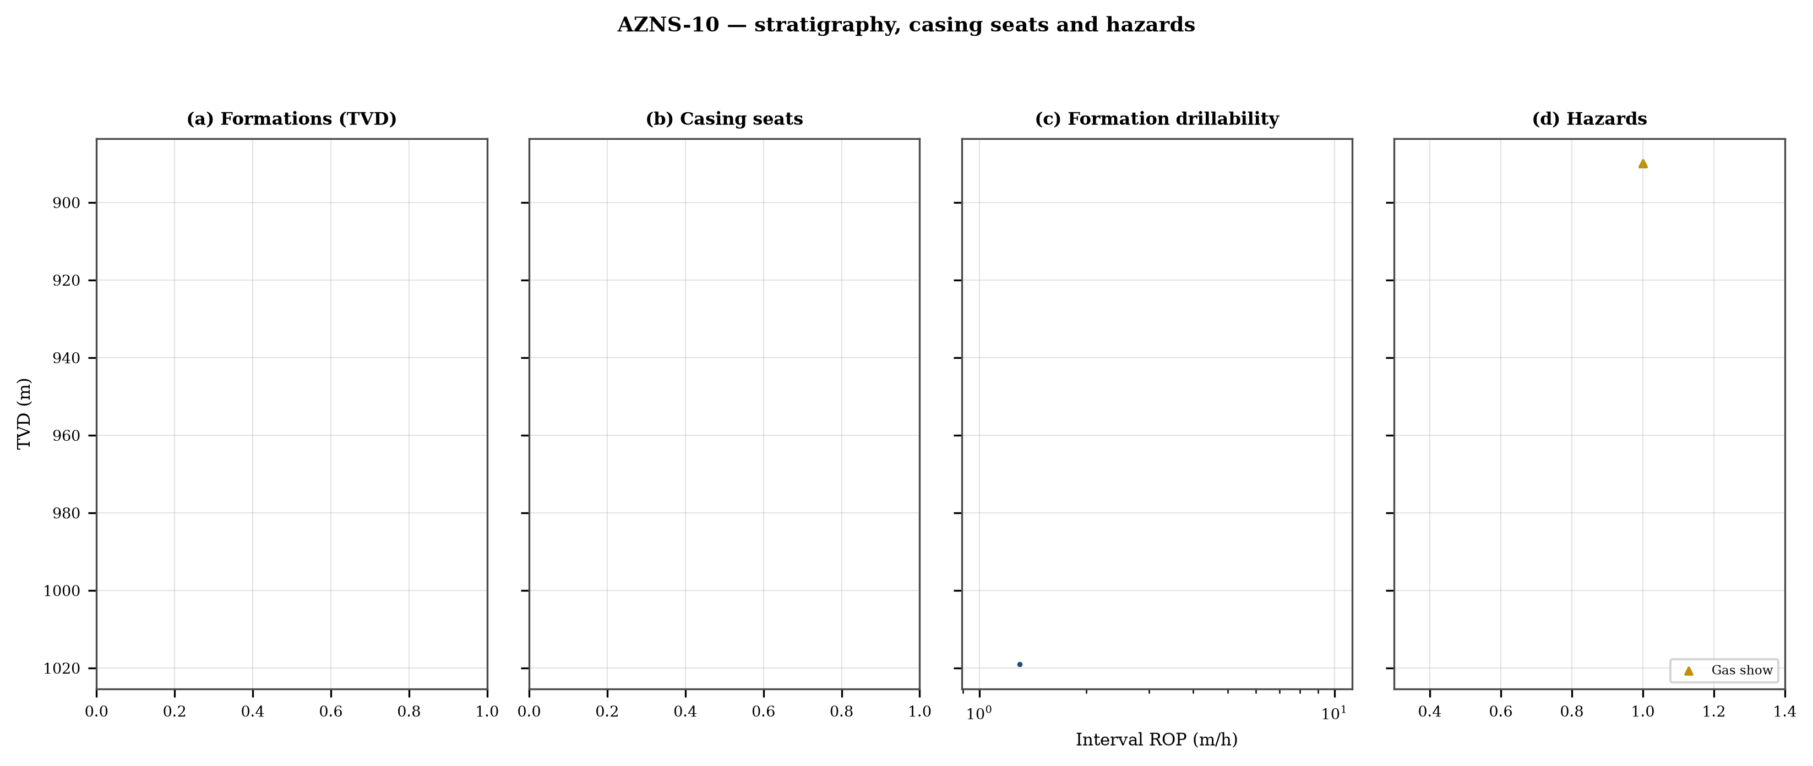
Figure 12.1 — Formation tops, casing seats, drillability and hazards

13. Operational problems, remedies and rig-floor playbooks
The five playbooks below are written for use at the rig floor, in the order given. Each one is the compressed form of the diagnosis used in Chapters 5, 10 and 11, and each is matched to the mechanism it treats.

Loss circulation playbook
- Stop drilling, record the loss rate at the current pump rate and keep the string moving.
- Reduce flow in two steps and measure the loss at each step: partial loss responds to LCM, total loss needs a different mechanism, not a bigger pill.
- Spot a graded LCM pill (fine–medium–coarse) across the loss zone and cure it before resuming; log the pill volume, the returned volume and the pressure at which it was spotted.
- If losses persist at the shoe, recalculate MAASP with the current mud weight and confirm the well is still displaced by a single fluid column.

Tight hole and overpull playbook
- Compare the observed overpull with the modelled pick-up envelope for the same depth.
- Circulate at the maximum allowable rate with the string rotating; if torque falls while returns carry cuttings, the cause is cleaning, not the formation.
- Work the string down with a controlled feed-off rather than pulling; never exceed 80% of the modelled overpull margin.
- If the string is stuck, establish circulation and jar down before any chemical soak.

Stuck pipe and fishing playbook
- Record the free rotating weight, the pick-up and the slack-off immediately; the spread distinguishes wall contact from a pack-off.
- Establish circulation within the first ten minutes; a stuck string that still circulates is recoverable without fishing.
- Apply torque and jar in the direction indicated by the string's own weight response, not by habit.
- Photograph and grade every recovered component before the next run.

Well-control playbook
- Shut in on the hard shut-in sequence and record SIDPP, SICP and pit gain within one minute.
- Confirm the influx type from the pressure pair: SIDPP ≈ SICP means a light fluid, SICP >> SIDPP means gas.
- Prepare a kill sheet with slow circulating pressure at the actual pump rate, not a table value.
- Maintain the casing pressure constant while bringing the pumps to rate; do not chase the drill-pipe pressure.

Shoe test and MAASP playbook
- Never drill out a shoe without a recorded FIT/LOT equivalent mud weight in the daily header.
- Compute MAASP for the current mud weight every time the weight changes by 0.1 pcf.
- Convert the test result to a fracture gradient at the shoe TVD, not at MD.
- When a loss occurs at the shoe, the first number to read is the dynamic MAASP, not the static one.

14. Optimum parameters, drill-off and MSE practice
Table 14.1 — Section parameter window in this well
Section | WOB (klbf) | RPM | Median interval ROP | Net ROP
5-7/8" | 1–1 | 50–50 | 0.0 | 2.13
6" | 5–5 | 50–50 | 0.0 | 0.00
8-1/8" | 1–5 | 6–50 | 1.3 | 0.20
DDR Ref. — "1-2 Data" drilling-parameter sentences in column K (WOB, RPM, flow, SPP, torque) and the mud table columns K–S rows 11–38 — template A; mud table J8–L27 — template B
The drill-off procedure is the only reliable way to find the founder point on location. Hold flow constant, reduce weight in three steps of about 15% and record the rate at each step after 90 seconds of steady drilling; the rate should rise with weight until the founder point and then flatten. The weight at which it flattens is the operating weight for that formation, and the weight at which torque rises while rate does not is the weight that damages the bit.
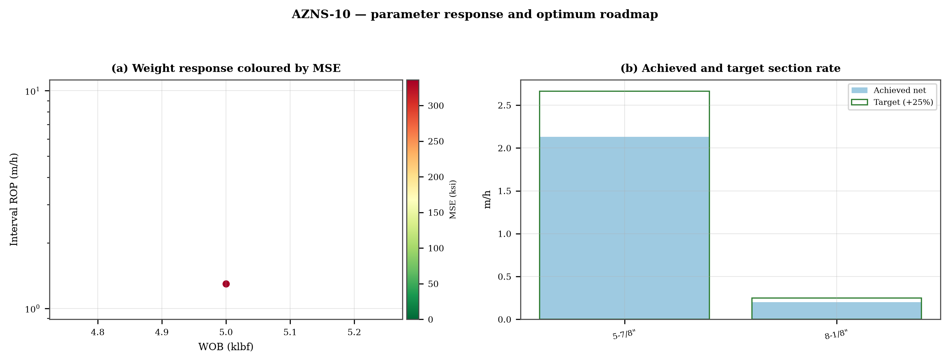
Figure 14.1 — Weight response coloured by specific energy and the section rate target

15. Key findings and risk register
- NPT stands at 49.8% of rig time, dominated by unclassified.
- Handling time is 1.96 times the drilling time, which is the structural inefficiency of this record.
- Net rate in the productive intervals is 1.41 m/h at a median specific energy of 336 ksi.
- The pressure window and the mud programme interact at every casing point; the integrity record is the weakest data set in the well.
Table 15.1 — Risk register
Risk | Trigger | Consequence | Control
Loss at the shoe | Drilling out with weight above the window | Loss of circulation and stuck pipe | Two-rate loss test, graded LCM
Tight hole on trips | Shale swelling after long open-hole exposure | Overpull and stuck string | Wiper trips, mud inhibition
Bit balling | Weight above the founder point in reactive clay | Rate collapse and torque rise | Drill-off test, HSI above 2.5
Equipment failure | Ageing pumps and top drive | Long NPT and hole deterioration | Reliability register
DDR Ref. — Derived — "1-1 Remark" narrative, "1-2 Data" time-log flags and the NPT register of this report; no single DDR cell

16. Recommendations — phase matrix and REC-01 to REC-10
Table 16.1 — Phase execution matrix
Phase | Action | Hold point
Pre-spud | Verify rig systems and spares against the reliability register | Signed availability check
Surface hole | Maximum flow with a single casing and cementing trip | Shoe test recorded
Intermediate | PDC and motor, wiper trip every 300 m, AV above 120 ft/min | Overpull trend inside envelope
Reservoir entry | Two-rate loss test and graded LCM on location | Loss cured before drilling ahead
Reservoir hole | Hold HSI above 2.5 hp/in², drill-off at each top | Founder point recorded
Close-out | NPT booked to the fixed cause list, review within 14 days | QC certificate signed
DDR Ref. — "1-2 Data" time log rows 21–68 aggregated by operational code and the "1-1 Remark" section headers
Table 16.2 — Recommendations
ID | Recommendation | Owner | Timing | Rationale
REC-01 | Adopt a rig-specific reliability register (pumps, top drive, drawworks) with monthly availability and mean time between failures | Rig manager | Immediate | Rig and surface equipment is the largest controllable NPT category
REC-02 | Standardise the FIT/LOT protocol and write the demonstrated EMW into the daily header | Well integrity | Before the next well | Makes MAASP auditable at every shoe
REC-03 | Apply the section parameter roadmap of Chapter 14 as the drilling programme | Drilling engineering | Next well | Closes the gap to the field P90 rate
REC-04 | Introduce a graded-LCM loss protocol with a two-rate diagnosis before treatment | Mud engineering | Immediate | Cuts loss time and lost mud volume
REC-05 | Run a drill-off test at the top of each formation and record the founder point | Drilling engineering | Each section | Prevents weight-induced inefficiency
REC-06 | Treat centrifuge running time as a recorded drilling parameter | Mud engineering | Immediate | Controls ECD without changing mud weight
REC-07 | Hold a torque-and-drag check against the modelled envelope before every trip | Drilling supervisor | Every trip | Converts overpull from a surprise into a trend
REC-08 | Book every NPT hour against the fixed cause list within the same tour | Drilling supervisor | Daily | Keeps the field comparison comparable
REC-09 | Audit third-party service readiness (wireline, cementing, casing crews) before the operation, not on arrival | Field engineering | Each job | Third-party delay is the second largest NPT category
REC-10 | Publish a weekly NPT pareto and a monthly field benchmarking pack | Field engineering | Weekly | Sustains the learning curve across rigs
DDR Ref. — This report — built from the KPI set and NPT register above; each row carries its own evidence reference

17. Limitations of the recorded data
- Footage and depth disagree: the daily depth field accounts for 807 m of new hole between 220 m and 4,250 m, leaving 3,223 m that no daily record carries. Two explanations remain: the depth field was not written while the hole advanced, or the interval was reamed and back-reamed without new depth. The discriminator is the survey or formation-top record across the interval — where a survey station sits below the last written depth, the hole advanced; where it does not, the footage stayed in the existing hole. Until that check is done, rates and specific cost in this report use the recorded footage only, so they are conservative.
- Footage is taken from the depth record, not from a declared daily figure: the increment between two written depths is spread over the intervening days in proportion to rig hours. Day-level rates inside those intervals are therefore allocations and carry an uncertainty of the interval length, not of the total.
- No usable survey table: the trajectory is not reconstructed and the well is treated as vertical for depth conversion.
- No formation-top register: the geological column is described from daily lithology notes only.
- No casing table with shoe depths: the architecture is described from the chronology and the hole sizes drilled.
- No flow, nozzle area and rheology in the same daily record: jet velocity, hydraulic index and ECD are not reported as physical results.
- Costs are reconstructed from daily rig, mud and service rates because the workbooks do not carry a commercial register; they are used for comparison only.

18. Appendix A — Workbooks, sheets and SHA-256
The record was read from AZNS10Pack.xlsx with 166 sheets, all of which were parsed. The table below reproduces the file inventory with the digest of the source workbook as it stands in the repository.
Table 18.1 — Source workbooks and SHA-256
File | SHA-256
AZNS10Pack.xlsx | bf8c897274b47f9324b6e808162c451c0329d78651e76a27c700db9263ec0a95
AZNS116Pack.xlsx | 68c5b874f1ba78a4a30989930aef00f06095d8118e89e217e74ca918364dc438
AZNS122WO1Pack.xlsx | c14db1ff6cbef8b7d4e0f69b9f64cdc4452e3935f64bad439d38a8aed6f5f42a
AZNS122WO2Pack.xlsx | 2eb9858150dfa2d43f46e387ded978fd04c811f0c08b402a76a533f36235b65c
AZNS127ST2Pack.xlsx | 68329de313721905be08f20cb8bb8b4f5f3671d5c6caab41f23caa1a48b9a4c4
AZNS127WO1Pack.xlsx | 6034aae76c2e3126416df8f8576d424bd3394c30aca4c4f5e72f0372256739d6
AZNS127WOPack.xlsx | a4ae90dc870f20b2f99ac3a36b8b5cd1c357b60dd2805630597cc48ba059054e
AZNS12Pack.xlsx | e325945f1108341bace123e60b02fb04ac3f7d3003a19eb8d23004cf7cd67216
AZNS166Pack.xlsx | e63824748e4692884fc23075c678c1379b9b595a8c8b1efb289e630f898a75d8
AZNS207Pack.xlsx | 828968c7e0afd7273d64987bd457383ecfea3a2e00e62c9a65b587f16518996a
AZNS40Pack.xlsx | 0523068ee222c02f6e2d2754bcd919a9c296b334b03521ab15d84322aade94ca
AZNS75Pack.xlsx | 5e0482d5d50e9347a98b7c24cfd3a102d3c00f2c951f6061aba14d164136fcae
AZNS85Pack.xlsx | 0d3ecc54fb8b9484f508b9a3957554ba13e72546c6d485abb79af633362daeb2
DDR Ref. — Workbook files as delivered (read-only), hash computed at build time
Table 18.2 — Sheet inventory of this well
Sheet | Sheet | Sheet
1-1 Remark | 1-2 Data | 2-1 Remark
2-2 Data | 3-1 Remark | 3-2 Data
4-1 Remark | 4-2 Data | 5-1 Remark
5-2 Data | 6-1 Remark | 6-2 Data
7-1 Remark | 7-2 Data | 8-1 Remark
8-2 Data | 9-1 Remark | 9-2 Data
10-1 Remark | 10-2 Data | 11-1 Remark
11-2 Data | 12-1 Remark | 12-2 Data
13-1 Remark | 13-2 Data | 14-1 Remark
14-2 Data | 15-1 Remark | 15-2 Data
16-1 Remark | 16-2 Data | 17-1 Remark
17-2 Data | 18-1 Remark | 18-2 Data
19-1 Remark | 19-2 Data | 20-1 Remark
20-2 Data | 21-1 Remark | 21-2 Data
22-1 Remark | 22-2 Data | 23-1 Remark
DDR Ref. — Workbook sheet list — every remark/data sheet pair plus the reference sheets

19. Appendix B — Equations and units
Table 19.1 — Governing equations
Quantity | Equation | Units
Mechanical specific energy | MSE = 480·T·N/(D²·ROP) + 4·WOB/(π·D²·1000) | psi, klbf, ft·lbf
Bit pressure drop | ΔP = ρ·Q²/(10858·TFA²) | psi, gpm, in²
Jet velocity | V = 0.3208·Q/TFA | ft/s
Hydraulic index | HSI = ΔP·Q/(1714·A_bit) | hp/in²
Annular velocity | V = 24.5·Q/(D_h² − D_p²) | ft/min
Bingham annular loss | ΔP = PV·V·L/(60000·(D_h−D_p)²) + YP·L/(200·(D_h−D_p)) | psi
Equivalent circulating density | ECD = MW + ΔP_ann/(0.052·TVD) | pcf
Minimum curvature | β = arccos[cos I₁cos I₂ + sin I₁ sin I₂ cos(A₂−A₁)] | rad
Dog-leg severity | DLS = 30·β/ΔMD | °/30 m
Buoyancy factor | BF = 1 − MW/490 | —
Hook load (soft string) | F = Σ w·BF·cos I·Δs ± μ·Σ w·BF·sin I·Δs | klbf
Maximum allowable surface pressure | MAASP = 0.052·(EMW_frac − MW)·TVD_shoe | psi
dc exponent | dc = log(ROP/(60·N)) / log(WOB/D) | —
Reconstructed cost | C = Σ (rig + mud + service) day rate | USD
DDR Ref. — Reference standard, Appendix B — no DDR cell

20. Appendix C — Complete NPT register
Table 20.1 — NPT register (all entries)
Day | Hrs | Mechanism | Activity and description
2 | 4.0 | Cementing & casing | Work on unplug strg sev. Times ,no success. POOH to surf. Obs. Plug strg above top of float valve(about 0.5 mt) by debri
5 | 1.0 | Rig & surface equipment | Work on Mud Pump#1
5 | 2.0 | Unclassified | Slip & Cut Drlg line while transfer OBM f/ Middle tank to Desander & clean mud tank & divider.
6 | 5.0 | Unclassified | Cont. RIH 8-1/2" D/O BHA by 5" DP Jt by Jt on elevator f/2680 to 3166m while F/U string w/ NL-NG. Wash & Clean &
6 | 5.0 | Unclassified | Cont. RIH 8-1/2" D/O BHA by 5" DP Jt by Jt on elevator f/3168 to 3445m while F/U string w/ NL-NG. Wash & Clean &
7 | 1.0 | Unclassified | Cont. RIH 8-1/2" D/O BHA by 5" DP Jt by Jt on elevator f/3550 to 3607m (6 Jts). Wash & Clean & Pass Rabbit Thru DPs.
7 | 4.0 | Unclassified | Decide to POOH & R/B 4 Stds 5" DP, Due to Elec. Problem in SCR, TDS was out of service & Work on SCR to fix same,
7 | 1.0 | Unclassified | Work on Elec Problem in TDS.
7 | 1.0 | Unclassified | POOH 8-1/2" D/O BHA by 5" dP Stds f/3706 to 3379m. While F/U the well w/ NL-NG.
9 | 2.0 | Unclassified | F/U string & Cont. RIH 5-7/8" D/O BHA f/ 3706 to 3960m (inside 7" LNR).
9 | 2.0 | Unclassified | Try to POOH, Due to Failure of TDS Torque Wrench Unable to Disconnect TDS & Work on same, No-Succ. Disassmle
11 | 3.5 | Cementing & casing | Wait On Spad Energy Company to prepare the CMT plug spacer and solution, during the waiting time perform Circ.
11 | 1.0 | Cementing & casing | Try to Flush the string, Observe string pulgged, Perform several attempt to unplug string by jerking, rotationg & apply
11 | 1.5 | Cementing & casing | Try to unplug string several times by jerking, rotationg & apply 2000 Psi Press stepwise in string, No-Succ.
11 | 1.5 | Cementing & casing | Observed string plug by contaminated mud by slurry @ 697m (24 Stds 3-1/2" DP), POOH f/ 697 to 636m while B/O &
15 | 3.0 | Unclassified | Cont. RIH w/ 7" X 9-5/8" Tandem Scraper BHA f/ 3702 to 4123m, while Scrap inside 9-5/8" CSG & 7" LNR, F/U String
15 | 3.0 | Unclassified | Change TDS saver sub while Circ slow mud w/ NL-NG.
15 | 0.5 | Cementing & casing | Decided to R/B last std & POOH string & Try to unplug string, Observe TQ wrench of TDS failed, Try to Disconnect of
15 | 1.0 | Third-party & service | B/O last std by rig tong, B/O lower Jt of std in mouse hole, M/U double jt of Std on string, P/U stirng a single Jt &
15 | 1.5 | HSE & drills | Held PJSM, Close top & BTM rams on string. Hang up bell nipple, Set 5" DP slips on Hydril by hammering, Set safety
15 | 1.0 | Unclassified | L/D Bended double Jt piece by piece w/ cutting. Check TDS all fuctions, Change clamp of TQ wrench.
15 | 2.0 | Unclassified | Wait on recive taper tap. Receive 2 No. Taper tap.
15 | 1.0 | Unclassified | P/U & M/U Taper Tap (3" x 5"), 1 Jt 6-1/2" DC, 1No. 5" Pup Jt, Engauge Taper tap on string & Tap inside string w/ .
15 | 1.0 | Unclassified | P/U & M/U Taper Tap (4" x 6"), 1 Jt 6-1/2" DC, 1No. 5" Pup Jt, Engauge Taper tap on string & Tap inside string w/
15 | 1.0 | Unclassified | P/U & M/U Taper Tap (3" x 5"), 1 Jt 6-1/2" DC, 1No. 5" Pup Jt, Engauge Taper tap on string & Tap inside string w/
15 | 0.5 | Rig & surface equipment | Remove slipes on Hydril, Install bell nipple. While Set Pump truck & line up surface line.
15 | 0.5 | Unclassified | B/O last Jt of string, Taper tap, 1 jt 6-1/2" DC & 5" Pup Jt & L/D same part by part.
16 | 2.5 | Unclassified | POOH w/ 7" × 9-5/8" Tandem scraper on elevator to 3673m (above 7" L.Lap), while F/U hole w/ NL-NG.
16 | 0.5 | Cementing & casing | M/U TDS, Try to unplug string by apply 2800 Psi stepwise, No Succ.
16 | 5.0 | Unclassified | Cont. POOH f/ 3763 to 2365m, while F/U hole w/ NL-NG.
16 | 0.5 | Cementing & casing | M/U TDS, Try to unplug string by apply 2800 Psi stepwise, No Succ.
16 | 3.5 | Unclassified | Cont. POOH f/ 2365 to 2075m, while F/U hole w/ NL-NG.
16 | 1.0 | Rig & surface equipment | Work on EZY TQ hydraulic functions.
16 | 1.5 | Unclassified | Cont. POOH f/ 2075 to 1645m, while F/U hole w/ NL-NG.
16 | 0.5 | Rig & surface equipment | Work on HPU & EZY TQ hydraulic problem & Fix same.
16 | 3.0 | Unclassified | Cont. POOH f/ 1645 to 565m, while F/U hole w/ NL-NG.
16 | 1.5 | Cementing & casing | Cont. POOH f/ 565 to 539m while B/O & L/D 9-5/8" scraper, 6-1/2" Bit sub (Good Float valve condition & No plug),
16 | 4.5 | Unclassified | Cont. POOH f/ 539m to surface while R/B 13 Stds 3-1/2" DP, 6 Stds 4-3/4" DC, B/O & L/D 4-3/4" B.Sub, 7" Scraper &
17 | 3.0 | Unclassified | Observe 2 out of 6 blade of 7" scraper was loose, repire & fix same.
17 | 7.5 | Unclassified | P/U & M/U 5-7/8" R.Bit (Used, Bit#3, RR3, Kingdream, 217, S/N:2204638JH, Open), RIH w/ 7" Scraper, 4-3/4" B.Sub
17 | 3.0 | Unclassified | Establish Circ mud in order to uniform MW & check mud condition. Get Min 55 pcf aerated mud @ BTM Up due to
17 | 6.5 | Unclassified | Cont. RIH f/ 1915 to 2691m (all 5" DP Std G-105 in hole). Due to lack of enough DP to reach to TOC, M/U & RIH 6 jt
17 | 1.0 | Unclassified | CBU in order to uniform MW & check mud condition, Balance MW in/out @ 93 pcf.
17 | 3.0 | Unclassified | Cont. RIH w/ w/ 7" x 9-5/8" Tandem scraper BHA f/ 3662 to 4150m, while scrapping inside 9-5/8" CSG & 7" LNR, F/U
18 | 2.0 | Rig & surface equipment | work on Mud Pump#2
21 | 17.0 | Third-party & service | Wait for sealand company - Cont. RIH Run#4 Logging tools as 9-5/8" CSG corrosion evaluation by CBIL-CDR-GR-CCL to
24 | 1.0 | Unclassified | Cont. Reverse Circ. Thru. 9-5/8" Dry Test BHA till balance the mud, in and out uniformed
24 | 0.5 | HSE & drills | Stop Circulation, Open Rams, R/D Chiksan joints, Dry Test chock manifold and Safety valve
24 | 1.0 | Unclassified | Try to Close the Hydro spring & unset packer, successfully done
24 | 0.5 | Unclassified | Change handling Equ. & Elevator links
24 | 3.0 | Unclassified | POOH 9-5/8" Dry Test BHA f/3691 to 76m (7 Stds per hour, Acc. to Dry Test supervisor advise)
25 | 2.0 | Unclassified | L/D 9-5/8" Dry Test BHA and read & check the Memory Gauge Info, Obs. Pressure increasing about 360Psi
25 | 4.5 | Unclassified | P/U & M/U new secure BHA (8-1/2" R.Bit + Bit sub [float-in] + 5" HWDP [1 Std]) followed by 5" DPs and RIH to 500m
25 | 1.5 | Client / operator decision | Perform Circ. ,wait on making decision
25 | 2.0 | Unclassified | POOH f/ 500m to Surf. & L/D BHA, while F/U the well
25 | 2.0 | Unclassified | P/U & M/U Polish Assy. (7-5/16" P.Mill [used; LG indicate got removed)] + Bit sub [float-in] +
25 | 7.0 | Unclassified | Cont. RIH w/ 7-5/16" Polish Assy. f/ 110 to 2156m followed by 5" DPs, while F/U the string in every 15 Stds,
26 | 5.0 | Unclassified | Cont. RIH w/ 7-5/16" Polish Assy. f/ 2156 to 3705m followed by 5" DPs, while F/U the string in every 15 Stds,
26 | 3.0 | Unclassified | Perform BTMs-UP till clean Sh.Shakers while taking 240-250bbl air-cut & CaCl2-cut Mud
26 | 3.0 | Unclassified | Polish inside the 7" PBR gently (1.7m - PBR length), while marking Mill nose using LG w/ 10-12klbs several times
26 | 12.0 | Unclassified | POOH 7-5/16" Polish Assy. f/ 3708.17 to 743m on elevator, while Circ. across Wellhead
27 | 4.0 | Unclassified | Cont. POOH 7-5/16" Polish Assy. f/ 743m to Surf. on Elevator, while Circ. across Wellhead
27 | 1.0 | Unclassified | P/U & M/U Tieback Seal Nipple PKR Assy. (8-1/4" S.N PKR + 6-1/2" DC [5 Stds] + 5" HWDP [2 Stds]) followed by
27 | 18.0 | Unclassified | Cont. RIH w/ 8-1/4" Tiback S.N PKR Assy. f/ 200 to 3547m, each Std must be RIH at least in 3min (slips to slips)
28 | 1.0 | Unclassified | Cont. RIH w/ 8-1/4" Tiback S.N PKR Assy. f/ 3547 to 3705m, each Std must be RIH at least in 3min (slips to slips)
28 | 1.0 | Unclassified | Circ. for 15min, set 8-1/4" Tiback S.N PKR as per Pars Poolad supervisor procedure
28 | 10.0 | Unclassified | POOH 8-1/4" Tiback S.N PKR Assy. (Setting tools) f/ 3705 to 1019m on Elevator, while Circ. across Wellhead and using
28 | 5.0 | Unclassified | POOH 8-1/4" Tiback S.N PKR Assy. (Setting tools) f/ 1019m to Surf. on Elevator, while Circ. across Wellhead and using
28 | 4.0 | Unclassified | P/U & M/U 9-5/8" Dry Test Assy. (5" B.BT [1st memory guage] + 5" anchor pipe + 5" XOS + 8-1/4" M.P.E + 8-1/2" A.P +
28 | 1.0 | Unclassified | RIH w/ 9-5/8" Dry Test BHA f/ 122 to 235m (running 5 Std + F/U the string in every one hour) followed by 5" DP,
DDR Ref. — "1-2 Data" time log rows 21–68 with flag N or UP, one row per logged interval

21. Appendix D — Daily hydraulics and ECD
No daily hydraulic record exists in this workbook, so the appendix is limited to the statement of absence.

22. Appendix E — Formation tops and survey stations
Neither a formation register nor a survey register exists in this record.

23. Reference, quality control and traceability
Table 23.1 — Traceability and QC
Item | Value
Source workbook | AZNS10Pack.xlsx
Sheets parsed | 166 of 166
Daily reports | 83
Rig | OEOC RIG 201
NPT entries | 221
Figures | 9 at 300 dpi
Fonts | Times New Roman (EN), B Nazanin with Times New Roman (FA)
Directionality | LTR (EN) and RTL with bidi tables (FA)
Reference integrity | SHA-256 verified for all six original workbooks
Cost basis | reconstructed from daily rates, comparison only
DDR Ref. — Cross-reference of this document against the workbook sheet inventory and hash register

24. Planned versus actual: the programme against the record
The operation was planned in AZNS-010 Workover Program Rev.06.pdf (Rev.06), which set 39 rig days to a planned total depth of 5,340 m, and was priced in CBS AZNS-10.xlsx. The record closes at 83 rig days and 4,250 m measured depth, so the schedule variance is +44.0 days (+113%) and the depth variance −1,090 m. Figure 24.1 places the planned baseline against the daily chronology recovered from the DDR.
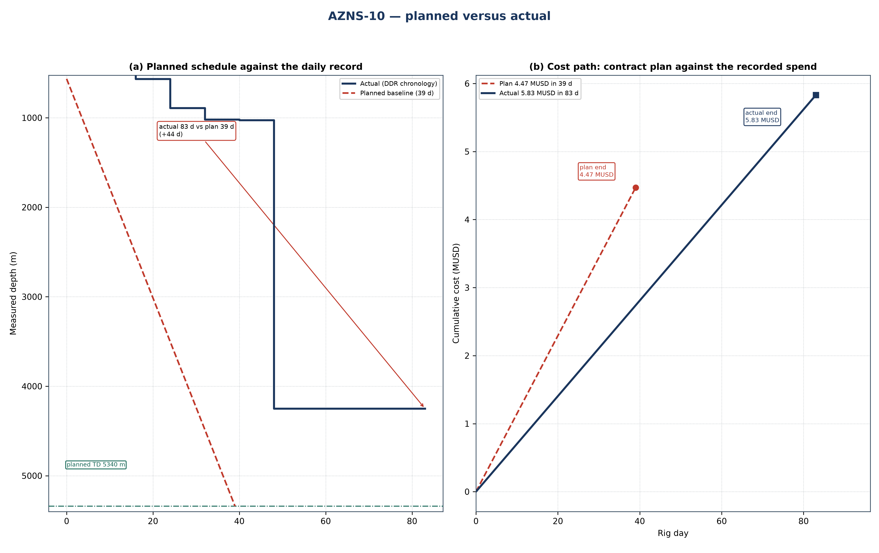
Figure 24.1 — AZNS-10: planned schedule and cost path against the recorded operation
Table 24.1 — Planned and actual milestones
Indicator | Programme | Record | Variance | Basis
Rig days | 39 | 83 | +44.0 | Programme duration / DDR rig hours
Total depth (m) | 5,340 | 4,250 | −1,090 | Programme TD / final MD
New hole (m) | — | 807 | — | DDR daily drilling figure
Rig | OEOC RIG 201 | OEOC RIG 201 | — | DDR header
NPT share | — | 988 h (49.8%) | — | Time-log flags
Contract value (MUSD) | 4.47 | 5.83 | +1.36 | CBS / daily-rate reconstruction
Specific cost (USD/m) | 5,540 | 7,224 | — | Cost over new hole

Ref. — duration and total depth from the approved programme; recorded rig days, new hole and final measured depth from the DDR sheets cited in Chapters 1 to 3; contract value from the cost breakdown structure and the recorded cost from the daily-rate reconstruction of Chapter 25.
Two explanations are open for a variance of this size, and they are separated before any recovery is credited. Either the scope grew after approval — an extra run, a second window, a deeper shoe — or the same scope took longer because rig time was lost. The discriminator is the NPT register: non-productive time is 988 h of 1,984 h (988 h (49.8%)), which accounts for about 41 days. Where that is close to the overrun, the scope did not change and the time was lost; where the operation count rises while NPT stays flat, the scope changed.
Technically the operation followed the programme sequence of drill-out and re-entry workover: the casing and hole programme of Chapter 2, the fluid programme of Chapter 7 and the bit and BHA record of Chapter 6 are the executed values, and Table 24.1 sets them against the plan. The planned section boundaries are reproduced in Figure 24.1 by the formation bands, so any section that ran long can be read directly off the depth axis.

25. Cost breakdown structure: contract plan against recorded cost
CBS AZNS-10.xlsx prices the scope at 4.47 MUSD, of which 1.25 MUSD is written on day-rate lines at a rig rate of 23,000 USD/day; the time-dependent element therefore costs about 32,143 USD per rig day. The record closes at 5.83 MUSD, a variance of +1.36 MUSD (+30%). Figure 25.1 splits that variance into the day-rate effect of the schedule and a scope-and-price residual.
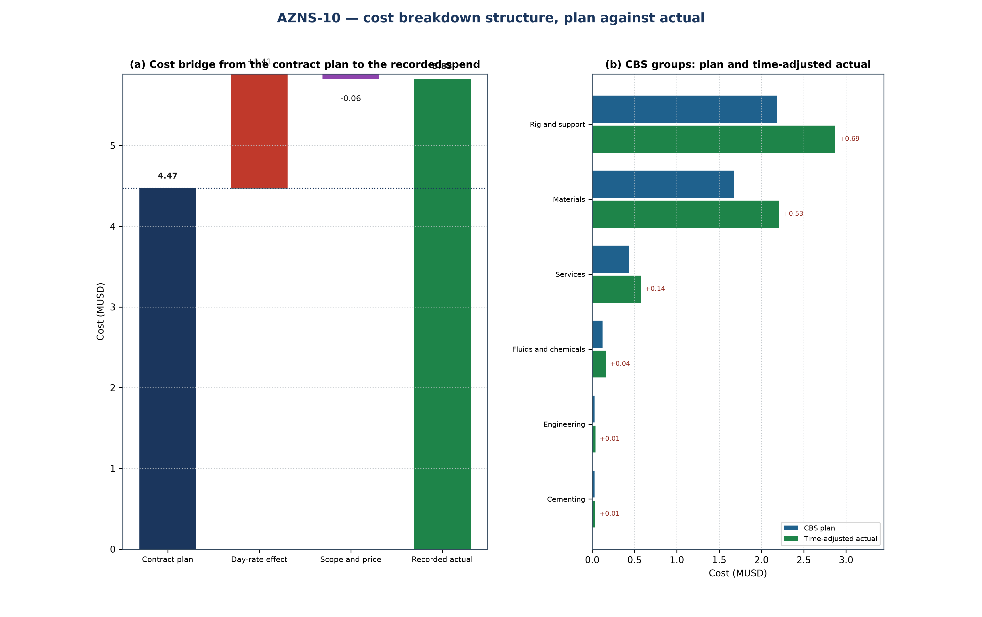
Figure 25.1 — AZNS-10: cost bridge and CBS groups
Table 25.1 — CBS groups: plan, share and time-adjusted value
CBS group | Plan (MUSD) | Share | Time-adjusted (MUSD) | Δ (MUSD)
Rig and support | 2.18 | 48.8% | 2.87 | +0.69
Materials | 1.68 | 37.5% | 2.21 | +0.53
Services | 0.44 | 9.7% | 0.57 | +0.14
Fluids and chemicals | 0.12 | 2.7% | 0.16 | +0.04
Engineering | 0.03 | 0.6% | 0.04 | +0.01
Cementing | 0.03 | 0.6% | 0.04 | +0.01
Total | 4.47 | 100.0% | 5.89 | +1.41

CBS Ref. — quantities and unit rates from "CBS AZNS-10.xlsx", sheet "Cost Breakdown-10 w. Extra Wor"; the recorded cost is the daily-rate reconstruction of Chapter 1, not a second reading of the workbook.
Table 25.2 — Variance bridge
Step | MUSD | Driver
Contract plan (CBS) | 4.47 | Contract quantities at contract rates
Day-rate effect | +1.41 | +44.0 rig days at 32,143 USD/day
Scope and price residual | −0.06 | Runs, materials and services beyond the priced quantity
Recorded cost | 5.83 | Daily-rate reconstruction

CBS Ref. — quantities and unit rates from "CBS AZNS-10.xlsx", sheet "Cost Breakdown-10 w. Extra Wor"; the recorded cost is the daily-rate reconstruction of Chapter 1, not a second reading of the workbook.
The residual is small against the contract value, so the variance is very nearly the price of rig time: the scope held and the schedule did not. That is the useful reading for the next well of the same scope, because it makes the day rate the only lever that matters in the estimate.

26. Intervention-specific execution notes
This is a workover: the well is killed and secured first, the existing completion is retrieved or milled, the productive interval is re-established and the well is returned to service. The programme's well-control chapter governs the kill, the cement programme governs any squeeze and the completion chapter governs the string and the packer setting depth. The hold points below are the ones that decide whether the operation closes on plan.
Table 26.1 — Execution hold points
Stage | Execution requirement | Hold point
Kill and secure | Kill fluid from the last recorded gradient, circulated at the minimum rate that keeps the annulus full | stable shut-in pressure before the tree is broken
Retrieve or mill the completion | Recorded make-up torque, fishing diagram and jarring procedure on the floor | string freed and torque recorded before the next run
Squeeze and test | Cement squeeze at the programmed pressure with the WOC time held in full | pressure test held before the interval is opened
Re-establish the interval | Perforation, acid or rig-less stimulation per the programme, treating pressure recorded | treating pressure inside the fracture gradient of Chapter 9

Ref. — hold points read from AZNS-010 Workover Program Rev.06.pdf; the sequence of the operation follows the approved programme and the daily record cited in Chapter 3.
The operation as recorded was of the drill-out and re-entry workover type. Its schedule closed at 83 rig days against 39 planned, the reading of Chapter 24, and its cost at 5.83 MUSD against 4.47 MUSD of contract value, which Chapter 25 decomposes. What remains for the next operation of this type is the hold-point discipline of Table 26.1: every recorded overrun is a hold point passed late rather than a step executed badly.

