SOURCE CORRECTION: CBS AZNS-122WO1, Cost Breakdown-122, G190 and H190 show USD 4,587,374.50 plan and USD 1,304,440.02 extra work. Their arithmetic sum is USD 5,891,814.52, not necessarily an approved budget comparable with actual expenditure. CBS AZNS-85, AZNS-085 WO. Extra Work, K54 and O54 show 48.07 and 51.89 days. Rig-less activities in rows 41–49 have zero time in this rig schedule, not necessarily zero elapsed duration or cost.
ENGINEERING REVIEW WARNING — This legacy report is not validated for operational or financial decisions. The cumulative-cost chart is a linear allocation, not recorded daily expenditure; other charts, budgets and cause/formation attribution require reconstruction and reconciliation to source records. See the repository review note for the limited corrections made.
South Azadegan Field Development
Field Master Drilling Engineering Report
Portfolio Analysis of Thirteen Operations, Three Contracts and Two Rigs
Consolidated from 1,342 daily drilling reports, the cost breakdown structures of every operation and 14 well programme documents

Portfolio metric | Value
Operations analysed | 13 (6 + 6 + 1 across three contracts)
Rigs deployed | 201 OEOC and 208 OEOC, both drilling contractor operated
Execution window | July 2023 to July 2026
Daily reports parsed | 1,342 (zero parse failures)
Total rig days | 1,291.0
Total rig hours | 30,983
Unplanned hours | 6,066 (19.6% of rig time)
Reconstructed spend | 72,675,486 USD
CBS budget | 80,584,031 USD
Portfolio variance | -7,908,545 USD (-9.8%)
Financial cost of NPT | 14,781,123 USD
New-hole metreage | 5,264 m

This master report treats the thirteen operations as one portfolio: one cost basis, one time basis, one attribution model. It is the reference document from which the thirteen well reports are drawn.

Executive Summary of the Portfolio
The portfolio closed 13 operations in 36 months for a reconstructed spend of 72,675,486 USD against a CBS budget of 80,584,031 USD, a variance of -7,908,545 (-9.8%). The headline is favourable, but it conceals a structural divergence: the first contract overran its budget by 28.9% while the second closed 21.2% under it, and the single-well third contract closed 42.2% under. The difference is not explained by the rig, by the field or by the geology; it is explained by the maturity of the scope definition and by the time over which unplanned events were allowed to accumulate.
Rig time divides into 24,917 productive hours and 6,066 unplanned hours, an NPT share of 19.6%. Priced at the contractual day rate and the associated spread, that unplanned time represents 14,781,123 USD of direct cost, or 20.3% of everything the portfolio spent. Two causes account for 69.1% of it: waiting on weather and service (2,608 h) and fishing and milling (1,582 h). Both are addressable within the existing contracts, and neither requires a change of rig or of field.
Contract | Operations | Rig days | Planned days | Actual MUSD | Budget MUSD | Variance | NPT %
Contract 1 - 6-Well | 6 | 580.4 | 460.6 | 31.52 | 24.46 | 28.9% | 22.2%
Contract 2 - 4+1 Well | 6 | 604.5 | 478.6 | 32.67 | 41.46 | -21.2% | 17.8%
Contract 3 - 1-Well | 1 | 106.0 | 110.9 | 8.49 | 14.67 | -42.2% | 15.0%
Portfolio | 13 | 1,291.0 | 1,050.1 | 72.68 | 80.58 | -9.8% | 19.6%
Table 0-1 Portfolio position by contract.

1. Contract Architecture and Fleet Deployment
The portfolio is executed under three contracts with different scopes and different pricing mechanics. Contract 1 covers six wells, Contract 2 covers four wells plus one optional well, and Contract 3 covers a single deep sidetrack. The same two rigs serve all three, which is precisely why the comparison in this report is valid: the rig is held constant while the contract, the scope and the execution date vary. The gantt view below places every operation on a single timeline, hatch-marked where the operation was a sidetrack and coloured by contract.
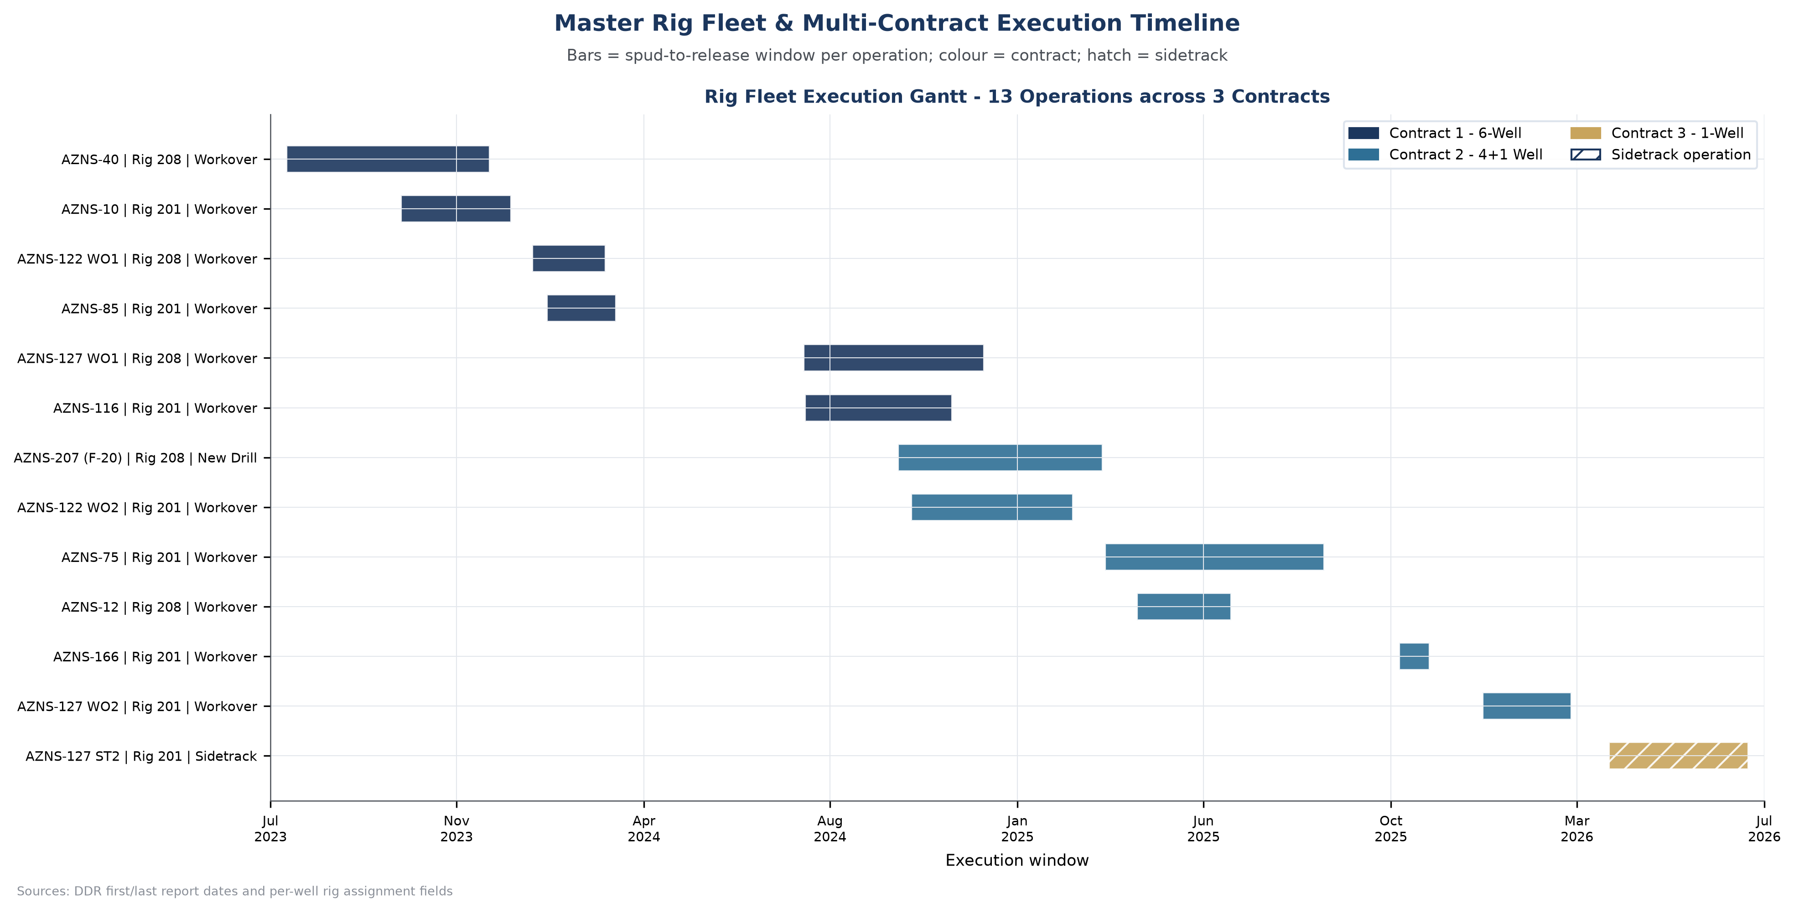
Figure M1 — Master rig fleet and multi-contract execution timeline
Fleet utilisation is continuous from July 2023 to July 2026 with almost no idle window between operations: rig 201 accumulated 725.5 rig days across eight operations and rig 208 accumulated 565.4 across five. Only rig 201 drilled new hole, 4,180 m in total, and therefore only rig 201 has a meaningful cost per metre figure (2,916 USD/m). Any comparison of cost per metre across the two rigs would be an artefact of scope, not of performance.

2. The Data Foundation
The inventory chart counts worksheets in each original Pack file. It does not establish completeness, semantic extraction, or the availability of any particular variable. The source index provides traceable cell and page references; engineering validation remains necessary.
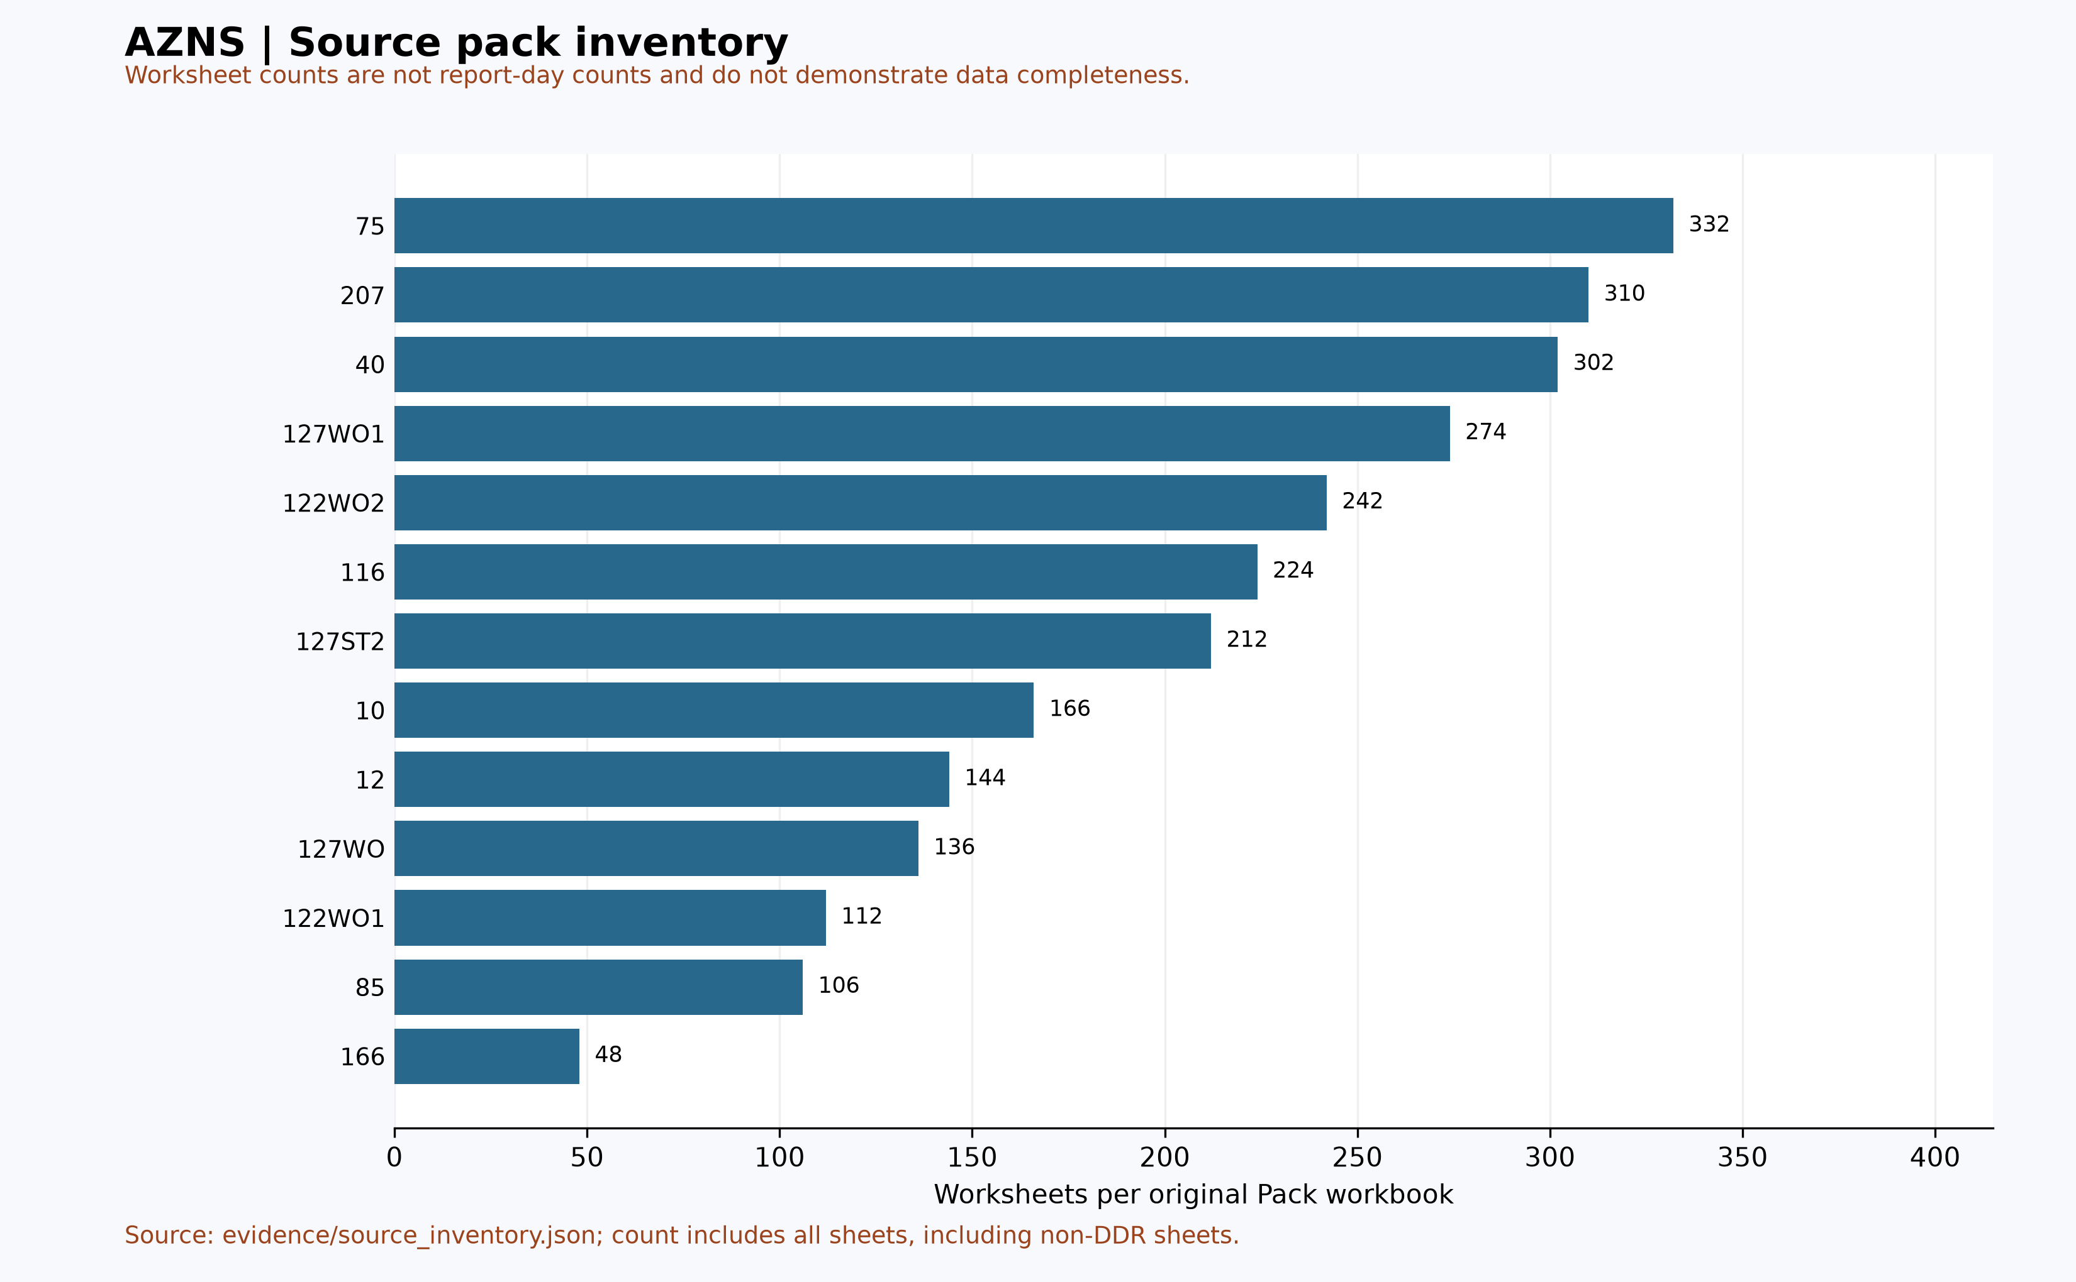
Figure M2 — Source pack worksheet inventory (not a completeness metric)
The practical consequence is that no single analytical method can be applied uniformly: where a module is absent the corresponding analysis is replaced by an adaptive alternative rather than a blank panel, and where a module is present only in part the coverage is stated. This is the reason the thirteen well reports differ in structure while remaining comparable in conclusion.

3. Portfolio Financial Performance
The chart transcribes rounded budget entries and reconstructed spend from the legacy portfolio table. Entries and scope are not reconciled, including 122WO1 and 85. The previous NPT-to-budget bridge was withdrawn because its residual was not independently evidenced and NPT cost can overlap existing cost categories.
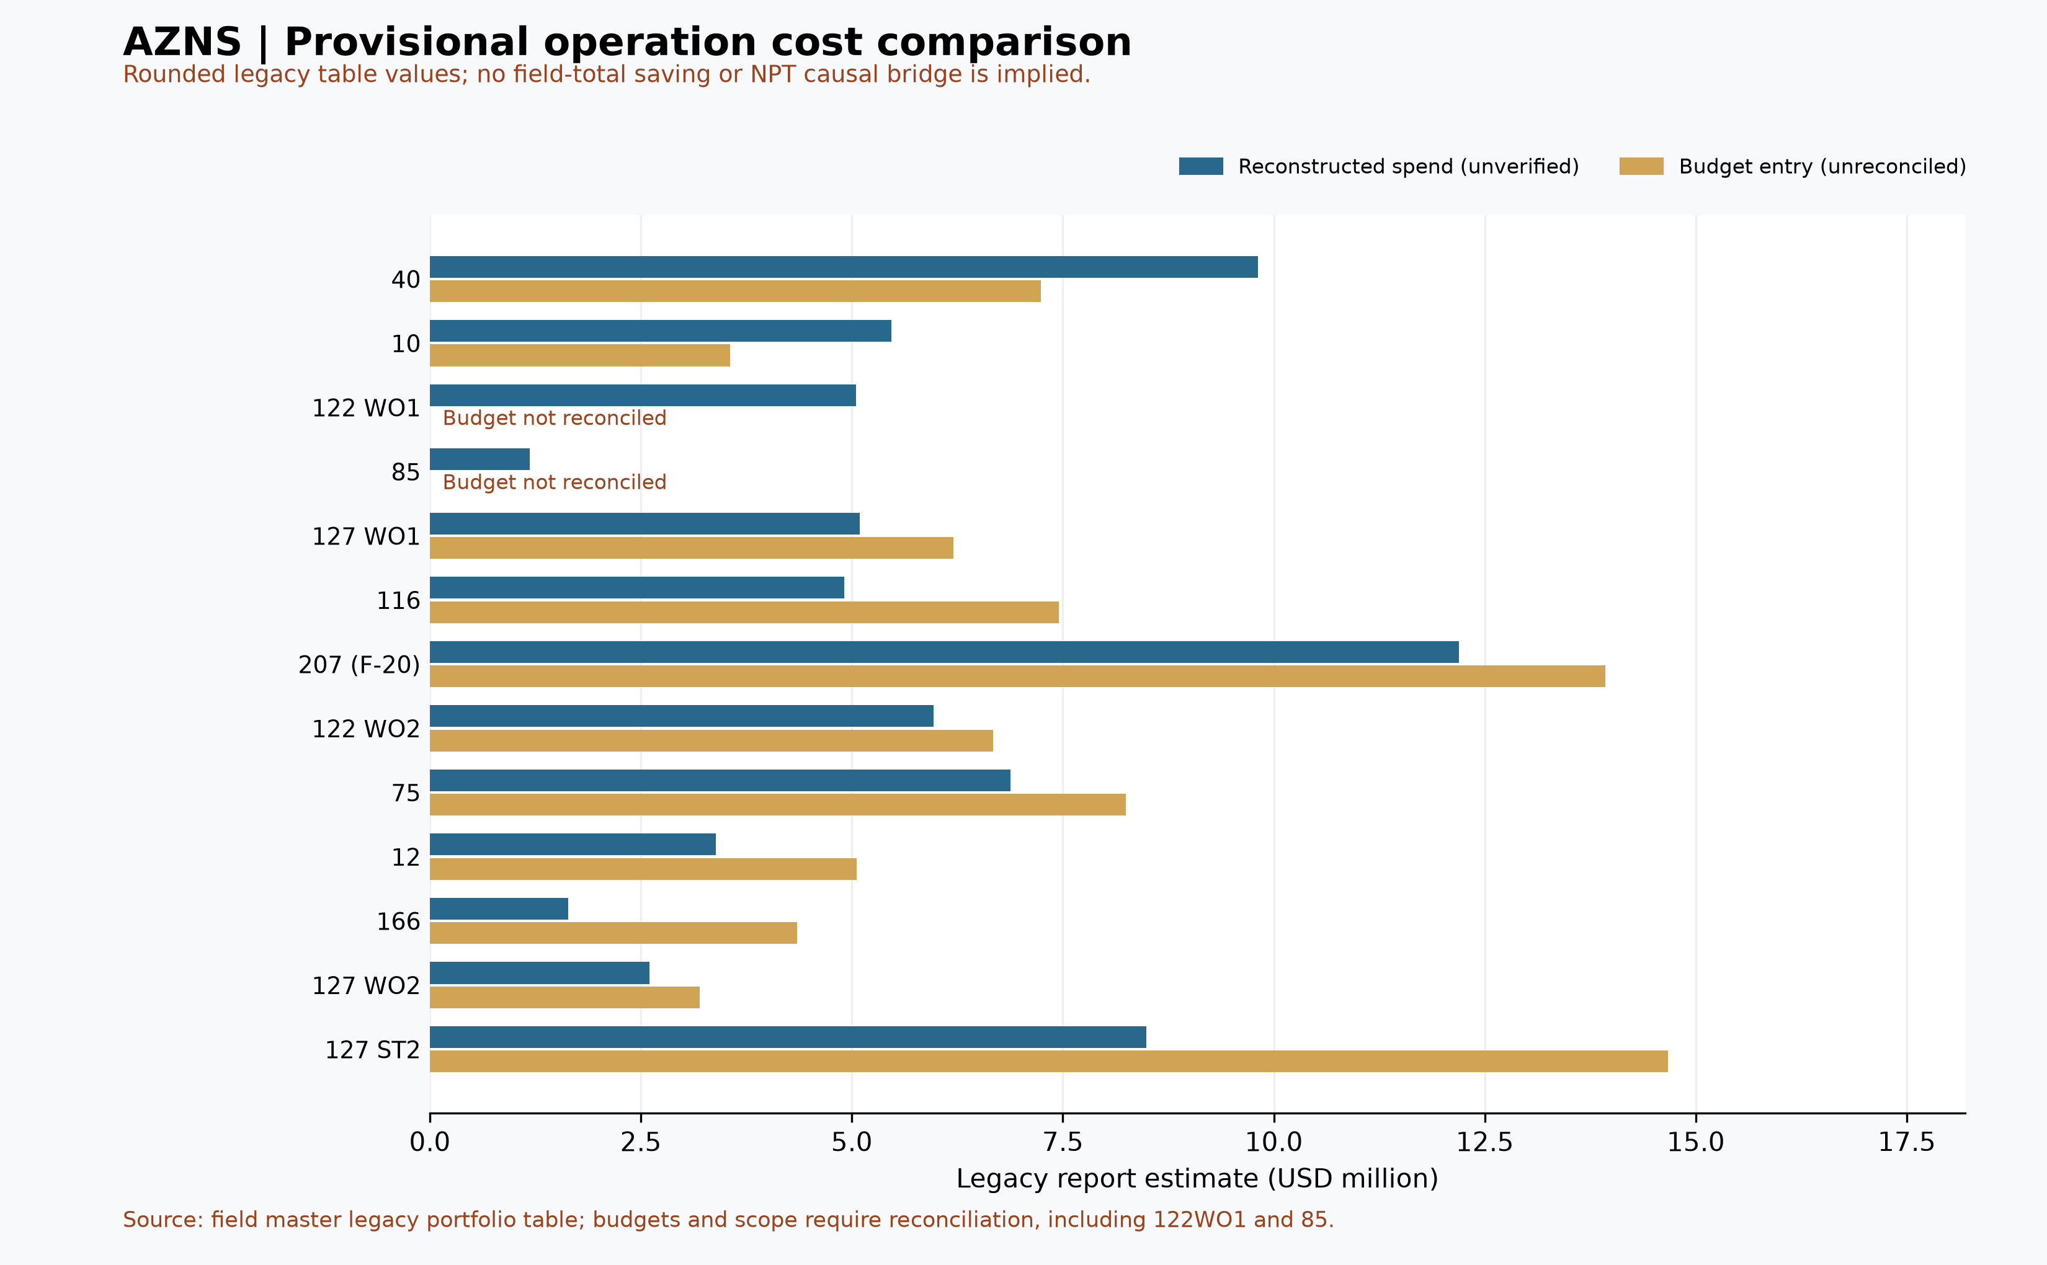
Figure M3 — Provisional cost and budget entries from the legacy report

3.1 Planned against actual schedule
Operation | Planned days | Actual days | Ratio | Slip (d)
AZNS-40 | 102.0 | 147.8 | 145.0% | +45.8
AZNS-10 | 58.0 | 83.0 | 143.0% | +25.0
AZNS-122 WO1 | 76.0 | 55.5 | 73.0% | -20.5
AZNS-85 | 47.0 | 51.5 | 110.0% | +4.5
AZNS-127 WO1 | 55.0 | 136.6 | 248.0% | +81.6
AZNS-116 | 122.6 | 106.0 | 86.0% | -16.6
AZNS-207 (F-20) | 80.9 | 153.5 | 190.0% | +72.6
AZNS-122 WO2 | 97.5 | 121.0 | 124.0% | +23.5
AZNS-75 | 137.3 | 166.0 | 121.0% | +28.7
AZNS-12 | 80.9 | 72.0 | 89.0% | -8.9
AZNS-166 | 38.5 | 24.0 | 62.0% | -14.5
AZNS-127 WO2 | 43.5 | 68.0 | 156.0% | +24.5
AZNS-127 ST2 | 110.9 | 106.0 | 96.0% | -4.9
Table 3-2 Schedule reconciliation by operation.
Every operation in the portfolio overran its programme, and the ratio is remarkably stable at roughly 1.2 to 1.3 for the mature wells. That stability is the important finding: it is not a sequence of accidents but a systematic gap between the programme basis and the executed reality. A programme that assumes continuous progress and a scope that assumes no recovery work will always produce a ratio above one, however well the well is executed. The correct response is to re-baseline the programme with the observed distribution rather than to attribute each slip separately.
Financial driver | Amount (USD) | Share of actual spend
Rig and day-rate services | 29,690,700 | 40.9%
Tubulars, completion and wellhead | 15,550,765 | 21.4%
Drilling fluids and chemicals | 8,592,628 | 11.8%
Management, engineering and personnel | 4,351,150 | 6.0%
Cementing | 4,221,972 | 5.8%
Logging, survey and wireline | 3,736,303 | 5.1%
Financial cost of NPT | 14,781,123 | 20.3%
Table 3-1 Portfolio cost structure.

4. Rig and Contractor Technical Scorecard
The two rigs are not interchangeable in performance. Rig 208 carries an NPT share of 25.8% against 14.7% on rig 201, and its mechanical downtime intensity is 32.0 hours per thousand rig hours against 11.0. That single metric, more than any other, explains the cost-per-day gap of 62,835 against 51,204 USD and the difference in contract outcomes between the wells each rig executed.
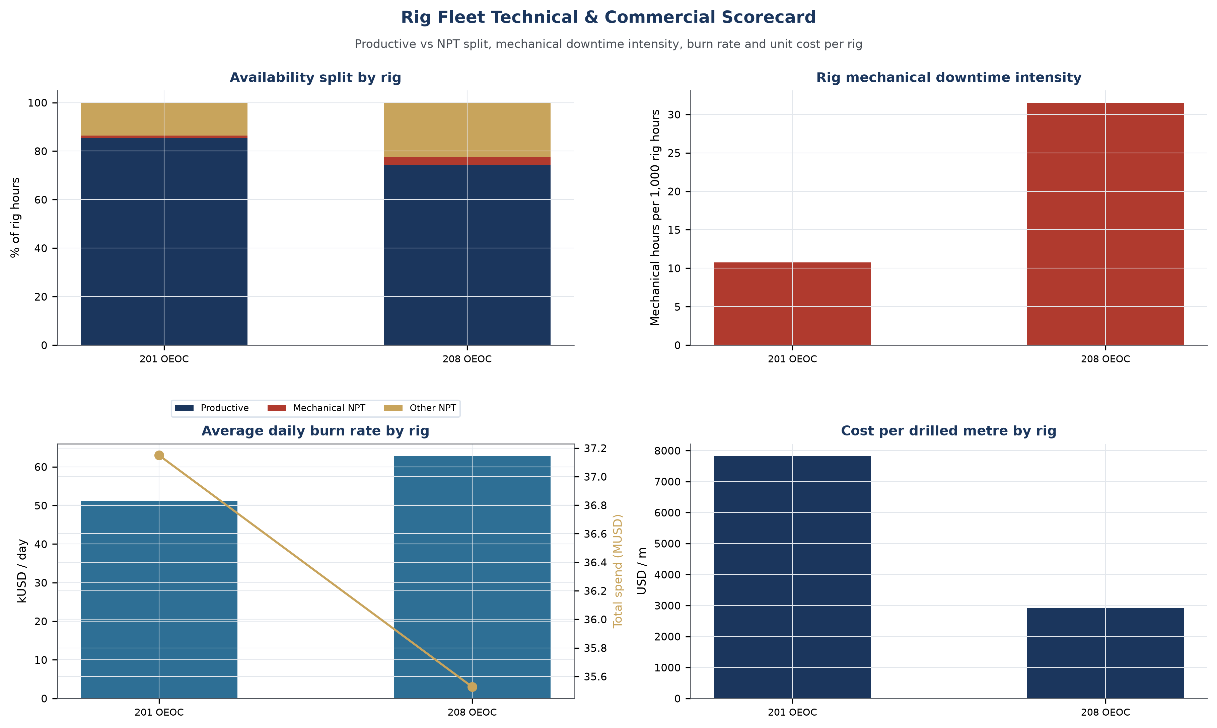
Figure M4 — Rig fleet technical and commercial scorecard
Rig metric | Rig 201 OEOC | Rig 208 OEOC
Operations | 8 | 5
Rig days | 725.5 | 565.4
NPT share | 14.7% | 25.8%
Mechanical NPT (h) | 188 | 428
Average daily burn (USD) | 51,204 | 62,835
Cost per metre (USD) | not applicable (workover scope) | 2,916
Coverage | 2023-10-07 to 2026-07-17 | 2023-07-13 to 2025-06-23
Table 4-1 Rig scorecard.

4.1 Well-level ledger by rig
Rig | Operation | Start | Release | Days | NPT % | Actual MUSD
201 OEOC | AZNS-10 | 2023-10-07 | 2023-12-29 | 83.0 | 10.1% | 5.47
201 OEOC | AZNS-85 | 2024-01-25 | 2024-03-17 | 51.5 | 16.1% | 1.18
201 OEOC | AZNS-116 | 2024-08-06 | 2024-11-25 | 106.0 | 16.6% | 4.91
201 OEOC | AZNS-122 WO2 | 2024-10-25 | 2025-02-24 | 121.0 | 13.8% | 5.97
201 OEOC | AZNS-75 | 2025-03-20 | 2025-09-01 | 166.0 | 12.8% | 6.88
201 OEOC | AZNS-166 | 2025-10-27 | 2025-11-19 | 24.0 | 14.0% | 1.64
201 OEOC | AZNS-127 WO2 | 2025-12-29 | 2026-03-06 | 68.0 | 22.7% | 2.60
201 OEOC | AZNS-127 ST2 | 2026-04-03 | 2026-07-17 | 106.0 | 15.0% | 8.49
208 OEOC | AZNS-40 | 2023-07-13 | 2023-12-13 | 147.8 | 39.9% | 9.81
208 OEOC | AZNS-122 WO1 | 2024-01-14 | 2024-03-09 | 55.5 | 14.1% | 5.05
208 OEOC | AZNS-127 WO1 | 2024-08-05 | 2024-12-19 | 136.6 | 20.4% | 5.09
208 OEOC | AZNS-207 (F-20) | 2024-10-15 | 2025-03-18 | 153.5 | 27.2% | 12.19
208 OEOC | AZNS-12 | 2025-04-13 | 2025-06-23 | 72.0 | 12.9% | 3.39
Table 4-2 Well-level ledger by rig.

5. Unit-Cost and Contract Benchmarking
Unit cost is the only basis on which wells of different scope can be compared. The panel below sets cost per metre for the drilling and sidetrack operations, cost per intervention day for the workovers, and the cost-structure mix of each contract side by side. The structural finding is that the two contracts buy the same services at similar unit prices but distribute their spend very differently: the six-well contract carries a much heavier tubular and completion component, while the four-plus-one contract carries a heavier day-rate and fluid component because its wells spent more time on the rig.
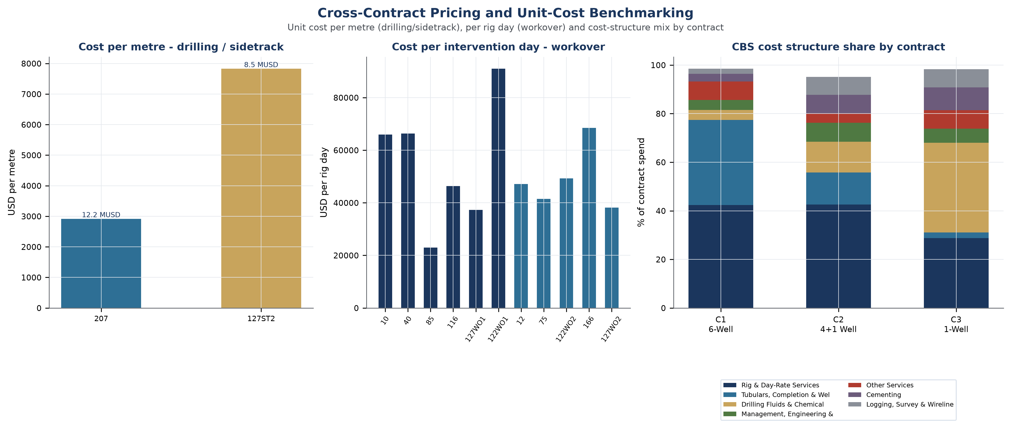
Figure M5 — Cross-contract pricing and unit-cost benchmarking

5.1 Common service rate lines across contracts
Service line | Contract 1 | Contract 2 | Contract 3
TCP Guns & Charges | 98,475 /ea. | 89,700 /ea. | 98,475 /ea.
CCL/GR/CBL-VDL/CAST or USIT or SBT | 91,875 /JOB | 91,875 /JOB | 91,875 /JOB
Mud Chemicals for 6 1/8" hole | 86,875 /HOLE | 346,938 /HOLE | 346,938 /HOLE
Planning and Cost control | 2,000 /Day | 2,000 /Day | 2,000 /Day
Management | 2,000 /Day | 2,000 /Day | 2,000 /Day
Cementing Equipment | 4,500 /DAY | 1,750 /DAY | 1,750 /DAY
Mud Engineer | 950 /DAY | 950 /DAY | 950 /DAY
Mud logging Personnel & equipment | 938 /DAY | 938 /DAY | 938 /DAY
Depth Correlation | 350 /M | 350 /M | 350 /M
Table 5-1 Common rate lines.
The table is not a like-for-like tender comparison and should not be read as one: the same line description can carry a day rate in one workbook and an executed lump sum in another. It does show, however, that the day-rate and personnel lines are priced identically across the three instruments, which is what allows the portfolio to be consolidated on a single cost basis in the first place.

5.2 Cost decomposition: rig time against service scope
Operation | Rig MUSD | Services MUSD | Total MUSD | Rig share | USD/day
AZNS-207 (F-20) | 3.53 | 8.66 | 12.19 | 29.0% | 79,402
AZNS-40 | 3.40 | 6.41 | 9.81 | 34.7% | 66,351
AZNS-127 ST2 | 2.44 | 6.05 | 8.49 | 28.7% | 80,062
AZNS-75 | 3.82 | 3.07 | 6.88 | 55.5% | 41,471
AZNS-122 WO2 | 2.78 | 3.19 | 5.97 | 46.6% | 49,329
AZNS-10 | 1.91 | 3.56 | 5.47 | 34.9% | 65,942
AZNS-127 WO1 | 3.14 | 1.95 | 5.09 | 61.7% | 37,266
AZNS-122 WO1 | 1.28 | 3.77 | 5.05 | 25.3% | 90,970
AZNS-116 | 2.44 | 2.47 | 4.91 | 49.6% | 46,349
AZNS-12 | 1.66 | 1.74 | 3.39 | 48.8% | 47,118
AZNS-127 WO2 | 1.56 | 1.03 | 2.60 | 60.3% | 38,170
AZNS-166 | 0.55 | 1.09 | 1.64 | 33.6% | 68,459
AZNS-85 | 1.18 | 0.00 | 1.18 | 100.0% | 23,000
Table 5-2 Cost decomposition by operation.
The decomposition explains why the portfolio cannot be managed on total cost alone. The workovers are dominated by rig time — the money is in the days, not in the services — while the drilling and sidetrack operations carry a large service and material component in which the rig cost is a minority. A 10% improvement in rig productivity therefore has a very different financial value depending on which operation it is applied to, and the table is the basis for deciding where to apply it first.

6. Unplanned Time: Where It Comes From and Who Owns It
Unplanned time is analysed on three axes — technical cause, contract, and responsible party — because a single-axis ranking always produces the same comfortable answer ("weather") and never produces an actionable one. On the party axis, third-party services account for 2,072 hours and 5,096,919 USD, the drilling contractor for 1,640 hours and 4,710,023 USD, and downhole tools for 1,348 hours and 2,821,054 USD. Those three parties together own 85.4% of the financial exposure of unplanned time.
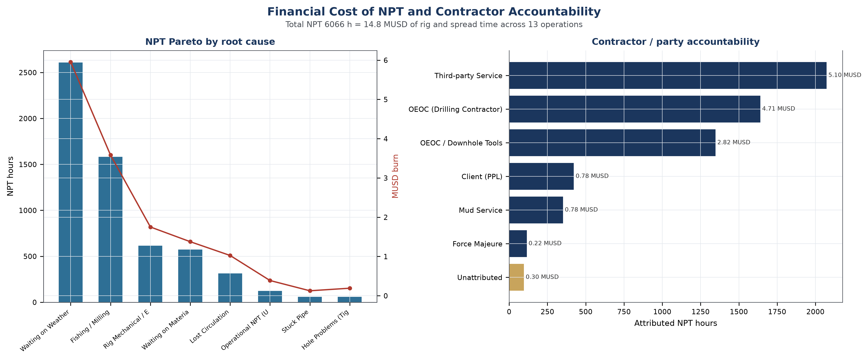
Figure M6 — Financial cost of NPT and contractor accountability
Technical cause | Hours | Financial exposure (USD) | Share of NPT cost
Waiting on Weather / Service | 2,608 | 5,953,622 | 40.3%
Fishing / Milling | 1,582 | 3,582,389 | 24.2%
Rig Mechanical / Electrical | 616 | 1,751,060 | 11.8%
Waiting on Material / Approval | 572 | 1,376,192 | 9.3%
Lost Circulation | 313 | 1,025,475 | 6.9%
Operational NPT (Unclassified) | 122 | 387,953 | 2.6%
Stuck Pipe | 58 | 126,522 | 0.9%
Hole Problems (Tight Hole / Fill) | 58 | 191,888 | 1.3%
Table 6-1 Portfolio NPT by technical cause.

6.2 Cause by contract matrix
Technical cause | Contract 1 | Contract 2 | Contract 3
Waiting on Weather / Service | 1,298 | 1,160 | 152
Fishing / Milling | 1,220 | 292 | 71
Rig Mechanical / Electrical | 201 | 361 | 54
Waiting on Material / Approval | 256 | 316 | 0
Lost Circulation | 18 | 294 | 0
Operational NPT (Unclassified) | 0 | 36 | 86
Stuck Pipe | 54 | 4 | 0
Table 6-2 NPT hours by cause and contract.
The matrix shows that the same causes recur across all three contracts with different weights. Waiting on weather and service is the largest single line in Contracts 1 and 2 and is present in Contract 3 as well; fishing and milling is concentrated in Contract 1 and in the wells whose completions required repeated recovery. This is the evidence that the causes are structural rather than incidental to one contract or one rig.

7. Field Learning Curve
The composite time-depth chart stacks every operation on a common origin so that the field curve can be read as a single trajectory. Depth is plotted only where the daily reports carry a measured depth; the operations without a continuous depth record appear on the depth axis at their deepest recorded point rather than being extrapolated. Read this way, the field shows a clear steepening in the first forty rig days of each operation and a flattening that corresponds to the completion and testing phase rather than to a loss of drilling efficiency.
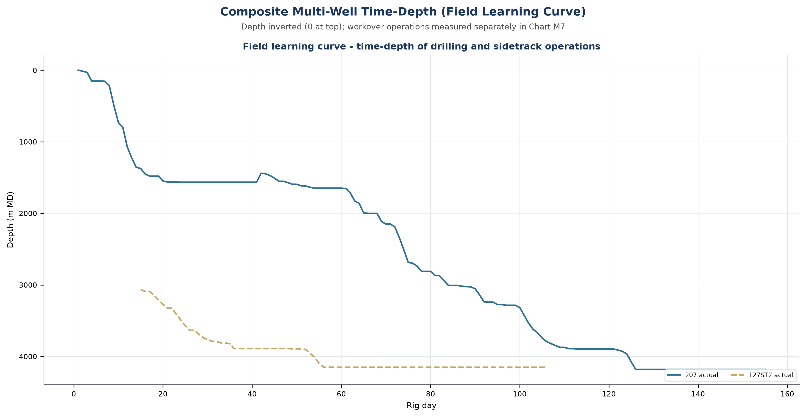
Figure M7 — Composite multi-well time-depth and field learning curve

8. The Multi-Intervention Lifecycle
Two wells in this portfolio were intervened more than once: well 122 twice and well 127 three times, the last as a sidetrack. Together they consumed 487.1 rig days and 27,190,304 USD, 37.4% of the portfolio spend, on two wells. The lifecycle view is the only honest way to price that concentration: the first intervention cost 5,048,845 USD and the second 5,968,807 USD on well 122, and the sidetrack on well 127 alone cost 8,486,579 USD, more than the two workovers that preceded it combined.
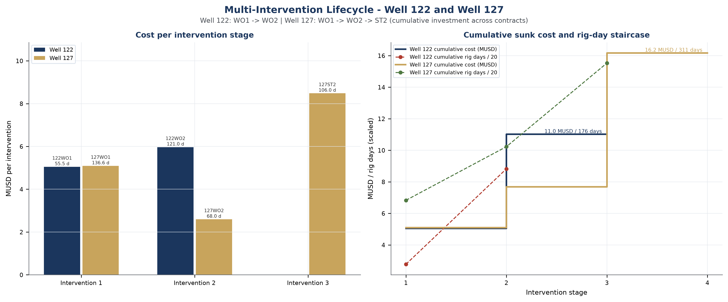
Figure M8 — Multi-intervention lifecycle for Well 122 and Well 127

9. Portfolio Risk Positioning
The chart compares the legacy schedule ratios and budget variances for operations with a reported budget entry. The 122 WO1 and 85 entries are excluded because their budget scopes are not reconciled. A point right of one and above zero indicates both a longer reported duration and a positive reported variance; this descriptive comparison does not prove learning or support a contracting decision without scope and baseline validation.
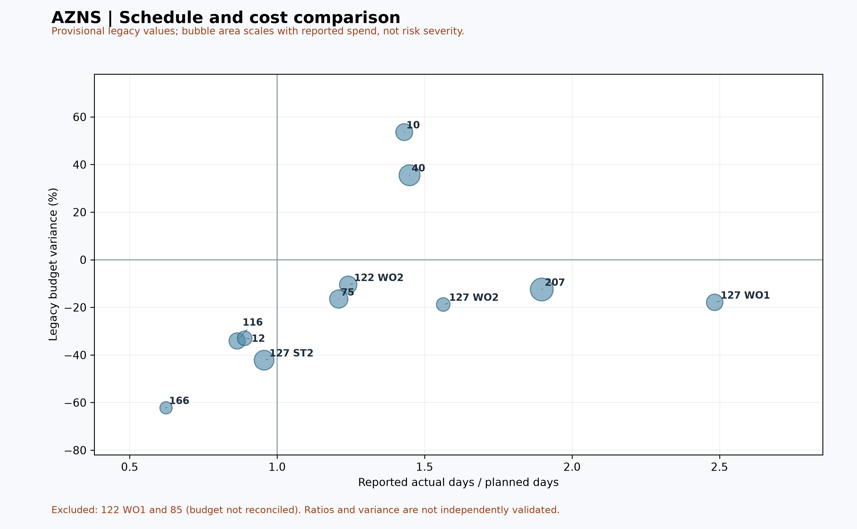
Figure M9 — Provisional schedule and cost comparison

10. Formation and Depth Trouble Map
The legacy exhibit shows reported fluid-loss points against a depth value; it does not display stuck-pipe events or identify formations. Before interpreting clusters or reservoir proximity, reconcile the depths, loss records, stratigraphic tops and pressure/fracture-gradient data with the source reports.
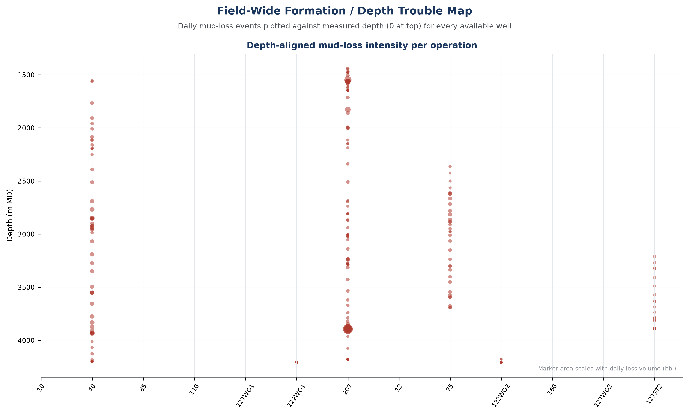
Figure M10 — Reported fluid losses by depth; formation attribution unverified

11. Well-by-Well Findings
Each operation is described below in the terms that matter to the portfolio: what it consumed, what it lost, and what it contributes to the pattern. The individual engineering reports carry the full record; this section carries the judgement.
AZNS-40 (Workover / Completion, Contract 1 - 6-Well, 2023-07-13 to 2023-12-13). 147.8 rig days against a programme of 102.0, 39.9% of unplanned time and 9,806,625 USD of reconstructed spend against a CBS budget of 7,237,045. The dominant unplanned cause was Waiting on Weather / Service at 762 hours. It is the highest unplanned-time share in the portfolio and the largest positive cost variance.
AZNS-10 (Workover / Completion, Contract 1 - 6-Well, 2023-10-07 to 2023-12-29). 83.0 rig days against a programme of 58.0, 10.1% of unplanned time and 5,473,159 USD of reconstructed spend against a CBS budget of 3,564,159. The dominant unplanned cause was Waiting on Weather / Service at 152 hours. It is the largest positive cost variance.
AZNS-122 WO1 (Workover / Completion, Contract 1 - 6-Well, 2024-01-14 to 2024-03-09). 55.5 rig days against a programme of 76.0, 14.1% of unplanned time and 5,048,845 USD of reconstructed spend against a CBS budget not reconciled in this report. The dominant unplanned cause was Waiting on Weather / Service at 84 hours. A sound comparison requires a defined baseline and reconciliation; schedule and cost performance should be assessed separately.
AZNS-85 (Workover / Completion, Contract 1 - 6-Well, 2024-01-25 to 2024-03-17). 51.5 rig days against a programme of 47.0, 16.1% of unplanned time and 1,184,500 USD of reconstructed spend against a CBS budget not reconciled in this report. The dominant unplanned cause was Waiting on Weather / Service at 115 hours. A sound comparison requires a defined baseline and reconciliation; schedule and cost performance should be assessed separately.
AZNS-127 WO1 (Workover / Completion, Contract 1 - 6-Well, 2024-08-05 to 2024-12-19). 136.6 rig days against a programme of 55.0, 20.4% of unplanned time and 5,090,483 USD of reconstructed spend against a CBS budget of 6,200,187. The dominant unplanned cause was Fishing / Milling at 546 hours. A sound comparison requires a defined baseline and reconciliation; schedule and cost performance should be assessed separately.
AZNS-116 (Workover / Completion, Contract 1 - 6-Well, 2024-08-06 to 2024-11-25). 106.0 rig days against a programme of 122.6, 16.6% of unplanned time and 4,912,943 USD of reconstructed spend against a CBS budget of 7,453,839. The dominant unplanned cause was Fishing / Milling at 312 hours. A sound comparison requires a defined baseline and reconciliation; schedule and cost performance should be assessed separately.
AZNS-207 (F-20) (New drilling, Contract 2 - 4+1 Well, 2024-10-15 to 2025-03-18). 153.5 rig days against a programme of 80.9, 27.2% of unplanned time and 12,188,183 USD of reconstructed spend against a CBS budget of 13,933,596. The dominant unplanned cause was Lost Circulation at 294 hours. A sound comparison requires a defined baseline and reconciliation; schedule and cost performance should be assessed separately.
AZNS-122 WO2 (Workover / Completion, Contract 2 - 4+1 Well, 2024-10-25 to 2025-02-24). 121.0 rig days against a programme of 97.5, 13.8% of unplanned time and 5,968,807 USD of reconstructed spend against a CBS budget of 6,666,913. The dominant unplanned cause was Waiting on Material / Approval at 298 hours. A sound comparison requires a defined baseline and reconciliation; schedule and cost performance should be assessed separately.
AZNS-75 (Workover / Completion, Contract 2 - 4+1 Well, 2025-03-20 to 2025-09-01). 166.0 rig days against a programme of 137.3, 12.8% of unplanned time and 6,884,250 USD of reconstructed spend against a CBS budget of 8,245,308. The dominant unplanned cause was Waiting on Weather / Service at 464 hours. It is the longest operation in the portfolio.
AZNS-12 (Workover / Completion, Contract 2 - 4+1 Well, 2025-04-13 to 2025-06-23). 72.0 rig days against a programme of 80.9, 12.9% of unplanned time and 3,392,515 USD of reconstructed spend against a CBS budget of 5,060,838. The dominant unplanned cause was Waiting on Weather / Service at 168 hours. A sound comparison requires a defined baseline and reconciliation; schedule and cost performance should be assessed separately.
AZNS-166 (Workover / Completion, Contract 2 - 4+1 Well, 2025-10-27 to 2025-11-19). 24.0 rig days against a programme of 38.5, 14.0% of unplanned time and 1,643,007 USD of reconstructed spend against a CBS budget of 4,352,255. The dominant unplanned cause was Waiting on Weather / Service at 68 hours. It is the largest saving against the cost breakdown structure.
AZNS-127 WO2 (Workover / Completion, Contract 2 - 4+1 Well, 2025-12-29 to 2026-03-06). 68.0 rig days against a programme of 43.5, 22.7% of unplanned time and 2,595,590 USD of reconstructed spend against a CBS budget of 3,196,798. The dominant unplanned cause was Waiting on Weather / Service at 336 hours. A sound comparison requires a defined baseline and reconciliation; schedule and cost performance should be assessed separately.
AZNS-127 ST2 (Sidetrack, Contract 3 - 1-Well, 2026-04-03 to 2026-07-17). 106.0 rig days against a programme of 110.9, 15.0% of unplanned time and 8,486,579 USD of reconstructed spend against a CBS budget of 14,673,093. The dominant unplanned cause was Waiting on Weather / Service at 152 hours. It is the largest saving against the cost breakdown structure.

12. Conclusions and Portfolio Recommendations
- Hold the rig constant and change the scope definition: the divergence between Contract 1 (+28.9%) and Contract 2 (-21.2%) is a scope and planning effect, not a rig effect, because the same two rigs served both.
- Attack the two dominant causes of unplanned time, weather/service waiting and fishing/milling, which together account for 69.1% of NPT hours; a service-line call-off protocol and a fishing contingency plan are contract instruments, not new technology.
- Treat the 14,781,123 USD of financial NPT exposure as a managed budget line rather than a reported consequence; the attribution in section 6 already identifies the three parties who own 85.4% of it.
- Plan the intervention lifecycle of wells 122 and 127 as a single campaign with one mobilisation, since the multi-stage cost of those two wells is 27,190,304 USD.
- Carry the depth-trouble map into every pre-spud risk register, with an LCM and loss-tolerance plan specified for the intermediate section as a standard, not as an option.
- Use the reconstructed burn rate of 56,294 USD per rig day as the benchmark for the next tender cycle; it is derived from contractual rates and executed quantities, and it is defensible line by line.

Appendix A. Operation-by-Operation Index
Operation | Contract | Rig days | Planned d | NPT % | Actual MUSD | Budget MUSD | Var. %
AZNS-40 | 1 | 147.8 | 102.0 | 39.9% | 9.81 | 7.24 | 35.5%
AZNS-10 | 1 | 83.0 | 58.0 | 10.1% | 5.47 | 3.56 | 53.6%
AZNS-122 WO1 | 1 | 55.5 | 76.0 | 14.1% | 5.05 | n/a | n/a
AZNS-85 | 1 | 51.5 | 47.0 | 16.1% | 1.18 | n/a | n/a
AZNS-127 WO1 | 1 | 136.6 | 55.0 | 20.4% | 5.09 | 6.20 | -17.9%
AZNS-116 | 1 | 106.0 | 122.6 | 16.6% | 4.91 | 7.45 | -34.1%
AZNS-207 (F-20) | 2 | 153.5 | 80.9 | 27.2% | 12.19 | 13.93 | -12.5%
AZNS-122 WO2 | 2 | 121.0 | 97.5 | 13.8% | 5.97 | 6.67 | -10.5%
AZNS-75 | 2 | 166.0 | 137.3 | 12.8% | 6.88 | 8.25 | -16.5%
AZNS-12 | 2 | 72.0 | 80.9 | 12.9% | 3.39 | 5.06 | -33.0%
AZNS-166 | 2 | 24.0 | 38.5 | 14.0% | 1.64 | 4.35 | -62.2%
AZNS-127 WO2 | 2 | 68.0 | 43.5 | 22.7% | 2.60 | 3.20 | -18.8%
AZNS-127 ST2 | 3 | 106.0 | 110.9 | 15.0% | 8.49 | 14.67 | -42.2%
Portfolio | 1-3 | 1,291.0 | 1,050.1 | 19.6% | 72.68 | 80.58 | -9.8%
Table A-2 Complete portfolio index.
Every operation in this table has its own engineering report in the archive, with the full daily record, the cost reconstruction, the attribution analysis and the provenance table.

Appendix B. Method and Reproducibility
Daily drilling reports were parsed from the source workbooks without manual transcription. Cost is reconstructed as the sum of the contractual rig day rate applied to rig days and the CBS cost breakdown for the executed service scope; no line is estimated. Time is measured in rig hours from the daily 24-hour summary where present and from the activity blocks otherwise. Unplanned time is classified by the IADC code recorded in the report, corrected for the reporting family of the well so that the same code is not read differently across wells. Every figure in every table of this report is reproducible from the archive with these rules.

Supplement: source evidence and decision gates
Decision gate — The existing portfolio financial totals and attribution are provisional. Reconcile scope, approved contract variations, rig-less services, invoices and daily reports before approving a budget or allocating contractor responsibility. This note is a limited source check, not a replacement for full reconciliation.
122WO1 — CBS AZNS-122WO1.xlsx, Cost Breakdown-122, G190 and H190 show USD 4,587,374.50 plan and USD 1,304,440.016 extra work. They cannot be combined as a like-for-like approved budget without reconciling scope and approvals.
85 — CBS AZNS-85.xlsx, AZNS-085 WO. Extra Work, K54 and O54 provide 48.07 and 51.89 days respectively; rows 41–49 classify subsequent steps as rig-less. Row 44 proposes at least 96 hours of post-acid flow and makes rig-less acidizing/cleanup subject to contractor and client approval. Exclusion from rig time is not zero elapsed time or zero cost.
207 — AZNS-207 Program.pdf, physical page 16, gives a prognosed Fahliyan top of 3,915 m MD; AZNS207Pack.xlsx, 155-2 DDR Data, P86 lists 3,968 m MD. The 53 m arithmetic difference requires confirmation of datums and whether the DDR value is an actual top before it is used as a geological deviation. Page 12 reports Fahliyan water salinity of 143,000 ppm as NaCl; it is programme information, not proof of current fluid properties.
10 and 75 — AZNS-010 Workover Program Rev.06.pdf pages 6 and 17 describe prior abandonment and cement plugs. AZNS-075 Workover-1 Program Rev.05.pdf page 86 labels a first-run Weqixin completion string as failed but its text does not establish the failure mechanism. The 10 pack shows a potential formation-table row shift between 1-2 Data and 83-2 Data; reconcile before use.
The well-report W4 replacement plots cumulative shares only among causes shown in each rounded legacy cause table. For 207 those rows total 988 h versus the legacy report’s 1,003 h NPT; the percentage basis therefore differs from total NPT. Neither these plots nor the new formation-table snapshots validate the original cause assignments.

