AZNS-122 WO#2 — Drilling Engineering Report
Workover record, rig OEOC RIG 201, AZNS field — drilling performance, bit and hydraulics mechanics, trajectory, integrity and field solutions

Rig: OEOC RIG 201 | Well type: workover | Spud: —
Rig days: 121 | New hole: 252 m | Final MD: 4,208 m
Reconstructed cost: 8.51 MUSD | NPT: 40.4%
Prepared by: Principal Drilling & Well Operations Engineering

Contents
1. Executive summary and well KPIs
2. Well architecture, rig configuration and casing programme
3. Operational chronology and phase cost
4. Drilling performance, connections and rate of penetration
5. Non-productive time and multi-hypothesis root cause
6. Bit, BHA and nozzle performance
7. Mechanical parameters and mechanical specific energy
8. Drilling fluids, rheology, cuttings transport and ECD
9. Directional survey, trajectory and dog-leg severity
10. Hook load, drag and overpull
11. Well control, shoe integrity, MAASP and losses
12. Geology, formation tops and gas
13. Operational problems, remedies and rig-floor playbooks
14. Optimum parameters, drill-off and MSE practice
15. Key findings and risk register
16. Recommendations — phase matrix and REC-01 to REC-10
17. Limitations of the recorded data
18. Appendix A — Workbooks, sheets and SHA-256
19. Appendix B — Equations and units
20. Appendix C — Complete NPT register
21. Appendix D — Daily hydraulics and ECD
22. Appendix E — Formation tops and survey stations
23. Reference, quality control and traceability

Table 0.1 — Management identity sheet
Attribute | Value | Attribute | Value
Well | AZNS-122 WO#2 | Rig | OEOC RIG 201
Well type | workover | Field | AZNS — South Azadegan
Spud date | — | Rig days | 121
Final MD | 4,208 m | New hole | 252 m
NPT | 1,174 h (40.4%) | Rig hours | 2,904 h
Reconstructed cost | 8.51 MUSD | USD per metre | 33,755
Source sheets | 242 | Primary NPT cause | Unclassified
DDR Ref. — "1-1 DDR Remark" cells K5–N9 (Report Date, Report No.) and "1-2 DDR Data" rows 5–9 (well header: name, rig, spud, depths, casing head)

1. Executive summary and well KPIs
AZNS-122 WO#2 was worked by rig OEOC RIG 201 over 121 rig days and 2,904 rig hours. The record carries 252 m of new hole to a final measured depth of 4,208 m, with 40.4% of rig time booked as non-productive and a reconstructed cost of 8.51 MUSD. The dominant loss mechanism is unclassified at 622 h, and the section-level rate in the productive part of the well is 0.97 m/h net against 0.09 m/h gross.
Table 1.1 — Well KPI set
Indicator | Value | Indicator | Value
Rig days | 121 | Rig hours | 2,904
New hole (m) | 252 | Final MD (m) | 4,208
Drilling hours | 260 | Reaming hours | 120
Trip hours | 1,078 | Casing/cement hours | 148
NPT hours | 1,174 | NPT share | 40.4%
Net ROP (m/h) | 0.97 | Gross ROP (m/h) | 0.09
ILT hours | 659 | ILT share | 22.7%
Cost (MUSD) | 8.51 | Cost per day (kUSD) | 70.3
DDR Ref. — "1-2 DDR Data" time log rows 21–68 (codes, hours, flags), daily state rows 9–13 (24 hrs Drilled, MD, MW) and "1-1 DDR Remark" activity narrative

2. Well architecture, rig configuration and casing programme
The well was executed by rig OEOC RIG 201, a workover unit operating in the AZNS field. The architecture follows the field standard: a large surface hole, an intermediate hole through the reactive shale sequence and a production hole in the carbonate reservoir. The section breakdown in this record is 6-1/8" (258 m in 81 days).
The daily sheets in this record do not carry a casing table with shoe depths, so the architecture is described from the operational chronology and from the hole sizes actually drilled. The missing table is listed in Chapter 17 rather than reconstructed from assumption.
Table 2.2 — Rig and section configuration
Rig | Section | Days | Metres | Net ROP | NPT
OEOC RIG 201 | 6-1/8" | 81 | 258 | 0.57 | 46.4%
DDR Ref. — "1-1 DDR Remark" header fields (rig, well type, section start depth, expected TD) and "1-2 DDR Data" rows 5–9

3. Operational chronology and phase cost
The record runs from the first report to the last report with 121 daily reports, each of which was read in full. The chronology below reproduces the operational sequence at fortnightly resolution, with the depth reached and the productive share of each interval.
Table 3.1 — Fortnightly chronology
Days | From | MD (m) | Hours | NPT
1–12 | — | 4,180 | 288 | 4.7%
13–24 | — | 4,180 | 288 | 7.8%
25–36 | — | 4,180 | 288 | 64.9%
37–48 | — | 4,180 | 288 | 22.4%
49–60 | — | 4,208 | 288 | 19.1%
61–72 | — | 4,208 | 288 | 76.0%
73–84 | — | 4,208 | 288 | 71.5%
85–96 | — | 4,208 | 288 | 25.5%
97–108 | — | 4,208 | 288 | 87.8%
109–120 | — | 4,208 | 288 | 27.8%
121–121 | — | 4,208 | 24 | 0.0%
DDR Ref. — "1-1 DDR Remark" “Summary of Activities in Last 24:00 hours” and “Operation Forecast”; day counter from the consecutive sheet pairing of the workbook
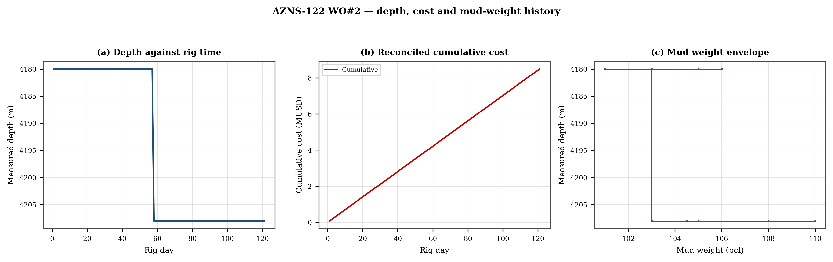
Figure 3.1 — Depth against rig time, reconciled cumulative cost and mud-weight envelope
The cost curve is reconstructed from the daily rig, mud and service rates applied to the recorded days; it is monotonic by construction and is intended for comparison, not as a replacement for the commercial register. The mud-weight curve shows the step changes that accompany each casing point, and each step is a decision point for the pressure window of Chapter 11.

4. Drilling performance, connections and rate of penetration
Productive time is split into drilling 260 h, reaming 120 h, trips 1,078 h, casing and cementing 148 h and logging 102 h. The ratio of handling time to drilling time is the single most informative number in this chapter: at 4.60 h of handling per hour of drilling, the well spends more time preparing the hole than making it.
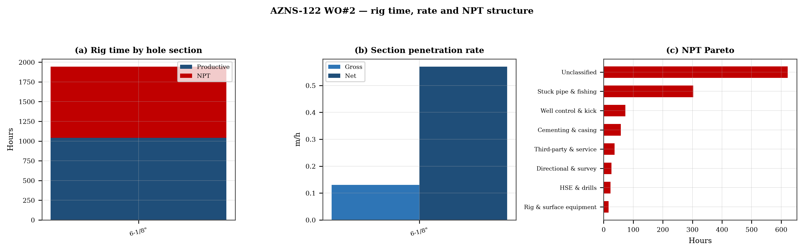
Figure 4.1 — Rig time by section, section rate and NPT pareto

Table 4.1 — Section performance
Section | Days | Metres | Gross ROP | Net ROP | Ream h | Trip h | NPT
6-1/8" | 81 | 258 | 0.13 | 0.57 | — | — | 46.4%
DDR Ref. — "1-2 DDR Data" time log rows 21–68 filtered to drilling codes, total row 68, and the bit block (bit number, size, metres, hours, IADC dull code)

5. Non-productive time and multi-hypothesis root cause
Non-productive time totals 1,174 h, or 40.4% of rig time, spread over 169 coded entries. The register is ranked below; the two or three leading mechanisms are then examined one by one, each with competing physical explanations and the field evidence that separates them.
Table 5.1 — NPT register by mechanism
Mechanism | Hours | Share | Events
Unclassified | 622 | 53.0% | 75
Stuck pipe & fishing | 302 | 25.8% | 31
Well control & kick | 74 | 6.3% | 17
Cementing & casing | 58 | 4.9% | 15
Third-party & service | 36 | 3.1% | 8
Directional & survey | 26 | 2.2% | 7
HSE & drills | 23 | 2.0% | 7
Rig & surface equipment | 17 | 1.4% | 6
Lost circulation | 15 | 1.3% | 3
DDR Ref. — "1-1 DDR Remark" activity status flag and "1-2 DDR Data" time-log flag column J (P / N / UP) with the code column A; hours from column E

5.1 Unclassified — competing mechanisms
This mechanism consumed 622 h across 75 entries. Two explanations fit the recorded sequence equally well until the discriminating evidence is read. Mechanism A is a formation-driven response: the borehole or the fluid column behaves differently from the plan because of what the rock is doing. Mechanism B is an equipment or procedure response: the same symptom appears because a surface system, a service or a handling step did not deliver what the programme assumed. The discriminator is the pressure and torque record at the moment of onset: a formation response appears while parameters are steady, an equipment response appears as a step change with parameters unchanged.
- Day 22 (—): 1.5 h — Work on TDS electrical problem While Slow Circ. Thru. Strg and Monitor The Well, NL-NG.
- Day 22 (—): 1.0 h — POOH 6" Milling BHA F/ 4094.5 To 4079m to work on TDS saver sub while Slow Circ. Thru. Strg and Monitor The Well, NL-NG.
- Day 26 (—): 6.0 h — Due to the night shift toolpusher’s refusal to carry out assigned duties, his disruptive behavior in the workplace, including raising his voice,

5.2 Stuck pipe & fishing — competing mechanisms
This mechanism consumed 302 h across 31 entries. Two explanations fit the recorded sequence equally well until the discriminating evidence is read. Mechanism A is a formation-driven response: the borehole or the fluid column behaves differently from the plan because of what the rock is doing. Mechanism B is an equipment or procedure response: the same symptom appears because a surface system, a service or a handling step did not deliver what the programme assumed. The discriminator is the pressure and torque record at the moment of onset: a formation response appears while parameters are steady, an equipment response appears as a step change with parameters unchanged.
- Day 24 (—): 7.0 h — String got Stuck @ 4112.8m, Work on Stuck W/ Applying Max. 10 Klbs.ft TQ, 150 Klbs Downward Wt. & 170klbs Overpull, While Circ. Thru. Strg
- Day 24 (—): 0.5 h — Prepare 65bbl Hi-Vis Pill (10% Lubricant), Circ. Pill out of mill & then Reduce Flow Rate to 50gpm, Cont. Work on Stuck W/ Applying Max.
- Day 24 (—): 12.5 h — Work on Stuck W/ Applying Max. 10 Klbs.ft TQ, 150 Klbs Downward Wt & 170 Klbs Overpull, While Circ. Thru. Strg W/ F.R: 100gpm,

6. Bit, BHA and nozzle performance
3 bit runs are recorded. The best run delivered 106 m and the shortest 54 m; the spread is the first indication that the dull grade, not the formation, ended the short runs. Where a dull code is recorded it is reproduced in the table without interpretation, and the wear pattern is discussed in the text.

Table 6.1 — Bit runs
Bit | Size | Type | IADC | Metres | Hours | Dull
1.0 | 6-1/8" | R.Bit | — | — | — | —
3.0 | 6-1/8 | PDC | M1665 | 54.0 | 18.0 | —
2.0 | 6-1/8 | Tri-cone | 537 | 106.0 | 4.5 | 1-2-CT-A-E-I-WT-TD
DDR Ref. — "1-1 DDR Remark" bit block columns C–H (bit no., size, type, metres, hours, dull grade) and the "1-2 DDR Data" bit/BHA block

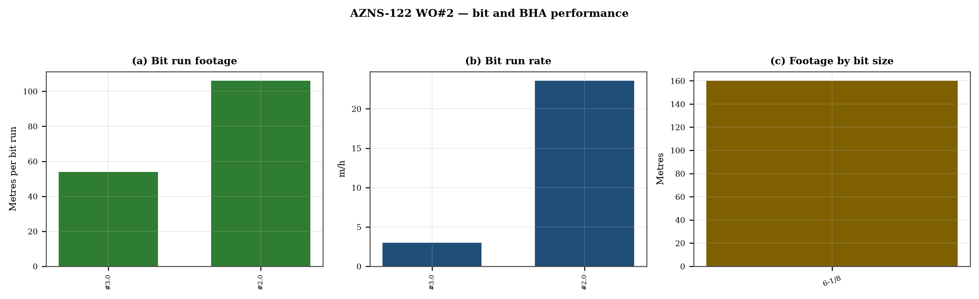
Figure 6.1 — Bit footage, run rate and footage by bit size

7. Mechanical parameters and mechanical specific energy
31 intervals carry a simultaneous weight and rotary-speed record. Weight on bit ranges 1.0–20.0 klbf with a median of 5.0 klbf, and rotary speed 2–90 rpm. The median mechanical specific energy is 768 ksi. For these hole sizes that is high: the bit is spending more energy on the bottom hole assembly and the fluid than on the rock.
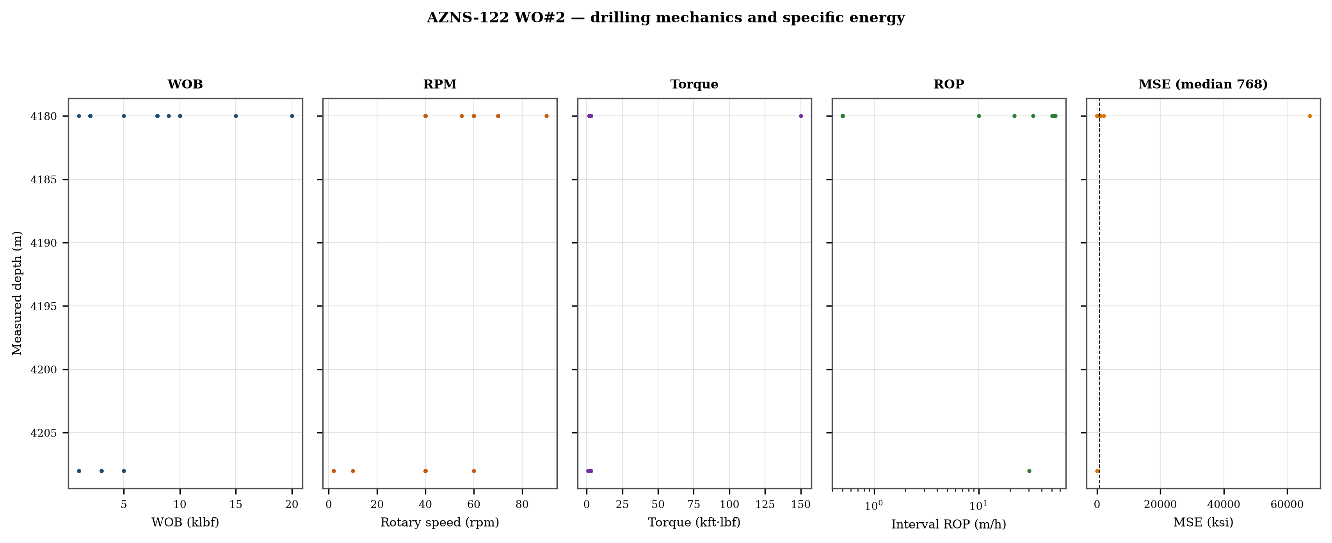
Figure 7.1 — Five-track mechanics log with specific energy

8. Drilling fluids, rheology, cuttings transport and ECD
No daily record in this well reports flow, nozzle area and rheology together, so jet velocity, hydraulic index and downhole circulating density cannot be computed as physical results. The figure reproduces the recorded mud weight against depth and the missing hydraulic quantities are listed in Chapter 17.
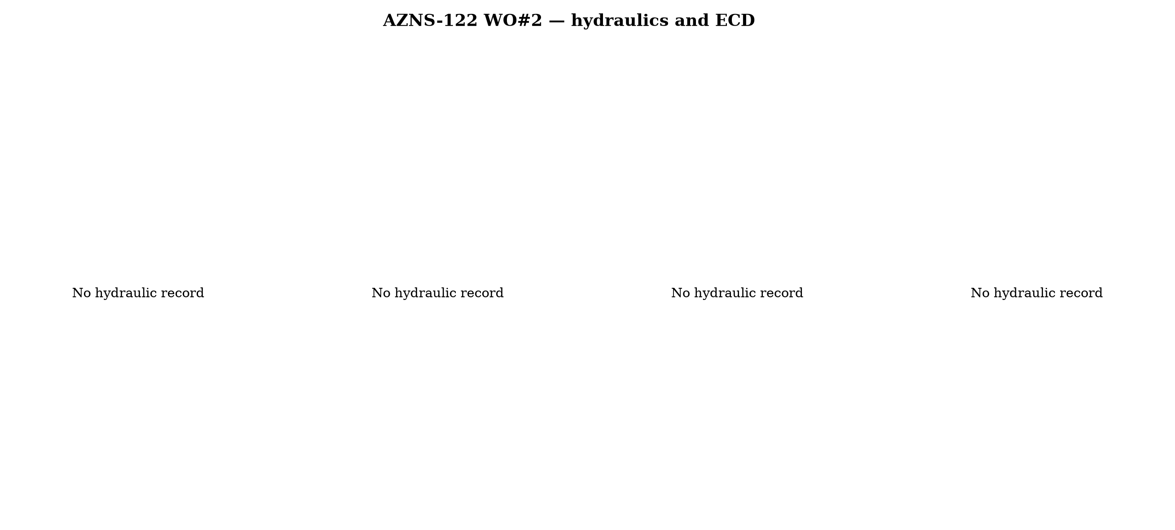
Figure 8.1 — Hydraulics and density record
Mud weight moves between 101 and 110 pcf across the record, in steps that coincide with casing points. Each step changes the equivalent circulating density by the same amount plus the annular loss term, which is why the pressure window narrows precisely when the weight is increased to control the shale.

9. Directional survey, trajectory and dog-leg severity
The trajectory was rebuilt from 21 survey stations with the minimum-curvature method. The well reaches a maximum inclination of 10.2°, a maximum dog-leg of 11.04°/30 m and a final TVD of 4,210 m at 4,210 m MD, with a bottom-hole closure of 31 m. Dog-legs stay inside the drilling limit throughout, so the directional programme did not create the drag that Chapter 10 measures.
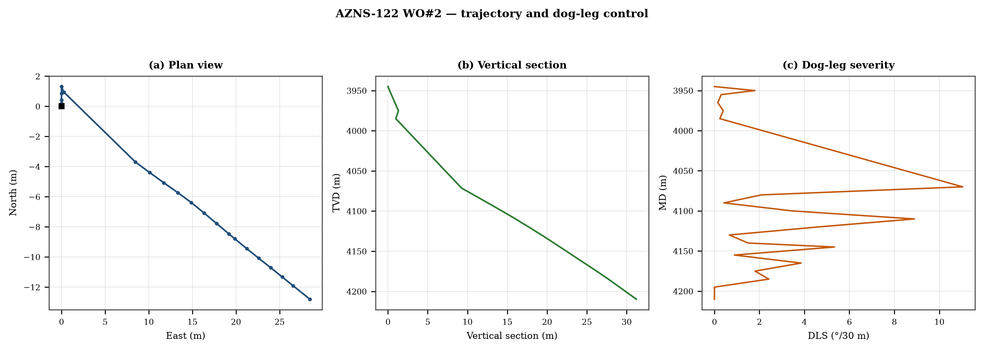
Figure 9.1 — Plan view, vertical section and dog-leg severity

Table 9.1 — Survey stations
MD | Inc | Azi | TVD | N | E | DLS
3,945.0 | 2.20 | — | 3,945.0 | 0.0 | 0.0 | 0.00
3,950.0 | 2.50 | — | 3,950.0 | 0.2 | 0.0 | 1.80
3,955.0 | 2.55 | — | 3,955.0 | 0.4 | 0.0 | 0.30
3,965.0 | 2.50 | — | 3,965.0 | 0.9 | 0.0 | 0.15
3,975.0 | 2.63 | — | 3,975.0 | 1.3 | 0.0 | 0.39
3,985.0 | 2.55 | 144.1 | 3,985.0 | 0.9 | 0.3 | 0.24
4,070.0 | 10.20 | 113.5 | 4,071.4 | -3.7 | 8.5 | 11.04
4,080.0 | 10.10 | 112.8 | 4,081.2 | -4.4 | 10.1 | 2.09
4,090.0 | 10.20 | 112.7 | 4,091.1 | -5.1 | 11.7 | 0.42
4,100.0 | 9.80 | 111.6 | 4,100.9 | -5.7 | 13.3 | 3.46
4,110.0 | 9.60 | 114.6 | 4,110.8 | -6.4 | 14.9 | 8.89
4,120.0 | 9.20 | 116.1 | 4,120.7 | -7.1 | 16.4 | 4.60
4,130.0 | 9.10 | 115.9 | 4,130.5 | -7.8 | 17.8 | 0.66
4,140.0 | 8.70 | 116.2 | 4,140.4 | -8.5 | 19.2 | 1.49
4,145.0 | 8.70 | 115.3 | 4,145.4 | -8.8 | 19.9 | 5.34
4,155.0 | 8.70 | 115.6 | 4,155.2 | -9.4 | 21.2 | 0.89
4,165.0 | 8.70 | 114.3 | 4,165.1 | -10.1 | 22.6 | 3.86
4,175.0 | 8.80 | 114.9 | 4,175.0 | -10.7 | 24.0 | 1.80
4,185.0 | 8.00 | 115.0 | 4,184.9 | -11.3 | 25.3 | 2.42
4,195.0 | 8.00 | 115.0 | 4,194.8 | -11.9 | 26.6 | 0.00
4,210.0 | 8.00 | 115.0 | 4,209.7 | -12.8 | 28.5 | 0.00
DDR Ref. — "1-2 DDR Data" survey table from header row 115 (MD, inclination, azimuth, TVD) — template A; "1-2 DDR Data" survey block J50+ — template B

10. Hook load, drag and overpull
A soft-string model was built on the recomputed survey with the buoyancy factor of the recorded mud weight and a tripping friction factor of 0.28. At 4,210 m the model gives a pick-up load of 7.1 klbf, a rotating load of 6.6 klbf and a slack-off of 6.6 klbf. The spread between pick-up and slack-off is 0.5 klbf; that is the friction the string actually carries, and it is the margin that must not be spent on a single pull.
- Day 14: recorded overpull 400 klbf
- Day 15: recorded overpull 400 klbf
- Day 72: recorded overpull 430 klbf
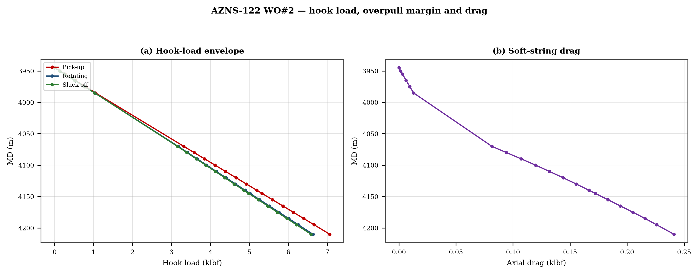
Figure 10.1 — Hook-load envelope and axial drag

11. Well control, shoe integrity, MAASP and losses
The record contains 0 formation-integrity tests with a numerical equivalent mud weight and 11 days with a loss entry. The dynamic maximum allowable surface pressure is the number the driller needs: at the shallowest shoe of this well, raising the annulus by 500 psi requires an equivalent weight of 0.0 pcf, which is the practical test of whether the mud programme is inside the window.

12. Geology, formation tops and gas
1 formation tops are recorded between 3,963 m and 3,963 m MD. The sequence and the depth of each top are reproduced below with the minimum-curvature TVD where a survey exists; the drillability of each interval is discussed against the rate record rather than against a general lithology table.
Table 12.1 — Formation tops
Formation | MD (m) | TVD (m)
Fahlian | 3,963 | 3,965
DDR Ref. — "1-2 DDR Data" rows 110–131: K = formation, L/M = forecast MD and TVD, O/Q = actual TVD
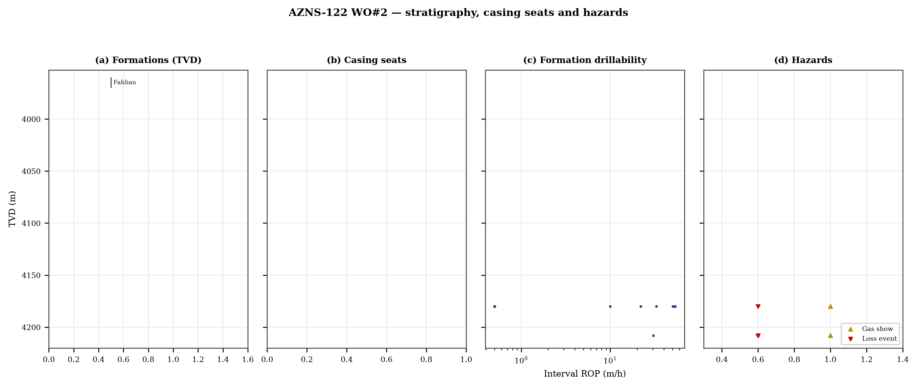
Figure 12.1 — Formation tops, casing seats, drillability and hazards

13. Operational problems, remedies and rig-floor playbooks
The five playbooks below are written for use at the rig floor, in the order given. Each one is the compressed form of the diagnosis used in Chapters 5, 10 and 11, and each is matched to the mechanism it treats.

Loss circulation playbook
- Stop drilling, record the loss rate at the current pump rate and keep the string moving.
- Reduce flow in two steps and measure the loss at each step: partial loss responds to LCM, total loss needs a different mechanism, not a bigger pill.
- Spot a graded LCM pill (fine–medium–coarse) across the loss zone and cure it before resuming; log the pill volume, the returned volume and the pressure at which it was spotted.
- If losses persist at the shoe, recalculate MAASP with the current mud weight and confirm the well is still displaced by a single fluid column.

Tight hole and overpull playbook
- Compare the observed overpull with the modelled pick-up envelope for the same depth.
- Circulate at the maximum allowable rate with the string rotating; if torque falls while returns carry cuttings, the cause is cleaning, not the formation.
- Work the string down with a controlled feed-off rather than pulling; never exceed 80% of the modelled overpull margin.
- If the string is stuck, establish circulation and jar down before any chemical soak.

Stuck pipe and fishing playbook
- Record the free rotating weight, the pick-up and the slack-off immediately; the spread distinguishes wall contact from a pack-off.
- Establish circulation within the first ten minutes; a stuck string that still circulates is recoverable without fishing.
- Apply torque and jar in the direction indicated by the string's own weight response, not by habit.
- Photograph and grade every recovered component before the next run.

Well-control playbook
- Shut in on the hard shut-in sequence and record SIDPP, SICP and pit gain within one minute.
- Confirm the influx type from the pressure pair: SIDPP ≈ SICP means a light fluid, SICP >> SIDPP means gas.
- Prepare a kill sheet with slow circulating pressure at the actual pump rate, not a table value.
- Maintain the casing pressure constant while bringing the pumps to rate; do not chase the drill-pipe pressure.

Shoe test and MAASP playbook
- Never drill out a shoe without a recorded FIT/LOT equivalent mud weight in the daily header.
- Compute MAASP for the current mud weight every time the weight changes by 0.1 pcf.
- Convert the test result to a fracture gradient at the shoe TVD, not at MD.
- When a loss occurs at the shoe, the first number to read is the dynamic MAASP, not the static one.

14. Optimum parameters, drill-off and MSE practice
Table 14.1 — Section parameter window in this well
Section | WOB (klbf) | RPM | Median interval ROP | Net ROP
6-1/8" | 1–8 | 2–60 | 26.2 | 0.57
DDR Ref. — "1-2 DDR Data" drilling-parameter sentences in column K (WOB, RPM, flow, SPP, torque) and the mud table columns K–S rows 11–38 — template A; mud table J8–L27 — template B
The drill-off procedure is the only reliable way to find the founder point on location. Hold flow constant, reduce weight in three steps of about 15% and record the rate at each step after 90 seconds of steady drilling; the rate should rise with weight until the founder point and then flatten. The weight at which it flattens is the operating weight for that formation, and the weight at which torque rises while rate does not is the weight that damages the bit.
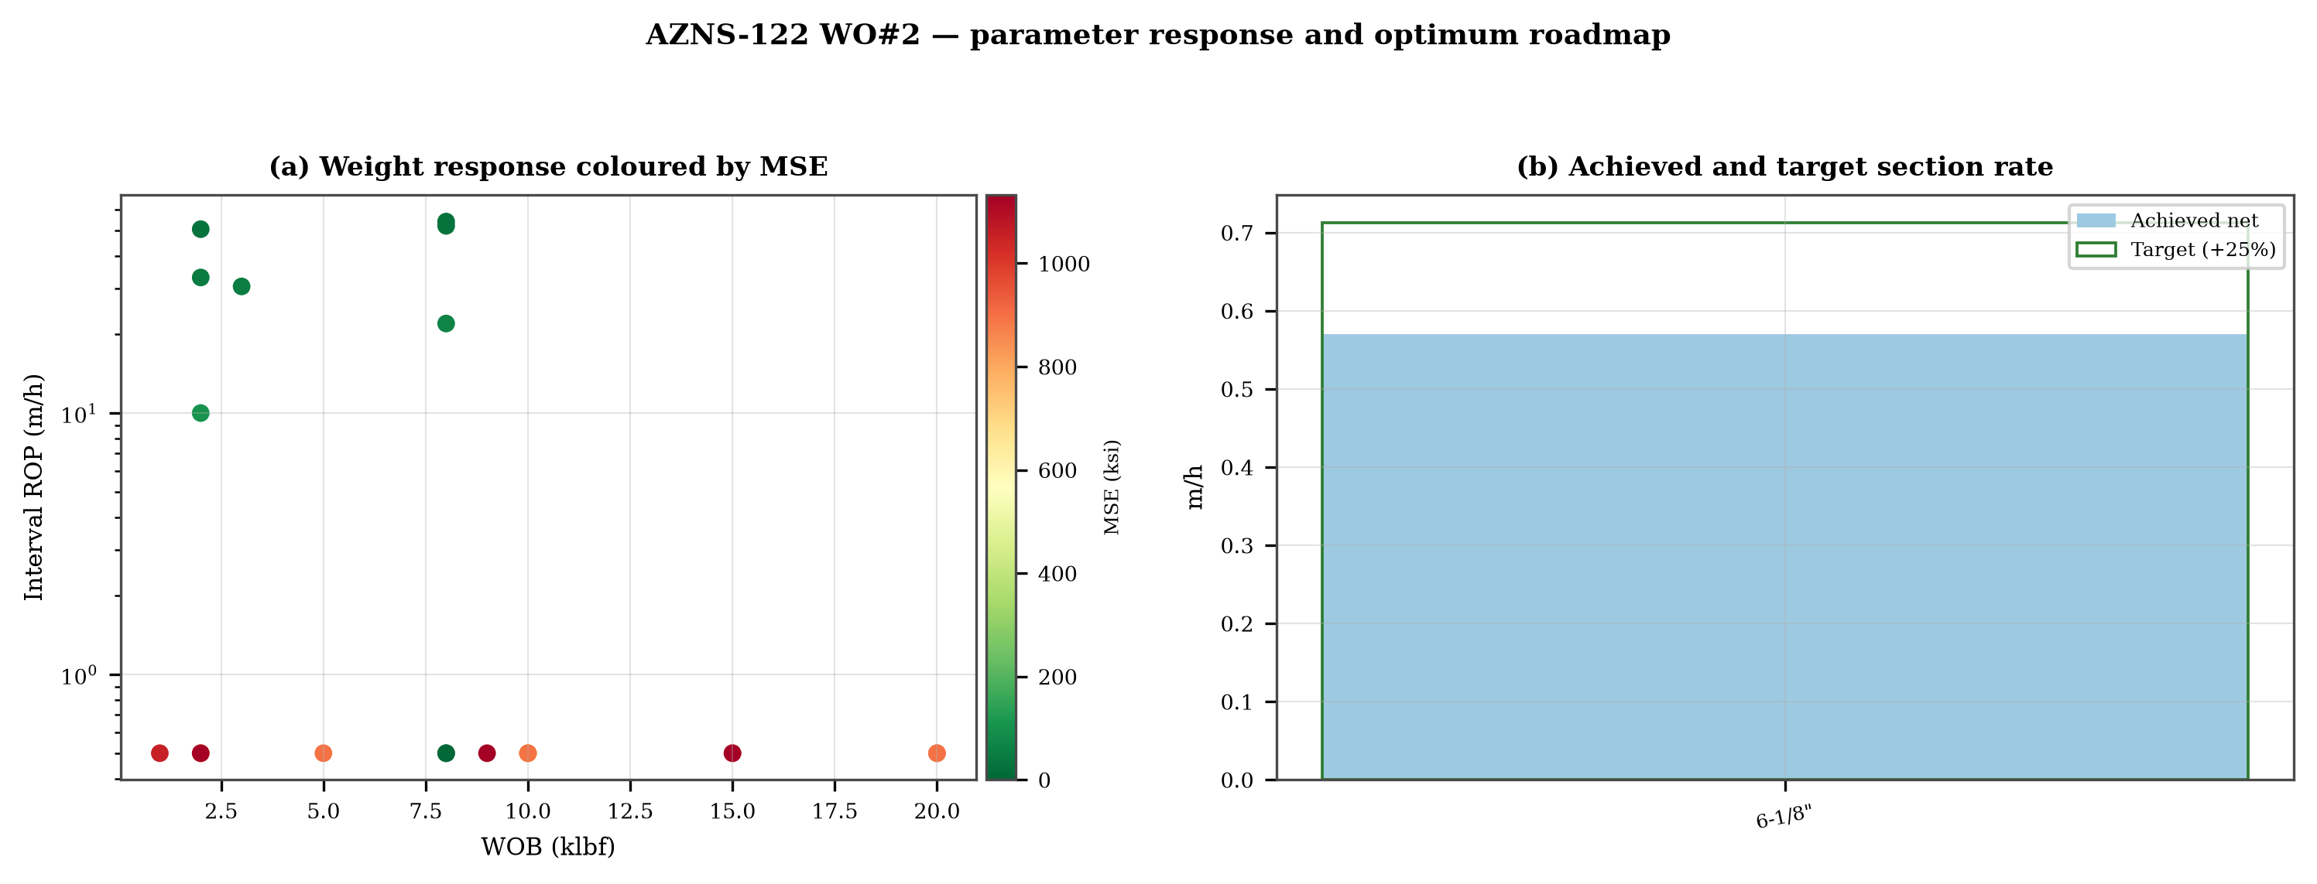
Figure 14.1 — Weight response coloured by specific energy and the section rate target

15. Key findings and risk register
- NPT stands at 40.4% of rig time, dominated by unclassified.
- Handling time is 4.60 times the drilling time, which is the structural inefficiency of this record.
- Net rate in the productive intervals is 0.97 m/h at a median specific energy of 768 ksi.
- The pressure window and the mud programme interact at every casing point; the integrity record is the weakest data set in the well.
Table 15.1 — Risk register
Risk | Trigger | Consequence | Control
Loss at the shoe | Drilling out with weight above the window | Loss of circulation and stuck pipe | Two-rate loss test, graded LCM
Tight hole on trips | Shale swelling after long open-hole exposure | Overpull and stuck string | Wiper trips, mud inhibition
Bit balling | Weight above the founder point in reactive clay | Rate collapse and torque rise | Drill-off test, HSI above 2.5
Equipment failure | Ageing pumps and top drive | Long NPT and hole deterioration | Reliability register
DDR Ref. — Derived — "1-1 DDR Remark" narrative, "1-2 DDR Data" time-log flags and the NPT register of this report; no single DDR cell

16. Recommendations — phase matrix and REC-01 to REC-10
Table 16.1 — Phase execution matrix
Phase | Action | Hold point
Pre-spud | Verify rig systems and spares against the reliability register | Signed availability check
Surface hole | Maximum flow with a single casing and cementing trip | Shoe test recorded
Intermediate | PDC and motor, wiper trip every 300 m, AV above 120 ft/min | Overpull trend inside envelope
Reservoir entry | Two-rate loss test and graded LCM on location | Loss cured before drilling ahead
Reservoir hole | Hold HSI above 2.5 hp/in², drill-off at each top | Founder point recorded
Close-out | NPT booked to the fixed cause list, review within 14 days | QC certificate signed
DDR Ref. — "1-2 DDR Data" time log rows 21–68 aggregated by operational code and the "1-1 DDR Remark" section headers
Table 16.2 — Recommendations
ID | Recommendation | Owner | Timing | Rationale
REC-01 | Adopt a rig-specific reliability register (pumps, top drive, drawworks) with monthly availability and mean time between failures | Rig manager | Immediate | Rig and surface equipment is the largest controllable NPT category
REC-02 | Standardise the FIT/LOT protocol and write the demonstrated EMW into the daily header | Well integrity | Before the next well | Makes MAASP auditable at every shoe
REC-03 | Apply the section parameter roadmap of Chapter 14 as the drilling programme | Drilling engineering | Next well | Closes the gap to the field P90 rate
REC-04 | Introduce a graded-LCM loss protocol with a two-rate diagnosis before treatment | Mud engineering | Immediate | Cuts loss time and lost mud volume
REC-05 | Run a drill-off test at the top of each formation and record the founder point | Drilling engineering | Each section | Prevents weight-induced inefficiency
REC-06 | Treat centrifuge running time as a recorded drilling parameter | Mud engineering | Immediate | Controls ECD without changing mud weight
REC-07 | Hold a torque-and-drag check against the modelled envelope before every trip | Drilling supervisor | Every trip | Converts overpull from a surprise into a trend
REC-08 | Book every NPT hour against the fixed cause list within the same tour | Drilling supervisor | Daily | Keeps the field comparison comparable
REC-09 | Audit third-party service readiness (wireline, cementing, casing crews) before the operation, not on arrival | Field engineering | Each job | Third-party delay is the second largest NPT category
REC-10 | Publish a weekly NPT pareto and a monthly field benchmarking pack | Field engineering | Weekly | Sustains the learning curve across rigs
DDR Ref. — This report — built from the KPI set and NPT register above; each row carries its own evidence reference

17. Limitations of the recorded data
- No casing table with shoe depths: the architecture is described from the chronology and the hole sizes drilled.
- No flow, nozzle area and rheology in the same daily record: jet velocity, hydraulic index and ECD are not reported as physical results.
- No formation-integrity test with a numerical equivalent mud weight: MAASP is reported as a sensitivity, not as a measured value.
- Costs are reconstructed from daily rig, mud and service rates because the workbooks do not carry a commercial register; they are used for comparison only.

18. Appendix A — Workbooks, sheets and SHA-256
The record was read from AZNS122WO2Pack.xlsx with 242 sheets, all of which were parsed. The table below reproduces the file inventory with the digest of the source workbook as it stands in the repository.
Table 18.1 — Source workbooks and SHA-256
File | SHA-256
AZNS10Pack.xlsx | bf8c897274b47f9324b6e808162c451c0329d78651e76a27c700db9263ec0a95
AZNS116Pack.xlsx | 68c5b874f1ba78a4a30989930aef00f06095d8118e89e217e74ca918364dc438
AZNS122WO1Pack.xlsx | c14db1ff6cbef8b7d4e0f69b9f64cdc4452e3935f64bad439d38a8aed6f5f42a
AZNS122WO2Pack.xlsx | 2eb9858150dfa2d43f46e387ded978fd04c811f0c08b402a76a533f36235b65c
AZNS127ST2Pack.xlsx | 68329de313721905be08f20cb8bb8b4f5f3671d5c6caab41f23caa1a48b9a4c4
AZNS127WO1Pack.xlsx | 6034aae76c2e3126416df8f8576d424bd3394c30aca4c4f5e72f0372256739d6
AZNS127WOPack.xlsx | a4ae90dc870f20b2f99ac3a36b8b5cd1c357b60dd2805630597cc48ba059054e
AZNS12Pack.xlsx | e325945f1108341bace123e60b02fb04ac3f7d3003a19eb8d23004cf7cd67216
AZNS166Pack.xlsx | e63824748e4692884fc23075c678c1379b9b595a8c8b1efb289e630f898a75d8
AZNS207Pack.xlsx | 828968c7e0afd7273d64987bd457383ecfea3a2e00e62c9a65b587f16518996a
AZNS40Pack.xlsx | 0523068ee222c02f6e2d2754bcd919a9c296b334b03521ab15d84322aade94ca
AZNS75Pack.xlsx | 5e0482d5d50e9347a98b7c24cfd3a102d3c00f2c951f6061aba14d164136fcae
AZNS85Pack.xlsx | 0d3ecc54fb8b9484f508b9a3957554ba13e72546c6d485abb79af633362daeb2
DDR Ref. — Workbook files as delivered (read-only), hash computed at build time
Table 18.2 — Sheet inventory of this well
Sheet | Sheet | Sheet
1-1 DDR Remark | 1-2 DDR Data | 2-1 DDR Remark
2-2 DDR Data | 3-1 DDR Remark | 3-2 DDR Data
4-1 DDR Remark | 4-2 DDR Data | 5-1 DDR Remark
5-2 DDR Data | 6-1 DDR Remark | 6-2 DDR Data
7-1 DDR Remark | 7-2 DDR Data | 8-1 DDR Remark
8-2 DDR Data | 9-1 DDR Remark | 9-2 DDR Data
10-1 DDR Remark | 10-2 DDR Data | 11-1 DDR Remark
11-2 DDR Data | 12-1 DDR Remark | 12-2 DDR Data
13-1 DDR Remark | 13-2 DDR Data | 14-1 DDR Remark
14-2 DDR Data | 15-1 DDR Remark | 15-2 DDR Data
16-1 DDR Remark | 16-2 DDR Data | 17-1 DDR Remark
17-2 DDR Data | 18-1 DDR Remark | 18-2 DDR Data
19-1 DDR Remark | 19-2 DDR Data | 20-1 DDR Remark
20-2 DDR Data | 21-1 DDR Remark | 21-2 DDR Data
22-1 DDR Remark | 22-2 DDR Data | 23-1 DDR Remark
DDR Ref. — Workbook sheet list — every remark/data sheet pair plus the reference sheets

19. Appendix B — Equations and units
Table 19.1 — Governing equations
Quantity | Equation | Units
Mechanical specific energy | MSE = 480·T·N/(D²·ROP) + 4·WOB/(π·D²·1000) | psi, klbf, ft·lbf
Bit pressure drop | ΔP = ρ·Q²/(10858·TFA²) | psi, gpm, in²
Jet velocity | V = 0.3208·Q/TFA | ft/s
Hydraulic index | HSI = ΔP·Q/(1714·A_bit) | hp/in²
Annular velocity | V = 24.5·Q/(D_h² − D_p²) | ft/min
Bingham annular loss | ΔP = PV·V·L/(60000·(D_h−D_p)²) + YP·L/(200·(D_h−D_p)) | psi
Equivalent circulating density | ECD = MW + ΔP_ann/(0.052·TVD) | pcf
Minimum curvature | β = arccos[cos I₁cos I₂ + sin I₁ sin I₂ cos(A₂−A₁)] | rad
Dog-leg severity | DLS = 30·β/ΔMD | °/30 m
Buoyancy factor | BF = 1 − MW/490 | —
Hook load (soft string) | F = Σ w·BF·cos I·Δs ± μ·Σ w·BF·sin I·Δs | klbf
Maximum allowable surface pressure | MAASP = 0.052·(EMW_frac − MW)·TVD_shoe | psi
dc exponent | dc = log(ROP/(60·N)) / log(WOB/D) | —
Reconstructed cost | C = Σ (rig + mud + service) day rate | USD
DDR Ref. — Reference standard, Appendix B — no DDR cell

20. Appendix C — Complete NPT register
Table 20.1 — NPT register (all entries)
Day | Hrs | Mechanism | Activity and description
1 | 5.5 | Rig & surface equipment | 5/5Hrs. NPT for OEOC Rig 201, Work On Drawworks, While Work on Burning Line Connections and Then Perform Press. Test on
2 | 6.0 | Third-party & service | 6Hrs. NPT for OEOC Rig 201 Due To Lack Of Crane Operator For The Night Shift, Cont. P/U & M/U 5" & 3-1/2" DP Stds Jt by
8 | 2.0 | Cementing & casing | Work On String To Unplug W/Apply Max. Press. & Jerk @ Several time, No Succ.POOH F/ 1635m to 1270m, Check String, Obs. S
22 | 1.5 | Unclassified | Work on TDS electrical problem While Slow Circ. Thru. Strg and Monitor The Well, NL-NG.
22 | 1.0 | Unclassified | POOH 6" Milling BHA F/ 4094.5 To 4079m to work on TDS saver sub while Slow Circ. Thru. Strg and Monitor The Well, NL-NG.
24 | 7.0 | Stuck pipe & fishing | String got Stuck @ 4112.8m, Work on Stuck W/ Applying Max. 10 Klbs.ft TQ, 150 Klbs Downward Wt. & 170klbs Overpull, Whil
24 | 0.5 | Stuck pipe & fishing | Prepare 65bbl Hi-Vis Pill (10% Lubricant), Circ. Pill out of mill & then Reduce Flow Rate to 50gpm, Cont. Work on Stuck
24 | 12.5 | Stuck pipe & fishing | Work on Stuck W/ Applying Max. 10 Klbs.ft TQ, 150 Klbs Downward Wt & 170 Klbs Overpull, While Circ. Thru. Strg W/ F.R: 1
25 | 3.0 | Stuck pipe & fishing | Cont. Work on Stuck W/ Applying Max. 10 Klbs.ft TQ, 150 Klbs Downward Wt & 170 Klbs Overpull, While Circ. Thru. Strg W/
25 | 6.0 | Stuck pipe & fishing | Pump 15 bbl pipelax pill (5%) & Circ. Out till 1 bbl of pipelax out of mill, pump off & Cont. work on stuck with same pa
25 | 15.0 | Stuck pipe & fishing | Cont. Work on Stuck W/ Applying Max. 10 Klbs.ft TQ, 150 Klbs Downward Wt & 170 Klbs Overpull, While Circ. Thru. Strg W/
26 | 6.0 | Unclassified | Due to the night shift toolpusher’s refusal to carry out assigned duties, his disruptive behavior in the workplace, incl
26 | 17.0 | Stuck pipe & fishing | Cont. Work on Stuck W/ Applying Max. 10 Klbs.ft TQ, 150 Klbs Downward Wt & 170 Klbs Overpull, While Circ. Thru. Strg W/
26 | 1.0 | Stuck pipe & fishing | R/D Mouse Hole, B/O & R/B Last 5" Std and P/U & M/U 5" Pup Joint, R/U Wireline is in progress @ M.N, While Monitor the W
27 | 21.0 | Stuck pipe & fishing | Cont. R/U Wireline Eqp. , Perform Op. as follow:
27 | 3.0 | Stuck pipe & fishing | R/U Mouse Hole, B/O & L/D 5" Pup Joint, M/U 5" Double Std, Cont. Work on Stuck W/ Applying Max. 80 Klbs Downward Wt.
28 | 24.0 | Stuck pipe & fishing | Cont. Work on Stuck W/ Applying Max. 80 Klbs Downward Wt. & 150 Klbs Overpull, While Circ. Thru. Strg W/ F.R: 100gpm,
29 | 24.0 | Stuck pipe & fishing | Cont. Work on Stuck W/ Applying Max. 80 Klbs Downward Wt. & 150 Klbs Overpull, While Circ. Thru. Strg W/ F.R: 100gpm,
30 | 19.0 | Stuck pipe & fishing | Cont. Work on Stuck W/ Applying Max. 80 Klbs Downward Wt. & 150 Klbs Overpull, While Circ. Thru. Strg W/ F.R: 100gpm,
30 | 5.0 | Stuck pipe & fishing | Receive Explosive Material @ 19:00, Wait Day On Daylight, While Circ. Thru. Strg W/ F.R: 100gpm, SPP: 1000-1200psi, NL-N
31 | 5.5 | Stuck pipe & fishing | Disconnect TDS, B/O & R/B Double Std 5" DP, P/U & M/U 5" Pup Jt. And Disp. String Cap W/ Fresh Mud, R/U Wireline Eqp. &
31 | 3.5 | Unclassified | Due to Cloudy and Rainy Weather, Not possible to work with explosives close to surface, While Disp. String Cap W/ Fresh
31 | 12.0 | Stuck pipe & fishing | Tighten up String Joints W/ Applying Right-hand Torque Sev. Times, Cont. Back off Wire line Operation as follow:
31 | 1.0 | Stuck pipe & fishing | R/D Wireline Eqp. And Prepare to Start POOH 6" Milling BHA To Check the Strg is in progress @ R.T.
32 | 21.0 | Stuck pipe & fishing | POOH 6" Milling BHA To Surface On Elevator W/ Speed Control to check Strg, Obs. String is Backed off according to planne
40 | 5.0 | Third-party & service | Pull out of hole string on BHA and check BHA with Run Gyro Tools while L/D 1 Jts 4-3/4" D.C Till M.N.
41 | 5.0 | Third-party & service | Continue check BHA @ several time with Run Gyro Tools While L/D 5 Jts 4-3/4" D.C ( Totally 6 jts 4-3/4" D.C L/D ) & Perf
41 | 3.0 | Unclassified | Commence Run in hole with 3-1/2" D.pipe to 474m meanwhile pass rabbit thru each stands & break circ every 10 stands.
41 | 3.0 | Stuck pipe & fishing | 3 hrs waiting for Rig 201 OEOC due to rabbit stucked in 2 stands 3-1/2" D.pipe & L/D same it.
44 | 12.5 | Unclassified | Continue pull out of hole with 7" Whipstock from 1255m to Surf & L/D 7" Hyd. whipstock + 6-1/8" tri-mill + 4-3/4" runing
44 | 11.5 | Unclassified | Run in hole by Open End BHA with 4 Stand 4-3/4" D.C & Follow by 3-1/2" D.P & 5" D.P to 3945m whit wash down 3 last stand
45 | 3.0 | Unclassified | Circ BTM's UP , Spot 30 BBL Hi-vis pill BTM of hole .
45 | 13.0 | Unclassified | Start pull out of hole on elevator from 3945m to surface while mud Circ cross well head, NL.NG.
48 | 3.0 | HSE & drills | Change Handling Eqp. & Elevator F/ 5" To 3-1/2", Resume POOH 7" Side-Tracking BHA F/ 2038 To 122m On Elevator, While usi
48 | 1.0 | Unclassified | Cont. RIH Back w/ 7"Side-Tracking BHA To 237m followed by 3-1/2" H.W.D.P Jt by Jt (totally 15Jts), while clean & pass Ra
48 | 2.0 | Unclassified | POOH 7"Side-Tracking BHA F/ 237m to surface, B/O & L/D 6-1/8" Tri-Mill [Condition: Rugby Mill 1/16" Under Gauge & 40% Us
48 | 2.5 | Rig & surface equipment | Attempt to perform BOP test as per NIOC Policy, Obs. Leakage in Top & B/Shear Rams Bonnet Seal and Top Chk Line BOP Side
49 | 2.0 | Unclassified | 2Hrs. NPT For OEOC Rig 201 due to Delay in Operation, P/U & M/U 3-1/2" H.W.D.Ps Jt by Jt and RIH to 105m (totally 11Jts)
49 | 1.0 | Third-party & service | 1Hrs. NPT For OEOC Rig 201 due to failure of Rig Tong Latches during M/U NFMDC, Cont. M/U 6-1/8" Directional BHA Includi
49 | 1.0 | Directional & survey | 1Hrs. NPT For OEOC Rig 201 due to lack of Drilling Crew, Cont. RIH w/ 6-1/8" Directional BHA F/ 410 To 520m Followed by
52 | 2.5 | Directional & survey | Cont. POOH 6-1/8" Directional BHA F/ 1060 to 278m On Elevator, while Circ. C.W.H, using Mud Box, and Monitor the Well, w
52 | 0.5 | Unclassified | Monitor The Well as Static Flow Check @ 278m for a while, Well Static, w/ N.L-N.G.
52 | 2.5 | Third-party & service | Cont. POOH 6-1/8" Directional BHA F/ 278m to surface, Shallow Test 4-3/4" DHM w/ 200GPM, got 850psi Diff. Pressure, L/D
52 | 9.5 | Unclassified | P/U 6-1/8" Back-up DHM + 4-3/4" F.Sub + 4-3/4" UBHO + 4-3/4" NFMDC, Perform Shallow Test w/ 200GPM, got 1200psi Diff. Pr
52 | 4.5 | Directional & survey | P/U & M/U 6-1/8" PDC Bit (Open, BESTE, S/N: 255421, IADC: M1665) and Cont. M/U 6-1/8" Directional BHA
52 | 4.5 | Directional & survey | Cont. RIH w/ 6-1/8" Directional BHA F/ 345 To 1356m Followed by 3-1/2"DPs On Elevator w/ Speed Control, While F/U String
53 | 1.5 | Directional & survey | Cont. RIH w/ 6-1/8" Directional BHA F/ 1356 To 1502m Followed by 3-1/2"DPs On Elevator w/ Speed Control, While F/U Strin
53 | 1.5 | Third-party & service | Attempt to Perform Dir. Drilling Tools Functional Tests @1502m, Obs. MWD Signal is lost, work on the same to make it fix
53 | 10.0 | Directional & survey | Resume RIH w/ 6-1/8" Directional BHA F/ 1502 To 3460m Followed by 3-1/2" & 5"DPs On Elevator w/ Speed Control, While F/U
53 | 2.0 | Directional & survey | 2Hrs. NPT for OEOC Rig 201 due to delay in RIH Operation, Cont. RIH w/ 6-1/8" Directional BHA F/ 3460 To 3949m Followed
60 | 4.0 | Stuck pipe & fishing | Change Top Ram F/ 7" Fix to 2-7/8"- 5" VBR and Press. Test on that, Ok, P/U & M/U Wear Bushing Running & Retrieving Tool
60 | 8.0 | Stuck pipe & fishing | Cont. RIH w/ 5-1/2" Fishing BHA F/ 327 To 2900m Followed by 3-1/2" & 5" DPs, While Break Circ. At 7" L.Lap, Change Eleva
61 | 3.5 | Stuck pipe & fishing | Cont. RIH w/ 5-1/2" Fishing BHA F/ 2900 To 3930m Followed by 5" DPs, While Circ. C.W.H & Monitor the Well, w/ N.L-N.G.
61 | 5.0 | Stuck pipe & fishing | Conn. TDS and Cont. RIH w/ 5-1/2" Fishing BHA w/ Wash Dn F/ 3930 To 4135m ( TOF ), Circ. to Clean off TOF, Take Up/Down
61 | 13.5 | Stuck pipe & fishing | POOH For Check overshot to Surface, No. Recover The Fish , no observe any Indication on overshot (Sealand Co.) & L/D it.
61 | 2.0 | HSE & drills | Slip & Cut 100 FT drilling line.
62 | 0.5 | HSE & drills | Cont. Slip & Cut 100 FT drilling line.
62 | 6.5 | Stuck pipe & fishing | P/U & run in hole with 5-1/4" overshot Assembly including : ( Guide + Bowel + Extention + Top Sub ) Dressed W/ 3-5/8" Sp
62 | 2.0 | Unclassified | 2 Hrs Waiting For Rig 201 OEOC Due to Delay To Operation While Cont. RIH To 2570m
62 | 10.0 | Stuck pipe & fishing | Cont. RIH To 4202m(TOF),Lower overshot slowly to touch TOF, Run over fish until swallow is full engaged, observe increas
62 | 5.0 | Lost circulation | Pull out of hole for checking to 2664m while circ mud cross well head with 0.5-1 BPH loss @ M.N.
63 | 1.0 | Lost circulation | Continue Pull out of hole for check to 2405m while circ mud cross well head with 0.5-1 BPH loss.
63 | 1.0 | Unclassified | Stop operation due to wind strong ( wind speed above 50 KPH ) by HSE supervisor request.
63 | 11.0 | Stuck pipe & fishing | Continue Pull out of hole for check string to surface, observe recovered 1.13m of the logging tools fish including : ( c
63 | 0.5 | HSE & drills | Perform Fire drill
63 | 10.5 | Stuck pipe & fishing | P/U & run in hole with 5-1/4" overshot Assembly including : ( Guide + Bowel + Extention + Top Sub ) Dressed W/ 3-5/8" Sp
64 | 24.0 | Stuck pipe & fishing | Cont. RIH W/Fishing BHA to 4201.5m (TOF) While Take Up/Down & Rotation Weights @ ( K.O.P , 4150, 4198), Clean off TOF,
66 | 10.5 | Cementing & casing | Pull out of hole from 3993m to 2311m on elevator , change elevator , Continue pull out of hole from 2311m to 1000m while
67 | 8.0 | Cementing & casing | Continue Pull out of hole on elevator from 1000m to 365m, R/U LNR running equipment (OEOC Co.). lay down liner hanger, c
67 | 14.0 | HSE & drills | P/U & M/U 6-1/8" Tri-cone Bit ( K.dream, 537, open, used ) + Bit sub ( float in ) + 11 stands 3-1/2" H.W.D.P & Follw by
DDR Ref. — "1-2 DDR Data" time log rows 21–68 with flag N or UP, one row per logged interval

21. Appendix D — Daily hydraulics and ECD
No daily hydraulic record exists in this workbook, so the appendix is limited to the statement of absence.

22. Appendix E — Formation tops and survey stations
Table 22.1 — Formation register
Formation | MD | TVD
Fahlian | 3,963 | 3,965
DDR Ref. — "1-2 DDR Data" rows 110–131, one row per top with forecast and actual TVD
Table 22.2 — Survey register
MD | Inc | Azi | TVD | DLS
3,945.0 | 2.20 | — | 3,945.0 | 0.00
3,950.0 | 2.50 | — | 3,950.0 | 1.80
3,955.0 | 2.55 | — | 3,955.0 | 0.30
3,965.0 | 2.50 | — | 3,965.0 | 0.15
3,975.0 | 2.63 | — | 3,975.0 | 0.39
3,985.0 | 2.55 | 144.1 | 3,985.0 | 0.24
4,070.0 | 10.20 | 113.5 | 4,071.4 | 11.04
4,080.0 | 10.10 | 112.8 | 4,081.2 | 2.09
4,090.0 | 10.20 | 112.7 | 4,091.1 | 0.42
4,100.0 | 9.80 | 111.6 | 4,100.9 | 3.46
4,110.0 | 9.60 | 114.6 | 4,110.8 | 8.89
4,120.0 | 9.20 | 116.1 | 4,120.7 | 4.60
4,130.0 | 9.10 | 115.9 | 4,130.5 | 0.66
4,140.0 | 8.70 | 116.2 | 4,140.4 | 1.49
4,145.0 | 8.70 | 115.3 | 4,145.4 | 5.34
4,155.0 | 8.70 | 115.6 | 4,155.2 | 0.89
4,165.0 | 8.70 | 114.3 | 4,165.1 | 3.86
4,175.0 | 8.80 | 114.9 | 4,175.0 | 1.80
4,185.0 | 8.00 | 115.0 | 4,184.9 | 2.42
4,195.0 | 8.00 | 115.0 | 4,194.8 | 0.00
4,210.0 | 8.00 | 115.0 | 4,209.7 | 0.00
DDR Ref. — "1-2 DDR Data" survey header row 115 onwards — template A; J50+ — template B

23. Reference, quality control and traceability
Table 23.1 — Traceability and QC
Item | Value
Source workbook | AZNS122WO2Pack.xlsx
Sheets parsed | 242 of 242
Daily reports | 121
Rig | OEOC RIG 201
NPT entries | 169
Figures | 9 at 300 dpi
Fonts | Times New Roman (EN), B Nazanin with Times New Roman (FA)
Directionality | LTR (EN) and RTL with bidi tables (FA)
Reference integrity | SHA-256 verified for all six original workbooks
Cost basis | reconstructed from daily rates, comparison only
DDR Ref. — Cross-reference of this document against the workbook sheet inventory and hash register

