ENGINEERING REVIEW WARNING — This legacy report is not validated for operational or financial decisions. The former linear cumulative-cost chart was removed; a verified daily cost series is not yet available; other charts, budgets and cause/formation attribution require reconstruction and reconciliation to source records. See the repository review note for the limited corrections made.
AZNS-10
Drilling, Workover and Well-Intervention Engineering Report
Technical, Operational, Contractual and Financial Analysis
Interim source review for South Azadegan; engineering approval pending

Item | Value
Well / operation | 10
Daily-report pack | AZNS10Pack.xlsx
Cost workbook | CBS AZNS-10.xlsx
Well programme | AZNS-010 Workover Program Rev.06.pdf
Status | Interim draft; source reconciliation and engineering approval required

Document control | Status
Official document code | Not established
Revision / status | Interim draft; not issued or approved
Official issue date | Not established
Preparation | Automated analytical draft
Specialist review | Completion and approval not established
Approval and distribution | Not established
Table 0-1 — Document control and review status.
This interim report compiles available records; its legacy analyses are not independently validated.

Executive KPI Summary
KPI | Value and scope
Programme-stated duration | 39 main; 9 contingency [physical p.7]
Recognized status pages | 83
Status pages with approximately 24 h classified | 66
Recognized data pages | 83
Numeric downhole-loss entries | 0
Maximum single source loss entry, bbl | No numeric entry recognized
Actual duration, total loss and actual cost | Not reconciled; not inferred from these observations

Legacy duration and NPT figures in this report remain subject to source reconciliation. Actual expenditure is not established.

Contents
No. | Section
1 | Well Identity, Rig Assignment and Data Inventory
2 | Planned versus Actual Execution Reconciliation
3 | Selected daily-report observations
4 | Performance and Parameter Analysis
5 | Drilling Fluid Engineering and Loss Accounting
6 | Completion, Casing and Service-Module Findings
7 | Source-coded non-planned time and partial coverage
8 | CBS Financial Analysis and Provisional Cost Categories
9 | Operational observations and engineering decision gates
10 | Risk-review checklist; ownership and severity not assigned
11 | Data Provenance and Cell-Level Traceability
12 | Appendix: source formation-table snapshot (unverified)
13 | Programme source summary and comparison limitations

Figures and tables are numbered by section and are listed in place.

Well Identity, Rig Assignment and Data Inventory
This interim report references AZNS10Pack.xlsx and AZNS-010 Workover Program Rev.06.pdf. The archive was indexed, but semantic extraction and verification remain incomplete; see the evidence notes and source inventory. Static identity and rig assignments below are legacy-compiled and require verification against cited source cells and approved records.

Static identity
Field | Recorded value
Well name in daily report | AZNS-10 / Fahliyan well in Block II
Well type declaration | Vertical
Field | South Azadegan
Client | Petro Pars Limited
Drilling contractor | OEOC
Rig | 201 OEOC
Operation classification | Workover / Completion
Hole section / scope declaration | as per programme
Spud / first report date | 2023-10-07
Release / last report date | 2023-12-29
Table 1-1 Static well identity.

Data inventory discovered for this operation
Source / extraction | Recognition and limitation
Daily pack | AZNS10Pack.xlsx
Status pages | 83 recognized; 66 with approximately 24 classified hours
Data pages | 83 of 83 candidate pairs
CBS workbook | CBS AZNS-10.xlsx; cached values and scope require reconciliation
Programme PDF | AZNS-010 Workover Program Rev.06.pdf; information page 7
Limitation | Recognition or absence in an extraction does not establish complete archive coverage
Table 1-2 Core and auto-discovered bonus modules.
The legacy module inventory requires review; absence from an extraction does not establish absence from the entire archive.

Planned versus Actual Execution Reconciliation
The programme AZNS-010 Workover Program Rev.06.pdf, physical page 7, states the following objective: De-suspend and complete as a Fahliyan producer. The stated duration in days is 39 main; 9 contingency. Contingency figures retain the source labels and should not be added or compared with execution without reconciliation.
Reconciliation metric | Planned | Actual | Variance
Programme-stated duration (days) | 39 main; 9 contingency | Not reconciled | Not reconciled
Depth reached / target (m MD) | Not reconciled | Not reconciled | Not reconciled
Cost (USD) | Not reconciled | Not reconciled | Not reconciled
Cost per rig day (USD) | Not reconciled | Not reconciled | Not reconciled
NPT share of rig time (%) | Not reconciled | Not reconciled | Not reconciled
Table 2-1 Planned versus actual reconciliation.
A planned-versus-actual duration comparison is not established until revision, scope, daily reports and time boundaries are reconciled; the previous ratio and causal attribution are withdrawn.
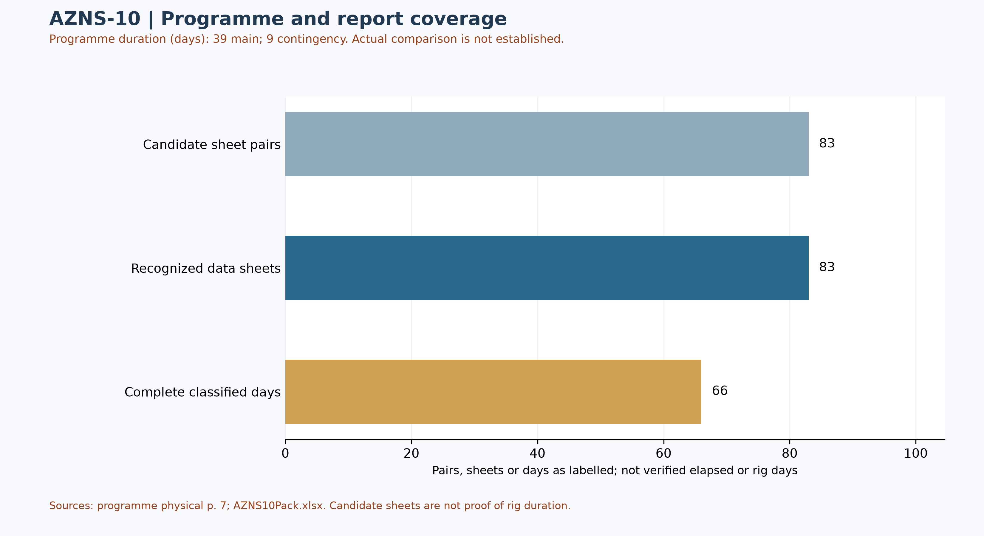
Figure W1 — Daily-record coverage and stated programme duration; actual comparison unverified
Status-page coverage is assessed independently: 83 status pages and 83 data sheets were recognized; 66 status pages contain classified durations totalling approximately 24 hours. Some reports have a status page but an absent or differently formatted data page. These counts are not verified rig duration.

Selected programme phases and limited execution evidence
The phases below are selected programme statements, not proof of execution or of the final approved revision. The selected daily observations are quoted separately; a similar topic alone does not establish phase timing, completion or deviation.
Programme — The plan calls for drilling out cement plugs and cleaning the liner before completing the well. [AZNS-010 Workover Program Rev.06.pdf, physical p. 29]
Programme — The opening sequence includes wellhead checks and BOP pressure testing. [AZNS-010 Workover Program Rev.06.pdf, physical p. 29]
Source worksheet 5 — The report records work on mud pump number 1; the selected cell does not identify a failure mechanism. [AZNS10Pack.xlsx, 5-1 Remark!K24]
Source worksheet 65 — The report records a two-step top-ram pressure test, 500 and 7,500 psi for 15 minutes, with an OK result as written. [AZNS10Pack.xlsx, 65-1 Remark!K30]
Services listed in the programme: drilling and completion fluids: VIRA; waste management: Pars Hafaran Arvand; electrical logging and perforation: PANIZ; mud logging: MAPSA KISH. [AZNS-010 Workover Program Rev.06.pdf, physical p. 26] These are programme assignments, not evidence of actual deployment, contractual award, cost or incident liability.

Worksheet-prefix and report-header reconciliation
Of 83 recognized status pages, the reported header number differs from the worksheet-name prefix on 49 pages; 0 headers have no readable numeric value. Axes based on worksheet prefix are not official report numbers or chronologies. Reconcile each entry's number, date and time with the header and signed records. Cell-level details are in evidence/sheet_report_number_audit.json.

Selected daily-report observations
Of 83 recognized status pages, 66 contain classified durations totalling approximately 24 hours. Planned, NPT and unplanned labels are source classifications; they do not independently establish cause, liability or total operation duration. The following examples are selective; complete extracted detail cells are retained in evidence/activity_observations.json.
Source worksheet 5 — The report records work on mud pump number 1; the selected cell does not identify a failure mechanism. [AZNS10Pack.xlsx, 5-1 Remark!K24]
Source worksheet 65 — The report records a two-step top-ram pressure test, 500 and 7,500 psi for 15 minutes, with an OK result as written. [AZNS10Pack.xlsx, 65-1 Remark!K30]
These are source statements, not independent verification of a test, failure mechanism, current well condition or an operating instruction. A description may continue into the next cell; reconcile the complete row and time before making decisions.

Additional selected daily-report evidence
These three entries are ordered by worksheet prefix, not necessarily report number; sheet order alone does not establish event time, complete chronology, operational completion or current well condition. Test outcomes are source labels and require reconciliation with signed charts and the tested scope.
Source worksheet 7 — A standpipe ground-line leak is reported, followed by stopping the operation and changing the mud-pump ground manifold; confirm the full event sequence separately. [AZNS10Pack.xlsx, 7-1 Remark!K33]
Source worksheet 11 — The cement-pump truck line pressure test is recorded at 3,000 psi with result “OK”; this is a historical source observation. [AZNS10Pack.xlsx, 11-1 Remark!K24]
Source worksheet 64 — The entry reports running a 5⅞-inch milling assembly from 3,559 to 4,077 m; it does not by itself establish milling success. [AZNS10Pack.xlsx, 64-1 Remark!K25]
The leak, line test and milling trip concern different systems. A pressure-test result should be checked against the signed chart, test envelope and later barrier records.
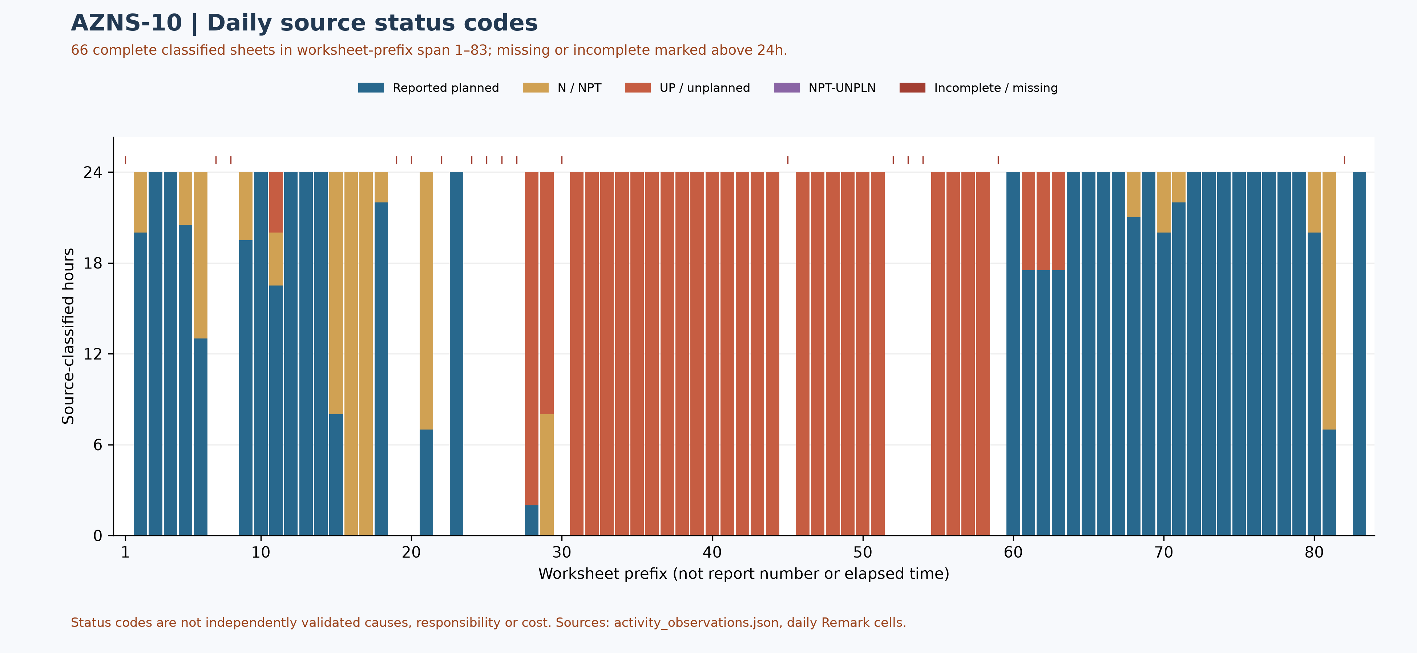
Figure W2 — Daily source-code composition in complete reports, with partial coverage

Performance and Parameter Analysis
Performance coverage: 66 status pages with classified durations totalling approximately 24 hours are used, out of 83 recognized status pages. Planned does not prove productive time; NPT, unplanned and mixed codes are distinct. Omitted hours are not zero; activity families, causes and total operation duration are not established by this table.
Source status code | Hours in complete reports | Share of classified hours
Reported planned | 799.00 | 50.4%
N / NPT | 147.50 | 9.3%
UP / unplanned | 637.50 | 40.2%
NPT-UNPLN (mixed) | 0.00 | 0.0%
Table 4-1 — Source status codes in recognized complete reports, not causal categories
Progress and phase-rate comparisons require reconciliation of scope, time and activity. Report-end depth is not tool depth or instantaneous rate.
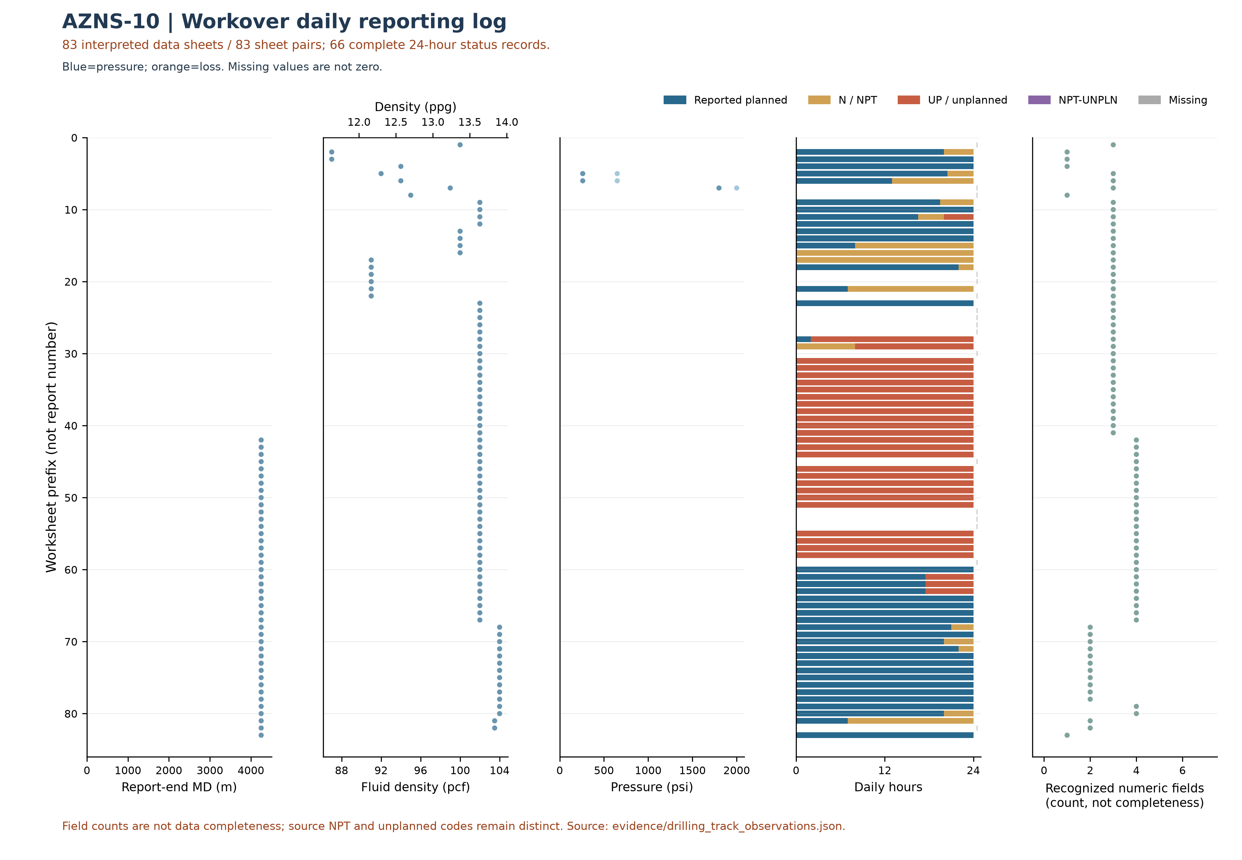
Figure W3 — Workover source observations by worksheet prefix, AZNS-10
W3 uses the data-linked extraction: its coverage and hours may be smaller than W2 and W4, which assess status pages independently of data sheets. Missing or unrecognized data sheets are not added as W3 observations.
This plot uses 83 recognized data sheets and 66 pages with classified durations totaling approximately 24 hours. Its axis is worksheet prefix, not report number or continuous time; for some workbooks sheet order is not chronological. Numeric-field counts are not data completeness. NPT and unplanned codes remain distinct; missing is not zero and report-end depth is not necessarily tool or event depth.
Bit | Rerun | Type / size | Max cumulative m / source | Max cumulative h / source | Dull in sheet order
1 | Unknown | Button bit; 8 1/2" | — | — | —
2 | Unknown | PDC; 8 1/2" | — | 27 [5-2 Data!K28] | 1-1-WT-A-X-I-PN-BHA [8-2 Data!K33]
3 | Unknown | R.Bit (RR2); R.Bit; 5-7/8"; CONFLICT | — | 11 [14-2 Data!M28] | 1-1-WT-A-E-I-NO-DST [10-2 Data!K33]
4 | Unknown | C.C Bit; 5-7/8" | — | — | —
5 | Unknown | R.Bit; 6" | — | 23 [49-2 Data!K28] | 1-1-HC-A-E-I-NO-BHA [49-2 Data!K33]
Table 4-2 — Identified bit observations and cumulative-counter sources.
Unassigned tool observations — grouped only by identical text, not verified runs.
Unassigned raw ID | Reported size / type | Entries | First source
— | — / — | 1 | 1-2 Data
R.R# 1 | 8 1/2" / Button bit | 3 | 2-2 Data!M11,M12,M13
RR#3 | 5-7/8" / R.Bit | 4 | 16-2 Data!M11,M12,M13
R.R# 2 | 8 1/2" / Button bit | 1 | 25-2 Data!K11,K12,K13
R.R# 3 | 8 1/2" / R.Bit | 2 | 31-2 Data!K11,K12,K13
R.R# 4 | 8 1/2" / R.Bit | 2 | 33-2 Data!K11,K12,K13
R.R# 5 | 8 1/2" / B.Bit | 9 | 35-2 Data!K11,K12,K13
RR | 8 1/2" / PDC | 4 | 45-2 Data!K11,K12,K13
RR6#3 | 5-7/8" / R.Bit | 2 | 49-2 Data!M11,M12,M13
RR7#3 | 5-7/8" / R.Bit | 2 | 51-2 Data!K11,K12,K13
RR8#3 | 5-7/8" / R.Bit | 4 | 66-2 Data!K11,K12,K13
Bit evidence is preliminary: source AZNS10Pack.xlsx; 83 data sheets were recognized from 83 candidate sheet pairs. 34 tool-column entries lack an unambiguous numeric bit ID. A cumulative-counter maximum is not necessarily incremental run performance; bit-number reuse, rerun, metadata conflicts and dull reports require reconciliation. Workbook order does not prove chronology; the displayed dull observation is not necessarily final. Missing values are not zero.
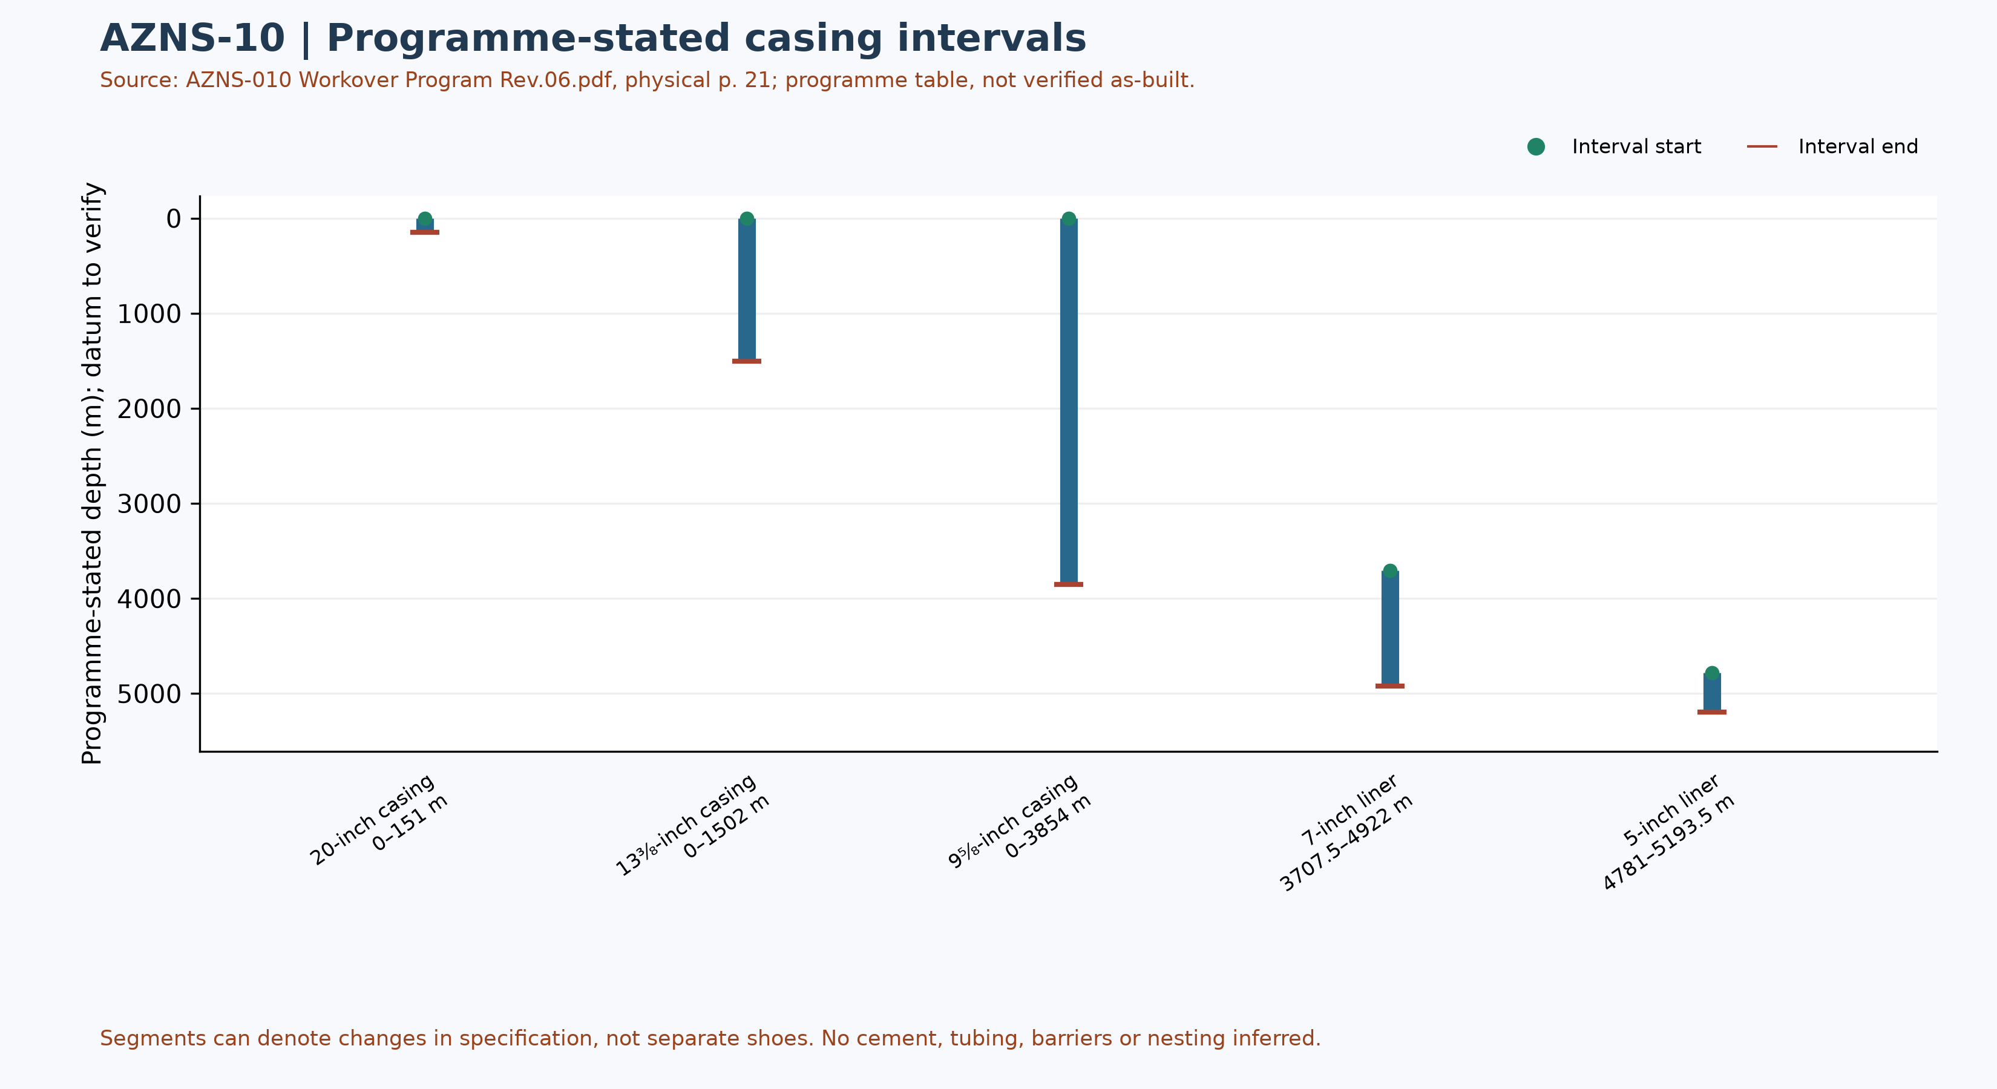
Figure W6 — Programme-stated casing intervals; not a verified as-built schematic

Drilling Fluid Engineering and Loss Accounting
This table summarizes numeric entries recovered from 83 recognized data sheets out of 83 candidate pairs. Each extreme has a source-cell example; coverage, simultaneity, units and test quality require verification. Minima and maxima are not a design window or current fluid condition.
Source observation | Numeric entries | Minimum and cell | Maximum and cell
Mud weight (pcf) | 82 | 87 [2-2 Data!R12] | 104 [68-2 Data!R12]
Plastic viscosity (cP) | 62 | 18 [14-2 Data!R18] | 26 [11-2 Data!R18]
Yield point (lb/100 ft²) | 62 | 6 [46-2 Data!R19] | 30 [13-2 Data!R19]
Source downhole loss (bbl) | 0 | No numeric entry recognized | No numeric entry recognized
Table 5-1 — Partial source-cell fluid and loss observations
A blank or nonnumeric entry is not zero. The source loss field is labelled downhole or formation loss volume; no sum or formation attribution is calculated until reporting basis, cumulative versus daily treatment and duplication are reconciled. Reconcile cell values with operational remarks and materials use separately.

Selected mud-material source entries
Table 5-2 selects source-used entries from two sheets of AZNS10Pack.xlsx. Recognizable materials headers were found in 83 of 83 data sheets; this count does not validate completeness or correctness of inventory or usage. Used-column header cells and row units are retained in the evidence file.
Selected sheet | Material and cell | Used value and cell | Source unit and cell
1-2 Data | Soda Ash (25 kg) [A42] | 2 [F42] | 25 kg [C42]
1-2 Data | Salt [A44] | 12 [F44] | 1 MT [C44]
1-2 Data | Xanthan Gum (XC Pol.) [A47] | 1 [F47] | 25 kg [C47]
3-2 Data | Soda Ash (25 kg) [A42] | 1 [F42] | 25 kg [C42]
3-2 Data | Salt [A44] | 6 [F44] | 1 MT [C44]
3-2 Data | Xanthan Gum (XC Pol.) [A47] | 1 [F47] | 25 kg [C47]
Table 5-2 — Selected mud-material used-column entries; units as printed
The used column is distinct from received, cumulative received and stock. Repeated material or values across sheets are not necessarily independent consumption; blanks and errors are not zero. Verify package size, unit abbreviation, reporting period, opening and closing balance, receipts, usage and mixing records before totals or conversion. These entries alone do not establish downhole use, treatment of losses or causality with fluid properties.

Completion, Casing and Service-Module Findings
Programme element | Interval start, m | Interval end, m | Source specification
20-inch casing | 0 | 151 | K-55, 133#
13⅜-inch casing | 0 | 1502 | N-80, 72#
9⅝-inch casing | 0 | 3854 | T-95, 53.5#
7-inch liner | 3707.5 | 4922 | T-95, 32#
5-inch liner | 4781 | 5193.5 | T-95, 18#
Table 6-1 — Casing and liner intervals in AZNS-010 Workover Program Rev.06.pdf, physical p. 21
Programme casing scope: these values transcribe the programme table and describe historical or pre-operation conditions, not a verified final wellbore. Endpoints of specification segments are not necessarily shoes or hangers; datum, actual configuration, tally and barrier integrity require approved records.
Personnel-on-board averages and peaks in the legacy report are withdrawn pending reconciliation of daily role-level counts, totals, missing entries and personnel scope.
The next figure displays only recognized bit and tool evidence; casing and cost evidence are presented in their respective sections. This is not a verified run count or continuous log.
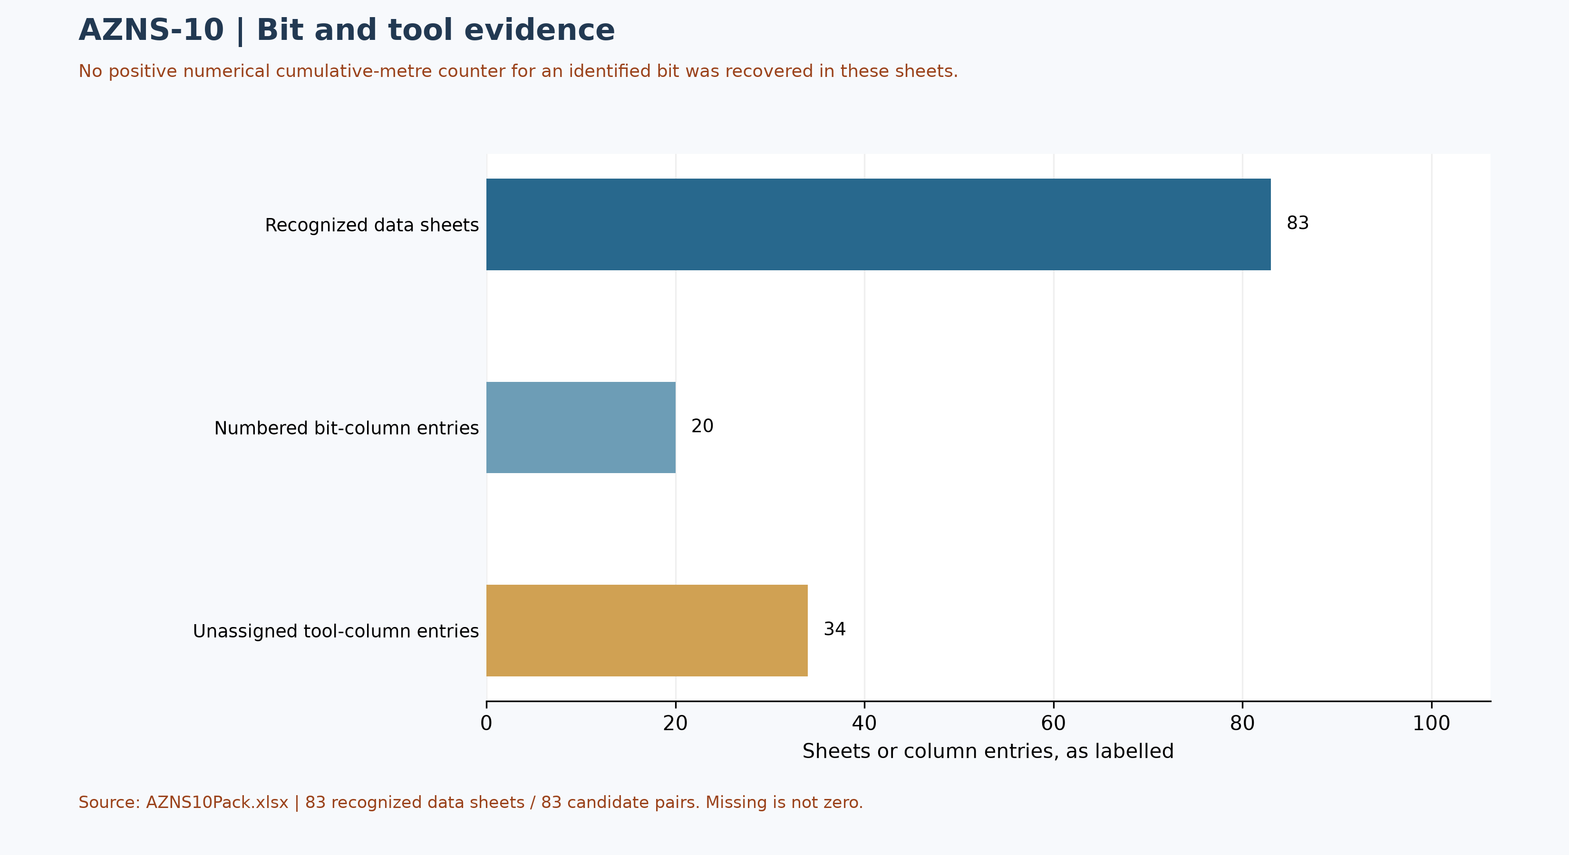
Figure W7 — Bit/tool evidence coverage, not a run count

Selected daily BHA components and hydraulic review
At least one nonempty recognized-format block was recovered in 62 of 83 data sheets. The table selects four rows from one block in AZNS10Pack.xlsx, sheet 2-2 Data; it is not the entire string, all runs, or the current well condition. A repeated identifier or parallel columns do not establish the number of runs.
Selected component and cell | Recorded outside diameter and cell | Evidence scope
R. Bit [I42] | 8 1/2" [K42] | Source observation
Bit Sub [I43] | 6 3/8" [K43] | Source observation
DC [I44] | 6 1/2" [K44] | Source observation
HWDP [I45] | 5" [K45] | Source observation
Table 6-2 — Selected source block components and recorded dimensions
Physical programme page 32 is a navigation anchor for the planned BHA discussion; matching phase or agreement with this daily example is not established. Reconcile stated dimensions with the component name, count, length, inside diameter, connection limits, sequence, run record and manufacturer data. Hydraulic review requires verified inside and outside diameters and annular geometry for each section, simultaneous flow and fluid properties, nozzle and surface-loss information and pressure calibration. Without these inputs, pressure loss, annular velocity, hole cleaning and a reliable operating window cannot be calculated; W3 alone is not a design.

Source-coded non-planned time and partial coverage
Only 66 daily reports with classified durations totalling approximately 24 hours were included out of 83 candidate sheet pairs. These are source-code hours, not a verified total for the operation; incomplete or unrecognized days are not zero. Status pages are recognized independently of data pages; row-level cells are retained in evidence/activity_observations.json.
Table 7-1 — Source-code hours in complete reports; references are examples.
Source code | Hours in coverage | Example status and duration cells
N / NPT | 147.50 | 2-1 Remark!J23,H23 ; 5-1 Remark!J24,H24
UP / unplanned | 637.50 | 11-1 Remark!J28,H28 ; 11-1 Remark!J31,H31
NPT-UNPLN | 0.00 | None in included complete days
Activity codes alone do not establish root cause or contractual responsibility. Legacy mechanism claims, contractor attribution and financial exposure are withdrawn pending review of actual daily narrative, contracts and event evidence. Different source codes must not be presented as a single NPT definition.
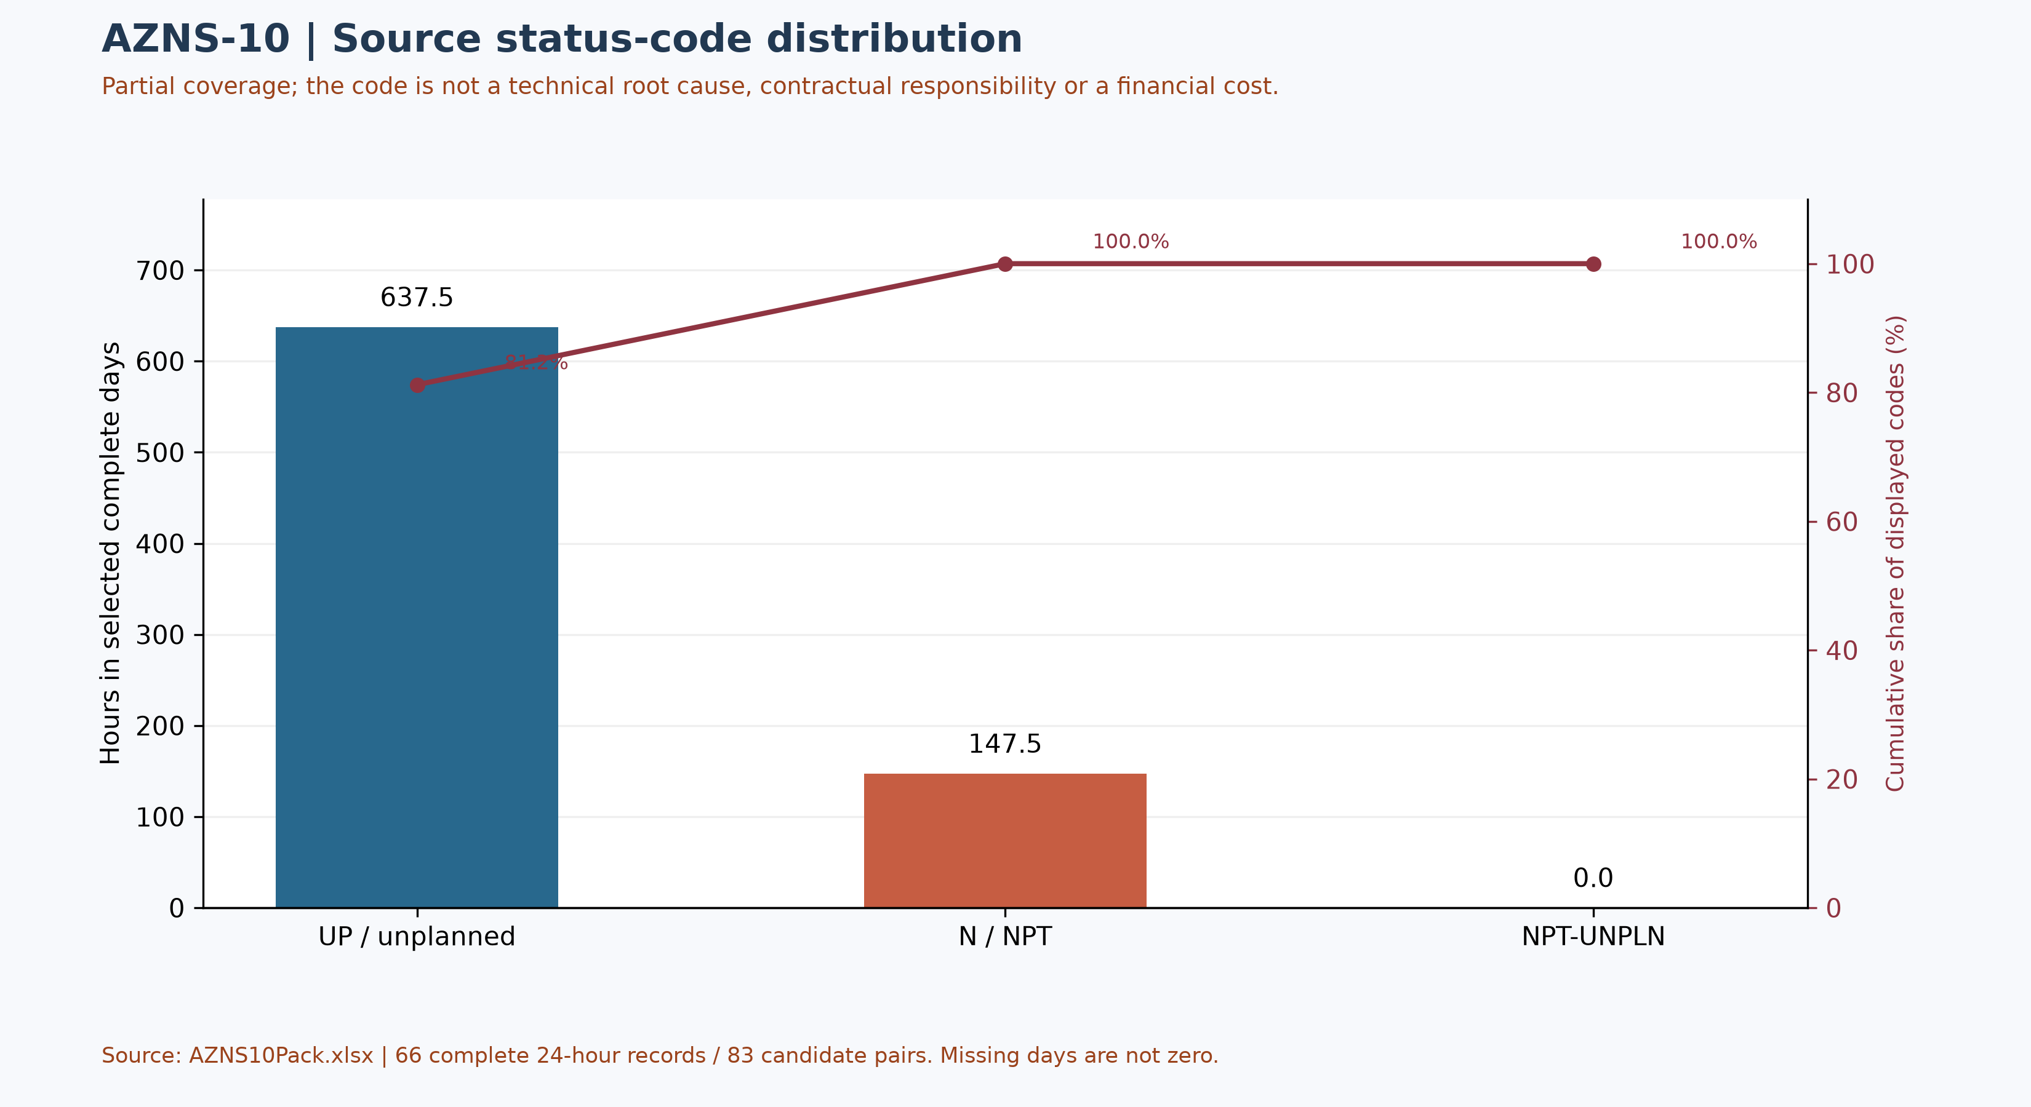
Figure W4 — Pareto of source status codes in complete days, not technical causes

CBS Financial Analysis and Provisional Cost Categories
Table 8-2 source: CBS AZNS-10.xlsx / Cost Breakdown-10 w. Extra Wor. The two values per row are source total and extra-work columns; additivity is not established. These cached source amounts are not actual expenditure or an approved comparable budget. Missing or erroneous values are not zeros; rates, scope, formulas and approvals require reconciliation. No daily expenditure series has been verified.
Source / scope | Cached value | Cell / sheet
Cached main-sheet total; scope unverified | 4,316,984.60 | F191 / Cost Breakdown-10 w. Extra Wor
Extra work in another sheet; reconcile | 1,150,266.11 | F190 / Cost Breakdown-10
Table 8-1 Source financial and schedule anchors (unreconciled).
Source category | Source amount (USD) | Amount cell
Rig service | 897,000.00 / 897,000.00 | G5 / H5
Drilling fluids | 121,128.10 / 121,128.10 | G6 / H6
Cementing | 27,500.00 / 27,500.00 | G13 / H13
Mud logging | 43,582.50 / 43,582.50 | G20 / H20
Wireline logging | 154,174.50 / 0.00 | G24 / H24
Drilling waste management | — / — | G62 / H62
Directional drilling | — / — | G74 / H74
Casing running | 25,675.00 / 25,675.00 | G87 / H87
Temporary well suspension | — / — | G95 / H95
Slickline | 12,799.00 / 12,799.00 | G99 / H99
Completion running | 15,000.00 / 15,000.00 | G102 / H102
Liner hanger running | — / — | G113 / H113
H2S service | 8,190.00 / 8,190.00 | G122 / H122
Perforation | 123,975.00 / 123,975.00 | G125 / H125
Wellhead services | 9,000.00 / 9,000.00 | G130 / H130
Dry test services | 13,875.00 / 13,875.00 | G134 / H134
Rig / completion services | 1,128,500.00 / 1,128,500.00 | G137 / H137
Other services | 19,500.00 / 19,500.00 | G147 / H147
Cleanup services | — / — | G151 / H151
Drilling materials | 1,676,760.00 / 1,676,760.00 | G158 / H158
Project management | 156,000.00 / 156,000.00 | G167 / H167
Engineering | 28,500.00 / 28,500.00 | G170 / H170
Tubing inspection | — / — | G180 / H180
Wellhead / tree inspection | 5,000.00 / 5,000.00 | G188 / H188
Downhole completion inspection | 5,000.00 / 5,000.00 | G189 / H189
Table 8-2 CBS source categories and cell references (unreconciled).
Topic | Observation | Source reference | Action
Scope / actuals | Values are not actual invoices or an approved comparable ceiling. | Source sheet and formulas | Reconcile
Extra work | F191 sums H-column rows; a separate extra-work sheet also exists. | F191; other sheet F190 | Do not add scopes
Table 8-3 CBS reconciliation checks.
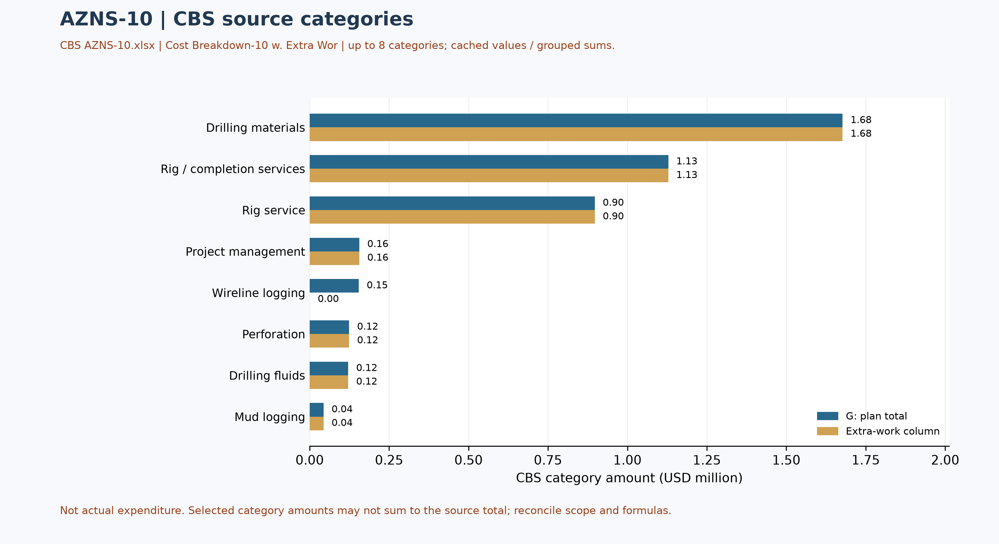
Figure W5 — CBS source cost categories, AZNS-10 (unreconciled)

Operational observations and engineering decision gates
Previous numerical operating envelopes were not validated and have been withdrawn. The entries below are examples of raw daily records only; tool location, phase, units and measurement validity require review. These observations are not safe limits, optimum windows or operating instructions.
Table 9-1 — Example recorded cells; units and measurement basis require verification.
Raw field | Example recorded value | Sheet and cell
Mud weight | 100 | 1-2 Data!R12
Bit load / WOB | 10-14 | 3-2 Data!K18
RPM | 30-70 | 3-2 Data!K19
Flow | 410 | 3-2 Data!K23
Standpipe pressure | 260-650 | 5-2 Data!K24

Recommendations and review requirements
- Reconcile the programme revision, scope, start/end boundaries and rig/service time against daily reports and approved schedules before reporting a variance.
- Have responsible specialists verify well barriers and formation, casing and equipment limits against current approved records; no numerical design setpoint is established by this report.
- Reconcile bit identifiers, cumulative counters, tool assembly and failure evidence with original field and vendor records before selecting future equipment or diagnosing a mechanism.
- Reconcile costs with signed contracts, approved scope and invoices; do not convert source status-code hours into financial liability without a contractual assessment.

Risk-review checklist; ownership and severity not assigned
Review topic | Available evidence | Required follow-up
Well integrity and pressure | Programme objective and stated background, not proof of current condition | Reconcile tests, barriers and current approved limits
Incidents and recorded time | Partial source-code coverage in table 7-1 | Review event narrative, duration, cause and contract without presumed attribution
Equipment and operations | Example cells in table 9-1 and tool observations in table 4-2 | Verify units, calibration, tool identity and vendor records
Schedule and cost | Programme page and cost-breakdown evidence | Reconcile scope, invoices, time basis and approved revision

Data Provenance and Cell-Level Traceability
The table lists selected source anchors only. Other entries and interpretations still require independent cell/page checks, unit and scope review; the current report is not fully reconciled or reproducible without engineering interpretation.
Data element | Archive anchor (file -> sheet!cell)
well_name | 1-1 Remark!C5
client | 1-1 Remark!H5
rig | 1-1 Remark!C6
field | 1-1 Remark!C7
well_type | 1-1 Remark!C9
report_date | 1-1 Remark!N5
spud_date | 1-1 Remark!N6
est_days | 1-1 Remark!N8
act_days | 1-1 Remark!N9
mud:mw | 1-2 Data!R12
mud:funnel_visc | 1-2 Data!R13
mud:fluid_loss | 1-2 Data!R14
mud:pv | 1-2 Data!R18
mud:yp | 1-2 Data!R19
CBS cost breakdown | CBS AZNS-10.xlsx -> sheet "Cost Breakdown-10 w. Extra Wor"
Well programme | AZNS-010 Workover Program Rev.06.pdf
Table 11-1 Provenance anchors.

Appendix: source formation-table snapshot (unverified)
Source: AZNS10Pack.xlsx, sheet 83-2 Data. Selected as the last sheet in workbook order with a recognized formation table containing a numeric depth; if none, the last table with formation names. This is not necessarily the latest dated report.
Column roles follow the source labels, not independent confirmation of prognosis or measurement. Unlabelled populated cells are shown separately; missing cells are unknown, not zero. Values are rounded to four decimals for display. Verify row alignment, depth datum, possible inconsistencies and lithology against the programme and geological report; this table alone does not establish event attribution or operating instructions.
Source table and anchor: Formation Geology Data / N109
Formation / cell | Source values / cell
Surface / K111 | Forc. MD (m.): Surface [L111]  Forc. TVD (m.): Surface [M111]  Act. MD (m.): Surface [O111]  Act. TVD (m.): Surface [Q111]
Aghajari / K112 | Act. MD (m.): 1138 [O112]  Unlabelled column P: 1151.5 [P112]  Act. TVD (m.): 1151.5 [Q112]
Gachsaran / K113 | Act. MD (m.): 1488.5 [O113]  Act. TVD (m.): 1502.1 [Q113]
Asmari / K114 | Act. MD (m.): 1771.2 [O114]  Act. TVD (m.): 1784.8 [Q114]
Pabdeh / K115 | Act. MD (m.): 2186.2 [O115]  Act. TVD (m.): 2199.8 [Q115]
U-Gurpi / K116 | Act. MD (m.): 2308 [O116]  Act. TVD (m.): 2321.6 [Q116]
Tarbur / K117 | Act. MD (m.): 2393.6 [O117]  Act. TVD (m.): 2407.2 [Q117]
L-Gurpi / K118 | Act. MD (m.): 2518.7 [O118]  Act. TVD (m.): 2532.3 [Q118]
Ilam / K119 | Act. MD (m.): 2626.6 [O119]  Act. TVD (m.): 2640.2 [Q119]
Laffan / K120 | Act. MD (m.): 2632.7 [O120]  Act. TVD (m.): 2646.3 [Q120]
Sarvak / K121 | Act. MD (m.): 3284.7 [O121]  Act. TVD (m.): 3298.3 [Q121]
Kazhdomi / K122 | Act. MD (m.): 3483.5 [O122]  Act. TVD (m.): 3497.1 [Q122]
Dariyan / K123 | Act. MD (m.): 3680.6 [O123]  Act. TVD (m.): 3694.2 [Q123]
Gadvan / K124 | Act. MD (m.): 3974.2 [O124]  Act. TVD (m.): 3987.8 [Q124]
Fahlian Top / K125 | Act. MD (m.): 4281.7 [O125]  Act. TVD (m.): 4295.3 [Q125]
Garau / K126 | Not recorded

Well-program evidence note
AZNS-010 Workover Program Rev.06.pdf, physical page 6, describes an abandoned well and plans de-suspension, perforation of the 7-inch liner in Fahliyan and completion. Page 17 records historical drilling to 5,340 m and abandonment with cement plugs, and describes tight hole, fishing and losses. These are historical events, not proof of the same incidents during the later workover. Data warning: in 1-2 Data K111:K112 are Aghajari and Gachsaran; in 83-2 Data Surface was inserted at K111 and the names shifted. Reconcile O112:Q112 row alignment before interpreting the depths.

Selected formation tops from programme page
Source: AZNS-010 Workover Program Rev.06.pdf, physical page 13. The programme labels the table actual formation tops; these are historical source values, not independent verification. Depth reference: RTE 13.45 m. Event-to-formation attribution requires a reconciled event depth and datum.
Formation / member | Source top, m MD
Gachsaran | 1151.5
Asmari | 1502.1
Pabdeh | 1784.8
U. Gurpi | 2199.8
Tarbur | 2321.6
L. Gurpi | 2407.2
Ilam | 2532.3
Laffan | 2640.2
Sarvak | 2646.3
Kazhdumi | 3298.3
Dariyan | 3497.1
Gadvan | 3694.2
Fahliyan | 3987.8

Programme source summary and comparison limitations
Source: AZNS-010 Workover Program Rev.06.pdf, physical page 7. Programme objective: De-suspend and complete as a Fahliyan producer. Stated programme duration, in days: 39 main; 9 contingency. The programme states measured depth 5340 m and producer/reservoir formation Fahliyan; these do not by themselves establish achieved depth or current condition. Time boundaries, scope and contingency interpretation require reconciliation.

