AZNS-85
Drilling, Workover and Well-Intervention Engineering Report
Technical, Operational, Contractual and Financial Analysis
Prepared for the South Azadegan Field Development — Contract 1 - 6-Well

Item | Value
Well / operation | AZNS-85
Contract | Contract 1 - 6-Well
Operation type | Workover / Completion
Rig | 201 OEOC (OEOC)
Client / operator | Petro Pars Limited
Execution window | 2024-01-25 to 2024-03-17
Reporting days | 53
Source archive | CBS AZNS-85.xlsx (+ AZNS-85 Workover Program Rev.02.pdf)

Document control | Record
Document code | AZNS-85-DER-001
Revision / status | 00 - Issued for information
Issue date | 04 November 2026
Prepared by | Drilling Engineering - Well Performance Team
Checked by | Senior Drilling Engineer
Approved by | Drilling Manager, South Azadegan Development
Distribution | Client, drilling contractor, cost engineering, well archive
Table 0-1 Document control and distribution.
This report consolidates every daily drilling report of the operation, the cost breakdown structure, the well programme and all additional datasets discovered in the archive into a single verified engineering record.

Executive KPI Summary
KPI | Value
Contract / operation type | Contract 1 - 6-Well | Workover / Completion
Rig and contractor | 201 OEOC | OEOC
Spud to release | 2024-01-25 to 2024-03-17 (53 report days)
Planned vs actual duration | 47.0 vs 51.5 rig days (110.0%)
Depth reached | 4,090 m MD
Productive vs NPT | 1,037 h productive / 198 h NPT (16.1% NPT)
Cost (actual vs CBS budget) | 1,184,500 USD (no CBS budget published)
Cost variance | budget not published in CBS for this well
Average burn rate | 23,000 USD/day
Financial cost of NPT | 190,229 USD
Total mud losses | 0 bbl
Drilling fluids density | 81.0 – 104.0 pcf (10.8 – 13.9 ppg)

Operation AZNS-85 closed at 51.5 rig days against a programme of 47.0 days, with 16.1% of rig time lost to unplanned events and a reconstructed spend of 1,184,500 USD.

Contents
No. | Section
1 | Well identity, rig assignment and data inventory
2 | Planned versus actual execution reconciliation
3 | Chronological operational narrative and day-by-day reconstruction
4 | Performance and parameter analysis
5 | Drilling fluid engineering and loss accounting
6 | Completion, casing and service-module findings
7 | Root-cause analysis and three-dimensional NPT attribution
8 | CBS financial analysis and reconstructed cumulative cost
9 | Section-wise optimum parameters and field recommendations
10 | Risk register and mitigations
11 | Data provenance and cell-level traceability

Figures and tables are numbered by section and are listed in place.

Well Identity, Rig Assignment and Data Inventory
The operation AZNS-85 was executed with rig 201 OEOC under the Contract 1 - 6-Well. The archive holds 53 daily drilling reports covering 2024-01-25 to 2024-03-17, complemented by the cost breakdown structure ("CBS AZNS-85.xlsx") and the well programme ("AZNS-85 Workover Program Rev.02.pdf"). All datasets were parsed cell by cell; the inventory below states exactly which data modules exist for this well and which do not, so that every analytical statement in this report rests on traceable evidence.

Static identity
Field | Recorded value
Well name in daily report | AZNS-85-PAD79
Well type declaration | Vertical
Field | South Azadegan
Client | Petro Pars Limited
Drilling contractor | OEOC
Rig | 201 OEOC
Operation classification | Workover / Completion
Hole section / scope declaration | as per programme
Spud / first report date | 2024-01-25
Release / last report date | 2024-03-17
Table 1-1 Static well identity.

Data inventory discovered for this operation
Dataset module | Records found
DDR daily reports | 53
Cost breakdown (CBS) | not present
EPD budget ceiling | not present
Program time breakdown | 1
Casing tally | 7
Bit records | 8
Survey stations | not present
Mud weight records | 48
Mud loss records | not present
NPT events (>=3h) | 26
Rig-less stimulation CBS | not present
Service sub-tabs | not present
Well program PDF | 1
Table 1-2 Core and auto-discovered bonus modules.
Modules reported as absent were genuinely unavailable in the archive of this well; no value has been imputed or substituted. Where a module is missing, the corresponding analysis in this report is replaced by an adaptive alternative rather than an empty panel.

Planned versus Actual Execution Reconciliation
The planned envelope of this operation is taken from two independent references: the CBS time breakdown for scope and duration (CBS time-breakdown "AZNS-085 WO. Extra Work"), and the well programme document (AZNS-85 Workover Program Rev.02.pdf). Actual execution is reconstructed from the 53 daily reports. Comparing the two sides isolates schedule drift, scope growth and productive-time loss.
Reconciliation metric | Planned | Actual | Variance
Duration (rig days) | 47.0 | 51.5 | +4.5 d
Depth reached / target (m MD) | n/a | 4,090 | n/a
Cost (USD) | n/a | 1,184,500 | n/a
Cost per rig day (USD) | 0 | 23,000 | —
NPT share of rig time (%) | 0.0% | 16.1% | 16.1%
Table 2-1 Planned versus actual reconciliation.
The execution consumed 51.5 rig days against a planned 47.0, a schedule ratio of 110.0%. The operation therefore overran the programme envelope, and the causes are traced in the NPT chapter rather than attributed to a single event.
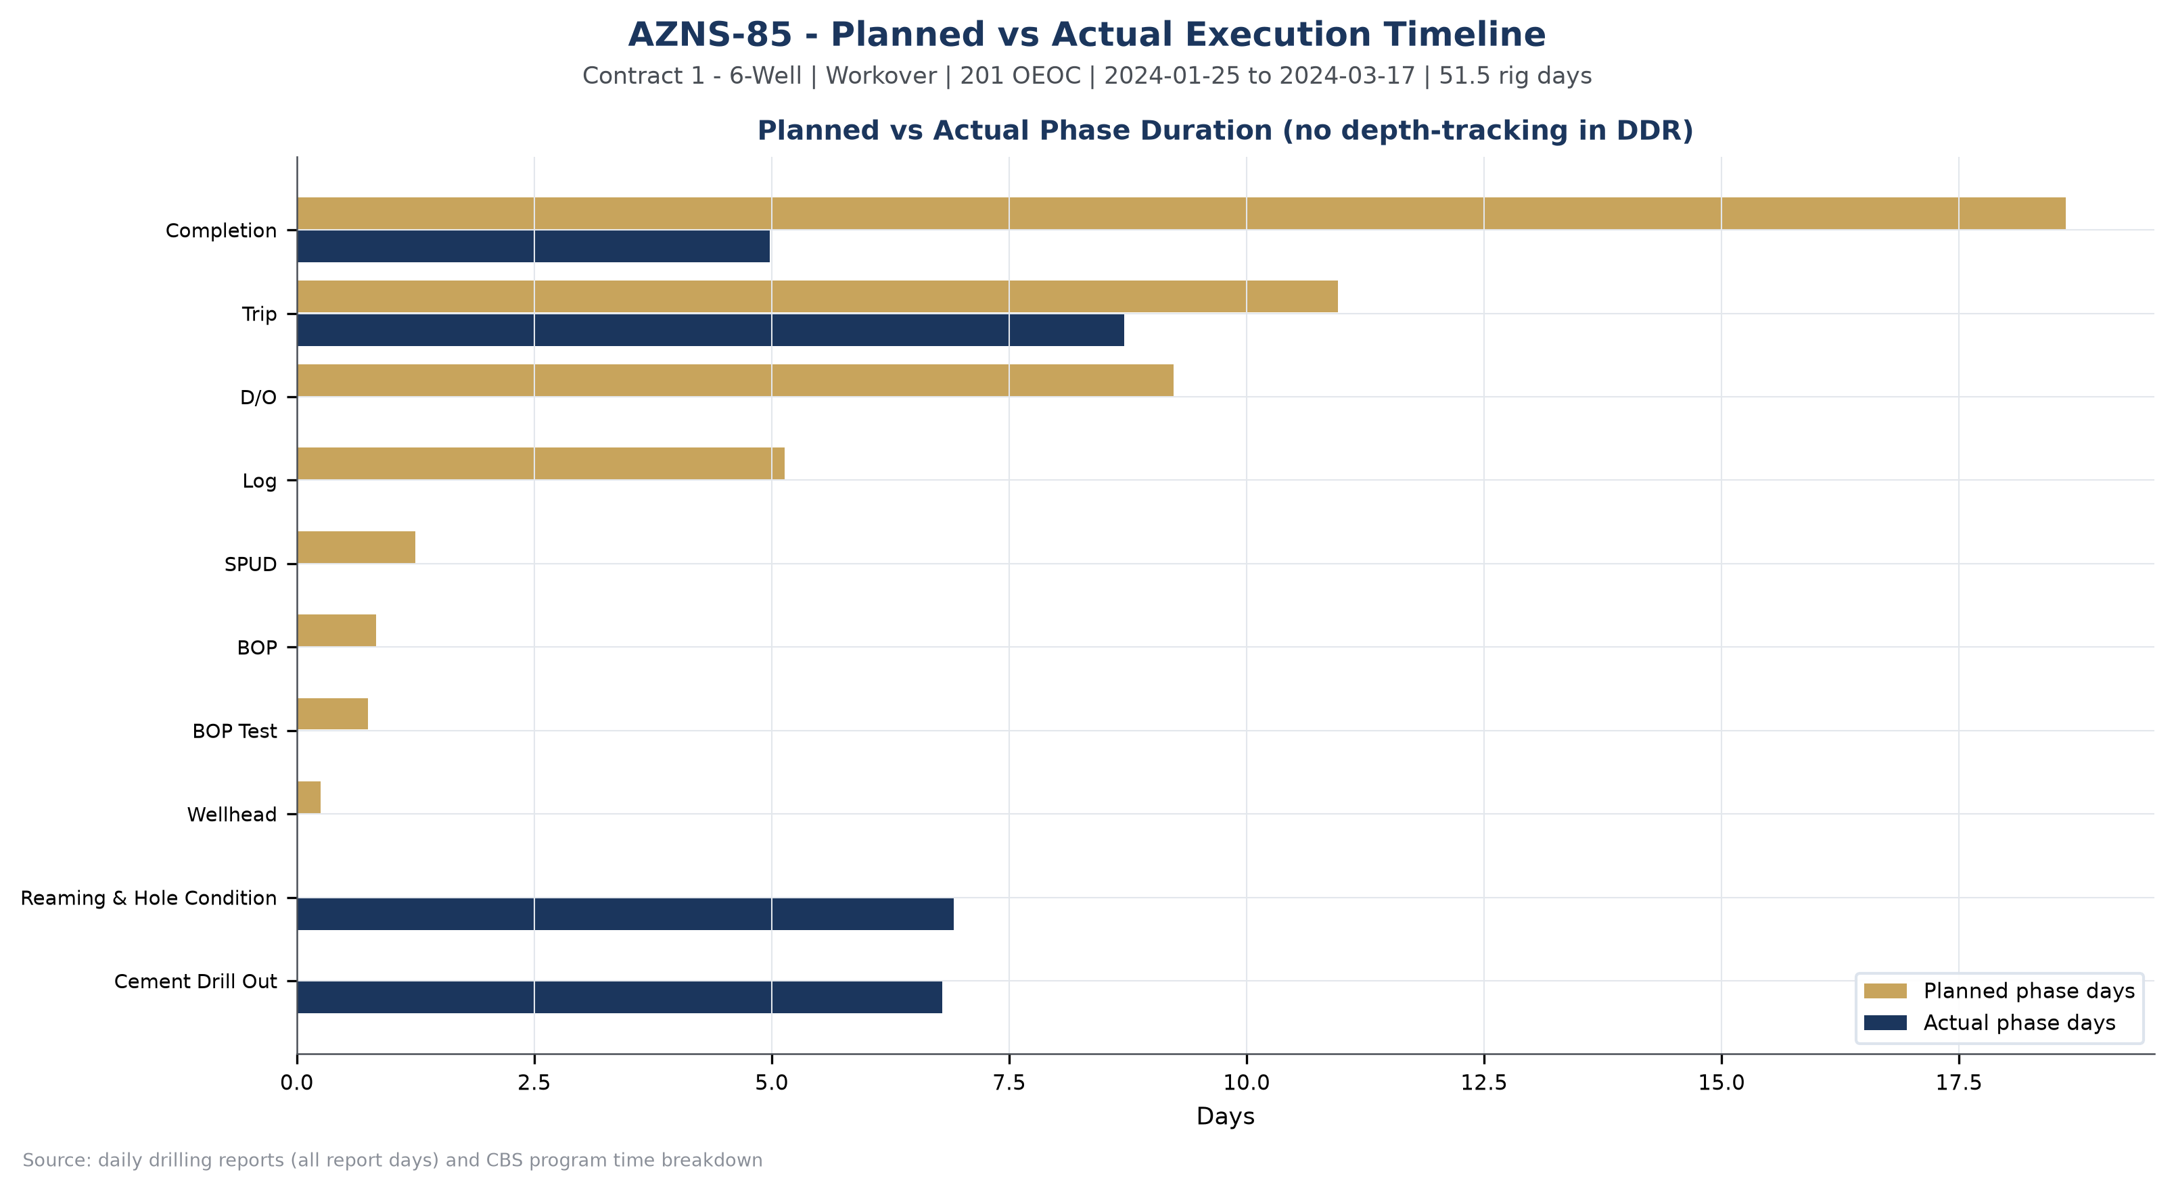
Figure W1 — Planned vs actual execution timeline, AZNS-85

Chronological Operational Narrative
The operation is documented over 53 report days. The following monthly roll-up summarises activity volume, productive output and unplanned time; the paragraphs that follow narrate the operation in sequence and isolate the days on which NPT reached or exceeded twelve hours.
Month | Report days | NPT (h) | Progress (m)
2024-01 | 7 | 33 | 0.0
2024-02 | 29 | 135 | 0.0
2024-03 | 17 | 30 | 0.0
Table 3-1 Monthly execution roll-up.
The dominant activity families of the operation were Trip (209 h), Reaming & Hole Condition (166 h), Cement Drill Out (163 h), Completion (120 h). Their share of productive time defines the operational character of the well: a clean-out and completion-dominated workover.

Critical days with NPT of twelve hours or more
Date | Day | NPT (h) | Dominant cause | Field record (extract)
2024-02-12 | 19 | 24.0 | Waiting on Weather / Service | NPT FOR OEOC: M/U & RIH 8-1/2"B.BIT + BIT SUB(FLOAT IN) FOLOW BY 5" DPS TO 500M WHILE SLOW CIRC. TO REC. NEW 9-5/8" DRY TEST PKR .POOH TO SURF & L/D 8 ...
2024-02-13 | 20 | 24.0 | Fishing / Milling | NPT FOR OEOC: CONT. RIH FISHING MAGNET W/5" DPS TO 3662M,TOOK WEIGHT,RIH WITH W/D TO 3665M,WORK ON JUNK SUB SEVERAL TIME,DROP BALL START PUMPING ,O.B ...
2024-02-14 | 21 | 24.0 | Waiting on Weather / Service | P/U & M/U 9-5/8" DRY TEST TOOLS(OEOC) AS:BOTTOM B.T +ANCHOR PIPE + 9-5/8"PACKER +V.R SAFETY JOINT + JAR +MIDDLE B.T + HYDRO SPRING(CLOSED POSITION) +D ...
2024-02-11 | 18 | 18.0 | Waiting on Weather / Service | OBS 9-5/8" DRY TEST PKR BACK UP WAS FAILDE WHILE WATING TO REC. 9-5/8" NEW DRY TEST PKR .
2024-01-29 | 5 | 13.0 | Stuck Pipe | Apply 70Klbf Over pull several times to make P.Tester free, No success, L/D 2 jt 5" DPs, P/U & M/U Fishing jar
2024-02-04 | 11 | 13.0 | Waiting on Weather / Service | Cont. RIH w/ 5-7/8" Clean out BHA f/ 222 to 1287m followed by 3-1/2" DPs, jt by jt, while F/U String
Table 3-2 Days with NPT of twelve hours or more.
These days concentrate the operational risk of the well. The field record shows that the unplanned time arose from Waiting on Weather / Service (115 h); Fishing / Milling (43 h); Rig Mechanical / Electrical (20 h), and the sequence matters more than any single entry: each event consumed a full reporting cycle before recovery work could start.
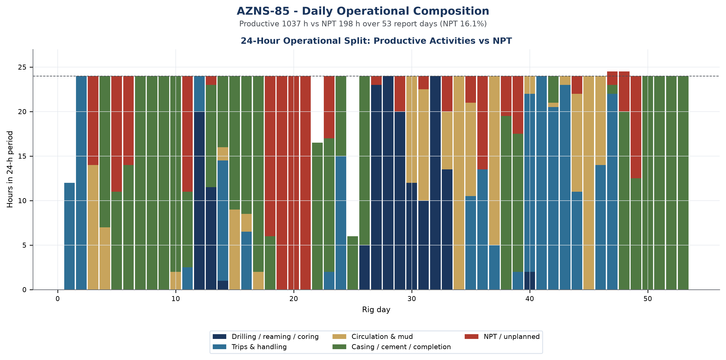
Figure W2 — Daily 24-hour operational composition, AZNS-85

Day-by-day reconstruction
Splitting the operation into three equal reporting blocks shows how the character of the work changed over time, and it is the most compact way to see whether unplanned time was a transient disturbance or a persistent condition.
Reporting block | Days | NPT (h) | NPT share | Progress (m) | Depth at end (m)
2024-01-25 to 2024-02-10 | 17 | 47 | 11.9% | 0.0 | 4,090
2024-02-11 to 2024-02-28 | 18 | 110 | 27.2% | 0.0 | 4,090
2024-02-29 to 2024-03-17 | 18 | 41 | 9.5% | 0.0 | 4,090
Table 3-3 Execution in three reporting blocks.
In the opening block (2024-01-25 to 2024-02-10, 17 days) the operation established the well condition and executed no new hole with 47 h of unplanned time, a share of 11.9%. This block was the cleanest of the three and establishes the achievable rate against which the rest of the operation should be judged.
The middle block (2024-02-11 to 2024-02-28) carried 110 h of unplanned time at 27.2%, and the closing block (2024-02-29 to 2024-03-17) carried 41 h at 9.5%. The improvement towards the end of the operation is the signature of a crew and a supervision team that had learned the well, and it is the rate that should be carried into the next operation on the same pad.

Performance and Parameter Analysis
Performance is evaluated on the activity mix, on penetration behaviour where the daily reports carry rate data, and on the bit records recovered from the DDR bit-data block. For this operation the productive time was 1,037 hours and the unplanned time 198 hours.
Activity family | Hours | Share of total time
Trip | 209 | 16.9%
Reaming & Hole Condition | 166 | 13.4%
Cement Drill Out | 163 | 13.2%
Completion | 120 | 9.7%
Service Waiting | 110 | 8.9%
Dry Test | 82 | 6.7%
Wireline Logging | 82 | 6.7%
Rig Waiting | 66 | 5.3%
Mud Circulation | 54 | 4.4%
Nipple Down / Up BOP | 38 | 3.1%
Table 4-1 Activity time distribution.
The daily reports of this operation do not carry a continuous penetration record; this is consistent with a workover in which the string re-enters an existing completion rather than making new hole. Performance is therefore expressed through phase duration, intervention effort and the depth of the deepest reached interval, not through ROP.
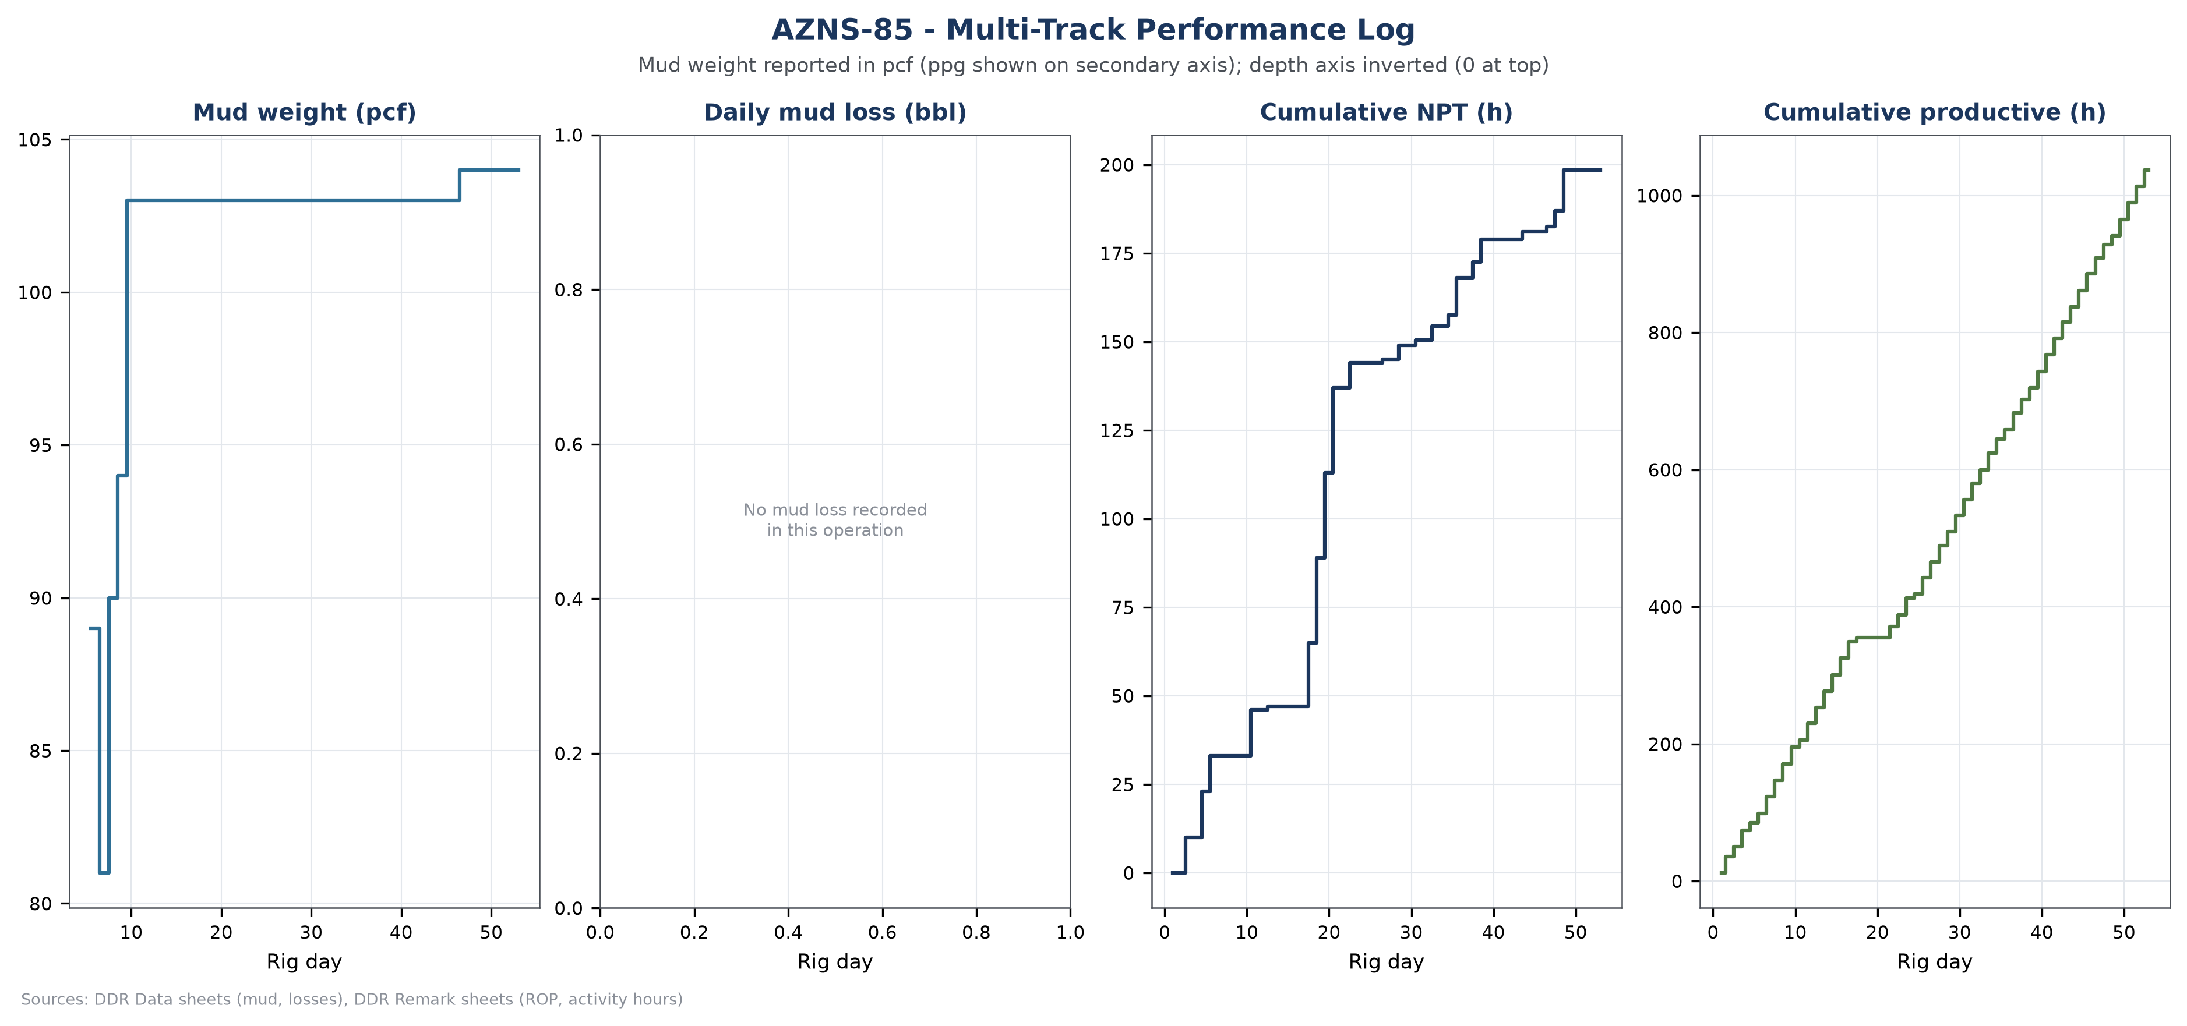
Figure W3 — Multi-track performance log, AZNS-85
Bit | Size (in) | Type | Drilled (m) | Hours | Dull grade
1 | 8-1/2" | PDC | n/a | n/a | -
2 | 5-7/8" | B.Bit | n/a | n/a | -
3 | 8-1/2" | B.BIT | n/a | n/a | -
4 | 5-7/8" | j.mill | n/a | n/a | -
4 | 5-7/8" | J.MILL | n/a | n/a | -
3 | 5-7/8 | B.Bit | n/a | n/a | -
RR#3 | 5-7/8 | B.Bit | n/a | n/a | -
4 | 6-1/8 | PDC | n/a | n/a | -
Table 4-2 Bit runs recovered from the daily reports.
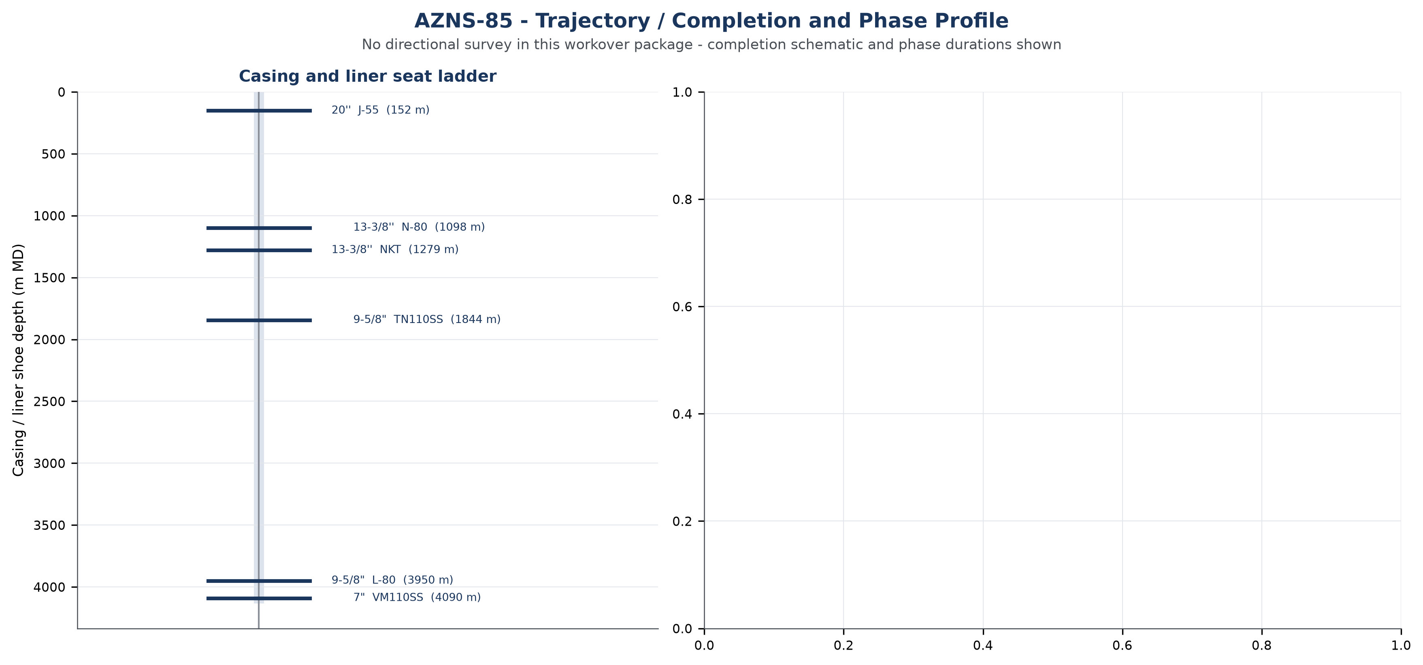
Figure W6 — Trajectory, completion and phase profile, AZNS-85

Drilling Fluid Engineering and Loss Accounting
Mud weight in this archive is recorded in pounds per cubic foot, the unit used on the daily report of the South Azadegan project. For engineering comparability each record is also expressed in pounds per gallon (ppg = pcf / 7.48052) and as a hydrostatic gradient (psi/ft = pcf / 144). The table below reports the envelope actually observed in this operation; no pcf value is presented as ppg anywhere in this report.
Mud weight envelope | pcf | ppg | Gradient (psi/ft) | SG equivalent
Minimum | 81.0 | 10.8 | 0.562 | 1.30
Median | 103.0 | 13.8 | 0.715 | 1.65
Maximum | 104.0 | 13.9 | 0.722 | 1.67
Table 5-1 Mud weight statistics with unit conversion.
Property | Min | Median | Max | Records
PV (cp) | 8.0 | 18.0 | 27.0 | 41
YP (lb/100ft²) | 3.0 | 11.0 | 20.0 | 41
Gel 10 s | 1.0 | 2.0 | 4.0 | 41
Gel 10 min | 3.0 | 4.0 | 6.0 | 41
pH | 9.2 | 10.8 | 10.9 | 41
Solids (% vol) | 23.0 | 30.0 | 30.0 | 40
Table 5-2 Rheology envelope.
Total fluid loss recorded against the formation is 0 bbl over 0 report days, with a maximum single-day loss of 0.0 bbl. The fluid system in use was not declared in the report.

Completion, Casing and Service-Module Findings
Casing / liner | Grade | Weight | Thread | Top (m) | Shoe (m)
20'' | J-55 | 133 | BTS | Surface | 152
13-3/8'' | N-80 | 72 | BTS | Surface | 1098
13-3/8'' | NKT | 72 | BTS | 1098 | 1279
9-5/8" | TN110SS | 47 | VAM | Surface | 1844
9-5/8" | L-80 | 53.5 | TPCQ | 1844 | 3950
7" | VM110SS | 35 | N.VAM | 3829 | 4090
1. Rigging & Moving | - | - | 02:00 | 29 | P
Table 6-1 Casing and liner tally.
Personnel on board averaged 244.9 and peaked at 311 during the operation, a figure that matters for accommodation, catering and safety-case loading of the contract.
The bonus panel below collects the modules that are specific to this well: casing and liner seat depths, service-cost line items from the CBS sub-tabs and the distribution of activity effort across the operation. Where a module is absent the panel states it rather than displaying an empty axis.
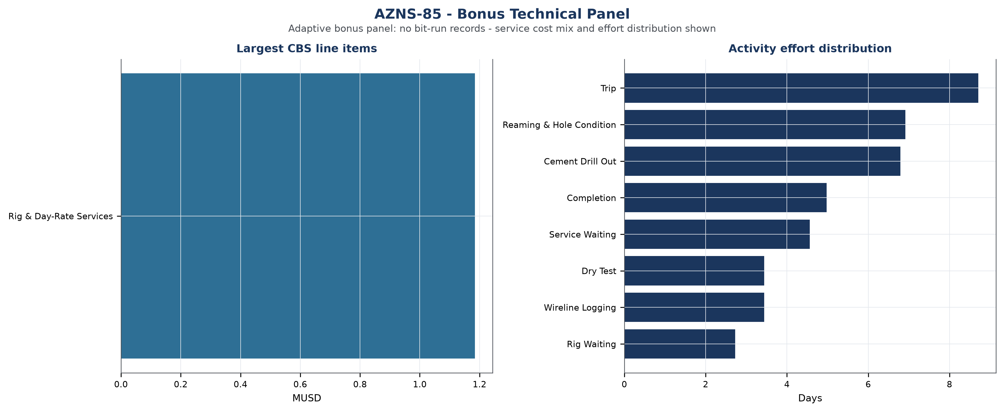
Figure W7 — Bonus technical panel, AZNS-85

Root-Cause Analysis and Three-Dimensional NPT Attribution
Every unplanned interval is classified on three axes: technical root cause, phase of the operation, and the party responsible under the contract. Attribution follows the field record and the NPT attribution field of the daily report; where the record names the rig contractor the hours are carried against OEOC, where it names a service company they are carried against that service line, and residual time is reported as unattributed rather than assigned by assumption.
Technical root cause | Hours | Share of NPT
Waiting on Weather / Service | 115 | 57.9%
Fishing / Milling | 43 | 21.7%
Rig Mechanical / Electrical | 20 | 10.3%
Waiting on Weather / Daylight | 11 | 5.5%
Stuck Pipe | 9 | 4.5%
Table 7-1 NPT by technical root cause.
Responsible party / contractor | Attributed hours | Financial exposure (USD)
Third-party Service | 115 | 110,208
OEOC / Downhole Tools | 43 | 41,208
OEOC (Drilling Contractor) | 30 | 28,271
Force Majeure | 11 | 10,542
Table 7-2 Attribution by responsible party.
Operational phase | NPT hours | Share of NPT
Service Waiting | 110 | 55.2%
Rig Waiting | 66 | 33.0%
Wait on Day Light | 11 | 5.5%
Work on Stuck Pipe | 9 | 4.5%
Force Majeure | 4 | 1.8%
Table 7-3 NPT by operational phase.

Mechanism analysis of the major incidents
Incident 1 — Waiting on Weather / Service (18.0 hours, 2024-02-11). Field record: OBS 9-5/8" DRY TEST PKR BACK UP WAS FAILDE WHILE WATING TO REC. 9-5/8" NEW DRY TEST PKR .
• A service company mobilisation that arrived later than the call-out because the equipment was engaged on another well of the same campaign, so the rig remained on standby.
• A material shortage at the wellsite, where the required tubular or consumable was not in stock and the operation could not proceed without it.
• Adverse weather or visibility limiting crane and lifting operations, which is documented in the daily report and affects the whole spread rather than a single contractor.
Incident 2 — Waiting on Weather / Service (18.0 hours, 2024-02-14). Field record: P/U & M/U 9-5/8" DRY TEST TOOLS(OEOC) AS:BOTTOM B.T +ANCHOR PIPE + 9-5/8"PACKER +V.R SAFETY JOINT + JAR +MIDDLE B.T + HYDRO SPRING(CLOSED POSITION) +D.C.I.P VALVE(OPEN POSITION) + X.O.S + 1 JTS 5" DP +REV. SUB + 4STD 6-1/2" DC TO 130M, CONT. RIH W/5" ...
• A service company mobilisation that arrived later than the call-out because the equipment was engaged on another well of the same campaign, so the rig remained on standby.
• A material shortage at the wellsite, where the required tubular or consumable was not in stock and the operation could not proceed without it.
• Adverse weather or visibility limiting crane and lifting operations, which is documented in the daily report and affects the whole spread rather than a single contractor.
Incident 3 — Waiting on Weather / Service (13.0 hours, 2024-02-12). Field record: NPT FOR OEOC: M/U & RIH 8-1/2"B.BIT + BIT SUB(FLOAT IN) FOLOW BY 5" DPS TO 500M WHILE SLOW CIRC. TO REC. NEW 9-5/8" DRY TEST PKR .POOH TO SURF & L/D 8-1/2"B.BIT &BHA,W/NL-NG.
• A service company mobilisation that arrived later than the call-out because the equipment was engaged on another well of the same campaign, so the rig remained on standby.
• A material shortage at the wellsite, where the required tubular or consumable was not in stock and the operation could not proceed without it.
• Adverse weather or visibility limiting crane and lifting operations, which is documented in the daily report and affects the whole spread rather than a single contractor.
The financial weight of this unplanned time is quantified in the financial chapter: at the applicable rig and spread rates the recorded NPT converts to 190,229 USD of direct cost, before any consequential cost of delayed production.
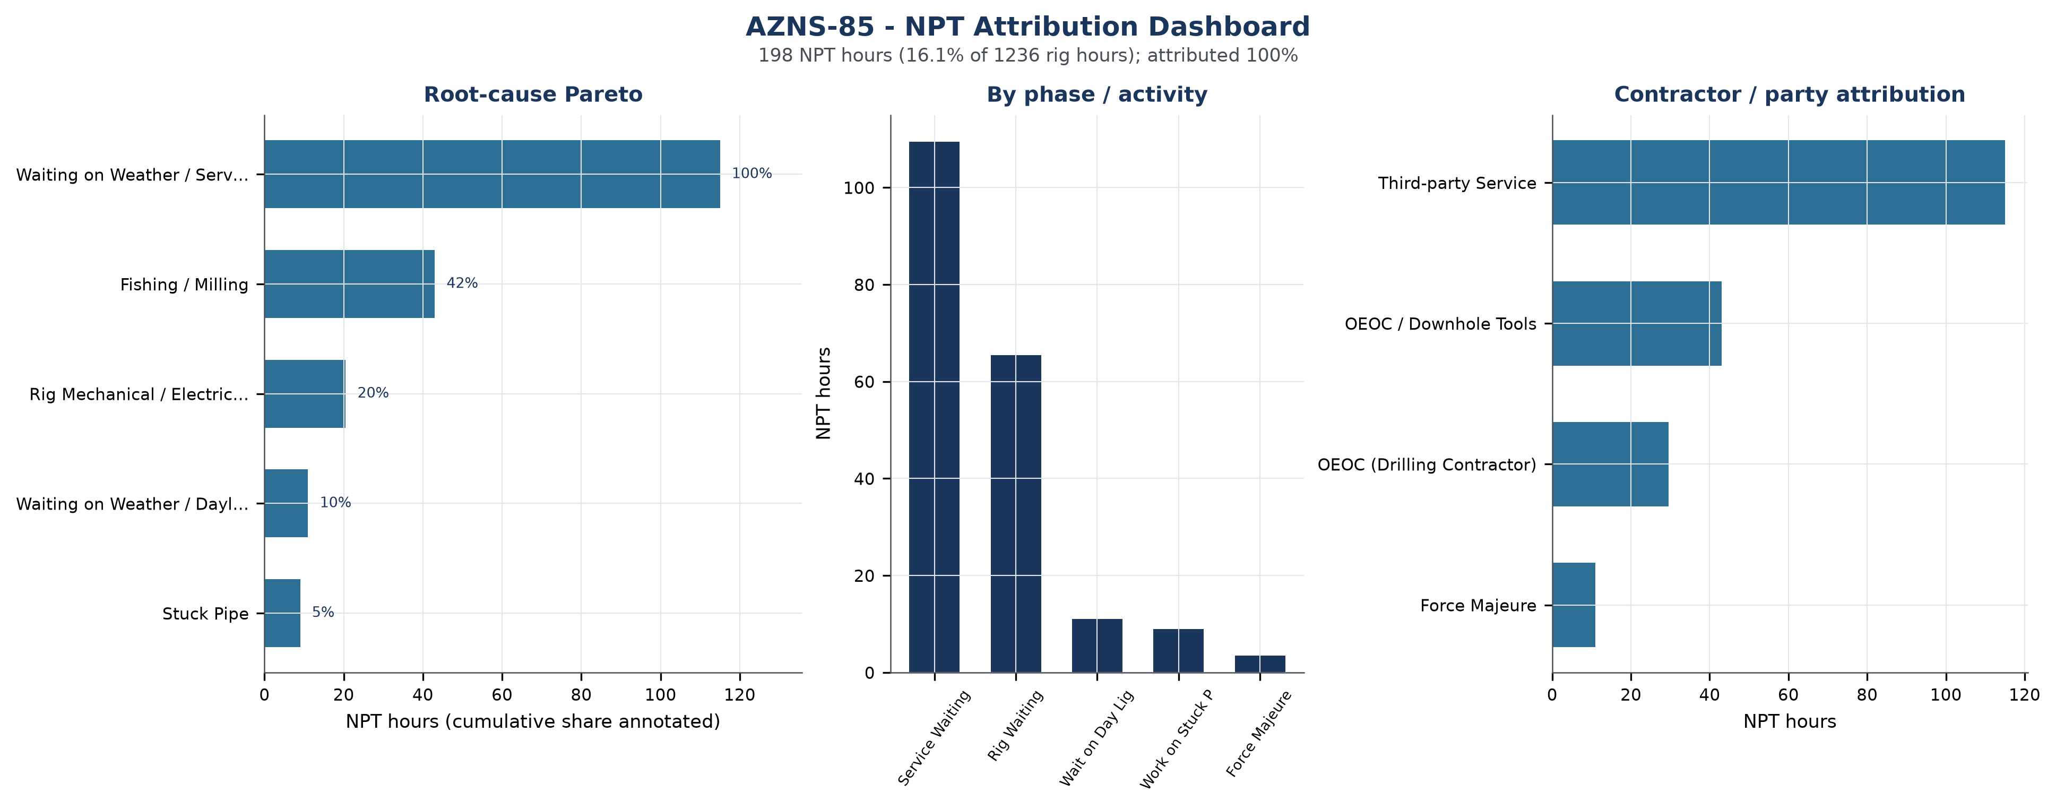
Figure W4 — NPT attribution dashboard, AZNS-85

CBS Financial Analysis and Reconstructed Cumulative Cost
The financial position of the well is reconstructed from two sources: the CBS cost breakdown for the executed service scope, and the contract rig day rate applied to the rig time documented in the daily reports. The reconstruction is deliberately conservative: the rig component is priced at the contractual day rate for every rig day on location, and the service component is taken line by line from the CBS. The cumulative curve is therefore monotonic by construction and reconciles to the CBS total without any manual adjustment.
Financial component | Amount (USD) | Basis
Rig day-rate component | 1,184,500 | 23,000 USD/day x 51.5 days
Service and material component | 0 | CBS cost breakdown, executed quantities
Reconstructed actual spend | 1,184,500 | sum of the two components
CBS budget / ceiling | n/a | no CBS budget in the archive
Variance | n/a | n/a
Average daily burn | 23,000 | actual spend / rig days
Financial cost of NPT | 190,229 | NPT hours x rig and spread rate
Unit cost | per-day basis only | workover scope has no new hole
Table 8-1 Financial reconstruction.
CBS cost category | Amount (USD) | Share
Rig & Day-Rate Services | 1,184,500 | 100.0%
Table 8-2 Cost structure by category.
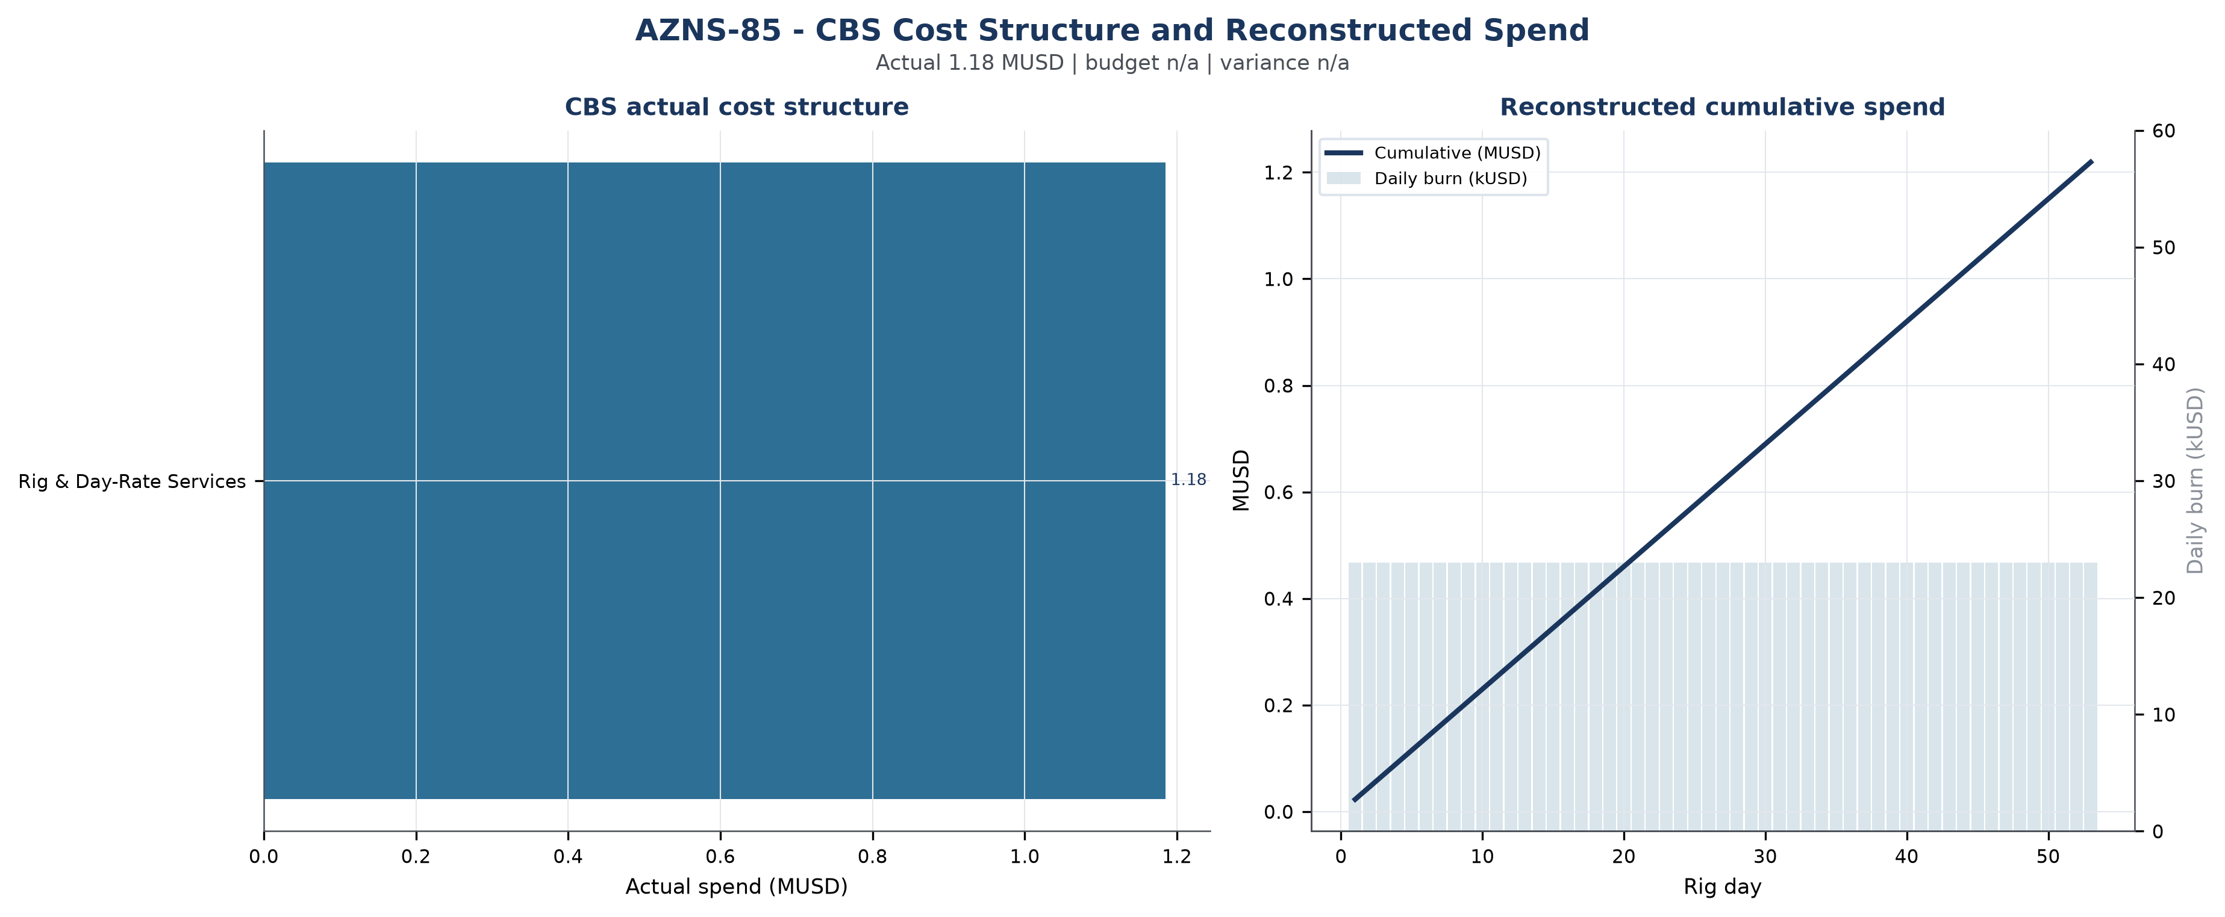
Figure W5 — CBS cost structure and reconstructed spend, AZNS-85

Section-Wise Optimum Parameters and Field Recommendations
The envelopes below are the operating windows recommended for the next campaign on the basis of what this operation demonstrated, both where it performed as designed and where it did not. The observed mud weight envelope of this well (81.0 – 104.0 pcf, equivalent to 10.8 – 13.9 ppg) is consistent with the recommended windows and confirms the unit convention used on the project.
Operation stage | Recommended parameter envelope | Engineering intent
Well killing / bullheading | kill fluid 1.02 – 1.05 x pore pressure; density stated in pcf and ppg | Hold well overbalance without exceeding the fracture gradient of the existing completion interval
Milling and clean-out | WOB 5 – 15 klbs, 60 – 90 rpm, flow 400 – 650 gpm, torque monitored continuously | Keep the mill loaded lightly and the hole clean; avoid packing off in the liner lap
Fishing | Jar load within 60 – 80% of string yield; maximum pull below the limit of the weakest joint | Protect the string while maximising impact energy at the fish
Coiled tubing / nitrogen | CT speed 15 – 25 m/min, N2 rate staged to achieve 300 – 500 psi underbalance | Lift the well without drawdown shock to the formation
Completion running | Running speed 15 – 20 stands/hour, torque-turn recording on every connection | Protect seal bores and avoid buckling in the horizontal section
Table 9-1 Recommended parameter envelopes.

Actionable recommendations
- Establish a joint root-cause review for Waiting on Weather / Service and Fishing / Milling, the two largest contributors to unplanned time, with a named owner from the drilling contractor and from the service line, and a closure date before the next well spuds.
- Introduce a daily NPT review at the 06:00 report handover so that any interval exceeding four hours is challenged while it is still recoverable, rather than reconstructed at month end.
- Treat the reconstructed daily burn of 23,000 USD as the planning bench-mark for the next well in this contract, and compare tendered rates against it rather than against the programme estimate.
- Convert the intervention sequence of this well into a standard workover time template; the deviation from the programme was driven by repeated recovery cycles that a template with contingency steps would have anticipated.
- Hold the well hand-over meeting with the completion and production teams before release so that the next intervention does not rediscover the well condition documented in this report.

Risk Register and Mitigations
The register below converts the evidence of this operation into forward-looking controls. Each row is tied to a documented exposure in the daily record, and the owner is the party who already carries the corresponding contractual responsibility.
Risk | Evidence / trigger | Mitigation | Owner | Severity
Unplanned time recurrence (Waiting on Weather / Service) | Any NPT interval exceeding four hours in a reporting cycle | Daily NPT challenge at handover; root-cause review within 72 hours | Drilling superintendent | High
Service-line mobilisation delay | 115 h already recorded under waiting on weather and service | Call-off protocol with 72-hour mobilisation guarantee and standby rate | Contracts | High
Rig equipment availability | 20 h recorded under rig mechanical and electrical | Preventive maintenance window aligned to tripping; critical spares on site | Drilling contractor | Medium
Loss of circulation | 0 bbl of recorded loss | LCM pill on standby; loss-tolerant mud programme; ECD monitoring | Mud service | Low
Cost overrun against CBS | budget not published in CBS; variance not measurable | Monthly cost-to-complete review against reconstructed actuals | Cost engineering | Medium
Data continuity | Modules absent in this archive (Cost breakdown (CBS), EPD budget ceiling, Survey stations) | Require the missing modules in the next well hand-over checklist | Data management | Low
Table 10-1 Risk register.

Data Provenance and Cell-Level Traceability
Every quantitative statement in this report resolves to a workbook, a worksheet and a cell. The table below lists the primary anchors used in the reconstruction; the remainder follows the same convention and is reproducible from the archive without manual interpretation.
Data element | Archive anchor (file -> sheet!cell)
well_name | 1-1 Remark!C5
client | 1-1 Remark!H5
rig | 1-1 Remark!C6
field | 1-1 Remark!C7
well_type | 1-1 Remark!C9
report_date | 1-1 Remark!N5
spud_date | 1-1 Remark!N6
est_days | 1-1 Remark!N8
act_days | 1-1 Remark!N9
depth:morning_depth | 1-2 Data!D16
depth:drilled_interval | 1-2 Data!D19
CBS cost breakdown | CBS AZNS-85.xlsx -> sheet "-"
Planned duration | CBS AZNS-85.xlsx -> CBS time-breakdown "AZNS-085 WO. Extra Work"
Well programme | AZNS-85 Workover Program Rev.02.pdf
Table 11-1 Provenance anchors.

