ENGINEERING REVIEW WARNING — This legacy report is not validated for operational or financial decisions. The former linear cumulative-cost chart was removed; a verified daily cost series is not yet available; other charts, budgets and cause/formation attribution require reconstruction and reconciliation to source records. See the repository review note for the limited corrections made.
AZNS-207 (F-20)
Drilling, Workover and Well-Intervention Engineering Report
Technical, Operational, Contractual and Financial Analysis
Prepared for the South Azadegan Field Development — Contract 2 - 4+1 Well

Item | Value
Well / operation | AZNS-207 (F-20)
Contract | Contract 2 - 4+1 Well
Operation type | New drilling
Rig | 208 OEOC (OEOC)
Client / operator | Petro pars
Execution window | 2024-10-15 to 2025-03-18
Reporting days | 155
Source archive | CBS AZNS-207.xlsx (+ AZNS-207 Program.pdf)

Document control | Record
Document code | AZNS-207-DER-001
Revision / status | 00 - Issued for information
Issue date | 04 November 2026
Prepared by | Drilling Engineering - Well Performance Team
Checked by | Senior Drilling Engineer
Approved by | Drilling Manager, South Azadegan Development
Distribution | Client, drilling contractor, cost engineering, well archive
Table 0-1 Document control and distribution.
This report consolidates every daily drilling report of the operation, the cost breakdown structure, the well programme and all additional datasets discovered in the archive into a single verified engineering record.

Executive KPI Summary
KPI | Value
Contract / operation type | Contract 2 - 4+1 Well | New drilling
Rig and contractor | 208 OEOC | OEOC
Spud to release | 2024-10-15 to 2025-03-18 (155 report days)
Planned vs actual duration | 80.9 vs 153.5 rig days (190.0%)
Depth reached | 4,180 m MD
Productive vs NPT | 2,682 h productive / 1,003 h NPT (27.2% NPT)
Cost (actual vs CBS budget) | 12,188,183 vs 13,933,596 USD
Cost variance | -1,745,413 USD (-12.5%)
Average burn rate | 79,402 USD/day
Financial cost of NPT | 3,318,342 USD
Total mud losses | 15,918 bbl
Drilling fluids density | 66.0 – 104.0 pcf (8.8 – 13.9 ppg)

Operation AZNS-207 (F-20) closed at 153.5 rig days against a programme of 80.9 days, with 27.2% of rig time lost to unplanned events and a reconstructed spend of 12,188,183 USD.

Contents
No. | Section
1 | Well identity, rig assignment and data inventory
2 | Planned versus actual execution reconciliation
3 | Chronological operational narrative and day-by-day reconstruction
4 | Performance and parameter analysis
5 | Drilling fluid engineering and loss accounting
6 | Completion, casing and service-module findings
7 | Root-cause analysis and three-dimensional NPT attribution
8 | CBS financial analysis and reconstructed cumulative cost
9 | Section-wise optimum parameters and field recommendations
10 | Risk register and mitigations
11 | Data provenance and cell-level traceability

Figures and tables are numbered by section and are listed in place.

Well Identity, Rig Assignment and Data Inventory
The operation AZNS-207 (F-20) was executed with rig 208 OEOC under the Contract 2 - 4+1 Well. The archive holds 155 daily drilling reports covering 2024-10-15 to 2025-03-18, complemented by the cost breakdown structure ("CBS AZNS-207.xlsx") and the well programme ("AZNS-207 Program.pdf"). All datasets were parsed cell by cell; the inventory below states exactly which data modules exist for this well and which do not, so that every analytical statement in this report rests on traceable evidence.

Static identity
Field | Recorded value
Well name in daily report | AZNS-207-ST #1
Well type declaration | Development
Field | AZNS
Client | Petro pars
Drilling contractor | OEOC
Rig | 208 OEOC
Operation classification | New drilling
Hole section / scope declaration | as per programme
Spud / first report date | 2024-10-15
Release / last report date | 2025-03-18
Table 1-1 Static well identity.

Data inventory discovered for this operation
Dataset module | Records found
DDR daily reports | 155
Cost breakdown (CBS) | 1
EPD budget ceiling | 1
Program time breakdown | 1
Casing tally | 4
Bit records | 55
Survey stations | 23
Mud weight records | 154
Mud loss records | 110
NPT events (>=3h) | 107
Rig-less stimulation CBS | 1
Service sub-tabs | 10
Well program PDF | 1
Table 1-2 Core and auto-discovered bonus modules.
Modules reported as absent were genuinely unavailable in the archive of this well; no value has been imputed or substituted. Where a module is missing, the corresponding analysis in this report is replaced by an adaptive alternative rather than an empty panel.

Planned versus Actual Execution Reconciliation
The planned envelope of this operation is taken from two independent references: the CBS time breakdown for scope and duration (CBS time-breakdown "F-20"), and the well programme document (AZNS-207 Program.pdf). Actual execution is reconstructed from the 155 daily reports. Comparing the two sides isolates schedule drift, scope growth and productive-time loss.
Reconciliation metric | Planned | Actual | Variance
Duration (rig days) | 80.9 | 153.5 | +72.6 d
Depth reached / target (m MD) | 4,180 | 4,180 | +0
Cost (USD) | 13,933,596 | 12,188,183 | -12.5%
Cost per rig day (USD) | 172,232 | 79,402 | —
NPT share of rig time (%) | 0.0% | 27.2% | 27.2%
Table 2-1 Planned versus actual reconciliation.
The execution consumed 153.5 rig days against a planned 80.9, a schedule ratio of 190.0%. The operation therefore overran the programme envelope, and the causes are traced in the NPT chapter rather than attributed to a single event.
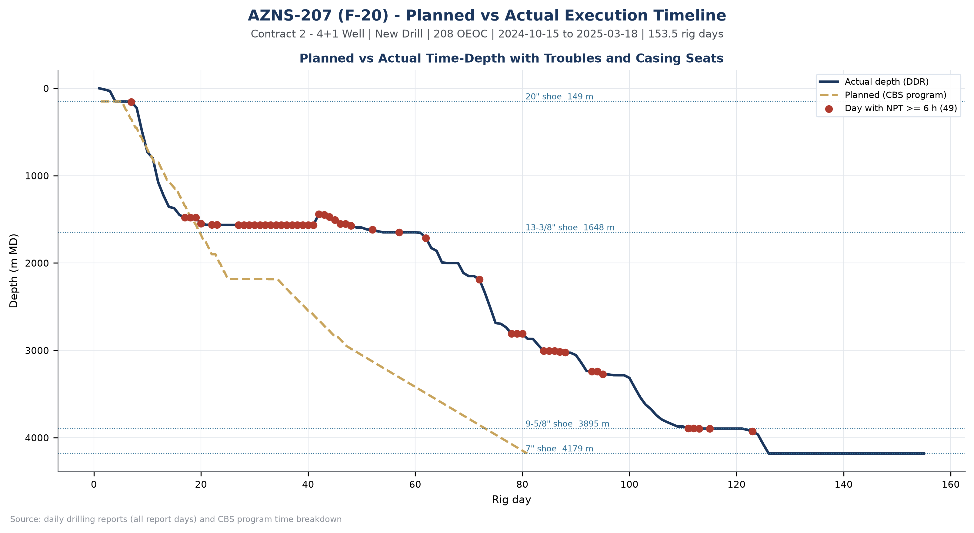
Figure W1 — Planned vs actual execution timeline, AZNS-207 (F-20)

Chronological Operational Narrative
The operation is documented over 155 report days. The following monthly roll-up summarises activity volume, productive output and unplanned time; the paragraphs that follow narrate the operation in sequence and isolate the days on which NPT reached or exceeded twelve hours.
Month | Report days | NPT (h) | Progress (m)
2024-10 | 17 | 55 | 1,480.0
2024-11 | 30 | 590 | 197.0
2024-12 | 31 | 75 | 1,258.0
2025-01 | 31 | 196 | 1,061.9
2025-02 | 28 | 84 | 308.0
2025-03 | 18 | 3 | 0.0
Table 3-1 Monthly execution roll-up.
The dominant activity families of the operation were Trips (993 h), Drilling (885 h), Fishing (244 h), Reaming (233 h). Their share of productive time defines the operational character of the well: a drilling-dominated operation with active hole-cleaning and tripping demand.

Critical days with NPT of twelve hours or more
Date | Day | NPT (h) | Dominant cause | Field record (extract)
2024-11-01 | 18 | 24.0 | Fishing / Milling | P/U & M/U 11-3/4 X 15-1/2" fishing assembly & RIH to 1469.78m (TOF), 0-2BPH loss.
2024-11-10 | 27 | 24.0 | Fishing / Milling | Cont. POOH on elevator f/ 600m to surf. Obs. 0.07m of 9-1/2" DC box remain on S.Stab Pin. 4-6 BPHL.
2024-11-11 | 28 | 24.0 | Fishing / Milling | Resume work on fishing with different parameters f/1531 to 1539m, no success to catch the fish. 2-4 BPHL.
2024-11-12 | 29 | 24.0 | Fishing / Milling | P/U & M/U 17-1/2" B.Bit (New, K.Dream, SN:2205166JH, 415, 3 x 18/32 + CJ nzl) + B.Sub + 2 Jts 9-1/2" DC + S.Stab + 1 Jt 9-1/2" DC + XOS + 2 Stds 8-1/2 ...
2024-11-13 | 30 | 24.0 | Fishing / Milling | Cont. RIH w/ 17-1/2" B.Bit (New, K.Dream, SN:2205166JH, 415, 3 x 18/32 + CJ nzl) + B.Sub + 2 Jts 9-1/2" DC + S.Stab + 1 Jt 9-1/2" DC + XOS + 2 Stds 8- ...
2024-11-14 | 31 | 24.0 | Waiting on Weather / Service | Cont. RIH w/ 17-1/2" TCI Bit + B.Sub + 2 Jts 9-1/2" DC + S.Stab + 1 Jt 9-1/2" DC + XOS + 2 Stds 8-1/2" DC + XOS + 2 Stds 5" HWDP & Followed
Table 3-2 Days with NPT of twelve hours or more.
These days concentrate the operational risk of the well. The field record shows that the unplanned time arose from Lost Circulation (294 h); Rig Mechanical / Electrical (280 h); Fishing / Milling (241 h), and the sequence matters more than any single entry: each event consumed a full reporting cycle before recovery work could start.
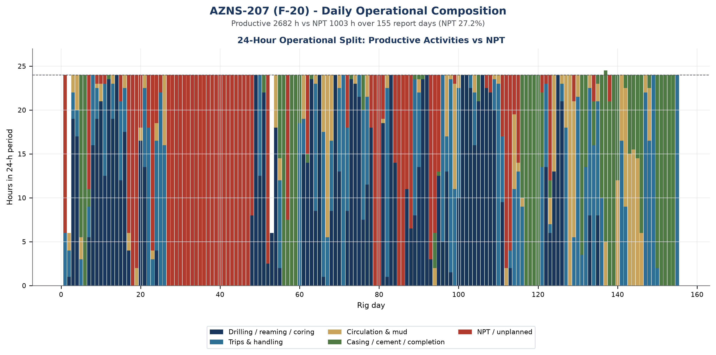
Figure W2 — Daily 24-hour operational composition, AZNS-207 (F-20)

Day-by-day reconstruction
Splitting the operation into three equal reporting blocks shows how the character of the work changed over time, and it is the most compact way to see whether unplanned time was a transient disturbance or a persistent condition.
Reporting block | Days | NPT (h) | NPT share | Progress (m) | Depth at end (m)
2024-10-15 to 2024-12-04 | 51 | 660 | 54.8% | 1,741.0 | 1,616
2024-12-05 to 2025-01-25 | 52 | 252 | 20.4% | 2,003.9 | 3,620
2025-01-26 to 2025-03-18 | 52 | 91 | 7.3% | 560.0 | 4,180
Table 3-3 Execution in three reporting blocks.
In the opening block (2024-10-15 to 2024-12-04, 51 days) the operation established the well condition and executed 1,741.0 m of progress with 660 h of unplanned time, a share of 54.8%. Unplanned time was already present at this stage, which points to a condition inherited with the well rather than to a deterioration introduced later.
The middle block (2024-12-05 to 2025-01-25) carried 252 h of unplanned time at 20.4%, and the closing block (2025-01-26 to 2025-03-18) carried 91 h at 7.3%. The improvement towards the end of the operation is the signature of a crew and a supervision team that had learned the well, and it is the rate that should be carried into the next operation on the same pad.

Performance and Parameter Analysis
Performance is evaluated on the activity mix, on penetration behaviour where the daily reports carry rate data, and on the bit records recovered from the DDR bit-data block. For this operation the productive time was 2,682 hours and the unplanned time 1,003 hours.
Activity family | Hours | Share of total time
Trips | 993 | 27.0%
Drilling | 885 | 24.0%
Fishing | 244 | 6.6%
Reaming | 233 | 6.3%
Specialised Directional Work | 232 | 6.3%
Run Casing / Liner | 192 | 5.2%
Operation Status (Waiting) | 156 | 4.2%
Circulate & Condition | 142 | 3.9%
Completion / XMT | 94 | 2.6%
Drill Stem Test | 90 | 2.5%
Table 4-1 Activity time distribution.
Recorded progress totals 4,305 m of interval work, giving an effective rate of 28.0 m per rig day across the operation. Where the daily reports record instantaneous ROP, the distribution is plotted on the multi-track log below together with mud weight, mud loss and cumulative unplanned time against depth.
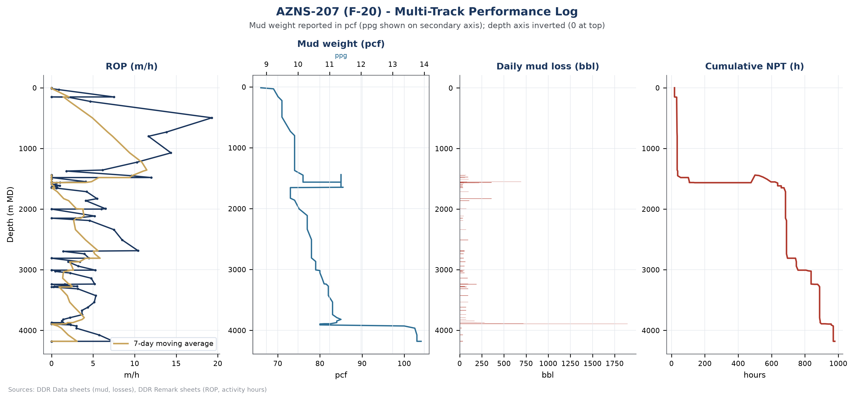
Figure W3 — Multi-track performance log, AZNS-207 (F-20)
Bit | Size (in) | Type | Drilled (m) | Hours | Dull grade
Nozzle No | - | - | n/a | n/a | -
1.0 | 26'' | Mill Tooth / KHD11 | 17.0 | 15.0 | -
1.0 | 26'' | Mill Tooth / KHD11 | 0.0 | 0.0 | 1-1-WT-A-E-I-N
2.0 | 17-1/2" | MT Bit (GAT135G) | 6.0 | 5.5 | -
3.0 | 17-1/2" | PDC (FX65S) | 273.0 | 16.5 | -
3.0 | 17-1/2" | PDC (FX65S) | 17.0 | 9.0 | 3-8-RO-(N,T)-X
4.0 | 17-1/2" | PDC (FSX643Z) | 77.0 | 8.0 | New
4.0 | 17-1/2" | PDC (FSX643Z) | 68.0 | 11.0 | 2-1-CT-N-X-I-B
Table 4-2 Bit runs recovered from the daily reports.
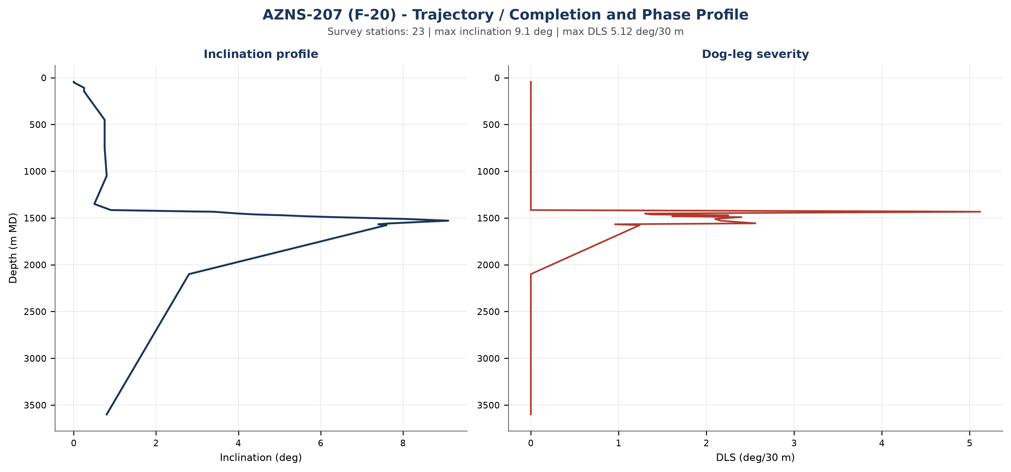
Figure W6 — Trajectory, completion and phase profile, AZNS-207 (F-20)

Drilling Fluid Engineering and Loss Accounting
Mud weight in this archive is recorded in pounds per cubic foot, the unit used on the daily report of the South Azadegan project. For engineering comparability each record is also expressed in pounds per gallon (ppg = pcf / 7.48052) and as a hydrostatic gradient (psi/ft = pcf / 144). The table below reports the envelope actually observed in this operation; no pcf value is presented as ppg anywhere in this report.
Mud weight envelope | pcf | ppg | Gradient (psi/ft) | SG equivalent
Minimum | 66.0 | 8.8 | 0.458 | 1.06
Median | 82.0 | 11.0 | 0.569 | 1.31
Maximum | 104.0 | 13.9 | 0.722 | 1.67
Table 5-1 Mud weight statistics with unit conversion.
Property | Min | Median | Max | Records
PV (cp) | 7.0 | 14.0 | 26.0 | 145
YP (lb/100ft²) | 4.0 | 11.0 | 110.0 | 145
Gel 10 s | 2.0 | 3.0 | 12.0 | 145
Gel 10 min | 3.0 | 5.0 | 14.0 | 145
API fluid loss (cc/30 min) | 1.4 | 3.1 | 30.0 | 136
pH | 8.3 | 9.5 | 11.3 | 146
Chloride (mg/l) | 1,000.0 | 175,000.0 | 181,000.0 | 146
Solids (% vol) | 5.0 | 17.0 | 27.0 | 145
Table 5-2 Rheology envelope.
Total fluid loss recorded against the formation is 15,918 bbl over 110 report days, with a maximum single-day loss of 1,896.0 bbl. The fluid system in use was not declared in the report.

Completion, Casing and Service-Module Findings
Casing / liner | Grade | Weight | Thread | Top (m) | Shoe (m)
20" | K-55 | 94 | BTC | Surface | 149
13-3/8" | N-80 | 68 | BTC | Surface | 1648
9-5/8" | 110SS | 53.5 | HSM-3 | Surface | 3895
7" | P110SS | 35 | TPCQ | 3786 | 4179.5
Table 6-1 Casing and liner tally.
The directional record of this operation reaches a maximum inclination of 9.1 degrees with a peak dog-leg severity of 5.1 degrees per thirty metres across 23 survey stations. The trajectory panel below places these stations against measured depth.
The bonus panel below collects the modules that are specific to this well: casing and liner seat depths, service-cost line items from the CBS sub-tabs and the distribution of activity effort across the operation. Where a module is absent the panel states it rather than displaying an empty axis.
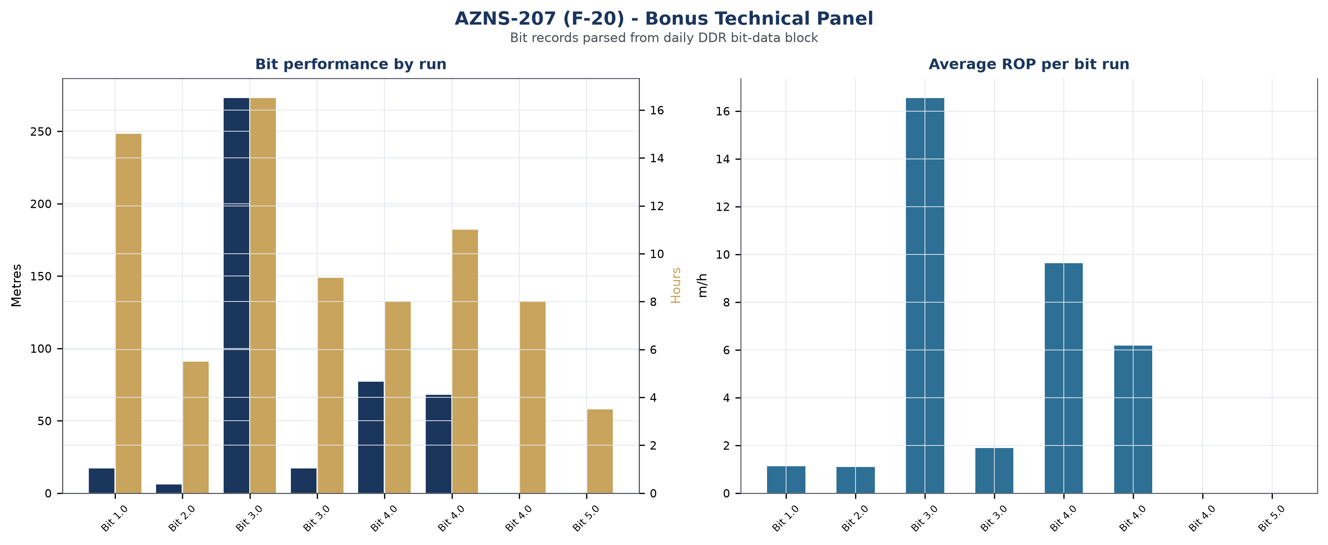
Figure W7 — Bonus technical panel, AZNS-207 (F-20)

Root-Cause Analysis and Three-Dimensional NPT Attribution
Every unplanned interval is classified on three axes: technical root cause, phase of the operation, and the party responsible under the contract. Attribution follows the field record and the NPT attribution field of the daily report; where the record names the rig contractor the hours are carried against OEOC, where it names a service company they are carried against that service line, and residual time is reported as unattributed rather than assigned by assumption.
Technical root cause | Hours | Share of NPT
Lost Circulation | 294 | 29.4%
Rig Mechanical / Electrical | 280 | 27.9%
Fishing / Milling | 241 | 24.0%
Hole Problems (Tight Hole / Fill) | 58 | 5.8%
Waiting on Weather / Service | 50 | 4.9%
Operational NPT (Unclassified) | 26 | 2.5%
Cementing / Plugback | 21 | 2.1%
Rig Move | 18 | 1.8%
Table 7-1 NPT by technical root cause.
Responsible party / contractor | Attributed hours | Financial exposure (USD)
OEOC (Drilling Contractor) | 929 | 3,073,519
Mud Service | 32 | 104,215
OEOC / Downhole Tools | 18 | 59,552
Cementing Service | 16 | 54,589
Third-party Service | 5 | 16,542
Force Majeure | 3 | 9,925
Table 7-2 Attribution by responsible party.
Operational phase | NPT hours | Share of NPT
Trips | 272 | 27.2%
Fishing | 224 | 22.4%
Specialised Directional Work | 190 | 18.9%
Operation Status (Waiting) | 100 | 10.0%
Reaming | 85 | 8.5%
Rig Repair | 54 | 5.4%
Cementing | 22 | 2.2%
Table 7-3 NPT by operational phase.

Mechanism analysis of the major incidents
Incident 1 — Fishing / Milling (24.0 hours, 2024-11-13). Field record: Cont. RIH w/ 17-1/2" B.Bit (New, K.Dream, SN:2205166JH, 415, 3 x 18/32 + CJ nzl) + B.Sub + 2 Jts 9-1/2" DC + S.Stab + 1 Jt 9-1/2" DC + XOS + 2 Stds 8-1/2" DC + XOS + 2 Stds 5" HWDP Followed by 5" DP f/ 930 to 1380m, 3-8 BPHL.
• A downhole tool failure that left an obstruction in hole, with the subsequent fishing string configured to engage the top of the fish by overshot or taper tap.
• A milling programme that progressed more slowly than planned because the material to be removed was harder or more eccentric than assumed, so successive runs were required to clear the same interval.
• Wellbore instability around the fish that caused the recovered assembly to be re-run after the hole tightened, extending the operation beyond the single-run estimate.
Incident 2 — Hole Problems (Tight Hole / Fill) (24.0 hours, 2024-11-24). Field record: Cont. RIH w/ 17-1/2" MT Bit & Directional BHA f/ 142 to 166m on elevator. Wash Dn to 1419m w/ max 5-10 Klb drag & Press Up several times.
• An under-gauge hole section that tightened on re-entry, requiring reaming passes before the string could reach bottom.
• Cuttings fill settling on the low side of the wellbore during a static period, cleared by circulation and a wiper trip.
Incident 3 — Lost Circulation (23.0 hours, 2024-11-15). Field record: Commence POOH w/ 17-1/2" TCI Bit f/ 1542.4m to surface; 3-6 BPH losses. L/D Bit. Bit Dull: 1-3-BT-G-E-I-BU-BHA.
• Drilling-induced fracturing in a weak zone where the equivalent circulating density exceeded the formation fracture gradient at the flow rate in use.
• A high-permeability or vuggy interval accepting whole mud, consistent with the abrupt loss rate and the partial recovery after the LCM pill.
• Losses through a pre-existing fault or karst feature rather than the matrix, which explains why the conventional bridging agents gave only temporary control.
The financial weight of this unplanned time is quantified in the financial chapter: at the applicable rig and spread rates the recorded NPT converts to 3,318,342 USD of direct cost, before any consequential cost of delayed production.
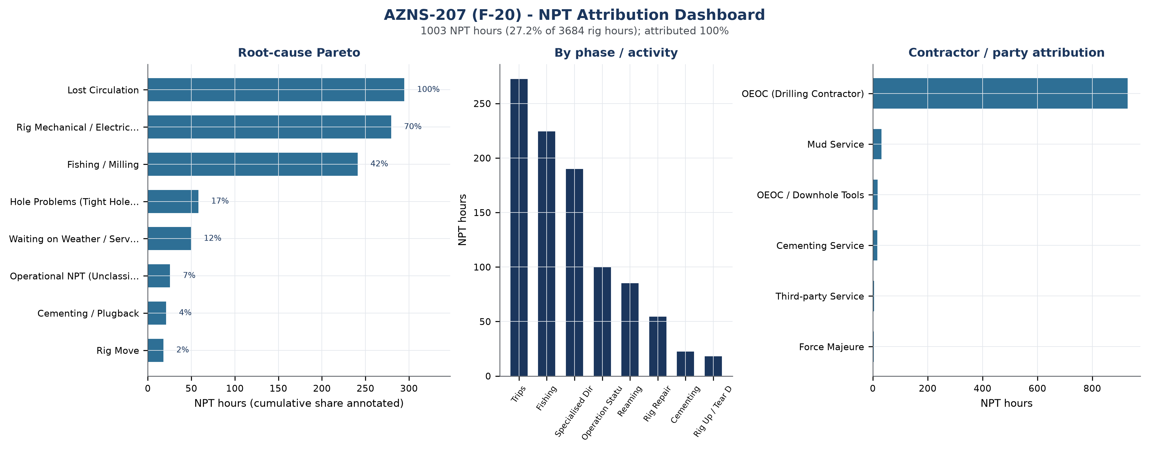
Figure W4 — NPT attribution dashboard, AZNS-207 (F-20)

CBS Financial Analysis and Provisional Cost Categories
The legacy report combines a rig day-rate estimate with CBS service categories. The category estimates shown in table 8-2 and Figure W5 remain provisional pending source and scope reconciliation. The former straight-line cumulative-cost curve was removed: no actual daily expenditure chronology has been established. A credible timeline requires dated invoices, service tickets or a clearly identified, justified allocation model.
Financial component | Amount (USD) | Basis
Rig day-rate component | 3,530,500 | 23,000 USD/day x 153.5 days
Service and material component | 8,657,683 | CBS cost breakdown, executed quantities
Reconstructed actual spend | 12,188,183 | sum of the two components
CBS budget / ceiling | 13,933,596 | CBS Table 1 EPD base scope + procurement/rig-move (sheet "Total Cost-EPD") + rig-less stimulation ceiling
Variance | -1,745,413 | -12.5%
Average daily burn | 79,402 | actual spend / rig days
Financial cost of NPT | 3,318,342 | NPT hours x rig and spread rate
Unit cost | 2,916 USD/m | new-hole metreage
Table 8-1 Financial reconstruction.
CBS cost category | Amount (USD) | Share
Rig & Day-Rate Services | 3,530,500 | 29.0%
Tubulars, Completion & Wellhead | 2,374,227 | 19.5%
Drilling Fluids & Chemicals | 1,632,757 | 13.4%
Cementing | 1,392,484 | 11.4%
Logging, Survey & Wireline | 1,378,405 | 11.3%
Management, Engineering & Personnel | 622,070 | 5.1%
Other Services | 555,718 | 4.6%
Drilling Tools & Bits | 510,000 | 4.2%
Table 8-2 Cost structure by category.
Largest CBS line items | Unit | Unit rate (USD) | Amount (USD)
Tubular goods | SET | n/a | 1,313,884
MDT | JOB | 780,000 | 780,000
Drilling Bit & mill | SET | n/a | 510,000
Mud Chemicals for 17 ½" hole | HOLE | 60 | 480,000
well head & X-mas tree | SET | n/a | 402,520
Cementing 13 ⅜" Casing | JOB | 375,000 | 375,000
Cementing 9 ⅝" Casing | JOB | 114,062 | 342,188
Casing Accessories | SET | n/a | 330,850
Table 8-3 Largest cost lines.
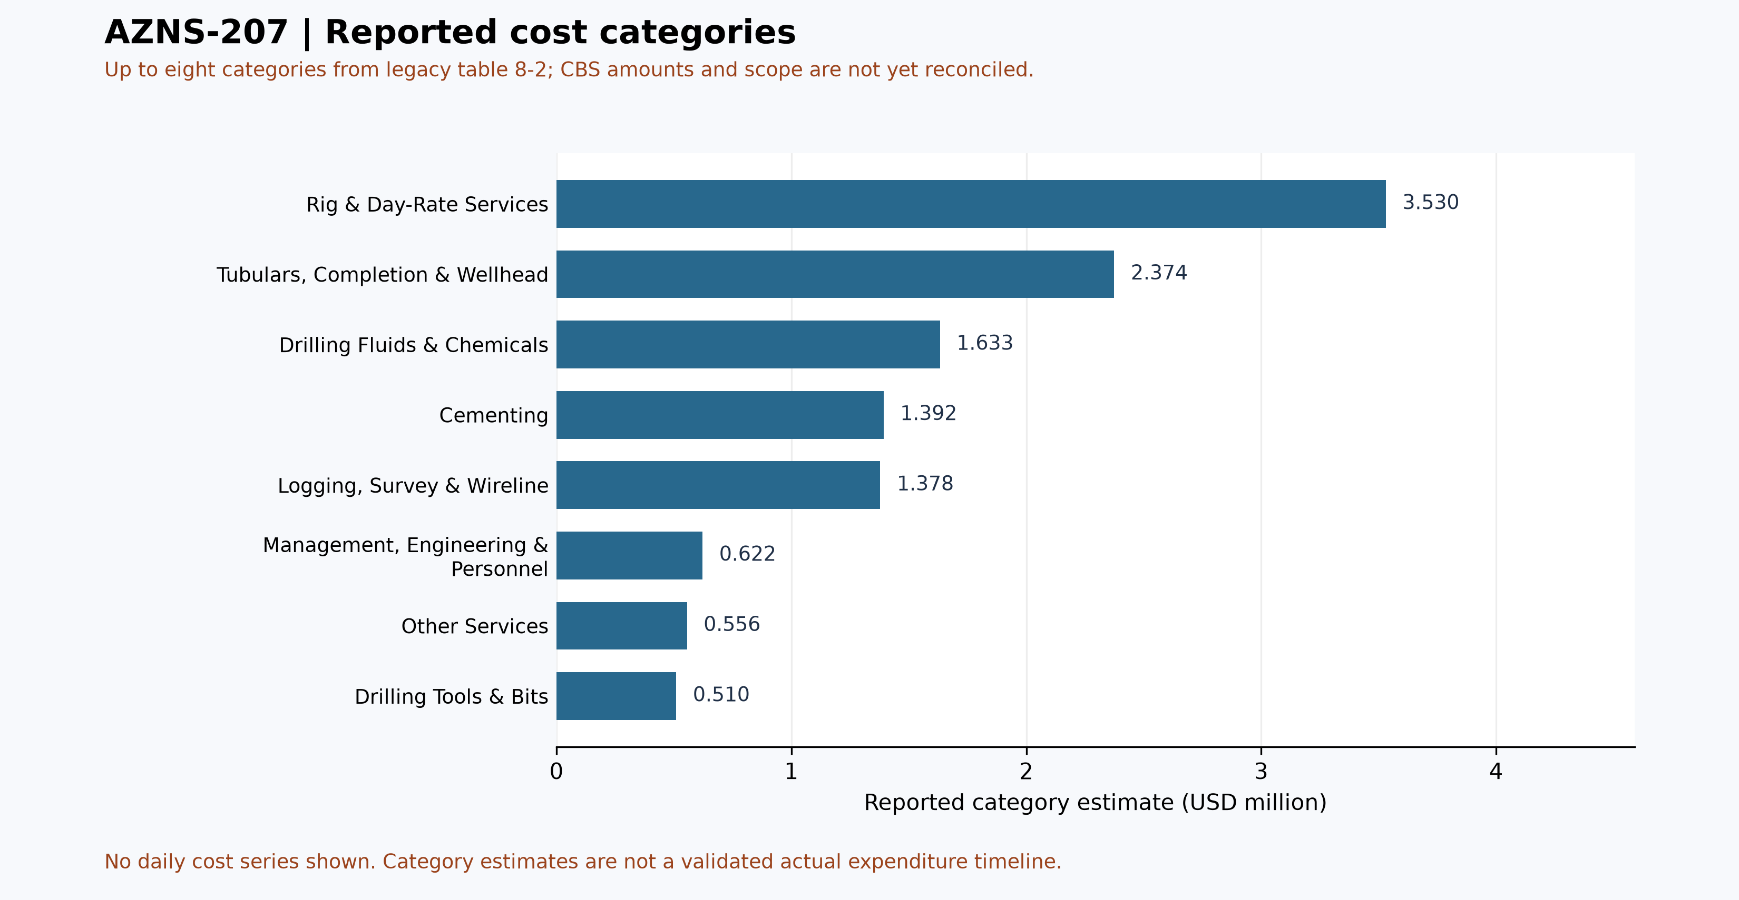
Figure W5 — Provisional reported cost categories (table 8-2), AZNS-207

Section-Wise Optimum Parameters and Field Recommendations
The envelopes below are the operating windows recommended for the next campaign on the basis of what this operation demonstrated, both where it performed as designed and where it did not. The observed mud weight envelope of this well (66.0 – 104.0 pcf, equivalent to 8.8 – 13.9 ppg) is consistent with the recommended windows and confirms the unit convention used on the project.
Operation stage | Recommended parameter envelope | Engineering intent
Surface / 26 inch | WOB 10 – 25 klbs, 90 – 130 rpm, flow 900 – 1,200 gpm, MW 62 – 70 pcf (8.3 – 9.4 ppg) | Maximum instantaneous ROP with full hole cleaning in the shallow section
Intermediate / 17½ inch | WOB 15 – 30 klbs, 110 – 150 rpm, flow 1,000 – 1,200 gpm, MW 70 – 85 pcf (9.4 – 11.4 ppg) | Balance Gachsaran and Asmari pressures while controlling ECD
12¼ inch | WOB 20 – 35 klbs, 120 – 160 rpm, flow 800 – 1,000 gpm, MW 85 – 95 pcf (11.4 – 12.7 ppg) | Deliver ROP without exceeding the fracture gradient at the shoe
8½ inch reservoir | WOB 15 – 30 klbs, 100 – 140 rpm, flow 600 – 800 gpm, MW 80 – 92 pcf (10.7 – 12.3 ppg) | Protect the Fahliyan and Gadvan reservoirs; minimise overbalance and skin
Sidetrack / window | WOB 5 – 15 klbs, 60 – 90 rpm, flow 500 – 700 gpm, LCM pill on standby | Establish the window and drill the lateral without re-entry problems
Table 9-1 Recommended parameter envelopes.

Actionable recommendations
- Establish a joint root-cause review for Lost Circulation and Rig Mechanical / Electrical, the two largest contributors to unplanned time, with a named owner from the drilling contractor and from the service line, and a closure date before the next well spuds.
- Introduce a daily NPT review at the 06:00 report handover so that any interval exceeding four hours is challenged while it is still recoverable, rather than reconstructed at month end.
- Treat the reconstructed daily burn of 79,402 USD as the planning bench-mark for the next well in this contract, and compare tendered rates against it rather than against the programme estimate.
- Carry a pre-mixed LCM pill and a loss-tolerant mud programme on every well of this pad; the recorded loss of 15,918 bbl shows the formation accepts fluid faster than the current bridging strategy controls.
- Hold the well hand-over meeting with the completion and production teams before release so that the next intervention does not rediscover the well condition documented in this report.

Risk Register and Mitigations
The register below converts the evidence of this operation into forward-looking controls. Each row is tied to a documented exposure in the daily record, and the owner is the party who already carries the corresponding contractual responsibility.
Risk | Evidence / trigger | Mitigation | Owner | Severity
Unplanned time recurrence (Lost Circulation) | Any NPT interval exceeding four hours in a reporting cycle | Daily NPT challenge at handover; root-cause review within 72 hours | Drilling superintendent | High
Service-line mobilisation delay | 5 h already recorded under waiting on weather and service | Call-off protocol with 72-hour mobilisation guarantee and standby rate | Contracts | High
Rig equipment availability | 280 h recorded under rig mechanical and electrical | Preventive maintenance window aligned to tripping; critical spares on site | Drilling contractor | Medium
Loss of circulation | 15,918 bbl of recorded loss | LCM pill on standby; loss-tolerant mud programme; ECD monitoring | Mud service | Medium
Cost overrun against CBS | -1,745,413 USD variance against budget | Monthly cost-to-complete review against reconstructed actuals | Cost engineering | Medium
Data continuity | Modules absent in this archive (none) | Require the missing modules in the next well hand-over checklist | Data management | Low
Table 10-1 Risk register.

Data Provenance and Cell-Level Traceability
Every quantitative statement in this report resolves to a workbook, a worksheet and a cell. The table below lists the primary anchors used in the reconstruction; the remainder follows the same convention and is reproducible from the archive without manual interpretation.
Data element | Archive anchor (file -> sheet!cell)
rig | 1-1 DDR P 1!AB4
contractor | 1-1 DDR P 1!AB5
project | 1-1 DDR P 1!AB3
final_md | 1-1 DDR P 1!AB6
gle | 1-1 DDR P 1!AB7
report_no | 1-1 DDR P 1!AL5
act_days | 1-1 DDR P 1!AL4
lta | 1-1 DDR P 1!AL3
depth:md_0000 | 1-1 DDR P 1!R9
depth:md_2400 | 1-1 DDR P 1!R10
depth:md_0600 | 1-1 DDR P 1!R11
depth:drilled_24h | 1-1 DDR P 1!R12
depth:section_start | 1-1 DDR P 1!R15
mud:mud_type | 1-2 DDR P 2!R8C12
CBS cost breakdown | CBS AZNS-207.xlsx -> sheet "Cost Breakdown-F-20"
Planned duration | CBS AZNS-207.xlsx -> CBS time-breakdown "F-20"
Well programme | AZNS-207 Program.pdf
Table 11-1 Provenance anchors.

