AZNS-12-ST #1 — Drilling Engineering Report
Sidetrack record, rig OEOC RIG 208, AZNS field — drilling performance, bit and hydraulics mechanics, trajectory, integrity and field solutions

Rig: OEOC RIG 208 | Well type: sidetrack | Spud: —
Rig days: 72 | New hole: 0 m | Final MD: 3,945 m
Reconstructed cost: 5.06 MUSD | NPT: 44.9%
Prepared by: Principal Drilling & Well Operations Engineering

Contents
1. Executive summary and well KPIs
2. Well architecture, rig configuration and casing programme
3. Operational chronology and phase cost
4. Drilling performance, connections and rate of penetration
5. Non-productive time and multi-hypothesis root cause
6. Bit, BHA and nozzle performance
7. Mechanical parameters and mechanical specific energy
8. Drilling fluids, rheology, cuttings transport and ECD
9. Directional survey, trajectory and dog-leg severity
10. Hook load, drag and overpull
11. Well control, shoe integrity, MAASP and losses
12. Geology, formation tops and gas
13. Operational problems, remedies and rig-floor playbooks
14. Optimum parameters, drill-off and MSE practice
15. Key findings and risk register
16. Recommendations — phase matrix and REC-01 to REC-10
17. Limitations of the recorded data
18. Appendix A — Workbooks, sheets and SHA-256
19. Appendix B — Equations and units
20. Appendix C — Complete NPT register
21. Appendix D — Daily hydraulics and ECD
22. Appendix E — Formation tops and survey stations
23. Reference, quality control and traceability

Table 0.1 — Management identity sheet
Attribute | Value | Attribute | Value
Well | AZNS-12-ST #1 | Rig | OEOC RIG 208
Well type | sidetrack | Field | AZNS — South Azadegan
Spud date | — | Rig days | 72
Final MD | 3,945 m | New hole | 0 m
NPT | 776 h (44.9%) | Rig hours | 1,728 h
Reconstructed cost | 5.06 MUSD | USD per metre | —
Source sheets | 144 | Primary NPT cause | Lost circulation
DDR Ref. — "1-1 DDR Remark" cells K5–N9 (Report Date, Report No.) and "1-2 DDR Data" rows 5–9 (well header: name, rig, spud, depths, casing head)

1. Executive summary and well KPIs
AZNS-12-ST #1 was worked by rig OEOC RIG 208 over 72 rig days and 1,728 rig hours. The record carries 0 m of new hole to a final measured depth of 3,945 m, with 44.9% of rig time booked as non-productive and a reconstructed cost of 5.06 MUSD. The dominant loss mechanism is lost circulation at 218 h, and the section-level rate in the productive part of the well is 0.00 m/h net against 0.00 m/h gross.
Table 1.1 — Well KPI set
Indicator | Value | Indicator | Value
Rig days | 72 | Rig hours | 1,728
New hole (m) | 0 | Final MD (m) | 3,945
Drilling hours | 76 | Reaming hours | 56
Trip hours | 1,018 | Casing/cement hours | 24
NPT hours | 776 | NPT share | 44.9%
Net ROP (m/h) | 0.00 | Gross ROP (m/h) | 0.00
ILT hours | 565 | ILT share | 32.7%
Cost (MUSD) | 5.06 | Cost per day (kUSD) | 70.3
DDR Ref. — "1-2 DDR Data" time log rows 21–68 (codes, hours, flags), daily state rows 9–13 (24 hrs Drilled, MD, MW) and "1-1 DDR Remark" activity narrative

2. Well architecture, rig configuration and casing programme
The well was executed by rig OEOC RIG 208, a sidetrack unit operating in the AZNS field. The architecture follows the field standard: a large surface hole, an intermediate hole through the reactive shale sequence and a production hole in the carbonate reservoir. The section breakdown in this record is 5-7/8" (0 m in 1 days), 8-3/8" (0 m in 6 days).
The daily sheets in this record do not carry a casing table with shoe depths, so the architecture is described from the operational chronology and from the hole sizes actually drilled. The missing table is listed in Chapter 17 rather than reconstructed from assumption.
Table 2.2 — Rig and section configuration
Rig | Section | Days | Metres | Net ROP | NPT
OEOC RIG 208 | 5-7/8" | 1 | 0 | 0.00 | 8.3%
OEOC RIG 208 | 8-3/8" | 6 | 0 | 0.00 | 41.0%
DDR Ref. — "1-1 DDR Remark" header fields (rig, well type, section start depth, expected TD) and "1-2 DDR Data" rows 5–9

3. Operational chronology and phase cost
The record runs from the first report to the last report with 72 daily reports, each of which was read in full. The chronology below reproduces the operational sequence at fortnightly resolution, with the depth reached and the productive share of each interval.
Table 3.1 — Fortnightly chronology
Days | From | MD (m) | Hours | NPT
1–7 | — | 3,945 | 168 | 40.5%
8–14 | — | 3,945 | 168 | 58.3%
15–21 | — | 3,945 | 168 | 45.5%
22–28 | — | 3,945 | 168 | 7.4%
29–35 | — | 3,945 | 168 | 13.4%
36–42 | — | 3,945 | 168 | 67.9%
43–49 | — | 3,945 | 168 | 45.2%
50–56 | — | 3,945 | 168 | 48.8%
57–63 | — | 3,945 | 168 | 32.4%
64–70 | — | 3,945 | 168 | 88.4%
71–72 | — | 3,945 | 48 | 50.0%
DDR Ref. — "1-1 DDR Remark" “Summary of Activities in Last 24:00 hours” and “Operation Forecast”; day counter from the consecutive sheet pairing of the workbook
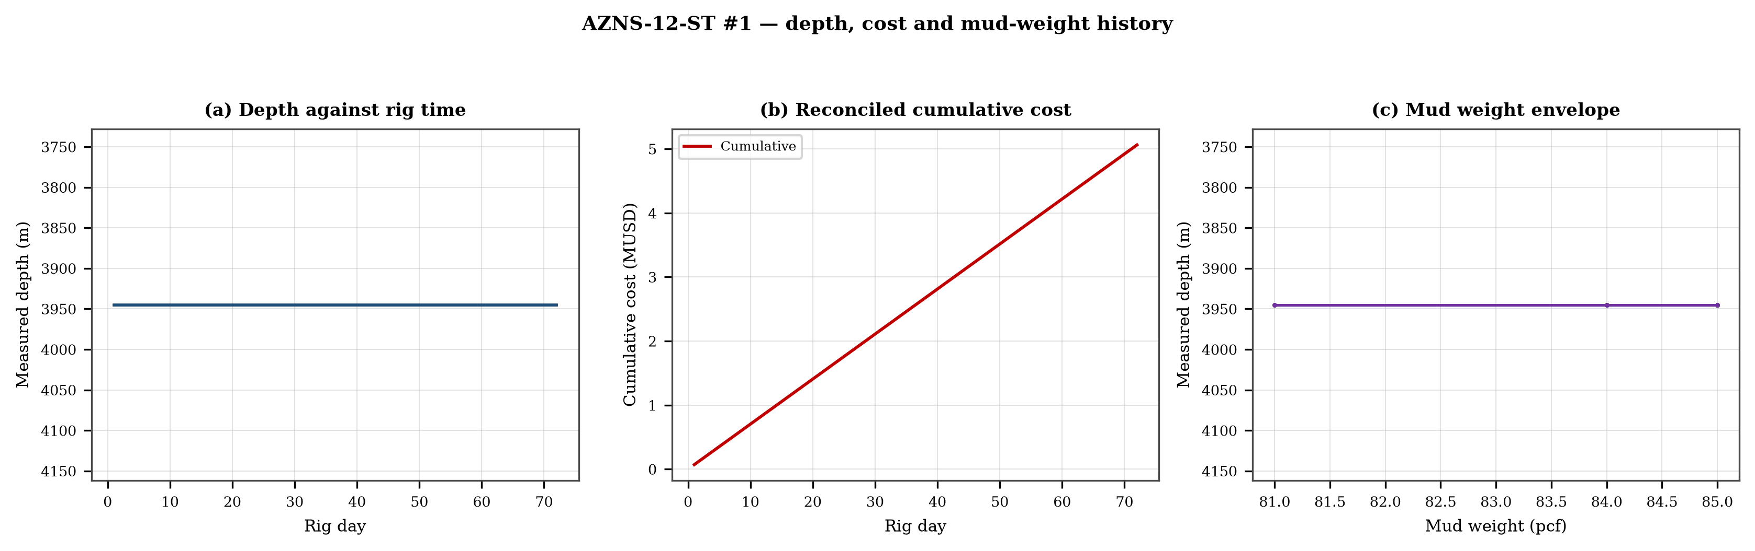
Figure 3.1 — Depth against rig time, reconciled cumulative cost and mud-weight envelope
The cost curve is reconstructed from the daily rig, mud and service rates applied to the recorded days; it is monotonic by construction and is intended for comparison, not as a replacement for the commercial register. The mud-weight curve shows the step changes that accompany each casing point, and each step is a decision point for the pressure window of Chapter 11.

4. Drilling performance, connections and rate of penetration
Productive time is split into drilling 76 h, reaming 56 h, trips 1,018 h, casing and cementing 24 h and logging 20 h. The ratio of handling time to drilling time is the single most informative number in this chapter: at 14.04 h of handling per hour of drilling, the well spends more time preparing the hole than making it.
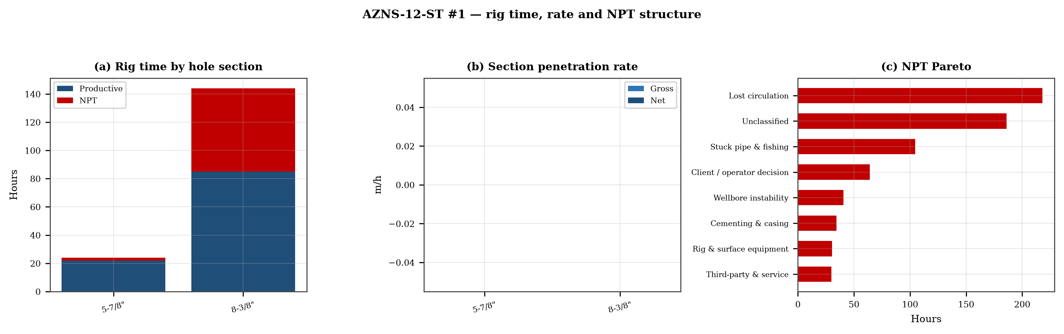
Figure 4.1 — Rig time by section, section rate and NPT pareto

Table 4.1 — Section performance
Section | Days | Metres | Gross ROP | Net ROP | Ream h | Trip h | NPT
5-7/8" | 1 | 0 | 0.00 | 0.00 | — | — | 8.3%
8-3/8" | 6 | 0 | 0.00 | 0.00 | — | — | 41.0%
DDR Ref. — "1-2 DDR Data" time log rows 21–68 filtered to drilling codes, total row 68, and the bit block (bit number, size, metres, hours, IADC dull code)

5. Non-productive time and multi-hypothesis root cause
Non-productive time totals 776 h, or 44.9% of rig time, spread over 115 coded entries. The register is ranked below; the two or three leading mechanisms are then examined one by one, each with competing physical explanations and the field evidence that separates them.
Table 5.1 — NPT register by mechanism
Mechanism | Hours | Share | Events
Lost circulation | 218 | 28.1% | 31
Unclassified | 186 | 24.0% | 31
Stuck pipe & fishing | 104 | 13.5% | 14
Client / operator decision | 64 | 8.2% | 5
Wellbore instability | 40 | 5.2% | 3
Cementing & casing | 34 | 4.4% | 7
Rig & surface equipment | 30 | 3.9% | 8
Third-party & service | 30 | 3.9% | 6
Directional & survey | 24 | 3.2% | 3
HSE & drills | 23 | 3.0% | 4
Well control & kick | 21 | 2.7% | 3
DDR Ref. — "1-1 DDR Remark" activity status flag and "1-2 DDR Data" time-log flag column J (P / N / UP) with the code column A; hours from column E

5.1 Lost circulation — competing mechanisms
This mechanism consumed 218 h across 31 entries. Two explanations fit the recorded sequence equally well until the discriminating evidence is read. Mechanism A is a formation-driven response: the borehole or the fluid column behaves differently from the plan because of what the rock is doing. Mechanism B is an equipment or procedure response: the same symptom appears because a surface system, a service or a handling step did not deliver what the programme assumed. The discriminator is the pressure and torque record at the moment of onset: a formation response appears while parameters are steady, an equipment response appears as a step change with parameters unchanged.
- Day 14 (—): 13.0 h — Cont. RIH W/ 3-1/2" Spear & Fishing BHA F/330 to 3285m (7"L.lap) while Circ. Mud C.W.H w/ 0-2 BPHL.
- Day 14 (—): 2.0 h — Circ. BTM's up @ 3285m (7"L.lap) to balanced MW in/out @ 81pcf W/0-1 BPHL.
- Day 14 (—): 3.0 h — In Order to check string & 3-1/2" Spear For any Probably fish caught, POOH as chain out F/3307 to 2550m while Circ. Mud C.W.H w/ 0-1 BPHL.

5.2 Unclassified — competing mechanisms
This mechanism consumed 186 h across 31 entries. Two explanations fit the recorded sequence equally well until the discriminating evidence is read. Mechanism A is a formation-driven response: the borehole or the fluid column behaves differently from the plan because of what the rock is doing. Mechanism B is an equipment or procedure response: the same symptom appears because a surface system, a service or a handling step did not deliver what the programme assumed. The discriminator is the pressure and torque record at the moment of onset: a formation response appears while parameters are steady, an equipment response appears as a step change with parameters unchanged.
- Day 2 (—): 4.0 h — Stop operation Due to Align TDS Rail meanwhile OEOC inspection &maintenance crew work on TDS.
- Day 2 (—): 2.0 h — Stop operation Due to Bad Weather (High win speed & dust storm)
- Day 2 (—): 2.0 h — Cont. Align TDS Rail meanwhile OEOC inspection &maintenance crew work on TDS.

6. Bit, BHA and nozzle performance
2 bit runs are recorded. The best run delivered 0 m and the shortest 0 m; the spread is the first indication that the dull grade, not the formation, ended the short runs. Where a dull code is recorded it is reproduced in the table without interpretation, and the wear pattern is discussed in the text.

Table 6.1 — Bit runs
Bit | Size | Type | IADC | Metres | Hours | Dull
1.0 | 8-3/8" | TCI Bit | 537 | — | — | —
2.0 | 8-3/8" | TCI Bit | 537 | — | — | 1-1-WT-A-E-I-PN-BH
DDR Ref. — "1-1 DDR Remark" bit block columns C–H (bit no., size, type, metres, hours, dull grade) and the "1-2 DDR Data" bit/BHA block


Figure 6.1 — Bit footage, run rate and footage by bit size

7. Mechanical parameters and mechanical specific energy
12 intervals carry a simultaneous weight and rotary-speed record. Weight on bit ranges 1.0–18.0 klbf with a median of 2.0 klbf, and rotary speed 10–60 rpm. The median mechanical specific energy is — ksi. For these hole sizes that is high: the bit is spending more energy on the bottom hole assembly and the fluid than on the rock.
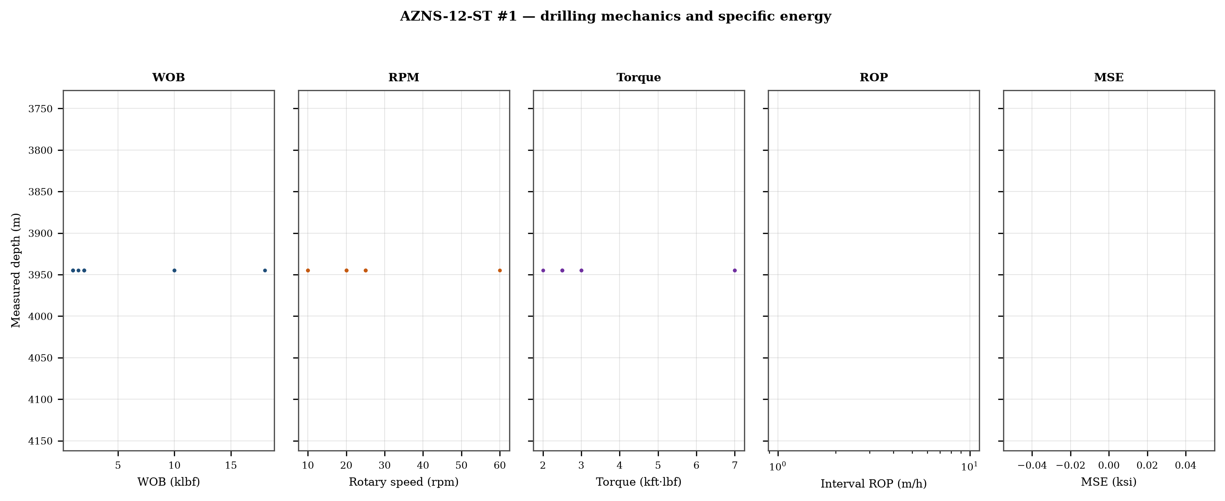
Figure 7.1 — Five-track mechanics log with specific energy

8. Drilling fluids, rheology, cuttings transport and ECD
The hydraulics record covers 5 days. Flow ranges 6–6 gpm, bit pressure drop 0–0 psi and the hydraulic index 0.0–0.0 hp/in². Annular velocity is computed for the recorded hole and pipe sizes; the 120 ft/min line on the figure is the field threshold for cuttings transport, not a regulatory limit.
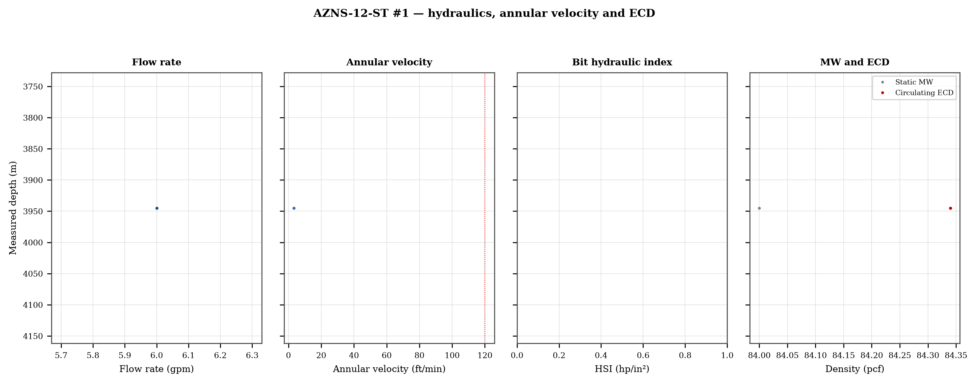
Figure 8.1 — Flow, annular velocity, hydraulic index and the ECD window
Mud weight moves between 81 and 85 pcf across the record, in steps that coincide with casing points. Each step changes the equivalent circulating density by the same amount plus the annular loss term, which is why the pressure window narrows precisely when the weight is increased to control the shale.

9. Directional survey, trajectory and dog-leg severity
The trajectory was rebuilt from 8 survey stations with the minimum-curvature method. The well reaches a maximum inclination of 63.0°, a maximum dog-leg of 10.46°/30 m and a final TVD of 3,825 m at 4,005 m MD, with a bottom-hole closure of 418 m. Dog-legs stay inside the drilling limit throughout, so the directional programme did not create the drag that Chapter 10 measures.
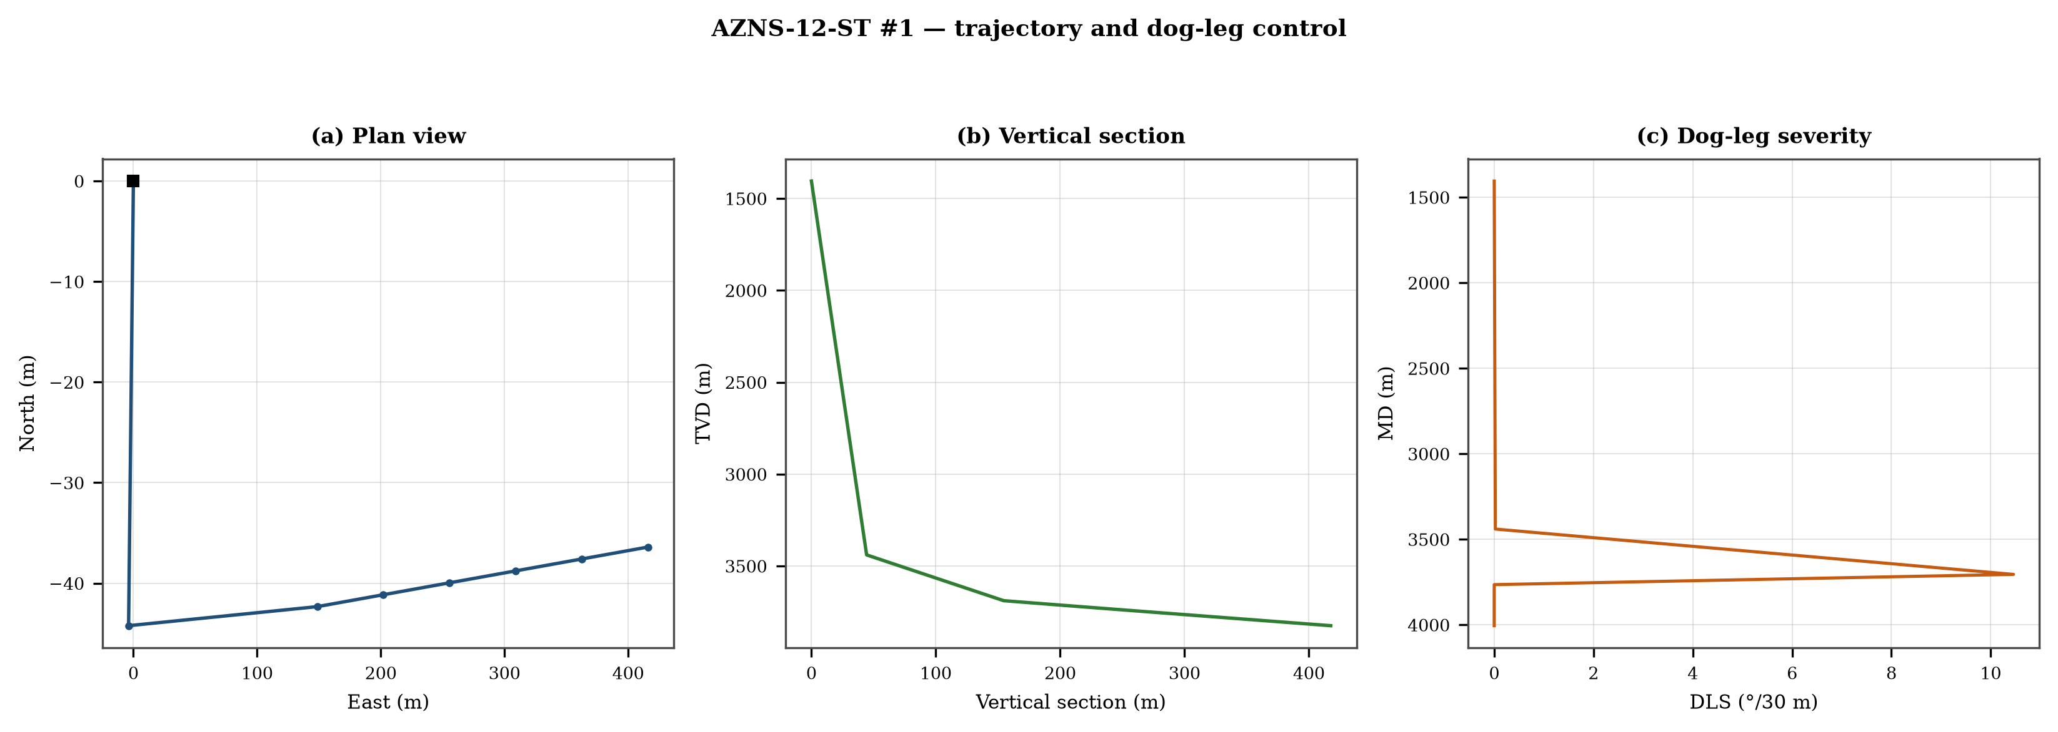
Figure 9.1 — Plan view, vertical section and dog-leg severity

Table 9.1 — Survey stations
MD | Inc | Azi | TVD | N | E | DLS
1,405.0 | 2.00 | — | 1,405.0 | 0.0 | 0.0 | 0.00
3,440.0 | 0.50 | 185.0 | 3,439.5 | -44.2 | -3.9 | 0.02
3,705.0 | 63.02 | 88.7 | 3,688.5 | -42.3 | 148.7 | 10.46
3,765.0 | 63.02 | 88.7 | 3,715.8 | -41.1 | 202.1 | 0.00
3,825.0 | 63.02 | 88.7 | 3,743.0 | -40.0 | 255.6 | 0.00
3,885.0 | 63.02 | 88.7 | 3,770.2 | -38.8 | 309.0 | 0.00
3,945.0 | 63.02 | 88.7 | 3,797.4 | -37.6 | 362.5 | 0.00
4,005.0 | 63.02 | 88.7 | 3,824.6 | -36.4 | 415.9 | 0.00
DDR Ref. — "1-2 DDR Data" survey table from header row 115 (MD, inclination, azimuth, TVD) — template A; "1-2 DDR Data" survey block J50+ — template B

10. Hook load, drag and overpull
A soft-string model was built on the recomputed survey with the buoyancy factor of the recorded mud weight and a tripping friction factor of 0.28. At 4,005 m the model gives a pick-up load of 69.0 klbf, a rotating load of 62.8 klbf and a slack-off of 62.1 klbf. The spread between pick-up and slack-off is 6.9 klbf; that is the friction the string actually carries, and it is the margin that must not be spent on a single pull.
- Day 10: recorded overpull 1 klbf
- Day 31: recorded overpull 377 klbf
- Day 31: recorded overpull 328 klbf
- Day 32: recorded overpull 378 klbf
- Day 44: recorded overpull 389 klbf
- Day 71: recorded overpull 35 klbf
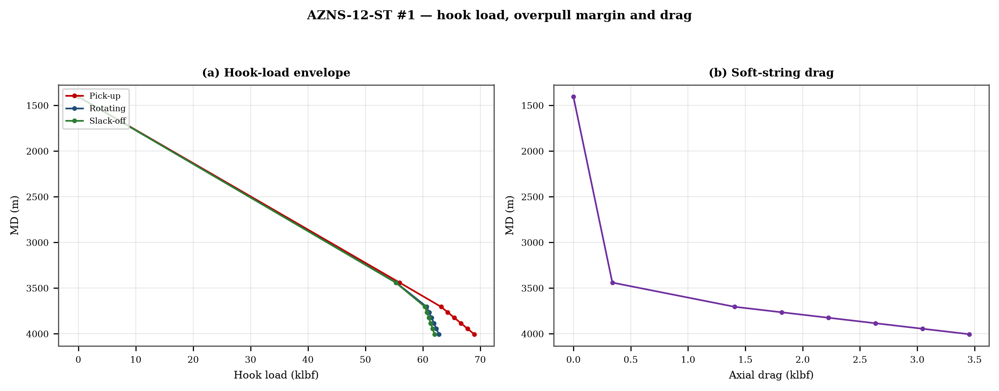
Figure 10.1 — Hook-load envelope and axial drag

11. Well control, shoe integrity, MAASP and losses
The record contains 0 formation-integrity tests with a numerical equivalent mud weight and 33 days with a loss entry. The dynamic maximum allowable surface pressure is the number the driller needs: at the shallowest shoe of this well, raising the annulus by 500 psi requires an equivalent weight of 0.0 pcf, which is the practical test of whether the mud programme is inside the window.

12. Geology, formation tops and gas
10 formation tops are recorded between 974 m and 3,627 m MD. The sequence and the depth of each top are reproduced below with the minimum-curvature TVD where a survey exists; the drillability of each interval is discussed against the rate record rather than against a general lithology table.
Table 12.1 — Formation tops
Formation | MD (m) | TVD (m)
Gachsaran | 974 | 974
Asmary | 1,280 | 1,280
Pabdeh | 1,474 | 1,405
Gurpi | 2,124 | 2,124
Ilam | 2,539 | 2,539
Laffan | 2,613 | 2,613
Sarvak | 2,620 | 2,620
Kazhdumi | 3,261 | 3,261
Dariyan | 3,465 | 3,439
Gadvan | 3,627 | 3,689
DDR Ref. — "1-2 DDR Data" rows 110–131: K = formation, L/M = forecast MD and TVD, O/Q = actual TVD
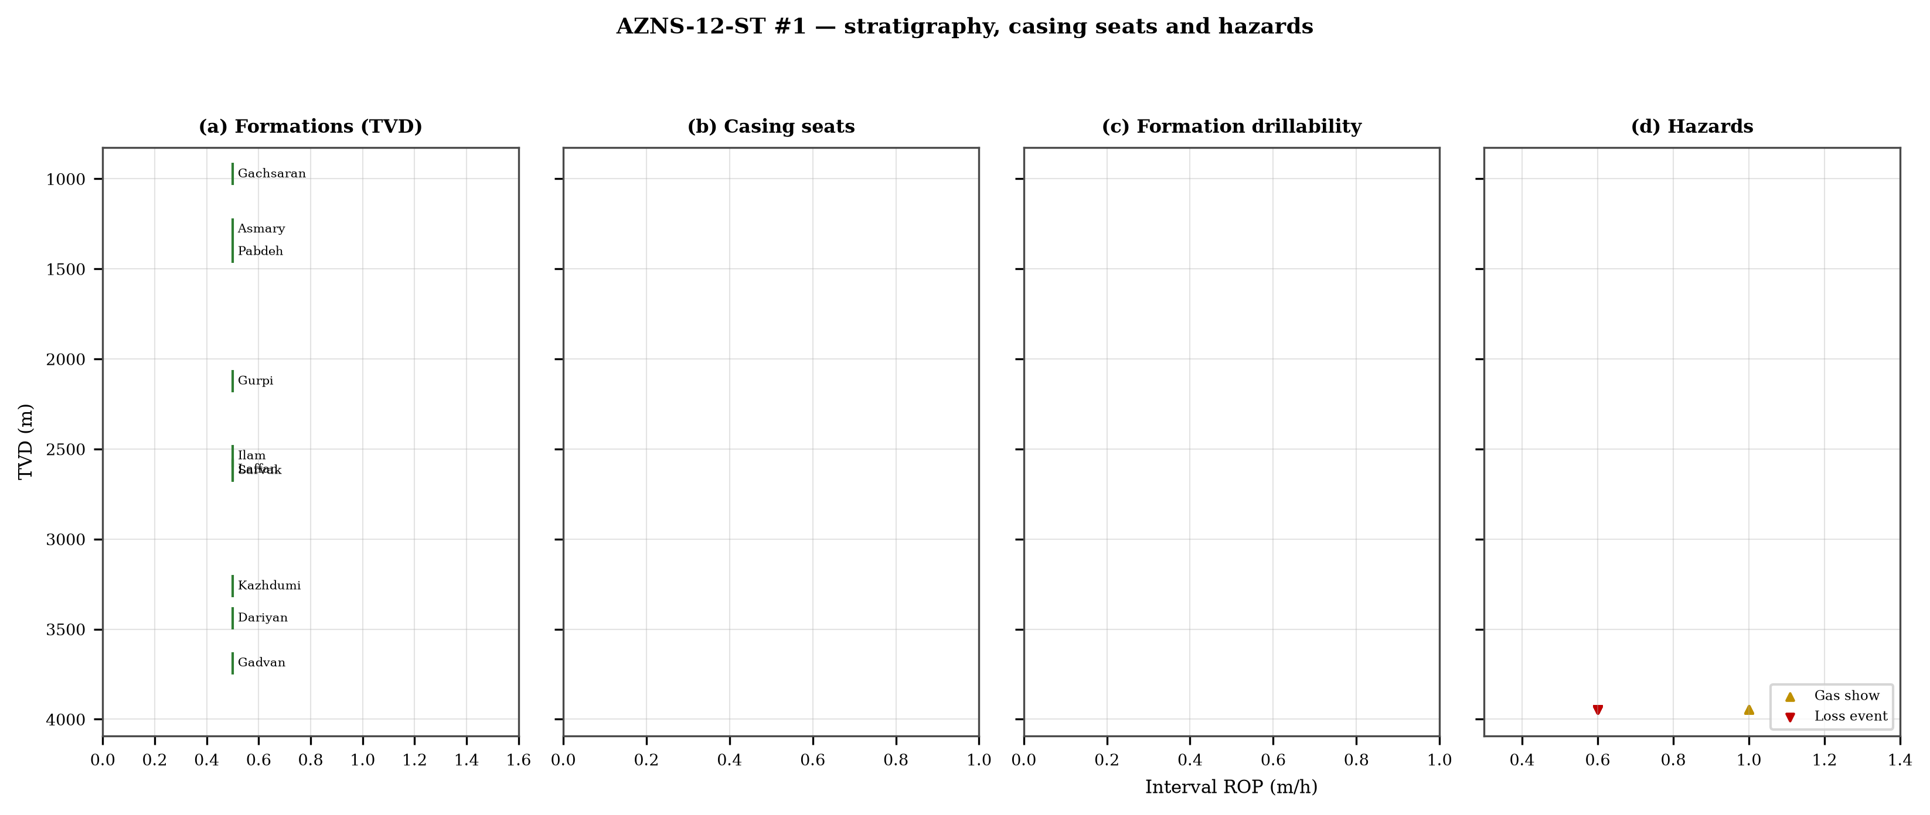
Figure 12.1 — Formation tops, casing seats, drillability and hazards

13. Operational problems, remedies and rig-floor playbooks
The five playbooks below are written for use at the rig floor, in the order given. Each one is the compressed form of the diagnosis used in Chapters 5, 10 and 11, and each is matched to the mechanism it treats.

Loss circulation playbook
- Stop drilling, record the loss rate at the current pump rate and keep the string moving.
- Reduce flow in two steps and measure the loss at each step: partial loss responds to LCM, total loss needs a different mechanism, not a bigger pill.
- Spot a graded LCM pill (fine–medium–coarse) across the loss zone and cure it before resuming; log the pill volume, the returned volume and the pressure at which it was spotted.
- If losses persist at the shoe, recalculate MAASP with the current mud weight and confirm the well is still displaced by a single fluid column.

Tight hole and overpull playbook
- Compare the observed overpull with the modelled pick-up envelope for the same depth.
- Circulate at the maximum allowable rate with the string rotating; if torque falls while returns carry cuttings, the cause is cleaning, not the formation.
- Work the string down with a controlled feed-off rather than pulling; never exceed 80% of the modelled overpull margin.
- If the string is stuck, establish circulation and jar down before any chemical soak.

Stuck pipe and fishing playbook
- Record the free rotating weight, the pick-up and the slack-off immediately; the spread distinguishes wall contact from a pack-off.
- Establish circulation within the first ten minutes; a stuck string that still circulates is recoverable without fishing.
- Apply torque and jar in the direction indicated by the string's own weight response, not by habit.
- Photograph and grade every recovered component before the next run.

Well-control playbook
- Shut in on the hard shut-in sequence and record SIDPP, SICP and pit gain within one minute.
- Confirm the influx type from the pressure pair: SIDPP ≈ SICP means a light fluid, SICP >> SIDPP means gas.
- Prepare a kill sheet with slow circulating pressure at the actual pump rate, not a table value.
- Maintain the casing pressure constant while bringing the pumps to rate; do not chase the drill-pipe pressure.

Shoe test and MAASP playbook
- Never drill out a shoe without a recorded FIT/LOT equivalent mud weight in the daily header.
- Compute MAASP for the current mud weight every time the weight changes by 0.1 pcf.
- Convert the test result to a fracture gradient at the shoe TVD, not at MD.
- When a loss occurs at the shoe, the first number to read is the dynamic MAASP, not the static one.

14. Optimum parameters, drill-off and MSE practice
The drill-off procedure is the only reliable way to find the founder point on location. Hold flow constant, reduce weight in three steps of about 15% and record the rate at each step after 90 seconds of steady drilling; the rate should rise with weight until the founder point and then flatten. The weight at which it flattens is the operating weight for that formation, and the weight at which torque rises while rate does not is the weight that damages the bit.
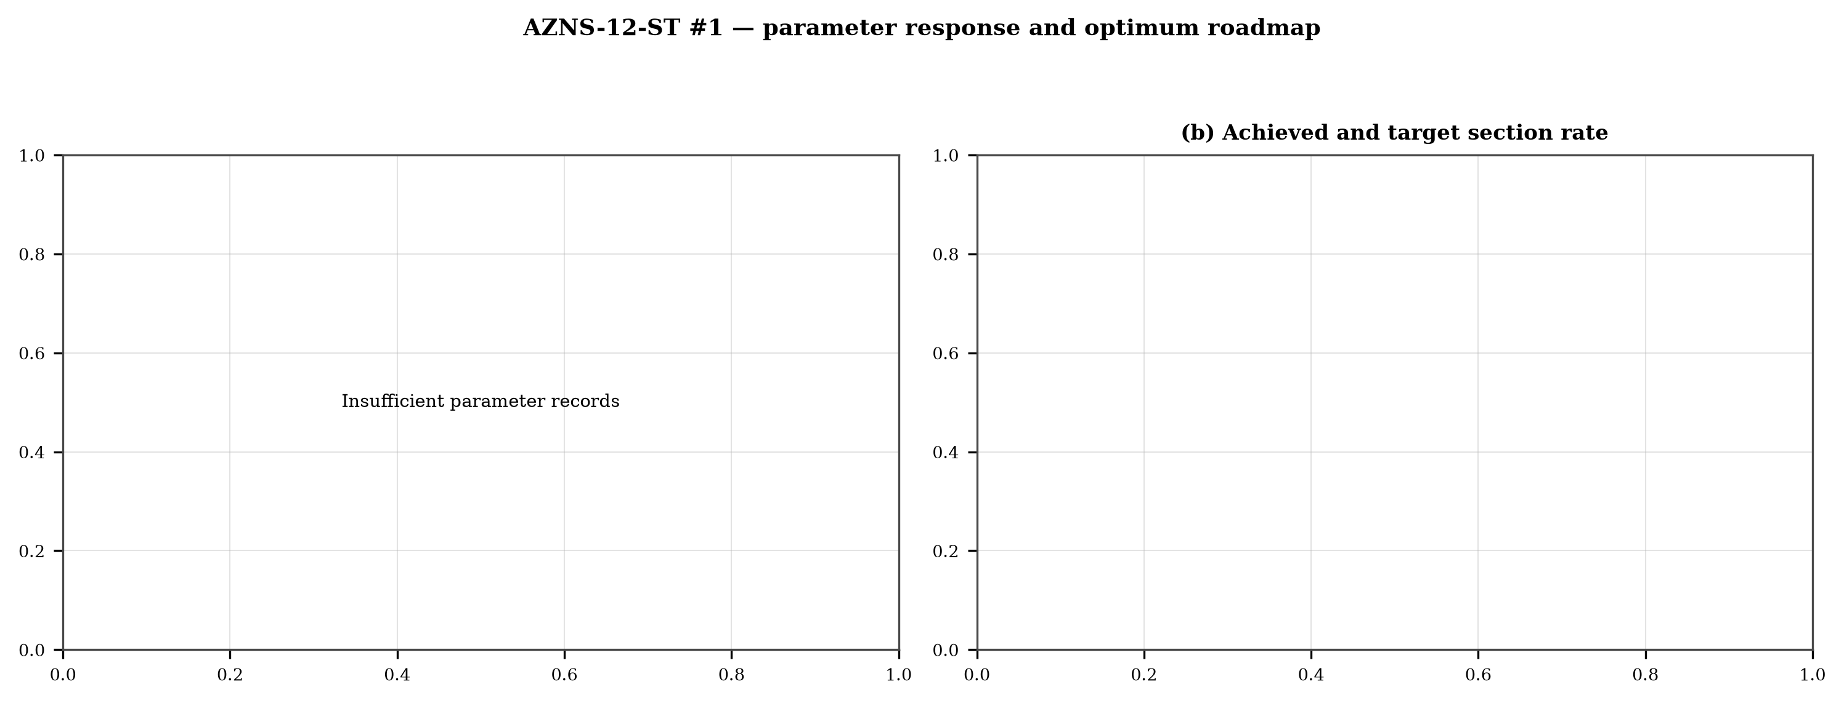
Figure 14.1 — Weight response coloured by specific energy and the section rate target

15. Key findings and risk register
- NPT stands at 44.9% of rig time, dominated by lost circulation.
- Handling time is 14.04 times the drilling time, which is the structural inefficiency of this record.
- Net rate in the productive intervals is 0.00 m/h at a median specific energy of 0 ksi.
- The pressure window and the mud programme interact at every casing point; the integrity record is the weakest data set in the well.
Table 15.1 — Risk register
Risk | Trigger | Consequence | Control
Loss at the shoe | Drilling out with weight above the window | Loss of circulation and stuck pipe | Two-rate loss test, graded LCM
Tight hole on trips | Shale swelling after long open-hole exposure | Overpull and stuck string | Wiper trips, mud inhibition
Bit balling | Weight above the founder point in reactive clay | Rate collapse and torque rise | Drill-off test, HSI above 2.5
Equipment failure | Ageing pumps and top drive | Long NPT and hole deterioration | Reliability register
DDR Ref. — Derived — "1-1 DDR Remark" narrative, "1-2 DDR Data" time-log flags and the NPT register of this report; no single DDR cell

16. Recommendations — phase matrix and REC-01 to REC-10
Table 16.1 — Phase execution matrix
Phase | Action | Hold point
Pre-spud | Verify rig systems and spares against the reliability register | Signed availability check
Surface hole | Maximum flow with a single casing and cementing trip | Shoe test recorded
Intermediate | PDC and motor, wiper trip every 300 m, AV above 120 ft/min | Overpull trend inside envelope
Reservoir entry | Two-rate loss test and graded LCM on location | Loss cured before drilling ahead
Reservoir hole | Hold HSI above 2.5 hp/in², drill-off at each top | Founder point recorded
Close-out | NPT booked to the fixed cause list, review within 14 days | QC certificate signed
DDR Ref. — "1-2 DDR Data" time log rows 21–68 aggregated by operational code and the "1-1 DDR Remark" section headers
Table 16.2 — Recommendations
ID | Recommendation | Owner | Timing | Rationale
REC-01 | Adopt a rig-specific reliability register (pumps, top drive, drawworks) with monthly availability and mean time between failures | Rig manager | Immediate | Rig and surface equipment is the largest controllable NPT category
REC-02 | Standardise the FIT/LOT protocol and write the demonstrated EMW into the daily header | Well integrity | Before the next well | Makes MAASP auditable at every shoe
REC-03 | Apply the section parameter roadmap of Chapter 14 as the drilling programme | Drilling engineering | Next well | Closes the gap to the field P90 rate
REC-04 | Introduce a graded-LCM loss protocol with a two-rate diagnosis before treatment | Mud engineering | Immediate | Cuts loss time and lost mud volume
REC-05 | Run a drill-off test at the top of each formation and record the founder point | Drilling engineering | Each section | Prevents weight-induced inefficiency
REC-06 | Treat centrifuge running time as a recorded drilling parameter | Mud engineering | Immediate | Controls ECD without changing mud weight
REC-07 | Hold a torque-and-drag check against the modelled envelope before every trip | Drilling supervisor | Every trip | Converts overpull from a surprise into a trend
REC-08 | Book every NPT hour against the fixed cause list within the same tour | Drilling supervisor | Daily | Keeps the field comparison comparable
REC-09 | Audit third-party service readiness (wireline, cementing, casing crews) before the operation, not on arrival | Field engineering | Each job | Third-party delay is the second largest NPT category
REC-10 | Publish a weekly NPT pareto and a monthly field benchmarking pack | Field engineering | Weekly | Sustains the learning curve across rigs
DDR Ref. — This report — built from the KPI set and NPT register above; each row carries its own evidence reference

17. Limitations of the recorded data
- No casing table with shoe depths: the architecture is described from the chronology and the hole sizes drilled.
- No formation-integrity test with a numerical equivalent mud weight: MAASP is reported as a sensitivity, not as a measured value.
- Costs are reconstructed from daily rig, mud and service rates because the workbooks do not carry a commercial register; they are used for comparison only.

18. Appendix A — Workbooks, sheets and SHA-256
The record was read from AZNS12Pack.xlsx with 144 sheets, all of which were parsed. The table below reproduces the file inventory with the digest of the source workbook as it stands in the repository.
Table 18.1 — Source workbooks and SHA-256
File | SHA-256
AZNS10Pack.xlsx | bf8c897274b47f9324b6e808162c451c0329d78651e76a27c700db9263ec0a95
AZNS116Pack.xlsx | 68c5b874f1ba78a4a30989930aef00f06095d8118e89e217e74ca918364dc438
AZNS122WO1Pack.xlsx | c14db1ff6cbef8b7d4e0f69b9f64cdc4452e3935f64bad439d38a8aed6f5f42a
AZNS122WO2Pack.xlsx | 2eb9858150dfa2d43f46e387ded978fd04c811f0c08b402a76a533f36235b65c
AZNS127ST2Pack.xlsx | 68329de313721905be08f20cb8bb8b4f5f3671d5c6caab41f23caa1a48b9a4c4
AZNS127WO1Pack.xlsx | 6034aae76c2e3126416df8f8576d424bd3394c30aca4c4f5e72f0372256739d6
AZNS127WOPack.xlsx | a4ae90dc870f20b2f99ac3a36b8b5cd1c357b60dd2805630597cc48ba059054e
AZNS12Pack.xlsx | e325945f1108341bace123e60b02fb04ac3f7d3003a19eb8d23004cf7cd67216
AZNS166Pack.xlsx | e63824748e4692884fc23075c678c1379b9b595a8c8b1efb289e630f898a75d8
AZNS207Pack.xlsx | 828968c7e0afd7273d64987bd457383ecfea3a2e00e62c9a65b587f16518996a
AZNS40Pack.xlsx | 0523068ee222c02f6e2d2754bcd919a9c296b334b03521ab15d84322aade94ca
AZNS75Pack.xlsx | 5e0482d5d50e9347a98b7c24cfd3a102d3c00f2c951f6061aba14d164136fcae
AZNS85Pack.xlsx | 0d3ecc54fb8b9484f508b9a3957554ba13e72546c6d485abb79af633362daeb2
DDR Ref. — Workbook files as delivered (read-only), hash computed at build time
Table 18.2 — Sheet inventory of this well
Sheet | Sheet | Sheet
1-1 DDR Remark | 1-2 DDR Data | 2-1 DDR Remark
2-2 DDR Data | 3-1 DDR Remark | 3-2 DDR Data
4-1 DDR Remark | 4-2 DDR Data | 5-1 DDR Remark
5-2 DDR Data | 6-1 DDR Remark | 6-2 DDR Data
7-1 DDR Remark | 7-2 DDR Data | 8-1 DDR Remark
8-2 DDR Data | 9-1 DDR Remark | 9-2 DDR Data
10-1 DDR Remark | 10-2 DDR Data | 11-1 DDR Remark
11-2 DDR Data | 12-1 DDR Remark | 12-2 DDR Data
13-1 DDR Remark | 13-2 DDR Data | 14-1 DDR Remark
14-2 DDR Data | 15-1 DDR Remark | 15-2 DDR Data
16-1 DDR Remark | 16-2 Lookahead | 17-1 DDR Remark
17-2 Lookahead | 18-1 DDR Remark | 18-2 Lookahead
19-1 DDR Remark | 19-2 Lookahead | 20-1 DDR Remark
20-2 Lookahead | 21-1 DDR Remark | 21-2 Lookahead
22-1 DDR Remark | 22-2 Lookahead | 23-1 DDR Remark
DDR Ref. — Workbook sheet list — every remark/data sheet pair plus the reference sheets

19. Appendix B — Equations and units
Table 19.1 — Governing equations
Quantity | Equation | Units
Mechanical specific energy | MSE = 480·T·N/(D²·ROP) + 4·WOB/(π·D²·1000) | psi, klbf, ft·lbf
Bit pressure drop | ΔP = ρ·Q²/(10858·TFA²) | psi, gpm, in²
Jet velocity | V = 0.3208·Q/TFA | ft/s
Hydraulic index | HSI = ΔP·Q/(1714·A_bit) | hp/in²
Annular velocity | V = 24.5·Q/(D_h² − D_p²) | ft/min
Bingham annular loss | ΔP = PV·V·L/(60000·(D_h−D_p)²) + YP·L/(200·(D_h−D_p)) | psi
Equivalent circulating density | ECD = MW + ΔP_ann/(0.052·TVD) | pcf
Minimum curvature | β = arccos[cos I₁cos I₂ + sin I₁ sin I₂ cos(A₂−A₁)] | rad
Dog-leg severity | DLS = 30·β/ΔMD | °/30 m
Buoyancy factor | BF = 1 − MW/490 | —
Hook load (soft string) | F = Σ w·BF·cos I·Δs ± μ·Σ w·BF·sin I·Δs | klbf
Maximum allowable surface pressure | MAASP = 0.052·(EMW_frac − MW)·TVD_shoe | psi
dc exponent | dc = log(ROP/(60·N)) / log(WOB/D) | —
Reconstructed cost | C = Σ (rig + mud + service) day rate | USD
DDR Ref. — Reference standard, Appendix B — no DDR cell

20. Appendix C — Complete NPT register
Table 20.1 — NPT register (all entries)
Day | Hrs | Mechanism | Activity and description
2 | 4.0 | Unclassified | Stop operation Due to Align TDS Rail meanwhile OEOC inspection &maintenance crew work on TDS.
2 | 2.0 | Unclassified | Stop operation Due to Bad Weather (High win speed & dust storm)
2 | 2.0 | Unclassified | Cont. Align TDS Rail meanwhile OEOC inspection &maintenance crew work on TDS.
2 | 6.0 | Unclassified | Stop operation Due to Bad Weather (High win speed & dust storm)
3 | 2.0 | Unclassified | Stop operation Due to Bad Weather (High win speed & dust storm)
3 | 7.0 | Unclassified | Wait on OEOC due to Rec. Crain to R/U CT Injetcor head.
4 | 24.0 | Unclassified | Wait on R/U CTU. OEOC Refuses to R/U CT Injector head. So 24 hours NPT has been applied for OEOC rig and services.
5 | 15.0 | Unclassified | Wait on R/U CTU. OEOC Refuses to R/U CT Injector head. So 15 hours NPT has been applied for OEOC rig and services.
5 | 2.0 | Third-party & service | Rec. 50 ton crane. M/U 1-1/2"Roll on Connector on 1-1/2"CT Pipe & Perform Pull Test to Max 12 Klbs, Ok. Install CT BOP o
7 | 4.0 | HSE & drills | Due to unable to establish circulation through the string and discrepancies between in/out mud weight values. In order t
8 | 8.0 | HSE & drills | Due to unable to establish circulation through the string and discrepancies between in/out mud weight values. In order t
8 | 5.0 | Third-party & service | Retrieve 6-5/16" 5K TWCV. P/U & Screw 7" Vam Thread L/J on TBG HGR. M/U 7" Vam x 4-1/2" IF + 4-1/2" IF x 7" Vam (c/w 2"
8 | 5.0 | Third-party & service | R/U Wireline logging Equip. (Sealand Co.). Install Wire Line BOP on 7" XOS. Press. Test same w/ 1000 psi; "Ok". L/U f/ 7
8 | 2.5 | Third-party & service | Held PJSM. Load & Armed 5 No. HMX Bullet on carrier. RIH w/L Punch Assy (Cable head, CCL, Wt. bar, Carrier, BTM Nose: Ma
8 | 1.5 | Unclassified | POOH W/L tools to 100m While Slow Circ. thru completion string.
8 | 2.0 | Rig & surface equipment | Wait on daylight due to explosive material safety regulation. Cont. Slow Circ. thru completion string. w/ Max 1 BPM, 500
9 | 3.5 | Rig & surface equipment | Cont. Wait on daylight due to explosive material safety regulation. Slow Circ. thru completion string. w/ Max 1 BPM, 500
9 | 2.0 | HSE & drills | Cont. Wait on daylight due to explosive material safety regulation.
9 | 2.5 | Third-party & service | POOH to surface, L/D Sealand Punch ass. & check all bullet is Fired, B/O & L/D Wire line BOP & Equip. & X.O.S - f/u tool
9 | 14.0 | Stuck pipe & fishing | M/U 5" DP on 7" vam thread L.j & connected to TDS, Check return from ann., work and try to pull out & retrieve Tubing Ha
9 | 2.0 | Unclassified | 2Hrs NPT for OEOC due to staffing shortage & Disobedience of MSA Co. man orders.
10 | 8.0 | Stuck pipe & fishing | Cont. Work on Pull out Tubing Hanger in THS, OBS Stuck Tubing Hanger in Tubing Head Spool, Apply 500psi in Ann. while Pu
10 | 10.0 | Stuck pipe & fishing | Got return mud & Movment 20cm Tubing hanger from THS seating area, Cont. Reverse Circ. Mud to clean & flush the same are
10 | 6.0 | Stuck pipe & fishing | B/O 7" X.O.S from Tubing Hanger, pull out & L/D 2jts 5" DPs ( S-Grade), P/up 7" N.vam thread L.J and M/up 7" * 4-1/2" N.
11 | 4.0 | Stuck pipe & fishing | Cont. Circ. Mud Thru string Till uniform MW in/out Checked Return Mud Noticed Cut the MW and OBS. Oil gas in return (Tot
14 | 13.0 | Lost circulation | Cont. RIH W/ 3-1/2" Spear & Fishing BHA F/330 to 3285m (7"L.lap) while Circ. Mud C.W.H w/ 0-2 BPHL.
14 | 2.0 | Lost circulation | Circ. BTM's up @ 3285m (7"L.lap) to balanced MW in/out @ 81pcf W/0-1 BPHL.
14 | 4.0 | Stuck pipe & fishing | Cont. RIH as Pump down to 3307m, String Took WT & Confirmed TOF (Comp. Strg) as per tally, Work on Fishing and Try to ca
14 | 3.0 | Lost circulation | In Order to check string & 3-1/2" Spear For any Probably fish caught, POOH as chain out F/3307 to 2550m while Circ. Mud
15 | 11.0 | Lost circulation | Cont. POOH W/ 3-1/2" Spear as chain out F/2550 to Surface & Recoverd about 100-150m Slick line, L/D 3-1/2" Spear while C
15 | 13.0 | Stuck pipe & fishing | P/U & M/U 2" * 4" Taper tap & RIH W/ Fishing BHA#02 To 3290m while Circ. Mud C.W.H w/ NL-NG.
16 | 3.0 | Stuck pipe & fishing | Cont. RIH W/ 2" * 4" Taper tap & Fishing BHA#02 F/ 3290 To 3305m (2M above Fish Depth), Record Upward & Downward WT W/ P
16 | 21.0 | Stuck pipe & fishing | POOH W/ 2" * 4" Taper tap & Fishing BHA#02 as chain out F/3307 to Surface, Recoverd Fish Completely as below:
17 | 2.0 | Stuck pipe & fishing | Wash and Clean Flow line, shale shakers, Divider box, Ditch lines, Change TDS elevator & Prepare 6JTs 4-3/4" DCs as requ
18 | 4.0 | Well control & kick | Closed the well @ 3454m, Circ. Mud to Kill the Well Thru C/M While weight Up Active Sys. mud To 83pcf Meanwhile OBS. Cut
18 | 9.0 | Well control & kick | Closed C/M and Monitor the Ann. press. while Prepared 82pcf Mud (totally: 1200BBLs Pumpable).
18 | 8.0 | Well control & kick | Start Circ. Mud thru C/M by 82pcf Mud and apply Back Press., After pumping Totally 984bbls 82-84pcf, Got 84pcf mud @ Ret
19 | 2.0 | Unclassified | Stopped Operation @ 100m Due to Bad Weather situation (Dust storm) While slow Circ. Mud thru string w/ NL-NG.
21 | 1.0 | Lost circulation | Stopped Operation Due to work on HYD. System of TDS (Severe Oil Leakage) and Fix same "OK" While Circ. Mud C.W.H w/ 0-1B
21 | 2.0 | Lost circulation | Stopped Operation @ 950m Due to Bad Weather situation (Dust storm) While slow Circ. Mud thru string w/ 0-1BPHL.
21 | 0.5 | Lost circulation | Stopped RIH @ 2050m Due to Bad Weather situation (Severe wind) While slow Circ. Mud thru string w/ 0-1BPHL.
22 | 2.0 | Lost circulation | Stopped Operation @ 2700m Due to Bad Weather situation (Dust storm) While Circ. C.W.H w/ 0-1 BPHL.
23 | 3.0 | Unclassified | Cont. Wait on bad weather (Dust storm) @ 2700m.
25 | 7.5 | Unclassified | Stop operation due to high wind speed.
34 | 0.5 | Stuck pipe & fishing | Due to change Disc break suddenly failure of the brake system in the drawworks; Apply 80klbs Wt. on spear to Push the fi
34 | 14.5 | Lost circulation | In order to check string & Tools; POOH w/ 2-7/8" Cable Spear to 550m, F/u the well; 0-1 BPHL.
35 | 2.5 | Rig & surface equipment | Stop Operation due to work on drawworks low clutch chain.
35 | 3.0 | Unclassified | Stop operation, due to High Wind Speed.
35 | 2.0 | Lost circulation | Resume RIH w/ 4-3/4" Fishing Jar + 9 Stds 3-1/2" HWDP + 20 Stds 3-1/2" DP + 10 Stds 3-1/2" HWDP & Followed by 5" DPs to
38 | 7.0 | Lost circulation | P/U & M/U 5-7/8" MT.Bit (Used, King dream,217, Open) + 4-3/4" Bit sub (Float in) + 10STDs 3-1/2" HWDPs + 5STDs 3-1/2" DP
38 | 2.0 | Lost circulation | While Wait on Rec. New Bit Sub from OEOC, Circ. C.W.H w/ 1 BPHL.
38 | 9.0 | Lost circulation | P/U & M/U 4" New M.M.J.Mill (1/16" UG) & C/O BHA Followed By 5" DPs to 2100m w/ 1 BPHL. >> Clean Out BHA Description: 4"
39 | 16.0 | Lost circulation | Cont. RIH w/ 4" New M.M.J.Mill & C/O BHA F/ 2100m to 3779m (5" L.Lap), Try to Pass This point W/Pumping "No Succ.", Hard
39 | 8.0 | Lost circulation | POOH w/ 4" M.M.J.Mill & C/O BHA F/ 3888.7 to 1000m While C.C.W.H w/ 0-1 BPHL.
40 | 5.0 | Lost circulation | Cont. POOH w/ 4" M.M.J.Mill & C/O BHA F/ 1000m to Surface, L/D 4" M.M.J.Mill (5% Used) While C.C.W.H w/ 0-1 BPHL. >> OBS
40 | 19.0 | Lost circulation | P/U & M/U 3-15/16" Used M.M.J.Mill & C/O BHA Followed By 5" DPs to 3779m (5" L.Lap), Cont. RIH as Med. to Soft Wash Down
41 | 8.0 | Stuck pipe & fishing | Cont. RIH w/ 3-15/16" Used M.M.J.Mill & C/O BHA as Med. to Soft Wash Down f/ 3870 to 3888.7m, Strig Took WT, Try to Pass
41 | 12.0 | Lost circulation | In Order to change BHA, POOH w/ 3-15/16" Used M.M.J.Mill f/ 3888.8m to Surface, L/D 3-15/16" Used M.M.J.Mill (20% Used)
41 | 4.0 | Lost circulation | P/U & M/U 3-1/2" Used M.M J.Mill & RIH w/ Clean Out BHA to 200m w/ 0-1 BPHL. >> Meanwhile RIH Change 5jts 3-1/8" DCs wit
42 | 12.0 | Lost circulation | Cont. RIH w/ 3-1/2" Used M.M J.Mill & C/O BHA f/ 200 to 3779m (5" L.Lap), Cont. RIH as Med. to Soft R/D to 3899m, String
42 | 2.0 | Lost circulation | Try to Resume Milling & Push the Obstacle W/ Low Parameters @ 3899m "No Progress", (Confirmed TOF), Stop Milling Operati
42 | 10.0 | Lost circulation | In Order to Perform Fishing job, POOH w/ 3-1/2" Used M.M.J.Mill & C/O BHA f/ 3899m to 600m While C.C.W.H w/ 0-1 BPHL.
43 | 3.0 | Lost circulation | Cont. POOH w/ 3-1/2" Used M.M.J.Mill f/ 600m to Surface, L/D 3-1/2" Used M.M.J.Mill (30% Used) While C.C.W.H w/ 0-1 BPHL
43 | 4.0 | Lost circulation | P/U & M/U 4-1/16" Overshot & RIH w/ Fishing BHA to 450m w/ 0-1 BPHL. >> Fishing BHA Description: 4-1/16" Overshot (Dress
43 | 5.5 | Lost circulation | RIH w/ 4-1/16" Overshot & Fishing BHA f/ 450 to 2100m w/ 0-1 BPHL.
43 | 3.0 | Lost circulation | Stopped Operation @ 2100m Due to Bad Weather situation (Severe Wind) While slow Circ. Mud thru string w/ 0-1BPHL.
43 | 6.5 | Lost circulation | Cont. RIH w/ 4-1/16" Overshot & Fishing BHA f/ 2100 to 3730m w/ 0-1 BPHL.
44 | 7.0 | Lost circulation | Cont. RIH w/ 4-1/16" Overshot & Fishing BHA f/ 3730 to 3760m, String Took WT, Cont. RIH as W/D f/ 3760 to 3899m (TOF) Wh
44 | 17.0 | Lost circulation | POOH as Pump Out w/ abnormal Over Pull f/ 3899m to 3779m (5" L.Lap), Cont. POOH f/ 3779 to 600m on elevator while Circ.
45 | 3.0 | Lost circulation | Cont. POOH w/ 4-1/16" Overshot & Fishing BHA f/ 600 to Surface, L/D 4-1/16" Overshot while Circ. C.W.H w/ 0-1 BPHL. >> N
DDR Ref. — "1-2 DDR Data" time log rows 21–68 with flag N or UP, one row per logged interval

21. Appendix D — Daily hydraulics and ECD

Table 21.1 — Hydraulics and ECD register
Day | MD | Q | MW | TFA | ΔP bit | HSI | AV | ECD
48 | 3,945 | 6 | 84 | 0.589 | 0 | 0.0 | 3 | 84.3
49 | 3,945 | 6 | 84 | 0.589 | 0 | 0.0 | 3 | 84.3
51 | 3,945 | 6 | 84 | 0.589 | 0 | 0.0 | 3 | 84.3
52 | 3,945 | 6 | 84 | 0.589 | 0 | 0.0 | 3 | 84.3
53 | 3,945 | 6 | 84 | 0.589 | 0 | 0.0 | 3 | 84.3
DDR Ref. — "1-2 DDR Data" mud table columns K–S rows 11–38 (density, FV, PV, YP, solids, chlorides, ECD) — template A; J8–L27 — template B

22. Appendix E — Formation tops and survey stations
Table 22.1 — Formation register
Formation | MD | TVD
Gachsaran | 974 | 974
Asmary | 1,280 | 1,280
Pabdeh | 1,474 | 1,405
Gurpi | 2,124 | 2,124
Ilam | 2,539 | 2,539
Laffan | 2,613 | 2,613
Sarvak | 2,620 | 2,620
Kazhdumi | 3,261 | 3,261
Dariyan | 3,465 | 3,439
Gadvan | 3,627 | 3,689
DDR Ref. — "1-2 DDR Data" rows 110–131, one row per top with forecast and actual TVD
Table 22.2 — Survey register
MD | Inc | Azi | TVD | DLS
1,405.0 | 2.00 | — | 1,405.0 | 0.00
3,440.0 | 0.50 | 185.0 | 3,439.5 | 0.02
3,705.0 | 63.02 | 88.7 | 3,688.5 | 10.46
3,765.0 | 63.02 | 88.7 | 3,715.8 | 0.00
3,825.0 | 63.02 | 88.7 | 3,743.0 | 0.00
3,885.0 | 63.02 | 88.7 | 3,770.2 | 0.00
3,945.0 | 63.02 | 88.7 | 3,797.4 | 0.00
4,005.0 | 63.02 | 88.7 | 3,824.6 | 0.00
DDR Ref. — "1-2 DDR Data" survey header row 115 onwards — template A; J50+ — template B

23. Reference, quality control and traceability
Table 23.1 — Traceability and QC
Item | Value
Source workbook | AZNS12Pack.xlsx
Sheets parsed | 144 of 144
Daily reports | 72
Rig | OEOC RIG 208
NPT entries | 115
Figures | 9 at 300 dpi
Fonts | Times New Roman (EN), B Nazanin with Times New Roman (FA)
Directionality | LTR (EN) and RTL with bidi tables (FA)
Reference integrity | SHA-256 verified for all six original workbooks
Cost basis | reconstructed from daily rates, comparison only
DDR Ref. — Cross-reference of this document against the workbook sheet inventory and hash register

