ENGINEERING REVIEW WARNING — This legacy report is not validated for operational or financial decisions. The former linear cumulative-cost chart was removed; a verified daily cost series is not yet available; other charts, budgets and cause/formation attribution require reconstruction and reconciliation to source records. See the repository review note for the limited corrections made.
AZNS-166
Drilling, Workover and Well-Intervention Engineering Report
Technical, Operational, Contractual and Financial Analysis
Prepared for the South Azadegan Field Development — Contract 2 - 4+1 Well

Item | Value
Well / operation | AZNS-166
Contract | Contract 2 - 4+1 Well
Operation type | Workover / Completion
Rig | 201 OEOC (OEOC)
Client / operator | PPL
Execution window | 2025-10-27 to 2025-11-19
Reporting days | 24
Source archive | CBS AZNS-166.xlsx (+ AZNS-166 Workover-1 Program Rev.05.pdf)

Document control | Record
Document code | AZNS-166-DER-001
Revision / status | 00 - Issued for information
Issue date | 04 November 2026
Prepared by | Drilling Engineering - Well Performance Team
Checked by | Senior Drilling Engineer
Approved by | Drilling Manager, South Azadegan Development
Distribution | Client, drilling contractor, cost engineering, well archive
Table 0-1 Document control and distribution.
This interim report compiles available records; its legacy analyses are not independently validated.

Executive KPI Summary
KPI | Value
Contract / operation type | Contract 2 - 4+1 Well | Workover / Completion
Rig and contractor | 201 OEOC | OEOC
Spud to release | 2025-10-27 to 2025-11-19 (24 report days)
Planned vs actual duration | Programme: 44.2 main; 95 contingency days (p. 7); actual comparison pending
Depth reached | 4,279 m MD
Productive vs NPT | Not reconciled; see table 7-1
Cost (actual vs CBS budget) | Pending reconciliation to actual cost records
Cost variance | Pending reconciliation to actual cost records
Average burn rate | Pending reconciliation to actual cost records
Financial cost of NPT | Pending reconciliation to actual cost records
Total mud losses | 0 bbl
Drilling fluids density | 83.0 – 83.0 pcf (11.1 – 11.1 ppg)

Legacy duration and NPT figures in this report remain subject to source reconciliation. Actual expenditure is not established.

Contents
No. | Section
1 | Well identity, rig assignment and data inventory
2 | Planned versus actual execution reconciliation
3 | Chronological operational narrative and day-by-day reconstruction
4 | Performance and parameter analysis
5 | Drilling fluid engineering and loss accounting
6 | Completion, casing and service-module findings
7 | Root-cause analysis and three-dimensional NPT attribution
8 | CBS financial analysis and reconstructed cumulative cost
9 | Section-wise optimum parameters and field recommendations
10 | Risk register and mitigations
11 | Data provenance and cell-level traceability

Figures and tables are numbered by section and are listed in place.

Well Identity, Rig Assignment and Data Inventory
This interim report references AZNS166Pack.xlsx and AZNS-166 Workover-1 Program Rev.05.pdf. The archive was indexed, but semantic extraction and verification remain incomplete; see the evidence notes and source inventory.

Static identity
Field | Recorded value
Well name in daily report | Work over, AZNS-166
Well type declaration | Development
Field | AZNS
Client | PPL
Drilling contractor | OEOC
Rig | 201 OEOC
Operation classification | Workover / Completion
Hole section / scope declaration | as per programme
Spud / first report date | 2025-10-27
Release / last report date | 2025-11-19
Table 1-1 Static well identity.

Data inventory discovered for this operation
Dataset module | Records found
DDR daily reports | 24
Cost breakdown (CBS) | 1
EPD budget ceiling | 1
Program time breakdown | 1
Casing tally | 6
Bit records | 5
Survey stations | not present
Mud weight records | 24
Mud loss records | not present
NPT events (>=3h) | 6
Rig-less stimulation CBS | 1
Service sub-tabs | 10
Well program PDF | 1
Table 1-2 Core and auto-discovered bonus modules.
The legacy module inventory requires review; absence from an extraction does not establish absence from the entire archive.

Planned versus Actual Execution Reconciliation
The programme AZNS-166 Workover-1 Program Rev.05.pdf, physical page 7, states the following objective: Remove and rerun completion; the stated producer is Kazhdumi through a 4½-inch slotted liner. The stated duration in days is 44.2 main; 95 contingency. Contingency figures retain the source labels and should not be added or compared with execution without reconciliation.
Reconciliation metric | Planned | Actual | Variance
Programme-stated duration (days) | 44.2 main; 95 contingency | Not reconciled | Not reconciled
Depth reached / target (m MD) | Not reconciled | Not reconciled | Not reconciled
Cost (USD) | Not reconciled | Not reconciled | Not reconciled
Cost per rig day (USD) | Not reconciled | Not reconciled | Not reconciled
NPT share of rig time (%) | Not reconciled | Not reconciled | Not reconciled
Table 2-1 Planned versus actual reconciliation.
A planned-versus-actual duration comparison is not established until revision, scope, daily reports and time boundaries are reconciled; the previous ratio and causal attribution are withdrawn.
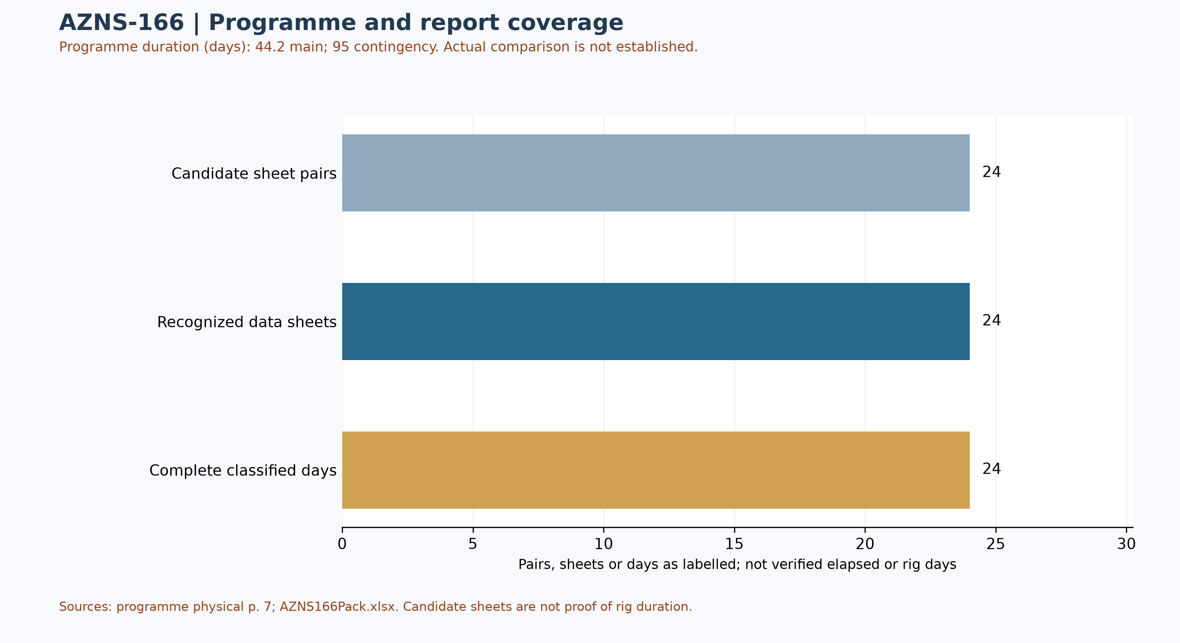
Figure W1 — Daily-record coverage and stated programme duration; actual comparison unverified
Status-page coverage is assessed independently: 24 status pages and 24 data sheets were recognized; 24 status pages contain classified durations totalling approximately 24 hours. Some reports have a status page but an absent or differently formatted data page. These counts are not verified rig duration.

Selected programme phases and limited execution evidence
The phases below are selected programme statements, not proof of execution or of the final approved revision. The selected daily observations are quoted separately; a similar topic alone does not establish phase timing, completion or deviation.
Programme — The programme distinguishes an initial rig-less sequence and conditional transition to operations with a rig. [AZNS-166 Workover-1 Program Rev.05.pdf, physical p. 30]
Programme — After the planned rig release, the programme includes further rig-less slickline, coiled-tubing and stimulation activities. [AZNS-166 Workover-1 Program Rev.05.pdf, physical p. 31]
Daily report 5 — The report describes waiting for continuation of the BOP test while BOP leakages were being repaired. [AZNS166Pack.xlsx, 5-1 DDR Remark!S25]
Daily report 6 — The report records an unsuccessful attempt to circulate mud through the string after leakage was observed at the top-drive kelly hose. [AZNS166Pack.xlsx, 6-1 DDR Remark!S26]
Services listed in the programme: drilling and completion fluids: VIRA; waste management: Pars Hafaran Arvand; electrical logging and perforation: SEALAND; mud logging: Pars Geo Data. [AZNS-166 Workover-1 Program Rev.05.pdf, physical p. 26] These are programme assignments, not evidence of actual deployment, contractual award, cost or incident liability.

Selected daily-report observations
Of 24 recognized status pages, 24 contain classified durations totalling approximately 24 hours. Planned, NPT and unplanned labels are source classifications; they do not independently establish cause, liability or total operation duration. The following examples are selective; complete extracted detail cells are retained in evidence/activity_observations.json.
Report 5 — The report describes waiting for continuation of the BOP test while BOP leakages were being repaired. [AZNS166Pack.xlsx, 5-1 DDR Remark!S25]
Report 6 — The report records an unsuccessful attempt to circulate mud through the string after leakage was observed at the top-drive kelly hose. [AZNS166Pack.xlsx, 6-1 DDR Remark!S26]
These are source statements, not independent verification of a test, failure mechanism, current well condition or an operating instruction. A description may continue into the next cell; reconcile the complete row and time before making decisions.
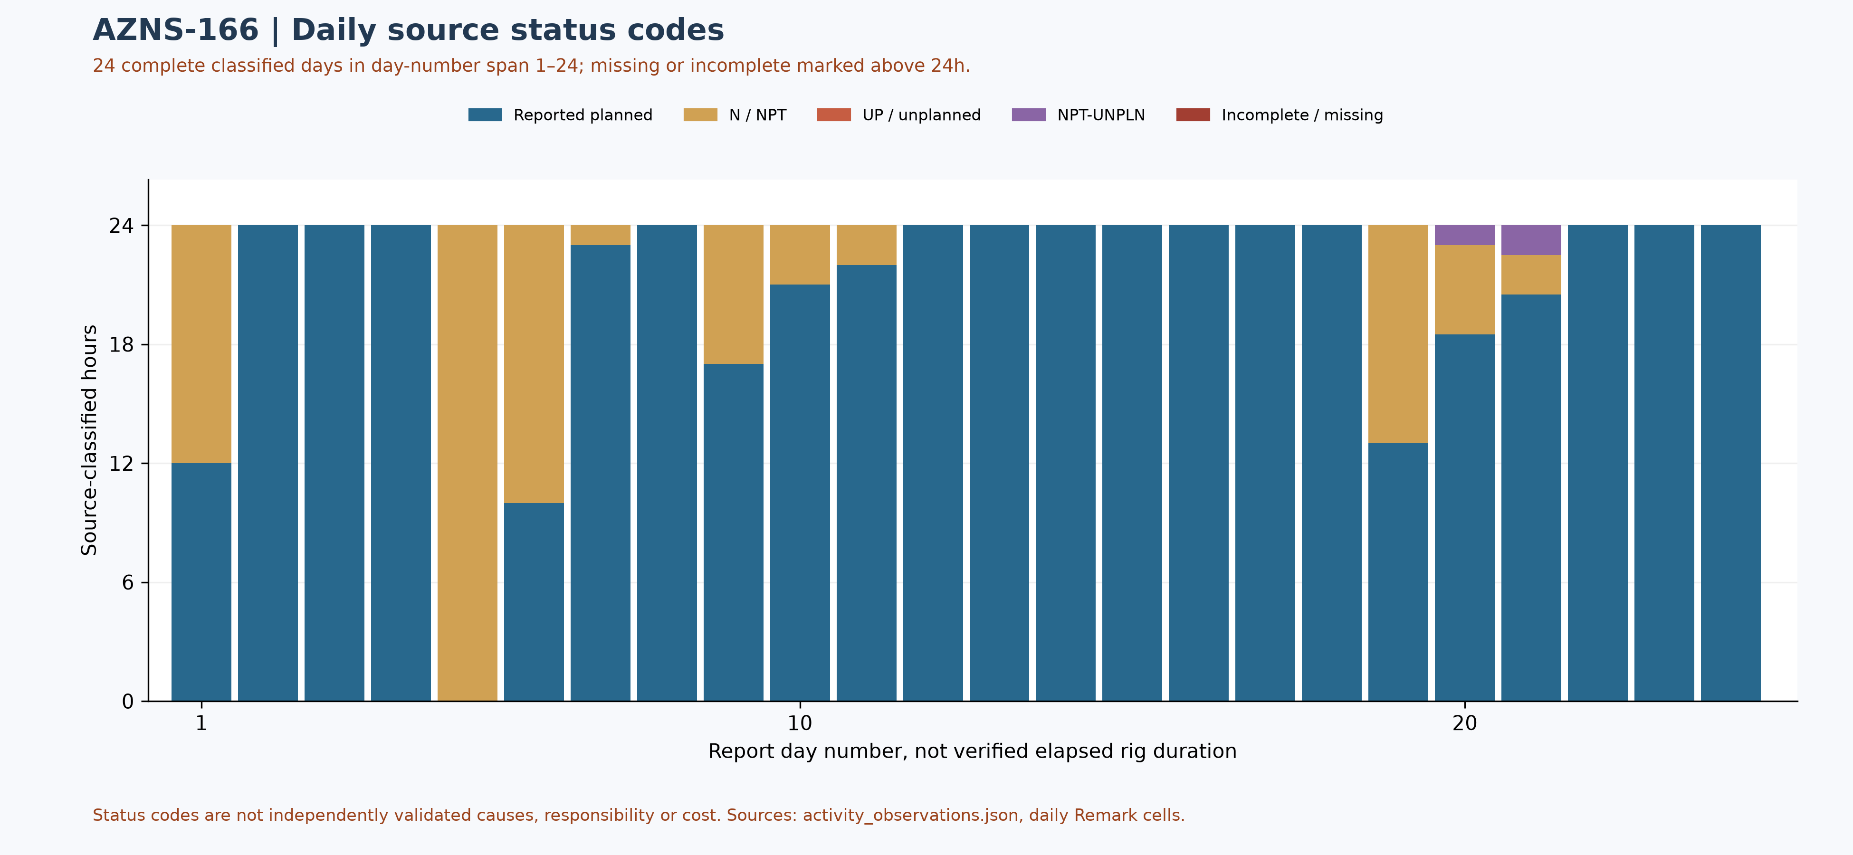
Figure W2 — Daily source-code composition in complete reports, with partial coverage

Performance and Parameter Analysis
Performance coverage: 24 status pages with classified durations totalling approximately 24 hours are used, out of 24 recognized status pages. Planned does not prove productive time; NPT, unplanned and mixed codes are distinct. Omitted hours are not zero; activity families, causes and total operation duration are not established by this table.
Source status code | Hours in complete reports | Share of classified hours
Reported planned | 493.00 | 85.6%
N / NPT | 80.50 | 14.0%
UP / unplanned | 0.00 | 0.0%
NPT-UNPLN (mixed) | 2.50 | 0.4%
Table 4-1 — Source status codes in recognized complete reports, not causal categories
Progress and phase-rate comparisons require reconciliation of scope, time and activity. Report-end depth is not tool depth or instantaneous rate.
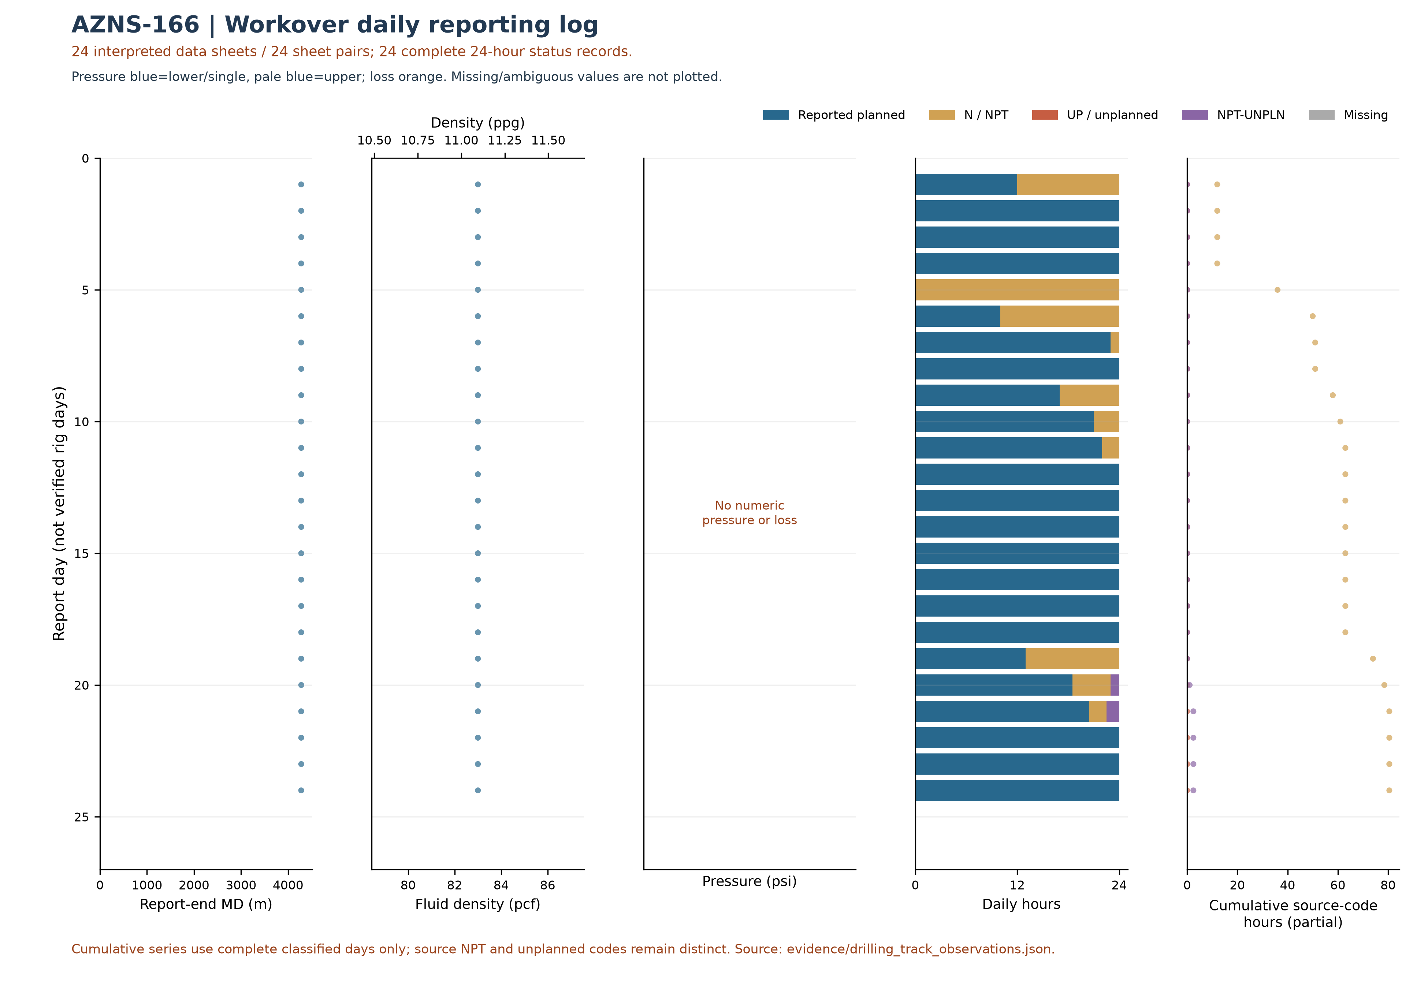
Figure W3 — Workover daily source observations by report day, AZNS-166
W3 uses the data-linked extraction: its coverage and hours may be smaller than W2 and W4, which assess status pages independently of data sheets. Missing or unrecognized data sheets are not added as W3 observations.
The workover log uses only 24 recognized data sheets of 24 sheet pairs and 24 reports with classified durations totaling approximately 24 hours. Unknown values are not treated as zero. Planned does not necessarily mean productive; cumulative code totals include only complete classified days; NPT and unplanned remain distinct and these are not verified total NPT or work progress. Report-end depth is not necessarily tool or incident depth.
Bit | Rerun | Type / size | Max cumulative m / source | Max cumulative h / source | Dull in sheet order
— | — | No numeric bit ID recognized | — | — | —
Table 4-2 — Identified bit observations and cumulative-counter sources.
Unassigned tool observations — grouped only by identical text, not verified runs.
Unassigned raw ID | Reported size / type | Entries | First source
— | 8-3/8" M.M.J.Mill ( New ) / — | 1 | 9-2 DDR Data!E11
— | 6" M.M.J.Mill ( New ) / — | 4 | 10-2 DDR Data!E11
— | 3-1/2" M.M.J.Mill ( New ) / — | 4 | 13-2 DDR Data!G11
— | 6" M.M.J.Mill ( Used ) / — | 4 | 15-2 DDR Data!G11
Bit evidence is preliminary: source AZNS166Pack.xlsx; 24 data sheets were recognized from 24 candidate sheet pairs. 13 tool-column entries lack an unambiguous numeric bit ID. A cumulative-counter maximum is not necessarily incremental run performance; bit-number reuse, rerun, metadata conflicts and dull reports require reconciliation. Workbook order does not prove chronology; the displayed dull observation is not necessarily final. Missing values are not zero.
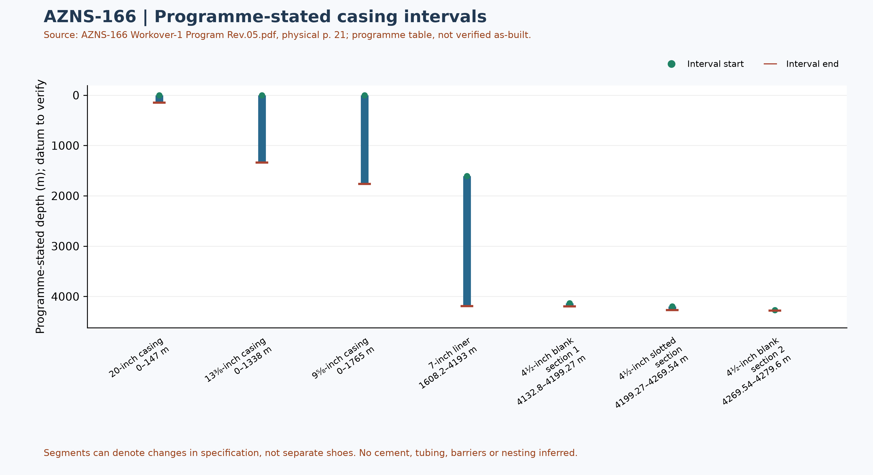
Figure W6 — Programme-stated casing intervals; not a verified as-built schematic

Drilling Fluid Engineering and Loss Accounting
This table summarizes numeric entries recovered from 24 recognized data sheets out of 24 candidate pairs. Each extreme has a source-cell example; coverage, simultaneity, units and test quality require verification. Minima and maxima are not a design window or current fluid condition.
Source observation | Numeric entries | Minimum and cell | Maximum and cell
Mud weight (pcf) | 24 | 83 [1-2 DDR Data!L9] | 83 [1-2 DDR Data!L9]
Plastic viscosity (cP) | 16 | 11 [9-2 DDR Data!L12] | 14 [1-2 DDR Data!L12]
Yield point (lb/100 ft²) | 16 | 11 [7-2 DDR Data!L13] | 12 [1-2 DDR Data!L13]
Source downhole loss (bbl) | 0 | No numeric entry recognized | No numeric entry recognized
Table 5-1 — Partial source-cell fluid and loss observations
A blank or nonnumeric entry is not zero. The source loss field is labelled downhole or formation loss volume; no sum or formation attribution is calculated until reporting basis, cumulative versus daily treatment and duplication are reconciled. Reconcile cell values with operational remarks and materials use separately.

Completion, Casing and Service-Module Findings
Programme element | Interval start, m | Interval end, m | Source specification
20-inch casing | 0 | 147 | K-55, 94#, BTC
13⅜-inch casing | 0 | 1338 | N-80, 68#, BTC
9⅝-inch casing | 0 | 1765 | L-80, 47#, PJE / TPCQ
7-inch liner | 1608.2 | 4193 | L-80, 29#, TPCQ
4½-inch blank section 1 | 4132.8 | 4199.27 | L-80, 13.5#, BTC
4½-inch slotted section | 4199.27 | 4269.54 | L-80, 13.5#, BTC
4½-inch blank section 2 | 4269.54 | 4279.6 | L-80, 13.5#, TPCQ
Table 6-1 — Casing and liner intervals in AZNS-166 Workover-1 Program Rev.05.pdf, physical p. 21
Programme casing scope: these values transcribe the programme table and describe historical or pre-operation conditions, not a verified final wellbore. Endpoints of specification segments are not necessarily shoes or hangers; datum, actual configuration, tally and barrier integrity require approved records.
The next figure displays only recognized bit and tool evidence; casing and cost evidence are presented in their respective sections. This is not a verified run count or continuous log.
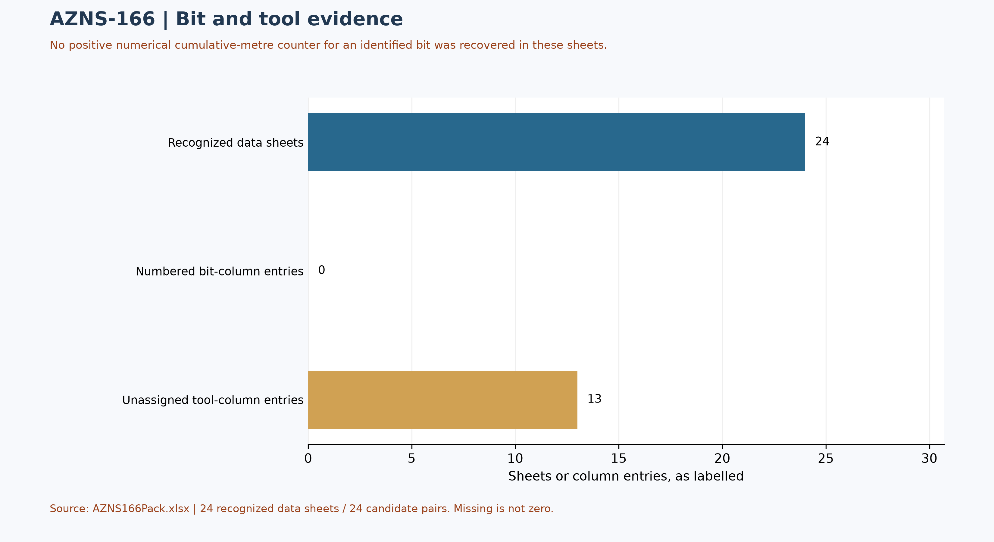
Figure W7 — Bit/tool evidence coverage, not a run count

Selected daily BHA components and hydraulic review
At least one nonempty recognized-format block was recovered in 10 of 24 data sheets. The table selects four rows from one block in AZNS166Pack.xlsx, sheet 9-2 DDR Data; it is not the entire string, all runs, or the current well condition. A repeated identifier or parallel columns do not establish the number of runs.
Selected component and cell | Recorded outside diameter and cell | Evidence scope
M.M.J.mill [B48] | 8-3/8" [C48] | Source observation
Bit Sub [B49] | 6-1/2" [C49] | Source observation
Scraper [B50] | 9-5/8" [C50] | Source observation
D.C [B51] | 6-1/2" [C51] | Source observation
Table 6-2 — Selected source block components and recorded dimensions
Physical programme page 33 is a navigation anchor for the planned BHA discussion; matching phase or agreement with this daily example is not established. Reconcile stated dimensions with the component name, count, length, inside diameter, connection limits, sequence, run record and manufacturer data. Hydraulic review requires verified inside and outside diameters and annular geometry for each section, simultaneous flow and fluid properties, nozzle and surface-loss information and pressure calibration. Without these inputs, pressure loss, annular velocity, hole cleaning and a reliable operating window cannot be calculated; W3 alone is not a design.

Source-coded non-planned time and partial coverage
Only 24 daily reports with classified durations totalling approximately 24 hours were included out of 24 candidate sheet pairs. These are source-code hours, not a verified total for the operation; incomplete or unrecognized days are not zero. Status pages are recognized independently of data pages; row-level cells are retained in evidence/activity_observations.json.
Table 7-1 — Source-code hours in complete reports; references are examples.
Source code | Hours in coverage | Example status and duration cells
N / NPT | 80.50 | 1-1 DDR Remark!M25,E25 ; 5-1 DDR Remark!M25,E25
UP / unplanned | 0.00 | None in included complete days
NPT-UNPLN | 2.50 | 20-1 DDR Remark!M36,E36 ; 21-1 DDR Remark!M25,E25
Activity codes alone do not establish root cause or contractual responsibility. Legacy mechanism claims, contractor attribution and financial exposure are withdrawn pending review of actual daily narrative, contracts and event evidence. Different source codes must not be presented as a single NPT definition.
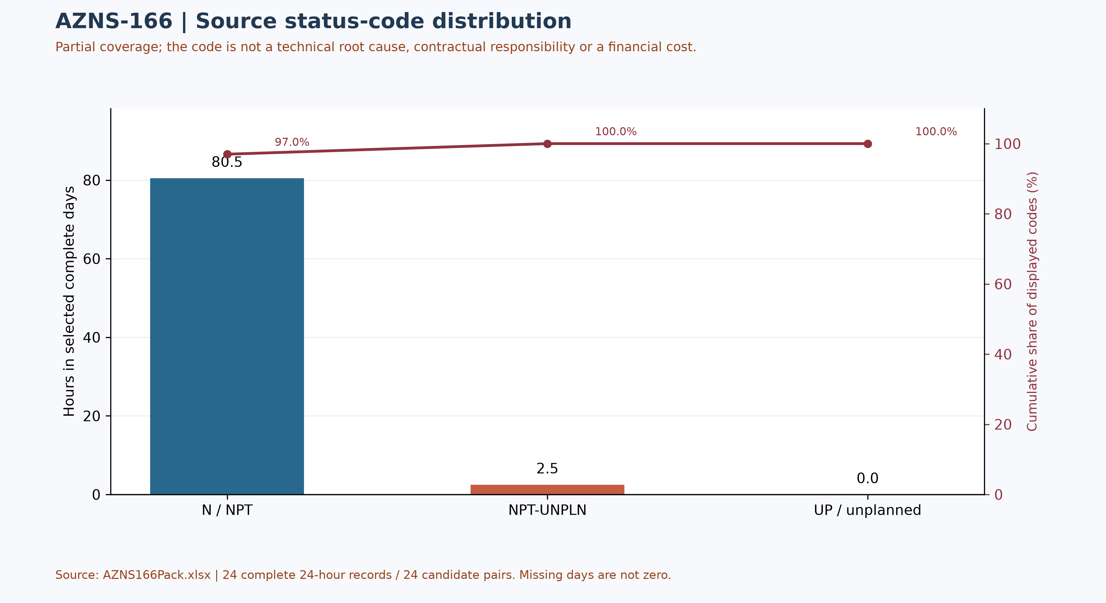
Figure W4 — Pareto of source status codes in complete days, not technical causes

CBS Financial Analysis and Provisional Cost Categories
Table 8-2 source: CBS AZNS-166.xlsx / Cost Breakdown-166. Categories are derived by summing numeric cached values within each cited row range; scope and formulas remain unverified. These cached source amounts are not actual expenditure or an approved comparable budget. Missing or erroneous values are not zeros; rates, scope, formulas and approvals require reconciliation. No daily expenditure series has been verified.
Source / scope | Cached value | Cell / sheet
Cached main-sheet total; scope unverified | 2,118,462.01 | F197 / Cost Breakdown-166
Source ceiling; scope to reconcile | 9,087,998.52 | C5 / Total Cost-EPD & Rigless
Table 8-1 Source financial and schedule anchors (unreconciled).
Source category | Source amount (USD) | Amount cell
Rig service | 1,017,455.31 | F5:F5
Drilling fluids | 388,980.52 | F6:F12
Cementing | 0.00 | F13:F19
Mud logging | 49,435.06 | F20:F23
Wireline logging | 0.00 | F24:F65
Drilling waste management | 88,754.17 | F66:F77
Directional drilling | 0.00 | F78:F90
Casing running | 55,627.00 | F91:F98
Temporary well suspension | 0.00 | F99:F102
Slickline | 25,598.00 | F103:F105
Completion running | 30,000.00 | F106:F117
Liner hanger running | 0.00 | F118:F126
H2S service | 9,289.81 | F127:F129
Perforation | 0.00 | F130:F134
Wellhead services | 18,000.00 | F135:F139
Dry test services | 0.00 | F140:F142
Rig / completion services | 153,378.80 | F143:F152
Other services | 22,118.59 | F153:F156
Cleanup services | 44,376.00 | F157:F163
Drilling materials | 0.00 | F164:F172
Project management | 176,948.75 | F173:F175
Engineering | 28,500.00 | F176:F186
Tubing inspection | 0.00 | F187:F194
Wellhead / tree inspection | 5,000.00 | F195:F195
Downhole completion inspection | 5,000.00 | F196:F196
Table 8-2 CBS source categories and cell references (unreconciled).
Topic | Observation | Source reference | Action
Scope / actuals | Values are not actual invoices or an approved comparable ceiling. | Source sheet and formulas | Reconcile
Table 8-3 CBS reconciliation checks.
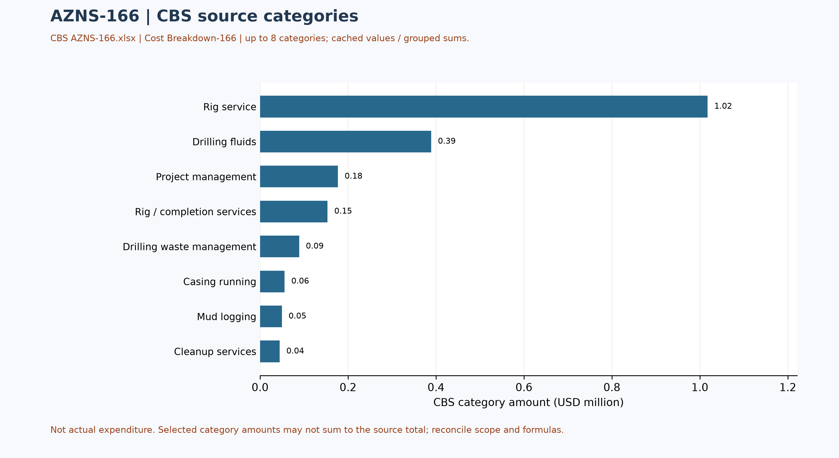
Figure W5 — CBS source cost categories, AZNS-166 (unreconciled)

Operational observations and engineering decision gates
Previous numerical operating envelopes were not validated and have been withdrawn. The entries below are examples of raw daily records only; tool location, phase, units and measurement validity require review. These observations are not safe limits, optimum windows or operating instructions.
Table 9-1 — Example recorded cells; units and measurement basis require verification.
Raw field | Example recorded value | Sheet and cell
Mud weight | 83 | 1-2 DDR Data!L9
Bit load / WOB | No interpretable numeric sample | —
RPM | No interpretable numeric sample | —
Flow | No interpretable numeric sample | —
Standpipe pressure | No interpretable numeric sample | —

Recommendations and review requirements
- Reconcile the programme revision, scope, start/end boundaries and rig/service time against daily reports and approved schedules before reporting a variance.
- Have responsible specialists verify well barriers and formation, casing and equipment limits against current approved records; no numerical design setpoint is established by this report.
- Reconcile bit identifiers, cumulative counters, tool assembly and failure evidence with original field and vendor records before selecting future equipment or diagnosing a mechanism.
- Reconcile costs with signed contracts, approved scope and invoices; do not convert source status-code hours into financial liability without a contractual assessment.

Risk-review checklist; ownership and severity not assigned
Review topic | Available evidence | Required follow-up
Well integrity and pressure | Programme objective and stated background, not proof of current condition | Reconcile tests, barriers and current approved limits
Incidents and recorded time | Partial source-code coverage in table 7-1 | Review event narrative, duration, cause and contract without presumed attribution
Equipment and operations | Example cells in table 9-1 and tool observations in table 4-2 | Verify units, calibration, tool identity and vendor records
Schedule and cost | Programme page and cost-breakdown evidence | Reconcile scope, invoices, time basis and approved revision

Data Provenance and Cell-Level Traceability
Every quantitative statement in this report resolves to a workbook, a worksheet and a cell. The table below lists the primary anchors used in the reconstruction; the remainder follows the same convention and is reproducible from the archive without manual interpretation.
Data element | Archive anchor (file -> sheet!cell)
rig | 1-1 DDR Remark!AB4
contractor | 1-1 DDR Remark!AB5
project | 1-1 DDR Remark!AB3
gle | 1-1 DDR Remark!AB7
report_no | 1-1 DDR Remark!AL5
act_days | 1-1 DDR Remark!AL4
depth:md_0000 | 1-1 DDR Remark!R9
depth:md_2400 | 1-1 DDR Remark!R10
depth:md_0600 | 1-1 DDR Remark!R11
mud:mud_type | 1-2 DDR Data!R8C12
mud:mw | 1-2 DDR Data!R9C12
mud:funnel_visc | 1-2 DDR Data!R11C12
mud:pv | 1-2 DDR Data!R12C12
mud:yp | 1-2 DDR Data!R13C12
CBS cost breakdown | CBS AZNS-166.xlsx -> sheet "Cost Breakdown-166"
Planned duration | CBS AZNS-166.xlsx -> CBS time-breakdown "AZNS-166 WO "
Well programme | AZNS-166 Workover-1 Program Rev.05.pdf
Table 11-1 Provenance anchors.

Appendix: source formation-table snapshot (unverified)
Source: AZNS166Pack.xlsx, sheet 24-2 DDR Data. Selected as the last sheet in workbook order with a recognized formation table containing a numeric depth; if none, the last table with formation names. This is not necessarily the latest dated report.
Column roles follow the source labels, not independent confirmation of prognosis or measurement. Unlabelled populated cells are shown separately; missing cells are unknown, not zero. Values are rounded to four decimals for display. Verify row alignment, depth datum, possible inconsistencies and lithology against the programme and geological report; this table alone does not establish event attribution or operating instructions.
Source table and anchor: Formation Top Data / N80
Formation / cell | Source values / cell
L. Gurpi / N82 | Lithology: Arg Lst [R82]
Ilam / N83 | Lithology: Mrl & Shale & Arg Lst [R83]
Lafan / N84 | Lithology: Clast [R84]
Sarvak / N85 | Lithology: Lst & Arg Lst [R85]
Kazhdumi / N86 | Lithology: Arg Lst [R86]
Dariyan / N87 | Lithology: Lst [R87]
Gadvan / N88 | Not recorded

Programme source summary and comparison limitations
Source: AZNS-166 Workover-1 Program Rev.05.pdf, physical page 7. Programme objective: Remove and rerun completion; the stated producer is Kazhdumi through a 4½-inch slotted liner. Stated programme duration, in days: 44.2 main; 95 contingency. The programme states measured depth 4280 m and producer/reservoir formation Kazhdumi; these do not by themselves establish achieved depth or current condition. Time boundaries, scope and contingency interpretation require reconciliation.

