ENGINEERING REVIEW WARNING — This legacy report is not validated for operational or financial decisions. The former linear cumulative-cost chart was removed; a verified daily cost series is not yet available; other charts, budgets and cause/formation attribution require reconstruction and reconciliation to source records. See the repository review note for the limited corrections made.
AZNS-127 WO2
Drilling, Workover and Well-Intervention Engineering Report
Technical, Operational, Contractual and Financial Analysis
Interim source review for South Azadegan; engineering approval pending

Item | Value
Well / operation | 127WO2
Daily-report pack | AZNS127WOPack.xlsx
Cost workbook | CBS AZNS-127WO2.xlsx
Well programme | AZNS-127 Workover #2 Program Rev.03.pdf
Status | Interim draft; source reconciliation and engineering approval required

Document control | Status
Official document code | Not established
Revision / status | Interim draft; not issued or approved
Official issue date | Not established
Preparation | Automated analytical draft
Specialist review | Completion and approval not established
Approval and distribution | Not established
Table 0-1 — Document control and review status.
This interim report compiles available records; its legacy analyses are not independently validated.

Executive KPI Summary
KPI | Value and scope
Programme-stated duration | 45.9 main; 110.8 contingency [physical p.7]
Recognized status pages | 68
Status pages with approximately 24 h classified | 67
Recognized data pages | 68
Numeric downhole-loss entries | 0
Maximum single source loss entry, bbl | No numeric entry recognized
Actual duration, total loss and actual cost | Not reconciled; not inferred from these observations

Legacy duration and NPT figures in this report remain subject to source reconciliation. Actual expenditure is not established.

Contents
No. | Section
1 | Well Identity, Rig Assignment and Data Inventory
2 | Planned versus Actual Execution Reconciliation
3 | Selected daily-report observations
4 | Performance and Parameter Analysis
5 | Drilling Fluid Engineering and Loss Accounting
6 | Completion, Casing and Service-Module Findings
7 | Source-coded non-planned time and partial coverage
8 | CBS Financial Analysis and Provisional Cost Categories
9 | Operational observations and engineering decision gates
10 | Risk-review checklist; ownership and severity not assigned
11 | Data Provenance and Cell-Level Traceability
12 | Appendix: source formation-table snapshot (unverified)
13 | Programme source summary and comparison limitations

Figures and tables are numbered by section and are listed in place.

Well Identity, Rig Assignment and Data Inventory
This interim report references AZNS127WOPack.xlsx and AZNS-127 Workover #2 Program Rev.03.pdf. The archive was indexed, but semantic extraction and verification remain incomplete; see the evidence notes and source inventory. Static identity and rig assignments below are legacy-compiled and require verification against cited source cells and approved records.

Static identity
Field | Recorded value
Well name in daily report | Work over # 2, AZNS-127
Well type declaration | Vertical
Field | AZNS
Client | PPL
Drilling contractor | OEOC
Rig | 201 OEOC
Operation classification | Workover / Completion
Hole section / scope declaration | as per programme
Spud / first report date | 2025-12-29
Release / last report date | 2026-03-06
Table 1-1 Static well identity.

Data inventory discovered for this operation
Source / extraction | Recognition and limitation
Daily pack | AZNS127WOPack.xlsx
Status pages | 68 recognized; 67 with approximately 24 classified hours
Data pages | 68 of 68 candidate pairs
CBS workbook | CBS AZNS-127WO2.xlsx; cached values and scope require reconciliation
Programme PDF | AZNS-127 Workover #2 Program Rev.03.pdf; information page 7
Limitation | Recognition or absence in an extraction does not establish complete archive coverage
Table 1-2 Core and auto-discovered bonus modules.
The legacy module inventory requires review; absence from an extraction does not establish absence from the entire archive.

Planned versus Actual Execution Reconciliation
The programme AZNS-127 Workover #2 Program Rev.03.pdf, physical page 7, states the following objective: Remove and rerun completion; the programme lists existing perforations in the 4½-inch liner. The stated duration in days is 45.9 main; 110.8 contingency. Contingency figures retain the source labels and should not be added or compared with execution without reconciliation.
Reconciliation metric | Planned | Actual | Variance
Programme-stated duration (days) | 45.9 main; 110.8 contingency | Not reconciled | Not reconciled
Depth reached / target (m MD) | Not reconciled | Not reconciled | Not reconciled
Cost (USD) | Not reconciled | Not reconciled | Not reconciled
Cost per rig day (USD) | Not reconciled | Not reconciled | Not reconciled
NPT share of rig time (%) | Not reconciled | Not reconciled | Not reconciled
Table 2-1 Planned versus actual reconciliation.
A planned-versus-actual duration comparison is not established until revision, scope, daily reports and time boundaries are reconciled; the previous ratio and causal attribution are withdrawn.
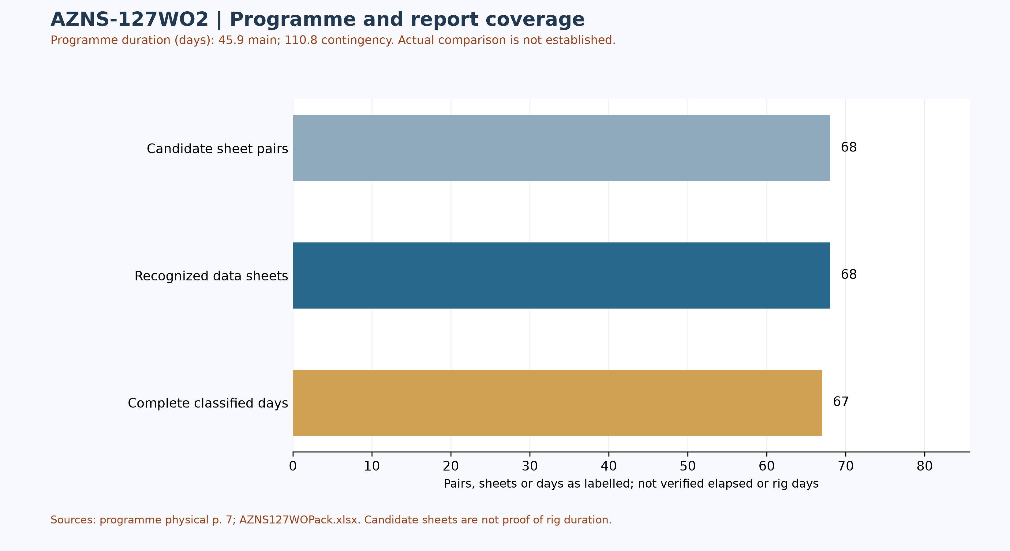
Figure W1 — Daily-record coverage and stated programme duration; actual comparison unverified
Status-page coverage is assessed independently: 68 status pages and 68 data sheets were recognized; 67 status pages contain classified durations totalling approximately 24 hours. Some reports have a status page but an absent or differently formatted data page. These counts are not verified rig duration.

Selected programme phases and limited execution evidence
The phases below are selected programme statements, not proof of execution or of the final approved revision. The selected daily observations are quoted separately; a similar topic alone does not establish phase timing, completion or deviation.
Programme — The main objective is completion removal and recompletion; the opening steps include wellhead checks and slickline operations. [AZNS-127 Workover #2 Program Rev.03.pdf, physical p. 45]
Programme — The programme describes installing and testing BOPs before retrieving the completion. [AZNS-127 Workover #2 Program Rev.03.pdf, physical p. 45]
Source worksheet 18 — The report records setting and pressure-testing the tubing-hanger valve to 7,000 psi, with an OK result as written. [AZNS127WOPack.xlsx, 18-1 DDR Remark!S33]
Source worksheet 44 — The report says 44 m of the fish was recovered while dismantling the fishing assembly; it does not by itself establish complete fish recovery. [AZNS127WOPack.xlsx, 44-1 DDR Remark!S35]
Services listed in the programme: drilling and completion fluids: VIRA; waste management: Pars Hafaran Arvand; electrical logging and perforation: SEALAND; mud logging: MAPSA KISH. [AZNS-127 Workover #2 Program Rev.03.pdf, physical p. 42] These are programme assignments, not evidence of actual deployment, contractual award, cost or incident liability.

Worksheet-prefix and report-header reconciliation
Of 68 recognized status pages, the reported header number differs from the worksheet-name prefix on 0 pages; 0 headers have no readable numeric value. Axes based on worksheet prefix are not official report numbers or chronologies. Reconcile each entry's number, date and time with the header and signed records. Cell-level details are in evidence/sheet_report_number_audit.json.

Status-page header-date audit
Of 68 recognized status pages, 68 header dates were readable under narrow rules; 0 remain uninterpreted because of ambiguous format, missing data or volatile formula. Among adjacent recognized worksheets with readable dates in prefix order, 0 go backwards and 0 repeat a date. These counts alone do not prove an error, operating days or true sequence. Volatile date formulas occur on 0 pages. Even readable Excel dates can be wrong in the source or locale; reconcile against signed records. [evidence/status_report_date_audit.json]

Selected daily-report observations
Of 68 recognized status pages, 67 contain classified durations totalling approximately 24 hours. Planned, NPT and unplanned labels are source classifications; they do not independently establish cause, liability or total operation duration. The following examples are selective; complete extracted detail cells are retained in evidence/activity_observations.json.
Source worksheet 18 — The report records setting and pressure-testing the tubing-hanger valve to 7,000 psi, with an OK result as written. [AZNS127WOPack.xlsx, 18-1 DDR Remark!S33]
Source worksheet 44 — The report says 44 m of the fish was recovered while dismantling the fishing assembly; it does not by itself establish complete fish recovery. [AZNS127WOPack.xlsx, 44-1 DDR Remark!S35]
These are source statements, not independent verification of a test, failure mechanism, current well condition or an operating instruction. A description may continue into the next cell; reconcile the complete row and time before making decisions.

Additional selected daily-report evidence
These three entries are ordered by worksheet prefix, not necessarily report number; sheet order alone does not establish event time, complete chronology, operational completion or current well condition. Test outcomes are source labels and require reconciliation with signed charts and the tested scope.
Source worksheet 15 — The entry describes a slickline tool string becoming stuck during retrieval and subsequently being freed; it does not establish the sticking mechanism. [AZNS127WOPack.xlsx, 15-1 DDR Remark!S34]
Source worksheet 44 — The report notes severe corrosion and washout observed on the retrieved fish; metallurgical mechanism and responsibility require separate evidence. [AZNS127WOPack.xlsx, 44-1 DDR Remark!S42]
Source worksheet 58 — The report describes pulling a wireline logging string for the 7-inch liner from 3,147 m to surface; the full logs are needed to interpret liner condition. [AZNS127WOPack.xlsx, 58-1 DDR Remark!S26]
The corrosion and washout note describes a retrieved object, not automatically the casing or the cause of the incident. Review photographs, identification and inspection before attributing a mechanism.
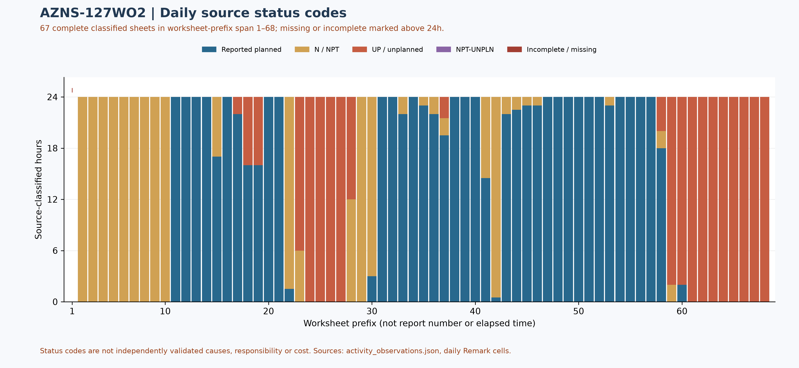
Figure W2 — Daily source-code composition in complete reports, with partial coverage

Selected AZNS-127 workover 2 and reported suspension reconstruction
These 26 selected entries are displayed by source header number; order and dates are not validated against signed records, and the selection does not cover every hour, barrier or present condition.
Worksheet 1, header report 1 — The page records rig spud at 12:00 on 1404.10.08 and a suspension while contractual clarification was sought. Its 12-hour wait is a source statement, not an independently established contract entitlement or verified start boundary. [AZNS127WOPack.xlsx, 1-1 DDR Remark!S25, S26, S27, S28, S29, S30, S31, S32]
Worksheet 6, header report 6 — The source describes the same wait as 132 hours from the earlier stated start. This is a running figure, not an additional 132 hours to add to the page-1 figure; entitlement requires signed time and contract records. [AZNS127WOPack.xlsx, 6-1 DDR Remark!S25, S26, S27, S28]
Worksheet 10, header report 10 — The source prints 228 cumulative waiting hours and refers to a client correspondence and anticipated contract actions. It does not itself prove that an addendum, final CBS or extra-work entitlement was actually approved; the running wait notes must not be summed. [AZNS127WOPack.xlsx, 10-1 DDR Remark!S25, S26, S27, S28, S34, S35, S36, S37, S38]
Worksheet 11, header report 11 — The page separately labels spud/start at 00:00 on 8 January 2026 and reports section-C annulus pressure of 4,900 psi. The earlier page's spud label is a different start boundary requiring reconciliation, not a basis for an automatic duration calculation. [AZNS127WOPack.xlsx, 11-1 DDR Remark!S25, S26, S27, S28, S29, S31]
Worksheet 14, header report 14 — The source records stepwise bleed-down followed by pressure buildup in the annulus and TWCV retrieval. These observations require the pressure history and integrity investigation; they do not prove a leak path or prescribe future well-control action. [AZNS127WOPack.xlsx, 14-1 DDR Remark!S25, S26, S27, S28, S29, S30, S31]
Worksheet 16, header report 16 — CT displacement is reported limited by pumping pressure, leading to CT pull-out and a separate well-kill operation in progress. Historical pressure and fluid parameters are not operational instructions or evidence of current well condition. [AZNS127WOPack.xlsx, 16-1 DDR Remark!S25, S26, S27, S28, S29, S30, S31, S32, S33, S34]
Worksheet 18, header report 18 — The source reports an unsuccessful check-valve passage attempt, a temporarily stuck slickline tool freed, and reservoir-fluid leakage at a chemical injection line during tree removal. The leakage path and root cause require independent records. [AZNS127WOPack.xlsx, 18-1 DDR Remark!S25, S26, S27, S28, S29, S30, S31, S32, S33, S34, S36, S37]
Worksheet 20, header report 20 — After an annular repair/test labelled OK, repeated ram-pressure tests failed due to reported BOP leakage. A later page describes repairs; this partial page is not final BOP-stack acceptance. [AZNS127WOPack.xlsx, 20-1 DDR Remark!S25, S26, S27, S28, S29, S30, S31]
Worksheet 21, header report 21 — The source records repairs and tests labelled OK, but attempts to unlatch the completion from its anchor seal remained unsuccessful. Historical loads and pressures must not be reused as operating recommendations. [AZNS127WOPack.xlsx, 21-1 DDR Remark!S25, S26, S27, S28, S29, S30, S31, S32, S33, S34, S36]
Worksheet 26, header report 26 — The page labels an integrity-test plan change as 90 hours of extra work and reports another failed passage at 3,089 m. The number is a source running figure and the contractual classification, overlap and approved entitlement remain unresolved. [AZNS127WOPack.xlsx, 26-1 DDR Remark!S25, S26, S27, S28, S29, S30, S31, S32]
Worksheet 28, header report 28 — The same source-labelled integrity-test change has a running 126-hour note and repeated unsuccessful plug/check-valve passage attempts. Do not add the 90 and 126-hour figures or equate the note with approved payment. [AZNS127WOPack.xlsx, 28-1 DDR Remark!S25, S26, S27, S28, S29, S31, S32, S34, S35, S36, S37, S44, S45, S46]
Worksheet 30, header report 30 — The source records a 57-hour running wait for explosive material and activates contingency 4 after unsuccessful unlatching. This waiting note has its own printed interval and must not be automatically added to the earlier integrity-test running figures. [AZNS127WOPack.xlsx, 30-1 DDR Remark!S25, S26, S27, S28, S29, S30, S43]
Worksheet 31, header report 31 — The page reports free-point readings, no indication on a first colliding shot, an indicated successful second shot and a subsequently freed string. These are source observations, not a complete approved fish or barrier inventory. [AZNS127WOPack.xlsx, 31-1 DDR Remark!S25, S26, S27, S28, S29, S30, S31, S32, S33, S34, S35, S36, S37, S38]
Worksheet 34, header report 34 — The page reports severe corrosion and a parted completion string. Its statement attributing failure to corrosion, washout and stretching is the source's cause assessment, not an independent failure analysis; component identification and remaining inventory require verification. [AZNS127WOPack.xlsx, 34-1 DDR Remark!S25, S26, S27, S28, S29, S30, S31, S32, S33, S34, S35, S36]
Worksheet 39, header report 39 — An overshot is reported to recover 14 m of the fish with severe corrosion and washout. Recovery of this portion does not establish complete fish recovery; later operations require separate review. [AZNS127WOPack.xlsx, 39-1 DDR Remark!S25, S26, S27, S28, S29, S30, S31, S42]
Worksheet 44, header report 44 — A later fishing run reports 44 m of fish recovered, including a pup joint and CIV#2, with source-observed corrosion. The 14 m and 44 m notes refer to separate reported runs; the complete joint tally is needed before any reconciled recovery total. [AZNS127WOPack.xlsx, 44-1 DDR Remark!S25, S26, S27, S28, S29, S30, S31, S32, S33, S34, S35, S36, S42]
Worksheet 46, header report 46 — The milling note prints SPP as 24500–2500 psi, while another entry on the same page prints 1500–2500 psi. Both strings are retained as source values; do not silently correct the first or use either as an operating setpoint. [AZNS127WOPack.xlsx, 46-1 DDR Remark!S25, S26, S27, S28, S29, S30, S31, S32, S33, S34, S35]
Worksheet 49, header report 49 — The report notes packer-element rubber and suspected slip metal on shakers, plus 1% LEL and a source hypothesis of trapped-gas release. The gas origin is not independently established and the observation does not prove all fragments were removed. [AZNS127WOPack.xlsx, 49-1 DDR Remark!S25, S26, S27, S28, S29, S30, S31, S32, S33, S34, S39, S40, S41, S42]
Worksheet 53, header report 53 — The source states all specified remaining completion equipment and packer tail were recovered, listing the packer, joint, No-Go and guide. This is a claim about the listed equipment, not proof that every piece of debris or all barriers are accounted for. [AZNS127WOPack.xlsx, 53-1 DDR Remark!S25, S26, S27, S28, S29, S30, S31, S32, S33]
Worksheet 57, header report 57 — The page reports CBIL/CDR/GR/CCL acquisition in the 7-inch liner, with a tension drop attributed to suspected trajectory issues. Log acquisition is not independent cement, corrosion or isolation interpretation, and the suspected cause remains unconfirmed. [AZNS127WOPack.xlsx, 57-1 DDR Remark!S25, S26, S27, S28, S29, S30, S31, S32, S33, S34]
Worksheet 60, header report 60 — The source records waiting for a decision from 24 February 2026 20:00, with a running note of 50 hours. It is not an increment to add to subsequent running wait notes. [AZNS127WOPack.xlsx, 60-1 DDR Remark!S25, S26, S27, S28, S39]
Worksheet 62, header report 62 — A cleanout run is reported to 4,134 m and a 98-hour running decision wait is printed. The depth is a source-reported run, not a continuous verified cleanout profile; wait figures must not be summed. [AZNS127WOPack.xlsx, 62-1 DDR Remark!S25, S27, S28, S39]
Worksheet 63, header report 63 — The report says that from 28 February 2026 the client was awaited for a suspension or remedial plan, citing war and unplanned well condition, and an open-ended assembly was run. This is the source's historical account, not independent verification of the circumstances or current condition. [AZNS127WOPack.xlsx, 63-1 DDR Remark!S25, S26, S27, S28, S29, S39, S40]
Worksheet 66, header report 66 — The source records two cement slurries of 12.2 and 19.9 bbl in separate stages, associated with stated 3,780 and 3,197 m references. Pumping and the printed depths alone do not certify plug top/bottom, pressure integrity, accepted suspension or present barriers. [AZNS127WOPack.xlsx, 66-1 DDR Remark!S25, S26, S27, S28, S29, S30, S31, S32, S33, S34, S35, S38, S39]
Worksheet 67, header report 67 — The page says the well was suspended per client instruction with two balanced cement-plug stages and records a four-hour static check. The source claim is not a signed suspension certificate or proof of plug integrity. [AZNS127WOPack.xlsx, 67-1 DDR Remark!S25, S26, S27, S28, S29, S39]
Worksheet 68, header report 68 — The last recognized page records a 12-hour static flow check, closure and zero pressure after monitoring, and a 242-hour running wait note. It does not state rig release, signed handover or current condition; 242 hours must not be added to earlier running figures. [AZNS127WOPack.xlsx, 68-1 DDR Remark!S25, S26, S27, S39]
Programme p.7 prints 45.9 main + 110.8 contingency days; relationship, scope and boundaries require approved-plan reconciliation and are not actual duration. CBS caches ceilings of USD 7,690,783.61 for re-entry/completion/procurement and USD 851,933.44 for rig-less stimulation, total USD 8,542,717.05. The formula was not recalculated; a ceiling is not actual expenditure or evidence of stimulation execution. [AZNS-127 Workover #2 Program Rev.03.pdf, p.7; CBS AZNS-127WO2.xlsx, Total Cost-EPD & Rigless!B3:C5; evidence/127wo2_campaign_review.json]

Performance and Parameter Analysis
Performance coverage: 67 status pages with classified durations totalling approximately 24 hours are used, out of 68 recognized status pages. Planned does not prove productive time; NPT, unplanned and mixed codes are distinct. Omitted hours are not zero; activity families, causes and total operation duration are not established by this table.
Source status code | Hours in complete reports | Share of classified hours
Reported planned | 862.50 | 53.6%
N / NPT | 359.00 | 22.3%
UP / unplanned | 386.50 | 24.0%
NPT-UNPLN (mixed) | 0.00 | 0.0%
Table 4-1 — Source status codes in recognized complete reports, not causal categories
Progress and phase-rate comparisons require reconciliation of scope, time and activity. Report-end depth is not tool depth or instantaneous rate.
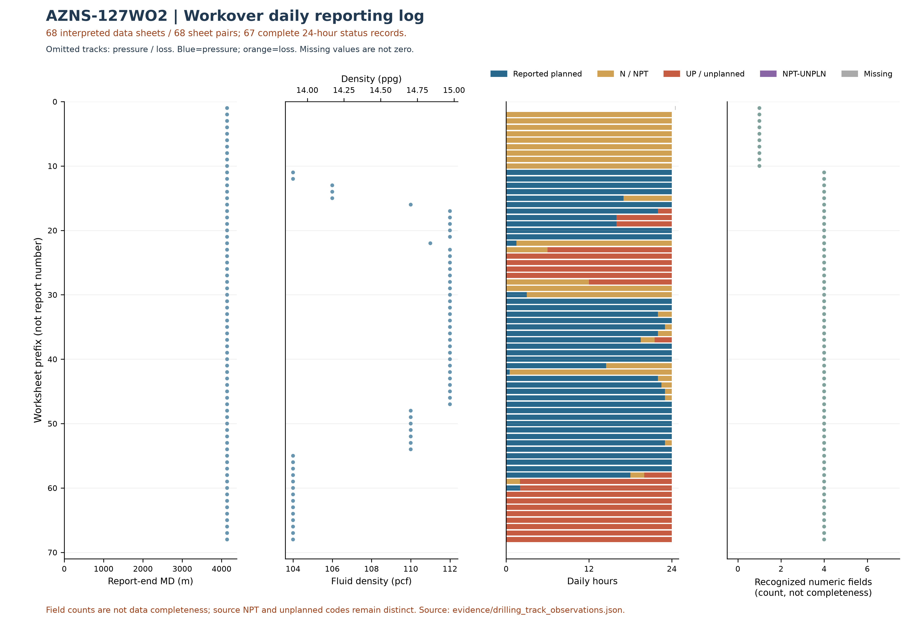
Figure W3 — Workover source observations by worksheet prefix, AZNS-127WO2
W3 uses the data-linked extraction: its coverage and hours may be smaller than W2 and W4, which assess status pages independently of data sheets. Missing or unrecognized data sheets are not added as W3 observations.
This plot uses 68 recognized data sheets and 67 pages with classified durations totaling approximately 24 hours. Its axis is worksheet prefix, not report number or continuous time; for some workbooks sheet order is not chronological. Numeric-field counts are not data completeness. NPT and unplanned codes remain distinct; missing is not zero and report-end depth is not necessarily tool or event depth.
Bit | Rerun | Type / size | Max cumulative m / source | Max cumulative h / source | Dull in sheet order
— | — | No numeric bit ID recognized | — | — | —
Table 4-2 — Identified bit observations and cumulative-counter sources.
Bit evidence is preliminary: source AZNS127WOPack.xlsx; 68 data sheets were recognized from 68 candidate sheet pairs. 0 tool-column entries lack an unambiguous numeric bit ID. A cumulative-counter maximum is not necessarily incremental run performance; bit-number reuse, rerun, metadata conflicts and dull reports require reconciliation. Workbook order does not prove chronology; the displayed dull observation is not necessarily final. Missing values are not zero.
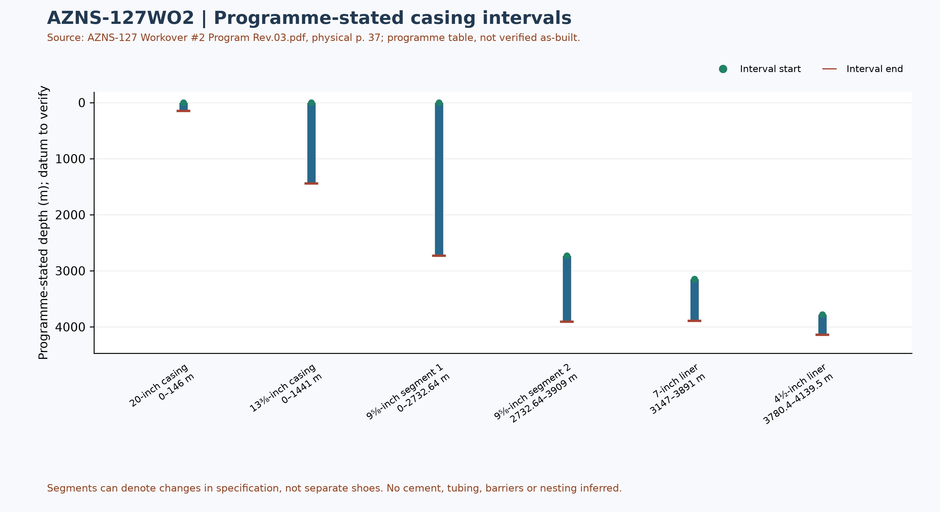
Figure W6 — Programme-stated casing intervals; not a verified as-built schematic

Drilling Fluid Engineering and Loss Accounting
This table summarizes numeric entries recovered from 68 recognized data sheets out of 68 candidate pairs. Each extreme has a source-cell example; coverage, simultaneity, units and test quality require verification. Minima and maxima are not a design window or current fluid condition.
Source observation | Numeric entries | Minimum and cell | Maximum and cell
Mud weight (pcf) | 58 | 104 [11-2 DDR Data!L9] | 112 [17-2 DDR Data!L9]
Plastic viscosity (cP) | 58 | 20 [11-2 DDR Data!L12] | 34 [24-2 DDR Data!L12]
Yield point (lb/100 ft²) | 58 | 12 [11-2 DDR Data!L13] | 17 [59-2 DDR Data!L13]
Source downhole loss (bbl) | 0 | No numeric entry recognized | No numeric entry recognized
Table 5-1 — Partial source-cell fluid and loss observations
A blank or nonnumeric entry is not zero. The source loss field is labelled downhole or formation loss volume; no sum or formation attribution is calculated until reporting basis, cumulative versus daily treatment and duplication are reconciled. Reconcile cell values with operational remarks and materials use separately.

Selected mud-material source entries
Table 5-2 selects source-used entries from two sheets of AZNS127WOPack.xlsx. Recognizable materials headers were found in 68 of 68 data sheets; this count does not validate completeness or correctness of inventory or usage. Used-column header cells and row units are retained in the evidence file.
Selected sheet | Material and cell | Used value and cell | Source unit and cell
11-2 DDR Data | Limestone [N10] | 116 [P10] | 1MT/BB [S10]
11-2 DDR Data | Salt [N11] | 36 [P11] | 1 MT/BB [S11]
11-2 DDR Data | Lime [N12] | 10 [P12] | 25 KG/SX [S12]
12-2 DDR Data | Limestone [N10] | 61 [P10] | 1MT/BB [S10]
12-2 DDR Data | Salt [N11] | 21 [P11] | 1 MT/BB [S11]
12-2 DDR Data | Lime [N12] | 5 [P12] | 25 KG/SX [S12]
Table 5-2 — Selected mud-material used-column entries; units as printed
The used column is distinct from received, cumulative received and stock. Repeated material or values across sheets are not necessarily independent consumption; blanks and errors are not zero. Verify package size, unit abbreviation, reporting period, opening and closing balance, receipts, usage and mixing records before totals or conversion. These entries alone do not establish downhole use, treatment of losses or causality with fluid properties.

Completion, Casing and Service-Module Findings
Programme element | Interval start, m | Interval end, m | Source specification
20-inch casing | 0 | 146 | K-55, 94#, BTC
13⅜-inch casing | 0 | 1441 | N-80, 68#, BTC
9⅝-inch segment 1 | 0 | 2732.64 | T-95, 53.5#, TPCQ
9⅝-inch segment 2 | 2732.64 | 3909 | T-95, 53.5#, TSH Blue
7-inch liner | 3147 | 3891 | 110 SS, 29#, TPCQ
4½-inch liner | 3780.4 | 4139.5 | 110 S, 13.5#, TPG2
Table 6-1 — Casing and liner intervals in AZNS-127 Workover #2 Program Rev.03.pdf, physical p. 37
Programme casing scope: these values transcribe the programme table and describe historical or pre-operation conditions, not a verified final wellbore. Endpoints of specification segments are not necessarily shoes or hangers; datum, actual configuration, tally and barrier integrity require approved records.
The next figure displays only recognized bit and tool evidence; casing and cost evidence are presented in their respective sections. This is not a verified run count or continuous log.
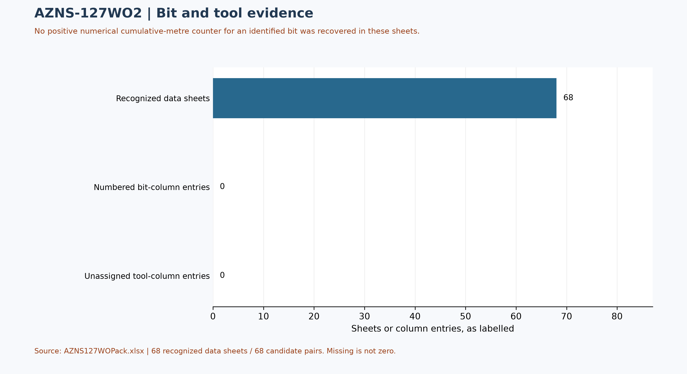
Figure W7 — Bit/tool evidence coverage, not a run count

Selected daily BHA components and hydraulic review
At least one nonempty recognized-format block was recovered in 34 of 68 data sheets. The table selects four rows from one block in AZNS127WOPack.xlsx, sheet 34-2 DDR Data; it is not the entire string, all runs, or the current well condition. A repeated identifier or parallel columns do not establish the number of runs.
Selected component and cell | Recorded outside diameter and cell | Evidence scope
5-5/8" O.Shot [B48] | 5-5/8" [C48] | Source observation
1 Jt 4-3/4" DC [B49] | 4-3/4" [C49] | Source observation
Fishing Jar [B50] | 4-3/4" [C50] | Source observation
1 Std 4-3/4" DC [B51] | 4-3/4" [C51] | Source observation
Table 6-2 — Selected source block components and recorded dimensions
Physical programme page 50 is a navigation anchor for the planned BHA discussion; matching phase or agreement with this daily example is not established. Reconcile stated dimensions with the component name, count, length, inside diameter, connection limits, sequence, run record and manufacturer data. Hydraulic review requires verified inside and outside diameters and annular geometry for each section, simultaneous flow and fluid properties, nozzle and surface-loss information and pressure calibration. Without these inputs, pressure loss, annular velocity, hole cleaning and a reliable operating window cannot be calculated; W3 alone is not a design.

Source-coded non-planned time and partial coverage
Only 67 daily reports with classified durations totalling approximately 24 hours were included out of 68 candidate sheet pairs. These are source-code hours, not a verified total for the operation; incomplete or unrecognized days are not zero. Status pages are recognized independently of data pages; row-level cells are retained in evidence/activity_observations.json.
Table 7-1 — Source-code hours in complete reports; references are examples.
Source code | Hours in coverage | Example status and duration cells
N / NPT | 359.00 | 2-1 DDR Remark!M25,E25 ; 3-1 DDR Remark!M25,E25
UP / unplanned | 386.50 | 17-1 DDR Remark!M30,E30 ; 18-1 DDR Remark!M25,E25
NPT-UNPLN | 0.00 | None in included complete days
Activity codes alone do not establish root cause or contractual responsibility. Legacy mechanism claims, contractor attribution and financial exposure are withdrawn pending review of actual daily narrative, contracts and event evidence. Different source codes must not be presented as a single NPT definition.
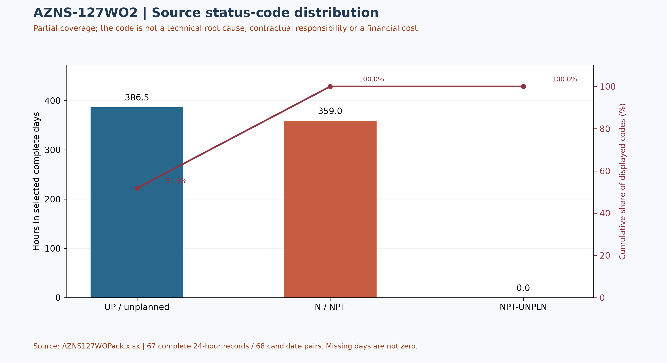
Figure W4 — Pareto of source status codes in complete days, not technical causes

CBS Financial Analysis and Provisional Cost Categories
Table 8-2 source: CBS AZNS-127WO2.xlsx / Cost Breakdown-127#2. Categories are derived by summing numeric cached values within each cited row range; scope and formulas remain unverified. These cached source amounts are not actual expenditure or an approved comparable budget. Missing or erroneous values are not zeros; rates, scope, formulas and approvals require reconciliation. No daily expenditure series has been verified.
Source / scope | Cached value | Cell / sheet
Cached main-sheet total; scope unverified | 2,097,864.51 | F197 / Cost Breakdown-127#2
Source ceiling; scope to reconcile | 8,542,717.05 | C5 / Total Cost-EPD & Rigless
Table 8-1 Source financial and schedule anchors (unreconciled).
Source category | Source amount (USD) | Amount cell
Rig service | 1,056,275.00 | F5:F5
Drilling fluids | 390,584.62 | F6:F12
Cementing | 0.00 | F13:F19
Mud logging | 51,321.19 | F20:F23
Wireline logging | 0.00 | F24:F65
Drilling waste management | 89,851.25 | F66:F77
Directional drilling | 0.00 | F78:F90
Casing running | 43,090.45 | F91:F98
Temporary well suspension | 0.00 | F99:F102
Slickline | 25,598.00 | F103:F105
Completion running | 30,000.00 | F106:F117
Liner hanger running | 0.00 | F118:F126
H2S service | 9,644.25 | F127:F129
Perforation | 0.00 | F130:F134
Wellhead services | 27,000.00 | F135:F139
Dry test services | 0.00 | F140:F142
Rig / completion services | 84,961.25 | F143:F152
Other services | 22,962.50 | F153:F156
Cleanup services | 44,376.00 | F157:F163
Drilling materials | 0.00 | F164:F172
Project management | 183,700.00 | F173:F175
Engineering | 28,500.00 | F176:F186
Tubing inspection | 0.00 | F187:F194
Wellhead / tree inspection | 5,000.00 | F195:F195
Downhole completion inspection | 5,000.00 | F196:F196
Table 8-2 CBS source categories and cell references (unreconciled).
Topic | Observation | Source reference | Action
Scope / actuals | Values are not actual invoices or an approved comparable ceiling. | Source sheet and formulas | Reconcile
Review comments | Some service/material exclusions are disputed in worksheet comments. | J12, Q12 / Total Cost-EPD | Check approvals
Table 8-3 CBS reconciliation checks.
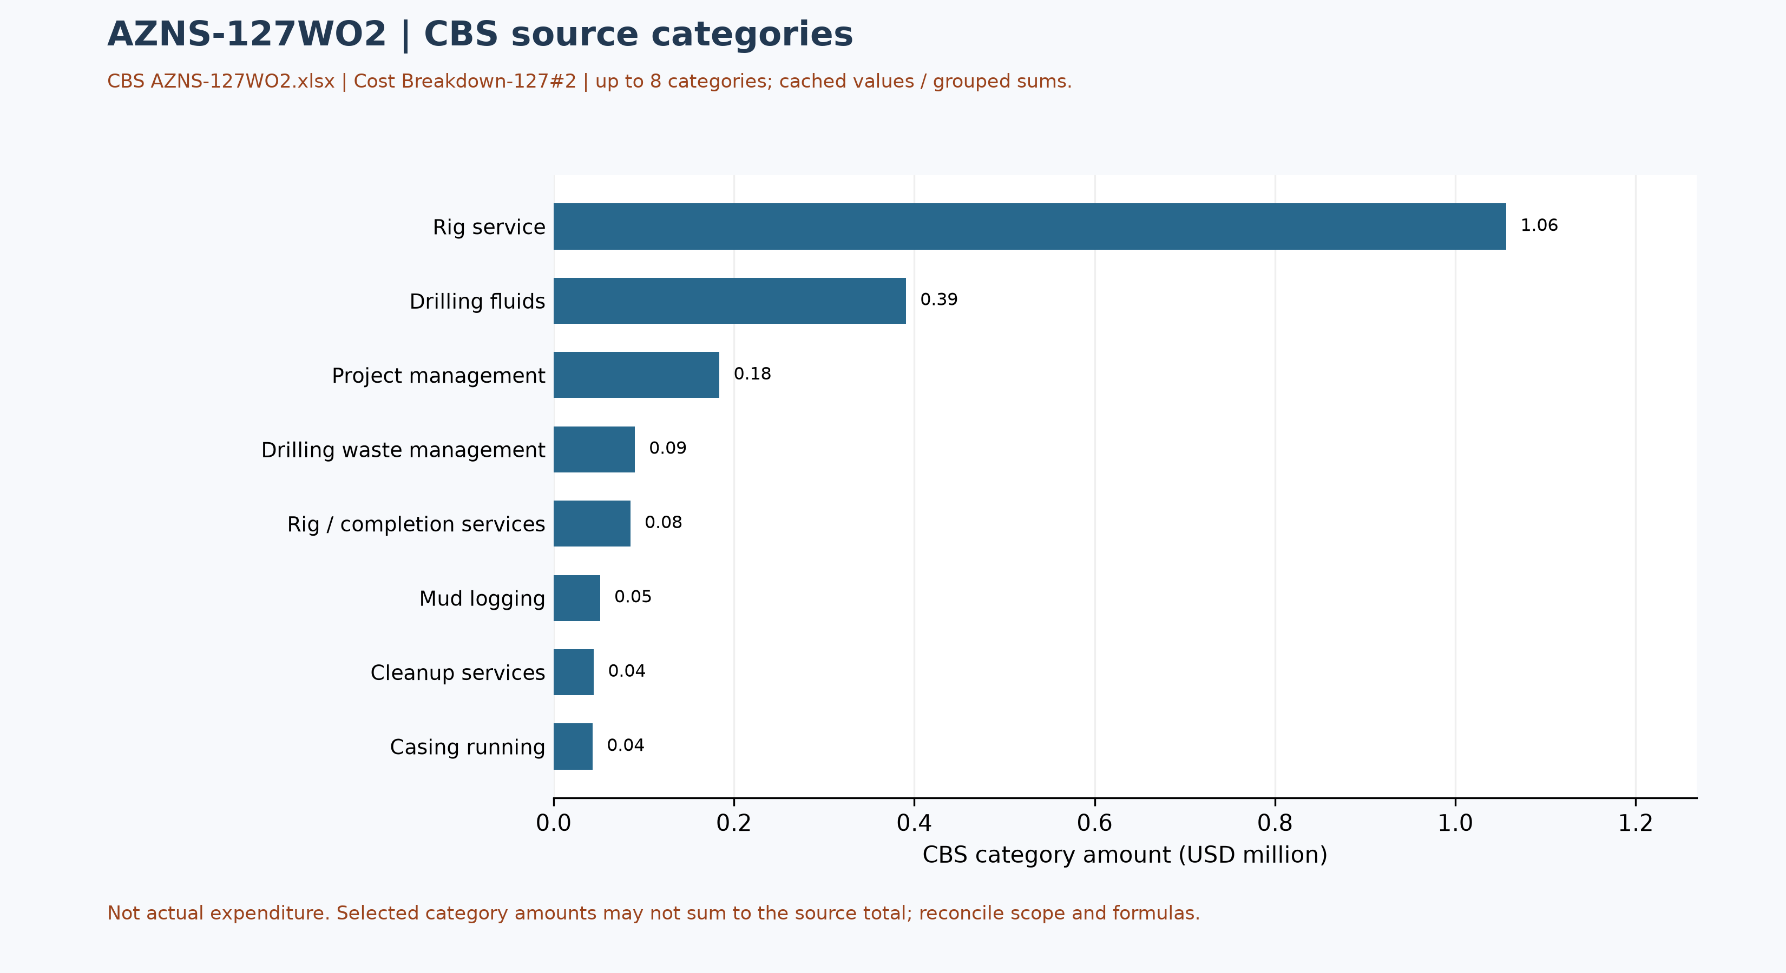
Figure W5 — CBS source cost categories, AZNS-127WO2 (unreconciled)

Selected CBS service-sheet checks
The coiled-tubing service sheet in CBS AZNS-127WO2.xlsx, Coil Tubing Service-127#2!B3:H3, lists one 1½-inch coiled-tubing unit, 6 standby days and 10 operating days, with both day rates at USD 4,800 and a cached line amount of USD 76,800. The source formula multiplies each day count by its corresponding rate. This is a selected estimated service line, not a verified operational record or invoice.
This sample is not an additional cost to be added to the main breakdown or ceiling: the roll-up, contingencies, units, contract scope and service execution must first be traced and reconciled. A repeated template line across workbooks is not independent evidence of repeated deployment.

Operational observations and engineering decision gates
Previous numerical operating envelopes were not validated and have been withdrawn. The entries below are examples of raw daily records only; tool location, phase, units and measurement validity require review. These observations are not safe limits, optimum windows or operating instructions.
Table 9-1 — Example recorded cells; units and measurement basis require verification.
Raw field | Example recorded value | Sheet and cell
Mud weight | 104 | 11-2 DDR Data!L9
Bit load / WOB | No interpretable numeric sample | —
RPM | No interpretable numeric sample | —
Flow | No interpretable numeric sample | —
Standpipe pressure | No interpretable numeric sample | —

Recommendations and review requirements
- Reconcile the programme revision, scope, start/end boundaries and rig/service time against daily reports and approved schedules before reporting a variance.
- Have responsible specialists verify well barriers and formation, casing and equipment limits against current approved records; no numerical design setpoint is established by this report.
- Reconcile bit identifiers, cumulative counters, tool assembly and failure evidence with original field and vendor records before selecting future equipment or diagnosing a mechanism.
- Reconcile costs with signed contracts, approved scope and invoices; do not convert source status-code hours into financial liability without a contractual assessment.

Risk-review checklist; ownership and severity not assigned
Review topic | Available evidence | Required follow-up
Well integrity and pressure | Programme objective and stated background, not proof of current condition | Reconcile tests, barriers and current approved limits
Incidents and recorded time | Partial source-code coverage in table 7-1 | Review event narrative, duration, cause and contract without presumed attribution
Equipment and operations | Example cells in table 9-1 and tool observations in table 4-2 | Verify units, calibration, tool identity and vendor records
Schedule and cost | Programme page and cost-breakdown evidence | Reconcile scope, invoices, time basis and approved revision

Data Provenance and Cell-Level Traceability
The table lists selected source anchors only. Other entries and interpretations still require independent cell/page checks, unit and scope review; the current report is not fully reconciled or reproducible without engineering interpretation.
Data element | Archive anchor (file -> sheet!cell)
rig | 1-1 DDR Remark!AB4
contractor | 1-1 DDR Remark!AB5
project | 1-1 DDR Remark!AB3
gle | 1-1 DDR Remark!AB7
report_no | 1-1 DDR Remark!AL5
act_days | 1-1 DDR Remark!AL4
depth:md_0000 | 1-1 DDR Remark!R9
depth:md_2400 | 1-1 DDR Remark!R10
depth:md_0600 | 1-1 DDR Remark!R11
CBS cost breakdown | CBS AZNS-127WO2.xlsx -> sheet "Cost Breakdown-127#2"
Planned duration | CBS AZNS-127WO2.xlsx -> CBS time-breakdown "AZNS-127 WO#2"
Well programme | AZNS-127 Workover #2 Program Rev.03.pdf
Table 11-1 Provenance anchors.

Appendix: source formation-table snapshot (unverified)
Source: AZNS127WOPack.xlsx, sheet 68-2 DDR Data. Selected as the last sheet in workbook order with a recognized formation table containing a numeric depth; if none, the last table with formation names. This is not necessarily the latest dated report.
Column roles follow the source labels, not independent confirmation of prognosis or measurement. Unlabelled populated cells are shown separately; missing cells are unknown, not zero. Values are rounded to four decimals for display. Verify row alignment, depth datum, possible inconsistencies and lithology against the programme and geological report; this table alone does not establish event attribution or operating instructions.
Source table and anchor: Formation Top Data / N80
Formation / cell | Source values / cell
L. Gurpi / N82 | Lithology: Arg Lst [R82]
Ilam / N83 | Lithology: Mrl & Shale & Arg Lst [R83]
Lafan / N84 | Lithology: Clast [R84]
Sarvak / N85 | Lithology: Lst & Arg Lst [R85]
Kazhdumi / N86 | Lithology: Arg Lst [R86]
Dariyan / N87 | Lithology: Lst [R87]
Gadvan / N88 | Not recorded

Selected tops from the programme schematic or image
Source: AZNS-127 Workover #2 Program Rev.03.pdf, physical page 38. These values were transcribed from a schematic labelled before the workover, not independently confirmed current tops or as-built status. Names and depths were visually paired; event attribution requires reconciliation of the event depth, branch and datum.
Formation / member | Source depth, m MD
Gachsaran | 1105
Asmari | 1448.84
Pabdeh | 1740.68
U. Gurpi | 2182.49
Tarbur | 2310.38
L. Gurpi | 2390.33
Ilam | 2516.7
Laffan | 2618.34
Sarvak | 2624.7
Kazhdumi | 3273.82
Dariyan | 3479.14
Gadvan | 3667
Fahliyan | 3938.87
Table — Selected formation tops as printed in the source schematic or image; see text for well and stage
The ST2 programme p.25 reproduces original-well tops with separate forecast, sample and log columns; the same source image occurs in the ST1 programme p.62. For Gachsaran these columns are 1,107, 1,105 and 1,084 m, respectively. The workover schematics show 1,105 m; this must not be silently identified as the log value. WO1 p.51 and WO2 p.38 also show different Dariyan (3,478.62 / 3,479.14 m), Gadvan (3,650.57 / 3,667 m) and Fahliyan (3,937.73 / 3,938.87 m) entries. These are source differences, not automatically geological movement or a validated sidetrack correlation.

Programme source summary and comparison limitations
Source: AZNS-127 Workover #2 Program Rev.03.pdf, physical page 7. Programme objective: Remove and rerun completion; the programme lists existing perforations in the 4½-inch liner. Stated programme duration, in days: 45.9 main; 110.8 contingency. The programme states measured depth 4140 m and producer/reservoir formation Fahliyan; these do not by themselves establish achieved depth or current condition. Time boundaries, scope and contingency interpretation require reconciliation.

