AZNS-207-ST #1 — Drilling Engineering Report
Development record, rig OEOC RIG 208, AZNS field — drilling performance, bit and hydraulics mechanics, trajectory, integrity and field solutions

Rig: OEOC RIG 208 | Well type: development | Spud: —
Rig days: 155 | New hole: 4,315 m | Final MD: 4,180 m
Reconstructed cost: 10.90 MUSD | NPT: 34.4%
Prepared by: Principal Drilling & Well Operations Engineering

Table 0.1 — Management identity sheet
Attribute | Value | Attribute | Value
Well | AZNS-207-ST #1 | Rig | OEOC RIG 208
Well type | development | Field | AZNS — South Azadegan
Spud date | — | Rig days | 155
Final MD | 4,180 m | New hole | 4,315 m
NPT | 1,262 h (34.4%) | Rig hours | 3,674 h
Reconstructed cost | 10.90 MUSD | USD per metre | 2,525
Source sheets | 310 | Primary NPT cause | Lost circulation
DDR Ref. — "1-1 DDR Remark" cells K5–N9 (Report Date, Report No.) and "1-2 DDR Data" rows 5–9 (well header: name, rig, spud, depths, casing head)

1. Executive summary and well KPIs
AZNS-207-ST #1 was worked by rig OEOC RIG 208 over 155 rig days and 3,674 rig hours. The record carries 4,315 m of new hole to a final measured depth of 4,180 m, with 34.4% of rig time booked as non-productive and a reconstructed cost of 10.90 MUSD. The dominant loss mechanism is lost circulation at 826 h, and the section-level rate in the productive part of the well is 3.52 m/h net against 1.17 m/h gross.
Table 1.1 — Well KPI set
Indicator | Value | Indicator | Value
Rig days | 155 | Rig hours | 3,674
New hole (m) | 4,315 | Final MD (m) | 4,180
Drilling hours | 1,227 | Reaming hours | 305
Trip hours | 1,410 | Casing/cement hours | 219
NPT hours | 1,262 | NPT share | 34.4%
Net ROP (m/h) | 3.52 | Gross ROP (m/h) | 1.17
ILT hours | 1,010 | ILT share | 27.5%
Cost (MUSD) | 10.90 | Cost per day (kUSD) | 70.3
DDR Ref. — "1-2 DDR Data" time log rows 21–68 (codes, hours, flags), daily state rows 9–13 (24 hrs Drilled, MD, MW) and "1-1 DDR Remark" activity narrative

2. Well architecture, rig configuration and casing programme
The well was executed by rig OEOC RIG 208, a development unit operating in the AZNS field. The architecture follows the field standard: a large surface hole, an intermediate hole through the reactive shale sequence and a production hole in the carbonate reservoir. The section breakdown in this record is 5-7/8" (0 m in 6 days), 8-3/8" (285 m in 16 days), 12-1/8" (2,246 m in 61 days), 17-1/8" (1,414 m in 35 days), 17-1/2" (219 m in 18 days).
The daily sheets in this record do not carry a casing table with shoe depths, so the architecture is described from the operational chronology and from the hole sizes actually drilled. The missing table is listed in Chapter 17 rather than reconstructed from assumption.
Table 2.2 — Rig and section configuration
Rig | Section | Days | Metres | Net ROP | NPT
OEOC RIG 208 | 5-7/8" | 6 | 0 | 0.00 | 25.0%
OEOC RIG 208 | 8-3/8" | 16 | 285 | 2.38 | 8.3%
OEOC RIG 208 | 12-1/8" | 61 | 2,246 | 2.18 | 33.8%
OEOC RIG 208 | 17-1/8" | 35 | 1,414 | 4.21 | 48.2%
OEOC RIG 208 | 17-1/2" | 18 | 219 | 0.76 | 64.7%
OEOC RIG 208 | 26" | 6 | 151 | 2.10 | 12.5%
DDR Ref. — "1-1 DDR Remark" header fields (rig, well type, section start depth, expected TD) and "1-2 DDR Data" rows 5–9

3. Operational chronology and phase cost
The record runs from the first report to the last report with 155 daily reports, each of which was read in full. The chronology below reproduces the operational sequence at fortnightly resolution, with the depth reached and the productive share of each interval.
Table 3.1 — Fortnightly chronology
Days | From | MD (m) | Hours | NPT
1–15 | — | 1,373 | 360 | 10.3%
16–30 | — | 1,564 | 314 | 57.2%
31–45 | — | 1,564 | 360 | 100.0%
46–60 | — | 1,648 | 360 | 31.1%
61–75 | — | 2,686 | 360 | 23.9%
76–90 | — | 3,054 | 360 | 41.0%
91–105 | — | 3,741 | 360 | 39.2%
106–120 | — | 3,895 | 360 | 31.2%
121–135 | — | 4,180 | 360 | 8.9%
136–150 | — | 4,180 | 360 | 15.3%
151–155 | — | 4,180 | 120 | 0.0%
DDR Ref. — "1-1 DDR Remark" “Summary of Activities in Last 24:00 hours” and “Operation Forecast”; day counter from the consecutive sheet pairing of the workbook
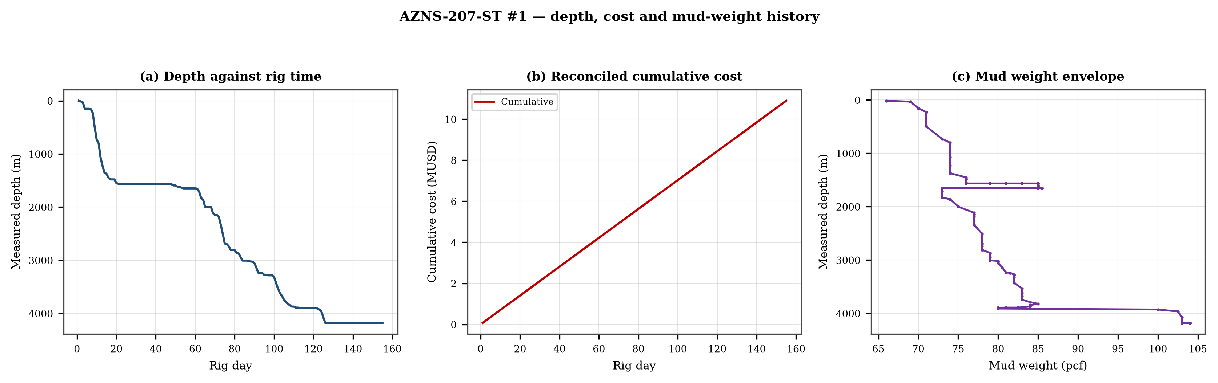
Figure 3.1 — Depth against rig time, reconciled cumulative cost and mud-weight envelope
The cost curve is reconstructed from the daily rig, mud and service rates applied to the recorded days; it is monotonic by construction and is intended for comparison, not as a replacement for the commercial register. The mud-weight curve shows the step changes that accompany each casing point, and each step is a decision point for the pressure window of Chapter 11.

4. Drilling performance, connections and rate of penetration
Productive time is split into drilling 1,227 h, reaming 305 h, trips 1,410 h, casing and cementing 219 h and logging 20 h. The ratio of handling time to drilling time is the single most informative number in this chapter: at 1.40 h of handling per hour of drilling, the well spends more time preparing the hole than making it.
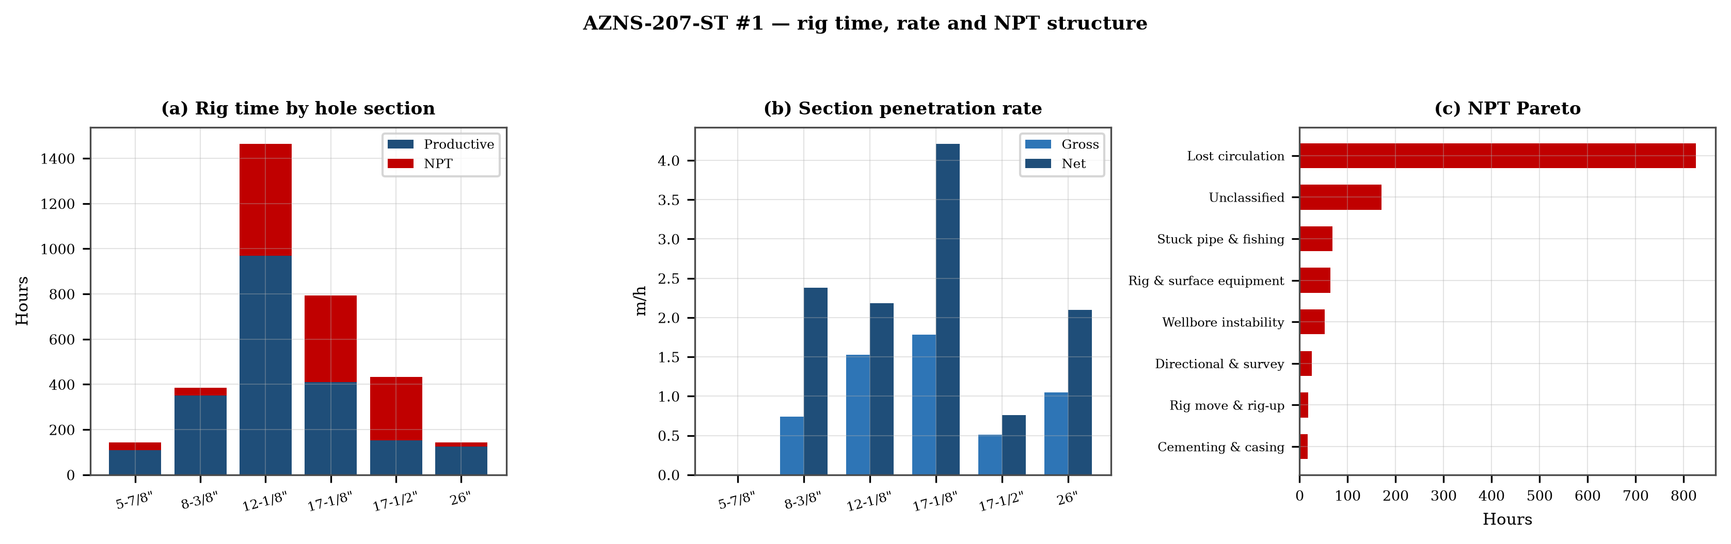
Figure 4.1 — Rig time by section, section rate and NPT pareto

Table 4.1 — Section performance
Section | Days | Metres | Gross ROP | Net ROP | Ream h | Trip h | NPT
5-7/8" | 6 | 0 | 0.00 | 0.00 | — | — | 25.0%
8-3/8" | 16 | 285 | 0.74 | 2.38 | — | — | 8.3%
12-1/8" | 61 | 2,246 | 1.53 | 2.18 | — | — | 33.8%
17-1/8" | 35 | 1,414 | 1.78 | 4.21 | — | — | 48.2%
17-1/2" | 18 | 219 | 0.51 | 0.76 | — | — | 64.7%
26" | 6 | 151 | 1.05 | 2.10 | — | — | 12.5%
DDR Ref. — "1-2 DDR Data" time log rows 21–68 filtered to drilling codes, total row 68, and the bit block (bit number, size, metres, hours, IADC dull code)

5. Non-productive time and multi-hypothesis root cause
Non-productive time totals 1,262 h, or 34.4% of rig time, spread over 237 coded entries. The register is ranked below; the two or three leading mechanisms are then examined one by one, each with competing physical explanations and the field evidence that separates them.
Table 5.1 — NPT register by mechanism
Mechanism | Hours | Share | Events
Lost circulation | 826 | 65.4% | 147
Unclassified | 170 | 13.5% | 35
Stuck pipe & fishing | 68 | 5.4% | 12
Rig & surface equipment | 64 | 5.1% | 22
Wellbore instability | 52 | 4.1% | 5
Directional & survey | 25 | 2.0% | 6
Rig move & rig-up | 18 | 1.4% | 1
Cementing & casing | 16 | 1.3% | 3
Logging & wireline | 14 | 1.1% | 2
Third-party & service | 6 | 0.4% | 2
Well control & kick | 3 | 0.2% | 2
DDR Ref. — "1-1 DDR Remark" activity status flag and "1-2 DDR Data" time-log flag column J (P / N / UP) with the code column A; hours from column E
5.1 Lost circulation — competing mechanisms
This mechanism consumed 826 h across 147 entries. Two explanations fit the recorded sequence equally well until the discriminating evidence is read. Mechanism A is a formation-driven response: the borehole or the fluid column behaves differently from the plan because of what the rock is doing. Mechanism B is an equipment or procedure response: the same symptom appears because a surface system, a service or a handling step did not deliver what the programme assumed. The discriminator is the pressure and torque record at the moment of onset: a formation response appears while parameters are steady, an equipment response appears as a step change with parameters unchanged.
- Day 17 (—): 2.0 h — Due to Obs. Severe FM losses; 40-50 BPH. Stop Drlg. POOH 1 Std. Pump 50 bbl. LCM pill (15 ppb Mica M & Kwik Seal M) & Displace same
- Day 17 (—): 1.0 h — While drlg 17 1/2" HS @ 1480.3, suddenly obs drop in press (300psi @ spp & 215psi @ m/l), check surface pressure equipment & string weight, obs approx
- Day 17 (—): 6.0 h — POOH string f/ 1480 to surf, obs twist off string f/ top of first 9 1/2" DC, 0-2BPH loss. >> left in hole: 17 1/2" PDC bit + Bit sub + 1 jt 9 1/2" DC
5.2 Unclassified — competing mechanisms
This mechanism consumed 170 h across 35 entries. Two explanations fit the recorded sequence equally well until the discriminating evidence is read. Mechanism A is a formation-driven response: the borehole or the fluid column behaves differently from the plan because of what the rock is doing. Mechanism B is an equipment or procedure response: the same symptom appears because a surface system, a service or a handling step did not deliver what the programme assumed. The discriminator is the pressure and torque record at the moment of onset: a formation response appears while parameters are steady, an equipment response appears as a step change with parameters unchanged.
- Day 9 (—): 1.0 h — B/R & R/D last drilled Std.
- Day 10 (—): 1.0 h — B/R & R/D last drilled Std.
- Day 11 (—): 1.0 h — P/U & M/U 17-1/2" PDC Bit (New, Haliburton, 6 Blade 16mm, FX65S, 9 x 14/32" Nozzle) & 2 Jts 9-1/2" DC + 17-1/2" S.stab + 1 Jts 9-1/2" DC to 30m.

6. Bit, BHA and nozzle performance
19 bit runs are recorded. The best run delivered 273 m and the shortest 6 m; the spread is the first indication that the dull grade, not the formation, ended the short runs. Where a dull code is recorded it is reproduced in the table without interpretation, and the wear pattern is discussed in the text.

Table 6.1 — Bit runs
Bit | Size | Type | IADC | Metres | Hours | Dull
1.0 | 26'' | Mill Tooth / K | 115 | 17.0 | 15.0 | —
2.0 | 17-1/2" | MT Bit (GAT135 | 135 | 6.0 | 5.5 | —
3.0 | 17-1/2" | PDC (FX65S) | S323 | 273.0 | 16.5 | —
4.0 | 17-1/2" | PDC (FSX643Z) | S234 | 77.0 | 8.0 | New
5.0 | 17-1/2" | PDC | TFR 716 | 0.0 | 3.5 | 1-1-WT-A-E-I-1/16-
6.0 | 17-1/2" | TCI Bit | 415 | — | — | —
7.0 | 17.5 | HJT517GL | 517 | 25.0 | 13.0 | New
8.0 | 17.5 | — | — | 19.0 | 11.5 | New
9.0 | 12-1/4" | PDC | — | — | — | 3-4-BT-N-X-H-(RO,C
10.0 | 12-1/4" | TCI Bit | 537 | 133.0 | 21.0 | —
11.0 | 12-1/4" | PDC | M423 | 38.0 | 6.5 | New
12.0 | 12-1/4" | PDC | M423 | 40.5 | 11.0 | New
13.0 | 12-1/4" | PDC | M423 | 71.0 | 19.5 | New
14.0 | 12-1/4" | PDC | M423 | 27.0 | 10.5 | New
DDR Ref. — "1-1 DDR Remark" bit block columns C–H (bit no., size, type, metres, hours, dull grade) and the "1-2 DDR Data" bit/BHA block

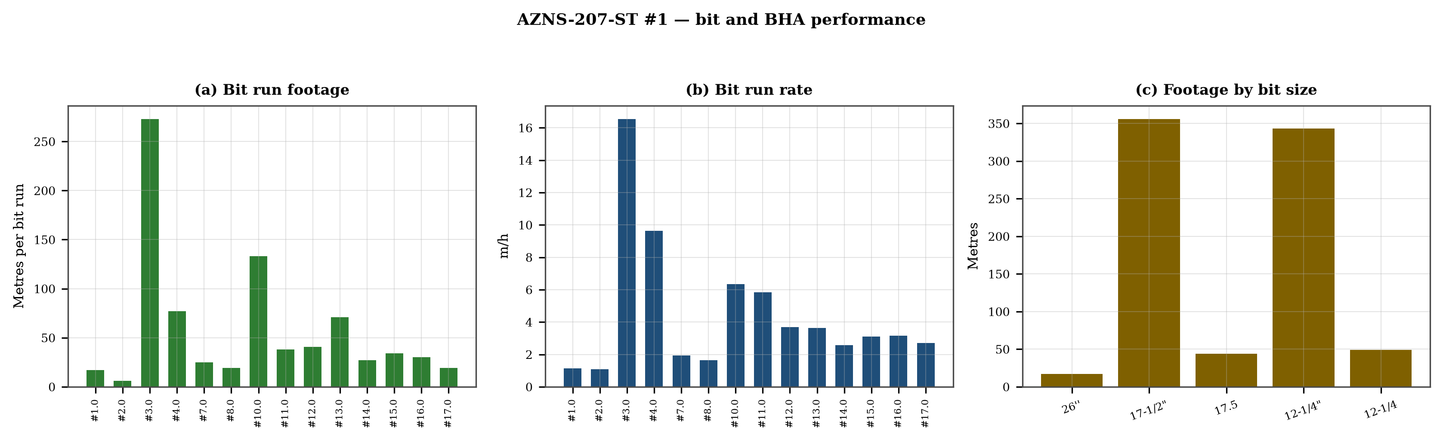
Figure 6.1 — Bit footage, run rate and footage by bit size

7. Mechanical parameters and mechanical specific energy
91 intervals carry a simultaneous weight and rotary-speed record. Weight on bit ranges 2.0–25.0 klbf with a median of 8.0 klbf, and rotary speed 6–1,593 rpm. The median mechanical specific energy is 21 ksi. For these hole sizes that is high: the bit is spending more energy on the bottom hole assembly and the fluid than on the rock.
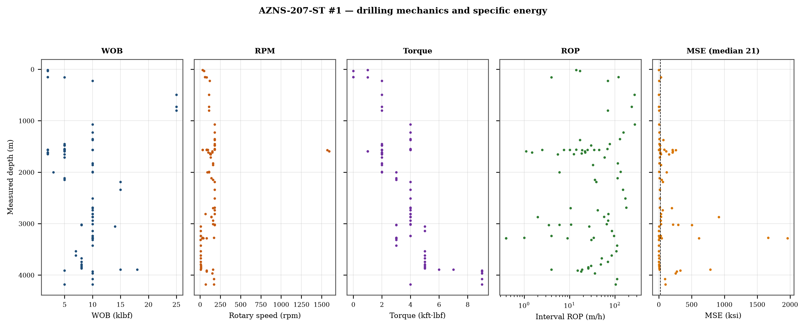
Figure 7.1 — Five-track mechanics log with specific energy

8. Drilling fluids, rheology, cuttings transport and ECD
The hydraulics record covers 77 days. Flow ranges 1–780 gpm, bit pressure drop 0–190 psi and the hydraulic index 0.1–0.5 hp/in². Annular velocity is computed for the recorded hole and pipe sizes; the 120 ft/min line on the figure is the field threshold for cuttings transport, not a regulatory limit.
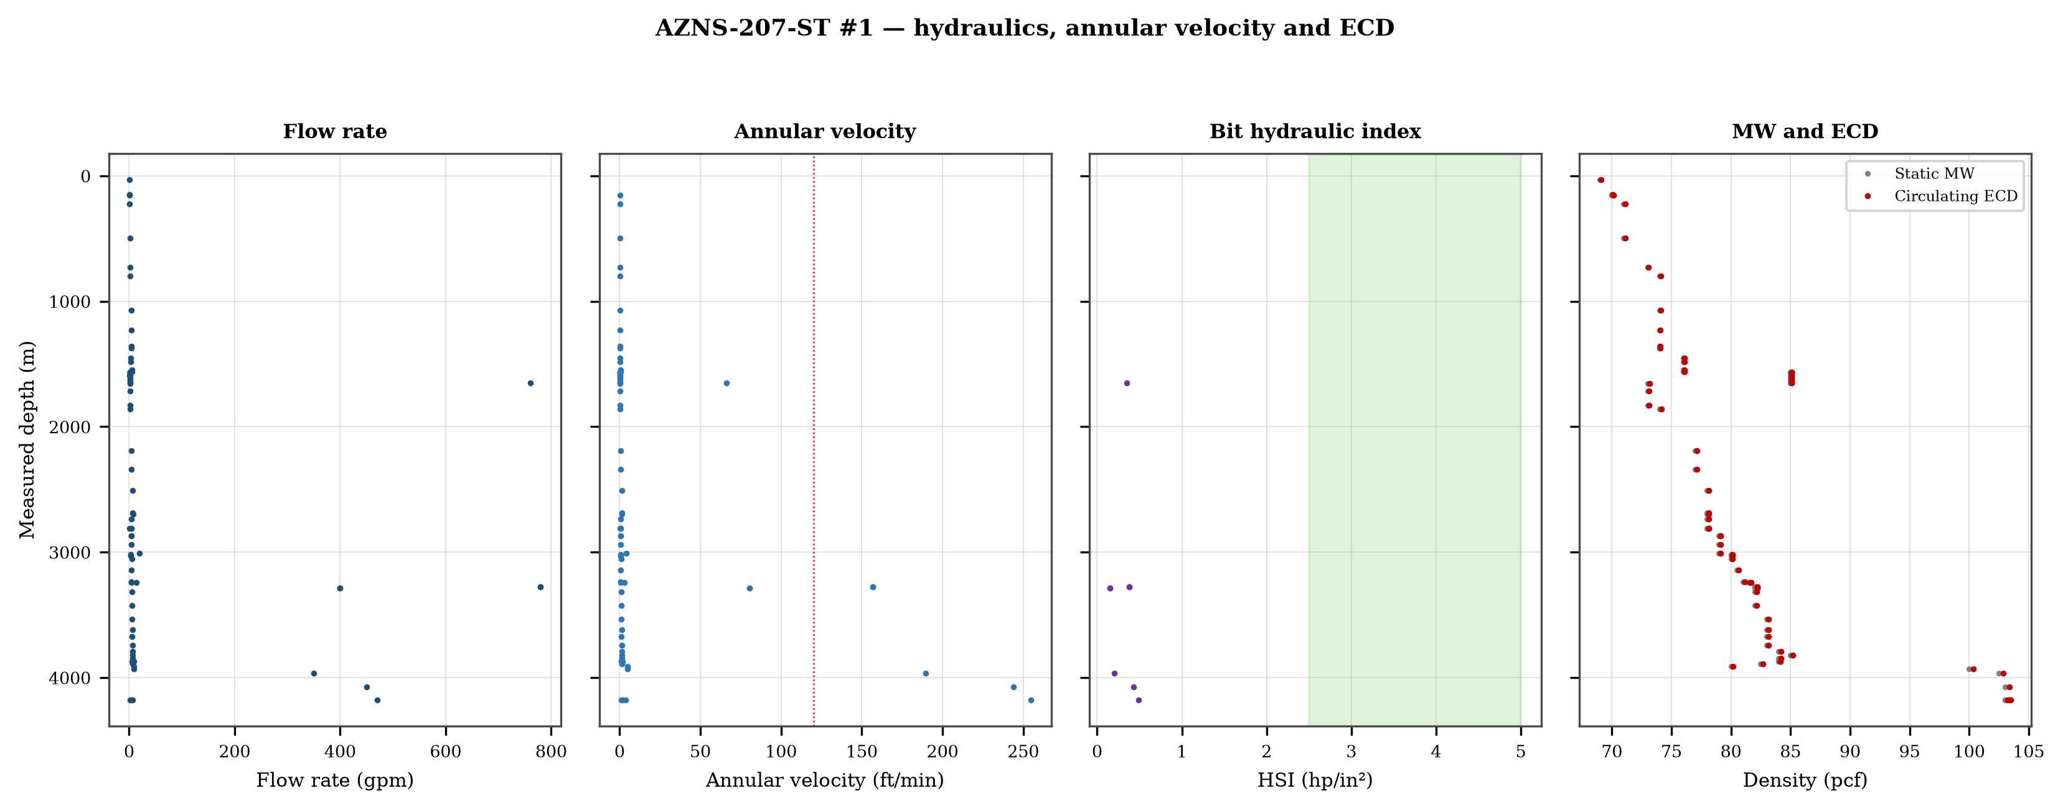
Figure 8.1 — Flow, annular velocity, hydraulic index and the ECD window
Mud weight moves between 66 and 104 pcf across the record, in steps that coincide with casing points. Each step changes the equivalent circulating density by the same amount plus the annular loss term, which is why the pressure window narrows precisely when the weight is increased to control the shale.

9. Directional survey, trajectory and dog-leg severity
The trajectory was rebuilt from 14 survey stations with the minimum-curvature method. The well reaches a maximum inclination of 7.7°, a maximum dog-leg of 10.80°/30 m and a final TVD of 3,606 m at 3,600 m MD, with a bottom-hole closure of 99 m. Dog-legs stay inside the drilling limit throughout, so the directional programme did not create the drag that Chapter 10 measures.
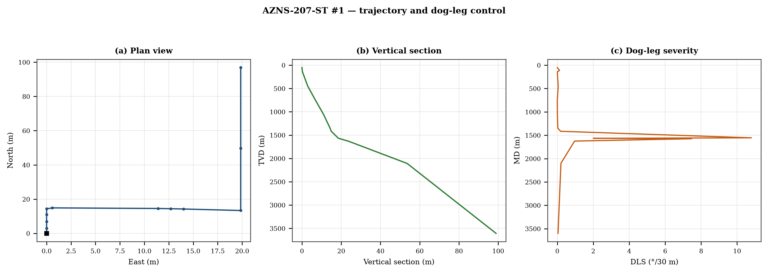
Figure 9.1 — Plan view, vertical section and dog-leg severity

Table 9.1 — Survey stations
MD | Inc | Azi | TVD | N | E | DLS
50.0 | 0.00 | — | 50.0 | 0.0 | 0.0 | 0.00
110.0 | 0.25 | — | 110.0 | 0.1 | 0.0 | 0.12
145.0 | 0.25 | — | 145.0 | 0.3 | 0.0 | 0.00
450.0 | 0.75 | — | 450.0 | 2.9 | 0.0 | 0.05
750.0 | 0.75 | — | 750.0 | 6.9 | 0.0 | 0.00
1,050.0 | 0.80 | — | 1,049.9 | 10.9 | 0.0 | 0.01
1,350.0 | 0.50 | — | 1,349.9 | 14.3 | 0.0 | 0.03
1,415.0 | 0.90 | 46.5 | 1,414.9 | 14.9 | 0.6 | 0.18
1,555.0 | 7.70 | 96.6 | 1,564.0 | 14.5 | 11.4 | 10.80
1,565.0 | 7.40 | 96.0 | 1,573.9 | 14.4 | 12.7 | 2.00
1,575.0 | 7.60 | 98.5 | 1,583.8 | 14.2 | 14.0 | 7.46
1,625.0 | 6.00 | — | 1,633.5 | 13.4 | 19.9 | 0.96
2,100.0 | 2.80 | — | 2,107.0 | 49.8 | 19.9 | 0.20
3,600.0 | 0.80 | — | 3,606.2 | 96.9 | 19.9 | 0.04
DDR Ref. — "1-2 DDR Data" survey table from header row 115 (MD, inclination, azimuth, TVD) — template A; "1-2 DDR Data" survey block J50+ — template B

10. Hook load, drag and overpull
A soft-string model was built on the recomputed survey with the buoyancy factor of the recorded mud weight and a tripping friction factor of 0.28. At 3,600 m the model gives a pick-up load of 93.1 klbf, a rotating load of 91.5 klbf and a slack-off of 91.3 klbf. The spread between pick-up and slack-off is 1.7 klbf; that is the friction the string actually carries, and it is the margin that must not be spent on a single pull.
- Day 11: recorded overpull 420 klbf
- Day 21: recorded overpull 25 klbf
- Day 22: recorded overpull 20 klbf
- Day 32: recorded overpull 520 klbf
- Day 79: recorded overpull 1 klbf
- Day 80: recorded overpull 1 klbf
- Day 153: recorded overpull 20 klbf
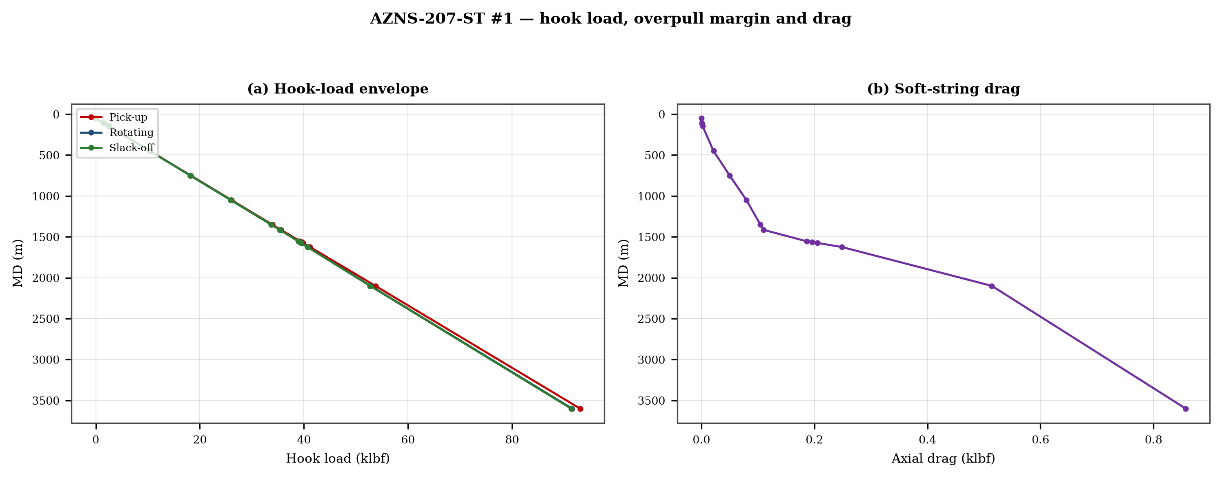
Figure 10.1 — Hook-load envelope and axial drag

11. Well control, shoe integrity, MAASP and losses
The record contains 4 formation-integrity tests with a numerical equivalent mud weight and 110 days with a loss entry. The dynamic maximum allowable surface pressure is the number the driller needs: at the shallowest shoe of this well, raising the annulus by 500 psi requires an equivalent weight of 0.0 pcf, which is the practical test of whether the mud programme is inside the window.
Table 11.1 — Integrity tests
Day | MD (m) | EMW (pcf)
62 | 1,713 | 90.0
122 | 3,910 | 8.0
123 | 3,928 | 105.0
123 | 3,928 | 8.0
DDR Ref. — "1-1 DDR Remark" field “FIT Depth (MD/TVD) / EMW (PCF)” and the leak-off lines in the daily narrative

12. Geology, formation tops and gas
16 formation tops are recorded between 1,020 m and 3,968 m MD. The sequence and the depth of each top are reproduced below with the minimum-curvature TVD where a survey exists; the drillability of each interval is discussed against the rate record rather than against a general lithology table.
Table 12.1 — Formation tops
Formation | MD (m) | TVD (m)
Gachsaran | 1,020 | 1,050
Asmary | 1,368 | 1,350
Pabdeh / Jahrum | 1,584 | 1,584
Jahrum | 1,684 | 1,633
Pabdeh | 1,991 | 2,107
Gurpi | 2,178 | 2,107
U.Gurpi | 2,178 | 2,107
Tarbur | 2,346 | 2,346
L.Gurpi | 2,423 | 2,423
Ilam | 2,563 | 2,563
Laffan | 2,633 | 2,633
Sarvak | 2,639 | 2,639
Kazhdumi | 3,266 | 3,266
Dariyan | 3,467 | 3,467
Gadvan | 3,626 | 3,606
Fahliyan | 3,968 | 3,968
DDR Ref. — "1-2 DDR Data" rows 110–131: K = formation, L/M = forecast MD and TVD, O/Q = actual TVD
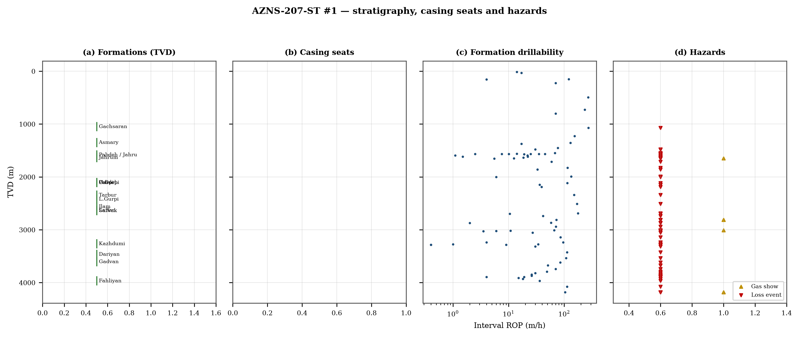
Figure 12.1 — Formation tops, casing seats, drillability and hazards

13. Operational problems, remedies and rig-floor playbooks
The five playbooks below are written for use at the rig floor, in the order given. Each one is the compressed form of the diagnosis used in Chapters 5, 10 and 11, and each is matched to the mechanism it treats.
Loss circulation playbook
- Stop drilling, record the loss rate at the current pump rate and keep the string moving.
- Reduce flow in two steps and measure the loss at each step: partial loss responds to LCM, total loss needs a different mechanism, not a bigger pill.
- Spot a graded LCM pill (fine–medium–coarse) across the loss zone and cure it before resuming; log the pill volume, the returned volume and the pressure at which it was spotted.
- If losses persist at the shoe, recalculate MAASP with the current mud weight and confirm the well is still displaced by a single fluid column.
Tight hole and overpull playbook
- Compare the observed overpull with the modelled pick-up envelope for the same depth.
- Circulate at the maximum allowable rate with the string rotating; if torque falls while returns carry cuttings, the cause is cleaning, not the formation.
- Work the string down with a controlled feed-off rather than pulling; never exceed 80% of the modelled overpull margin.
- If the string is stuck, establish circulation and jar down before any chemical soak.
Stuck pipe and fishing playbook
- Record the free rotating weight, the pick-up and the slack-off immediately; the spread distinguishes wall contact from a pack-off.
- Establish circulation within the first ten minutes; a stuck string that still circulates is recoverable without fishing.
- Apply torque and jar in the direction indicated by the string's own weight response, not by habit.
- Photograph and grade every recovered component before the next run.
Well-control playbook
- Shut in on the hard shut-in sequence and record SIDPP, SICP and pit gain within one minute.
- Confirm the influx type from the pressure pair: SIDPP ≈ SICP means a light fluid, SICP >> SIDPP means gas.
- Prepare a kill sheet with slow circulating pressure at the actual pump rate, not a table value.
- Maintain the casing pressure constant while bringing the pumps to rate; do not chase the drill-pipe pressure.
Shoe test and MAASP playbook
- Never drill out a shoe without a recorded FIT/LOT equivalent mud weight in the daily header.
- Compute MAASP for the current mud weight every time the weight changes by 0.1 pcf.
- Convert the test result to a fracture gradient at the shoe TVD, not at MD.
- When a loss occurs at the shoe, the first number to read is the dynamic MAASP, not the static one.

14. Optimum parameters, drill-off and MSE practice
Table 14.1 — Section parameter window in this well
Section | WOB (klbf) | RPM | Median interval ROP | Net ROP
8-3/8" | 5–10 | 70–170 | 36.0 | 2.38
12-1/8" | 3–18 | 6–180 | 36.0 | 2.18
17-1/8" | 2–25 | 80–180 | 70.0 | 4.21
17-1/2" | 2–10 | 30–1,593 | 18.8 | 0.76
26" | 2–2 | 30–60 | 17.0 | 2.10
DDR Ref. — "1-2 DDR Data" drilling-parameter sentences in column K (WOB, RPM, flow, SPP, torque) and the mud table columns K–S rows 11–38 — template A; mud table J8–L27 — template B
The drill-off procedure is the only reliable way to find the founder point on location. Hold flow constant, reduce weight in three steps of about 15% and record the rate at each step after 90 seconds of steady drilling; the rate should rise with weight until the founder point and then flatten. The weight at which it flattens is the operating weight for that formation, and the weight at which torque rises while rate does not is the weight that damages the bit.
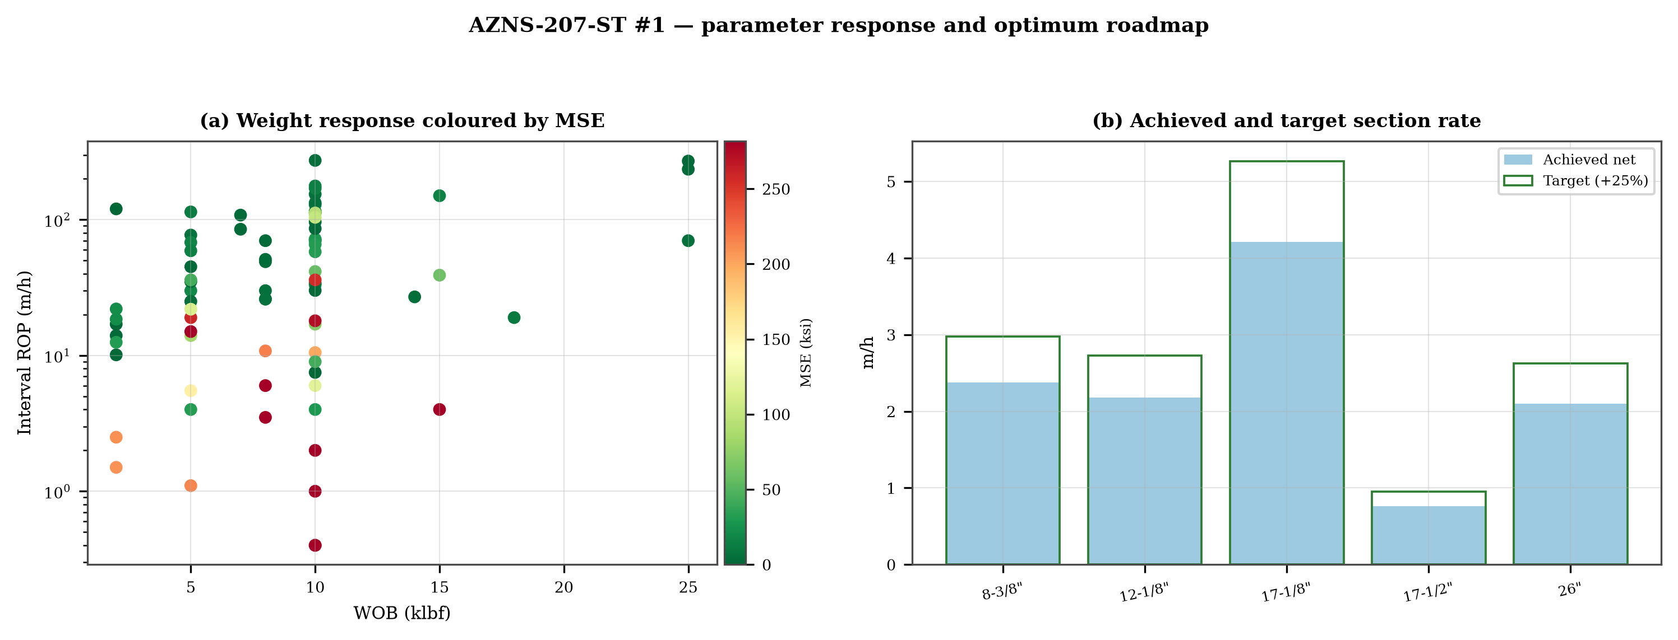
Figure 14.1 — Weight response coloured by specific energy and the section rate target

15. Key findings and risk register
- NPT stands at 34.4% of rig time, dominated by lost circulation.
- Handling time is 1.40 times the drilling time, which is the structural inefficiency of this record.
- Net rate in the productive intervals is 3.52 m/h at a median specific energy of 21 ksi.
- The pressure window and the mud programme interact at every casing point; the integrity record is the weakest data set in the well.
Table 15.1 — Risk register
Risk | Trigger | Consequence | Control
Loss at the shoe | Drilling out with weight above the window | Loss of circulation and stuck pipe | Two-rate loss test, graded LCM
Tight hole on trips | Shale swelling after long open-hole exposure | Overpull and stuck string | Wiper trips, mud inhibition
Bit balling | Weight above the founder point in reactive clay | Rate collapse and torque rise | Drill-off test, HSI above 2.5
Equipment failure | Ageing pumps and top drive | Long NPT and hole deterioration | Reliability register
DDR Ref. — Derived — "1-1 DDR Remark" narrative, "1-2 DDR Data" time-log flags and the NPT register of this report; no single DDR cell

16. Recommendations — phase matrix and REC-01 to REC-10
Table 16.1 — Phase execution matrix
Phase | Action | Hold point
Pre-spud | Verify rig systems and spares against the reliability register | Signed availability check
Surface hole | Maximum flow with a single casing and cementing trip | Shoe test recorded
Intermediate | PDC and motor, wiper trip every 300 m, AV above 120 ft/min | Overpull trend inside envelope
Reservoir entry | Two-rate loss test and graded LCM on location | Loss cured before drilling ahead
Reservoir hole | Hold HSI above 2.5 hp/in², drill-off at each top | Founder point recorded
Close-out | NPT booked to the fixed cause list, review within 14 days | QC certificate signed
DDR Ref. — "1-2 DDR Data" time log rows 21–68 aggregated by operational code and the "1-1 DDR Remark" section headers
Table 16.2 — Recommendations
ID | Recommendation | Owner | Timing | Rationale
REC-01 | Adopt a rig-specific reliability register (pumps, top drive, drawworks) with monthly availability and mean time between failures | Rig manager | Immediate | Rig and surface equipment is the largest controllable NPT category
REC-02 | Standardise the FIT/LOT protocol and write the demonstrated EMW into the daily header | Well integrity | Before the next well | Makes MAASP auditable at every shoe
REC-03 | Apply the section parameter roadmap of Chapter 14 as the drilling programme | Drilling engineering | Next well | Closes the gap to the field P90 rate
REC-04 | Introduce a graded-LCM loss protocol with a two-rate diagnosis before treatment | Mud engineering | Immediate | Cuts loss time and lost mud volume
REC-05 | Run a drill-off test at the top of each formation and record the founder point | Drilling engineering | Each section | Prevents weight-induced inefficiency
REC-06 | Treat centrifuge running time as a recorded drilling parameter | Mud engineering | Immediate | Controls ECD without changing mud weight
REC-07 | Hold a torque-and-drag check against the modelled envelope before every trip | Drilling supervisor | Every trip | Converts overpull from a surprise into a trend
REC-08 | Book every NPT hour against the fixed cause list within the same tour | Drilling supervisor | Daily | Keeps the field comparison comparable
REC-09 | Audit third-party service readiness (wireline, cementing, casing crews) before the operation, not on arrival | Field engineering | Each job | Third-party delay is the second largest NPT category
REC-10 | Publish a weekly NPT pareto and a monthly field benchmarking pack | Field engineering | Weekly | Sustains the learning curve across rigs
DDR Ref. — This report — built from the KPI set and NPT register above; each row carries its own evidence reference

17. Limitations of the recorded data
- No casing table with shoe depths: the architecture is described from the chronology and the hole sizes drilled.
- Costs are reconstructed from daily rig, mud and service rates because the workbooks do not carry a commercial register; they are used for comparison only.

18. Appendix A — Workbooks, sheets and SHA-256
The record was read from AZNS207Pack.xlsx with 310 sheets, all of which were parsed. The table below reproduces the file inventory with the digest of the source workbook as it stands in the repository.
Table 18.1 — Source workbooks and SHA-256
File | SHA-256
AZNS10Pack.xlsx | bf8c897274b47f9324b6e808162c451c0329d78651e76a27c700db9263ec0a95
AZNS116Pack.xlsx | 68c5b874f1ba78a4a30989930aef00f06095d8118e89e217e74ca918364dc438
AZNS122WO1Pack.xlsx | c14db1ff6cbef8b7d4e0f69b9f64cdc4452e3935f64bad439d38a8aed6f5f42a
AZNS122WO2Pack.xlsx | 2eb9858150dfa2d43f46e387ded978fd04c811f0c08b402a76a533f36235b65c
AZNS127ST2Pack.xlsx | 68329de313721905be08f20cb8bb8b4f5f3671d5c6caab41f23caa1a48b9a4c4
AZNS127WO1Pack.xlsx | 6034aae76c2e3126416df8f8576d424bd3394c30aca4c4f5e72f0372256739d6
AZNS127WOPack.xlsx | a4ae90dc870f20b2f99ac3a36b8b5cd1c357b60dd2805630597cc48ba059054e
AZNS12Pack.xlsx | e325945f1108341bace123e60b02fb04ac3f7d3003a19eb8d23004cf7cd67216
AZNS166Pack.xlsx | e63824748e4692884fc23075c678c1379b9b595a8c8b1efb289e630f898a75d8
AZNS207Pack.xlsx | 828968c7e0afd7273d64987bd457383ecfea3a2e00e62c9a65b587f16518996a
AZNS40Pack.xlsx | 0523068ee222c02f6e2d2754bcd919a9c296b334b03521ab15d84322aade94ca
AZNS75Pack.xlsx | 5e0482d5d50e9347a98b7c24cfd3a102d3c00f2c951f6061aba14d164136fcae
AZNS85Pack.xlsx | 0d3ecc54fb8b9484f508b9a3957554ba13e72546c6d485abb79af633362daeb2
DDR Ref. — Workbook files as delivered (read-only), hash computed at build time
Table 18.2 — Sheet inventory of this well
Sheet | Sheet | Sheet
1-1 DDR P 1 | 1-2 DDR P 2 | 2-1 DDR P 1
2-2 DDR P 2 | 3-1 DDR P 1 | 3-2 DDR P 2
4-1 DDR P 1 | 4-2 DDR P 2 | 5-1 DDR Remark
5-2 DDR Data | 6-1 DDR Remark | 6-2 DDR Data
7-1 DDR Remark | 7-2 DDR Data | 8-1 DDR Remark
8-2 DDR Data | 9-1 DDR Remark | 9-2 DDR Data
10-1 DDR Remark | 10-2 DDR Data | 11-1 DDR Remark
11-2 DDR Data | 12-1 DDR Remark | 12-2 DDR Data
13-1 DDR Remark | 13-2 DDR Data | 14-1 DDR Remark
14-2 DDR Data | 15-1 DDR Remark | 15-2 DDR Data
16-1 DDR Remark | 16-2 DDR Data | 17-1 DDR Remark
17-2 DDR Data | 18-1 DDR Remark | 18-2 DDR Data
19-1 DDR Remark | 19-2 DDR Data | 20-1 DDR Remark
20-2 DDR Data | 21-1 DDR Remark | 21-2 DDR Data
22-1 DDR Remark | 22-2 DDR Data | 23-1 DDR Remark
DDR Ref. — Workbook sheet list — every remark/data sheet pair plus the reference sheets

19. Appendix B — Equations and units
Table 19.1 — Governing equations
Quantity | Equation | Units
Mechanical specific energy | MSE = 480·T·N/(D²·ROP) + 4·WOB/(π·D²·1000) | psi, klbf, ft·lbf
Bit pressure drop | ΔP = ρ·Q²/(10858·TFA²) | psi, gpm, in²
Jet velocity | V = 0.3208·Q/TFA | ft/s
Hydraulic index | HSI = ΔP·Q/(1714·A_bit) | hp/in²
Annular velocity | V = 24.5·Q/(D_h² − D_p²) | ft/min
Bingham annular loss | ΔP = PV·V·L/(60000·(D_h−D_p)²) + YP·L/(200·(D_h−D_p)) | psi
Equivalent circulating density | ECD = MW + ΔP_ann/(0.052·TVD) | pcf
Minimum curvature | β = arccos[cos I₁cos I₂ + sin I₁ sin I₂ cos(A₂−A₁)] | rad
Dog-leg severity | DLS = 30·β/ΔMD | °/30 m
Buoyancy factor | BF = 1 − MW/490 | —
Hook load (soft string) | F = Σ w·BF·cos I·Δs ± μ·Σ w·BF·sin I·Δs | klbf
Maximum allowable surface pressure | MAASP = 0.052·(EMW_frac − MW)·TVD_shoe | psi
dc exponent | dc = log(ROP/(60·N)) / log(WOB/D) | —
Reconstructed cost | C = Σ (rig + mud + service) day rate | USD
DDR Ref. — Reference standard, Appendix B — no DDR cell

20. Appendix C — Complete NPT register
Table 20.1 — NPT register (all entries)
Day | Hrs | Mechanism | Activity and description
1 | 18.0 | Rig move & rig-up | Wait on OEOC to submit inspection reports for all tubulars meanwhile inspect onbard tubulars. Install support for burnin
7 | 13.0 | Cementing & casing | Cont. Tighten the all nuts. N/U 3K Ann Preventer. Connect Side outlet valves. Connect choke lines & kill lines. Flash BO
9 | 1.0 | Unclassified | B/R & R/D last drilled Std.
10 | 1.0 | Unclassified | B/R & R/D last drilled Std.
11 | 1.0 | Unclassified | P/U & M/U 17-1/2" PDC Bit (New, Haliburton, 6 Blade 16mm, FX65S, 9 x 14/32" Nozzle) & 2 Jts 9-1/2" DC + 17-1/2" S.stab +
15 | 3.0 | Unclassified | Due to failure TDS Sys. Work on same; OK.
17 | 2.0 | Lost circulation | Due to Obs. Severe FM losses; 40-50 BPH. Stop Drlg. POOH 1 Std. Pump 50 bbl. LCM pill (15 ppb Mica M & Kwik Seal M) & Di
17 | 1.0 | Lost circulation | While drlg 17 1/2" HS @ 1480.3, suddenly obs drop in press (300psi @ spp & 215psi @ m/l), check surface pressure equipme
17 | 6.0 | Lost circulation | POOH string f/ 1480 to surf, obs twist off string f/ top of first 9 1/2" DC, 0-2BPH loss. >> left in hole: 17 1/2" PDC b
17 | 7.5 | Lost circulation | P/U & M/U fishing assembly & RIH to 1469.78m (tof), 0-2BPH loss. >> 12-3/4" Bowl, 9-1/2" Basket grapple, 9-1/2" Mill con
17 | 3.5 | Lost circulation | Establish circ mud (120psi), Record string weight (up 160kips / down 163kips) & rotating 5rpm, engage the fish, check st
18 | 1.5 | Lost circulation | Cont. work on engage and catch the fish by apply differenet parametes and several times attempt, no success. 0-2BPH loss
18 | 5.5 | Lost circulation | POOH w/ 12-3/4" x 15-1/2" fishing assembly f/ 1469m to surface. L/D 12-3/4" O.Shot. 0-2BPH loss.
18 | 12.0 | Lost circulation | P/U & M/U 11-3/4 X 15-1/2" fishing assembly & RIH to 1469.78m (TOF), 0-2BPH loss. >> Wash & R/D & Rotation String @ Seve
18 | 1.5 | Lost circulation | Establish Circ. Mud (130psi), Record String Weight (up 160kips / Down 163kips), Rotaiting 5rpm, Try To Engage The Fish,
18 | 3.5 | Lost circulation | POOH With Fish to1220 while got over pull @ several points, 1 BPH Loss.
19 | 12.0 | Stuck pipe & fishing | Cont. POOH W/Fish f/ 1220m to Surf., Recover 9-1/2" DC, Bit Sub, 17-1/2" PDC Bit, L/D same. >> Bit Dull Cond. : (2-1-CT-
19 | 2.5 | Lost circulation | RIH W/ 17-1/2 Used PDC Bit, 1Std 9-1/2DC, 2Std 8-1/2" DC to 100m, 1BPH Loss.
19 | 3.0 | Lost circulation | POOH to Surf. L/D All DCs, Bit Sub, S.Stab, XOS. 1BPH Loss.
19 | 4.5 | Lost circulation | P/U & M/U 17-1/2" PDC Bit (Recovered, Haliburton, 6 Blade, 13mm, FSX643Z, 2 x 14/32" + 7 x 16/32" Nozzle) + B.Sub (Baffl
20 | 6.0 | Lost circulation | Cont. RIH w/ 2 Stds 5" HWDP followed by 5" DP f/ 110 to 1479m (1m off btm) while W&R last stand. 1-4 BPH Loss. >> Fill u
22 | 6.0 | Lost circulation | Stop operation @ 544mt due to failure in TDS elec. Sys. While slow circ. through strg & rotating by R.Table, 5-10BPH Los
23 | 2.5 | Lost circulation | Cont. RIH w/ 17-1/2" R.Bit & J.Sub f/ 734m to 802m with hard W&R. 5-15BPH Loss. >> NPT considered for VIRA mud company d
23 | 9.5 | Lost circulation | Cont. RIH with hard W&R f/ 859 to 1060m. 5-15BPH Loss. >> NPT considered for VIRA mud company due to out of range mud pa
23 | 8.0 | Lost circulation | Cont. RIH with hard W&R f/ 1307 to 1562m(BTM). 5-20BPH Loss. >> NPT considered for VIRA mud company due to out of range
24 | 1.0 | Lost circulation | Pump & spot 100bbl LCM pill (20ppb Mica M + 20ppb Kwik seal M) @ Btm prior to POOH.
24 | 5.5 | Unclassified | In order to improve mud properties, Circ. btm's up while daluting active sys. with fresh Salt-Poly mud 76 pcf.
24 | 1.0 | Lost circulation | Pump & spot 50bbl LCM pill (20ppb Mica M + 20ppb Kwik seal M)
25 | 2.0 | Rig & surface equipment | Work on TDS due to oil leakage.
27 | 16.0 | Lost circulation | Cont. POOH on elevator f/ 600m to surf. Obs. 0.07m of 9-1/2" DC box remain on S.Stab Pin. 4-6 BPHL. >> left in hole: 17
27 | 3.5 | Lost circulation | P/U & M/U 11-3/4" O.Shot. RIH w/ fishing BHA to 1495.6mt (estimated TOF), 2-4 BPHL. >> Fishing assy: 11 3/4" TOP SUB + 1
27 | 4.5 | Lost circulation | While wash down last std @ 1495.6m Obs. Dropped the fish. Wash down to 1531m, took weight (TOF). Work on fishing with di
29 | 7.0 | Lost circulation | Cont. POOH on elevator w/ 11-3/4" O.Shot f/1400m to surf.L/D 11-3/4" O.Shot assembly. 3-6 BPHL. >> Fishing assy: 11 3/4"
29 | 17.0 | Lost circulation | P/U & M/U 17-1/2" B.Bit (New, K.Dream, SN:2205166JH, 415, 3 x 18/32 + CJ nzl) + B.Sub + 2 Jts 9-1/2" DC + S.Stab + 1 Jt
30 | 24.0 | Lost circulation | Cont. RIH w/ 17-1/2" B.Bit (New, K.Dream, SN:2205166JH, 415, 3 x 18/32 + CJ nzl) + B.Sub + 2 Jts 9-1/2" DC + S.Stab + 1
31 | 21.0 | Unclassified | Cont. RIH w/ 17-1/2" TCI Bit + B.Sub + 2 Jts 9-1/2" DC + S.Stab + 1 Jt 9-1/2" DC + XOS + 2 Stds 8-1/2" DC + XOS + 2 Stds
31 | 3.0 | Lost circulation | Circ. Out 50 bbl Hi-Vis pill & Over Circ. Mud meanwhile reciprocate string & work on mud rheology (Dec. FL f/ 20 to 9 cc
32 | 23.0 | Lost circulation | Commence POOH w/ 17-1/2" TCI Bit f/ 1542.4m to surface; 3-6 BPH losses. L/D Bit. Bit Dull: 1-3-BT-G-E-I-BU-BHA.
32 | 1.0 | Stuck pipe & fishing | M/U & Assemble 11-3/4" Overshot (Dressed w/ 9-1/2" Spiral Grapple & Spiral Grapple Control, 15-1/2" Oversize guide) on 1
33 | 20.0 | Stuck pipe & fishing | RIH w/ 11-3/4" Overshot + 1 Jt 8-1/2" DC + 8" Fishing Jar + 1 Jt 8-1/2" DC + 2 Stds 5" HWDP & Followed by 5" DPs to 1539
33 | 1.5 | Lost circulation | Pump & Circ. Out 50 bbl Hi-Vis Pill. Meanwhile Hard wash & Ream Dn to 1539.5 m; 6-8 BPH Losses.
33 | 2.5 | Lost circulation | Cont. Hard wash & Ream Dn f/ 1539.5 to 1540.5m; 6-8 BPH Losses till M.N.
34 | 12.0 | Lost circulation | Cont. Hard wash & Ream Dn f/ 1540.5 to 1541.4m (1m Above TOF); 6-8 BPH Losses. Meanwhile pump 80 bbl tandem Pill. Try to
34 | 11.0 | Lost circulation | Commence POOH w/ 11-3/4" Overshot BHA f/ 1541.4m to surface on elevator, F/U the well; 1-3 BPH Losses. B/O & L/D Oversho
34 | 1.0 | Unclassified | P/U & M/U 17-1/2" Taper Mill (8 x 1-1/4" Side Ports + 1 x 3-1/8" Center Port) + 9-1/2" Bit Sub (F.Valve In) + XOS + 1 Jt
35 | 4.0 | Unclassified | RIH w/ 17-1/2" Taper Mill + 9-1/2" Bit Sub (F.Valve In) + XOS + 1 Jt 5" HWDP + XOS + 3 Stds 8-1/2" DC (P/U 2 Stds Jt by
35 | 15.5 | Lost circulation | Cont. RIH as Hard wash & Ream Dn to 700m; 1-3 BPH Losses. Meanwhile Add. 1 % Vol Diesel to active mud system.
35 | 4.5 | Lost circulation | POOH w/ 17-1/2" Taper Mill f/ 700 to 70m, While L/D 3 Jts 8-1/2" DC. Circ. Across wellhead; 1-3 BPH Losses.
36 | 3.0 | Unclassified | L/D totally 9 Jts 8-1/2" DC.
36 | 1.0 | Lost circulation | Cont. POOH w/ 17-1/2" Taper Mill to surface, Circ. Across wellhead; 1-3 BPH Losses.
36 | 7.0 | Lost circulation | P/U & M/U 7-7/8" Center Cut Bit + 6-1/2" Bit Sub (F.Valve In) & RIH on 5" DPs to 1538m, F/U & Break Circ. Every 15 Stds;
36 | 0.5 | Unclassified | Cont. RIH as Soft Wash & Ream Dn to 1541.5 (1m Above TOF). Try to Cont. Wash & Ream Dn; No-Succ. POOH string to 1536m &
36 | 1.0 | Lost circulation | CBU, Meanwhile L/U CMT Line & Prepare CMT Slurry solution.; 1-4 BPH Losses.
36 | 2.5 | Rig & surface equipment | L/U CMT line to string, Press test CMT line to 500/3000 psi for 15 min; Ok. Pump 27 bbl 75 pcf brine as spacer ahead. Mi
36 | 1.5 | Lost circulation | B/O CMT Line, POOH 10 Stds to 1250m, Flush the string. Resume POOH 10 Stds more to 960m. CBU; 2-3 BPH Losses.
36 | 3.0 | Cementing & casing | M/U FOSV on string. Close Top Rams & WOC to get hard. Monitor Ann Press; Zero.
36 | 4.5 | Lost circulation | Open the well. Established Circ. Mud, While reciprocate string; 1-3 BPH Losses.
37 | 2.0 | Wellbore instability | RIH w/ 7-7/8" Center Cut Bit f/ 960 to 1330m (Expected TOC). While W/D (100 GPM) last 3 Stds w/o any drag.
37 | 2.0 | Lost circulation | CBU, meanwhile reciprocate string; 1-2 BPH Losses.
37 | 6.0 | Lost circulation | Resume W/D (100 GPM) to 1486m w/o any drag; 1-2 BPH Losses. Try to W/D w/ max 560 GPM; No-Succ.
37 | 1.0 | Lost circulation | CBU, Meanwhile L/U CMT Line & Prepare CMT Slurry solution.; 1-2 BPH Losses.
37 | 1.5 | Rig & surface equipment | L/U CMT line to string, Press test CMT line to 500/3000 psi for 15 min; Ok. Pump 27 bbl 75 pcf brine as spacer ahead. Mi
37 | 0.5 | Cementing & casing | B/O CMT Line, POOH 10 Stds to 1192m, Flush the string.
37 | 3.0 | Lost circulation | Resume POOH w/ 7-7/8" C.Cut Bit to 130m. Circ. Across wellhead; 1-3 BPH Losses.
37 | 7.5 | Lost circulation | Stop operation. Work on TDS Blowers & Fix same; while Circ. Thru string; 1-3 BPH Losses.
37 | 0.5 | Lost circulation | Resume POOH w/ 7-7/8" C.Cut Bit to surface. Circ. Across wellhead; 1-3 BPH Losses.
38 | 2.0 | Unclassified | L/D 3 Jts 9-1/2" DC.
38 | 7.0 | Unclassified | P/U & M/U 17-1/2" TCI Bit (Used, Kingdream, 415, Type: GAT415GC, 3 x 18/32" + C.Jet 16/32") + 9-1/2" Bit Sub (F.Valve In
38 | 15.0 | Lost circulation | Cont. RIH as soft to Med wash and ream down to 960m, Med to hard wash and ream down to 1330m; 2-3 BPH Losses.
39 | 10.0 | Lost circulation | Cont. Med to hard wash and ream down f/ 1330 to 1407m; 2-3 BPH Losses.
DDR Ref. — "1-2 DDR Data" time log rows 21–68 with flag N or UP, one row per logged interval

21. Appendix D — Daily hydraulics and ECD

Table 21.1 — Hydraulics and ECD register
Day | MD | Q | MW | TFA | ΔP bit | HSI | AV | ECD
3 | 31 | 1 | 69 | 1.052 | 0 | 0.0 | 0 | 69.1
4 | 151 | 1 | 70 | 1.052 | 0 | 0.0 | 0 | 70.1
7 | 155 | 1 | 70 | 0.746 | 0 | 0.0 | 0 | 70.2
8 | 225 | 1 | 71 | 4.320 | 0 | 0.0 | 0 | 71.1
9 | 495 | 2 | 71 | 4.320 | 0 | 0.0 | 0 | 71.1
10 | 730 | 2 | 73 | 4.320 | 0 | 0.0 | 0 | 73.1
11 | 800 | 2 | 74 | 4.320 | 0 | 0.0 | 0 | 74.1
12 | 1,073 | 4 | 74 | 1.353 | 0 | 0.0 | 0 | 74.1
13 | 1,227 | 4 | 74 | 1.353 | 0 | 0.0 | 0 | 74.1
14 | 1,356 | 4 | 74 | 1.353 | 0 | 0.0 | 0 | 74.1
15 | 1,373 | 4 | 74 | 1.353 | 0 | 0.0 | 0 | 74.1
16 | 1,450 | 3 | 76 | 1.672 | 0 | 0.0 | 0 | 76.1
17 | 1,480 | 3 | 76 | 1.672 | 0 | 0.0 | 0 | 76.1
20 | 1,548 | 6 | 76 | 1.672 | 0 | 0.0 | 0 | 76.1
21 | 1,562 | 6 | 76 | 1.672 | 0 | 0.0 | 0 | 76.1
38 | 1,564 | 2 | 85 | 0.942 | 0 | 0.0 | 0 | 85.1
39 | 1,564 | 2 | 85 | 0.942 | 0 | 0.0 | 0 | 85.1
44 | 1,564 | 2 | 85 | 1.114 | 0 | 0.0 | 0 | 85.1
45 | 1,564 | 2 | 85 | 1.114 | 0 | 0.0 | 0 | 85.1
46 | 1,564 | 2 | 85 | 1.114 | 0 | 0.0 | 0 | 85.1
48 | 1,571 | 2 | 85 | 2.279 | 0 | 0.0 | 0 | 85.1
49 | 1,593 | 1 | 85 | 2.279 | 0 | 0.0 | 0 | 85.1
50 | 1,594 | 2 | 85 | 2.279 | 0 | 0.0 | 0 | 85.1
51 | 1,616 | 2 | 85 | 1.114 | 0 | 0.0 | 0 | 85.1
52 | 1,618 | 2 | 85 | 1.114 | 0 | 0.0 | 0 | 85.1
53 | 1,636 | 2 | 85 | 1.114 | 0 | 0.0 | 0 | 85.1
54 | 1,648 | 2 | 85 | 1.114 | 0 | 0.0 | 0 | 85.1
55 | 1,648 | 760 | 85 | 1.114 | 190 | 0.3 | 66 | 85.1
61 | 1,654 | 2 | 73 | 1.035 | 0 | 0.0 | 0 | 73.2
62 | 1,713 | 2 | 73 | 1.035 | 0 | 0.0 | 0 | 73.1
63 | 1,828 | 2 | 73 | 1.035 | 0 | 0.0 | 0 | 73.1
64 | 1,861 | 2 | 74 | 1.035 | 0 | 0.0 | 0 | 74.2
72 | 2,189 | 4 | 77 | 1.170 | 0 | 0.0 | 1 | 77.1
73 | 2,339 | 4 | 77 | 1.170 | 0 | 0.0 | 1 | 77.2
74 | 2,509 | 7 | 78 | 1.170 | 0 | 0.0 | 1 | 78.2
75 | 2,686 | 7 | 78 | 1.170 | 0 | 0.0 | 1 | 78.2
76 | 2,696 | 8 | 78 | 1.170 | 0 | 0.0 | 2 | 78.2
77 | 2,738 | 4 | 78 | 1.240 | 0 | 0.0 | 1 | 78.2
78 | 2,810 | 4 | 78 | 1.240 | 0 | 0.0 | 1 | 78.2
79 | 2,810 | 1 | 78 | 1.240 | 0 | 0.0 | 0 | 78.2
80 | 2,810 | 4 | 78 | 1.240 | 0 | 0.0 | 1 | 78.2
81 | 2,868 | 4 | 79 | 1.240 | 0 | 0.0 | 1 | 79.2
82 | 2,870 | 4 | 79 | 1.240 | 0 | 0.0 | 1 | 79.2
83 | 2,941 | 4 | 79 | 1.240 | 0 | 0.0 | 1 | 79.2
84 | 3,007 | 20 | 79 | 1.240 | 0 | 0.0 | 4 | 79.2
87 | 3,018 | 3 | 80 | 1.240 | 0 | 0.0 | 1 | 80.2
88 | 3,024 | 3 | 80 | 1.240 | 0 | 0.0 | 1 | 80.2
89 | 3,027 | 3 | 80 | 1.240 | 0 | 0.0 | 1 | 80.2
90 | 3,054 | 5 | 80 | 1.240 | 0 | 0.0 | 1 | 80.2
91 | 3,140 | 4 | 80 | 1.240 | 0 | 0.0 | 1 | 80.7
92 | 3,236 | 4 | 81 | 1.240 | 0 | 0.0 | 1 | 81.2
93 | 3,240 | 4 | 82 | 1.240 | 0 | 0.0 | 1 | 81.7
94 | 3,240 | 14 | 82 | 1.240 | 0 | 0.0 | 3 | 81.7
95 | 3,274 | 780 | 82 | 1.571 | 97 | 0.4 | 157 | 82.2
96 | 3,275 | 780 | 82 | 1.571 | 97 | 0.4 | 157 | 82.2
97 | 3,284 | 400 | 82 | 0.920 | 74 | 0.1 | 80 | 82.2
98 | 3,284 | 400 | 82 | 0.920 | 74 | 0.1 | 80 | 82.2
100 | 3,315 | 5 | 82 | 1.167 | 0 | 0.0 | 1 | 82.2
101 | 3,427 | 5 | 82 | 1.167 | 0 | 0.0 | 1 | 82.2
102 | 3,535 | 5 | 83 | 1.167 | 0 | 0.0 | 1 | 83.2
DDR Ref. — "1-2 DDR Data" mud table columns K–S rows 11–38 (density, FV, PV, YP, solids, chlorides, ECD) — template A; J8–L27 — template B

22. Appendix E — Formation tops and survey stations
Table 22.1 — Formation register
Formation | MD | TVD
Gachsaran | 1,020 | 1,050
Asmary | 1,368 | 1,350
Pabdeh / Jahrum | 1,584 | 1,584
Jahrum | 1,684 | 1,633
Pabdeh | 1,991 | 2,107
Gurpi | 2,178 | 2,107
U.Gurpi | 2,178 | 2,107
Tarbur | 2,346 | 2,346
L.Gurpi | 2,423 | 2,423
Ilam | 2,563 | 2,563
Laffan | 2,633 | 2,633
Sarvak | 2,639 | 2,639
Kazhdumi | 3,266 | 3,266
Dariyan | 3,467 | 3,467
Gadvan | 3,626 | 3,606
Fahliyan | 3,968 | 3,968
DDR Ref. — "1-2 DDR Data" rows 110–131, one row per top with forecast and actual TVD
Table 22.2 — Survey register
MD | Inc | Azi | TVD | DLS
50.0 | 0.00 | — | 50.0 | 0.00
110.0 | 0.25 | — | 110.0 | 0.12
145.0 | 0.25 | — | 145.0 | 0.00
450.0 | 0.75 | — | 450.0 | 0.05
750.0 | 0.75 | — | 750.0 | 0.00
1,050.0 | 0.80 | — | 1,049.9 | 0.01
1,350.0 | 0.50 | — | 1,349.9 | 0.03
1,415.0 | 0.90 | 46.5 | 1,414.9 | 0.18
1,555.0 | 7.70 | 96.6 | 1,564.0 | 10.80
1,565.0 | 7.40 | 96.0 | 1,573.9 | 2.00
1,575.0 | 7.60 | 98.5 | 1,583.8 | 7.46
1,625.0 | 6.00 | — | 1,633.5 | 0.96
2,100.0 | 2.80 | — | 2,107.0 | 0.20
3,600.0 | 0.80 | — | 3,606.2 | 0.04
DDR Ref. — "1-2 DDR Data" survey header row 115 onwards — template A; J50+ — template B

23. Reference, quality control and traceability
Table 23.1 — Traceability and QC
Item | Value
Source workbook | AZNS207Pack.xlsx
Sheets parsed | 310 of 310
Daily reports | 155
Rig | OEOC RIG 208
NPT entries | 237
Figures | 9 at 300 dpi
Fonts | Times New Roman (EN), B Nazanin with Times New Roman (FA)
Directionality | LTR (EN) and RTL with bidi tables (FA)
Reference integrity | SHA-256 verified for all six original workbooks
Cost basis | reconstructed from daily rates, comparison only
DDR Ref. — Cross-reference of this document against the workbook sheet inventory and hash register

