AZNS-116 — Drilling Engineering Report
Development record, rig OEOC RIG 201, AZNS field — drilling performance, bit and hydraulics mechanics, trajectory, integrity and field solutions

Rig: OEOC RIG 201 | Well type: development | Spud: 08-Jun-2024
Rig days: 112 | New hole: 2,168 m | Final MD: 2,440 m
Reconstructed cost: 7.87 MUSD | NPT: 38.1%
Prepared by: Principal Drilling & Well Operations Engineering

Contents
1. Executive summary and well KPIs
2. Well architecture, rig configuration and casing programme
3. Operational chronology and phase cost
4. Drilling performance, connections and rate of penetration
5. Non-productive time and multi-hypothesis root cause
6. Bit, BHA and nozzle performance
7. Mechanical parameters and mechanical specific energy
8. Drilling fluids, rheology, cuttings transport and ECD
9. Directional survey, trajectory and dog-leg severity
10. Hook load, drag and overpull
11. Well control, shoe integrity, MAASP and losses
12. Geology, formation tops and gas
13. Operational problems, remedies and rig-floor playbooks
14. Optimum parameters, drill-off and MSE practice
15. Key findings and risk register
16. Recommendations — phase matrix and REC-01 to REC-10
17. Limitations of the recorded data
18. Appendix A — Workbooks, sheets and SHA-256
19. Appendix B — Equations and units
20. Appendix C — Complete NPT register
21. Appendix D — Daily hydraulics and ECD
22. Appendix E — Formation tops and survey stations
23. Reference, quality control and traceability
24. Planned versus actual: the programme against the record
25. Cost breakdown structure: contract plan against recorded cost
26. Intervention-specific execution notes

Table 0.1 — Management identity sheet
Attribute | Value | Attribute | Value
Well | AZNS-116 | Rig | OEOC RIG 201
Well type | development | Field | AZNS — South Azadegan
Spud date | 08-Jun-2024 | Rig days | 112
Final MD | 2,440 m | New hole | 2,168 m
NPT | 1,024 h (38.1%) | Rig hours | 2,685 h
Reconstructed cost | 7.87 MUSD | USD per metre | 3,632
Source sheets | 224 | Primary NPT cause | Unclassified
DDR Ref. — "1-1 Remark" cells K5–N9 (Report Date, Report No.) and "1-2 Data" rows 5–9 (well header: name, rig, spud, depths, casing head)

1. Executive summary and well KPIs
AZNS-116 was worked by rig OEOC RIG 201 over 112 rig days and 2,685 rig hours. The record carries 2,168 m of new hole to a final measured depth of 2,440 m, with 38.1% of rig time booked as non-productive and a reconstructed cost of 7.87 MUSD. The dominant loss mechanism is unclassified at 814 h, and the section-level rate in the productive part of the well is 0.95 m/h net against 0.81 m/h gross.
Table 1.1 — Well KPI set
Indicator | Value | Indicator | Value
Rig days | 112 | Rig hours | 2,685
New hole (m) | 2,168 | Final MD (m) | 2,440
Drilling hours | 2,277 | Reaming hours | 11
Trip hours | 1,856 | Casing/cement hours | 7
NPT hours | 1,024 | NPT share | 38.1%
Net ROP (m/h) | 0.95 | Gross ROP (m/h) | 0.81
ILT hours | 939 | ILT share | 35.0%
Cost (MUSD) | 7.87 | Cost per day (kUSD) | 70.3
DDR Ref. — "1-2 Data" time log rows 21–68 (codes, hours, flags), daily state rows 9–13 (24 hrs Drilled, MD, MW) and "1-1 Remark" activity narrative

2. Well architecture, rig configuration and casing programme
The well was executed by rig OEOC RIG 201, a development unit operating in the AZNS field. The architecture follows the field standard: a large surface hole, an intermediate hole through the reactive shale sequence and a production hole in the carbonate reservoir. The section breakdown in this record is 2024-1/8" (12 m in 1 days), 2024.75" (0 m in 1 days).
The daily sheets in this record do not carry a casing table with shoe depths, so the architecture is described from the operational chronology and from the hole sizes actually drilled. The missing table is listed in Chapter 17 rather than reconstructed from assumption.
Table 2.2 — Rig and section configuration
Rig | Section | Days | Metres | Net ROP | NPT
OEOC RIG 201 | 2024-1/8" | 1 | 12 | 0.49 | 0.0%
OEOC RIG 201 | 2024.75" | 1 | 0 | 0.00 | 0.0%
DDR Ref. — "1-1 Remark" header fields (rig, well type, section start depth, expected TD) and "1-2 Data" rows 5–9

3. Operational chronology and phase cost
The record runs from 2024-06-08 to the last report with 112 daily reports, each of which was read in full. The chronology below reproduces the operational sequence at fortnightly resolution, with the depth reached and the productive share of each interval.
Table 3.1 — Fortnightly chronology
Days | From | MD (m) | Hours | NPT
1–11 | 2024-06-08 | 273 | 264 | 9.1%
12–22 | — | 554 | 264 | 3.8%
23–33 | — | 554 | 263 | 4.9%
34–44 | — | 1,049 | 264 | 1.5%
45–55 | — | 1,200 | 262 | 0.8%
56–66 | — | 1,453 | 264 | 52.7%
67–77 | — | 1,650 | 264 | 88.6%
78–88 | — | 1,650 | 264 | 86.7%
89–99 | — | 2,149 | 264 | 93.2%
100–110 | — | 2,440 | 264 | 46.6%
111–112 | — | 2,440 | 48 | 0.0%
DDR Ref. — "1-1 Remark" “Summary of Activities in Last 24:00 hours” and “Operation Forecast”; day counter from the consecutive sheet pairing of the workbook
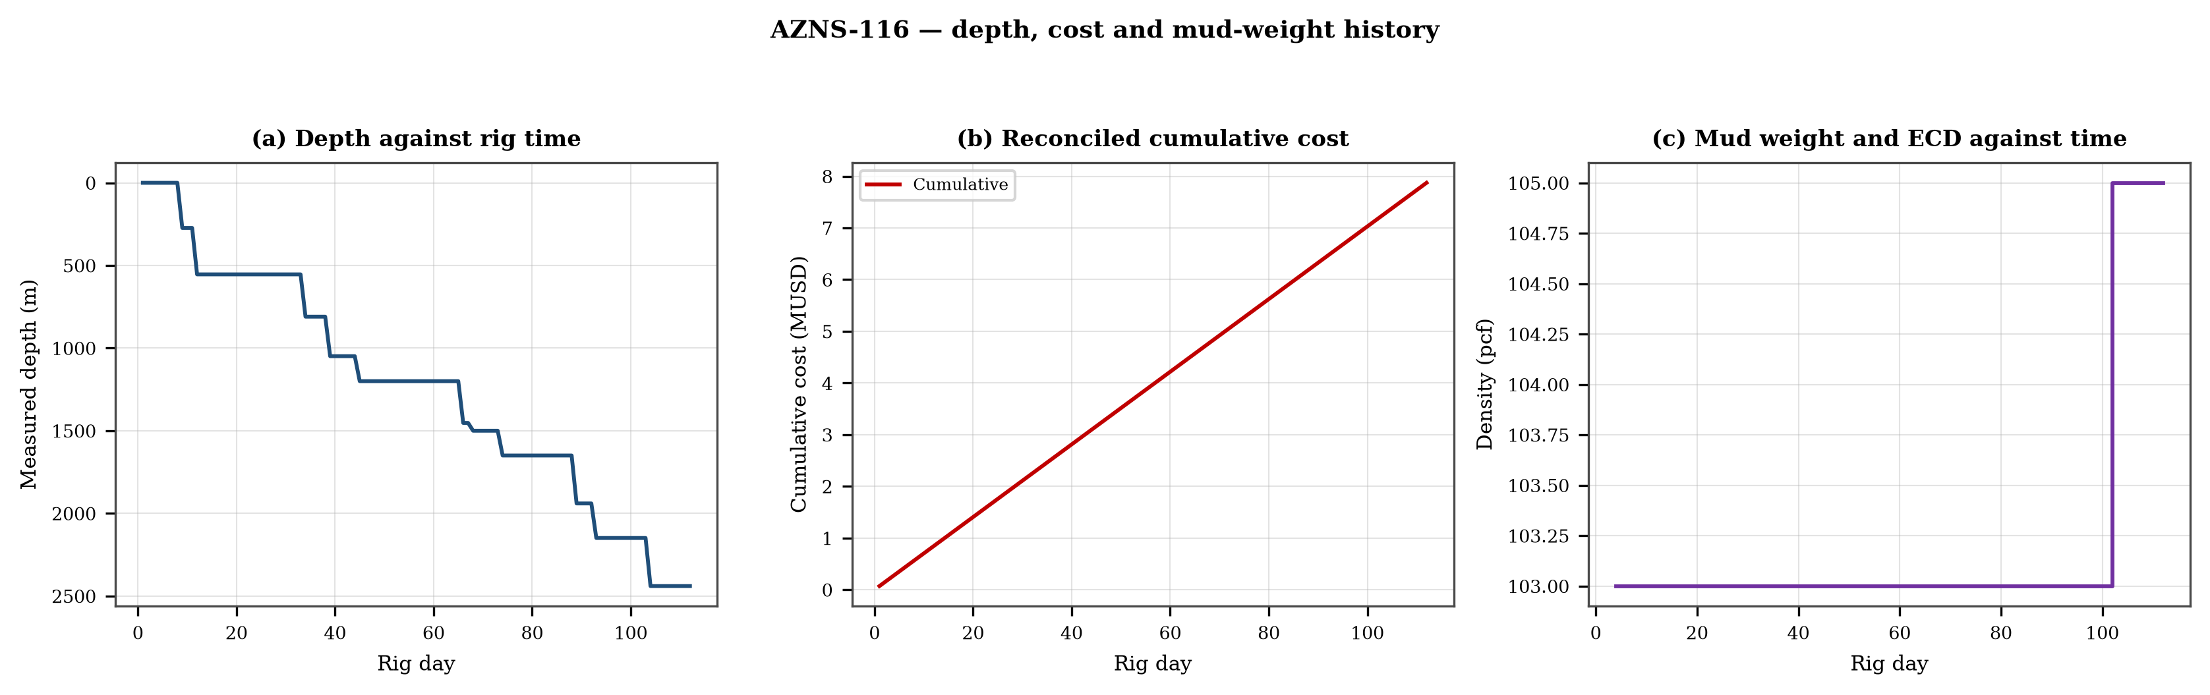
Figure 3.1 — Depth against rig time, reconciled cumulative cost and mud-weight envelope
The cost curve is reconstructed from the daily rig, mud and service rates applied to the recorded days; it is monotonic by construction and is intended for comparison, not as a replacement for the commercial register. The mud-weight curve shows the step changes that accompany each casing point, and each step is a decision point for the pressure window of Chapter 11.

4. Drilling performance, connections and rate of penetration
Productive time is split into drilling 2,277 h, reaming 11 h, trips 1,856 h, casing and cementing 7 h and logging 10 h. The ratio of handling time to drilling time is the single most informative number in this chapter: at 0.82 h of handling per hour of drilling, the well spends more time preparing the hole than making it.
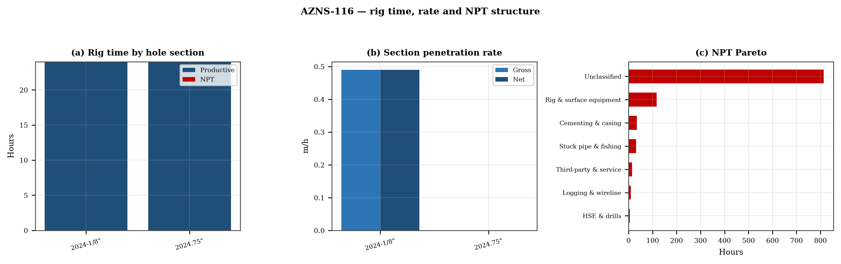
Figure 4.1 — Rig time by section, section rate and NPT pareto

Table 4.1 — Section performance
Section | Days | Metres | Gross ROP | Net ROP | Ream h | Trip h | NPT
2024-1/8" | 1 | 12 | 0.49 | 0.49 | — | — | 0.0%
2024.75" | 1 | 0 | 0.00 | 0.00 | — | — | 0.0%
DDR Ref. — "1-2 Data" time log rows 21–68 filtered to drilling codes, total row 68, and the bit block (bit number, size, metres, hours, IADC dull code)

5. Non-productive time and multi-hypothesis root cause
Non-productive time totals 1,024 h, or 38.1% of rig time, spread over 208 coded entries. The register is ranked below; the two or three leading mechanisms are then examined one by one, each with competing physical explanations and the field evidence that separates them.
Table 5.1 — NPT register by mechanism
Mechanism | Hours | Share | Events
Unclassified | 814 | 79.5% | 162
Rig & surface equipment | 117 | 11.4% | 24
Cementing & casing | 34 | 3.3% | 11
Stuck pipe & fishing | 31 | 3.0% | 4
Third-party & service | 14 | 1.4% | 2
Logging & wireline | 9 | 0.9% | 4
HSE & drills | 5 | 0.5% | 1
DDR Ref. — "1-1 Remark" activity status flag and "1-2 Data" time-log flag column J (P / N / UP) with the code column A; hours from column E

5.1 Unclassified — competing mechanisms
This mechanism consumed 814 h across 162 entries. Two explanations fit the recorded sequence equally well until the discriminating evidence is read. Mechanism A is a formation-driven response: the borehole or the fluid column behaves differently from the plan because of what the rock is doing. Mechanism B is an equipment or procedure response: the same symptom appears because a surface system, a service or a handling step did not deliver what the programme assumed. The discriminator is the pressure and torque record at the moment of onset: a formation response appears while parameters are steady, an equipment response appears as a step change with parameters unchanged.
- Day 3 (—): 4.0 h — 4Hrs. NPT for OEOC Rig 201 due to behind schedule, Rack Back & M/U Stand In Derrick.
- Day 4 (—): 15.0 h — 2 Hrs. NPT for OEOC Rig 201 due to Weakness in welfare services, P/U & M/U Lubricator, Set TWCV, Perform Press. Test against TWCV
- Day 17 (—): 1.0 h — 1.5 Hrs Waiting For OEOC Rig 201 Due to Change TDS Saver sub.

5.2 Rig & surface equipment — competing mechanisms
This mechanism consumed 117 h across 24 entries. Two explanations fit the recorded sequence equally well until the discriminating evidence is read. Mechanism A is a formation-driven response: the borehole or the fluid column behaves differently from the plan because of what the rock is doing. Mechanism B is an equipment or procedure response: the same symptom appears because a surface system, a service or a handling step did not deliver what the programme assumed. The discriminator is the pressure and torque record at the moment of onset: a formation response appears while parameters are steady, an equipment response appears as a step change with parameters unchanged.
- Day 14 (—): 3.0 h — 3/5 Hrs. NPT for OEOC Rig 201 due to Hoisting Sys. Failure, Work on Drawworks.
- Day 16 (—): 2.0 h — 2/5 Hrs. NPT for OEOC Rig 201 due to work on Drawworks & Top Drive, Due to a technical fault, TDS Elevator collided with
- Day 18 (—): 1.0 h — 1 Hr Waiting For OEOC Rig 201 due To Work On Drawworks.

6. Bit, BHA and nozzle performance
This record is an intervention on an existing well and carries no bit run of its own; the mill or bit used for the clean-out is described in the chronology rather than tabulated as a drilling bit. The absence of a bit table is a property of the record, not of the operation.

Figure 6.1 — Bit footage, run rate and footage by bit size

7. Mechanical parameters and mechanical specific energy
22 intervals carry a simultaneous weight and rotary-speed record. Weight on bit ranges 1.0–10.0 klbf with a median of 2.0 klbf, and rotary speed 10–3,952 rpm. The median mechanical specific energy is 54 ksi. For these hole sizes that is high: the bit is spending more energy on the bottom hole assembly and the fluid than on the rock.
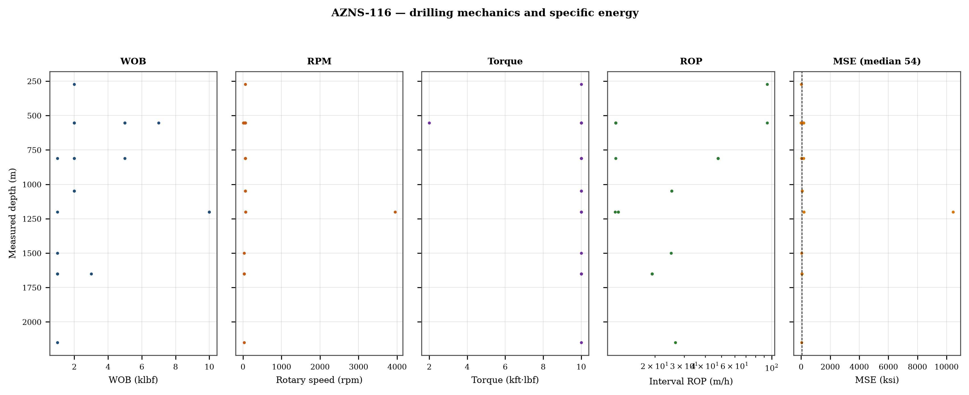
Figure 7.1 — Five-track mechanics log with specific energy

8. Drilling fluids, rheology, cuttings transport and ECD
No daily record in this well reports flow, nozzle area and rheology together, so jet velocity, hydraulic index and downhole circulating density cannot be computed as physical results. The figure reproduces the recorded mud weight against depth and the missing hydraulic quantities are listed in Chapter 17.
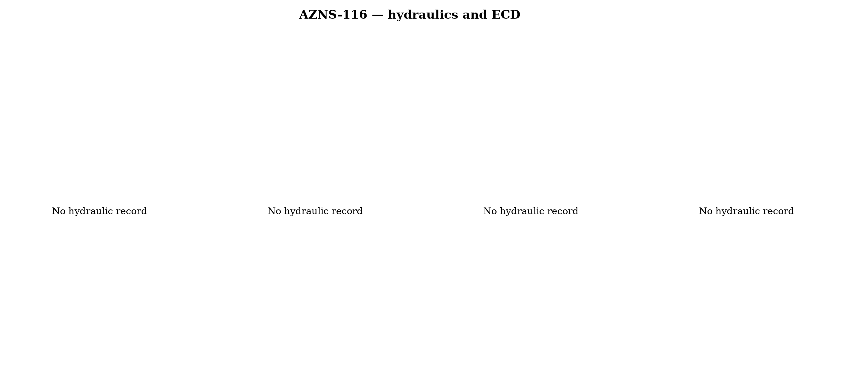
Figure 8.1 — Hydraulics and density record
Mud weight moves between 103 and 105 pcf across the record, in steps that coincide with casing points. Each step changes the equivalent circulating density by the same amount plus the annular loss term, which is why the pressure window narrows precisely when the weight is increased to control the shale.

9. Directional survey, trajectory and dog-leg severity
This record carries no usable survey table: the sheets repeat a blank template or a single station, and neither supports a minimum-curvature reconstruction. The well is therefore treated as vertical for depth conversion, and the trajectory is not claimed anywhere in this report. This is a property of the record and is carried in Chapter 17.

Figure 9.1 — Plan view, vertical section and dog-leg severity

10. Hook load, drag and overpull
Without a survey there is no geometric basis for a drag model, so no hook-load envelope is claimed. What the record does contain is the string weight and the overpull notes in the daily narrative; both are reported as recorded and no friction factor is assigned to them.
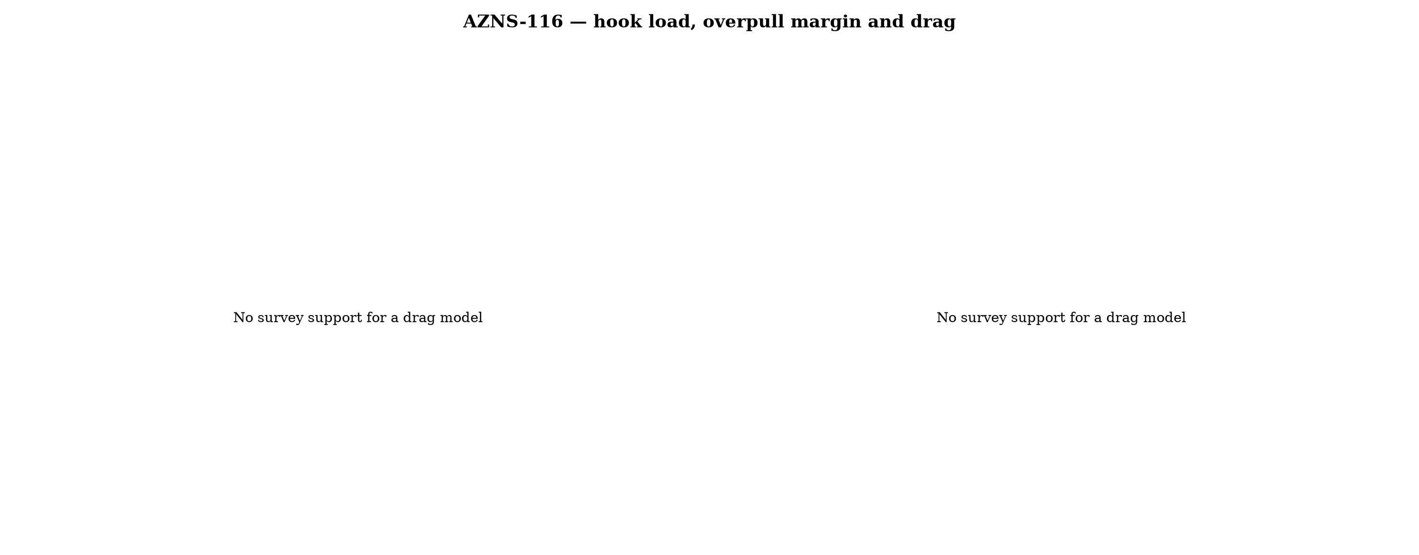
Figure 10.1 — Hook load and drag

11. Well control, shoe integrity, MAASP and losses
The record contains 48 formation-integrity tests with a numerical equivalent mud weight and 1 days with a loss entry. The dynamic maximum allowable surface pressure is the number the driller needs: at the shallowest shoe of this well, raising the annulus by 500 psi requires an equivalent weight of 0.0 pcf, which is the practical test of whether the mud programme is inside the window.
Table 11.1 — Integrity tests
Day | MD (m) | EMW (pcf)
1 | 0 | 30.0
39 | 1,049 | 30.0
42 | 1,049 | 30.0
43 | 1,049 | 30.0
44 | 1,049 | 30.0
45 | 1,200 | 30.0
46 | 1,200 | 30.0
47 | 1,200 | 30.0
48 | 1,200 | 30.0
49 | 1,200 | 30.0
50 | 1,200 | 30.0
51 | 1,200 | 30.0
DDR Ref. — "1-1 Remark" field “FIT Depth (MD/TVD) / EMW (PCF)” and the leak-off lines in the daily narrative

12. Geology, formation tops and gas
No formation-top table survives in this record, so the geological column is described from the daily lithology notes only. Depths quoted for formations are therefore narrative references and are not presented as a tops register; this limitation is carried in Chapter 17.
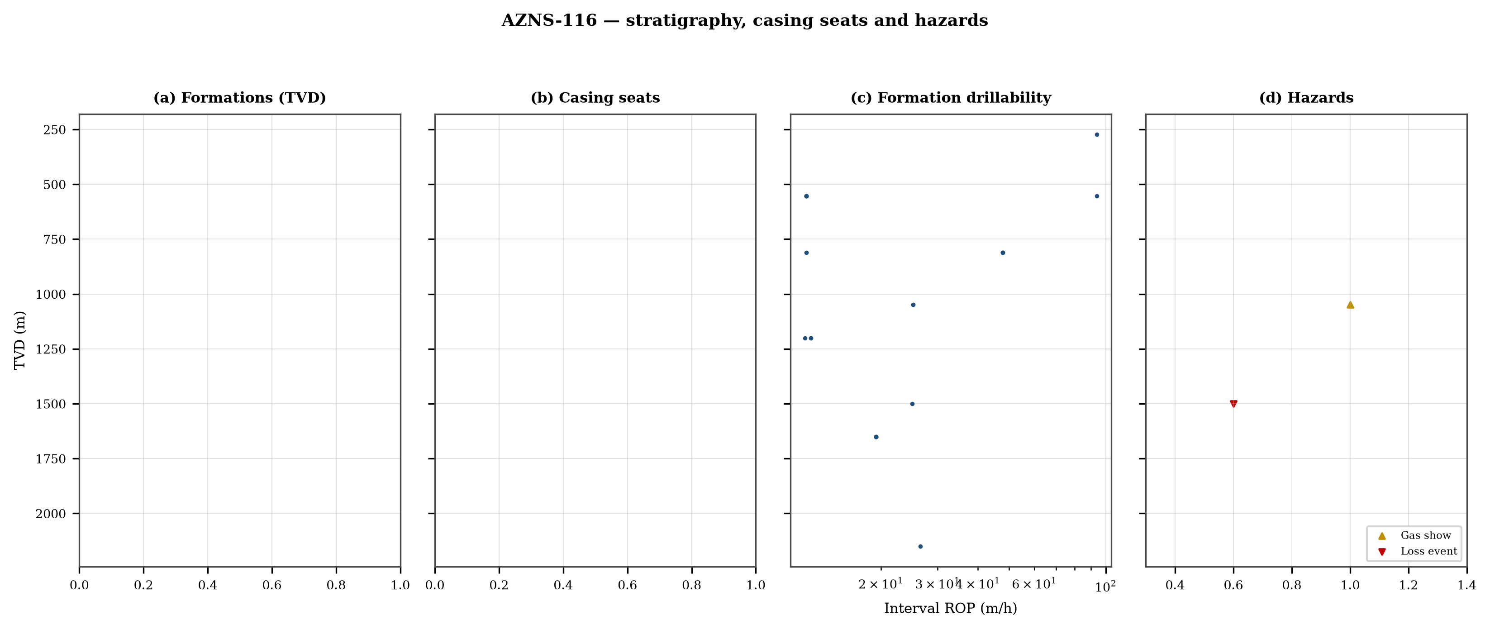
Figure 12.1 — Formation tops, casing seats, drillability and hazards

13. Operational problems, remedies and rig-floor playbooks
The five playbooks below are written for use at the rig floor, in the order given. Each one is the compressed form of the diagnosis used in Chapters 5, 10 and 11, and each is matched to the mechanism it treats.

Loss circulation playbook
- Stop drilling, record the loss rate at the current pump rate and keep the string moving.
- Reduce flow in two steps and measure the loss at each step: partial loss responds to LCM, total loss needs a different mechanism, not a bigger pill.
- Spot a graded LCM pill (fine–medium–coarse) across the loss zone and cure it before resuming; log the pill volume, the returned volume and the pressure at which it was spotted.
- If losses persist at the shoe, recalculate MAASP with the current mud weight and confirm the well is still displaced by a single fluid column.

Tight hole and overpull playbook
- Compare the observed overpull with the modelled pick-up envelope for the same depth.
- Circulate at the maximum allowable rate with the string rotating; if torque falls while returns carry cuttings, the cause is cleaning, not the formation.
- Work the string down with a controlled feed-off rather than pulling; never exceed 80% of the modelled overpull margin.
- If the string is stuck, establish circulation and jar down before any chemical soak.

Stuck pipe and fishing playbook
- Record the free rotating weight, the pick-up and the slack-off immediately; the spread distinguishes wall contact from a pack-off.
- Establish circulation within the first ten minutes; a stuck string that still circulates is recoverable without fishing.
- Apply torque and jar in the direction indicated by the string's own weight response, not by habit.
- Photograph and grade every recovered component before the next run.

Well-control playbook
- Shut in on the hard shut-in sequence and record SIDPP, SICP and pit gain within one minute.
- Confirm the influx type from the pressure pair: SIDPP ≈ SICP means a light fluid, SICP >> SIDPP means gas.
- Prepare a kill sheet with slow circulating pressure at the actual pump rate, not a table value.
- Maintain the casing pressure constant while bringing the pumps to rate; do not chase the drill-pipe pressure.

Shoe test and MAASP playbook
- Never drill out a shoe without a recorded FIT/LOT equivalent mud weight in the daily header.
- Compute MAASP for the current mud weight every time the weight changes by 0.1 pcf.
- Convert the test result to a fracture gradient at the shoe TVD, not at MD.
- When a loss occurs at the shoe, the first number to read is the dynamic MAASP, not the static one.

14. Optimum parameters, drill-off and MSE practice
Table 14.1 — Section parameter window in this well
Section | WOB (klbf) | RPM | Median interval ROP | Net ROP
2024-1/8" | 2–2 | 25–25 | 11.7 | 0.49
DDR Ref. — "1-2 Data" drilling-parameter sentences in column K (WOB, RPM, flow, SPP, torque) and the mud table columns K–S rows 11–38 — template A; mud table J8–L27 — template B
The drill-off procedure is the only reliable way to find the founder point on location. Hold flow constant, reduce weight in three steps of about 15% and record the rate at each step after 90 seconds of steady drilling; the rate should rise with weight until the founder point and then flatten. The weight at which it flattens is the operating weight for that formation, and the weight at which torque rises while rate does not is the weight that damages the bit.
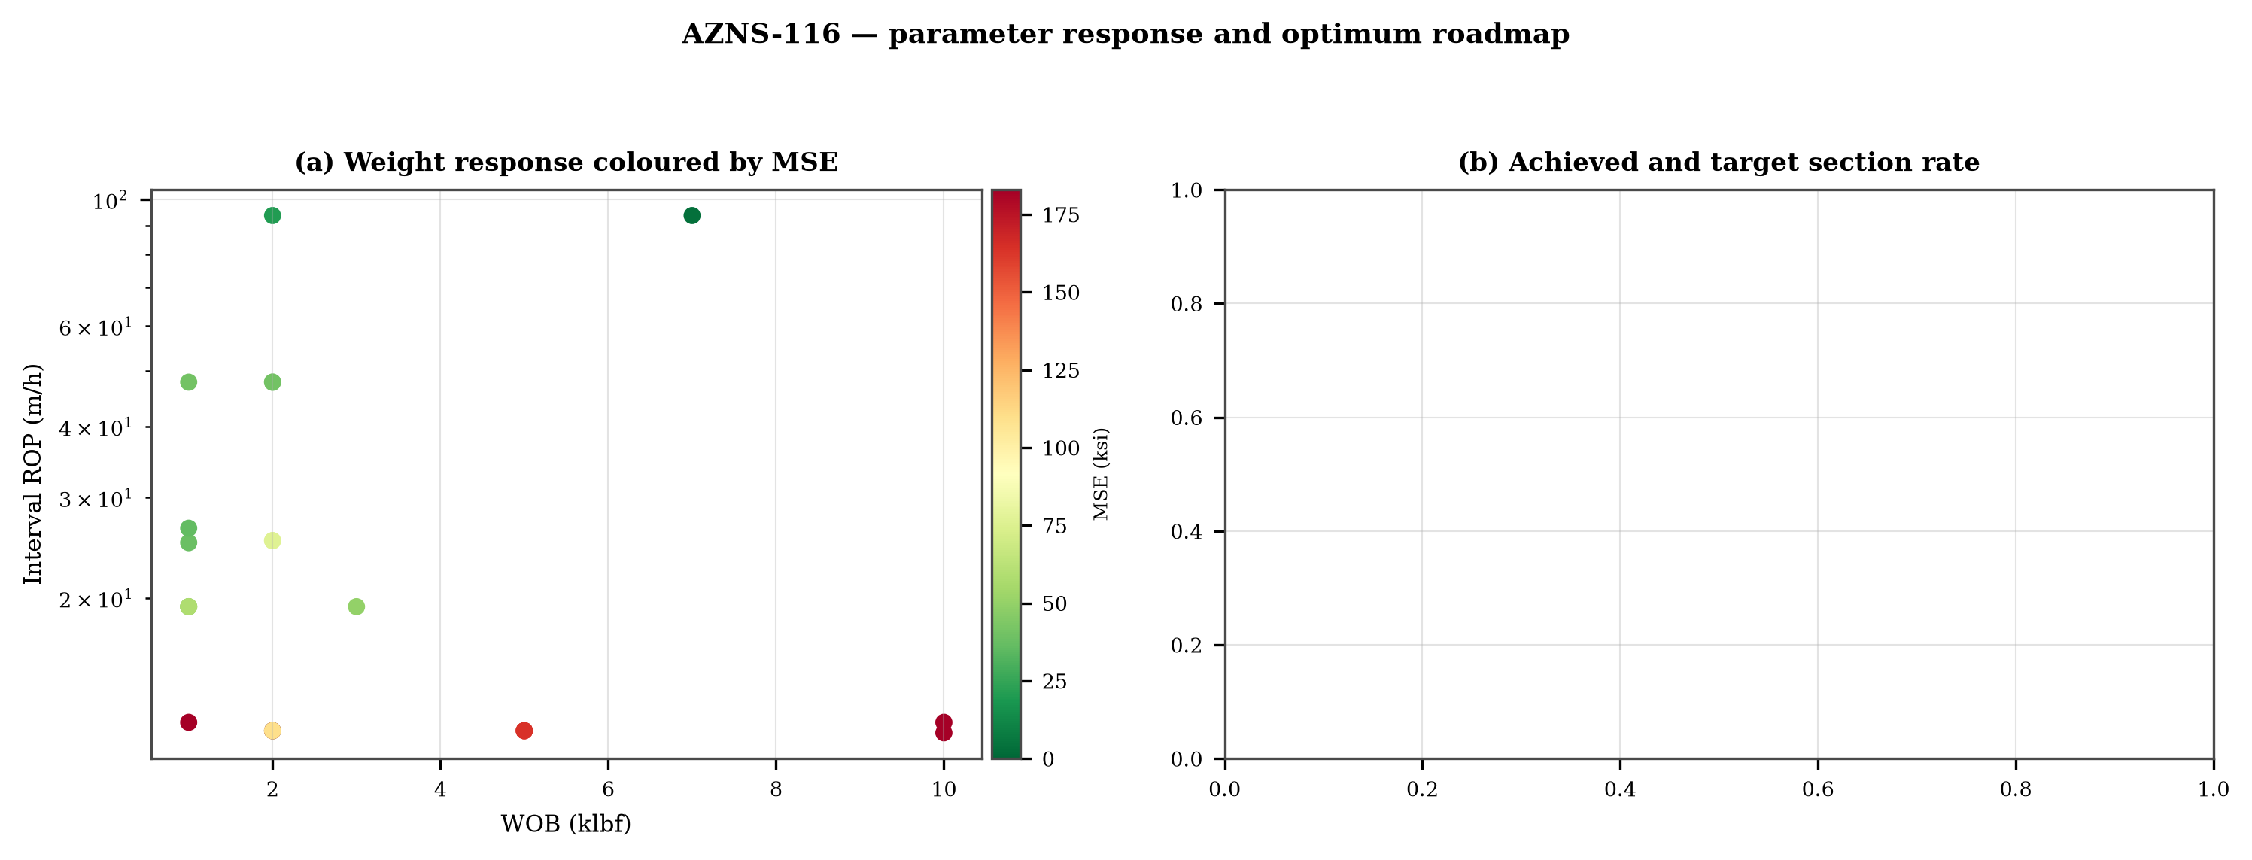
Figure 14.1 — Weight response coloured by specific energy and the section rate target

15. Key findings and risk register
- NPT stands at 38.1% of rig time, dominated by unclassified.
- Handling time is 0.82 times the drilling time, which is the structural inefficiency of this record.
- Net rate in the productive intervals is 0.95 m/h at a median specific energy of 54 ksi.
- The pressure window and the mud programme interact at every casing point; the integrity record is the weakest data set in the well.
Table 15.1 — Risk register
Risk | Trigger | Consequence | Control
Loss at the shoe | Drilling out with weight above the window | Loss of circulation and stuck pipe | Two-rate loss test, graded LCM
Tight hole on trips | Shale swelling after long open-hole exposure | Overpull and stuck string | Wiper trips, mud inhibition
Bit balling | Weight above the founder point in reactive clay | Rate collapse and torque rise | Drill-off test, HSI above 2.5
Equipment failure | Ageing pumps and top drive | Long NPT and hole deterioration | Reliability register
DDR Ref. — Derived — "1-1 Remark" narrative, "1-2 Data" time-log flags and the NPT register of this report; no single DDR cell

16. Recommendations — phase matrix and REC-01 to REC-10
Table 16.1 — Phase execution matrix
Phase | Action | Hold point
Pre-spud | Verify rig systems and spares against the reliability register | Signed availability check
Surface hole | Maximum flow with a single casing and cementing trip | Shoe test recorded
Intermediate | PDC and motor, wiper trip every 300 m, AV above 120 ft/min | Overpull trend inside envelope
Reservoir entry | Two-rate loss test and graded LCM on location | Loss cured before drilling ahead
Reservoir hole | Hold HSI above 2.5 hp/in², drill-off at each top | Founder point recorded
Close-out | NPT booked to the fixed cause list, review within 14 days | QC certificate signed
DDR Ref. — "1-2 Data" time log rows 21–68 aggregated by operational code and the "1-1 Remark" section headers
Table 16.2 — Recommendations
ID | Recommendation | Owner | Timing | Rationale
REC-01 | Adopt a rig-specific reliability register (pumps, top drive, drawworks) with monthly availability and mean time between failures | Rig manager | Immediate | Rig and surface equipment is the largest controllable NPT category
REC-02 | Standardise the FIT/LOT protocol and write the demonstrated EMW into the daily header | Well integrity | Before the next well | Makes MAASP auditable at every shoe
REC-03 | Apply the section parameter roadmap of Chapter 14 as the drilling programme | Drilling engineering | Next well | Closes the gap to the field P90 rate
REC-04 | Introduce a graded-LCM loss protocol with a two-rate diagnosis before treatment | Mud engineering | Immediate | Cuts loss time and lost mud volume
REC-05 | Run a drill-off test at the top of each formation and record the founder point | Drilling engineering | Each section | Prevents weight-induced inefficiency
REC-06 | Treat centrifuge running time as a recorded drilling parameter | Mud engineering | Immediate | Controls ECD without changing mud weight
REC-07 | Hold a torque-and-drag check against the modelled envelope before every trip | Drilling supervisor | Every trip | Converts overpull from a surprise into a trend
REC-08 | Book every NPT hour against the fixed cause list within the same tour | Drilling supervisor | Daily | Keeps the field comparison comparable
REC-09 | Audit third-party service readiness (wireline, cementing, casing crews) before the operation, not on arrival | Field engineering | Each job | Third-party delay is the second largest NPT category
REC-10 | Publish a weekly NPT pareto and a monthly field benchmarking pack | Field engineering | Weekly | Sustains the learning curve across rigs
DDR Ref. — This report — built from the KPI set and NPT register above; each row carries its own evidence reference

17. Limitations of the recorded data
- Footage is taken from the depth record, not from a declared daily figure: the increment between two written depths is spread over the intervening days in proportion to rig hours. Day-level rates inside those intervals are therefore allocations and carry an uncertainty of the interval length, not of the total.
- No usable survey table: the trajectory is not reconstructed and the well is treated as vertical for depth conversion.
- No formation-top register: the geological column is described from daily lithology notes only.
- No casing table with shoe depths: the architecture is described from the chronology and the hole sizes drilled.
- No flow, nozzle area and rheology in the same daily record: jet velocity, hydraulic index and ECD are not reported as physical results.
- Costs are reconstructed from daily rig, mud and service rates because the workbooks do not carry a commercial register; they are used for comparison only.

18. Appendix A — Workbooks, sheets and SHA-256
The record was read from AZNS116Pack.xlsx with 224 sheets, all of which were parsed. The table below reproduces the file inventory with the digest of the source workbook as it stands in the repository.
Table 18.1 — Source workbooks and SHA-256
File | SHA-256
AZNS10Pack.xlsx | bf8c897274b47f9324b6e808162c451c0329d78651e76a27c700db9263ec0a95
AZNS116Pack.xlsx | 68c5b874f1ba78a4a30989930aef00f06095d8118e89e217e74ca918364dc438
AZNS122WO1Pack.xlsx | c14db1ff6cbef8b7d4e0f69b9f64cdc4452e3935f64bad439d38a8aed6f5f42a
AZNS122WO2Pack.xlsx | 2eb9858150dfa2d43f46e387ded978fd04c811f0c08b402a76a533f36235b65c
AZNS127ST2Pack.xlsx | 68329de313721905be08f20cb8bb8b4f5f3671d5c6caab41f23caa1a48b9a4c4
AZNS127WO1Pack.xlsx | 6034aae76c2e3126416df8f8576d424bd3394c30aca4c4f5e72f0372256739d6
AZNS127WOPack.xlsx | a4ae90dc870f20b2f99ac3a36b8b5cd1c357b60dd2805630597cc48ba059054e
AZNS12Pack.xlsx | e325945f1108341bace123e60b02fb04ac3f7d3003a19eb8d23004cf7cd67216
AZNS166Pack.xlsx | e63824748e4692884fc23075c678c1379b9b595a8c8b1efb289e630f898a75d8
AZNS207Pack.xlsx | 828968c7e0afd7273d64987bd457383ecfea3a2e00e62c9a65b587f16518996a
AZNS40Pack.xlsx | 0523068ee222c02f6e2d2754bcd919a9c296b334b03521ab15d84322aade94ca
AZNS75Pack.xlsx | 5e0482d5d50e9347a98b7c24cfd3a102d3c00f2c951f6061aba14d164136fcae
AZNS85Pack.xlsx | 0d3ecc54fb8b9484f508b9a3957554ba13e72546c6d485abb79af633362daeb2
DDR Ref. — Workbook files as delivered (read-only), hash computed at build time
Table 18.2 — Sheet inventory of this well
Sheet | Sheet | Sheet
1-1 Remark | 1-2 Data | 2-1 Remark
2-2 Data | 3-1 Remark | 3-2 Data
4-1 Remark | 4-2 Data | 5-1 Remark
5-2 Data | 6-1 Remark | 6-2 Data
7-1 Remark | 7-2 Data | 8-1 Remark
8-2 Data | 9-1 Remark | 9-2 Data
10-1 Remark | 10-2 Data | 11-1 Remark
11-2 Data | 12-1 Remark | 12-2 Data
13-1 Table 1 | 13-2 Sheet1 | 14-1 Remark
14-2 Data | 15-1 Remark | 15-2 Data
16-1 Remark | 16-2 Data | 17-1 Remark
17-2 Data | 18-1 Remark | 18-2 Data
19-1 Remark | 19-2 Data | 20-1 Remark
20-2 Data | 21-1 Remark | 21-2 Data
22-1 Remark | 22-2 Data | 23-1 Remark
DDR Ref. — Workbook sheet list — every remark/data sheet pair plus the reference sheets

19. Appendix B — Equations and units
Table 19.1 — Governing equations
Quantity | Equation | Units
Mechanical specific energy | MSE = 480·T·N/(D²·ROP) + 4·WOB/(π·D²·1000) | psi, klbf, ft·lbf
Bit pressure drop | ΔP = ρ·Q²/(10858·TFA²) | psi, gpm, in²
Jet velocity | V = 0.3208·Q/TFA | ft/s
Hydraulic index | HSI = ΔP·Q/(1714·A_bit) | hp/in²
Annular velocity | V = 24.5·Q/(D_h² − D_p²) | ft/min
Bingham annular loss | ΔP = PV·V·L/(60000·(D_h−D_p)²) + YP·L/(200·(D_h−D_p)) | psi
Equivalent circulating density | ECD = MW + ΔP_ann/(0.052·TVD) | pcf
Minimum curvature | β = arccos[cos I₁cos I₂ + sin I₁ sin I₂ cos(A₂−A₁)] | rad
Dog-leg severity | DLS = 30·β/ΔMD | °/30 m
Buoyancy factor | BF = 1 − MW/490 | —
Hook load (soft string) | F = Σ w·BF·cos I·Δs ± μ·Σ w·BF·sin I·Δs | klbf
Maximum allowable surface pressure | MAASP = 0.052·(EMW_frac − MW)·TVD_shoe | psi
dc exponent | dc = log(ROP/(60·N)) / log(WOB/D) | —
Reconstructed cost | C = Σ (rig + mud + service) day rate | USD
DDR Ref. — Reference standard, Appendix B — no DDR cell

20. Appendix C — Complete NPT register
Table 20.1 — NPT register (all entries)
Day | Hrs | Mechanism | Activity and description
3 | 4.0 | Unclassified | 4Hrs. NPT for OEOC Rig 201 due to behind schedule, Rack Back & M/U Stand In Derrick.
4 | 15.0 | Unclassified | 2 Hrs. NPT for OEOC Rig 201 due to Weakness in welfare services, P/U & M/U Lubricator, Set TWCV, Perform Press. Test aga
5 | 5.0 | Third-party & service | 5 Hrs. NPT for OEOC Rig 201 due to the crane being out of service & human failure, 13-5/8" 10k Shear/Blind Rams
14 | 3.0 | Rig & surface equipment | 3/5 Hrs. NPT for OEOC Rig 201 due to Hoisting Sys. Failure, Work on Drawworks.
16 | 2.0 | Rig & surface equipment | 2/5 Hrs. NPT for OEOC Rig 201 due to work on Drawworks & Top Drive, Due to a technical fault, TDS Elevator collided with
17 | 1.0 | Unclassified | 1.5 Hrs Waiting For OEOC Rig 201 Due to Change TDS Saver sub.
18 | 3.0 | Unclassified | 3Hrs Waiting For OEOC Rig 201 due To Delay in Operation While CONT. POOH For Checking 5-5/8" O.Shot to 900 m.
18 | 1.0 | Rig & surface equipment | 1 Hr Waiting For OEOC Rig 201 due To Work On Drawworks.
25 | 2.0 | Unclassified | 2 Hrs Waiting For OEOC Rig 201 Due To Delay In Operation While POOH To 2040m, Circ. Cross Well Head w/NL-NG Till M.N.
26 | 2.0 | Unclassified | 2 Hrs Waiting For OEOC Rig 201 Due To Delay In Operation While Cont. POOH To 80m While Circ. Cross well Head W/NL-NG.
26 | 1.0 | Rig & surface equipment | 1 Hr Waiting For OEOC Rig 201 Due To Work On Mud Pump.
26 | 1.0 | Unclassified | 1 Hrs Waiting For OEOC Rig 201 Due To Delay In RIH Operation TILL M.N.
27 | 2.0 | Unclassified | 2 Hrs Waiting For OEOC Rig 201 Due To Delay In POOH Operation, Till M.N.
29 | 1.0 | Unclassified | 1 Hrs Waiting For OEOC Rig 201 Due to delay in Operation.
29 | 1.0 | Unclassified | 1 Hrs Waiting For OEOC Rig 201 Due to delay in Operation While RIH To 1780m While Circ. F/Cross well Head W/NL-NG
30 | 1.0 | Stuck pipe & fishing | 1 Hrs Waiting For MAPSA ( Mud Logging Service ) Due To No valid Data Through out Fishing Job Because Fault In Depth & Pu
30 | 1.0 | Unclassified | 1.5 Hrs Waiting for OEOC Rig 201 Due To delay In Operation Cont POOH F/ 1000m To 500m W/NL-NG.
32 | 1.0 | Rig & surface equipment | 1/5 Hrs. NPT for OEOC Rig 201 due to technical failure in hoisting system, Work on Drawworks.
35 | 1.0 | Unclassified | 1 Hrs. NPT for OEOC due to weakness in welfare services, Start Milling Op. f/ 3876.15 to 3878.20m w/ applying parameters
38 | 2.0 | Unclassified | 2Hrs. NPT for OEOC Rig 201 due to technical failure in hoisting Sys. , POOH w/ 5-7/8" Milling BHA f/ 3926 to 3878m and p
39 | 1.0 | Unclassified | 1/5 Hrs. NPT for OEOC Rig 201 due to technical failure in TDS, Work on TDS, while Circ. C.W.H, w/ NL-NG.
46 | 2.0 | Unclassified | 2 hrs waiting for OEOC RIG 201 Due to delay in RIH Operation.
60 | 4.0 | Unclassified | Wait on OEOC Operation, Due to Delay in Operation, Meanwhile Cont. RIH f/ 3400 to 3930m, While Pass 7"L.Lap (@3802m) Gen
60 | 1.0 | Rig & surface equipment | Wait on OEOC Operation, Due to Engine failure, Shut Down Diesel Generator#01 & Work on Driller Panel, Fix Same.
60 | 1.0 | Unclassified | Cont. RIH w/ Pumping & Rotation f/ 3930 to 3951.5m, Took Weight.
60 | 6.0 | Stuck pipe & fishing | Start Milling f/ 3951.5 to 3951.75m, While Due to an Unusual & Sudden Increase in Torque, String Got Stalled During Mill
60 | 3.0 | Stuck pipe & fishing | Decided to POOH, Circ. BTM's Up & work on junk subs, Start POOH 6"Clean Out BHA f/ 3951.75 to 3078m on Elevator, While C
61 | 9.0 | Unclassified | Cont. POOH 6"Clean Out BHA f/ 900m to 230m, While L/D 2No J.Sub (4lb Junk Recoverd), While Circ. Cross Well Head, w/ N.L
61 | 2.0 | Rig & surface equipment | 2 Hrs. NPT for OEOC Rig 201 due to Shut Down Diesel Generator#01.
61 | 2.0 | Unclassified | Cont. POOH f/ 230m to Surf., L/D 6"M.M Junk Mill (15%Used, Obs. 5 2/16"-6"Ring Out) & While Circ. Cross Wellhead, w/ N.L
61 | 4.0 | Unclassified | P/U & M/U 5-3/4"Taper Mill (New, T.S.E.KH.Co Esfahan, S/N: 040, w/ 6*18/32"Nozzle Port) + 4-3/4"Bit Sub (Float in)
61 | 1.0 | Rig & surface equipment | 1.5 Hrs. NPT for OEOC Rig 201 due to Shut Down Diesel Generator#01.
61 | 5.0 | Unclassified | Cont. RIH Followed by 5"DPs f/ 400 to 1673m, While F/U String & Break Circ. Every 15 STDs, w/ N.L-N.G, Till M.N.
62 | 6.0 | Unclassified | Cont. RIH w/ 5-3/4"Clean Out BHA Followed by 5"DPs f/ 1673 to 3936m, While F/U String & Break Circ. Every 15 STDs, w/ N.
62 | 8.0 | Rig & surface equipment | Cont. RIH w/ Wash Down f/ 3936 to 3951.75m, Took Weight, Perform Milling to Take Mark on Taper Mill, Pump 30bbl Hi-Vis P
62 | 9.0 | Unclassified | POOH 5-3/4" Clean Out BHA f/ 3951.75 to 532m, while Circ. Cross Well Head, w/ N.L-N.G, Till M.N.
63 | 3.0 | Unclassified | Cont. POOH 5-3/4"Clean Out BHA f/ 532m to Surface, L/D 5-3/4"Taper Mill & Rest of BHA, Obs. Mark on 5-3/4"Taper Mill,
63 | 4.0 | Unclassified | P/U & M/U 3-1/2"M.M Junk Mill (w/ 5*10/32"Nozzle Port) + 3-1/8"Bit Sub + 17Jts 3-1/8"DC (Jt by Jt)+ 3-1/2"X.O.S (2-7/8"P
63 | 13.0 | Unclassified | Cont. RIH w/ 3-1/2" Clean out BHA f/ 307 to 2407m On Elevator, while F/U Strg and Break Circ. Every 5 Stds, w/ NL-NG.
63 | 2.0 | Cementing & casing | Cont. RIH w/ 3-1/2" Clean out BHA f/ 2407 to 2552m On Elevator, attempt to Break Circ. After RIH 5 Stds, , No Success, O
63 | 1.0 | Unclassified | Resume RIH w/ 3-1/2" Clean out BHA f/ 2552 to 2692m On Elevator, attempt to Break Circ. After RIH 5 Stds, No Success, ag
64 | 2.0 | Cementing & casing | Cont. Work on Strg to make it unplugged, Strg got unplugged and SPP got back to Normal, Perform Circ. (150bbl), attempt
64 | 11.0 | Unclassified | Cont. RIH w/ 3-1/2" Clean out BHA f/ 2692 to 3580m On Elevator, while F/U Strg and Break Circ. Every 2 Stds. Meanwhile P
64 | 2.0 | Unclassified | Resume RIH w/ 3-1/2" Clean out BHA w/ Wash Dn f/ 3580 to 3951.75m (Obstruction Depth), w/ NL-NG.
64 | 2.0 | Unclassified | Try to pass Obstruction w/ applying 2klbs WOB, No Success, BTM's Up and POOH 3-1/2" BHA.
64 | 5.0 | Unclassified | POOH 3-1/2" Clean out BHA f/ 3951.75 to 2432m On Elevator, while Circ. C.W.H, w/ NL-NG.
65 | 13.0 | Unclassified | Cont. POOH 3-1/2" Clean out BHA f/ 2432m to surface On Elevator, L/D 3-1/2" M.M.J.Mill & Rest of BHA, while Circ. C.W.H,
65 | 1.0 | Unclassified | P/U & M/U 7" × 9-5/8" Scrapping BHA including 6" J.J.M.Mill + 7" Scraper + 4-3/4" Bit Sub + 11 Jts of 4-3/4" DC + 6-1/2"
65 | 9.0 | Unclassified | Cont. RIH w/ 7" × 9-5/8" Scrapping BHA f/ 135 to 3605m On Elevator, while F/U Strg Every 15Stds, w/ NL-NG.
66 | 2.0 | Cementing & casing | Seek to perform Break Circ. at last 15Stds @ 3605m, Obs. Strg is plugged, work on Strg to make it unplugged, No success,
66 | 2.0 | Cementing & casing | POOH 7" × 9-5/8" Scrapping BHA f/ 3605 to 3464m On Elevator, while Circ. C.W.H, Conn. TDS and Work on String to make it
66 | 4.0 | Cementing & casing | POOH 7" × 9-5/8" Scrapping BHA f/ 3464 to 3176m On Elevator, while Circ. C.W.H, Conn. TDS and Work on String to make it
66 | 2.0 | Unclassified | Perform Slip & Cut Drlg Line
67 | 2.0 | Unclassified | P/U & M/U 7" × 9-5/8" Open-End Scrapping BHA including 4-3/4" X.O.S + 7" Scraper + 4-3/4" Bit Sub [float-in] + 11 Jts of
67 | 13.0 | Unclassified | Cont. RIH w/ 7" × 9-5/8" Open-End Scrapping BHA f/ 134 to 3802m (7" L.Lap) On Elevator, while Scrapping 9-5/8" CSG & F/U
67 | 3.0 | Unclassified | Cont. RIH w/ 7" × 9-5/8" Open-End Scrapping BHA f/ 3802 to 3900m w/ Wash Dn, while Scrapping 7" LNR & 9-5/8" CSG,
67 | 6.0 | Unclassified | POOH 7" × 9-5/8" Open-End Scrapping BHA f/ 3900 to 1830m On Elevator, while Circ. C.W.H, w/ NL-NG.
68 | 6.0 | Unclassified | POOH 7" × 9-5/8" Open-End Scrapping BHA f/ 1830m to Surface On Elevator, L/D BHA, while Circ. C.W.H, w/ NL-NG.
68 | 3.0 | Unclassified | Change 13-5/8" 10k Top Rams f/ 2-7/8" - 5" VBR to 4-1/2" * 7" VBR, perform Press. Test on BOP, Ok, L/D Mouse Hole & R/U
68 | 5.0 | Unclassified | RIH w/ Wire Line Tools as Run1# CBIL-CDR-GR-CCL for 7" LNR f/ surface to 3944m with 30 m/min speed and record normal ten
68 | 9.0 | Unclassified | Change the overbody Centralizers according to 9-5/8" CSG size, M/U Tool string and perform surface checks, RIH w/ Wire L
69 | 9.0 | Third-party & service | Cont. Log Up f/ 1500m to surface with 4m/min speed and fully cover the logging interval, all in presence of Client Wells
69 | 2.0 | Unclassified | P/U & M/U 6"M.M.J Mill (New, T.S.E.KH.Co Esfahan, w/ 5*16/32"Nozzle Port) & RIH w/ 4-3/4"Bit Sub (Float in) + 7 STDs 4-3
69 | 11.0 | Unclassified | Cont. RIH w/ 6"Clean Out BHA f/ 207 to 3802m (7" L.Lap) Followed by 5"DPs On Elevator, While Break Circ. Every 15 STDs,
70 | 4.0 | Unclassified | Cont. RIH w/ 6"Clean Out BHA f/ 3840 to 3951.5m (Obstruction Depth) Followed by 5"DPs w/ Wash Dn, Took Weight @ 3951.5m,
70 | 6.0 | Unclassified | Cont. Milling w/ 6" Clean out BHA f/ 3951.75 to 3952.3m w/ applying parameters [WOB: 1-5klb, Rotation: 30RPM, Tq: 1-3klb
70 | 5.0 | Unclassified | Perform Circ. @ 3952.3m , w/ NL-NG.
70 | 2.0 | Unclassified | Cont. Milling & Cleaning w/ 6" Clean out BHA f/ 3952.4 to 3956.3m w/ applying parameters [WOB: 1-3klb, Rotation: 30RPM,
70 | 1.0 | Unclassified | Cont. Milling w/ 6" Clean out BHA f/ 3956.3 to 3956.4m w/ applying parameters [WOB: 1-5klb, Rotation: 30RPM, Tq: 1-3klbf
70 | 5.0 | Unclassified | Cont. Milling & Cleaning w/ 6" Clean out BHA f/ 3956.4 to 3960.8m w/ applying parameters [WOB: 1-3klb, Rotation: 30RPM,
DDR Ref. — "1-2 Data" time log rows 21–68 with flag N or UP, one row per logged interval

21. Appendix D — Daily hydraulics and ECD
No daily hydraulic record exists in this workbook, so the appendix is limited to the statement of absence.

22. Appendix E — Formation tops and survey stations
Neither a formation register nor a survey register exists in this record.

23. Reference, quality control and traceability
Table 23.1 — Traceability and QC
Item | Value
Source workbook | AZNS116Pack.xlsx
Sheets parsed | 224 of 224
Daily reports | 112
Rig | OEOC RIG 201
NPT entries | 208
Figures | 9 at 300 dpi
Fonts | Times New Roman (EN), B Nazanin with Times New Roman (FA)
Directionality | LTR (EN) and RTL with bidi tables (FA)
Reference integrity | SHA-256 verified for all six original workbooks
Cost basis | reconstructed from daily rates, comparison only
DDR Ref. — Cross-reference of this document against the workbook sheet inventory and hash register

24. Planned versus actual: the programme against the record
The operation was planned in AZNS-116 Workover Program Rev.04.pdf (Rev.04), which set 77 rig days to a planned total depth of 4,150 m, and was priced in CBS AZNS-127WO1 and 116.xlsx. The record closes at 112 rig days and 2,440 m measured depth, so the schedule variance is +34.6 days (+45%) and the depth variance −1,710 m. Figure 24.1 places the planned baseline against the daily chronology recovered from the DDR.
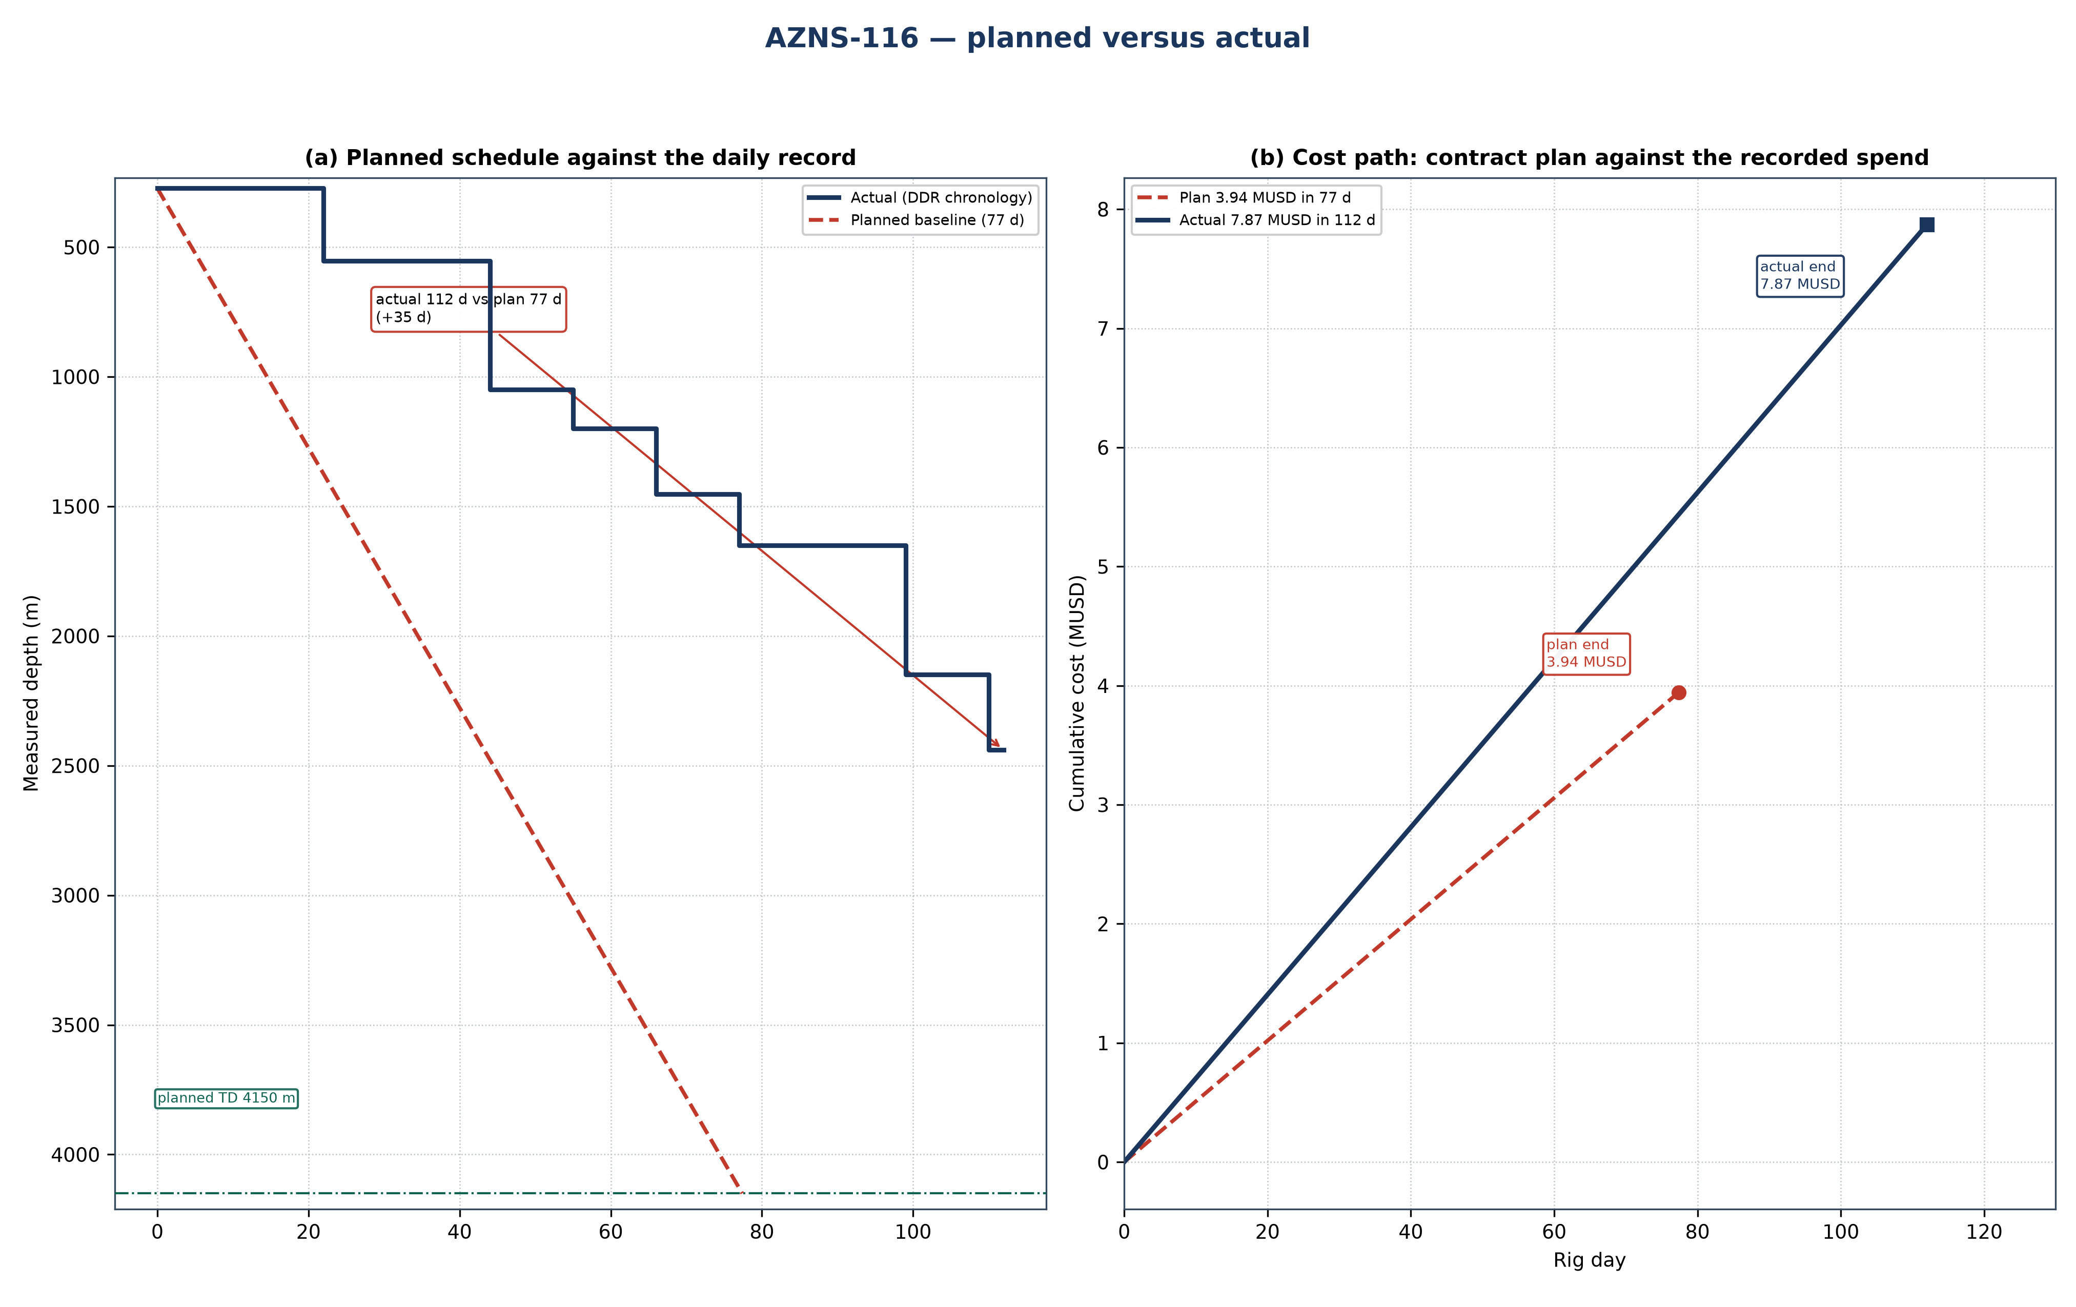
Figure 24.1 — AZNS-116: planned schedule and cost path against the recorded operation
Table 24.1 — Planned and actual milestones
Indicator | Programme | Record | Variance | Basis
Rig days | 77 | 112 | +34.6 | Programme duration / DDR rig hours
Total depth (m) | 4,150 | 2,440 | −1,710 | Programme TD / final MD
New hole (m) | — | 2,168 | — | DDR daily drilling figure
Rig | OEOC RIG 201 | OEOC RIG 201 | — | DDR header
NPT share | — | 1,024 h (38.1%) | — | Time-log flags
Contract value (MUSD) | 3.94 | 7.87 | +3.93 | CBS / daily-rate reconstruction
Specific cost (USD/m) | 1,819 | 3,630 | — | Cost over new hole

Ref. — duration and total depth from the approved programme; recorded rig days, new hole and final measured depth from the DDR sheets cited in Chapters 1 to 3; contract value from the cost breakdown structure and the recorded cost from the daily-rate reconstruction of Chapter 25.
Two explanations are open for a variance of this size, and they are separated before any recovery is credited. Either the scope grew after approval — an extra run, a second window, a deeper shoe — or the same scope took longer because rig time was lost. The discriminator is the NPT register: non-productive time is 1,024 h of 2,685 h (1,024 h (38.1%)), which accounts for about 43 days. Where that is close to the overrun, the scope did not change and the time was lost; where the operation count rises while NPT stays flat, the scope changed.
Technically the operation followed the programme sequence of workover with drill-out: the casing and hole programme of Chapter 2, the fluid programme of Chapter 7 and the bit and BHA record of Chapter 6 are the executed values, and Table 24.1 sets them against the plan. The planned section boundaries are reproduced in Figure 24.1 by the formation bands, so any section that ran long can be read directly off the depth axis.

25. Cost breakdown structure: contract plan against recorded cost
CBS AZNS-127WO1 and 116.xlsx prices the scope at 3.94 MUSD, of which 2.50 MUSD is written on day-rate lines at a rig rate of 23,000 USD/day; the time-dependent element therefore costs about 32,278 USD per rig day. The record closes at 7.87 MUSD, a variance of +3.93 MUSD (+100%). Figure 25.1 splits that variance into the day-rate effect of the schedule and a scope-and-price residual.
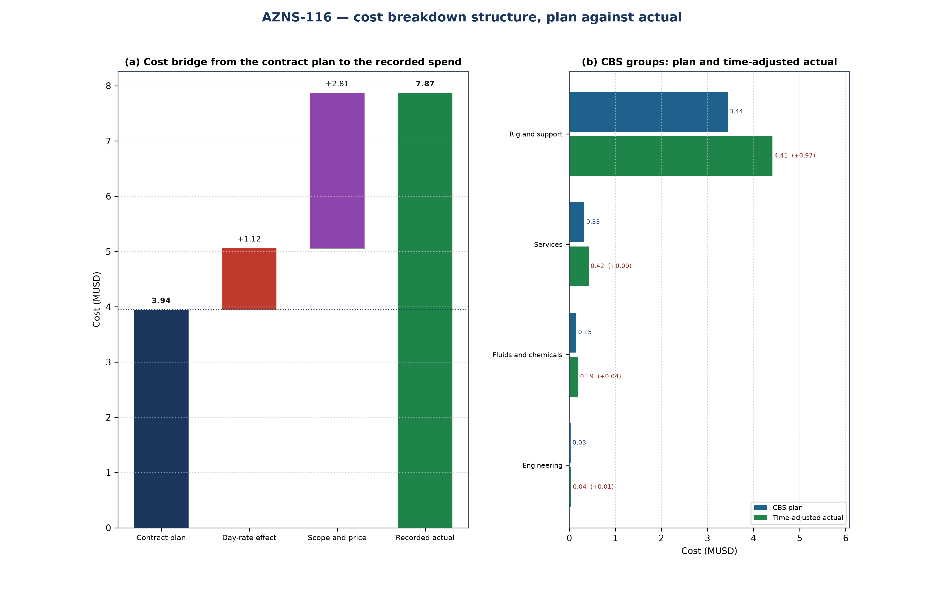
Figure 25.1 — AZNS-116: cost bridge and CBS groups
Table 25.1 — CBS groups: plan, share and time-adjusted value
CBS group | Plan (MUSD) | Share | Time-adjusted (MUSD) | Δ (MUSD)
Rig and support | 3.44 | 87.1% | 4.41 | +0.97
Services | 0.33 | 8.3% | 0.42 | +0.09
Fluids and chemicals | 0.15 | 3.8% | 0.19 | +0.04
Engineering | 0.03 | 0.7% | 0.04 | +0.01
Total | 3.94 | 100.0% | 5.06 | +1.12

CBS Ref. — quantities and unit rates from "CBS AZNS-127WO1 and 116.xlsx", sheet "Cost Breakdown-116"; the recorded cost is the daily-rate reconstruction of Chapter 1, not a second reading of the workbook.
Table 25.2 — Variance bridge
Step | MUSD | Driver
Contract plan (CBS) | 3.94 | Contract quantities at contract rates
Day-rate effect | +1.12 | +34.6 rig days at 32,278 USD/day
Scope and price residual | +2.81 | Runs, materials and services beyond the priced quantity
Recorded cost | 7.87 | Daily-rate reconstruction

CBS Ref. — quantities and unit rates from "CBS AZNS-127WO1 and 116.xlsx", sheet "Cost Breakdown-116"; the recorded cost is the daily-rate reconstruction of Chapter 1, not a second reading of the workbook.
The residual is large, which means the record carries work that the priced schedule does not: either the scope was extended after approval, or services were called out that the lump-sum schedule treats as included. The discriminator is the extra-work column of the CBS and the service tickets behind it — where the same line appears in both, the scope grew; where it does not, the variance is a measurement of the lump-sum boundary.

26. Intervention-specific execution notes
This is a workover: the well is killed and secured first, the existing completion is retrieved or milled, the productive interval is re-established and the well is returned to service. The programme's well-control chapter governs the kill, the cement programme governs any squeeze and the completion chapter governs the string and the packer setting depth. The hold points below are the ones that decide whether the operation closes on plan.
Table 26.1 — Execution hold points
Stage | Execution requirement | Hold point
Kill and secure | Kill fluid from the last recorded gradient, circulated at the minimum rate that keeps the annulus full | stable shut-in pressure before the tree is broken
Retrieve or mill the completion | Recorded make-up torque, fishing diagram and jarring procedure on the floor | string freed and torque recorded before the next run
Squeeze and test | Cement squeeze at the programmed pressure with the WOC time held in full | pressure test held before the interval is opened
Re-establish the interval | Perforation, acid or rig-less stimulation per the programme, treating pressure recorded | treating pressure inside the fracture gradient of Chapter 9

Ref. — hold points read from AZNS-116 Workover Program Rev.04.pdf; the sequence of the operation follows the approved programme and the daily record cited in Chapter 3.
Table 26.2 reads the daily log reproduced in Chapter 17 as an effort split. The log transcribes 70 entries carrying 284.0 h; of these, 220.0 h carry wording that identifies the intervention task, and the remainder is general rig work. The split shows where the executed scope actually lay, which is the input the next programme of the same type needs: a task that takes a third of the transcribed hours is the task whose duration has to be estimated from the record rather than from the template.
Table 26.2 — Recorded effort by intervention task
Task | Entries | Hours | Share
Kill and well control | 25 | 126.0 | 44.4%
Milling, dress-out and clean-out | 19 | 78.0 | 27.5%
Perforation and acid | 1 | 5.0 | 1.8%
Completion and tubing | 2 | 10.0 | 3.5%
Fishing and freeing | 1 | 1.0 | 0.4%
Assigned to a task | 48 | 220.0 | 77.5%
All transcribed entries | 70 | 284.0 | 100.0%

Ref. — activity log of Chapter 17 (DDR "1-1 Remark" and "1-2 Data" time log); each entry is assigned to the first task whose wording it matches, so no hour is counted twice.
The operation as recorded was of the workover with drill-out type. Its schedule closed at 112 rig days against 77 planned, the reading of Chapter 24, and its cost at 7.87 MUSD against 3.94 MUSD of contract value, which Chapter 25 decomposes. What remains for the next operation of this type is the hold-point discipline of Table 26.1: every recorded overrun is a hold point passed late rather than a step executed badly. The largest identified task in the transcribed log is Kill and well control at 126.0 h (44%).

