AZNS-40 — Drilling Engineering Report
Development record, rig OEOC RIG 208, AZNS field — drilling performance, bit and hydraulics mechanics, trajectory, integrity and field solutions

Rig: OEOC RIG 208 | Well type: development | Spud: —
Rig days: 151 | New hole: 2,688 m | Final MD: 4,200 m
Reconstructed cost: 10.62 MUSD | NPT: 31.3%
Prepared by: Principal Drilling & Well Operations Engineering

Contents
1. Executive summary and well KPIs
2. Well architecture, rig configuration and casing programme
3. Operational chronology and phase cost
4. Drilling performance, connections and rate of penetration
5. Non-productive time and multi-hypothesis root cause
6. Bit, BHA and nozzle performance
7. Mechanical parameters and mechanical specific energy
8. Drilling fluids, rheology, cuttings transport and ECD
9. Directional survey, trajectory and dog-leg severity
10. Hook load, drag and overpull
11. Well control, shoe integrity, MAASP and losses
12. Geology, formation tops and gas
13. Operational problems, remedies and rig-floor playbooks
14. Optimum parameters, drill-off and MSE practice
15. Key findings and risk register
16. Recommendations — phase matrix and REC-01 to REC-10
17. Limitations of the recorded data
18. Appendix A — Workbooks, sheets and SHA-256
19. Appendix B — Equations and units
20. Appendix C — Complete NPT register
21. Appendix D — Daily hydraulics and ECD
22. Appendix E — Formation tops and survey stations
23. Reference, quality control and traceability
24. Planned versus actual: the programme against the record
25. Cost breakdown structure: contract plan against recorded cost
26. Intervention-specific execution notes

Table 0.1 — Management identity sheet
Attribute | Value | Attribute | Value
Well | AZNS-40 | Rig | OEOC RIG 208
Well type | development | Field | AZNS — South Azadegan
Spud date | — | Rig days | 151
Final MD | 4,200 m | New hole | 2,688 m
NPT | 1,134 h (31.3%) | Rig hours | 3,624 h
Reconstructed cost | 10.62 MUSD | USD per metre | 3,949
Source sheets | 302 | Primary NPT cause | Unclassified
DDR Ref. — "1-1 Remark" cells K5–N9 (Report Date, Report No.) and "1-2 Data" rows 5–9 (well header: name, rig, spud, depths, casing head)

1. Executive summary and well KPIs
AZNS-40 was worked by rig OEOC RIG 208 over 151 rig days and 3,624 rig hours. The record carries 2,688 m of new hole to a final measured depth of 4,200 m, with 31.3% of rig time booked as non-productive and a reconstructed cost of 10.62 MUSD. The dominant loss mechanism is unclassified at 658 h, and the section-level rate in the productive part of the well is 2.03 m/h net against 0.74 m/h gross.
Table 1.1 — Well KPI set
Indicator | Value | Indicator | Value
Rig days | 151 | Rig hours | 3,624
New hole (m) | 2,688 | Final MD (m) | 4,200
Drilling hours | 1,324 | Reaming hours | 82
Trip hours | 1,262 | Casing/cement hours | 80
NPT hours | 1,134 | NPT share | 31.3%
Net ROP (m/h) | 2.03 | Gross ROP (m/h) | 0.74
ILT hours | 712 | ILT share | 19.7%
Cost (MUSD) | 10.62 | Cost per day (kUSD) | 70.3
DDR Ref. — "1-2 Data" time log rows 21–68 (codes, hours, flags), daily state rows 9–13 (24 hrs Drilled, MD, MW) and "1-1 Remark" activity narrative

2. Well architecture, rig configuration and casing programme
The well was executed by rig OEOC RIG 208, a development unit operating in the AZNS field. The architecture follows the field standard: a large surface hole, an intermediate hole through the reactive shale sequence and a production hole in the carbonate reservoir. The section breakdown in this record is 5-7/8" (0 m in 2 days), 8-1/8" (398 m in 11 days), 12-1/8" (2,951 m in 51 days), 16-7/8" (3 m in 5 days), 2023-7/8" (0 m in 68 days).
The daily sheets in this record do not carry a casing table with shoe depths, so the architecture is described from the operational chronology and from the hole sizes actually drilled. The missing table is listed in Chapter 17 rather than reconstructed from assumption.
Table 2.2 — Rig and section configuration
Rig | Section | Days | Metres | Net ROP | NPT
OEOC RIG 208 | 5-7/8" | 2 | 0 | 0.00 | 0.0%
OEOC RIG 208 | 8-1/8" | 11 | 398 | 1.51 | 2.5%
OEOC RIG 208 | 12-1/8" | 51 | 2,951 | 2.67 | 22.1%
OEOC RIG 208 | 16-7/8" | 5 | 3 | 0.03 | 34.2%
OEOC RIG 208 | 2023-7/8" | 68 | 0 | 0.00 | 41.5%
OEOC RIG 208 | 2024-1/4" | 13 | 130 | 5.44 | 44.4%
DDR Ref. — "1-1 Remark" header fields (rig, well type, section start depth, expected TD) and "1-2 Data" rows 5–9

3. Operational chronology and phase cost
The record runs from the first report to the last report with 151 daily reports, each of which was read in full. The chronology below reproduces the operational sequence at fortnightly resolution, with the depth reached and the productive share of each interval.
Table 3.1 — Fortnightly chronology
Days | From | MD (m) | Hours | NPT
1–15 | — | 2,191 | 360 | 20.7%
16–30 | — | 2,922 | 360 | 36.8%
31–45 | 2023-12-08 | 3,656 | 360 | 16.1%
46–60 | 2023-08-27 | 3,939 | 360 | 13.9%
61–76 | 2023-11-09 | 4,200 | 360 | 3.5%
77–91 | — | 4,200 | 360 | 46.4%
92–106 | — | 4,200 | 360 | 38.3%
107–121 | — | 4,200 | 360 | 82.8%
122–136 | — | 4,200 | 360 | 30.3%
137–151 | — | 4,200 | 360 | 26.1%
152–152 | — | 4,200 | 24 | 0.0%
DDR Ref. — "1-1 Remark" “Summary of Activities in Last 24:00 hours” and “Operation Forecast”; day counter from the consecutive sheet pairing of the workbook
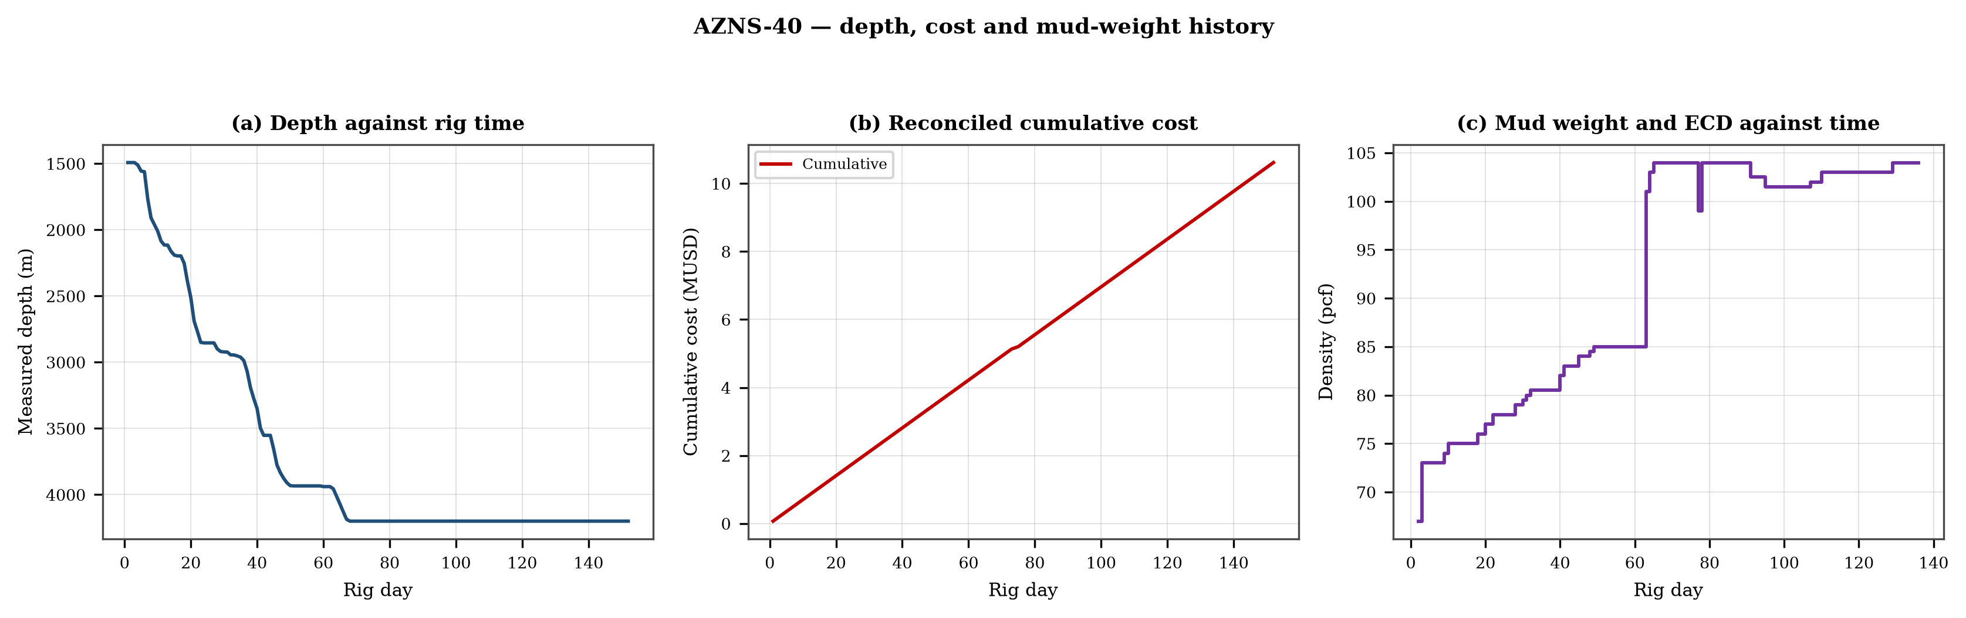
Figure 3.1 — Depth against rig time, reconciled cumulative cost and mud-weight envelope
The cost curve is reconstructed from the daily rig, mud and service rates applied to the recorded days; it is monotonic by construction and is intended for comparison, not as a replacement for the commercial register. The mud-weight curve shows the step changes that accompany each casing point, and each step is a decision point for the pressure window of Chapter 11.

4. Drilling performance, connections and rate of penetration
Productive time is split into drilling 1,324 h, reaming 82 h, trips 1,262 h, casing and cementing 80 h and logging 81 h. The ratio of handling time to drilling time is the single most informative number in this chapter: at 1.01 h of handling per hour of drilling, the well spends more time preparing the hole than making it.
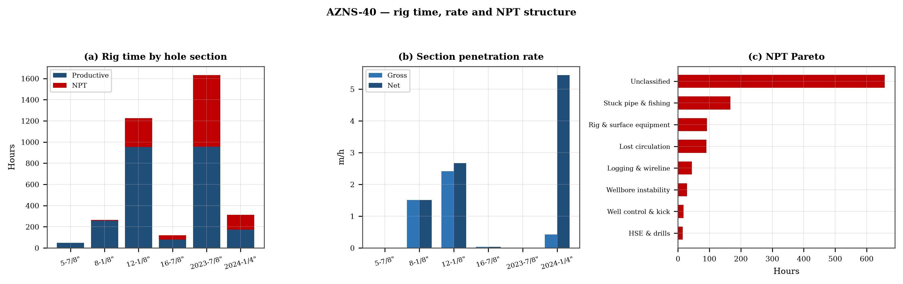
Figure 4.1 — Rig time by section, section rate and NPT pareto

Table 4.1 — Section performance
Section | Days | Metres | Gross ROP | Net ROP | Ream h | Trip h | NPT
5-7/8" | 2 | 0 | 0.00 | 0.00 | — | — | 0.0%
8-1/8" | 11 | 398 | 1.51 | 1.51 | — | — | 2.5%
12-1/8" | 51 | 2,951 | 2.41 | 2.67 | — | — | 22.1%
16-7/8" | 5 | 3 | 0.03 | 0.03 | — | — | 34.2%
2023-7/8" | 68 | 0 | 0.00 | 0.00 | — | — | 41.5%
2024-1/4" | 13 | 130 | 0.42 | 5.44 | — | — | 44.4%
DDR Ref. — "1-2 Data" time log rows 21–68 filtered to drilling codes, total row 68, and the bit block (bit number, size, metres, hours, IADC dull code)

5. Non-productive time and multi-hypothesis root cause
Non-productive time totals 1,134 h, or 31.3% of rig time, spread over 212 coded entries. The register is ranked below; the two or three leading mechanisms are then examined one by one, each with competing physical explanations and the field evidence that separates them.
Table 5.1 — NPT register by mechanism
Mechanism | Hours | Share | Events
Unclassified | 658 | 58.0% | 119
Stuck pipe & fishing | 167 | 14.7% | 21
Rig & surface equipment | 92 | 8.1% | 21
Lost circulation | 90 | 8.0% | 25
Logging & wireline | 44 | 3.9% | 6
Wellbore instability | 29 | 2.6% | 5
Well control & kick | 18 | 1.6% | 1
HSE & drills | 15 | 1.3% | 5
Client / operator decision | 10 | 0.8% | 3
Third-party & service | 7 | 0.6% | 4
Cementing & casing | 4 | 0.4% | 2
DDR Ref. — "1-1 Remark" activity status flag and "1-2 Data" time-log flag column J (P / N / UP) with the code column A; hours from column E

5.1 Unclassified — competing mechanisms
This mechanism consumed 658 h across 119 entries. Two explanations fit the recorded sequence equally well until the discriminating evidence is read. Mechanism A is a formation-driven response: the borehole or the fluid column behaves differently from the plan because of what the rock is doing. Mechanism B is an equipment or procedure response: the same symptom appears because a surface system, a service or a handling step did not deliver what the programme assumed. The discriminator is the pressure and torque record at the moment of onset: a formation response appears while parameters are steady, an equipment response appears as a step change with parameters unchanged.
- Day 5 (—): 9.0 h — Stop Drlg due to Obs. jumping string, drop 390 psi SPP & 5 klbs drop string Wt regarding to last string Wt. Check on BTM TQ : 1.5klb.ft same
- Day 5 (—): 2.5 h — Assemble 10-1/8"over shot w/ standard size guide (dressed w/ 8-1/4" spiral grapple control + 8-1/4"spiral grapple + type A packer) Below
- Day 6 (—): 2.5 h — L/D 12-1/4" PDC Bit (Dull: 1-1-CT-A-X-I-PN & WT-LIH) & 1 Jt 8-1/2" DC, Release Over Shot.

5.2 Stuck pipe & fishing — competing mechanisms
This mechanism consumed 167 h across 21 entries. Two explanations fit the recorded sequence equally well until the discriminating evidence is read. Mechanism A is a formation-driven response: the borehole or the fluid column behaves differently from the plan because of what the rock is doing. Mechanism B is an equipment or procedure response: the same symptom appears because a surface system, a service or a handling step did not deliver what the programme assumed. The discriminator is the pressure and torque record at the moment of onset: a formation response appears while parameters are steady, an equipment response appears as a step change with parameters unchanged.
- Day 6 (—): 1.5 h — Cont. RIH w/ 10-1/8" over shot & fishing BHA to TOF (1547.2 m). Tag TOF while W/D last JT Record parameters & Clean TOF. Try to catch fish;
- Day 12 (—): 14.5 h — POOH to Surf. String was twisted off f/ mandrel of 8" D.Jar.
- Day 13 (—): 24.0 h — Cont. RIH w/ 10-1/8" O.Shot & Fishing BHA to TOF @ 1997.5m, Tag TOF.

6. Bit, BHA and nozzle performance
10 bit runs are recorded. The best run delivered 56 m and the shortest 4 m; the spread is the first indication that the dull grade, not the formation, ended the short runs. Where a dull code is recorded it is reproduced in the table without interpretation, and the wear pattern is discussed in the text.

Table 6.1 — Bit runs
Bit | Size | Type | IADC | Metres | Hours | Dull
1.0 | 12-1/4" | HJT217GL | 217 | — | — | HPHT
2.0 | 12-1/4" | PDC | Salinity | 46.0 | 2.5 | HPHT
3.0 | 12-1/4" | PDC | Salinity | 4.3 | 1.0 | 1-1-CT-A-X-I-PN &
4.0 | 12-1/4" | B.Bit | 517 | 50.0 | 11.0 | New
5.0 | 12-1/4" | PDC.Bit | Salinity | 56.0 | 8.5 | New
6.0 | 12-1/4" | PDC | M422 | 21.0 | 11.0 | New
7.0 | 12-1/4" | PDC.Bit | - | 26.5 | 7.5 | -
8.0 | 8-1/2" | HJT517GL | 517 | — | — | New
9.0 | 8-1/2" PDC | VTD616DGX | Salinity | — | — | New
10.0 | 5-7/8 | MT Bit | 217 | — | — | New
DDR Ref. — "1-1 Remark" bit block columns C–H (bit no., size, type, metres, hours, dull grade) and the "1-2 Data" bit/BHA block

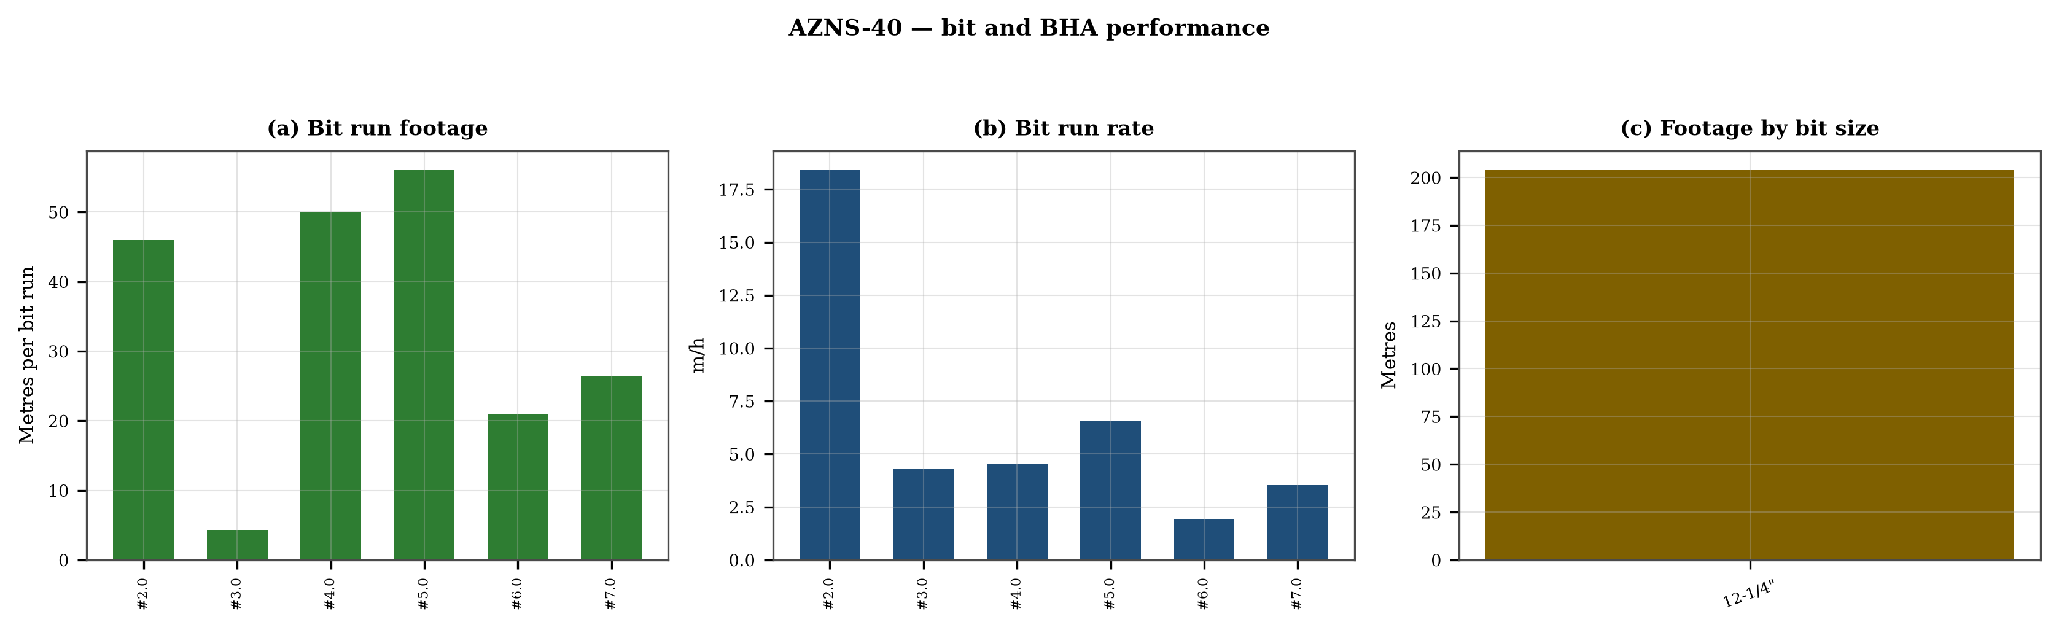
Figure 6.1 — Bit footage, run rate and footage by bit size

7. Mechanical parameters and mechanical specific energy
46 intervals carry a simultaneous weight and rotary-speed record. Weight on bit ranges 1.0–15.0 klbf with a median of 5.0 klbf, and rotary speed 50–170 rpm. The median mechanical specific energy is 40 ksi. For these hole sizes that is high: the bit is spending more energy on the bottom hole assembly and the fluid than on the rock.
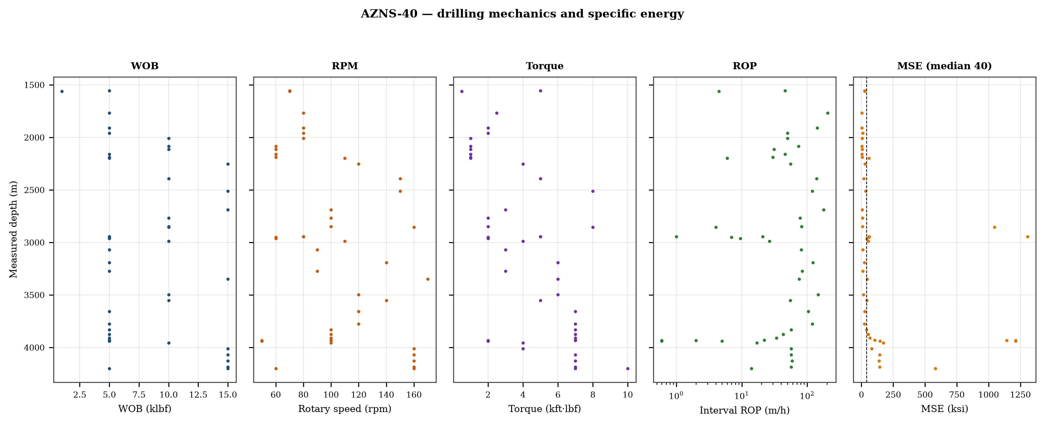
Figure 7.1 — Five-track mechanics log with specific energy

8. Drilling fluids, rheology, cuttings transport and ECD
The hydraulics record covers 55 days. Flow ranges 5–3,568 gpm, bit pressure drop 0–5,060 psi and the hydraulic index 0.1–91.3 hp/in². Annular velocity is computed for the recorded hole and pipe sizes; the 120 ft/min line on the figure is the field threshold for cuttings transport, not a regulatory limit.
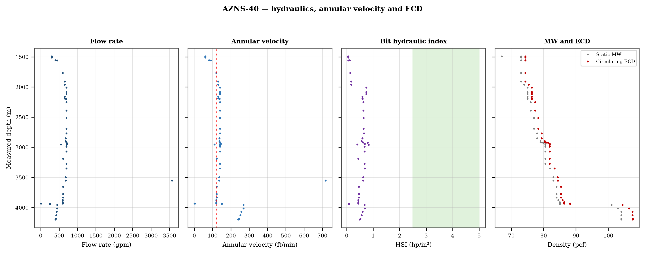
Figure 8.1 — Flow, annular velocity, hydraulic index and the ECD window
Mud weight moves between 67 and 104 pcf across the record, in steps that coincide with casing points. Each step changes the equivalent circulating density by the same amount plus the annular loss term, which is why the pressure window narrows precisely when the weight is increased to control the shale.

9. Directional survey, trajectory and dog-leg severity
The trajectory was rebuilt from 5 survey stations with the minimum-curvature method. The well reaches a maximum inclination of 1.0°, a maximum dog-leg of 0.02°/30 m and a final TVD of 3,545 m at 3,545 m MD, with a bottom-hole closure of 27 m. Dog-legs stay inside the drilling limit throughout, so the directional programme did not create the drag that Chapter 10 measures.
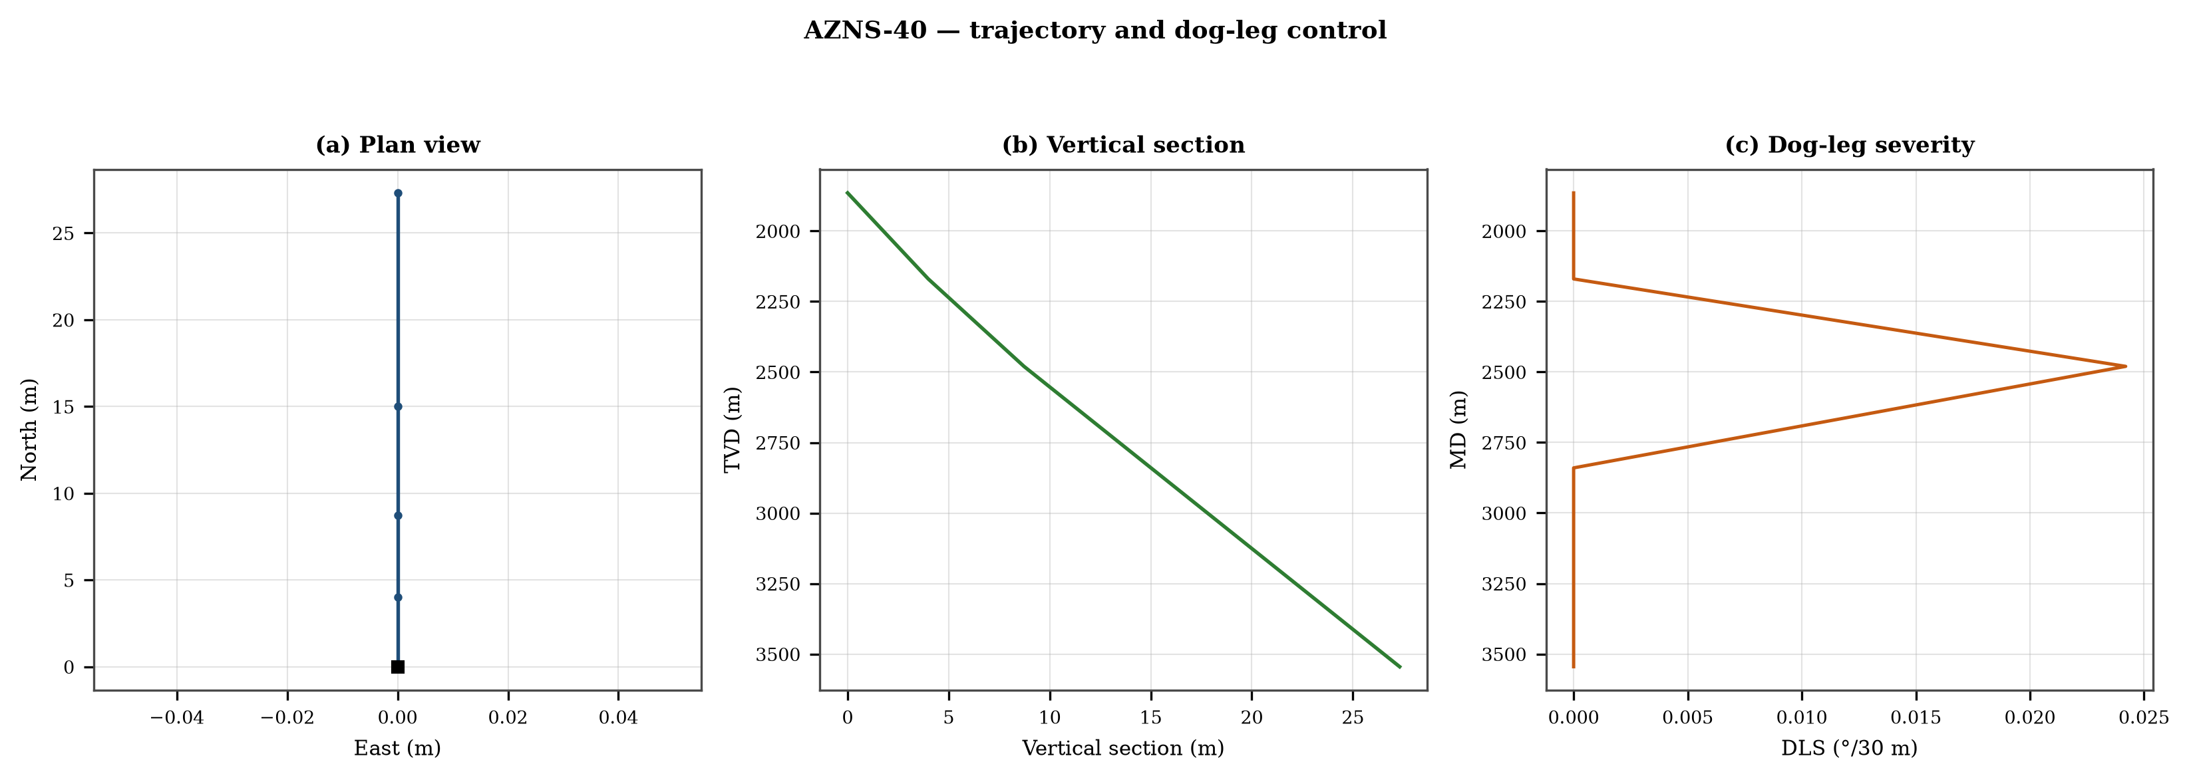
Figure 9.1 — Plan view, vertical section and dog-leg severity

Table 9.1 — Survey stations
MD | Inc | Azi | TVD | N | E | DLS
1,865.0 | 0.75 | — | 1,865.0 | 0.0 | 0.0 | 0.00
2,170.0 | 0.75 | — | 2,170.0 | 4.0 | 0.0 | 0.00
2,480.0 | 1.00 | — | 2,479.9 | 8.7 | 0.0 | 0.02
2,840.0 | 1.00 | — | 2,839.9 | 15.0 | 0.0 | 0.00
3,545.0 | 1.00 | — | 3,544.8 | 27.3 | 0.0 | 0.00
DDR Ref. — "60-2 Data" survey table from header row 115 (MD, inclination, azimuth, TVD) — template A; "60-2 Data" survey block J50+ — template B

10. Hook load, drag and overpull
A soft-string model was built on the recomputed survey with the buoyancy factor of the recorded mud weight and a tripping friction factor of 0.28. At 3,545 m the model gives a pick-up load of 43.9 klbf, a rotating load of 43.5 klbf and a slack-off of 43.5 klbf. The spread between pick-up and slack-off is 0.4 klbf; that is the friction the string actually carries, and it is the margin that must not be spent on a single pull.
- Day 81: recorded overpull 4 klbf
- Day 81: recorded overpull 6 klbf
- Day 110: recorded overpull 7 klbf
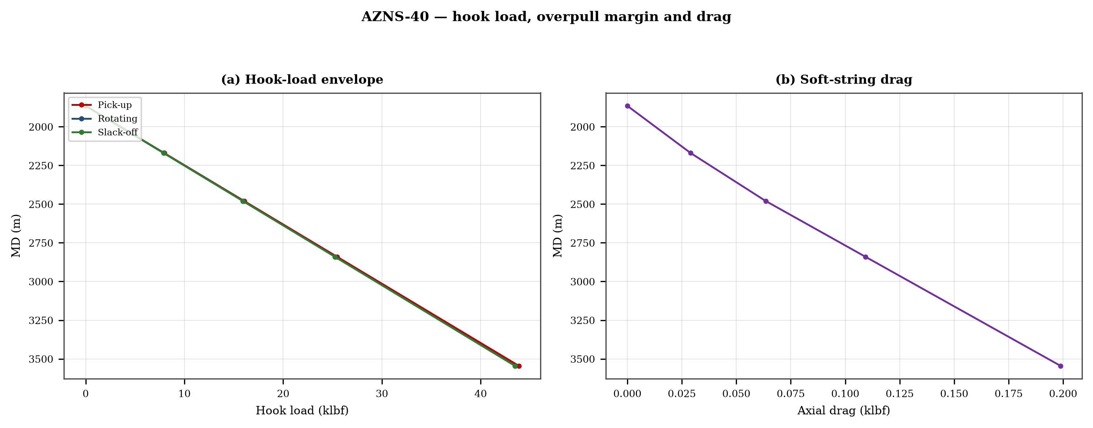
Figure 10.1 — Hook-load envelope and axial drag

11. Well control, shoe integrity, MAASP and losses
The record contains 21 formation-integrity tests with a numerical equivalent mud weight and 72 days with a loss entry. The dynamic maximum allowable surface pressure is the number the driller needs: at the shallowest shoe of this well, raising the annulus by 500 psi requires an equivalent weight of 0.0 pcf, which is the practical test of whether the mud programme is inside the window.
Table 11.1 — Integrity tests
Day | MD (m) | EMW (pcf)
1 | 1,492 | 30.0
4 | 1,510 | 87.0
7 | 1,767 | 30.0
8 | 1,910 | 30.0
10 | 2,010 | 30.0
11 | 2,084 | 30.0
12 | 2,115 | 30.0
14 | 2,161 | 30.0
15 | 2,191 | 30.0
18 | 2,253 | 30.0
21 | 2,690 | 30.0
22 | 2,768 | 30.0
DDR Ref. — "1-1 Remark" field “FIT Depth (MD/TVD) / EMW (PCF)” and the leak-off lines in the daily narrative

12. Geology, formation tops and gas
13 formation tops are recorded between 1,138 m and 3,986 m MD. The sequence and the depth of each top are reproduced below with the minimum-curvature TVD where a survey exists; the drillability of each interval is discussed against the rate record rather than against a general lithology table.
Table 12.1 — Formation tops
Formation | MD (m) | TVD (m)
Gachsaran | 1,138 | 1,138
Asmari | 1,494 | 1,494
Pabdeh | 1,776 | 1,865
U-Gurpi | 2,198 | 2,170
Tarbur | 2,322 | 2,322
L-Gurpi | 2,410 | 2,480
Ilam | 2,535 | 2,480
Laffan | 2,639 | 2,639
Sarvak | 2,645 | 2,645
Kazhdumi | 3,284 | 3,284
Dariyan | 3,490 | 3,545
Gadvan | 3,683 | 3,683
Fahliyan | 3,986 | 3,986
DDR Ref. — "60-2 Data" rows 110–131: K = formation, L/M = forecast MD and TVD, O/Q = actual TVD
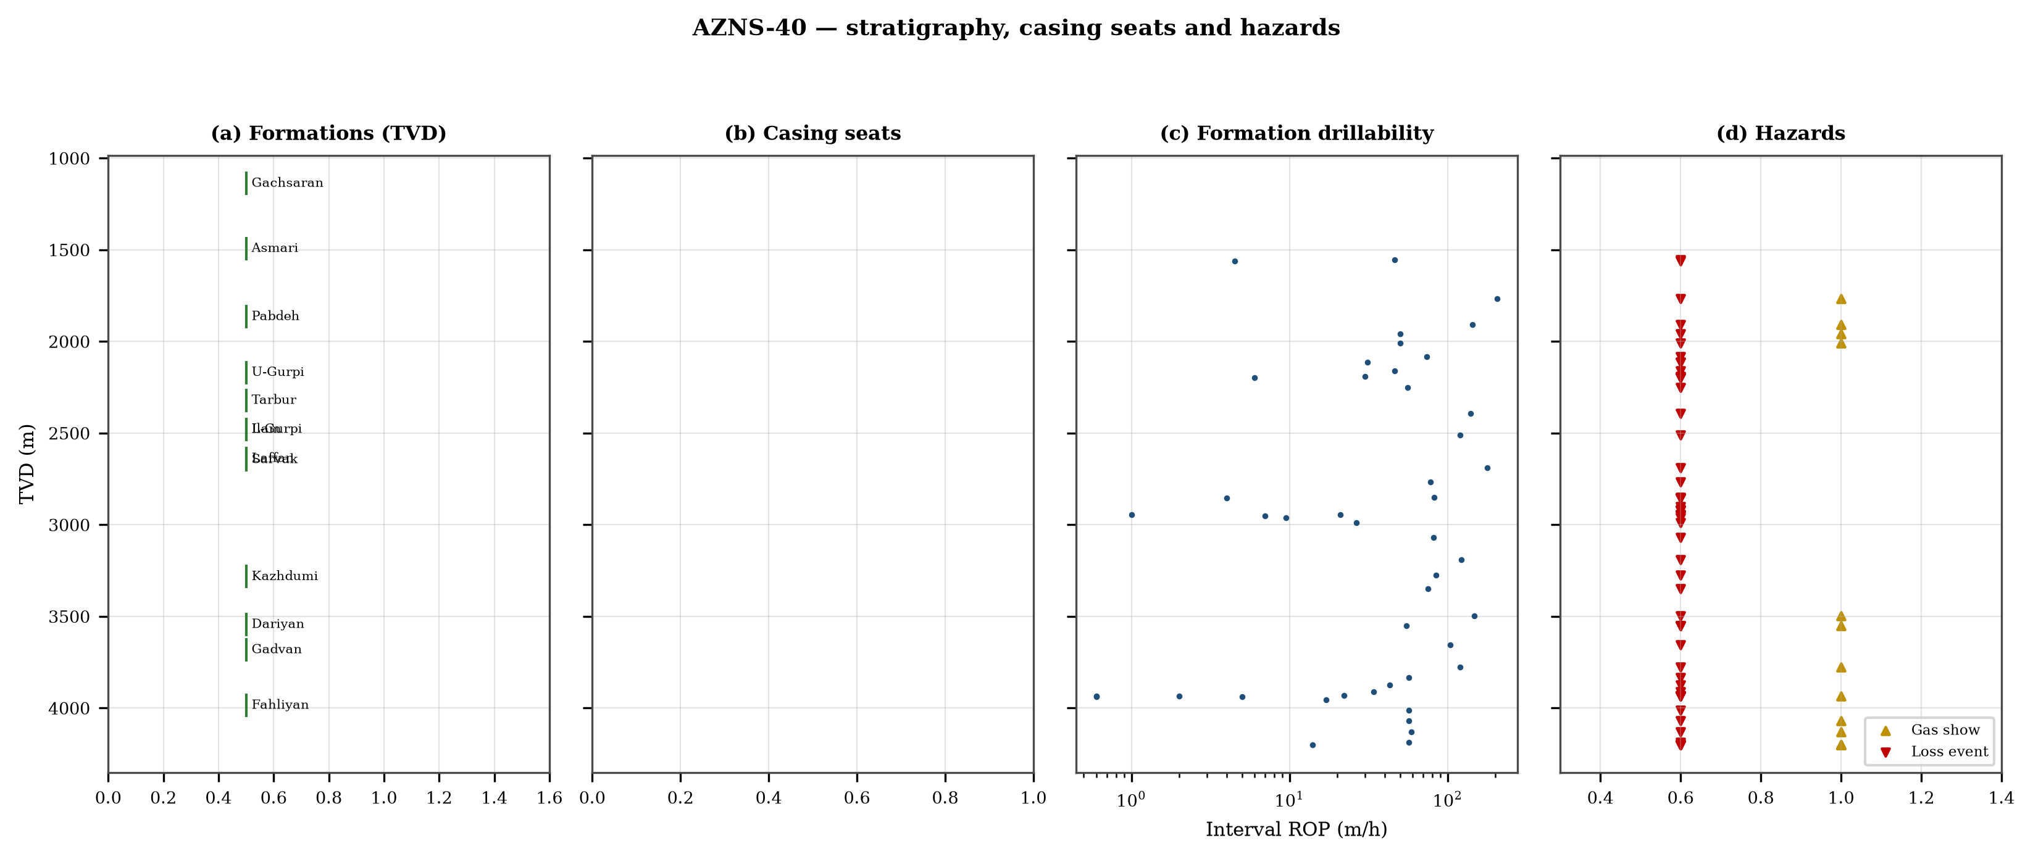
Figure 12.1 — Formation tops, casing seats, drillability and hazards

13. Operational problems, remedies and rig-floor playbooks
The five playbooks below are written for use at the rig floor, in the order given. Each one is the compressed form of the diagnosis used in Chapters 5, 10 and 11, and each is matched to the mechanism it treats.

Loss circulation playbook
- Stop drilling, record the loss rate at the current pump rate and keep the string moving.
- Reduce flow in two steps and measure the loss at each step: partial loss responds to LCM, total loss needs a different mechanism, not a bigger pill.
- Spot a graded LCM pill (fine–medium–coarse) across the loss zone and cure it before resuming; log the pill volume, the returned volume and the pressure at which it was spotted.
- If losses persist at the shoe, recalculate MAASP with the current mud weight and confirm the well is still displaced by a single fluid column.

Tight hole and overpull playbook
- Compare the observed overpull with the modelled pick-up envelope for the same depth.
- Circulate at the maximum allowable rate with the string rotating; if torque falls while returns carry cuttings, the cause is cleaning, not the formation.
- Work the string down with a controlled feed-off rather than pulling; never exceed 80% of the modelled overpull margin.
- If the string is stuck, establish circulation and jar down before any chemical soak.

Stuck pipe and fishing playbook
- Record the free rotating weight, the pick-up and the slack-off immediately; the spread distinguishes wall contact from a pack-off.
- Establish circulation within the first ten minutes; a stuck string that still circulates is recoverable without fishing.
- Apply torque and jar in the direction indicated by the string's own weight response, not by habit.
- Photograph and grade every recovered component before the next run.

Well-control playbook
- Shut in on the hard shut-in sequence and record SIDPP, SICP and pit gain within one minute.
- Confirm the influx type from the pressure pair: SIDPP ≈ SICP means a light fluid, SICP >> SIDPP means gas.
- Prepare a kill sheet with slow circulating pressure at the actual pump rate, not a table value.
- Maintain the casing pressure constant while bringing the pumps to rate; do not chase the drill-pipe pressure.

Shoe test and MAASP playbook
- Never drill out a shoe without a recorded FIT/LOT equivalent mud weight in the daily header.
- Compute MAASP for the current mud weight every time the weight changes by 0.1 pcf.
- Convert the test result to a fracture gradient at the shoe TVD, not at MD.
- When a loss occurs at the shoe, the first number to read is the dynamic MAASP, not the static one.

14. Optimum parameters, drill-off and MSE practice
Table 14.1 — Section parameter window in this well
Section | WOB (klbf) | RPM | Median interval ROP | Net ROP
5-7/8" | 5–5 | 60–60 | 0.0 | 0.00
8-1/8" | 5–15 | 50–160 | 17.0 | 1.51
12-1/8" | 1–15 | 60–170 | 52.5 | 2.67
DDR Ref. — "1-2 Data" drilling-parameter sentences in column K (WOB, RPM, flow, SPP, torque) and the mud table columns K–S rows 11–38 — template A; mud table J8–L27 — template B
The drill-off procedure is the only reliable way to find the founder point on location. Hold flow constant, reduce weight in three steps of about 15% and record the rate at each step after 90 seconds of steady drilling; the rate should rise with weight until the founder point and then flatten. The weight at which it flattens is the operating weight for that formation, and the weight at which torque rises while rate does not is the weight that damages the bit.
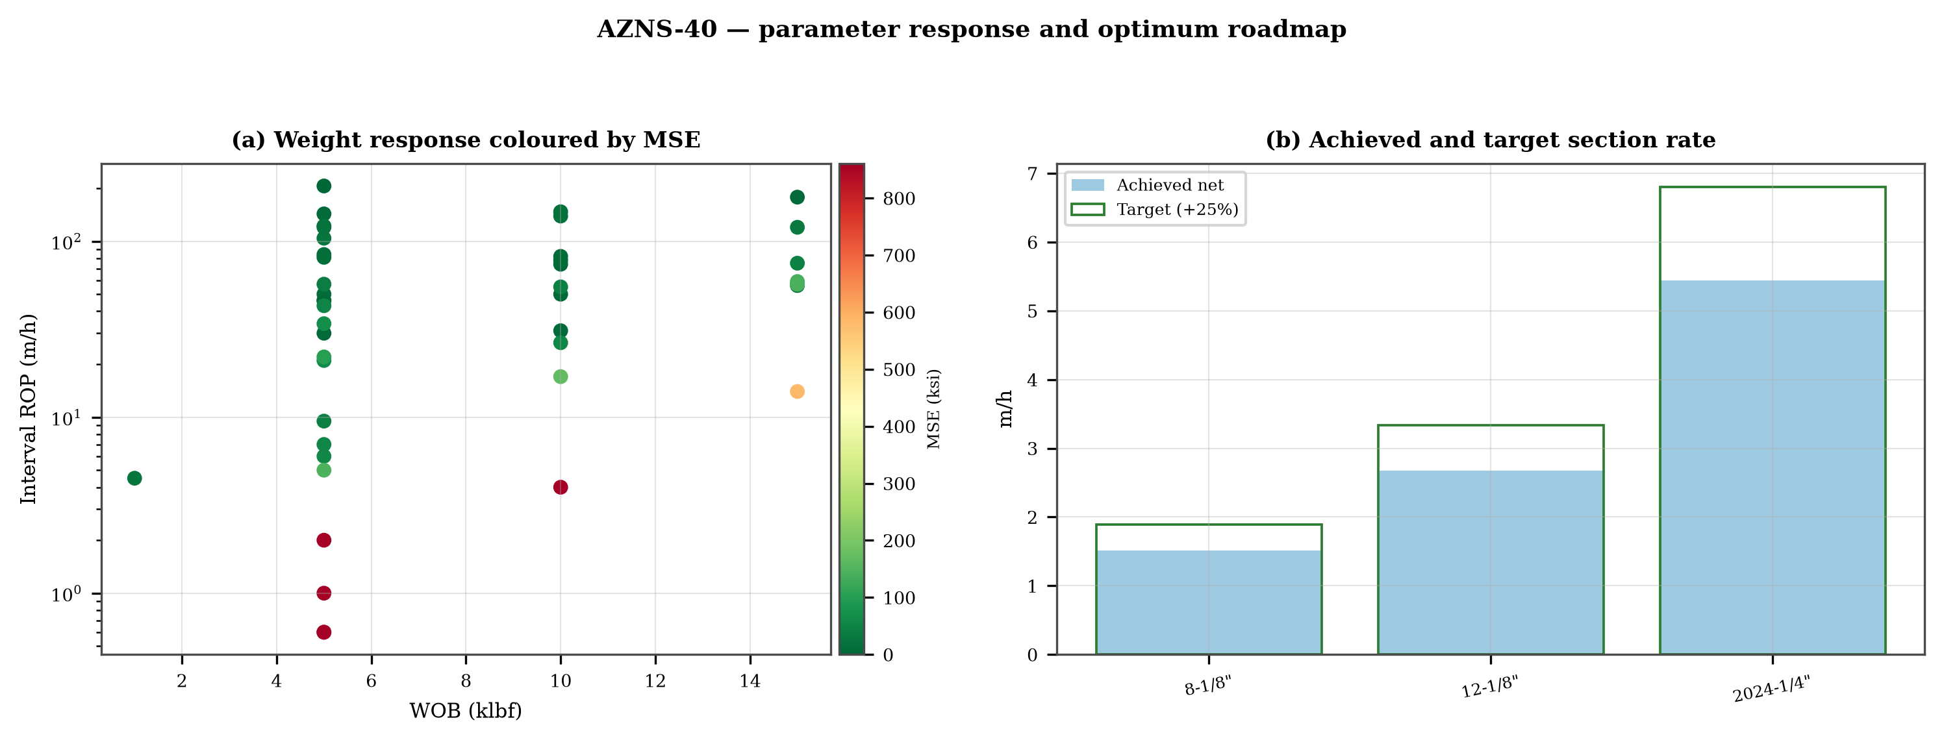
Figure 14.1 — Weight response coloured by specific energy and the section rate target

15. Key findings and risk register
- NPT stands at 31.3% of rig time, dominated by unclassified.
- Handling time is 1.01 times the drilling time, which is the structural inefficiency of this record.
- Net rate in the productive intervals is 2.03 m/h at a median specific energy of 40 ksi.
- The pressure window and the mud programme interact at every casing point; the integrity record is the weakest data set in the well.
Table 15.1 — Risk register
Risk | Trigger | Consequence | Control
Loss at the shoe | Drilling out with weight above the window | Loss of circulation and stuck pipe | Two-rate loss test, graded LCM
Tight hole on trips | Shale swelling after long open-hole exposure | Overpull and stuck string | Wiper trips, mud inhibition
Bit balling | Weight above the founder point in reactive clay | Rate collapse and torque rise | Drill-off test, HSI above 2.5
Equipment failure | Ageing pumps and top drive | Long NPT and hole deterioration | Reliability register
DDR Ref. — Derived — "1-1 Remark" narrative, "1-2 Data" time-log flags and the NPT register of this report; no single DDR cell

16. Recommendations — phase matrix and REC-01 to REC-10
Table 16.1 — Phase execution matrix
Phase | Action | Hold point
Pre-spud | Verify rig systems and spares against the reliability register | Signed availability check
Surface hole | Maximum flow with a single casing and cementing trip | Shoe test recorded
Intermediate | PDC and motor, wiper trip every 300 m, AV above 120 ft/min | Overpull trend inside envelope
Reservoir entry | Two-rate loss test and graded LCM on location | Loss cured before drilling ahead
Reservoir hole | Hold HSI above 2.5 hp/in², drill-off at each top | Founder point recorded
Close-out | NPT booked to the fixed cause list, review within 14 days | QC certificate signed
DDR Ref. — "1-2 Data" time log rows 21–68 aggregated by operational code and the "1-1 Remark" section headers
Table 16.2 — Recommendations
ID | Recommendation | Owner | Timing | Rationale
REC-01 | Adopt a rig-specific reliability register (pumps, top drive, drawworks) with monthly availability and mean time between failures | Rig manager | Immediate | Rig and surface equipment is the largest controllable NPT category
REC-02 | Standardise the FIT/LOT protocol and write the demonstrated EMW into the daily header | Well integrity | Before the next well | Makes MAASP auditable at every shoe
REC-03 | Apply the section parameter roadmap of Chapter 14 as the drilling programme | Drilling engineering | Next well | Closes the gap to the field P90 rate
REC-04 | Introduce a graded-LCM loss protocol with a two-rate diagnosis before treatment | Mud engineering | Immediate | Cuts loss time and lost mud volume
REC-05 | Run a drill-off test at the top of each formation and record the founder point | Drilling engineering | Each section | Prevents weight-induced inefficiency
REC-06 | Treat centrifuge running time as a recorded drilling parameter | Mud engineering | Immediate | Controls ECD without changing mud weight
REC-07 | Hold a torque-and-drag check against the modelled envelope before every trip | Drilling supervisor | Every trip | Converts overpull from a surprise into a trend
REC-08 | Book every NPT hour against the fixed cause list within the same tour | Drilling supervisor | Daily | Keeps the field comparison comparable
REC-09 | Audit third-party service readiness (wireline, cementing, casing crews) before the operation, not on arrival | Field engineering | Each job | Third-party delay is the second largest NPT category
REC-10 | Publish a weekly NPT pareto and a monthly field benchmarking pack | Field engineering | Weekly | Sustains the learning curve across rigs
DDR Ref. — This report — built from the KPI set and NPT register above; each row carries its own evidence reference

17. Limitations of the recorded data
- No casing table with shoe depths: the architecture is described from the chronology and the hole sizes drilled.
- Costs are reconstructed from daily rig, mud and service rates because the workbooks do not carry a commercial register; they are used for comparison only.

18. Appendix A — Workbooks, sheets and SHA-256
The record was read from AZNS40Pack.xlsx with 302 sheets, all of which were parsed. The table below reproduces the file inventory with the digest of the source workbook as it stands in the repository.
Table 18.1 — Source workbooks and SHA-256
File | SHA-256
AZNS10Pack.xlsx | bf8c897274b47f9324b6e808162c451c0329d78651e76a27c700db9263ec0a95
AZNS116Pack.xlsx | 68c5b874f1ba78a4a30989930aef00f06095d8118e89e217e74ca918364dc438
AZNS122WO1Pack.xlsx | c14db1ff6cbef8b7d4e0f69b9f64cdc4452e3935f64bad439d38a8aed6f5f42a
AZNS122WO2Pack.xlsx | 2eb9858150dfa2d43f46e387ded978fd04c811f0c08b402a76a533f36235b65c
AZNS127ST2Pack.xlsx | 68329de313721905be08f20cb8bb8b4f5f3671d5c6caab41f23caa1a48b9a4c4
AZNS127WO1Pack.xlsx | 6034aae76c2e3126416df8f8576d424bd3394c30aca4c4f5e72f0372256739d6
AZNS127WOPack.xlsx | a4ae90dc870f20b2f99ac3a36b8b5cd1c357b60dd2805630597cc48ba059054e
AZNS12Pack.xlsx | e325945f1108341bace123e60b02fb04ac3f7d3003a19eb8d23004cf7cd67216
AZNS166Pack.xlsx | e63824748e4692884fc23075c678c1379b9b595a8c8b1efb289e630f898a75d8
AZNS207Pack.xlsx | 828968c7e0afd7273d64987bd457383ecfea3a2e00e62c9a65b587f16518996a
AZNS40Pack.xlsx | 0523068ee222c02f6e2d2754bcd919a9c296b334b03521ab15d84322aade94ca
AZNS75Pack.xlsx | 5e0482d5d50e9347a98b7c24cfd3a102d3c00f2c951f6061aba14d164136fcae
AZNS85Pack.xlsx | 0d3ecc54fb8b9484f508b9a3957554ba13e72546c6d485abb79af633362daeb2
DDR Ref. — Workbook files as delivered (read-only), hash computed at build time
Table 18.2 — Sheet inventory of this well
Sheet | Sheet | Sheet
1-1 Remark | 1-2 Data | 2-1 Remark
2-2 Data | 3-1 Remark | 3-2 Data
4-1 Remark | 4-2 Data | 5-1 Remark
5-2 Data | 6-1 Remark | 6-2 Data
7-1 Remark | 7-2 Data | 8-1 Remark
8-2 Data | 9-1 Remark | 9-2 Data
10-1 Remark | 10-2 Data | 11-1 Remark
11-2 Data | 12-1 Remark | 12-2 Data
13-1 Remark | 13-2 Data | 14-1 Remark
14-2 Data | 15-1 Remark | 15-2 Data
16-1 Remark | 16-2 Data | 17-1 Remark
17-2 Data | 18-1 Remark | 18-2 Data
19-1 Remark | 19-2 Data | 20-1 Remark
20-2 Data | 21-1 Remark | 21-2 Data
22-1 Remark | 22-2 Data | 23-1 Remark
DDR Ref. — Workbook sheet list — every remark/data sheet pair plus the reference sheets

19. Appendix B — Equations and units
Table 19.1 — Governing equations
Quantity | Equation | Units
Mechanical specific energy | MSE = 480·T·N/(D²·ROP) + 4·WOB/(π·D²·1000) | psi, klbf, ft·lbf
Bit pressure drop | ΔP = ρ·Q²/(10858·TFA²) | psi, gpm, in²
Jet velocity | V = 0.3208·Q/TFA | ft/s
Hydraulic index | HSI = ΔP·Q/(1714·A_bit) | hp/in²
Annular velocity | V = 24.5·Q/(D_h² − D_p²) | ft/min
Bingham annular loss | ΔP = PV·V·L/(60000·(D_h−D_p)²) + YP·L/(200·(D_h−D_p)) | psi
Equivalent circulating density | ECD = MW + ΔP_ann/(0.052·TVD) | pcf
Minimum curvature | β = arccos[cos I₁cos I₂ + sin I₁ sin I₂ cos(A₂−A₁)] | rad
Dog-leg severity | DLS = 30·β/ΔMD | °/30 m
Buoyancy factor | BF = 1 − MW/490 | —
Hook load (soft string) | F = Σ w·BF·cos I·Δs ± μ·Σ w·BF·sin I·Δs | klbf
Maximum allowable surface pressure | MAASP = 0.052·(EMW_frac − MW)·TVD_shoe | psi
dc exponent | dc = log(ROP/(60·N)) / log(WOB/D) | —
Reconstructed cost | C = Σ (rig + mud + service) day rate | USD
DDR Ref. — Reference standard, Appendix B — no DDR cell

20. Appendix C — Complete NPT register
Table 20.1 — NPT register (all entries)
Day | Hrs | Mechanism | Activity and description
5 | 9.0 | Unclassified | Stop Drlg due to Obs. jumping string, drop 390 psi SPP & 5 klbs drop string Wt regarding to last string Wt. Check on BTM
5 | 2.5 | Unclassified | Assemble 10-1/8"over shot w/ standard size guide (dressed w/ 8-1/4" spiral grapple control + 8-1/4"spiral grapple + type
6 | 1.5 | Stuck pipe & fishing | Cont. RIH w/ 10-1/8" over shot & fishing BHA to TOF (1547.2 m). Tag TOF while W/D last JT Record parameters & Clean TOF.
6 | 7.5 | Lost circulation | POOH W/ 10-1/8" Over Shot & Fishing BHA chain out & wet f/ 1547.2m to surface; F/U the well w/ 1-2 BPH Loss. Recover all
6 | 2.5 | Unclassified | L/D 12-1/4" PDC Bit (Dull: 1-1-CT-A-X-I-PN & WT-LIH) & 1 Jt 8-1/2" DC, Release Over Shot.
6 | 4.5 | Unclassified | P/U & M/U 12-1/4" new PDC bit(burintekh, M323, B616YCM, 8*16/32"+1*13/32" Nz) & RIH W/ Drlg BHA (baffle & f.valve in B.s
6 | 4.0 | Lost circulation | Cont. RIH f/ 230 to 1492m (13-3/8" CSG Shoe) while F/U String, W/R to 1556.65m (BTM) w/ 2 BPH loss.
12 | 14.5 | Stuck pipe & fishing | POOH to Surf. String was twisted off f/ mandrel of 8" D.Jar.
13 | 24.0 | Stuck pipe & fishing | Cont. RIH w/ 10-1/8" O.Shot & Fishing BHA to TOF @ 1997.5m, Tag TOF.
14 | 4.5 | Lost circulation | Cont. RIH w/ 12-1/4" B.Bit & Drlg BHA to BTM (2115m), W&R last Std, F/U string w/ 2-3 BPHL.
16 | 1.0 | Lost circulation | Spot 40 bbl Hi-vis pill @ TOF, 2-4 BPHL.
16 | 4.5 | Lost circulation | POOH to surface. string was twisted off f/ pin of 8 1/2" DC, 1-2 BPHL.
16 | 8.0 | Stuck pipe & fishing | M/U 10-1/8" O.Shot & 10-1/8" S.Guide, Dressed w/ 8-1/2" S.G.C + 8-1/2" S.G, RIH w/ 1 Jt 8-1/2" DC + 8" F.Jar + 1 Jt 8-1/
17 | 1.0 | Stuck pipe & fishing | Cont. RIH w/ 10-1/8" O.Shot & Fishing BHA f/ 2100m to TOF @ 2124m, Tag TOF.
17 | 9.0 | Stuck pipe & fishing | Pump out f/ 2124 to 2070m w/ Max 20 Klbs overpull, Cont. POOH w/ 10-1/8" O.Shot f/ 2070m to surface, Recover all compone
17 | 11.0 | Stuck pipe & fishing | Release O.Shot, L/D fishing BHA & Bit (Dull: 2-1-CT-A-X-I-PN&WT-TW), L/D 15 Jts 8-1/2" DC while Receive 12 Jts new 8-1/2
17 | 3.0 | Unclassified | P/U & M/U 12-1/4" PDC.Bit (Beste, S/N: 224110, New, 4*12/32" + 4*14/32" Nz) + 8-1/2" B.Sub (Float & Baffle in), RIH 2 Jt
18 | 11.5 | Unclassified | Cont. RIH w/ 12-1/4" PDC.Bit (Beste, S/N: 224110, New, 4*12/32" + 4*14/32" Nz) & Drlg BHA f/ 40m to BTM (2197m) while W/
24 | 3.5 | Unclassified | Shift change between driller & night toolpusher; driller didn't care about weight indicator. P/U string on elevator to 2
24 | 5.0 | Lost circulation | Work on TDS while wait on Rec. TDS hydraulic radiator, Slow Circ. Thru string; 8-10 BPHL.
24 | 2.5 | Unclassified | Work on TDS radiator to change & Test same; Ok.
24 | 1.5 | Unclassified | POOH to Surf. String was twisted off f/ above shoulder of pin (50cm remained f/ body above shoulder) of 5" DP.
24 | 3.0 | Unclassified | M/U 10 1/8" Over shot & 6-1/2" Basket grapple, Dressed w/ 6 1/2" Basket grapple mill control (Included Extension), RIH W
24 | 1.0 | Lost circulation | Stop RIH, Work on TDS to change saver sub. 6-8 BPHL.
24 | 1.5 | Stuck pipe & fishing | Cont. RIH w/ 10-1/8" O.Shot & Fishing BHA to TOF @ 749m, Tag TOF.
24 | 0.5 | Stuck pipe & fishing | Clean TOF. Try to engage fish by applying rotation & weight while Circ., Obs. Press up & According to hydraulic data; Es
24 | 2.5 | Stuck pipe & fishing | Pump out w/ 10-1/8" O.Shot & Fishing BHA f/ 2800 to 2650m (Bit Depth) w/ max 30 Klbs drag.
24 | 0.5 | Stuck pipe & fishing | Due to abnormal drag; Pump 40 bbl Brine, 30 bbl Hi-Vis pill & Displace brine around BHA. Pump out w/ 10-1/8" O.Shot & Fi
25 | 4.5 | Lost circulation | Cont. POOH w/ 10-1/8" Over shot & Fishing BHA f/ 2600 to 2100 m on elevator w/ good hole condition; F/U the well, 6-8 BP
25 | 1.5 | Stuck pipe & fishing | 10-1/8" Over shot on surface & Obs. overshot engage to fish. L/D 1 Jt 8 1/2" DC & 8" Fishing Jar. Release over shot. L/D
25 | 3.5 | Lost circulation | Resume POOH w/ 12-1/4" PDC Bit & Drlg BHA f/ 2100 to 1492m (13-3/8" CSG Shoe) w/ good hole condition; 6-8 BPHL.
25 | 9.0 | Unclassified | Cont. POOH f/ 13-3/8" CSG Shoe to surface while check string; 15 Stds DP, 3 Stds 5" HWDP & 2 Stds 8-1/2" DC were sinusoi
25 | 2.5 | Unclassified | L/D mouse hole in order to wash & clean. Install same.
25 | 3.0 | Lost circulation | L/D 18 Jts 5" DP "G" (Buckled) Jt by Jt till M.N (Totally 35 Jts), Circ. Across well head; 4-5 BPHL.
26 | 8.0 | Lost circulation | RIH & L/D 60 Jts 5" DP "G" (Buckled) Jt by Jt (Totally 107 Jts), Circ. Across well head; 3-5 BPHL.
26 | 8.0 | Unclassified | P/U & M/U 12-1/4" PDC.Bit (ReedHycalog, S/N: 124344, RR2, 6*15/32" Nz), 8-1/2" B.Sub (Float & Baffle in) & RIH w/ 2 Jts
27 | 22.0 | Unclassified | Resume RIH w/ 12-1/4" PDC Bit & Drlg BHA & followed by 5" DP "G" (219 Jts, New) (Wash & Pass proper drift) f/ 235 to 232
34 | 2.0 | Lost circulation | Stop Drlg due to work on Weght indicator & fix same, while Circ out 90 bbl Hi-vis LCM Pill, 2-4 BPHL.
35 | 1.5 | Lost circulation | Stop operation due to change Sensator, 2-5 BPHL.
36 | 2.0 | Lost circulation | Stop operation due to change hook load Sensator & adjust WOB indicator, 2-5 BPHL.
42 | 5.5 | Unclassified | Twist off string, suddenly lost 40 Klbs string Wt (due to Inc FL f/ 3 to 5.5 add solution to active mud Sys, Dec 70 Psi
43 | 24.0 | Stuck pipe & fishing | POOH f/ 1100m to Surface; String was twisted off f/ Shock sub of 8" D.Jar.
44 | 9.5 | Stuck pipe & fishing | POOH w/ 10-1/8" O.Shot & Fishing BHA f/ 300m to Surf. Recover all components of fish, Release O.Shot. B/O Bit (Dull: 2-2
44 | 1.0 | Lost circulation | Cont RIH w/ 12-1/4" PDC Bit to 1000m, 4-8 BPHL.
44 | 4.5 | Lost circulation | Due to bad weather; stop operation while slow Circ, 4-8 BPHL.
44 | 7.0 | Lost circulation | Cont RIH w/ 12-1/4" PDC Bit to 1490m (13-3/8" Csg Shoe), RIH to 3400m w/ good hole condition, F/U String each 15 Stds, 4
45 | 1.0 | Lost circulation | Cont. RIH f/ 3400 to 3552m (BTM) while R/D last Std w/ good hole condition, 4-8 BPH loss.
51 | 1.5 | Unclassified | L/D 7 Stds 5" DP (Buckle) Jt by Jt.
52 | 4.0 | Unclassified | L/D 17 Stds 5" DP (Buckle) Jt by Jt. (Totally 24 Stds)
55 | 7.0 | Stuck pipe & fishing | While Wait on SPAD Energy Co. due not approved CMT Program, Lack of pump truck & CMT Add. Work on stuck downward; No-Suc
56 | 24.0 | Stuck pipe & fishing | While Wait on SPAD Energy Co. due not approved CMT Program & CMT Add. Work on stuck; Try to wash Dn by apply Max 80 Klb;
57 | 10.0 | Rig & surface equipment | R/U 9-5/8" CMT head, Plug already loaded. L/U CMT head to pump, Prepare totally 900 bbl CMT Solution & Transfer to CMT s
58 | 2.5 | Unclassified | RIH w/ 5" DPto 520 m .POOH to 380 while L/D 15 Jts 5" DP (Buckle) Jt by Jt.
59 | 1.0 | Unclassified | Cont. POOH to 20m while L/D 39 Jts 5" DP (Buckle) Jt by Jt. (Totally 18 Stds)
61 | 2.0 | Rig & surface equipment | Stop operation due to work on drawworks, while Circ. Mud thru string; NL-NG.
64 | 1.0 | Unclassified | Due to failure of wash pipe; stop Drlg. B/R to 9-5/8" Csg shoe (3930m), change & test same. Run back in hole to Btm.
70 | 1.5 | Third-party & service | Set Sealand truck in position, R/U logging surface equipment, Assemble logging tools (LDT/NGS), Perform surface check &
70 | 5.0 | Logging & wireline | Run W/L in hole as Run #4 to 3933m, Log down to 4200m & Tag TD, P/U tools & Open Density tools pad, Log Up to 3900m, Pul
70 | 1.0 | Lost circulation | L/D logging tools, R/D Sealand logging surface equipment, while Circ. CWH, 1-3 BPHL.
70 | 1.0 | Lost circulation | Stop operation due to work on drawworks (Cooling system of Eddy current brake), while Circ. CWH, 1-3 BPHL.
70 | 1.0 | Lost circulation | Work on Jam system unit, while Circ. CWH, 1-3 BPHL.
78 | 6.0 | Unclassified | RIH w/ 5" OEDPs to 1200m, Circ. Out Hi-Vis Pill & Displace contaminated mud. Obs. Huge amount of mud Flocculation on sha
78 | 1.5 | Client / operator decision | Due to not acceptable results of SBT according to client order; P/U & Assemble back up SBT on previous W/L tools.
78 | 2.5 | Third-party & service | RIH w/ W/L Logging tools (CCL/GR/SBT/VDL #2) to 3770m as per client order was repeat. Due to signal interruption, decide
78 | 1.0 | Third-party & service | POOH w/ W/L Logging tools to surface.
79 | 11.5 | Unclassified | P/U & M/U 7-5/16" Polish Mill(PPA, Used, 4*20/32" Nozzle ports) & RIH w/ 2 Stds 6-1/2"DC & 2 Stds 5"HWDP, followed by 5"
79 | 1.5 | Unclassified | Dress, Polish & Clean inside 7" TBS several times. Tag LG @ 3814.4m & Try to take LG mark by apply max 8 Klbs Wt & 15-30
80 | 1.0 | Unclassified | Uniform MW in/out on 104 pcf. Spot 20 bbl Hi-Vis Pill.
80 | 9.0 | Unclassified | POOH w/ 7-5/16" Polish Mill f/ 3812 to surface, L/D 7-5/16" Polish mill; Obs. Mark of LG on same, Circ. Across Wellhead;
80 | 13.0 | Unclassified | P/U & M/U 7’’ SN Packer Assy included: 7" Seal Nipple (PPA Co, 29#, L-80, ACME, Dressed w/ 4 set V-Packing, Length: 90 c
DDR Ref. — "1-2 Data" time log rows 21–68 with flag N or UP, one row per logged interval

21. Appendix D — Daily hydraulics and ECD

Table 21.1 — Hydraulics and ECD register
Day | MD | Q | MW | TFA | ΔP bit | HSI | AV | ECD
2 | 1,492 | 300 | 67 | 0.920 | 34 | 0.1 | 60 | —
3 | 1,492 | 300 | 73 | 0.920 | 37 | 0.1 | 60 | 74.4
4 | 1,510 | 300 | 73 | 0.920 | 37 | 0.1 | 60 | 74.4
5 | 1,556 | 400 | 73 | 1.000 | 56 | 0.1 | 80 | 74.4
6 | 1,561 | 450 | 73 | 1.700 | 24 | 0.1 | 90 | 74.4
7 | 1,767 | 600 | 73 | 1.700 | 44 | 0.1 | 121 | 74.4
8 | 1,910 | 650 | 73 | 1.700 | 51 | 0.2 | 131 | 74.4
9 | 1,960 | 650 | 74 | 1.700 | 52 | 0.2 | 131 | 75.4
10 | 2,010 | 700 | 75 | 0.920 | 208 | 0.7 | 141 | 76.4
11 | 2,084 | 700 | 75 | 0.920 | 208 | 0.7 | 141 | 76.4
12 | 2,115 | 700 | 75 | 0.920 | 208 | 0.7 | 141 | 76.4
14 | 2,161 | 650 | 75 | 0.920 | 179 | 0.6 | 131 | 76.4
15 | 2,191 | 650 | 75 | 0.920 | 179 | 0.6 | 131 | 76.4
16 | 2,197 | 690 | 75 | 1.000 | 171 | 0.6 | 139 | 76.4
18 | 2,253 | 700 | 76 | 1.000 | 178 | 0.6 | 141 | 77.4
19 | 2,392 | 700 | 76 | 1.000 | 178 | 0.6 | 141 | 77.4
20 | 2,512 | 700 | 77 | 1.000 | 181 | 0.6 | 141 | 78.4
21 | 2,690 | 700 | 77 | 1.000 | 181 | 0.6 | 141 | 78.4
22 | 2,768 | 700 | 78 | 1.000 | 183 | 0.7 | 141 | 79.4
23 | 2,850 | 680 | 78 | 1.000 | 173 | 0.6 | 137 | 79.4
24 | 2,854 | 680 | 78 | 1.000 | 173 | 0.6 | 137 | 79.4
28 | 2,900 | 680 | 79 | 1.035 | 163 | 0.6 | 137 | 80.4
29 | 2,919 | 700 | 79 | 1.035 | 173 | 0.6 | 141 | 80.4
30 | 2,922 | 700 | 80 | 1.035 | 174 | 0.6 | 141 | 80.9
31 | 2,923 | 700 | 80 | 0.920 | 222 | 0.8 | 141 | 81.4
32 | 2,944 | 720 | 80 | 1.035 | 186 | 0.7 | 145 | 81.9
33 | 2,945 | 720 | 80 | 1.035 | 186 | 0.7 | 145 | 81.9
34 | 2,952 | 550 | 80 | 0.900 | 144 | 0.4 | 110 | 81.9
35 | 2,962 | 700 | 80 | 0.900 | 233 | 0.8 | 141 | 81.9
36 | 2,988 | 700 | 80 | 1.000 | 189 | 0.7 | 141 | 81.9
37 | 3,069 | 700 | 80 | 1.000 | 189 | 0.7 | 141 | 81.9
38 | 3,191 | 610 | 80 | 1.000 | 144 | 0.4 | 123 | 81.9
39 | 3,275 | 700 | 80 | 1.000 | 189 | 0.7 | 141 | 81.9
40 | 3,350 | 700 | 82 | 1.000 | 192 | 0.7 | 141 | 83.4
41 | 3,497 | 675 | 83 | 1.000 | 181 | 0.6 | 136 | 84.4
42 | 3,552 | 675 | 83 | 1.000 | 181 | 0.6 | 136 | 84.4
44 | 3,552 | 3,568 | 83 | 1.000 | 5,060 | 91.3 | 717 | 84.4
45 | 3,656 | 610 | 84 | 1.000 | 150 | 0.5 | 123 | 85.4
46 | 3,776 | 610 | 84 | 1.000 | 150 | 0.5 | 123 | 85.4
47 | 3,833 | 610 | 84 | 1.000 | 150 | 0.5 | 123 | 85.4
48 | 3,876 | 600 | 84 | 1.000 | 146 | 0.4 | 121 | 85.9
49 | 3,910 | 600 | 85 | 1.000 | 146 | 0.4 | 121 | 86.4
50 | 3,932 | 600 | 85 | 1.000 | 146 | 0.4 | 121 | 86.4
51 | 3,934 | 600 | 85 | 1.000 | 146 | 0.4 | 121 | 86.4
52 | 3,934 | 5 | 85 | 1.000 | 0 | 0.0 | 1 | 86.3
58 | 3,934 | 5 | 85 | 0.920 | 0 | 0.0 | 3 | 88.1
59 | 3,934 | 250 | 85 | 0.920 | 30 | 0.1 | 150 | 88.2
60 | 3,939 | 250 | 85 | 0.920 | 30 | 0.1 | 150 | 88.2
61 | 3,939 | 250 | 85 | 0.920 | 30 | 0.1 | 150 | 88.2
63 | 3,956 | 450 | 101 | 0.860 | 132 | 0.7 | 269 | 104.4
64 | 4,013 | 450 | 103 | 0.860 | 135 | 0.7 | 269 | 106.5
65 | 4,070 | 430 | 104 | 0.860 | 124 | 0.6 | 257 | 107.5
66 | 4,129 | 420 | 104 | 0.860 | 119 | 0.6 | 251 | 107.5
67 | 4,186 | 410 | 104 | 0.860 | 113 | 0.5 | 245 | 107.5
68 | 4,200 | 400 | 104 | 0.860 | 108 | 0.5 | 239 | 107.5
DDR Ref. — "1-2 Data" mud table columns K–S rows 11–38 (density, FV, PV, YP, solids, chlorides, ECD) — template A; J8–L27 — template B

22. Appendix E — Formation tops and survey stations
Table 22.1 — Formation register
Formation | MD | TVD
Gachsaran | 1,138 | 1,138
Asmari | 1,494 | 1,494
Pabdeh | 1,776 | 1,865
U-Gurpi | 2,198 | 2,170
Tarbur | 2,322 | 2,322
L-Gurpi | 2,410 | 2,480
Ilam | 2,535 | 2,480
Laffan | 2,639 | 2,639
Sarvak | 2,645 | 2,645
Kazhdumi | 3,284 | 3,284
Dariyan | 3,490 | 3,545
Gadvan | 3,683 | 3,683
Fahliyan | 3,986 | 3,986
DDR Ref. — "60-2 Data" rows 110–131, one row per top with forecast and actual TVD
Table 22.2 — Survey register
MD | Inc | Azi | TVD | DLS
1,865.0 | 0.75 | — | 1,865.0 | 0.00
2,170.0 | 0.75 | — | 2,170.0 | 0.00
2,480.0 | 1.00 | — | 2,479.9 | 0.02
2,840.0 | 1.00 | — | 2,839.9 | 0.00
3,545.0 | 1.00 | — | 3,544.8 | 0.00
DDR Ref. — "60-2 Data" survey header row 115 onwards — template A; J50+ — template B

23. Reference, quality control and traceability
Table 23.1 — Traceability and QC
Item | Value
Source workbook | AZNS40Pack.xlsx
Sheets parsed | 302 of 302
Daily reports | 151
Rig | OEOC RIG 208
NPT entries | 212
Figures | 9 at 300 dpi
Fonts | Times New Roman (EN), B Nazanin with Times New Roman (FA)
Directionality | LTR (EN) and RTL with bidi tables (FA)
Reference integrity | SHA-256 verified for all six original workbooks
Cost basis | reconstructed from daily rates, comparison only
DDR Ref. — Cross-reference of this document against the workbook sheet inventory and hash register

24. Planned versus actual: the programme against the record
The operation was planned in AZNS-040 RE-Entry Well Program Rev.03.pdf (Rev.03), which set 102 rig days to a planned total depth of 4,200 m, and was priced in CBS AZNS-40.xlsx. The record closes at 151 rig days and 4,200 m measured depth, so the schedule variance is +49.0 days (+48%) and the depth variance +0 m. Figure 24.1 places the planned baseline against the daily chronology recovered from the DDR.
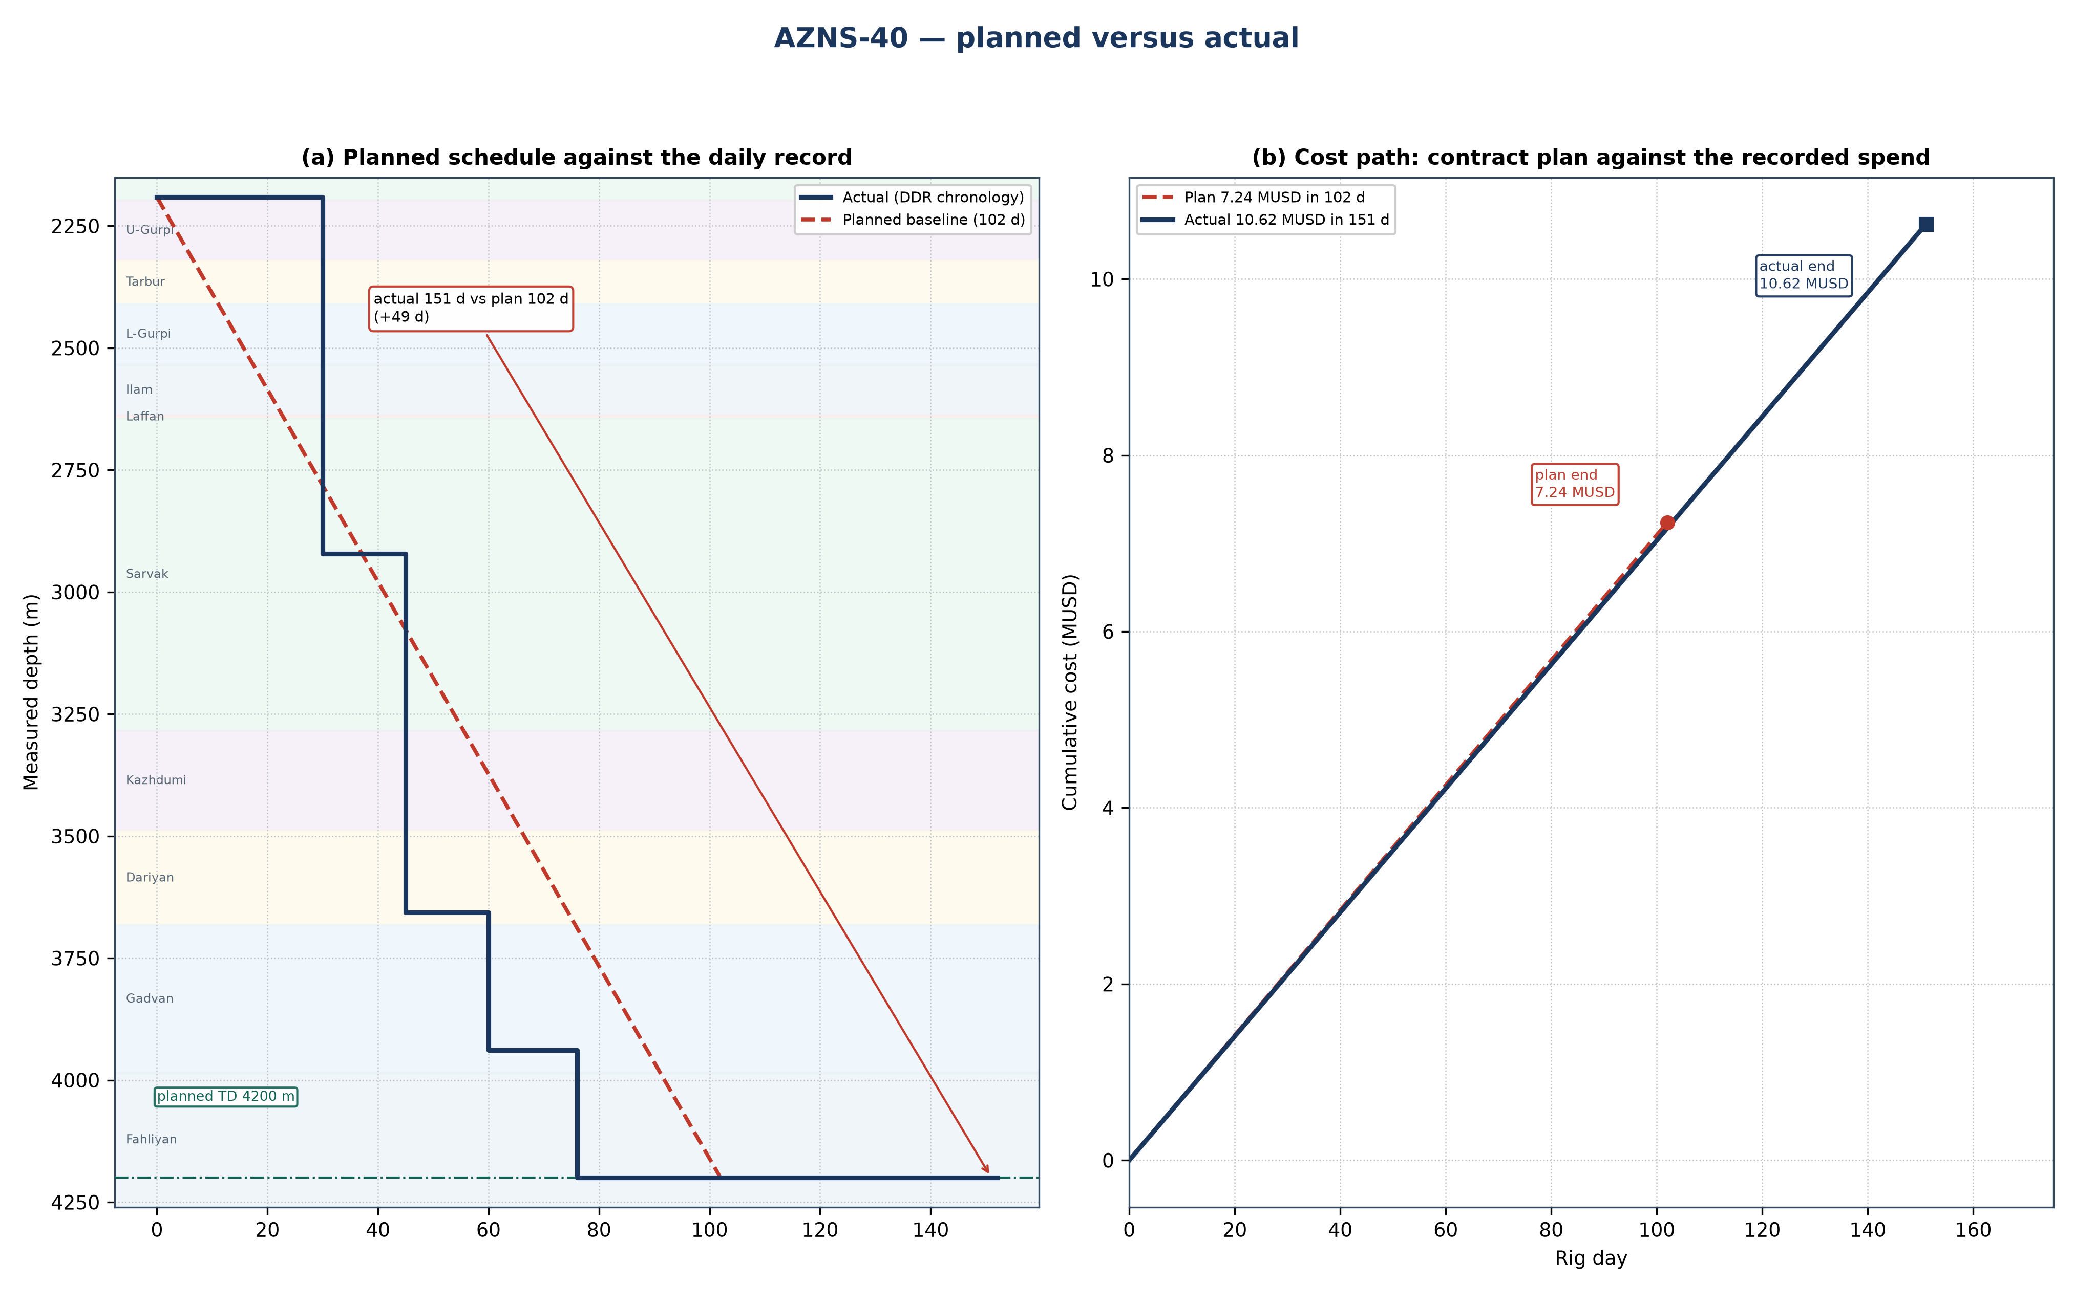
Figure 24.1 — AZNS-40: planned schedule and cost path against the recorded operation
Table 24.1 — Planned and actual milestones
Indicator | Programme | Record | Variance | Basis
Rig days | 102 | 151 | +49.0 | Programme duration / DDR rig hours
Total depth (m) | 4,200 | 4,200 | +0 | Programme TD / final MD
New hole (m) | — | 2,688 | — | DDR daily drilling figure
Rig | OEOC RIG 208 | OEOC RIG 208 | — | DDR header
NPT share | — | 1,134 h (31.3%) | — | Time-log flags
Contract value (MUSD) | 7.24 | 10.62 | +3.38 | CBS / daily-rate reconstruction
Specific cost (USD/m) | 2,692 | 3,951 | — | Cost over new hole

Ref. — duration and total depth from the approved programme; recorded rig days, new hole and final measured depth from the DDR sheets cited in Chapters 1 to 3; contract value from the cost breakdown structure and the recorded cost from the daily-rate reconstruction of Chapter 25.
Two explanations are open for a variance of this size, and they are separated before any recovery is credited. Either the scope grew after approval — an extra run, a second window, a deeper shoe — or the same scope took longer because rig time was lost. The discriminator is the NPT register: non-productive time is 1,134 h of 3,624 h (1,134 h (31.3%)), which accounts for about 47 days. Where that is close to the overrun, the scope did not change and the time was lost; where the operation count rises while NPT stays flat, the scope changed.
Technically the operation followed the programme sequence of re-entry drilling: the casing and hole programme of Chapter 2, the fluid programme of Chapter 7 and the bit and BHA record of Chapter 6 are the executed values, and Table 24.1 sets them against the plan. The planned section boundaries are reproduced in Figure 24.1 by the formation bands, so any section that ran long can be read directly off the depth axis.

25. Cost breakdown structure: contract plan against recorded cost
CBS AZNS-40.xlsx prices the scope at 7.24 MUSD, of which 3.18 MUSD is written on day-rate lines at a rig rate of 23,000 USD/day; the time-dependent element therefore costs about 31,162 USD per rig day. The record closes at 10.62 MUSD, a variance of +3.38 MUSD (+47%). Figure 25.1 splits that variance into the day-rate effect of the schedule and a scope-and-price residual.
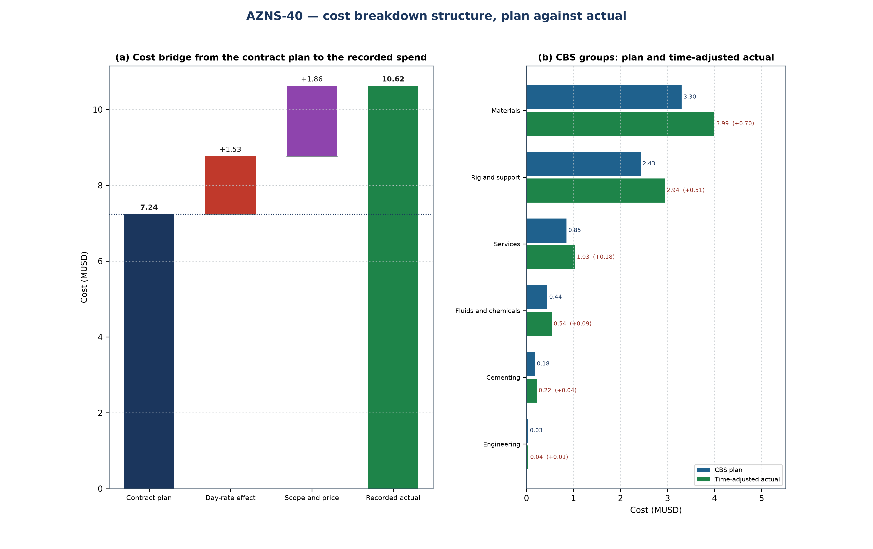
Figure 25.1 — AZNS-40: cost bridge and CBS groups
Table 25.1 — CBS groups: plan, share and time-adjusted value
CBS group | Plan (MUSD) | Share | Time-adjusted (MUSD) | Δ (MUSD)
Materials | 3.30 | 45.6% | 3.99 | +0.70
Rig and support | 2.43 | 33.6% | 2.94 | +0.51
Services | 0.85 | 11.8% | 1.03 | +0.18
Fluids and chemicals | 0.44 | 6.1% | 0.54 | +0.09
Cementing | 0.18 | 2.5% | 0.22 | +0.04
Engineering | 0.03 | 0.4% | 0.04 | +0.01
Total | 7.24 | 100.0% | 8.76 | +1.53

CBS Ref. — quantities and unit rates from "CBS AZNS-40.xlsx", sheet "Cost Breakdown-40"; the recorded cost is the daily-rate reconstruction of Chapter 1, not a second reading of the workbook.
Table 25.2 — Variance bridge
Step | MUSD | Driver
Contract plan (CBS) | 7.24 | Contract quantities at contract rates
Day-rate effect | +1.53 | +49.0 rig days at 31,162 USD/day
Scope and price residual | +1.86 | Runs, materials and services beyond the priced quantity
Recorded cost | 10.62 | Daily-rate reconstruction

CBS Ref. — quantities and unit rates from "CBS AZNS-40.xlsx", sheet "Cost Breakdown-40"; the recorded cost is the daily-rate reconstruction of Chapter 1, not a second reading of the workbook.
The residual is large, which means the record carries work that the priced schedule does not: either the scope was extended after approval, or services were called out that the lump-sum schedule treats as included. The discriminator is the extra-work column of the CBS and the service tickets behind it — where the same line appears in both, the scope grew; where it does not, the variance is a measurement of the lump-sum boundary.

26. Intervention-specific execution notes
This is a side-track or re-entry: a window is milled in the existing casing, the whipstock is oriented and set, and the new hole is drilled directionally to the target before a liner is run and cemented. The window-milling chapter of the programme governs the exit, the directional plan governs the build, and the liner and cement chapters govern the close.
Table 26.1 — Execution hold points
Stage | Execution requirement | Hold point
Window milling | Mill length and orientation checked against the survey at the window depth | window dressed and reamed before the whipstock is pulled
Whipstock set and oriented | Orientation verified against the gyro or MWD azimuth | tool face confirmed before the first metre of new hole
Directional drilling | Build rate against the plan with the dog-leg inside the limit of Chapter 9 | survey at the end of the build before the tangent
Liner and cement | Liner shoe at the programmed depth and cement volume with the programme excess | top of liner confirmed before the tie-back

Ref. — hold points read from AZNS-040 RE-Entry Well Program Rev.03.pdf; the sequence of the operation follows the approved programme and the daily record cited in Chapter 3.
Table 26.2 reads the daily log reproduced in Chapter 17 as an effort split. The log transcribes 70 entries carrying 374.5 h; of these, 261.5 h carry wording that identifies the intervention task, and the remainder is general rig work. The split shows where the executed scope actually lay, which is the input the next programme of the same type needs: a task that takes a third of the transcribed hours is the task whose duration has to be estimated from the record rather than from the template.
Table 26.2 — Recorded effort by intervention task
Task | Entries | Hours | Share
Kill and well control | 12 | 43.0 | 11.5%
Milling, dress-out and clean-out | 6 | 39.5 | 10.5%
Squeeze and plug cement | 1 | 10.0 | 2.7%
Perforation and acid | 3 | 16.0 | 4.3%
Completion and tubing | 12 | 89.0 | 23.8%
Fishing and freeing | 7 | 64.0 | 17.1%
Assigned to a task | 41 | 261.5 | 69.8%
All transcribed entries | 70 | 374.5 | 100.0%

Ref. — activity log of Chapter 17 (DDR "1-1 Remark" and "1-2 Data" time log); each entry is assigned to the first task whose wording it matches, so no hour is counted twice.
The operation as recorded was of the re-entry drilling type. Its schedule closed at 151 rig days against 102 planned, the reading of Chapter 24, and its cost at 10.62 MUSD against 7.24 MUSD of contract value, which Chapter 25 decomposes. What remains for the next operation of this type is the hold-point discipline of Table 26.1: every recorded overrun is a hold point passed late rather than a step executed badly. The largest identified task in the transcribed log is Completion and tubing at 89.0 h (24%).

