ENGINEERING REVIEW WARNING — This legacy report is not validated for operational or financial decisions. The former linear cumulative-cost chart was removed; a verified daily cost series is not yet available; other charts, budgets and cause/formation attribution require reconstruction and reconciliation to source records. See the repository review note for the limited corrections made.
AZNS-75
Drilling, Workover and Well-Intervention Engineering Report
Technical, Operational, Contractual and Financial Analysis
Interim source review for South Azadegan; engineering approval pending

Item | Value
Well / operation | 75
Daily-report pack | AZNS75Pack.xlsx
Cost workbook | CBS AZNS-075.xlsx
Well programme | AZNS-075 Workover-1 Program Rev.05.pdf
Status | Interim draft; source reconciliation and engineering approval required

Document control | Status
Official document code | Not established
Revision / status | Interim draft; not issued or approved
Official issue date | Not established
Preparation | Automated analytical draft
Specialist review | Completion and approval not established
Approval and distribution | Not established
Table 0-1 — Document control and review status.
This interim report compiles available records; its legacy analyses are not independently validated.

Executive KPI Summary
KPI | Value and scope
Programme-stated duration | 141.4 main; 149.2 with contingency [physical p.8]
Recognized status pages | 166
Status pages with approximately 24 h classified | 165
Recognized data pages | 166
Numeric downhole-loss entries | 51
Maximum single source loss entry, bbl | 140 [43-2 DDR Data!L36]
Actual duration, total loss and actual cost | Not reconciled; not inferred from these observations

Legacy duration and NPT figures in this report remain subject to source reconciliation. Actual expenditure is not established.

Contents
No. | Section
1 | Well Identity, Rig Assignment and Data Inventory
2 | Planned versus Actual Execution Reconciliation
3 | Selected daily-report observations
4 | Performance and Parameter Analysis
5 | Drilling Fluid Engineering and Loss Accounting
6 | Completion, Casing and Service-Module Findings
7 | Source-coded non-planned time and partial coverage
8 | CBS Financial Analysis and Provisional Cost Categories
9 | Operational observations and engineering decision gates
10 | Risk-review checklist; ownership and severity not assigned
11 | Data Provenance and Cell-Level Traceability
12 | Appendix: source formation-table snapshot (unverified)
13 | Programme source summary and comparison limitations

Figures and tables are numbered by section and are listed in place.

Well Identity, Rig Assignment and Data Inventory
This interim report references AZNS75Pack.xlsx and AZNS-075 Workover-1 Program Rev.05.pdf. The archive was indexed, but semantic extraction and verification remain incomplete; see the evidence notes and source inventory. Static identity and rig assignments below are legacy-compiled and require verification against cited source cells and approved records.

Static identity
Field | Recorded value
Well name in daily report | Work over, AZNS-075
Well type declaration | Development
Field | AZNS
Client | PPL
Drilling contractor | OEOC
Rig | 201 OEOC
Operation classification | Workover / Completion
Hole section / scope declaration | as per programme
Spud / first report date | 2025-03-20
Release / last report date | 2025-09-01
Table 1-1 Static well identity.

Data inventory discovered for this operation
Source / extraction | Recognition and limitation
Daily pack | AZNS75Pack.xlsx
Status pages | 166 recognized; 165 with approximately 24 classified hours
Data pages | 166 of 166 candidate pairs
CBS workbook | CBS AZNS-075.xlsx; cached values and scope require reconciliation
Programme PDF | AZNS-075 Workover-1 Program Rev.05.pdf; information page 8
Limitation | Recognition or absence in an extraction does not establish complete archive coverage
Table 1-2 Core and auto-discovered bonus modules.
The legacy module inventory requires review; absence from an extraction does not establish absence from the entire archive.

Planned versus Actual Execution Reconciliation
The programme AZNS-075 Workover-1 Program Rev.05.pdf, physical page 8, states the following objective: Remove completion, sidetrack and recomplete; these are programme objectives, not proof of execution. The stated duration in days is 141.4 main; 149.2 with contingency. Contingency figures retain the source labels and should not be added or compared with execution without reconciliation.
Reconciliation metric | Planned | Actual | Variance
Programme-stated duration (days) | 141.4 main; 149.2 with contingency | Not reconciled | Not reconciled
Depth reached / target (m MD) | Not reconciled | Not reconciled | Not reconciled
Cost (USD) | Not reconciled | Not reconciled | Not reconciled
Cost per rig day (USD) | Not reconciled | Not reconciled | Not reconciled
NPT share of rig time (%) | Not reconciled | Not reconciled | Not reconciled
Table 2-1 Planned versus actual reconciliation.
A planned-versus-actual duration comparison is not established until revision, scope, daily reports and time boundaries are reconciled; the previous ratio and causal attribution are withdrawn.
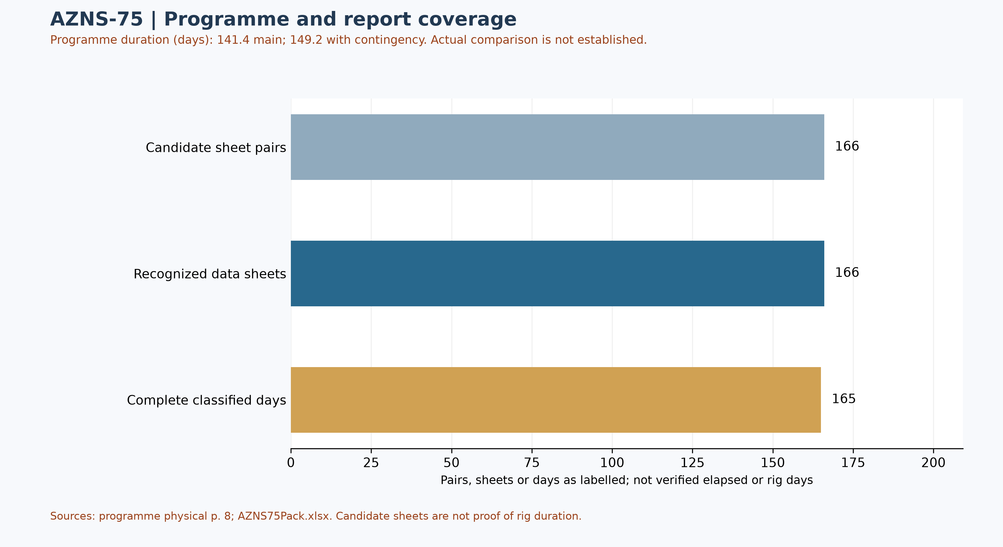
Figure W1 — Daily-record coverage and stated programme duration; actual comparison unverified
Status-page coverage is assessed independently: 166 status pages and 166 data sheets were recognized; 165 status pages contain classified durations totalling approximately 24 hours. Some reports have a status page but an absent or differently formatted data page. These counts are not verified rig duration.

Selected programme phases and limited execution evidence
The phases below are selected programme statements, not proof of execution or of the final approved revision. The selected daily observations are quoted separately; a similar topic alone does not establish phase timing, completion or deviation.
Programme — The stated main sequence is to pull completion, sidetrack the well and recomplete it. [AZNS-075 Workover-1 Program Rev.05.pdf, physical p. 33]
Programme — The time breakdown includes installation and testing of the BOP before the listed completion-string removal. [AZNS-075 Workover-1 Program Rev.05.pdf, physical p. 27]
Source worksheet 5 — The report describes repeated unsuccessful BOP test attempts while work continued on BOP leakages. [AZNS75Pack.xlsx, 5-1 DDR Remark!S25]
Source worksheet 5 — The next entry records waiting for completion of the BOP test while leakage repairs continued to midnight; attribution requires contract review. [AZNS75Pack.xlsx, 5-1 DDR Remark!S26]
Services listed in the programme: drilling and completion fluids: VIRA; waste management: Pars Hafaran Arvand; electrical logging and perforation: SEALAND; mud logging: Pars Geo Data. [AZNS-075 Workover-1 Program Rev.05.pdf, physical p. 25] These are programme assignments, not evidence of actual deployment, contractual award, cost or incident liability.

Worksheet-prefix and report-header reconciliation
Of 166 recognized status pages, the reported header number differs from the worksheet-name prefix on 0 pages; 0 headers have no readable numeric value. Axes based on worksheet prefix are not official report numbers or chronologies. Reconcile each entry's number, date and time with the header and signed records. Cell-level details are in evidence/sheet_report_number_audit.json.

Status-page header-date audit
Of 166 recognized status pages, 166 header dates were readable under narrow rules; 0 remain uninterpreted because of ambiguous format, missing data or volatile formula. Among adjacent recognized worksheets with readable dates in prefix order, 0 go backwards and 4 repeat a date. These counts alone do not prove an error, operating days or true sequence. Volatile date formulas occur on 0 pages. Even readable Excel dates can be wrong in the source or locale; reconcile against signed records. [evidence/status_report_date_audit.json]

Selected daily-report observations
Of 166 recognized status pages, 165 contain classified durations totalling approximately 24 hours. Planned, NPT and unplanned labels are source classifications; they do not independently establish cause, liability or total operation duration. The following examples are selective; complete extracted detail cells are retained in evidence/activity_observations.json.
Source worksheet 5 — The report describes repeated unsuccessful BOP test attempts while work continued on BOP leakages. [AZNS75Pack.xlsx, 5-1 DDR Remark!S25]
Source worksheet 5 — The next entry records waiting for completion of the BOP test while leakage repairs continued to midnight; attribution requires contract review. [AZNS75Pack.xlsx, 5-1 DDR Remark!S26]
These are source statements, not independent verification of a test, failure mechanism, current well condition or an operating instruction. A description may continue into the next cell; reconcile the complete row and time before making decisions.

Additional selected daily-report evidence
These three entries are ordered by worksheet prefix, not necessarily report number; sheet order alone does not establish event time, complete chronology, operational completion or current well condition. Test outcomes are source labels and require reconciliation with signed charts and the tested scope.
Source worksheet 17 — The report records a surface-line pressure test at 3,000 psi for 15 minutes, with the test confirmed “OK”. [AZNS75Pack.xlsx, 17-1 DDR Remark!S28]
Source worksheet 29 — The report states that window milling and dressing with an 8½-inch mill started and reached 2,266 m. [AZNS75Pack.xlsx, 29-1 DDR Remark!S26]
Source worksheet 38 — The report describes sliding directional drilling from 2,609 to 2,610 m with 8–10 barrels per hour of reported losses. [AZNS75Pack.xlsx, 38-1 DDR Remark!S44]
Depths from the original and sidetrack intervals require phase and datum reconciliation. A logged loss rate does not identify a formation or a validated total-loss volume.
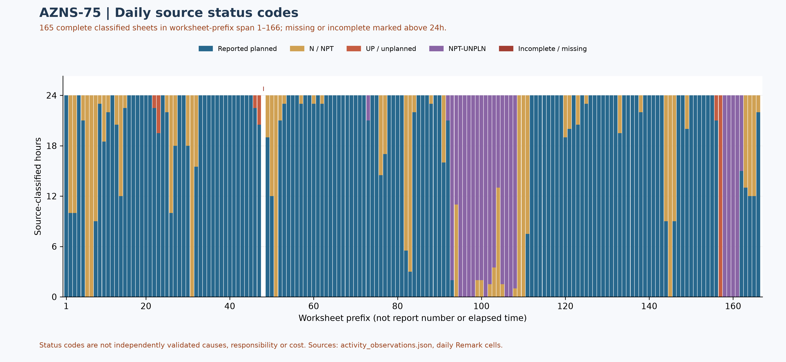
Figure W2 — Daily source-code composition in complete reports, with partial coverage

Selected AZNS-075 workover and sidetrack campaign reconstruction
These 26 selected entries are ordered by source header number, not verified chronology; dates and order require signed-record reconciliation. They do not establish all operations, accepted results or present barriers.
Worksheet 1, header report 1 — The source records spud of OEOC-201 on 20 March 2025 at 00:00, wellhead pressure tests labelled OK and no TWCV found during an attempted retrieval. The start boundary and initial equipment status require signed records. [AZNS75Pack.xlsx, 1-1 DDR Remark!S25, S28, S29, S30, S31, S32]
Worksheet 5, header report 5 — The BOP test is reported unsuccessful during leakage repairs; this page alone is not proof of the eventual test outcome. [AZNS75Pack.xlsx, 5-1 DDR Remark!S25, S26]
Worksheet 6, header report 6 — Repairs and several BOP tests are labelled OK, while the top kill-line check valve still leaked on the reported test. Do not substitute selected results for the complete approved pressure-test record. [AZNS75Pack.xlsx, 6-1 DDR Remark!S25, S26, S27, S28, S29, S30, S31, S32, S33]
Worksheet 10, header report 10 — Recovery of completion tubing, expansion joint, closed SSD and anchor seal is described; the seal is labelled in good condition. A 5.5-hour waiting entry is attributed to the rig; cause, overlap and responsibility need independent reconciliation. [AZNS75Pack.xlsx, 10-1 DDR Remark!S25, S26, S27, S28, S29, S31]
Worksheet 20, header report 20 — The 9⅝-inch dry-test entry reports a three-hour open observation with no bubbles and static annulus fluid, followed by a six-hour closed-period entry that also says “maintain open condition”. The wording is internally inconsistent; actual test interpretation requires the full pressure record, procedure and acceptance criteria. [AZNS75Pack.xlsx, 20-1 DDR Remark!S25, S26, S28, S29, S30, S31, S32, S33, S34, S35, S36, S37, S38]
Worksheet 26, header report 26 — The report describes failure to obtain gyro data with the initial and backup tools and records 14 hours NPT attributed to the service provider. Attribution and any aggregation across pages must be checked against detailed time and contract records. [AZNS75Pack.xlsx, 26-1 DDR Remark!S27, S28, S29, S30, S31, S32, S33, S34]
Worksheet 27, header report 27 — After further failed attempts, gyro data is reported OK after changing the mule shoe. The source records whipstock orientation, top at 2,257.9 m and window milling beginning there; these are reported depths, not a verified survey or as-built trajectory. [AZNS75Pack.xlsx, 27-1 DDR Remark!S25, S26, S27, S28, S29, S30, S31, S32, S33, S34, S35, S36, S37, S38, S39]
Worksheet 29, header report 29 — Window milling and dressing to 2,266 m and a source-described nonrotating pass are recorded. This alone does not certify window dimensions or integrity. [AZNS75Pack.xlsx, 29-1 DDR Remark!S25, S26, S27, S28, S29, S30]
Worksheet 30, header report 30 — A later directional-assembly gyro attempt also failed to obtain data; the source attributes six hours NPT to the service provider. It is a separate entry from the earlier whipstock orientation attempt. [AZNS75Pack.xlsx, 30-1 DDR Remark!S32, S33, S34, S35, S36]
Worksheet 60, header report 60 — The source reports alternating sliding and rotary drilling from 3,401.5 to 3,450.6 m, with 2–4 bbl/h loss reported during monitoring. It is a selected interval, not a continuous validated ROP, loss volume or formation attribution. [AZNS75Pack.xlsx, 60-1 DDR Remark!S25, S26, S27, S28, S29, S30, S32, S33, S34, S35]
Worksheet 90, header report 90 — At the reported 3,888 m depth the source describes up to 30 klbf overpull and subsequent conditioning and trips. The entry is not a root-cause determination or a verified continuous wellbore profile. [AZNS75Pack.xlsx, 90-1 DDR Remark!S25, S26, S28, S29, S32, S33, S34]
Worksheet 105, header report 105 — The report describes a temporary stuck drill-out assembly around 3,880 m and says it was freed, followed by reaming and a later trip with normal hole condition. NPT labels on the page are source attributions, not independently established liability. [AZNS75Pack.xlsx, 105-1 DDR Remark!S25, S26, S28, S29, S31, S32, S33, S35, S36, S37, S38, S39]
Worksheet 110, header report 110 — The page reports a damaged logging-tool bridle and 24 hours NPT attributed to the logging provider, followed by conditioning. It does not establish the final extent or quality of logging data; time and liability require signed records. [AZNS75Pack.xlsx, 110-1 DDR Remark!S25, S26, S27, S28, S29, S30, S31, S32, S33, S34, S40]
Worksheet 114, header report 114 — The source reports running the 5-inch liner to 3,888 m, setting the hanger at 3,887 m and pumping 30.72 bbl cement slurry, with a reported plug bump and integrity test labelled OK. This is not independent cement evaluation or proof of present isolation. [AZNS75Pack.xlsx, 114-1 DDR Remark!S25, S26, S27, S28, S29, S30, S31, S32, S34]
Worksheet 125, header report 125 — The page reports a 5-inch liner-lap reference of approximately 3,600 m, about four metres deeper than an earlier 3,596 m reference. The measurement basis and tool marks need reconciliation rather than silent correction. [AZNS75Pack.xlsx, 125-1 DDR Remark!S25, S26, S27, S28, S29]
Worksheet 135, header report 135 — The source describes the 7-inch tie-back cement job with 30 bbl of 118 pcf slurry and a subsequent cement hardness check labelled hard at 2,007 m. The test entry is not a complete cement evaluation or approved as-built barrier. [AZNS75Pack.xlsx, 135-1 DDR Remark!S25, S26, S27, S28, S29, S30, S31, S32, S38, S39, S40, S41]
Worksheet 140, header report 140 — The page reports SBT/VDL/GR/CCL data acquisition from 3,875 to 3,545 m with a repeat over 3,850–3,745 m. Data acquisition or repetition alone is not an interpretation of cement bond or isolation. [AZNS75Pack.xlsx, 140-1 DDR Remark!S28, S29, S30, S31, S32, S33]
Worksheet 147, header report 147 — Three perforating runs are recorded at 3,859–3,865 m, 3,853–3,859 m and 3,849–3,852 m. The intervals are individual source-reported runs, not evidence of productivity or continuous coverage across gaps. [AZNS75Pack.xlsx, 147-1 DDR Remark!S26, S27, S28, S29, S30, S31, S32]
Worksheet 148, header report 148 — A fourth perforating run is reported at 3,842–3,846.3 m. Confirm depth datum, shot and gun records and accepted perforation tally before assigning coverage or production performance. [AZNS75Pack.xlsx, 148-1 DDR Remark!S26, S27, S28]
Worksheet 152, header report 152 — The source reports displacement with 650 bbl of 84 pcf non-solid completion fluid, 50 bbl mud-contaminated returns and a one-hour flow check labelled static. Volumes and properties need the fluid ledger and sample records; this is not current well status. [AZNS75Pack.xlsx, 152-1 DDR Remark!S25, S26, S27, S28, S29, S30, S31]
Worksheet 156, header report 156 — The first reported completion run held up at 2,050 m and the attempt to pass failed; the page then records check-valve retrieval and pulling the completion to inspect. Subsequent actions should not be conflated with this run. [AZNS75Pack.xlsx, 156-1 DDR Remark!S25, S26, S27, S28, S29, S30, S31, S32, S33, S34, S35]
Worksheet 158, header report 158 — A 6.100-inch gauge ring could not pass the 7-inch liner lap, after which a cleanout assembly was run. The entry alone does not prove the restriction's cause or final clearance. [AZNS75Pack.xlsx, 158-1 DDR Remark!S25, S26, S27, S28, S29]
Worksheet 159, header report 159 — The page reports smoothing the 2,037–2,038 m tie-back liner-lap interval and checking other intervals; independent drift records and the subsequent completion run are needed to assess clearance. [AZNS75Pack.xlsx, 159-1 DDR Remark!S25, S26, S27]
Worksheet 163, header report 163 — The report describes a completion pressure test and a TRSSV inflow observation with no pressure buildup over 15 minutes. These source results are historical and do not certify present barrier condition. [AZNS75Pack.xlsx, 163-1 DDR Remark!S25, S26, S27, S34, S35]
Worksheet 164, header report 164 — The page first reports retrieval of the slickline assembly except the blanking plug, then states the 2.750-inch plug was retrieved for checking and subsequently set again, with prong, SSD closure check and packer tests. The stated 12-hour NPT attribution requires independent review; current barriers need signed handover and later records. [AZNS75Pack.xlsx, 164-1 DDR Remark!S25, S26, S27, S28, S29, S30, S31, S32, S34, S36, S37, S38, S39, S40, S41]
Worksheet 166, header report 166 — The final recognized page reports release of Rig 201 at 06:00 on 1404.06.10 as printed, and a tree-body pressure test labelled OK. The calendar format and start/end boundaries require confirmation against signed records; release alone does not certify present well integrity. [AZNS75Pack.xlsx, 166-1 DDR Remark!S25, S26, S27, S36]
Programme p.8 prints 141.4 days main and 149.2 days with contingency. The latter is described as the total with contingency and must not automatically be added to the main value; scope and boundaries require the approved plan. Neither value is verified actual duration or contractual overrun. [AZNS-075 Workover-1 Program Rev.05.pdf, p.8]

Performance and Parameter Analysis
Performance coverage: 165 status pages with classified durations totalling approximately 24 hours are used, out of 166 recognized status pages. Planned does not prove productive time; NPT, unplanned and mixed codes are distinct. Omitted hours are not zero; activity families, causes and total operation duration are not established by this table.
Source status code | Hours in complete reports | Share of classified hours
Reported planned | 2,954.50 | 74.6%
N / NPT | 510.00 | 12.9%
UP / unplanned | 38.00 | 1.0%
NPT-UNPLN (mixed) | 457.50 | 11.6%
Table 4-1 — Source status codes in recognized complete reports, not causal categories
Progress and phase-rate comparisons require reconciliation of scope, time and activity. Report-end depth is not tool depth or instantaneous rate.
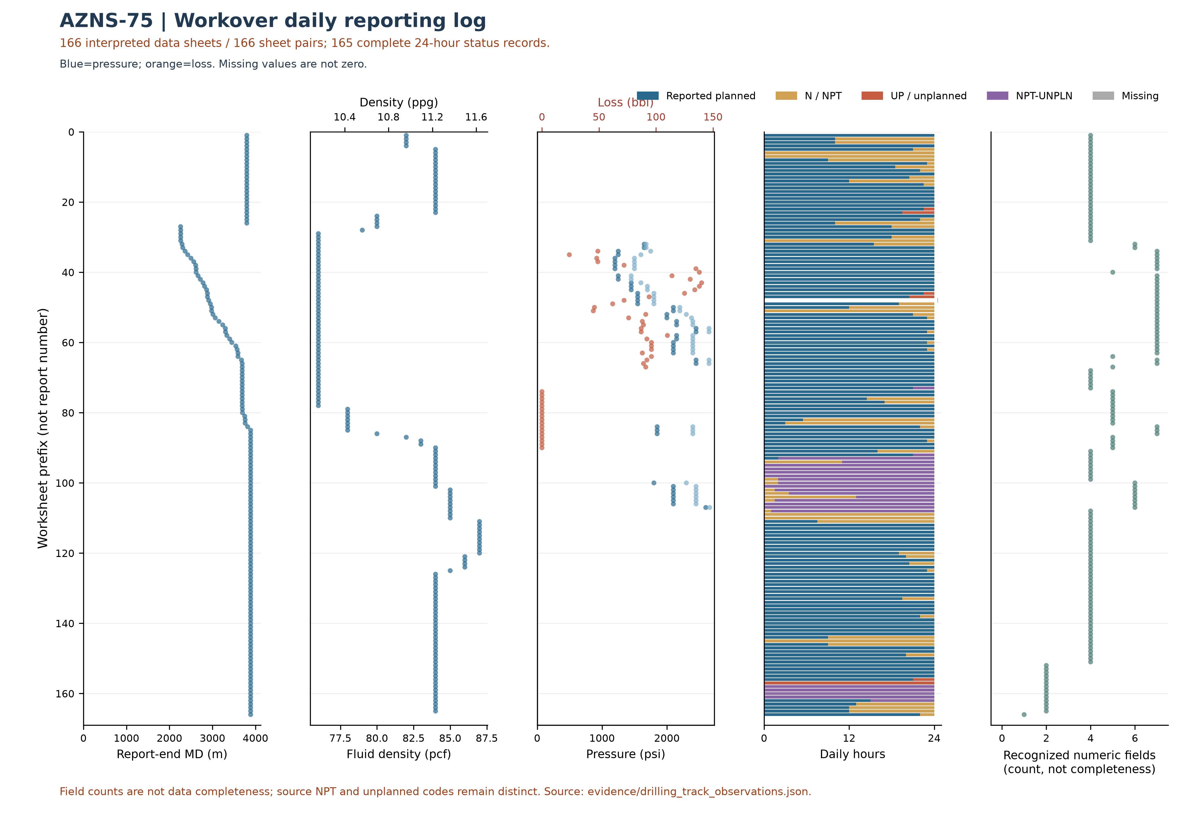
Figure W3 — Workover source observations by worksheet prefix, AZNS-75
W3 uses the data-linked extraction: its coverage and hours may be smaller than W2 and W4, which assess status pages independently of data sheets. Missing or unrecognized data sheets are not added as W3 observations.
This plot uses 166 recognized data sheets and 165 pages with classified durations totaling approximately 24 hours. Its axis is worksheet prefix, not report number or continuous time; for some workbooks sheet order is not chronological. Numeric-field counts are not data completeness. NPT and unplanned codes remain distinct; missing is not zero and report-end depth is not necessarily tool or event depth.
Bit | Rerun | Type / size | Max cumulative m / source | Max cumulative h / source | Dull in sheet order
1 | 0 | Tri-Cone; Tri Cone ( B.Bit ); 6-1/8; 8-3/8"; CONFLICT | 43.9 [33-2 DDR Data!E28] | 31.5 [15-2 DDR Data!E30] | 1.1.WT.A.E.I.NO.BHA [33-2 DDR Data!E32]
1 | 1 | T.Bit; B.Bit; 6"; CONFLICT | — | — | —
2 | Unknown | PDC Bit; 8-3/8" | 599.7 [45-2 DDR Data!E28] | 207 [45-2 DDR Data!E30] | —
2 | 0 | PDC Bit; 8-3/8" | 310 [39-2 DDR Data!E28] | 99 [39-2 DDR Data!E30] | 0.1.BT.S.X.I.NO.DMF [39-2 DDR Data!E32]
2 | 1 | Tri-Cone; 8-1/2 | — | — | 2-2-WT-A-E-I-BT-DTF [22-2 DDR Data!E32]
2 | 2 | Tri-cone; 6-1/8 | — | 55 [75-2 DDR Data!E30] | 2-2-WT-A-E-I-BT-BHA [75-2 DDR Data!E32]
2 | 3 | Tri-cone; T.Cone; 6-1/8; 6-18; CONFLICT | — | 75 [137-2 DDR Data!G30] | 2.3.WT.A.E.I.BT.BHA [138-2 DDR Data!G32]
2 | 4 | Tri-cone; 6-1/8 | — | 60 [79-2 DDR Data!E30] | 2-2-WT-A-E-I-BT-BHA [82-2 DDR Data!E32]
2 | 5 | Tri-Cone; 6-1/8 | — | 76.5 [100-2 DDR Data!E30] | 2-2-WT-A-E-I-BT-BHA [106-2 DDR Data!E32]
3 | 0 | Tri-Cone; 8-1/2 | — | 13.5 [23-2 DDR Data!E30] | 2-2-WT-A-E-I-BT-BHA [24-2 DDR Data!E32]
3 | 1 | Tri-Cone; T.Cone; 8-1/2; 8-3/8; CONFLICT | 154 [135-2 DDR Data!E28] | 268 [136-2 DDR Data!E30] | 1.1.WT.A.E.I.NO.BHA [136-2 DDR Data!E32]
4 | 3 | Tri.cone 537; 8-3/8" | 141.4 [98-2 DDR Data!E28] | 39 [98-2 DDR Data!E30] | 1.1.WT.A.E.I.NO.BHA [99-2 DDR Data!E32]
5 | 7 | TCI; 8-3/8 | — | — | 1.1.WT.A.E.I.NO.BHA [141-2 DDR Data!E32]
6 | Unknown | PDC Bit; 8-3/8"; CONFLICT | 1036.3 [57-2 DDR Data!E28] | 331.8 [57-2 DDR Data!E30] | 3-5-BT-A-X-I-BU(5%)-BHA [57-2 DDR Data!E32]
6 | 2 | PDC Bit; 8-3/8" | 619 [47-2 DDR Data!G28] | 207 [47-2 DDR Data!G30] | —
7 | Unknown | PDC Bit M1375; 8-3/8" | 387.88 [66-2 DDR Data!E28] | 165 [66-2 DDR Data!E30] | 1.1.WT.A.X.I.NO.TD [67-2 DDR Data!E32]
7 | 0 | PDC Bit M1375; 8-3/8"; CONFLICT | 289.88 [63-2 DDR Data!E28] | 117 [63-2 DDR Data!E30] | —
8 | Unknown | 8-3/8" | — | — | 1.1.WT.A.E.I.NO.BHA ( Before Run ) [69-2 DDR Data!E32]
Table 4-2 — Identified bit observations and cumulative-counter sources.
Unassigned tool observations — grouped only by identical text, not verified runs.
Unassigned raw ID | Reported size / type | Entries | First source
— / 0 | 8-3/8" / Tri Cone ( B.Bit ) | 4 | 29-2 DDR Data!E10,E11,E12
— | 6-1/8 / Tri-cone | 5 | 73-2 DDR Data!E11,E12
— / 1 | 6-1/8 / PDC | 10 | 80-2 DDR Data!G10,G11,G12
— | 6-1/8" / Tci.cone | 3 | 89-2 DDR Data!G11,G12
— / RR2 | 39600 / PDC | 1 | 106-2 DDR Data!G10,G11,G12
— / RR2 | 6-1/8" / PDC | 6 | 107-2 DDR Data!E10,E11,E12
— | 4-1/8" M.M.J.M / — | 4 | 116-2 DDR Data!G11
— | 3-3/4" M.M.J.Mill / — | 3 | 119-2 DDR Data!G11
— | 5-7/8" Center Cut Bit / — | 1 | 122-2 DDR Data!E11
— | — / 5-1/8" Polish mill | 2 | 124-2 DDR Data!E11,E12
Bit evidence is preliminary: source AZNS75Pack.xlsx; 166 data sheets were recognized from 166 candidate sheet pairs. 39 tool-column entries lack an unambiguous numeric bit ID. A cumulative-counter maximum is not necessarily incremental run performance; bit-number reuse, rerun, metadata conflicts and dull reports require reconciliation. Workbook order does not prove chronology; the displayed dull observation is not necessarily final. Missing values are not zero.
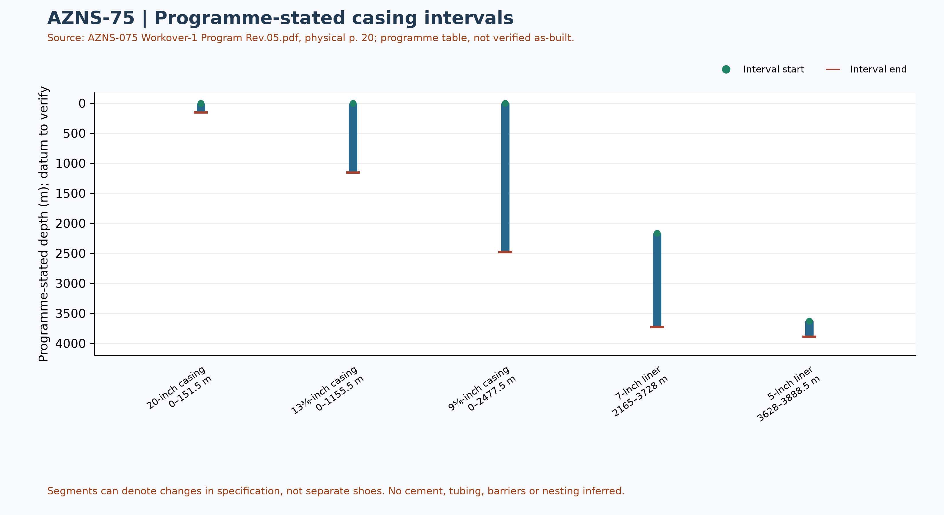
Figure W6 — Programme-stated casing intervals; not a verified as-built schematic

Drilling Fluid Engineering and Loss Accounting
This table summarizes numeric entries recovered from 166 recognized data sheets out of 166 candidate pairs. Each extreme has a source-cell example; coverage, simultaneity, units and test quality require verification. Minima and maxima are not a design window or current fluid condition.
Source observation | Numeric entries | Minimum and cell | Maximum and cell
Mud weight (pcf) | 165 | 76 [29-2 DDR Data!L9] | 87 [111-2 DDR Data!L9]
Plastic viscosity (cP) | 151 | 9 [34-2 DDR Data!L12] | 16 [79-2 DDR Data!L12]
Yield point (lb/100 ft²) | 151 | 6 [15-2 DDR Data!L13] | 16 [138-2 DDR Data!L13]
Source downhole loss (bbl) | 51 | 0 [74-2 DDR Data!L36] | 140 [43-2 DDR Data!L36]
Table 5-1 — Partial source-cell fluid and loss observations
A blank or nonnumeric entry is not zero. The source loss field is labelled downhole or formation loss volume; no sum or formation attribution is calculated until reporting basis, cumulative versus daily treatment and duplication are reconciled. Reconcile cell values with operational remarks and materials use separately.

Selected mud-material source entries
Table 5-2 selects source-used entries from two sheets of AZNS75Pack.xlsx. Recognizable materials headers were found in 166 of 166 data sheets; this count does not validate completeness or correctness of inventory or usage. Used-column header cells and row units are retained in the evidence file.
Selected sheet | Material and cell | Used value and cell | Source unit and cell
3-2 DDR Data | Limestone [N10] | 6 [P10] | 1MT/BB [S10]
3-2 DDR Data | Salt [N11] | 5 [P11] | 1 MT/BB [S11]
3-2 DDR Data | Starch LV [N13] | 18 [P13] | 25 KG/SX [S13]
4-2 DDR Data | Limestone [N10] | 29 [P10] | 1MT/BB [S10]
4-2 DDR Data | Salt [N11] | 7 [P11] | 1 MT/BB [S11]
4-2 DDR Data | Lime [N12] | 3 [P12] | 25 KG/SX [S12]
Table 5-2 — Selected mud-material used-column entries; units as printed
The used column is distinct from received, cumulative received and stock. Repeated material or values across sheets are not necessarily independent consumption; blanks and errors are not zero. Verify package size, unit abbreviation, reporting period, opening and closing balance, receipts, usage and mixing records before totals or conversion. These entries alone do not establish downhole use, treatment of losses or causality with fluid properties.

Completion, Casing and Service-Module Findings
Programme element | Interval start, m | Interval end, m | Source specification
20-inch casing | 0 | 151.5 | K-55, 94 ppf, BTC
13⅜-inch casing | 0 | 1155.5 | N-80, 68 ppf, BTC
9⅝-inch casing | 0 | 2477.5 | L-80 (1), 47 ppf, PJE
7-inch liner | 2165 | 3728 | L-80 (1), 29 ppf, HSM-1
5-inch liner | 3628 | 3888.5 | L-80 (1), 18 ppf, HSG3-FJ
Table 6-1 — Casing and liner intervals in AZNS-075 Workover-1 Program Rev.05.pdf, physical p. 20
Programme casing scope: these values transcribe the programme table and describe historical or pre-operation conditions, not a verified final wellbore. Endpoints of specification segments are not necessarily shoes or hangers; datum, actual configuration, tally and barrier integrity require approved records.
The legacy directional survey statistics and trajectory have not been independently reconciled; W7 now shows bit/tool evidence, not a trajectory.
Personnel-on-board averages and peaks in the legacy report are withdrawn pending reconciliation of daily role-level counts, totals, missing entries and personnel scope.
The next figure displays only recognized bit and tool evidence; casing and cost evidence are presented in their respective sections. This is not a verified run count or continuous log.
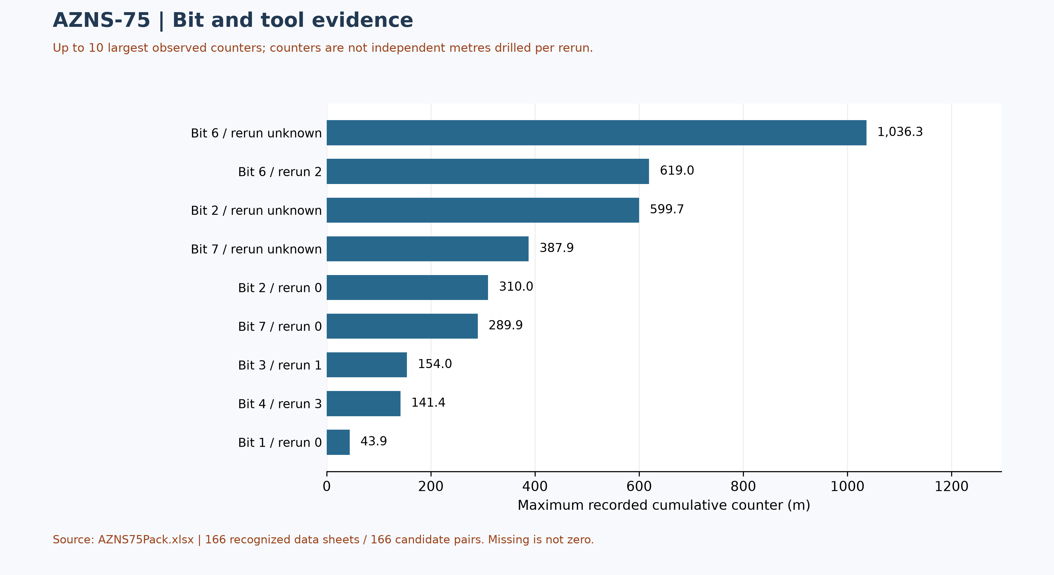
Figure W7 — Maximum source cumulative counters, not incremental run performance

Selected daily BHA components and hydraulic review
At least one nonempty recognized-format block was recovered in 120 of 166 data sheets. The table selects four rows from one block in AZNS75Pack.xlsx, sheet 80-2 DDR Data; it is not the entire string, all runs, or the current well condition. A repeated identifier or parallel columns do not establish the number of runs.
Selected component and cell | Recorded outside diameter and cell | Evidence scope
Tri-Cone Bit [B48] | 6-1/8 [C48] | Source observation
Bit Sub [B49] | 4-3/4 [C49] | Source observation
HWDP [B50] | 3-1/2 [C50] | Source observation
DP [B51] | 3-1/2 [C51] | Source observation
Table 6-2 — Selected source block components and recorded dimensions
Physical programme page 42 is a navigation anchor for the planned BHA discussion; matching phase or agreement with this daily example is not established. Reconcile stated dimensions with the component name, count, length, inside diameter, connection limits, sequence, run record and manufacturer data. Hydraulic review requires verified inside and outside diameters and annular geometry for each section, simultaneous flow and fluid properties, nozzle and surface-loss information and pressure calibration. Without these inputs, pressure loss, annular velocity, hole cleaning and a reliable operating window cannot be calculated; W3 alone is not a design.

Source-coded non-planned time and partial coverage
Only 165 daily reports with classified durations totalling approximately 24 hours were included out of 166 candidate sheet pairs. These are source-code hours, not a verified total for the operation; incomplete or unrecognized days are not zero. Status pages are recognized independently of data pages; row-level cells are retained in evidence/activity_observations.json.
Table 7-1 — Source-code hours in complete reports; references are examples.
Source code | Hours in coverage | Example status and duration cells
N / NPT | 510.00 | 2-1 DDR Remark!M28,E28 ; 3-1 DDR Remark!M25,E25
UP / unplanned | 38.00 | 22-1 DDR Remark!M37,E37 ; 22-1 DDR Remark!M39,E39
NPT-UNPLN | 457.50 | 73-1 DDR Remark!M30,E30 ; 92-1 DDR Remark!M30,E30
Activity codes alone do not establish root cause or contractual responsibility. Legacy mechanism claims, contractor attribution and financial exposure are withdrawn pending review of actual daily narrative, contracts and event evidence. Different source codes must not be presented as a single NPT definition.
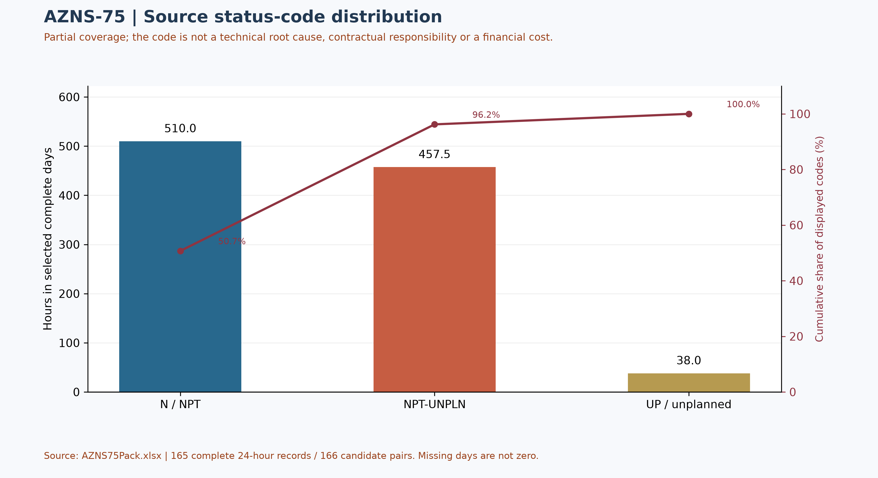
Figure W4 — Pareto of source status codes in complete days, not technical causes

CBS Financial Analysis and Provisional Cost Categories
Table 8-2 source: CBS AZNS-075.xlsx / Cost Breakdown-075. Categories are derived by summing numeric cached values within each cited row range; scope and formulas remain unverified. These cached source amounts are not actual expenditure or an approved comparable budget. Missing or erroneous values are not zeros; rates, scope, formulas and approvals require reconciliation. No daily expenditure series has been verified.
Source / scope | Cached value | Cell / sheet
Cached main-sheet total; scope unverified | 6,640,387.27 | F197 / Cost Breakdown-075
Source ceiling; scope to reconcile | 8,245,307.79 | C5 / Total Cost-EPD & Rigless
Table 8-1 Source financial and schedule anchors (unreconciled).
Source category | Source amount (USD) | Amount cell
Rig service | 3,564,137.50 | F5:F5
Drilling fluids | 381,088.86 | F6:F12
Cementing | 106,200.00 | F13:F19
Mud logging | 173,170.59 | F20:F23
Wireline logging | 448,812.50 | F24:F65
Drilling waste management | 160,725.62 | F66:F77
Directional drilling | 187,016.87 | F78:F90
Casing running | 74,355.00 | F91:F98
Temporary well suspension | 0.00 | F99:F102
Slickline | 38,397.00 | F103:F105
Completion running | 30,000.00 | F106:F117
Liner hanger running | 3,900.00 | F118:F126
H2S service | 32,542.12 | F127:F129
Perforation | 123,501.00 | F130:F134
Wellhead services | 18,000.00 | F135:F139
Dry test services | 41,625.00 | F140:F142
Rig / completion services | 357,625.11 | F143:F152
Other services | 77,481.25 | F153:F156
Cleanup services | 159,458.84 | F157:F163
Drilling materials | 0.00 | F164:F172
Project management | 619,850.00 | F173:F175
Engineering | 32,500.00 | F176:F186
Tubing inspection | 0.00 | F187:F194
Wellhead / tree inspection | 5,000.00 | F195:F195
Downhole completion inspection | 5,000.00 | F196:F196
Table 8-2 CBS source categories and cell references (unreconciled).
Topic | Observation | Source reference | Action
Scope / actuals | Values are not actual invoices or an approved comparable ceiling. | Source sheet and formulas | Reconcile
Table 8-3 CBS reconciliation checks.
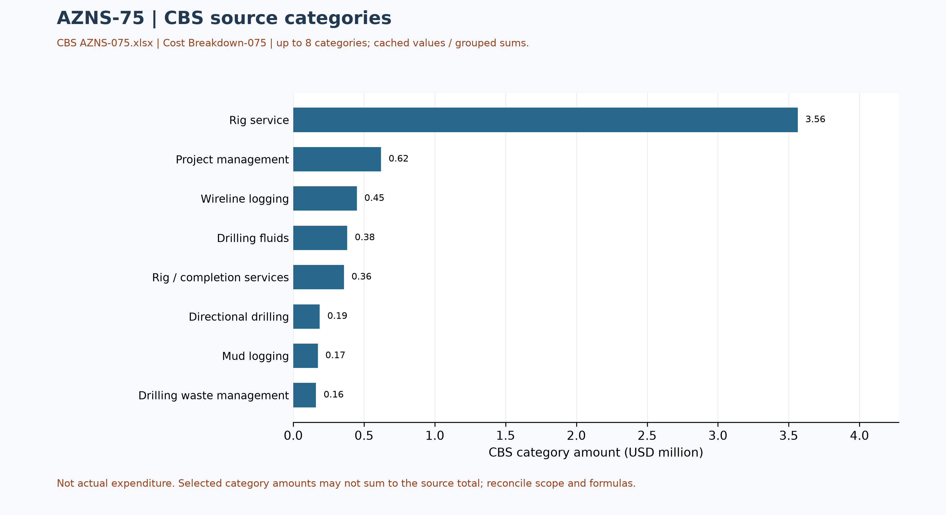
Figure W5 — CBS source cost categories, AZNS-75 (unreconciled)

Selected CBS service-sheet checks
The coiled-tubing service sheet in CBS AZNS-075.xlsx, Coil Tubing Service-075!B3:H3, lists one 1½-inch coiled-tubing unit, 3 standby days and 5 operating days, with both day rates at USD 4,800 and a cached line amount of USD 38,400. The source formula multiplies each day count by its corresponding rate. This is a selected estimated service line, not a verified operational record or invoice.
This sample is not an additional cost to be added to the main breakdown or ceiling: the roll-up, contingencies, units, contract scope and service execution must first be traced and reconciled. A repeated template line across workbooks is not independent evidence of repeated deployment.

Operational observations and engineering decision gates
Previous numerical operating envelopes were not validated and have been withdrawn. The entries below are examples of raw daily records only; tool location, phase, units and measurement validity require review. These observations are not safe limits, optimum windows or operating instructions.
Table 9-1 — Example recorded cells; units and measurement basis require verification.
Raw field | Example recorded value | Sheet and cell
Mud weight | 82 | 1-2 DDR Data!L9
Bit load / WOB | 6 | 32-2 DDR Data!E38
RPM | 40 | 84-2 DDR Data!E40
Flow | 450 | 32-2 DDR Data!E36
Standpipe pressure | 1650 | 32-2 DDR Data!E42

Recommendations and review requirements
- Reconcile the programme revision, scope, start/end boundaries and rig/service time against daily reports and approved schedules before reporting a variance.
- Have responsible specialists verify well barriers and formation, casing and equipment limits against current approved records; no numerical design setpoint is established by this report.
- Reconcile bit identifiers, cumulative counters, tool assembly and failure evidence with original field and vendor records before selecting future equipment or diagnosing a mechanism.
- Reconcile costs with signed contracts, approved scope and invoices; do not convert source status-code hours into financial liability without a contractual assessment.

Risk-review checklist; ownership and severity not assigned
Review topic | Available evidence | Required follow-up
Well integrity and pressure | Programme objective and stated background, not proof of current condition | Reconcile tests, barriers and current approved limits
Incidents and recorded time | Partial source-code coverage in table 7-1 | Review event narrative, duration, cause and contract without presumed attribution
Equipment and operations | Example cells in table 9-1 and tool observations in table 4-2 | Verify units, calibration, tool identity and vendor records
Schedule and cost | Programme page and cost-breakdown evidence | Reconcile scope, invoices, time basis and approved revision

Data Provenance and Cell-Level Traceability
The table lists selected source anchors only. Other entries and interpretations still require independent cell/page checks, unit and scope review; the current report is not fully reconciled or reproducible without engineering interpretation.
Data element | Archive anchor (file -> sheet!cell)
rig | 1-1 DDR Remark!AB4
contractor | 1-1 DDR Remark!AB5
project | 1-1 DDR Remark!AB3
gle | 1-1 DDR Remark!AB7
report_no | 1-1 DDR Remark!AL5
lta | 1-1 DDR Remark!AL3
depth:md_0000 | 1-1 DDR Remark!R9
depth:md_2400 | 1-1 DDR Remark!R10
depth:md_0600 | 1-1 DDR Remark!R11
depth:drilled_24h | 1-1 DDR Remark!R12
mud:mud_type | 1-2 DDR Data!R8C12
mud:mw | 1-2 DDR Data!R9C12
mud:funnel_visc | 1-2 DDR Data!R11C12
mud:pv | 1-2 DDR Data!R12C12
CBS cost breakdown | CBS AZNS-075.xlsx -> sheet "Cost Breakdown-075"
Planned duration | CBS AZNS-075.xlsx -> CBS time-breakdown "AZNS-075 WO (Gadvan)"
Well programme | AZNS-075 Workover-1 Program Rev.05.pdf
Table 11-1 Provenance anchors.

Appendix: source formation-table snapshot (unverified)
Source: AZNS75Pack.xlsx, sheet 165-2 DDR Data. Selected as the last sheet in workbook order with a recognized formation table containing a numeric depth; if none, the last table with formation names. This is not necessarily the latest dated report.
Column roles follow the source labels, not independent confirmation of prognosis or measurement. Unlabelled populated cells are shown separately; missing cells are unknown, not zero. Values are rounded to four decimals for display. Verify row alignment, depth datum, possible inconsistencies and lithology against the programme and geological report; this table alone does not establish event attribution or operating instructions.
Source table and anchor: Formation Top Data / N80
Formation / cell | Source values / cell
L. Gurpi / N82 | m MD: 2328 [P82]  m TVD: 2327.71 [Q82]  Lithology: Arg Lst [R82]
Ilam / N83 | m MD: 2469 [P83]  m TVD: 2466.32 [Q83]  Lithology: Mrl & Shale & Arg Lst [R83]
Lafan / N84 | m MD: 2510 [P84]  m TVD: 2541.35 [Q84]  Lithology: Clast [R84]
Sarvak / N85 | m MD: 2555.5 [P85]  m TVD: 2547.76 [Q85]  Lithology: Lst & Arg Lst [R85]
Kazhdumi / N86 | m MD: 3299 [P86]  m TVD: 3193.27 [Q86]  Lithology: Arg Lst [R86]
Dariyan / N87 | m MD: 3527 [P87]  m TVD: 3393.23 [Q87]  Lithology: Lst [R87]
Gadvan / N88 | m MD: 3708.2 [P88]  m TVD: 3550.63 [Q88]

Well-program evidence note
AZNS-075 Workover-1 Program Rev.05.pdf, physical page 7, identifies removing the completion and running a new completion string as the main workover objectives. The section 10.2 heading on page 86 identifies the first-run completion string as failed and names Weqixin; the text extract on that page does not establish the mechanical failure mechanism. Review the schematic, failure investigation and operational records before attributing root cause.

Selected tops from the programme schematic or image
Source: AZNS-075 Workover-1 Program Rev.05.pdf, physical page 21. These values were transcribed from a schematic labelled before the workover, not independently confirmed current tops or as-built status. Names and depths were visually paired; event attribution requires reconciliation of the event depth, branch and datum.
Formation / member | Source depth, m MD
Gachsaran | 897.46
Asmari | 1197.47
Pabdeh or Pd./Ja. | 1382.48
Jahrum | 1506.49
Pabdeh | 1778.54
U. Gurpi | 2023.55
Tarbur | 2234.57
L. Gurpi | 2334.58
Ilam | 2472.58
Laffan | 2547.59
Sarvak | 2554.59
Kazhdumi | 3196.65
Dariyan | 3401.70
Gadvan-1 | 3557.76
Gadvan-5a | 3660.82
Gadvan-5c | 3670.82
Gadvan-8 | 3726.86
Table — Selected formation tops as printed in the source schematic or image; see text for well and stage

Programme source summary and comparison limitations
Source: AZNS-075 Workover-1 Program Rev.05.pdf, physical page 8. Programme objective: Remove completion, sidetrack and recomplete; these are programme objectives, not proof of execution. Stated programme duration, in days: 141.4 main; 149.2 with contingency. The programme states measured depth 3888.5 m and producer/reservoir formation Gadvan; these do not by themselves establish achieved depth or current condition. Time boundaries, scope and contingency interpretation require reconciliation.

