ENGINEERING REVIEW WARNING — This legacy report is not validated for operational or financial decisions. The former linear cumulative-cost chart was removed; a verified daily cost series is not yet available; other charts, budgets and cause/formation attribution require reconstruction and reconciliation to source records. See the repository review note for the limited corrections made.
AZNS-40
Drilling, Workover and Well-Intervention Engineering Report
Technical, Operational, Contractual and Financial Analysis
Interim source review for South Azadegan; engineering approval pending

Item | Value
Well / operation | 40
Daily-report pack | AZNS40Pack.xlsx
Cost workbook | CBS AZNS-40.xlsx
Well programme | AZNS-040 RE-Entry Well Program Rev.03.pdf
Status | Interim draft; source reconciliation and engineering approval required

Document control | Status
Official document code | Not established
Revision / status | Interim draft; not issued or approved
Official issue date | Not established
Preparation | Automated analytical draft
Specialist review | Completion and approval not established
Approval and distribution | Not established
Table 0-1 — Document control and review status.
This interim report compiles available records; its legacy analyses are not independently validated.

Executive KPI Summary
KPI | Value and scope
Programme-stated duration | 102 estimated well duration; 10 estimated moving [physical p.13]
Recognized status pages | 151
Status pages with approximately 24 h classified | 151
Recognized data pages | 151
Numeric downhole-loss entries | 75
Maximum single source loss entry, bbl | 305 [57-2 Data!R41]
Actual duration, total loss and actual cost | Not reconciled; not inferred from these observations

Legacy duration and NPT figures in this report remain subject to source reconciliation. Actual expenditure is not established.

Contents
No. | Section
1 | Well Identity, Rig Assignment and Data Inventory
2 | Planned versus Actual Execution Reconciliation
3 | Selected daily-report observations
4 | Performance and Parameter Analysis
5 | Drilling Fluid Engineering and Loss Accounting
6 | Completion, Casing and Service-Module Findings
7 | Source-coded non-planned time and partial coverage
8 | CBS Financial Analysis and Provisional Cost Categories
9 | Operational observations and engineering decision gates
10 | Risk-review checklist; ownership and severity not assigned
11 | Data Provenance and Cell-Level Traceability
12 | Appendix: source formation-table snapshot (unverified)
13 | Programme source summary and comparison limitations

Figures and tables are numbered by section and are listed in place.

Well Identity, Rig Assignment and Data Inventory
This interim report references AZNS40Pack.xlsx and AZNS-040 RE-Entry Well Program Rev.03.pdf. The archive was indexed, but semantic extraction and verification remain incomplete; see the evidence notes and source inventory. Static identity and rig assignments below are legacy-compiled and require verification against cited source cells and approved records.

Static identity
Field | Recorded value
Well name in daily report | AZNS-040
Well type declaration | IIF VERTICAL WELL
Field | AZADEGAN
Client | PPL/PEDEC
Drilling contractor | OEOC
Rig | 208 OEOC
Operation classification | Workover / Completion
Hole section / scope declaration | DE-SUSPEND
Spud / first report date | 2023-07-13
Release / last report date | 2023-12-13
Table 1-1 Static well identity.

Data inventory discovered for this operation
Source / extraction | Recognition and limitation
Daily pack | AZNS40Pack.xlsx
Status pages | 151 recognized; 151 with approximately 24 classified hours
Data pages | 151 of 151 candidate pairs
CBS workbook | CBS AZNS-40.xlsx; cached values and scope require reconciliation
Programme PDF | AZNS-040 RE-Entry Well Program Rev.03.pdf; information page 13
Limitation | Recognition or absence in an extraction does not establish complete archive coverage
Table 1-2 Core and auto-discovered bonus modules.
The legacy module inventory requires review; absence from an extraction does not establish absence from the entire archive.

Planned versus Actual Execution Reconciliation
The programme AZNS-040 RE-Entry Well Program Rev.03.pdf, physical page 13, states the following objective: Re-enter the suspended well and target oil production from Fahliyan; the re-entry objective is detailed on page 19. The stated duration in days is 102 estimated well duration; 10 estimated moving. Contingency figures retain the source labels and should not be added or compared with execution without reconciliation.
Reconciliation metric | Planned | Actual | Variance
Programme-stated duration (days) | 102 estimated well duration; 10 estimated moving | Not reconciled | Not reconciled
Depth reached / target (m MD) | Not reconciled | Not reconciled | Not reconciled
Cost (USD) | Not reconciled | Not reconciled | Not reconciled
Cost per rig day (USD) | Not reconciled | Not reconciled | Not reconciled
NPT share of rig time (%) | Not reconciled | Not reconciled | Not reconciled
Table 2-1 Planned versus actual reconciliation.
A planned-versus-actual duration comparison is not established until revision, scope, daily reports and time boundaries are reconciled; the previous ratio and causal attribution are withdrawn.
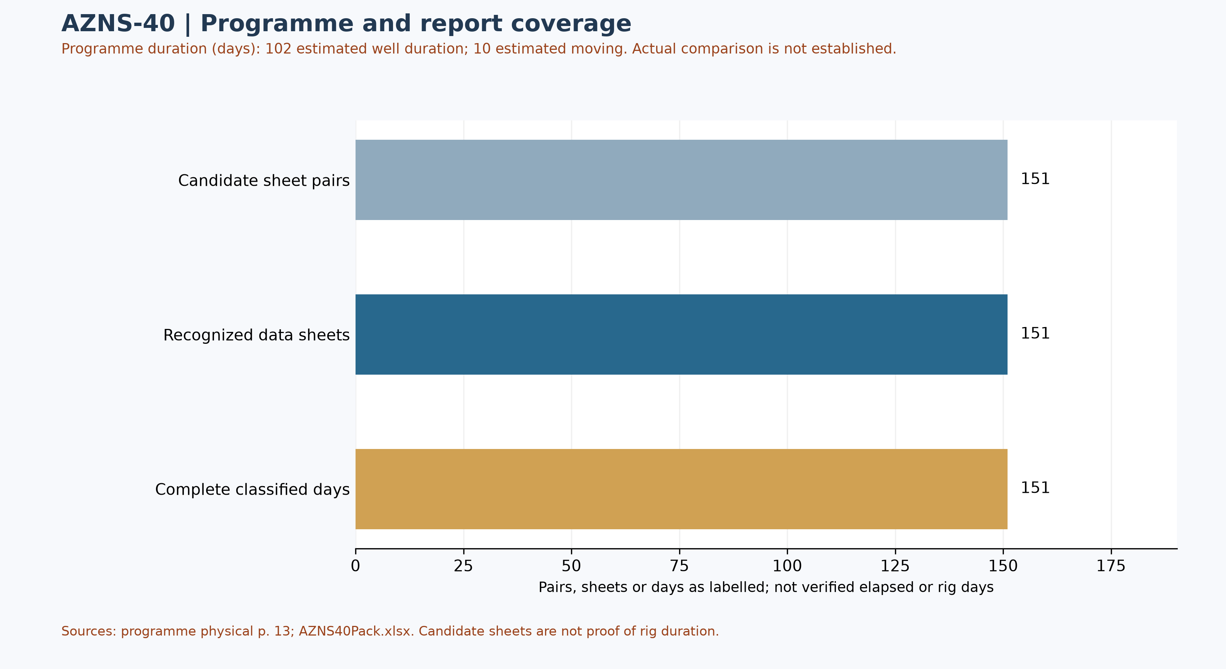
Figure W1 — Daily-record coverage and stated programme duration; actual comparison unverified
Status-page coverage is assessed independently: 151 status pages and 151 data sheets were recognized; 151 status pages contain classified durations totalling approximately 24 hours. Some reports have a status page but an absent or differently formatted data page. These counts are not verified rig duration.

Selected programme phases and limited execution evidence
The phases below are selected programme statements, not proof of execution or of the final approved revision. The selected daily observations are quoted separately; a similar topic alone does not establish phase timing, completion or deviation.
Programme — The re-entry sequence includes drilling out cement and shoe to the stated 1,493 m. [AZNS-040 RE-Entry Well Program Rev.03.pdf, physical p. 75]
Programme — The plan describes wireline logging across 1,493–3,986 m before casing operations. [AZNS-040 RE-Entry Well Program Rev.03.pdf, physical p. 78]
Daily report 6 — The report records pulling the fishing assembly from 1,547.2 m and recovering all fish components, with 1–2 barrels per hour of losses. [AZNS40Pack.xlsx, 6-1 Remark!K24]
Daily report 147 — The report says surface leakages were worked on and a 6,000 psi pressure test was reported as satisfactory; the cell does not identify a complete test programme. [AZNS40Pack.xlsx, 147-1 Remark!K26]
Services listed in the programme: drilling and completion fluids: VIRA; waste management: TBA; electrical logging and perforation: PANIZ; mud logging: MAPSA KISH. [AZNS-040 RE-Entry Well Program Rev.03.pdf, physical p. 21] These are programme assignments, not evidence of actual deployment, contractual award, cost or incident liability.

Selected daily-report observations
Of 151 recognized status pages, 151 contain classified durations totalling approximately 24 hours. Planned, NPT and unplanned labels are source classifications; they do not independently establish cause, liability or total operation duration. The following examples are selective; complete extracted detail cells are retained in evidence/activity_observations.json.
Report 6 — The report records pulling the fishing assembly from 1,547.2 m and recovering all fish components, with 1–2 barrels per hour of losses. [AZNS40Pack.xlsx, 6-1 Remark!K24]
Report 147 — The report says surface leakages were worked on and a 6,000 psi pressure test was reported as satisfactory; the cell does not identify a complete test programme. [AZNS40Pack.xlsx, 147-1 Remark!K26]
These are source statements, not independent verification of a test, failure mechanism, current well condition or an operating instruction. A description may continue into the next cell; reconcile the complete row and time before making decisions.

Additional selected daily-report evidence
These three entries are ordered by report number; sheet order alone does not establish event time, complete chronology, operational completion or current well condition. Test outcomes are source labels and require reconciliation with signed charts and the tested scope.
Report 33 — The report describes low-progress drilling from 2,944 to 2,945 m with losses of 8–10 barrels per hour and two pill treatments. [AZNS40Pack.xlsx, 33-1 Remark!K22]
Report 53 — During the reported gamma-ray log-up from 300 m to surface, the same cell notes circulation and losses of 3–5 barrels per hour. [AZNS40Pack.xlsx, 53-1 Remark!K22]
Report 105 — The entry reports an overshot trip to 2,455 m, tagging the top of fish and a confirmed catch; a complete recovery outcome requires subsequent records. [AZNS40Pack.xlsx, 105-1 Remark!K22]
Loss rate is not a formation assignment or cumulative volume. Reconcile report-end depths with the actual event depth, fluid ledger and fishing record before building a phase balance.
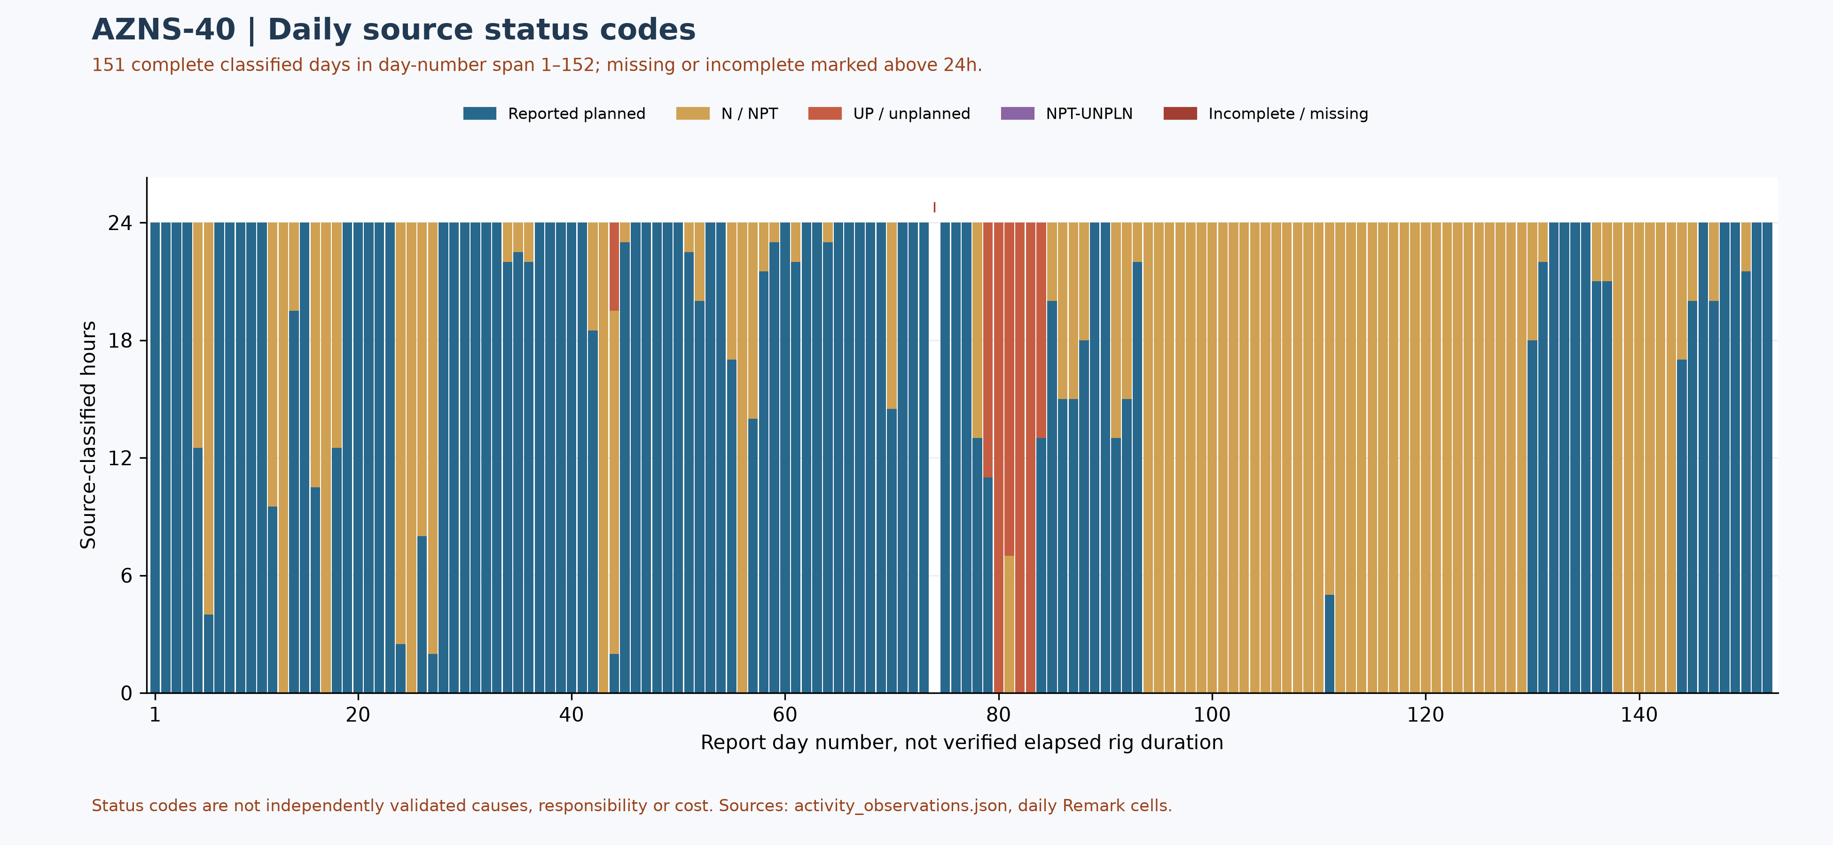
Figure W2 — Daily source-code composition in complete reports, with partial coverage

Performance and Parameter Analysis
Performance coverage: 151 status pages with classified durations totalling approximately 24 hours are used, out of 151 recognized status pages. Planned does not prove productive time; NPT, unplanned and mixed codes are distinct. Omitted hours are not zero; activity families, causes and total operation duration are not established by this table.
Source status code | Hours in complete reports | Share of classified hours
Reported planned | 2,081.00 | 57.4%
N / NPT | 1,425.50 | 39.3%
UP / unplanned | 117.50 | 3.2%
NPT-UNPLN (mixed) | 0.00 | 0.0%
Table 4-1 — Source status codes in recognized complete reports, not causal categories
Progress and phase-rate comparisons require reconciliation of scope, time and activity. Report-end depth is not tool depth or instantaneous rate.
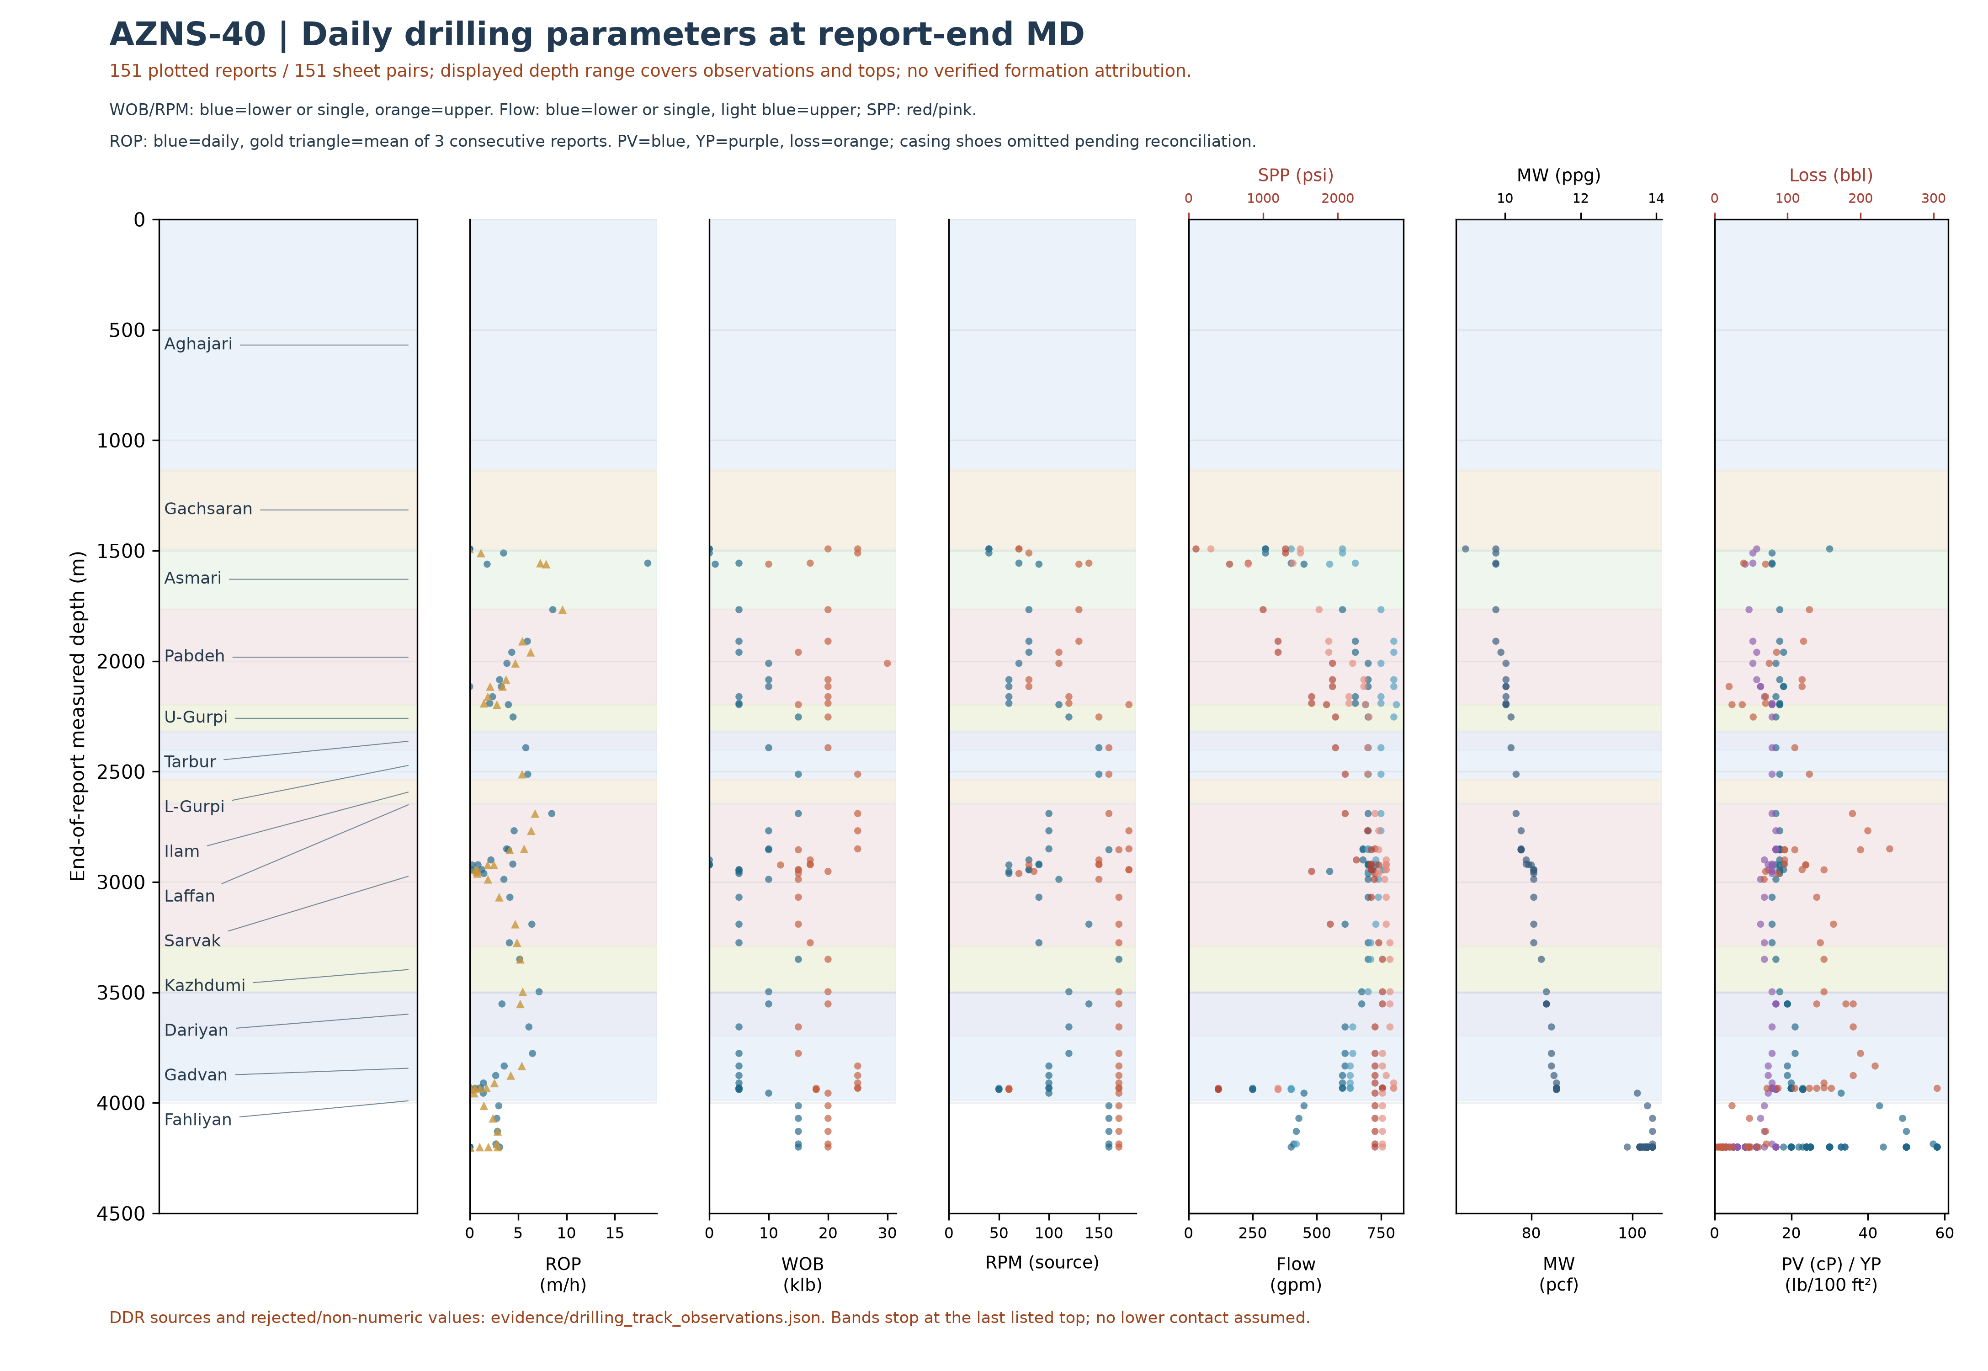
Figure W3 — Daily drilling parameters at report-end depth, AZNS-40; formation attribution unverified
W3 uses the data-linked extraction: its coverage and hours may be smaller than W2 and W4, which assess status pages independently of data sheets. Missing or unrecognized data sheets are not added as W3 observations.
Points combine daily entries with report-end depth; they do not establish event/tool depth or a continuous log. Points use the first bit column or explicit source range, not an optimum envelope; scalar entries are not necessarily minima, and legacy RPM may include motor RPM; ROP triangles average three consecutive reports. Formation bands are unverified and shoe markers are omitted pending reconciliation. The suspect 7,500 gpm entry in well 207 is excluded from the plot but retained in the source evidence.
Bit | Rerun | Type / size | Max cumulative m / source | Max cumulative h / source | Dull in sheet order
1 | Unknown | HJT217GL; MT Bit (HJT217GL); 12-1/4"; CONFLICT | 17.5 [4-2 Data!K26] | 5 [4-2 Data!K28] | 1-1-WT-A-E-I-NO-BHA [4-2 Data!K33]
2 | Unknown | PDC; 12-1/4" | 46 [5-2 Data!K26] | 2.5 [5-2 Data!K28] | 1-1-CT-A-X-I-PN & WT-LIH [6-2 Data!M33]
2 | 1 | PDC.Bit; 12-1/4" | 6 [16-2 Data!K26] | 1.5 [16-2 Data!K28] | 1-1-CT-A-X-I-PN&WT-LIH [17-2 Data!K33]
2 | 2 | PDC.Bit; 12-1/4" | 116 [29-2 Data!K26] | 33 [29-2 Data!K28] | 4-6-BT-(N,T)-X-I-(LT,CT)-PR [30-2 Data!K33]
3 | Unknown | PDC; 12-1/4" | 403.5 [9-2 Data!K26] | 42 [9-2 Data!K28] | 2-4-BT-N-X-I-CT&LT-BHA [10-2 Data!M33]
4 | Unknown | B.Bit; 12-1/4" | 155 [12-2 Data!K26] | 37 [12-2 Data!K28] | New [13-2 Data!M33]
4 | 1 | B.Bit; 12-1/4" | 155 [13-2 Data!K26] | 37 [13-2 Data!K28] | 2-2-WT-A-E-IG-CT-TW [15-2 Data!K33]
4 | 2 | TCI Bit; 12-1/4" | 235 [31-2 Data!K26] | 72 [31-2 Data!K28] | 2-2-BT-M-E-I-NO-BHA [31-2 Data!K33]
4 | 3 | TCI Bit; 12-1/4" | 251.5 [35-2 Data!K26] | 86.5 [35-2 Data!K28] | 2-2-WT-A-E-I-CT-BHA [35-2 Data!K33]
5 | Unknown | PDC.Bit; 12-1/4" | 657 [24-2 Data!K26] | 102 [24-2 Data!K28] | 3-3-BT-A-X-I-CT-TW [25-2 Data!K33]
6 | Unknown | PDC; 12-1/4" | 22 [33-2 Data!K26] | 12.5 [33-2 Data!K28] | 4-4-BT&CT-N&T-X-I-LT-PR [33-2 Data!K33]
7 | Unknown | PDC.Bit; 12-1/4" | 590 [42-2 Data!K26] | 118 [42-2 Data!K28] | —
7 | 1 | PDC.Bit; 12-1/4" | 970 [51-2 Data!K26] | 221 [51-2 Data!K28] | 3-4-BT-N-X-I-(RO,CT)-TD [52-2 Data!K33]
8 | Unknown | HJT517GL; 8-1/2" | 5 [60-2 Data!K26] | 1.5 [60-2 Data!K28] | New [60-2 Data!K33]
8 | 1 | HJT517GL; 8-1/2" | 5 [61-2 Data!K26] | 1.5 [61-2 Data!K28] | 1-1-WT-A-E-I-PN-LOG [61-2 Data!K33]
9 | Unknown | VTD616DGX; 8-1/2" PDC | 261 [68-2 Data!K26] | 96.5 [68-2 Data!K28] | New [68-2 Data!K33]
10 | Unknown | MT Bit; 5-7/8 | — | — | New [73-2 Data!K33]
10 | 1 | MT Bit; 5-7/8 | — | — | 1-1-WT-A-E-I-NO-BHA [75-2 Data!K33]
Table 4-2 — Identified bit observations and cumulative-counter sources.
Bit evidence is preliminary: source AZNS40Pack.xlsx; 151 data sheets were recognized from 151 candidate sheet pairs. 0 tool-column entries lack an unambiguous numeric bit ID. A cumulative-counter maximum is not necessarily incremental run performance; bit-number reuse, rerun, metadata conflicts and dull reports require reconciliation. Workbook order does not prove chronology; the displayed dull observation is not necessarily final. Missing values are not zero.
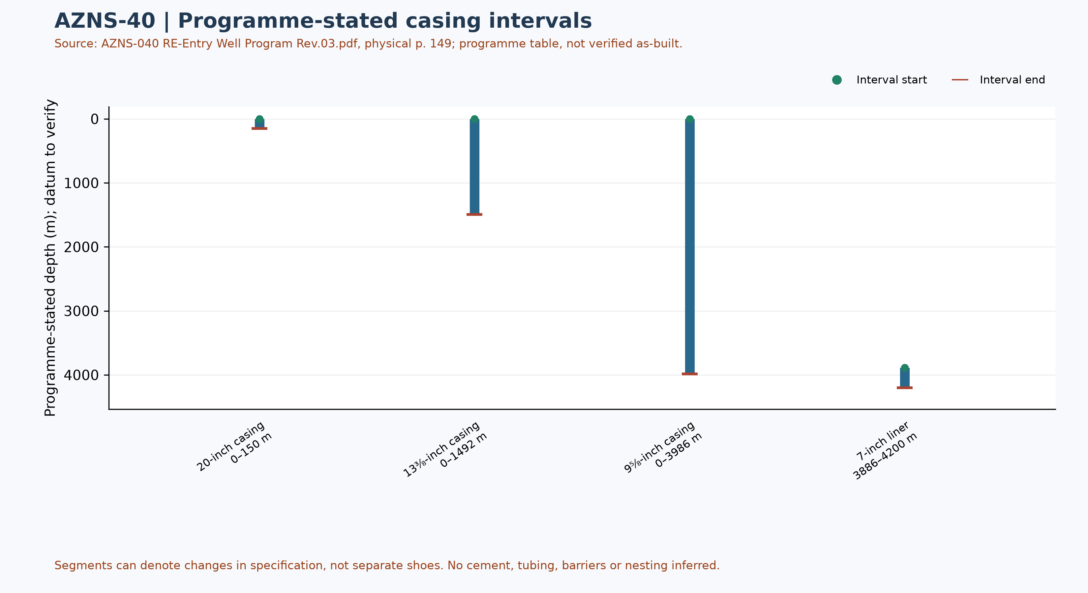
Figure W6 — Programme-stated casing intervals; not a verified as-built schematic

Drilling Fluid Engineering and Loss Accounting
This table summarizes numeric entries recovered from 151 recognized data sheets out of 151 candidate pairs. Each extreme has a source-cell example; coverage, simultaneity, units and test quality require verification. Minima and maxima are not a design window or current fluid condition.
Source observation | Numeric entries | Minimum and cell | Maximum and cell
Mud weight (pcf) | 134 | 67 [2-2 Data!R12] | 104 [65-2 Data!R12]
Plastic viscosity (cP) | 120 | 15 [4-2 Data!R18] | 58 [68-2 Data!R18]
Yield point (lb/100 ft²) | 120 | 0 [77-2 Data!R19] | 16 [22-2 Data!R19]
Source downhole loss (bbl) | 75 | 2 [72-2 Data!R41] | 305 [57-2 Data!R41]
Table 5-1 — Partial source-cell fluid and loss observations
A blank or nonnumeric entry is not zero. The source loss field is labelled downhole or formation loss volume; no sum or formation attribution is calculated until reporting basis, cumulative versus daily treatment and duplication are reconciled. Reconcile cell values with operational remarks and materials use separately.

Selected mud-material source entries
Table 5-2 selects source-used entries from two sheets of AZNS40Pack.xlsx. Recognizable materials headers were found in 151 of 151 data sheets; this count does not validate completeness or correctness of inventory or usage. Used-column header cells and row units are retained in the evidence file.
Selected sheet | Material and cell | Used value and cell | Source unit and cell
1-2 Data | Caustic Soda [A41] | 7 [F41] | 25 kg [C41]
1-2 Data | Salt [A44] | 40 [F44] | 1 MT [C44]
1-2 Data | Starch LV (Green) [A45] | 180 [F45] | 55 lbs [C45]
2-2 Data | Caustic Soda [A41] | 7 [F41] | 25 kg [C41]
2-2 Data | Salt [A44] | 40 [F44] | 1 MT [C44]
2-2 Data | Starch LV (Green) [A45] | 180 [F45] | 55 lbs [C45]
Table 5-2 — Selected mud-material used-column entries; units as printed
The used column is distinct from received, cumulative received and stock. Repeated material or values across sheets are not necessarily independent consumption; blanks and errors are not zero. Verify package size, unit abbreviation, reporting period, opening and closing balance, receipts, usage and mixing records before totals or conversion. These entries alone do not establish downhole use, treatment of losses or causality with fluid properties.

Completion, Casing and Service-Module Findings
Programme element | Interval start, m | Interval end, m | Source specification
20-inch casing | 0 | 150 | K-55, 133 ppf, BTS
13⅜-inch casing | 0 | 1492 | N-80, 68 ppf, BTS
9⅝-inch casing | 0 | 3986 | 110SS, 53.5 ppf SD, Premium Gas Tight
7-inch liner | 3886 | 4200 | 110SS, 32 ppf, Premium Gas Tight
Table 6-1 — Casing and liner intervals in AZNS-040 RE-Entry Well Program Rev.03.pdf, physical p. 149
Programme casing scope: the source labels the first two casings already run; the later two rows are design, not verified final configuration. Page 13 states 152.5 m for the 20-inch casing while page 149 states 150 m; reconcile the discrepancy.
The legacy directional survey statistics and trajectory have not been independently reconciled; W7 now shows bit/tool evidence, not a trajectory.
Personnel-on-board averages and peaks in the legacy report are withdrawn pending reconciliation of daily role-level counts, totals, missing entries and personnel scope.
The next figure displays only recognized bit and tool evidence; casing and cost evidence are presented in their respective sections. This is not a verified run count or continuous log.
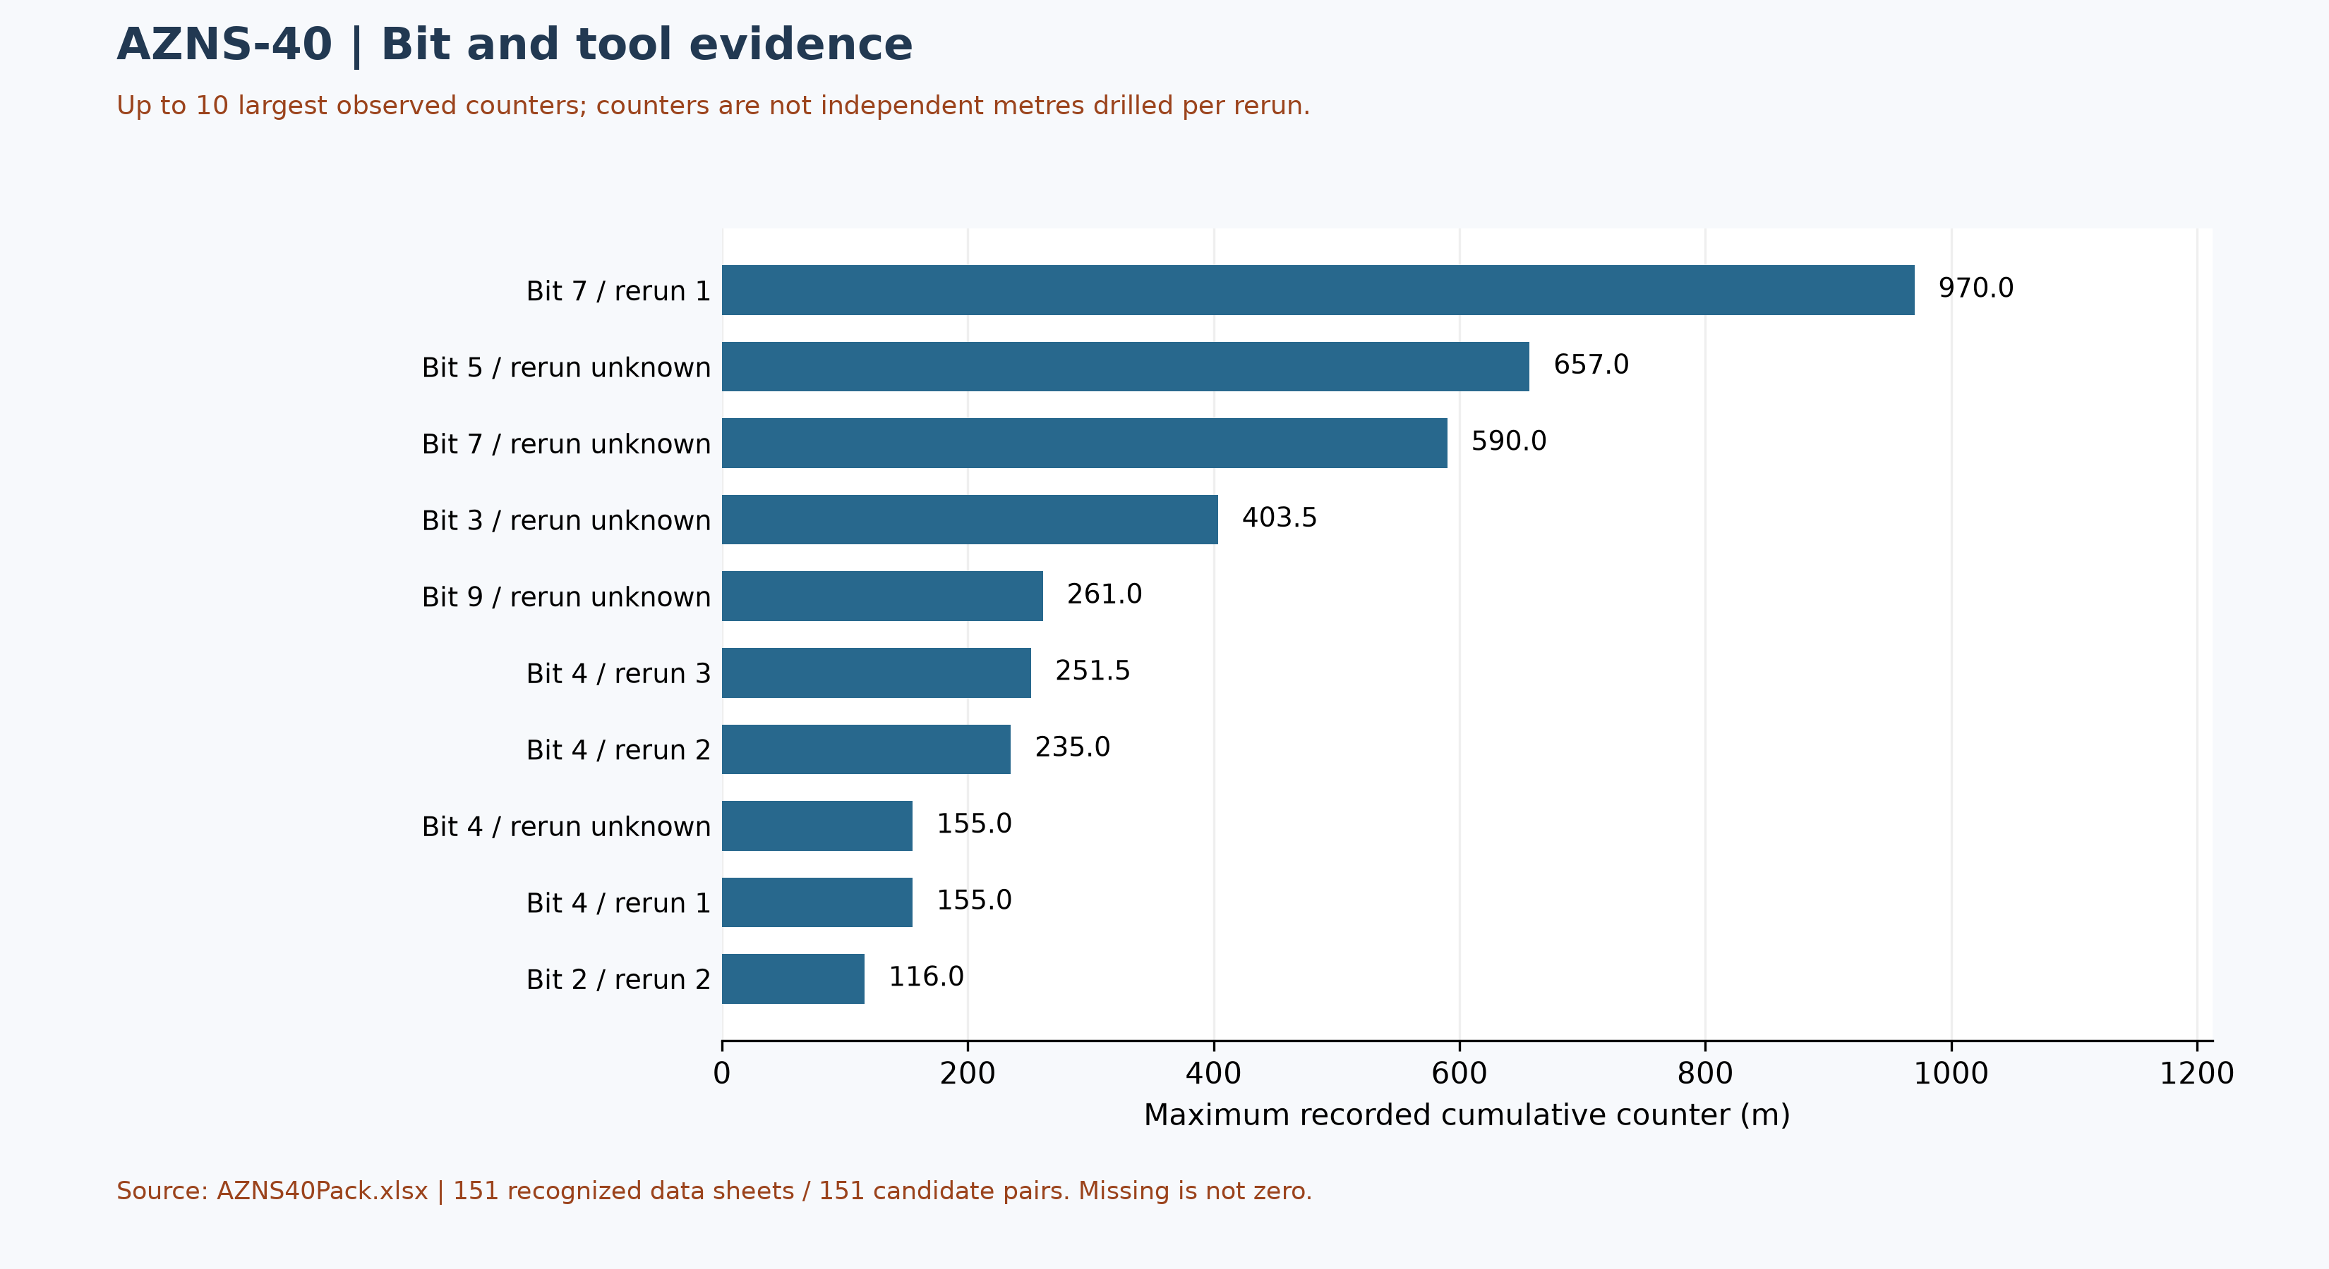
Figure W7 — Maximum source cumulative counters, not incremental run performance

Selected daily BHA components and hydraulic review
At least one nonempty recognized-format block was recovered in 69 of 151 data sheets. The table selects four rows from one block in AZNS40Pack.xlsx, sheet 2-2 Data; it is not the entire string, all runs, or the current well condition. A repeated identifier or parallel columns do not establish the number of runs.
Selected component and cell | Recorded outside diameter and cell | Evidence scope
12-1/4" R.BIT [I41] | 12-1/4" [K41] | Source observation
BIT SUB (FLOAT IN) [I42] | 8-1/2" [K42] | Source observation
8-1/2" D.C [I43] | 8-1/2" [K43] | Source observation
XOS (6-5/8" REG X 4-1/2" IF) [I44] | 6-5/8" [K44] | Source observation
Table 6-2 — Selected source block components and recorded dimensions
Physical programme page 91 is a navigation anchor for the planned BHA discussion; matching phase or agreement with this daily example is not established. Reconcile stated dimensions with the component name, count, length, inside diameter, connection limits, sequence, run record and manufacturer data. Hydraulic review requires verified inside and outside diameters and annular geometry for each section, simultaneous flow and fluid properties, nozzle and surface-loss information and pressure calibration. Without these inputs, pressure loss, annular velocity, hole cleaning and a reliable operating window cannot be calculated; W3 alone is not a design.

Source-coded non-planned time and partial coverage
Only 151 daily reports with classified durations totalling approximately 24 hours were included out of 151 candidate sheet pairs. These are source-code hours, not a verified total for the operation; incomplete or unrecognized days are not zero. Status pages are recognized independently of data pages; row-level cells are retained in evidence/activity_observations.json.
Table 7-1 — Source-code hours in complete reports; references are examples.
Source code | Hours in coverage | Example status and duration cells
N / NPT | 1,425.50 | 5-1 Remark!J29,H29 ; 5-1 Remark!J34,H34
UP / unplanned | 117.50 | 44-1 Remark!J26,H26 ; 79-1 Remark!J30,H30
NPT-UNPLN | 0.00 | None in included complete days
Activity codes alone do not establish root cause or contractual responsibility. Legacy mechanism claims, contractor attribution and financial exposure are withdrawn pending review of actual daily narrative, contracts and event evidence. Different source codes must not be presented as a single NPT definition.
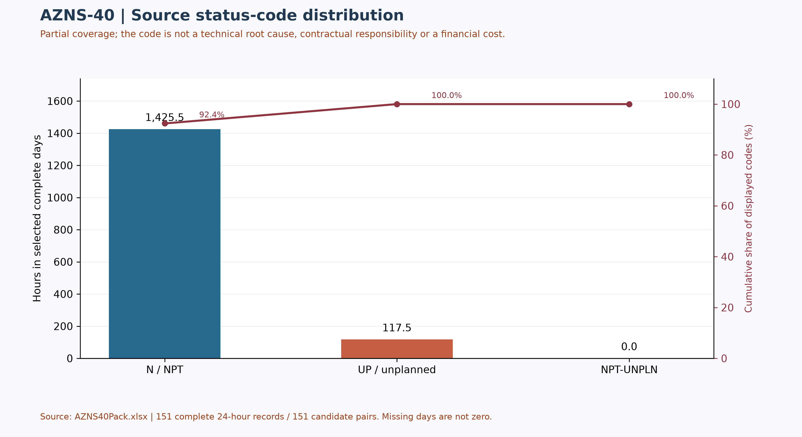
Figure W4 — Pareto of source status codes in complete days, not technical causes

CBS Financial Analysis and Provisional Cost Categories
Table 8-2 source: CBS AZNS-40.xlsx / Cost Breakdown-40. These cached source amounts are not actual expenditure or an approved comparable budget. Missing or erroneous values are not zeros; rates, scope, formulas and approvals require reconciliation. No daily expenditure series has been verified.
Source / scope | Cached value | Cell / sheet
Cached main-sheet total; scope unverified | 7,237,044.80 | F178 / Cost Breakdown-40
Table 8-1 Source financial and schedule anchors (unreconciled).
Source category | Source amount (USD) | Amount cell
Rig service | 819,820.00 | F5
Drilling fluids | 443,878.30 | F6
Cementing | 181,075.00 | F13
Mud logging | 113,985.00 | F20
Wireline logging | 405,207.50 | F24
Drilling waste management | 126,300.00 | F62
Directional drilling | — | F69
Casing running | 64,535.00 | F79
Temporary well suspension | — | F87
Slickline | 12,799.00 | F91
Completion running | 15,000.00 | F94
Liner hanger running | 3,900.00 | F105
H2S service | 21,420.00 | F113
Perforation | 124,315.00 | F116
Wellhead services | 15,000.00 | F121
Dry test services | 13,875.00 | F125
Rig / completion services | 1,075,700.00 | F128
Other services | 51,000.00 | F136
Cleanup services | — | F140
Drilling materials | 3,298,735.00 | F147
Project management | 408,000.00 | F156
Engineering | 32,500.00 | F159
Tubing inspection | — | F168
Wellhead / tree inspection | 5,000.00 | F176
Downhole completion inspection | 5,000.00 | F177
Table 8-2 CBS source categories and cell references (unreconciled).
Topic | Observation | Source reference | Action
Scope / actuals | Values are not actual invoices or an approved comparable ceiling. | Source sheet and formulas | Reconcile
Rig service | 23,000 × 102 differs from the cached 819,820 amount. | D5, E5, F5 | Reconcile basis
Table 8-3 CBS reconciliation checks.
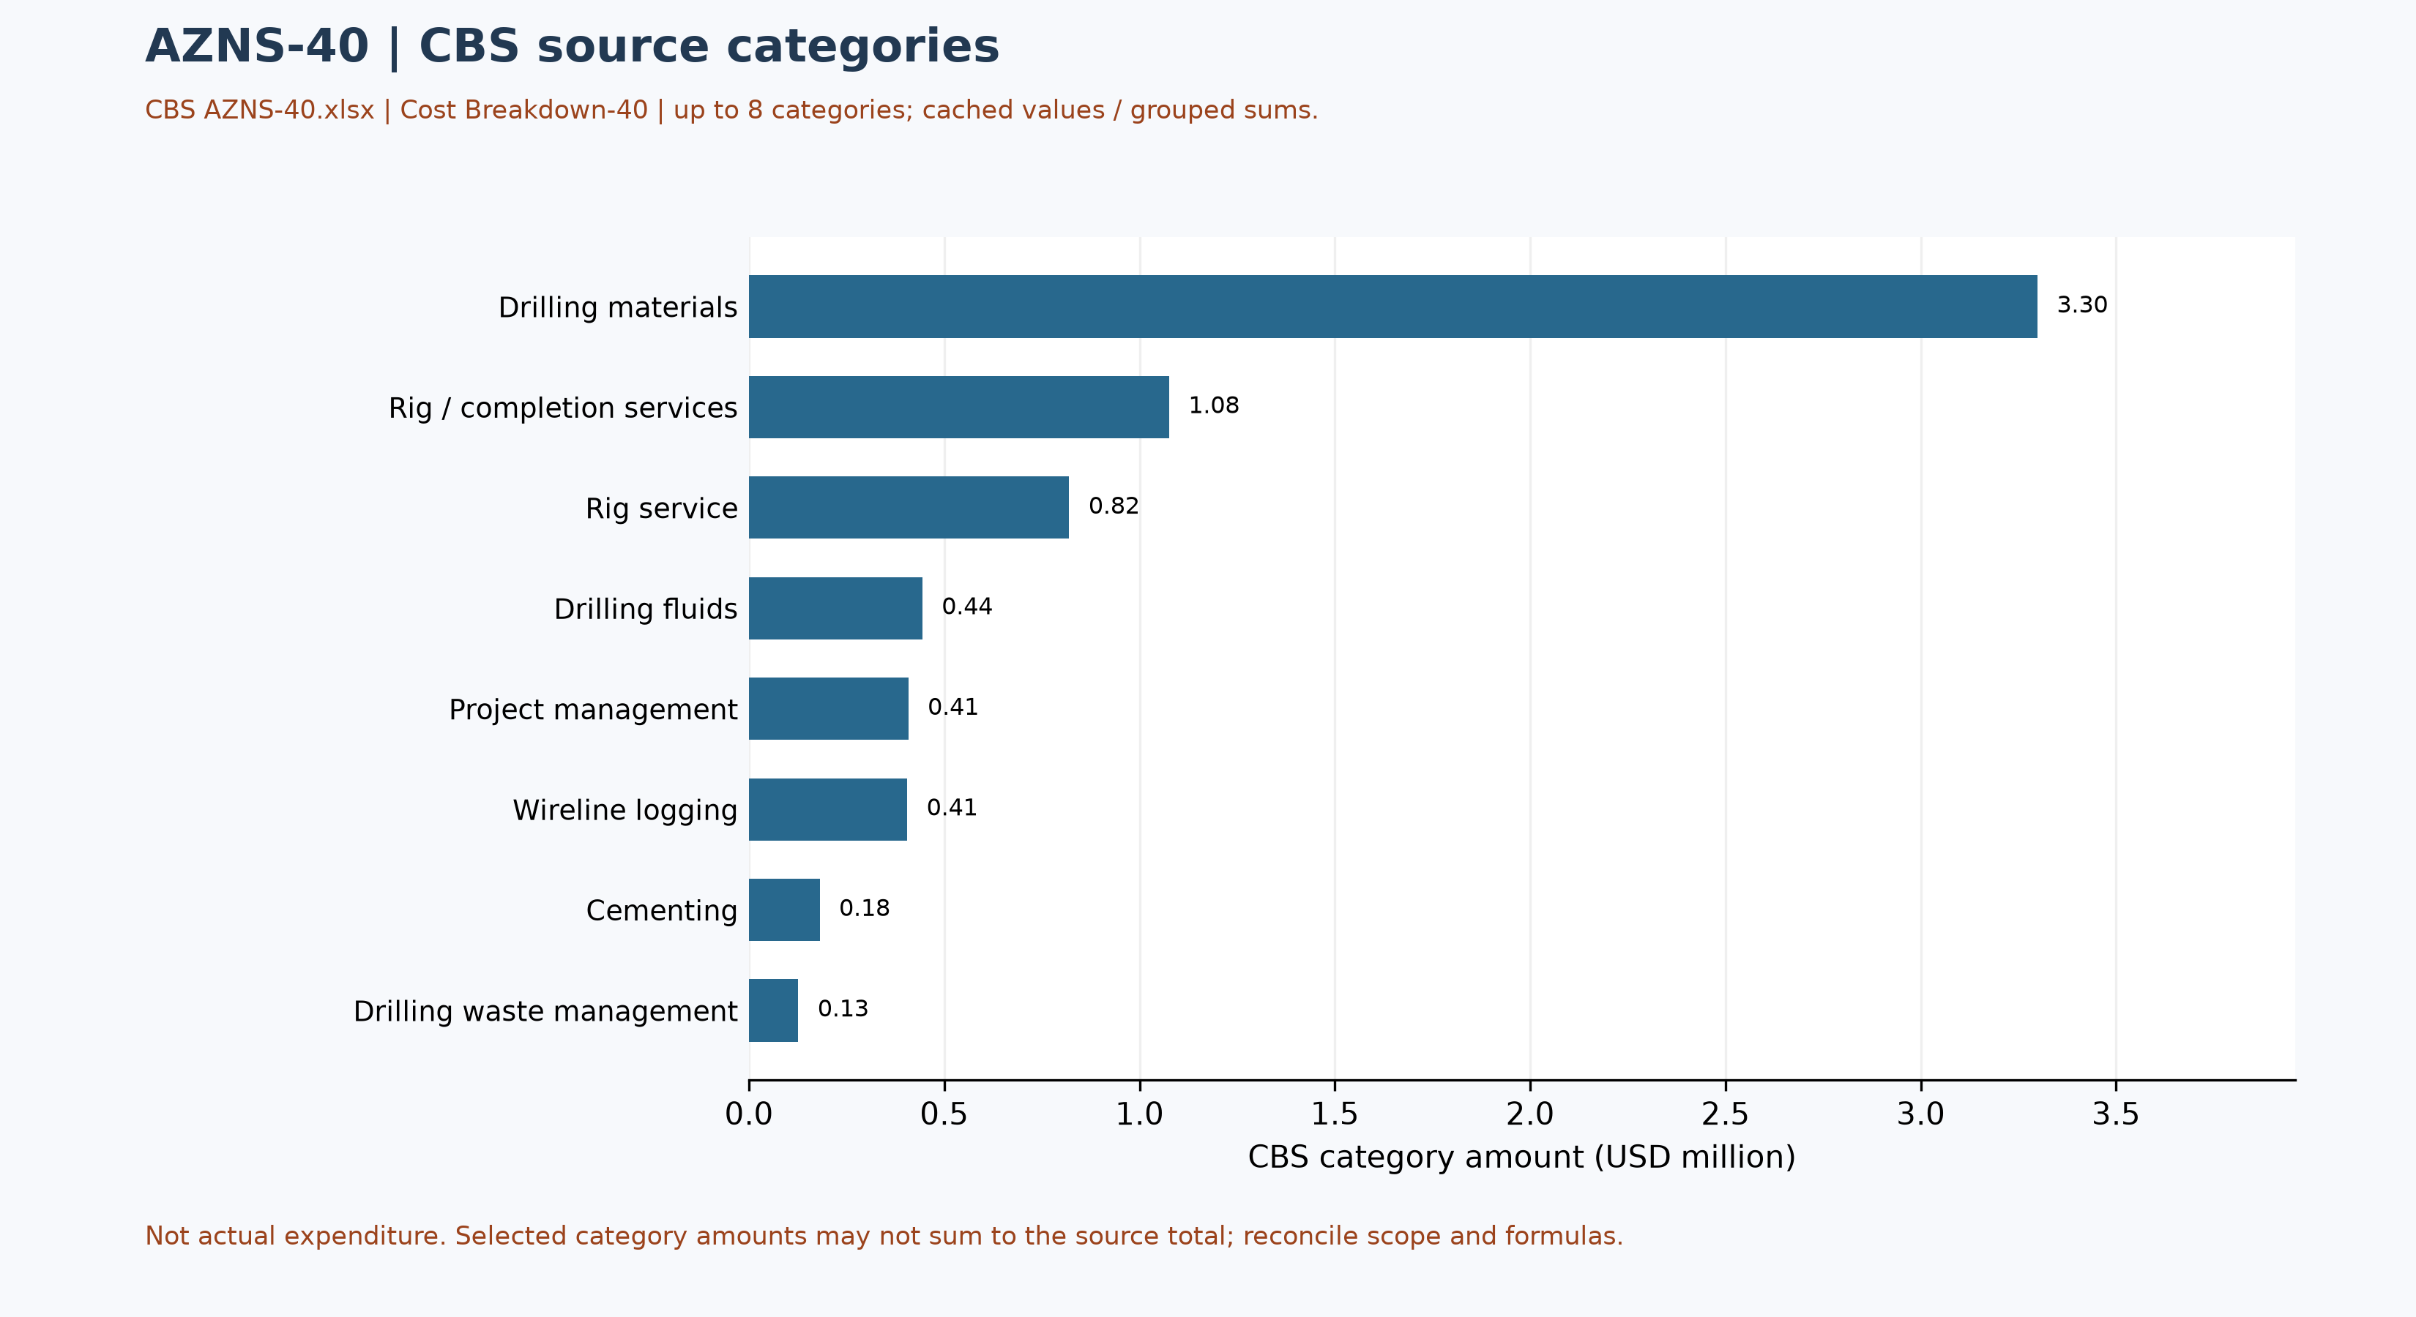
Figure W5 — CBS source cost categories, AZNS-40 (unreconciled)

Selected CBS service-sheet checks
The rig-less stimulation bidder breakdown is separately labelled for AZN-40: CBS AZNS-40.xlsx, Cost breakdown Rigless Stim.-40!A1, B3:C16. Its 13 source lines total USD 749,473.64 in C16; the independently checked sum of C3:C15 matches that amount. Examples are materials USD 159,182.50 (C4), acidizing and nitrogen services USD 117,529 (C5), coiled tubing USD 44,900 (C6), and well testing and production USD 83,282.84 (C8).
This is a bidder-scope breakdown, not an invoice or confirmation of rig-less treatment. Do not add it to the main-sheet total until the contract boundaries, any included services and roll-up are verified; the arithmetic match alone does not validate inputs or rates.

Operational observations and engineering decision gates
Previous numerical operating envelopes were not validated and have been withdrawn. The entries below are examples of raw daily records only; tool location, phase, units and measurement validity require review. These observations are not safe limits, optimum windows or operating instructions.
Table 9-1 — Example recorded cells; units and measurement basis require verification.
Raw field | Example recorded value | Sheet and cell
Mud weight | 67 | 2-2 Data!R12
Bit load / WOB | 0-20 | 2-2 Data!K18
RPM | 40-70 | 2-2 Data!K19
Flow | 300-400 | 2-2 Data!K23
Standpipe pressure | 100-300 | 2-2 Data!K24

Recommendations and review requirements
- Reconcile the programme revision, scope, start/end boundaries and rig/service time against daily reports and approved schedules before reporting a variance.
- Have responsible specialists verify well barriers and formation, casing and equipment limits against current approved records; no numerical design setpoint is established by this report.
- Reconcile bit identifiers, cumulative counters, tool assembly and failure evidence with original field and vendor records before selecting future equipment or diagnosing a mechanism.
- Reconcile costs with signed contracts, approved scope and invoices; do not convert source status-code hours into financial liability without a contractual assessment.

Risk-review checklist; ownership and severity not assigned
Review topic | Available evidence | Required follow-up
Well integrity and pressure | Programme objective and stated background, not proof of current condition | Reconcile tests, barriers and current approved limits
Incidents and recorded time | Partial source-code coverage in table 7-1 | Review event narrative, duration, cause and contract without presumed attribution
Equipment and operations | Example cells in table 9-1 and tool observations in table 4-2 | Verify units, calibration, tool identity and vendor records
Schedule and cost | Programme page and cost-breakdown evidence | Reconcile scope, invoices, time basis and approved revision

Data Provenance and Cell-Level Traceability
The table lists selected source anchors only. Other entries and interpretations still require independent cell/page checks, unit and scope review; the current report is not fully reconciled or reproducible without engineering interpretation.
Data element | Archive anchor (file -> sheet!cell)
well_name | 1-1 Remark!C5
client | 1-1 Remark!H5
rig | 1-1 Remark!C6
field | 1-1 Remark!C7
hole_section | 1-1 Remark!C8
well_type | 1-1 Remark!C9
report_date | 1-1 Remark!N5
spud_date | 1-1 Remark!N6
est_days | 1-1 Remark!N8
act_days | 1-1 Remark!N9
depth:project_md | 1-2 Data!D15
depth:morning_depth | 1-2 Data!D16
depth:midnight_depth | 1-2 Data!D17
depth:prev_depth | 1-2 Data!D18
CBS cost breakdown | CBS AZNS-40.xlsx -> sheet "Cost Breakdown-40"
Well programme | AZNS-040 RE-Entry Well Program Rev.03.pdf
Table 11-1 Provenance anchors.

Appendix: source formation-table snapshot (unverified)
Source: AZNS40Pack.xlsx, sheet 152-2 Data. Selected as the last sheet in workbook order with a recognized formation table containing a numeric depth; if none, the last table with formation names. This is not necessarily the latest dated report.
Column roles follow the source labels, not independent confirmation of prognosis or measurement. Unlabelled populated cells are shown separately; missing cells are unknown, not zero. Values are rounded to four decimals for display. Verify row alignment, depth datum, possible inconsistencies and lithology against the programme and geological report; this table alone does not establish event attribution or operating instructions.
Source table and anchor: Formation Geology Data / N109
Formation / cell | Source values / cell
Aghajari / K111 | Forc. MD (m.): Surface [L111]  Forc. TVD (m.): Surface [M111]  Act. MD (m.): Surface [O111]  Act. TVD (m.): Surface [Q111]  Lithology: S.St, Clst. [R111]
Gachsaran / K112 | Forc. MD (m.): 1138 [L112]  Forc. TVD (m.): 1138 [M112]  Act. MD (m.): 1138 [O112]  Act. TVD (m.): 1138 [Q112]  Lithology: Anhy, RD Mrl, Gr Mrl [R112]
Asmari / K113 | Forc. MD (m.): 1493.7 [L113]  Forc. TVD (m.): 1493.7 [M113]  Act. MD (m.): 1493 [O113]  Act. TVD (m.): 1493 [Q113]  Lithology: S.St, Lst [R113]
Pabdeh / K114 | Forc. MD (m.): 1776.1 [L114]  Forc. TVD (m.): 1776.1 [M114]  Act. MD (m.): 1766 [O114]  Act. TVD (m.): 1766 [Q114]  Lithology: Mrl, Clst, Shale, cht [R114]
U-Gurpi / K115 | Forc. MD (m.): 2197.9 [L115]  Forc. TVD (m.): 2179.9 [M115]  Act. MD (m.): 2198 [O115]  Act. TVD (m.): 2198 [Q115]  Lithology: Arg lst [R115]
Tarbur / K116 | Forc. MD (m.): 2322 [L116]  Forc. TVD (m.): 2322 [M116]  Act. MD (m.): 2320 [O116]  Act. TVD (m.): 2320 [Q116]  Lithology: Lst [R116]
L-Gurpi / K117 | Forc. MD (m.): 2409.6 [L117]  Forc. TVD (m.): 2409.6 [M117]  Act. MD (m.): 2402 [O117]  Act. TVD (m.): 2402 [Q117]  Lithology: Arg lst [R117]
Ilam / K118 | Forc. MD (m.): 2535 [L118]  Forc. TVD (m.): 2535 [M118]  Act. MD (m.): 2536 [O118]  Act. TVD (m.): 2536 [Q118]  Lithology: Lst, Sh, Clst, Mrl [R118]
Laffan / K119 | Forc. MD (m.): 2639.1 [L119]  Forc. TVD (m.): 2639.1 [M119]  Act. MD (m.): 2641 [O119]  Act. TVD (m.): 2641 [Q119]  Lithology: Clst, Lst [R119]
Sarvak / K120 | Forc. MD (m.): 2645.4 [L120]  Forc. TVD (m.): 2645.4 [M120]  Act. MD (m.): 2646 [O120]  Act. TVD (m.): 2646 [Q120]  Lithology: Lst [R120]
Kazhdumi / K121 | Forc. MD (m.): 3283.5 [L121]  Forc. TVD (m.): 3283.5 [M121]  Act. MD (m.): 3292 [O121]  Act. TVD (m.): 3292 [Q121]  Lithology: Lst [R121]
Dariyan / K122 | Forc. MD (m.): 3489.7 [L122]  Forc. TVD (m.): 3489.7 [M122]  Act. MD (m.): 3498 [O122]  Act. TVD (m.): 3498 [Q122]  Lithology: Lst [R122]
Gadvan / K123 | Forc. MD (m.): 3682.7 [L123]  Forc. TVD (m.): 3682.7 [M123]  Act. MD (m.): 3696 [O123]  Act. TVD (m.): 3696 [Q123]  Lithology: Lst, Clst, Arg Lst [R123]
Fahliyan / K124 | Forc. MD (m.): 3985.79 [L124]  Forc. TVD (m.): 3985.8 [M124]  Act. MD (m.): 3989 [O124]  Act. TVD (m.): 3989 [Q124]  Lithology: Lst [R124]

Selected formation tops from programme page
Source: AZNS-040 RE-Entry Well Program Rev.03.pdf, physical page 39. The programme labels these expected tops; only clearly paired names and depths are included. Depth reference: RTE 13.45 m. Event-to-formation attribution requires a reconciled event depth and datum.
Formation / member | Source top, m MD
U. Gurpi | 2197.9
Tarbur | 2322.0
L. Gurpi | 2409.6
Sar-1 | 2645.4
Kaz-Top | 3283.5
Gad-1 | 3682.7
Fahliyan | 3985.79

Programme source summary and comparison limitations
Source: AZNS-040 RE-Entry Well Program Rev.03.pdf, physical page 13. Programme objective: Re-enter the suspended well and target oil production from Fahliyan; the re-entry objective is detailed on page 19. Stated programme duration, in days: 102 estimated well duration; 10 estimated moving. The programme states measured depth 4200 m and producer/reservoir formation Fahliyan; these do not by themselves establish achieved depth or current condition. Time boundaries, scope and contingency interpretation require reconciliation.

