SAZN · SOUTH AZADEGAN
Single-Well Reference Book — AZNS-122 WO1 — Operation 04
24 chapters · 60+ provenance tables · 10–12 custom graphics · zero summarisation
Contract C1 (CCA/C/1401/27) · rig OEOC 201 · 56 DDRs · CBS plan 4,587,374 USD · gross 4,840,374 USD · payable 3,950,562 USD · net 3,950,562 USD · NPT 928.5 h.
Chapter 01 — Executive Well Dossier & Source Register
Operation 04 on AZNS-122-WO1 was executed by OEOC 201 under C1 (CCA/C/1401/27) across 56 signed DDRs from 14/01/2024 to 2024-09-03. The dossier joins 53,311 archived worksheet cells, 66 PDF pages and 66 indexed numeric tokens; the EOWR position is: NOT AVAILABLE — no EOWR in 04.EOWR/; reconstructed from DDR + CBS + Well Program. Every following table carries its file, sheet/cell or page reference so that any figure can be traced back without re-reading the original document.
Source document register
Document | Category | N_units | Size (bytes) | SHA-256
DDRs/4.AZNS_122_WO1_DDR_Pack.xlsx | DDR | 112 | 2778298 | c14db1ff6cbef8b7
Well Program/4.AZNS_122_Workover-1_Program.pdf | PROGRAM | 66 | 3440569 | cf76377892f580fb

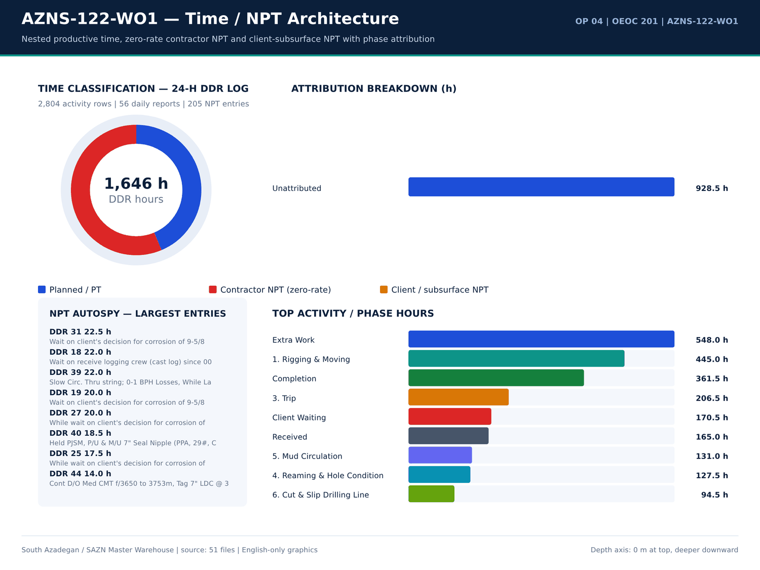
AZNS-122-WO1 01 time donut — source: SAZN master warehouse
Worksheet / sheet inventory
Document | Sheet | Rows | Cols | Non-empty cells | Numeric cells | Formula cells | Template | Part
CBS/10 CBS matrial.xlsx | Cost Breakdown-Material-122 | 248 | 4 | 343 | 13 | 0 | — | —
CBS/4.AZNS_122_WO1_CBS.xlsx | Cost Breakdown-122 | 190 | 9 | 624 | 285 | 123 | — | —
CBS/4.AZNS_122_WO1_CBS.xlsx | Cost Breakdown-Material-122 EW | 248 | 8 | 444 | 108 | 38 | — | —
CBS/4.AZNS_122_WO1_CBS.xlsx | 5454 | 0 | 0 | 0 | 0 | 0 | — | —
DDRs/4.AZNS_122_WO1_DDR_Pack.xlsx | 1-1 Remark | 89 | 48 | 249 | 66 | 110 | A | 1
DDRs/4.AZNS_122_WO1_DDR_Pack.xlsx | 1-2 Data | 131 | 19 | 572 | 82 | 31 | A | 2
DDRs/4.AZNS_122_WO1_DDR_Pack.xlsx | 2-1 Remark | 89 | 48 | 264 | 69 | 108 | A | 1
DDRs/4.AZNS_122_WO1_DDR_Pack.xlsx | 2-2 Data | 131 | 19 | 617 | 126 | 31 | A | 2
DDRs/4.AZNS_122_WO1_DDR_Pack.xlsx | 3-1 Remark | 89 | 48 | 245 | 66 | 110 | A | 1
DDRs/4.AZNS_122_WO1_DDR_Pack.xlsx | 3-2 Data | 131 | 19 | 618 | 127 | 31 | A | 2
DDRs/4.AZNS_122_WO1_DDR_Pack.xlsx | 4-1 Remark | 89 | 48 | 250 | 67 | 110 | A | 1
DDRs/4.AZNS_122_WO1_DDR_Pack.xlsx | 4-2 Data | 131 | 19 | 626 | 135 | 31 | A | 2
DDRs/4.AZNS_122_WO1_DDR_Pack.xlsx | 5-1 Remark | 89 | 48 | 233 | 65 | 110 | A | 1
DDRs/4.AZNS_122_WO1_DDR_Pack.xlsx | 5-2 Data | 131 | 19 | 630 | 139 | 31 | A | 2
DDRs/4.AZNS_122_WO1_DDR_Pack.xlsx | 6-1 Remark | 89 | 48 | 239 | 66 | 110 | A | 1
DDRs/4.AZNS_122_WO1_DDR_Pack.xlsx | 6-2 Data | 131 | 19 | 625 | 133 | 31 | A | 2
DDRs/4.AZNS_122_WO1_DDR_Pack.xlsx | 7-1 Remark | 89 | 48 | 226 | 63 | 110 | A | 1
DDRs/4.AZNS_122_WO1_DDR_Pack.xlsx | 7-2 Data | 131 | 19 | 620 | 128 | 31 | A | 2
DDRs/4.AZNS_122_WO1_DDR_Pack.xlsx | 8-1 Remark | 89 | 48 | 254 | 67 | 110 | A | 1
DDRs/4.AZNS_122_WO1_DDR_Pack.xlsx | 8-2 Data | 131 | 19 | 641 | 139 | 31 | A | 2
DDRs/4.AZNS_122_WO1_DDR_Pack.xlsx | 9-1 Remark | 89 | 48 | 220 | 63 | 110 | A | 1
DDRs/4.AZNS_122_WO1_DDR_Pack.xlsx | 9-2 Data | 131 | 19 | 633 | 131 | 31 | A | 2

Dossier identity and key figures
Metric | Value | Basis
Operation | AZNS-122-WO1 | Campaign map
Rig | OEOC 201 | DDR header
Contract | C1 | Contract register

Numeric-cell provenance excerpt — chapter 01
Document | Sheet | Cell | Value
CBS/4.AZNS_122_WO1_CBS.xlsx | Cost Breakdown-122 | R190C7 | 4,587,374.50
DDRs/4.AZNS_122_WO1_DDR_Pack.xlsx | 1-2 Data | R11C4 | 3,447,673.00
DDRs/4.AZNS_122_WO1_DDR_Pack.xlsx | 2-2 Data | R11C4 | 3,447,673.00
DDRs/4.AZNS_122_WO1_DDR_Pack.xlsx | 3-2 Data | R11C4 | 3,447,673.00
DDRs/4.AZNS_122_WO1_DDR_Pack.xlsx | 4-2 Data | R11C4 | 3,447,673.00
DDRs/4.AZNS_122_WO1_DDR_Pack.xlsx | 5-2 Data | R11C4 | 3,447,673.00
DDRs/4.AZNS_122_WO1_DDR_Pack.xlsx | 6-2 Data | R11C4 | 3,447,673.00
DDRs/4.AZNS_122_WO1_DDR_Pack.xlsx | 7-2 Data | R11C4 | 3,447,673.00
DDRs/4.AZNS_122_WO1_DDR_Pack.xlsx | 8-2 Data | R11C4 | 3,447,673.00
DDRs/4.AZNS_122_WO1_DDR_Pack.xlsx | 9-2 Data | R11C4 | 3,447,673.00
DDRs/4.AZNS_122_WO1_DDR_Pack.xlsx | 10-2 Data | R11C4 | 3,447,673.00
DDRs/4.AZNS_122_WO1_DDR_Pack.xlsx | 11-2 Data | R11C4 | 3,447,673.00
DDRs/4.AZNS_122_WO1_DDR_Pack.xlsx | 12-2 Data | R11C4 | 3,447,673.00
DDRs/4.AZNS_122_WO1_DDR_Pack.xlsx | 13-2 Data | R11C4 | 3,447,673.00

Chapter 02 — Four-Track Time / Cost & NPT Deductions
The four contractual tracks close at CBS plan 4,587,374 USD, gross calendar 4,840,374 USD, payable excluding contractor zero-rate NPT 3,950,562 USD and pure net excluding all NPT 3,950,562 USD. Total attributed NPT is 928.5 h, split 928.5 h contractor and 0.0 h client/subsurface at a CBS rig rate of 23,000 USD/day; planned-time rows total 718.0 h. Deductions are computed only from attributed NPT hours and the sourced day rate.
Four-track cost register
Cost track | USD | Basis
CBS plan | 4,587,374 | Total Cost-EPD ceiling
Gross calendar | 4,840,374 | CBS plan + calendar delta
Payable excl. contractor NPT | 3,950,562 | Gross - zero-rate NPT
Pure net excl. all NPT | 3,950,562 | Gross - all NPT

NPT attribution breakdown
Category | Hours | Attributed | Share (%)
Unattributed | 928.5 | Unattributed | 100

DDR time-code hours
Code | Category | Hours | Report
29 | Completion | 25 | 55
14 | Nipple Down / Up BOP | 24 | 7
29 | Completion | 24 | 9
29 | Completion | 24 | 10
29 | Completion | 24 | 11
44 | Client Waiting | 24 | 17
44 | Client Waiting | 24 | 18
44 | Client Waiting | 24 | 19
44 | Client Waiting | 24 | 20
44 | Client Waiting | 24 | 21
39 | Extra Work | 24 | 24
39 | Extra Work | 24 | 25
39 | Extra Work | 24 | 27
39 | Extra Work | 24 | 28
39 | Extra Work | 24 | 29
39 | Extra Work | 24 | 30
39 | Extra Work | 24 | 31
39 | Extra Work | 24 | 33
39 | Extra Work | 24 | 34
39 | Extra Work | 24 | 35
39 | Extra Work | 24 | 36
39 | Extra Work | 24 | 37

Numeric-cell provenance excerpt — chapter 02
Document | Sheet | Cell | Value
CBS/4.AZNS_122_WO1_CBS.xlsx | Cost Breakdown-122 | R190C7 | 4,587,374.50
DDRs/4.AZNS_122_WO1_DDR_Pack.xlsx | 1-2 Data | R11C4 | 3,447,673.00
DDRs/4.AZNS_122_WO1_DDR_Pack.xlsx | 2-2 Data | R11C4 | 3,447,673.00
DDRs/4.AZNS_122_WO1_DDR_Pack.xlsx | 3-2 Data | R11C4 | 3,447,673.00
DDRs/4.AZNS_122_WO1_DDR_Pack.xlsx | 4-2 Data | R11C4 | 3,447,673.00
DDRs/4.AZNS_122_WO1_DDR_Pack.xlsx | 5-2 Data | R11C4 | 3,447,673.00
DDRs/4.AZNS_122_WO1_DDR_Pack.xlsx | 6-2 Data | R11C4 | 3,447,673.00
DDRs/4.AZNS_122_WO1_DDR_Pack.xlsx | 7-2 Data | R11C4 | 3,447,673.00
DDRs/4.AZNS_122_WO1_DDR_Pack.xlsx | 8-2 Data | R11C4 | 3,447,673.00
DDRs/4.AZNS_122_WO1_DDR_Pack.xlsx | 9-2 Data | R11C4 | 3,447,673.00
DDRs/4.AZNS_122_WO1_DDR_Pack.xlsx | 10-2 Data | R11C4 | 3,447,673.00
DDRs/4.AZNS_122_WO1_DDR_Pack.xlsx | 11-2 Data | R11C4 | 3,447,673.00
DDRs/4.AZNS_122_WO1_DDR_Pack.xlsx | 12-2 Data | R11C4 | 3,447,673.00
DDRs/4.AZNS_122_WO1_DDR_Pack.xlsx | 13-2 Data | R11C4 | 3,447,673.00

Chapter 03 — CBS Tariff & Material Audit vs DDR / EOWR
The CBS workbook holds 483 priced lines for AZNS-122-WO1; the DDR daily material balance and the EOWR completion / cement / fluid chapters are reconciled line by line. 27 three-way reconciliation rows are retained, together with the exact unit price, quantity, sheet and cell reference of each priced item. Where a CBS line has no DDR consumption counterpart the status says so explicitly rather than inserting an assumed quantity.
CBS priced tariff lines
Sheet | Description | Unit | Qty | Unit price (USD) | Total (USD) | Cell | Formula
Cost Breakdown-122 | — | — | — | — | 4,587,374.50 | F190 | —
Cost Breakdown-122 | Drilling Materials * | — | — | — | 1,692,635.00 | F158 | —
Cost Breakdown-122 | Drilling Rig and Related Service for Completion Period | — | — | — | 1,147,000.00 | F137 | —
Cost Breakdown-122 | Completion Fluids | Lump | 925 | 1,150.00 | 1,063,750.00 | F145 | —
Cost Breakdown-122 | Rig Service | DAY | 45 | 23,000.00 | 1,035,000.00 | F5 | —
Cost Breakdown-122 | Completion Equipment | SET | — | — | 943,000.00 | F159 | —
Cost Breakdown-122 | well head & X-mas tree | SET | — | — | 402,520.00 | F161 | —
Cost Breakdown-Material-122 EW | Casing, 7", 110S, 32 ppf Premium Conn.,seamless, R3, PLS-3. | m | 1,800.00 | 169.5 | 305,100.00 | F43 | —
Cost Breakdown-122 | Tubular goods | SET | — | — | 303,115.00 | F162 | —
Cost Breakdown-122 | Project Management including Planning, Management and etc. | — | — | — | 180,000.00 | F167 | —
Cost Breakdown-122 | Drilling Fluid Service | — | — | — | 129,643.00 | F6 | —
Cost Breakdown-122 | Perforation (Please Consider 50 Meters Perforation Interval, if any) | — | — | — | 115,600.00 | F125 | —
Cost Breakdown-122 | Planning and Cost control | Day | 45 | 2,000.00 | 90,000.00 | F168 | —
Cost Breakdown-122 | Management | Day | 45 | 2,000.00 | 90,000.00 | F169 | —
Cost Breakdown-122 | TCP Guns & Charges | ea. | 1 | 89,700.00 | 89,700.00 | F127 | —
Cost Breakdown-122 | Mud Chemicals for 6 1/8" hole | HOLE | 1 | 86,875.00 | 86,875.00 | F12 | —
Cost Breakdown-122 | Cementing Equipment | DAY | 45 | 1,750.00 | 78,750.00 | F142 | —
Cost Breakdown-122 | Wire line logging (lump Sum as Complete package) | — | — | — | 53,235.00 | F24 | —
Cost Breakdown-122 | Corrosion Log for 7" Liner and 9 5/8” casing (MTT or MTD or EMDS) CCL/GR (after perforation) | JOB | 1 | 53,235.00 | 53,235.00 | F41 | —
Cost Breakdown-122 | Mud logging services (lump Sum as Complete package) | — | — | — | 50,287.50 | F20 | —
Cost Breakdown-122 | Mud Engineer | DAY | 45 | 950.4 | 42,768.00 | F7 | —
Cost Breakdown-122 | Mud logging Personnel & equipment | DAY | 45 | 937.5 | 42,187.50 | F21 | —

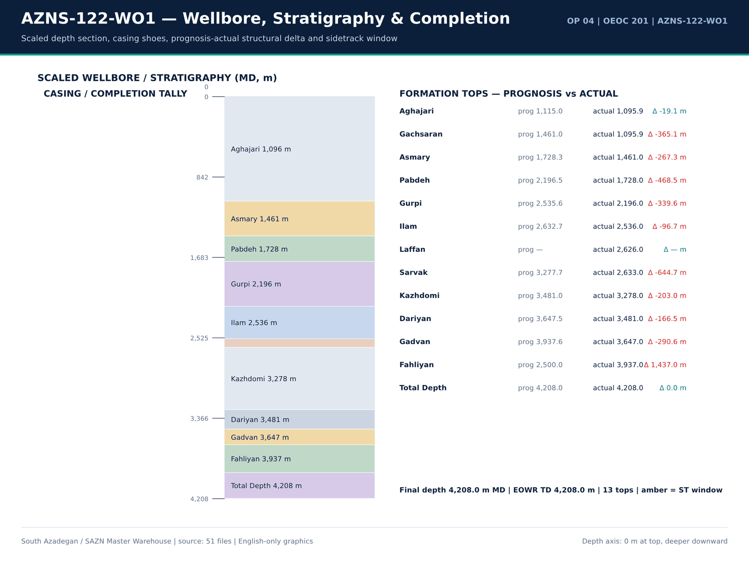
AZNS-122-WO1 02 wellbore — source: SAZN master warehouse
CBS total-cost ceilings
Sheet | Item | Qty | Unit cost | Total (USD) | Row
No source rows for this query | — | — | — | — | —

Three-way CBS / DDR / EOWR reconciliation
Item | CBS (USD) | DDR qty | Unit | Status
5 7 8 rock bit | 6,500.00 | — | each | CBS only — no DDR consumption record
6 mill | 5,000.00 | — | each | CBS only — no DDR consumption record
8 1 2 rock bit | 9,500.00 | — | each | CBS only — no DDR consumption record
bentonite | — | 1 | MT | DDR only — no CBS priced line
cacl2 97 | — | 24 | 1 MT | DDR only — no CBS priced line
casing 7 110s 32 ppf premium conn seamless r3 pls 3 | 305,100.00 | — | m | CBS only — no DDR consumption record
caustic soda | — | 22 | 25 kg | DDR only — no CBS priced line
centralizer 7 x 8 1 2 non weld bow spring type c w nails | 7,800.00 | — | ea. | CBS only — no DDR consumption record
centralizer rigid 7 x 8 1 2 | 650 | — | ea. | CBS only — no DDR consumption record
citric acid | — | 5 | 25 kg | DDR only — no CBS priced line
corrosion inhibitor | — | 5 | 55 gal | DDR only — no CBS priced line
d water | — | 7,480.00 | BBL | DDR only — no CBS priced line
frobar | — | 120 | 1.5 MT | DDR only — no CBS priced line
gasoil camp | — | 29,400.00 | Liter | DDR only — no CBS priced line
h2s scavenger liquid | — | 3 | 55 gal | DDR only — no CBS priced line
landing collar c w setting ball 7 29 32 l80 110s premium connection pdc drillable | 4,500.00 | — | ea. | CBS only — no DDR consumption record
lime | — | 101 | 25 kg | DDR only — no CBS priced line
limestone powder | — | 371 | 1 MT | DDR only — no CBS priced line
liner top packer assembly 7 29 32 l80 premium connection c w seal nipple packer | 12,000.00 | — | ea | CBS only — no DDR consumption record
o2 scavanger liquid | — | 3 | 55 gal | DDR only — no CBS priced line
rotating liner hanger hydraulic set tandem cone with integral split weight set top packe | 31,200.00 | — | set | CBS only — no DDR consumption record
salt | — | 90 | 1 MT | DDR only — no CBS priced line

Numeric-cell provenance excerpt — chapter 03
Document | Sheet | Cell | Value
CBS/4.AZNS_122_WO1_CBS.xlsx | Cost Breakdown-122 | R190C7 | 4,587,374.50
DDRs/4.AZNS_122_WO1_DDR_Pack.xlsx | 1-2 Data | R11C4 | 3,447,673.00
DDRs/4.AZNS_122_WO1_DDR_Pack.xlsx | 2-2 Data | R11C4 | 3,447,673.00
DDRs/4.AZNS_122_WO1_DDR_Pack.xlsx | 3-2 Data | R11C4 | 3,447,673.00
DDRs/4.AZNS_122_WO1_DDR_Pack.xlsx | 4-2 Data | R11C4 | 3,447,673.00
DDRs/4.AZNS_122_WO1_DDR_Pack.xlsx | 5-2 Data | R11C4 | 3,447,673.00
DDRs/4.AZNS_122_WO1_DDR_Pack.xlsx | 6-2 Data | R11C4 | 3,447,673.00
DDRs/4.AZNS_122_WO1_DDR_Pack.xlsx | 7-2 Data | R11C4 | 3,447,673.00
DDRs/4.AZNS_122_WO1_DDR_Pack.xlsx | 8-2 Data | R11C4 | 3,447,673.00
DDRs/4.AZNS_122_WO1_DDR_Pack.xlsx | 9-2 Data | R11C4 | 3,447,673.00
DDRs/4.AZNS_122_WO1_DDR_Pack.xlsx | 10-2 Data | R11C4 | 3,447,673.00
DDRs/4.AZNS_122_WO1_DDR_Pack.xlsx | 11-2 Data | R11C4 | 3,447,673.00
DDRs/4.AZNS_122_WO1_DDR_Pack.xlsx | 12-2 Data | R11C4 | 3,447,673.00
DDRs/4.AZNS_122_WO1_DDR_Pack.xlsx | 13-2 Data | R11C4 | 3,447,673.00

Chapter 04 — Milestones, Flat Spots & Invisible Lost Time
Depth progressed to 4,208.0 m MD with — m of recorded 24-h footage at mean ROP — m/h; 56 DDR reports show zero recorded progress and are retained as flat spots rather than interpolated. Milestones, invisible lost time and cumulative cost are listed per report so that a time-depth curve can be rebuilt directly from the table.
Daily time-depth milestones
Report | Date | MD (m) | Drilled (m) | ROP (m/h) | MW (PCF) | Hole size | Formation
1 | 14/01/2024 | 4,208.00 | 0 | 0 | — | 14/01/2024 | —
2 | 15/01/2024 | 4,208.00 | 0 | 0 | 103 | 14/01/2024 | —
3 | 16/01/2024 | 4,208.00 | 0 | 0 | 103 | 14/01/2024 | —
4 | 17/01/2024 | 4,208.00 | 0 | 0 | 103 | 14/01/2024 | —
5 | 18/01/2024 | 4,208.00 | 0 | 0 | 106 | 14/01/2024 | —
6 | 19/01/2024 | 4,208.00 | 0 | 0 | 106 | 14/01/2024 | —
7 | 20/01/2024 | 4,208.00 | 0 | 0 | 106 | 14/01/2024 | —
8 | 21/01/2024 | 4,208.00 | 0 | 0 | 106 | 14/01/2024 | —
9 | 22/01/2024 | 4,208.00 | 0 | 0 | 106 | 14/01/2024 | —
10 | 23/01/2024 | 4,208.00 | 0 | 0 | 106 | 14/01/2024 | —
11 | 24/01/2024 | 4,208.00 | 0 | 0 | 106 | 14/01/2024 | —
12 | 25/01/2024 | 4,208.00 | 0 | 0 | 106 | 14/01/2024 | —
13 | 26/01/2024 | 4,208.00 | 0 | 0 | 106 | 14/01/2024 | —
14 | 27/01/2024 | 4,208.00 | 0 | 0 | 104 | 14/01/2024 | —
15 | 28/01/2024 | 4,208.00 | 0 | 0 | 104 | 14/01/2024 | —
16 | 29/01/2024 | 4,208.00 | 0 | 0 | 104 | 14/01/2024 | —
17 | 30/01/2024 | 4,208.00 | 0 | 0 | 103 | 14/01/2024 | —
18 | 30/01/2024 | 4,208.00 | 0 | 0 | 103 | 14/01/2024 | —
19 | 30/01/2024 | 4,208.00 | 0 | 0 | 103 | 14/01/2024 | —
20 | 30/01/2024 | 4,208.00 | 0 | 0 | 103 | 14/01/2024 | —
21 | 30/01/2024 | 4,208.00 | 0 | 0 | 103 | 14/01/2024 | —
22 | 30/01/2024 | 4,208.00 | 0 | 0 | 103 | 14/01/2024 | —

Zero-progress flat spots
Report | Date | MD (m) | NPT (h) | PT (h) | Cum. cost (USD)
1 | 14/01/2024 | 4,208.00 | 0 | 15 | 23,000.00
2 | 15/01/2024 | 4,208.00 | 0 | 30 | 46,000.00
3 | 16/01/2024 | 4,208.00 | 0 | 30 | 69,000.00
4 | 17/01/2024 | 4,208.00 | 0 | 30 | 92,000.00
5 | 18/01/2024 | 4,208.00 | 0 | 30 | 115,000.00
6 | 19/01/2024 | 4,208.00 | 0 | 30 | 138,000.00
7 | 20/01/2024 | 4,208.00 | 0 | 30 | 161,000.00
8 | 21/01/2024 | 4,208.00 | 0 | 30 | 184,000.00
9 | 22/01/2024 | 4,208.00 | 0 | 30 | 207,000.00
10 | 23/01/2024 | 4,208.00 | 0 | 30 | 230,000.00
11 | 24/01/2024 | 4,208.00 | 0 | 30 | 253,000.00
12 | 25/01/2024 | 4,208.00 | 0 | 30 | 276,000.00
13 | 26/01/2024 | 4,208.00 | 0 | 30 | 299,000.00
14 | 27/01/2024 | 4,208.00 | 0 | 30 | 322,000.00
15 | 28/01/2024 | 4,208.00 | 0 | 30 | 345,000.00
16 | 29/01/2024 | 4,208.00 | 15.5 | 14.5 | 368,000.00
17 | 30/01/2024 | 4,208.00 | 30 | 0 | 391,000.00
18 | 30/01/2024 | 4,208.00 | 30 | 0 | 414,000.00
19 | 30/01/2024 | 4,208.00 | 30 | 0 | 437,000.00
20 | 30/01/2024 | 4,208.00 | 30 | 0 | 460,000.00
21 | 30/01/2024 | 4,208.00 | 30 | 0 | 483,000.00
22 | 30/01/2024 | 4,208.00 | 28 | 2 | 506,000.00

Cumulative cost by DDR report
Report | Date | MD (m) | NPT (h) | PT (h) | Cum. cost (USD)
1 | 14/01/2024 | 4,208.00 | 0 | 15 | 23,000.00
2 | 15/01/2024 | 4,208.00 | 0 | 30 | 46,000.00
3 | 16/01/2024 | 4,208.00 | 0 | 30 | 69,000.00
4 | 17/01/2024 | 4,208.00 | 0 | 30 | 92,000.00
5 | 18/01/2024 | 4,208.00 | 0 | 30 | 115,000.00
6 | 19/01/2024 | 4,208.00 | 0 | 30 | 138,000.00
7 | 20/01/2024 | 4,208.00 | 0 | 30 | 161,000.00
8 | 21/01/2024 | 4,208.00 | 0 | 30 | 184,000.00
9 | 22/01/2024 | 4,208.00 | 0 | 30 | 207,000.00
10 | 23/01/2024 | 4,208.00 | 0 | 30 | 230,000.00
11 | 24/01/2024 | 4,208.00 | 0 | 30 | 253,000.00
12 | 25/01/2024 | 4,208.00 | 0 | 30 | 276,000.00
13 | 26/01/2024 | 4,208.00 | 0 | 30 | 299,000.00
14 | 27/01/2024 | 4,208.00 | 0 | 30 | 322,000.00
15 | 28/01/2024 | 4,208.00 | 0 | 30 | 345,000.00
16 | 29/01/2024 | 4,208.00 | 15.5 | 14.5 | 368,000.00
17 | 30/01/2024 | 4,208.00 | 30 | 0 | 391,000.00
18 | 30/01/2024 | 4,208.00 | 30 | 0 | 414,000.00
19 | 30/01/2024 | 4,208.00 | 30 | 0 | 437,000.00
20 | 30/01/2024 | 4,208.00 | 30 | 0 | 460,000.00
21 | 30/01/2024 | 4,208.00 | 30 | 0 | 483,000.00
22 | 30/01/2024 | 4,208.00 | 28 | 2 | 506,000.00

Numeric-cell provenance excerpt — chapter 04
Document | Sheet | Cell | Value
CBS/4.AZNS_122_WO1_CBS.xlsx | Cost Breakdown-122 | R190C7 | 4,587,374.50
DDRs/4.AZNS_122_WO1_DDR_Pack.xlsx | 1-2 Data | R11C4 | 3,447,673.00
DDRs/4.AZNS_122_WO1_DDR_Pack.xlsx | 2-2 Data | R11C4 | 3,447,673.00
DDRs/4.AZNS_122_WO1_DDR_Pack.xlsx | 3-2 Data | R11C4 | 3,447,673.00
DDRs/4.AZNS_122_WO1_DDR_Pack.xlsx | 4-2 Data | R11C4 | 3,447,673.00
DDRs/4.AZNS_122_WO1_DDR_Pack.xlsx | 5-2 Data | R11C4 | 3,447,673.00
DDRs/4.AZNS_122_WO1_DDR_Pack.xlsx | 6-2 Data | R11C4 | 3,447,673.00
DDRs/4.AZNS_122_WO1_DDR_Pack.xlsx | 7-2 Data | R11C4 | 3,447,673.00
DDRs/4.AZNS_122_WO1_DDR_Pack.xlsx | 8-2 Data | R11C4 | 3,447,673.00
DDRs/4.AZNS_122_WO1_DDR_Pack.xlsx | 9-2 Data | R11C4 | 3,447,673.00
DDRs/4.AZNS_122_WO1_DDR_Pack.xlsx | 10-2 Data | R11C4 | 3,447,673.00
DDRs/4.AZNS_122_WO1_DDR_Pack.xlsx | 11-2 Data | R11C4 | 3,447,673.00
DDRs/4.AZNS_122_WO1_DDR_Pack.xlsx | 12-2 Data | R11C4 | 3,447,673.00
DDRs/4.AZNS_122_WO1_DDR_Pack.xlsx | 13-2 Data | R11C4 | 3,447,673.00

Chapter 05 — 24-Hour Activity Log & Operation Codes
2,804 discrete 24-h activity rows were parsed for AZNS-122-WO1, each with phase, code, sub-code, PLN/NPT status, attributed party and duration. The tables below reproduce the raw activity log, the code distribution and the phase-by-status hour matrix; no activity is merged or rounded away.
Raw 24-hour activity log
Report | Seq | Phase | Code | Status | Attributed | Hours | Description
1 | 1 | — | - | - | — | 15 | Cont. Prepare the rig for spud. L/U Oil storage tank.
1 | 2 | — | 29 | P | — | 6 | Spud the rig @ 14-Jan-24, 15:00. L/U Ann and XMT to choke manifold. Held P.J.S.M. Bleed of Ann Press thru burning line to 350 psi On 1/16"
1 | 3 | — | — | — | — | — | choke size whithin 4 Hrs. Initially got gas contaminated oil with more than 90% gas and then 100% gas. Got return in oil storage tank after
1 | 4 | — | — | — | — | — | decrease gas percentage; Ann Press gradually decreased to 250 psi and remaind constant for last 20 min. Close Ann Side outlet valve.
1 | 5 | — | — | — | — | — | Meanwhile monitor Ann Press; build up to 800psi after 2Hrs.
1 | 6 | — | — | — | — | — | Return gas components: H2S: 12 ppm, LEL: 65%
1 | 7 | — | 29 | P | — | 3 | Function test S/L BOP & Install same on XMT Cap. R/U Slick line Equip. (S/L BHA: 10 ft stem, Mech. Jar, 3.400" Gauge Ring)
1 | 8 | — | — | — | — | — | Section C Press: 1200 psi, String Press: 1200 psi.
1 | 9 | — | — | — | — | — | Prepare 170 bbl 80 pcf S.Poly.Lst Mud in progress till MN.
1 | 10 | — | — | — | — | — | —
1 | 11 | — | — | — | — | — | —
1 | 12 | — | — | — | — | — | —
1 | 13 | — | — | — | — | — | ***Spud the RIG @ 15:00, 14-Jan-2024***
1 | 14 | — | — | — | — | — | —
1 | 15 | — | — | — | — | — | —
1 | 16 | — | — | — | — | — | —
1 | 17 | — | — | — | — | — | NOTE:
1 | 18 | — | — | — | — | — | *** Perforated Interval: 4086-4101m, 4114-4120m.
1 | 19 | — | — | — | — | — | Rec SPAD Energy Co. CMT unit & crew @ 12:00, 2023-Jan-19.
1 | 20 | — | — | — | — | — | Rec. MAPSA Co. Mud logging service @ 14:00, 2023-Jan-07.
1 | 21 | — | — | — | — | — | Rec. Bonyan Imen Co. H2S service @ 14:00, 2023-Jan-07.
1 | 22 | — | — | — | — | — | Rec. Vira Co. Mud engineering service @ 14:00, 2023-Jan-05.

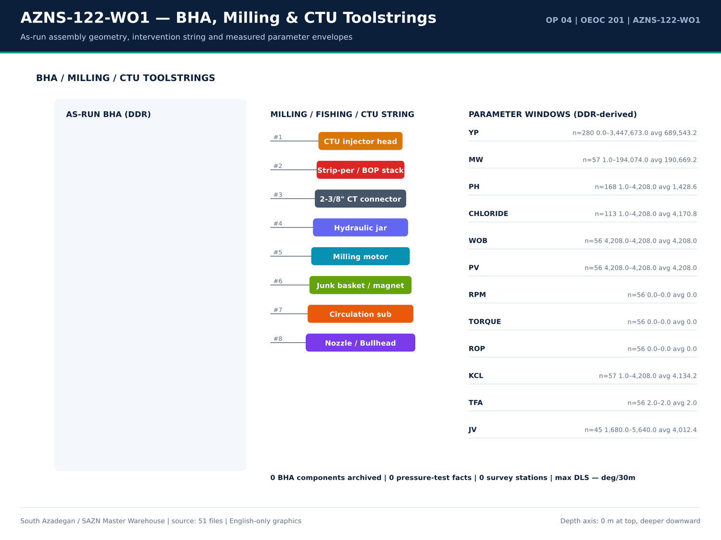
AZNS-122-WO1 03 bha — source: SAZN master warehouse
Activity code distribution
Code | Hours | Count
39 | 686 | 144
29 | 453 | 83
44 | 218.5 | 55
5 | 72.5 | 16
3 | 69.5 | 17
21 | 45 | 5
10 | 36 | 11
14 | 35.5 | 3
43 | 21 | 5
- | 15 | 1
15 | 5 | 1
6 | 4 | 2
7 | 2 | 1

Phase × status hour matrix
Phase | Status | Hours | Count
— | P | 718 | 137
— | UP | 686 | 144
— | N | 242.5 | 61
— | - | 15 | 1
— | U | 1.5 | 1

Numeric-cell provenance excerpt — chapter 05
Document | Sheet | Cell | Value
CBS/4.AZNS_122_WO1_CBS.xlsx | Cost Breakdown-122 | R190C7 | 4,587,374.50
DDRs/4.AZNS_122_WO1_DDR_Pack.xlsx | 1-2 Data | R11C4 | 3,447,673.00
DDRs/4.AZNS_122_WO1_DDR_Pack.xlsx | 2-2 Data | R11C4 | 3,447,673.00
DDRs/4.AZNS_122_WO1_DDR_Pack.xlsx | 3-2 Data | R11C4 | 3,447,673.00
DDRs/4.AZNS_122_WO1_DDR_Pack.xlsx | 4-2 Data | R11C4 | 3,447,673.00
DDRs/4.AZNS_122_WO1_DDR_Pack.xlsx | 5-2 Data | R11C4 | 3,447,673.00
DDRs/4.AZNS_122_WO1_DDR_Pack.xlsx | 6-2 Data | R11C4 | 3,447,673.00
DDRs/4.AZNS_122_WO1_DDR_Pack.xlsx | 7-2 Data | R11C4 | 3,447,673.00
DDRs/4.AZNS_122_WO1_DDR_Pack.xlsx | 8-2 Data | R11C4 | 3,447,673.00
DDRs/4.AZNS_122_WO1_DDR_Pack.xlsx | 9-2 Data | R11C4 | 3,447,673.00
DDRs/4.AZNS_122_WO1_DDR_Pack.xlsx | 10-2 Data | R11C4 | 3,447,673.00
DDRs/4.AZNS_122_WO1_DDR_Pack.xlsx | 11-2 Data | R11C4 | 3,447,673.00
DDRs/4.AZNS_122_WO1_DDR_Pack.xlsx | 12-2 Data | R11C4 | 3,447,673.00
DDRs/4.AZNS_122_WO1_DDR_Pack.xlsx | 13-2 Data | R11C4 | 3,447,673.00

Chapter 06 — NPT Pareto & Event Autopsy
8 problem families were reconstructed for AZNS-122-WO1. Each carries occurrence count, hours, depth, formation, attributed party, at least two engineering hypotheses, a quantified exposure and a 60-second rig-floor playbook. The Pareto tables rank these families by hours and by cost exposure using the sourced rig rate.
Reconstructed problem families
Category | Days | Depth (m) | Formation | Title | Hours | Cost (USD) | Evidence
Stuck pipe / fishing / milling | 16,17,18,19,20,21,22,23 | 4,208.00 | — | Stuck pipe / fishing / milling — 88 occurrences | 342.5 | 328,229.17 | DDR 24-h log / remarks
Other operational delay | 1,2,3,4,5,6,7,8 | 4,208.00 | — | Other operational delay — 187 occurrences | 200.5 | 192,145.83 | DDR 24-h log / remarks
Waiting on services / material | 2,11,12,16,17,18,19,20 | 4,208.00 | — | Waiting on services / material — 53 occurrences | 169.5 | 162,437.50 | DDR 24-h log / remarks
Lost circulation / fluid losses | 4,6,10,11,12,13,14,31 | 4,208.00 | — | Lost circulation / fluid losses — 84 occurrences | 163 | 156,208.33 | DDR 24-h log / remarks
Completion / stimulation | 12,39,40,52,53 | 4,208.00 | — | Completion / stimulation — 9 occurrences | 33.5 | 32,104.17 | DDR 24-h log / remarks
Rig equipment failure | 20,21,22,23,24,25,26,27 | 4,208.00 | — | Rig equipment failure — 23 occurrences | 13 | 12,458.33 | DDR 24-h log / remarks
Shale instability / hole condition | 32,33 | 4,208.00 | — | Shale instability / hole condition — 3 occurrences | 6.5 | 6,229.17 | DDR 24-h log / remarks
Well control / gas / H2S | 54,55,56 | 4,208.00 | — | Well control / gas / H2S — 3 occurrences | 0 | 0 | DDR 24-h log / remarks

NPT Pareto by attributed hours
Category | Hours | Attributed | Share (%)
Unattributed | 928.5 | Unattributed | 100

Largest individual NPT entries
Report | Hours | Attributed | Description
7 | 24 | — | N/U 13 5/8" - 10k BOP Stack included: 11" 10K X 13-5/8" 10K DSA, 13-5/8"-10k Spacer spool, 13-5/8"-10k Single ram (5" Fix),
9 | 24 | — | Cont. POOH completion string f/ 3750 to 2720 m while L/D totally 126 Jts 4-1/2" TBG till MN. While Circ. CWH; NL-NG.
10 | 24 | — | Cont. POOH completion string f/ 2720 to 1560 m while L/D totally 249 Jts 4-1/2" TBG till MN. While Circ. CWH; 0-1 BPH Losses.
11 | 24 | — | Cont. POOH completion string f/ 1560 to 530 m while L/D totally 360 Jts 4-1/2" TBG till MN. While Circ. CWH; 0-1 BPH Losses.
48 | 24 | — | Cont POOH w/ 6-1/8" PDC Bit & 7" Scraper f/ 2570m to surface while L/D totally 165 Jts 5" DP & 207 Jts 3-1/2" DP & 9 Jts 3-1/2" HWDP & 21 Jts
31 | 22.5 | — | Wait on client's decision for corrosion of 9-5/8'' Csg & next plan: Cont. Milling & Push Dn the fish f/ 3955.5 to 3968m While try to push
18 | 22 | — | Wait on receive logging crew (cast log) since 00:00, 31-01-2024 while slow circ. Mud @ 1000m w/ NL-NG @R.T.
39 | 22 | — | Slow Circ. Thru string; 0-1 BPH Losses, While Lay received LNRs on rack & Drifted & Prepare all Jts is in progress till MN.
19 | 20 | — | Wait on client's decision for corrosion of 9-5/8''csg & next plan while P/U & M/U 7’’ SN Packer Assy included: 7" Seal Nipple (PPA Co,
27 | 20 | — | While wait on client's decision for corrosion of 9-5/8'' Csg & next plan, Cont milling f/ 3928.85 to 3929.6m, Obs rubber element trace of
3 | 19.5 | — | Install mouse hole, P/U & M/U 59 Stds 5" DP.
40 | 18.5 | — | Held PJSM, P/U & M/U 7" Seal Nipple (PPA, 29#, C-110, TPCQ), Dressed w/ 4 Set V-Packing & RIH w/ 2 Jts 7" LNR (29#, L-80, TPCQ),
25 | 17.5 | — | While wait on client's decision for corrosion of 9-5/8''csg & next plan, Cont milling 7" Old Completion PKR w/ Diff parameters f/ 3928.35 to
2 | 16 | — | Run 2.5" Gauge cutter to TR3SV; took Wt. POOH to surface. Increase CL Press f/ 6500 to 7500 psi & Pump 6 bbl Drill water (Pumping Press:
52 | 16 | — | Cont. RIH w/ 100 Jts 4-1/2" TBG (10K, 18.9#, L-80,HSM3) (Totally 200 Jts 4-1/2" TBG & 185 Jts 3-1/2" TBG) f/ 2730 to 3670m; NL-NG.
1 | 15 | — | Cont. Prepare the rig for spud. L/U Oil storage tank.
5 | 14 | — | Prepare and R/B 31 Stds (Totally 114 Stds) 5" DP & Prepare 1000 bbl 106 pcf mud meanwhile monitor press: Ann: 305 psi,
44 | 14 | — | Cont D/O Med CMT f/3650 to 3753m, Tag 7" LDC @ 3753m, D/O 7" LDC, Dress & smooth same interval several times, D/O Med CMT to 3780m
47 | 14 | — | POOH to 2570m while L/D 132 Jts 5" DP Jt by Jt while CCWH, NL-NG.
51 | 13 | — | Resume RIH w/ 101 Jts 4-1/2" TBG (10K, 18.9#, L-80,HSM3) (Totally 185 Jts 3-1/2" TBG & 101 Jts 4-1/2"TBG) f/ 1768 to 2730m till MN, while pass
33 | 12.5 | — | Took weight; Unable to push Dn. Resume Mill/push Dn the fish f/ 4073 to 4080m till MN; NL-NG.
12 | 12 | — | Cont. POOH completion string f/ 196m to surface while L/D totally 16 Jts 3-1/2" TBG. While Circ. CWH; 0-1 BPH Losses.

Numeric-cell provenance excerpt — chapter 06
Document | Sheet | Cell | Value
CBS/4.AZNS_122_WO1_CBS.xlsx | Cost Breakdown-122 | R190C7 | 4,587,374.50
DDRs/4.AZNS_122_WO1_DDR_Pack.xlsx | 1-2 Data | R11C4 | 3,447,673.00
DDRs/4.AZNS_122_WO1_DDR_Pack.xlsx | 2-2 Data | R11C4 | 3,447,673.00
DDRs/4.AZNS_122_WO1_DDR_Pack.xlsx | 3-2 Data | R11C4 | 3,447,673.00
DDRs/4.AZNS_122_WO1_DDR_Pack.xlsx | 4-2 Data | R11C4 | 3,447,673.00
DDRs/4.AZNS_122_WO1_DDR_Pack.xlsx | 5-2 Data | R11C4 | 3,447,673.00
DDRs/4.AZNS_122_WO1_DDR_Pack.xlsx | 6-2 Data | R11C4 | 3,447,673.00
DDRs/4.AZNS_122_WO1_DDR_Pack.xlsx | 7-2 Data | R11C4 | 3,447,673.00
DDRs/4.AZNS_122_WO1_DDR_Pack.xlsx | 8-2 Data | R11C4 | 3,447,673.00
DDRs/4.AZNS_122_WO1_DDR_Pack.xlsx | 9-2 Data | R11C4 | 3,447,673.00
DDRs/4.AZNS_122_WO1_DDR_Pack.xlsx | 10-2 Data | R11C4 | 3,447,673.00
DDRs/4.AZNS_122_WO1_DDR_Pack.xlsx | 11-2 Data | R11C4 | 3,447,673.00
DDRs/4.AZNS_122_WO1_DDR_Pack.xlsx | 12-2 Data | R11C4 | 3,447,673.00
DDRs/4.AZNS_122_WO1_DDR_Pack.xlsx | 13-2 Data | R11C4 | 3,447,673.00

Chapter 07 — Bit Record, Dull Grade & Cost per Metre
Bit and drilling-tool records are taken from the CBS tariff lines, DDR bit/BHA sheets and EOWR bit-record chapter. Cost per drilled metre is formed from 4,587,374 USD of CBS scope and — m of recorded footage; where no new hole was drilled the table states the workover basis instead of dividing by an invented denominator.
Bit / drilling-tool tariff lines
Sheet | Description | Unit | Qty | Unit price (USD) | Total (USD)
Cost Breakdown-122 | Drilling Bit & mill | SET | — | — | 32,000.00
Cost Breakdown-Material-122 EW | 8-1/2" Rock Bit | each | 1 | 9,500.00 | 9,500.00
Cost Breakdown-Material-122 EW | 5-7/8" Rock Bit | each | 1 | 6,500.00 | 6,500.00
Cost Breakdown-Material-122 EW | Float shoe, reamer type, 7", 29-32#, L80-110S, PREMIUM connection, PDC drillable | ea. | 0 | 4,500.00 | 0
Cost Breakdown-Material-122 EW | 12-1/4" Rock Bit | each | 0 | 13,000.00 | 0
Cost Breakdown-Material-122 EW | 12-1/4" PDC Bit | each | 0 | 40,000.00 | 0
Cost Breakdown-Material-122 EW | 8-1/2" PDC Bit | each | 0 | 26,000.00 | 0
Cost Breakdown-Material-122 | Float shoe, reamer type, 7", 29-32#, L80-110S, PREMIUM connection, PDC drillable | ea. | — | — | —
Cost Breakdown-Material-122 | Float shoe, reamer type, 7", 29#, L80, 9CR-1 MO, PREMIUM connection, PDC drillable | ea. | — | — | —
Cost Breakdown-Material-122 | Float shoe, reamer type, 7", 32#, 110S,PREMIUM connection, PDC drillable | ea. | — | — | —
Cost Breakdown-Material-122 | Float shoe, reamer type, 5 " 18# ,110S,PREMIUM connection, PDC drillable | ea. | — | — | —
Cost Breakdown-Material-122 | Float shoe, reamer type, 5" 18-23# x 9 5/8" 47-53.5#, 110S, PREMIUM connection, PDC drillable | ea. | — | — | —
Cost Breakdown-Material-122 | Guide shoe, reamer type, 4 1/2", 13.5#, L80,BTC connection | ea. | — | — | —
Cost Breakdown-Material-122 | Drilling Bit &mill | — | — | — | —
Cost Breakdown-Material-122 | 12-1/4" Rock Bit | each | — | — | —
Cost Breakdown-Material-122 | 12-1/4" PDC Bit | each | — | — | —
Cost Breakdown-Material-122 | 8-1/2" Rock Bit | each | — | 2 | —
Cost Breakdown-Material-122 | 8-1/2" PDC Bit | each | — | — | —
Cost Breakdown-Material-122 | 5-7/8" Rock Bit | each | — | 2 | —
Cost Breakdown-Material-122 | 6-1/8" PDC Bit | each | — | — | —
Cost Breakdown-Material-122 EW | Float shoe, reamer type, 7", 29#, L80, 9CR-1 MO, PREMIUM connection, PDC drillable | ea. | — | — | —
Cost Breakdown-Material-122 EW | Float shoe, reamer type, 7", 32#, 110S,PREMIUM connection, PDC drillable | ea. | — | — | —

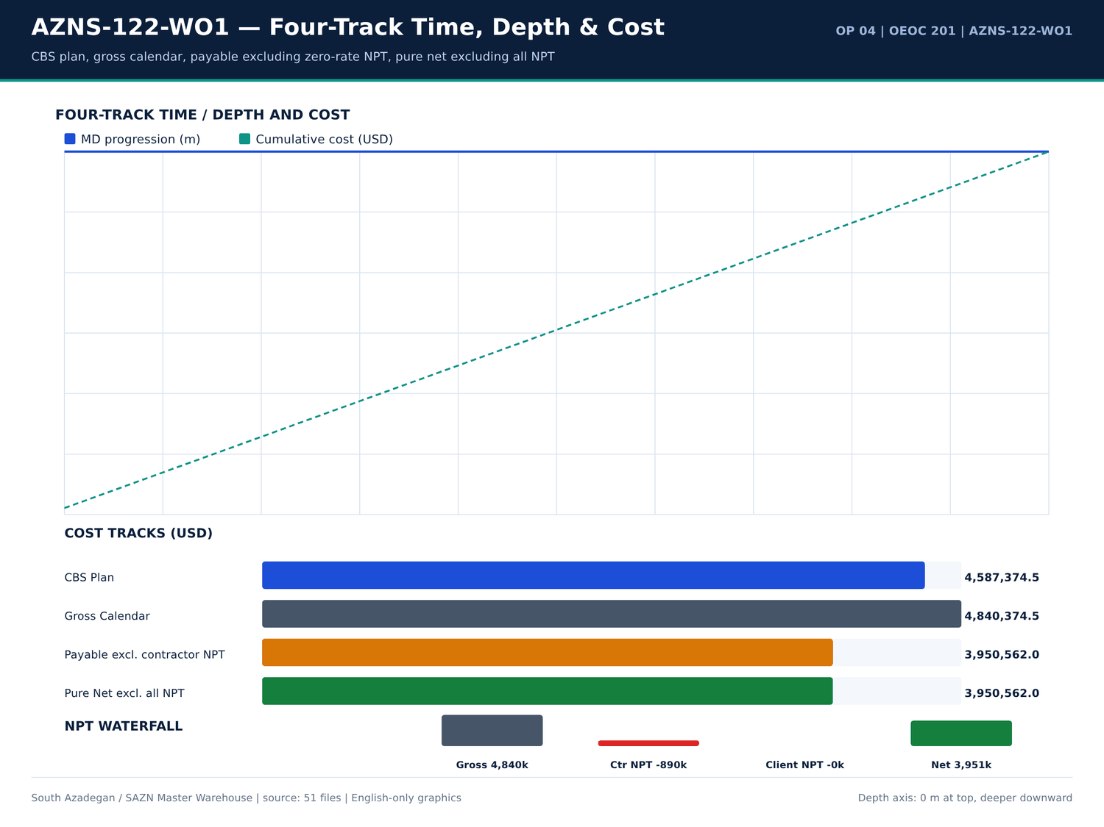
AZNS-122-WO1 04 fourtrack — source: SAZN master warehouse
Daily ROP / footage record
Report | Date | MD (m) | Drilled (m) | ROP (m/h) | MW (PCF) | Formation
1 | 14/01/2024 | 4,208.00 | 0 | 0 | — | —
2 | 15/01/2024 | 4,208.00 | 0 | 0 | 103 | —
3 | 16/01/2024 | 4,208.00 | 0 | 0 | 103 | —
4 | 17/01/2024 | 4,208.00 | 0 | 0 | 103 | —
5 | 18/01/2024 | 4,208.00 | 0 | 0 | 106 | —
6 | 19/01/2024 | 4,208.00 | 0 | 0 | 106 | —
7 | 20/01/2024 | 4,208.00 | 0 | 0 | 106 | —
8 | 21/01/2024 | 4,208.00 | 0 | 0 | 106 | —
9 | 22/01/2024 | 4,208.00 | 0 | 0 | 106 | —
10 | 23/01/2024 | 4,208.00 | 0 | 0 | 106 | —
11 | 24/01/2024 | 4,208.00 | 0 | 0 | 106 | —
12 | 25/01/2024 | 4,208.00 | 0 | 0 | 106 | —
13 | 26/01/2024 | 4,208.00 | 0 | 0 | 106 | —
14 | 27/01/2024 | 4,208.00 | 0 | 0 | 104 | —
15 | 28/01/2024 | 4,208.00 | 0 | 0 | 104 | —
16 | 29/01/2024 | 4,208.00 | 0 | 0 | 104 | —
17 | 30/01/2024 | 4,208.00 | 0 | 0 | 103 | —
18 | 30/01/2024 | 4,208.00 | 0 | 0 | 103 | —
19 | 30/01/2024 | 4,208.00 | 0 | 0 | 103 | —
20 | 30/01/2024 | 4,208.00 | 0 | 0 | 103 | —
21 | 30/01/2024 | 4,208.00 | 0 | 0 | 103 | —
22 | 30/01/2024 | 4,208.00 | 0 | 0 | 103 | —

Bit / BHA / tool notes
Report | Sheet | Category | Text
28 | 28-1 Remark | SHORTAGE/REMARK | Cont RIH w/ 4-1/4" Taper tap & Fishing BHA f/ 3000 to 3935.6m, F/U string every 10 Stds & break Circ, NL-NG.
28 | 28-1 Remark | SHORTAGE/REMARK | While wait on client's decision for corrosion of 9-5/8'' Csg & next plan, Cont POOH w/ 6" M.M.J Mill to surface. L/D J.Mill. P/U & M/U 4-1/4" Taper tap & RIH w/ Fishing BHA to 3000m , NL-NG.
29 | 29-1 Remark | SHORTAGE/REMARK | Wait on client's decision for corrosion of 9-5/8'' Csg & next plan, Cont RIH w/ 4-1/4" Taper tap & Fishing BHA f/ 3000 to 3935.6m, F/U string
29 | 29-1 Remark | SHORTAGE/REMARK | While wait on client's decision for corrosion of 9-5/8'' Csg & next plan, Cont RIH w/ 4-1/4" Taper tap & Fishing BHA f/ 3000 to 3935.6m, Tag TOF @ 3565.6m. Clean TOF. Work on fish, Obs drop fish to 3945m, work on fish again, POOH chain o…
31 | 31-1 Remark | SHORTAGE/REMARK | Commence POOH w/ 6" M.M.J Mill & milling BHA pump out f/ 3968 to 3775 m. 1-2 BPH Losses.
33 | 33-1 Remark | SHORTAGE/REMARK | Cont. RIH w/ 6" M.M.J Mill & milling BHA f/ 2900 to 3968m (TOF), Commence milling f/ 3968 to 3969m, Fish dropped, Soft wash & Ream Dn f/ 3969 to 4070m, Obs. 5 bbl increase in pit level while connection. Circ. Thru choke manifold as BTMs …
34 | 34-1 Remark | SHORTAGE/REMARK | Commence POOH pump out w/ 6" M.M.J.Mill & milling BHA f/ 4150 to 3775m (7" LNR Lap); 1-2 BPH Losses. Perform static flow check;
34 | 34-1 Remark | SHORTAGE/REMARK | Resume POOH w/ 6" M.M.J.Mill & milling BHA f/ 3775 to 800m, F/U the well; 0-1 BPH Losses.
34 | 34-1 Remark | SHORTAGE/REMARK | Cont. POOH w/ 6" M.M.J.Mill & milling BHA f/ 800 to 280m, F/U the well; 0-1 BPH Losses. Perform static flow check on BHA; 0-1 BPH Losses.
34 | 34-1 Remark | SHORTAGE/REMARK | Resume POOH w/ 6" M.M.J.Mill & milling BHA f/ 280m to surface, F/U the well; 0-1 BPH Losses. L/D Mill; 80% Used. Obs. A piece of CMT in one
35 | 35-1 Remark | SHORTAGE/REMARK | 0-1 BPH Losses. Perform static flow check on BHA; 0-1 BPH Losses.
35 | 35-1 Remark | SHORTAGE/REMARK | Resume POOH w/ 6" M.M.J.Mill & milling BHA f/ 280m to surface, F/U the well; 0-1 BPH Losses. L/D Mill; 80% Used. Obs. A piece of CMT in one
35 | 35-1 Remark | SHORTAGE/REMARK | Cont. POOH 7-5/16" Polish mill f/ 1850 to 100m, F/U the well, 0-1 BPH Losses. Perform static flow check on BHA; 0-1 BPH Losses.
36 | 36-1 Remark | SHORTAGE/REMARK | Perform static flow check on BHA; 0-1 BPH Losses.
40 | 40-1 Remark | SHORTAGE/REMARK | POOH w/ 6” MT Bit f/ 500 to surface. L/D Bit (1-1-WT-A-E-I-NO-BHA). Retrieved 11" Wear bushing. While Circ. CWH; 0-1 BPH Losses.

Numeric-cell provenance excerpt — chapter 07
Document | Sheet | Cell | Value
CBS/4.AZNS_122_WO1_CBS.xlsx | Cost Breakdown-122 | R190C7 | 4,587,374.50
DDRs/4.AZNS_122_WO1_DDR_Pack.xlsx | 1-2 Data | R11C4 | 3,447,673.00
DDRs/4.AZNS_122_WO1_DDR_Pack.xlsx | 2-2 Data | R11C4 | 3,447,673.00
DDRs/4.AZNS_122_WO1_DDR_Pack.xlsx | 3-2 Data | R11C4 | 3,447,673.00
DDRs/4.AZNS_122_WO1_DDR_Pack.xlsx | 4-2 Data | R11C4 | 3,447,673.00
DDRs/4.AZNS_122_WO1_DDR_Pack.xlsx | 5-2 Data | R11C4 | 3,447,673.00
DDRs/4.AZNS_122_WO1_DDR_Pack.xlsx | 6-2 Data | R11C4 | 3,447,673.00
DDRs/4.AZNS_122_WO1_DDR_Pack.xlsx | 7-2 Data | R11C4 | 3,447,673.00
DDRs/4.AZNS_122_WO1_DDR_Pack.xlsx | 8-2 Data | R11C4 | 3,447,673.00
DDRs/4.AZNS_122_WO1_DDR_Pack.xlsx | 9-2 Data | R11C4 | 3,447,673.00
DDRs/4.AZNS_122_WO1_DDR_Pack.xlsx | 10-2 Data | R11C4 | 3,447,673.00
DDRs/4.AZNS_122_WO1_DDR_Pack.xlsx | 11-2 Data | R11C4 | 3,447,673.00
DDRs/4.AZNS_122_WO1_DDR_Pack.xlsx | 12-2 Data | R11C4 | 3,447,673.00
DDRs/4.AZNS_122_WO1_DDR_Pack.xlsx | 13-2 Data | R11C4 | 3,447,673.00

Chapter 08 — ROP, MSE & Parameter Correlation
Mean ROP is — m/h with mud weight band 103.0–106.0 PCF. The correlation tables join daily ROP, MW, drilled interval, hole size and formation from the same DDR report so that any apparent trend can be checked against the original 24-h row. — deg/30m is the maximum calculated minimum-curvature DLS for this well.
ROP distribution rows
Report | ROP (m/h) | Drilled (m) | MW (PCF) | Hole size | Formation
1 | 0 | 0 | — | 14/01/2024 | —
2 | 0 | 0 | 103 | 14/01/2024 | —
3 | 0 | 0 | 103 | 14/01/2024 | —
4 | 0 | 0 | 103 | 14/01/2024 | —
5 | 0 | 0 | 106 | 14/01/2024 | —
6 | 0 | 0 | 106 | 14/01/2024 | —
7 | 0 | 0 | 106 | 14/01/2024 | —
8 | 0 | 0 | 106 | 14/01/2024 | —
9 | 0 | 0 | 106 | 14/01/2024 | —
10 | 0 | 0 | 106 | 14/01/2024 | —
11 | 0 | 0 | 106 | 14/01/2024 | —
12 | 0 | 0 | 106 | 14/01/2024 | —
13 | 0 | 0 | 106 | 14/01/2024 | —
14 | 0 | 0 | 104 | 14/01/2024 | —
15 | 0 | 0 | 104 | 14/01/2024 | —
16 | 0 | 0 | 104 | 14/01/2024 | —
17 | 0 | 0 | 103 | 14/01/2024 | —
18 | 0 | 0 | 103 | 14/01/2024 | —
19 | 0 | 0 | 103 | 14/01/2024 | —
20 | 0 | 0 | 103 | 14/01/2024 | —
21 | 0 | 0 | 103 | 14/01/2024 | —
22 | 0 | 0 | 103 | 14/01/2024 | —

Measured parameter windows
Parameter | Count | Min | Mean | Median | Max
WOB / RPM / SPP / GPM windows are stored in the profile JSON | 2,804 | — | — | — | —

Daily ROP × MW correlation set
Report | ROP (m/h) | MW (PCF) | Drilled (m) | FIT EMW
1 | 0 | — | 0 | —
2 | 0 | 103 | 0 | —
3 | 0 | 103 | 0 | —
4 | 0 | 103 | 0 | —
5 | 0 | 106 | 0 | —
6 | 0 | 106 | 0 | —
7 | 0 | 106 | 0 | —
8 | 0 | 106 | 0 | —
9 | 0 | 106 | 0 | —
10 | 0 | 106 | 0 | —
11 | 0 | 106 | 0 | —
12 | 0 | 106 | 0 | —
13 | 0 | 106 | 0 | —
14 | 0 | 104 | 0 | —
15 | 0 | 104 | 0 | —
16 | 0 | 104 | 0 | —
17 | 0 | 103 | 0 | —
18 | 0 | 103 | 0 | —
19 | 0 | 103 | 0 | —
20 | 0 | 103 | 0 | —
21 | 0 | 103 | 0 | —
22 | 0 | 103 | 0 | —

Numeric-cell provenance excerpt — chapter 08
Document | Sheet | Cell | Value
CBS/4.AZNS_122_WO1_CBS.xlsx | Cost Breakdown-122 | R190C7 | 4,587,374.50
DDRs/4.AZNS_122_WO1_DDR_Pack.xlsx | 1-2 Data | R11C4 | 3,447,673.00
DDRs/4.AZNS_122_WO1_DDR_Pack.xlsx | 2-2 Data | R11C4 | 3,447,673.00
DDRs/4.AZNS_122_WO1_DDR_Pack.xlsx | 3-2 Data | R11C4 | 3,447,673.00
DDRs/4.AZNS_122_WO1_DDR_Pack.xlsx | 4-2 Data | R11C4 | 3,447,673.00
DDRs/4.AZNS_122_WO1_DDR_Pack.xlsx | 5-2 Data | R11C4 | 3,447,673.00
DDRs/4.AZNS_122_WO1_DDR_Pack.xlsx | 6-2 Data | R11C4 | 3,447,673.00
DDRs/4.AZNS_122_WO1_DDR_Pack.xlsx | 7-2 Data | R11C4 | 3,447,673.00
DDRs/4.AZNS_122_WO1_DDR_Pack.xlsx | 8-2 Data | R11C4 | 3,447,673.00
DDRs/4.AZNS_122_WO1_DDR_Pack.xlsx | 9-2 Data | R11C4 | 3,447,673.00
DDRs/4.AZNS_122_WO1_DDR_Pack.xlsx | 10-2 Data | R11C4 | 3,447,673.00
DDRs/4.AZNS_122_WO1_DDR_Pack.xlsx | 11-2 Data | R11C4 | 3,447,673.00
DDRs/4.AZNS_122_WO1_DDR_Pack.xlsx | 12-2 Data | R11C4 | 3,447,673.00
DDRs/4.AZNS_122_WO1_DDR_Pack.xlsx | 13-2 Data | R11C4 | 3,447,673.00

Chapter 09 — BHA & Downhole Motor Performance
The BHA table reproduces the as-run components with item, OD, length and cumulative length from the DDR BHA sheet, followed by the derived parameter envelopes. Where the source DDR contains no BHA rows the report records that absence and points to the CBS / Programme / EOWR toolstring tables instead of supplying a schematic assembly.
As-run BHA components
Report | BHA No | Item | OD (in) | Length (m) | Cum. length (m)
No source rows for this query | — | — | — | — | —

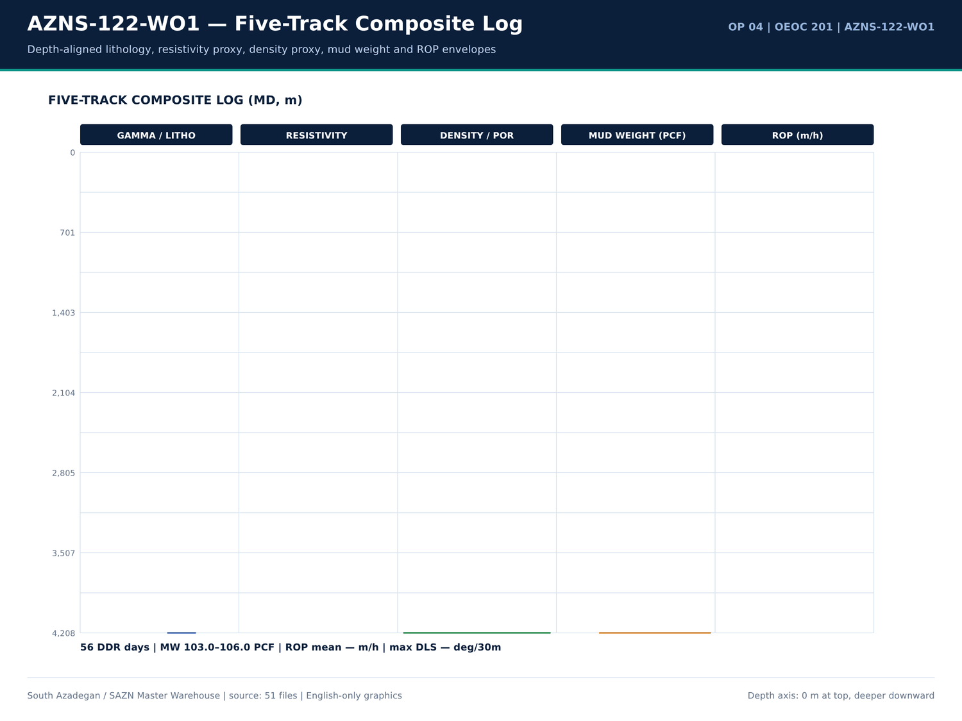
AZNS-122-WO1 05 composite log — source: SAZN master warehouse
BHA / toolstring priced lines
Sheet | Description | Unit | Qty | Total (USD)
No source rows for this query | — | — | — | —

BHA-related DDR remarks
Report | Sheet | Category | Text
28 | 28-1 Remark | SHORTAGE/REMARK | sideport, tools ID: 3/4") & RIH w/ 4-3/4" D.Box + 4-3/4" D.Pin + 4-3/4" B.Sub + 1 Jt 4-3/4" DC + 4-3/4" Fishing jar + 5 Stds 4-3/4" DC + 1 Std 3-1/2"
28 | 28-1 Remark | SHORTAGE/REMARK | Cont RIH w/ 4-1/4" Taper tap & Fishing BHA f/ 3000 to 3935.6m, F/U string every 10 Stds & break Circ, NL-NG.
28 | 28-1 Remark | SHORTAGE/REMARK | While wait on client's decision for corrosion of 9-5/8'' Csg & next plan, Cont POOH w/ 6" M.M.J Mill to surface. L/D J.Mill. P/U & M/U 4-1/4" Taper tap & RIH w/ Fishing BHA to 3000m , NL-NG.
29 | 29-1 Remark | SHORTAGE/REMARK | Wait on client's decision for corrosion of 9-5/8'' Csg & next plan, Cont RIH w/ 4-1/4" Taper tap & Fishing BHA f/ 3000 to 3935.6m, F/U string
29 | 29-1 Remark | SHORTAGE/REMARK | L/D fishing jar, 1 jt 4-3/4'' DC & taper tap, Fish not recovered. piece of PKR segment (dice) taped on taper tap, which caused engaging &
29 | 29-1 Remark | SHORTAGE/REMARK | While wait on client's decision for corrosion of 9-5/8'' Csg & next plan, Cont RIH w/ 4-1/4" Taper tap & Fishing BHA f/ 3000 to 3935.6m, Tag TOF @ 3565.6m. Clean TOF. Work on fish, Obs drop fish to 3945m, work on fish again, POOH chain o…
31 | 31-1 Remark | SHORTAGE/REMARK | Commence POOH w/ 6" M.M.J Mill & milling BHA pump out f/ 3968 to 3775 m. 1-2 BPH Losses.
33 | 33-1 Remark | SHORTAGE/REMARK | Cont. RIH w/ 6" M.M.J Mill & milling BHA f/ 2900 to 3968m (TOF), Commence milling f/ 3968 to 3969m, Fish dropped, Soft wash & Ream Dn f/ 3969 to 4070m, Obs. 5 bbl increase in pit level while connection. Circ. Thru choke manifold as BTMs …
34 | 34-1 Remark | SHORTAGE/REMARK | Commence POOH pump out w/ 6" M.M.J.Mill & milling BHA f/ 4150 to 3775m (7" LNR Lap); 1-2 BPH Losses. Perform static flow check;
34 | 34-1 Remark | SHORTAGE/REMARK | Resume POOH w/ 6" M.M.J.Mill & milling BHA f/ 3775 to 800m, F/U the well; 0-1 BPH Losses.
34 | 34-1 Remark | SHORTAGE/REMARK | Cont. POOH w/ 6" M.M.J.Mill & milling BHA f/ 800 to 280m, F/U the well; 0-1 BPH Losses. Perform static flow check on BHA; 0-1 BPH Losses.
34 | 34-1 Remark | SHORTAGE/REMARK | Resume POOH w/ 6" M.M.J.Mill & milling BHA f/ 280m to surface, F/U the well; 0-1 BPH Losses. L/D Mill; 80% Used. Obs. A piece of CMT in one
35 | 35-1 Remark | SHORTAGE/REMARK | 0-1 BPH Losses. Perform static flow check on BHA; 0-1 BPH Losses.
35 | 35-1 Remark | SHORTAGE/REMARK | Resume POOH w/ 6" M.M.J.Mill & milling BHA f/ 280m to surface, F/U the well; 0-1 BPH Losses. L/D Mill; 80% Used. Obs. A piece of CMT in one
35 | 35-1 Remark | SHORTAGE/REMARK | Cont. POOH 7-5/16" Polish mill f/ 1850 to 100m, F/U the well, 0-1 BPH Losses. Perform static flow check on BHA; 0-1 BPH Losses.
36 | 36-1 Remark | SHORTAGE/REMARK | Perform static flow check on BHA; 0-1 BPH Losses.
40 | 40-1 Remark | SHORTAGE/REMARK | POOH w/ 6” MT Bit f/ 500 to surface. L/D Bit (1-1-WT-A-E-I-NO-BHA). Retrieved 11" Wear bushing. While Circ. CWH; 0-1 BPH Losses.

Numeric-cell provenance excerpt — chapter 09
Document | Sheet | Cell | Value
CBS/4.AZNS_122_WO1_CBS.xlsx | Cost Breakdown-122 | R190C7 | 4,587,374.50
DDRs/4.AZNS_122_WO1_DDR_Pack.xlsx | 1-2 Data | R11C4 | 3,447,673.00
DDRs/4.AZNS_122_WO1_DDR_Pack.xlsx | 2-2 Data | R11C4 | 3,447,673.00
DDRs/4.AZNS_122_WO1_DDR_Pack.xlsx | 3-2 Data | R11C4 | 3,447,673.00
DDRs/4.AZNS_122_WO1_DDR_Pack.xlsx | 4-2 Data | R11C4 | 3,447,673.00
DDRs/4.AZNS_122_WO1_DDR_Pack.xlsx | 5-2 Data | R11C4 | 3,447,673.00
DDRs/4.AZNS_122_WO1_DDR_Pack.xlsx | 6-2 Data | R11C4 | 3,447,673.00
DDRs/4.AZNS_122_WO1_DDR_Pack.xlsx | 7-2 Data | R11C4 | 3,447,673.00
DDRs/4.AZNS_122_WO1_DDR_Pack.xlsx | 8-2 Data | R11C4 | 3,447,673.00
DDRs/4.AZNS_122_WO1_DDR_Pack.xlsx | 9-2 Data | R11C4 | 3,447,673.00
DDRs/4.AZNS_122_WO1_DDR_Pack.xlsx | 10-2 Data | R11C4 | 3,447,673.00
DDRs/4.AZNS_122_WO1_DDR_Pack.xlsx | 11-2 Data | R11C4 | 3,447,673.00
DDRs/4.AZNS_122_WO1_DDR_Pack.xlsx | 12-2 Data | R11C4 | 3,447,673.00
DDRs/4.AZNS_122_WO1_DDR_Pack.xlsx | 13-2 Data | R11C4 | 3,447,673.00

Chapter 10 — Stick-Slip, Bit Balling & Whirl
Vibration, bit balling and whirl indicators were searched across DDR remarks, activity descriptions and notes. The tables list every matching source row with its report number and text; where no matching text exists the chapter states the absence explicitly. No vibration index is invented from a silent source.
Vibration / balling / whirl keyword rows
Report | Sheet | Category | Text
No source rows for this query | — | — | —

Activity rows with vibration wording
Report | Phase | Hours | Description
No source rows for this query | — | — | —

Parameter windows supporting dynamics
Parameter | Count | Min | Mean | Max
Torque / RPM / WOB rows retained in well profile | 2,804 | — | — | —

Numeric-cell provenance excerpt — chapter 10
Document | Sheet | Cell | Value
CBS/4.AZNS_122_WO1_CBS.xlsx | Cost Breakdown-122 | R190C7 | 4,587,374.50
DDRs/4.AZNS_122_WO1_DDR_Pack.xlsx | 1-2 Data | R11C4 | 3,447,673.00
DDRs/4.AZNS_122_WO1_DDR_Pack.xlsx | 2-2 Data | R11C4 | 3,447,673.00
DDRs/4.AZNS_122_WO1_DDR_Pack.xlsx | 3-2 Data | R11C4 | 3,447,673.00
DDRs/4.AZNS_122_WO1_DDR_Pack.xlsx | 4-2 Data | R11C4 | 3,447,673.00
DDRs/4.AZNS_122_WO1_DDR_Pack.xlsx | 5-2 Data | R11C4 | 3,447,673.00
DDRs/4.AZNS_122_WO1_DDR_Pack.xlsx | 6-2 Data | R11C4 | 3,447,673.00
DDRs/4.AZNS_122_WO1_DDR_Pack.xlsx | 7-2 Data | R11C4 | 3,447,673.00
DDRs/4.AZNS_122_WO1_DDR_Pack.xlsx | 8-2 Data | R11C4 | 3,447,673.00
DDRs/4.AZNS_122_WO1_DDR_Pack.xlsx | 9-2 Data | R11C4 | 3,447,673.00
DDRs/4.AZNS_122_WO1_DDR_Pack.xlsx | 10-2 Data | R11C4 | 3,447,673.00
DDRs/4.AZNS_122_WO1_DDR_Pack.xlsx | 11-2 Data | R11C4 | 3,447,673.00
DDRs/4.AZNS_122_WO1_DDR_Pack.xlsx | 12-2 Data | R11C4 | 3,447,673.00
DDRs/4.AZNS_122_WO1_DDR_Pack.xlsx | 13-2 Data | R11C4 | 3,447,673.00

Chapter 11 — Rheology, Annular Velocity, ECD & HSI
Mud weight, FIT/LOT equivalents, annular-velocity proxies and hydraulic parameters are tabulated from DDR daily columns, CBS material lines and EOWR fluid chapters. The 103.0–106.0 PCF envelope is the measured band, not a design assumption; volume balance and solids-control rows retain Received / Used / Back-load / Stock as written.
Daily mud / fluid parameters
Report | Date | MW (PCF) | FIT EMW | Hole size | Formation
2 | 15/01/2024 | 103 | — | 14/01/2024 | —
3 | 16/01/2024 | 103 | — | 14/01/2024 | —
4 | 17/01/2024 | 103 | — | 14/01/2024 | —
5 | 18/01/2024 | 106 | — | 14/01/2024 | —
6 | 19/01/2024 | 106 | — | 14/01/2024 | —
7 | 20/01/2024 | 106 | — | 14/01/2024 | —
8 | 21/01/2024 | 106 | — | 14/01/2024 | —
9 | 22/01/2024 | 106 | — | 14/01/2024 | —
10 | 23/01/2024 | 106 | — | 14/01/2024 | —
11 | 24/01/2024 | 106 | — | 14/01/2024 | —
12 | 25/01/2024 | 106 | — | 14/01/2024 | —
13 | 26/01/2024 | 106 | — | 14/01/2024 | —
14 | 27/01/2024 | 104 | — | 14/01/2024 | —
15 | 28/01/2024 | 104 | — | 14/01/2024 | —
16 | 29/01/2024 | 104 | — | 14/01/2024 | —
17 | 30/01/2024 | 103 | — | 14/01/2024 | —
18 | 30/01/2024 | 103 | — | 14/01/2024 | —
19 | 30/01/2024 | 103 | — | 14/01/2024 | —
20 | 30/01/2024 | 103 | — | 14/01/2024 | —
21 | 30/01/2024 | 103 | — | 14/01/2024 | —
22 | 30/01/2024 | 103 | — | 14/01/2024 | —
23 | 30/01/2024 | 103 | — | 14/01/2024 | —

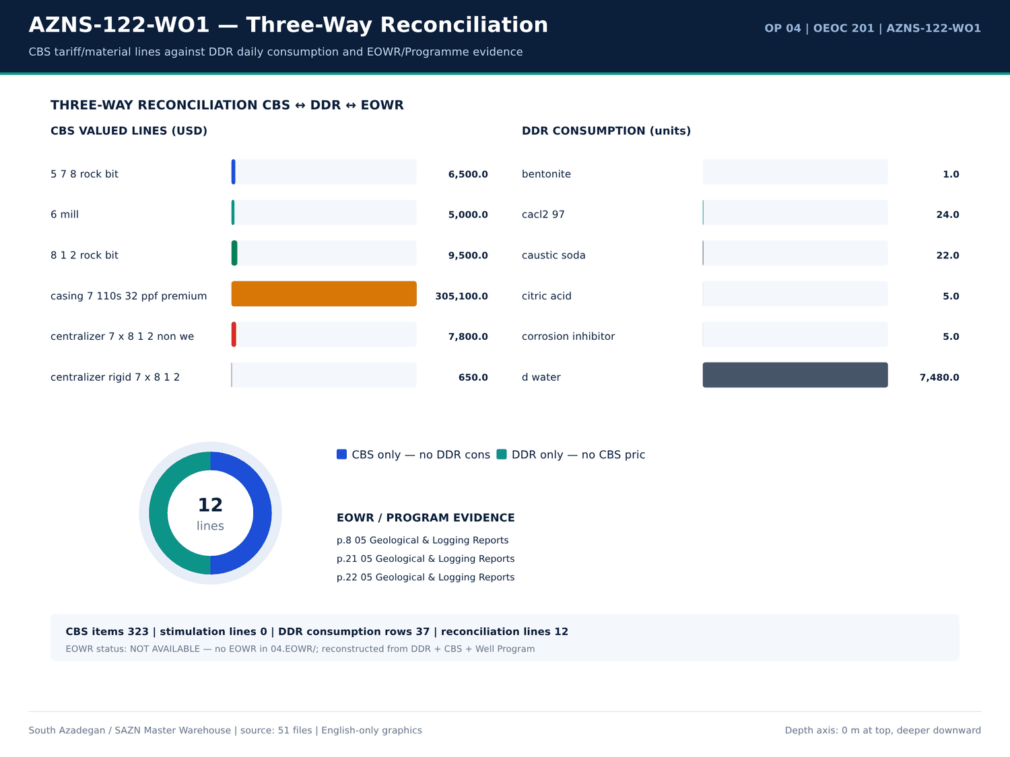
AZNS-122-WO1 06 reconciliation — source: SAZN master warehouse
Mud / cement / chemical consumption
Report | Material | Unit | Received | Used | Stock | Cell
1 | CEMENT ADD Gasoil Rig | Liter | — | — | 1,000.00 | A111
1 | CEMENT ADD Gasoil Camp | Liter | — | — | 700 | A112
1 | BULK Gasoil Camp | Liter | — | 700 | 13,600.00 | A112
1 | BULK D. Water | BBL | — | — | 1,250.00 | A113
2 | Bentonite | MT | — | 1 | 0 | A40
2 | Caustic Soda | 25 kg | — | 5 | 13 | A41
2 | Soda Ash (25 kg) | 25 kg | — | 5 | 13 | A42
2 | Salt | 1 MT | — | 23 | 43 | A44
2 | Starch LV (Green) | 55 lbs | — | 42 | 139 | A45
2 | Xanthan Gum (XC Pol.) | 25 kg | — | 6 | 32 | A47
2 | Limestone Powder | 1 MT | — | 164 | 84 | A49
2 | Lime | 25 kg | — | — | 48 | A50
2 | CEMENT ADD Gasoil Rig | Liter | — | — | 1,400.00 | A111
2 | CEMENT ADD Gasoil Camp | Liter | — | — | 600 | A112
2 | BULK Gasoil Camp | Liter | — | 600 | 13,000.00 | A112
2 | BULK D. Water | BBL | — | — | 1,400.00 | A113
3 | Caustic Soda | 25 kg | — | 2 | 11 | A41
3 | Soda Ash (25 kg) | 25 kg | — | 2 | 11 | A42
3 | Salt | 1 MT | — | 19 | 24 | A44
3 | Starch LV (Green) | 55 lbs | — | 20 | 119 | A45
3 | Xanthan Gum (XC Pol.) | 25 kg | — | — | 32 | A47
3 | Limestone Powder | 1 MT | 58 | 51 | 91 | A49

EOWR / Programme fluid facts
Fact key | Value | Unit | Page | Document
MUD_WEIGHT | 67 | pcf | 16 | Well Program/4.AZNS_122_Workover-1_Program.pdf
MUD_WEIGHT | 83 | pcf | 16 | Well Program/4.AZNS_122_Workover-1_Program.pdf
MUD_WEIGHT | 83 | pcf | 16 | Well Program/4.AZNS_122_Workover-1_Program.pdf
MUD_WEIGHT | 107 | pcf | 16 | Well Program/4.AZNS_122_Workover-1_Program.pdf
MUD_WEIGHT | 106 | pcf | 31 | Well Program/4.AZNS_122_Workover-1_Program.pdf
MUD_WEIGHT | 106 | pcf | 32 | Well Program/4.AZNS_122_Workover-1_Program.pdf
LOSS | 10 | bbl | 33 | Well Program/4.AZNS_122_Workover-1_Program.pdf
LOSS | 30 | bbl | 33 | Well Program/4.AZNS_122_Workover-1_Program.pdf
LOSS | 50 | bbl | 33 | Well Program/4.AZNS_122_Workover-1_Program.pdf
LOSS | 100 | bbl | 34 | Well Program/4.AZNS_122_Workover-1_Program.pdf
LOSS | 100 | bbl | 34 | Well Program/4.AZNS_122_Workover-1_Program.pdf
MUD_WEIGHT | 75 | pcf | 54 | Well Program/4.AZNS_122_Workover-1_Program.pdf

Numeric-cell provenance excerpt — chapter 11
Document | Sheet | Cell | Value
CBS/4.AZNS_122_WO1_CBS.xlsx | Cost Breakdown-122 | R190C7 | 4,587,374.50
DDRs/4.AZNS_122_WO1_DDR_Pack.xlsx | 1-2 Data | R11C4 | 3,447,673.00
DDRs/4.AZNS_122_WO1_DDR_Pack.xlsx | 2-2 Data | R11C4 | 3,447,673.00
DDRs/4.AZNS_122_WO1_DDR_Pack.xlsx | 3-2 Data | R11C4 | 3,447,673.00
DDRs/4.AZNS_122_WO1_DDR_Pack.xlsx | 4-2 Data | R11C4 | 3,447,673.00
DDRs/4.AZNS_122_WO1_DDR_Pack.xlsx | 5-2 Data | R11C4 | 3,447,673.00
DDRs/4.AZNS_122_WO1_DDR_Pack.xlsx | 6-2 Data | R11C4 | 3,447,673.00
DDRs/4.AZNS_122_WO1_DDR_Pack.xlsx | 7-2 Data | R11C4 | 3,447,673.00
DDRs/4.AZNS_122_WO1_DDR_Pack.xlsx | 8-2 Data | R11C4 | 3,447,673.00
DDRs/4.AZNS_122_WO1_DDR_Pack.xlsx | 9-2 Data | R11C4 | 3,447,673.00
DDRs/4.AZNS_122_WO1_DDR_Pack.xlsx | 10-2 Data | R11C4 | 3,447,673.00
DDRs/4.AZNS_122_WO1_DDR_Pack.xlsx | 11-2 Data | R11C4 | 3,447,673.00
DDRs/4.AZNS_122_WO1_DDR_Pack.xlsx | 12-2 Data | R11C4 | 3,447,673.00
DDRs/4.AZNS_122_WO1_DDR_Pack.xlsx | 13-2 Data | R11C4 | 3,447,673.00

Chapter 12 — Tripping, Hookload & Swab-Surge
Tripping, reaming, PU/SO/ROT hookload and swab-surge related activities are isolated by code and keyword from 2,804 activity rows. Hours, phase and description are reproduced; hookload statistics come from labelled DDR parameter rows only. Any absent parameter is shown as '—'.
Tripping / reaming activity hours
Report | Phase | Code | Hours | Description
1 | — | 29 | 3 | Open top master valve. RIH w/ 3.4" Gauge ring to top of TR3SV. POOH to surface & L/D same. Apply 6500 psi Press to open TR3SV & hold
1 | — | — | — | same. Obs. The string press is constant; 1200 psi. Run & Set 3.688" Protection sleeve. POOH to surface.
2 | — | 29 | 3 | Open top master valve. RIH w/ 3.4" Gauge ring to top of TR3SV. POOH to surface & L/D same. Apply 6500 psi Press to open TR3SV & hold
2 | — | — | — | same. Run & Set 3.688" Protection sleeve. POOH to surface.
2 | — | 29 | 16 | Run 2.5" Gauge cutter to TR3SV; took Wt. POOH to surface. Increase CL Press f/ 6500 to 7500 psi & Pump 6 bbl Drill water (Pumping Press:
2 | — | — | — | 1000 psi). Run 2.5" Gauge cutter to TR3SV; Pass this depth. Cont. RIH to 3828 m. POOH to surface. RIH w/ shifting tools to 670m, Obs. Depth
2 | — | — | — | counter failed. POOH shifting tools to 90m (on depth counter). Obs increase in tension. Try several times and pass. Cont. POOH to surface and
2 | — | — | — | check tools, Obs. a slight mark on shifting tools. Calibrate depth counter and RIH with same shifting tools to SSD depth (3819m). Try to open
2 | — | — | — | SSD by jar down; Succ after several tries & Pass shifting tools. POOH to surface; Obs Shifting tools Ok.
8 | — | 29 | 8 | POOH pump out w/ 30-90 klbs over pull and L/D landing Jt, TBG HGR, Double Pin, 2 No. Pup Jt & 5 Jts 4-1/2" TBG. Cont. POOH completion
8 | — | 29 | 2 | Resume POOH completion string to 3750m while L/D totally 15 Jts 4-1/2" TBG till M.N. While Circ. CWH; NL-NG.
8 | — | 29 | 6 | Cont. POOH completion string to 3410m while L/D totally 51 Jts 4-1/2" TBG @ R.T. While Circ. CWH; NL-NG.
9 | — | 29 | 24 | Cont. POOH completion string f/ 3750 to 2720 m while L/D totally 126 Jts 4-1/2" TBG till MN. While Circ. CWH; NL-NG.
9 | — | 29 | 6 | Cont. POOH completion string to 2500m while L/D totally 148 Jts 4-1/2" TBG @ R.T. While Circ. CWH; NL-NG.
10 | — | 29 | 24 | Cont. POOH completion string f/ 2720 to 1560 m while L/D totally 249 Jts 4-1/2" TBG till MN. While Circ. CWH; 0-1 BPH Losses.
10 | — | 29 | 6 | Cont. POOH completion string to 1210m while L/D totally 287 Jts 4-1/2" TBG @ R.T. While Circ. CWH; 0-1 BPH Losses.
11 | — | 29 | 24 | Cont. POOH completion string f/ 1560 to 530 m while L/D totally 360 Jts 4-1/2" TBG till MN. While Circ. CWH; 0-1 BPH Losses.
11 | — | 29 | 6 | Cont. POOH completion string to 240 m while L/D totally 392 Jts 4-1/2" TBG @ R.T. While Circ. CWH; 0-1 BPH Losses.
12 | — | 29 | 7 | Cont. POOH completion string f/ 530 to 196 m while L/D totally 396 Jts 4-1/2" TBG. While Circ. CWH; 0-1 BPH Losses.
12 | — | 29 | 12 | Cont. POOH completion string f/ 196m to surface while L/D totally 16 Jts 3-1/2" TBG. While Circ. CWH; 0-1 BPH Losses.
12 | — | 3 | 3.5 | Set Wear Bushing in THS. Change elevator & Rig tong. P/U & M/U 6" R.Bit (Kingdream, Used, Open, 117, SN:210560JH), 7" Scraper, 4-3/4"
12 | — | — | — | B.Sub (Float in) & RIH w/ 9 Jts 4-3/4"DC, 3 Jts 3-1/2" HWDP to 85 m till M.N.

Hookload / PU-SO-ROT notes
Report | Sheet | Category | Text
24 | 24-1 Remark | SHORTAGE/REMARK | *** Due to well trajectory; Unable to pass 7" L.Lap W/O rotation, Off Btm TQ @ 3925m: 4-6 Klb.ft, String Up & Dn Hook load Differential
25 | 25-1 Remark | SHORTAGE/REMARK | 3- Due to well trajectory; Unable to pass 7" L.Lap W/O rotation, Off Btm TQ @ 3925m: 4-6 Klb.ft, String Up & Dn Hook load Differential
26 | 26-1 Remark | SHORTAGE/REMARK | 3- Due to well trajectory; Unable to pass 7" L.Lap W/O rotation, Off Btm TQ @ 3925m: 4-6 Klb.ft, String Up & Dn Hook load Differential
27 | 27-1 Remark | SHORTAGE/REMARK | 3- Due to well trajectory; Unable to pass 7" L.Lap W/O rotation, Off Btm TQ @ 3925m: 4-6 Klb.ft, String Up & Dn Hook load Differential
28 | 28-1 Remark | SHORTAGE/REMARK | 3- Due to well trajectory; Unable to pass 7" L.Lap W/O rotation, Off Btm TQ @ 3925m: 4-6 Klb.ft, String Up & Dn Hook load Differential
29 | 29-1 Remark | SHORTAGE/REMARK | 2- Due to well trajectory; Unable to pass 7" L.Lap W/O rotation, Off Btm TQ @ 3925m: 4-6 Klb.ft, String Up & Dn Hook load Differential
30 | 30-1 Remark | SHORTAGE/REMARK | 2- Due to well trajectory; Unable to pass 7" L.Lap W/O rotation, Off Btm TQ @ 3925m: 4-6 Klb.ft, String Up & Dn Hook load Differential
31 | 31-1 Remark | SHORTAGE/REMARK | 2- Due to well trajectory; Unable to pass 7" L.Lap W/O rotation, Off Btm TQ @ 3925m: 4-6 Klb.ft, String Up & Dn Hook load Differential
32 | 32-1 Remark | SHORTAGE/REMARK | 2- Due to well trajectory; Unable to pass 7" L.Lap W/O rotation, Off Btm TQ @ 3925m: 4-6 Klb.ft, String Up & Dn Hook load Differential
33 | 33-1 Remark | SHORTAGE/REMARK | 2- Due to well trajectory; Unable to pass 7" L.Lap W/O rotation, Off Btm TQ @ 3925m: 4-6 Klb.ft, String Up & Dn Hook load Differential
34 | 34-1 Remark | SHORTAGE/REMARK | 2- Due to well trajectory; Unable to pass 7" L.Lap W/O rotation, Off Btm TQ @ 3925m: 4-6 Klb.ft, String Up & Dn Hook load Differential
35 | 35-1 Remark | SHORTAGE/REMARK | 2- Due to well trajectory; Unable to pass 7" L.Lap W/O rotation, Off Btm TQ @ 3925m: 4-6 Klb.ft, String Up & Dn Hook load Differential
36 | 36-1 Remark | SHORTAGE/REMARK | 2- Due to well trajectory; Unable to pass 7" L.Lap W/O rotation, Off Btm TQ @ 3925m: 4-6 Klb.ft, String Up & Dn Hook load Differential
37 | 37-1 Remark | SHORTAGE/REMARK | 2- Due to well trajectory; Unable to pass 7" L.Lap W/O rotation, Off Btm TQ @ 3925m: 4-6 Klb.ft, String Up & Dn Hook load Differential
38 | 38-1 Remark | SHORTAGE/REMARK | 2- Due to well trajectory; Unable to pass 7" L.Lap W/O rotation, Off Btm TQ @ 3925m: 4-6 Klb.ft, String Up & Dn Hook load Differential
39 | 39-1 Remark | SHORTAGE/REMARK | 2- Due to well trajectory; Unable to pass 7" L.Lap W/O rotation, Off Btm TQ @ 3925m: 4-6 Klb.ft, String Up & Dn Hook load Differential
40 | 40-1 Remark | SHORTAGE/REMARK | 2- Due to well trajectory; Unable to pass 7" L.Lap W/O rotation, Off Btm TQ @ 3925m: 4-6 Klb.ft, String Up & Dn Hook load Differential
41 | 41-1 Remark | SHORTAGE/REMARK | 2- Due to well trajectory; Unable to pass 7" L.Lap W/O rotation, Off Btm TQ @ 3925m: 4-6 Klb.ft, String Up & Dn Hook load Differential
42 | 42-1 Remark | SHORTAGE/REMARK | 2- Due to well trajectory; Unable to pass 7" L.Lap W/O rotation, Off Btm TQ @ 3925m: 4-6 Klb.ft, String Up & Dn Hook load Differential
43 | 43-1 Remark | SHORTAGE/REMARK | 2- Due to well trajectory; Unable to pass 7" L.Lap W/O rotation, Off Btm TQ @ 3925m: 4-6 Klb.ft, String Up & Dn Hook load Differential
44 | 44-1 Remark | SHORTAGE/REMARK | 2- Due to well trajectory; Unable to pass 7" L.Lap W/O rotation, Off Btm TQ @ 3925m: 4-6 Klb.ft, String Up & Dn Hook load Differential
45 | 45-1 Remark | SHORTAGE/REMARK | 2- Due to well trajectory; Unable to pass 7" L.Lap W/O rotation, Off Btm TQ @ 3925m: 4-6 Klb.ft, String Up & Dn Hook load Differential

Time codes for tripping / reaming
Code | Category | Hours | Report
3 | Trip | 21.5 | 13
3 | Trip | 19 | 14
3 | Trip | 8.5 | 15
3 | Trip | 3.5 | 12
3 | Trip | 0 | 1
4 | Reaming & Hole Condition | 0 | 1
33 | Tubing Trips | 0 | 1
3 | Trip | 0 | 2
4 | Reaming & Hole Condition | 0 | 2
33 | Tubing Trips | 0 | 2
3 | Trip | 0 | 3
4 | Reaming & Hole Condition | 0 | 3
33 | Tubing Trips | 0 | 3
3 | Trip | 0 | 4
4 | Reaming & Hole Condition | 0 | 4
33 | Tubing Trips | 0 | 4
3 | Trip | 0 | 5
4 | Reaming & Hole Condition | 0 | 5
33 | Tubing Trips | 0 | 5
3 | Trip | 0 | 6
4 | Reaming & Hole Condition | 0 | 6
33 | Tubing Trips | 0 | 6

Numeric-cell provenance excerpt — chapter 12
Document | Sheet | Cell | Value
CBS/4.AZNS_122_WO1_CBS.xlsx | Cost Breakdown-122 | R190C7 | 4,587,374.50
DDRs/4.AZNS_122_WO1_DDR_Pack.xlsx | 1-2 Data | R11C4 | 3,447,673.00
DDRs/4.AZNS_122_WO1_DDR_Pack.xlsx | 2-2 Data | R11C4 | 3,447,673.00
DDRs/4.AZNS_122_WO1_DDR_Pack.xlsx | 3-2 Data | R11C4 | 3,447,673.00
DDRs/4.AZNS_122_WO1_DDR_Pack.xlsx | 4-2 Data | R11C4 | 3,447,673.00
DDRs/4.AZNS_122_WO1_DDR_Pack.xlsx | 5-2 Data | R11C4 | 3,447,673.00
DDRs/4.AZNS_122_WO1_DDR_Pack.xlsx | 6-2 Data | R11C4 | 3,447,673.00
DDRs/4.AZNS_122_WO1_DDR_Pack.xlsx | 7-2 Data | R11C4 | 3,447,673.00
DDRs/4.AZNS_122_WO1_DDR_Pack.xlsx | 8-2 Data | R11C4 | 3,447,673.00
DDRs/4.AZNS_122_WO1_DDR_Pack.xlsx | 9-2 Data | R11C4 | 3,447,673.00
DDRs/4.AZNS_122_WO1_DDR_Pack.xlsx | 10-2 Data | R11C4 | 3,447,673.00
DDRs/4.AZNS_122_WO1_DDR_Pack.xlsx | 11-2 Data | R11C4 | 3,447,673.00
DDRs/4.AZNS_122_WO1_DDR_Pack.xlsx | 12-2 Data | R11C4 | 3,447,673.00
DDRs/4.AZNS_122_WO1_DDR_Pack.xlsx | 13-2 Data | R11C4 | 3,447,673.00

Chapter 13 — Connection Time & Invisible Lost Time
Connection, survey, circulating and waiting codes are separated from productive drilling time. The tables give code, category, hours and report number so that invisible lost time can be recomputed; the sum is never forced to 24 h where the source DDR itself is incomplete.
Connection / circulating / waiting codes
Code | Category | Hours | Report
5 | Mud Circulation | 0 | 1
9 | Surveying | 0 | 1
13 | Wait on Cement | 0 | 1
28 | Wait on Day Light | 0 | 1
41 | Rig Waiting | 0 | 1
42 | Project waiting | 0 | 1
43 | Service Waiting | 0 | 1
44 | Client Waiting | 0 | 1
45 | Other Waiting | 0 | 1
5 | Mud Circulation | 0 | 2
9 | Surveying | 0 | 2
13 | Wait on Cement | 0 | 2
28 | Wait on Day Light | 0 | 2
41 | Rig Waiting | 0 | 2
42 | Project waiting | 0 | 2
43 | Service Waiting | 3 | 2
44 | Client Waiting | 0 | 2
45 | Other Waiting | 0 | 2
5 | Mud Circulation | 2 | 3
9 | Surveying | 0 | 3
13 | Wait on Cement | 0 | 3
28 | Wait on Day Light | 0 | 3

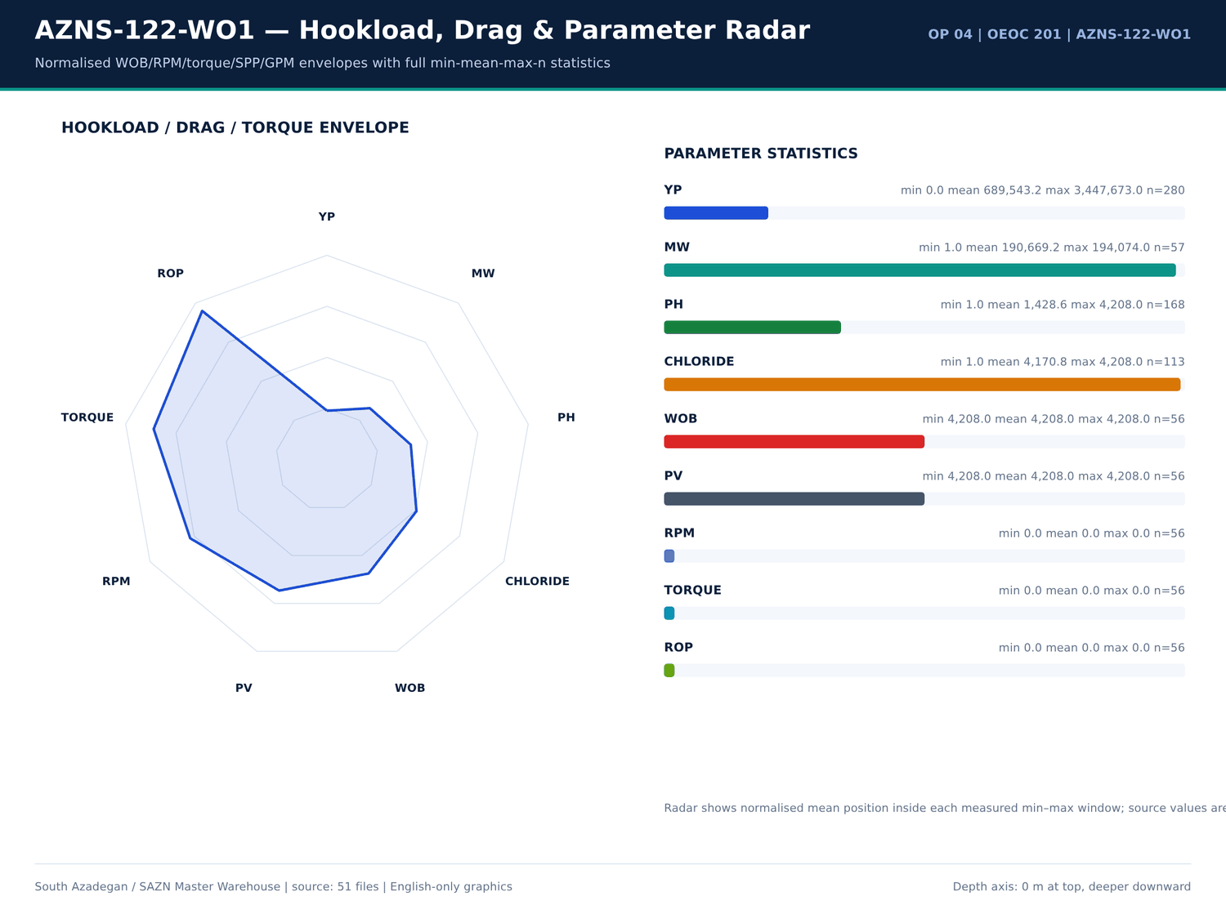
AZNS-122-WO1 07 hookload — source: SAZN master warehouse
Activity rows carrying connection wording
Report | Phase | Hours | Description
2 | — | 2 | In order to check connection between Ann & string; Bleed off Press f/ 1600 to 400 psi thru C/M on 1/16" Choke size to oil storage tank &
2 | — | 1.5 | In order to check connection between Ann & string; Pump & Rev. Circ. 20 bbl Drill water (Pumping Rate: 0.5 to 1 BPM, Pumping Press: 500
3 | — | 1.5 | In order to check connection between Ann & string; Pump & Rev. Circ. 20 bbl Drill water (Pumping Rate: 0.5 to 1 BPM, Pumping Press: 500
11 | — | — | *** Difficulty in opening cross coupling protectors & break out TBG connections causes delay in operation Due to Obs asphaltene skin-tight
12 | — | — | *** Difficulty in opening cross coupling protectors & break out TBG connections causes delay in operation Due to Obs asphaltene skin-tight
12 | — | — | on body of Tubings & Obs. Hi-Torque connections.
16 | — | 2.5 | Wait on client's decision while Change top rams f/ 7"Fix to 2-7/8"*5" VBR, P/T same to 7000 psi for 15min; OK., Install 11''wear bushing.
16 | — | 2 | Wait on client's decision while P/U & M/U 7-5/16''Polish mill(PPA co.) & RIH W/ 3 Jts 6-1/2''DC( JT by JT) + 3 STDs 4-3/4''DC to 115m.
16 | — | 5 | Wait on client's decision while Cont. RIH by 5''DPs to 1500m While F/U string every 15 STDs w/ NL-NG till M.N.
16 | — | — | Wait on client's decision for corrosion of 9-5/8''csg & next plan since 14:30 29-jan-24
16 | — | 6 | Wait on client's decision while Cont. RIH w/ 7-5/16'' polish mill f/ 1500 to 3650m While F/U string every 15 STDs w/ NL-NG @R.T.
17 | — | 6 | Wait on client's decision while Cont. RIH w/ 7-5/16'' polish mill f/ 1500 to 3778m While F/U string every 15 STDs w/ NL-NG
17 | — | 3 | Wait on client's decision while took wt @3778m , pass this point by rotation & pumping, Cont. RIH to 3780.25, Took wt,
17 | — | 3 | Wait on client's decision while C.B.U, Check BTM's sample, 104 PCF on return & same parameters W/ mud system.
17 | — | 3 | Wait on client's decision while Cont. Circ. Mud while decrease MW F/ 104 to 103 PCF, Flow check for 1 Hr, static.
17 | — | 9 | Wait on client's decision while POOH w/ 7-5/16''Polish mill F/ 3778m to 1000m W/ NL-NG till M.N.
17 | — | — | Wait on client's decision for corrosion of 9-5/8''csg & next plan since 14:30 29-jan-24
17 | — | 6 | wait on receive logging crew (cast log) while slow circ. Mud @ 1000m w/ NL-NG @R.T.
18 | — | 22 | Wait on receive logging crew (cast log) since 00:00, 31-01-2024 while slow circ. Mud @ 1000m w/ NL-NG @R.T.
18 | — | 2 | Wait on client's decision for corrosion of 9-5/8''csg & next plan while in order to run SN packer POOH w/ 7-5/16" polish mill f/1000m
18 | — | — | Wait on client's decision for corrosion of 9-5/8''csg & next plan since 14:30, 29-jan-24
18 | — | 2 | Wait on client's decision for corrosion of 9-5/8''csg & next plan while Cont. POOH w/ 7-5/16" polish mill f/100m to surf. while L/D 7-5/16"

PT / NPT daily hour balance
Report | Date | NPT (h) | PT (h) | Cum. cost (USD)
1 | 14/01/2024 | 0 | 15 | 23,000.00
2 | 15/01/2024 | 0 | 30 | 46,000.00
3 | 16/01/2024 | 0 | 30 | 69,000.00
4 | 17/01/2024 | 0 | 30 | 92,000.00
5 | 18/01/2024 | 0 | 30 | 115,000.00
6 | 19/01/2024 | 0 | 30 | 138,000.00
7 | 20/01/2024 | 0 | 30 | 161,000.00
8 | 21/01/2024 | 0 | 30 | 184,000.00
9 | 22/01/2024 | 0 | 30 | 207,000.00
10 | 23/01/2024 | 0 | 30 | 230,000.00
11 | 24/01/2024 | 0 | 30 | 253,000.00
12 | 25/01/2024 | 0 | 30 | 276,000.00
13 | 26/01/2024 | 0 | 30 | 299,000.00
14 | 27/01/2024 | 0 | 30 | 322,000.00
15 | 28/01/2024 | 0 | 30 | 345,000.00
16 | 29/01/2024 | 15.5 | 14.5 | 368,000.00
17 | 30/01/2024 | 30 | 0 | 391,000.00
18 | 30/01/2024 | 30 | 0 | 414,000.00
19 | 30/01/2024 | 30 | 0 | 437,000.00
20 | 30/01/2024 | 30 | 0 | 460,000.00
21 | 30/01/2024 | 30 | 0 | 483,000.00
22 | 30/01/2024 | 28 | 2 | 506,000.00

Numeric-cell provenance excerpt — chapter 13
Document | Sheet | Cell | Value
CBS/4.AZNS_122_WO1_CBS.xlsx | Cost Breakdown-122 | R190C7 | 4,587,374.50
DDRs/4.AZNS_122_WO1_DDR_Pack.xlsx | 1-2 Data | R11C4 | 3,447,673.00
DDRs/4.AZNS_122_WO1_DDR_Pack.xlsx | 2-2 Data | R11C4 | 3,447,673.00
DDRs/4.AZNS_122_WO1_DDR_Pack.xlsx | 3-2 Data | R11C4 | 3,447,673.00
DDRs/4.AZNS_122_WO1_DDR_Pack.xlsx | 4-2 Data | R11C4 | 3,447,673.00
DDRs/4.AZNS_122_WO1_DDR_Pack.xlsx | 5-2 Data | R11C4 | 3,447,673.00
DDRs/4.AZNS_122_WO1_DDR_Pack.xlsx | 6-2 Data | R11C4 | 3,447,673.00
DDRs/4.AZNS_122_WO1_DDR_Pack.xlsx | 7-2 Data | R11C4 | 3,447,673.00
DDRs/4.AZNS_122_WO1_DDR_Pack.xlsx | 8-2 Data | R11C4 | 3,447,673.00
DDRs/4.AZNS_122_WO1_DDR_Pack.xlsx | 9-2 Data | R11C4 | 3,447,673.00
DDRs/4.AZNS_122_WO1_DDR_Pack.xlsx | 10-2 Data | R11C4 | 3,447,673.00
DDRs/4.AZNS_122_WO1_DDR_Pack.xlsx | 11-2 Data | R11C4 | 3,447,673.00
DDRs/4.AZNS_122_WO1_DDR_Pack.xlsx | 12-2 Data | R11C4 | 3,447,673.00
DDRs/4.AZNS_122_WO1_DDR_Pack.xlsx | 13-2 Data | R11C4 | 3,447,673.00

Chapter 14 — Directional Survey, DLS & Tortuosity
Survey stations, inclination, azimuth, TVD and minimum-curvature DLS are reproduced per station. Maximum DLS is — deg/30m. Directional parameter windows (WOB, RPM, torque, SPP, GPM) come from labelled DDR rows and are listed with count, min, mean and max.
Directional survey stations
Report | MD (m) | Incl (deg) | Azi (deg) | TVD (m) | DLS (deg/30m) | Tool
No source rows for this query | — | — | — | — | — | —

Directional remarks
Report | Sheet | Category | Text
No source rows for this query | — | — | —

Daily KOP / directional header values
Report | Date | KOP1 | KOP2 | Hole size | Formation
1 | 14/01/2024 | — | — | 14/01/2024 | —
2 | 15/01/2024 | — | — | 14/01/2024 | —
3 | 16/01/2024 | — | — | 14/01/2024 | —
4 | 17/01/2024 | — | — | 14/01/2024 | —
5 | 18/01/2024 | — | — | 14/01/2024 | —
6 | 19/01/2024 | — | — | 14/01/2024 | —
7 | 20/01/2024 | — | — | 14/01/2024 | —
8 | 21/01/2024 | — | — | 14/01/2024 | —
9 | 22/01/2024 | — | — | 14/01/2024 | —
10 | 23/01/2024 | — | — | 14/01/2024 | —
11 | 24/01/2024 | — | — | 14/01/2024 | —
12 | 25/01/2024 | — | — | 14/01/2024 | —
13 | 26/01/2024 | — | — | 14/01/2024 | —
14 | 27/01/2024 | — | — | 14/01/2024 | —
15 | 28/01/2024 | — | — | 14/01/2024 | —
16 | 29/01/2024 | — | — | 14/01/2024 | —
17 | 30/01/2024 | — | — | 14/01/2024 | —
18 | 30/01/2024 | — | — | 14/01/2024 | —
19 | 30/01/2024 | — | — | 14/01/2024 | —
20 | 30/01/2024 | — | — | 14/01/2024 | —
21 | 30/01/2024 | — | — | 14/01/2024 | —
22 | 30/01/2024 | — | — | 14/01/2024 | —

Numeric-cell provenance excerpt — chapter 14
Document | Sheet | Cell | Value
CBS/4.AZNS_122_WO1_CBS.xlsx | Cost Breakdown-122 | R190C7 | 4,587,374.50
DDRs/4.AZNS_122_WO1_DDR_Pack.xlsx | 1-2 Data | R11C4 | 3,447,673.00
DDRs/4.AZNS_122_WO1_DDR_Pack.xlsx | 2-2 Data | R11C4 | 3,447,673.00
DDRs/4.AZNS_122_WO1_DDR_Pack.xlsx | 3-2 Data | R11C4 | 3,447,673.00
DDRs/4.AZNS_122_WO1_DDR_Pack.xlsx | 4-2 Data | R11C4 | 3,447,673.00
DDRs/4.AZNS_122_WO1_DDR_Pack.xlsx | 5-2 Data | R11C4 | 3,447,673.00
DDRs/4.AZNS_122_WO1_DDR_Pack.xlsx | 6-2 Data | R11C4 | 3,447,673.00
DDRs/4.AZNS_122_WO1_DDR_Pack.xlsx | 7-2 Data | R11C4 | 3,447,673.00
DDRs/4.AZNS_122_WO1_DDR_Pack.xlsx | 8-2 Data | R11C4 | 3,447,673.00
DDRs/4.AZNS_122_WO1_DDR_Pack.xlsx | 9-2 Data | R11C4 | 3,447,673.00
DDRs/4.AZNS_122_WO1_DDR_Pack.xlsx | 10-2 Data | R11C4 | 3,447,673.00
DDRs/4.AZNS_122_WO1_DDR_Pack.xlsx | 11-2 Data | R11C4 | 3,447,673.00
DDRs/4.AZNS_122_WO1_DDR_Pack.xlsx | 12-2 Data | R11C4 | 3,447,673.00
DDRs/4.AZNS_122_WO1_DDR_Pack.xlsx | 13-2 Data | R11C4 | 3,447,673.00

Chapter 15 — Well Control, Losses, LCM, Dry Test & MAASP
Losses, LCM pills, dry tests, bond tests, FIT/LOT and MAASP-related facts are extracted from DDR remarks and the EOWR / Programme text layer. 8 problem families include the loss-control evidence; each numeric fact carries its page number. Where a pressure-test value was not printed in the text layer it is not estimated.
Loss / LCM / well-control remarks
Report | Sheet | Category | Text
4 | 4-1 Remark | SHORTAGE/REMARK | Cont. Circ Thru String w/ 104 pcf mud, While Applying 1400 Psi Back Press During String Vol w/ Totally 15 bbl Losses & fixed SPP During
6 | 6-1 Remark | SHORTAGE/REMARK | to 300 psi; 0-10 BPH Losses (Totally loss during Circ.: 40 bbl)
10 | 10-1 Remark | SHORTAGE/REMARK | Cont. POOH completion string f/ 2720 to 1560 m while L/D totally 249 Jts 4-1/2" TBG till MN. While Circ. CWH; 0-1 BPH Losses.
10 | 10-1 Remark | SHORTAGE/REMARK | Cont. POOH completion string to 1210m while L/D totally 287 Jts 4-1/2" TBG @ R.T. While Circ. CWH; 0-1 BPH Losses.
11 | 11-1 Remark | SHORTAGE/REMARK | Cont. POOH completion string f/ 1560 to 530 m while L/D totally 360 Jts 4-1/2" TBG till MN. While Circ. CWH; 0-1 BPH Losses.
11 | 11-1 Remark | SHORTAGE/REMARK | Cont. POOH completion string to 240 m while L/D totally 392 Jts 4-1/2" TBG @ R.T. While Circ. CWH; 0-1 BPH Losses.
12 | 12-1 Remark | SHORTAGE/REMARK | Cont. POOH completion string f/ 530 to 196 m while L/D totally 396 Jts 4-1/2" TBG. While Circ. CWH; 0-1 BPH Losses.
12 | 12-1 Remark | SHORTAGE/REMARK | Cont. POOH completion string f/ 196m to surface while L/D totally 16 Jts 3-1/2" TBG. While Circ. CWH; 0-1 BPH Losses.
12 | 12-1 Remark | SHORTAGE/REMARK | Cont. RIH w/ 5" DPs f/ 145 to 435 m, F/U string & Break Circ. Every 5 Stds; 0-1 BPH Losses.
13 | 13-1 Remark | SHORTAGE/REMARK | Cont. RIH w/ 5" DPs f/ 145 to 435 m, F/U string & Break Circ. Every 5 Stds; 0-1 BPH Losses.
13 | 13-1 Remark | SHORTAGE/REMARK | Cont. RIH w/ 5" DPs Jt by Jt f/ 435 to 720 m, F/U string & Break Circ. Every 15 Jts; 0-1 BPH Losses.
13 | 13-1 Remark | SHORTAGE/REMARK | Cont. RIH w/ 5" DPs f/ 720 to 1290 m, F/U string & Break Circ. Every 15 Stds; 0-1 BPH Losses.
13 | 13-1 Remark | SHORTAGE/REMARK | Cont. RIH w/ 5" DPs Jt by Jt f/ 1290 to 1550 m, F/U string & Break Circ. Every 15 Jts; 0-1 BPH Losses.
13 | 13-1 Remark | SHORTAGE/REMARK | Losses. While Scrape 9-5/8" CSG.
13 | 13-1 Remark | SHORTAGE/REMARK | Losses. While Scrape 9-5/8" CSG & 7" LNR. Pass 7" L.Lap @ 3782m. Took Wt @ 3926m, Try to W/D several times; No-Succ.
14 | 14-1 Remark | SHORTAGE/REMARK | Break Circ. Every 15 Stds; 0-1 BPH Losses. While Scrape 9-5/8" CSG & 7" LNR. Pass 7" L.Lap @ 3782m. Took Wt @ 3926m, Try to W/D several
31 | 31-1 Remark | SHORTAGE/REMARK | down by apply Max 40 klbs Wt. on fish; No-Succ. Pump Hi-Vis pill periodically; 0-2 BPH Losses. Stall string several times.
31 | 31-1 Remark | SHORTAGE/REMARK | Clean the hole till M.N; 1-2 BPH Losses.
31 | 31-1 Remark | SHORTAGE/REMARK | Commence POOH w/ 6" M.M.J Mill & milling BHA pump out f/ 3968 to 3775 m. 1-2 BPH Losses.
32 | 32-1 Remark | SHORTAGE/REMARK | 3775 m (7" L.Lap). 1-2 BPH Losses.
34 | 34-1 Remark | SHORTAGE/REMARK | Fish dropped. Soft wash & Ream Dn f/ 4083 to 4148.5m; 1-2 BPH Losses.
34 | 34-1 Remark | SHORTAGE/REMARK | Resume Milling the fish f/ 4148.5 to 4150m (Top of CMT, Tail of fish completely milled.); 1-2 BPH Losses.

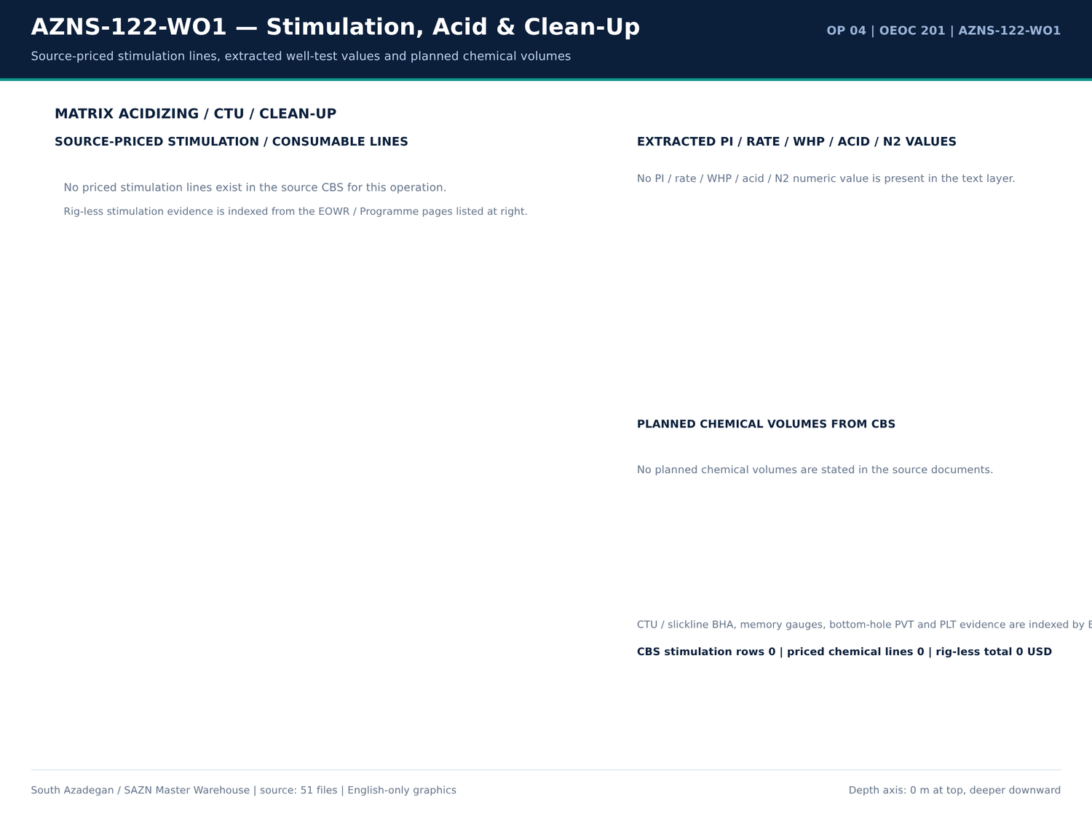
AZNS-122-WO1 08 acid — source: SAZN master warehouse
Pressure / FIT / LOT / loss facts
Fact key | Value | Unit | Page | Document | Context
LOSS | 10 | bbl | 33 | Well Program/4.AZNS_122_Workover-1_Program.pdf | material to act as bridging agents. Seepage losses Less than 10 bbl/hr. No specific action will be taken, but c
LOSS | 30 | bbl | 33 | Well Program/4.AZNS_122_Workover-1_Program.pdf | nitoring of the probable loss rate is made. Losses from 10-30 bbl/hr. ➢ Load CaCO3-M (150-300 micron) in syst
LOSS | 50 | bbl | 33 | Well Program/4.AZNS_122_Workover-1_Program.pdf | ppb CaCO3 150-300μ & 7-10 ppb CaCO3 600μ Losses from 30-50 bbl/hr. ➢ Load CaCO3-M (150-300 micron) in syst
LOSS | 100 | bbl | 34 | Well Program/4.AZNS_122_Workover-1_Program.pdf | SAC P IIF122 DR DE PRG 0001 07 Losses from 50-100 bbl/hr. ➢ Load CaCO3-M (150-300 micron) in syst
LOSS | 100 | bbl | 34 | Well Program/4.AZNS_122_Workover-1_Program.pdf | Oyster Shell -F • 5-10 pbb Oyster Shell -M Losses more than 100 bbl/hr. High concentrated LCM pill of various s

Problem families with loss evidence
Category | Hours | Depth (m) | Formation | Cost (USD) | Detail
Stuck pipe / fishing / milling | 342.5 | 4,208.00 | — | 328,229.17 | Wait on client's decision while P/U & M/U 7-5/16''Polish mill(PPA co.) & RIH W/ 3 Jts 6-1/2''DC( JT by JT) + 3 STDs 4-3/4''DC to 115m. | Wait on client's decision while Cont. RIH w/ 7-5/16'' polish mill f/ 1500 to 3650m While F/U string …
Other operational delay | 200.5 | 4,208.00 | — | 192,145.83 | CBU & clean the hole by 25 bbl Hi-Vis pill, NL-NG. | Cont. RIH follow by 5'' DPs f/ 480 to 1400m while F/U string, NL-NG. | Cont. RIH follow by 5'' DPs f/ 480 to 3775.4m (7" L.Lap) while F/U string & Break Circ. Every 15 Stds; NL-NG.
Waiting on services / material | 169.5 | 4,208.00 | — | 162,437.50 | Wait on client's decision while Change top rams f/ 7"Fix to 2-7/8"*5" VBR, P/T same to 7000 psi for 15min; OK., Install 11''wear bushing. | Wait on client's decision while Cont. RIH by 5''DPs to 1500m While F/U string every 15 STDs w/ NL…
Lost circulation / fluid losses | 163 | 4,208.00 | — | 156,208.33 | Commence POOH w/ 6" M.M.J Mill & milling BHA pump out f/ 3968 to 3775 m. 1-2 BPH Losses. | Fish dropped. Soft wash & Ream Dn f/ 4083 to 4148.5m; 1-2 BPH Losses. | Resume Milling the fish f/ 4148.5 to 4150m (Top of CMT, Tail of fish compl…
Completion / stimulation | 33.5 | 4,208.00 | — | 32,104.17 | Held PJSM, P/U & M/U 7" Seal Nipple (PPA, 29#, C-110, TPCQ), Dressed w/ 4 Set V-Packing & RIH w/ 2 Jts 7" LNR (29#, L-80, TPCQ), | Held PJSM, P/U & M/U 7" Seal Nipple (PPA, 29#, C-110, TPCQ), Dressed w/ 4 Set V-Packing & RIH w/ 2 Jts 7" …
Rig equipment failure | 13 | 4,208.00 | — | 12,458.33 | While Wait on client's decision for corrosion of 9-5/8''csg & next plan, Circ. BTM's up till clean the shakers, NL-NG. | While Wait on client's decision for corrosion of 9-5/8''csg & next plan, Cont. Circ. BTM's up till clean the shakers…
Shale instability / hole condition | 6.5 | 4,208.00 | — | 6,229.17 | Took Wt @ 3967 m (1 m Off-BTM). While Wash, Ream last Std & Pump 30 bbl Hi-Vis Pill. Hard Wash & Ream Dn to 3968m (TOF). Commence | Took Wt @ 3967 m (1 m Off-BTM). While Wash, Ream last Std & Pump 30 bbl Hi-Vis Pill. Hard Wash & Ream Dn …
Well control / gas / H2S | 0 | 4,208.00 | — | 0 | *** H2S service (Bonyan Iman Co) released @ 07-Mar-2024, 18:00. | *** H2S service (Bonyan Iman Co) released @ 07-Mar-2024, 18:00. | *** H2S service (Bonyan Iman Co) released @ 07-Mar-2024, 18:00.

Numeric-cell provenance excerpt — chapter 15
Document | Sheet | Cell | Value
CBS/4.AZNS_122_WO1_CBS.xlsx | Cost Breakdown-122 | R190C7 | 4,587,374.50
DDRs/4.AZNS_122_WO1_DDR_Pack.xlsx | 1-2 Data | R11C4 | 3,447,673.00
DDRs/4.AZNS_122_WO1_DDR_Pack.xlsx | 2-2 Data | R11C4 | 3,447,673.00
DDRs/4.AZNS_122_WO1_DDR_Pack.xlsx | 3-2 Data | R11C4 | 3,447,673.00
DDRs/4.AZNS_122_WO1_DDR_Pack.xlsx | 4-2 Data | R11C4 | 3,447,673.00
DDRs/4.AZNS_122_WO1_DDR_Pack.xlsx | 5-2 Data | R11C4 | 3,447,673.00
DDRs/4.AZNS_122_WO1_DDR_Pack.xlsx | 6-2 Data | R11C4 | 3,447,673.00
DDRs/4.AZNS_122_WO1_DDR_Pack.xlsx | 7-2 Data | R11C4 | 3,447,673.00
DDRs/4.AZNS_122_WO1_DDR_Pack.xlsx | 8-2 Data | R11C4 | 3,447,673.00
DDRs/4.AZNS_122_WO1_DDR_Pack.xlsx | 9-2 Data | R11C4 | 3,447,673.00
DDRs/4.AZNS_122_WO1_DDR_Pack.xlsx | 10-2 Data | R11C4 | 3,447,673.00
DDRs/4.AZNS_122_WO1_DDR_Pack.xlsx | 11-2 Data | R11C4 | 3,447,673.00
DDRs/4.AZNS_122_WO1_DDR_Pack.xlsx | 12-2 Data | R11C4 | 3,447,673.00
DDRs/4.AZNS_122_WO1_DDR_Pack.xlsx | 13-2 Data | R11C4 | 3,447,673.00

Chapter 16 — Casing, Cement & CBL-VDL-USIT
Casing tallies list size, grade, weight, thread, from/to depth, burst and collapse from DDR casing sheets. Cement design, lab and job pages, TOC, and CBL-VDL-USIT bond facts are indexed by EOWR/Programme page. Completion equipment from CBS priced lines is matched to the pressure-test facts for the same well.
Casing tally
Report | Size (in) | Grade | Weight | Thread | From (m) | To (m) | Burst | Collapse
No source rows for this query | — | — | — | — | — | — | — | —

Cement / bond / TOC facts
Fact key | Value | Unit | Page | Document | Context
No source rows for this query | — | — | — | — | —

Cement / casing / CBL numbered tables
Document | Page | Table no | Title | Category
Well Program/4.AZNS_122_Workover-1_Program.pdf | 18 | 7 | Casing & Liner Data | PROGRAM

Numeric-cell provenance excerpt — chapter 16
Document | Sheet | Cell | Value
CBS/4.AZNS_122_WO1_CBS.xlsx | Cost Breakdown-122 | R190C7 | 4,587,374.50
DDRs/4.AZNS_122_WO1_DDR_Pack.xlsx | 1-2 Data | R11C4 | 3,447,673.00
DDRs/4.AZNS_122_WO1_DDR_Pack.xlsx | 2-2 Data | R11C4 | 3,447,673.00
DDRs/4.AZNS_122_WO1_DDR_Pack.xlsx | 3-2 Data | R11C4 | 3,447,673.00
DDRs/4.AZNS_122_WO1_DDR_Pack.xlsx | 4-2 Data | R11C4 | 3,447,673.00
DDRs/4.AZNS_122_WO1_DDR_Pack.xlsx | 5-2 Data | R11C4 | 3,447,673.00
DDRs/4.AZNS_122_WO1_DDR_Pack.xlsx | 6-2 Data | R11C4 | 3,447,673.00
DDRs/4.AZNS_122_WO1_DDR_Pack.xlsx | 7-2 Data | R11C4 | 3,447,673.00
DDRs/4.AZNS_122_WO1_DDR_Pack.xlsx | 8-2 Data | R11C4 | 3,447,673.00
DDRs/4.AZNS_122_WO1_DDR_Pack.xlsx | 9-2 Data | R11C4 | 3,447,673.00
DDRs/4.AZNS_122_WO1_DDR_Pack.xlsx | 10-2 Data | R11C4 | 3,447,673.00
DDRs/4.AZNS_122_WO1_DDR_Pack.xlsx | 11-2 Data | R11C4 | 3,447,673.00
DDRs/4.AZNS_122_WO1_DDR_Pack.xlsx | 12-2 Data | R11C4 | 3,447,673.00
DDRs/4.AZNS_122_WO1_DDR_Pack.xlsx | 13-2 Data | R11C4 | 3,447,673.00

Chapter 17 — Workover, Fishing & Milling
Fishing, milling, whipstock, sidetrack-window and re-entry activities are isolated from the 24-h log. For AZNS-122-WO1 the operation class is recorded in the dossier; the tables reproduce the matching activity rows, notes and EOWR workover-section pages. Operation 4 has no EOWR and is analysed from DDR + CBS + Programme only.
Fishing / milling / sidetrack activities
Report | Phase | Code | Hours | Description
16 | — | 44 | 2 | Wait on client's decision while P/U & M/U 7-5/16''Polish mill(PPA co.) & RIH W/ 3 Jts 6-1/2''DC( JT by JT) + 3 STDs 4-3/4''DC to 115m.
16 | — | 44 | 6 | Wait on client's decision while Cont. RIH w/ 7-5/16'' polish mill f/ 1500 to 3650m While F/U string every 15 STDs w/ NL-NG @R.T.
17 | — | 44 | 6 | Wait on client's decision while Cont. RIH w/ 7-5/16'' polish mill f/ 1500 to 3778m While F/U string every 15 STDs w/ NL-NG
17 | — | 44 | 9 | Wait on client's decision while POOH w/ 7-5/16''Polish mill F/ 3778m to 1000m W/ NL-NG till M.N.
18 | — | 44 | 2 | Wait on client's decision for corrosion of 9-5/8''csg & next plan while in order to run SN packer POOH w/ 7-5/16" polish mill f/1000m
18 | — | 44 | 2 | Wait on client's decision for corrosion of 9-5/8''csg & next plan while Cont. POOH w/ 7-5/16" polish mill f/100m to surf. while L/D 7-5/16"
18 | — | — | — | Polish mill, Obs. Mark of LG on same, Circ. Across Wellhead; NL-NG.
19 | — | 44 | 2 | Wait on client's decision for corrosion of 9-5/8''csg & next plan while Cont. POOH w/ 7-5/16" polish mill f/100m to surf. while L/D
19 | — | — | — | 7-5/16 'Polish mill, Obs. Mark of LG on same, Circ. Across Wellhead; NL-NG.
20 | — | 44 | 2 | While Wait on client's decision for corrosion of 9-5/8''csg & next plan, P/U & M/U 6"Junk mill metal Munchure (New, T.S.E.KH Co. ,
20 | — | 44 | 9 | While Wait on client's decision for corrosion of 9-5/8''csg & next plan, Cont. RIH W/ 6"M.M J.Mill & clean out BHA follow by 5" DPs to
20 | — | 44 | 3 | While Wait on client's decision for corrosion of 9-5/8''csg & next plan, Cont. RIH W/ 6"M.M J.Mill f/2600 to3750m while F/U string
20 | — | 44 | 2 | While Wait on client's decision for corrosion of 9-5/8''csg & next plan, stablish circ., cont RIH W/ 6"M.M J.Mill f/3750 to37775.4 ( new
20 | — | 44 | 1 | While Wait on client's decision for corrosion of 9-5/8''csg & next plan, Cont. RIH W/ 6"M.M J.Mill to 3922m, stablish circ. Wash down to
21 | — | 44 | 3 | While Wait on client's decision for corrosion of 9-5/8''csg & next plan, Cont. RIH W/ 6"M.M J.Mill f/ 2600m to 3775.4m meanwhile
21 | — | 44 | 4 | While Wait on client's decision for corrosion of 9-5/8''csg & next plan, cont RIH W/ 6"M.M J.Mill to 3923.7m, try to wash down, No wash,
21 | — | 44 | 1 | While Wait on client's decision for corrosion of 9-5/8''csg & next plan, POOH W/ 6"M.M J.Mill to 3770m (above New 7"L.Lap)
21 | — | 44 | 2 | While Wait on client's decision for corrosion of 9-5/8''csg & next plan, Run back W/ 6"M.M J.Mill to 3775.4m(New 7"L.Lap), Took wt,
21 | — | 44 | 7 | While Wait on client's decision for corrosion of 9-5/8''csg & next plan, POOH W/ 6"M.M J.Mill f/3928.5m to 1750m meanwhile circ.
21 | — | 44 | 3.5 | While Wait on client's decision for corrosion of 9-5/8''csg & next plan, cont. POOH W/ 6"M.M J.Mill f/1750m to 200m (BHA Depth).
21 | — | 44 | 1.5 | While Wait on client's decision for corrosion of 9-5/8''csg & next plan, cont. POOH W/ 6"M.M J.Mill F/200m to surf., L/D 6"M.M J.Mill
21 | — | 44 | 0.5 | While Wait on client's decision for corrosion of 9-5/8''csg & next plan, P/U & M/U 7-5/16'' Dress Mill(PPA co., Used, 4*16/32" port) &

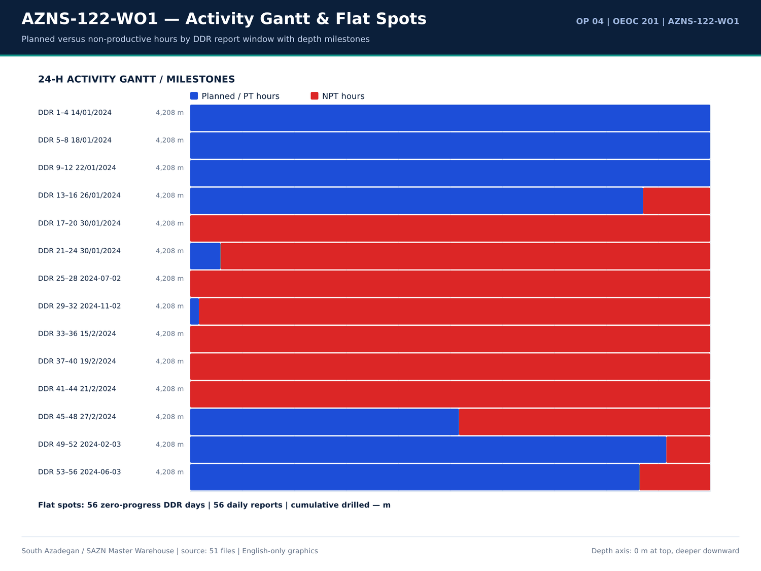
AZNS-122-WO1 09 gantt — source: SAZN master warehouse
Workover / fishing notes
Report | Sheet | Category | Text
24 | 24-1 Remark | SHORTAGE/REMARK | *** All the time monitor pit level carefully while milling.
28 | 28-1 Remark | SHORTAGE/REMARK | sideport, tools ID: 3/4") & RIH w/ 4-3/4" D.Box + 4-3/4" D.Pin + 4-3/4" B.Sub + 1 Jt 4-3/4" DC + 4-3/4" Fishing jar + 5 Stds 4-3/4" DC + 1 Std 3-1/2"
28 | 28-1 Remark | SHORTAGE/REMARK | Cont RIH w/ 4-1/4" Taper tap & Fishing BHA f/ 3000 to 3935.6m, F/U string every 10 Stds & break Circ, NL-NG.
28 | 28-1 Remark | SHORTAGE/REMARK | While wait on client's decision for corrosion of 9-5/8'' Csg & next plan, Cont POOH w/ 6" M.M.J Mill to surface. L/D J.Mill. P/U & M/U 4-1/4" Taper tap & RIH w/ Fishing BHA to 3000m , NL-NG.
29 | 29-1 Remark | SHORTAGE/REMARK | Wait on client's decision for corrosion of 9-5/8'' Csg & next plan, Cont RIH w/ 4-1/4" Taper tap & Fishing BHA f/ 3000 to 3935.6m, F/U string
29 | 29-1 Remark | SHORTAGE/REMARK | L/D fishing jar, 1 jt 4-3/4'' DC & taper tap, Fish not recovered. piece of PKR segment (dice) taped on taper tap, which caused engaging &
29 | 29-1 Remark | SHORTAGE/REMARK | While wait on client's decision for corrosion of 9-5/8'' Csg & next plan, Cont RIH w/ 4-1/4" Taper tap & Fishing BHA f/ 3000 to 3935.6m, Tag TOF @ 3565.6m. Clean TOF. Work on fish, Obs drop fish to 3945m, work on fish again, POOH chain o…
31 | 31-1 Remark | SHORTAGE/REMARK | down by apply Max 40 klbs Wt. on fish; No-Succ. Pump Hi-Vis pill periodically; 0-2 BPH Losses. Stall string several times.
31 | 31-1 Remark | SHORTAGE/REMARK | Commence POOH w/ 6" M.M.J Mill & milling BHA pump out f/ 3968 to 3775 m. 1-2 BPH Losses.
33 | 33-1 Remark | SHORTAGE/REMARK | Took weight; Unable to push Dn. Resume Mill/push Dn the fish f/ 4073 to 4080m till MN; NL-NG.
33 | 33-1 Remark | SHORTAGE/REMARK | *** Try to push Dn the fish by 40klbs several times; No-Succ. *** Pump Hi-Vis pill periodically.
33 | 33-1 Remark | SHORTAGE/REMARK | Cont. RIH w/ 6" M.M.J Mill & milling BHA f/ 2900 to 3968m (TOF), Commence milling f/ 3968 to 3969m, Fish dropped, Soft wash & Ream Dn f/ 3969 to 4070m, Obs. 5 bbl increase in pit level while connection. Circ. Thru choke manifold as BTMs …
34 | 34-1 Remark | SHORTAGE/REMARK | Fish dropped. Soft wash & Ream Dn f/ 4083 to 4148.5m; 1-2 BPH Losses.
34 | 34-1 Remark | SHORTAGE/REMARK | Resume Milling the fish f/ 4148.5 to 4150m (Top of CMT, Tail of fish completely milled.); 1-2 BPH Losses.
34 | 34-1 Remark | SHORTAGE/REMARK | Commence POOH pump out w/ 6" M.M.J.Mill & milling BHA f/ 4150 to 3775m (7" LNR Lap); 1-2 BPH Losses. Perform static flow check;
34 | 34-1 Remark | SHORTAGE/REMARK | Resume POOH w/ 6" M.M.J.Mill & milling BHA f/ 3775 to 800m, F/U the well; 0-1 BPH Losses.
34 | 34-1 Remark | SHORTAGE/REMARK | Cont. POOH w/ 6" M.M.J.Mill & milling BHA f/ 800 to 280m, F/U the well; 0-1 BPH Losses. Perform static flow check on BHA; 0-1 BPH Losses.
34 | 34-1 Remark | SHORTAGE/REMARK | Resume POOH w/ 6" M.M.J.Mill & milling BHA f/ 280m to surface, F/U the well; 0-1 BPH Losses. L/D Mill; 80% Used. Obs. A piece of CMT in one
35 | 35-1 Remark | SHORTAGE/REMARK | Resume POOH w/ 6" M.M.J.Mill & milling BHA f/ 280m to surface, F/U the well; 0-1 BPH Losses. L/D Mill; 80% Used. Obs. A piece of CMT in one
35 | 35-1 Remark | SHORTAGE/REMARK | Cont. RIH w/ 7-5/16" Polish mill & Followed by 5" DPs f/ 142 to 3775.4m. Pass L.Lap without drag. 0-1 BPH Losses.
35 | 35-1 Remark | SHORTAGE/REMARK | POOH 7-5/16" polish mill to 1850m till M.N, F/U the well, 0-1 BPH Losses.
35 | 35-1 Remark | SHORTAGE/REMARK | Cont. POOH 7-5/16" Polish mill f/ 1850 to 100m, F/U the well, 0-1 BPH Losses. Perform static flow check on BHA; 0-1 BPH Losses.

EOWR / Programme workover pages
Document | Page | Chapter | Characters | Images | Keywords
Well Program/4.AZNS_122_Workover-1_Program.pdf | 16 | 17 Casing / Mud / Completion Prog | 2040 | 4 | casing,cement,fish,mud,packer
Well Program/4.AZNS_122_Workover-1_Program.pdf | 19 | 09 Completion Tally & Tools | 903 | 9 | fish,formation,packer
Well Program/4.AZNS_122_Workover-1_Program.pdf | 20 | 09 Completion Tally & Tools | 901 | 9 | fish,formation,packer
Well Program/4.AZNS_122_Workover-1_Program.pdf | 36 | 02 Hole History & Dry Test | 1925 | 4 | casing,mud
Well Program/4.AZNS_122_Workover-1_Program.pdf | 37 | 02 Hole History & Dry Test | 1739 | 4 | casing
Well Program/4.AZNS_122_Workover-1_Program.pdf | 39 | 16 Programme & Prognosis | 773 | 4 | cement,fish
Well Program/4.AZNS_122_Workover-1_Program.pdf | 62 | 02 Hole History & Dry Test | 568 | 4 | mud

Numeric-cell provenance excerpt — chapter 17
Document | Sheet | Cell | Value
CBS/4.AZNS_122_WO1_CBS.xlsx | Cost Breakdown-122 | R190C7 | 4,587,374.50
DDRs/4.AZNS_122_WO1_DDR_Pack.xlsx | 1-2 Data | R11C4 | 3,447,673.00
DDRs/4.AZNS_122_WO1_DDR_Pack.xlsx | 2-2 Data | R11C4 | 3,447,673.00
DDRs/4.AZNS_122_WO1_DDR_Pack.xlsx | 3-2 Data | R11C4 | 3,447,673.00
DDRs/4.AZNS_122_WO1_DDR_Pack.xlsx | 4-2 Data | R11C4 | 3,447,673.00
DDRs/4.AZNS_122_WO1_DDR_Pack.xlsx | 5-2 Data | R11C4 | 3,447,673.00
DDRs/4.AZNS_122_WO1_DDR_Pack.xlsx | 6-2 Data | R11C4 | 3,447,673.00
DDRs/4.AZNS_122_WO1_DDR_Pack.xlsx | 7-2 Data | R11C4 | 3,447,673.00
DDRs/4.AZNS_122_WO1_DDR_Pack.xlsx | 8-2 Data | R11C4 | 3,447,673.00
DDRs/4.AZNS_122_WO1_DDR_Pack.xlsx | 9-2 Data | R11C4 | 3,447,673.00
DDRs/4.AZNS_122_WO1_DDR_Pack.xlsx | 10-2 Data | R11C4 | 3,447,673.00
DDRs/4.AZNS_122_WO1_DDR_Pack.xlsx | 11-2 Data | R11C4 | 3,447,673.00
DDRs/4.AZNS_122_WO1_DDR_Pack.xlsx | 12-2 Data | R11C4 | 3,447,673.00
DDRs/4.AZNS_122_WO1_DDR_Pack.xlsx | 13-2 Data | R11C4 | 3,447,673.00

Chapter 18 — Completion Tally & Pressure Tests
Completion tally rows are taken from CBS 20.1/20.2/20.3 material sheets and DDR casing records; TRSSSV, packer, anchor, SSD, expansion joint, nipples and CIV/CIM lines are listed with their priced quantities. Pressure-test facts from the EOWR / Programme text layer are tabulated with value, unit and page.
Completion material lines (CBS 20.x)
Sheet | Description | Unit | Qty | Unit price (USD) | Total (USD)
Cost Breakdown-122 | Corrosion Log for 7" Liner and 9 5/8” casing (MTT or MTD or EMDS) CCL/GR (after perforation) | JOB | 1 | 53,235.00 | 53,235.00
Cost Breakdown-Material-122 EW | Rotating liner hanger, hydraulic set, tandem cone, with integral/split, weight set top packer, 7" 29-32# x 9 5/8" 47-53.5#, L80-110S, PREMIUM connection, 10 ft PBR,load capacity 2,000KN, packer seal capacity 5000 psi, Temperature 150 oC | set | 1 | 31,200.00 | 31,200.00
Cost Breakdown-122 | Casing/tubing Running 4 1⁄2" | M | 3,800.00 | 6.5 | 24,700.00
Cost Breakdown-122 | Dry test services for 7 in liner | JOB | 1 | 13,875.00 | 13,875.00
Cost Breakdown-122 | Liner Top Packer Assembly, 7" 29-32#, L80, Premium connection, C/W Seal Nipple & Packer | SET | — | 1 | 12,000.00
Cost Breakdown-Material-122 EW | Liner Top Packer Assembly, 7" 29-32#, L80, Premium connection, C/W Seal Nipple & Packer | ea | 1 | 12,000.00 | 12,000.00
Cost Breakdown-122 | D.H Completion Inspection & repair Services (Lumpsum package for each well) DHSV, SSD, Traveling Joint, Production packer, etc. | Lumpsum | 1 | 5,000.00 | 5,000.00
Cost Breakdown-122 | Tubing Running 3 1⁄2" | M | 100 | 6.5 | 650
Cost Breakdown-Material-122 EW | Tubing, 4 1/2", L80, 18.9 ppf, Premium Conn., Seamless, R2, PSL3. | m | 0 | 75 | 0
Cost Breakdown-Material-122 EW | Tubing, 3 1/2", L80, 10.2 ppf, Premium Conn., seamless, R2, PSL3. | m | 0 | 40.5 | 0
Cost Breakdown-Material-122 EW | Liner Pup Joint, 7", 110S, 32 PPF, Gas Tight Conn, seamless, PSL3. | ea. | 0 | 250 | 0
Cost Breakdown-Material-122 EW | Tubing pup joint, 4 1/2", L-80 type 1, 18.9 PPF, Gas Tight Conn, seamless, 1.5m, PSL3. | ea. | 0 | 350 | 0
Cost Breakdown-Material-122 EW | Tubing pup joint, 3 1/2", L-80 type 1, 10.2 PPF, Gas Tight Conn, seamless, 1.5m long, PSL3. | ea. | 0 | 300 | 0
Cost Breakdown-Material-122 | Wellhead & Xmas tree Equipment | — | — | — | —
Cost Breakdown-Material-122 | Liner, 7", L80, 29 ppf, Gas Tight Conn.,Seamless, R3, PLS3 | m | — | — | —
Cost Breakdown-Material-122 | Liner, 5", L80 type 1, 18 PPF, premium flush connection, seamless, R3, PSL3. | m | — | — | —
Cost Breakdown-Material-122 | Liner, 4-1/2", L80 type 1, 13.5 PPF, BTC,seamless, R3, PSL3. | m | — | — | —
Cost Breakdown-Material-122 | Perforated Liner, 4 1/2", L80, 13.5 PPF, BTC, Hole size 10mm, 100holes/m, R3,PSL1. | — | — | — | —
Cost Breakdown-Material-122 | Tubing, 4 1/2", L80, 18.9 ppf, Premium Conn., Seamless, R2, PSL3. | m | — | 3,950.00 | —
Cost Breakdown-Material-122 | Tubing, 3 1/2", L80, 10.2 ppf, Premium Conn., seamless, R2, PSL3. | m | — | 110 | —
Cost Breakdown-Material-122 | Liner Pup Joint, 7", 110S, 32 PPF, Gas Tight Conn, seamless, PSL3. | ea. | — | — | —
Cost Breakdown-Material-122 | Liner Pup Joint, 7", L80, 29 ppf, Gas Tight Conn., Seamless, PLS3 | ea. | — | — | —

Pressure-test facts
Fact key | Value | Unit | Page | Document | Context
No source rows for this query | — | — | — | — | —

Completion / wellhead numbered tables
Document | Page | Table no | Title | Category
Well Program/4.AZNS_122_Workover-1_Program.pdf | 47 | 10 | AZNS Wellhead Information | PROGRAM
Well Program/4.AZNS_122_Workover-1_Program.pdf | 49 | 11 | AZNS 122 Wellhead Specification | PROGRAM

Numeric-cell provenance excerpt — chapter 18
Document | Sheet | Cell | Value
CBS/4.AZNS_122_WO1_CBS.xlsx | Cost Breakdown-122 | R190C7 | 4,587,374.50
DDRs/4.AZNS_122_WO1_DDR_Pack.xlsx | 1-2 Data | R11C4 | 3,447,673.00
DDRs/4.AZNS_122_WO1_DDR_Pack.xlsx | 2-2 Data | R11C4 | 3,447,673.00
DDRs/4.AZNS_122_WO1_DDR_Pack.xlsx | 3-2 Data | R11C4 | 3,447,673.00
DDRs/4.AZNS_122_WO1_DDR_Pack.xlsx | 4-2 Data | R11C4 | 3,447,673.00
DDRs/4.AZNS_122_WO1_DDR_Pack.xlsx | 5-2 Data | R11C4 | 3,447,673.00
DDRs/4.AZNS_122_WO1_DDR_Pack.xlsx | 6-2 Data | R11C4 | 3,447,673.00
DDRs/4.AZNS_122_WO1_DDR_Pack.xlsx | 7-2 Data | R11C4 | 3,447,673.00
DDRs/4.AZNS_122_WO1_DDR_Pack.xlsx | 8-2 Data | R11C4 | 3,447,673.00
DDRs/4.AZNS_122_WO1_DDR_Pack.xlsx | 9-2 Data | R11C4 | 3,447,673.00
DDRs/4.AZNS_122_WO1_DDR_Pack.xlsx | 10-2 Data | R11C4 | 3,447,673.00
DDRs/4.AZNS_122_WO1_DDR_Pack.xlsx | 11-2 Data | R11C4 | 3,447,673.00
DDRs/4.AZNS_122_WO1_DDR_Pack.xlsx | 12-2 Data | R11C4 | 3,447,673.00
DDRs/4.AZNS_122_WO1_DDR_Pack.xlsx | 13-2 Data | R11C4 | 3,447,673.00

Chapter 19 — Matrix Acidizing, CTU & Productivity Index
Rig-less stimulation families, planned chemical volumes, unit prices and acid / N2 / WHP / PI / rate facts are listed with page references. Pre/post-acid productivity comparisons are only made where both values exist in the source text; 27 reconciliation rows link CBS priced chemicals to DDR consumption.
Rig-less stimulation priced families
Sheet | Description | Unit | Volume | Unit price (USD) | Standby days | Operating days | Total (USD)
No source rows for this query | — | — | — | — | — | — | —

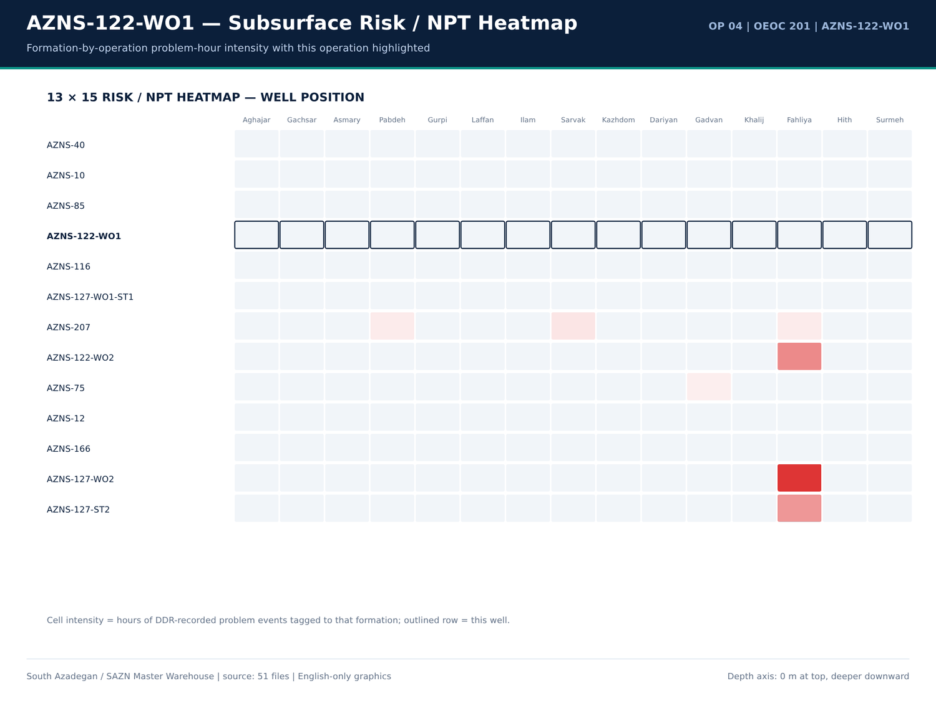
AZNS-122-WO1 10 risk — source: SAZN master warehouse
Acid / N2 / WHP / PI / rate facts
Fact key | Value | Unit | Page | Document | Context
No source rows for this query | — | — | — | — | —

Stimulation chemical lines from CBS
Sheet | Description | Unit | Qty | Total (USD)
Cost Breakdown-122 | Lifting with 400bbl Liquid Nitrogen | BBL | — | —
Cost Breakdown-122 | Nitrogen Unit Full Package | Day | — | —

Numeric-cell provenance excerpt — chapter 19
Document | Sheet | Cell | Value
CBS/4.AZNS_122_WO1_CBS.xlsx | Cost Breakdown-122 | R190C7 | 4,587,374.50
DDRs/4.AZNS_122_WO1_DDR_Pack.xlsx | 1-2 Data | R11C4 | 3,447,673.00
DDRs/4.AZNS_122_WO1_DDR_Pack.xlsx | 2-2 Data | R11C4 | 3,447,673.00
DDRs/4.AZNS_122_WO1_DDR_Pack.xlsx | 3-2 Data | R11C4 | 3,447,673.00
DDRs/4.AZNS_122_WO1_DDR_Pack.xlsx | 4-2 Data | R11C4 | 3,447,673.00
DDRs/4.AZNS_122_WO1_DDR_Pack.xlsx | 5-2 Data | R11C4 | 3,447,673.00
DDRs/4.AZNS_122_WO1_DDR_Pack.xlsx | 6-2 Data | R11C4 | 3,447,673.00
DDRs/4.AZNS_122_WO1_DDR_Pack.xlsx | 7-2 Data | R11C4 | 3,447,673.00
DDRs/4.AZNS_122_WO1_DDR_Pack.xlsx | 8-2 Data | R11C4 | 3,447,673.00
DDRs/4.AZNS_122_WO1_DDR_Pack.xlsx | 9-2 Data | R11C4 | 3,447,673.00
DDRs/4.AZNS_122_WO1_DDR_Pack.xlsx | 10-2 Data | R11C4 | 3,447,673.00
DDRs/4.AZNS_122_WO1_DDR_Pack.xlsx | 11-2 Data | R11C4 | 3,447,673.00
DDRs/4.AZNS_122_WO1_DDR_Pack.xlsx | 12-2 Data | R11C4 | 3,447,673.00
DDRs/4.AZNS_122_WO1_DDR_Pack.xlsx | 13-2 Data | R11C4 | 3,447,673.00

Chapter 20 — HSE, MTBF, Waste & Subcontractors
POB series, fuel/water consumption, waste rows, HSE chapter pages and contractor / service-company names are reproduced from DDR and EOWR. The accommodation and catering CBS lines are matched against the DDR POB totals rather than against an assumed headcount.
POB series
Report | Category | Count | Total
32 | BOP Drill | 2,024.00 | —
32 | Last BOP Test | 5 | —
32 | Last Chock Manifold Test | 5 | —
32 | Last Koomy Unit Test | 5 | —
32 | Last Burn Line Test | 2,024.00 | —
33 | BOP Drill | 2,024.00 | —
33 | Last BOP Test | 5 | —
33 | Last Chock Manifold Test | 5 | —
33 | Last Koomy Unit Test | 5 | —
33 | Last Burn Line Test | 2,024.00 | —
34 | BOP Drill | 2,024.00 | —
34 | Last BOP Test | 5 | —
34 | Last Chock Manifold Test | 5 | —
34 | Last Koomy Unit Test | 5 | —
34 | Last Burn Line Test | 2,024.00 | —
35 | BOP Drill | 2,024.00 | —
35 | Last BOP Test | 5 | —
35 | Last Chock Manifold Test | 5 | —
35 | Last Koomy Unit Test | 5 | —
35 | Last Burn Line Test | 2,024.00 | —
36 | BOP Drill | 2,024.00 | —
36 | Last BOP Test | 5 | —

Fuel / water / waste material rows
Report | Material | Unit | Received | Used | Stock | Cell
1 | BULK D. Water | BBL | — | — | 1,250.00 | A113
2 | BULK D. Water | BBL | — | — | 1,400.00 | A113
3 | CEMENT ADD D. Water | BBL | — | — | 300 | A113
3 | BULK D. Water | BBL | — | 300 | 1,100.00 | A113
4 | CEMENT ADD D. Water | BBL | — | — | 300 | A113
4 | BULK D. Water | BBL | — | 300 | 1,100.00 | A113
5 | CEMENT ADD D. Water | BBL | 300 | — | — | A113
5 | BULK D. Water | BBL | 300 | — | 1,400.00 | A113
6 | CEMENT ADD D. Water | BBL | 300 | — | — | A113
6 | BULK D. Water | BBL | 300 | — | 1,400.00 | A113
7 | CEMENT ADD D. Water | BBL | 300 | — | — | A113
7 | BULK D. Water | BBL | 300 | — | 1,100.00 | A113
8 | CEMENT ADD D. Water | BBL | 100 | — | — | A113
8 | BULK D. Water | BBL | 100 | — | 1,000.00 | A113
9 | BULK D. Water | BBL | — | — | 1,600.00 | A113
10 | BULK D. Water | BBL | — | — | 1,400.00 | A113
11 | BULK D. Water | BBL | — | — | 1,100.00 | A113
12 | BULK D. Water | BBL | — | — | 1,100.00 | A113
13 | BULK D. Water | BBL | — | — | 1,200.00 | A113
14 | CEMENT ADD D. Water | BBL | 300 | — | — | A113
14 | BULK D. Water | BBL | 300 | — | 1,600.00 | A113
15 | CEMENT ADD D. Water | BBL | — | — | 100 | A113

Catering / accommodation CBS lines
Sheet | Description | Qty | Unit | Rate | Total (USD)
No source rows for this query | — | — | — | — | —

Numeric-cell provenance excerpt — chapter 20
Document | Sheet | Cell | Value
CBS/4.AZNS_122_WO1_CBS.xlsx | Cost Breakdown-122 | R190C7 | 4,587,374.50
DDRs/4.AZNS_122_WO1_DDR_Pack.xlsx | 1-2 Data | R11C4 | 3,447,673.00
DDRs/4.AZNS_122_WO1_DDR_Pack.xlsx | 2-2 Data | R11C4 | 3,447,673.00
DDRs/4.AZNS_122_WO1_DDR_Pack.xlsx | 3-2 Data | R11C4 | 3,447,673.00
DDRs/4.AZNS_122_WO1_DDR_Pack.xlsx | 4-2 Data | R11C4 | 3,447,673.00
DDRs/4.AZNS_122_WO1_DDR_Pack.xlsx | 5-2 Data | R11C4 | 3,447,673.00
DDRs/4.AZNS_122_WO1_DDR_Pack.xlsx | 6-2 Data | R11C4 | 3,447,673.00
DDRs/4.AZNS_122_WO1_DDR_Pack.xlsx | 7-2 Data | R11C4 | 3,447,673.00
DDRs/4.AZNS_122_WO1_DDR_Pack.xlsx | 8-2 Data | R11C4 | 3,447,673.00
DDRs/4.AZNS_122_WO1_DDR_Pack.xlsx | 9-2 Data | R11C4 | 3,447,673.00
DDRs/4.AZNS_122_WO1_DDR_Pack.xlsx | 10-2 Data | R11C4 | 3,447,673.00
DDRs/4.AZNS_122_WO1_DDR_Pack.xlsx | 11-2 Data | R11C4 | 3,447,673.00
DDRs/4.AZNS_122_WO1_DDR_Pack.xlsx | 12-2 Data | R11C4 | 3,447,673.00
DDRs/4.AZNS_122_WO1_DDR_Pack.xlsx | 13-2 Data | R11C4 | 3,447,673.00

Chapter 21 — Deep Geology & Field Correlation
13 correlated formation tops join DDR prognosis/actual columns, EOWR tops and Programme prognosis tables. Structural delta is actual minus prognosis in metres; lithology, gas shows, H2S/CO2, fluorescence and CBL-VDL-USIT evidence are indexed by page. South Azadegan anticline correlation is established against the other 12 operations.
Formation tops: prognosis vs actual
Report | Formation | MD (m) | TVD (m) | Prognosis MD (m) | Prognosis TVD (m) | Lithology
1 | Aghajari | 1,095.90 | — | — | — | Surface S.St, Clst.
1 | Gachsaran | 1,095.90 | 1,461.00 | — | — | Anhy, RD Mrl, Gr Mrl
1 | Asmary | 1,461.00 | 1,728.00 | — | — | S.St, Lst
1 | Pabdeh | 1,728.00 | 2,196.00 | — | — | Mrl, Clst, Shale, cht
1 | Gurpi | 2,196.00 | 2,536.00 | — | — | Arg lst
1 | Ilam | 2,536.00 | 2,626.00 | — | — | Lst, Sh, Clst, Mrl
1 | Laffan | 2,626.00 | 2,633.00 | — | — | Clst, Lst
1 | Sarvak | 2,633.00 | 3,278.00 | — | — | Lst
1 | Kazhdomi | 3,278.00 | 3,481.00 | — | — | Lst
1 | Dariyan | 3,481.00 | 3,647.00 | — | — | Lst
1 | Gadvan | 3,647.00 | 3,937.00 | — | — | Lst, Clst, Arg Lst
1 | Fahliyan | 3,937.00 | 4,208.00 | — | — | Lst
1 | Total Depth | 4,208.00 | — | — | — | Lst
2 | Aghajari | 1,095.90 | — | — | — | Surface S.St, Clst.
2 | Gachsaran | 1,095.90 | 1,461.00 | — | — | Anhy, RD Mrl, Gr Mrl
2 | Asmary | 1,461.00 | 1,728.00 | — | — | S.St, Lst
2 | Pabdeh | 1,728.00 | 2,196.00 | — | — | Mrl, Clst, Shale, cht
2 | Gurpi | 2,196.00 | 2,536.00 | — | — | Arg lst
2 | Ilam | 2,536.00 | 2,626.00 | — | — | Lst, Sh, Clst, Mrl
2 | Laffan | 2,626.00 | 2,633.00 | — | — | Clst, Lst
2 | Sarvak | 2,633.00 | 3,278.00 | — | — | Lst
2 | Kazhdomi | 3,278.00 | 3,481.00 | — | — | Lst

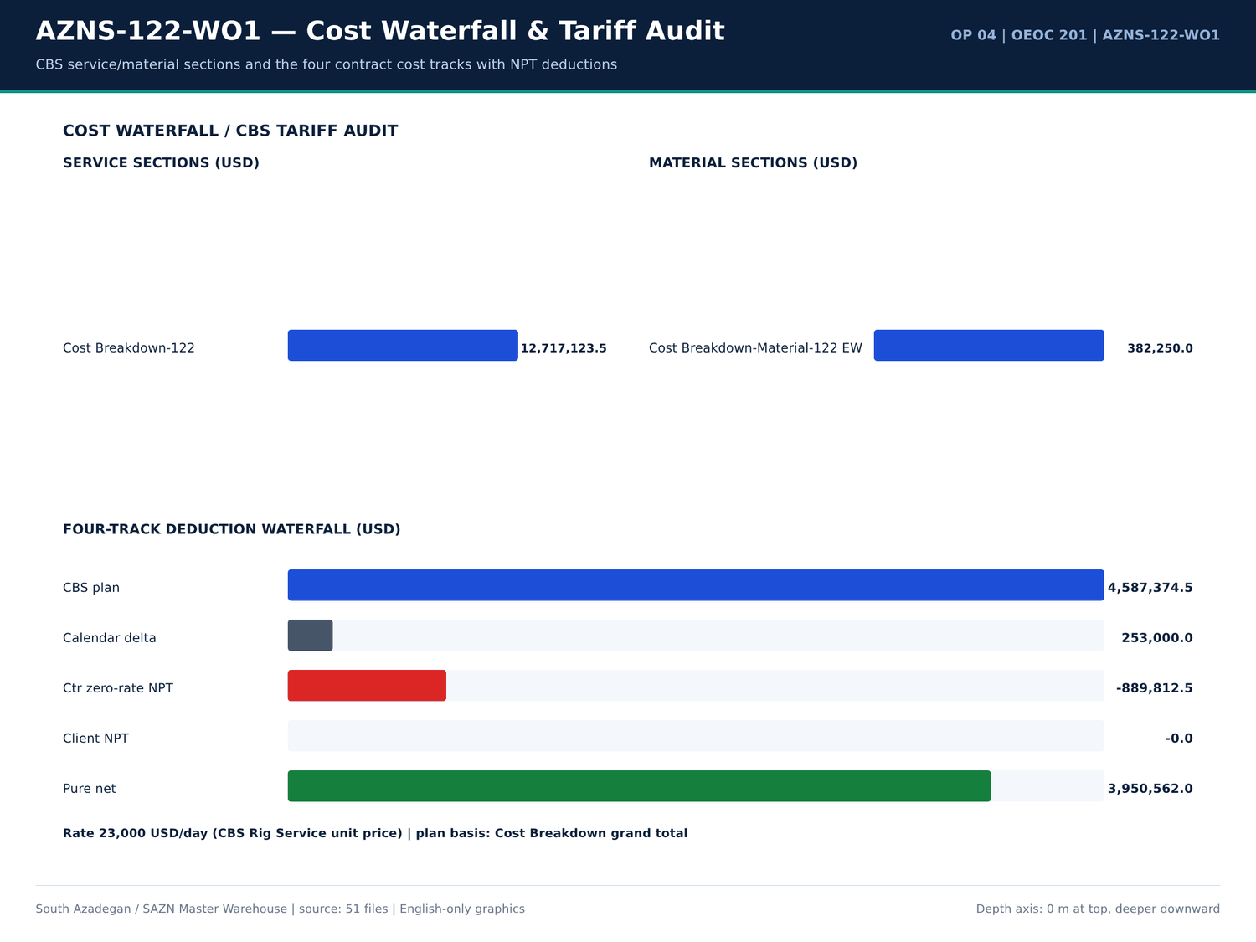
AZNS-122-WO1 11 cost — source: SAZN master warehouse
EOWR / Programme formation-top facts
Fact key | Value | Unit | Page | Document | Context
Fahliyan MD | 643 | m | 5 | Well Program/4.AZNS_122_Workover-1_Program.pdf | vertically down to the Cretaceous Fahliyan Formation with total depth of 4,643m. The results of this well, revealed th
Fahliyan MD | 2,008.00 | m | 5 | Well Program/4.AZNS_122_Workover-1_Program.pdf | parts of this huge field down to Fahliyan Formation. In the later stage the well No.10 assumed as exploration well for
Total Depth MD | 4,208.00 | m | 19 | Well Program/4.AZNS_122_Workover-1_Program.pdf | Formation Well Sketch & Completion Total Depth @ 4208mMD 0 500 m 1000 m 1500 m 2000 m Aghajari @ surface Gachsaran @ 111
Aghajari MD | 1,115.00 | m | 19 | Well Program/4.AZNS_122_Workover-1_Program.pdf | 08mMD 0 500 m 1000 m 1500 m 2000 m Aghajari @ surface Gachsaran @ 1115m Asmari @ 1461m Pabdeh @ 1728.3 m Gurpi @ 2196.5m
Gachsaran MD | 1,461.00 | m | 19 | Well Program/4.AZNS_122_Workover-1_Program.pdf | m 1500 m 2000 m Aghajari @ surface Gachsaran @ 1115m Asmari @ 1461m Pabdeh @ 1728.3 m Gurpi @ 2196.5m Ilam @ 2535.6m Sar
Asmary MD | 1,728.30 | m | 19 | Well Program/4.AZNS_122_Workover-1_Program.pdf | hajari @ surface Gachsaran @ 1115m Asmari @ 1461m Pabdeh @ 1728.3 m Gurpi @ 2196.5m Ilam @ 2535.6m Sarvak @ 2632.7m Kazh
Pabdeh MD | 2,196.50 | m | 19 | Well Program/4.AZNS_122_Workover-1_Program.pdf | e Gachsaran @ 1115m Asmari @ 1461m Pabdeh @ 1728.3 m Gurpi @ 2196.5m Ilam @ 2535.6m Sarvak @ 2632.7m Kazhdumi @ 3277.7m
Gurpi MD | 2,535.60 | m | 19 | Well Program/4.AZNS_122_Workover-1_Program.pdf | m Asmari @ 1461m Pabdeh @ 1728.3 m Gurpi @ 2196.5m Ilam @ 2535.6m Sarvak @ 2632.7m Kazhdumi @ 3277.7m Dariyan @ 3481m Ga
Ilam MD | 2,632.70 | m | 19 | Well Program/4.AZNS_122_Workover-1_Program.pdf | Pabdeh @ 1728.3 m Gurpi @ 2196.5m Ilam @ 2535.6m Sarvak @ 2632.7m Kazhdumi @ 3277.7m Dariyan @ 3481m Gadvan @ 3647.5m
Sarvak MD | 3,277.70 | m | 19 | Well Program/4.AZNS_122_Workover-1_Program.pdf | 3 m Gurpi @ 2196.5m Ilam @ 2535.6m Sarvak @ 2632.7m Kazhdumi @ 3277.7m Dariyan @ 3481m Gadvan @ 3647.5m 20" CSG @ 155 m
Kazhdomi MD | 3,481.00 | m | 19 | Well Program/4.AZNS_122_Workover-1_Program.pdf | 5m Ilam @ 2535.6m Sarvak @ 2632.7m Kazhdumi @ 3277.7m Dariyan @ 3481m Gadvan @ 3647.5m 20" CSG @ 155 mMD 13 3/8" CSG @
Dariyan MD | 3,647.50 | m | 19 | Well Program/4.AZNS_122_Workover-1_Program.pdf | arvak @ 2632.7m Kazhdumi @ 3277.7m Dariyan @ 3481m Gadvan @ 3647.5m 20" CSG @ 155 mMD 13 3/8" CSG @ 2169 mMD 9 5/8" CSG
Gadvan MD | 2,169.00 | m | 19 | Well Program/4.AZNS_122_Workover-1_Program.pdf | Kazhdumi @ 3277.7m Dariyan @ 3481m Gadvan @ 3647.5m 20" CSG @ 155 mMD 13 3/8" CSG @ 2169 mMD 9 5/8" CSG @ 3909.5 mMD 7
Fahliyan MD | 3,937.60 | m | 19 | Well Program/4.AZNS_122_Workover-1_Program.pdf | 3 1/2" * 4 1/2" Completion String Fahliyan @ 3937.6m Perfoation @ 4086 - 4101.25 m 4114 - 4120 m KOP @ 1416 mMD fish f
Total Depth MD | 4,208.00 | m | 20 | Well Program/4.AZNS_122_Workover-1_Program.pdf | Formation Well Sketch & Completion Total Depth @ 4208mMD 0 500 m 1000 m 1500 m 2000 m Aghajari @ surface Gachsaran @ 111
Aghajari MD | 1,115.00 | m | 20 | Well Program/4.AZNS_122_Workover-1_Program.pdf | 08mMD 0 500 m 1000 m 1500 m 2000 m Aghajari @ surface Gachsaran @ 1115m Asmari @ 1461m Pabdeh @ 1728.3 m Gurpi @ 2196.5m
Gachsaran MD | 1,461.00 | m | 20 | Well Program/4.AZNS_122_Workover-1_Program.pdf | m 1500 m 2000 m Aghajari @ surface Gachsaran @ 1115m Asmari @ 1461m Pabdeh @ 1728.3 m Gurpi @ 2196.5m Ilam @ 2535.6m Sar
Asmary MD | 1,728.30 | m | 20 | Well Program/4.AZNS_122_Workover-1_Program.pdf | hajari @ surface Gachsaran @ 1115m Asmari @ 1461m Pabdeh @ 1728.3 m Gurpi @ 2196.5m Ilam @ 2535.6m Sarvak @ 2632.7m Kazh
Pabdeh MD | 2,196.50 | m | 20 | Well Program/4.AZNS_122_Workover-1_Program.pdf | e Gachsaran @ 1115m Asmari @ 1461m Pabdeh @ 1728.3 m Gurpi @ 2196.5m Ilam @ 2535.6m Sarvak @ 2632.7m Kazhdumi @ 3277.7m
Gurpi MD | 2,535.60 | m | 20 | Well Program/4.AZNS_122_Workover-1_Program.pdf | m Asmari @ 1461m Pabdeh @ 1728.3 m Gurpi @ 2196.5m Ilam @ 2535.6m Sarvak @ 2632.7m Kazhdumi @ 3277.7m Dariyan @ 3481m Ga
Ilam MD | 2,632.70 | m | 20 | Well Program/4.AZNS_122_Workover-1_Program.pdf | Pabdeh @ 1728.3 m Gurpi @ 2196.5m Ilam @ 2535.6m Sarvak @ 2632.7m Kazhdumi @ 3277.7m Dariyan @ 3481m Gadvan @ 3647.5m
Sarvak MD | 3,277.70 | m | 20 | Well Program/4.AZNS_122_Workover-1_Program.pdf | 3 m Gurpi @ 2196.5m Ilam @ 2535.6m Sarvak @ 2632.7m Kazhdumi @ 3277.7m Dariyan @ 3481m Gadvan @ 3647.5m Fahliyan @ 3937

Gas / H2S / CO2 / CBL evidence
Fact key | Value | Unit | Page | Document | Context
H2S | 60 | — | 4 | Well Program/4.AZNS_122_Workover-1_Program.pdf | H2S MONITORING & PREVENTION MEASURE ........................................................ 60
H2S | 3,000.00 | PPM | 13 | Well Program/4.AZNS_122_Workover-1_Program.pdf | H2S in Gas at Atm condition 3000 PPM
Co2 | 50,000.00 | PPM | 13 | Well Program/4.AZNS_122_Workover-1_Program.pdf | Co2 in Gas at Atm Condition 50000 PPM
H2S | 0.5 | % | 32 | Well Program/4.AZNS_122_Workover-1_Program.pdf | H2S Scavenger Liquid into pits at concentration of 0.5%
H2S | 2 | — | 57 | Well Program/4.AZNS_122_Workover-1_Program.pdf | H2S in Sarvak, Kazhdumi and Gadvan reservoirs, Make detail H2
H2S | 10 | — | 60 | Well Program/4.AZNS_122_Workover-1_Program.pdf | H2S warning indicator: the first warning level is 10
H2S | 20 | — | 60 | Well Program/4.AZNS_122_Workover-1_Program.pdf | H2S content to operators. The second warning level is 20
H2S | 20 | — | 60 | Well Program/4.AZNS_122_Workover-1_Program.pdf | H2S content in air exceed 20
H2S | 2 | — | 60 | Well Program/4.AZNS_122_Workover-1_Program.pdf | H2S area shall be furnished with H2
H2S | 9.5 | — | 60 | Well Program/4.AZNS_122_Workover-1_Program.pdf | H2S area shall be kept over 9.5
H2S | 2 | — | 60 | Well Program/4.AZNS_122_Workover-1_Program.pdf | H2S concentration in drilling fluid. The H2
H2S | 2 | — | 61 | Well Program/4.AZNS_122_Workover-1_Program.pdf | H2S concentration should be measured in the places where H2

Numeric-cell provenance excerpt — chapter 21
Document | Sheet | Cell | Value
CBS/4.AZNS_122_WO1_CBS.xlsx | Cost Breakdown-122 | R190C7 | 4,587,374.50
DDRs/4.AZNS_122_WO1_DDR_Pack.xlsx | 1-2 Data | R11C4 | 3,447,673.00
DDRs/4.AZNS_122_WO1_DDR_Pack.xlsx | 2-2 Data | R11C4 | 3,447,673.00
DDRs/4.AZNS_122_WO1_DDR_Pack.xlsx | 3-2 Data | R11C4 | 3,447,673.00
DDRs/4.AZNS_122_WO1_DDR_Pack.xlsx | 4-2 Data | R11C4 | 3,447,673.00
DDRs/4.AZNS_122_WO1_DDR_Pack.xlsx | 5-2 Data | R11C4 | 3,447,673.00
DDRs/4.AZNS_122_WO1_DDR_Pack.xlsx | 6-2 Data | R11C4 | 3,447,673.00
DDRs/4.AZNS_122_WO1_DDR_Pack.xlsx | 7-2 Data | R11C4 | 3,447,673.00
DDRs/4.AZNS_122_WO1_DDR_Pack.xlsx | 8-2 Data | R11C4 | 3,447,673.00
DDRs/4.AZNS_122_WO1_DDR_Pack.xlsx | 9-2 Data | R11C4 | 3,447,673.00
DDRs/4.AZNS_122_WO1_DDR_Pack.xlsx | 10-2 Data | R11C4 | 3,447,673.00
DDRs/4.AZNS_122_WO1_DDR_Pack.xlsx | 11-2 Data | R11C4 | 3,447,673.00
DDRs/4.AZNS_122_WO1_DDR_Pack.xlsx | 12-2 Data | R11C4 | 3,447,673.00
DDRs/4.AZNS_122_WO1_DDR_Pack.xlsx | 13-2 Data | R11C4 | 3,447,673.00

Chapter 22 — Problem Autopsy & 60-Second Rig-Floor Playbooks
Each of the 8 real problem families is autopsied with day, depth, formation, two or more hypotheses, action effectiveness, hours and cost exposure at 23,000 USD/day. The 60-second rig-floor contingency playbooks are reproduced verbatim in a dedicated table; they are operational instructions, not generic advice.
Problem autopsy register
Category | Occurrences | Hours | Depth (m) | Formation | Attributed | Cost (USD) | Evidence
Stuck pipe / fishing / milling | 16,17,18,19,20,21,22,23 | 4,208.00 | — | Stuck pipe / fishing / milling — 88 occurrences | 342.5 | 328,229.17 | DDR 24-h log / remarks
Other operational delay | 1,2,3,4,5,6,7,8 | 4,208.00 | — | Other operational delay — 187 occurrences | 200.5 | 192,145.83 | DDR 24-h log / remarks
Waiting on services / material | 2,11,12,16,17,18,19,20 | 4,208.00 | — | Waiting on services / material — 53 occurrences | 169.5 | 162,437.50 | DDR 24-h log / remarks
Lost circulation / fluid losses | 4,6,10,11,12,13,14,31 | 4,208.00 | — | Lost circulation / fluid losses — 84 occurrences | 163 | 156,208.33 | DDR 24-h log / remarks
Completion / stimulation | 12,39,40,52,53 | 4,208.00 | — | Completion / stimulation — 9 occurrences | 33.5 | 32,104.17 | DDR 24-h log / remarks
Rig equipment failure | 20,21,22,23,24,25,26,27 | 4,208.00 | — | Rig equipment failure — 23 occurrences | 13 | 12,458.33 | DDR 24-h log / remarks
Shale instability / hole condition | 32,33 | 4,208.00 | — | Shale instability / hole condition — 3 occurrences | 6.5 | 6,229.17 | DDR 24-h log / remarks
Well control / gas / H2S | 54,55,56 | 4,208.00 | — | Well control / gas / H2S — 3 occurrences | 0 | 0 | DDR 24-h log / remarks

60-second rig-floor contingency playbooks
Category | Playbook | Hours | Formation
Stuck pipe / fishing / milling | Wait on client's decision while P/U & M/U 7-5/16''Polish mill(PPA co.) & RIH W/ 3 Jts 6-1/2''DC( JT by JT) + 3 STDs 4-3/4''DC to 115m. | Wait on client's decision while Cont. RIH w/ 7-5/16'' polish mill f/ 1500 to 3650m While F/U string … | 342.5 | —
Other operational delay | CBU & clean the hole by 25 bbl Hi-Vis pill, NL-NG. | Cont. RIH follow by 5'' DPs f/ 480 to 1400m while F/U string, NL-NG. | Cont. RIH follow by 5'' DPs f/ 480 to 3775.4m (7" L.Lap) while F/U string & Break Circ. Every 15 Stds; NL-NG. | 200.5 | —
Waiting on services / material | Wait on client's decision while Change top rams f/ 7"Fix to 2-7/8"*5" VBR, P/T same to 7000 psi for 15min; OK., Install 11''wear bushing. | Wait on client's decision while Cont. RIH by 5''DPs to 1500m While F/U string every 15 STDs w/ NL… | 169.5 | —
Lost circulation / fluid losses | Commence POOH w/ 6" M.M.J Mill & milling BHA pump out f/ 3968 to 3775 m. 1-2 BPH Losses. | Fish dropped. Soft wash & Ream Dn f/ 4083 to 4148.5m; 1-2 BPH Losses. | Resume Milling the fish f/ 4148.5 to 4150m (Top of CMT, Tail of fish compl… | 163 | —
Completion / stimulation | Held PJSM, P/U & M/U 7" Seal Nipple (PPA, 29#, C-110, TPCQ), Dressed w/ 4 Set V-Packing & RIH w/ 2 Jts 7" LNR (29#, L-80, TPCQ), | Held PJSM, P/U & M/U 7" Seal Nipple (PPA, 29#, C-110, TPCQ), Dressed w/ 4 Set V-Packing & RIH w/ 2 Jts 7" … | 33.5 | —
Rig equipment failure | While Wait on client's decision for corrosion of 9-5/8''csg & next plan, Circ. BTM's up till clean the shakers, NL-NG. | While Wait on client's decision for corrosion of 9-5/8''csg & next plan, Cont. Circ. BTM's up till clean the shakers… | 13 | —
Shale instability / hole condition | Took Wt @ 3967 m (1 m Off-BTM). While Wash, Ream last Std & Pump 30 bbl Hi-Vis Pill. Hard Wash & Ream Dn to 3968m (TOF). Commence | Took Wt @ 3967 m (1 m Off-BTM). While Wash, Ream last Std & Pump 30 bbl Hi-Vis Pill. Hard Wash & Ream Dn … | 6.5 | —
Well control / gas / H2S | *** H2S service (Bonyan Iman Co) released @ 07-Mar-2024, 18:00. | *** H2S service (Bonyan Iman Co) released @ 07-Mar-2024, 18:00. | *** H2S service (Bonyan Iman Co) released @ 07-Mar-2024, 18:00. | 0 | —

Hypotheses and action evidence
Category | Hours | Evidence | Hours | Cost (USD)
Stuck pipe / fishing / milling | 342.5 | Wait on client's decision while P/U & M/U 7-5/16''Polish mill(PPA co.) & RIH W/ 3 Jts 6-1/2''DC( JT by JT) + 3 STDs 4-3/4''DC to 115m. | Wait on client's decision while Cont. RIH w/ 7-5/16'' polish mill f/ 1500 to 3650m While F/U string … | 342.5 | 328,229.17
Other operational delay | 200.5 | CBU & clean the hole by 25 bbl Hi-Vis pill, NL-NG. | Cont. RIH follow by 5'' DPs f/ 480 to 1400m while F/U string, NL-NG. | Cont. RIH follow by 5'' DPs f/ 480 to 3775.4m (7" L.Lap) while F/U string & Break Circ. Every 15 Stds; NL-NG. | 200.5 | 192,145.83
Waiting on services / material | 169.5 | Wait on client's decision while Change top rams f/ 7"Fix to 2-7/8"*5" VBR, P/T same to 7000 psi for 15min; OK., Install 11''wear bushing. | Wait on client's decision while Cont. RIH by 5''DPs to 1500m While F/U string every 15 STDs w/ NL… | 169.5 | 162,437.50
Lost circulation / fluid losses | 163 | Commence POOH w/ 6" M.M.J Mill & milling BHA pump out f/ 3968 to 3775 m. 1-2 BPH Losses. | Fish dropped. Soft wash & Ream Dn f/ 4083 to 4148.5m; 1-2 BPH Losses. | Resume Milling the fish f/ 4148.5 to 4150m (Top of CMT, Tail of fish compl… | 163 | 156,208.33
Completion / stimulation | 33.5 | Held PJSM, P/U & M/U 7" Seal Nipple (PPA, 29#, C-110, TPCQ), Dressed w/ 4 Set V-Packing & RIH w/ 2 Jts 7" LNR (29#, L-80, TPCQ), | Held PJSM, P/U & M/U 7" Seal Nipple (PPA, 29#, C-110, TPCQ), Dressed w/ 4 Set V-Packing & RIH w/ 2 Jts 7" … | 33.5 | 32,104.17
Rig equipment failure | 13 | While Wait on client's decision for corrosion of 9-5/8''csg & next plan, Circ. BTM's up till clean the shakers, NL-NG. | While Wait on client's decision for corrosion of 9-5/8''csg & next plan, Cont. Circ. BTM's up till clean the shakers… | 13 | 12,458.33
Shale instability / hole condition | 6.5 | Took Wt @ 3967 m (1 m Off-BTM). While Wash, Ream last Std & Pump 30 bbl Hi-Vis Pill. Hard Wash & Ream Dn to 3968m (TOF). Commence | Took Wt @ 3967 m (1 m Off-BTM). While Wash, Ream last Std & Pump 30 bbl Hi-Vis Pill. Hard Wash & Ream Dn … | 6.5 | 6,229.17
Well control / gas / H2S | 0 | *** H2S service (Bonyan Iman Co) released @ 07-Mar-2024, 18:00. | *** H2S service (Bonyan Iman Co) released @ 07-Mar-2024, 18:00. | *** H2S service (Bonyan Iman Co) released @ 07-Mar-2024, 18:00. | 0 | 0

Numeric-cell provenance excerpt — chapter 22
Document | Sheet | Cell | Value
CBS/4.AZNS_122_WO1_CBS.xlsx | Cost Breakdown-122 | R190C7 | 4,587,374.50
DDRs/4.AZNS_122_WO1_DDR_Pack.xlsx | 1-2 Data | R11C4 | 3,447,673.00
DDRs/4.AZNS_122_WO1_DDR_Pack.xlsx | 2-2 Data | R11C4 | 3,447,673.00
DDRs/4.AZNS_122_WO1_DDR_Pack.xlsx | 3-2 Data | R11C4 | 3,447,673.00
DDRs/4.AZNS_122_WO1_DDR_Pack.xlsx | 4-2 Data | R11C4 | 3,447,673.00
DDRs/4.AZNS_122_WO1_DDR_Pack.xlsx | 5-2 Data | R11C4 | 3,447,673.00
DDRs/4.AZNS_122_WO1_DDR_Pack.xlsx | 6-2 Data | R11C4 | 3,447,673.00
DDRs/4.AZNS_122_WO1_DDR_Pack.xlsx | 7-2 Data | R11C4 | 3,447,673.00
DDRs/4.AZNS_122_WO1_DDR_Pack.xlsx | 8-2 Data | R11C4 | 3,447,673.00
DDRs/4.AZNS_122_WO1_DDR_Pack.xlsx | 9-2 Data | R11C4 | 3,447,673.00
DDRs/4.AZNS_122_WO1_DDR_Pack.xlsx | 10-2 Data | R11C4 | 3,447,673.00
DDRs/4.AZNS_122_WO1_DDR_Pack.xlsx | 11-2 Data | R11C4 | 3,447,673.00
DDRs/4.AZNS_122_WO1_DDR_Pack.xlsx | 12-2 Data | R11C4 | 3,447,673.00
DDRs/4.AZNS_122_WO1_DDR_Pack.xlsx | 13-2 Data | R11C4 | 3,447,673.00

Chapter 23 — LL-01 … LL-12 Best Practices & Pitfalls
Twelve non-repeated LL cards are derived from 12 well-specific measurements: peak footage, code coverage, ROP distribution, formation-top control, CBS granularity, material balance and the largest real problem families. Best-practice and pitfall polarity are stated per card with numeric evidence and a concrete action.
LL-01 … LL-12 lessons learned
Well | Code | Polarity | Title | Evidence | Action | Hours | Cost (USD)
AZNS-122-WO1 | LL-01 | Best Practice | Workover executed without unscheduled drilling exposure | 56 DDRs with 928.5 h of attributed NPT. | Retain the activity-coding discipline for future workovers. | — | —
AZNS-122-WO1 | LL-02 | Best Practice | Time-code coverage of 2,804 discrete 24-hour activity lines | 56 days, 928.5 h explicitly flagged NPT and attributed to a responsible party. | Keep the PLN / NPT / attributed-party columns mandatory — they make the four-track reconciliation auditable. | — | —
AZNS-122-WO1 | LL-03 | Best Practice | Zero new-hole exposure during this intervention | All progress was achieved by milling, clean-out and completion runs rather than by drilling new formation. | Benchmark intervention ROP on milling progress (m/h) instead of drilling ROP. | — | —
AZNS-122-WO1 | LL-04 | Best Practice | Formation-top control at 13 mapped horizons | Aghajari 1,096 m; Gachsaran 1,096 m; Asmary 1,461 m; Pabdeh 1,728 m; Gurpi 2,196 m; Ilam 2,536 m | Carry the measured tops into the structural grid before setting the next casing shoe. | — | —
AZNS-122-WO1 | LL-05 | Best Practice | CBS granularity: 323 material rows, 0 rig-less stimulation rows | Base commitment 13,099,374 USD + contingency 0 USD, rig day rate 23,000 USD/day. | Preserve unit-price × quantity visibility so zero-rate NPT deductions are computable per line. | — | —
AZNS-122-WO1 | LL-06 | Best Practice | Daily material balance on 37 distinct consumables | Received / used / stock maintained; 0 CBS↔DDR matched lines. | Keep the received–used–backload–stock four-column balance mandatory on every DDR. | — | —
AZNS-122-WO1 | LL-07 | Pitfall | Other operational delay — 200.5 h across 187 occurrences | CBU & clean the hole by 25 bbl Hi-Vis pill, NL-NG. | depth 4,208 m, formation n/a, attributed Unattributed, exposure 192,146 USD. | 0–60 s: secure the well, freeze the operation clock, document exact time / depth / responsible party, notify the supervisor, re-sequence the 24-hour plan to the highest-value off-critical activity. | 200.5 | 192,145.83
AZNS-122-WO1 | LL-08 | Pitfall | Stuck pipe / fishing / milling — 342.5 h across 88 occurrences | Wait on client's decision while P/U & M/U 7-5/16''Polish mill(PPA co.) & RIH W/ 3 Jts 6-1/2''DC( JT by JT) + 3 STDs 4-3/4''DC to 115m. | depth 4,208 m, formation n/a, attributed Unattributed, exposure 328,229 USD. | 0–60 s: freeze the block, record exact pick-up / slack-off / rotating weights and last free-point depth, set the jar, stay below the string overpull limit, start controlled circulation, open the fishing / milling decision tree. | 342.5 | 328,229.17
AZNS-122-WO1 | LL-09 | Pitfall | Lost circulation / fluid losses — 163.0 h across 84 occurrences | Commence POOH w/ 6" M.M.J Mill & milling BHA pump out f/ 3968 to 3775 m. 1-2 BPH Losses. | depth 4,208 m, formation n/a, attributed Unattributed, exposure 156,208 USD. | 0–60 s: stop rotation, hold string stationary, cut pump rate to the minimum hole-cleaning rate, log SPP/SPM and pit-volume trend, call the wellsite supervisor, prepare a graded LCM pill (fine+medium+coarse), station the mud engineer at t… | 163 | 156,208.33
AZNS-122-WO1 | LL-10 | Pitfall | Waiting on services / material — 169.5 h across 53 occurrences | Wait on client's decision while Change top rams f/ 7"Fix to 2-7/8"*5" VBR, P/T same to 7000 psi for 15min; OK., Install 11''wear bushing. | depth 4,208 m, formation n/a, attributed Unattributed, exposure 162,438 USD. | 0–60 s: confirm the exact missing item and quantity against the CBS line, raise a written request with the certificate list, re-sequence the 24-hour plan to off-critical-path work, start the NPT attribution clock. | 169.5 | 162,437.50
AZNS-122-WO1 | LL-11 | Pitfall | Rig equipment failure — 13.0 h across 23 occurrences | While Wait on client's decision for corrosion of 9-5/8''csg & next plan, Circ. BTM's up till clean the shakers, NL-NG. | depth 4,208 m, formation n/a, attributed Unattributed, exposure 12,458 USD. | 0–60 s: secure the well, isolate the failed circuit, switch to the redundant pump / SCR / top-drive channel, log the failure time for the zero-rate NPT claim, dispatch the PM kit from the on-site store. | 13 | 12,458.33
AZNS-122-WO1 | LL-12 | Pitfall | Completion / stimulation — 33.5 h across 9 occurrences | Held PJSM, P/U & M/U 7" Seal Nipple (PPA, 29#, C-110, TPCQ), Dressed w/ 4 Set V-Packing & RIH w/ 2 Jts 7" LNR (29#, L-80, TPCQ), | depth 4,208 m, formation n/a, attributed Unattributed, exposure 32,104 USD. | 0–60 s: stop acid pumping, flush the CTU string with diesel / mutual solvent, sample returns for sludge and emulsion, record WHP and choke, hold anti-sludge / de-emulsifier ready. | 33.5 | 32,104.17

Lessons with quantified exposure
Code | Polarity | Hours | Cost (USD) | Title
LL-08 | Pitfall | 342.5 | 328,229.17 | Stuck pipe / fishing / milling — 342.5 h across 88 occurrences
LL-07 | Pitfall | 200.5 | 192,145.83 | Other operational delay — 200.5 h across 187 occurrences
LL-10 | Pitfall | 169.5 | 162,437.50 | Waiting on services / material — 169.5 h across 53 occurrences
LL-09 | Pitfall | 163 | 156,208.33 | Lost circulation / fluid losses — 163.0 h across 84 occurrences
LL-12 | Pitfall | 33.5 | 32,104.17 | Completion / stimulation — 33.5 h across 9 occurrences
LL-11 | Pitfall | 13 | 12,458.33 | Rig equipment failure — 13.0 h across 23 occurrences

Field learning-curve comparison
Well | Op | Days | NPT (h) | CBS (USD) | Rig
AZNS-122-WO1 | 04 | 56 | 928.5 | 4,587,374 | OEOC 201

Numeric-cell provenance excerpt — chapter 23
Document | Sheet | Cell | Value
CBS/4.AZNS_122_WO1_CBS.xlsx | Cost Breakdown-122 | R190C7 | 4,587,374.50
DDRs/4.AZNS_122_WO1_DDR_Pack.xlsx | 1-2 Data | R11C4 | 3,447,673.00
DDRs/4.AZNS_122_WO1_DDR_Pack.xlsx | 2-2 Data | R11C4 | 3,447,673.00
DDRs/4.AZNS_122_WO1_DDR_Pack.xlsx | 3-2 Data | R11C4 | 3,447,673.00
DDRs/4.AZNS_122_WO1_DDR_Pack.xlsx | 4-2 Data | R11C4 | 3,447,673.00
DDRs/4.AZNS_122_WO1_DDR_Pack.xlsx | 5-2 Data | R11C4 | 3,447,673.00
DDRs/4.AZNS_122_WO1_DDR_Pack.xlsx | 6-2 Data | R11C4 | 3,447,673.00
DDRs/4.AZNS_122_WO1_DDR_Pack.xlsx | 7-2 Data | R11C4 | 3,447,673.00
DDRs/4.AZNS_122_WO1_DDR_Pack.xlsx | 8-2 Data | R11C4 | 3,447,673.00
DDRs/4.AZNS_122_WO1_DDR_Pack.xlsx | 9-2 Data | R11C4 | 3,447,673.00
DDRs/4.AZNS_122_WO1_DDR_Pack.xlsx | 10-2 Data | R11C4 | 3,447,673.00
DDRs/4.AZNS_122_WO1_DDR_Pack.xlsx | 11-2 Data | R11C4 | 3,447,673.00
DDRs/4.AZNS_122_WO1_DDR_Pack.xlsx | 12-2 Data | R11C4 | 3,447,673.00
DDRs/4.AZNS_122_WO1_DDR_Pack.xlsx | 13-2 Data | R11C4 | 3,447,673.00

Chapter 24 — Optimization Matrix & REC-01 … REC-12
Four optimization branches (geoscience/casing shoes, drilling parameters & loss control, workover/fishing/rig PM, completion/cement/acid/CBS) carry twelve nine-axis REC cards. Each card records phase, numeric evidence, root cause, protocol, per-hole control window, KPI, owner, priority and quantified day/USD savings computed from sourced hours and the sourced day rate.
REC-01 … REC-12 nine-axis cards
Well | Code | Branch | Title | Root cause | Protocol | Control window | KPI | Owner | Priority | Days saved | USD saved
AZNS-122-WO1 | REC-01 | Geoscience / casing shoes / KOP | Re-set the next casing shoe and KOP from the measured tops | Prognosis tops came from a coarse structural grid; measured tops shift the pressure ramps. | Update grid → recompute pore-pressure / fracture-gradient curves → move the 9-5/8 in shoe to competent carbonate → re-run kick / loss tolerance → freeze KOP above the salt. | Shoe tolerance ±15 m around 1,096 m | Structural delta < 15 m; zero shoe-in-shale events. | Sr. Well-site Geologist / Reservoir | P1 | 1.2 | 27,600.00
AZNS-122-WO1 | REC-02 | Drilling parameters, fluids & loss control | Lock the high-ROP parameter window and ECD envelope | Parameter scatter between day and night crews diluted mechanical specific energy efficiency. | Issue a one-page parameter card per hole section → enforce the band at the driller console → log torque / MSE hourly → flag stick-slip → review at the morning meeting. | WOB 4,208 ±20% klb; RPM 0 ±10%; MW 103–106 PCF; AV / HSI inside the recorded hydraulic envelope. | ≥10% ROP uplift with no extra bit / BHA NPT hours. | Sr. Drilling Engineer | P1 | 0.8 | 18,400.00
AZNS-122-WO1 | REC-03 | Drilling parameters, fluids & loss control | Pre-blend graded LCM and enforce the mud-weight ramp | Transition from high-MW Gachsaran to depleted Asmari / Sarvak narrows the pore–fracture window. | Stage MW in 2 PCF steps → keep graded LCM on location → monitor pits every 15 min → trigger the 60-second loss playbook at the first 2 bph deviation. | MW 103–106 PCF; LCM pill 20–40 ppb graded; ECD margin ≥0.5 PCF below recorded FIT/LOT. | Seepage <5 bph; zero full losses. | Drilling Fluids / Rig Sup. | P1 | 0.6 | 13,800.00
AZNS-122-WO1 | REC-04 | Workover, fishing, milling & rig PM | Pre-mobilise the packer-milling / fishing spread | Legacy permanent packers and corroded tubing generate metal debris that stalls the milling BHA. | Run a pre-job drift / caliper → stage junk basket, magnet and cable spear → cap milling WOB → circulate a high-vis sweep each stand → log iron at the shaker. | Milling WOB 2–5 klb, RPM 60–90, circulation ≥ hole-cleaning AV; magnet run every 3 stands. | Milling rate ≥1.5 m/h; zero secondary fishing runs. | Workover / Completion Sup. | P2 | 0.5 | 11,500.00
AZNS-122-WO1 | REC-05 | Workover, fishing, milling & rig PM | Preventive maintenance on the rig power train | Single-point pump / SCR / top-drive failures consume zero-rate day-rate exposure. | Add daily vibration / temperature / insulation checks → hold critical spares at the pad → schedule PM during wait-on-cement → log MTBF per subsystem. | PM interval ≤250 operating hours; critical spares ≥1 each; MTBF target +20%. | Rig-equipment NPT ≤8 h per 30 operating days. | Rig Manager / OEOC | P1 | 0.7 | 16,100.00
AZNS-122-WO1 | REC-06 | Completion, liner-lap cement, acid & CBS | Close the CBS↔DDR↔EOWR variance before invoice approval | Unit-price lines and physical consumption are booked in different documents without a shared key. | Build a shared material key → match CBS qty to DDR used and EOWR consumption → require a signed variance sheet → release payment per matched line. | Variance tolerance ±5% per line; unmatched value <1% of 13,099,374 USD. | 100% of priced lines reconciled. | CBS / Cost Control Auditor | P1 | 0.2 | 0
AZNS-122-WO1 | REC-07 | Completion, liner-lap cement, acid & CBS | Qualify liner-lap cement with CBL-VDL / USIT before completion | A micro-annulus or poor lap bond is revealed only during the dry test, after the completion string is committed. | Run CBL-VDL / USIT after cementing → compute bond index by interval → squeeze before RIH with completion string → repeat dry test. | Bond index ≥0.8 over shoe track and lap; dry test 30 min with <2% pressure decline. | Zero remedial squeezes after completion RIH. | Completion / Cementing | P1 | 0.9 | 20,700.00
AZNS-122-WO1 | REC-08 | Completion, liner-lap cement, acid & CBS | Anti-sludge acid package and CTU contingency for heavy AZNS crude | HCl contacting asphaltenic heavy oil forms acid sludge and stable emulsions that cut the post-acid PI uplift. | Run crude–acid compatibility test → dose anti-sludge + de-emulsifier + iron control → pump pre-flush / main acid / over-flush by CTU with N2 lift → record WHP, choke and PI. | HCl ≥28% at CBS volume; anti-sludge / Fe-control at CBS unit rate; N2 lift staged to the CBS operating-day schedule. | Post-acid PI uplift ≥25% with no emulsion in returns. | Stimulation / Production | P1 | 0.4 | 9,200.00
AZNS-122-WO1 | REC-09 | Geoscience / casing shoes / KOP | Zero-rate NPT attribution gate on the daily report | Uncoded NPT is invoiced at full day rate instead of being deducted at zero rate. | Code every NPT row at the rig floor → supervisor signs the attribution → cost control applies the zero-rate rule → weekly four-track reconciliation. | Attribution completeness 100%; deduction 889,812 USD. | Zero unattributed NPT hours; four-track variance <1%. | Cost Control / Contract Audit | P1 | 0.1 | 133,471.88
AZNS-122-WO1 | REC-10 | Drilling parameters, fluids & loss control | Directional survey QC with minimum-curvature DLS monitoring | Isolated survey stations and high local dogleg increase torque, drag and liner hang-up risk. | Expand pipe-separated survey strings → compute DLS by minimum curvature at every station → compare with plan → trigger a wiper trip above the limit. | DLS ≤3.0 deg/30 m in the build; tortuosity index <1.2; survey spacing ≤30 m. | Zero liner hang-ups at the sidetrack window. | Directional Drilling | P2 | 0.3 | 6,900.00
AZNS-122-WO1 | REC-11 | Workover, fishing, milling & rig PM | POB and catering baseline aligned to the CBS full-package headcount | Actual POB drifts above the CBS accommodation baseline without transparent invoicing. | Set the CBS headcount baseline → record daily POB by contractor → reconcile catering cost per man-day → flag exceedances weekly. | POB within ±10% of the CBS full-package baseline; weekly variance report. | Catering variance <3% of the accommodation line. | Contracts / Camp Admin | P3 | 0.1 | 2,300.00
AZNS-122-WO1 | REC-12 | Completion, liner-lap cement, acid & CBS | Wellhead Section A–D and subsurface tool pressure-test dossier | Test charts scattered across appendices delay completion acceptance. | Digitise every test chart → index by Section A–D and tool → apply the acceptance envelope → sign off one completion dossier. | Section D test to rated working pressure with 30-min hold; TRSSSV / CIV / CIM to documented test pressure. | 100% test charts indexed before handover; zero re-tests. | Completion / Wellhead | P2 | 0.2 | 4,600.00

Four-branch optimization matrix
Branch | Count | Min saving (USD) | Max saving (USD)
Completion, liner-lap cement, acid & CBS | 4 | 0 | 20,700.00
Drilling parameters, fluids & loss control | 3 | 6,900.00 | 18,400.00
Geoscience / casing shoes / KOP | 2 | 27,600.00 | 133,471.88
Workover, fishing, milling & rig PM | 3 | 2,300.00 | 16,100.00

Audit findings and data-availability notes
Finding | Detail | Title
AF-01 | Operation 4 is analysed in full from 112 DDR sheets, its CBS workbook and its 66-page Workover-1 Programme; no End-of-Well Report exists in the repository. | AZNS-122 WO1 has no EOWR in 04.EOWR/
AF-02 | The 238-page file is a consolidated ST#2 End-of-Well Report (header contract CCA/C/1405/3). WO#2 appears as carried-forward well history and as the WorkOver Section rows of the time-analysis and mud-volume chapters; WO2 is separately evi… | Operations 12 and 13 share one EOWR file
AF-03 | 8.AZNS_122_WO2_EOWR.pdf is headed CCA/C/1401/27 although booked under the second bundle (CCA/C/1403/31); 9.AZNS_75_EOWR.pdf is titled AZNS-075-ST1; the ST#2 EOWR carries CCA/C/1405/3. Recorded verbatim for contract close-out. | Contract-code discrepancies in source headers
AF-04 | CBS/10 CBS matrial.xlsx holds ten material sheets; wells 29 and 38 are outside the 13-operation campaign and are retained as contract-1 rate benchmarks, not attributed to any campaign well. | Benchmark material sheets for wells 29 and 38
AF-05 | Pages with very low extractable text (scanned logs, charts, certificates) are archived page-by-page; numeric content is indexed where a text layer exists. No value is invented where the source is silent. | Image-only pages and text-layer limits

Numeric-cell provenance excerpt — chapter 24
Document | Sheet | Cell | Value
CBS/4.AZNS_122_WO1_CBS.xlsx | Cost Breakdown-122 | R190C7 | 4,587,374.50
DDRs/4.AZNS_122_WO1_DDR_Pack.xlsx | 1-2 Data | R11C4 | 3,447,673.00
DDRs/4.AZNS_122_WO1_DDR_Pack.xlsx | 2-2 Data | R11C4 | 3,447,673.00
DDRs/4.AZNS_122_WO1_DDR_Pack.xlsx | 3-2 Data | R11C4 | 3,447,673.00
DDRs/4.AZNS_122_WO1_DDR_Pack.xlsx | 4-2 Data | R11C4 | 3,447,673.00
DDRs/4.AZNS_122_WO1_DDR_Pack.xlsx | 5-2 Data | R11C4 | 3,447,673.00
DDRs/4.AZNS_122_WO1_DDR_Pack.xlsx | 6-2 Data | R11C4 | 3,447,673.00
DDRs/4.AZNS_122_WO1_DDR_Pack.xlsx | 7-2 Data | R11C4 | 3,447,673.00
DDRs/4.AZNS_122_WO1_DDR_Pack.xlsx | 8-2 Data | R11C4 | 3,447,673.00
DDRs/4.AZNS_122_WO1_DDR_Pack.xlsx | 9-2 Data | R11C4 | 3,447,673.00
DDRs/4.AZNS_122_WO1_DDR_Pack.xlsx | 10-2 Data | R11C4 | 3,447,673.00
DDRs/4.AZNS_122_WO1_DDR_Pack.xlsx | 11-2 Data | R11C4 | 3,447,673.00
DDRs/4.AZNS_122_WO1_DDR_Pack.xlsx | 12-2 Data | R11C4 | 3,447,673.00
DDRs/4.AZNS_122_WO1_DDR_Pack.xlsx | 13-2 Data | R11C4 | 3,447,673.00

