سازن · میدان نفتی آزادگان جنوبی
کتاب مرجع تکچاه — AZNS-12 — عملیات 10
۲۴ فصل · بیش از ۶۰ جدول مستند · ۱۰ تا ۱۲ شکل اختصاصی · بدون خلاصهسازی
قرارداد C2 (CCA/C/1403/31) · دکل OEOC 208 · 72 گزارش DDR · برنامه CBS برابر 10,877,522 دلار · ناخالص 10,419,411 دلار · قابلپرداخت 9,589,015 دلار · خالص 9,488,390 دلار · NPT برابر 971.5 ساعت.
Chapter 01 — پرونده جامع چاه و فهرست اسناد منبع
عملیات 10 روی چاه AZNS-12 توسط دکل OEOC 208 ذیل قرارداد C2 (CCA/C/1403/31) در 72 گزارش روزانه امضاشده از 2025-Apr-13 تا 2025-Jun-23 اجرا شد. این پرونده 63,401 سلول کارپوشه، 1,566 صفحه PDF و 1,566 عدد نمایهشده را بههم پیوند میدهد؛ وضعیت EOWR چنین است: AVAILABLE. هر جدول بعدی نشانی فایل، شیت/سلول یا صفحه را همراه دارد تا هر رقم بدون مراجعه مجدد به سند اصلی قابل ردیابی باشد.
فهرست اسناد منبع
سند | دسته | تعداد واحد | حجم (بایت) | SHA-256
04.EOWR/10.AZNS_12_EOWR.pdf | EOWR | 140 | 9559064 | 687250f825d4146b
04.EOWR/12,13.AZNS_127_WO2_and ST2_EOWR.pdf | EOWR | 238 | 12355986 | b41f214bf308dd84
04.EOWR/6.AZNS_127_WO1_EOWR.pdf | EOWR | 223 | 13816565 | 8047c70f0bbbf738
04.EOWR/8.AZNS_122_WO2_EOWR.pdf | EOWR | 175 | 10876290 | d74d51b572469e07
DDRs/10.AZNS_12_DDR_Pack.xlsx | DDR | 144 | 5040981 | e325945f1108341b
DDRs/12.AZNS_127_WO2_DDR_Pack.xlsx | DDR | 136 | 4889271 | a4ae90dc870f20b2
DDRs/13.AZNS_127_ST2_DDR_Pack.xlsx | DDR | 212 | 7612567 | 68329de313721905
DDRs/4.AZNS_122_WO1_DDR_Pack.xlsx | DDR | 112 | 2778298 | c14db1ff6cbef8b7
DDRs/6.AZNS_127_WO1_and_ST1_DDR_Pack.xlsx | DDR | 274 | 5608483 | 6034aae76c2e3126
DDRs/8.AZNS_122_WO2_DDR_Pack.xlsx | DDR | 242 | 8763975 | 2eb9858150dfa2d4
Well Program/10.AZNS_12_Workover_Program.pdf | PROGRAM | 64 | 2959591 | b8b098e0d956c0b9
Well Program/12.AZNS_127_Workover#2_Program.pdf | PROGRAM | 86 | 4024281 | d9889fcd3db6f1a7
Well Program/13.AZNS_127_Side Track-2_Program.pdf | PROGRAM | 179 | 6782020 | 7faf783d594d3b78
Well Program/4.AZNS_122_Workover-1_Program.pdf | PROGRAM | 66 | 3440569 | cf76377892f580fb
Well Program/6.AZNS_127_Side_Track#01_Program.pdf | PROGRAM | 228 | 7959900 | 405e8d03d8a05188
Well Program/6.AZNS_127_Workover1_Program.pdf | PROGRAM | 96 | 3975235 | 4eb5147b205165a9
Well Program/8.AZNS_122_Workover-2_Program.pdf | PROGRAM | 71 | 4277265 | d0ff87ba2d03222e

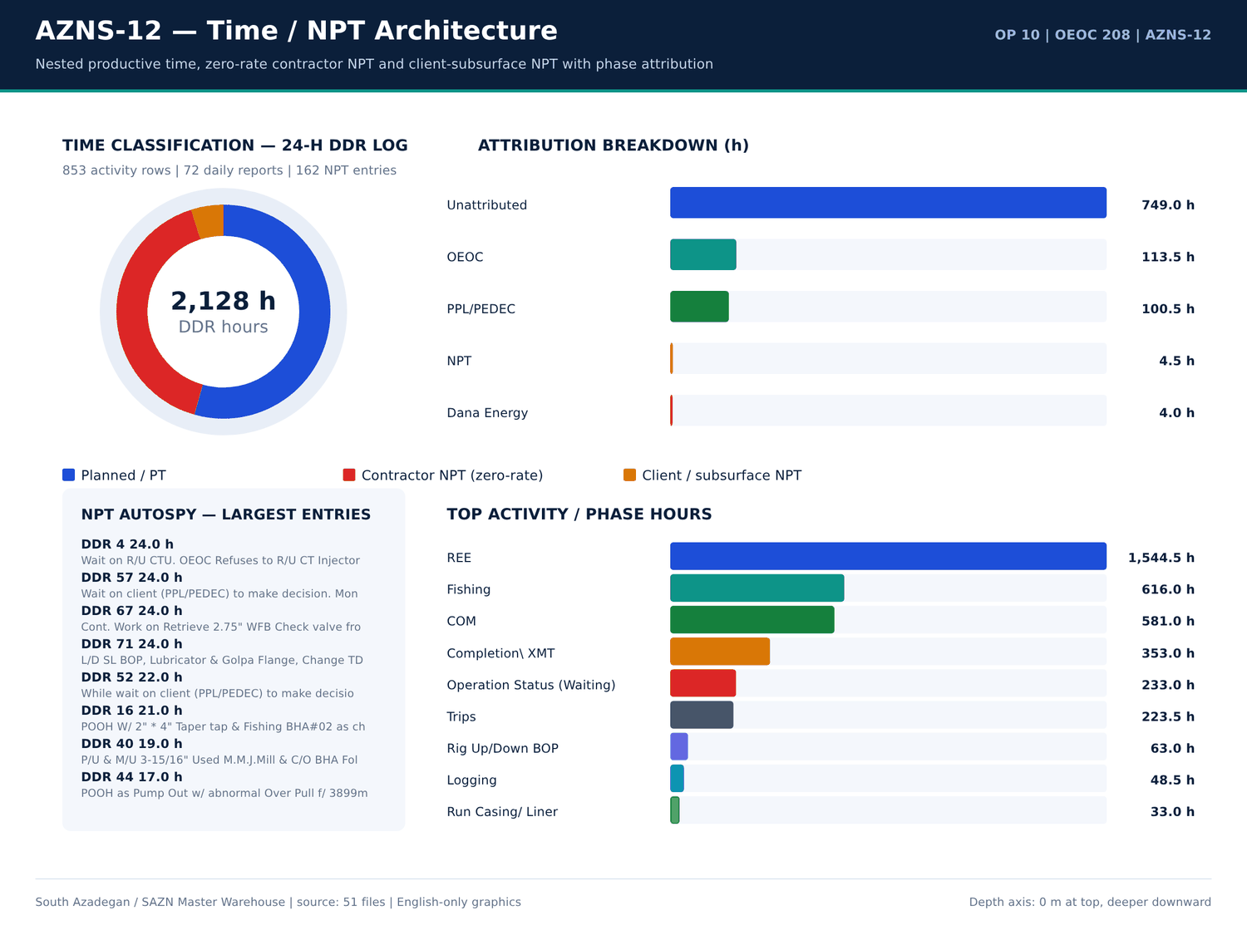
AZNS-12 01 time donut — منبع: انبار داده جامع سازن
سیاهه شیتها
سند | شیت | سطرها | ستونها | سلولهای پر | سلولهای عددی | سلولهای فرمولی | قالب | بخش
CBS/10 CBS matrial.xlsx | Cost Breakdown-Material-12 | 248 | 4 | 345 | 15 | 0 | — | —
CBS/10.AZNS_12_CBS.xlsx | AZNS-12 WO (Gadvan) | 65 | 20 | 623 | 423 | 313 | — | —
CBS/10.AZNS_12_CBS.xlsx | Total Cost-EPD | 19 | 7 | 100 | 68 | 27 | — | —
CBS/10.AZNS_12_CBS.xlsx | Rig-less Stimulation total cost | 16 | 6 | 45 | 27 | 14 | — | —
CBS/10.AZNS_12_CBS.xlsx | Total Cost-EPD & Rigless | 5 | 3 | 12 | 5 | 3 | — | —
CBS/10.AZNS_12_CBS.xlsx | Cost Breakdown-12 | 197 | 9 | 633 | 329 | 206 | — | —
CBS/10.AZNS_12_CBS.xlsx | Cost Breakdown-12 Contingecy | 183 | 20 | 854 | 486 | 360 | — | —
CBS/10.AZNS_12_CBS.xlsx | Cost Breakdown-Material-12 | 249 | 7 | 624 | 291 | 246 | — | —
CBS/10.AZNS_12_CBS.xlsx | Rig Move | 4 | 5 | 16 | 8 | 2 | — | —
CBS/10.AZNS_12_CBS.xlsx | Catering & Accommodation | 15 | 7 | 29 | 12 | 0 | — | —
CBS/10.AZNS_12_CBS.xlsx | Cost breakdown R-less Stim.-12 | 16 | 4 | 45 | 27 | 14 | — | —
CBS/10.AZNS_12_CBS.xlsx | Mob.& Demob for Stim.-12 | 21 | 6 | 113 | 69 | 18 | — | —
CBS/10.AZNS_12_CBS.xlsx | Material & Consumable-12 | 34 | 6 | 195 | 125 | 32 | — | —
CBS/10.AZNS_12_CBS.xlsx | Acidizing &N2 service-12 | 21 | 9 | 155 | 99 | 18 | — | —
CBS/10.AZNS_12_CBS.xlsx | Coil Tubing Service-12 | 14 | 9 | 67 | 33 | 10 | — | —
CBS/10.AZNS_12_CBS.xlsx | Oil Transportation Service-12 | 9 | 7 | 40 | 20 | 6 | — | —
CBS/10.AZNS_12_CBS.xlsx | Well testing and production-12 | 31 | 11 | 233 | 164 | 29 | — | —
CBS/10.AZNS_12_CBS.xlsx | Wireline production logging-12 | 18 | 10 | 139 | 93 | 11 | — | —
CBS/10.AZNS_12_CBS.xlsx | Slick line-12 | 17 | 11 | 113 | 77 | 14 | — | —
CBS/10.AZNS_12_CBS.xlsx | Memory gauge-12 | 5 | 11 | 27 | 13 | 3 | — | —
CBS/10.AZNS_12_CBS.xlsx | Bottom Hole PVT Samp.-12 | 8 | 11 | 43 | 25 | 5 | — | —
CBS/10.AZNS_12_CBS.xlsx | Personnel rate-12 | 28 | 12 | 220 | 176 | 26 | — | —

شناسنامه و ارقام کلیدی
معیار | مقدار | مبنا
Operation | AZNS-12 | Campaign map
Rig | OEOC 208 | DDR header
Contract | C2 | Contract register

گزییده نشانی سلولهای عددی — فصل 01
سند | شیت | سلول | مقدار
DDRs/10.AZNS_12_DDR_Pack.xlsx | 15-2 DDR Data | R52C11 | 256,180,062.00
DDRs/10.AZNS_12_DDR_Pack.xlsx | 23-2 DDR Data | R52C11 | 256,180,062.00
CBS/10.AZNS_12_CBS.xlsx | Total Cost-EPD & Rigless | R5C3 | 10,877,522.07
CBS/10.AZNS_12_CBS.xlsx | Total Cost-EPD | R19C7 | 10,162,895.93
CBS/10.AZNS_12_CBS.xlsx | Total Cost-EPD & Rigless | R3C3 | 10,162,895.93
CBS/10.AZNS_12_CBS.xlsx | Total Cost-EPD | R3C6 | 3,860,626.98
CBS/10.AZNS_12_CBS.xlsx | Total Cost-EPD | R3C7 | 3,860,626.98
CBS/10.AZNS_12_CBS.xlsx | Cost Breakdown-12 | R197C6 | 3,860,626.98
DDRs/10.AZNS_12_DDR_Pack.xlsx | 1-1 DDR Remark | R12C35 | 3,437,769.78
DDRs/10.AZNS_12_DDR_Pack.xlsx | 2-1 DDR Remark | R12C35 | 3,437,769.78
DDRs/10.AZNS_12_DDR_Pack.xlsx | 3-1 DDR Remark | R12C35 | 3,437,769.78
DDRs/10.AZNS_12_DDR_Pack.xlsx | 4-1 DDR Remark | R12C35 | 3,437,769.78
DDRs/10.AZNS_12_DDR_Pack.xlsx | 5-1 DDR Remark | R12C35 | 3,437,769.78
DDRs/10.AZNS_12_DDR_Pack.xlsx | 6-1 DDR Remark | R12C35 | 3,437,769.78

Chapter 02 — چهار مسیر زمان / هزینه و کسر NPT
چهار مسیر قراردادی عبارتاند از برنامه CBS برابر 10,877,522 دلار، ناخالص تقویمی 10,419,411 دلار، قابلپرداخت بدون NPT نرخ صفر پیمانکار 9,589,015 دلار و خالص مطلق بدون همه NPT برابر 9,488,390 دلار. جمع NPT منتسب 971.5 ساعت است که 866.5 ساعت پیمانکار و 105.0 ساعت کارفرما/زیرسطحی، با نرخ دکل 23,000 دلار در روز محاسبه شده است؛ ردیفهای زمان برنامه 1,157.0 ساعت است. کسورات تنها از ساعات NPT منتسب و نرخ منبع محاسبه میشود.
دفتر چهار مسیر هزینه
مسیر هزینه | دلار | مبنا
CBS plan | 10,877,522 | Total Cost-EPD ceiling
Gross calendar | 10,419,411 | CBS plan + calendar delta
Payable excl. contractor NPT | 9,589,015 | Gross - zero-rate NPT
Pure net excl. all NPT | 9,488,390 | Gross - all NPT

تفکیک انتساب NPT
دسته | ساعت | منتسب به | سهم (درصد)
Unattributed | 749 | Unattributed | 77.1
OEOC | 113.5 | OEOC | 11.68
PPL/PEDEC | 100.5 | PPL/PEDEC | 10.34
NPT | 4.5 | NPT | 0.46
Dana Energy | 4 | Dana Energy | 0.41

ساعات کدهای زمان DDR
کد | دسته | ساعت | شماره گزارش
20 | Operation Status (Waiting) | 24 | 4
18 | Fishing | 24 | 10
23 | Completion\ XMT | 24 | 12
18 | Fishing | 24 | 15
18 | Fishing | 24 | 16
18 | Fishing | 24 | 17
18 | Fishing | 24 | 20
18 | Fishing | 24 | 26
6 | Trips | 24 | 29
18 | Fishing | 24 | 34
18 | Fishing | 24 | 36
18 | Fishing | 24 | 37
18 | Fishing | 24 | 39
18 | Fishing | 24 | 40
18 | Fishing | 24 | 41
20 | Operation Status (Waiting) | 24 | 42
18 | Fishing | 24 | 44
20 | Operation Status (Waiting) | 24 | 57
23 | Completion\ XMT | 24 | 61
23 | Completion\ XMT | 24 | 62
23 | Completion\ XMT | 24 | 63
23 | Completion\ XMT | 24 | 65

گزییده نشانی سلولهای عددی — فصل 02
سند | شیت | سلول | مقدار
DDRs/10.AZNS_12_DDR_Pack.xlsx | 15-2 DDR Data | R52C11 | 256,180,062.00
DDRs/10.AZNS_12_DDR_Pack.xlsx | 23-2 DDR Data | R52C11 | 256,180,062.00
CBS/10.AZNS_12_CBS.xlsx | Total Cost-EPD & Rigless | R5C3 | 10,877,522.07
CBS/10.AZNS_12_CBS.xlsx | Total Cost-EPD | R19C7 | 10,162,895.93
CBS/10.AZNS_12_CBS.xlsx | Total Cost-EPD & Rigless | R3C3 | 10,162,895.93
CBS/10.AZNS_12_CBS.xlsx | Total Cost-EPD | R3C6 | 3,860,626.98
CBS/10.AZNS_12_CBS.xlsx | Total Cost-EPD | R3C7 | 3,860,626.98
CBS/10.AZNS_12_CBS.xlsx | Cost Breakdown-12 | R197C6 | 3,860,626.98
DDRs/10.AZNS_12_DDR_Pack.xlsx | 1-1 DDR Remark | R12C35 | 3,437,769.78
DDRs/10.AZNS_12_DDR_Pack.xlsx | 2-1 DDR Remark | R12C35 | 3,437,769.78
DDRs/10.AZNS_12_DDR_Pack.xlsx | 3-1 DDR Remark | R12C35 | 3,437,769.78
DDRs/10.AZNS_12_DDR_Pack.xlsx | 4-1 DDR Remark | R12C35 | 3,437,769.78
DDRs/10.AZNS_12_DDR_Pack.xlsx | 5-1 DDR Remark | R12C35 | 3,437,769.78
DDRs/10.AZNS_12_DDR_Pack.xlsx | 6-1 DDR Remark | R12C35 | 3,437,769.78

Chapter 03 — ممیزی تعرفهها و مواد CBS در برابر DDR و EOWR
کارپوشه CBS دارای 1,039 ردیف قیمتی برای AZNS-12 است؛ تراز روزانه مواد DDR و فصلهای تکمیل/سیمان/سیال EOWR ردیفبهردیف تطبیق داده شد. 55 ردیف تطبیق سهجانبه همراه قیمت واحد، مقدار، شیت و نشانی سلول هر قلم نگهداری شده است. هرجا ردیف CBS معادل مصرف DDR نداشته باشد، وضعیت صریحاً اعلام میشود و مقداری فرضی درج نمیگردد.
ردیفهای تعرفه قیمتی CBS
شیت | شرح | واحد | مقدار | قیمت واحد (دلار) | مبلغ (دلار) | سلول | فرمول
Total Cost-EPD | AZNS-12 well, De-Complete & Re-Complete with 7.5K Completion Equipment | — | 1 | 3,860,626.98 | 3,860,626.98 | G3 | —
Cost Breakdown-12 | — | — | — | — | 3,860,626.98 | F197 | —
Cost Breakdown-12 | Rig Service | DAY | 91.92 | 23,000.00 | 2,114,111.48 | F5 | —
Total Cost-EPD | Contingency 5 | — | 1 | 1,392,344.73 | 1,392,344.73 | G8 | —
Total Cost-EPD | Contingency 6 | — | 1 | 1,125,005.93 | 1,125,005.93 | G9 | —
Total Cost-EPD | Contingency 8 | — | 1 | 942,332.25 | 942,332.25 | G11 | —
Total Cost-EPD | Contingency 1 | — | 1 | 875,413.80 | 875,413.80 | G4 | —
Cost Breakdown-12 Contingecy | — | — | — | — | 875,413.80 | F183 | —
Total Cost-EPD | Contingency 2 | — | 1 | 688,953.35 | 688,953.35 | G5 | —
Cost Breakdown-12 Contingecy | Rig Service | DAY | 22 | 23,000.00 | 506,000.00 | F5 | —
Total Cost-EPD | Contingency 7 | — | 1 | 474,068.28 | 474,068.28 | G10 | —
Cost Breakdown-12 | Mud Chemicals for 8 1⁄2" hole | HOLE | 1 | 346,937.50 | 346,937.50 | F11 | —
Total Cost-EPD | Rig Moving (Pad to Pad) | — | 1 | 247,000.00 | 247,000.00 | G15 | —
Rig Move | Rig move between well pads | — | 1 | 247,000.00 | 247,000.00 | F3 | —
Total Cost-EPD | Procurement for AZNS-12 | — | 1 | 238,585.00 | 238,585.00 | G12 | —
Cost Breakdown-Material-12 | — | — | — | — | 238,585.00 | F249 | —
Total Cost-EPD | Contingency 3 | — | 1 | 199,554.23 | 199,554.23 | G6 | —
Cost Breakdown-12 | Planning and Cost control | Day | 91.92 | 2,000.00 | 183,835.78 | F174 | —
Cost Breakdown-12 | Management | Day | 91.92 | 2,000.00 | 183,835.78 | F175 | —
Cost Breakdown-12 | Cementing Equipment | DAY | 91.92 | 1,750.00 | 160,856.31 | F148 | —
Cost Breakdown-Material-12 | Wellhead & Xmas tree Equipment | — | — | — | 142,085.00 | F15 | —
Cost Breakdown-Material-12 | Section C | set | 1 | 142,085.00 | 142,085.00 | F34 | —

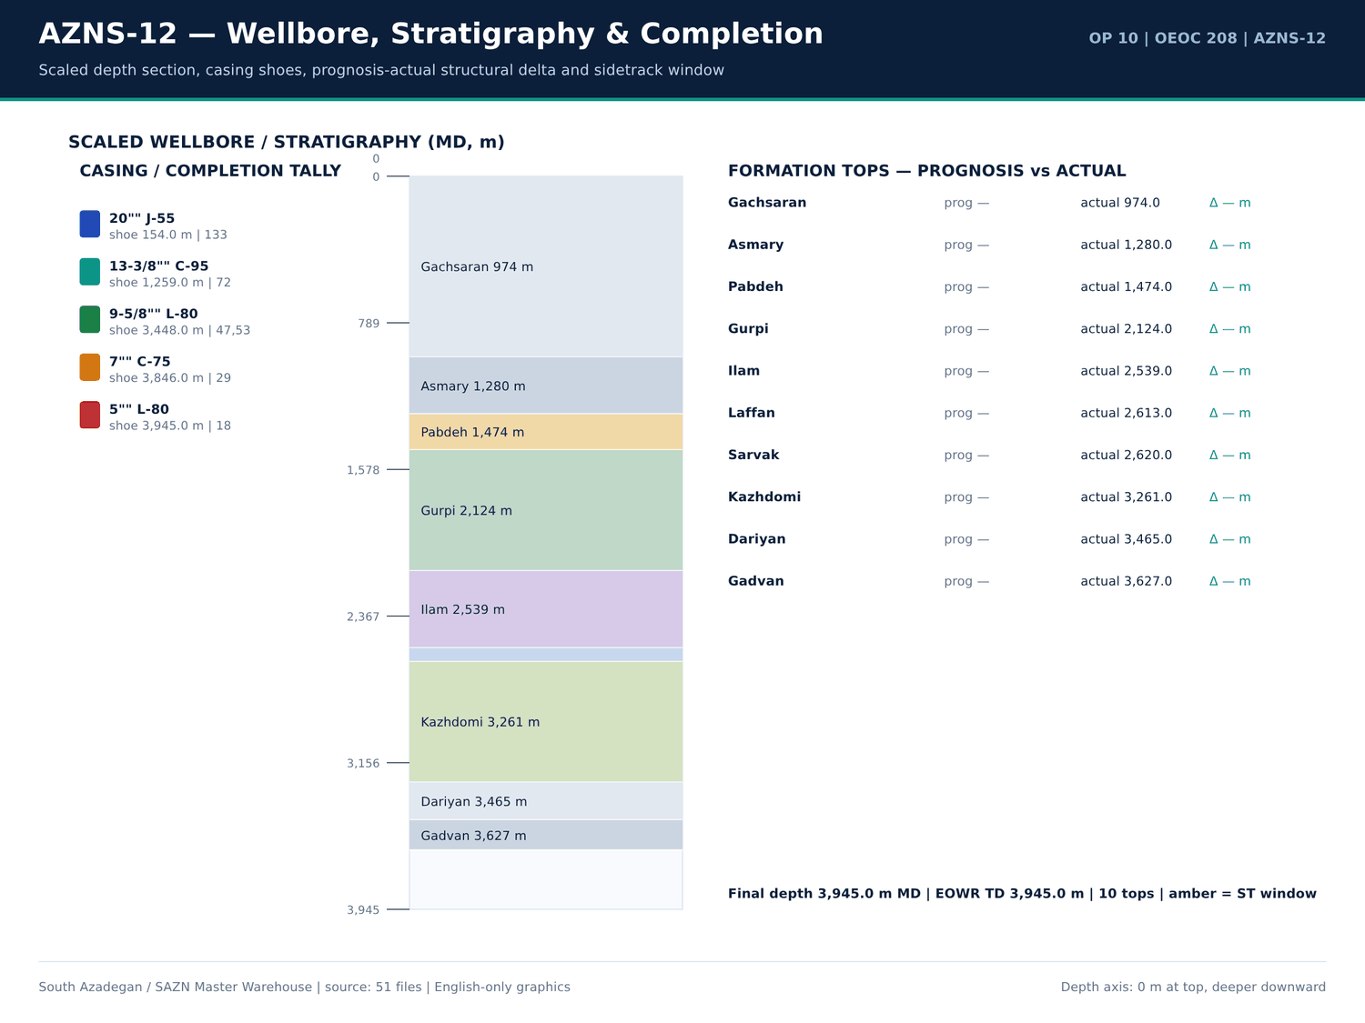
AZNS-12 02 wellbore — منبع: انبار داده جامع سازن
سقفهای هزینه CBS
شیت | قلم | مقدار | Unit cost | مبلغ (دلار) | Row
Total Cost-EPD | AZNS-12 well, De-Complete & Re-Complete with 7.5K Completion Equipment | 1 | 3,860,626.98 | 3,860,626.98 | 3
Total Cost-EPD | Contingency 1 | 1 | 875,413.80 | 875,413.80 | 4
Total Cost-EPD | Contingency 2 | 1 | 688,953.35 | 688,953.35 | 5
Total Cost-EPD | Contingency 3 | 1 | 199,554.23 | 199,554.23 | 6
Total Cost-EPD | Contingency 4 | 1 | 119,011.38 | 119,011.38 | 7
Total Cost-EPD | Contingency 5 | 1 | 1,392,344.73 | 1,392,344.73 | 8
Total Cost-EPD | Contingency 6 | 1 | 1,125,005.93 | 1,125,005.93 | 9
Total Cost-EPD | Contingency 7 | 1 | 474,068.28 | 474,068.28 | 10
Total Cost-EPD | Contingency 8 | 1 | 942,332.25 | 942,332.25 | 11
Total Cost-EPD | Procurement for AZNS-12 | 1 | 238,585.00 | 238,585.00 | 12
Total Cost-EPD | Rig mobilization | 0 | 1,092,550.00 | 0 | 13
Total Cost-EPD | Rig demobilization | 0 | 478,500.00 | 0 | 14
Total Cost-EPD | Rig Moving (Pad to Pad) | 1 | 247,000.00 | 247,000.00 | 15
Total Cost-EPD | Rig Moving (Celler to Celler) | 0 | 0 | 0 | 16
Total Cost-EPD | Mission cost | 0 | 150 | 0 | 17
Total Cost-EPD | Re-Entry, Completion & Procurement COST CEILING (USD) | — | — | 10,162,895.93 | 19
Total Cost-EPD | 1 | — | — | 3,860,626.98 | 3
Total Cost-EPD | Contingency 1 | — | — | 875,413.80 | 4
Total Cost-EPD | Contingency 2 | — | — | 688,953.35 | 5
Total Cost-EPD | Contingency 3 | — | — | 199,554.23 | 6
Total Cost-EPD | Contingency 4 | — | — | 119,011.38 | 7
Total Cost-EPD | Contingency 5 | — | — | 1,392,344.73 | 8

تطبیق سهجانبه
قلم | CBS (دلار) | مقدار DDR | واحد | وضعیت
3 3 4 mill | 13,000.00 | — | each | CBS only — no DDR consumption record
4 1 8 mill | 13,000.00 | — | each | CBS only — no DDR consumption record
6 mill | 19,500.00 | — | each | CBS only — no DDR consumption record
8 1 2 rock bit | 19,000.00 | — | each | CBS only — no DDR consumption record
acid chemical pump | 594 | — | 1 EA | CBS only — no DDR consumption record
acid mixing tanks | 5,950.00 | — | 1 EA | CBS only — no DDR consumption record
acid storage tanks | 5,950.00 | — | 1 EA | CBS only — no DDR consumption record
acid testing lab or acid testing costs in accredited lab | 2,565.00 | — | 1 EA | CBS only — no DDR consumption record
anti sludge agent | 1,275.00 | — | Gal | CBS only — no DDR consumption record
batch mixer | 34,000.00 | — | 1 EA | CBS only — no DDR consumption record
blender | 8,500.00 | — | 1 EA | CBS only — no DDR consumption record
booster pump | 594 | — | 1 EA | CBS only — no DDR consumption record
casing accessories | 17,600.00 | — | — | CBS only — no DDR consumption record
corrosion inhibitor | 2,850.00 | — | Gal | CBS only — no DDR consumption record
corrosion inhibitor aid | 2,100.00 | — | Gal | CBS only — no DDR consumption record
corrosive fluid | 600 | — | BBL | CBS only — no DDR consumption record
crane with driver | 1,350.00 | — | 1 EA | CBS only — no DDR consumption record
crossover 4 1 2 18 9 ppf box 3 1 2 10 2 ppf pin gas tight conn l080 type1 1 2m long psl3 | 1,900.00 | — | ea. | CBS only — no DDR consumption record
d w | — | 300 | BBL | DDR only — no CBS priced line
data acquisition system | 1,188.00 | — | 1 EA | CBS only — no DDR consumption record
de emulsifier | 900 | — | Gal | CBS only — no DDR consumption record
diesel | 60,000.00 | — | BBL | CBS only — no DDR consumption record

گزییده نشانی سلولهای عددی — فصل 03
سند | شیت | سلول | مقدار
DDRs/10.AZNS_12_DDR_Pack.xlsx | 15-2 DDR Data | R52C11 | 256,180,062.00
DDRs/10.AZNS_12_DDR_Pack.xlsx | 23-2 DDR Data | R52C11 | 256,180,062.00
CBS/10.AZNS_12_CBS.xlsx | Total Cost-EPD & Rigless | R5C3 | 10,877,522.07
CBS/10.AZNS_12_CBS.xlsx | Total Cost-EPD | R19C7 | 10,162,895.93
CBS/10.AZNS_12_CBS.xlsx | Total Cost-EPD & Rigless | R3C3 | 10,162,895.93
CBS/10.AZNS_12_CBS.xlsx | Total Cost-EPD | R3C6 | 3,860,626.98
CBS/10.AZNS_12_CBS.xlsx | Total Cost-EPD | R3C7 | 3,860,626.98
CBS/10.AZNS_12_CBS.xlsx | Cost Breakdown-12 | R197C6 | 3,860,626.98
DDRs/10.AZNS_12_DDR_Pack.xlsx | 1-1 DDR Remark | R12C35 | 3,437,769.78
DDRs/10.AZNS_12_DDR_Pack.xlsx | 2-1 DDR Remark | R12C35 | 3,437,769.78
DDRs/10.AZNS_12_DDR_Pack.xlsx | 3-1 DDR Remark | R12C35 | 3,437,769.78
DDRs/10.AZNS_12_DDR_Pack.xlsx | 4-1 DDR Remark | R12C35 | 3,437,769.78
DDRs/10.AZNS_12_DDR_Pack.xlsx | 5-1 DDR Remark | R12C35 | 3,437,769.78
DDRs/10.AZNS_12_DDR_Pack.xlsx | 6-1 DDR Remark | R12C35 | 3,437,769.78

Chapter 04 — نقاط عطف، توقفهای بدون پیشروی و زمان پنهان
عمق تا 3,945.0 متر MD پیش رفت و — متر حفاری ۲۴ ساعته با ROP میانگین 24.25 متر بر ساعت ثبت شد؛ 72 گزارش DDR بدون پیشروی ثبتشدهاند و بهجای درونیابی، بهعنوان توقف تخت نگهداری میشوند. نقاط عطف، زمان پنهان و هزینه تجمعی بهتفکیک گزارش آمده است تا منحنی زمان–عمق مستقیماً بازسازی شود.
نقاط عطف زمان–عمق روزانه
شماره گزارش | تاریخ | عمق اندازهگیری (متر) | حفاری (متر) | ROP (متر/ساعت) | گل (PCF) | اندازه چاله | سازند
1 | 2025-Apr-13 | 3,945.00 | 0 | 55 | 1.5 | De-Completion | -
2 | 2025-Apr-14 | 3,945.00 | 0 | 55 | 81 | De-Completion | -
3 | 2025-Apr-15 | 3,945.00 | 0 | 55 | 81 | De-Completion | -
4 | 2025-Apr-16 | 3,945.00 | 0 | 55 | 84 | De-Completion | -
5 | 2025-Apr-17 | 3,945.00 | 0 | 55 | 84 | De-Completion | -
6 | 2025-Apr-18 | 3,945.00 | 0 | 55 | 84 | De-Completion | -
7 | 2025-Apr-19 | 3,945.00 | 0 | 55 | 84 | De-Completion | -
8 | 2025-Apr-20 | 3,945.00 | 0 | 55 | 84 | De-Completion | -
9 | 2025-Apr-21 | 3,945.00 | 0 | 55 | 84 | De-Completion | -
10 | 2025-Apr-22 | 3,945.00 | 0 | 55 | 84 | De-Completion | -
11 | 2025-Apr-23 | 3,945.00 | 0 | 55 | 81 | De-Completion | -
12 | 2025-Apr-24 | 3,945.00 | 0 | 55 | 81 | De-Completion | -
13 | 2025-Apr-25 | 3,945.00 | 0 | 55 | 81 | De-Completion | -
14 | 2025-Apr-26 | 3,945.00 | 0 | 55 | 81 | De-Completion | -
15 | 2025-Apr-27 | 3,945.00 | 0 | 55 | 81 | De-Completion | -
16 | 2025-Apr-28 | 3,945.00 | 0 | 1 | — | De-Completion | -
17 | 2025-Apr-29 | 3,945.00 | 0 | 1 | — | De-Completion | -
18 | 2025-Apr-30 | 3,945.00 | 0 | 1 | — | De-Completion | -
19 | 2025-May-1 | 3,945.00 | 0 | 1 | — | De-Completion | -
20 | 2025-May-2 | 3,945.00 | 0 | 1 | — | De-Completion | -
21 | 2025-May-3 | 3,945.00 | 0 | 1 | — | De-Completion | -
22 | 2025-May-4 | 3,945.00 | 0 | 1 | — | De-Completion | -

توقفهای بدون پیشروی
شماره گزارش | تاریخ | عمق اندازهگیری (متر) | NPT (ساعت) | PT (ساعت) | هزینه تجمعی (دلار)
1 | 2025-Apr-13 | 3,945.00 | 0 | 12 | 23,000.00
2 | 2025-Apr-14 | 3,945.00 | 16 | 14 | 46,000.00
3 | 2025-Apr-15 | 3,945.00 | 15 | 15 | 69,000.00
4 | 2025-Apr-16 | 3,945.00 | 30 | 0 | 92,000.00
5 | 2025-Apr-17 | 3,945.00 | 17 | 13 | 115,000.00
6 | 2025-Apr-18 | 3,945.00 | 0 | 30 | 138,000.00
7 | 2025-Apr-19 | 3,945.00 | 10 | 20 | 161,000.00
8 | 2025-Apr-20 | 3,945.00 | 30 | 0 | 184,000.00
9 | 2025-Apr-21 | 3,945.00 | 30 | 0 | 207,000.00
10 | 2025-Apr-22 | 3,945.00 | 28 | 2 | 230,000.00
11 | 2025-Apr-23 | 3,945.00 | 4 | 26 | 253,000.00
12 | 2025-Apr-24 | 3,945.00 | 0 | 30 | 276,000.00
13 | 2025-Apr-25 | 3,945.00 | 0 | 30 | 299,000.00
14 | 2025-Apr-26 | 3,945.00 | 28 | 2 | 322,000.00
15 | 2025-Apr-27 | 3,945.00 | 30 | 0 | 345,000.00
16 | 2025-Apr-28 | 3,945.00 | 26 | 4 | 368,000.00
17 | 2025-Apr-29 | 3,945.00 | 5 | 25 | 391,000.00
18 | 2025-Apr-30 | 3,945.00 | 21 | 9 | 414,000.00
19 | 2025-May-1 | 3,945.00 | 2 | 28 | 437,000.00
20 | 2025-May-2 | 3,945.00 | 0 | 30 | 460,000.00
21 | 2025-May-3 | 3,945.00 | 3.5 | 26.5 | 483,000.00
22 | 2025-May-4 | 3,945.00 | 5 | 25 | 506,000.00

هزینه تجمعی بهتفکیک گزارش
شماره گزارش | تاریخ | عمق اندازهگیری (متر) | NPT (ساعت) | PT (ساعت) | هزینه تجمعی (دلار)
1 | 2025-Apr-13 | 3,945.00 | 0 | 12 | 23,000.00
2 | 2025-Apr-14 | 3,945.00 | 16 | 14 | 46,000.00
3 | 2025-Apr-15 | 3,945.00 | 15 | 15 | 69,000.00
4 | 2025-Apr-16 | 3,945.00 | 30 | 0 | 92,000.00
5 | 2025-Apr-17 | 3,945.00 | 17 | 13 | 115,000.00
6 | 2025-Apr-18 | 3,945.00 | 0 | 30 | 138,000.00
7 | 2025-Apr-19 | 3,945.00 | 10 | 20 | 161,000.00
8 | 2025-Apr-20 | 3,945.00 | 30 | 0 | 184,000.00
9 | 2025-Apr-21 | 3,945.00 | 30 | 0 | 207,000.00
10 | 2025-Apr-22 | 3,945.00 | 28 | 2 | 230,000.00
11 | 2025-Apr-23 | 3,945.00 | 4 | 26 | 253,000.00
12 | 2025-Apr-24 | 3,945.00 | 0 | 30 | 276,000.00
13 | 2025-Apr-25 | 3,945.00 | 0 | 30 | 299,000.00
14 | 2025-Apr-26 | 3,945.00 | 28 | 2 | 322,000.00
15 | 2025-Apr-27 | 3,945.00 | 30 | 0 | 345,000.00
16 | 2025-Apr-28 | 3,945.00 | 26 | 4 | 368,000.00
17 | 2025-Apr-29 | 3,945.00 | 5 | 25 | 391,000.00
18 | 2025-Apr-30 | 3,945.00 | 21 | 9 | 414,000.00
19 | 2025-May-1 | 3,945.00 | 2 | 28 | 437,000.00
20 | 2025-May-2 | 3,945.00 | 0 | 30 | 460,000.00
21 | 2025-May-3 | 3,945.00 | 3.5 | 26.5 | 483,000.00
22 | 2025-May-4 | 3,945.00 | 5 | 25 | 506,000.00

گزییده نشانی سلولهای عددی — فصل 04
سند | شیت | سلول | مقدار
DDRs/10.AZNS_12_DDR_Pack.xlsx | 15-2 DDR Data | R52C11 | 256,180,062.00
DDRs/10.AZNS_12_DDR_Pack.xlsx | 23-2 DDR Data | R52C11 | 256,180,062.00
CBS/10.AZNS_12_CBS.xlsx | Total Cost-EPD & Rigless | R5C3 | 10,877,522.07
CBS/10.AZNS_12_CBS.xlsx | Total Cost-EPD | R19C7 | 10,162,895.93
CBS/10.AZNS_12_CBS.xlsx | Total Cost-EPD & Rigless | R3C3 | 10,162,895.93
CBS/10.AZNS_12_CBS.xlsx | Total Cost-EPD | R3C6 | 3,860,626.98
CBS/10.AZNS_12_CBS.xlsx | Total Cost-EPD | R3C7 | 3,860,626.98
CBS/10.AZNS_12_CBS.xlsx | Cost Breakdown-12 | R197C6 | 3,860,626.98
DDRs/10.AZNS_12_DDR_Pack.xlsx | 1-1 DDR Remark | R12C35 | 3,437,769.78
DDRs/10.AZNS_12_DDR_Pack.xlsx | 2-1 DDR Remark | R12C35 | 3,437,769.78
DDRs/10.AZNS_12_DDR_Pack.xlsx | 3-1 DDR Remark | R12C35 | 3,437,769.78
DDRs/10.AZNS_12_DDR_Pack.xlsx | 4-1 DDR Remark | R12C35 | 3,437,769.78
DDRs/10.AZNS_12_DDR_Pack.xlsx | 5-1 DDR Remark | R12C35 | 3,437,769.78
DDRs/10.AZNS_12_DDR_Pack.xlsx | 6-1 DDR Remark | R12C35 | 3,437,769.78

Chapter 05 — گزارش فعالیت ۲۴ ساعته و کدهای عملیاتی
تعداد 853 ردیف فعالیت ۲۴ ساعته مجزا برای AZNS-12 استخراج شد که هر یک فاز، کد، زیرکد، وضعیت PLN/NPT، طرف مسئول و مدت دارد. جداول زیر لاگ خام فعالیت، توزیع کدها و ماتریس ساعات فاز بر وضعیت را عیناً بازتولید میکنند؛ هیچ فعالیتی ادغام یا گرد نشده است.
لاگ خام فعالیت ۲۴ ساعته
شماره گزارش | Seq | فاز | کد | وضعیت | منتسب به | ساعت | شرح
1 | 1 | - | - | - | — | 18 | Check Mud Tanks, Function Test Disilter, Degasser & all Equip. & Line, Function Test Diesel Generators (#1, #2, #3 & #4), Check SCR Room & VFD, Function Test Drawworks (Low
1 | 2 | — | — | — | — | — | Clutch, High Clutch, Test Crown - Omatic, Electrical Brake & Emergency Brake, Function Test TDS (TQ. Rot (200 Rpm), Trq. Wrench, Link Tilt Counter Balance), Align Mast, Body Press
1 | 3 | — | — | — | — | — | Test Stand Pipe w/ 3000 psi & Middle Valve, Function Test Mud Pumps (#1, #2 & #3). Press test Lower & Upper I BOP w/ 2500 psi; OK. Prepare rig to Spud.
1 | 4 | REE | 28 | Plan | — | 6 | Held PJSM. Spud the rig @ 13-Apr-2025, 18:00. Check Section C: Press Test Between Lower P-Seal, Ring Gasket & 9-5/8" CSG Slips w/ 3000 psi; "OK". Press Test Upper P-Seal w/ max
1 | 5 | — | — | — | — | — | 600 psi; "OK" & Try to inject plastic packing; "No-Succ". Check 7" X 9 5/8" Ann Press; Zero. Install 7-1/16" 5k Companion flange on 2SV. Open all valve & Monitor Wellhead Press;
1 | 6 | — | — | — | — | — | Zero. Press test 7-1/16" 5K Top master valve w/ 3000 psi; "OK" & Check all Ann. Press., Bleed off to zero.
1 | 7 | — | — | — | — | — | Meanwhile Prepare 300 bbl 81 pcf mud.
1 | 8 | — | — | — | — | — | Arrived Vira Crew (Mud Engineering Service) @ 03-Apr-2025
1 | 9 | — | — | — | — | — | Arrived Geo Data Crew (Mud Logging Service) @ 09-Apr-2025 12:00
1 | 10 | — | — | — | — | — | Rec. OEOC Slick line Service @ 11-Apr-2025 18:00
1 | 11 | — | — | — | — | — | Arrived OEOC Well Head crew @ 11-Apr-2025 22:00
1 | 12 | — | — | — | — | — | Arrived APAD Crew (H2S Service) @ 13-Apr-2025 10:00
1 | 13 | Main Phase | Code | Status | NPT/ Unplan Attributed | — | Rig Activity
1 | 14 | REE | 28 | Plan | — | 6 | Ensure that there is no TWCV/BPV in TBG HGR. N/D 7-1/16" Companion Flange. Install 7-1/16" 5K Sweep bend on 2SV. Close TMV. Press test XMT; OK.
2 | 1 | REE | 28 | Plan | — | 9 | Ensure that there is no TWCV/BPV in TBG HGR. N/D 7-1/16" Companion Flange. Install 7-1/16" 5K Sweep bend on 2SV. Close TMV. Press test XMT; "OK". Connect Hand Pump to
2 | 2 | — | — | — | — | — | 1/4" C/L & Try to Open 3SV w/ Gradually to Max 4500 psi Press. several times "No-Succ" No indication to open 3SV. Inject Plastic Packing to BMV P-Seals. L/U f/ mud pump to Sweep
2 | 3 | — | — | — | — | — | bend. F/U String. L/U f/ Ann to C/M.
2 | 4 | REE | 20 | NPT | OEOC | 4 | Stop operation Due to Align TDS Rail meanwhile OEOC inspection &maintenance crew work on TDS.
2 | 5 | REE | 20 | NPT | OEOC | 2 | Stop operation Due to Bad Weather (High win speed & dust storm)
2 | 6 | REE | 20 | NPT | OEOC | 2 | Cont. Align TDS Rail meanwhile OEOC inspection &maintenance crew work on TDS.
2 | 7 | REE | 6 | Plan | — | 1 | P/U 6 Jts 5" DP Jt By Jt, Make & R/B 2 Stds to Derrick
2 | 8 | REE | 20 | NPT | OEOC | 6 | Stop operation Due to Bad Weather (High win speed & dust storm)

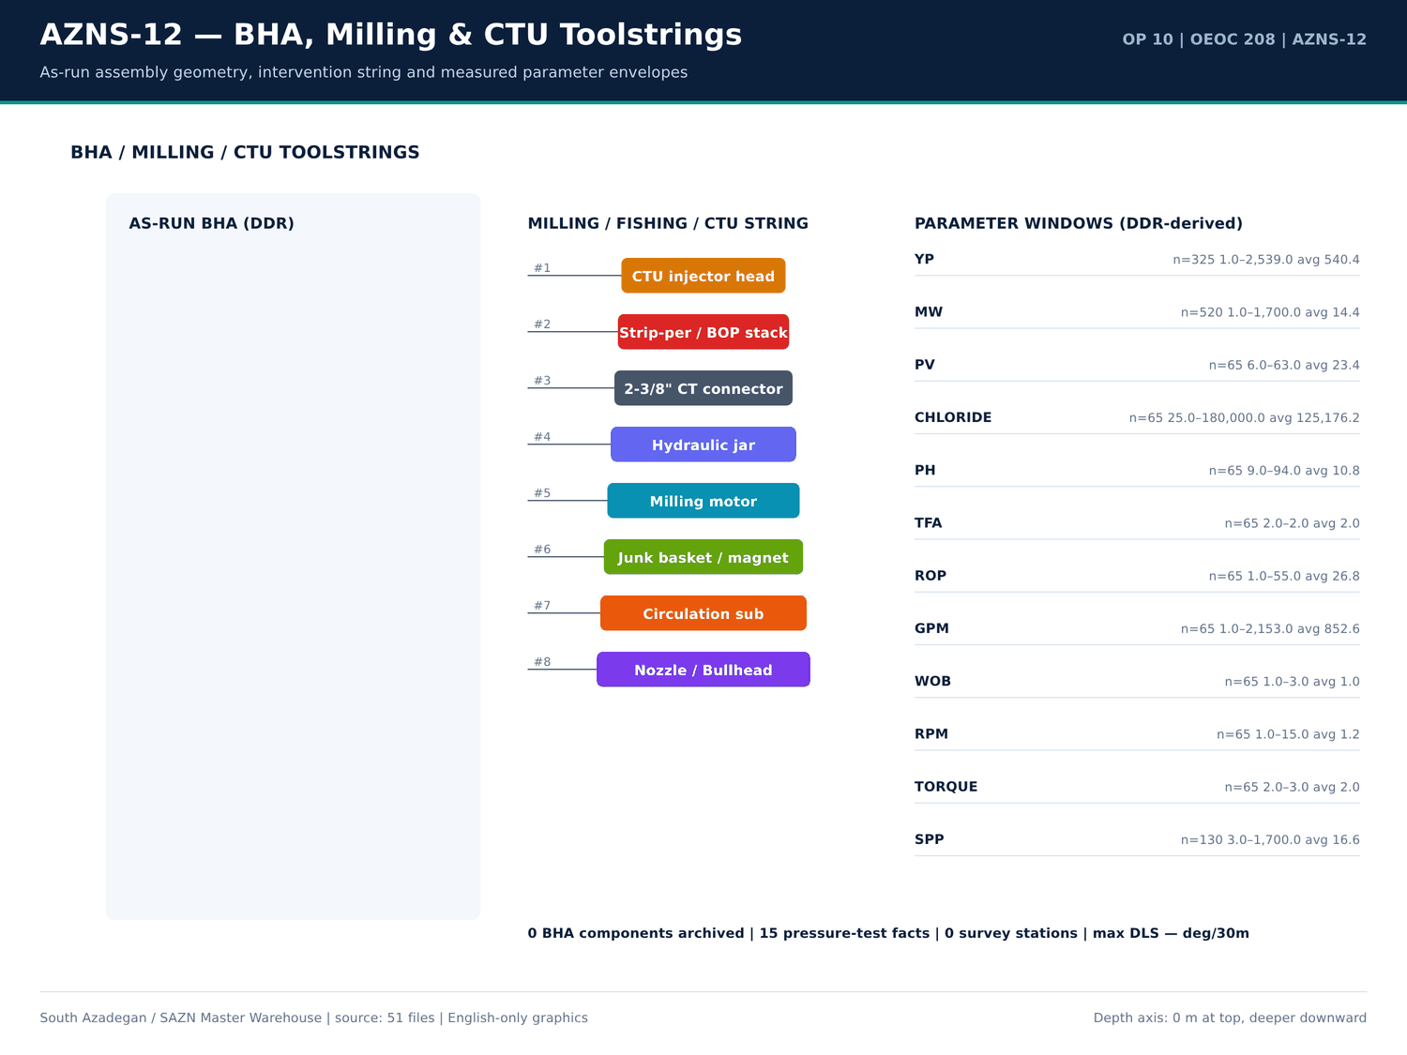
AZNS-12 03 bha — منبع: انبار داده جامع سازن
توزیع کدهای فعالیت
کد | ساعت | تعداد
18 | 774.5 | 114
23 | 436.5 | 75
20 | 290 | 56
6 | 264 | 53
15 | 79 | 11
11 | 55 | 13
12 | 49.5 | 11
5 | 48 | 15
3 | 31 | 6
28 | 30 | 6
27 | 27.5 | 8
13 | 25 | 5
- | 18 | 1
9 | 8 | 5
16 | 6 | 1
24 | 4 | 1
8 | 3.5 | 2

ماتریس ساعات فاز بر وضعیت
فاز | وضعیت | ساعت | تعداد
REE | Plan | 859 | 156
COM | Plan | 287.5 | 58
REE | Unplan | 280 | 55
COM | UnPlan | 218 | 28
REE | NPT | 206 | 40
REE | UnPlan | 195 | 29
COM | NPT | 72.5 | 10
- | - | 18 | 1
CSG | Plan | 6 | 2
COM | OEOC | 3 | 2
REE | p | 2.5 | 1
REE | PLAN | 2 | 1

گزییده نشانی سلولهای عددی — فصل 05
سند | شیت | سلول | مقدار
DDRs/10.AZNS_12_DDR_Pack.xlsx | 15-2 DDR Data | R52C11 | 256,180,062.00
DDRs/10.AZNS_12_DDR_Pack.xlsx | 23-2 DDR Data | R52C11 | 256,180,062.00
CBS/10.AZNS_12_CBS.xlsx | Total Cost-EPD & Rigless | R5C3 | 10,877,522.07
CBS/10.AZNS_12_CBS.xlsx | Total Cost-EPD | R19C7 | 10,162,895.93
CBS/10.AZNS_12_CBS.xlsx | Total Cost-EPD & Rigless | R3C3 | 10,162,895.93
CBS/10.AZNS_12_CBS.xlsx | Total Cost-EPD | R3C6 | 3,860,626.98
CBS/10.AZNS_12_CBS.xlsx | Total Cost-EPD | R3C7 | 3,860,626.98
CBS/10.AZNS_12_CBS.xlsx | Cost Breakdown-12 | R197C6 | 3,860,626.98
DDRs/10.AZNS_12_DDR_Pack.xlsx | 1-1 DDR Remark | R12C35 | 3,437,769.78
DDRs/10.AZNS_12_DDR_Pack.xlsx | 2-1 DDR Remark | R12C35 | 3,437,769.78
DDRs/10.AZNS_12_DDR_Pack.xlsx | 3-1 DDR Remark | R12C35 | 3,437,769.78
DDRs/10.AZNS_12_DDR_Pack.xlsx | 4-1 DDR Remark | R12C35 | 3,437,769.78
DDRs/10.AZNS_12_DDR_Pack.xlsx | 5-1 DDR Remark | R12C35 | 3,437,769.78
DDRs/10.AZNS_12_DDR_Pack.xlsx | 6-1 DDR Remark | R12C35 | 3,437,769.78

Chapter 06 — پارتو NPT و کالبدشکافی رویدادها
تعداد 8 خانواده مسئله برای AZNS-12 بازسازی شد. هر خانواده تعداد رخداد، ساعات، عمق، سازند، طرف مسئول، دستکم دو فرضیه مهندسی، مواجهه کمیشده و دستورالعمل ۶۰ ثانیهای دارد. جداول پارتو این خانوادهها را بر پایه ساعات و مواجهه هزینهای با نرخ دکل منبع رتبهبندی میکنند.
خانوادههای مسئله بازسازی شده
دسته | Days | عمق (متر) | سازند | عنوان | ساعت | هزینه (دلار) | شاهد عددی
Lost circulation / fluid losses | 14,15,20,21,22,25,27,28 | 3,945.00 | - | Lost circulation / fluid losses — 73 occurrences | 248.5 | 238,145.83 | DDR 24-h log / remarks
Other operational delay | 2,3,5,7,8,9,10,15 | 3,945.00 | - | Other operational delay — 61 occurrences | 235 | 225,208.33 | DDR 24-h log / remarks
Waiting on services / material | 3,4,5,7,8,9,10,11 | 3,945.00 | - | Waiting on services / material — 71 occurrences | 163.5 | 156,687.50 | DDR 24-h log / remarks
Stuck pipe / fishing / milling | 9,10,13,14,15,16,19,20 | 3,945.00 | - | Stuck pipe / fishing / milling — 56 occurrences | 115 | 110,208.33 | DDR 24-h log / remarks
Completion / stimulation | 53,54,55,65,66,67,68,69 | 3,945.00 | - | Completion / stimulation — 20 occurrences | 104.5 | 100,145.83 | DDR 24-h log / remarks
Rig equipment failure | 5,8,9,16,17,35,66,68 | 3,945.00 | - | Rig equipment failure — 14 occurrences | 97 | 92,958.33 | DDR 24-h log / remarks
Well control / gas / H2S | 10,11 | 3,945.00 | - | Well control / gas / H2S — 2 occurrences | 8 | 7,666.67 | DDR 24-h log / remarks
Cement / liner / dry test | 32,43 | 3,945.00 | - | Cement / liner / dry test — 2 occurrences | 0 | 0 | DDR 24-h log / remarks

پارتو NPT بر پایه ساعات
دسته | ساعت | منتسب به | سهم (درصد)
Unattributed | 749 | Unattributed | 77.1
OEOC | 113.5 | OEOC | 11.68
PPL/PEDEC | 100.5 | PPL/PEDEC | 10.34
NPT | 4.5 | NPT | 0.46
Dana Energy | 4 | Dana Energy | 0.41

بزرگترین ردیفهای NPT منفرد
شماره گزارش | ساعت | منتسب به | شرح
4 | 24 | OEOC | Wait on R/U CTU. OEOC Refuses to R/U CT Injector head. So 24 hours NPT has been applied for OEOC rig and services.
12 | 24 | — | Cont. POOH Completion string To Surface and OBS. Cutted off Comp. String from Box of Expan. JT 20ft stroke N.vam (fully open position) While C.W.H w/ 4-6 BPHL.
57 | 24 | — | Wait on client (PPL/PEDEC) to make decision. Monitor pit level; NL-NG.
67 | 24 | — | Cont. Work on Retrieve 2.75" WFB Check valve from SSD, RIH w/ 1.87" Bailers to SSD Depth, Work on same to Clean settled debris on top of 2.75" WFB Check valve @ Five Run till Clean inside Bailers, RIH w/ 3" SB Pulling, try to Engage & Re…
71 | 24 | — | L/D SL BOP, Lubricator & Golpa Flange, Change TDS Link & Elevator, Line up surface test Line, Try to Press test same "No Succ.", Work on Leakage and Perform Press. Test Finally "Ok", L/U surface test Line to string. Set PKR as per proced…
52 | 22 | PPL/PEDEC | While wait on client (PPL/PEDEC) to make decision, Slow Circ. Thru string; NL-NG. POOH w/ 8-3/8" TCI Bit to surface. L/D Bit.
13 | 21 | — | In Order to Stand back Required 4-3/4" DCs + 3-1/2" HWDP & 3-1/2" DPs in Derrick, P/U & RIH W/ 18JTs 4-3/4" DCs + 60JTs 3-1/2" DPs jt by jt To 730m While Washed, Hammerd,
16 | 21 | — | POOH W/ 2" * 4" Taper tap & Fishing BHA#02 as chain out F/3307 to Surface, Recoverd Fish Completely as below:
7 | 20 | — | N/U 13-5/8" 10K Drlg Spool (SOVs have already been installed), Double rams (Top Rams 4-1/2" X 7" VBR & Middle Rams Shear/Blind), 13-5/8" 5K Annular Preventer. Connect 2" & 4"
11 | 20 | — | Disconnect TDS, L/D 7" N.vam L.J + 7" * 4-1/2" N.vam X.O.S + 5" DP ( S-Grade) Pup Jt.
40 | 19 | — | P/U & M/U 3-15/16" Used M.M.J.Mill & C/O BHA Followed By 5" DPs to 3779m (5" L.Lap), Cont. RIH as Med. to Soft Wash Down & Cleance 5" LNR to 3870m w/ 0-1 BPHL. >> Clean Out BHA Description: 3-15/16" Used M.M.J.Mill + 3-1/8" Bit sub + 5ST…
46 | 18.5 | — | Hang Up 13-5/8"-10K BOP Stack, N/D 11" 5K * 13-5/8" 10K DSA Pack off + 13-5/8" 3K * 11" 5K T.H.S, Rough Cut 9-5/8" CSG Neck Dress and Bevel same, Install New 11" 5K TOP x 13-5/8" 5K BTM (MSP Co.) on 13-5/8" 5K TOP x 20-3/4" 3K BTM C.H.S.…
1 | 18 | — | Check Mud Tanks, Function Test Disilter, Degasser & all Equip. & Line, Function Test Diesel Generators (#1, #2, #3 & #4), Check SCR Room & VFD, Function Test Drawworks (Low
23 | 17.5 | — | Resume POOH chain out w/ 2" x 4" Taper tap f/ 2700m to surface, While Circ. CWH; 0-1 BPHL. Obs. Packer & Tail retrieved successfully. L/D completion packer & Tail Jt by Jt (A piece of
44 | 17 | — | POOH as Pump Out w/ abnormal Over Pull f/ 3899m to 3779m (5" L.Lap), Cont. POOH f/ 3779 to 600m on elevator while Circ. C.W.H w/ 0-1 BPHL. >> Pump Out Prameters: F.R: 55-95gpm, SPP: 200-720psi.
20 | 16 | — | Cont. RIH W/ 2" * 4" Taper tap (New, Cylindersazi, S/N: CS7569) & Fishing BHA#04 F/ 250 To 3516m (4m above Fish) Record Upward & Downward WT W/ Pumping & W/O Pumping
39 | 16 | — | Cont. RIH w/ 4" New M.M.J.Mill & C/O BHA F/ 2100m to 3779m (5" L.Lap), Try to Pass This point W/Pumping "No Succ.", Hard to Med Wash & Ream Down & Cleance 5" LNR to 3888.6m (10m above TOF) Push Down & Milling to 3888.7m w/Low Parameters …
70 | 16 | — | POOH W/ 3" JDC Pulling to Surface, Checked 3" JDC Nose & Body "OK", Run Back w/ 1-1/2" CT & same 3" JDC Pulling again and work on to Pass TR3SV Depth (61m) "No Succ.", POOH to Surf., Change 3" JDC Pulling with 3" SB Pulling, Meanwhile Cl…
5 | 15 | OEOC | Wait on R/U CTU. OEOC Refuses to R/U CT Injector head. So 15 hours NPT has been applied for OEOC rig and services.
22 | 15 | — | Cont. RIH W/ 2"- 4" Taper tap & Fishing BHA#05 f/ 2050 to 3474m (4m below KOP), String Took WT Max. 15klbs Record Upward & Downward WT W/ Pumping & W/O Pumping
29 | 15 | — | P/U & M/U 3-1/2" M.M.J.Mill + 3-1/4" Bit Sub & RIH w/ 5 Stds 3-1/8" DC + 3Stds 2-7/8" DP + 2Stds 3-1/2"HWDP + 4-3/4" Fishing Jar + 8 Stds 3-1/2" HWDP + 20 Stds 3-1/2" DP &
37 | 15 | — | Stop Milling Operation @ 3900m Due to Low Progress Decided to POOH and check the Mill, POOH W/ 3-1/2" M.M.J.Mill & C/O BHA f/ 3900 to 150m while C.C.W.H w/ 0-2 BPHL.

گزییده نشانی سلولهای عددی — فصل 06
سند | شیت | سلول | مقدار
DDRs/10.AZNS_12_DDR_Pack.xlsx | 15-2 DDR Data | R52C11 | 256,180,062.00
DDRs/10.AZNS_12_DDR_Pack.xlsx | 23-2 DDR Data | R52C11 | 256,180,062.00
CBS/10.AZNS_12_CBS.xlsx | Total Cost-EPD & Rigless | R5C3 | 10,877,522.07
CBS/10.AZNS_12_CBS.xlsx | Total Cost-EPD | R19C7 | 10,162,895.93
CBS/10.AZNS_12_CBS.xlsx | Total Cost-EPD & Rigless | R3C3 | 10,162,895.93
CBS/10.AZNS_12_CBS.xlsx | Total Cost-EPD | R3C6 | 3,860,626.98
CBS/10.AZNS_12_CBS.xlsx | Total Cost-EPD | R3C7 | 3,860,626.98
CBS/10.AZNS_12_CBS.xlsx | Cost Breakdown-12 | R197C6 | 3,860,626.98
DDRs/10.AZNS_12_DDR_Pack.xlsx | 1-1 DDR Remark | R12C35 | 3,437,769.78
DDRs/10.AZNS_12_DDR_Pack.xlsx | 2-1 DDR Remark | R12C35 | 3,437,769.78
DDRs/10.AZNS_12_DDR_Pack.xlsx | 3-1 DDR Remark | R12C35 | 3,437,769.78
DDRs/10.AZNS_12_DDR_Pack.xlsx | 4-1 DDR Remark | R12C35 | 3,437,769.78
DDRs/10.AZNS_12_DDR_Pack.xlsx | 5-1 DDR Remark | R12C35 | 3,437,769.78
DDRs/10.AZNS_12_DDR_Pack.xlsx | 6-1 DDR Remark | R12C35 | 3,437,769.78

Chapter 07 — کارنامه متهها، درجه سایش و هزینه هر متر
کارنامه متهها و ابزارهای حفاری از ردیفهای تعرفه CBS، شیتهای مته/BHA در DDR و فصل کارنامه مته EOWR گرفته شده است. هزینه هر متر حفاری از محدوده 10,877,522 دلار و — متر فوتیج ثبتشده تشکیل میشود؛ هرگاه حفر چاله جدیدی ثبت نشده باشد، جدول مبنای workover را اعلام میکند و بر مخرج فرضی تقسیم نمیکند.
ردیفهای مته و ابزار حفاری
شیت | شرح | واحد | مقدار | قیمت واحد (دلار) | مبلغ (دلار)
Cost Breakdown-Material-12 | Drilling Bit &mill | — | — | — | 64,500.00
Cost Breakdown-Material-12 | 8 1/2" Rock Bit | each | 2 | 9,500.00 | 19,000.00
Material & Consumable-12 | Corrosion Inhibitor | Gal | 50 | 57 | 2,850.00
Material & Consumable-12 | Corrosion Inhibitor Aid | Gal | 70 | 30 | 2,100.00
Material & Consumable-12 | Iron Stabilizer | Gal | 40 | 30 | 1,200.00
Cost Breakdown-12 | Drilling Bit & mill | SET | — | — | 0
Cost Breakdown-Material-12 | Float shoe, reamer type, 7", 29 32#, L80 110S, PREMIUM connection, PDC drillable | ea. | — | — | 0
Cost Breakdown-Material-12 | Float shoe, reamer type, 7", 29#, L80, 9CR01 MO, PREMIUM connection, PDC drillable | ea. | — | — | 0
Cost Breakdown-Material-12 | Float shoe, reamer type, 7", 32#, 110S,PREMIUM connection, PDC drillable | ea. | — | — | 0
Cost Breakdown-Material-12 | Float shoe, reamer type, 5 " 18# ,110S,PREMIUM connection, PDC drillable | ea. | — | — | 0
Cost Breakdown-Material-12 | Float shoe, reamer type, 5" 18 23# x 9 5/8" 47 53.5#, 110S, PREMIUM connection, PDC drillable | ea. | — | 1,500.00 | 0
Cost Breakdown-Material-12 | Guide shoe, reamer type, 4 1/2", 13.5#, L80,BTC connection | ea. | — | — | 0
Cost Breakdown-Material-12 | 12 1/4" Rock Bit | each | — | — | 0
Cost Breakdown-Material-12 | 12 1/4" PDC Bit | each | — | — | 0
Cost Breakdown-Material-12 | 8 1/2" PDC Bit | each | — | — | 0
Cost Breakdown-Material-12 | 5 7/8" Rock Bit | each | 0 | 6,500.00 | 0
Cost Breakdown-Material-12 | 6 1/8" PDC Bit | each | — | — | 0
Material & Consumable-12 | Clay Stabilizer | Gal | 0 | 22.5 | 0
Cost Breakdown-Material-12 | Float shoe, reamer type, 7", 29-32#, L80-110S, PREMIUM connection, PDC drillable | ea. | — | — | —
Cost Breakdown-Material-12 | Float shoe, reamer type, 7", 29#, L80, 9CR-1 MO, PREMIUM connection, PDC drillable | ea. | — | — | —
Cost Breakdown-Material-12 | Float shoe, reamer type, 7", 32#, 110S,PREMIUM connection, PDC drillable | ea. | — | — | —
Cost Breakdown-Material-12 | Float shoe, reamer type, 5 " 18# ,110S,PREMIUM connection, PDC drillable | ea. | — | — | —

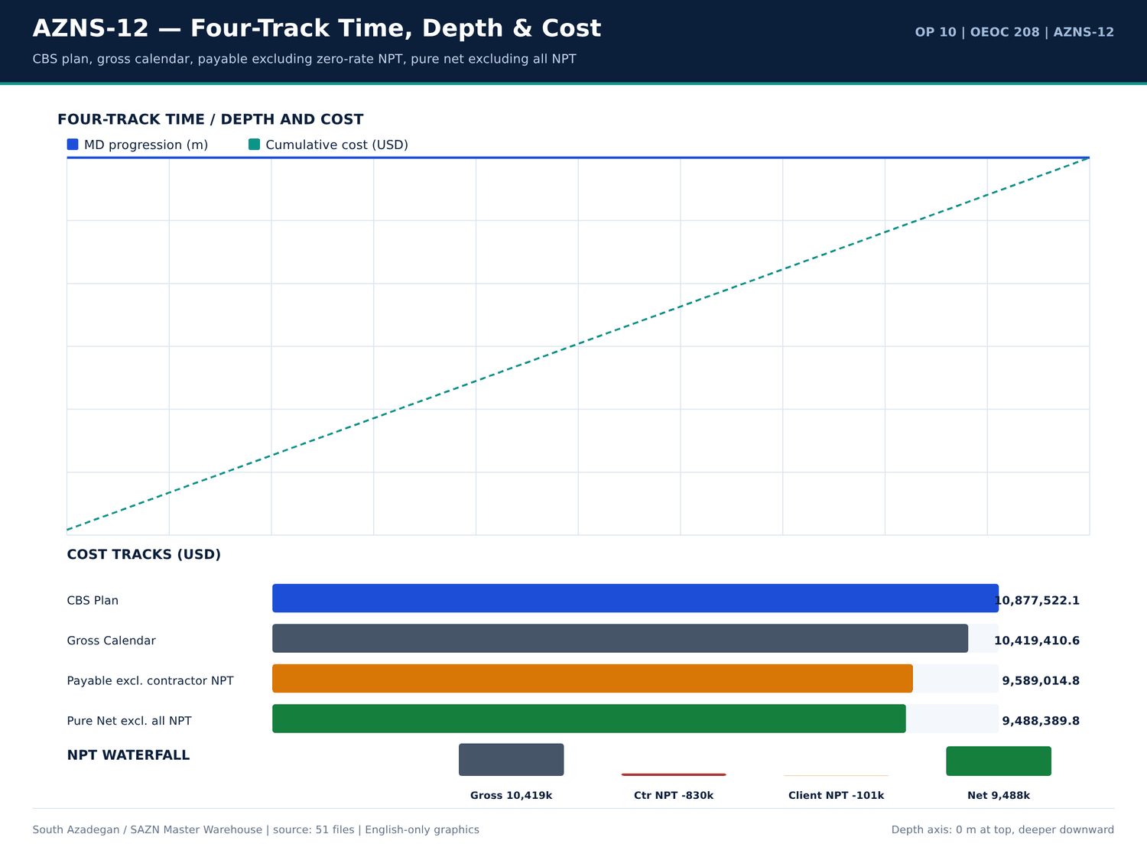
AZNS-12 04 fourtrack — منبع: انبار داده جامع سازن
کارنامه روزانه ROP و فوتیج
شماره گزارش | تاریخ | عمق اندازهگیری (متر) | حفاری (متر) | ROP (متر/ساعت) | گل (PCF) | سازند
1 | 2025-Apr-13 | 3,945.00 | 0 | 55 | 1.5 | -
2 | 2025-Apr-14 | 3,945.00 | 0 | 55 | 81 | -
3 | 2025-Apr-15 | 3,945.00 | 0 | 55 | 81 | -
4 | 2025-Apr-16 | 3,945.00 | 0 | 55 | 84 | -
5 | 2025-Apr-17 | 3,945.00 | 0 | 55 | 84 | -
6 | 2025-Apr-18 | 3,945.00 | 0 | 55 | 84 | -
7 | 2025-Apr-19 | 3,945.00 | 0 | 55 | 84 | -
8 | 2025-Apr-20 | 3,945.00 | 0 | 55 | 84 | -
9 | 2025-Apr-21 | 3,945.00 | 0 | 55 | 84 | -
10 | 2025-Apr-22 | 3,945.00 | 0 | 55 | 84 | -
11 | 2025-Apr-23 | 3,945.00 | 0 | 55 | 81 | -
12 | 2025-Apr-24 | 3,945.00 | 0 | 55 | 81 | -
13 | 2025-Apr-25 | 3,945.00 | 0 | 55 | 81 | -
14 | 2025-Apr-26 | 3,945.00 | 0 | 55 | 81 | -
15 | 2025-Apr-27 | 3,945.00 | 0 | 55 | 81 | -
16 | 2025-Apr-28 | 3,945.00 | 0 | 1 | — | -
17 | 2025-Apr-29 | 3,945.00 | 0 | 1 | — | -
18 | 2025-Apr-30 | 3,945.00 | 0 | 1 | — | -
19 | 2025-May-1 | 3,945.00 | 0 | 1 | — | -
20 | 2025-May-2 | 3,945.00 | 0 | 1 | — | -
21 | 2025-May-3 | 3,945.00 | 0 | 1 | — | -
22 | 2025-May-4 | 3,945.00 | 0 | 1 | — | -

یادداشتهای مته و BHA
شماره گزارش | شیت | دسته | Text
13 | 13-1 DDR Remark | SHORTAGE/REMARK | Cont. RIH W/ 3-1/2" Spear & Fishing BHA F/330 to 1500m while Circ. Mud C.W.H w/ 2-4 BPL.
13 | 13-1 DDR Remark | SHORTAGE/REMARK | >> Fishing BHA Description: 3-1/2" Spear + 2STDs 4-3/4" DCs + 9STDs 3-1/2" HWDPs + 20STDs 3-1/2" DPs + 3-1/2" * 4-1/2 IF X.O.S.
14 | 14-1 DDR Remark | SHORTAGE/REMARK | RIH W/ 3-1/2" Spear & Fishing BHA F/330 to 3285m (7"L.lap), Circ. BTM's up, Cont. RIH to 3307m, Confirmed TOF Work on Fishing and Try to catch same, POOH as chain out F/3307 to 2550m while Circ. Mud C.W.H w/ 0-1 BPHL.
14 | 14-1 DDR Remark | SHORTAGE/REMARK | Cont. RIH W/ 3-1/2" Spear & Fishing BHA F/330 to 3285m (7"L.lap) while Circ. Mud C.W.H w/ 0-2 BPHL.
14 | 14-1 DDR Remark | SHORTAGE/REMARK | >> Fishing BHA Description: 3-1/2" Spear + 2STDs 4-3/4" DCs + 9STDs 3-1/2" HWDPs + 20STDs 3-1/2" DPs + 3-1/2" * 4-1/2 IF X.O.S.
15 | 15-1 DDR Remark | SHORTAGE/REMARK | Cont. POOH F/2550 to Surface & Recoverd about 100-150m Slick line, RIH W/ 2" * 4" Taper tap & Fishing BHA#02 To 3290m while Circ. Mud C.W.H w/ 0-1 BPHL.
15 | 15-1 DDR Remark | SHORTAGE/REMARK | P/U & M/U 2" * 4" Taper tap & RIH W/ Fishing BHA#02 To 3290m while Circ. Mud C.W.H w/ NL-NG.
15 | 15-1 DDR Remark | SHORTAGE/REMARK | >> Fishing BHA Description: 2" * 4" Taper tap + 4-3/4" Bit sub + 1jt 4-3/4" DC + 4-3/4" F.Jar + 1jt 4-3/4" DC + 2STDs 3-1/2" HWDPs + 20STDs 3-1/2" DPs + X.O.S.
15 | 15-1 DDR Remark | SHORTAGE/REMARK | Cont. RIH W/ 2" * 4" Taper tap & Fishing BHA#02 F/ 3290 To 3305m (2M above Fish Depth), Record Upward & Downward WT W/ Pumping & W/O Pumping
15 | 15-1 DDR Remark | SHORTAGE/REMARK | >> Fishing BHA Description: 2" * 4" Taper tap + 4-3/4" Bit sub + 1jt 4-3/4" DC + 4-3/4" F.Jar + 1jt 4-3/4" DC + 2STDs 3-1/2" HWDPs + 20STDs 3-1/2" DPs + X.O.S.
16 | 16-1 DDR Remark | SHORTAGE/REMARK | Cont. RIH W/ 2" * 4" Taper tap & Fishing BHA#02 F/ 3290 To 3305m Engage w/ Fish & Tap inside Fish, POOH W/ 2" * 4" Taper tap & Fishing BHA#02 as chain out F/3307 to Surface, Recoverd Fish Completely While Circ. C.W.H w/ NL-NG.
16 | 16-1 DDR Remark | SHORTAGE/REMARK | Cont. RIH W/ 2" * 4" Taper tap & Fishing BHA#02 F/ 3290 To 3305m (2M above Fish Depth), Record Upward & Downward WT W/ Pumping & W/O Pumping
16 | 16-1 DDR Remark | SHORTAGE/REMARK | >> Fishing BHA Description: 2" * 4" Taper tap + 4-3/4" Bit sub + 1jt 4-3/4" DC + 4-3/4" F.Jar + 1jt 4-3/4" DC + 2STDs 3-1/2" HWDPs + 20STDs 3-1/2" DPs + X.O.S.
16 | 16-1 DDR Remark | SHORTAGE/REMARK | POOH W/ 2" * 4" Taper tap & Fishing BHA#02 as chain out F/3307 to Surface, Recoverd Fish Completely as below:
19 | 19-1 DDR Remark | SHORTAGE/REMARK | Cont. RIH W/ 6" M.M J.Mill F/ 3454 to 3520m, String Took WT, Try To Wash & Push same three Times "No movment", Circ. BTM's Up, POOH to Surface, RIH w/ 2" * 4" Taper tap & Fishing BHA#04 To 100m Stopped Operation Due to Bad Weather, Cont.…
19 | 19-1 DDR Remark | SHORTAGE/REMARK | P/U & M/U 2" * 4" Taper tap (New, Cylindersazi, S/N: CS7569) & RIH W/ Fishing BHA#04 To 100m while Circ. Mud C.W.H w/ NL-NG.
19 | 19-1 DDR Remark | SHORTAGE/REMARK | >> Fishing BHA Description: 2" * 4" Taper tap + 4-3/4" Bit sub + 1jt 4-3/4" DC + 4-3/4" F.Jar + 10STDs 3-1/2" HWDPs + 20STDs 3-1/2" DPs + X.O.S (Length: 870m)
19 | 19-1 DDR Remark | SHORTAGE/REMARK | Cont. RIH W/ 2" * 4" Taper tap & Fishing BHA#04 F/ 100 To 250 while Circ. Mud C.W.H w/ NL-NG.
19 | 19-1 DDR Remark | SHORTAGE/REMARK | Cont. RIH W/ 2" * 4" Taper tap & Fishing BHA#04 F/ 250 To 1400m while Circ. Mud C.W.H w/ NL-NG.
20 | 20-1 DDR Remark | SHORTAGE/REMARK | Cont. RIH W/ 2" * 4" Taper tap & Fishing BHA#04 F/ 3290 To 3516m Engage w/ Fish, Chase same to 3641m, Tap inside Fish, POOH as chain out F/3641 to 2500 While Circ. C.W.H w/ 0-1 BPHL.
20 | 20-1 DDR Remark | SHORTAGE/REMARK | Cont. RIH W/ 2" * 4" Taper tap (New, Cylindersazi, S/N: CS7569) & Fishing BHA#04 F/ 250 To 3516m (4m above Fish) Record Upward & Downward WT W/ Pumping & W/O Pumping
20 | 20-1 DDR Remark | SHORTAGE/REMARK | In Order to Check 2" * 4" Taper tap For any Probably fish caugh, POOH W/ 2" * 4" Taper tap & Fishing BHA#04 as chain out F/3641 to 2500m While Circ. Mud C.W.H w/ 0-1BPHL.

گزییده نشانی سلولهای عددی — فصل 07
سند | شیت | سلول | مقدار
DDRs/10.AZNS_12_DDR_Pack.xlsx | 15-2 DDR Data | R52C11 | 256,180,062.00
DDRs/10.AZNS_12_DDR_Pack.xlsx | 23-2 DDR Data | R52C11 | 256,180,062.00
CBS/10.AZNS_12_CBS.xlsx | Total Cost-EPD & Rigless | R5C3 | 10,877,522.07
CBS/10.AZNS_12_CBS.xlsx | Total Cost-EPD | R19C7 | 10,162,895.93
CBS/10.AZNS_12_CBS.xlsx | Total Cost-EPD & Rigless | R3C3 | 10,162,895.93
CBS/10.AZNS_12_CBS.xlsx | Total Cost-EPD | R3C6 | 3,860,626.98
CBS/10.AZNS_12_CBS.xlsx | Total Cost-EPD | R3C7 | 3,860,626.98
CBS/10.AZNS_12_CBS.xlsx | Cost Breakdown-12 | R197C6 | 3,860,626.98
DDRs/10.AZNS_12_DDR_Pack.xlsx | 1-1 DDR Remark | R12C35 | 3,437,769.78
DDRs/10.AZNS_12_DDR_Pack.xlsx | 2-1 DDR Remark | R12C35 | 3,437,769.78
DDRs/10.AZNS_12_DDR_Pack.xlsx | 3-1 DDR Remark | R12C35 | 3,437,769.78
DDRs/10.AZNS_12_DDR_Pack.xlsx | 4-1 DDR Remark | R12C35 | 3,437,769.78
DDRs/10.AZNS_12_DDR_Pack.xlsx | 5-1 DDR Remark | R12C35 | 3,437,769.78
DDRs/10.AZNS_12_DDR_Pack.xlsx | 6-1 DDR Remark | R12C35 | 3,437,769.78

Chapter 08 — ROP، MSE و همبستگی پارامترها
ROP میانگین 24.25 متر بر ساعت با باند وزن گل 81.0 تا 86.5 PCF است. جداول همبستگی، ROP روزانه، MW، بازه حفاری، اندازه چاله و سازند را از همان گزارش DDR بههم میپیوندند. بیشینه DLS محاسبهشده بهروش انحنای کمینه — درجه بر ۳۰ متر است.
ردیفهای توزیع ROP
شماره گزارش | ROP (متر/ساعت) | حفاری (متر) | گل (PCF) | اندازه چاله | سازند
1 | 55 | 0 | 1.5 | De-Completion | -
2 | 55 | 0 | 81 | De-Completion | -
3 | 55 | 0 | 81 | De-Completion | -
4 | 55 | 0 | 84 | De-Completion | -
5 | 55 | 0 | 84 | De-Completion | -
6 | 55 | 0 | 84 | De-Completion | -
7 | 55 | 0 | 84 | De-Completion | -
8 | 55 | 0 | 84 | De-Completion | -
9 | 55 | 0 | 84 | De-Completion | -
10 | 55 | 0 | 84 | De-Completion | -
11 | 55 | 0 | 81 | De-Completion | -
12 | 55 | 0 | 81 | De-Completion | -
13 | 55 | 0 | 81 | De-Completion | -
14 | 55 | 0 | 81 | De-Completion | -
15 | 55 | 0 | 81 | De-Completion | -
23 | 55 | 0 | 86.5 | De-Completion | -
24 | 55 | 0 | 85 | De-Completion | -
25 | 55 | 0 | 85 | De-Completion | -
26 | 55 | 0 | 85 | De-Completion | -
27 | 55 | 0 | 85 | De-Completion | -
28 | 55 | 0 | 85 | De-Completion | -
29 | 55 | 0 | 85 | De-Completion | -

پنجرههای پارامتری اندازهگیری
پارامتر | تعداد | کمینه | میانگین | میانه | بیشینه
WOB / RPM / SPP / GPM windows are stored in the profile JSON | 853 | — | — | — | —

مجموعه همبستگی ROP و MW
شماره گزارش | ROP (متر/ساعت) | گل (PCF) | حفاری (متر) | FIT EMW
1 | 55 | 1.5 | 0 | —
2 | 55 | 81 | 0 | —
3 | 55 | 81 | 0 | —
4 | 55 | 84 | 0 | —
5 | 55 | 84 | 0 | —
6 | 55 | 84 | 0 | —
7 | 55 | 84 | 0 | —
8 | 55 | 84 | 0 | —
9 | 55 | 84 | 0 | —
10 | 55 | 84 | 0 | —
11 | 55 | 81 | 0 | —
12 | 55 | 81 | 0 | —
13 | 55 | 81 | 0 | —
14 | 55 | 81 | 0 | —
15 | 55 | 81 | 0 | —
16 | 1 | — | 0 | —
17 | 1 | — | 0 | —
18 | 1 | — | 0 | —
19 | 1 | — | 0 | —
20 | 1 | — | 0 | —
21 | 1 | — | 0 | —
22 | 1 | — | 0 | —

گزییده نشانی سلولهای عددی — فصل 08
سند | شیت | سلول | مقدار
DDRs/10.AZNS_12_DDR_Pack.xlsx | 15-2 DDR Data | R52C11 | 256,180,062.00
DDRs/10.AZNS_12_DDR_Pack.xlsx | 23-2 DDR Data | R52C11 | 256,180,062.00
CBS/10.AZNS_12_CBS.xlsx | Total Cost-EPD & Rigless | R5C3 | 10,877,522.07
CBS/10.AZNS_12_CBS.xlsx | Total Cost-EPD | R19C7 | 10,162,895.93
CBS/10.AZNS_12_CBS.xlsx | Total Cost-EPD & Rigless | R3C3 | 10,162,895.93
CBS/10.AZNS_12_CBS.xlsx | Total Cost-EPD | R3C6 | 3,860,626.98
CBS/10.AZNS_12_CBS.xlsx | Total Cost-EPD | R3C7 | 3,860,626.98
CBS/10.AZNS_12_CBS.xlsx | Cost Breakdown-12 | R197C6 | 3,860,626.98
DDRs/10.AZNS_12_DDR_Pack.xlsx | 1-1 DDR Remark | R12C35 | 3,437,769.78
DDRs/10.AZNS_12_DDR_Pack.xlsx | 2-1 DDR Remark | R12C35 | 3,437,769.78
DDRs/10.AZNS_12_DDR_Pack.xlsx | 3-1 DDR Remark | R12C35 | 3,437,769.78
DDRs/10.AZNS_12_DDR_Pack.xlsx | 4-1 DDR Remark | R12C35 | 3,437,769.78
DDRs/10.AZNS_12_DDR_Pack.xlsx | 5-1 DDR Remark | R12C35 | 3,437,769.78
DDRs/10.AZNS_12_DDR_Pack.xlsx | 6-1 DDR Remark | R12C35 | 3,437,769.78

Chapter 09 — رشته BHA و عملکرد موتور درونچاهی
جدول BHA اجزای اجراشده شامل شرح، قطر خارجی، طول و طول تجمعی را از شیت BHA در DDR بازتولید میکند و پنجرههای پارامتری بهدنبال آن میآیند. اگر DDR منبع فاقد ردیف BHA باشد، گزارش نبود آن را ثبت و به جداول رشته ابزار CBS / Programme / EOWR ارجاع میدهد و چیدمانی فرضی ترسیم نمیکند.
اجزای BHA اجراشده
شماره گزارش | شماره BHA | قلم | قطر خارجی (اینچ) | طول (متر) | طول تجمعی (متر)
No source rows for this query | — | — | — | — | —

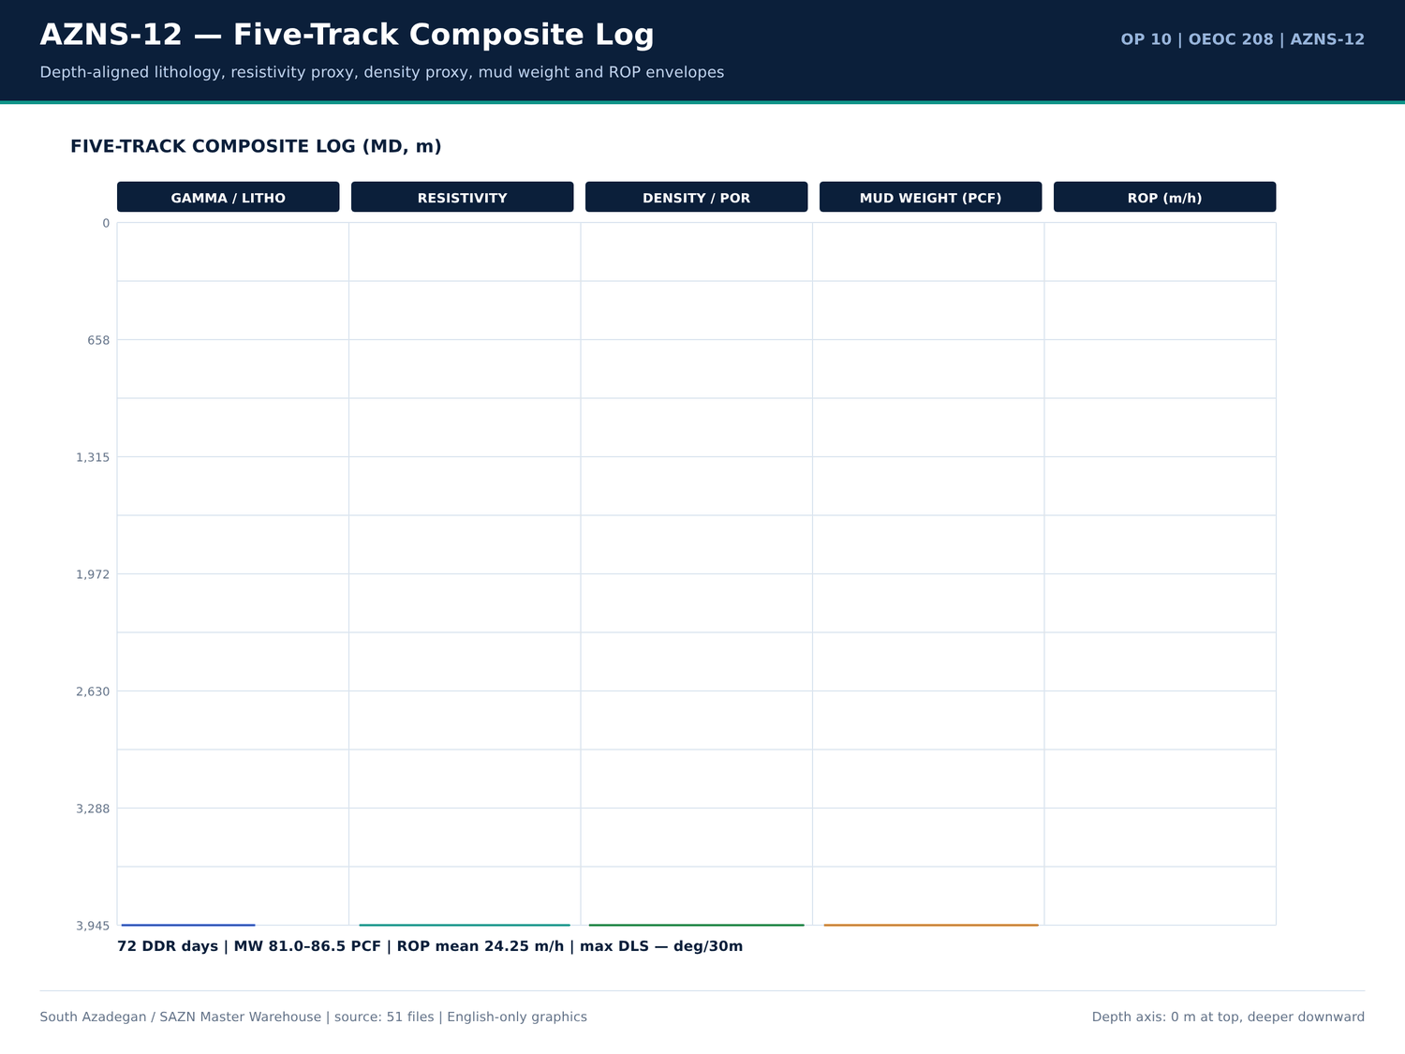
AZNS-12 05 composite log — منبع: انبار داده جامع سازن
ردیفهای قیمتی رشته ابزار
شیت | شرح | واحد | مقدار | مبلغ (دلار)
AZNS-12 WO (Gadvan) | RIH with 8 1⁄2" Mill and clean out BHA (mill remaining fish if Not Retrieved in previus Step) to 7" L.LAP (3285m), CBU, POOH. | — | — | —
AZNS-12 WO (Gadvan) | RIH with 6” or 5-7/8 bit and clean out BHA to 5" Liner lap (3779m), CBU shakers clean, POOH. | — | — | —
AZNS-12 WO (Gadvan) | RIH with 4 1/8” Mill and clean out BHA to bottom (TD: 3945m), take care inside pre-perforation interval (3867m – 3908m), CBU till hole clean, POOH to surface. | — | — | —
AZNS-12 WO (Gadvan) | M/U Tandem scraper BHA, RIH with tandem scrapers including 9-5/8" casing scraper & 7" liner scraper to top of 5" liner (3779m). Scrap 9-5/8” casing and 7” liner and L/D same. | — | — | —

توضیحات مرتبط با BHA در DDR
شماره گزارش | شیت | دسته | Text
9 | 9-1 DDR Remark | SHORTAGE/REMARK | Prepare & M/U New 7" * 4-1/2" N.vam X.O.S on Tubing Hanger w/ 6-1/2" Fishing Jar, 1jt 6-1/2" D.C, 1jt 5" DP Aabove it.
9 | 9-1 DDR Remark | SHORTAGE/REMARK | Work on Pull out Tubing Hanger On T.H.S "No action Jar & Failure to achieve the result, try to pull out string W/Max 200lkb over pull "No Succ."
13 | 13-1 DDR Remark | SHORTAGE/REMARK | Cont. RIH W/ 3-1/2" Spear & Fishing BHA F/330 to 1500m while Circ. Mud C.W.H w/ 2-4 BPL.
13 | 13-1 DDR Remark | SHORTAGE/REMARK | >> Fishing BHA Description: 3-1/2" Spear + 2STDs 4-3/4" DCs + 9STDs 3-1/2" HWDPs + 20STDs 3-1/2" DPs + 3-1/2" * 4-1/2 IF X.O.S.
14 | 14-1 DDR Remark | SHORTAGE/REMARK | RIH W/ 3-1/2" Spear & Fishing BHA F/330 to 3285m (7"L.lap), Circ. BTM's up, Cont. RIH to 3307m, Confirmed TOF Work on Fishing and Try to catch same, POOH as chain out F/3307 to 2550m while Circ. Mud C.W.H w/ 0-1 BPHL.
14 | 14-1 DDR Remark | SHORTAGE/REMARK | Cont. RIH W/ 3-1/2" Spear & Fishing BHA F/330 to 3285m (7"L.lap) while Circ. Mud C.W.H w/ 0-2 BPHL.
14 | 14-1 DDR Remark | SHORTAGE/REMARK | >> Fishing BHA Description: 3-1/2" Spear + 2STDs 4-3/4" DCs + 9STDs 3-1/2" HWDPs + 20STDs 3-1/2" DPs + 3-1/2" * 4-1/2 IF X.O.S.
15 | 15-1 DDR Remark | SHORTAGE/REMARK | Cont. POOH F/2550 to Surface & Recoverd about 100-150m Slick line, RIH W/ 2" * 4" Taper tap & Fishing BHA#02 To 3290m while Circ. Mud C.W.H w/ 0-1 BPHL.
15 | 15-1 DDR Remark | SHORTAGE/REMARK | P/U & M/U 2" * 4" Taper tap & RIH W/ Fishing BHA#02 To 3290m while Circ. Mud C.W.H w/ NL-NG.
15 | 15-1 DDR Remark | SHORTAGE/REMARK | >> Fishing BHA Description: 2" * 4" Taper tap + 4-3/4" Bit sub + 1jt 4-3/4" DC + 4-3/4" F.Jar + 1jt 4-3/4" DC + 2STDs 3-1/2" HWDPs + 20STDs 3-1/2" DPs + X.O.S.
15 | 15-1 DDR Remark | SHORTAGE/REMARK | Cont. RIH W/ 2" * 4" Taper tap & Fishing BHA#02 F/ 3290 To 3305m (2M above Fish Depth), Record Upward & Downward WT W/ Pumping & W/O Pumping
15 | 15-1 DDR Remark | SHORTAGE/REMARK | >> Fishing BHA Description: 2" * 4" Taper tap + 4-3/4" Bit sub + 1jt 4-3/4" DC + 4-3/4" F.Jar + 1jt 4-3/4" DC + 2STDs 3-1/2" HWDPs + 20STDs 3-1/2" DPs + X.O.S.
16 | 16-1 DDR Remark | SHORTAGE/REMARK | Cont. RIH W/ 2" * 4" Taper tap & Fishing BHA#02 F/ 3290 To 3305m Engage w/ Fish & Tap inside Fish, POOH W/ 2" * 4" Taper tap & Fishing BHA#02 as chain out F/3307 to Surface, Recoverd Fish Completely While Circ. C.W.H w/ NL-NG.
16 | 16-1 DDR Remark | SHORTAGE/REMARK | Cont. RIH W/ 2" * 4" Taper tap & Fishing BHA#02 F/ 3290 To 3305m (2M above Fish Depth), Record Upward & Downward WT W/ Pumping & W/O Pumping
16 | 16-1 DDR Remark | SHORTAGE/REMARK | >> Fishing BHA Description: 2" * 4" Taper tap + 4-3/4" Bit sub + 1jt 4-3/4" DC + 4-3/4" F.Jar + 1jt 4-3/4" DC + 2STDs 3-1/2" HWDPs + 20STDs 3-1/2" DPs + X.O.S.
16 | 16-1 DDR Remark | SHORTAGE/REMARK | POOH W/ 2" * 4" Taper tap & Fishing BHA#02 as chain out F/3307 to Surface, Recoverd Fish Completely as below:
19 | 19-1 DDR Remark | SHORTAGE/REMARK | Cont. RIH W/ 6" M.M J.Mill F/ 3454 to 3520m, String Took WT, Try To Wash & Push same three Times "No movment", Circ. BTM's Up, POOH to Surface, RIH w/ 2" * 4" Taper tap & Fishing BHA#04 To 100m Stopped Operation Due to Bad Weather, Cont.…
19 | 19-1 DDR Remark | SHORTAGE/REMARK | P/U & M/U 2" * 4" Taper tap (New, Cylindersazi, S/N: CS7569) & RIH W/ Fishing BHA#04 To 100m while Circ. Mud C.W.H w/ NL-NG.
19 | 19-1 DDR Remark | SHORTAGE/REMARK | >> Fishing BHA Description: 2" * 4" Taper tap + 4-3/4" Bit sub + 1jt 4-3/4" DC + 4-3/4" F.Jar + 10STDs 3-1/2" HWDPs + 20STDs 3-1/2" DPs + X.O.S (Length: 870m)
19 | 19-1 DDR Remark | SHORTAGE/REMARK | Cont. RIH W/ 2" * 4" Taper tap & Fishing BHA#04 F/ 100 To 250 while Circ. Mud C.W.H w/ NL-NG.
19 | 19-1 DDR Remark | SHORTAGE/REMARK | Cont. RIH W/ 2" * 4" Taper tap & Fishing BHA#04 F/ 250 To 1400m while Circ. Mud C.W.H w/ NL-NG.
20 | 20-1 DDR Remark | SHORTAGE/REMARK | Cont. RIH W/ 2" * 4" Taper tap & Fishing BHA#04 F/ 3290 To 3516m Engage w/ Fish, Chase same to 3641m, Tap inside Fish, POOH as chain out F/3641 to 2500 While Circ. C.W.H w/ 0-1 BPHL.

گزییده نشانی سلولهای عددی — فصل 09
سند | شیت | سلول | مقدار
DDRs/10.AZNS_12_DDR_Pack.xlsx | 15-2 DDR Data | R52C11 | 256,180,062.00
DDRs/10.AZNS_12_DDR_Pack.xlsx | 23-2 DDR Data | R52C11 | 256,180,062.00
CBS/10.AZNS_12_CBS.xlsx | Total Cost-EPD & Rigless | R5C3 | 10,877,522.07
CBS/10.AZNS_12_CBS.xlsx | Total Cost-EPD | R19C7 | 10,162,895.93
CBS/10.AZNS_12_CBS.xlsx | Total Cost-EPD & Rigless | R3C3 | 10,162,895.93
CBS/10.AZNS_12_CBS.xlsx | Total Cost-EPD | R3C6 | 3,860,626.98
CBS/10.AZNS_12_CBS.xlsx | Total Cost-EPD | R3C7 | 3,860,626.98
CBS/10.AZNS_12_CBS.xlsx | Cost Breakdown-12 | R197C6 | 3,860,626.98
DDRs/10.AZNS_12_DDR_Pack.xlsx | 1-1 DDR Remark | R12C35 | 3,437,769.78
DDRs/10.AZNS_12_DDR_Pack.xlsx | 2-1 DDR Remark | R12C35 | 3,437,769.78
DDRs/10.AZNS_12_DDR_Pack.xlsx | 3-1 DDR Remark | R12C35 | 3,437,769.78
DDRs/10.AZNS_12_DDR_Pack.xlsx | 4-1 DDR Remark | R12C35 | 3,437,769.78
DDRs/10.AZNS_12_DDR_Pack.xlsx | 5-1 DDR Remark | R12C35 | 3,437,769.78
DDRs/10.AZNS_12_DDR_Pack.xlsx | 6-1 DDR Remark | R12C35 | 3,437,769.78

Chapter 10 — Stick-Slip، Balling و Whirl
نشانههای ارتعاش، Balling مته و Whirl در توضیحات DDR، شرح فعالیتها و یادداشتها جستوجو شد. جداول هر ردیف منطبق را با شماره گزارش و متن آن میآورند؛ اگر متنی یافت نشود فصل صریحاً نبود آن را اعلام میکند و هیچ شاخص ارتعاشی از منبع خاموش ساخته نمیشود.
ردیفهای ارتعاش و Balling
شماره گزارش | شیت | دسته | Text
No source rows for this query | — | — | —

فعالیتهای دارای واژگان ارتعاش
شماره گزارش | فاز | ساعت | شرح
No source rows for this query | — | — | —

پنجرههای پارامتری دینامیک
پارامتر | تعداد | کمینه | میانگین | بیشینه
Torque / RPM / WOB rows retained in well profile | 853 | — | — | —

گزییده نشانی سلولهای عددی — فصل 10
سند | شیت | سلول | مقدار
DDRs/10.AZNS_12_DDR_Pack.xlsx | 15-2 DDR Data | R52C11 | 256,180,062.00
DDRs/10.AZNS_12_DDR_Pack.xlsx | 23-2 DDR Data | R52C11 | 256,180,062.00
CBS/10.AZNS_12_CBS.xlsx | Total Cost-EPD & Rigless | R5C3 | 10,877,522.07
CBS/10.AZNS_12_CBS.xlsx | Total Cost-EPD | R19C7 | 10,162,895.93
CBS/10.AZNS_12_CBS.xlsx | Total Cost-EPD & Rigless | R3C3 | 10,162,895.93
CBS/10.AZNS_12_CBS.xlsx | Total Cost-EPD | R3C6 | 3,860,626.98
CBS/10.AZNS_12_CBS.xlsx | Total Cost-EPD | R3C7 | 3,860,626.98
CBS/10.AZNS_12_CBS.xlsx | Cost Breakdown-12 | R197C6 | 3,860,626.98
DDRs/10.AZNS_12_DDR_Pack.xlsx | 1-1 DDR Remark | R12C35 | 3,437,769.78
DDRs/10.AZNS_12_DDR_Pack.xlsx | 2-1 DDR Remark | R12C35 | 3,437,769.78
DDRs/10.AZNS_12_DDR_Pack.xlsx | 3-1 DDR Remark | R12C35 | 3,437,769.78
DDRs/10.AZNS_12_DDR_Pack.xlsx | 4-1 DDR Remark | R12C35 | 3,437,769.78
DDRs/10.AZNS_12_DDR_Pack.xlsx | 5-1 DDR Remark | R12C35 | 3,437,769.78
DDRs/10.AZNS_12_DDR_Pack.xlsx | 6-1 DDR Remark | R12C35 | 3,437,769.78

Chapter 11 — رئولوژی، سرعت آنالوس، ECD و HSI
وزن گل، معادلهای FIT/LOT، نمایههای سرعت آنالوس و پارامترهای هیدرولیکی از ستونهای روزانه DDR، ردیفهای مواد CBS و فصول سیال EOWR جدولبندی شدهاند. باند 81.0 تا 86.5 PCF باند اندازهگیری است، نه فرض طراحی؛ ردیفهای تراز حجمی و کنترل جامدات عیناً Received / Used / Back-load / Stock را نگهداری میکنند.
پارامترهای روزانه گل و سیال
شماره گزارش | تاریخ | گل (PCF) | FIT EMW | اندازه چاله | سازند
1 | 2025-Apr-13 | 1.5 | — | De-Completion | -
2 | 2025-Apr-14 | 81 | — | De-Completion | -
3 | 2025-Apr-15 | 81 | — | De-Completion | -
4 | 2025-Apr-16 | 84 | — | De-Completion | -
5 | 2025-Apr-17 | 84 | — | De-Completion | -
6 | 2025-Apr-18 | 84 | — | De-Completion | -
7 | 2025-Apr-19 | 84 | — | De-Completion | -
8 | 2025-Apr-20 | 84 | — | De-Completion | -
9 | 2025-Apr-21 | 84 | — | De-Completion | -
10 | 2025-Apr-22 | 84 | — | De-Completion | -
11 | 2025-Apr-23 | 81 | — | De-Completion | -
12 | 2025-Apr-24 | 81 | — | De-Completion | -
13 | 2025-Apr-25 | 81 | — | De-Completion | -
14 | 2025-Apr-26 | 81 | — | De-Completion | -
15 | 2025-Apr-27 | 81 | — | De-Completion | -
23 | 2025-May-5 | 86.5 | — | De-Completion | -
24 | 2025-May-6 | 85 | — | De-Completion | -
25 | 2025-May-7 | 85 | — | De-Completion | -
26 | 2025-May-8 | 85 | — | De-Completion | -
27 | 2025-May-9 | 85 | — | De-Completion | -
28 | 2025-May-10 | 85 | — | De-Completion | -
29 | 2025-May-11 | 85 | — | De-Completion | -

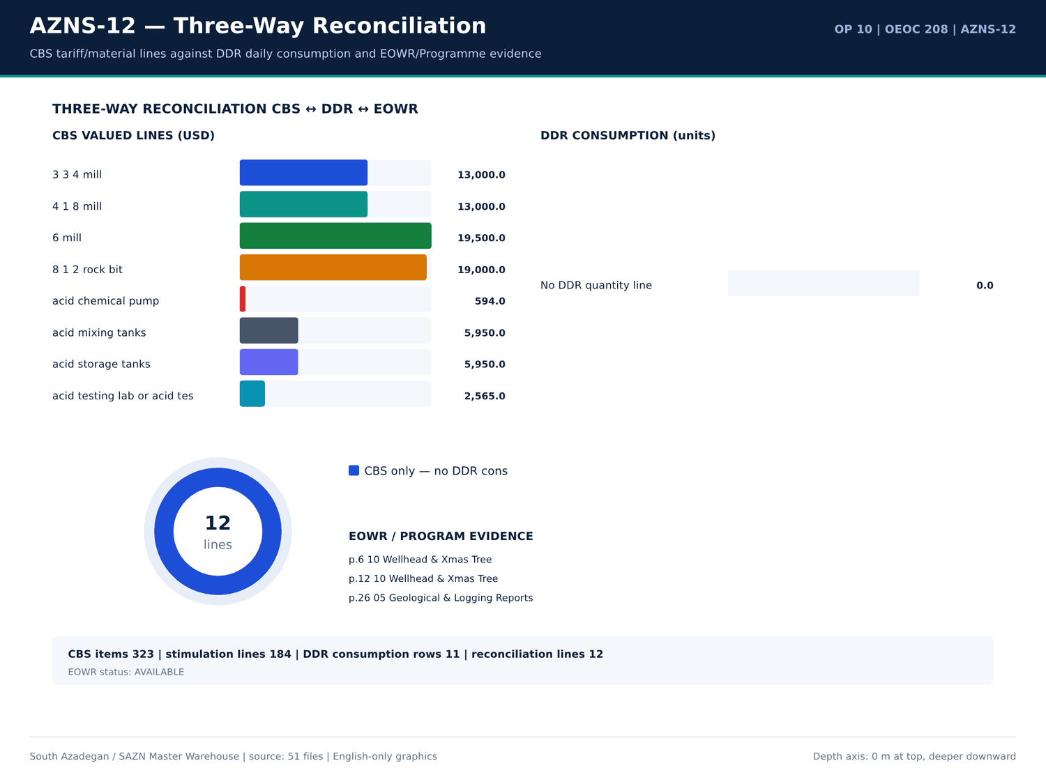
AZNS-12 06 reconciliation — منبع: انبار داده جامع سازن
مصرف گل، سیمان و مواد شیمیایی
شماره گزارش | ماده | واحد | دریافتی | مصرف | موجودی | سلول
1 | BULK F.W | Lit | — | — | 19,000.00 | D72
1 | BULK D.W | BBL | — | — | 1,000.00 | E72
1 | BULK Fuel Rig | Lit | — | — | 86,000.00 | F72
1 | BULK Fuel Camp | Lit | — | — | 800 | G72
1 | BULK F.W | Lit | — | 2,000.00 | — | D73
1 | BULK Fuel Rig | Lit | — | 1,000.00 | — | F73
1 | BULK Fuel Camp | Lit | — | 500 | — | G73
2 | Limestone | 1MT/BB | — | — | 51 | N10
2 | Salt | 1 MT/BB | — | — | 40 | N11
2 | Lime | 25 KG/SX | — | — | 50 | N12
2 | Starch LV | 25 KG/SX | — | — | 100 | N13
2 | Caustic Soda | 25 KG/SX | — | — | 39 | N15
2 | Soda Ash | 25 KG/SX | — | — | 8 | N16
2 | Xanthan Gum | 25 KG/SX | — | — | 30 | N17
2 | BULK F.W | Lit | — | — | 17,000.00 | D72
2 | BULK D.W | BBL | — | — | 1,700.00 | E72
2 | BULK Fuel Rig | Lit | — | — | 84,000.00 | F72
2 | BULK Fuel Camp | Lit | — | — | 7,500.00 | G72
2 | BULK F.W | Lit | — | 2,000.00 | — | D73
2 | BULK Fuel Rig | Lit | — | 2,000.00 | — | F73
2 | BULK Fuel Camp | Lit | — | 500 | — | G73
3 | Limestone | 1MT/BB | — | 14 | 37 | N10

واقعهمندیهای سیال EOWR/Programme
کلید | مقدار | واحد | صفحه | سند
MUD_WEIGHT | 69 | pcf | 17 | 04.EOWR/10.AZNS_12_EOWR.pdf
MUD_WEIGHT | 85 | pcf | 20 | 04.EOWR/10.AZNS_12_EOWR.pdf
LOSS | 1 | BPH | 20 | 04.EOWR/10.AZNS_12_EOWR.pdf
LOSS | 1 | BPH | 20 | 04.EOWR/10.AZNS_12_EOWR.pdf
MUD_WEIGHT | 84 | pcf | 22 | 04.EOWR/10.AZNS_12_EOWR.pdf
MUD_WEIGHT | 85 | pcf | 28 | Well Program/10.AZNS_12_Workover_Program.pdf
MUD_WEIGHT | 75 | pcf | 52 | Well Program/10.AZNS_12_Workover_Program.pdf
MUD_WEIGHT | 84 | pcf | 107 | 04.EOWR/10.AZNS_12_EOWR.pdf

گزییده نشانی سلولهای عددی — فصل 11
سند | شیت | سلول | مقدار
DDRs/10.AZNS_12_DDR_Pack.xlsx | 15-2 DDR Data | R52C11 | 256,180,062.00
DDRs/10.AZNS_12_DDR_Pack.xlsx | 23-2 DDR Data | R52C11 | 256,180,062.00
CBS/10.AZNS_12_CBS.xlsx | Total Cost-EPD & Rigless | R5C3 | 10,877,522.07
CBS/10.AZNS_12_CBS.xlsx | Total Cost-EPD | R19C7 | 10,162,895.93
CBS/10.AZNS_12_CBS.xlsx | Total Cost-EPD & Rigless | R3C3 | 10,162,895.93
CBS/10.AZNS_12_CBS.xlsx | Total Cost-EPD | R3C6 | 3,860,626.98
CBS/10.AZNS_12_CBS.xlsx | Total Cost-EPD | R3C7 | 3,860,626.98
CBS/10.AZNS_12_CBS.xlsx | Cost Breakdown-12 | R197C6 | 3,860,626.98
DDRs/10.AZNS_12_DDR_Pack.xlsx | 1-1 DDR Remark | R12C35 | 3,437,769.78
DDRs/10.AZNS_12_DDR_Pack.xlsx | 2-1 DDR Remark | R12C35 | 3,437,769.78
DDRs/10.AZNS_12_DDR_Pack.xlsx | 3-1 DDR Remark | R12C35 | 3,437,769.78
DDRs/10.AZNS_12_DDR_Pack.xlsx | 4-1 DDR Remark | R12C35 | 3,437,769.78
DDRs/10.AZNS_12_DDR_Pack.xlsx | 5-1 DDR Remark | R12C35 | 3,437,769.78
DDRs/10.AZNS_12_DDR_Pack.xlsx | 6-1 DDR Remark | R12C35 | 3,437,769.78

Chapter 12 — ترپینگ، هوکلواد و Swab-Surge
فعالیتهای ترپینگ، ریمینگ، هوکلواد PU/SO/ROT و Swab-Surge بر پایه کد و کلیدواژه از 853 ردیف فعالیت جدا شدهاند. ساعات، فاز و شرح عیناً آمده است؛ آمار هوکلواد فقط از ردیفهای پارامتری برچسبخورده DDR گرفته میشود و پارامتر غایب با «—» نمایش داده میشود.
ساعات ترپینگ و ریمینگ
شماره گزارش | فاز | کد | ساعت | شرح
3 | REE | 23 | 5.5 | Hold 4500 psi Press in 1/4" C/L. R/U Slick line Equip, Lubricator & BOP Stack. Press Test same w/ 3000 psi; " Ok". Run Gauge Ring to 3SV Depth, POOH To surface. RIH w/ 5.200"
3 | — | — | — | M.Pulling to Retrieve 3SV. Try to retrieve several times; "Unable to retrieve 3SV". POOH to surface. Run 2.5” Gauge Ring to 2798m (Probable TOF). Drop Tension, POOH to surface.
5 | REE | 24 | 4 | Perform Press test w/ 3500 psi; "Ok". RIH w/ 1-1/2"C.TBG to to 2798m (TOF), Meanwhile Slow Circ. Mud thru CT. Try to Pass this Point (2798m) w/ Apply Max. 2000 Lb Wt.; "No-Succ.
5 | REE | 5 | 3 | Displace the string w/ 200 bbl 84 pcf CaCO3 Poly Mud till M.N. Meanwhile POOH to 2780m.
5 | REE | 5 | 1 | Resume POOH 1-1/2" CT f/ 2780 to 500 m, Meanwhile Circ. Mud thru CT.
6 | REE | 5 | 2.5 | Resume POOH 1-1/2" CT f/ 2780m to to surface, Meanwhile Circ. Mud thru CT. Flush CT w/ F.Water
8 | REE | 11 | 2.5 | Held PJSM. Load & Armed 5 No. HMX Bullet on carrier. RIH w/L Punch Assy (Cable head, CCL, Wt. bar, Carrier, BTM Nose: Max OD: 1-11/16", Tot Len: 4.35m) to 2794m, Meanwhile
8 | REE | 5 | 1.5 | POOH W/L tools to 100m While Slow Circ. thru completion string.
9 | REE | 11 | 2.5 | POOH to surface, L/D Sealand Punch ass. & check all bullet is Fired, B/O & L/D Wire line BOP & Equip. & X.O.S - f/u tools.
10 | — | — | — | POOH & OBS Tubing Hanger (Baker Type) to Surf. , Connected TDS and Circ. Mud Thru string Till BTMs up & uniform MW in/out meanwhile R/U OEOC CSG Running Equip. Till M.N
11 | — | — | — | POOH Ret. Completion string as: B/O & L/D Tubing Hanger & fluted Adapter + 5JT 7" Tubing 29#, L-80 N.vam + 5No. 7" Fluted Swage 29#, L-80 N.vam + 7" baker type 3SV w/ Long (20ft) +
11 | COM | 23 | 6 | Cont. POOH Completion string as: 41Jts 7" Tubing 29#, L-80 N.vam (Totally 138Jts) While Circ. Mud C.W.H w/ 4-6 BPHL.
12 | COM | 23 | 24 | Cont. POOH Completion string To Surface and OBS. Cutted off Comp. String from Box of Expan. JT 20ft stroke N.vam (fully open position) While C.W.H w/ 4-6 BPHL.
12 | — | — | — | >> During POOH OBS. Obstruction by slick line @ jt#229 (2795m) , #242(2944m), #248 (3001m) also OBS. Plugged 7" * 4-1/2" N.vam X.O.S with debris of asphaltene and sand.
12 | — | — | — | >> After POOH Comp. string to surface Noticed the Expan. Jt was completely open when the 7" PKR was set.
13 | REE | 6 | 21 | In Order to Stand back Required 4-3/4" DCs + 3-1/2" HWDP & 3-1/2" DPs in Derrick, P/U & RIH W/ 18JTs 4-3/4" DCs + 60JTs 3-1/2" DPs jt by jt To 730m While Washed, Hammerd,
13 | — | — | — | POOH String to surface while R/B totally 6STDs 4-3/4" DCs + 20STDs 3-1/2" DPs in Derrick.
13 | — | — | — | P/U & RIH W/ 3-1/2" Spear + 2STDs 4-3/4" DCs + 6STDs 3-1/2" HWDPs to 200m while P/U 3-1/2" HWDPs jt by jt, Circ. Mud C.W.H w/ 2-4 BPHL.Till. M.N.
13 | — | — | — | >> After POOH Comp. string to surface Noticed the Expan. Jt was completely open when the 7" PKR was set.
13 | REE | 6 | 2 | RIH W/ 3-1/2" Spear + 2STDs 4-3/4" DCs + 9STDs 3-1/2" HWDPs to 330m while P/U 3-1/2" HWDPs jt by jt, Circ. Mud C.W.H w/ 2-4 BPHL.
13 | REE | 18 | 4 | Cont. RIH W/ 3-1/2" Spear & Fishing BHA F/330 to 1500m while Circ. Mud C.W.H w/ 2-4 BPL.
14 | REE | 6 | 2 | RIH W/ 3-1/2" Spear + 2STDs 4-3/4" DCs + 9STDs 3-1/2" HWDPs to 330m while P/U 3-1/2" HWDPs jt by jt, Circ. Mud C.W.H w/ 2-4 BPHL.

یادداشتهای هوکلواد و PU/SO/ROT
شماره گزارش | شیت | دسته | Text
10 | 10-1 DDR Remark | SHORTAGE/REMARK | Cont. Work on Pull out Tubing Hanger in THS, OBS Stuck Tubing Hanger in Tubing Head Spool, Apply 500psi in Ann. while Pull out string w/ Max. 530klbs, OBS. Dec. Hookload to 470klbs

کدهای زمان ترپینگ و ریمینگ
کد | دسته | ساعت | شماره گزارش
6 | Trips | 24 | 29
6 | Trips | 21.5 | 49
6 | Trips | 21.5 | 55
6 | Trips | 21 | 13
6 | Trips | 18.5 | 28
6 | Trips | 17 | 59
6 | Trips | 15 | 56
6 | Trips | 14 | 30
6 | Trips | 13 | 53
6 | Trips | 12 | 58
3 | Reaming | 11.5 | 48
6 | Trips | 11.5 | 35
6 | Trips | 7 | 48
3 | Reaming | 7 | 47
6 | Trips | 6 | 32
6 | Trips | 5.5 | 27
6 | Trips | 5.5 | 50
6 | Trips | 3 | 3
6 | Trips | 2 | 14
6 | Trips | 2 | 52
6 | Trips | 1.5 | 31
6 | Trips | 1 | 54

گزییده نشانی سلولهای عددی — فصل 12
سند | شیت | سلول | مقدار
DDRs/10.AZNS_12_DDR_Pack.xlsx | 15-2 DDR Data | R52C11 | 256,180,062.00
DDRs/10.AZNS_12_DDR_Pack.xlsx | 23-2 DDR Data | R52C11 | 256,180,062.00
CBS/10.AZNS_12_CBS.xlsx | Total Cost-EPD & Rigless | R5C3 | 10,877,522.07
CBS/10.AZNS_12_CBS.xlsx | Total Cost-EPD | R19C7 | 10,162,895.93
CBS/10.AZNS_12_CBS.xlsx | Total Cost-EPD & Rigless | R3C3 | 10,162,895.93
CBS/10.AZNS_12_CBS.xlsx | Total Cost-EPD | R3C6 | 3,860,626.98
CBS/10.AZNS_12_CBS.xlsx | Total Cost-EPD | R3C7 | 3,860,626.98
CBS/10.AZNS_12_CBS.xlsx | Cost Breakdown-12 | R197C6 | 3,860,626.98
DDRs/10.AZNS_12_DDR_Pack.xlsx | 1-1 DDR Remark | R12C35 | 3,437,769.78
DDRs/10.AZNS_12_DDR_Pack.xlsx | 2-1 DDR Remark | R12C35 | 3,437,769.78
DDRs/10.AZNS_12_DDR_Pack.xlsx | 3-1 DDR Remark | R12C35 | 3,437,769.78
DDRs/10.AZNS_12_DDR_Pack.xlsx | 4-1 DDR Remark | R12C35 | 3,437,769.78
DDRs/10.AZNS_12_DDR_Pack.xlsx | 5-1 DDR Remark | R12C35 | 3,437,769.78
DDRs/10.AZNS_12_DDR_Pack.xlsx | 6-1 DDR Remark | R12C35 | 3,437,769.78

Chapter 13 — زمان اتصالات و زمان پنهان ازدسترفته
کدهای اتصال، نگرشی، گردش و انتظار از زمان حفاری مولد جدا شدهاند. جداول کد، دسته، ساعات و شماره_reportno را میدهند تا زمان پنهان ازدسترفته قابل محاسبه مجدد باشد؛ هرجا خود DDR ناقص است، مجموع بر ۲۴ ساعت تحمیل نمیشود.
کدهای اتصال، گردش و انتظار
کد | دسته | ساعت | شماره گزارش
5 | Circulate & Condition | — | 1
10 | Deviation Survey | — | 1
14 | Wait on Cement | — | 1
20 | Operation Status (Waiting) | — | 1
5 | Circulate & Condition | — | 2
10 | Deviation Survey | — | 2
14 | Wait on Cement | — | 2
20 | Operation Status (Waiting) | 14 | 2
5 | Circulate & Condition | — | 3
10 | Deviation Survey | — | 3
14 | Wait on Cement | — | 3
20 | Operation Status (Waiting) | 9 | 3
5 | Circulate & Condition | — | 4
10 | Deviation Survey | — | 4
14 | Wait on Cement | — | 4
20 | Operation Status (Waiting) | 24 | 4
5 | Circulate & Condition | 3 | 5
10 | Deviation Survey | — | 5
14 | Wait on Cement | — | 5
20 | Operation Status (Waiting) | 17 | 5
5 | Circulate & Condition | 9.5 | 6
10 | Deviation Survey | — | 6

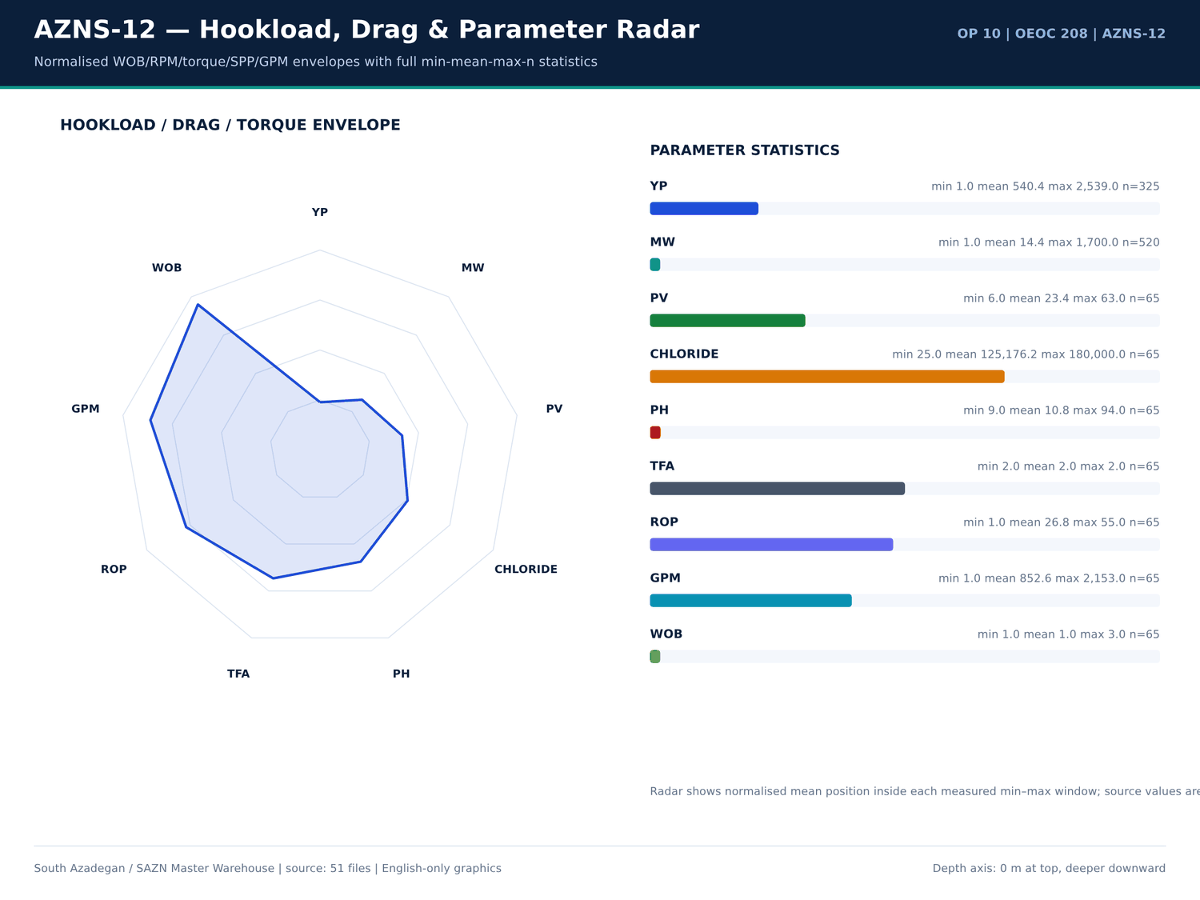
AZNS-12 07 hookload — منبع: انبار داده جامع سازن
فعالیتهای دارای واژه اتصال
شماره گزارش | فاز | ساعت | شرح
3 | — | — | to 1500 psi on CL P.Gauge) Also check connection between string & Ann w/ 1000 psi Press; Negative.
3 | REE | 7 | Wait on OEOC due to Rec. Crain to R/U CT Injetcor head.
3 | REE | 6 | Wait on OEOC due to Rec. Crain to R/U CT Injetcor head.
4 | REE | 24 | Wait on R/U CTU. OEOC Refuses to R/U CT Injector head. So 24 hours NPT has been applied for OEOC rig and services.
4 | REE | 6 | Cont. Wait on R/U CTU. OEOC Refuses to R/U CT Injector head. So 24 hours NPT has been applied for OEOC rig and services.
5 | REE | 15 | Wait on R/U CTU. OEOC Refuses to R/U CT Injector head. So 15 hours NPT has been applied for OEOC rig and services.
7 | REE | 4 | Due to unable to establish circulation through the string and discrepancies between in/out mud weight values. In order to well safety before unlatch the anchor seal from the PKR and
7 | — | — | addressing trapped pressure below the 7" PKR, Wait on daylight to proceed with punching the string from 2800 m.
7 | REE | 6 | Due to unable to establish circulation through the string and discrepancies between in/out mud weight values. In order to well safety before unlatch the anchor seal from the PKR and
7 | — | — | addressing trapped pressure below the 7" PKR, Wait on daylight to proceed with punching the string from 2800 m.
8 | REE | 8 | Due to unable to establish circulation through the string and discrepancies between in/out mud weight values. In order to well safety before unlatch the anchor seal from the PKR and
8 | — | — | addressing trapped pressure below the 7" PKR, Wait on daylight to proceed with punching the string from 2800 m.
8 | REE | 2 | Wait on daylight due to explosive material safety regulation. Cont. Slow Circ. thru completion string. w/ Max 1 BPM, 500 psi Press. (Totally Pump 140bbl Mud 84pcf).
8 | REE | 3.5 | Cont. Wait on daylight due to explosive material safety regulation. Slow Circ. thru completion string. w/ Max 1 BPM, 500 psi Press. After Totally Pump 230bbl 84 pcf CaCO3 Poly Mud.
8 | REE | 2.5 | Cont. Wait on daylight due to explosive material safety regulation.
9 | REE | 3.5 | Cont. Wait on daylight due to explosive material safety regulation. Slow Circ. thru completion string. w/ Max 1 BPM, 500 psi Press. After Totally Pump 230bbl 84 pcf CaCO3 Poly Mud.
9 | REE | 2 | Cont. Wait on daylight due to explosive material safety regulation.
22 | REE | 3 | Wait on Bad Weather situation (Dust storm) @ 2700m While Circ. C.W.H w/ 0-1 BPHL.
23 | REE | 3 | Cont. Wait on bad weather (Dust storm) @ 2700m.
38 | REE | 2 | While Wait on Rec. New Bit Sub from OEOC, Circ. C.W.H w/ 1 BPHL.
45 | REE | 3.5 | RIH w/ 1STDs 6-1/2" DC + 11STDs 5" DPs + 9-5/8" RTTS PKR + 6-1/2" Circulating Valve + 1jts 5" DPs + 5" Safety Valve (in Close Position) + 1STDs 5" DPs to 385m, Set RTTS PKR @ 40m as Per RTTS Specialist Procedure , Press. Test RTTS PKR ag…
46 | REE | 3.5 | RIH w/ 1STDs 6-1/2" DC + 11STDs 5" DPs + 9-5/8" RTTS PKR + 6-1/2" Circulating Valve + 1jts 5" DPs + 5" Safety Valve (in Close Position) + 1STDs 5" DPs to 385m, Set RTTS PKR @ 40m as Per RTTS Specialist Procedure , Press. Test RTTS PKR ag…

تراز ساعانه روزانه PT/NPT
شماره گزارش | تاریخ | NPT (ساعت) | PT (ساعت) | هزینه تجمعی (دلار)
1 | 2025-Apr-13 | 0 | 12 | 23,000.00
2 | 2025-Apr-14 | 16 | 14 | 46,000.00
3 | 2025-Apr-15 | 15 | 15 | 69,000.00
4 | 2025-Apr-16 | 30 | 0 | 92,000.00
5 | 2025-Apr-17 | 17 | 13 | 115,000.00
6 | 2025-Apr-18 | 0 | 30 | 138,000.00
7 | 2025-Apr-19 | 10 | 20 | 161,000.00
8 | 2025-Apr-20 | 30 | 0 | 184,000.00
9 | 2025-Apr-21 | 30 | 0 | 207,000.00
10 | 2025-Apr-22 | 28 | 2 | 230,000.00
11 | 2025-Apr-23 | 4 | 26 | 253,000.00
12 | 2025-Apr-24 | 0 | 30 | 276,000.00
13 | 2025-Apr-25 | 0 | 30 | 299,000.00
14 | 2025-Apr-26 | 28 | 2 | 322,000.00
15 | 2025-Apr-27 | 30 | 0 | 345,000.00
16 | 2025-Apr-28 | 26 | 4 | 368,000.00
17 | 2025-Apr-29 | 5 | 25 | 391,000.00
18 | 2025-Apr-30 | 21 | 9 | 414,000.00
19 | 2025-May-1 | 2 | 28 | 437,000.00
20 | 2025-May-2 | 0 | 30 | 460,000.00
21 | 2025-May-3 | 3.5 | 26.5 | 483,000.00
22 | 2025-May-4 | 5 | 25 | 506,000.00

گزییده نشانی سلولهای عددی — فصل 13
سند | شیت | سلول | مقدار
DDRs/10.AZNS_12_DDR_Pack.xlsx | 15-2 DDR Data | R52C11 | 256,180,062.00
DDRs/10.AZNS_12_DDR_Pack.xlsx | 23-2 DDR Data | R52C11 | 256,180,062.00
CBS/10.AZNS_12_CBS.xlsx | Total Cost-EPD & Rigless | R5C3 | 10,877,522.07
CBS/10.AZNS_12_CBS.xlsx | Total Cost-EPD | R19C7 | 10,162,895.93
CBS/10.AZNS_12_CBS.xlsx | Total Cost-EPD & Rigless | R3C3 | 10,162,895.93
CBS/10.AZNS_12_CBS.xlsx | Total Cost-EPD | R3C6 | 3,860,626.98
CBS/10.AZNS_12_CBS.xlsx | Total Cost-EPD | R3C7 | 3,860,626.98
CBS/10.AZNS_12_CBS.xlsx | Cost Breakdown-12 | R197C6 | 3,860,626.98
DDRs/10.AZNS_12_DDR_Pack.xlsx | 1-1 DDR Remark | R12C35 | 3,437,769.78
DDRs/10.AZNS_12_DDR_Pack.xlsx | 2-1 DDR Remark | R12C35 | 3,437,769.78
DDRs/10.AZNS_12_DDR_Pack.xlsx | 3-1 DDR Remark | R12C35 | 3,437,769.78
DDRs/10.AZNS_12_DDR_Pack.xlsx | 4-1 DDR Remark | R12C35 | 3,437,769.78
DDRs/10.AZNS_12_DDR_Pack.xlsx | 5-1 DDR Remark | R12C35 | 3,437,769.78
DDRs/10.AZNS_12_DDR_Pack.xlsx | 6-1 DDR Remark | R12C35 | 3,437,769.78

Chapter 14 — جهتداری، DLS و پیچخوردگی مسیر
ایستگاههای نگرشی، انحراف، آزیموت، TVD و DLS انحنای کمینه بهتفکیک ایستگاه بازتولید شدهاند. بیشینه DLS برابر — درجه بر ۳۰ متر است. پنجرههای پارامتر جهتدار (WOB، RPM، گشتاور، SPP، GPM) از ردیفهای برچسبخورده DDR همراه تعداد، کمینه، میانگین و بیشینه آمدهاند.
ایستگاههای نگرشی جهتداری
شماره گزارش | عمق اندازهگیری (متر) | انحراف (درجه) | آزیموت (درجه) | عمق قائم (متر) | DLS (درجه/30 متر) | ابزار
No source rows for this query | — | — | — | — | — | —

توضیحات جهتداری
شماره گزارش | شیت | دسته | Text
No source rows for this query | — | — | —

مقادیر سرنگرشی KOP
شماره گزارش | تاریخ | KOP1 | KOP2 | اندازه چاله | سازند
1 | 2025-Apr-13 | 3,470.00 | 7 | De-Completion | -
2 | 2025-Apr-14 | 3,470.00 | 7 | De-Completion | -
3 | 2025-Apr-15 | 3,470.00 | 7 | De-Completion | -
4 | 2025-Apr-16 | 3,470.00 | 7 | De-Completion | -
5 | 2025-Apr-17 | 3,470.00 | 7 | De-Completion | -
6 | 2025-Apr-18 | 3,470.00 | 7 | De-Completion | -
7 | 2025-Apr-19 | 3,470.00 | 7 | De-Completion | -
8 | 2025-Apr-20 | 3,470.00 | 7 | De-Completion | -
9 | 2025-Apr-21 | 3,470.00 | 7 | De-Completion | -
10 | 2025-Apr-22 | 3,470.00 | 7 | De-Completion | -
11 | 2025-Apr-23 | 3,470.00 | 7 | De-Completion | -
12 | 2025-Apr-24 | 3,470.00 | 7 | De-Completion | -
13 | 2025-Apr-25 | 3,470.00 | 7 | De-Completion | -
14 | 2025-Apr-26 | 3,470.00 | 7 | De-Completion | -
15 | 2025-Apr-27 | 3,470.00 | 7 | De-Completion | -
16 | 2025-Apr-28 | 3,470.00 | 7 | De-Completion | -
17 | 2025-Apr-29 | 3,470.00 | 7 | De-Completion | -
18 | 2025-Apr-30 | 3,470.00 | 7 | De-Completion | -
19 | 2025-May-1 | 3,470.00 | 7 | De-Completion | -
20 | 2025-May-2 | 3,470.00 | 7 | De-Completion | -
21 | 2025-May-3 | 3,470.00 | 7 | De-Completion | -
22 | 2025-May-4 | 3,470.00 | 7 | De-Completion | -

گزییده نشانی سلولهای عددی — فصل 14
سند | شیت | سلول | مقدار
DDRs/10.AZNS_12_DDR_Pack.xlsx | 15-2 DDR Data | R52C11 | 256,180,062.00
DDRs/10.AZNS_12_DDR_Pack.xlsx | 23-2 DDR Data | R52C11 | 256,180,062.00
CBS/10.AZNS_12_CBS.xlsx | Total Cost-EPD & Rigless | R5C3 | 10,877,522.07
CBS/10.AZNS_12_CBS.xlsx | Total Cost-EPD | R19C7 | 10,162,895.93
CBS/10.AZNS_12_CBS.xlsx | Total Cost-EPD & Rigless | R3C3 | 10,162,895.93
CBS/10.AZNS_12_CBS.xlsx | Total Cost-EPD | R3C6 | 3,860,626.98
CBS/10.AZNS_12_CBS.xlsx | Total Cost-EPD | R3C7 | 3,860,626.98
CBS/10.AZNS_12_CBS.xlsx | Cost Breakdown-12 | R197C6 | 3,860,626.98
DDRs/10.AZNS_12_DDR_Pack.xlsx | 1-1 DDR Remark | R12C35 | 3,437,769.78
DDRs/10.AZNS_12_DDR_Pack.xlsx | 2-1 DDR Remark | R12C35 | 3,437,769.78
DDRs/10.AZNS_12_DDR_Pack.xlsx | 3-1 DDR Remark | R12C35 | 3,437,769.78
DDRs/10.AZNS_12_DDR_Pack.xlsx | 4-1 DDR Remark | R12C35 | 3,437,769.78
DDRs/10.AZNS_12_DDR_Pack.xlsx | 5-1 DDR Remark | R12C35 | 3,437,769.78
DDRs/10.AZNS_12_DDR_Pack.xlsx | 6-1 DDR Remark | R12C35 | 3,437,769.78

Chapter 15 — کنترل چاه، هرزروی، LCM، Dry Test و MAASP
هرزروی، پیلهای LCM، تست خشک، تست باند، FIT/LOT و واقعهمندیهای مرتبط با MAASP از توضیحات DDR و لایه متن EOWR / Programme استخراج شدهاند. 8 خانواده مسئله شواهد کنترل هرزروی را دارند و هر رقم شماره صفحه خود را همراه دارد. مقداری که در لایه متن چاپ نشده تخمین زده نمیشود.
توضیحات هرزروی، LCM و کنترل چاه
شماره گزارش | شیت | دسته | Text
25 | 25-1 DDR Remark | SHORTAGE/REMARK | Resume RIH w/ 3-1/2" Cable Spear + 10 Stds 3-1/2" HWDP + 20 Stds 3-1/2" DP + XOS & Followed by 5" DPs to 3200m. 0-1 BPH Losses.
27 | 27-1 DDR Remark | SHORTAGE/REMARK | Circ. Every 15 Stds; 6-8 BPH Losses.
27 | 27-1 DDR Remark | SHORTAGE/REMARK | Cont. RIH w/ 6" M.M J.Mill f/ 1300 to 3400m, F/U the string & Break Circ. Every 15 Stds; 8-2 BPH Losses.
28 | 28-1 DDR Remark | SHORTAGE/REMARK | Cont. RIH w/ 6" M.M J.Mill f/ 1300 to 3778m (5" L.Lap), F/U the string & Break Circ. Every 15 Stds; 8-2 BPH Losses. Meanwhile wash Dn last 2 Std & Confirm 5" L.Lap.
28 | 28-1 DDR Remark | SHORTAGE/REMARK | Circ. BTM's Up & Uniform MW to 85 pcf; 2 BPH Losses.
28 | 28-1 DDR Remark | SHORTAGE/REMARK | Perform static flow check; 1 BPH Losses.
30 | 30-1 DDR Remark | SHORTAGE/REMARK | RIH w/ 2-7/8" Cable Spear + 29 Jts 3-1/2" HWDP + 20 Stds 3-1/2" DP + XOS & Followed by 5" DPs to 1300m; 0-1 BPH Losses.
63 | 63-1 DDR Remark | SHORTAGE/REMARK | While Work on Tie Down Screw & try to remove it to Check Landing port of Tubing Hanger Inside Tubing head spool & try to regulate Mark slot of ESP Orientation indicator on Tubing Hanger against Tubing Head spool Tie-down POOH to change 5…

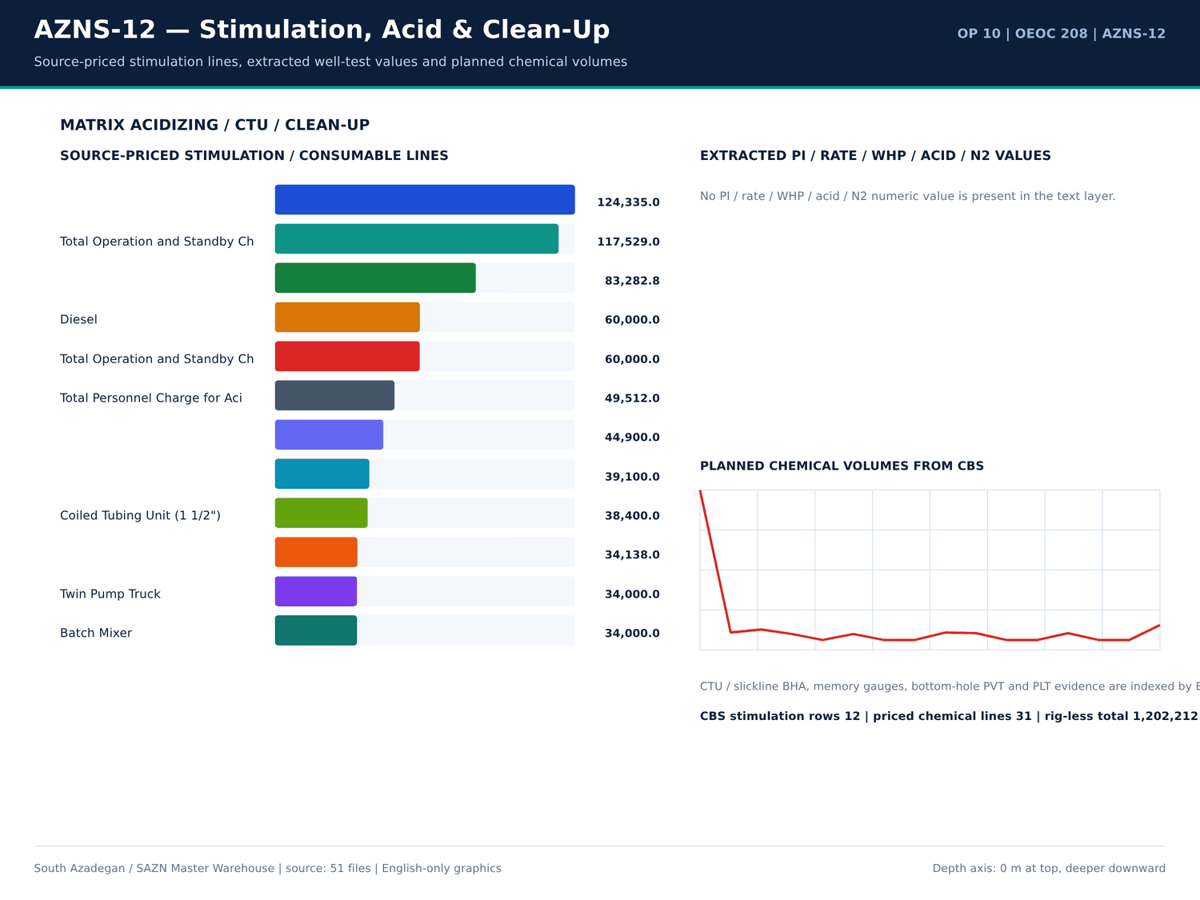
AZNS-12 08 acid — منبع: انبار داده جامع سازن
واقعهمندیهای فشار و FIT/LOT
کلید | مقدار | واحد | صفحه | سند | زمینه
LOSS | 1 | BPH | 20 | 04.EOWR/10.AZNS_12_EOWR.pdf | Circ. BTM's Up & Uniform MW to 85pcf; 2 BPH Losses. Perform static flow check; 1 BPH Losses. POOH w/ 6" M.M J.Mill f/ 3778 to 850
LOSS | 1 | BPH | 20 | 04.EOWR/10.AZNS_12_EOWR.pdf | PH Losses. Perform static flow check; 1 BPH Losses. POOH w/ 6" M.M J.Mill f/ 3778 to 850m, F/U the well; 0-1 BPHL. Install G Board Cont. POOH w/ 6" M.
PRESSURE_TEST | 4,500.00 | psi | 29 | 04.EOWR/10.AZNS_12_EOWR.pdf | tubing Hanger, Install 1/4" Fitting on C/L. Pressure test of CL w/4500psi for 15min "Ok" Release Press. to 3000psi. P
PRESSURE_TEST | 4,500.00 | psi | 30 | 04.EOWR/10.AZNS_12_EOWR.pdf | tubing Hanger, Install 1/4" Fitting on C/L. Pressure test of CL w/4500psi for 15min "Ok" Release Press. to 3000psi.
PRESSURE_TEST | 4,500.00 | psi | 80 | 04.EOWR/10.AZNS_12_EOWR.pdf | – 12 Page 80 of 140 valve Inside. Pressure Test Tubing String 4500psi/15min Every 100 JTs. √ RIH Completion Stri
PRESSURE_TEST | 6,000.00 | psi | 80 | 04.EOWR/10.AZNS_12_EOWR.pdf | RSSSV √ Install control line to TRSSSV and pressure test control line 6000psi x 15mins. And then keep 3000psi pressure wh
PRESSURE_TEST | 4,500.00 | psi | 81 | 04.EOWR/10.AZNS_12_EOWR.pdf | bonnet. √ Check hanger for any damage and pressure test control line to 4500psi √ Pressure test chemical injection line &
PRESSURE_TEST | 4,500.00 | Psi | 100 | 04.EOWR/10.AZNS_12_EOWR.pdf | ion) Item Test Check Mark and Result 1 Pressure test for the kill Valve W/ 1000 & 4500 Psi / 15 min OK 2 Pressure test for the SSV W
PRESSURE_TEST | 4,500.00 | Psi | 100 | 04.EOWR/10.AZNS_12_EOWR.pdf | l Valve W/ 1000 & 4500 Psi / 15 min OK 2 Pressure test for the SSV W/ 1000 & 4500 Psi / 15 min OK 3 Pressure test for the top m
PRESSURE_TEST | 4,500.00 | Psi | 100 | 04.EOWR/10.AZNS_12_EOWR.pdf | the SSV W/ 1000 & 4500 Psi / 15 min OK 3 Pressure test for the top master valve W/ 1000 & 4500 Psi / 15 min OK 4 Pressure test for Swab val
PRESSURE_TEST | 4,500.00 | Psi | 100 | 04.EOWR/10.AZNS_12_EOWR.pdf | valve W/ 1000 & 4500 Psi / 15 min OK 4 Pressure test for Swab valve W/ 1000 & 4500 Psi / 15 min OK 5 Pressure test for the Produ
PRESSURE_TEST | 4,500.00 | Psi | 100 | 04.EOWR/10.AZNS_12_EOWR.pdf | ab valve W/ 1000 & 4500 Psi / 15 min OK 5 Pressure test for the Production valve W/ 1000 & 4500 Psi / 15 min OK Table 8-5: AZNS-12 Section "D
PRESSURE_TEST | 4,500.00 | Psi | 100 | 04.EOWR/10.AZNS_12_EOWR.pdf | section W/1000 &4500 psi for 15min OK 2 Pressure test for the SSV Exit block W/ 4500 Psi / 15 min OK 3 Pressure test neck of tubin
PRESSURE_TEST | 4,500.00 | psi | 100 | 04.EOWR/10.AZNS_12_EOWR.pdf | SSV Exit block W/ 4500 Psi / 15 min OK 3 Pressure test neck of tubing hanger metal seal W/1000 &4500 psi for 15min OK 4 Pressure test for Swab val
PRESSURE_TEST | 4,500.00 | Psi | 100 | 04.EOWR/10.AZNS_12_EOWR.pdf | al seal W/1000 &4500 psi for 15min OK 4 Pressure test for Swab valve W/ 4500 Psi / 15 min - 5 Pressure test for Production
PRESSURE_TEST | 4,500.00 | Psi | 100 | 04.EOWR/10.AZNS_12_EOWR.pdf | t for Swab valve W/ 4500 Psi / 15 min - 5 Pressure test for Production valve W/4500 Psi / 15 min - 6 Pressure test cavity of FS.s
PRESSURE_TEST | 4,500.00 | Psi | 100 | 04.EOWR/10.AZNS_12_EOWR.pdf | Production valve W/4500 Psi / 15 min - 6 Pressure test cavity of FS.seal and Ring Gasket W 4500 Psi / 15 min OK Table 8-6: AZNS-12 Section "D

خانوادههای مسئله با شاهد هرزروی
دسته | ساعت | عمق (متر) | سازند | هزینه (دلار) | جزئیات
Lost circulation / fluid losses | 248.5 | 3,945.00 | - | 238,145.83 | Cont. RIH W/ 3-1/2" Spear & Fishing BHA F/330 to 3285m (7"L.lap) while Circ. Mud C.W.H w/ 0-2 BPHL. | Circ. BTM's up @ 3285m (7"L.lap) to balanced MW in/out @ 81pcf W/0-1 BPHL. | In Order to check string & 3-1/2" Spear For any Probably f…
Other operational delay | 235 | 3,945.00 | - | 225,208.33 | Stop operation Due to Align TDS Rail meanwhile OEOC inspection &maintenance crew work on TDS. | Stop operation Due to Bad Weather (High win speed & dust storm) | Cont. Align TDS Rail meanwhile OEOC inspection &maintenance crew work on TDS.
Waiting on services / material | 163.5 | 3,945.00 | - | 156,687.50 | Wait on OEOC due to Rec. Crain to R/U CT Injetcor head. | Wait on OEOC due to Rec. Crain to R/U CT Injetcor head. | Wait on R/U CTU. OEOC Refuses to R/U CT Injector head. So 24 hours NPT has been applied for OEOC rig and services.
Stuck pipe / fishing / milling | 115 | 3,945.00 | - | 110,208.33 | Cont. Work on Pull out Tubing Hanger in THS, OBS Stuck Tubing Hanger in Tubing Head Spool, Apply 500psi in Ann. while Pull out string w/ Max. 530klbs, OBS. Dec. Hookload to 470klbs | Cont. RIH as Pump down to 3307m, String Took WT & Conf…
Completion / stimulation | 104.5 | 3,945.00 | - | 100,145.83 | P/U & M/U 7" SN Packer Assy included: 7" Seal Nipple (PPA Co, 29#, L-80, Dressed w/ 4 set V-Packing, Length: 95 cm, ID:6-1/8", OD:7-1/4"), LG c/w PKR & Slips (PPA Co, 29#, L-80, | P/U & M/U 7" SN Packer Assy included: 7" Seal Nipple (PPA…
Rig equipment failure | 97 | 3,945.00 | - | 92,958.33 | Rec. 50 ton crane. M/U 1-1/2"Roll on Connector on 1-1/2"CT Pipe & Perform Pull Test to Max 12 Klbs, Ok. Install CT BOP on 7-1/16" Riser. R/U CT Injector Head & Install on BOP. | R/U Wireline logging Equip. (Sealand Co.). Install Wire Lin…
Well control / gas / H2S | 8 | 3,945.00 | - | 7,666.67 | Cont. Circ. Mud Thru string Till uniform MW in/out Checked Return Mud Noticed Cut the MW and OBS. Oil gas in return (Totally 350bbl). | Cont. Circ. Mud Thru string Till uniform MW in/out Checked Return Mud Noticed Cut the MW and OBS. Oil…
Cement / liner / dry test | 0 | 3,945.00 | - | 0 | 2 No 4-1/16" Handwheel, 1 No. 2-1/16" Handwheel, 2 No CIV Manifold c/w 2 No 10k Press Gauge, 2No 2" Bull plug autoclave x 1/2" NPT port to AZNS-207. | 2No. 4-1/16" Handwheel, 1No. 2-1/16" Handwheel, 2No. CIV Manifold c/w 2No. 10k Press G…

گزییده نشانی سلولهای عددی — فصل 15
سند | شیت | سلول | مقدار
DDRs/10.AZNS_12_DDR_Pack.xlsx | 15-2 DDR Data | R52C11 | 256,180,062.00
DDRs/10.AZNS_12_DDR_Pack.xlsx | 23-2 DDR Data | R52C11 | 256,180,062.00
CBS/10.AZNS_12_CBS.xlsx | Total Cost-EPD & Rigless | R5C3 | 10,877,522.07
CBS/10.AZNS_12_CBS.xlsx | Total Cost-EPD | R19C7 | 10,162,895.93
CBS/10.AZNS_12_CBS.xlsx | Total Cost-EPD & Rigless | R3C3 | 10,162,895.93
CBS/10.AZNS_12_CBS.xlsx | Total Cost-EPD | R3C6 | 3,860,626.98
CBS/10.AZNS_12_CBS.xlsx | Total Cost-EPD | R3C7 | 3,860,626.98
CBS/10.AZNS_12_CBS.xlsx | Cost Breakdown-12 | R197C6 | 3,860,626.98
DDRs/10.AZNS_12_DDR_Pack.xlsx | 1-1 DDR Remark | R12C35 | 3,437,769.78
DDRs/10.AZNS_12_DDR_Pack.xlsx | 2-1 DDR Remark | R12C35 | 3,437,769.78
DDRs/10.AZNS_12_DDR_Pack.xlsx | 3-1 DDR Remark | R12C35 | 3,437,769.78
DDRs/10.AZNS_12_DDR_Pack.xlsx | 4-1 DDR Remark | R12C35 | 3,437,769.78
DDRs/10.AZNS_12_DDR_Pack.xlsx | 5-1 DDR Remark | R12C35 | 3,437,769.78
DDRs/10.AZNS_12_DDR_Pack.xlsx | 6-1 DDR Remark | R12C35 | 3,437,769.78

Chapter 16 — لولهگذاری، سیمان و CBL-VDL-USIT
تالی لولهگذاری شامل اندازه، گرید، وزن، رزوه، عمق از/تا، ترکیدگی و لهیدگی از شیتهای DDR است. صفحات طراحی، آزمایشگاه و اجرای سیمان، TOC و واقعهمندیهای باند CBL-VDL-USIT بر پایه صفحه EOWR/Programme نمایه شدهاند. تجهیزات تکمیل از ردیفهای قیمتی CBS با تستهای فشار همان چاه تطبیق داده شده است.
تالی لولهگذاری
شماره گزارش | اندازه (اینچ) | گرید | وزن | Thread | از (متر) | تا (متر) | ترکیدگی | لهیدگی
1 | 20" | J-55 | 133 | BTC | — | 154 | — | —
1 | 13-3/8" | C-95 | 72 | BTC | — | 1,259.00 | — | —
1 | 9-5/8" | L-80 | 47,53 | Vam,N.Va | — | 3,448.00 | — | —
1 | 7" | C-75 | 29 | N.Vam | 3,285.00 | 3,846.00 | — | —
1 | 5" | L-80 | 18 | VFJ | 3,779.00 | 3,945.00 | — | —
2 | 20" | J-55 | 133 | BTC | — | 154 | — | —
2 | 13-3/8" | C-95 | 72 | BTC | — | 1,259.00 | — | —
2 | 9-5/8" | L-80 | 47,53 | Vam,N.Va | — | 3,448.00 | — | —
2 | 7" | C-75 | 29 | N.Vam | 3,285.00 | 3,846.00 | — | —
2 | 5" | L-80 | 18 | VFJ | 3,779.00 | 3,945.00 | — | —
3 | 20" | J-55 | 133 | BTC | — | 154 | — | —
3 | 13-3/8" | C-95 | 72 | BTC | — | 1,259.00 | — | —
3 | 9-5/8" | L-80 | 47,53 | Vam,N.Va | — | 3,448.00 | — | —
3 | 7" | C-75 | 29 | N.Vam | 3,285.00 | 3,846.00 | — | —
3 | 5" | L-80 | 18 | VFJ | 3,779.00 | 3,945.00 | — | —
4 | 20" | J-55 | 133 | BTC | — | 154 | 3,060.00 | 1,500.00
4 | 13-3/8" | C-95 | 72 | BTC | — | 1,259.00 | 6,390.00 | 2,820.00
4 | 9-5/8" | L-80 | 47 53.5 | Vam N.Vam | — | 3,448.00 | 6,870.00 | 4,760.00
4 | 7" | C-75 | 29 | N.Vam | 3,285.00 | 3,846.00 | 7,650.00 | 6,760.00
4 | 5" | L-80 | 18 | VFJ | 3,779.00 | 3,945.00 | 10,140.00 | 10,500.00
5 | 20" | J-55 | 133 | BTC | — | 154 | 3,060.00 | 1,500.00
5 | 13-3/8" | C-95 | 72 | BTC | — | 1,259.00 | 6,390.00 | 2,820.00

واقعهمندیهای سیمان و باند
کلید | مقدار | واحد | صفحه | سند | زمینه
Bond / TOC depth | 379 | m | 26 | 04.EOWR/10.AZNS_12_EOWR.pdf | VDL: Max OD: 3.62", Total Len: 16.32m, Total Wt.: 379kg) f/ surface to
Bond / TOC depth | 3,774.00 | m | 26 | 04.EOWR/10.AZNS_12_EOWR.pdf | VDL for 7" LNR) to 3774m.

جداول شمارهدار سیمان و لولهگذاری
سند | صفحه | شماره جدول | عنوان | دسته
04.EOWR/10.AZNS_12_EOWR.pdf | 5 | 5-1 | AZNS-12 FINAL CASING DATA ........................................................................................................ 68 | EOWR
Well Program/10.AZNS_12_Workover_Program.pdf | 19 | 7 | Casing & Liner Data | PROGRAM
04.EOWR/10.AZNS_12_EOWR.pdf | 68 | 5-1 | AZNS-12 Final Casing Data | EOWR

گزییده نشانی سلولهای عددی — فصل 16
سند | شیت | سلول | مقدار
DDRs/10.AZNS_12_DDR_Pack.xlsx | 15-2 DDR Data | R52C11 | 256,180,062.00
DDRs/10.AZNS_12_DDR_Pack.xlsx | 23-2 DDR Data | R52C11 | 256,180,062.00
CBS/10.AZNS_12_CBS.xlsx | Total Cost-EPD & Rigless | R5C3 | 10,877,522.07
CBS/10.AZNS_12_CBS.xlsx | Total Cost-EPD | R19C7 | 10,162,895.93
CBS/10.AZNS_12_CBS.xlsx | Total Cost-EPD & Rigless | R3C3 | 10,162,895.93
CBS/10.AZNS_12_CBS.xlsx | Total Cost-EPD | R3C6 | 3,860,626.98
CBS/10.AZNS_12_CBS.xlsx | Total Cost-EPD | R3C7 | 3,860,626.98
CBS/10.AZNS_12_CBS.xlsx | Cost Breakdown-12 | R197C6 | 3,860,626.98
DDRs/10.AZNS_12_DDR_Pack.xlsx | 1-1 DDR Remark | R12C35 | 3,437,769.78
DDRs/10.AZNS_12_DDR_Pack.xlsx | 2-1 DDR Remark | R12C35 | 3,437,769.78
DDRs/10.AZNS_12_DDR_Pack.xlsx | 3-1 DDR Remark | R12C35 | 3,437,769.78
DDRs/10.AZNS_12_DDR_Pack.xlsx | 4-1 DDR Remark | R12C35 | 3,437,769.78
DDRs/10.AZNS_12_DDR_Pack.xlsx | 5-1 DDR Remark | R12C35 | 3,437,769.78
DDRs/10.AZNS_12_DDR_Pack.xlsx | 6-1 DDR Remark | R12C35 | 3,437,769.78

Chapter 17 — Workover، ماهیگیری و میلینگ
فعالیتهای ماهیگیری، میلینگ، ویپاستاک، پنجره سایدترک و ورود مجدد از لاگ ۲۴ ساعته جدا شدهاند. برای AZNS-12 کلاس عملیات در پرونده ثبت شده است؛ جداول ردیفهای منطبق، یادداشتها و صفحات بخش Workover EOWR را بازتولید میکنند. عملیات ۴ فاقد EOWR است و تنها از DDR + CBS + Programme تحلیل میشود.
فعالیتهای ماهیگیری، میلینگ و سایدترک
شماره گزارش | فاز | کد | ساعت | شرح
9 | — | — | — | Prepare & M/U New 7" * 4-1/2" N.vam X.O.S on Tubing Hanger w/ 6-1/2" Fishing Jar, 1jt 6-1/2" D.C, 1jt 5" DP Aabove it.
12 | — | — | — | >> Fish Description: TOF Depht: 3302m, OD: 5-3/8", ID: 4-3/8", TOF to BTM Comp. string: 47m.
13 | — | — | — | >> Fish Description: TOF Depht: 3302m, OD: 5-3/8", ID: 4-3/8", TOF to BTM Comp. string: 47m.
13 | REE | 18 | 4 | Cont. RIH W/ 3-1/2" Spear & Fishing BHA F/330 to 1500m while Circ. Mud C.W.H w/ 2-4 BPL.
13 | — | — | — | >> Fishing BHA Description: 3-1/2" Spear + 2STDs 4-3/4" DCs + 9STDs 3-1/2" HWDPs + 20STDs 3-1/2" DPs + 3-1/2" * 4-1/2 IF X.O.S.
14 | REE | 18 | 13 | Cont. RIH W/ 3-1/2" Spear & Fishing BHA F/330 to 3285m (7"L.lap) while Circ. Mud C.W.H w/ 0-2 BPHL.
14 | — | — | — | >> Fishing BHA Description: 3-1/2" Spear + 2STDs 4-3/4" DCs + 9STDs 3-1/2" HWDPs + 20STDs 3-1/2" DPs + 3-1/2" * 4-1/2 IF X.O.S.
14 | REE | 18 | 4 | Cont. RIH as Pump down to 3307m, String Took WT & Confirmed TOF (Comp. Strg) as per tally, Work on Fishing and Try to catch the slick line Several times as Procedure with
14 | REE | 18 | 3 | In Order to check string & 3-1/2" Spear For any Probably fish caught, POOH as chain out F/3307 to 2550m while Circ. Mud C.W.H w/ 0-1 BPHL.
14 | — | — | — | >> Fish Description: TOF Depht: 3307m, OD: 5-3/8", ID: 4-3/8", TOF to BTM Comp. string: 47m.
15 | REE | 18 | 13 | P/U & M/U 2" * 4" Taper tap & RIH W/ Fishing BHA#02 To 3290m while Circ. Mud C.W.H w/ NL-NG.
15 | — | — | — | >> Fishing BHA Description: 2" * 4" Taper tap + 4-3/4" Bit sub + 1jt 4-3/4" DC + 4-3/4" F.Jar + 1jt 4-3/4" DC + 2STDs 3-1/2" HWDPs + 20STDs 3-1/2" DPs + X.O.S.
15 | — | — | — | >> Fish Description: TOF Depht: 3307m, OD: 5-3/8", ID: 4-3/8", TOF to BTM Comp. string: 47m.
15 | REE | 18 | 3 | Cont. RIH W/ 2" * 4" Taper tap & Fishing BHA#02 F/ 3290 To 3305m (2M above Fish Depth), Record Upward & Downward WT W/ Pumping & W/O Pumping
15 | — | — | — | Clean TOF & Tag same @ 3307m, RIH W/ Min. rpm & Slow circ mud, Engage w/ Fish & OBS. Press indication, Tap inside Fish, Keep string in Tension (10klbs) and Rotate same 30rounds
15 | — | — | — | Clockwise, In Order to Confirm catching the fish, Estab. Circ. Mud Check the press. & String Upward WT (were more than before).
15 | — | — | — | >> Fishing BHA Description: 2" * 4" Taper tap + 4-3/4" Bit sub + 1jt 4-3/4" DC + 4-3/4" F.Jar + 1jt 4-3/4" DC + 2STDs 3-1/2" HWDPs + 20STDs 3-1/2" DPs + X.O.S.
16 | REE | 18 | 3 | Cont. RIH W/ 2" * 4" Taper tap & Fishing BHA#02 F/ 3290 To 3305m (2M above Fish Depth), Record Upward & Downward WT W/ Pumping & W/O Pumping
16 | — | — | — | Clean TOF & Tag same @ 3307m, RIH W/ Min. rpm & Slow circ mud, Engage w/ Fish & OBS. Press indication, Tap inside Fish, Keep string in Tension (10klbs) and Rotate same 30rounds
16 | — | — | — | Clockwise, In Order to Confirm catching the fish, Estab. Circ. Mud Check the press. & String Upward WT (were more than before).
16 | — | — | — | >> Fishing BHA Description: 2" * 4" Taper tap + 4-3/4" Bit sub + 1jt 4-3/4" DC + 4-3/4" F.Jar + 1jt 4-3/4" DC + 2STDs 3-1/2" HWDPs + 20STDs 3-1/2" DPs + X.O.S.
16 | REE | 18 | 21 | POOH W/ 2" * 4" Taper tap & Fishing BHA#02 as chain out F/3307 to Surface, Recoverd Fish Completely as below:

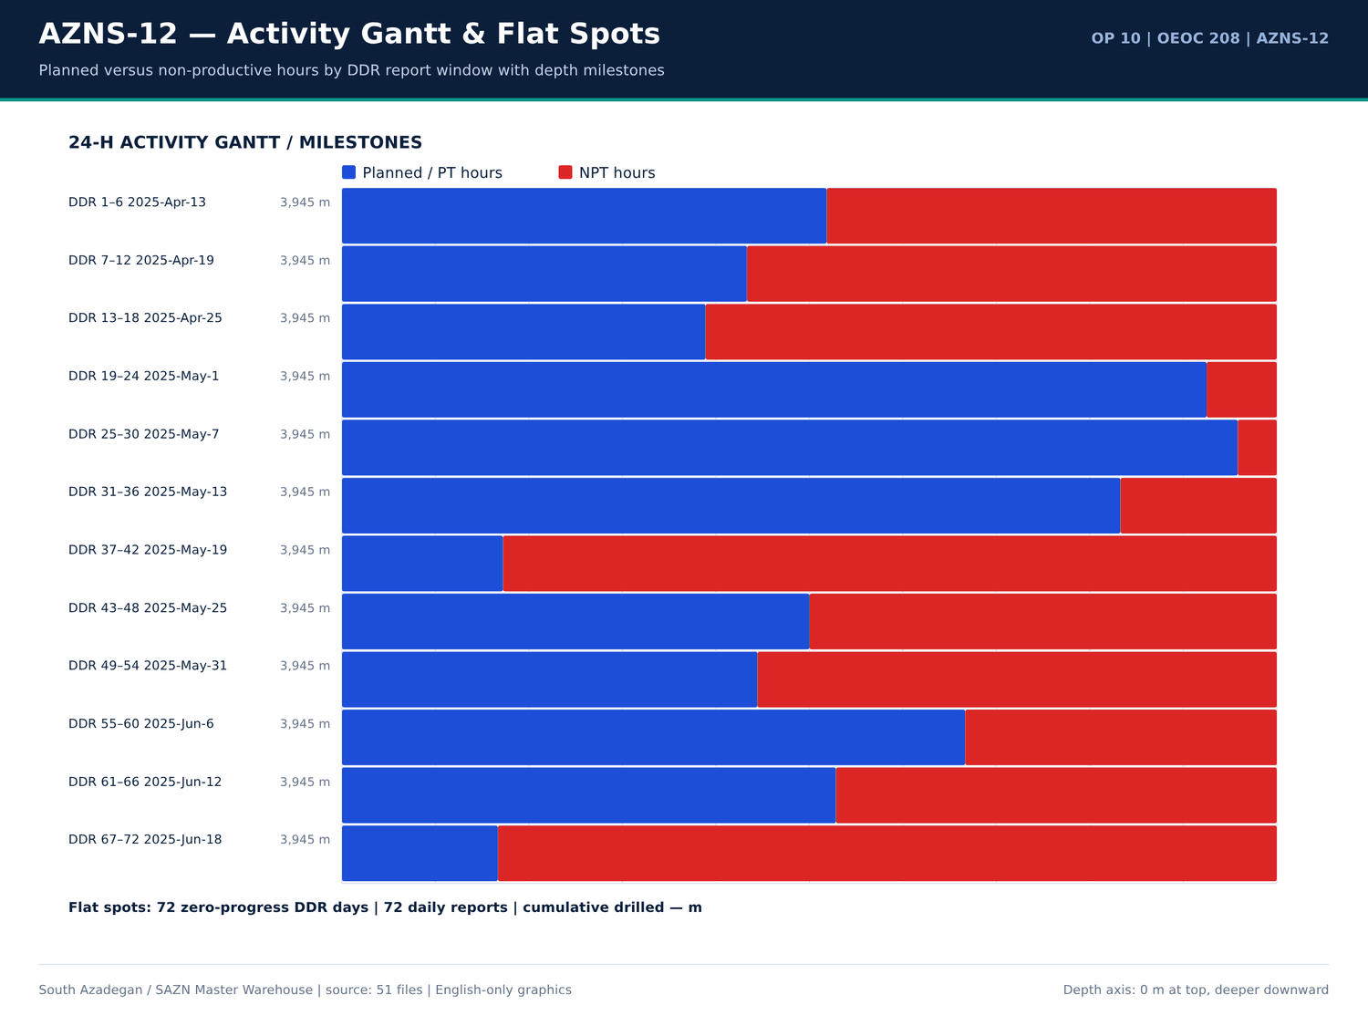
AZNS-12 09 gantt — منبع: انبار داده جامع سازن
یادداشتهای Workover و ماهیگیری
شماره گزارش | شیت | دسته | Text
9 | 9-1 DDR Remark | SHORTAGE/REMARK | Prepare & M/U New 7" * 4-1/2" N.vam X.O.S on Tubing Hanger w/ 6-1/2" Fishing Jar, 1jt 6-1/2" D.C, 1jt 5" DP Aabove it.
13 | 13-1 DDR Remark | SHORTAGE/REMARK | Cont. RIH W/ 3-1/2" Spear & Fishing BHA F/330 to 1500m while Circ. Mud C.W.H w/ 2-4 BPL.
13 | 13-1 DDR Remark | SHORTAGE/REMARK | >> Fishing BHA Description: 3-1/2" Spear + 2STDs 4-3/4" DCs + 9STDs 3-1/2" HWDPs + 20STDs 3-1/2" DPs + 3-1/2" * 4-1/2 IF X.O.S.
14 | 14-1 DDR Remark | SHORTAGE/REMARK | RIH W/ 3-1/2" Spear & Fishing BHA F/330 to 3285m (7"L.lap), Circ. BTM's up, Cont. RIH to 3307m, Confirmed TOF Work on Fishing and Try to catch same, POOH as chain out F/3307 to 2550m while Circ. Mud C.W.H w/ 0-1 BPHL.
14 | 14-1 DDR Remark | SHORTAGE/REMARK | RIH W/ 2*4 Taper tap & Perform Fishing job.
14 | 14-1 DDR Remark | SHORTAGE/REMARK | Cont. RIH W/ 3-1/2" Spear & Fishing BHA F/330 to 3285m (7"L.lap) while Circ. Mud C.W.H w/ 0-2 BPHL.
14 | 14-1 DDR Remark | SHORTAGE/REMARK | >> Fishing BHA Description: 3-1/2" Spear + 2STDs 4-3/4" DCs + 9STDs 3-1/2" HWDPs + 20STDs 3-1/2" DPs + 3-1/2" * 4-1/2 IF X.O.S.
14 | 14-1 DDR Remark | SHORTAGE/REMARK | Cont. RIH as Pump down to 3307m, String Took WT & Confirmed TOF (Comp. Strg) as per tally, Work on Fishing and Try to catch the slick line Several times as Procedure with
15 | 15-1 DDR Remark | SHORTAGE/REMARK | Cont. POOH F/2550 to Surface & Recoverd about 100-150m Slick line, RIH W/ 2" * 4" Taper tap & Fishing BHA#02 To 3290m while Circ. Mud C.W.H w/ 0-1 BPHL.
15 | 15-1 DDR Remark | SHORTAGE/REMARK | P/U & M/U 2" * 4" Taper tap & RIH W/ Fishing BHA#02 To 3290m while Circ. Mud C.W.H w/ NL-NG.
15 | 15-1 DDR Remark | SHORTAGE/REMARK | >> Fishing BHA Description: 2" * 4" Taper tap + 4-3/4" Bit sub + 1jt 4-3/4" DC + 4-3/4" F.Jar + 1jt 4-3/4" DC + 2STDs 3-1/2" HWDPs + 20STDs 3-1/2" DPs + X.O.S.
15 | 15-1 DDR Remark | SHORTAGE/REMARK | Cont. RIH W/ 2" * 4" Taper tap & Fishing BHA#02 F/ 3290 To 3305m (2M above Fish Depth), Record Upward & Downward WT W/ Pumping & W/O Pumping
15 | 15-1 DDR Remark | SHORTAGE/REMARK | >> Fishing BHA Description: 2" * 4" Taper tap + 4-3/4" Bit sub + 1jt 4-3/4" DC + 4-3/4" F.Jar + 1jt 4-3/4" DC + 2STDs 3-1/2" HWDPs + 20STDs 3-1/2" DPs + X.O.S.
16 | 16-1 DDR Remark | SHORTAGE/REMARK | Cont. RIH W/ 2" * 4" Taper tap & Fishing BHA#02 F/ 3290 To 3305m Engage w/ Fish & Tap inside Fish, POOH W/ 2" * 4" Taper tap & Fishing BHA#02 as chain out F/3307 to Surface, Recoverd Fish Completely While Circ. C.W.H w/ NL-NG.
16 | 16-1 DDR Remark | SHORTAGE/REMARK | Cont. RIH W/ 2" * 4" Taper tap & Fishing BHA#02 F/ 3290 To 3305m (2M above Fish Depth), Record Upward & Downward WT W/ Pumping & W/O Pumping
16 | 16-1 DDR Remark | SHORTAGE/REMARK | >> Fishing BHA Description: 2" * 4" Taper tap + 4-3/4" Bit sub + 1jt 4-3/4" DC + 4-3/4" F.Jar + 1jt 4-3/4" DC + 2STDs 3-1/2" HWDPs + 20STDs 3-1/2" DPs + X.O.S.
16 | 16-1 DDR Remark | SHORTAGE/REMARK | POOH W/ 2" * 4" Taper tap & Fishing BHA#02 as chain out F/3307 to Surface, Recoverd Fish Completely as below:
19 | 19-1 DDR Remark | SHORTAGE/REMARK | Cont. RIH W/ 6" M.M J.Mill F/ 3454 to 3520m, String Took WT, Try To Wash & Push same three Times "No movment", Circ. BTM's Up, POOH to Surface, RIH w/ 2" * 4" Taper tap & Fishing BHA#04 To 100m Stopped Operation Due to Bad Weather, Cont.…
19 | 19-1 DDR Remark | SHORTAGE/REMARK | Perform Fishing Job as Program.
19 | 19-1 DDR Remark | SHORTAGE/REMARK | P/U & M/U 2" * 4" Taper tap (New, Cylindersazi, S/N: CS7569) & RIH W/ Fishing BHA#04 To 100m while Circ. Mud C.W.H w/ NL-NG.
19 | 19-1 DDR Remark | SHORTAGE/REMARK | >> Fishing BHA Description: 2" * 4" Taper tap + 4-3/4" Bit sub + 1jt 4-3/4" DC + 4-3/4" F.Jar + 10STDs 3-1/2" HWDPs + 20STDs 3-1/2" DPs + X.O.S (Length: 870m)
19 | 19-1 DDR Remark | SHORTAGE/REMARK | Cont. RIH W/ 2" * 4" Taper tap & Fishing BHA#04 F/ 100 To 250 while Circ. Mud C.W.H w/ NL-NG.

صفحات Workover در EOWR/Programme
سند | صفحه | فصل | کاراکتر | تصویر | کلیدواژه
Well Program/10.AZNS_12_Workover_Program.pdf | 7 | 16 Programme & Prognosis | 918 | 4 | fish,formation
04.EOWR/10.AZNS_12_EOWR.pdf | 10 | 17 Casing / Mud / Completion Prog | 2446 | 6 | bha,bit,casing,cement,fish,formation
04.EOWR/10.AZNS_12_EOWR.pdf | 11 | 17 Casing / Mud / Completion Prog | 1603 | 5 | bha,bit,fish,formation
04.EOWR/10.AZNS_12_EOWR.pdf | 16 | 00 General / Unclassified | 2646 | 5 | bha,bit,fish,mud
Well Program/10.AZNS_12_Workover_Program.pdf | 16 | 17 Casing / Mud / Completion Prog | 2059 | 4 | bha,bit,casing,cement,fish,formation
04.EOWR/10.AZNS_12_EOWR.pdf | 17 | 00 General / Unclassified | 2708 | 5 | bha,bit,fish,milling,mud
Well Program/10.AZNS_12_Workover_Program.pdf | 17 | 17 Casing / Mud / Completion Prog | 1953 | 4 | bha,bit,casing,fish,formation
04.EOWR/10.AZNS_12_EOWR.pdf | 18 | 00 General / Unclassified | 2560 | 5 | bha,bit,fish,mud
04.EOWR/10.AZNS_12_EOWR.pdf | 19 | 09 Completion Tally & Tools | 2801 | 5 | bha,fish,losses,mud,packer
04.EOWR/10.AZNS_12_EOWR.pdf | 20 | 00 General / Unclassified | 2503 | 5 | bha,bit,fish,losses,milling,mud
04.EOWR/10.AZNS_12_EOWR.pdf | 21 | 09 Completion Tally & Tools | 2632 | 5 | bit,fish,mud,packer
04.EOWR/10.AZNS_12_EOWR.pdf | 22 | 00 General / Unclassified | 2393 | 5 | bha,bit,fish,milling,mud
04.EOWR/10.AZNS_12_EOWR.pdf | 23 | 00 General / Unclassified | 2741 | 5 | bha,bit,milling,mud
04.EOWR/10.AZNS_12_EOWR.pdf | 24 | 00 General / Unclassified | 2433 | 5 | bha,bit,fish,mud
Well Program/10.AZNS_12_Workover_Program.pdf | 25 | 10 Wellhead & Xmas Tree | 3345 | 6 | fish,formation,mud
Well Program/10.AZNS_12_Workover_Program.pdf | 26 | 09 Completion Tally & Tools | 3659 | 8 | acid,bha,bit,casing,cbl,fish,packer
Well Program/10.AZNS_12_Workover_Program.pdf | 27 | 12 Well Stimulation & Clean-Up | 3886 | 36 | acid,contractor,fish,formation,mud,packer
Well Program/10.AZNS_12_Workover_Program.pdf | 29 | 16 Programme & Prognosis | 2042 | 4 | bha,fish
Well Program/10.AZNS_12_Workover_Program.pdf | 31 | 12 Well Stimulation & Clean-Up | 2014 | 4 | acid,contractor,fish,mud
Well Program/10.AZNS_12_Workover_Program.pdf | 32 | 09 Completion Tally & Tools | 1560 | 4 | fish,packer
04.EOWR/10.AZNS_12_EOWR.pdf | 44 | 10 Wellhead & Xmas Tree | 1958 | 16 | fish,formation,mud
04.EOWR/10.AZNS_12_EOWR.pdf | 45 | 09 Completion Tally & Tools | 2742 | 15 | bha,bit,casing,fish,mud,packer

گزییده نشانی سلولهای عددی — فصل 17
سند | شیت | سلول | مقدار
DDRs/10.AZNS_12_DDR_Pack.xlsx | 15-2 DDR Data | R52C11 | 256,180,062.00
DDRs/10.AZNS_12_DDR_Pack.xlsx | 23-2 DDR Data | R52C11 | 256,180,062.00
CBS/10.AZNS_12_CBS.xlsx | Total Cost-EPD & Rigless | R5C3 | 10,877,522.07
CBS/10.AZNS_12_CBS.xlsx | Total Cost-EPD | R19C7 | 10,162,895.93
CBS/10.AZNS_12_CBS.xlsx | Total Cost-EPD & Rigless | R3C3 | 10,162,895.93
CBS/10.AZNS_12_CBS.xlsx | Total Cost-EPD | R3C6 | 3,860,626.98
CBS/10.AZNS_12_CBS.xlsx | Total Cost-EPD | R3C7 | 3,860,626.98
CBS/10.AZNS_12_CBS.xlsx | Cost Breakdown-12 | R197C6 | 3,860,626.98
DDRs/10.AZNS_12_DDR_Pack.xlsx | 1-1 DDR Remark | R12C35 | 3,437,769.78
DDRs/10.AZNS_12_DDR_Pack.xlsx | 2-1 DDR Remark | R12C35 | 3,437,769.78
DDRs/10.AZNS_12_DDR_Pack.xlsx | 3-1 DDR Remark | R12C35 | 3,437,769.78
DDRs/10.AZNS_12_DDR_Pack.xlsx | 4-1 DDR Remark | R12C35 | 3,437,769.78
DDRs/10.AZNS_12_DDR_Pack.xlsx | 5-1 DDR Remark | R12C35 | 3,437,769.78
DDRs/10.AZNS_12_DDR_Pack.xlsx | 6-1 DDR Remark | R12C35 | 3,437,769.78

Chapter 18 — تالی تکمیل و تستهای فشار
ردیفهای تالی تکمیل از شیتهای مواد 20.1/20.2/20.3 در CBS و رکوردهای لولهگذاری DDR گرفته شدهاند؛ خطوط TRSSSV، پکر، انکر، SSD، درز انبساط، نیپل و CIV/CIM با مقادیر قیمتی آمدهاند. واقعهمندیهای تست فشار از لایه متن EOWR / Programme با مقدار، واحد و صفحه جدولبندی شدهاند.
ردیفهای مواد تکمیل 20.x
شیت | شرح | واحد | مقدار | قیمت واحد (دلار) | مبلغ (دلار)
Cost Breakdown-Material-12 | Wellhead & Xmas tree Equipment | — | — | — | 142,085.00
Cost Breakdown-12 Contingecy | Coiled tubing equipment and personnel | DAY | 22 | 5,400.00 | 118,800.00
Cost Breakdown-12 | Corrosion Log for 7" Liner and 9 5/8” casing (MTT or MTD or EMDS) CCL/GR (after perforation) | JOB | 2 | 55,643.25 | 111,286.50
Cost Breakdown-12 | Casing/tubing Running 4 1⁄2" | M | 7,890.00 | 6.5 | 51,285.00
Coil Tubing Service-12 | Coiled Tubing Unit (1 1/2") | 1 EA | — | — | 38,400.00
Mob.& Demob for Stim.-12 | Coiled Tubing Unit and Personnel | 1set | 1 | — | 8,100.00
Cost Breakdown-Material-12 | Tubing pup joint, 3 1/2", L080 type 1, 10.2 PPF, Gas Tight Conn, seamless, 1.5m long, PSL3. | ea. | 15 | 300 | 4,500.00
Cost Breakdown-Material-12 | Tubing pup joint, 3 1/2", L080,premium Connection 10.2 ppf,13CR01 MO, seamless,3 m long , PSL3 | ea. | 15 | 300 | 4,500.00
Cost Breakdown-12 | Tubing Running 3 1⁄2" | M | 500 | 6.5 | 3,250.00
Cost Breakdown-Material-12 | Drift Gauge, API, for 3 1/2" 10.2# tubing | ea. | 2 | 900 | 1,800.00
Cost Breakdown-Material-12 | Drift Gauge, API, for 4 1/2" 18.9# tubing | ea. | 2 | 900 | 1,800.00
Cost Breakdown-Material-12 | Tubing pup joint, 4 1/2", L080 type 1, 18.9 PPF, Gas Tight Conn, seamless, 1.5m, PSL3. | ea. | 5 | 350 | 1,750.00
Cost Breakdown-Material-12 | Tubing pup joint, 4 1/2", L080,premium Connection 18.9 ppf,13CR01 MO, seamless,3 m long , PSL3 | ea. | 5 | 350 | 1,750.00
Cost Breakdown-12 | Cementing 7" Liner | JOB | — | — | 0
Cost Breakdown-12 | Casing Running 7" Liner | M | 0 | 0 | 0
Cost Breakdown-12 | Casing Running 5" Liner | M | — | — | 0
Cost Breakdown-12 | Coiled tubing equipment and personnel | DAY | — | — | 0
Cost Breakdown-12 | Liner hanger running (lump Sum as Complete package) | — | — | — | 0
Cost Breakdown-12 | 7" liner hanger running equipment and personnel (lump Sum as Complete package) | JOB | — | — | 0
Cost Breakdown-12 | 5 1⁄2" liner hanger running equipment and personnel (lump Sum as Complete package) | JOB | — | — | 0
Cost Breakdown-12 | 5" liner hanger running equipment and personnel (lump Sum as Complete package) | JOB | — | — | 0
Cost Breakdown-12 | 4 1⁄2" liner hanger running equipment and personnel (lump Sum as Complete package | JOB | — | — | 0

واقعهمندیهای تست فشار
کلید | مقدار | واحد | صفحه | سند | زمینه
PRESSURE_TEST | 4,500.00 | psi | 29 | 04.EOWR/10.AZNS_12_EOWR.pdf | tubing Hanger, Install 1/4" Fitting on C/L. Pressure test of CL w/4500psi for 15min "Ok" Release Press. to 3000psi. P
PRESSURE_TEST | 4,500.00 | psi | 30 | 04.EOWR/10.AZNS_12_EOWR.pdf | tubing Hanger, Install 1/4" Fitting on C/L. Pressure test of CL w/4500psi for 15min "Ok" Release Press. to 3000psi.
PRESSURE_TEST | 4,500.00 | psi | 80 | 04.EOWR/10.AZNS_12_EOWR.pdf | – 12 Page 80 of 140 valve Inside. Pressure Test Tubing String 4500psi/15min Every 100 JTs. √ RIH Completion Stri
PRESSURE_TEST | 6,000.00 | psi | 80 | 04.EOWR/10.AZNS_12_EOWR.pdf | RSSSV √ Install control line to TRSSSV and pressure test control line 6000psi x 15mins. And then keep 3000psi pressure wh
PRESSURE_TEST | 4,500.00 | psi | 81 | 04.EOWR/10.AZNS_12_EOWR.pdf | bonnet. √ Check hanger for any damage and pressure test control line to 4500psi √ Pressure test chemical injection line &
PRESSURE_TEST | 4,500.00 | Psi | 100 | 04.EOWR/10.AZNS_12_EOWR.pdf | ion) Item Test Check Mark and Result 1 Pressure test for the kill Valve W/ 1000 & 4500 Psi / 15 min OK 2 Pressure test for the SSV W
PRESSURE_TEST | 4,500.00 | Psi | 100 | 04.EOWR/10.AZNS_12_EOWR.pdf | l Valve W/ 1000 & 4500 Psi / 15 min OK 2 Pressure test for the SSV W/ 1000 & 4500 Psi / 15 min OK 3 Pressure test for the top m
PRESSURE_TEST | 4,500.00 | Psi | 100 | 04.EOWR/10.AZNS_12_EOWR.pdf | the SSV W/ 1000 & 4500 Psi / 15 min OK 3 Pressure test for the top master valve W/ 1000 & 4500 Psi / 15 min OK 4 Pressure test for Swab val
PRESSURE_TEST | 4,500.00 | Psi | 100 | 04.EOWR/10.AZNS_12_EOWR.pdf | valve W/ 1000 & 4500 Psi / 15 min OK 4 Pressure test for Swab valve W/ 1000 & 4500 Psi / 15 min OK 5 Pressure test for the Produ
PRESSURE_TEST | 4,500.00 | Psi | 100 | 04.EOWR/10.AZNS_12_EOWR.pdf | ab valve W/ 1000 & 4500 Psi / 15 min OK 5 Pressure test for the Production valve W/ 1000 & 4500 Psi / 15 min OK Table 8-5: AZNS-12 Section "D
PRESSURE_TEST | 4,500.00 | Psi | 100 | 04.EOWR/10.AZNS_12_EOWR.pdf | section W/1000 &4500 psi for 15min OK 2 Pressure test for the SSV Exit block W/ 4500 Psi / 15 min OK 3 Pressure test neck of tubin
PRESSURE_TEST | 4,500.00 | psi | 100 | 04.EOWR/10.AZNS_12_EOWR.pdf | SSV Exit block W/ 4500 Psi / 15 min OK 3 Pressure test neck of tubing hanger metal seal W/1000 &4500 psi for 15min OK 4 Pressure test for Swab val
PRESSURE_TEST | 4,500.00 | Psi | 100 | 04.EOWR/10.AZNS_12_EOWR.pdf | al seal W/1000 &4500 psi for 15min OK 4 Pressure test for Swab valve W/ 4500 Psi / 15 min - 5 Pressure test for Production
PRESSURE_TEST | 4,500.00 | Psi | 100 | 04.EOWR/10.AZNS_12_EOWR.pdf | t for Swab valve W/ 4500 Psi / 15 min - 5 Pressure test for Production valve W/4500 Psi / 15 min - 6 Pressure test cavity of FS.s
PRESSURE_TEST | 4,500.00 | Psi | 100 | 04.EOWR/10.AZNS_12_EOWR.pdf | Production valve W/4500 Psi / 15 min - 6 Pressure test cavity of FS.seal and Ring Gasket W 4500 Psi / 15 min OK Table 8-6: AZNS-12 Section "D

جداول شمارهدار تکمیل و سرچاه
سند | صفحه | شماره جدول | عنوان | دسته
04.EOWR/10.AZNS_12_EOWR.pdf | 5 | 8-2 | AZNS-12 WELLHEAD & X-MASS TREE EQUIPMENT SPECIFICATION ................................................ 96 | EOWR
04.EOWR/10.AZNS_12_EOWR.pdf | 5 | 9-3 | AZNS-12 DE-COMPLETION SECTION VOLUME ANALYSIS TABLE ................................................... 112 | EOWR
04.EOWR/10.AZNS_12_EOWR.pdf | 5 | 10-1 | AZNS-12 CHEMICAL CONSUMPTION AND WATER TREATMENT VOLUMES BY DATE FOR COMPLETION | EOWR
Well Program/10.AZNS_12_Workover_Program.pdf | 44 | 10 | AZNS Wellhead Information | PROGRAM
Well Program/10.AZNS_12_Workover_Program.pdf | 46 | 11 | AZNS 122 Wellhead Specification | PROGRAM
04.EOWR/10.AZNS_12_EOWR.pdf | 96 | 8-2 | AZNS-12 Wellhead & X-Mass Tree Equipment Specification | EOWR
04.EOWR/10.AZNS_12_EOWR.pdf | 112 | 9-3 | AZNS-12 De-Completion Section Volume Analysis Table | EOWR
04.EOWR/10.AZNS_12_EOWR.pdf | 128 | 10-1 | AZNS-12 chemical consumption and water treatment volumes by date for Completion section | EOWR

گزییده نشانی سلولهای عددی — فصل 18
سند | شیت | سلول | مقدار
DDRs/10.AZNS_12_DDR_Pack.xlsx | 15-2 DDR Data | R52C11 | 256,180,062.00
DDRs/10.AZNS_12_DDR_Pack.xlsx | 23-2 DDR Data | R52C11 | 256,180,062.00
CBS/10.AZNS_12_CBS.xlsx | Total Cost-EPD & Rigless | R5C3 | 10,877,522.07
CBS/10.AZNS_12_CBS.xlsx | Total Cost-EPD | R19C7 | 10,162,895.93
CBS/10.AZNS_12_CBS.xlsx | Total Cost-EPD & Rigless | R3C3 | 10,162,895.93
CBS/10.AZNS_12_CBS.xlsx | Total Cost-EPD | R3C6 | 3,860,626.98
CBS/10.AZNS_12_CBS.xlsx | Total Cost-EPD | R3C7 | 3,860,626.98
CBS/10.AZNS_12_CBS.xlsx | Cost Breakdown-12 | R197C6 | 3,860,626.98
DDRs/10.AZNS_12_DDR_Pack.xlsx | 1-1 DDR Remark | R12C35 | 3,437,769.78
DDRs/10.AZNS_12_DDR_Pack.xlsx | 2-1 DDR Remark | R12C35 | 3,437,769.78
DDRs/10.AZNS_12_DDR_Pack.xlsx | 3-1 DDR Remark | R12C35 | 3,437,769.78
DDRs/10.AZNS_12_DDR_Pack.xlsx | 4-1 DDR Remark | R12C35 | 3,437,769.78
DDRs/10.AZNS_12_DDR_Pack.xlsx | 5-1 DDR Remark | R12C35 | 3,437,769.78
DDRs/10.AZNS_12_DDR_Pack.xlsx | 6-1 DDR Remark | R12C35 | 3,437,769.78

Chapter 19 — اسیدکاری ماتریس، CTU و شاخص بهرهدهی
خانوادههای تحریک بدون دکل، حجمهای برنامهریزشده مواد، قیمت واحد و واقعهمندیهای اسید / N2 / WHP / PI / نرخ با نشانی صفحه آمدهاند. مقایسه بهرهدهی پیش/پس اسید تنها وقتی انجام میشود که هر دو مقدار در متن منبع موجود باشند؛ 55 ردیف تطبیق، مواد قیمتی CBS را به مصرف DDR پیوند میدهد.
خانوادههای قیمتی تحریک بدون دکل
شیت | شرح | واحد | حجم | قیمت واحد (دلار) | روز آمادهباش | روز عملیات | مبلغ (دلار)
Cost breakdown R-less Stim.-12 | Mobilization, Demobilization | 34138 | — | — | — | — | —
Cost breakdown R-less Stim.-12 | Materials and Consumables | 124335 | — | — | — | — | —
Cost breakdown R-less Stim.-12 | Acidizing and N2 services | 117529 | — | — | — | — | —
Cost breakdown R-less Stim.-12 | Coiled Tubing Services | 44900 | — | — | — | — | —
Cost breakdown R-less Stim.-12 | Oil Transportation Services | 60000 | — | — | — | — | —
Cost breakdown R-less Stim.-12 | Well Testing and Production Services | 83282.84 | — | — | — | — | —
Cost breakdown R-less Stim.-12 | Wireline Production Logging Services | 76170 | — | — | — | — | —
Cost breakdown R-less Stim.-12 | Slickline Services | 19732.3 | — | — | — | — | —
Cost breakdown R-less Stim.-12 | Memory Gauge Service | 2927 | — | — | — | — | —
Cost breakdown R-less Stim.-12 | Bottomhole PVT Sampling | 39100 | — | — | — | — | —
Cost breakdown R-less Stim.-12 | Personnel Rates | 49512 | — | — | — | — | —
Cost breakdown R-less Stim.-12 | Design, Interpretation, Reporting | 13000 | — | — | — | — | —
Cost breakdown R-less Stim.-12 | Accommodation | 50000 | — | — | — | — | —
Mob.& Demob for Stim.-12 | Liquid Pumping Unit, and Personnel | 1 set | 1 | — | — | — | 3,038.00
Mob.& Demob for Stim.-12 | Fracturing Unit and Personnel | 1set | 0 | — | — | — | 0
Mob.& Demob for Stim.-12 | Storage/Mixing Tank (water,acid, diesel) 500BBL Minimum | 1x500 BBL tank | 1 | — | — | — | 300
Mob.& Demob for Stim.-12 | Batch mixer | 1 set | 1 | — | — | — | 2,500.00
Mob.& Demob for Stim.-12 | Blender | 1 set | 1 | — | — | — | 2,500.00
Mob.& Demob for Stim.-12 | Liquid N2 Pump Unit and Personnel | 1set | 1 | — | — | — | 2,500.00
Mob.& Demob for Stim.-12 | Liquid Nitrogen Storage Tank | 1set | 1 | — | — | — | 1,000.00
Mob.& Demob for Stim.-12 | Coiled Tubing Unit and Personnel | 1set | 1 | — | — | — | 8,100.00
Mob.& Demob for Stim.-12 | Test Choke Manifold | 1set | 1 | — | — | — | 1,500.00

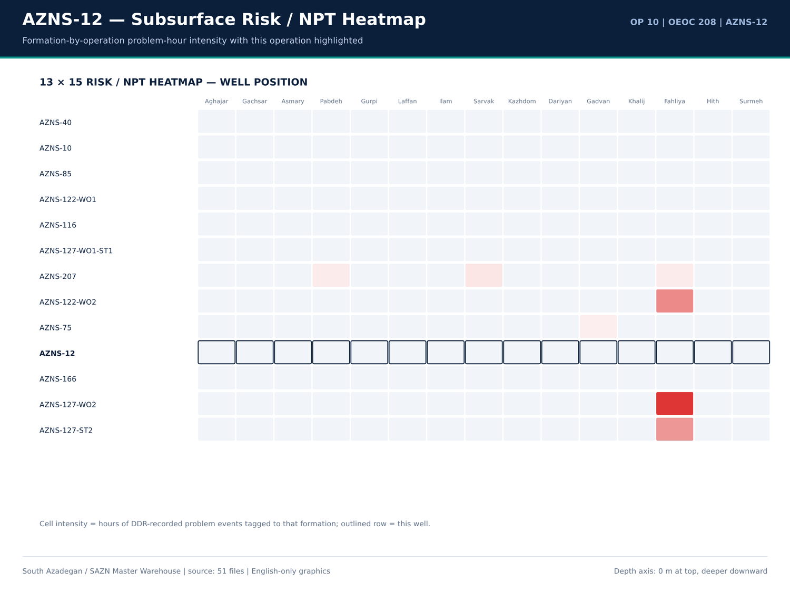
AZNS-12 10 risk — منبع: انبار داده جامع سازن
واقعهمندیهای اسید، N2، WHP، PI و نرخ
کلید | مقدار | واحد | صفحه | سند | زمینه
No source rows for this query | — | — | — | — | —

ردیفهای شیمیایی تحریک از CBS
شیت | شرح | واحد | مقدار | مبلغ (دلار)
Acidizing &N2 service-12 | Total Operation and Standby Charges for Acidizing and Nitrogen Services (USD) | — | — | 117,529.00
Personnel rate-12 | Total Personnel Charge for Acidizing, Testing and Related Services (USD) | — | — | 49,512.00
Material & Consumable-12 | Liquid Nitrogen (N2) | Gal | 7,000.00 | 28,000.00
Cost Breakdown-12 Contingecy | Xylene | Gal | 2,000.00 | 18,000.00
Material & Consumable-12 | Xylene | Gal | 2,000.00 | 18,000.00
Acidizing &N2 service-12 | Liquid Nitrogen Unit | 1 EA | — | 9,900.00
Acidizing &N2 service-12 | Acid Storage Tanks | 1 EA | — | 5,950.00
Acidizing &N2 service-12 | Acid Mixing Tanks | 1 EA | — | 5,950.00
Material & Consumable-12 | Mutual Solvent | Gal | 100 | 3,000.00
Acidizing &N2 service-12 | Liquid Nitrogen Tank | 1 EA | — | 2,800.00
Acidizing &N2 service-12 | Acid Testing Lab (or Acid Testing costs in accredited lab | 1 EA | — | 2,565.00
Material & Consumable-12 | HCL (≥28%) | Gal | 1,000.00 | 2,000.00
Design,Interp.,Reporting-12 | Acid Labaratory Experiments | Test of Acidizing Fluid | 1 | 2,000.00
Mob.& Demob for Stim.-12 | Liquid Nitrogen Storage Tank | 1set | 1 | 1,000.00
Material & Consumable-12 | Surfactant | Gal | 45 | 675
Acidizing &N2 service-12 | Acid and Chemical Pump | 1 EA | — | 594
Mob.& Demob for Stim.-12 | Storage/Mixing Tank (water,acid, diesel) 500BBL Minimum | 1x500 BBL tank | 1 | 300
Cost Breakdown-12 | Lifting with 400bbl Liquid Nitrogen | BBL | — | 0
Cost Breakdown-12 | Nitrogen Unit Full Package | Day | — | 0
Material & Consumable-12 | Acetic Acid (98%) | Gal | 0 | 0
Material & Consumable-12 | Self Diverting Viscoelastic Surfactant (SDVES) | Gal | 0 | 0
Material & Consumable-12 | Benzoic Acid | lb | 0 | 0

گزییده نشانی سلولهای عددی — فصل 19
سند | شیت | سلول | مقدار
DDRs/10.AZNS_12_DDR_Pack.xlsx | 15-2 DDR Data | R52C11 | 256,180,062.00
DDRs/10.AZNS_12_DDR_Pack.xlsx | 23-2 DDR Data | R52C11 | 256,180,062.00
CBS/10.AZNS_12_CBS.xlsx | Total Cost-EPD & Rigless | R5C3 | 10,877,522.07
CBS/10.AZNS_12_CBS.xlsx | Total Cost-EPD | R19C7 | 10,162,895.93
CBS/10.AZNS_12_CBS.xlsx | Total Cost-EPD & Rigless | R3C3 | 10,162,895.93
CBS/10.AZNS_12_CBS.xlsx | Total Cost-EPD | R3C6 | 3,860,626.98
CBS/10.AZNS_12_CBS.xlsx | Total Cost-EPD | R3C7 | 3,860,626.98
CBS/10.AZNS_12_CBS.xlsx | Cost Breakdown-12 | R197C6 | 3,860,626.98
DDRs/10.AZNS_12_DDR_Pack.xlsx | 1-1 DDR Remark | R12C35 | 3,437,769.78
DDRs/10.AZNS_12_DDR_Pack.xlsx | 2-1 DDR Remark | R12C35 | 3,437,769.78
DDRs/10.AZNS_12_DDR_Pack.xlsx | 3-1 DDR Remark | R12C35 | 3,437,769.78
DDRs/10.AZNS_12_DDR_Pack.xlsx | 4-1 DDR Remark | R12C35 | 3,437,769.78
DDRs/10.AZNS_12_DDR_Pack.xlsx | 5-1 DDR Remark | R12C35 | 3,437,769.78
DDRs/10.AZNS_12_DDR_Pack.xlsx | 6-1 DDR Remark | R12C35 | 3,437,769.78

Chapter 20 — HSE، MTBF، پسماند و پیمانکاران جزء
سری POB، مصرف سوخت/آب، ردیفهای پسماند، صفحات فصل HSE و نام پیمانکاران/شرکتهای خدماتی از DDR و EOWR بازتولید شدهاند. ردیفهای اسکان و پذیرایی CBS بر جمع POB ثبتشده در DDR تطبیق داده میشوند، نه بر سرنفر فرضی.
سری افراد حاضر
شماره گزارش | دسته | تعداد | جمع
1 | OEOC Rig | 71 | —
1 | Client (KPE) | 2 | —
1 | MSA | 6 | —
1 | Service company | 17 | —
1 | Catering + Guard | 22 | —
1 | Labour | 8 | —
1 | Other | 0 | —
1 | TOTAL POB | 126 | 126
2 | OEOC Rig | 71 | —
2 | Client (KPE) | 2 | —
2 | MSA | 6 | —
2 | Service company | 17 | —
2 | Catering + Guard | 22 | —
2 | Labour | 8 | —
2 | Other | 0 | —
2 | TOTAL POB | 126 | 126
3 | OEOC Rig | 71 | —
3 | Client (KPE) | 2 | —
3 | MSA | 6 | —
3 | Service company | 17 | —
3 | Catering + Guard | 22 | —
3 | Labour | 8 | —

ردیفهای سوخت، آب و پسماند
شماره گزارش | ماده | واحد | دریافتی | مصرف | موجودی | سلول
1 | BULK Fuel Rig | Lit | — | — | 86,000.00 | F72
1 | BULK Fuel Camp | Lit | — | — | 800 | G72
1 | BULK Fuel Rig | Lit | — | 1,000.00 | — | F73
1 | BULK Fuel Camp | Lit | — | 500 | — | G73
2 | BULK Fuel Rig | Lit | — | — | 84,000.00 | F72
2 | BULK Fuel Camp | Lit | — | — | 7,500.00 | G72
2 | BULK Fuel Rig | Lit | — | 2,000.00 | — | F73
2 | BULK Fuel Camp | Lit | — | 500 | — | G73
3 | BULK Fuel Rig | Lit | — | — | 84,000.00 | F72
3 | BULK Fuel Camp | Lit | — | — | 7,500.00 | G72
3 | BULK Fuel Rig | Lit | — | 2,000.00 | — | F73
3 | BULK Fuel Camp | Lit | — | 500 | — | G73
4 | BULK Fuel Rig | Lit | — | — | 80,000.00 | F72
4 | BULK Fuel Camp | Lit | — | — | 6,500.00 | G72
4 | BULK Fuel Rig | Lit | — | 2,000.00 | — | F73
4 | BULK Fuel Camp | Lit | — | 500 | — | G73
5 | BULK Fuel Rig | Lit | — | — | 73,000.00 | F72
5 | BULK Fuel Camp | Lit | — | — | 10,000.00 | G72
5 | BULK Fuel Rig | Lit | — | 3,000.00 | — | F73
5 | BULK Fuel Camp | Lit | — | 500 | — | G73
5 | BULK Fuel Camp | Lit | 4,000.00 | — | — | G74

ردیفهای اسکان و پذیرایی CBS
شیت | شرح | مقدار | واحد | Rate | مبلغ (دلار)
Rig Move | Rig move between well pads | 1 | — | 247,000.00 | 247,000.00
Rig Move | Rig move between Cellar-to-Cellar within the same pad | 0 | — | 0 | 0
Catering & Accommodation | Full board catering and accommodation | — | 30 | — | —
Catering & Accommodation | Breakfast | — | 10 | — | —
Catering & Accommodation | Lunch | — | 15 | — | —
Catering & Accommodation | Dinner | — | 15 | — | —
Catering & Accommodation | Night Meals | — | 10 | — | —
Catering & Accommodation | Accommodation | — | 15 | — | —
Full package Accomm-AZNS-12 | Full package Accommodation | 10 | Day | 5,000.00 | 50,000.00
Full package Accomm-AZNS-12 | — | — | — | — | 50,000.00

گزییده نشانی سلولهای عددی — فصل 20
سند | شیت | سلول | مقدار
DDRs/10.AZNS_12_DDR_Pack.xlsx | 15-2 DDR Data | R52C11 | 256,180,062.00
DDRs/10.AZNS_12_DDR_Pack.xlsx | 23-2 DDR Data | R52C11 | 256,180,062.00
CBS/10.AZNS_12_CBS.xlsx | Total Cost-EPD & Rigless | R5C3 | 10,877,522.07
CBS/10.AZNS_12_CBS.xlsx | Total Cost-EPD | R19C7 | 10,162,895.93
CBS/10.AZNS_12_CBS.xlsx | Total Cost-EPD & Rigless | R3C3 | 10,162,895.93
CBS/10.AZNS_12_CBS.xlsx | Total Cost-EPD | R3C6 | 3,860,626.98
CBS/10.AZNS_12_CBS.xlsx | Total Cost-EPD | R3C7 | 3,860,626.98
CBS/10.AZNS_12_CBS.xlsx | Cost Breakdown-12 | R197C6 | 3,860,626.98
DDRs/10.AZNS_12_DDR_Pack.xlsx | 1-1 DDR Remark | R12C35 | 3,437,769.78
DDRs/10.AZNS_12_DDR_Pack.xlsx | 2-1 DDR Remark | R12C35 | 3,437,769.78
DDRs/10.AZNS_12_DDR_Pack.xlsx | 3-1 DDR Remark | R12C35 | 3,437,769.78
DDRs/10.AZNS_12_DDR_Pack.xlsx | 4-1 DDR Remark | R12C35 | 3,437,769.78
DDRs/10.AZNS_12_DDR_Pack.xlsx | 5-1 DDR Remark | R12C35 | 3,437,769.78
DDRs/10.AZNS_12_DDR_Pack.xlsx | 6-1 DDR Remark | R12C35 | 3,437,769.78

Chapter 21 — زمینشناسی عمیق و همبستگی میدانی
تعداد 14 سر سازند همبسته، ستونهای پیشبینی/واقعی DDR، سرهای EOWR و جداول پیشبینی Programme را بههم پیوند میدهد. اختلاف ساختمانی، عمق واقعی منهای پیشبینی بر حسب متر است؛ سنگشناسی، نشانههای گاز، H2S/CO2، فلورسانس و شواهد CBL-VDL-USIT بر پایه صفحه نمایه شدهاند. همبستگی تاقدیس South Azadegan با ۱۲ عملیات دیگر برقرار شده است.
سر سازندها: پیشبینی در برابر واقعی
شماره گزارش | سازند | عمق اندازهگیری (متر) | عمق قائم (متر) | عمق پیشبینی (متر) | Prognosis TVD (m) | سنگشناسی
1 | Gachsaran | 974 | — | — | — | Gy Mrl, Rd Mrl, Anhy, Lst
1 | Asmary | 1,280.00 | — | — | — | Mrl, SST
1 | Pabdeh | 1,474.00 | — | — | — | Dol, Lst, Arg Lst, Cht
1 | Gurpi | 2,124.00 | — | — | — | Arg Lst
1 | Ilam | 2,539.00 | — | — | — | Lst, Sh, Clst
1 | Laffan | 2,613.00 | — | — | — | Clst, Sh
1 | Sarvak | 2,620.00 | — | — | — | Lst, Cht, ArgLst
1 | Kazhdomi | 3,261.00 | — | — | — | Sh, Lst
1 | Dariyan | 3,465.00 | — | — | — | Lst
1 | Gadvan | 3,627.00 | — | — | — | Mrl,Clst, Arg Lst.
2 | Gachsaran | 974 | — | — | — | Gy Mrl, Rd Mrl, Anhy, Lst
2 | Asmary | 1,280.00 | — | — | — | Mrl, SST
2 | Pabdeh | 1,474.00 | — | — | — | Dol, Lst, Arg Lst, Cht
2 | Gurpi | 2,124.00 | — | — | — | Arg Lst
2 | Ilam | 2,539.00 | — | — | — | Lst, Sh, Clst
2 | Laffan | 2,613.00 | — | — | — | Clst, Sh
2 | Sarvak | 2,620.00 | — | — | — | Lst, Cht, ArgLst
2 | Kazhdomi | 3,261.00 | — | — | — | Sh, Lst
2 | Dariyan | 3,465.00 | — | — | — | Lst
2 | Gadvan | 3,627.00 | — | — | — | Mrl,Clst, Arg Lst.
3 | Gachsaran | 974 | — | — | — | Gy Mrl, Rd Mrl, Anhy, Lst
3 | Asmary | 1,280.00 | — | — | — | Mrl, SST

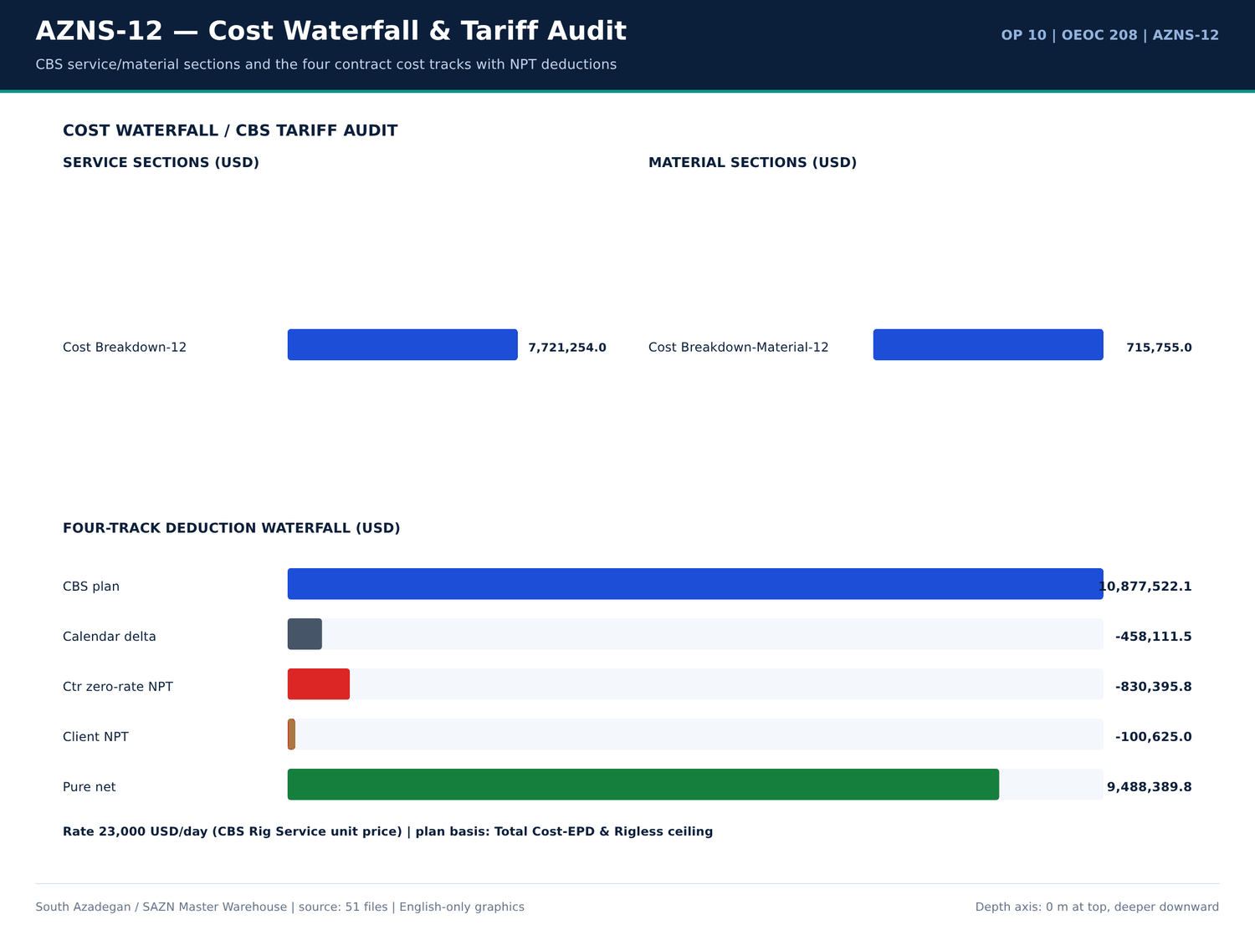
AZNS-12 11 cost — منبع: انبار داده جامع سازن
واقعهمندیهای سر سازند
کلید | مقدار | واحد | صفحه | سند | زمینه
Fahliyan MD | 643 | m | 5 | Well Program/10.AZNS_12_Workover_Program.pdf | vertically down to the Cretaceous Fahliyan Formation with total depth of 4,643m. The results of this well, revealed th
Fahliyan MD | 2,008.00 | m | 5 | Well Program/10.AZNS_12_Workover_Program.pdf | parts of this huge field down to Fahliyan Formation. In the later stage the well No.10 assumed as exploration well for
Aghajari MD | 945 | m | 55 | 04.EOWR/10.AZNS_12_EOWR.pdf | Dss (m) MD (m) Thickness (TVDm) Aghajari 4 11 Gachsaran -945 961 306 Asmari -1252 1267 193 Pabdeh or Pa/
Gachsaran MD | 961 | m | 55 | 04.EOWR/10.AZNS_12_EOWR.pdf | ickness (TVDm) Aghajari 4 11 Gachsaran -945 961 306 Asmari -1252 1267 193 Pabdeh or Pa/Ja -1445 1460 52
Asmary MD | 1,252.00 | m | 55 | 04.EOWR/10.AZNS_12_EOWR.pdf | 11 Gachsaran -945 961 306 Asmari -1252 1267 193 Pabdeh or Pa/Ja -1445 1460 522 U – Gurpi -1967 1982
Pabdeh MD | 1,445.00 | m | 55 | 04.EOWR/10.AZNS_12_EOWR.pdf | 61 306 Asmari -1252 1267 193 Pabdeh or Pa/Ja -1445 1460 522 U – Gurpi -1967 1982 305 Gurpi _ Tarbur Mb.
Gurpi MD | 1,967.00 | m | 55 | 04.EOWR/10.AZNS_12_EOWR.pdf | eh or Pa/Ja -1445 1460 522 U – Gurpi -1967 1982 305 Gurpi _ Tarbur Mb. -2272 2287 91 L – Gurpi -2363 2379
Gurpi MD | 2,272.00 | m | 55 | 04.EOWR/10.AZNS_12_EOWR.pdf | 522 U – Gurpi -1967 1982 305 Gurpi _ Tarbur Mb. -2272 2287 91 L – Gurpi -2363 2379 142 Ilam -2505 2520
Tarbur MD | 2,287.00 | m | 55 | 04.EOWR/10.AZNS_12_EOWR.pdf | – Gurpi -1967 1982 305 Gurpi _ Tarbur Mb. -2272 2287 91 L – Gurpi -2363 2379 142 Ilam -2505 2520 65 Laf
Gurpi MD | 2,363.00 | m | 55 | 04.EOWR/10.AZNS_12_EOWR.pdf | Tarbur Mb. -2272 2287 91 L – Gurpi -2363 2379 142 Ilam -2505 2520 65 Laffan -2570 2586 7 Sar – 1 -257
Ilam MD | 2,505.00 | m | 55 | 04.EOWR/10.AZNS_12_EOWR.pdf | 91 L – Gurpi -2363 2379 142 Ilam -2505 2520 65 Laffan -2570 2586 7 Sar – 1 -2577 2592 19 Sar – 2 -25
Laffan MD | 2,570.00 | m | 55 | 04.EOWR/10.AZNS_12_EOWR.pdf | 2379 142 Ilam -2505 2520 65 Laffan -2570 2586 7 Sar – 1 -2577 2592 19 Sar – 2 -2596 2612 9 Sar – 3 -
Dariyan MD | 3,424.00 | m | 55 | 04.EOWR/10.AZNS_12_EOWR.pdf | 1 Kaz – 5 shale -3411 3427 13 Dariyan -3424 3439 157 KOP 3470 Gad – 1 -3582 3597 11 Gad – 2u -3593 36
Khalij MD | 3,647.00 | m | 55 | 04.EOWR/10.AZNS_12_EOWR.pdf | 97 11 Gad – 2u -3593 3608 54 Khalij -3647 3784.39 9 Gad – 2I -3656 3803.54 4 Gad – 3 -3660 3812.3 5 Ga

شواهد گاز، H2S، CO2 و CBL
کلید | مقدار | واحد | صفحه | سند | زمینه
H2S | 58 | — | 4 | Well Program/10.AZNS_12_Workover_Program.pdf | H2S MONITORING & PREVENTION MEASURE ........................................................ 58
Bond / TOC depth | 379 | m | 26 | 04.EOWR/10.AZNS_12_EOWR.pdf | VDL: Max OD: 3.62", Total Len: 16.32m, Total Wt.: 379kg) f/ surface to
Bond / TOC depth | 3,774.00 | m | 26 | 04.EOWR/10.AZNS_12_EOWR.pdf | VDL for 7" LNR) to 3774m.
H2S | 2 | — | 28 | 04.EOWR/10.AZNS_12_EOWR.pdf | H2S Scavenger & O2
H2S | 2 | — | 55 | Well Program/10.AZNS_12_Workover_Program.pdf | H2S in Sarvak, Kazhdumi and Gadvan reservoirs, Make detail H2
H2S | 10 | — | 58 | Well Program/10.AZNS_12_Workover_Program.pdf | H2S warning indicator: the first warning level is 10
H2S | 20 | — | 58 | Well Program/10.AZNS_12_Workover_Program.pdf | H2S content to operators. The second warning level is 20
H2S | 20 | — | 58 | Well Program/10.AZNS_12_Workover_Program.pdf | H2S content in air exceed 20
H2S | 2 | — | 58 | Well Program/10.AZNS_12_Workover_Program.pdf | H2S area shall be furnished with H2
H2S | 9.5 | — | 58 | Well Program/10.AZNS_12_Workover_Program.pdf | H2S area shall be kept over 9.5
H2S | 2 | — | 58 | Well Program/10.AZNS_12_Workover_Program.pdf | H2S concentration in drilling fluid. The H2
H2S | 2 | — | 59 | Well Program/10.AZNS_12_Workover_Program.pdf | H2S concentration should be measured in the places where H2

گزییده نشانی سلولهای عددی — فصل 21
سند | شیت | سلول | مقدار
DDRs/10.AZNS_12_DDR_Pack.xlsx | 15-2 DDR Data | R52C11 | 256,180,062.00
DDRs/10.AZNS_12_DDR_Pack.xlsx | 23-2 DDR Data | R52C11 | 256,180,062.00
CBS/10.AZNS_12_CBS.xlsx | Total Cost-EPD & Rigless | R5C3 | 10,877,522.07
CBS/10.AZNS_12_CBS.xlsx | Total Cost-EPD | R19C7 | 10,162,895.93
CBS/10.AZNS_12_CBS.xlsx | Total Cost-EPD & Rigless | R3C3 | 10,162,895.93
CBS/10.AZNS_12_CBS.xlsx | Total Cost-EPD | R3C6 | 3,860,626.98
CBS/10.AZNS_12_CBS.xlsx | Total Cost-EPD | R3C7 | 3,860,626.98
CBS/10.AZNS_12_CBS.xlsx | Cost Breakdown-12 | R197C6 | 3,860,626.98
DDRs/10.AZNS_12_DDR_Pack.xlsx | 1-1 DDR Remark | R12C35 | 3,437,769.78
DDRs/10.AZNS_12_DDR_Pack.xlsx | 2-1 DDR Remark | R12C35 | 3,437,769.78
DDRs/10.AZNS_12_DDR_Pack.xlsx | 3-1 DDR Remark | R12C35 | 3,437,769.78
DDRs/10.AZNS_12_DDR_Pack.xlsx | 4-1 DDR Remark | R12C35 | 3,437,769.78
DDRs/10.AZNS_12_DDR_Pack.xlsx | 5-1 DDR Remark | R12C35 | 3,437,769.78
DDRs/10.AZNS_12_DDR_Pack.xlsx | 6-1 DDR Remark | R12C35 | 3,437,769.78

Chapter 22 — کالبدشکافی مسائل و Playbook شصتثانیهای
هر یک از 8 خانواده مسئله واقعی با روز، عمق، سازند، دو یا چند فرضیه، اثربخشی اقدام، ساعات و مواجهه هزینهای بر پایه 23,000 دلار در روز کالبدشکافی شده است. دستورالعملهای ۶۰ ثانیهای سکوی دکل عیناً در جدول جداگانهای آمدهاند؛ اینها دستور عملیاتیاند، نه توصیه کلی.
دفتر کالبدشکافی مسائل
دسته | Occurrences | ساعت | عمق (متر) | سازند | منتسب به | هزینه (دلار) | شاهد عددی
Lost circulation / fluid losses | 14,15,20,21,22,25,27,28 | 3,945.00 | - | Lost circulation / fluid losses — 73 occurrences | 248.5 | 238,145.83 | DDR 24-h log / remarks
Other operational delay | 2,3,5,7,8,9,10,15 | 3,945.00 | - | Other operational delay — 61 occurrences | 235 | 225,208.33 | DDR 24-h log / remarks
Waiting on services / material | 3,4,5,7,8,9,10,11 | 3,945.00 | - | Waiting on services / material — 71 occurrences | 163.5 | 156,687.50 | DDR 24-h log / remarks
Stuck pipe / fishing / milling | 9,10,13,14,15,16,19,20 | 3,945.00 | - | Stuck pipe / fishing / milling — 56 occurrences | 115 | 110,208.33 | DDR 24-h log / remarks
Completion / stimulation | 53,54,55,65,66,67,68,69 | 3,945.00 | - | Completion / stimulation — 20 occurrences | 104.5 | 100,145.83 | DDR 24-h log / remarks
Rig equipment failure | 5,8,9,16,17,35,66,68 | 3,945.00 | - | Rig equipment failure — 14 occurrences | 97 | 92,958.33 | DDR 24-h log / remarks
Well control / gas / H2S | 10,11 | 3,945.00 | - | Well control / gas / H2S — 2 occurrences | 8 | 7,666.67 | DDR 24-h log / remarks
Cement / liner / dry test | 32,43 | 3,945.00 | - | Cement / liner / dry test — 2 occurrences | 0 | 0 | DDR 24-h log / remarks

دستورالعملهای ۶۰ ثانیهای سکوی دکل
دسته | دستورالعمل ۶۰ ثانیهای | ساعت | سازند
Lost circulation / fluid losses | Cont. RIH W/ 3-1/2" Spear & Fishing BHA F/330 to 3285m (7"L.lap) while Circ. Mud C.W.H w/ 0-2 BPHL. | Circ. BTM's up @ 3285m (7"L.lap) to balanced MW in/out @ 81pcf W/0-1 BPHL. | In Order to check string & 3-1/2" Spear For any Probably f… | 248.5 | -
Other operational delay | Stop operation Due to Align TDS Rail meanwhile OEOC inspection &maintenance crew work on TDS. | Stop operation Due to Bad Weather (High win speed & dust storm) | Cont. Align TDS Rail meanwhile OEOC inspection &maintenance crew work on TDS. | 235 | -
Waiting on services / material | Wait on OEOC due to Rec. Crain to R/U CT Injetcor head. | Wait on OEOC due to Rec. Crain to R/U CT Injetcor head. | Wait on R/U CTU. OEOC Refuses to R/U CT Injector head. So 24 hours NPT has been applied for OEOC rig and services. | 163.5 | -
Stuck pipe / fishing / milling | Cont. Work on Pull out Tubing Hanger in THS, OBS Stuck Tubing Hanger in Tubing Head Spool, Apply 500psi in Ann. while Pull out string w/ Max. 530klbs, OBS. Dec. Hookload to 470klbs | Cont. RIH as Pump down to 3307m, String Took WT & Conf… | 115 | -
Completion / stimulation | P/U & M/U 7" SN Packer Assy included: 7" Seal Nipple (PPA Co, 29#, L-80, Dressed w/ 4 set V-Packing, Length: 95 cm, ID:6-1/8", OD:7-1/4"), LG c/w PKR & Slips (PPA Co, 29#, L-80, | P/U & M/U 7" SN Packer Assy included: 7" Seal Nipple (PPA… | 104.5 | -
Rig equipment failure | Rec. 50 ton crane. M/U 1-1/2"Roll on Connector on 1-1/2"CT Pipe & Perform Pull Test to Max 12 Klbs, Ok. Install CT BOP on 7-1/16" Riser. R/U CT Injector Head & Install on BOP. | R/U Wireline logging Equip. (Sealand Co.). Install Wire Lin… | 97 | -
Well control / gas / H2S | Cont. Circ. Mud Thru string Till uniform MW in/out Checked Return Mud Noticed Cut the MW and OBS. Oil gas in return (Totally 350bbl). | Cont. Circ. Mud Thru string Till uniform MW in/out Checked Return Mud Noticed Cut the MW and OBS. Oil… | 8 | -
Cement / liner / dry test | 2 No 4-1/16" Handwheel, 1 No. 2-1/16" Handwheel, 2 No CIV Manifold c/w 2 No 10k Press Gauge, 2No 2" Bull plug autoclave x 1/2" NPT port to AZNS-207. | 2No. 4-1/16" Handwheel, 1No. 2-1/16" Handwheel, 2No. CIV Manifold c/w 2No. 10k Press G… | 0 | -

فرضیهها و شواهد اقدام
دسته | ساعت | شاهد عددی | ساعت | هزینه (دلار)
Lost circulation / fluid losses | 248.5 | Cont. RIH W/ 3-1/2" Spear & Fishing BHA F/330 to 3285m (7"L.lap) while Circ. Mud C.W.H w/ 0-2 BPHL. | Circ. BTM's up @ 3285m (7"L.lap) to balanced MW in/out @ 81pcf W/0-1 BPHL. | In Order to check string & 3-1/2" Spear For any Probably f… | 248.5 | 238,145.83
Other operational delay | 235 | Stop operation Due to Align TDS Rail meanwhile OEOC inspection &maintenance crew work on TDS. | Stop operation Due to Bad Weather (High win speed & dust storm) | Cont. Align TDS Rail meanwhile OEOC inspection &maintenance crew work on TDS. | 235 | 225,208.33
Waiting on services / material | 163.5 | Wait on OEOC due to Rec. Crain to R/U CT Injetcor head. | Wait on OEOC due to Rec. Crain to R/U CT Injetcor head. | Wait on R/U CTU. OEOC Refuses to R/U CT Injector head. So 24 hours NPT has been applied for OEOC rig and services. | 163.5 | 156,687.50
Stuck pipe / fishing / milling | 115 | Cont. Work on Pull out Tubing Hanger in THS, OBS Stuck Tubing Hanger in Tubing Head Spool, Apply 500psi in Ann. while Pull out string w/ Max. 530klbs, OBS. Dec. Hookload to 470klbs | Cont. RIH as Pump down to 3307m, String Took WT & Conf… | 115 | 110,208.33
Completion / stimulation | 104.5 | P/U & M/U 7" SN Packer Assy included: 7" Seal Nipple (PPA Co, 29#, L-80, Dressed w/ 4 set V-Packing, Length: 95 cm, ID:6-1/8", OD:7-1/4"), LG c/w PKR & Slips (PPA Co, 29#, L-80, | P/U & M/U 7" SN Packer Assy included: 7" Seal Nipple (PPA… | 104.5 | 100,145.83
Rig equipment failure | 97 | Rec. 50 ton crane. M/U 1-1/2"Roll on Connector on 1-1/2"CT Pipe & Perform Pull Test to Max 12 Klbs, Ok. Install CT BOP on 7-1/16" Riser. R/U CT Injector Head & Install on BOP. | R/U Wireline logging Equip. (Sealand Co.). Install Wire Lin… | 97 | 92,958.33
Well control / gas / H2S | 8 | Cont. Circ. Mud Thru string Till uniform MW in/out Checked Return Mud Noticed Cut the MW and OBS. Oil gas in return (Totally 350bbl). | Cont. Circ. Mud Thru string Till uniform MW in/out Checked Return Mud Noticed Cut the MW and OBS. Oil… | 8 | 7,666.67
Cement / liner / dry test | 0 | 2 No 4-1/16" Handwheel, 1 No. 2-1/16" Handwheel, 2 No CIV Manifold c/w 2 No 10k Press Gauge, 2No 2" Bull plug autoclave x 1/2" NPT port to AZNS-207. | 2No. 4-1/16" Handwheel, 1No. 2-1/16" Handwheel, 2No. CIV Manifold c/w 2No. 10k Press G… | 0 | 0

گزییده نشانی سلولهای عددی — فصل 22
سند | شیت | سلول | مقدار
DDRs/10.AZNS_12_DDR_Pack.xlsx | 15-2 DDR Data | R52C11 | 256,180,062.00
DDRs/10.AZNS_12_DDR_Pack.xlsx | 23-2 DDR Data | R52C11 | 256,180,062.00
CBS/10.AZNS_12_CBS.xlsx | Total Cost-EPD & Rigless | R5C3 | 10,877,522.07
CBS/10.AZNS_12_CBS.xlsx | Total Cost-EPD | R19C7 | 10,162,895.93
CBS/10.AZNS_12_CBS.xlsx | Total Cost-EPD & Rigless | R3C3 | 10,162,895.93
CBS/10.AZNS_12_CBS.xlsx | Total Cost-EPD | R3C6 | 3,860,626.98
CBS/10.AZNS_12_CBS.xlsx | Total Cost-EPD | R3C7 | 3,860,626.98
CBS/10.AZNS_12_CBS.xlsx | Cost Breakdown-12 | R197C6 | 3,860,626.98
DDRs/10.AZNS_12_DDR_Pack.xlsx | 1-1 DDR Remark | R12C35 | 3,437,769.78
DDRs/10.AZNS_12_DDR_Pack.xlsx | 2-1 DDR Remark | R12C35 | 3,437,769.78
DDRs/10.AZNS_12_DDR_Pack.xlsx | 3-1 DDR Remark | R12C35 | 3,437,769.78
DDRs/10.AZNS_12_DDR_Pack.xlsx | 4-1 DDR Remark | R12C35 | 3,437,769.78
DDRs/10.AZNS_12_DDR_Pack.xlsx | 5-1 DDR Remark | R12C35 | 3,437,769.78
DDRs/10.AZNS_12_DDR_Pack.xlsx | 6-1 DDR Remark | R12C35 | 3,437,769.78

Chapter 23 — درسهای آموخته LL-01 تا LL-12
دوازده کارت LL غیرتکراری از 12 اندازهگیری ویژه چاه مشتق شدهاند: اوج فوتیج، پوشش کدها، توزیع ROP، کنترل سر سازندها، ریزدانهبودن CBS، تراز مواد و بزرگترین خانوادههای مسئله واقعی. جهت «بهترین رویه» یا «دام» هر کارت با شاهد عددی و اقدام مشخص اعلام میشود.
درسهای آموخته LL-01 تا LL-12
چاه | کد | جهت | عنوان | شاهد عددی | اقدام | ساعت | هزینه (دلار)
AZNS-12 | LL-01 | Best Practice | Workover executed without unscheduled drilling exposure | 72 DDRs with 971.5 h of attributed NPT. | Retain the activity-coding discipline for future workovers. | — | —
AZNS-12 | LL-02 | Best Practice | Time-code coverage of 853 discrete 24-hour activity lines | 72 days, 971.5 h explicitly flagged NPT and attributed to a responsible party. | Keep the PLN / NPT / attributed-party columns mandatory — they make the four-track reconciliation auditable. | — | —
AZNS-12 | LL-03 | Best Practice | ROP distribution peaked at 55.00 m/h | 72 daily ROP entries, band 1.00–55.00 m/h (median 5.00 m/h). | Use the upper-quartile ROP as the AFE / time–depth assumption for this formation and rig pair. | — | —
AZNS-12 | LL-04 | Best Practice | Formation-top control at 14 mapped horizons | Aghajari — m; Gachsaran 974 m; Asmary 1,280 m; Pabdeh 1,474 m; Fahliyan — m; Gurpi 2,124 m | Carry the measured tops into the structural grid before setting the next casing shoe. | — | —
AZNS-12 | LL-05 | Best Practice | CBS granularity: 323 material rows, 184 rig-less stimulation rows | Base commitment 8,437,009 USD + contingency 1,750,828 USD, rig day rate 23,000 USD/day. | Preserve unit-price × quantity visibility so zero-rate NPT deductions are computable per line. | — | —
AZNS-12 | LL-06 | Best Practice | Daily material balance on 11 distinct consumables | Received / used / stock maintained; 0 CBS↔DDR matched lines. | Keep the received–used–backload–stock four-column balance mandatory on every DDR. | — | —
AZNS-12 | LL-07 | Pitfall | Lost circulation / fluid losses — 248.5 h across 73 occurrences | Cont. RIH W/ 3-1/2" Spear & Fishing BHA F/330 to 3285m (7"L.lap) while Circ. Mud C.W.H w/ 0-2 BPHL. | depth 3,945 m, formation -, attributed Unattributed, exposure 238,146 USD. | 0–60 s: stop rotation, hold string stationary, cut pump rate to the minimum hole-cleaning rate, log SPP/SPM and pit-volume trend, call the wellsite supervisor, prepare a graded LCM pill (fine+medium+coarse), station the mud engineer at t… | 248.5 | 238,145.83
AZNS-12 | LL-08 | Pitfall | Waiting on services / material — 163.5 h across 71 occurrences | Wait on OEOC due to Rec. Crain to R/U CT Injetcor head. | depth 3,945 m, formation -, attributed Unattributed, exposure 156,688 USD. | 0–60 s: confirm the exact missing item and quantity against the CBS line, raise a written request with the certificate list, re-sequence the 24-hour plan to off-critical-path work, start the NPT attribution clock. | 163.5 | 156,687.50
AZNS-12 | LL-09 | Pitfall | Other operational delay — 235.0 h across 61 occurrences | Stop operation Due to Align TDS Rail meanwhile OEOC inspection &maintenance crew work on TDS. | depth 3,945 m, formation -, attributed Unattributed, exposure 225,208 USD. | 0–60 s: secure the well, freeze the operation clock, document exact time / depth / responsible party, notify the supervisor, re-sequence the 24-hour plan to the highest-value off-critical activity. | 235 | 225,208.33
AZNS-12 | LL-10 | Pitfall | Stuck pipe / fishing / milling — 115.0 h across 56 occurrences | Cont. Work on Pull out Tubing Hanger in THS, OBS Stuck Tubing Hanger in Tubing Head Spool, Apply 500psi in Ann. while Pull out string w/ Max. 530klbs, OBS. Dec. Hookload to 470klbs | depth 3,945 m, formation -, attributed Unattributed, e… | 0–60 s: freeze the block, record exact pick-up / slack-off / rotating weights and last free-point depth, set the jar, stay below the string overpull limit, start controlled circulation, open the fishing / milling decision tree. | 115 | 110,208.33
AZNS-12 | LL-11 | Pitfall | Completion / stimulation — 104.5 h across 20 occurrences | P/U & M/U 7" SN Packer Assy included: 7" Seal Nipple (PPA Co, 29#, L-80, Dressed w/ 4 set V-Packing, Length: 95 cm, ID:6-1/8", OD:7-1/4"), LG c/w PKR & Slips (PPA Co, 29#, L-80, | depth 3,945 m, formation -, attributed Unattributed, expo… | 0–60 s: stop acid pumping, flush the CTU string with diesel / mutual solvent, sample returns for sludge and emulsion, record WHP and choke, hold anti-sludge / de-emulsifier ready. | 104.5 | 100,145.83
AZNS-12 | LL-12 | Pitfall | Rig equipment failure — 97.0 h across 14 occurrences | Rec. 50 ton crane. M/U 1-1/2"Roll on Connector on 1-1/2"CT Pipe & Perform Pull Test to Max 12 Klbs, Ok. Install CT BOP on 7-1/16" Riser. R/U CT Injector Head & Install on BOP. | depth 3,945 m, formation -, attributed Unattributed, exposu… | 0–60 s: secure the well, isolate the failed circuit, switch to the redundant pump / SCR / top-drive channel, log the failure time for the zero-rate NPT claim, dispatch the PM kit from the on-site store. | 97 | 92,958.33

درسهای دارای مواجهه کمّی
کد | جهت | ساعت | هزینه (دلار) | عنوان
LL-07 | Pitfall | 248.5 | 238,145.83 | Lost circulation / fluid losses — 248.5 h across 73 occurrences
LL-09 | Pitfall | 235 | 225,208.33 | Other operational delay — 235.0 h across 61 occurrences
LL-08 | Pitfall | 163.5 | 156,687.50 | Waiting on services / material — 163.5 h across 71 occurrences
LL-10 | Pitfall | 115 | 110,208.33 | Stuck pipe / fishing / milling — 115.0 h across 56 occurrences
LL-11 | Pitfall | 104.5 | 100,145.83 | Completion / stimulation — 104.5 h across 20 occurrences
LL-12 | Pitfall | 97 | 92,958.33 | Rig equipment failure — 97.0 h across 14 occurrences

مقایسه منحنی یادگیری میدانی
چاه | عملیات | Days | NPT (ساعت) | CBS (دلار) | دکل
AZNS-12 | 10 | 72 | 971.5 | 10,877,522 | OEOC 208

گزییده نشانی سلولهای عددی — فصل 23
سند | شیت | سلول | مقدار
DDRs/10.AZNS_12_DDR_Pack.xlsx | 15-2 DDR Data | R52C11 | 256,180,062.00
DDRs/10.AZNS_12_DDR_Pack.xlsx | 23-2 DDR Data | R52C11 | 256,180,062.00
CBS/10.AZNS_12_CBS.xlsx | Total Cost-EPD & Rigless | R5C3 | 10,877,522.07
CBS/10.AZNS_12_CBS.xlsx | Total Cost-EPD | R19C7 | 10,162,895.93
CBS/10.AZNS_12_CBS.xlsx | Total Cost-EPD & Rigless | R3C3 | 10,162,895.93
CBS/10.AZNS_12_CBS.xlsx | Total Cost-EPD | R3C6 | 3,860,626.98
CBS/10.AZNS_12_CBS.xlsx | Total Cost-EPD | R3C7 | 3,860,626.98
CBS/10.AZNS_12_CBS.xlsx | Cost Breakdown-12 | R197C6 | 3,860,626.98
DDRs/10.AZNS_12_DDR_Pack.xlsx | 1-1 DDR Remark | R12C35 | 3,437,769.78
DDRs/10.AZNS_12_DDR_Pack.xlsx | 2-1 DDR Remark | R12C35 | 3,437,769.78
DDRs/10.AZNS_12_DDR_Pack.xlsx | 3-1 DDR Remark | R12C35 | 3,437,769.78
DDRs/10.AZNS_12_DDR_Pack.xlsx | 4-1 DDR Remark | R12C35 | 3,437,769.78
DDRs/10.AZNS_12_DDR_Pack.xlsx | 5-1 DDR Remark | R12C35 | 3,437,769.78
DDRs/10.AZNS_12_DDR_Pack.xlsx | 6-1 DDR Remark | R12C35 | 3,437,769.78

Chapter 24 — ماتریس بهینهمسازی و کارتهای REC-01 تا REC-12
چهار شاخه بهینهمسازی (زمینشناسی/کفشکها، پارامترها و کنترل هرزروی، workover/ماهیگیری/نگهداری دکل، تکمیل/سیمان/اسید/CBS) دوازده کارت نهبعدی REC را حمل میکنند. هر کارت فاز، شاهد عددی، علت ریشهای، پروتکل، پنجره کنترل بهتفکیک چاله، KPI، مسئول، اولویت و صرفهجویی کمّی روز/دلار محاسبهشده از ساعات و نرخ منبع را ثبت میکند.
کارتهای نهبعدی REC-01 تا REC-12
چاه | کد | شاخه | عنوان | علت ریشهای | پروتکل | پنجره کنترل | شاخص | مسئول | اولویت | روز صرفهجویی | دلار صرفهجویی
AZNS-12 | REC-01 | Geoscience / casing shoes / KOP | Re-set the next casing shoe and KOP from the measured tops | Prognosis tops came from a coarse structural grid; measured tops shift the pressure ramps. | Update grid → recompute pore-pressure / fracture-gradient curves → move the 9-5/8 in shoe to competent carbonate → re-run kick / loss tolerance → freeze KOP above the salt. | Shoe tolerance ±15 m around — m | Structural delta < 15 m; zero shoe-in-shale events. | Sr. Well-site Geologist / Reservoir | P1 | 1.2 | 27,600.00
AZNS-12 | REC-02 | Drilling parameters, fluids & loss control | Lock the high-ROP parameter window and ECD envelope | Parameter scatter between day and night crews diluted mechanical specific energy efficiency. | Issue a one-page parameter card per hole section → enforce the band at the driller console → log torque / MSE hourly → flag stick-slip → review at the morning meeting. | WOB 1 ±20% klb; RPM 1 ±10%; MW 81–86 PCF; AV / HSI inside the recorded hydraulic envelope. | ≥10% ROP uplift with no extra bit / BHA NPT hours. | Sr. Drilling Engineer | P1 | 0.8 | 18,400.00
AZNS-12 | REC-03 | Drilling parameters, fluids & loss control | Pre-blend graded LCM and enforce the mud-weight ramp | Transition from high-MW Gachsaran to depleted Asmari / Sarvak narrows the pore–fracture window. | Stage MW in 2 PCF steps → keep graded LCM on location → monitor pits every 15 min → trigger the 60-second loss playbook at the first 2 bph deviation. | MW 81–86 PCF; LCM pill 20–40 ppb graded; ECD margin ≥0.5 PCF below recorded FIT/LOT. | Seepage <5 bph; zero full losses. | Drilling Fluids / Rig Sup. | P1 | 0.6 | 13,800.00
AZNS-12 | REC-04 | Workover, fishing, milling & rig PM | Pre-mobilise the packer-milling / fishing spread | Legacy permanent packers and corroded tubing generate metal debris that stalls the milling BHA. | Run a pre-job drift / caliper → stage junk basket, magnet and cable spear → cap milling WOB → circulate a high-vis sweep each stand → log iron at the shaker. | Milling WOB 2–5 klb, RPM 60–90, circulation ≥ hole-cleaning AV; magnet run every 3 stands. | Milling rate ≥1.5 m/h; zero secondary fishing runs. | Workover / Completion Sup. | P2 | 0.5 | 11,500.00
AZNS-12 | REC-05 | Workover, fishing, milling & rig PM | Preventive maintenance on the rig power train | Single-point pump / SCR / top-drive failures consume zero-rate day-rate exposure. | Add daily vibration / temperature / insulation checks → hold critical spares at the pad → schedule PM during wait-on-cement → log MTBF per subsystem. | PM interval ≤250 operating hours; critical spares ≥1 each; MTBF target +20%. | Rig-equipment NPT ≤8 h per 30 operating days. | Rig Manager / OEOC | P1 | 0.7 | 16,100.00
AZNS-12 | REC-06 | Completion, liner-lap cement, acid & CBS | Close the CBS↔DDR↔EOWR variance before invoice approval | Unit-price lines and physical consumption are booked in different documents without a shared key. | Build a shared material key → match CBS qty to DDR used and EOWR consumption → require a signed variance sheet → release payment per matched line. | Variance tolerance ±5% per line; unmatched value <1% of 8,437,009 USD. | 100% of priced lines reconciled. | CBS / Cost Control Auditor | P1 | 0.2 | 52,524.83
AZNS-12 | REC-07 | Completion, liner-lap cement, acid & CBS | Qualify liner-lap cement with CBL-VDL / USIT before completion | A micro-annulus or poor lap bond is revealed only during the dry test, after the completion string is committed. | Run CBL-VDL / USIT after cementing → compute bond index by interval → squeeze before RIH with completion string → repeat dry test. | Bond index ≥0.8 over shoe track and lap; dry test 30 min with <2% pressure decline. | Zero remedial squeezes after completion RIH. | Completion / Cementing | P1 | 0.9 | 20,700.00
AZNS-12 | REC-08 | Completion, liner-lap cement, acid & CBS | Anti-sludge acid package and CTU contingency for heavy AZNS crude | HCl contacting asphaltenic heavy oil forms acid sludge and stable emulsions that cut the post-acid PI uplift. | Run crude–acid compatibility test → dose anti-sludge + de-emulsifier + iron control → pump pre-flush / main acid / over-flush by CTU with N2 lift → record WHP, choke and PI. | HCl ≥28% at CBS volume; anti-sludge / Fe-control at CBS unit rate; N2 lift staged to the CBS operating-day schedule. | Post-acid PI uplift ≥25% with no emulsion in returns. | Stimulation / Production | P1 | 0.4 | 9,200.00
AZNS-12 | REC-09 | Geoscience / casing shoes / KOP | Zero-rate NPT attribution gate on the daily report | Uncoded NPT is invoiced at full day rate instead of being deducted at zero rate. | Code every NPT row at the rig floor → supervisor signs the attribution → cost control applies the zero-rate rule → weekly four-track reconciliation. | Attribution completeness 100%; deduction 830,396 USD. | Zero unattributed NPT hours; four-track variance <1%. | Cost Control / Contract Audit | P1 | 0.1 | 124,559.37
AZNS-12 | REC-10 | Drilling parameters, fluids & loss control | Directional survey QC with minimum-curvature DLS monitoring | Isolated survey stations and high local dogleg increase torque, drag and liner hang-up risk. | Expand pipe-separated survey strings → compute DLS by minimum curvature at every station → compare with plan → trigger a wiper trip above the limit. | DLS ≤3.0 deg/30 m in the build; tortuosity index <1.2; survey spacing ≤30 m. | Zero liner hang-ups at the sidetrack window. | Directional Drilling | P2 | 0.3 | 6,900.00
AZNS-12 | REC-11 | Workover, fishing, milling & rig PM | POB and catering baseline aligned to the CBS full-package headcount | Actual POB drifts above the CBS accommodation baseline without transparent invoicing. | Set the CBS headcount baseline → record daily POB by contractor → reconcile catering cost per man-day → flag exceedances weekly. | POB within ±10% of the CBS full-package baseline; weekly variance report. | Catering variance <3% of the accommodation line. | Contracts / Camp Admin | P3 | 0.1 | 2,300.00
AZNS-12 | REC-12 | Completion, liner-lap cement, acid & CBS | Wellhead Section A–D and subsurface tool pressure-test dossier | Test charts scattered across appendices delay completion acceptance. | Digitise every test chart → index by Section A–D and tool → apply the acceptance envelope → sign off one completion dossier. | Section D test to rated working pressure with 30-min hold; TRSSSV / CIV / CIM to documented test pressure. | 100% test charts indexed before handover; zero re-tests. | Completion / Wellhead | P2 | 0.2 | 4,600.00

ماتریس چهارشاخه بهینهمسازی
شاخه | تعداد | Min saving (USD) | Max saving (USD)
Completion, liner-lap cement, acid & CBS | 4 | 4,600.00 | 52,524.83
Drilling parameters, fluids & loss control | 3 | 6,900.00 | 18,400.00
Geoscience / casing shoes / KOP | 2 | 27,600.00 | 124,559.37
Workover, fishing, milling & rig PM | 3 | 2,300.00 | 16,100.00

یافتههای ممیزی و دسترسپذیری داده
یافته | جزئیات | عنوان
AF-01 | Operation 4 is analysed in full from 112 DDR sheets, its CBS workbook and its 66-page Workover-1 Programme; no End-of-Well Report exists in the repository. | AZNS-122 WO1 has no EOWR in 04.EOWR/
AF-02 | The 238-page file is a consolidated ST#2 End-of-Well Report (header contract CCA/C/1405/3). WO#2 appears as carried-forward well history and as the WorkOver Section rows of the time-analysis and mud-volume chapters; WO2 is separately evi… | Operations 12 and 13 share one EOWR file
AF-03 | 8.AZNS_122_WO2_EOWR.pdf is headed CCA/C/1401/27 although booked under the second bundle (CCA/C/1403/31); 9.AZNS_75_EOWR.pdf is titled AZNS-075-ST1; the ST#2 EOWR carries CCA/C/1405/3. Recorded verbatim for contract close-out. | Contract-code discrepancies in source headers
AF-04 | CBS/10 CBS matrial.xlsx holds ten material sheets; wells 29 and 38 are outside the 13-operation campaign and are retained as contract-1 rate benchmarks, not attributed to any campaign well. | Benchmark material sheets for wells 29 and 38
AF-05 | Pages with very low extractable text (scanned logs, charts, certificates) are archived page-by-page; numeric content is indexed where a text layer exists. No value is invented where the source is silent. | Image-only pages and text-layer limits

گزییده نشانی سلولهای عددی — فصل 24
سند | شیت | سلول | مقدار
DDRs/10.AZNS_12_DDR_Pack.xlsx | 15-2 DDR Data | R52C11 | 256,180,062.00
DDRs/10.AZNS_12_DDR_Pack.xlsx | 23-2 DDR Data | R52C11 | 256,180,062.00
CBS/10.AZNS_12_CBS.xlsx | Total Cost-EPD & Rigless | R5C3 | 10,877,522.07
CBS/10.AZNS_12_CBS.xlsx | Total Cost-EPD | R19C7 | 10,162,895.93
CBS/10.AZNS_12_CBS.xlsx | Total Cost-EPD & Rigless | R3C3 | 10,162,895.93
CBS/10.AZNS_12_CBS.xlsx | Total Cost-EPD | R3C6 | 3,860,626.98
CBS/10.AZNS_12_CBS.xlsx | Total Cost-EPD | R3C7 | 3,860,626.98
CBS/10.AZNS_12_CBS.xlsx | Cost Breakdown-12 | R197C6 | 3,860,626.98
DDRs/10.AZNS_12_DDR_Pack.xlsx | 1-1 DDR Remark | R12C35 | 3,437,769.78
DDRs/10.AZNS_12_DDR_Pack.xlsx | 2-1 DDR Remark | R12C35 | 3,437,769.78
DDRs/10.AZNS_12_DDR_Pack.xlsx | 3-1 DDR Remark | R12C35 | 3,437,769.78
DDRs/10.AZNS_12_DDR_Pack.xlsx | 4-1 DDR Remark | R12C35 | 3,437,769.78
DDRs/10.AZNS_12_DDR_Pack.xlsx | 5-1 DDR Remark | R12C35 | 3,437,769.78
DDRs/10.AZNS_12_DDR_Pack.xlsx | 6-1 DDR Remark | R12C35 | 3,437,769.78

