SAZN · SOUTH AZADEGAN
Single-Well Reference Book — AZNS-166 — Operation 11
24 chapters · 60+ provenance tables · 10–12 custom graphics · zero summarisation
Contract C2 (CCA/C/1403/31) · rig OEOC 201 · 24 DDRs · CBS plan 9,087,999 USD · gross 8,622,543 USD · payable 8,527,668 USD · net 8,526,710 USD · NPT 100.0 h.
Chapter 01 — Executive Well Dossier & Source Register
Operation 11 on AZNS-166 was executed by OEOC 201 under C2 (CCA/C/1403/31) across 24 signed DDRs from 2025-Oct-27 to 2025-Nov-19. The dossier joins 22,648 archived worksheet cells, 207 PDF pages and 207 indexed numeric tokens; the EOWR position is: AVAILABLE. Every following table carries its file, sheet/cell or page reference so that any figure can be traced back without re-reading the original document.
Source document register
Document | Category | N_units | Size (bytes) | SHA-256
04.EOWR/11.AZNS_166_EOWR.pdf | EOWR | 139 | 8137563 | c7a0398c0a2dbb9a
DDRs/11.AZNS_166_DDR_Pack.xlsx | DDR | 48 | 1780457 | e63824748e469288
Well Program/11.AZNS_166_Workover-1_Program.pdf | PROGRAM | 68 | 4883987 | 7dce561657a00cbd

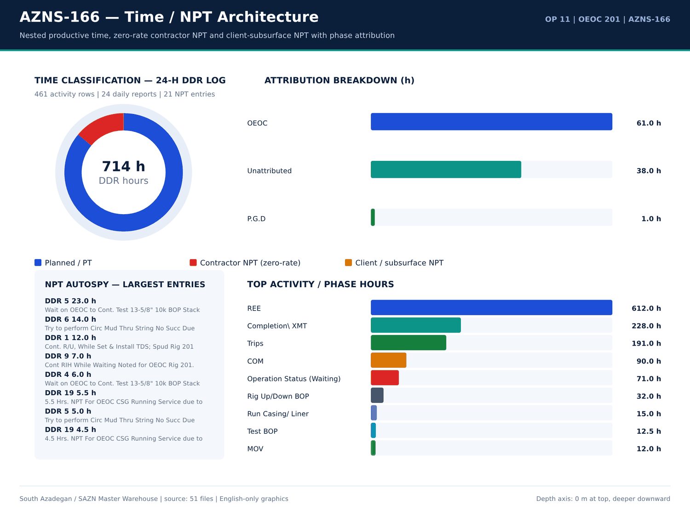
AZNS-166 01 time donut — source: SAZN master warehouse
Worksheet / sheet inventory
Document | Sheet | Rows | Cols | Non-empty cells | Numeric cells | Formula cells | Template | Part
CBS/11.AZNS_166_CBS.xlsx | AZNS-166 WO | 60 | 19 | 568 | 376 | 264 | — | —
CBS/11.AZNS_166_CBS.xlsx | Total Cost-EPD | 19 | 7 | 100 | 68 | 27 | — | —
CBS/11.AZNS_166_CBS.xlsx | Rig-less Stimulation total cost | 16 | 6 | 45 | 27 | 14 | — | —
CBS/11.AZNS_166_CBS.xlsx | Total Cost-EPD & Rigless | 5 | 3 | 12 | 5 | 3 | — | —
CBS/11.AZNS_166_CBS.xlsx | Cost Breakdown-166 | 197 | 9 | 633 | 328 | 207 | — | —
CBS/11.AZNS_166_CBS.xlsx | Cost Breakdown-166 Contingecy | 183 | 20 | 850 | 483 | 359 | — | —
CBS/11.AZNS_166_CBS.xlsx | Cost Breakdown-Material-166 | 249 | 7 | 619 | 286 | 246 | — | —
CBS/11.AZNS_166_CBS.xlsx | Rig Move | 4 | 5 | 16 | 8 | 2 | — | —
CBS/11.AZNS_166_CBS.xlsx | Catering & Accommodation | 15 | 7 | 29 | 12 | 0 | — | —
CBS/11.AZNS_166_CBS.xlsx | Cost breakdown R-less Stim.-166 | 16 | 4 | 45 | 27 | 14 | — | —
CBS/11.AZNS_166_CBS.xlsx | Mob.& Demob for Stim.-166 | 21 | 6 | 113 | 69 | 18 | — | —
CBS/11.AZNS_166_CBS.xlsx | Material & Consumable-166 | 34 | 6 | 195 | 125 | 32 | — | —
CBS/11.AZNS_166_CBS.xlsx | Acidizing &N2 service-166 | 21 | 9 | 155 | 99 | 18 | — | —
CBS/11.AZNS_166_CBS.xlsx | Coil Tubing Service-166 | 14 | 9 | 67 | 33 | 10 | — | —
CBS/11.AZNS_166_CBS.xlsx | Oil Transportation Service-166 | 9 | 7 | 40 | 20 | 6 | — | —
CBS/11.AZNS_166_CBS.xlsx | Well testing and production-166 | 31 | 11 | 233 | 164 | 29 | — | —
CBS/11.AZNS_166_CBS.xlsx | Wireline production logging-166 | 18 | 10 | 139 | 93 | 11 | — | —
CBS/11.AZNS_166_CBS.xlsx | Slick line-166 | 17 | 11 | 113 | 77 | 14 | — | —
CBS/11.AZNS_166_CBS.xlsx | Memory gauge-166 | 5 | 11 | 27 | 13 | 3 | — | —
CBS/11.AZNS_166_CBS.xlsx | Bottom Hole PVT Samp.-166 | 8 | 11 | 43 | 25 | 5 | — | —
CBS/11.AZNS_166_CBS.xlsx | Personnel rate-166 | 28 | 12 | 220 | 176 | 26 | — | —
CBS/11.AZNS_166_CBS.xlsx | Design,Interp.,Reporting-166 | 8 | 8 | 37 | 20 | 6 | — | —

Dossier identity and key figures
Metric | Value | Basis
Operation | AZNS-166 | Campaign map
Rig | OEOC 201 | DDR header
Contract | C2 | Contract register

Numeric-cell provenance excerpt — chapter 01
Document | Sheet | Cell | Value
CBS/11.AZNS_166_CBS.xlsx | Total Cost-EPD & Rigless | R5C3 | 9,087,998.52
CBS/11.AZNS_166_CBS.xlsx | Total Cost-EPD | R19C7 | 8,275,165.08
CBS/11.AZNS_166_CBS.xlsx | Total Cost-EPD & Rigless | R3C3 | 8,275,165.08
CBS/11.AZNS_166_CBS.xlsx | Total Cost-EPD | R3C6 | 2,118,462.01
CBS/11.AZNS_166_CBS.xlsx | Total Cost-EPD | R3C7 | 2,118,462.01
CBS/11.AZNS_166_CBS.xlsx | Cost Breakdown-166 | R197C6 | 2,118,462.01
CBS/11.AZNS_166_CBS.xlsx | Total Cost-EPD | R7C6 | 1,214,816.28
CBS/11.AZNS_166_CBS.xlsx | Total Cost-EPD | R7C7 | 1,214,816.28
CBS/11.AZNS_166_CBS.xlsx | Cost Breakdown-166 Contingecy | R183C16 | 1,214,816.28
CBS/11.AZNS_166_CBS.xlsx | Total Cost-EPD | R12C6 | 1,173,960.00
CBS/11.AZNS_166_CBS.xlsx | Total Cost-EPD | R12C7 | 1,173,960.00
CBS/11.AZNS_166_CBS.xlsx | Cost Breakdown-Material-166 | R249C6 | 1,173,960.00
CBS/11.AZNS_166_CBS.xlsx | Total Cost-EPD | R13C6 | 1,092,550.00
CBS/11.AZNS_166_CBS.xlsx | Cost Breakdown-166 | R5C6 | 1,017,455.31

Chapter 02 — Four-Track Time / Cost & NPT Deductions
The four contractual tracks close at CBS plan 9,087,999 USD, gross calendar 8,622,543 USD, payable excluding contractor zero-rate NPT 8,527,668 USD and pure net excluding all NPT 8,526,710 USD. Total attributed NPT is 100.0 h, split 99.0 h contractor and 1.0 h client/subsurface at a CBS rig rate of 23,000 USD/day; planned-time rows total 614.0 h. Deductions are computed only from attributed NPT hours and the sourced day rate.
Four-track cost register
Cost track | USD | Basis
CBS plan | 9,087,999 | Total Cost-EPD ceiling
Gross calendar | 8,622,543 | CBS plan + calendar delta
Payable excl. contractor NPT | 8,527,668 | Gross - zero-rate NPT
Pure net excl. all NPT | 8,526,710 | Gross - all NPT

NPT attribution breakdown
Category | Hours | Attributed | Share (%)
OEOC | 61 | OEOC | 61
Unattributed | 38 | Unattributed | 38
P.G.D | 1 | P.G.D | 1

DDR time-code hours
Code | Category | Hours | Report
20 | Operation Status (Waiting) | 24 | 5
23 | Completion\ XMT | 24 | 8
6 | Trips | 24 | 13
6 | Trips | 24 | 14
23 | Completion\ XMT | 24 | 22
23 | Completion\ XMT | 23 | 7
6 | Trips | 23 | 17
6 | Trips | 22 | 15
6 | Trips | 21.5 | 11
6 | Trips | 21.5 | 12
23 | Completion\ XMT | 21 | 2
6 | Trips | 21 | 10
23 | Completion\ XMT | 20.5 | 21
23 | Completion\ XMT | 19.5 | 23
6 | Trips | 18.5 | 18
23 | Completion\ XMT | 18.5 | 20
23 | Completion\ XMT | 18.5 | 24
23 | Completion\ XMT | 18 | 3
23 | Completion\ XMT | 17 | 9
15 | Rig Up/Down BOP | 16 | 4
6 | Trips | 15.5 | 16
20 | Operation Status (Waiting) | 14 | 6

Numeric-cell provenance excerpt — chapter 02
Document | Sheet | Cell | Value
CBS/11.AZNS_166_CBS.xlsx | Total Cost-EPD & Rigless | R5C3 | 9,087,998.52
CBS/11.AZNS_166_CBS.xlsx | Total Cost-EPD | R19C7 | 8,275,165.08
CBS/11.AZNS_166_CBS.xlsx | Total Cost-EPD & Rigless | R3C3 | 8,275,165.08
CBS/11.AZNS_166_CBS.xlsx | Total Cost-EPD | R3C6 | 2,118,462.01
CBS/11.AZNS_166_CBS.xlsx | Total Cost-EPD | R3C7 | 2,118,462.01
CBS/11.AZNS_166_CBS.xlsx | Cost Breakdown-166 | R197C6 | 2,118,462.01
CBS/11.AZNS_166_CBS.xlsx | Total Cost-EPD | R7C6 | 1,214,816.28
CBS/11.AZNS_166_CBS.xlsx | Total Cost-EPD | R7C7 | 1,214,816.28
CBS/11.AZNS_166_CBS.xlsx | Cost Breakdown-166 Contingecy | R183C16 | 1,214,816.28
CBS/11.AZNS_166_CBS.xlsx | Total Cost-EPD | R12C6 | 1,173,960.00
CBS/11.AZNS_166_CBS.xlsx | Total Cost-EPD | R12C7 | 1,173,960.00
CBS/11.AZNS_166_CBS.xlsx | Cost Breakdown-Material-166 | R249C6 | 1,173,960.00
CBS/11.AZNS_166_CBS.xlsx | Total Cost-EPD | R13C6 | 1,092,550.00
CBS/11.AZNS_166_CBS.xlsx | Cost Breakdown-166 | R5C6 | 1,017,455.31

Chapter 03 — CBS Tariff & Material Audit vs DDR / EOWR
The CBS workbook holds 872 priced lines for AZNS-166; the DDR daily material balance and the EOWR completion / cement / fluid chapters are reconciled line by line. 66 three-way reconciliation rows are retained, together with the exact unit price, quantity, sheet and cell reference of each priced item. Where a CBS line has no DDR consumption counterpart the status says so explicitly rather than inserting an assumed quantity.
CBS priced tariff lines
Sheet | Description | Unit | Qty | Unit price (USD) | Total (USD) | Cell | Formula
Total Cost-EPD | AZNS-166 well, De-Complete & Re-Complete with 7.5K Completion Equipment | — | 1 | 2,118,462.01 | 2,118,462.01 | G3 | —
Cost Breakdown-166 | — | — | — | — | 2,118,462.01 | F197 | —
Total Cost-EPD | Contingency 4 | — | 1 | 1,214,816.28 | 1,214,816.28 | G7 | —
Total Cost-EPD | Procurement for AZNS-166 | — | 1 | 1,173,960.00 | 1,173,960.00 | G12 | —
Cost Breakdown-Material-166 | — | — | — | — | 1,173,960.00 | F249 | —
Cost Breakdown-166 | Rig Service | DAY | 44.24 | 23,000.00 | 1,017,455.31 | F5 | —
Total Cost-EPD | Contingency 8 | — | 1 | 917,729.66 | 917,729.66 | G11 | —
Total Cost-EPD | Contingency 5 | — | 1 | 876,466.10 | 876,466.10 | G8 | —
Cost Breakdown-Material-166 | Tubular goods | — | — | — | 566,500.00 | F41 | —
Total Cost-EPD | Contingency 2 | — | 1 | 510,264.90 | 510,264.90 | G5 | —
Cost Breakdown-Material-166 | Wellhead & Xmas tree Equipment | — | — | — | 483,360.00 | F15 | —
Cost Breakdown-Material-166 | Tubing, 4 1/2", L80, 18.9 ppf, Premium Conn., Seamless, R2, PSL3. | m | 3,100.00 | 151 | 468,100.00 | F53 | —
Total Cost-EPD | Contingency 6 | — | 1 | 446,269.40 | 446,269.40 | G9 | —
Total Cost-EPD | Contingency 7 | — | 1 | 403,056.90 | 403,056.90 | G10 | —
Cost Breakdown-166 | Mud Chemicals for 8 1⁄2" hole | HOLE | 1 | 346,937.50 | 346,937.50 | F11 | —
Cost Breakdown-Material-166 | Section D | set | 1 | 341,275.00 | 341,275.00 | F30 | —
Total Cost-EPD | Contingency 1 | — | 1 | 254,628.45 | 254,628.45 | G4 | —
Cost Breakdown-166 Contingecy | — | — | — | — | 254,628.45 | F183 | —
Total Cost-EPD | Rig Moving (Pad to Pad) | — | 1 | 247,000.00 | 247,000.00 | G15 | —
Rig Move | Rig move between well pads | — | 1 | 247,000.00 | 247,000.00 | F3 | —
Cost Breakdown-Material-166 | Section C | set | 1 | 142,085.00 | 142,085.00 | F29 | —
Cost Breakdown-166 Contingecy | Rig Service | DAY | 5.5 | 23,000.00 | 126,500.00 | F5 | —

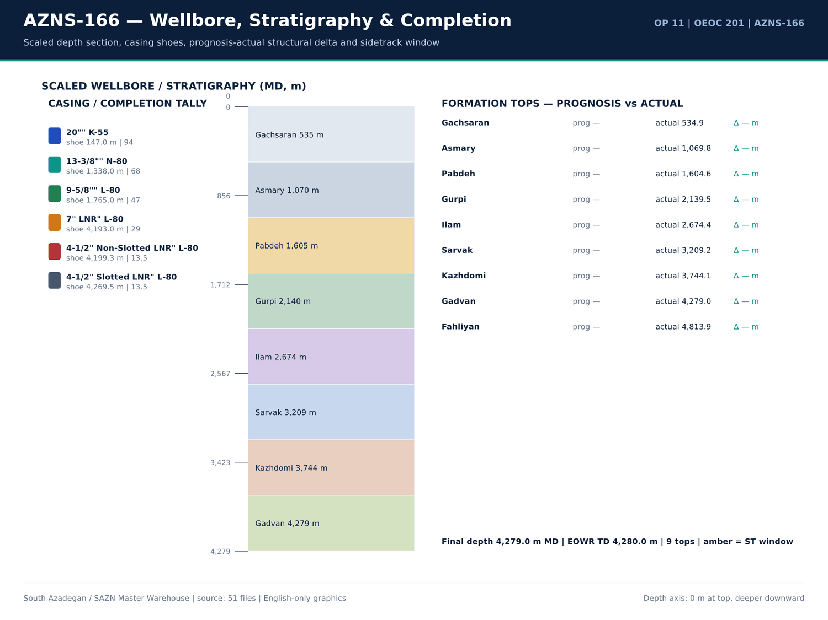
AZNS-166 02 wellbore — source: SAZN master warehouse
CBS total-cost ceilings
Sheet | Item | Qty | Unit cost | Total (USD) | Row
Total Cost-EPD | AZNS-166 well, De-Complete & Re-Complete with 7.5K Completion Equipment | 1 | 2,118,462.01 | 2,118,462.01 | 3
Total Cost-EPD | Contingency 1 | 1 | 254,628.45 | 254,628.45 | 4
Total Cost-EPD | Contingency 2 | 1 | 510,264.90 | 510,264.90 | 5
Total Cost-EPD | Contingency 3 | 1 | 112,511.38 | 112,511.38 | 6
Total Cost-EPD | Contingency 4 | 1 | 1,214,816.28 | 1,214,816.28 | 7
Total Cost-EPD | Contingency 5 | 1 | 876,466.10 | 876,466.10 | 8
Total Cost-EPD | Contingency 6 | 1 | 446,269.40 | 446,269.40 | 9
Total Cost-EPD | Contingency 7 | 1 | 403,056.90 | 403,056.90 | 10
Total Cost-EPD | Contingency 8 | 1 | 917,729.66 | 917,729.66 | 11
Total Cost-EPD | Procurement for AZNS-166 | 1 | 1,173,960.00 | 1,173,960.00 | 12
Total Cost-EPD | Rig mobilization | 0 | 1,092,550.00 | 0 | 13
Total Cost-EPD | Rig demobilization | 0 | 478,500.00 | 0 | 14
Total Cost-EPD | Rig Moving (Pad to Pad) | 1 | 247,000.00 | 247,000.00 | 15
Total Cost-EPD | Rig Moving (Celler to Celler) | 0 | 0 | 0 | 16
Total Cost-EPD | Mission cost | 0 | 150 | 0 | 17
Total Cost-EPD | Re-Entry, Completion & Procurement COST CEILING (USD) | — | — | 8,275,165.08 | 19
Total Cost-EPD | 1 | — | — | 2,118,462.01 | 3
Total Cost-EPD | Contingency 1 | — | — | 254,628.45 | 4
Total Cost-EPD | Contingency 2 | — | — | 510,264.90 | 5
Total Cost-EPD | Contingency 3 | — | — | 112,511.38 | 6
Total Cost-EPD | Contingency 4 | — | — | 1,214,816.28 | 7
Total Cost-EPD | Contingency 5 | — | — | 876,466.10 | 8

Three-way CBS / DDR / EOWR reconciliation
Item | CBS (USD) | DDR qty | Unit | Status
3 3 4 mill | 26,000.00 | — | each | CBS only — no DDR consumption record
5 7 8 rock bit | 19,500.00 | — | each | CBS only — no DDR consumption record
6 mill | 32,500.00 | — | each | CBS only — no DDR consumption record
8 1 2 rock bit | 28,500.00 | — | each | CBS only — no DDR consumption record
acid chemical pump | 594 | — | 1 EA | CBS only — no DDR consumption record
acid mixing tanks | 5,950.00 | — | 1 EA | CBS only — no DDR consumption record
acid storage tanks | 5,950.00 | — | 1 EA | CBS only — no DDR consumption record
acid testing lab or acid testing costs in accredited lab | 2,565.00 | — | 1 EA | CBS only — no DDR consumption record
anti sludge agent | 1,275.00 | — | Gal | CBS only — no DDR consumption record
batch mixer | 34,000.00 | — | 1 EA | CBS only — no DDR consumption record
bentonite | — | 1 | — | DDR only — no CBS priced line
blender | 8,500.00 | — | 1 EA | CBS only — no DDR consumption record
booster pump | 594 | — | 1 EA | CBS only — no DDR consumption record
cacl2 85 | — | 87 | — | DDR only — no CBS priced line
cacl2 95 | — | 39 | — | DDR only — no CBS priced line
casing accessories | 17,600.00 | — | — | CBS only — no DDR consumption record
caustic soda | — | 12 | — | DDR only — no CBS priced line
corrosion inhibitor | 2,850.00 | — | Gal | CBS only — no DDR consumption record
corrosion inhibitor aid | 2,100.00 | — | Gal | CBS only — no DDR consumption record
corrosive fluid | 600 | — | BBL | CBS only — no DDR consumption record
crane with driver | 1,350.00 | — | 1 EA | CBS only — no DDR consumption record
crossover 4 1 2 18 9 ppf box 3 1 2 10 2 ppf pin gas tight conn l080 type1 1 2m long psl3 | 1,900.00 | — | ea. | CBS only — no DDR consumption record

Numeric-cell provenance excerpt — chapter 03
Document | Sheet | Cell | Value
CBS/11.AZNS_166_CBS.xlsx | Total Cost-EPD & Rigless | R5C3 | 9,087,998.52
CBS/11.AZNS_166_CBS.xlsx | Total Cost-EPD | R19C7 | 8,275,165.08
CBS/11.AZNS_166_CBS.xlsx | Total Cost-EPD & Rigless | R3C3 | 8,275,165.08
CBS/11.AZNS_166_CBS.xlsx | Total Cost-EPD | R3C6 | 2,118,462.01
CBS/11.AZNS_166_CBS.xlsx | Total Cost-EPD | R3C7 | 2,118,462.01
CBS/11.AZNS_166_CBS.xlsx | Cost Breakdown-166 | R197C6 | 2,118,462.01
CBS/11.AZNS_166_CBS.xlsx | Total Cost-EPD | R7C6 | 1,214,816.28
CBS/11.AZNS_166_CBS.xlsx | Total Cost-EPD | R7C7 | 1,214,816.28
CBS/11.AZNS_166_CBS.xlsx | Cost Breakdown-166 Contingecy | R183C16 | 1,214,816.28
CBS/11.AZNS_166_CBS.xlsx | Total Cost-EPD | R12C6 | 1,173,960.00
CBS/11.AZNS_166_CBS.xlsx | Total Cost-EPD | R12C7 | 1,173,960.00
CBS/11.AZNS_166_CBS.xlsx | Cost Breakdown-Material-166 | R249C6 | 1,173,960.00
CBS/11.AZNS_166_CBS.xlsx | Total Cost-EPD | R13C6 | 1,092,550.00
CBS/11.AZNS_166_CBS.xlsx | Cost Breakdown-166 | R5C6 | 1,017,455.31

Chapter 04 — Milestones, Flat Spots & Invisible Lost Time
Depth progressed to 4,279.0 m MD with 312.0 m of recorded 24-h footage at mean ROP 9.00 m/h; 0 DDR reports show zero recorded progress and are retained as flat spots rather than interpolated. Milestones, invisible lost time and cumulative cost are listed per report so that a time-depth curve can be rebuilt directly from the table.
Daily time-depth milestones
Report | Date | MD (m) | Drilled (m) | ROP (m/h) | MW (PCF) | Hole size | Formation
1 | 2025-Oct-27 | 4,279.00 | 13 | 9 | 83 | Estimated Final Depth MD (m): | 4-1/2" Non-Slotted LNR
2 | 2025-Oct-28 | 4,279.00 | 13 | 9 | 83 | Estimated Final Depth MD (m): | 4-1/2" Non-Slotted LNR
3 | 2025-Oct-29 | 4,279.00 | 13 | 9 | 83 | Estimated Final Depth MD (m): | 4-1/2" Non-Slotted LNR
4 | 2025-Oct-30 | 4,279.00 | 13 | 9 | 83 | Estimated Final Depth MD (m): | 4-1/2" Non-Slotted LNR
5 | 2025-Oct-31 | 4,279.00 | 13 | 9 | 83 | Estimated Final Depth MD (m): | 4-1/2" Non-Slotted LNR
6 | 2025-Nov-1 | 4,279.00 | 13 | 9 | 83 | Estimated Final Depth MD (m): | 4-1/2" Non-Slotted LNR
7 | 2025-Nov-2 | 4,279.00 | 13 | 9 | 83 | Estimated Final Depth MD (m): | 4-1/2" Non-Slotted LNR
8 | 2025-Nov-3 | 4,279.00 | 13 | 9 | 83 | Estimated Final Depth MD (m): | 4-1/2" Non-Slotted LNR
9 | 2025-Nov-4 | 4,279.00 | 13 | 9 | 83 | Estimated Final Depth MD (m): | 4-1/2" Non-Slotted LNR
10 | 2025-Nov-5 | 4,279.00 | 13 | 9 | 83 | Estimated Final Depth MD (m): | 4-1/2" Non-Slotted LNR
11 | 2025-Nov-6 | 4,279.00 | 13 | 9 | 83 | Estimated Final Depth MD (m): | 4-1/2" Non-Slotted LNR
12 | 2025-Nov-7 | 4,279.00 | 13 | 9 | 83 | Estimated Final Depth MD (m): | 4-1/2" Non-Slotted LNR
13 | 2025-Nov-8 | 4,279.00 | 13 | 9 | 83 | Estimated Final Depth MD (m): | 4-1/2" Non-Slotted LNR
14 | 2025-Nov-9 | 4,279.00 | 13 | 9 | 83 | Estimated Final Depth MD (m): | 4-1/2" Non-Slotted LNR
15 | 2025-Nov-10 | 4,279.00 | 13 | 9 | 83 | Estimated Final Depth MD (m): | 4-1/2" Non-Slotted LNR
16 | 2025-Nov-11 | 4,279.00 | 13 | 9 | 83 | Estimated Final Depth MD (m): | 4-1/2" Non-Slotted LNR
17 | 2025-Nov-12 | 4,279.00 | 13 | 9 | 83 | Estimated Final Depth MD (m): | 4-1/2" Non-Slotted LNR
18 | 2025-Nov-13 | 4,279.00 | 13 | 9 | 83 | Estimated Final Depth MD (m): | 4-1/2" Non-Slotted LNR
19 | 2025-Nov-14 | 4,279.00 | 13 | 9 | 83 | Estimated Final Depth MD (m): | 4-1/2" Non-Slotted LNR
20 | 2025-Nov-15 | 4,279.00 | 13 | 9 | 83 | Estimated Final Depth MD (m): | 4-1/2" Non-Slotted LNR
21 | 2025-Nov-16 | 4,279.00 | 13 | 9 | 83 | Estimated Final Depth MD (m): | 4-1/2" Non-Slotted LNR
22 | 2025-Nov-17 | 4,279.00 | 13 | 9 | 83 | Estimated Final Depth MD (m): | 4-1/2" Non-Slotted LNR

Zero-progress flat spots
Report | Date | MD (m) | NPT (h) | PT (h) | Cum. cost (USD)
No source rows for this query | — | — | — | — | —

Cumulative cost by DDR report
Report | Date | MD (m) | NPT (h) | PT (h) | Cum. cost (USD)
1 | 2025-Oct-27 | 4,279.00 | 12 | 18 | 23,000.00
2 | 2025-Oct-28 | 4,279.00 | 0 | 30 | 46,000.00
3 | 2025-Oct-29 | 4,279.00 | 0 | 30 | 69,000.00
4 | 2025-Oct-30 | 4,279.00 | 6 | 24 | 92,000.00
5 | 2025-Oct-31 | 4,279.00 | 29 | 1 | 115,000.00
6 | 2025-Nov-1 | 4,279.00 | 14 | 16 | 138,000.00
7 | 2025-Nov-2 | 4,279.00 | 1 | 29 | 161,000.00
8 | 2025-Nov-3 | 4,279.00 | 0 | 30 | 184,000.00
9 | 2025-Nov-4 | 4,279.00 | 7 | 23 | 207,000.00
10 | 2025-Nov-5 | 4,279.00 | 3 | 27 | 230,000.00
11 | 2025-Nov-6 | 4,279.00 | 2 | 28 | 253,000.00
12 | 2025-Nov-7 | 4,279.00 | 0 | 30 | 276,000.00
13 | 2025-Nov-8 | 4,279.00 | 0 | 30 | 299,000.00
14 | 2025-Nov-9 | 4,279.00 | 0 | 30 | 322,000.00
15 | 2025-Nov-10 | 4,279.00 | 0 | 30 | 345,000.00
16 | 2025-Nov-11 | 4,279.00 | 0 | 30 | 368,000.00
17 | 2025-Nov-12 | 4,279.00 | 0 | 30 | 391,000.00
18 | 2025-Nov-13 | 4,279.00 | 0 | 30 | 414,000.00
19 | 2025-Nov-14 | 4,279.00 | 15.5 | 14.5 | 437,000.00
20 | 2025-Nov-15 | 4,279.00 | 7 | 23 | 460,000.00
21 | 2025-Nov-16 | 4,279.00 | 3.5 | 26.5 | 483,000.00
22 | 2025-Nov-17 | 4,279.00 | 0 | 30 | 506,000.00

Numeric-cell provenance excerpt — chapter 04
Document | Sheet | Cell | Value
CBS/11.AZNS_166_CBS.xlsx | Total Cost-EPD & Rigless | R5C3 | 9,087,998.52
CBS/11.AZNS_166_CBS.xlsx | Total Cost-EPD | R19C7 | 8,275,165.08
CBS/11.AZNS_166_CBS.xlsx | Total Cost-EPD & Rigless | R3C3 | 8,275,165.08
CBS/11.AZNS_166_CBS.xlsx | Total Cost-EPD | R3C6 | 2,118,462.01
CBS/11.AZNS_166_CBS.xlsx | Total Cost-EPD | R3C7 | 2,118,462.01
CBS/11.AZNS_166_CBS.xlsx | Cost Breakdown-166 | R197C6 | 2,118,462.01
CBS/11.AZNS_166_CBS.xlsx | Total Cost-EPD | R7C6 | 1,214,816.28
CBS/11.AZNS_166_CBS.xlsx | Total Cost-EPD | R7C7 | 1,214,816.28
CBS/11.AZNS_166_CBS.xlsx | Cost Breakdown-166 Contingecy | R183C16 | 1,214,816.28
CBS/11.AZNS_166_CBS.xlsx | Total Cost-EPD | R12C6 | 1,173,960.00
CBS/11.AZNS_166_CBS.xlsx | Total Cost-EPD | R12C7 | 1,173,960.00
CBS/11.AZNS_166_CBS.xlsx | Cost Breakdown-Material-166 | R249C6 | 1,173,960.00
CBS/11.AZNS_166_CBS.xlsx | Total Cost-EPD | R13C6 | 1,092,550.00
CBS/11.AZNS_166_CBS.xlsx | Cost Breakdown-166 | R5C6 | 1,017,455.31

Chapter 05 — 24-Hour Activity Log & Operation Codes
461 discrete 24-h activity rows were parsed for AZNS-166, each with phase, code, sub-code, PLN/NPT status, attributed party and duration. The tables below reproduce the raw activity log, the code distribution and the phase-by-status hour matrix; no activity is merged or rounded away.
Raw 24-hour activity log
Report | Seq | Phase | Code | Status | Attributed | Hours | Description
1 | 1 | MOV | 1 | NPT | — | 12 | Cont. R/U, While Set & Install TDS; Spud Rig 201 as per Prespud Check List @ 1404.08.05 - 12:00
1 | 2 | REE | 12 | PLN | — | 12 | L/U 4" 10k psi Co-Flex Hose F/ Choke Manifold outlet To X-Mas Tree Production Valve; L/U 2" Chicksan Flowline F/ Pump Unit discharge
1 | 3 | — | — | — | — | — | To T.H.S side outlet; Set Storage Tank & Conn. To Burning Line;
1 | 4 | — | — | — | — | — | Check & Record Annulus pressures of all Wellhead sections as follows:
1 | 5 | — | — | — | — | — | Section A – 0 psi / 15 min; Section B – 0 psi / 15 min; Section C – 0 psi / 15 min; All wellhead sections confirmed pressure-free and stable.
1 | 6 | — | — | — | — | — | Press. Test P-Seal Test of B & C Section as follows:
1 | 7 | — | — | — | — | — | Section B (13-3/8" P-Seal) – 1500 psi / 15 min; Section C (9-5/8" P-Seal) tested @ 2500 psi / 15 min – Press. Test between two P-Seals OK,
1 | 8 | — | — | — | — | — | but Press. Test between lower P-Seal & CSG HGR failed; Press. Test Chiksan Pipes & Co-Flex Hose W/ 7000psi / 15 min, Ok;
1 | 9 | — | — | — | — | — | P/U & M/U Wellhead Lubricator on X-Mas Tree, Press. Test the same W/ 4000psi / 15min.
1 | 10 | — | — | — | — | — | Arr. of Vira Mud Engineer & Unit @ 1404.07.30 - 12:00
1 | 11 | — | — | — | — | — | Rec. Petro Sanaat Atras Jonoub H2S Unit @ 1404.07.30 - 16:00
1 | 12 | — | — | — | — | — | Arr. of Petro Sanaat Atras Jonoub H2S Crew @ 1404.08.03 - 14:00
1 | 13 | — | — | — | — | — | Rec. Mud Logging Unit & Crew @ 1404.08.03 - 15:00
1 | 14 | — | — | — | — | — | Rec. OEOC Slickline Crew & Unit @ 1404.08.03 - 16:30
1 | 15 | — | — | — | — | — | Rec. OEOC Wellhead Crew & Tools @ 1404.08.03 - 16:45
1 | 16 | — | — | — | — | — | Arr. of SPAD Energy Crew & Pump Unit @ 1404.08.04 - 00:30
1 | 17 | — | — | — | — | — | Arr. of PEDEC Security Crew & Explosive material @ 1404.08.04 - 19:00
1 | 18 | — | — | — | — | — | Rec. Storage Tank @ 1404.08.05 - 16:00
1 | 19 | — | — | — | — | — | Arr. of OEOC Coiled Tubing Crew & Unit @ 1404.08.05 - 17:00
1 | 20 | Main Phase | Code | Status | NPT/ Unplan Attributed | — | Rig Activity Type
1 | 21 | REE | 12 | PLN | — | 6 | Ret. TWCV W/ Wellhead Lubricator, While Record 800psi Pressure on Wellhead Lubricator Press. Gauge; L/D Wellhead Lubricator
1 | 22 | — | — | — | — | — | and X-Mas Tree Cap; Flush Solid Block upper valves W/ 10bbl Drill Water.

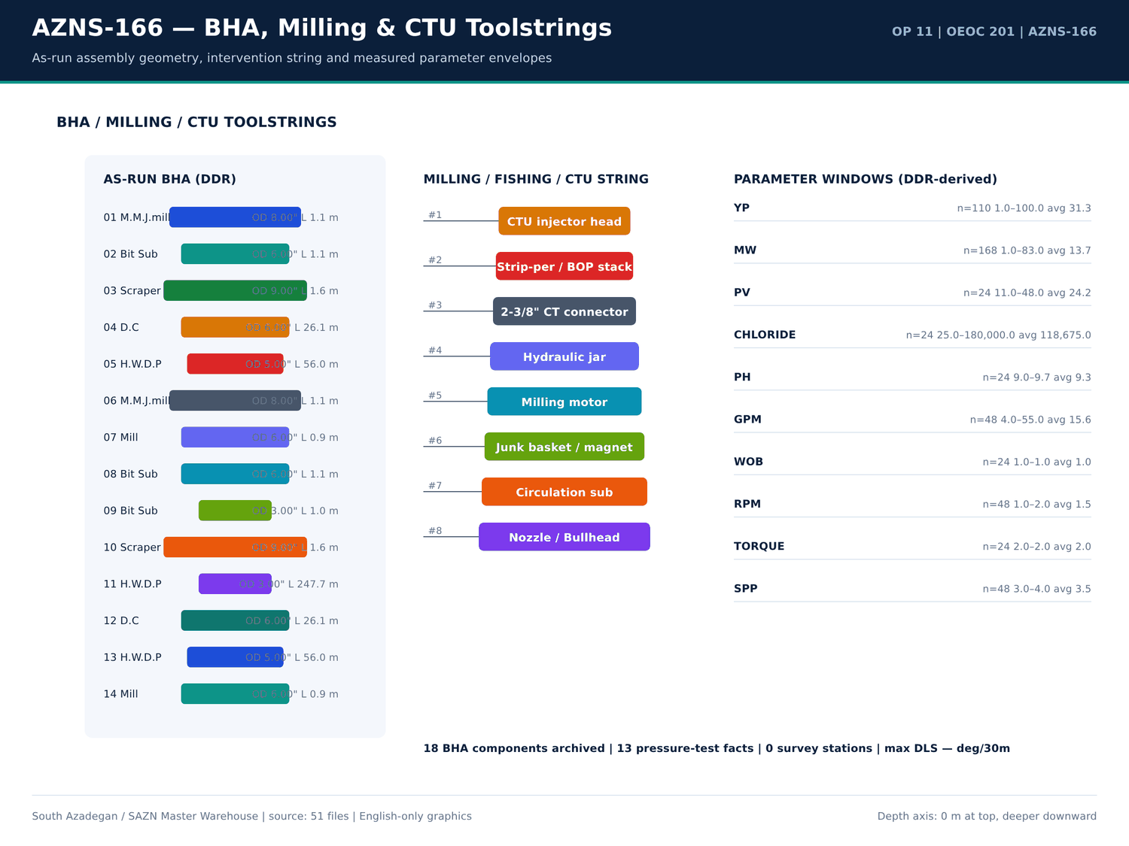
AZNS-166 03 bha — source: SAZN master warehouse
Activity code distribution
Code | Hours | Count
23 | 283.5 | 62
6 | 237.5 | 28
20 | 88 | 20
15 | 43.5 | 6
12 | 21 | 3
5 | 13 | 5
16 | 12.5 | 2
1 | 12 | 1
9 | 2.5 | 2
21 | 0.5 | 1

Phase × status hour matrix
Phase | Status | Hours | Count
REE | PLN | 524 | 86
COM | PLN | 90 | 23
REE | NPT | 84 | 17
MOV | NPT | 12 | 1
REE | NPT-UNPLN | 4 | 3

Numeric-cell provenance excerpt — chapter 05
Document | Sheet | Cell | Value
CBS/11.AZNS_166_CBS.xlsx | Total Cost-EPD & Rigless | R5C3 | 9,087,998.52
CBS/11.AZNS_166_CBS.xlsx | Total Cost-EPD | R19C7 | 8,275,165.08
CBS/11.AZNS_166_CBS.xlsx | Total Cost-EPD & Rigless | R3C3 | 8,275,165.08
CBS/11.AZNS_166_CBS.xlsx | Total Cost-EPD | R3C6 | 2,118,462.01
CBS/11.AZNS_166_CBS.xlsx | Total Cost-EPD | R3C7 | 2,118,462.01
CBS/11.AZNS_166_CBS.xlsx | Cost Breakdown-166 | R197C6 | 2,118,462.01
CBS/11.AZNS_166_CBS.xlsx | Total Cost-EPD | R7C6 | 1,214,816.28
CBS/11.AZNS_166_CBS.xlsx | Total Cost-EPD | R7C7 | 1,214,816.28
CBS/11.AZNS_166_CBS.xlsx | Cost Breakdown-166 Contingecy | R183C16 | 1,214,816.28
CBS/11.AZNS_166_CBS.xlsx | Total Cost-EPD | R12C6 | 1,173,960.00
CBS/11.AZNS_166_CBS.xlsx | Total Cost-EPD | R12C7 | 1,173,960.00
CBS/11.AZNS_166_CBS.xlsx | Cost Breakdown-Material-166 | R249C6 | 1,173,960.00
CBS/11.AZNS_166_CBS.xlsx | Total Cost-EPD | R13C6 | 1,092,550.00
CBS/11.AZNS_166_CBS.xlsx | Cost Breakdown-166 | R5C6 | 1,017,455.31

Chapter 06 — NPT Pareto & Event Autopsy
3 problem families were reconstructed for AZNS-166. Each carries occurrence count, hours, depth, formation, attributed party, at least two engineering hypotheses, a quantified exposure and a 60-second rig-floor playbook. The Pareto tables rank these families by hours and by cost exposure using the sourced rig rate.
Reconstructed problem families
Category | Days | Depth (m) | Formation | Title | Hours | Cost (USD) | Evidence
Other operational delay | 1,5,6,14,19,20,21 | 4,279.00 | 4-1/2" Non-Slotted LNR | Other operational delay — 18 occurrences | 53 | 50,791.67 | DDR 24-h log / remarks
Rig equipment failure | 4,5 | 4,279.00 | 4-1/2" Non-Slotted LNR | Rig equipment failure — 2 occurrences | 29 | 27,791.67 | DDR 24-h log / remarks
Waiting on services / material | 3,4,5,6,7,9,10,11 | 4,279.00 | 4-1/2" Non-Slotted LNR | Waiting on services / material — 18 occurrences | 18 | 17,250.00 | DDR 24-h log / remarks

NPT Pareto by attributed hours
Category | Hours | Attributed | Share (%)
OEOC | 61 | OEOC | 61
Unattributed | 38 | Unattributed | 38
P.G.D | 1 | P.G.D | 1

Largest individual NPT entries
Report | Hours | Attributed | Description
8 | 24 | — | Cont. POOH & L/D Completion String to 50m While f/u well continuously, NL-NG.
5 | 23 | OEOC | Wait on OEOC to Cont. Test 13-5/8" 10k BOP Stack While Work on fixing BOP leakages as Below:
7 | 23 | — | As Client Request ( P.P.L ), Cont. POOH with 2 Jts 4-1/2" TBG ( 18.9PPF, TPG2 BOX * PIN ), OBS 15-30klb over pull @ 2759-2758.3m
17 | 23 | — | Start POOH from 4132m ( 4-1/2" L.Lap ) to 1376m while L/D 5" D.Pipe ( Jt by Jt ) & 3-1/2" D.Pipe ( Jt by Jt ) & F/U the well with CaCl2
14 | 20 | — | Cont. Run in hole by 5" D.Pipe from 2800m to 3100m while F/U string & break Circulate each 15 STD, NL.NG.
18 | 18.5 | — | Cont. POOH 6" Clean out BHA F/ 1376m To surface On Elevator, While L/D All Tubular ( Jt by Jt ) & 6" Mill (10% Used, same as RIH
2 | 18 | — | Prepare Rig To Kill the Well W/ Coiled Tubing; R/U Coiled Tubing Facilities as follows:
24 | 18 | — | Press. Test M.M.Seal @ 6,000 Psi / 15 Min – Ok;
21 | 17.5 | — | Cont. RIH W/ 3-1/2" * 4-1/2" 7.5k Comp. Strg F/ 1671 To 2640m, While Clean & Wash all Connections; Use Thread Seal Compound, and
4 | 16 | — | Cont. N/U 13-5/8" 10k BOP Stack.
13 | 16 | — | P/U & Run in hole W/ NEW 3-1/2" M.M.J.Mill ( T.S.E.KH, SN : 084 ) + 15 Jts 3-1/8" D.C ( Jt by Jt ) + R/U 2-7/8 "D.Pipe handling tools and RIH
6 | 14 | OEOC | Try to perform Circ Mud Thru String No Succ Due to Observe Leakage TDS Kelly Hose .
12 | 13.5 | — | Cont RIH with 6" Junk Mill ( T.S.E.KH ) + 27 jts 3-1/2" HWDP (Jt by Jt ) + 3-1/2" D.Pipe ( Jt by Jt ) + 4.3/4" D.PIN + 4 3/4" Bit Sub ( Float In ) +
11 | 13 | — | Cont RIH with 6" Junk Mill ( T.S.E.KH ) + 27 jts 3-1/2" HWDP (Jt by Jt ) & Follow by 3-1/2" D.Pipe ( Jt by Jt ) from 1153m to 2540m for Cleaning
16 | 13 | — | Cont RIH with 6" M.M.J.mill ( 5% Used / T.S.E.KH ) + 4 3/4" Bit Sub ( F. In ) + HWDP 3 1/2" & Follow by 3 1/2" DP to 1608m ( 7" L.Lap )
1 | 12 | — | Cont. R/U, While Set & Install TDS; Spud Rig 201 as per Prespud Check List @ 1404.08.05 - 12:00
1 | 12 | — | L/U 4" 10k psi Co-Flex Hose F/ Choke Manifold outlet To X-Mas Tree Production Valve; L/U 2" Chicksan Flowline F/ Pump Unit discharge
9 | 11 | — | Cont. Run in hole with 127 Jts 5" D.pipe ( Jts by Jts ) from 100 To 1360m W F/U String every 20 Jts.
15 | 9.5 | — | Cont. POOH To 200m. Change the handling tools and Cont. POOH while L/D 2STD 2-7/8" D.Pipe & 5 STD 3-1/8" D.c ( jt by jt ).
22 | 9.5 | — | P/U & M/U G.FLG + 4-1/16" 10K Gate Valve + Slickline BOP + Lubricator & BOP Panel; Test BOP, Ok; R/D Mouse Hole; R/U Surface
19 | 9 | — | Cont. RIH W/ 3-1/2" * 4-1/2" 7.5k Comp. Strg F/ 72 To 676m, While Clean & Wash all Connections; Use Thread Seal Compound, and
20 | 9 | — | Cont. RIH W/ 3-1/2" * 4-1/2" 7.5k Comp. Strg F/ 676 To 1223m, While Clean & Wash all Connections; Use Thread Seal Compound, and

Numeric-cell provenance excerpt — chapter 06
Document | Sheet | Cell | Value
CBS/11.AZNS_166_CBS.xlsx | Total Cost-EPD & Rigless | R5C3 | 9,087,998.52
CBS/11.AZNS_166_CBS.xlsx | Total Cost-EPD | R19C7 | 8,275,165.08
CBS/11.AZNS_166_CBS.xlsx | Total Cost-EPD & Rigless | R3C3 | 8,275,165.08
CBS/11.AZNS_166_CBS.xlsx | Total Cost-EPD | R3C6 | 2,118,462.01
CBS/11.AZNS_166_CBS.xlsx | Total Cost-EPD | R3C7 | 2,118,462.01
CBS/11.AZNS_166_CBS.xlsx | Cost Breakdown-166 | R197C6 | 2,118,462.01
CBS/11.AZNS_166_CBS.xlsx | Total Cost-EPD | R7C6 | 1,214,816.28
CBS/11.AZNS_166_CBS.xlsx | Total Cost-EPD | R7C7 | 1,214,816.28
CBS/11.AZNS_166_CBS.xlsx | Cost Breakdown-166 Contingecy | R183C16 | 1,214,816.28
CBS/11.AZNS_166_CBS.xlsx | Total Cost-EPD | R12C6 | 1,173,960.00
CBS/11.AZNS_166_CBS.xlsx | Total Cost-EPD | R12C7 | 1,173,960.00
CBS/11.AZNS_166_CBS.xlsx | Cost Breakdown-Material-166 | R249C6 | 1,173,960.00
CBS/11.AZNS_166_CBS.xlsx | Total Cost-EPD | R13C6 | 1,092,550.00
CBS/11.AZNS_166_CBS.xlsx | Cost Breakdown-166 | R5C6 | 1,017,455.31

Chapter 07 — Bit Record, Dull Grade & Cost per Metre
Bit and drilling-tool records are taken from the CBS tariff lines, DDR bit/BHA sheets and EOWR bit-record chapter. Cost per drilled metre is formed from 9,087,999 USD of CBS scope and 312.0 m of recorded footage; where no new hole was drilled the table states the workover basis instead of dividing by an invented denominator.
Bit / drilling-tool tariff lines
Sheet | Description | Unit | Qty | Unit price (USD) | Total (USD)
Cost Breakdown-Material-166 | Drilling Bit &mill | — | — | — | 106,500.00
Cost Breakdown-Material-166 | 8 1/2" Rock Bit | each | 3 | 9,500.00 | 28,500.00
Cost Breakdown-Material-166 | 5 7/8" Rock Bit | each | 3 | 6,500.00 | 19,500.00
Material & Consumable-166 | Corrosion Inhibitor | Gal | 50 | 57 | 2,850.00
Material & Consumable-166 | Corrosion Inhibitor Aid | Gal | 70 | 30 | 2,100.00
Material & Consumable-166 | Iron Stabilizer | Gal | 40 | 30 | 1,200.00
Cost Breakdown-166 | Drilling Bit & mill | SET | — | — | 0
Cost Breakdown-Material-166 | Float shoe, reamer type, 7", 29 32#, L80 110S, PREMIUM connection, PDC drillable | ea. | — | — | 0
Cost Breakdown-Material-166 | Float shoe, reamer type, 7", 29#, L80, 9CR01 MO, PREMIUM connection, PDC drillable | ea. | — | — | 0
Cost Breakdown-Material-166 | Float shoe, reamer type, 7", 32#, 110S,PREMIUM connection, PDC drillable | ea. | — | — | 0
Cost Breakdown-Material-166 | Float shoe, reamer type, 5 " 18# ,110S,PREMIUM connection, PDC drillable | ea. | — | — | 0
Cost Breakdown-Material-166 | Float shoe, reamer type, 5" 18 23# x 9 5/8" 47 53.5#, 110S, PREMIUM connection, PDC drillable | ea. | — | — | 0
Cost Breakdown-Material-166 | Guide shoe, reamer type, 4 1/2", 13.5#, L80,BTC connection | ea. | — | — | 0
Cost Breakdown-Material-166 | 12 1/4" Rock Bit | each | — | — | 0
Cost Breakdown-Material-166 | 12 1/4" PDC Bit | each | — | — | 0
Cost Breakdown-Material-166 | 8 1/2" PDC Bit | each | — | — | 0
Cost Breakdown-Material-166 | 6 1/8" PDC Bit | each | — | — | 0
Material & Consumable-166 | Clay Stabilizer | Gal | 0 | 22.5 | 0
AZNS-166 WO | RIH with 8 1⁄2" bit and clean out BHA (P/U DP's JT by JT) to 7" L.LAP (1608.2m), CBU, POOH. | — | — | — | —
Cost Breakdown-166 Contingecy | Drilling Bit & mill | SET | — | 6,500.00 | —

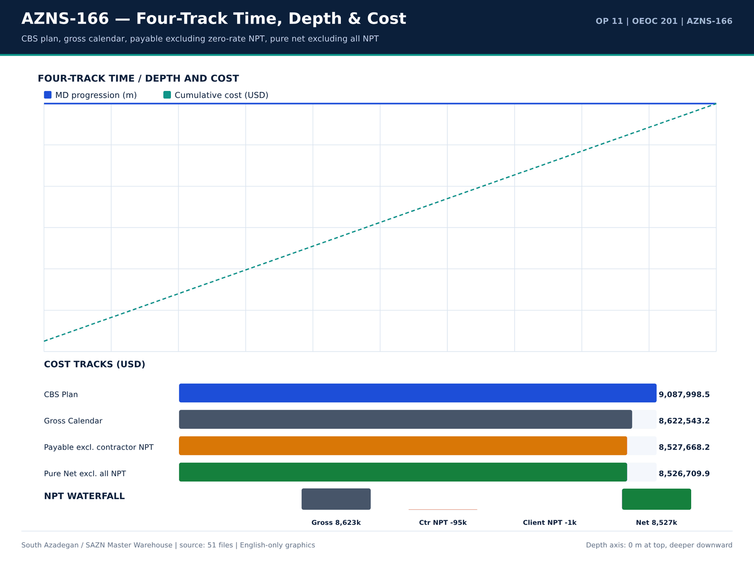
AZNS-166 04 fourtrack — source: SAZN master warehouse
Daily ROP / footage record
Report | Date | MD (m) | Drilled (m) | ROP (m/h) | MW (PCF) | Formation
1 | 2025-Oct-27 | 4,279.00 | 13 | 9 | 83 | 4-1/2" Non-Slotted LNR
2 | 2025-Oct-28 | 4,279.00 | 13 | 9 | 83 | 4-1/2" Non-Slotted LNR
3 | 2025-Oct-29 | 4,279.00 | 13 | 9 | 83 | 4-1/2" Non-Slotted LNR
4 | 2025-Oct-30 | 4,279.00 | 13 | 9 | 83 | 4-1/2" Non-Slotted LNR
5 | 2025-Oct-31 | 4,279.00 | 13 | 9 | 83 | 4-1/2" Non-Slotted LNR
6 | 2025-Nov-1 | 4,279.00 | 13 | 9 | 83 | 4-1/2" Non-Slotted LNR
7 | 2025-Nov-2 | 4,279.00 | 13 | 9 | 83 | 4-1/2" Non-Slotted LNR
8 | 2025-Nov-3 | 4,279.00 | 13 | 9 | 83 | 4-1/2" Non-Slotted LNR
9 | 2025-Nov-4 | 4,279.00 | 13 | 9 | 83 | 4-1/2" Non-Slotted LNR
10 | 2025-Nov-5 | 4,279.00 | 13 | 9 | 83 | 4-1/2" Non-Slotted LNR
11 | 2025-Nov-6 | 4,279.00 | 13 | 9 | 83 | 4-1/2" Non-Slotted LNR
12 | 2025-Nov-7 | 4,279.00 | 13 | 9 | 83 | 4-1/2" Non-Slotted LNR
13 | 2025-Nov-8 | 4,279.00 | 13 | 9 | 83 | 4-1/2" Non-Slotted LNR
14 | 2025-Nov-9 | 4,279.00 | 13 | 9 | 83 | 4-1/2" Non-Slotted LNR
15 | 2025-Nov-10 | 4,279.00 | 13 | 9 | 83 | 4-1/2" Non-Slotted LNR
16 | 2025-Nov-11 | 4,279.00 | 13 | 9 | 83 | 4-1/2" Non-Slotted LNR
17 | 2025-Nov-12 | 4,279.00 | 13 | 9 | 83 | 4-1/2" Non-Slotted LNR
18 | 2025-Nov-13 | 4,279.00 | 13 | 9 | 83 | 4-1/2" Non-Slotted LNR
19 | 2025-Nov-14 | 4,279.00 | 13 | 9 | 83 | 4-1/2" Non-Slotted LNR
20 | 2025-Nov-15 | 4,279.00 | 13 | 9 | 83 | 4-1/2" Non-Slotted LNR
21 | 2025-Nov-16 | 4,279.00 | 13 | 9 | 83 | 4-1/2" Non-Slotted LNR
22 | 2025-Nov-17 | 4,279.00 | 13 | 9 | 83 | 4-1/2" Non-Slotted LNR

Bit / BHA / tool notes
Report | Sheet | Category | Text
No source rows for this query | — | — | —

Numeric-cell provenance excerpt — chapter 07
Document | Sheet | Cell | Value
CBS/11.AZNS_166_CBS.xlsx | Total Cost-EPD & Rigless | R5C3 | 9,087,998.52
CBS/11.AZNS_166_CBS.xlsx | Total Cost-EPD | R19C7 | 8,275,165.08
CBS/11.AZNS_166_CBS.xlsx | Total Cost-EPD & Rigless | R3C3 | 8,275,165.08
CBS/11.AZNS_166_CBS.xlsx | Total Cost-EPD | R3C6 | 2,118,462.01
CBS/11.AZNS_166_CBS.xlsx | Total Cost-EPD | R3C7 | 2,118,462.01
CBS/11.AZNS_166_CBS.xlsx | Cost Breakdown-166 | R197C6 | 2,118,462.01
CBS/11.AZNS_166_CBS.xlsx | Total Cost-EPD | R7C6 | 1,214,816.28
CBS/11.AZNS_166_CBS.xlsx | Total Cost-EPD | R7C7 | 1,214,816.28
CBS/11.AZNS_166_CBS.xlsx | Cost Breakdown-166 Contingecy | R183C16 | 1,214,816.28
CBS/11.AZNS_166_CBS.xlsx | Total Cost-EPD | R12C6 | 1,173,960.00
CBS/11.AZNS_166_CBS.xlsx | Total Cost-EPD | R12C7 | 1,173,960.00
CBS/11.AZNS_166_CBS.xlsx | Cost Breakdown-Material-166 | R249C6 | 1,173,960.00
CBS/11.AZNS_166_CBS.xlsx | Total Cost-EPD | R13C6 | 1,092,550.00
CBS/11.AZNS_166_CBS.xlsx | Cost Breakdown-166 | R5C6 | 1,017,455.31

Chapter 08 — ROP, MSE & Parameter Correlation
Mean ROP is 9.00 m/h with mud weight band 83.0–83.0 PCF. The correlation tables join daily ROP, MW, drilled interval, hole size and formation from the same DDR report so that any apparent trend can be checked against the original 24-h row. — deg/30m is the maximum calculated minimum-curvature DLS for this well.
ROP distribution rows
Report | ROP (m/h) | Drilled (m) | MW (PCF) | Hole size | Formation
1 | 9 | 13 | 83 | Estimated Final Depth MD (m): | 4-1/2" Non-Slotted LNR
2 | 9 | 13 | 83 | Estimated Final Depth MD (m): | 4-1/2" Non-Slotted LNR
3 | 9 | 13 | 83 | Estimated Final Depth MD (m): | 4-1/2" Non-Slotted LNR
4 | 9 | 13 | 83 | Estimated Final Depth MD (m): | 4-1/2" Non-Slotted LNR
5 | 9 | 13 | 83 | Estimated Final Depth MD (m): | 4-1/2" Non-Slotted LNR
6 | 9 | 13 | 83 | Estimated Final Depth MD (m): | 4-1/2" Non-Slotted LNR
7 | 9 | 13 | 83 | Estimated Final Depth MD (m): | 4-1/2" Non-Slotted LNR
8 | 9 | 13 | 83 | Estimated Final Depth MD (m): | 4-1/2" Non-Slotted LNR
9 | 9 | 13 | 83 | Estimated Final Depth MD (m): | 4-1/2" Non-Slotted LNR
10 | 9 | 13 | 83 | Estimated Final Depth MD (m): | 4-1/2" Non-Slotted LNR
11 | 9 | 13 | 83 | Estimated Final Depth MD (m): | 4-1/2" Non-Slotted LNR
12 | 9 | 13 | 83 | Estimated Final Depth MD (m): | 4-1/2" Non-Slotted LNR
13 | 9 | 13 | 83 | Estimated Final Depth MD (m): | 4-1/2" Non-Slotted LNR
14 | 9 | 13 | 83 | Estimated Final Depth MD (m): | 4-1/2" Non-Slotted LNR
15 | 9 | 13 | 83 | Estimated Final Depth MD (m): | 4-1/2" Non-Slotted LNR
16 | 9 | 13 | 83 | Estimated Final Depth MD (m): | 4-1/2" Non-Slotted LNR
17 | 9 | 13 | 83 | Estimated Final Depth MD (m): | 4-1/2" Non-Slotted LNR
18 | 9 | 13 | 83 | Estimated Final Depth MD (m): | 4-1/2" Non-Slotted LNR
19 | 9 | 13 | 83 | Estimated Final Depth MD (m): | 4-1/2" Non-Slotted LNR
20 | 9 | 13 | 83 | Estimated Final Depth MD (m): | 4-1/2" Non-Slotted LNR
21 | 9 | 13 | 83 | Estimated Final Depth MD (m): | 4-1/2" Non-Slotted LNR
22 | 9 | 13 | 83 | Estimated Final Depth MD (m): | 4-1/2" Non-Slotted LNR

Measured parameter windows
Parameter | Count | Min | Mean | Median | Max
WOB / RPM / SPP / GPM windows are stored in the profile JSON | 461 | — | — | — | —

Daily ROP × MW correlation set
Report | ROP (m/h) | MW (PCF) | Drilled (m) | FIT EMW
1 | 9 | 83 | 13 | —
2 | 9 | 83 | 13 | —
3 | 9 | 83 | 13 | —
4 | 9 | 83 | 13 | —
5 | 9 | 83 | 13 | —
6 | 9 | 83 | 13 | —
7 | 9 | 83 | 13 | —
8 | 9 | 83 | 13 | —
9 | 9 | 83 | 13 | —
10 | 9 | 83 | 13 | —
11 | 9 | 83 | 13 | —
12 | 9 | 83 | 13 | —
13 | 9 | 83 | 13 | —
14 | 9 | 83 | 13 | —
15 | 9 | 83 | 13 | —
16 | 9 | 83 | 13 | —
17 | 9 | 83 | 13 | —
18 | 9 | 83 | 13 | —
19 | 9 | 83 | 13 | —
20 | 9 | 83 | 13 | —
21 | 9 | 83 | 13 | —
22 | 9 | 83 | 13 | —

Numeric-cell provenance excerpt — chapter 08
Document | Sheet | Cell | Value
CBS/11.AZNS_166_CBS.xlsx | Total Cost-EPD & Rigless | R5C3 | 9,087,998.52
CBS/11.AZNS_166_CBS.xlsx | Total Cost-EPD | R19C7 | 8,275,165.08
CBS/11.AZNS_166_CBS.xlsx | Total Cost-EPD & Rigless | R3C3 | 8,275,165.08
CBS/11.AZNS_166_CBS.xlsx | Total Cost-EPD | R3C6 | 2,118,462.01
CBS/11.AZNS_166_CBS.xlsx | Total Cost-EPD | R3C7 | 2,118,462.01
CBS/11.AZNS_166_CBS.xlsx | Cost Breakdown-166 | R197C6 | 2,118,462.01
CBS/11.AZNS_166_CBS.xlsx | Total Cost-EPD | R7C6 | 1,214,816.28
CBS/11.AZNS_166_CBS.xlsx | Total Cost-EPD | R7C7 | 1,214,816.28
CBS/11.AZNS_166_CBS.xlsx | Cost Breakdown-166 Contingecy | R183C16 | 1,214,816.28
CBS/11.AZNS_166_CBS.xlsx | Total Cost-EPD | R12C6 | 1,173,960.00
CBS/11.AZNS_166_CBS.xlsx | Total Cost-EPD | R12C7 | 1,173,960.00
CBS/11.AZNS_166_CBS.xlsx | Cost Breakdown-Material-166 | R249C6 | 1,173,960.00
CBS/11.AZNS_166_CBS.xlsx | Total Cost-EPD | R13C6 | 1,092,550.00
CBS/11.AZNS_166_CBS.xlsx | Cost Breakdown-166 | R5C6 | 1,017,455.31

Chapter 09 — BHA & Downhole Motor Performance
The BHA table reproduces the as-run components with item, OD, length and cumulative length from the DDR BHA sheet, followed by the derived parameter envelopes. Where the source DDR contains no BHA rows the report records that absence and points to the CBS / Programme / EOWR toolstring tables instead of supplying a schematic assembly.
As-run BHA components
Report | BHA No | Item | OD (in) | Length (m) | Cum. length (m)
9 | BHA 1 | M.M.J.mill | 8 | 1.14 | 1.14
9 | BHA 1 | Bit Sub | 6 | 1.15 | 2.29
9 | BHA 1 | Scraper | 9 | 1.63 | 3.92
9 | BHA 1 | D.C | 6 | 26.05 | 29.97
9 | BHA 1 | H.W.D.P | 5 | 55.98 | 85.95
10 | BHA 1 | M.M.J.mill | 8 | 1.14 | 1.14
10 | BHA 2 | Mill | 6 | 0.93 | 0.93
10 | BHA 1 | Bit Sub | 6 | 1.15 | 2.29
10 | BHA 2 | Bit Sub | 3 | 0.99 | 1.92
10 | BHA 1 | Scraper | 9 | 1.63 | 3.92
10 | BHA 2 | H.W.D.P | 3 | 247.7 | 249.6
10 | BHA 1 | D.C | 6 | 26.05 | 29.97
10 | BHA 1 | H.W.D.P | 5 | 55.98 | 85.95
11 | BHA 2 | Mill | 6 | 0.93 | 0.93
11 | BHA 2 | Bit Sub | 3 | 0.99 | 1.92
11 | BHA 2 | H.W.D.P | 3 | 247.7 | 249.6
12 | BHA 2 | Mill | 6 | 0.93 | 0.93
12 | BHA 2 | Bit Sub | 3 | 0.99 | 1.92
12 | BHA 2 | H.W.D.P | 3 | 247.7 | 249.6
13 | BHA 2 | Mill | 6 | 0.93 | 0.93
13 | BHA 3 | MILL | 3 | 0.865 | 0.865
13 | BHA 2 | Bit Sub | 3 | 0.99 | 1.92

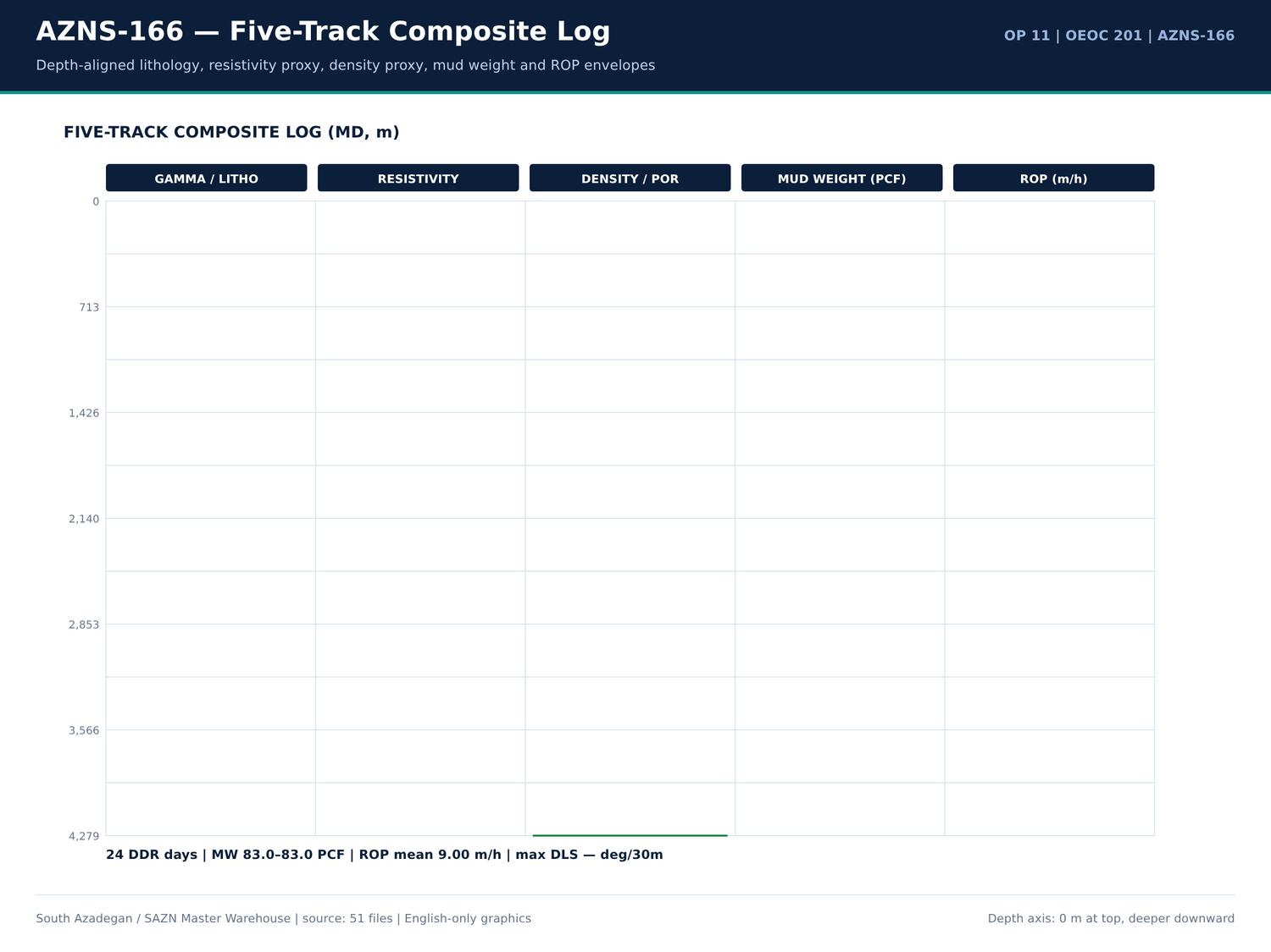
AZNS-166 05 composite log — source: SAZN master warehouse
BHA / toolstring priced lines
Sheet | Description | Unit | Qty | Total (USD)
AZNS-166 WO | RIH with 8 1⁄2" bit and clean out BHA (P/U DP's JT by JT) to 7" L.LAP (1608.2m), CBU, POOH. | — | — | —
AZNS-166 WO | RIH with 5-7/8 Mill and clean out BHA to 4-1/2" Slotted Liner Lap @ 4132.8 m, CBU,POOH to Surface. | — | — | —
AZNS-166 WO | RIH with 3-1/2" Mill and clean out BHA to BTM, take care inside Slotted interval (4008m – 4068m) CBU shakers clean, POOH. Note:for Corrosion Logging Inside 7" Liner follow contingency plan#8 | — | — | —
AZNS-166 WO | M/U Tandem scraper BHA, RIH with tandem scrapers including 9-5/8" casing scraper & 7" liner scraper to 4130m. Scrap 9-5/8” casing and 7” liner and L/D same. | — | — | —

BHA-related DDR remarks
Report | Sheet | Category | Text
No source rows for this query | — | — | —

Numeric-cell provenance excerpt — chapter 09
Document | Sheet | Cell | Value
CBS/11.AZNS_166_CBS.xlsx | Total Cost-EPD & Rigless | R5C3 | 9,087,998.52
CBS/11.AZNS_166_CBS.xlsx | Total Cost-EPD | R19C7 | 8,275,165.08
CBS/11.AZNS_166_CBS.xlsx | Total Cost-EPD & Rigless | R3C3 | 8,275,165.08
CBS/11.AZNS_166_CBS.xlsx | Total Cost-EPD | R3C6 | 2,118,462.01
CBS/11.AZNS_166_CBS.xlsx | Total Cost-EPD | R3C7 | 2,118,462.01
CBS/11.AZNS_166_CBS.xlsx | Cost Breakdown-166 | R197C6 | 2,118,462.01
CBS/11.AZNS_166_CBS.xlsx | Total Cost-EPD | R7C6 | 1,214,816.28
CBS/11.AZNS_166_CBS.xlsx | Total Cost-EPD | R7C7 | 1,214,816.28
CBS/11.AZNS_166_CBS.xlsx | Cost Breakdown-166 Contingecy | R183C16 | 1,214,816.28
CBS/11.AZNS_166_CBS.xlsx | Total Cost-EPD | R12C6 | 1,173,960.00
CBS/11.AZNS_166_CBS.xlsx | Total Cost-EPD | R12C7 | 1,173,960.00
CBS/11.AZNS_166_CBS.xlsx | Cost Breakdown-Material-166 | R249C6 | 1,173,960.00
CBS/11.AZNS_166_CBS.xlsx | Total Cost-EPD | R13C6 | 1,092,550.00
CBS/11.AZNS_166_CBS.xlsx | Cost Breakdown-166 | R5C6 | 1,017,455.31

Chapter 10 — Stick-Slip, Bit Balling & Whirl
Vibration, bit balling and whirl indicators were searched across DDR remarks, activity descriptions and notes. The tables list every matching source row with its report number and text; where no matching text exists the chapter states the absence explicitly. No vibration index is invented from a silent source.
Vibration / balling / whirl keyword rows
Report | Sheet | Category | Text
No source rows for this query | — | — | —

Activity rows with vibration wording
Report | Phase | Hours | Description
No source rows for this query | — | — | —

Parameter windows supporting dynamics
Parameter | Count | Min | Mean | Max
Torque / RPM / WOB rows retained in well profile | 461 | — | — | —

Numeric-cell provenance excerpt — chapter 10
Document | Sheet | Cell | Value
CBS/11.AZNS_166_CBS.xlsx | Total Cost-EPD & Rigless | R5C3 | 9,087,998.52
CBS/11.AZNS_166_CBS.xlsx | Total Cost-EPD | R19C7 | 8,275,165.08
CBS/11.AZNS_166_CBS.xlsx | Total Cost-EPD & Rigless | R3C3 | 8,275,165.08
CBS/11.AZNS_166_CBS.xlsx | Total Cost-EPD | R3C6 | 2,118,462.01
CBS/11.AZNS_166_CBS.xlsx | Total Cost-EPD | R3C7 | 2,118,462.01
CBS/11.AZNS_166_CBS.xlsx | Cost Breakdown-166 | R197C6 | 2,118,462.01
CBS/11.AZNS_166_CBS.xlsx | Total Cost-EPD | R7C6 | 1,214,816.28
CBS/11.AZNS_166_CBS.xlsx | Total Cost-EPD | R7C7 | 1,214,816.28
CBS/11.AZNS_166_CBS.xlsx | Cost Breakdown-166 Contingecy | R183C16 | 1,214,816.28
CBS/11.AZNS_166_CBS.xlsx | Total Cost-EPD | R12C6 | 1,173,960.00
CBS/11.AZNS_166_CBS.xlsx | Total Cost-EPD | R12C7 | 1,173,960.00
CBS/11.AZNS_166_CBS.xlsx | Cost Breakdown-Material-166 | R249C6 | 1,173,960.00
CBS/11.AZNS_166_CBS.xlsx | Total Cost-EPD | R13C6 | 1,092,550.00
CBS/11.AZNS_166_CBS.xlsx | Cost Breakdown-166 | R5C6 | 1,017,455.31

Chapter 11 — Rheology, Annular Velocity, ECD & HSI
Mud weight, FIT/LOT equivalents, annular-velocity proxies and hydraulic parameters are tabulated from DDR daily columns, CBS material lines and EOWR fluid chapters. The 83.0–83.0 PCF envelope is the measured band, not a design assumption; volume balance and solids-control rows retain Received / Used / Back-load / Stock as written.
Daily mud / fluid parameters
Report | Date | MW (PCF) | FIT EMW | Hole size | Formation
1 | 2025-Oct-27 | 83 | — | Estimated Final Depth MD (m): | 4-1/2" Non-Slotted LNR
2 | 2025-Oct-28 | 83 | — | Estimated Final Depth MD (m): | 4-1/2" Non-Slotted LNR
3 | 2025-Oct-29 | 83 | — | Estimated Final Depth MD (m): | 4-1/2" Non-Slotted LNR
4 | 2025-Oct-30 | 83 | — | Estimated Final Depth MD (m): | 4-1/2" Non-Slotted LNR
5 | 2025-Oct-31 | 83 | — | Estimated Final Depth MD (m): | 4-1/2" Non-Slotted LNR
6 | 2025-Nov-1 | 83 | — | Estimated Final Depth MD (m): | 4-1/2" Non-Slotted LNR
7 | 2025-Nov-2 | 83 | — | Estimated Final Depth MD (m): | 4-1/2" Non-Slotted LNR
8 | 2025-Nov-3 | 83 | — | Estimated Final Depth MD (m): | 4-1/2" Non-Slotted LNR
9 | 2025-Nov-4 | 83 | — | Estimated Final Depth MD (m): | 4-1/2" Non-Slotted LNR
10 | 2025-Nov-5 | 83 | — | Estimated Final Depth MD (m): | 4-1/2" Non-Slotted LNR
11 | 2025-Nov-6 | 83 | — | Estimated Final Depth MD (m): | 4-1/2" Non-Slotted LNR
12 | 2025-Nov-7 | 83 | — | Estimated Final Depth MD (m): | 4-1/2" Non-Slotted LNR
13 | 2025-Nov-8 | 83 | — | Estimated Final Depth MD (m): | 4-1/2" Non-Slotted LNR
14 | 2025-Nov-9 | 83 | — | Estimated Final Depth MD (m): | 4-1/2" Non-Slotted LNR
15 | 2025-Nov-10 | 83 | — | Estimated Final Depth MD (m): | 4-1/2" Non-Slotted LNR
16 | 2025-Nov-11 | 83 | — | Estimated Final Depth MD (m): | 4-1/2" Non-Slotted LNR
17 | 2025-Nov-12 | 83 | — | Estimated Final Depth MD (m): | 4-1/2" Non-Slotted LNR
18 | 2025-Nov-13 | 83 | — | Estimated Final Depth MD (m): | 4-1/2" Non-Slotted LNR
19 | 2025-Nov-14 | 83 | — | Estimated Final Depth MD (m): | 4-1/2" Non-Slotted LNR
20 | 2025-Nov-15 | 83 | — | Estimated Final Depth MD (m): | 4-1/2" Non-Slotted LNR
21 | 2025-Nov-16 | 83 | — | Estimated Final Depth MD (m): | 4-1/2" Non-Slotted LNR
22 | 2025-Nov-17 | 83 | — | Estimated Final Depth MD (m): | 4-1/2" Non-Slotted LNR

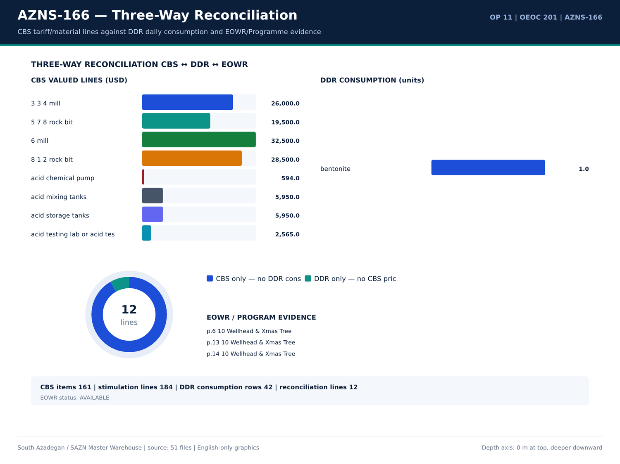
AZNS-166 06 reconciliation — source: SAZN master warehouse
Mud / cement / chemical consumption
Report | Material | Unit | Received | Used | Stock | Cell
1 | Bentonite | — | — | — | 1 | N8
1 | Barite | — | — | — | 1.5 | N9
1 | Limestone | — | 44 | — | 1 | N10
1 | Salt | — | 41 | — | 1 | N11
1 | Lime | — | — | — | 25 | N12
1 | Starch LV | — | 62 | — | 25 | N13
1 | Caustic Soda | — | 6 | — | 25 | N14
1 | Soda Ash | — | 6 | — | 25 | N15
1 | Xanthan Gum | — | — | — | 25 | N16
1 | Wall.Nut Plug (C) | — | — | — | 1 | N17
1 | Wall.Nut Plug (M) | — | — | — | 1 | N18
1 | Wall.Nut Plug (F) | — | — | — | 1 | N19
1 | Oyster Shell (C) | — | — | — | 25 | N20
1 | Oyster Shell (M) | — | — | — | 25 | N21
1 | Oyster Shell (F) | — | — | — | 25 | N22
1 | Limestone chips(M) | — | — | — | 25 | N23
1 | Limestone chips(C) | — | — | — | 1 | N24
1 | Limestone chips(F) | — | — | — | 25 | N25
1 | Mica (F) | — | — | — | 25 | N26
1 | Mica (M) | — | — | — | 25 | N27
1 | Mica (C) | — | — | — | 25 | N28
1 | Sodium Bicarbonate | — | — | — | 25 | N29

EOWR / Programme fluid facts
Fact key | Value | Unit | Page | Document
MUD_WEIGHT | 124 | pcf | 11 | 04.EOWR/11.AZNS_166_EOWR.pdf
MUD_WEIGHT | 112 | PCF | 11 | 04.EOWR/11.AZNS_166_EOWR.pdf
MUD_WEIGHT | 130 | PCF | 11 | 04.EOWR/11.AZNS_166_EOWR.pdf
MUD_WEIGHT | 82 | PCF | 11 | 04.EOWR/11.AZNS_166_EOWR.pdf
MUD_WEIGHT | 71 | pcf | 15 | 04.EOWR/11.AZNS_166_EOWR.pdf
MUD_WEIGHT | 83 | pcf | 16 | 04.EOWR/11.AZNS_166_EOWR.pdf
MUD_WEIGHT | 124 | pcf | 16 | Well Program/11.AZNS_166_Workover-1_Program.pdf
MUD_WEIGHT | 112 | PCF | 16 | Well Program/11.AZNS_166_Workover-1_Program.pdf
MUD_WEIGHT | 130 | PCF | 16 | Well Program/11.AZNS_166_Workover-1_Program.pdf
MUD_WEIGHT | 82 | PCF | 16 | Well Program/11.AZNS_166_Workover-1_Program.pdf
MUD_WEIGHT | 78 | PCF | 17 | 04.EOWR/11.AZNS_166_EOWR.pdf
MUD_WEIGHT | 83 | pcf | 18 | 04.EOWR/11.AZNS_166_EOWR.pdf
MUD_WEIGHT | 75 | pcf | 52 | Well Program/11.AZNS_166_Workover-1_Program.pdf
MUD_WEIGHT | 83 | PCF | 85 | 04.EOWR/11.AZNS_166_EOWR.pdf
MUD_WEIGHT | 83 | pcf | 136 | 04.EOWR/11.AZNS_166_EOWR.pdf

Numeric-cell provenance excerpt — chapter 11
Document | Sheet | Cell | Value
CBS/11.AZNS_166_CBS.xlsx | Total Cost-EPD & Rigless | R5C3 | 9,087,998.52
CBS/11.AZNS_166_CBS.xlsx | Total Cost-EPD | R19C7 | 8,275,165.08
CBS/11.AZNS_166_CBS.xlsx | Total Cost-EPD & Rigless | R3C3 | 8,275,165.08
CBS/11.AZNS_166_CBS.xlsx | Total Cost-EPD | R3C6 | 2,118,462.01
CBS/11.AZNS_166_CBS.xlsx | Total Cost-EPD | R3C7 | 2,118,462.01
CBS/11.AZNS_166_CBS.xlsx | Cost Breakdown-166 | R197C6 | 2,118,462.01
CBS/11.AZNS_166_CBS.xlsx | Total Cost-EPD | R7C6 | 1,214,816.28
CBS/11.AZNS_166_CBS.xlsx | Total Cost-EPD | R7C7 | 1,214,816.28
CBS/11.AZNS_166_CBS.xlsx | Cost Breakdown-166 Contingecy | R183C16 | 1,214,816.28
CBS/11.AZNS_166_CBS.xlsx | Total Cost-EPD | R12C6 | 1,173,960.00
CBS/11.AZNS_166_CBS.xlsx | Total Cost-EPD | R12C7 | 1,173,960.00
CBS/11.AZNS_166_CBS.xlsx | Cost Breakdown-Material-166 | R249C6 | 1,173,960.00
CBS/11.AZNS_166_CBS.xlsx | Total Cost-EPD | R13C6 | 1,092,550.00
CBS/11.AZNS_166_CBS.xlsx | Cost Breakdown-166 | R5C6 | 1,017,455.31

Chapter 12 — Tripping, Hookload & Swab-Surge
Tripping, reaming, PU/SO/ROT hookload and swab-surge related activities are isolated by code and keyword from 461 activity rows. Hours, phase and description are reproduced; hookload statistics come from labelled DDR parameter rows only. Any absent parameter is shown as '—'.
Tripping / reaming activity hours
Report | Phase | Code | Hours | Description
1 | — | — | — | Conn. Lubricator to Slick line BOP; Press. Test Slick Line BOP & Lubricator W/ 4000psi / 15min, Ok; RIH W/ 2.75" Ring Gauge Tool Strg To
1 | — | — | — | not received from the client), Confirm Protection Sleeve is in TR3SV; POOH Slick Line Tool Strg To Surface, Flush Solid Block,
1 | — | — | — | L/D 2.75" Ring Gauge Tool String; P/U & Assemble 2.2" Ring Gauge Tool Strg and RIH To 3056m (No-Go Depth: 2770m),
1 | — | — | — | Obs. Slick Line Tension Drop due to Well Deviation, Decide To POOH Slick line Tool String To Surface; Flush Solid Block;
2 | — | — | — | Conn. Lubricator to Slick line BOP; Press. Test Slick Line BOP & Lubricator W/ 4000psi / 15min, Ok; RIH W/ 2.75" Ring Gauge Tool Strg To
2 | — | — | — | not received from the client), Confirm Protection Sleeve is in TR3SV; POOH Slick Line Tool Strg To Surface, Flush Solid Block,
2 | — | — | — | L/D 2.75" Ring Gauge Tool String; P/U & Assemble 2.2" Ring Gauge Tool Strg and RIH To 3056m (No-Go Depth: 2770m),
2 | — | — | — | Obs. Slick Line Tension Drop due to Well Deviation, Decide To POOH Slick line Tool String To Surface; Flush Solid Block;
2 | — | — | — | Cont. RIH W/ 1-3/4" C.T BHA, While Circ. Thru. Choke Manifold @ 0.2BPH F.R & 1100psi Back Pressure, and Take Return in Storage Tank.
3 | REE | 23 | 7 | POOH 1-3/4" C.T BHA To Surface, While Circ. Thru. C.T BHA, NL-NG; Flush C.T; Static Flow Check & Obs. The Well for 1 Hr. , Well Static;
6 | — | — | — | POOH & L/D 4-1/2" TBG HGR ( 18.9PPF, TPCQ-EX Box * Box ) + 4-1/2" Double pin ( 18.9PPF, TPCQ-EX P*P ) + 1 Jts X.O.S TPG2 + 4-1/2" Cross
6 | REE | 23 | 6 | Cont. POOH with 2 Jts 4-1/2" TBG ( 18.9PPF, TPG2 BOX * PIN ), OBS 15-30klb over pull @ 2759-2758.3m
6 | — | — | — | Try to Cont POOH with max 30Klb over pull step by step and several times, No Succ. Perform Circ Mud Thru String, No Return Mud and
6 | — | — | — | Hold Pressure in String, try again Cont POOH with max 60klb over pull step by step and several times, No Succ & Perform Circ.
6 | — | — | — | Mud Thru String, No Return Mud and Hold Pressure in String, try again Cont POOH with max 100klb over pull step by step and
6 | — | — | — | Cont. POOH W/Normal Drag to 2750m While f/u well continuously, NL-NG.
7 | REE | 23 | 23 | As Client Request ( P.P.L ), Cont. POOH with 2 Jts 4-1/2" TBG ( 18.9PPF, TPG2 BOX * PIN ), OBS 15-30klb over pull @ 2759-2758.3m
7 | — | — | — | Try to Cont. POOH with max 30Klb over pull step by step and several times, No Succ. Perform Circ Mud Thru String, No Return Mud and
7 | — | — | — | Hold Pressure in String, try again Cont POOH with max 60klb over pull step by step and several times, No Succ & Perform Circ.
7 | — | — | — | Mud Thru String, No Return Mud and Hold Pressure in String, try again Cont POOH with max 100klb over pull step by step and
7 | — | — | — | Cont. POOH & L/D with Normal Drag to 1530m While f/u well continuously, NL-NG.
7 | REE | 20 | 1 | Meanwhile POOH, 1 Hrs waiting for Rig 201 OEOC Due to shortage has been identified within the Drilling Fluid crew.

Hookload / PU-SO-ROT notes
Report | Sheet | Category | Text
No source rows for this query | — | — | —

Time codes for tripping / reaming
Code | Category | Hours | Report
6 | Trips | 24 | 13
6 | Trips | 24 | 14
6 | Trips | 23 | 17
6 | Trips | 22 | 15
6 | Trips | 21.5 | 11
6 | Trips | 21.5 | 12
6 | Trips | 21 | 10
6 | Trips | 18.5 | 18
6 | Trips | 15.5 | 16
3 | Reaming | — | 1
6 | Trips | — | 1
3 | Reaming | — | 2
6 | Trips | — | 2
3 | Reaming | — | 3
6 | Trips | — | 3
3 | Reaming | — | 4
6 | Trips | — | 4
3 | Reaming | — | 5
6 | Trips | — | 5
3 | Reaming | — | 6
6 | Trips | — | 6
3 | Reaming | — | 7

Numeric-cell provenance excerpt — chapter 12
Document | Sheet | Cell | Value
CBS/11.AZNS_166_CBS.xlsx | Total Cost-EPD & Rigless | R5C3 | 9,087,998.52
CBS/11.AZNS_166_CBS.xlsx | Total Cost-EPD | R19C7 | 8,275,165.08
CBS/11.AZNS_166_CBS.xlsx | Total Cost-EPD & Rigless | R3C3 | 8,275,165.08
CBS/11.AZNS_166_CBS.xlsx | Total Cost-EPD | R3C6 | 2,118,462.01
CBS/11.AZNS_166_CBS.xlsx | Total Cost-EPD | R3C7 | 2,118,462.01
CBS/11.AZNS_166_CBS.xlsx | Cost Breakdown-166 | R197C6 | 2,118,462.01
CBS/11.AZNS_166_CBS.xlsx | Total Cost-EPD | R7C6 | 1,214,816.28
CBS/11.AZNS_166_CBS.xlsx | Total Cost-EPD | R7C7 | 1,214,816.28
CBS/11.AZNS_166_CBS.xlsx | Cost Breakdown-166 Contingecy | R183C16 | 1,214,816.28
CBS/11.AZNS_166_CBS.xlsx | Total Cost-EPD | R12C6 | 1,173,960.00
CBS/11.AZNS_166_CBS.xlsx | Total Cost-EPD | R12C7 | 1,173,960.00
CBS/11.AZNS_166_CBS.xlsx | Cost Breakdown-Material-166 | R249C6 | 1,173,960.00
CBS/11.AZNS_166_CBS.xlsx | Total Cost-EPD | R13C6 | 1,092,550.00
CBS/11.AZNS_166_CBS.xlsx | Cost Breakdown-166 | R5C6 | 1,017,455.31

Chapter 13 — Connection Time & Invisible Lost Time
Connection, survey, circulating and waiting codes are separated from productive drilling time. The tables give code, category, hours and report number so that invisible lost time can be recomputed; the sum is never forced to 24 h where the source DDR itself is incomplete.
Connection / circulating / waiting codes
Code | Category | Hours | Report
5 | Circulate & Condition | — | 1
10 | Deviation Survey | — | 1
14 | Wait on Cement | — | 1
20 | Operation Status (Waiting) | — | 1
5 | Circulate & Condition | — | 2
10 | Deviation Survey | — | 2
14 | Wait on Cement | — | 2
20 | Operation Status (Waiting) | — | 2
5 | Circulate & Condition | — | 3
10 | Deviation Survey | — | 3
14 | Wait on Cement | — | 3
20 | Operation Status (Waiting) | — | 3
5 | Circulate & Condition | — | 4
10 | Deviation Survey | — | 4
14 | Wait on Cement | — | 4
20 | Operation Status (Waiting) | — | 4
5 | Circulate & Condition | — | 5
10 | Deviation Survey | — | 5
14 | Wait on Cement | — | 5
20 | Operation Status (Waiting) | 24 | 5
5 | Circulate & Condition | — | 6
10 | Deviation Survey | — | 6

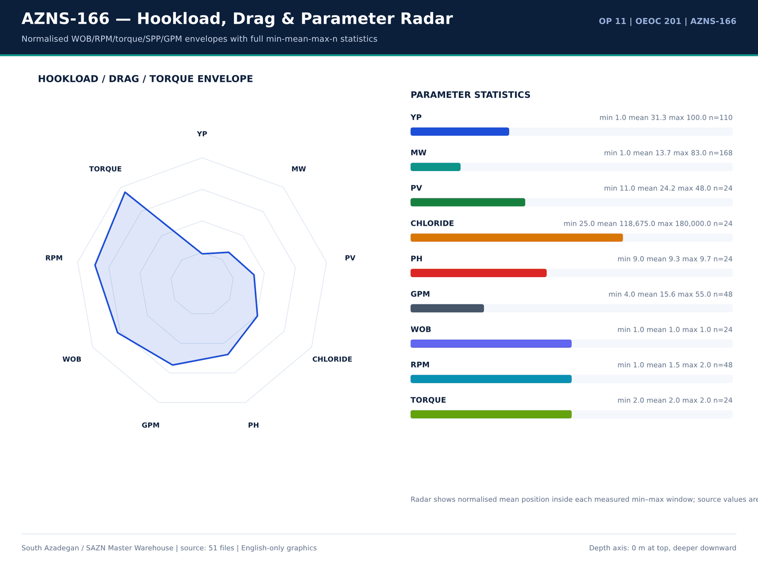
AZNS-166 07 hookload — source: SAZN master warehouse
Activity rows carrying connection wording
Report | Phase | Hours | Description
2 | — | — | P/U C.T Injector Head & M/U on C.T BOP, Press. Test C.T Riser, BOP Rams, and Injector Head Connections Thru. C.T BHA W/ 4000psi – OK;
4 | REE | 6 | Wait on OEOC to Cont. Test 13-5/8" 10k BOP Stack While Work on fixing BOP leakages as Below:
4 | — | — | Work on leakages between BTM Rams & Spacer Spool Connection @ several times No. Succ Till R.T.
5 | REE | 23 | Wait on OEOC to Cont. Test 13-5/8" 10k BOP Stack While Work on fixing BOP leakages as Below:
5 | — | — | Work on leakages between BTM Rams & Spacer Spool Connection after several times and Test W/ 4500Psi, OK.
5 | REE | 1 | 1 HRS Waiting for Mud Logging Unit ( Pars Geo Data ) Due to Failure weight indicator Sensor.
7 | REE | 1 | Meanwhile POOH, 1 Hrs waiting for Rig 201 OEOC Due to shortage has been identified within the Drilling Fluid crew.
9 | REE | 7 | Cont RIH While Waiting Noted for OEOC Rig 201.
9 | — | — | Waiting Causes / Notes: Air Tongs Malfunction. Rig Tongs Without Proper Latch. Insufficient Drawworks Air Supply.
10 | REE | 2 | Waiting For Rig 201 OEOC Due to Delay in operation.
10 | REE | 1 | Waiting For Rig 201 OEOC Due to Delay in operation.
13 | — | — | Circulate each 15 STD, NL.NG.
13 | REE | 6 | Cont. Run in hole by 5" D.Pipe from 2800m to 3530m while break Circulate each 15 STD, NL.NG. Till R.T. Internet Installation – MSA Completion Test Tools Completion String
14 | REE | 20 | Cont. Run in hole by 5" D.Pipe from 2800m to 3100m while F/U string & break Circulate each 15 STD, NL.NG.
18 | — | — | w/ 2 Jt 3-1/2" TBG To 72m; Run 2.8" Gauge Ring to SSD Depth, Ok; While Clean & Wash all Connections; Use Thread Seal
19 | — | — | w/ 2 Jt 3-1/2" TBG To 72m; Run 2.8" Gauge Ring to SSD Depth, Ok; While Clean & Wash all Connections; Use Thread Seal
19 | REE | 9 | Cont. RIH W/ 3-1/2" * 4-1/2" 7.5k Comp. Strg F/ 72 To 676m, While Clean & Wash all Connections; Use Thread Seal Compound, and
19 | — | — | While Clean & Wash all Connections; Use Thread Seal Compound, and JAM System, and Circ. C.W.H by Trip Tank & Monitor
19 | REE | 0.5 | Cont. RIH W/ 3-1/2" * 4-1/2" 7.5k Comp. Strg F/ 676 To 695m, While Clean & Wash all Connections; Use Thread Seal Compound, and
20 | — | — | While Clean & Wash all Connections; Use Thread Seal Compound, and JAM System, and Circ. C.W.H by Trip Tank & Monitor
20 | REE | 9 | Cont. RIH W/ 3-1/2" * 4-1/2" 7.5k Comp. Strg F/ 676 To 1223m, While Clean & Wash all Connections; Use Thread Seal Compound, and
20 | REE | 5.5 | Cont. RIH W/ 3-1/2" * 4-1/2" 7.5k Comp. Strg F/ 1223 To 1671m, While Pass 7" LNR gently, Clean & Wash all Connections;

PT / NPT daily hour balance
Report | Date | NPT (h) | PT (h) | Cum. cost (USD)
1 | 2025-Oct-27 | 12 | 18 | 23,000.00
2 | 2025-Oct-28 | 0 | 30 | 46,000.00
3 | 2025-Oct-29 | 0 | 30 | 69,000.00
4 | 2025-Oct-30 | 6 | 24 | 92,000.00
5 | 2025-Oct-31 | 29 | 1 | 115,000.00
6 | 2025-Nov-1 | 14 | 16 | 138,000.00
7 | 2025-Nov-2 | 1 | 29 | 161,000.00
8 | 2025-Nov-3 | 0 | 30 | 184,000.00
9 | 2025-Nov-4 | 7 | 23 | 207,000.00
10 | 2025-Nov-5 | 3 | 27 | 230,000.00
11 | 2025-Nov-6 | 2 | 28 | 253,000.00
12 | 2025-Nov-7 | 0 | 30 | 276,000.00
13 | 2025-Nov-8 | 0 | 30 | 299,000.00
14 | 2025-Nov-9 | 0 | 30 | 322,000.00
15 | 2025-Nov-10 | 0 | 30 | 345,000.00
16 | 2025-Nov-11 | 0 | 30 | 368,000.00
17 | 2025-Nov-12 | 0 | 30 | 391,000.00
18 | 2025-Nov-13 | 0 | 30 | 414,000.00
19 | 2025-Nov-14 | 15.5 | 14.5 | 437,000.00
20 | 2025-Nov-15 | 7 | 23 | 460,000.00
21 | 2025-Nov-16 | 3.5 | 26.5 | 483,000.00
22 | 2025-Nov-17 | 0 | 30 | 506,000.00

Numeric-cell provenance excerpt — chapter 13
Document | Sheet | Cell | Value
CBS/11.AZNS_166_CBS.xlsx | Total Cost-EPD & Rigless | R5C3 | 9,087,998.52
CBS/11.AZNS_166_CBS.xlsx | Total Cost-EPD | R19C7 | 8,275,165.08
CBS/11.AZNS_166_CBS.xlsx | Total Cost-EPD & Rigless | R3C3 | 8,275,165.08
CBS/11.AZNS_166_CBS.xlsx | Total Cost-EPD | R3C6 | 2,118,462.01
CBS/11.AZNS_166_CBS.xlsx | Total Cost-EPD | R3C7 | 2,118,462.01
CBS/11.AZNS_166_CBS.xlsx | Cost Breakdown-166 | R197C6 | 2,118,462.01
CBS/11.AZNS_166_CBS.xlsx | Total Cost-EPD | R7C6 | 1,214,816.28
CBS/11.AZNS_166_CBS.xlsx | Total Cost-EPD | R7C7 | 1,214,816.28
CBS/11.AZNS_166_CBS.xlsx | Cost Breakdown-166 Contingecy | R183C16 | 1,214,816.28
CBS/11.AZNS_166_CBS.xlsx | Total Cost-EPD | R12C6 | 1,173,960.00
CBS/11.AZNS_166_CBS.xlsx | Total Cost-EPD | R12C7 | 1,173,960.00
CBS/11.AZNS_166_CBS.xlsx | Cost Breakdown-Material-166 | R249C6 | 1,173,960.00
CBS/11.AZNS_166_CBS.xlsx | Total Cost-EPD | R13C6 | 1,092,550.00
CBS/11.AZNS_166_CBS.xlsx | Cost Breakdown-166 | R5C6 | 1,017,455.31

Chapter 14 — Directional Survey, DLS & Tortuosity
Survey stations, inclination, azimuth, TVD and minimum-curvature DLS are reproduced per station. Maximum DLS is — deg/30m. Directional parameter windows (WOB, RPM, torque, SPP, GPM) come from labelled DDR rows and are listed with count, min, mean and max.
Directional survey stations
Report | MD (m) | Incl (deg) | Azi (deg) | TVD (m) | DLS (deg/30m) | Tool
No source rows for this query | — | — | — | — | — | —

Directional remarks
Report | Sheet | Category | Text
No source rows for this query | — | — | —

Daily KOP / directional header values
Report | Date | KOP1 | KOP2 | Hole size | Formation
1 | 2025-Oct-27 | — | — | Estimated Final Depth MD (m): | 4-1/2" Non-Slotted LNR
2 | 2025-Oct-28 | — | — | Estimated Final Depth MD (m): | 4-1/2" Non-Slotted LNR
3 | 2025-Oct-29 | — | — | Estimated Final Depth MD (m): | 4-1/2" Non-Slotted LNR
4 | 2025-Oct-30 | — | — | Estimated Final Depth MD (m): | 4-1/2" Non-Slotted LNR
5 | 2025-Oct-31 | — | — | Estimated Final Depth MD (m): | 4-1/2" Non-Slotted LNR
6 | 2025-Nov-1 | — | — | Estimated Final Depth MD (m): | 4-1/2" Non-Slotted LNR
7 | 2025-Nov-2 | — | — | Estimated Final Depth MD (m): | 4-1/2" Non-Slotted LNR
8 | 2025-Nov-3 | — | — | Estimated Final Depth MD (m): | 4-1/2" Non-Slotted LNR
9 | 2025-Nov-4 | — | — | Estimated Final Depth MD (m): | 4-1/2" Non-Slotted LNR
10 | 2025-Nov-5 | — | — | Estimated Final Depth MD (m): | 4-1/2" Non-Slotted LNR
11 | 2025-Nov-6 | — | — | Estimated Final Depth MD (m): | 4-1/2" Non-Slotted LNR
12 | 2025-Nov-7 | — | — | Estimated Final Depth MD (m): | 4-1/2" Non-Slotted LNR
13 | 2025-Nov-8 | — | — | Estimated Final Depth MD (m): | 4-1/2" Non-Slotted LNR
14 | 2025-Nov-9 | — | — | Estimated Final Depth MD (m): | 4-1/2" Non-Slotted LNR
15 | 2025-Nov-10 | — | — | Estimated Final Depth MD (m): | 4-1/2" Non-Slotted LNR
16 | 2025-Nov-11 | — | — | Estimated Final Depth MD (m): | 4-1/2" Non-Slotted LNR
17 | 2025-Nov-12 | — | — | Estimated Final Depth MD (m): | 4-1/2" Non-Slotted LNR
18 | 2025-Nov-13 | — | — | Estimated Final Depth MD (m): | 4-1/2" Non-Slotted LNR
19 | 2025-Nov-14 | — | — | Estimated Final Depth MD (m): | 4-1/2" Non-Slotted LNR
20 | 2025-Nov-15 | — | — | Estimated Final Depth MD (m): | 4-1/2" Non-Slotted LNR
21 | 2025-Nov-16 | — | — | Estimated Final Depth MD (m): | 4-1/2" Non-Slotted LNR
22 | 2025-Nov-17 | — | — | Estimated Final Depth MD (m): | 4-1/2" Non-Slotted LNR

Numeric-cell provenance excerpt — chapter 14
Document | Sheet | Cell | Value
CBS/11.AZNS_166_CBS.xlsx | Total Cost-EPD & Rigless | R5C3 | 9,087,998.52
CBS/11.AZNS_166_CBS.xlsx | Total Cost-EPD | R19C7 | 8,275,165.08
CBS/11.AZNS_166_CBS.xlsx | Total Cost-EPD & Rigless | R3C3 | 8,275,165.08
CBS/11.AZNS_166_CBS.xlsx | Total Cost-EPD | R3C6 | 2,118,462.01
CBS/11.AZNS_166_CBS.xlsx | Total Cost-EPD | R3C7 | 2,118,462.01
CBS/11.AZNS_166_CBS.xlsx | Cost Breakdown-166 | R197C6 | 2,118,462.01
CBS/11.AZNS_166_CBS.xlsx | Total Cost-EPD | R7C6 | 1,214,816.28
CBS/11.AZNS_166_CBS.xlsx | Total Cost-EPD | R7C7 | 1,214,816.28
CBS/11.AZNS_166_CBS.xlsx | Cost Breakdown-166 Contingecy | R183C16 | 1,214,816.28
CBS/11.AZNS_166_CBS.xlsx | Total Cost-EPD | R12C6 | 1,173,960.00
CBS/11.AZNS_166_CBS.xlsx | Total Cost-EPD | R12C7 | 1,173,960.00
CBS/11.AZNS_166_CBS.xlsx | Cost Breakdown-Material-166 | R249C6 | 1,173,960.00
CBS/11.AZNS_166_CBS.xlsx | Total Cost-EPD | R13C6 | 1,092,550.00
CBS/11.AZNS_166_CBS.xlsx | Cost Breakdown-166 | R5C6 | 1,017,455.31

Chapter 15 — Well Control, Losses, LCM, Dry Test & MAASP
Losses, LCM pills, dry tests, bond tests, FIT/LOT and MAASP-related facts are extracted from DDR remarks and the EOWR / Programme text layer. 3 problem families include the loss-control evidence; each numeric fact carries its page number. Where a pressure-test value was not printed in the text layer it is not estimated.
Loss / LCM / well-control remarks
Report | Sheet | Category | Text
No source rows for this query | — | — | —

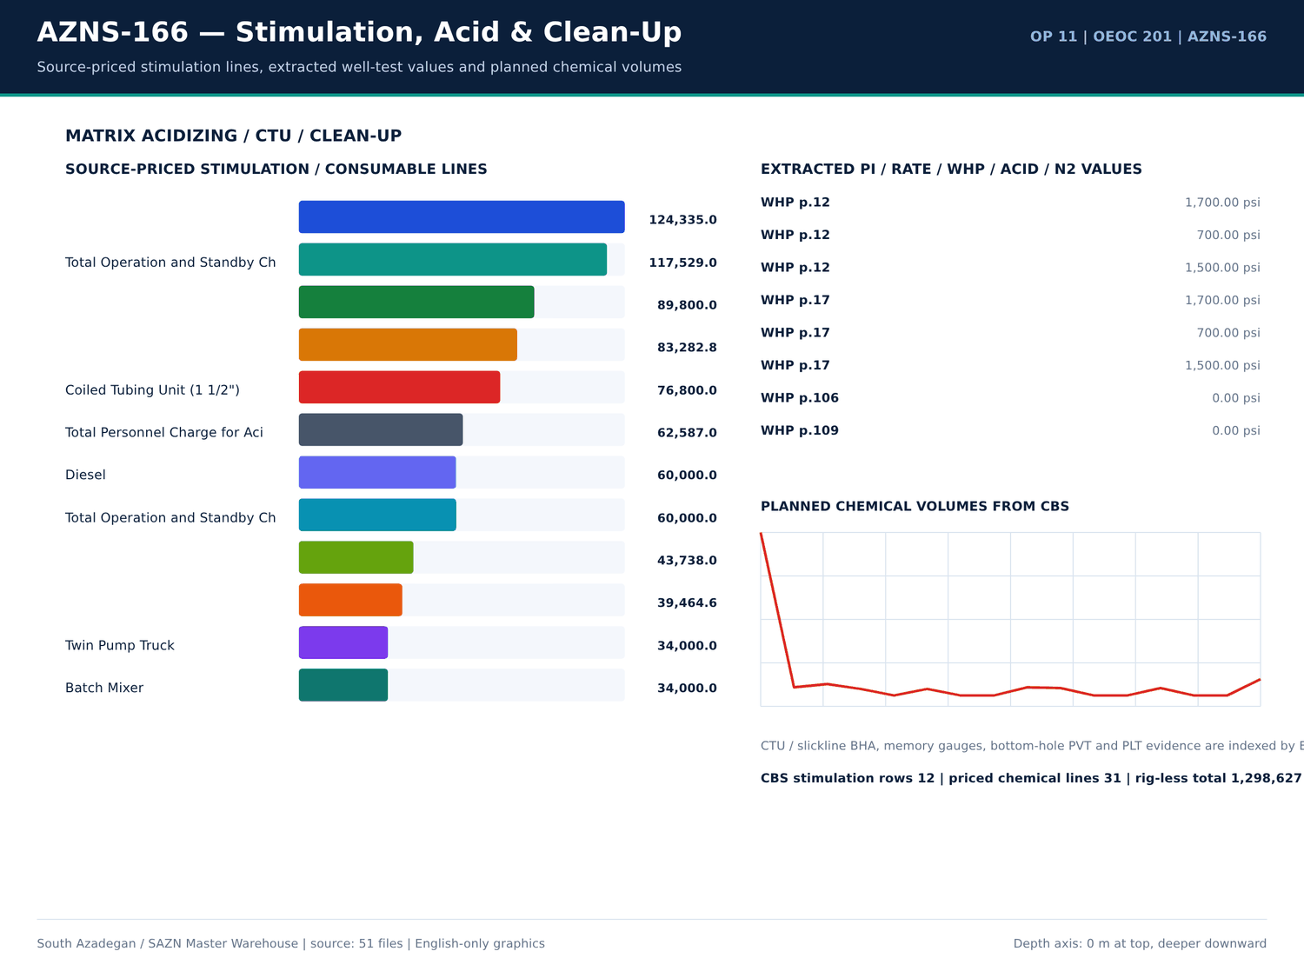
AZNS-166 08 acid — source: SAZN master warehouse
Pressure / FIT / LOT / loss facts
Fact key | Value | Unit | Page | Document | Context
WHP | 1,700.00 | psi | 12 | 04.EOWR/11.AZNS_166_EOWR.pdf | of 3SV flapper observed on neck of plug. SIWHP = 1700psi, flow the well (FWHP = 700psi), close 3SV fl
WHP | 700 | psi | 12 | 04.EOWR/11.AZNS_166_EOWR.pdf | k of plug. SIWHP = 1700psi, flow the well (FWHP = 700psi), close 3SV flowing continued, RIH SL with L
WHP | 1,500.00 | psi | 12 | 04.EOWR/11.AZNS_166_EOWR.pdf | dropped & remained constant. (600 – 800psi) WHP = 1500psi, RIH SL with special protection sleeve (prof
PRESSURE_TEST | 4,500.00 | psi | 16 | Well Program/11.AZNS_166_Workover-1_Program.pdf | lling & Plug to 2770.1m Set Prong in NO-GO. Pressure test Comp. String W/4500psi for 15MIN, Ok. Close 3SV, laydown41/2''L. J
WHP | 1,700.00 | psi | 17 | Well Program/11.AZNS_166_Workover-1_Program.pdf | 3SV flapper observed on neck of plug. • SIWHP = 1700psi, flow the well (FWHP = 700psi), close 3SV fl
WHP | 700 | psi | 17 | Well Program/11.AZNS_166_Workover-1_Program.pdf | plug. • SIWHP = 1700psi, flow the well (FWHP = 700psi), close 3SV flowing continued, RIH SL with
WHP | 1,500.00 | psi | 17 | Well Program/11.AZNS_166_Workover-1_Program.pdf | pped & remained constant. (600 – 800psi) • WHP = 1500psi, RIH SL with special protection sleeve (prof
PRESSURE_TEST | 4,500.00 | psi | 43 | Well Program/11.AZNS_166_Workover-1_Program.pdf | lling & Plug to 2770.1m Set Prong in NO-GO. Pressure test Comp. String W/4500psi for 15MIN, Ok. Close 3SV, laydown 41/2''L.
PRESSURE_TEST | 6,000.00 | psi | 58 | 04.EOWR/11.AZNS_166_EOWR.pdf | Tubing String With check valve Inside. √ Pressure Test Tubing String 6000psi/15min Every 100 JTs. √ RIH Completion Stri
PRESSURE_TEST | 6,000.00 | psi | 58 | 04.EOWR/11.AZNS_166_EOWR.pdf | RSSSV √ Install control line to TRSSSV and pressure test control line 6000psi x 15mins. And then keep 3000psi pressure wh
PRESSURE_TEST | 4,500.00 | psi | 59 | 04.EOWR/11.AZNS_166_EOWR.pdf | bonnet. √ Check hanger for any damage and pressure test control line to 4500psi √ Pressure test chemical injection line &
PRESSURE_TEST | 6,000.00 | Psi | 78 | 04.EOWR/11.AZNS_166_EOWR.pdf | all) Item Test Check Mark and Result 1 Pressure test for the kill Valve W/ 1000 & 6000 Psi / 15 min OK 2 Pressure test for the SSV
PRESSURE_TEST | 6,000.00 | Psi | 78 | 04.EOWR/11.AZNS_166_EOWR.pdf | Valve W/ 1000 & 6000 Psi / 15 min OK 2 Pressure test for the SSV W/ 1000 & 6000 Psi / 15 min OK 3 Pressure test for the top
PRESSURE_TEST | 6,000.00 | Psi | 78 | 04.EOWR/11.AZNS_166_EOWR.pdf | valve W/ 1000 & 6000 Psi / 15 min OK 4 Pressure test for Swab valve W/ 1000 & 6000 Psi / 15 min OK 5 Pressure test for the Prod
PRESSURE_TEST | 6,000.00 | Psi | 79 | 04.EOWR/11.AZNS_166_EOWR.pdf | section W/1000 &6000 psi for 15min OK 2 Pressure test for the SSV Exit block W/ 6000 Psi / 15 min OK 3 Pressure test neck of tubi
PRESSURE_TEST | 6,000.00 | Psi | 79 | 04.EOWR/11.AZNS_166_EOWR.pdf | al seal W/1000 &6000 psi for 15min OK 4 Pressure test for Swab valve W/ 6000 Psi / 15 min - 5 Pressure test for Productio
PRESSURE_TEST | 6,000.00 | Psi | 79 | 04.EOWR/11.AZNS_166_EOWR.pdf | for Swab valve W/ 6000 Psi / 15 min - 5 Pressure test for Production valve W/6000 Psi / 15 min - 6 Pressure test cavity of FS.
WHP | 0 | psi | 106 | 04.EOWR/11.AZNS_166_EOWR.pdf | ng pressure recorded at 32/64 choke setting, wellhead pressure at 0psi and no observable returns at surface. In o
WHP | 0 | psi | 109 | 04.EOWR/11.AZNS_166_EOWR.pdf | st on coiled tubing equipment C/S: 32/64 - WHP: 0 psi - outlet from the well: no return Retrieve
WHP | 0 | psi | 111 | 04.EOWR/11.AZNS_166_EOWR.pdf | uipment (S/L), set P.S at 63.7m, Open TMV, SIWHP: 0psi, RIH S/L to Max accessible TD (2950m) 24 –
WHP | 0 | psi | 111 | 04.EOWR/11.AZNS_166_EOWR.pdf | head pressure monitoring ( C/S: closed - WHP: 0 psi - outlet from the well: no return) 26 – Jan
WHP | 800 | psi | 111 | 04.EOWR/11.AZNS_166_EOWR.pdf | S, flow the well & monitor well condition, SIWHP: 800psi. 30 – Jan – 2026 flowing the well & monito

Problem families with loss evidence
Category | Hours | Depth (m) | Formation | Cost (USD) | Detail
Other operational delay | 53 | 4,279.00 | 4-1/2" Non-Slotted LNR | 50,791.67 | Cont. R/U, While Set & Install TDS; Spud Rig 201 as per Prespud Check List @ 1404.08.05 - 12:00 | Try to perform Circ Mud Thru String No Succ Due to Observe Failure TDS Kelly Hose . | Try to perform Circ Mud Thru String No Succ Due to Ob…
Rig equipment failure | 29 | 4,279.00 | 4-1/2" Non-Slotted LNR | 27,791.67 | Wait on OEOC to Cont. Test 13-5/8" 10k BOP Stack While Work on fixing BOP leakages as Below: | Wait on OEOC to Cont. Test 13-5/8" 10k BOP Stack While Work on fixing BOP leakages as Below:
Waiting on services / material | 18 | 4,279.00 | 4-1/2" Non-Slotted LNR | 17,250.00 | 1 HRS Waiting for Mud Logging Unit ( Pars Geo Data ) Due to Failure weight indicator Sensor. | Meanwhile POOH, 1 Hrs waiting for Rig 201 OEOC Due to shortage has been identified within the Drilling Fluid crew. | Cont RIH While Waiting No…

Numeric-cell provenance excerpt — chapter 15
Document | Sheet | Cell | Value
CBS/11.AZNS_166_CBS.xlsx | Total Cost-EPD & Rigless | R5C3 | 9,087,998.52
CBS/11.AZNS_166_CBS.xlsx | Total Cost-EPD | R19C7 | 8,275,165.08
CBS/11.AZNS_166_CBS.xlsx | Total Cost-EPD & Rigless | R3C3 | 8,275,165.08
CBS/11.AZNS_166_CBS.xlsx | Total Cost-EPD | R3C6 | 2,118,462.01
CBS/11.AZNS_166_CBS.xlsx | Total Cost-EPD | R3C7 | 2,118,462.01
CBS/11.AZNS_166_CBS.xlsx | Cost Breakdown-166 | R197C6 | 2,118,462.01
CBS/11.AZNS_166_CBS.xlsx | Total Cost-EPD | R7C6 | 1,214,816.28
CBS/11.AZNS_166_CBS.xlsx | Total Cost-EPD | R7C7 | 1,214,816.28
CBS/11.AZNS_166_CBS.xlsx | Cost Breakdown-166 Contingecy | R183C16 | 1,214,816.28
CBS/11.AZNS_166_CBS.xlsx | Total Cost-EPD | R12C6 | 1,173,960.00
CBS/11.AZNS_166_CBS.xlsx | Total Cost-EPD | R12C7 | 1,173,960.00
CBS/11.AZNS_166_CBS.xlsx | Cost Breakdown-Material-166 | R249C6 | 1,173,960.00
CBS/11.AZNS_166_CBS.xlsx | Total Cost-EPD | R13C6 | 1,092,550.00
CBS/11.AZNS_166_CBS.xlsx | Cost Breakdown-166 | R5C6 | 1,017,455.31

Chapter 16 — Casing, Cement & CBL-VDL-USIT
Casing tallies list size, grade, weight, thread, from/to depth, burst and collapse from DDR casing sheets. Cement design, lab and job pages, TOC, and CBL-VDL-USIT bond facts are indexed by EOWR/Programme page. Completion equipment from CBS priced lines is matched to the pressure-test facts for the same well.
Casing tally
Report | Size (in) | Grade | Weight | Thread | From (m) | To (m) | Burst | Collapse
1 | 20" | K-55 | 94 | BTC | — | 147 | 2,110.00 | —
1 | 13-3/8" | N-80 | 68 | BTC | — | 1,338.00 | 5,020.00 | —
1 | 9-5/8" | L-80 | 47 | PJE | — | 1,765.00 | 15,110.00 | —
1 | 7" LNR | L-80 | 29 | TPCQ | 1,608.20 | 4,193.00 | 11,220.00 | —
1 | 4-1/2" Non-Slotted LNR | L-80 | 13.5 | BTC | 4,132.80 | 4,199.27 | 8,160.00 | —
1 | 4-1/2" Slotted LNR | L-80 | 13.5 | BTC | 4,199.30 | 4,269.54 | 10,131.00 | —
2 | 20" | K-55 | 94 | BTC | — | 147 | 2,110.00 | —
2 | 13-3/8" | N-80 | 68 | BTC | — | 1,338.00 | 5,020.00 | —
2 | 9-5/8" | L-80 | 47 | PJE | — | 1,765.00 | 15,110.00 | —
2 | 7" LNR | L-80 | 29 | TPCQ | 1,608.20 | 4,193.00 | 11,220.00 | —
2 | 4-1/2" Non-Slotted LNR | L-80 | 13.5 | BTC | 4,132.80 | 4,199.27 | 8,160.00 | —
2 | 4-1/2" Slotted LNR | L-80 | 13.5 | BTC | 4,199.30 | 4,269.54 | 10,131.00 | —
3 | 20" | K-55 | 94 | BTC | — | 147 | 2,110.00 | —
3 | 13-3/8" | N-80 | 68 | BTC | — | 1,338.00 | 5,020.00 | —
3 | 9-5/8" | L-80 | 47 | PJE | — | 1,765.00 | 15,110.00 | —
3 | 7" LNR | L-80 | 29 | TPCQ | 1,608.20 | 4,193.00 | 11,220.00 | —
3 | 4-1/2" Non-Slotted LNR | L-80 | 13.5 | BTC | 4,132.80 | 4,199.27 | 8,160.00 | —
3 | 4-1/2" Slotted LNR | L-80 | 13.5 | BTC | 4,199.30 | 4,269.54 | 10,131.00 | —
4 | 20" | K-55 | 94 | BTC | — | 147 | 2,110.00 | —
4 | 13-3/8" | N-80 | 68 | BTC | — | 1,338.00 | 5,020.00 | —
4 | 9-5/8" | L-80 | 47 | PJE | — | 1,765.00 | 15,110.00 | —
4 | 7" LNR | L-80 | 29 | TPCQ | 1,608.20 | 4,193.00 | 11,220.00 | —

Cement / bond / TOC facts
Fact key | Value | Unit | Page | Document | Context
No source rows for this query | — | — | — | — | —

Cement / casing / CBL numbered tables
Document | Page | Table no | Title | Category
04.EOWR/11.AZNS_166_EOWR.pdf | 5 | 2-2 | AZNS-166 CASING HISTORY............................................................................................................ 13 | EOWR
04.EOWR/11.AZNS_166_EOWR.pdf | 5 | 5-1 | AZNS-166 FINAL CASING DATA ...................................................................................................... 39 | EOWR
04.EOWR/11.AZNS_166_EOWR.pdf | 13 | 2-2 | AZNS-166 Casing History | EOWR
Well Program/11.AZNS_166_Workover-1_Program.pdf | 21 | 7 | Casing & Liner Data | PROGRAM
04.EOWR/11.AZNS_166_EOWR.pdf | 39 | 5-1 | AZNS-166 Final Casing Data | EOWR

Numeric-cell provenance excerpt — chapter 16
Document | Sheet | Cell | Value
CBS/11.AZNS_166_CBS.xlsx | Total Cost-EPD & Rigless | R5C3 | 9,087,998.52
CBS/11.AZNS_166_CBS.xlsx | Total Cost-EPD | R19C7 | 8,275,165.08
CBS/11.AZNS_166_CBS.xlsx | Total Cost-EPD & Rigless | R3C3 | 8,275,165.08
CBS/11.AZNS_166_CBS.xlsx | Total Cost-EPD | R3C6 | 2,118,462.01
CBS/11.AZNS_166_CBS.xlsx | Total Cost-EPD | R3C7 | 2,118,462.01
CBS/11.AZNS_166_CBS.xlsx | Cost Breakdown-166 | R197C6 | 2,118,462.01
CBS/11.AZNS_166_CBS.xlsx | Total Cost-EPD | R7C6 | 1,214,816.28
CBS/11.AZNS_166_CBS.xlsx | Total Cost-EPD | R7C7 | 1,214,816.28
CBS/11.AZNS_166_CBS.xlsx | Cost Breakdown-166 Contingecy | R183C16 | 1,214,816.28
CBS/11.AZNS_166_CBS.xlsx | Total Cost-EPD | R12C6 | 1,173,960.00
CBS/11.AZNS_166_CBS.xlsx | Total Cost-EPD | R12C7 | 1,173,960.00
CBS/11.AZNS_166_CBS.xlsx | Cost Breakdown-Material-166 | R249C6 | 1,173,960.00
CBS/11.AZNS_166_CBS.xlsx | Total Cost-EPD | R13C6 | 1,092,550.00
CBS/11.AZNS_166_CBS.xlsx | Cost Breakdown-166 | R5C6 | 1,017,455.31

Chapter 17 — Workover, Fishing & Milling
Fishing, milling, whipstock, sidetrack-window and re-entry activities are isolated from the 24-h log. For AZNS-166 the operation class is recorded in the dossier; the tables reproduce the matching activity rows, notes and EOWR workover-section pages. Operation 4 has no EOWR and is analysed from DDR + CBS + Programme only.
Fishing / milling / sidetrack activities
Report | Phase | Code | Hours | Description
8 | REE | 23 | 4 | P/U & M/U new 8-3/8" M.M.J.mill ( TSK , SN: 408 , 5*15/32 ) + Bit Sub + 9-5/8" Scraper + 1 Std 6-1/2" D.C + 6 Jts 5" H.W.D.P ( Jts by Jts ) + 1 Jts 5"
9 | REE | 23 | 4 | P/U & M/U New 8-3/8" M.M.J.mill (TSK, SN: 408, 5*15/32) + Bit Sub (F.Valve in) + 9-5/8" Scraper + 1 Std 6-1/2" D.C + 6 Jts 5" H.W.D.P (Jts by Jts)
9 | REE | 23 | 6 | Cont. RIH W/ 8-3/8" M.M.J.mill (TSK, SN: 408, 5*15/32) + Bit Sub (F.Valve in) + 9-5/8" Scraper + 1 Std 6-1/2" D.C + 6 Jts 5" H.W.D.P (Jts by Jts)
10 | REE | 6 | 6 | Cont. RIH W/ 8-3/8" M.M.J.mill (TSK, SN: 408, 5*15/32) + Bit Sub (F.Valve in) + 9-5/8" Scraper + 1 Std 6-1/2" D.C + 6 Jts 5" H.W.D.P (Jts by Jts)
10 | REE | 6 | 5 | POOH From 1609.6m to Surface and L/D 9-5/8" Scraper & 8-3/8" Junk Mill While C.W.H, NL.NG.
10 | REE | 6 | 8 | M/U New 6" Junk Mill ( T.S.E.KH ) & RIH W/ 27 jts 3-1/2" HWDP (Jt by Jt ) & Follow by 3-1/2" D.Pipe ( Jt by Jt ) to 540m for Cleaning
10 | REE | 6 | 6 | Cont RIH with 6" Junk Mill ( T.S.E.KH ) + 27 jts 3-1/2" HWDP (Jt by Jt ) & Follow by 3-1/2" D.Pipe ( Jt by Jt ) from 540m to 1040m for Cleaning
11 | REE | 6 | 8.5 | Cont RIH with 6" Junk Mill ( T.S.E.KH ) + 27 jts 3-1/2" HWDP (Jt by Jt ) & Follow by 3-1/2" D.Pipe ( Jt by Jt ) from 540m to 1153m for Cleaning
11 | REE | 6 | 13 | Cont RIH with 6" Junk Mill ( T.S.E.KH ) + 27 jts 3-1/2" HWDP (Jt by Jt ) & Follow by 3-1/2" D.Pipe ( Jt by Jt ) from 1153m to 2540m for Cleaning
11 | REE | 6 | 6 | Cont RIH with 6" Junk Mill ( T.S.E.KH ) + 27 jts 3-1/2" HWDP (Jt by Jt ) + 3-1/2" D.Pipe ( Jt by Jt ) + 4.3/4" D.PIN + 4 3/4" Bit Sub ( Float In ) +
12 | REE | 6 | 13.5 | Cont RIH with 6" Junk Mill ( T.S.E.KH ) + 27 jts 3-1/2" HWDP (Jt by Jt ) + 3-1/2" D.Pipe ( Jt by Jt ) + 4.3/4" D.PIN + 4 3/4" Bit Sub ( Float In ) +
13 | REE | 6 | 8 | Cont. POOH from 2820m to surface & L/D 6" J. Mill ( T.S.E.KH, 5% Used ) while Circ mud Cross well head, NL.NG.
13 | REE | 6 | 16 | P/U & Run in hole W/ NEW 3-1/2" M.M.J.Mill ( T.S.E.KH, SN : 084 ) + 15 Jts 3-1/8" D.C ( Jt by Jt ) + R/U 2-7/8 "D.Pipe handling tools and RIH
15 | — | — | — | Check and L/D 3-1/2" J.mill ( 10%used ). R/D 2-7/8" D.Pipe handling tools and release all the 4-1/2" LNR clean out BHA.
15 | REE | 6 | 7 | M/up 6" M.M.J.mill ( 5% Used / T.S.E.KH) + 4 3/4" Bit Sub ( F. In ) + HWDP 3 1/2" & Follow by 3 1/2 DP "G" to 1350m W/ F/U String Each
15 | REE | 6 | 6 | Cont RIH with 6" M.M.J.mill ( 5% Used / T.S.E.KH ) + 4 3/4" Bit Sub ( F. In ) + HWDP 3 1/2" & Follow by 3 1/2" DP "G" to 1608m ( 7" L.Lap )
16 | REE | 6 | 13 | Cont RIH with 6" M.M.J.mill ( 5% Used / T.S.E.KH ) + 4 3/4" Bit Sub ( F. In ) + HWDP 3 1/2" & Follow by 3 1/2" DP to 1608m ( 7" L.Lap )
16 | — | — | — | Obs. Drag @ 7" L.Lap during pass 6" Mill; Smooth this interval, several times & Check w/o Rot, Ok. Cont RIH to 3925m .
16 | REE | 6 | 2.5 | Cont. RIH W/ 6" M.M J.Mill and 7" Scraper to 4132m ( 4-1/2" L.Lap ) and Pass 7" L.Lap W/ 7" Scraper Without any Drag and
18 | REE | 6 | 18.5 | Cont. POOH 6" Clean out BHA F/ 1376m To surface On Elevator, While L/D All Tubular ( Jt by Jt ) & 6" Mill (10% Used, same as RIH

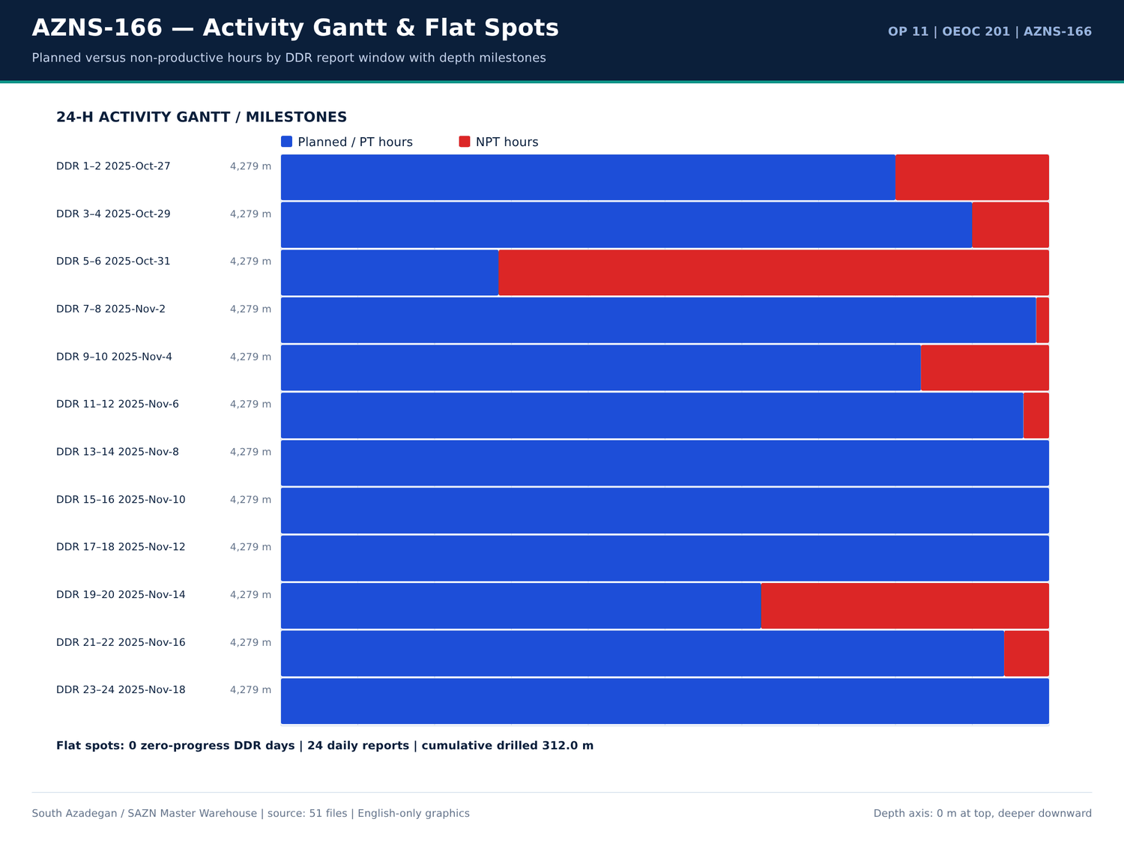
AZNS-166 09 gantt — source: SAZN master warehouse
Workover / fishing notes
Report | Sheet | Category | Text
No source rows for this query | — | — | —

EOWR / Programme workover pages
Document | Page | Chapter | Characters | Images | Keywords
Well Program/11.AZNS_166_Workover-1_Program.pdf | 3 | 01 Well History & Summary | 7607 | 4 | bha,casing,cement,formation,milling,mud,waste
04.EOWR/11.AZNS_166_EOWR.pdf | 13 | 10 Wellhead & Xmas Tree | 1754 | 6 | casing,fish
Well Program/11.AZNS_166_Workover-1_Program.pdf | 18 | 10 Wellhead & Xmas Tree | 1337 | 4 | fish
04.EOWR/11.AZNS_166_EOWR.pdf | 26 | 09 Completion Tally & Tools | 2726 | 10 | casing,cement,contractor,fish,formation,mud,packer
Well Program/11.AZNS_166_Workover-1_Program.pdf | 29 | 09 Completion Tally & Tools | 3221 | 6 | casing,cement,fish,formation,mud,packer
Well Program/11.AZNS_166_Workover-1_Program.pdf | 32 | 12 Well Stimulation & Clean-Up | 2578 | 4 | acid,casing,cement,contractor,fish,mud,packer
Well Program/11.AZNS_166_Workover-1_Program.pdf | 33 | 06 BHA Record | 720 | 5 | bha,bit,milling,mud
Well Program/11.AZNS_166_Workover-1_Program.pdf | 46 | 02 Hole History & Dry Test | 3918 | 8 | casing,contractor,packer
Well Program/11.AZNS_166_Workover-1_Program.pdf | 60 | 02 Hole History & Dry Test | 461 | 4 | mud
04.EOWR/11.AZNS_166_EOWR.pdf | 63 | 02 Hole History & Dry Test | 3821 | 10 | contractor,packer

Numeric-cell provenance excerpt — chapter 17
Document | Sheet | Cell | Value
CBS/11.AZNS_166_CBS.xlsx | Total Cost-EPD & Rigless | R5C3 | 9,087,998.52
CBS/11.AZNS_166_CBS.xlsx | Total Cost-EPD | R19C7 | 8,275,165.08
CBS/11.AZNS_166_CBS.xlsx | Total Cost-EPD & Rigless | R3C3 | 8,275,165.08
CBS/11.AZNS_166_CBS.xlsx | Total Cost-EPD | R3C6 | 2,118,462.01
CBS/11.AZNS_166_CBS.xlsx | Total Cost-EPD | R3C7 | 2,118,462.01
CBS/11.AZNS_166_CBS.xlsx | Cost Breakdown-166 | R197C6 | 2,118,462.01
CBS/11.AZNS_166_CBS.xlsx | Total Cost-EPD | R7C6 | 1,214,816.28
CBS/11.AZNS_166_CBS.xlsx | Total Cost-EPD | R7C7 | 1,214,816.28
CBS/11.AZNS_166_CBS.xlsx | Cost Breakdown-166 Contingecy | R183C16 | 1,214,816.28
CBS/11.AZNS_166_CBS.xlsx | Total Cost-EPD | R12C6 | 1,173,960.00
CBS/11.AZNS_166_CBS.xlsx | Total Cost-EPD | R12C7 | 1,173,960.00
CBS/11.AZNS_166_CBS.xlsx | Cost Breakdown-Material-166 | R249C6 | 1,173,960.00
CBS/11.AZNS_166_CBS.xlsx | Total Cost-EPD | R13C6 | 1,092,550.00
CBS/11.AZNS_166_CBS.xlsx | Cost Breakdown-166 | R5C6 | 1,017,455.31

Chapter 18 — Completion Tally & Pressure Tests
Completion tally rows are taken from CBS 20.1/20.2/20.3 material sheets and DDR casing records; TRSSSV, packer, anchor, SSD, expansion joint, nipples and CIV/CIM lines are listed with their priced quantities. Pressure-test facts from the EOWR / Programme text layer are tabulated with value, unit and page.
Completion material lines (CBS 20.x)
Sheet | Description | Unit | Qty | Unit price (USD) | Total (USD)
Cost Breakdown-Material-166 | Wellhead & Xmas tree Equipment | — | — | — | 483,360.00
Cost Breakdown-Material-166 | Tubing, 4 1/2", L80, 18.9 ppf, Premium Conn., Seamless, R2, PSL3. | m | 3,100.00 | 151 | 468,100.00
Cost Breakdown-Material-166 | Tubing, 3 1/2", L80, 10.2 ppf, Premium Conn., seamless, R2, PSL3. | m | 700 | 120 | 84,000.00
Coil Tubing Service-166 | Coiled Tubing Unit (1 1/2") | 1 EA | — | — | 76,800.00
Cost Breakdown-166 | Casing/tubing Running 4 1⁄2" | M | 8,000.00 | 6.5 | 52,000.00
Cost Breakdown-166 Contingecy | Coiled tubing equipment and personnel | DAY | 5.5 | 5,400.00 | 29,700.00
Mob.& Demob for Stim.-166 | Coiled Tubing Unit and Personnel | 1set | 2 | — | 16,200.00
Cost Breakdown-Material-166 | Tubing pup joint, 3 1/2", L080 type 1, 10.2 PPF, Gas Tight Conn, seamless, 1.5m long, PSL3. | ea. | 15 | 300 | 4,500.00
Cost Breakdown-Material-166 | Tubing pup joint, 3 1/2", L080,premium Connection 10.2 ppf,13CR01 MO, seamless,3 m long , PSL3 | ea. | 15 | 300 | 4,500.00
Cost Breakdown-166 | Tubing Running 3 1⁄2" | M | 558 | 6.5 | 3,627.00
Cost Breakdown-Material-166 | Drift Gauge, API, for 3 1/2" 10.2# tubing | ea. | 2 | 900 | 1,800.00
Cost Breakdown-Material-166 | Drift Gauge, API, for 4 1/2" 18.9# tubing | ea. | 2 | 900 | 1,800.00
Cost Breakdown-Material-166 | Tubing pup joint, 4 1/2", L080 type 1, 18.9 PPF, Gas Tight Conn, seamless, 1.5m, PSL3. | ea. | 5 | 350 | 1,750.00
Cost Breakdown-Material-166 | Tubing pup joint, 4 1/2", L080,premium Connection 18.9 ppf,13CR01 MO, seamless,3 m long , PSL3 | ea. | 5 | 350 | 1,750.00
Cost Breakdown-166 | Cementing 7" Liner | JOB | — | — | 0
Cost Breakdown-166 | Corrosion Log for 7" Liner and 9 5/8” casing (MTT or MTD or EMDS) CCL/GR (after perforation) | JOB | 0 | — | 0
Cost Breakdown-166 | Casing Running 7" Liner | M | 0 | 0 | 0
Cost Breakdown-166 | Casing Running 5" Liner | M | — | — | 0
Cost Breakdown-166 | Coiled tubing equipment and personnel | DAY | — | — | 0
Cost Breakdown-166 | Liner hanger running (lump Sum as Complete package) | — | — | — | 0
Cost Breakdown-166 | 7" liner hanger running equipment and personnel (lump Sum as Complete package) | JOB | — | — | 0
Cost Breakdown-166 | 5 1⁄2" liner hanger running equipment and personnel (lump Sum as Complete package) | JOB | — | — | 0

Pressure-test facts
Fact key | Value | Unit | Page | Document | Context
PRESSURE_TEST | 4,500.00 | psi | 16 | Well Program/11.AZNS_166_Workover-1_Program.pdf | lling & Plug to 2770.1m Set Prong in NO-GO. Pressure test Comp. String W/4500psi for 15MIN, Ok. Close 3SV, laydown41/2''L. J
PRESSURE_TEST | 4,500.00 | psi | 43 | Well Program/11.AZNS_166_Workover-1_Program.pdf | lling & Plug to 2770.1m Set Prong in NO-GO. Pressure test Comp. String W/4500psi for 15MIN, Ok. Close 3SV, laydown 41/2''L.
PRESSURE_TEST | 6,000.00 | psi | 58 | 04.EOWR/11.AZNS_166_EOWR.pdf | Tubing String With check valve Inside. √ Pressure Test Tubing String 6000psi/15min Every 100 JTs. √ RIH Completion Stri
PRESSURE_TEST | 6,000.00 | psi | 58 | 04.EOWR/11.AZNS_166_EOWR.pdf | RSSSV √ Install control line to TRSSSV and pressure test control line 6000psi x 15mins. And then keep 3000psi pressure wh
PRESSURE_TEST | 4,500.00 | psi | 59 | 04.EOWR/11.AZNS_166_EOWR.pdf | bonnet. √ Check hanger for any damage and pressure test control line to 4500psi √ Pressure test chemical injection line &
PRESSURE_TEST | 6,000.00 | Psi | 78 | 04.EOWR/11.AZNS_166_EOWR.pdf | all) Item Test Check Mark and Result 1 Pressure test for the kill Valve W/ 1000 & 6000 Psi / 15 min OK 2 Pressure test for the SSV
PRESSURE_TEST | 6,000.00 | Psi | 78 | 04.EOWR/11.AZNS_166_EOWR.pdf | Valve W/ 1000 & 6000 Psi / 15 min OK 2 Pressure test for the SSV W/ 1000 & 6000 Psi / 15 min OK 3 Pressure test for the top
PRESSURE_TEST | 6,000.00 | Psi | 78 | 04.EOWR/11.AZNS_166_EOWR.pdf | valve W/ 1000 & 6000 Psi / 15 min OK 4 Pressure test for Swab valve W/ 1000 & 6000 Psi / 15 min OK 5 Pressure test for the Prod
PRESSURE_TEST | 6,000.00 | Psi | 79 | 04.EOWR/11.AZNS_166_EOWR.pdf | section W/1000 &6000 psi for 15min OK 2 Pressure test for the SSV Exit block W/ 6000 Psi / 15 min OK 3 Pressure test neck of tubi
PRESSURE_TEST | 6,000.00 | Psi | 79 | 04.EOWR/11.AZNS_166_EOWR.pdf | al seal W/1000 &6000 psi for 15min OK 4 Pressure test for Swab valve W/ 6000 Psi / 15 min - 5 Pressure test for Productio
PRESSURE_TEST | 6,000.00 | Psi | 79 | 04.EOWR/11.AZNS_166_EOWR.pdf | for Swab valve W/ 6000 Psi / 15 min - 5 Pressure test for Production valve W/6000 Psi / 15 min - 6 Pressure test cavity of FS.
PRESSURE_TEST | 5,500.00 | psi | 113 | 04.EOWR/11.AZNS_166_EOWR.pdf | jector CTU 27 – Jan – 2026 14:50 perform pressure test the rubber striper and injector and BOP with( 5500 psi )(ok) 28 – Jan – 2026 05:15 displacement
PRESSURE_TEST | 5,000.00 | psi | 114 | 04.EOWR/11.AZNS_166_EOWR.pdf | e (SIWHP: 800 psi). 29 – Jan – 2026 16:30 Pressure test up to 5000 psi, ok 29 – Jan – 2026 16:45 Start RIH slick

Completion / wellhead numbered tables
Document | Page | Table no | Title | Category
04.EOWR/11.AZNS_166_EOWR.pdf | 5 | 7-5 | AZNS-166 COMPLETION TALLY ...................................................................................................... 70 | EOWR
04.EOWR/11.AZNS_166_EOWR.pdf | 5 | 10-2 | AZNS-166 WATER ANALYSIS DE-COMPLETION SECTION ............................................................. 105 | EOWR
04.EOWR/11.AZNS_166_EOWR.pdf | 70 | 7-5 | AZNS-166 Completion Tally | EOWR
04.EOWR/11.AZNS_166_EOWR.pdf | 105 | 10-2 | AZNS-166 Water Analysis De-Completion section | EOWR

Numeric-cell provenance excerpt — chapter 18
Document | Sheet | Cell | Value
CBS/11.AZNS_166_CBS.xlsx | Total Cost-EPD & Rigless | R5C3 | 9,087,998.52
CBS/11.AZNS_166_CBS.xlsx | Total Cost-EPD | R19C7 | 8,275,165.08
CBS/11.AZNS_166_CBS.xlsx | Total Cost-EPD & Rigless | R3C3 | 8,275,165.08
CBS/11.AZNS_166_CBS.xlsx | Total Cost-EPD | R3C6 | 2,118,462.01
CBS/11.AZNS_166_CBS.xlsx | Total Cost-EPD | R3C7 | 2,118,462.01
CBS/11.AZNS_166_CBS.xlsx | Cost Breakdown-166 | R197C6 | 2,118,462.01
CBS/11.AZNS_166_CBS.xlsx | Total Cost-EPD | R7C6 | 1,214,816.28
CBS/11.AZNS_166_CBS.xlsx | Total Cost-EPD | R7C7 | 1,214,816.28
CBS/11.AZNS_166_CBS.xlsx | Cost Breakdown-166 Contingecy | R183C16 | 1,214,816.28
CBS/11.AZNS_166_CBS.xlsx | Total Cost-EPD | R12C6 | 1,173,960.00
CBS/11.AZNS_166_CBS.xlsx | Total Cost-EPD | R12C7 | 1,173,960.00
CBS/11.AZNS_166_CBS.xlsx | Cost Breakdown-Material-166 | R249C6 | 1,173,960.00
CBS/11.AZNS_166_CBS.xlsx | Total Cost-EPD | R13C6 | 1,092,550.00
CBS/11.AZNS_166_CBS.xlsx | Cost Breakdown-166 | R5C6 | 1,017,455.31

Chapter 19 — Matrix Acidizing, CTU & Productivity Index
Rig-less stimulation families, planned chemical volumes, unit prices and acid / N2 / WHP / PI / rate facts are listed with page references. Pre/post-acid productivity comparisons are only made where both values exist in the source text; 66 reconciliation rows link CBS priced chemicals to DDR consumption.
Rig-less stimulation priced families
Sheet | Description | Unit | Volume | Unit price (USD) | Standby days | Operating days | Total (USD)
Cost breakdown R-less Stim.-166 | Mobilization, Demobilization | 43738 | — | — | — | — | —
Cost breakdown R-less Stim.-166 | Materials and Consumables | 124335 | — | — | — | — | —
Cost breakdown R-less Stim.-166 | Acidizing and N2 services | 117529 | — | — | — | — | —
Cost breakdown R-less Stim.-166 | Coiled Tubing Services | 89800 | — | — | — | — | —
Cost breakdown R-less Stim.-166 | Oil Transportation Services | 60000 | — | — | — | — | —
Cost breakdown R-less Stim.-166 | Well Testing and Production Services | 83282.84 | — | — | — | — | —
Cost breakdown R-less Stim.-166 | Wireline Production Logging Services | 76170 | — | — | — | — | —
Cost breakdown R-less Stim.-166 | Slickline Services | 39464.6 | — | — | — | — | —
Cost breakdown R-less Stim.-166 | Memory Gauge Service | 2927 | — | — | — | — | —
Cost breakdown R-less Stim.-166 | Bottomhole PVT Sampling | 0 | — | — | — | — | —
Cost breakdown R-less Stim.-166 | Personnel Rates | 62587 | — | — | — | — | —
Cost breakdown R-less Stim.-166 | Design, Interpretation, Reporting | 13000 | — | — | — | — | —
Cost breakdown R-less Stim.-166 | Accommodation | 100000 | — | — | — | — | —
Mob.& Demob for Stim.-166 | Liquid Pumping Unit, and Personnel | 1 set | 1 | — | — | — | 3,038.00
Mob.& Demob for Stim.-166 | Fracturing Unit and Personnel | 1set | 0 | — | — | — | 0
Mob.& Demob for Stim.-166 | Storage/Mixing Tank (water,acid, diesel) 500BBL Minimum | 1x500 BBL tank | 1 | — | — | — | 300
Mob.& Demob for Stim.-166 | Batch mixer | 1 set | 1 | — | — | — | 2,500.00
Mob.& Demob for Stim.-166 | Blender | 1 set | 1 | — | — | — | 2,500.00
Mob.& Demob for Stim.-166 | Liquid N2 Pump Unit and Personnel | 1set | 1 | — | — | — | 2,500.00
Mob.& Demob for Stim.-166 | Liquid Nitrogen Storage Tank | 1set | 1 | — | — | — | 1,000.00
Mob.& Demob for Stim.-166 | Coiled Tubing Unit and Personnel | 1set | 2 | — | — | — | 16,200.00
Mob.& Demob for Stim.-166 | Test Choke Manifold | 1set | 1 | — | — | — | 1,500.00

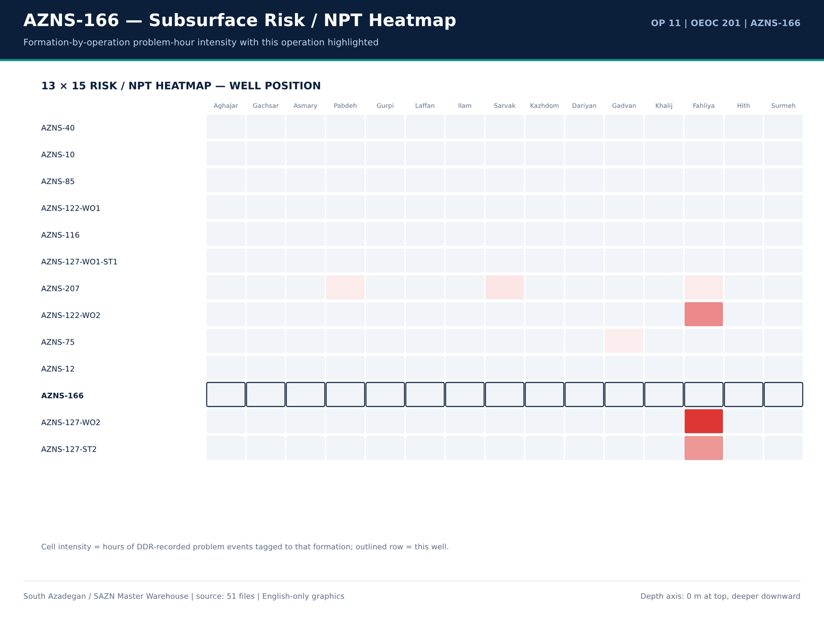
AZNS-166 10 risk — source: SAZN master warehouse
Acid / N2 / WHP / PI / rate facts
Fact key | Value | Unit | Page | Document | Context
WHP | 1,700.00 | psi | 12 | 04.EOWR/11.AZNS_166_EOWR.pdf | of 3SV flapper observed on neck of plug. SIWHP = 1700psi, flow the well (FWHP = 700psi), close 3SV fl
WHP | 700 | psi | 12 | 04.EOWR/11.AZNS_166_EOWR.pdf | k of plug. SIWHP = 1700psi, flow the well (FWHP = 700psi), close 3SV flowing continued, RIH SL with L
WHP | 1,500.00 | psi | 12 | 04.EOWR/11.AZNS_166_EOWR.pdf | dropped & remained constant. (600 – 800psi) WHP = 1500psi, RIH SL with special protection sleeve (prof
WHP | 1,700.00 | psi | 17 | Well Program/11.AZNS_166_Workover-1_Program.pdf | 3SV flapper observed on neck of plug. • SIWHP = 1700psi, flow the well (FWHP = 700psi), close 3SV fl
WHP | 700 | psi | 17 | Well Program/11.AZNS_166_Workover-1_Program.pdf | plug. • SIWHP = 1700psi, flow the well (FWHP = 700psi), close 3SV flowing continued, RIH SL with
WHP | 1,500.00 | psi | 17 | Well Program/11.AZNS_166_Workover-1_Program.pdf | pped & remained constant. (600 – 800psi) • WHP = 1500psi, RIH SL with special protection sleeve (prof
WHP | 0 | psi | 106 | 04.EOWR/11.AZNS_166_EOWR.pdf | ng pressure recorded at 32/64 choke setting, wellhead pressure at 0psi and no observable returns at surface. In o
WHP | 0 | psi | 109 | 04.EOWR/11.AZNS_166_EOWR.pdf | st on coiled tubing equipment C/S: 32/64 - WHP: 0 psi - outlet from the well: no return Retrieve
WHP | 0 | psi | 111 | 04.EOWR/11.AZNS_166_EOWR.pdf | uipment (S/L), set P.S at 63.7m, Open TMV, SIWHP: 0psi, RIH S/L to Max accessible TD (2950m) 24 –
WHP | 0 | psi | 111 | 04.EOWR/11.AZNS_166_EOWR.pdf | head pressure monitoring ( C/S: closed - WHP: 0 psi - outlet from the well: no return) 26 – Jan
WHP | 800 | psi | 111 | 04.EOWR/11.AZNS_166_EOWR.pdf | S, flow the well & monitor well condition, SIWHP: 800psi. 30 – Jan – 2026 flowing the well & monito
N2_VOL | 2,430.00 | gal | 111 | 04.EOWR/11.AZNS_166_EOWR.pdf | le TD (2950m) 24 – Jan – 2026 Line Up CT & N2 Track, Perform N2 lifting (T.V: 2430 gal ) 25 – Jan – 2026 Well head pressure monit
WHP | 0 | psi | 112 | 04.EOWR/11.AZNS_166_EOWR.pdf | V, OK 23 – Jan – 2026 21:45 Open TMV ( SIWHP:0 psi) 23 – Jan – 2026 21:50 Start RIH S/L to s
WHP | 0 | psi | 112 | 04.EOWR/11.AZNS_166_EOWR.pdf | /5500psi ,5/15min Against TMV. Open TMV ( SIWHP:0 psi)@ Start RIH S/L to Max acceseble TD 23 – Ja
WHP | 0 | psi | 113 | 04.EOWR/11.AZNS_166_EOWR.pdf | e monitoring @ 16:50 to 23:55 ( C/S: 32/64 - WHP: 0 psi - outlet from the well: no return) 24 – Ja
WHP | 0 | psi | 113 | 04.EOWR/11.AZNS_166_EOWR.pdf | head pressure monitoring ( C/S: closed - WHP: 0 psi - outlet from the well: no return) 25 – Ja
WHP | 0 | psi | 113 | 04.EOWR/11.AZNS_166_EOWR.pdf | head pressure monitoring ( C/S: closed - WHP: 0 psi - outlet from the well: no return) R/D th
WHP | 800 | psi | 114 | 04.EOWR/11.AZNS_166_EOWR.pdf | T 29 – Jan – 2026 16:00 R/U slick line (SIWHP: 800 psi). 29 – Jan – 2026 16:30 Pressure test up

Stimulation chemical lines from CBS
Sheet | Description | Unit | Qty | Total (USD)
Acidizing &N2 service-166 | Total Operation and Standby Charges for Acidizing and Nitrogen Services (USD) | — | — | 117,529.00
Personnel rate-166 | Total Personnel Charge for Acidizing, Testing and Related Services (USD) | — | — | 62,587.00
Material & Consumable-166 | Liquid Nitrogen (N2) | Gal | 7,000.00 | 28,000.00
Cost Breakdown-166 Contingecy | Xylene | Gal | 2,100.00 | 18,900.00
Material & Consumable-166 | Xylene | Gal | 2,000.00 | 18,000.00
Acidizing &N2 service-166 | Liquid Nitrogen Unit | 1 EA | — | 9,900.00
Acidizing &N2 service-166 | Acid Storage Tanks | 1 EA | — | 5,950.00
Acidizing &N2 service-166 | Acid Mixing Tanks | 1 EA | — | 5,950.00
Material & Consumable-166 | Mutual Solvent | Gal | 100 | 3,000.00
Acidizing &N2 service-166 | Liquid Nitrogen Tank | 1 EA | — | 2,800.00
Acidizing &N2 service-166 | Acid Testing Lab (or Acid Testing costs in accredited lab | 1 EA | — | 2,565.00
Material & Consumable-166 | HCL (≥28%) | Gal | 1,000.00 | 2,000.00
Design,Interp.,Reporting-166 | Acid Labaratory Experiments | Test of Acidizing Fluid | 1 | 2,000.00
Mob.& Demob for Stim.-166 | Liquid Nitrogen Storage Tank | 1set | 1 | 1,000.00
Material & Consumable-166 | Surfactant | Gal | 45 | 675
Acidizing &N2 service-166 | Acid and Chemical Pump | 1 EA | — | 594
Mob.& Demob for Stim.-166 | Storage/Mixing Tank (water,acid, diesel) 500BBL Minimum | 1x500 BBL tank | 1 | 300
Cost Breakdown-166 | Lifting with 400bbl Liquid Nitrogen | BBL | — | 0
Cost Breakdown-166 | Nitrogen Unit Full Package | Day | — | 0
Material & Consumable-166 | Acetic Acid (98%) | Gal | 0 | 0
Material & Consumable-166 | Self Diverting Viscoelastic Surfactant (SDVES) | Gal | 0 | 0
Material & Consumable-166 | Benzoic Acid | lb | 0 | 0

Numeric-cell provenance excerpt — chapter 19
Document | Sheet | Cell | Value
CBS/11.AZNS_166_CBS.xlsx | Total Cost-EPD & Rigless | R5C3 | 9,087,998.52
CBS/11.AZNS_166_CBS.xlsx | Total Cost-EPD | R19C7 | 8,275,165.08
CBS/11.AZNS_166_CBS.xlsx | Total Cost-EPD & Rigless | R3C3 | 8,275,165.08
CBS/11.AZNS_166_CBS.xlsx | Total Cost-EPD | R3C6 | 2,118,462.01
CBS/11.AZNS_166_CBS.xlsx | Total Cost-EPD | R3C7 | 2,118,462.01
CBS/11.AZNS_166_CBS.xlsx | Cost Breakdown-166 | R197C6 | 2,118,462.01
CBS/11.AZNS_166_CBS.xlsx | Total Cost-EPD | R7C6 | 1,214,816.28
CBS/11.AZNS_166_CBS.xlsx | Total Cost-EPD | R7C7 | 1,214,816.28
CBS/11.AZNS_166_CBS.xlsx | Cost Breakdown-166 Contingecy | R183C16 | 1,214,816.28
CBS/11.AZNS_166_CBS.xlsx | Total Cost-EPD | R12C6 | 1,173,960.00
CBS/11.AZNS_166_CBS.xlsx | Total Cost-EPD | R12C7 | 1,173,960.00
CBS/11.AZNS_166_CBS.xlsx | Cost Breakdown-Material-166 | R249C6 | 1,173,960.00
CBS/11.AZNS_166_CBS.xlsx | Total Cost-EPD | R13C6 | 1,092,550.00
CBS/11.AZNS_166_CBS.xlsx | Cost Breakdown-166 | R5C6 | 1,017,455.31

Chapter 20 — HSE, MTBF, Waste & Subcontractors
POB series, fuel/water consumption, waste rows, HSE chapter pages and contractor / service-company names are reproduced from DDR and EOWR. The accommodation and catering CBS lines are matched against the DDR POB totals rather than against an assumed headcount.
POB series
Report | Category | Count | Total
1 | OEOC Rig | 79 | —
1 | Client (TEC) | 3 | —
1 | MSA | 7 | —
1 | Service company | 18 | —
1 | Catering + Guard | 12 | —
1 | Labour | 0 | —
1 | Other | 0 | —
1 | TOTAL POB | 119 | 119
2 | OEOC Rig | 79 | —
2 | Client (TEC) | 3 | —
2 | MSA | 7 | —
2 | Service company | 18 | —
2 | Catering + Guard | 12 | —
2 | Labour | 0 | —
2 | Other | 0 | —
2 | TOTAL POB | 119 | 119
3 | OEOC Rig | 79 | —
3 | Client (TEC) | 3 | —
3 | MSA | 7 | —
3 | Service company | 18 | —
3 | Catering + Guard | 12 | —
3 | Labour | 0 | —

Fuel / water / waste material rows
Report | Material | Unit | Received | Used | Stock | Cell
1 | BULK Fuel Rig | Lit | — | — | 46,000.00 | F72
1 | BULK Fuel Camp | Lit | — | — | 3,600.00 | G72
1 | BULK Fuel Rig | Lit | — | 4,500.00 | — | F73
1 | BULK Fuel Camp | Lit | — | 600 | — | G73
2 | BULK Fuel Rig | Lit | — | — | 38,000.00 | F72
2 | BULK Fuel Camp | Lit | — | — | 7,000.00 | G72
2 | BULK Fuel Rig | Lit | — | 4,000.00 | — | F73
2 | BULK Fuel Camp | Lit | — | 600 | — | G73
2 | BULK Fuel Camp | Lit | 4,000.00 | — | — | G74
3 | BULK Fuel Rig | Lit | — | — | 34,000.00 | F72
3 | BULK Fuel Camp | Lit | — | — | 6,400.00 | G72
3 | BULK Fuel Rig | Lit | — | 4,000.00 | — | F73
3 | BULK Fuel Camp | Lit | — | 600 | — | G73
4 | BULK Fuel Rig | Lit | — | — | 34,000.00 | F72
4 | BULK Fuel Camp | Lit | — | — | 6,400.00 | G72
4 | BULK Fuel Rig | Lit | — | 4,000.00 | — | F73
4 | BULK Fuel Camp | Lit | — | 600 | — | G73
5 | BULK Fuel Rig | Lit | — | — | 56,000.00 | F72
5 | BULK Fuel Camp | Lit | — | — | 5,200.00 | G72
5 | BULK Fuel Rig | Lit | — | 3,000.00 | — | F73
5 | BULK Fuel Camp | Lit | — | 600 | — | G73
5 | BULK Fuel Rig | Lit | 29,000.00 | — | — | F74

Catering / accommodation CBS lines
Sheet | Description | Qty | Unit | Rate | Total (USD)
Rig Move | Rig move between well pads | 1 | — | 247,000.00 | 247,000.00
Rig Move | Rig move between Cellar-to-Cellar within the same pad | 0 | — | 0 | 0
Catering & Accommodation | Full board catering and accommodation | — | 30 | — | —
Catering & Accommodation | Breakfast | — | 10 | — | —
Catering & Accommodation | Lunch | — | 15 | — | —
Catering & Accommodation | Dinner | — | 15 | — | —
Catering & Accommodation | Night Meals | — | 10 | — | —
Catering & Accommodation | Accommodation | — | 15 | — | —
Full package Accomm-AZNS166 | Full package Accommodation | 20 | Day | 5,000.00 | 100,000.00
Full package Accomm-AZNS166 | — | — | — | — | 100,000.00

Numeric-cell provenance excerpt — chapter 20
Document | Sheet | Cell | Value
CBS/11.AZNS_166_CBS.xlsx | Total Cost-EPD & Rigless | R5C3 | 9,087,998.52
CBS/11.AZNS_166_CBS.xlsx | Total Cost-EPD | R19C7 | 8,275,165.08
CBS/11.AZNS_166_CBS.xlsx | Total Cost-EPD & Rigless | R3C3 | 8,275,165.08
CBS/11.AZNS_166_CBS.xlsx | Total Cost-EPD | R3C6 | 2,118,462.01
CBS/11.AZNS_166_CBS.xlsx | Total Cost-EPD | R3C7 | 2,118,462.01
CBS/11.AZNS_166_CBS.xlsx | Cost Breakdown-166 | R197C6 | 2,118,462.01
CBS/11.AZNS_166_CBS.xlsx | Total Cost-EPD | R7C6 | 1,214,816.28
CBS/11.AZNS_166_CBS.xlsx | Total Cost-EPD | R7C7 | 1,214,816.28
CBS/11.AZNS_166_CBS.xlsx | Cost Breakdown-166 Contingecy | R183C16 | 1,214,816.28
CBS/11.AZNS_166_CBS.xlsx | Total Cost-EPD | R12C6 | 1,173,960.00
CBS/11.AZNS_166_CBS.xlsx | Total Cost-EPD | R12C7 | 1,173,960.00
CBS/11.AZNS_166_CBS.xlsx | Cost Breakdown-Material-166 | R249C6 | 1,173,960.00
CBS/11.AZNS_166_CBS.xlsx | Total Cost-EPD | R13C6 | 1,092,550.00
CBS/11.AZNS_166_CBS.xlsx | Cost Breakdown-166 | R5C6 | 1,017,455.31

Chapter 21 — Deep Geology & Field Correlation
11 correlated formation tops join DDR prognosis/actual columns, EOWR tops and Programme prognosis tables. Structural delta is actual minus prognosis in metres; lithology, gas shows, H2S/CO2, fluorescence and CBL-VDL-USIT evidence are indexed by page. South Azadegan anticline correlation is established against the other 12 operations.
Formation tops: prognosis vs actual
Report | Formation | MD (m) | TVD (m) | Prognosis MD (m) | Prognosis TVD (m) | Lithology
No source rows for this query | — | — | — | — | — | —

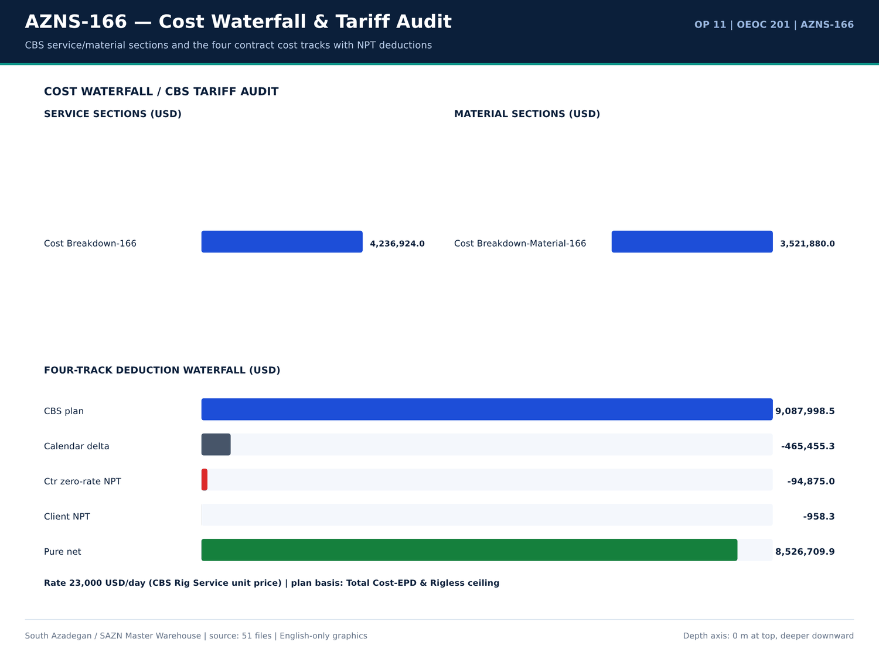
AZNS-166 11 cost — source: SAZN master warehouse
EOWR / Programme formation-top facts
Fact key | Value | Unit | Page | Document | Context
Fahliyan MD | 643 | m | 5 | Well Program/11.AZNS_166_Workover-1_Program.pdf | vertically down to the Cretaceous Fahliyan Formation with total depth of 4,643m. The results of this well, revealed th
Fahliyan MD | 2,008.00 | m | 5 | Well Program/11.AZNS_166_Workover-1_Program.pdf | parts of this huge field down to Fahliyan Formation. In the later stage the well No.10 assumed as exploration well for
Total Depth MD | 4,280.00 | m | 22 | Well Program/11.AZNS_166_Workover-1_Program.pdf | rkover#1 Well Sketch & Completion Total Depth @ 4280 mMD Formation Formation Tops Depth (mMD) 0 1000 m 2000 m 3000 m 40
Aghajari MD | 1,262.00 | m | 22 | Well Program/11.AZNS_166_Workover-1_Program.pdf | mMD) 0 1000 m 2000 m 3000 m 4000 m Aghajari 1262 m 1773 m Gachsaran Asmari 2119 m 2353 m Gurpi 2724 m Ilam Sarvak 3847 m
Gachsaran MD | 2,119.00 | m | 22 | Well Program/11.AZNS_166_Workover-1_Program.pdf | 00 m 4000 m Aghajari 1262 m 1773 m Gachsaran Asmari 2119 m 2353 m Gurpi 2724 m Ilam Sarvak 3847 m Kazhdumi 4183 m Dariya
Asmary MD | 2,353.00 | m | 22 | Well Program/11.AZNS_166_Workover-1_Program.pdf | m Aghajari 1262 m 1773 m Gachsaran Asmari 2119 m 2353 m Gurpi 2724 m Ilam Sarvak 3847 m Kazhdumi 4183 m Dariyan 20" CSG
Gurpi MD | 2,724.00 | m | 22 | Well Program/11.AZNS_166_Workover-1_Program.pdf | 3 m Gachsaran Asmari 2119 m 2353 m Gurpi 2724 m Ilam Sarvak 3847 m Kazhdumi 4183 m Dariyan 20" CSG @ 147 mMD 13 3/8" CSG
Ilam MD | 3,847.00 | m | 22 | Well Program/11.AZNS_166_Workover-1_Program.pdf | Asmari 2119 m 2353 m Gurpi 2724 m Ilam Sarvak 3847 m Kazhdumi 4183 m Dariyan 20" CSG @ 147 mMD 13 3/8" CSG @ 1338 mMD 9
Sarvak MD | 4,183.00 | m | 22 | Well Program/11.AZNS_166_Workover-1_Program.pdf | ri 2119 m 2353 m Gurpi 2724 m Ilam Sarvak 3847 m Kazhdumi 4183 m Dariyan 20" CSG @ 147 mMD 13 3/8" CSG @ 1338 mMD 9 5/8"
Kazhdomi MD | 1,338.00 | m | 22 | Well Program/11.AZNS_166_Workover-1_Program.pdf | m Gurpi 2724 m Ilam Sarvak 3847 m Kazhdumi 4183 m Dariyan 20" CSG @ 147 mMD 13 3/8" CSG @ 1338 mMD 9 5/8" CSG @ 1764.6
Dariyan MD | 1,764.60 | m | 22 | Well Program/11.AZNS_166_Workover-1_Program.pdf | Ilam Sarvak 3847 m Kazhdumi 4183 m Dariyan 20" CSG @ 147 mMD 13 3/8" CSG @ 1338 mMD 9 5/8" CSG @ 1764.6 mMD 7" L.lap @ 1
Pabdeh MD | 2,616.00 | m | 22 | Well Program/11.AZNS_166_Workover-1_Program.pdf | 132.8 mMD 4-1/2" S.Liner 4279 mMD Pabdeh 2616 m KOP @ 2735 m MD Packer depth @ 2754 mMD Figure 4: Well Schematic Befo
Total Depth MD | 4,280.00 | m | 23 | Well Program/11.AZNS_166_Workover-1_Program.pdf | ll Sketch & Completion Depth (mMD) Total Depth @ 4280 mMD 0 1000 m 2000 m 3000 m 4000 m Aghajari 1262 m 1773 m Gachsaran
Aghajari MD | 1,262.00 | m | 23 | Well Program/11.AZNS_166_Workover-1_Program.pdf | mMD 0 1000 m 2000 m 3000 m 4000 m Aghajari 1262 m 1773 m Gachsaran Asmari 2119 m 2353 m Gurpi 2724 m Ilam Sarvak 3847 m
Gachsaran MD | 2,119.00 | m | 23 | Well Program/11.AZNS_166_Workover-1_Program.pdf | 00 m 4000 m Aghajari 1262 m 1773 m Gachsaran Asmari 2119 m 2353 m Gurpi 2724 m Ilam Sarvak 3847 m Kazhdumi 4183 m Dariya
Asmary MD | 2,353.00 | m | 23 | Well Program/11.AZNS_166_Workover-1_Program.pdf | m Aghajari 1262 m 1773 m Gachsaran Asmari 2119 m 2353 m Gurpi 2724 m Ilam Sarvak 3847 m Kazhdumi 4183 m Dariyan 20" CSG
Gurpi MD | 2,724.00 | m | 23 | Well Program/11.AZNS_166_Workover-1_Program.pdf | 3 m Gachsaran Asmari 2119 m 2353 m Gurpi 2724 m Ilam Sarvak 3847 m Kazhdumi 4183 m Dariyan 20" CSG @ 147 mMD 13 3/8" CSG
Ilam MD | 3,847.00 | m | 23 | Well Program/11.AZNS_166_Workover-1_Program.pdf | Asmari 2119 m 2353 m Gurpi 2724 m Ilam Sarvak 3847 m Kazhdumi 4183 m Dariyan 20" CSG @ 147 mMD 13 3/8" CSG @ 1338 mMD 9
Sarvak MD | 4,183.00 | m | 23 | Well Program/11.AZNS_166_Workover-1_Program.pdf | ri 2119 m 2353 m Gurpi 2724 m Ilam Sarvak 3847 m Kazhdumi 4183 m Dariyan 20" CSG @ 147 mMD 13 3/8" CSG @ 1338 mMD 9 5/8"
Kazhdomi MD | 1,338.00 | m | 23 | Well Program/11.AZNS_166_Workover-1_Program.pdf | m Gurpi 2724 m Ilam Sarvak 3847 m Kazhdumi 4183 m Dariyan 20" CSG @ 147 mMD 13 3/8" CSG @ 1338 mMD 9 5/8" CSG @ 1764.6
Dariyan MD | 1,764.60 | m | 23 | Well Program/11.AZNS_166_Workover-1_Program.pdf | Ilam Sarvak 3847 m Kazhdumi 4183 m Dariyan 20" CSG @ 147 mMD 13 3/8" CSG @ 1338 mMD 9 5/8" CSG @ 1764.6 mMD 7" L.lap @ 1
Pabdeh MD | 2,616.00 | m | 23 | Well Program/11.AZNS_166_Workover-1_Program.pdf | 132.8 mMD 4-1/2" S.Liner 4279 mMD Pabdeh 2616 m KOP @ 2735 m MD Packer depth @ 2706 mMD Figure 5: Well Schematic Afte

Gas / H2S / CO2 / CBL evidence
Fact key | Value | Unit | Page | Document | Context
H2S | 58 | — | 4 | Well Program/11.AZNS_166_Workover-1_Program.pdf | H2S MONITORING & PREVENTION MEASURE ........................................................ 58
H2S | 6 | — | 17 | 04.EOWR/11.AZNS_166_EOWR.pdf | H2S Drill. Cont RIH with 6
H2S | 2 | — | 55 | Well Program/11.AZNS_166_Workover-1_Program.pdf | H2S in Sarvak, Kazhdumi and Gadvan reservoirs, Make detail H2
H2S | 10 | — | 58 | Well Program/11.AZNS_166_Workover-1_Program.pdf | H2S warning indicator: the first warning level is 10
H2S | 20 | — | 58 | Well Program/11.AZNS_166_Workover-1_Program.pdf | H2S content to operators. The second warning level is 20
H2S | 20 | — | 58 | Well Program/11.AZNS_166_Workover-1_Program.pdf | H2S content in air exceed 20
H2S | 2 | — | 58 | Well Program/11.AZNS_166_Workover-1_Program.pdf | H2S area shall be furnished with H2
H2S | 9.5 | — | 58 | Well Program/11.AZNS_166_Workover-1_Program.pdf | H2S area shall be kept over 9.5
H2S | 2 | — | 58 | Well Program/11.AZNS_166_Workover-1_Program.pdf | H2S concentration in drilling fluid. The H2
H2S | 2 | — | 59 | Well Program/11.AZNS_166_Workover-1_Program.pdf | H2S concentration should be measured in the places where H2

Numeric-cell provenance excerpt — chapter 21
Document | Sheet | Cell | Value
CBS/11.AZNS_166_CBS.xlsx | Total Cost-EPD & Rigless | R5C3 | 9,087,998.52
CBS/11.AZNS_166_CBS.xlsx | Total Cost-EPD | R19C7 | 8,275,165.08
CBS/11.AZNS_166_CBS.xlsx | Total Cost-EPD & Rigless | R3C3 | 8,275,165.08
CBS/11.AZNS_166_CBS.xlsx | Total Cost-EPD | R3C6 | 2,118,462.01
CBS/11.AZNS_166_CBS.xlsx | Total Cost-EPD | R3C7 | 2,118,462.01
CBS/11.AZNS_166_CBS.xlsx | Cost Breakdown-166 | R197C6 | 2,118,462.01
CBS/11.AZNS_166_CBS.xlsx | Total Cost-EPD | R7C6 | 1,214,816.28
CBS/11.AZNS_166_CBS.xlsx | Total Cost-EPD | R7C7 | 1,214,816.28
CBS/11.AZNS_166_CBS.xlsx | Cost Breakdown-166 Contingecy | R183C16 | 1,214,816.28
CBS/11.AZNS_166_CBS.xlsx | Total Cost-EPD | R12C6 | 1,173,960.00
CBS/11.AZNS_166_CBS.xlsx | Total Cost-EPD | R12C7 | 1,173,960.00
CBS/11.AZNS_166_CBS.xlsx | Cost Breakdown-Material-166 | R249C6 | 1,173,960.00
CBS/11.AZNS_166_CBS.xlsx | Total Cost-EPD | R13C6 | 1,092,550.00
CBS/11.AZNS_166_CBS.xlsx | Cost Breakdown-166 | R5C6 | 1,017,455.31

Chapter 22 — Problem Autopsy & 60-Second Rig-Floor Playbooks
Each of the 3 real problem families is autopsied with day, depth, formation, two or more hypotheses, action effectiveness, hours and cost exposure at 23,000 USD/day. The 60-second rig-floor contingency playbooks are reproduced verbatim in a dedicated table; they are operational instructions, not generic advice.
Problem autopsy register
Category | Occurrences | Hours | Depth (m) | Formation | Attributed | Cost (USD) | Evidence
Other operational delay | 1,5,6,14,19,20,21 | 4,279.00 | 4-1/2" Non-Slotted LNR | Other operational delay — 18 occurrences | 53 | 50,791.67 | DDR 24-h log / remarks
Rig equipment failure | 4,5 | 4,279.00 | 4-1/2" Non-Slotted LNR | Rig equipment failure — 2 occurrences | 29 | 27,791.67 | DDR 24-h log / remarks
Waiting on services / material | 3,4,5,6,7,9,10,11 | 4,279.00 | 4-1/2" Non-Slotted LNR | Waiting on services / material — 18 occurrences | 18 | 17,250.00 | DDR 24-h log / remarks

60-second rig-floor contingency playbooks
Category | Playbook | Hours | Formation
Other operational delay | Cont. R/U, While Set & Install TDS; Spud Rig 201 as per Prespud Check List @ 1404.08.05 - 12:00 | Try to perform Circ Mud Thru String No Succ Due to Observe Failure TDS Kelly Hose . | Try to perform Circ Mud Thru String No Succ Due to Ob… | 53 | 4-1/2" Non-Slotted LNR
Rig equipment failure | Wait on OEOC to Cont. Test 13-5/8" 10k BOP Stack While Work on fixing BOP leakages as Below: | Wait on OEOC to Cont. Test 13-5/8" 10k BOP Stack While Work on fixing BOP leakages as Below: | 29 | 4-1/2" Non-Slotted LNR
Waiting on services / material | 1 HRS Waiting for Mud Logging Unit ( Pars Geo Data ) Due to Failure weight indicator Sensor. | Meanwhile POOH, 1 Hrs waiting for Rig 201 OEOC Due to shortage has been identified within the Drilling Fluid crew. | Cont RIH While Waiting No… | 18 | 4-1/2" Non-Slotted LNR

Hypotheses and action evidence
Category | Hours | Evidence | Hours | Cost (USD)
Other operational delay | 53 | Cont. R/U, While Set & Install TDS; Spud Rig 201 as per Prespud Check List @ 1404.08.05 - 12:00 | Try to perform Circ Mud Thru String No Succ Due to Observe Failure TDS Kelly Hose . | Try to perform Circ Mud Thru String No Succ Due to Ob… | 53 | 50,791.67
Rig equipment failure | 29 | Wait on OEOC to Cont. Test 13-5/8" 10k BOP Stack While Work on fixing BOP leakages as Below: | Wait on OEOC to Cont. Test 13-5/8" 10k BOP Stack While Work on fixing BOP leakages as Below: | 29 | 27,791.67
Waiting on services / material | 18 | 1 HRS Waiting for Mud Logging Unit ( Pars Geo Data ) Due to Failure weight indicator Sensor. | Meanwhile POOH, 1 Hrs waiting for Rig 201 OEOC Due to shortage has been identified within the Drilling Fluid crew. | Cont RIH While Waiting No… | 18 | 17,250.00

Numeric-cell provenance excerpt — chapter 22
Document | Sheet | Cell | Value
CBS/11.AZNS_166_CBS.xlsx | Total Cost-EPD & Rigless | R5C3 | 9,087,998.52
CBS/11.AZNS_166_CBS.xlsx | Total Cost-EPD | R19C7 | 8,275,165.08
CBS/11.AZNS_166_CBS.xlsx | Total Cost-EPD & Rigless | R3C3 | 8,275,165.08
CBS/11.AZNS_166_CBS.xlsx | Total Cost-EPD | R3C6 | 2,118,462.01
CBS/11.AZNS_166_CBS.xlsx | Total Cost-EPD | R3C7 | 2,118,462.01
CBS/11.AZNS_166_CBS.xlsx | Cost Breakdown-166 | R197C6 | 2,118,462.01
CBS/11.AZNS_166_CBS.xlsx | Total Cost-EPD | R7C6 | 1,214,816.28
CBS/11.AZNS_166_CBS.xlsx | Total Cost-EPD | R7C7 | 1,214,816.28
CBS/11.AZNS_166_CBS.xlsx | Cost Breakdown-166 Contingecy | R183C16 | 1,214,816.28
CBS/11.AZNS_166_CBS.xlsx | Total Cost-EPD | R12C6 | 1,173,960.00
CBS/11.AZNS_166_CBS.xlsx | Total Cost-EPD | R12C7 | 1,173,960.00
CBS/11.AZNS_166_CBS.xlsx | Cost Breakdown-Material-166 | R249C6 | 1,173,960.00
CBS/11.AZNS_166_CBS.xlsx | Total Cost-EPD | R13C6 | 1,092,550.00
CBS/11.AZNS_166_CBS.xlsx | Cost Breakdown-166 | R5C6 | 1,017,455.31

Chapter 23 — LL-01 … LL-12 Best Practices & Pitfalls
Twelve non-repeated LL cards are derived from 12 well-specific measurements: peak footage, code coverage, ROP distribution, formation-top control, CBS granularity, material balance and the largest real problem families. Best-practice and pitfall polarity are stated per card with numeric evidence and a concrete action.
LL-01 … LL-12 lessons learned
Well | Code | Polarity | Title | Evidence | Action | Hours | Cost (USD)
AZNS-166 | LL-01 | Best Practice | Peak 24-h footage of 13.0 m on report 1 | Report 1 (2025-Oct-27) drilled 13.0 m to MD 4,279 m with MW 83 PCF and ROP 9.00 m/h. | Freeze the WOB / RPM / hydraulic window of this interval as the baseline for the next well in the same formation. | — | —
AZNS-166 | LL-02 | Best Practice | Time-code coverage of 461 discrete 24-hour activity lines | 24 days, 100.0 h explicitly flagged NPT and attributed to a responsible party. | Keep the PLN / NPT / attributed-party columns mandatory — they make the four-track reconciliation auditable. | — | —
AZNS-166 | LL-03 | Best Practice | ROP distribution peaked at 9.00 m/h | 24 daily ROP entries, band 9.00–9.00 m/h (median 9.00 m/h). | Use the upper-quartile ROP as the AFE / time–depth assumption for this formation and rig pair. | — | —
AZNS-166 | LL-04 | Best Practice | Formation-top control at 11 mapped horizons | Aghajari — m; Kazhdomi — m; Dariyan — m; Fahliyan — m; Gachsaran — m; Asmary — m | Carry the measured tops into the structural grid before setting the next casing shoe. | — | —
AZNS-166 | LL-05 | Best Practice | CBS granularity: 161 material rows, 184 rig-less stimulation rows | Base commitment 7,758,804 USD + contingency 509,257 USD, rig day rate 23,000 USD/day. | Preserve unit-price × quantity visibility so zero-rate NPT deductions are computable per line. | — | —
AZNS-166 | LL-06 | Best Practice | Daily material balance on 42 distinct consumables | Received / used / stock maintained; 0 CBS↔DDR matched lines. | Keep the received–used–backload–stock four-column balance mandatory on every DDR. | — | —
AZNS-166 | LL-07 | Pitfall | Other operational delay — 53.0 h across 18 occurrences | Cont. R/U, While Set & Install TDS; Spud Rig 201 as per Prespud Check List @ 1404.08.05 - 12:00 | depth 4,279 m, formation 4-1/2" Non-Slotted LNR, attributed Unattributed, exposure 50,792 USD. | 0–60 s: secure the well, freeze the operation clock, document exact time / depth / responsible party, notify the supervisor, re-sequence the 24-hour plan to the highest-value off-critical activity. | 53 | 50,791.67
AZNS-166 | LL-08 | Pitfall | Waiting on services / material — 18.0 h across 18 occurrences | 1 HRS Waiting for Mud Logging Unit ( Pars Geo Data ) Due to Failure weight indicator Sensor. | depth 4,279 m, formation 4-1/2" Non-Slotted LNR, attributed OEOC, exposure 17,250 USD. | 0–60 s: confirm the exact missing item and quantity against the CBS line, raise a written request with the certificate list, re-sequence the 24-hour plan to off-critical-path work, start the NPT attribution clock. | 18 | 17,250.00
AZNS-166 | LL-09 | Pitfall | Rig equipment failure — 29.0 h across 2 occurrences | Wait on OEOC to Cont. Test 13-5/8" 10k BOP Stack While Work on fixing BOP leakages as Below: | depth 4,279 m, formation 4-1/2" Non-Slotted LNR, attributed OEOC, exposure 27,792 USD. | 0–60 s: secure the well, isolate the failed circuit, switch to the redundant pump / SCR / top-drive channel, log the failure time for the zero-rate NPT claim, dispatch the PM kit from the on-site store. | 29 | 27,791.67
AZNS-166 | LL-10 | Pitfall | Unattributed waiting time in the daily log | 38.0 h of NPT carries no responsible-party code. | Require an attributed-party code on every NPT row before DDR sign-off. | — | —
AZNS-166 | LL-11 | Pitfall | Unattributed waiting time in the daily log | 38.0 h of NPT carries no responsible-party code. | Require an attributed-party code on every NPT row before DDR sign-off. | — | —
AZNS-166 | LL-12 | Pitfall | Unattributed waiting time in the daily log | 38.0 h of NPT carries no responsible-party code. | Require an attributed-party code on every NPT row before DDR sign-off. | — | —

Lessons with quantified exposure
Code | Polarity | Hours | Cost (USD) | Title
LL-07 | Pitfall | 53 | 50,791.67 | Other operational delay — 53.0 h across 18 occurrences
LL-09 | Pitfall | 29 | 27,791.67 | Rig equipment failure — 29.0 h across 2 occurrences
LL-08 | Pitfall | 18 | 17,250.00 | Waiting on services / material — 18.0 h across 18 occurrences

Field learning-curve comparison
Well | Op | Days | NPT (h) | CBS (USD) | Rig
AZNS-166 | 11 | 24 | 100.0 | 9,087,999 | OEOC 201

Numeric-cell provenance excerpt — chapter 23
Document | Sheet | Cell | Value
CBS/11.AZNS_166_CBS.xlsx | Total Cost-EPD & Rigless | R5C3 | 9,087,998.52
CBS/11.AZNS_166_CBS.xlsx | Total Cost-EPD | R19C7 | 8,275,165.08
CBS/11.AZNS_166_CBS.xlsx | Total Cost-EPD & Rigless | R3C3 | 8,275,165.08
CBS/11.AZNS_166_CBS.xlsx | Total Cost-EPD | R3C6 | 2,118,462.01
CBS/11.AZNS_166_CBS.xlsx | Total Cost-EPD | R3C7 | 2,118,462.01
CBS/11.AZNS_166_CBS.xlsx | Cost Breakdown-166 | R197C6 | 2,118,462.01
CBS/11.AZNS_166_CBS.xlsx | Total Cost-EPD | R7C6 | 1,214,816.28
CBS/11.AZNS_166_CBS.xlsx | Total Cost-EPD | R7C7 | 1,214,816.28
CBS/11.AZNS_166_CBS.xlsx | Cost Breakdown-166 Contingecy | R183C16 | 1,214,816.28
CBS/11.AZNS_166_CBS.xlsx | Total Cost-EPD | R12C6 | 1,173,960.00
CBS/11.AZNS_166_CBS.xlsx | Total Cost-EPD | R12C7 | 1,173,960.00
CBS/11.AZNS_166_CBS.xlsx | Cost Breakdown-Material-166 | R249C6 | 1,173,960.00
CBS/11.AZNS_166_CBS.xlsx | Total Cost-EPD | R13C6 | 1,092,550.00
CBS/11.AZNS_166_CBS.xlsx | Cost Breakdown-166 | R5C6 | 1,017,455.31

Chapter 24 — Optimization Matrix & REC-01 … REC-12
Four optimization branches (geoscience/casing shoes, drilling parameters & loss control, workover/fishing/rig PM, completion/cement/acid/CBS) carry twelve nine-axis REC cards. Each card records phase, numeric evidence, root cause, protocol, per-hole control window, KPI, owner, priority and quantified day/USD savings computed from sourced hours and the sourced day rate.
REC-01 … REC-12 nine-axis cards
Well | Code | Branch | Title | Root cause | Protocol | Control window | KPI | Owner | Priority | Days saved | USD saved
AZNS-166 | REC-01 | Geoscience / casing shoes / KOP | Re-set the next casing shoe and KOP from the measured tops | Prognosis tops came from a coarse structural grid; measured tops shift the pressure ramps. | Update grid → recompute pore-pressure / fracture-gradient curves → move the 9-5/8 in shoe to competent carbonate → re-run kick / loss tolerance → freeze KOP above the salt. | Shoe tolerance ±15 m around — m | Structural delta < 15 m; zero shoe-in-shale events. | Sr. Well-site Geologist / Reservoir | P1 | 1.2 | 27,600.00
AZNS-166 | REC-02 | Drilling parameters, fluids & loss control | Lock the high-ROP parameter window and ECD envelope | Parameter scatter between day and night crews diluted mechanical specific energy efficiency. | Issue a one-page parameter card per hole section → enforce the band at the driller console → log torque / MSE hourly → flag stick-slip → review at the morning meeting. | WOB 1 ±20% klb; RPM 2 ±10%; MW 83–83 PCF; AV / HSI inside the recorded hydraulic envelope. | ≥10% ROP uplift with no extra bit / BHA NPT hours. | Sr. Drilling Engineer | P1 | 0.8 | 18,400.00
AZNS-166 | REC-03 | Drilling parameters, fluids & loss control | Pre-blend graded LCM and enforce the mud-weight ramp | Transition from high-MW Gachsaran to depleted Asmari / Sarvak narrows the pore–fracture window. | Stage MW in 2 PCF steps → keep graded LCM on location → monitor pits every 15 min → trigger the 60-second loss playbook at the first 2 bph deviation. | MW 83–83 PCF; LCM pill 20–40 ppb graded; ECD margin ≥0.5 PCF below recorded FIT/LOT. | Seepage <5 bph; zero full losses. | Drilling Fluids / Rig Sup. | P1 | 0.6 | 13,800.00
AZNS-166 | REC-04 | Workover, fishing, milling & rig PM | Pre-mobilise the packer-milling / fishing spread | Legacy permanent packers and corroded tubing generate metal debris that stalls the milling BHA. | Run a pre-job drift / caliper → stage junk basket, magnet and cable spear → cap milling WOB → circulate a high-vis sweep each stand → log iron at the shaker. | Milling WOB 2–5 klb, RPM 60–90, circulation ≥ hole-cleaning AV; magnet run every 3 stands. | Milling rate ≥1.5 m/h; zero secondary fishing runs. | Workover / Completion Sup. | P2 | 0.5 | 11,500.00
AZNS-166 | REC-05 | Workover, fishing, milling & rig PM | Preventive maintenance on the rig power train | Single-point pump / SCR / top-drive failures consume zero-rate day-rate exposure. | Add daily vibration / temperature / insulation checks → hold critical spares at the pad → schedule PM during wait-on-cement → log MTBF per subsystem. | PM interval ≤250 operating hours; critical spares ≥1 each; MTBF target +20%. | Rig-equipment NPT ≤8 h per 30 operating days. | Rig Manager / OEOC | P1 | 0.7 | 16,100.00
AZNS-166 | REC-06 | Completion, liner-lap cement, acid & CBS | Close the CBS↔DDR↔EOWR variance before invoice approval | Unit-price lines and physical consumption are booked in different documents without a shared key. | Build a shared material key → match CBS qty to DDR used and EOWR consumption → require a signed variance sheet → release payment per matched line. | Variance tolerance ±5% per line; unmatched value <1% of 7,758,804 USD. | 100% of priced lines reconciled. | CBS / Cost Control Auditor | P1 | 0.2 | 15,277.71
AZNS-166 | REC-07 | Completion, liner-lap cement, acid & CBS | Qualify liner-lap cement with CBL-VDL / USIT before completion | A micro-annulus or poor lap bond is revealed only during the dry test, after the completion string is committed. | Run CBL-VDL / USIT after cementing → compute bond index by interval → squeeze before RIH with completion string → repeat dry test. | Bond index ≥0.8 over shoe track and lap; dry test 30 min with <2% pressure decline. | Zero remedial squeezes after completion RIH. | Completion / Cementing | P1 | 0.9 | 20,700.00
AZNS-166 | REC-08 | Completion, liner-lap cement, acid & CBS | Anti-sludge acid package and CTU contingency for heavy AZNS crude | HCl contacting asphaltenic heavy oil forms acid sludge and stable emulsions that cut the post-acid PI uplift. | Run crude–acid compatibility test → dose anti-sludge + de-emulsifier + iron control → pump pre-flush / main acid / over-flush by CTU with N2 lift → record WHP, choke and PI. | HCl ≥28% at CBS volume; anti-sludge / Fe-control at CBS unit rate; N2 lift staged to the CBS operating-day schedule. | Post-acid PI uplift ≥25% with no emulsion in returns. | Stimulation / Production | P1 | 0.4 | 9,200.00
AZNS-166 | REC-09 | Geoscience / casing shoes / KOP | Zero-rate NPT attribution gate on the daily report | Uncoded NPT is invoiced at full day rate instead of being deducted at zero rate. | Code every NPT row at the rig floor → supervisor signs the attribution → cost control applies the zero-rate rule → weekly four-track reconciliation. | Attribution completeness 100%; deduction 94,875 USD. | Zero unattributed NPT hours; four-track variance <1%. | Cost Control / Contract Audit | P1 | 0.1 | 14,231.25
AZNS-166 | REC-10 | Drilling parameters, fluids & loss control | Directional survey QC with minimum-curvature DLS monitoring | Isolated survey stations and high local dogleg increase torque, drag and liner hang-up risk. | Expand pipe-separated survey strings → compute DLS by minimum curvature at every station → compare with plan → trigger a wiper trip above the limit. | DLS ≤3.0 deg/30 m in the build; tortuosity index <1.2; survey spacing ≤30 m. | Zero liner hang-ups at the sidetrack window. | Directional Drilling | P2 | 0.3 | 6,900.00
AZNS-166 | REC-11 | Workover, fishing, milling & rig PM | POB and catering baseline aligned to the CBS full-package headcount | Actual POB drifts above the CBS accommodation baseline without transparent invoicing. | Set the CBS headcount baseline → record daily POB by contractor → reconcile catering cost per man-day → flag exceedances weekly. | POB within ±10% of the CBS full-package baseline; weekly variance report. | Catering variance <3% of the accommodation line. | Contracts / Camp Admin | P3 | 0.1 | 2,300.00
AZNS-166 | REC-12 | Completion, liner-lap cement, acid & CBS | Wellhead Section A–D and subsurface tool pressure-test dossier | Test charts scattered across appendices delay completion acceptance. | Digitise every test chart → index by Section A–D and tool → apply the acceptance envelope → sign off one completion dossier. | Section D test to rated working pressure with 30-min hold; TRSSSV / CIV / CIM to documented test pressure. | 100% test charts indexed before handover; zero re-tests. | Completion / Wellhead | P2 | 0.2 | 4,600.00

Four-branch optimization matrix
Branch | Count | Min saving (USD) | Max saving (USD)
Completion, liner-lap cement, acid & CBS | 4 | 4,600.00 | 20,700.00
Drilling parameters, fluids & loss control | 3 | 6,900.00 | 18,400.00
Geoscience / casing shoes / KOP | 2 | 14,231.25 | 27,600.00
Workover, fishing, milling & rig PM | 3 | 2,300.00 | 16,100.00

Audit findings and data-availability notes
Finding | Detail | Title
AF-01 | Operation 4 is analysed in full from 112 DDR sheets, its CBS workbook and its 66-page Workover-1 Programme; no End-of-Well Report exists in the repository. | AZNS-122 WO1 has no EOWR in 04.EOWR/
AF-02 | The 238-page file is a consolidated ST#2 End-of-Well Report (header contract CCA/C/1405/3). WO#2 appears as carried-forward well history and as the WorkOver Section rows of the time-analysis and mud-volume chapters; WO2 is separately evi… | Operations 12 and 13 share one EOWR file
AF-03 | 8.AZNS_122_WO2_EOWR.pdf is headed CCA/C/1401/27 although booked under the second bundle (CCA/C/1403/31); 9.AZNS_75_EOWR.pdf is titled AZNS-075-ST1; the ST#2 EOWR carries CCA/C/1405/3. Recorded verbatim for contract close-out. | Contract-code discrepancies in source headers
AF-04 | CBS/10 CBS matrial.xlsx holds ten material sheets; wells 29 and 38 are outside the 13-operation campaign and are retained as contract-1 rate benchmarks, not attributed to any campaign well. | Benchmark material sheets for wells 29 and 38
AF-05 | Pages with very low extractable text (scanned logs, charts, certificates) are archived page-by-page; numeric content is indexed where a text layer exists. No value is invented where the source is silent. | Image-only pages and text-layer limits

Numeric-cell provenance excerpt — chapter 24
Document | Sheet | Cell | Value
CBS/11.AZNS_166_CBS.xlsx | Total Cost-EPD & Rigless | R5C3 | 9,087,998.52
CBS/11.AZNS_166_CBS.xlsx | Total Cost-EPD | R19C7 | 8,275,165.08
CBS/11.AZNS_166_CBS.xlsx | Total Cost-EPD & Rigless | R3C3 | 8,275,165.08
CBS/11.AZNS_166_CBS.xlsx | Total Cost-EPD | R3C6 | 2,118,462.01
CBS/11.AZNS_166_CBS.xlsx | Total Cost-EPD | R3C7 | 2,118,462.01
CBS/11.AZNS_166_CBS.xlsx | Cost Breakdown-166 | R197C6 | 2,118,462.01
CBS/11.AZNS_166_CBS.xlsx | Total Cost-EPD | R7C6 | 1,214,816.28
CBS/11.AZNS_166_CBS.xlsx | Total Cost-EPD | R7C7 | 1,214,816.28
CBS/11.AZNS_166_CBS.xlsx | Cost Breakdown-166 Contingecy | R183C16 | 1,214,816.28
CBS/11.AZNS_166_CBS.xlsx | Total Cost-EPD | R12C6 | 1,173,960.00
CBS/11.AZNS_166_CBS.xlsx | Total Cost-EPD | R12C7 | 1,173,960.00
CBS/11.AZNS_166_CBS.xlsx | Cost Breakdown-Material-166 | R249C6 | 1,173,960.00
CBS/11.AZNS_166_CBS.xlsx | Total Cost-EPD | R13C6 | 1,092,550.00
CBS/11.AZNS_166_CBS.xlsx | Cost Breakdown-166 | R5C6 | 1,017,455.31

