سازن · میدان نفتی آزادگان جنوبی
کتاب مرجع تکچاه — AZNS-166 — عملیات 11
۲۴ فصل · بیش از ۶۰ جدول مستند · ۱۰ تا ۱۲ شکل اختصاصی · بدون خلاصهسازی
قرارداد C2 (CCA/C/1403/31) · دکل OEOC 201 · 24 گزارش DDR · برنامه CBS برابر 9,087,999 دلار · ناخالص 8,622,543 دلار · قابلپرداخت 8,527,668 دلار · خالص 8,526,710 دلار · NPT برابر 100.0 ساعت.
Chapter 01 — پرونده جامع چاه و فهرست اسناد منبع
عملیات 11 روی چاه AZNS-166 توسط دکل OEOC 201 ذیل قرارداد C2 (CCA/C/1403/31) در 24 گزارش روزانه امضاشده از 2025-Oct-27 تا 2025-Nov-19 اجرا شد. این پرونده 22,648 سلول کارپوشه، 207 صفحه PDF و 207 عدد نمایهشده را بههم پیوند میدهد؛ وضعیت EOWR چنین است: AVAILABLE. هر جدول بعدی نشانی فایل، شیت/سلول یا صفحه را همراه دارد تا هر رقم بدون مراجعه مجدد به سند اصلی قابل ردیابی باشد.
فهرست اسناد منبع
سند | دسته | تعداد واحد | حجم (بایت) | SHA-256
04.EOWR/11.AZNS_166_EOWR.pdf | EOWR | 139 | 8137563 | c7a0398c0a2dbb9a
DDRs/11.AZNS_166_DDR_Pack.xlsx | DDR | 48 | 1780457 | e63824748e469288
Well Program/11.AZNS_166_Workover-1_Program.pdf | PROGRAM | 68 | 4883987 | 7dce561657a00cbd

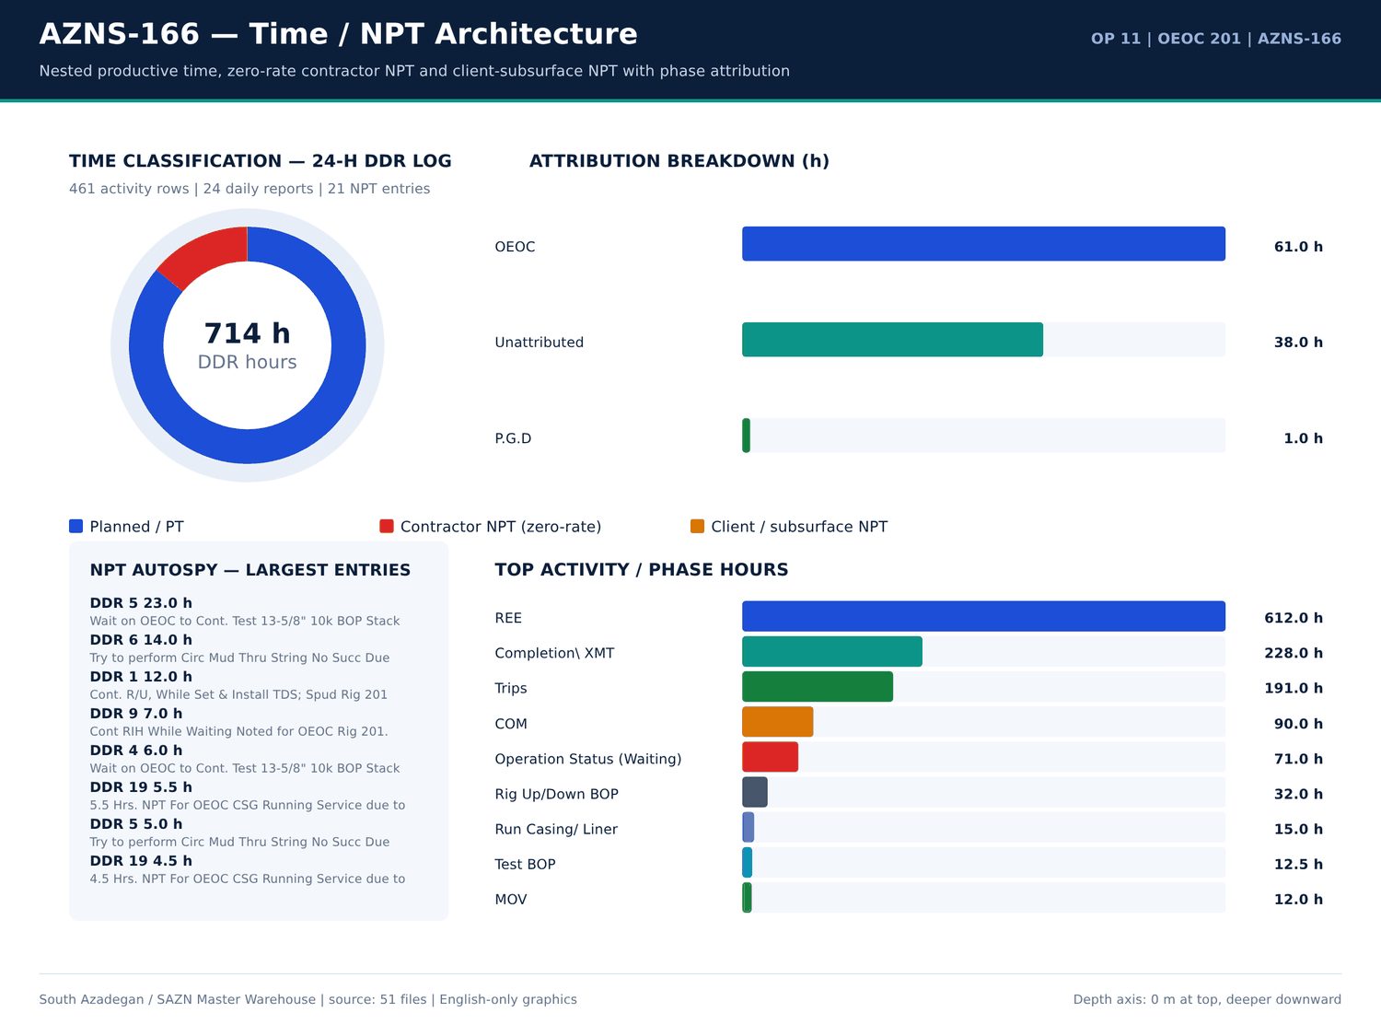
AZNS-166 01 time donut — منبع: انبار داده جامع سازن
سیاهه شیتها
سند | شیت | سطرها | ستونها | سلولهای پر | سلولهای عددی | سلولهای فرمولی | قالب | بخش
CBS/11.AZNS_166_CBS.xlsx | AZNS-166 WO | 60 | 19 | 568 | 376 | 264 | — | —
CBS/11.AZNS_166_CBS.xlsx | Total Cost-EPD | 19 | 7 | 100 | 68 | 27 | — | —
CBS/11.AZNS_166_CBS.xlsx | Rig-less Stimulation total cost | 16 | 6 | 45 | 27 | 14 | — | —
CBS/11.AZNS_166_CBS.xlsx | Total Cost-EPD & Rigless | 5 | 3 | 12 | 5 | 3 | — | —
CBS/11.AZNS_166_CBS.xlsx | Cost Breakdown-166 | 197 | 9 | 633 | 328 | 207 | — | —
CBS/11.AZNS_166_CBS.xlsx | Cost Breakdown-166 Contingecy | 183 | 20 | 850 | 483 | 359 | — | —
CBS/11.AZNS_166_CBS.xlsx | Cost Breakdown-Material-166 | 249 | 7 | 619 | 286 | 246 | — | —
CBS/11.AZNS_166_CBS.xlsx | Rig Move | 4 | 5 | 16 | 8 | 2 | — | —
CBS/11.AZNS_166_CBS.xlsx | Catering & Accommodation | 15 | 7 | 29 | 12 | 0 | — | —
CBS/11.AZNS_166_CBS.xlsx | Cost breakdown R-less Stim.-166 | 16 | 4 | 45 | 27 | 14 | — | —
CBS/11.AZNS_166_CBS.xlsx | Mob.& Demob for Stim.-166 | 21 | 6 | 113 | 69 | 18 | — | —
CBS/11.AZNS_166_CBS.xlsx | Material & Consumable-166 | 34 | 6 | 195 | 125 | 32 | — | —
CBS/11.AZNS_166_CBS.xlsx | Acidizing &N2 service-166 | 21 | 9 | 155 | 99 | 18 | — | —
CBS/11.AZNS_166_CBS.xlsx | Coil Tubing Service-166 | 14 | 9 | 67 | 33 | 10 | — | —
CBS/11.AZNS_166_CBS.xlsx | Oil Transportation Service-166 | 9 | 7 | 40 | 20 | 6 | — | —
CBS/11.AZNS_166_CBS.xlsx | Well testing and production-166 | 31 | 11 | 233 | 164 | 29 | — | —
CBS/11.AZNS_166_CBS.xlsx | Wireline production logging-166 | 18 | 10 | 139 | 93 | 11 | — | —
CBS/11.AZNS_166_CBS.xlsx | Slick line-166 | 17 | 11 | 113 | 77 | 14 | — | —
CBS/11.AZNS_166_CBS.xlsx | Memory gauge-166 | 5 | 11 | 27 | 13 | 3 | — | —
CBS/11.AZNS_166_CBS.xlsx | Bottom Hole PVT Samp.-166 | 8 | 11 | 43 | 25 | 5 | — | —
CBS/11.AZNS_166_CBS.xlsx | Personnel rate-166 | 28 | 12 | 220 | 176 | 26 | — | —
CBS/11.AZNS_166_CBS.xlsx | Design,Interp.,Reporting-166 | 8 | 8 | 37 | 20 | 6 | — | —

شناسنامه و ارقام کلیدی
معیار | مقدار | مبنا
Operation | AZNS-166 | Campaign map
Rig | OEOC 201 | DDR header
Contract | C2 | Contract register

گزییده نشانی سلولهای عددی — فصل 01
سند | شیت | سلول | مقدار
CBS/11.AZNS_166_CBS.xlsx | Total Cost-EPD & Rigless | R5C3 | 9,087,998.52
CBS/11.AZNS_166_CBS.xlsx | Total Cost-EPD | R19C7 | 8,275,165.08
CBS/11.AZNS_166_CBS.xlsx | Total Cost-EPD & Rigless | R3C3 | 8,275,165.08
CBS/11.AZNS_166_CBS.xlsx | Total Cost-EPD | R3C6 | 2,118,462.01
CBS/11.AZNS_166_CBS.xlsx | Total Cost-EPD | R3C7 | 2,118,462.01
CBS/11.AZNS_166_CBS.xlsx | Cost Breakdown-166 | R197C6 | 2,118,462.01
CBS/11.AZNS_166_CBS.xlsx | Total Cost-EPD | R7C6 | 1,214,816.28
CBS/11.AZNS_166_CBS.xlsx | Total Cost-EPD | R7C7 | 1,214,816.28
CBS/11.AZNS_166_CBS.xlsx | Cost Breakdown-166 Contingecy | R183C16 | 1,214,816.28
CBS/11.AZNS_166_CBS.xlsx | Total Cost-EPD | R12C6 | 1,173,960.00
CBS/11.AZNS_166_CBS.xlsx | Total Cost-EPD | R12C7 | 1,173,960.00
CBS/11.AZNS_166_CBS.xlsx | Cost Breakdown-Material-166 | R249C6 | 1,173,960.00
CBS/11.AZNS_166_CBS.xlsx | Total Cost-EPD | R13C6 | 1,092,550.00
CBS/11.AZNS_166_CBS.xlsx | Cost Breakdown-166 | R5C6 | 1,017,455.31

Chapter 02 — چهار مسیر زمان / هزینه و کسر NPT
چهار مسیر قراردادی عبارتاند از برنامه CBS برابر 9,087,999 دلار، ناخالص تقویمی 8,622,543 دلار، قابلپرداخت بدون NPT نرخ صفر پیمانکار 8,527,668 دلار و خالص مطلق بدون همه NPT برابر 8,526,710 دلار. جمع NPT منتسب 100.0 ساعت است که 99.0 ساعت پیمانکار و 1.0 ساعت کارفرما/زیرسطحی، با نرخ دکل 23,000 دلار در روز محاسبه شده است؛ ردیفهای زمان برنامه 614.0 ساعت است. کسورات تنها از ساعات NPT منتسب و نرخ منبع محاسبه میشود.
دفتر چهار مسیر هزینه
مسیر هزینه | دلار | مبنا
CBS plan | 9,087,999 | Total Cost-EPD ceiling
Gross calendar | 8,622,543 | CBS plan + calendar delta
Payable excl. contractor NPT | 8,527,668 | Gross - zero-rate NPT
Pure net excl. all NPT | 8,526,710 | Gross - all NPT

تفکیک انتساب NPT
دسته | ساعت | منتسب به | سهم (درصد)
OEOC | 61 | OEOC | 61
Unattributed | 38 | Unattributed | 38
P.G.D | 1 | P.G.D | 1

ساعات کدهای زمان DDR
کد | دسته | ساعت | شماره گزارش
20 | Operation Status (Waiting) | 24 | 5
23 | Completion\ XMT | 24 | 8
6 | Trips | 24 | 13
6 | Trips | 24 | 14
23 | Completion\ XMT | 24 | 22
23 | Completion\ XMT | 23 | 7
6 | Trips | 23 | 17
6 | Trips | 22 | 15
6 | Trips | 21.5 | 11
6 | Trips | 21.5 | 12
23 | Completion\ XMT | 21 | 2
6 | Trips | 21 | 10
23 | Completion\ XMT | 20.5 | 21
23 | Completion\ XMT | 19.5 | 23
6 | Trips | 18.5 | 18
23 | Completion\ XMT | 18.5 | 20
23 | Completion\ XMT | 18.5 | 24
23 | Completion\ XMT | 18 | 3
23 | Completion\ XMT | 17 | 9
15 | Rig Up/Down BOP | 16 | 4
6 | Trips | 15.5 | 16
20 | Operation Status (Waiting) | 14 | 6

گزییده نشانی سلولهای عددی — فصل 02
سند | شیت | سلول | مقدار
CBS/11.AZNS_166_CBS.xlsx | Total Cost-EPD & Rigless | R5C3 | 9,087,998.52
CBS/11.AZNS_166_CBS.xlsx | Total Cost-EPD | R19C7 | 8,275,165.08
CBS/11.AZNS_166_CBS.xlsx | Total Cost-EPD & Rigless | R3C3 | 8,275,165.08
CBS/11.AZNS_166_CBS.xlsx | Total Cost-EPD | R3C6 | 2,118,462.01
CBS/11.AZNS_166_CBS.xlsx | Total Cost-EPD | R3C7 | 2,118,462.01
CBS/11.AZNS_166_CBS.xlsx | Cost Breakdown-166 | R197C6 | 2,118,462.01
CBS/11.AZNS_166_CBS.xlsx | Total Cost-EPD | R7C6 | 1,214,816.28
CBS/11.AZNS_166_CBS.xlsx | Total Cost-EPD | R7C7 | 1,214,816.28
CBS/11.AZNS_166_CBS.xlsx | Cost Breakdown-166 Contingecy | R183C16 | 1,214,816.28
CBS/11.AZNS_166_CBS.xlsx | Total Cost-EPD | R12C6 | 1,173,960.00
CBS/11.AZNS_166_CBS.xlsx | Total Cost-EPD | R12C7 | 1,173,960.00
CBS/11.AZNS_166_CBS.xlsx | Cost Breakdown-Material-166 | R249C6 | 1,173,960.00
CBS/11.AZNS_166_CBS.xlsx | Total Cost-EPD | R13C6 | 1,092,550.00
CBS/11.AZNS_166_CBS.xlsx | Cost Breakdown-166 | R5C6 | 1,017,455.31

Chapter 03 — ممیزی تعرفهها و مواد CBS در برابر DDR و EOWR
کارپوشه CBS دارای 872 ردیف قیمتی برای AZNS-166 است؛ تراز روزانه مواد DDR و فصلهای تکمیل/سیمان/سیال EOWR ردیفبهردیف تطبیق داده شد. 66 ردیف تطبیق سهجانبه همراه قیمت واحد، مقدار، شیت و نشانی سلول هر قلم نگهداری شده است. هرجا ردیف CBS معادل مصرف DDR نداشته باشد، وضعیت صریحاً اعلام میشود و مقداری فرضی درج نمیگردد.
ردیفهای تعرفه قیمتی CBS
شیت | شرح | واحد | مقدار | قیمت واحد (دلار) | مبلغ (دلار) | سلول | فرمول
Total Cost-EPD | AZNS-166 well, De-Complete & Re-Complete with 7.5K Completion Equipment | — | 1 | 2,118,462.01 | 2,118,462.01 | G3 | —
Cost Breakdown-166 | — | — | — | — | 2,118,462.01 | F197 | —
Total Cost-EPD | Contingency 4 | — | 1 | 1,214,816.28 | 1,214,816.28 | G7 | —
Total Cost-EPD | Procurement for AZNS-166 | — | 1 | 1,173,960.00 | 1,173,960.00 | G12 | —
Cost Breakdown-Material-166 | — | — | — | — | 1,173,960.00 | F249 | —
Cost Breakdown-166 | Rig Service | DAY | 44.24 | 23,000.00 | 1,017,455.31 | F5 | —
Total Cost-EPD | Contingency 8 | — | 1 | 917,729.66 | 917,729.66 | G11 | —
Total Cost-EPD | Contingency 5 | — | 1 | 876,466.10 | 876,466.10 | G8 | —
Cost Breakdown-Material-166 | Tubular goods | — | — | — | 566,500.00 | F41 | —
Total Cost-EPD | Contingency 2 | — | 1 | 510,264.90 | 510,264.90 | G5 | —
Cost Breakdown-Material-166 | Wellhead & Xmas tree Equipment | — | — | — | 483,360.00 | F15 | —
Cost Breakdown-Material-166 | Tubing, 4 1/2", L80, 18.9 ppf, Premium Conn., Seamless, R2, PSL3. | m | 3,100.00 | 151 | 468,100.00 | F53 | —
Total Cost-EPD | Contingency 6 | — | 1 | 446,269.40 | 446,269.40 | G9 | —
Total Cost-EPD | Contingency 7 | — | 1 | 403,056.90 | 403,056.90 | G10 | —
Cost Breakdown-166 | Mud Chemicals for 8 1⁄2" hole | HOLE | 1 | 346,937.50 | 346,937.50 | F11 | —
Cost Breakdown-Material-166 | Section D | set | 1 | 341,275.00 | 341,275.00 | F30 | —
Total Cost-EPD | Contingency 1 | — | 1 | 254,628.45 | 254,628.45 | G4 | —
Cost Breakdown-166 Contingecy | — | — | — | — | 254,628.45 | F183 | —
Total Cost-EPD | Rig Moving (Pad to Pad) | — | 1 | 247,000.00 | 247,000.00 | G15 | —
Rig Move | Rig move between well pads | — | 1 | 247,000.00 | 247,000.00 | F3 | —
Cost Breakdown-Material-166 | Section C | set | 1 | 142,085.00 | 142,085.00 | F29 | —
Cost Breakdown-166 Contingecy | Rig Service | DAY | 5.5 | 23,000.00 | 126,500.00 | F5 | —

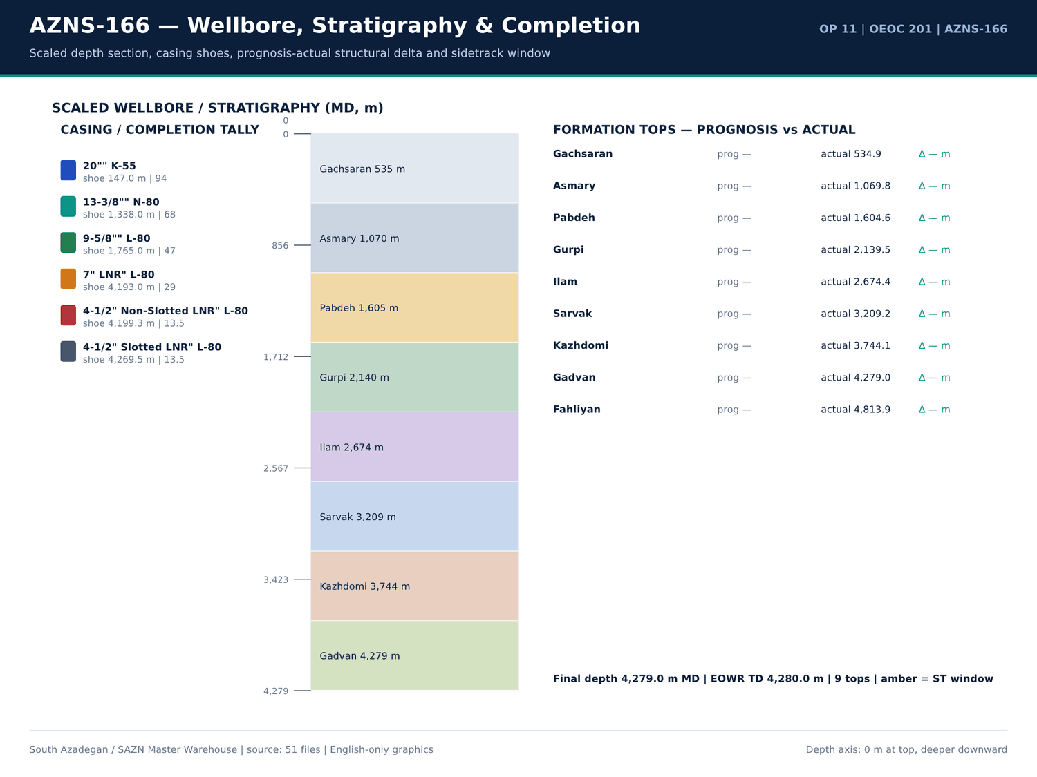
AZNS-166 02 wellbore — منبع: انبار داده جامع سازن
سقفهای هزینه CBS
شیت | قلم | مقدار | Unit cost | مبلغ (دلار) | Row
Total Cost-EPD | AZNS-166 well, De-Complete & Re-Complete with 7.5K Completion Equipment | 1 | 2,118,462.01 | 2,118,462.01 | 3
Total Cost-EPD | Contingency 1 | 1 | 254,628.45 | 254,628.45 | 4
Total Cost-EPD | Contingency 2 | 1 | 510,264.90 | 510,264.90 | 5
Total Cost-EPD | Contingency 3 | 1 | 112,511.38 | 112,511.38 | 6
Total Cost-EPD | Contingency 4 | 1 | 1,214,816.28 | 1,214,816.28 | 7
Total Cost-EPD | Contingency 5 | 1 | 876,466.10 | 876,466.10 | 8
Total Cost-EPD | Contingency 6 | 1 | 446,269.40 | 446,269.40 | 9
Total Cost-EPD | Contingency 7 | 1 | 403,056.90 | 403,056.90 | 10
Total Cost-EPD | Contingency 8 | 1 | 917,729.66 | 917,729.66 | 11
Total Cost-EPD | Procurement for AZNS-166 | 1 | 1,173,960.00 | 1,173,960.00 | 12
Total Cost-EPD | Rig mobilization | 0 | 1,092,550.00 | 0 | 13
Total Cost-EPD | Rig demobilization | 0 | 478,500.00 | 0 | 14
Total Cost-EPD | Rig Moving (Pad to Pad) | 1 | 247,000.00 | 247,000.00 | 15
Total Cost-EPD | Rig Moving (Celler to Celler) | 0 | 0 | 0 | 16
Total Cost-EPD | Mission cost | 0 | 150 | 0 | 17
Total Cost-EPD | Re-Entry, Completion & Procurement COST CEILING (USD) | — | — | 8,275,165.08 | 19
Total Cost-EPD | 1 | — | — | 2,118,462.01 | 3
Total Cost-EPD | Contingency 1 | — | — | 254,628.45 | 4
Total Cost-EPD | Contingency 2 | — | — | 510,264.90 | 5
Total Cost-EPD | Contingency 3 | — | — | 112,511.38 | 6
Total Cost-EPD | Contingency 4 | — | — | 1,214,816.28 | 7
Total Cost-EPD | Contingency 5 | — | — | 876,466.10 | 8

تطبیق سهجانبه
قلم | CBS (دلار) | مقدار DDR | واحد | وضعیت
3 3 4 mill | 26,000.00 | — | each | CBS only — no DDR consumption record
5 7 8 rock bit | 19,500.00 | — | each | CBS only — no DDR consumption record
6 mill | 32,500.00 | — | each | CBS only — no DDR consumption record
8 1 2 rock bit | 28,500.00 | — | each | CBS only — no DDR consumption record
acid chemical pump | 594 | — | 1 EA | CBS only — no DDR consumption record
acid mixing tanks | 5,950.00 | — | 1 EA | CBS only — no DDR consumption record
acid storage tanks | 5,950.00 | — | 1 EA | CBS only — no DDR consumption record
acid testing lab or acid testing costs in accredited lab | 2,565.00 | — | 1 EA | CBS only — no DDR consumption record
anti sludge agent | 1,275.00 | — | Gal | CBS only — no DDR consumption record
batch mixer | 34,000.00 | — | 1 EA | CBS only — no DDR consumption record
bentonite | — | 1 | — | DDR only — no CBS priced line
blender | 8,500.00 | — | 1 EA | CBS only — no DDR consumption record
booster pump | 594 | — | 1 EA | CBS only — no DDR consumption record
cacl2 85 | — | 87 | — | DDR only — no CBS priced line
cacl2 95 | — | 39 | — | DDR only — no CBS priced line
casing accessories | 17,600.00 | — | — | CBS only — no DDR consumption record
caustic soda | — | 12 | — | DDR only — no CBS priced line
corrosion inhibitor | 2,850.00 | — | Gal | CBS only — no DDR consumption record
corrosion inhibitor aid | 2,100.00 | — | Gal | CBS only — no DDR consumption record
corrosive fluid | 600 | — | BBL | CBS only — no DDR consumption record
crane with driver | 1,350.00 | — | 1 EA | CBS only — no DDR consumption record
crossover 4 1 2 18 9 ppf box 3 1 2 10 2 ppf pin gas tight conn l080 type1 1 2m long psl3 | 1,900.00 | — | ea. | CBS only — no DDR consumption record

گزییده نشانی سلولهای عددی — فصل 03
سند | شیت | سلول | مقدار
CBS/11.AZNS_166_CBS.xlsx | Total Cost-EPD & Rigless | R5C3 | 9,087,998.52
CBS/11.AZNS_166_CBS.xlsx | Total Cost-EPD | R19C7 | 8,275,165.08
CBS/11.AZNS_166_CBS.xlsx | Total Cost-EPD & Rigless | R3C3 | 8,275,165.08
CBS/11.AZNS_166_CBS.xlsx | Total Cost-EPD | R3C6 | 2,118,462.01
CBS/11.AZNS_166_CBS.xlsx | Total Cost-EPD | R3C7 | 2,118,462.01
CBS/11.AZNS_166_CBS.xlsx | Cost Breakdown-166 | R197C6 | 2,118,462.01
CBS/11.AZNS_166_CBS.xlsx | Total Cost-EPD | R7C6 | 1,214,816.28
CBS/11.AZNS_166_CBS.xlsx | Total Cost-EPD | R7C7 | 1,214,816.28
CBS/11.AZNS_166_CBS.xlsx | Cost Breakdown-166 Contingecy | R183C16 | 1,214,816.28
CBS/11.AZNS_166_CBS.xlsx | Total Cost-EPD | R12C6 | 1,173,960.00
CBS/11.AZNS_166_CBS.xlsx | Total Cost-EPD | R12C7 | 1,173,960.00
CBS/11.AZNS_166_CBS.xlsx | Cost Breakdown-Material-166 | R249C6 | 1,173,960.00
CBS/11.AZNS_166_CBS.xlsx | Total Cost-EPD | R13C6 | 1,092,550.00
CBS/11.AZNS_166_CBS.xlsx | Cost Breakdown-166 | R5C6 | 1,017,455.31

Chapter 04 — نقاط عطف، توقفهای بدون پیشروی و زمان پنهان
عمق تا 4,279.0 متر MD پیش رفت و 312.0 متر حفاری ۲۴ ساعته با ROP میانگین 9.00 متر بر ساعت ثبت شد؛ 0 گزارش DDR بدون پیشروی ثبتشدهاند و بهجای درونیابی، بهعنوان توقف تخت نگهداری میشوند. نقاط عطف، زمان پنهان و هزینه تجمعی بهتفکیک گزارش آمده است تا منحنی زمان–عمق مستقیماً بازسازی شود.
نقاط عطف زمان–عمق روزانه
شماره گزارش | تاریخ | عمق اندازهگیری (متر) | حفاری (متر) | ROP (متر/ساعت) | گل (PCF) | اندازه چاله | سازند
1 | 2025-Oct-27 | 4,279.00 | 13 | 9 | 83 | Estimated Final Depth MD (m): | 4-1/2" Non-Slotted LNR
2 | 2025-Oct-28 | 4,279.00 | 13 | 9 | 83 | Estimated Final Depth MD (m): | 4-1/2" Non-Slotted LNR
3 | 2025-Oct-29 | 4,279.00 | 13 | 9 | 83 | Estimated Final Depth MD (m): | 4-1/2" Non-Slotted LNR
4 | 2025-Oct-30 | 4,279.00 | 13 | 9 | 83 | Estimated Final Depth MD (m): | 4-1/2" Non-Slotted LNR
5 | 2025-Oct-31 | 4,279.00 | 13 | 9 | 83 | Estimated Final Depth MD (m): | 4-1/2" Non-Slotted LNR
6 | 2025-Nov-1 | 4,279.00 | 13 | 9 | 83 | Estimated Final Depth MD (m): | 4-1/2" Non-Slotted LNR
7 | 2025-Nov-2 | 4,279.00 | 13 | 9 | 83 | Estimated Final Depth MD (m): | 4-1/2" Non-Slotted LNR
8 | 2025-Nov-3 | 4,279.00 | 13 | 9 | 83 | Estimated Final Depth MD (m): | 4-1/2" Non-Slotted LNR
9 | 2025-Nov-4 | 4,279.00 | 13 | 9 | 83 | Estimated Final Depth MD (m): | 4-1/2" Non-Slotted LNR
10 | 2025-Nov-5 | 4,279.00 | 13 | 9 | 83 | Estimated Final Depth MD (m): | 4-1/2" Non-Slotted LNR
11 | 2025-Nov-6 | 4,279.00 | 13 | 9 | 83 | Estimated Final Depth MD (m): | 4-1/2" Non-Slotted LNR
12 | 2025-Nov-7 | 4,279.00 | 13 | 9 | 83 | Estimated Final Depth MD (m): | 4-1/2" Non-Slotted LNR
13 | 2025-Nov-8 | 4,279.00 | 13 | 9 | 83 | Estimated Final Depth MD (m): | 4-1/2" Non-Slotted LNR
14 | 2025-Nov-9 | 4,279.00 | 13 | 9 | 83 | Estimated Final Depth MD (m): | 4-1/2" Non-Slotted LNR
15 | 2025-Nov-10 | 4,279.00 | 13 | 9 | 83 | Estimated Final Depth MD (m): | 4-1/2" Non-Slotted LNR
16 | 2025-Nov-11 | 4,279.00 | 13 | 9 | 83 | Estimated Final Depth MD (m): | 4-1/2" Non-Slotted LNR
17 | 2025-Nov-12 | 4,279.00 | 13 | 9 | 83 | Estimated Final Depth MD (m): | 4-1/2" Non-Slotted LNR
18 | 2025-Nov-13 | 4,279.00 | 13 | 9 | 83 | Estimated Final Depth MD (m): | 4-1/2" Non-Slotted LNR
19 | 2025-Nov-14 | 4,279.00 | 13 | 9 | 83 | Estimated Final Depth MD (m): | 4-1/2" Non-Slotted LNR
20 | 2025-Nov-15 | 4,279.00 | 13 | 9 | 83 | Estimated Final Depth MD (m): | 4-1/2" Non-Slotted LNR
21 | 2025-Nov-16 | 4,279.00 | 13 | 9 | 83 | Estimated Final Depth MD (m): | 4-1/2" Non-Slotted LNR
22 | 2025-Nov-17 | 4,279.00 | 13 | 9 | 83 | Estimated Final Depth MD (m): | 4-1/2" Non-Slotted LNR

توقفهای بدون پیشروی
شماره گزارش | تاریخ | عمق اندازهگیری (متر) | NPT (ساعت) | PT (ساعت) | هزینه تجمعی (دلار)
No source rows for this query | — | — | — | — | —

هزینه تجمعی بهتفکیک گزارش
شماره گزارش | تاریخ | عمق اندازهگیری (متر) | NPT (ساعت) | PT (ساعت) | هزینه تجمعی (دلار)
1 | 2025-Oct-27 | 4,279.00 | 12 | 18 | 23,000.00
2 | 2025-Oct-28 | 4,279.00 | 0 | 30 | 46,000.00
3 | 2025-Oct-29 | 4,279.00 | 0 | 30 | 69,000.00
4 | 2025-Oct-30 | 4,279.00 | 6 | 24 | 92,000.00
5 | 2025-Oct-31 | 4,279.00 | 29 | 1 | 115,000.00
6 | 2025-Nov-1 | 4,279.00 | 14 | 16 | 138,000.00
7 | 2025-Nov-2 | 4,279.00 | 1 | 29 | 161,000.00
8 | 2025-Nov-3 | 4,279.00 | 0 | 30 | 184,000.00
9 | 2025-Nov-4 | 4,279.00 | 7 | 23 | 207,000.00
10 | 2025-Nov-5 | 4,279.00 | 3 | 27 | 230,000.00
11 | 2025-Nov-6 | 4,279.00 | 2 | 28 | 253,000.00
12 | 2025-Nov-7 | 4,279.00 | 0 | 30 | 276,000.00
13 | 2025-Nov-8 | 4,279.00 | 0 | 30 | 299,000.00
14 | 2025-Nov-9 | 4,279.00 | 0 | 30 | 322,000.00
15 | 2025-Nov-10 | 4,279.00 | 0 | 30 | 345,000.00
16 | 2025-Nov-11 | 4,279.00 | 0 | 30 | 368,000.00
17 | 2025-Nov-12 | 4,279.00 | 0 | 30 | 391,000.00
18 | 2025-Nov-13 | 4,279.00 | 0 | 30 | 414,000.00
19 | 2025-Nov-14 | 4,279.00 | 15.5 | 14.5 | 437,000.00
20 | 2025-Nov-15 | 4,279.00 | 7 | 23 | 460,000.00
21 | 2025-Nov-16 | 4,279.00 | 3.5 | 26.5 | 483,000.00
22 | 2025-Nov-17 | 4,279.00 | 0 | 30 | 506,000.00

گزییده نشانی سلولهای عددی — فصل 04
سند | شیت | سلول | مقدار
CBS/11.AZNS_166_CBS.xlsx | Total Cost-EPD & Rigless | R5C3 | 9,087,998.52
CBS/11.AZNS_166_CBS.xlsx | Total Cost-EPD | R19C7 | 8,275,165.08
CBS/11.AZNS_166_CBS.xlsx | Total Cost-EPD & Rigless | R3C3 | 8,275,165.08
CBS/11.AZNS_166_CBS.xlsx | Total Cost-EPD | R3C6 | 2,118,462.01
CBS/11.AZNS_166_CBS.xlsx | Total Cost-EPD | R3C7 | 2,118,462.01
CBS/11.AZNS_166_CBS.xlsx | Cost Breakdown-166 | R197C6 | 2,118,462.01
CBS/11.AZNS_166_CBS.xlsx | Total Cost-EPD | R7C6 | 1,214,816.28
CBS/11.AZNS_166_CBS.xlsx | Total Cost-EPD | R7C7 | 1,214,816.28
CBS/11.AZNS_166_CBS.xlsx | Cost Breakdown-166 Contingecy | R183C16 | 1,214,816.28
CBS/11.AZNS_166_CBS.xlsx | Total Cost-EPD | R12C6 | 1,173,960.00
CBS/11.AZNS_166_CBS.xlsx | Total Cost-EPD | R12C7 | 1,173,960.00
CBS/11.AZNS_166_CBS.xlsx | Cost Breakdown-Material-166 | R249C6 | 1,173,960.00
CBS/11.AZNS_166_CBS.xlsx | Total Cost-EPD | R13C6 | 1,092,550.00
CBS/11.AZNS_166_CBS.xlsx | Cost Breakdown-166 | R5C6 | 1,017,455.31

Chapter 05 — گزارش فعالیت ۲۴ ساعته و کدهای عملیاتی
تعداد 461 ردیف فعالیت ۲۴ ساعته مجزا برای AZNS-166 استخراج شد که هر یک فاز، کد، زیرکد، وضعیت PLN/NPT، طرف مسئول و مدت دارد. جداول زیر لاگ خام فعالیت، توزیع کدها و ماتریس ساعات فاز بر وضعیت را عیناً بازتولید میکنند؛ هیچ فعالیتی ادغام یا گرد نشده است.
لاگ خام فعالیت ۲۴ ساعته
شماره گزارش | Seq | فاز | کد | وضعیت | منتسب به | ساعت | شرح
1 | 1 | MOV | 1 | NPT | — | 12 | Cont. R/U, While Set & Install TDS; Spud Rig 201 as per Prespud Check List @ 1404.08.05 - 12:00
1 | 2 | REE | 12 | PLN | — | 12 | L/U 4" 10k psi Co-Flex Hose F/ Choke Manifold outlet To X-Mas Tree Production Valve; L/U 2" Chicksan Flowline F/ Pump Unit discharge
1 | 3 | — | — | — | — | — | To T.H.S side outlet; Set Storage Tank & Conn. To Burning Line;
1 | 4 | — | — | — | — | — | Check & Record Annulus pressures of all Wellhead sections as follows:
1 | 5 | — | — | — | — | — | Section A – 0 psi / 15 min; Section B – 0 psi / 15 min; Section C – 0 psi / 15 min; All wellhead sections confirmed pressure-free and stable.
1 | 6 | — | — | — | — | — | Press. Test P-Seal Test of B & C Section as follows:
1 | 7 | — | — | — | — | — | Section B (13-3/8" P-Seal) – 1500 psi / 15 min; Section C (9-5/8" P-Seal) tested @ 2500 psi / 15 min – Press. Test between two P-Seals OK,
1 | 8 | — | — | — | — | — | but Press. Test between lower P-Seal & CSG HGR failed; Press. Test Chiksan Pipes & Co-Flex Hose W/ 7000psi / 15 min, Ok;
1 | 9 | — | — | — | — | — | P/U & M/U Wellhead Lubricator on X-Mas Tree, Press. Test the same W/ 4000psi / 15min.
1 | 10 | — | — | — | — | — | Arr. of Vira Mud Engineer & Unit @ 1404.07.30 - 12:00
1 | 11 | — | — | — | — | — | Rec. Petro Sanaat Atras Jonoub H2S Unit @ 1404.07.30 - 16:00
1 | 12 | — | — | — | — | — | Arr. of Petro Sanaat Atras Jonoub H2S Crew @ 1404.08.03 - 14:00
1 | 13 | — | — | — | — | — | Rec. Mud Logging Unit & Crew @ 1404.08.03 - 15:00
1 | 14 | — | — | — | — | — | Rec. OEOC Slickline Crew & Unit @ 1404.08.03 - 16:30
1 | 15 | — | — | — | — | — | Rec. OEOC Wellhead Crew & Tools @ 1404.08.03 - 16:45
1 | 16 | — | — | — | — | — | Arr. of SPAD Energy Crew & Pump Unit @ 1404.08.04 - 00:30
1 | 17 | — | — | — | — | — | Arr. of PEDEC Security Crew & Explosive material @ 1404.08.04 - 19:00
1 | 18 | — | — | — | — | — | Rec. Storage Tank @ 1404.08.05 - 16:00
1 | 19 | — | — | — | — | — | Arr. of OEOC Coiled Tubing Crew & Unit @ 1404.08.05 - 17:00
1 | 20 | Main Phase | Code | Status | NPT/ Unplan Attributed | — | Rig Activity Type
1 | 21 | REE | 12 | PLN | — | 6 | Ret. TWCV W/ Wellhead Lubricator, While Record 800psi Pressure on Wellhead Lubricator Press. Gauge; L/D Wellhead Lubricator
1 | 22 | — | — | — | — | — | and X-Mas Tree Cap; Flush Solid Block upper valves W/ 10bbl Drill Water.

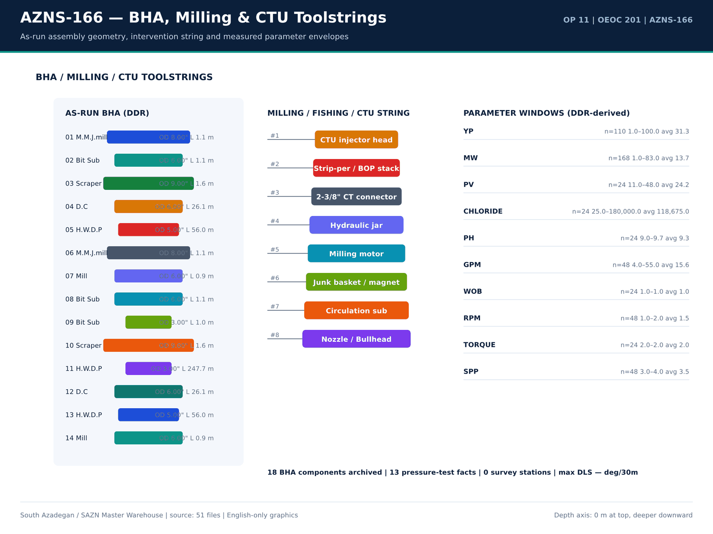
AZNS-166 03 bha — منبع: انبار داده جامع سازن
توزیع کدهای فعالیت
کد | ساعت | تعداد
23 | 283.5 | 62
6 | 237.5 | 28
20 | 88 | 20
15 | 43.5 | 6
12 | 21 | 3
5 | 13 | 5
16 | 12.5 | 2
1 | 12 | 1
9 | 2.5 | 2
21 | 0.5 | 1

ماتریس ساعات فاز بر وضعیت
فاز | وضعیت | ساعت | تعداد
REE | PLN | 524 | 86
COM | PLN | 90 | 23
REE | NPT | 84 | 17
MOV | NPT | 12 | 1
REE | NPT-UNPLN | 4 | 3

گزییده نشانی سلولهای عددی — فصل 05
سند | شیت | سلول | مقدار
CBS/11.AZNS_166_CBS.xlsx | Total Cost-EPD & Rigless | R5C3 | 9,087,998.52
CBS/11.AZNS_166_CBS.xlsx | Total Cost-EPD | R19C7 | 8,275,165.08
CBS/11.AZNS_166_CBS.xlsx | Total Cost-EPD & Rigless | R3C3 | 8,275,165.08
CBS/11.AZNS_166_CBS.xlsx | Total Cost-EPD | R3C6 | 2,118,462.01
CBS/11.AZNS_166_CBS.xlsx | Total Cost-EPD | R3C7 | 2,118,462.01
CBS/11.AZNS_166_CBS.xlsx | Cost Breakdown-166 | R197C6 | 2,118,462.01
CBS/11.AZNS_166_CBS.xlsx | Total Cost-EPD | R7C6 | 1,214,816.28
CBS/11.AZNS_166_CBS.xlsx | Total Cost-EPD | R7C7 | 1,214,816.28
CBS/11.AZNS_166_CBS.xlsx | Cost Breakdown-166 Contingecy | R183C16 | 1,214,816.28
CBS/11.AZNS_166_CBS.xlsx | Total Cost-EPD | R12C6 | 1,173,960.00
CBS/11.AZNS_166_CBS.xlsx | Total Cost-EPD | R12C7 | 1,173,960.00
CBS/11.AZNS_166_CBS.xlsx | Cost Breakdown-Material-166 | R249C6 | 1,173,960.00
CBS/11.AZNS_166_CBS.xlsx | Total Cost-EPD | R13C6 | 1,092,550.00
CBS/11.AZNS_166_CBS.xlsx | Cost Breakdown-166 | R5C6 | 1,017,455.31

Chapter 06 — پارتو NPT و کالبدشکافی رویدادها
تعداد 3 خانواده مسئله برای AZNS-166 بازسازی شد. هر خانواده تعداد رخداد، ساعات، عمق، سازند، طرف مسئول، دستکم دو فرضیه مهندسی، مواجهه کمیشده و دستورالعمل ۶۰ ثانیهای دارد. جداول پارتو این خانوادهها را بر پایه ساعات و مواجهه هزینهای با نرخ دکل منبع رتبهبندی میکنند.
خانوادههای مسئله بازسازی شده
دسته | Days | عمق (متر) | سازند | عنوان | ساعت | هزینه (دلار) | شاهد عددی
Other operational delay | 1,5,6,14,19,20,21 | 4,279.00 | 4-1/2" Non-Slotted LNR | Other operational delay — 18 occurrences | 53 | 50,791.67 | DDR 24-h log / remarks
Rig equipment failure | 4,5 | 4,279.00 | 4-1/2" Non-Slotted LNR | Rig equipment failure — 2 occurrences | 29 | 27,791.67 | DDR 24-h log / remarks
Waiting on services / material | 3,4,5,6,7,9,10,11 | 4,279.00 | 4-1/2" Non-Slotted LNR | Waiting on services / material — 18 occurrences | 18 | 17,250.00 | DDR 24-h log / remarks

پارتو NPT بر پایه ساعات
دسته | ساعت | منتسب به | سهم (درصد)
OEOC | 61 | OEOC | 61
Unattributed | 38 | Unattributed | 38
P.G.D | 1 | P.G.D | 1

بزرگترین ردیفهای NPT منفرد
شماره گزارش | ساعت | منتسب به | شرح
8 | 24 | — | Cont. POOH & L/D Completion String to 50m While f/u well continuously, NL-NG.
5 | 23 | OEOC | Wait on OEOC to Cont. Test 13-5/8" 10k BOP Stack While Work on fixing BOP leakages as Below:
7 | 23 | — | As Client Request ( P.P.L ), Cont. POOH with 2 Jts 4-1/2" TBG ( 18.9PPF, TPG2 BOX * PIN ), OBS 15-30klb over pull @ 2759-2758.3m
17 | 23 | — | Start POOH from 4132m ( 4-1/2" L.Lap ) to 1376m while L/D 5" D.Pipe ( Jt by Jt ) & 3-1/2" D.Pipe ( Jt by Jt ) & F/U the well with CaCl2
14 | 20 | — | Cont. Run in hole by 5" D.Pipe from 2800m to 3100m while F/U string & break Circulate each 15 STD, NL.NG.
18 | 18.5 | — | Cont. POOH 6" Clean out BHA F/ 1376m To surface On Elevator, While L/D All Tubular ( Jt by Jt ) & 6" Mill (10% Used, same as RIH
2 | 18 | — | Prepare Rig To Kill the Well W/ Coiled Tubing; R/U Coiled Tubing Facilities as follows:
24 | 18 | — | Press. Test M.M.Seal @ 6,000 Psi / 15 Min – Ok;
21 | 17.5 | — | Cont. RIH W/ 3-1/2" * 4-1/2" 7.5k Comp. Strg F/ 1671 To 2640m, While Clean & Wash all Connections; Use Thread Seal Compound, and
4 | 16 | — | Cont. N/U 13-5/8" 10k BOP Stack.
13 | 16 | — | P/U & Run in hole W/ NEW 3-1/2" M.M.J.Mill ( T.S.E.KH, SN : 084 ) + 15 Jts 3-1/8" D.C ( Jt by Jt ) + R/U 2-7/8 "D.Pipe handling tools and RIH
6 | 14 | OEOC | Try to perform Circ Mud Thru String No Succ Due to Observe Leakage TDS Kelly Hose .
12 | 13.5 | — | Cont RIH with 6" Junk Mill ( T.S.E.KH ) + 27 jts 3-1/2" HWDP (Jt by Jt ) + 3-1/2" D.Pipe ( Jt by Jt ) + 4.3/4" D.PIN + 4 3/4" Bit Sub ( Float In ) +
11 | 13 | — | Cont RIH with 6" Junk Mill ( T.S.E.KH ) + 27 jts 3-1/2" HWDP (Jt by Jt ) & Follow by 3-1/2" D.Pipe ( Jt by Jt ) from 1153m to 2540m for Cleaning
16 | 13 | — | Cont RIH with 6" M.M.J.mill ( 5% Used / T.S.E.KH ) + 4 3/4" Bit Sub ( F. In ) + HWDP 3 1/2" & Follow by 3 1/2" DP to 1608m ( 7" L.Lap )
1 | 12 | — | Cont. R/U, While Set & Install TDS; Spud Rig 201 as per Prespud Check List @ 1404.08.05 - 12:00
1 | 12 | — | L/U 4" 10k psi Co-Flex Hose F/ Choke Manifold outlet To X-Mas Tree Production Valve; L/U 2" Chicksan Flowline F/ Pump Unit discharge
9 | 11 | — | Cont. Run in hole with 127 Jts 5" D.pipe ( Jts by Jts ) from 100 To 1360m W F/U String every 20 Jts.
15 | 9.5 | — | Cont. POOH To 200m. Change the handling tools and Cont. POOH while L/D 2STD 2-7/8" D.Pipe & 5 STD 3-1/8" D.c ( jt by jt ).
22 | 9.5 | — | P/U & M/U G.FLG + 4-1/16" 10K Gate Valve + Slickline BOP + Lubricator & BOP Panel; Test BOP, Ok; R/D Mouse Hole; R/U Surface
19 | 9 | — | Cont. RIH W/ 3-1/2" * 4-1/2" 7.5k Comp. Strg F/ 72 To 676m, While Clean & Wash all Connections; Use Thread Seal Compound, and
20 | 9 | — | Cont. RIH W/ 3-1/2" * 4-1/2" 7.5k Comp. Strg F/ 676 To 1223m, While Clean & Wash all Connections; Use Thread Seal Compound, and

گزییده نشانی سلولهای عددی — فصل 06
سند | شیت | سلول | مقدار
CBS/11.AZNS_166_CBS.xlsx | Total Cost-EPD & Rigless | R5C3 | 9,087,998.52
CBS/11.AZNS_166_CBS.xlsx | Total Cost-EPD | R19C7 | 8,275,165.08
CBS/11.AZNS_166_CBS.xlsx | Total Cost-EPD & Rigless | R3C3 | 8,275,165.08
CBS/11.AZNS_166_CBS.xlsx | Total Cost-EPD | R3C6 | 2,118,462.01
CBS/11.AZNS_166_CBS.xlsx | Total Cost-EPD | R3C7 | 2,118,462.01
CBS/11.AZNS_166_CBS.xlsx | Cost Breakdown-166 | R197C6 | 2,118,462.01
CBS/11.AZNS_166_CBS.xlsx | Total Cost-EPD | R7C6 | 1,214,816.28
CBS/11.AZNS_166_CBS.xlsx | Total Cost-EPD | R7C7 | 1,214,816.28
CBS/11.AZNS_166_CBS.xlsx | Cost Breakdown-166 Contingecy | R183C16 | 1,214,816.28
CBS/11.AZNS_166_CBS.xlsx | Total Cost-EPD | R12C6 | 1,173,960.00
CBS/11.AZNS_166_CBS.xlsx | Total Cost-EPD | R12C7 | 1,173,960.00
CBS/11.AZNS_166_CBS.xlsx | Cost Breakdown-Material-166 | R249C6 | 1,173,960.00
CBS/11.AZNS_166_CBS.xlsx | Total Cost-EPD | R13C6 | 1,092,550.00
CBS/11.AZNS_166_CBS.xlsx | Cost Breakdown-166 | R5C6 | 1,017,455.31

Chapter 07 — کارنامه متهها، درجه سایش و هزینه هر متر
کارنامه متهها و ابزارهای حفاری از ردیفهای تعرفه CBS، شیتهای مته/BHA در DDR و فصل کارنامه مته EOWR گرفته شده است. هزینه هر متر حفاری از محدوده 9,087,999 دلار و 312.0 متر فوتیج ثبتشده تشکیل میشود؛ هرگاه حفر چاله جدیدی ثبت نشده باشد، جدول مبنای workover را اعلام میکند و بر مخرج فرضی تقسیم نمیکند.
ردیفهای مته و ابزار حفاری
شیت | شرح | واحد | مقدار | قیمت واحد (دلار) | مبلغ (دلار)
Cost Breakdown-Material-166 | Drilling Bit &mill | — | — | — | 106,500.00
Cost Breakdown-Material-166 | 8 1/2" Rock Bit | each | 3 | 9,500.00 | 28,500.00
Cost Breakdown-Material-166 | 5 7/8" Rock Bit | each | 3 | 6,500.00 | 19,500.00
Material & Consumable-166 | Corrosion Inhibitor | Gal | 50 | 57 | 2,850.00
Material & Consumable-166 | Corrosion Inhibitor Aid | Gal | 70 | 30 | 2,100.00
Material & Consumable-166 | Iron Stabilizer | Gal | 40 | 30 | 1,200.00
Cost Breakdown-166 | Drilling Bit & mill | SET | — | — | 0
Cost Breakdown-Material-166 | Float shoe, reamer type, 7", 29 32#, L80 110S, PREMIUM connection, PDC drillable | ea. | — | — | 0
Cost Breakdown-Material-166 | Float shoe, reamer type, 7", 29#, L80, 9CR01 MO, PREMIUM connection, PDC drillable | ea. | — | — | 0
Cost Breakdown-Material-166 | Float shoe, reamer type, 7", 32#, 110S,PREMIUM connection, PDC drillable | ea. | — | — | 0
Cost Breakdown-Material-166 | Float shoe, reamer type, 5 " 18# ,110S,PREMIUM connection, PDC drillable | ea. | — | — | 0
Cost Breakdown-Material-166 | Float shoe, reamer type, 5" 18 23# x 9 5/8" 47 53.5#, 110S, PREMIUM connection, PDC drillable | ea. | — | — | 0
Cost Breakdown-Material-166 | Guide shoe, reamer type, 4 1/2", 13.5#, L80,BTC connection | ea. | — | — | 0
Cost Breakdown-Material-166 | 12 1/4" Rock Bit | each | — | — | 0
Cost Breakdown-Material-166 | 12 1/4" PDC Bit | each | — | — | 0
Cost Breakdown-Material-166 | 8 1/2" PDC Bit | each | — | — | 0
Cost Breakdown-Material-166 | 6 1/8" PDC Bit | each | — | — | 0
Material & Consumable-166 | Clay Stabilizer | Gal | 0 | 22.5 | 0
AZNS-166 WO | RIH with 8 1⁄2" bit and clean out BHA (P/U DP's JT by JT) to 7" L.LAP (1608.2m), CBU, POOH. | — | — | — | —
Cost Breakdown-166 Contingecy | Drilling Bit & mill | SET | — | 6,500.00 | —

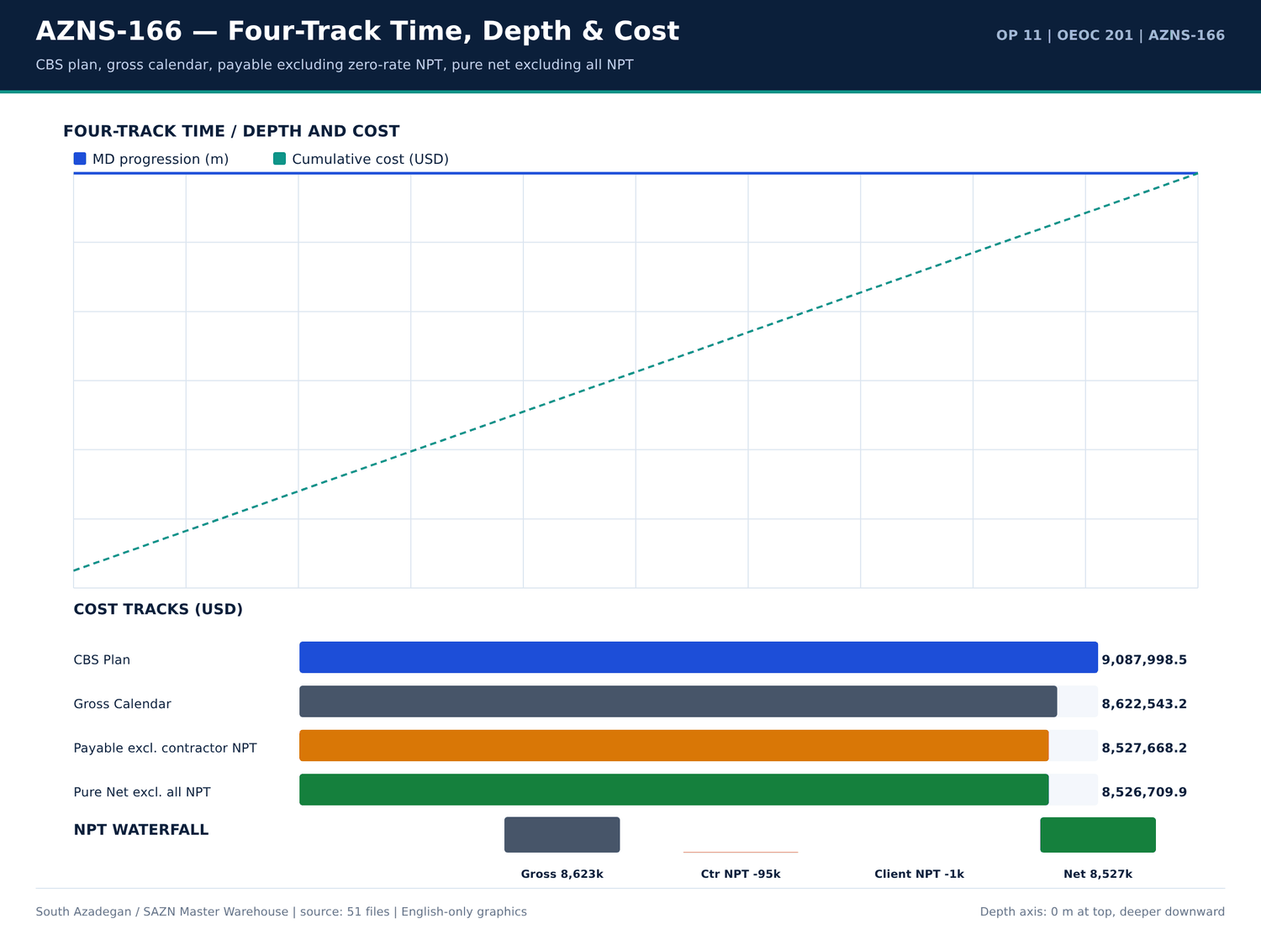
AZNS-166 04 fourtrack — منبع: انبار داده جامع سازن
کارنامه روزانه ROP و فوتیج
شماره گزارش | تاریخ | عمق اندازهگیری (متر) | حفاری (متر) | ROP (متر/ساعت) | گل (PCF) | سازند
1 | 2025-Oct-27 | 4,279.00 | 13 | 9 | 83 | 4-1/2" Non-Slotted LNR
2 | 2025-Oct-28 | 4,279.00 | 13 | 9 | 83 | 4-1/2" Non-Slotted LNR
3 | 2025-Oct-29 | 4,279.00 | 13 | 9 | 83 | 4-1/2" Non-Slotted LNR
4 | 2025-Oct-30 | 4,279.00 | 13 | 9 | 83 | 4-1/2" Non-Slotted LNR
5 | 2025-Oct-31 | 4,279.00 | 13 | 9 | 83 | 4-1/2" Non-Slotted LNR
6 | 2025-Nov-1 | 4,279.00 | 13 | 9 | 83 | 4-1/2" Non-Slotted LNR
7 | 2025-Nov-2 | 4,279.00 | 13 | 9 | 83 | 4-1/2" Non-Slotted LNR
8 | 2025-Nov-3 | 4,279.00 | 13 | 9 | 83 | 4-1/2" Non-Slotted LNR
9 | 2025-Nov-4 | 4,279.00 | 13 | 9 | 83 | 4-1/2" Non-Slotted LNR
10 | 2025-Nov-5 | 4,279.00 | 13 | 9 | 83 | 4-1/2" Non-Slotted LNR
11 | 2025-Nov-6 | 4,279.00 | 13 | 9 | 83 | 4-1/2" Non-Slotted LNR
12 | 2025-Nov-7 | 4,279.00 | 13 | 9 | 83 | 4-1/2" Non-Slotted LNR
13 | 2025-Nov-8 | 4,279.00 | 13 | 9 | 83 | 4-1/2" Non-Slotted LNR
14 | 2025-Nov-9 | 4,279.00 | 13 | 9 | 83 | 4-1/2" Non-Slotted LNR
15 | 2025-Nov-10 | 4,279.00 | 13 | 9 | 83 | 4-1/2" Non-Slotted LNR
16 | 2025-Nov-11 | 4,279.00 | 13 | 9 | 83 | 4-1/2" Non-Slotted LNR
17 | 2025-Nov-12 | 4,279.00 | 13 | 9 | 83 | 4-1/2" Non-Slotted LNR
18 | 2025-Nov-13 | 4,279.00 | 13 | 9 | 83 | 4-1/2" Non-Slotted LNR
19 | 2025-Nov-14 | 4,279.00 | 13 | 9 | 83 | 4-1/2" Non-Slotted LNR
20 | 2025-Nov-15 | 4,279.00 | 13 | 9 | 83 | 4-1/2" Non-Slotted LNR
21 | 2025-Nov-16 | 4,279.00 | 13 | 9 | 83 | 4-1/2" Non-Slotted LNR
22 | 2025-Nov-17 | 4,279.00 | 13 | 9 | 83 | 4-1/2" Non-Slotted LNR

یادداشتهای مته و BHA
شماره گزارش | شیت | دسته | Text
No source rows for this query | — | — | —

گزییده نشانی سلولهای عددی — فصل 07
سند | شیت | سلول | مقدار
CBS/11.AZNS_166_CBS.xlsx | Total Cost-EPD & Rigless | R5C3 | 9,087,998.52
CBS/11.AZNS_166_CBS.xlsx | Total Cost-EPD | R19C7 | 8,275,165.08
CBS/11.AZNS_166_CBS.xlsx | Total Cost-EPD & Rigless | R3C3 | 8,275,165.08
CBS/11.AZNS_166_CBS.xlsx | Total Cost-EPD | R3C6 | 2,118,462.01
CBS/11.AZNS_166_CBS.xlsx | Total Cost-EPD | R3C7 | 2,118,462.01
CBS/11.AZNS_166_CBS.xlsx | Cost Breakdown-166 | R197C6 | 2,118,462.01
CBS/11.AZNS_166_CBS.xlsx | Total Cost-EPD | R7C6 | 1,214,816.28
CBS/11.AZNS_166_CBS.xlsx | Total Cost-EPD | R7C7 | 1,214,816.28
CBS/11.AZNS_166_CBS.xlsx | Cost Breakdown-166 Contingecy | R183C16 | 1,214,816.28
CBS/11.AZNS_166_CBS.xlsx | Total Cost-EPD | R12C6 | 1,173,960.00
CBS/11.AZNS_166_CBS.xlsx | Total Cost-EPD | R12C7 | 1,173,960.00
CBS/11.AZNS_166_CBS.xlsx | Cost Breakdown-Material-166 | R249C6 | 1,173,960.00
CBS/11.AZNS_166_CBS.xlsx | Total Cost-EPD | R13C6 | 1,092,550.00
CBS/11.AZNS_166_CBS.xlsx | Cost Breakdown-166 | R5C6 | 1,017,455.31

Chapter 08 — ROP، MSE و همبستگی پارامترها
ROP میانگین 9.00 متر بر ساعت با باند وزن گل 83.0 تا 83.0 PCF است. جداول همبستگی، ROP روزانه، MW، بازه حفاری، اندازه چاله و سازند را از همان گزارش DDR بههم میپیوندند. بیشینه DLS محاسبهشده بهروش انحنای کمینه — درجه بر ۳۰ متر است.
ردیفهای توزیع ROP
شماره گزارش | ROP (متر/ساعت) | حفاری (متر) | گل (PCF) | اندازه چاله | سازند
1 | 9 | 13 | 83 | Estimated Final Depth MD (m): | 4-1/2" Non-Slotted LNR
2 | 9 | 13 | 83 | Estimated Final Depth MD (m): | 4-1/2" Non-Slotted LNR
3 | 9 | 13 | 83 | Estimated Final Depth MD (m): | 4-1/2" Non-Slotted LNR
4 | 9 | 13 | 83 | Estimated Final Depth MD (m): | 4-1/2" Non-Slotted LNR
5 | 9 | 13 | 83 | Estimated Final Depth MD (m): | 4-1/2" Non-Slotted LNR
6 | 9 | 13 | 83 | Estimated Final Depth MD (m): | 4-1/2" Non-Slotted LNR
7 | 9 | 13 | 83 | Estimated Final Depth MD (m): | 4-1/2" Non-Slotted LNR
8 | 9 | 13 | 83 | Estimated Final Depth MD (m): | 4-1/2" Non-Slotted LNR
9 | 9 | 13 | 83 | Estimated Final Depth MD (m): | 4-1/2" Non-Slotted LNR
10 | 9 | 13 | 83 | Estimated Final Depth MD (m): | 4-1/2" Non-Slotted LNR
11 | 9 | 13 | 83 | Estimated Final Depth MD (m): | 4-1/2" Non-Slotted LNR
12 | 9 | 13 | 83 | Estimated Final Depth MD (m): | 4-1/2" Non-Slotted LNR
13 | 9 | 13 | 83 | Estimated Final Depth MD (m): | 4-1/2" Non-Slotted LNR
14 | 9 | 13 | 83 | Estimated Final Depth MD (m): | 4-1/2" Non-Slotted LNR
15 | 9 | 13 | 83 | Estimated Final Depth MD (m): | 4-1/2" Non-Slotted LNR
16 | 9 | 13 | 83 | Estimated Final Depth MD (m): | 4-1/2" Non-Slotted LNR
17 | 9 | 13 | 83 | Estimated Final Depth MD (m): | 4-1/2" Non-Slotted LNR
18 | 9 | 13 | 83 | Estimated Final Depth MD (m): | 4-1/2" Non-Slotted LNR
19 | 9 | 13 | 83 | Estimated Final Depth MD (m): | 4-1/2" Non-Slotted LNR
20 | 9 | 13 | 83 | Estimated Final Depth MD (m): | 4-1/2" Non-Slotted LNR
21 | 9 | 13 | 83 | Estimated Final Depth MD (m): | 4-1/2" Non-Slotted LNR
22 | 9 | 13 | 83 | Estimated Final Depth MD (m): | 4-1/2" Non-Slotted LNR

پنجرههای پارامتری اندازهگیری
پارامتر | تعداد | کمینه | میانگین | میانه | بیشینه
WOB / RPM / SPP / GPM windows are stored in the profile JSON | 461 | — | — | — | —

مجموعه همبستگی ROP و MW
شماره گزارش | ROP (متر/ساعت) | گل (PCF) | حفاری (متر) | FIT EMW
1 | 9 | 83 | 13 | —
2 | 9 | 83 | 13 | —
3 | 9 | 83 | 13 | —
4 | 9 | 83 | 13 | —
5 | 9 | 83 | 13 | —
6 | 9 | 83 | 13 | —
7 | 9 | 83 | 13 | —
8 | 9 | 83 | 13 | —
9 | 9 | 83 | 13 | —
10 | 9 | 83 | 13 | —
11 | 9 | 83 | 13 | —
12 | 9 | 83 | 13 | —
13 | 9 | 83 | 13 | —
14 | 9 | 83 | 13 | —
15 | 9 | 83 | 13 | —
16 | 9 | 83 | 13 | —
17 | 9 | 83 | 13 | —
18 | 9 | 83 | 13 | —
19 | 9 | 83 | 13 | —
20 | 9 | 83 | 13 | —
21 | 9 | 83 | 13 | —
22 | 9 | 83 | 13 | —

گزییده نشانی سلولهای عددی — فصل 08
سند | شیت | سلول | مقدار
CBS/11.AZNS_166_CBS.xlsx | Total Cost-EPD & Rigless | R5C3 | 9,087,998.52
CBS/11.AZNS_166_CBS.xlsx | Total Cost-EPD | R19C7 | 8,275,165.08
CBS/11.AZNS_166_CBS.xlsx | Total Cost-EPD & Rigless | R3C3 | 8,275,165.08
CBS/11.AZNS_166_CBS.xlsx | Total Cost-EPD | R3C6 | 2,118,462.01
CBS/11.AZNS_166_CBS.xlsx | Total Cost-EPD | R3C7 | 2,118,462.01
CBS/11.AZNS_166_CBS.xlsx | Cost Breakdown-166 | R197C6 | 2,118,462.01
CBS/11.AZNS_166_CBS.xlsx | Total Cost-EPD | R7C6 | 1,214,816.28
CBS/11.AZNS_166_CBS.xlsx | Total Cost-EPD | R7C7 | 1,214,816.28
CBS/11.AZNS_166_CBS.xlsx | Cost Breakdown-166 Contingecy | R183C16 | 1,214,816.28
CBS/11.AZNS_166_CBS.xlsx | Total Cost-EPD | R12C6 | 1,173,960.00
CBS/11.AZNS_166_CBS.xlsx | Total Cost-EPD | R12C7 | 1,173,960.00
CBS/11.AZNS_166_CBS.xlsx | Cost Breakdown-Material-166 | R249C6 | 1,173,960.00
CBS/11.AZNS_166_CBS.xlsx | Total Cost-EPD | R13C6 | 1,092,550.00
CBS/11.AZNS_166_CBS.xlsx | Cost Breakdown-166 | R5C6 | 1,017,455.31

Chapter 09 — رشته BHA و عملکرد موتور درونچاهی
جدول BHA اجزای اجراشده شامل شرح، قطر خارجی، طول و طول تجمعی را از شیت BHA در DDR بازتولید میکند و پنجرههای پارامتری بهدنبال آن میآیند. اگر DDR منبع فاقد ردیف BHA باشد، گزارش نبود آن را ثبت و به جداول رشته ابزار CBS / Programme / EOWR ارجاع میدهد و چیدمانی فرضی ترسیم نمیکند.
اجزای BHA اجراشده
شماره گزارش | شماره BHA | قلم | قطر خارجی (اینچ) | طول (متر) | طول تجمعی (متر)
9 | BHA 1 | M.M.J.mill | 8 | 1.14 | 1.14
9 | BHA 1 | Bit Sub | 6 | 1.15 | 2.29
9 | BHA 1 | Scraper | 9 | 1.63 | 3.92
9 | BHA 1 | D.C | 6 | 26.05 | 29.97
9 | BHA 1 | H.W.D.P | 5 | 55.98 | 85.95
10 | BHA 1 | M.M.J.mill | 8 | 1.14 | 1.14
10 | BHA 2 | Mill | 6 | 0.93 | 0.93
10 | BHA 1 | Bit Sub | 6 | 1.15 | 2.29
10 | BHA 2 | Bit Sub | 3 | 0.99 | 1.92
10 | BHA 1 | Scraper | 9 | 1.63 | 3.92
10 | BHA 2 | H.W.D.P | 3 | 247.7 | 249.6
10 | BHA 1 | D.C | 6 | 26.05 | 29.97
10 | BHA 1 | H.W.D.P | 5 | 55.98 | 85.95
11 | BHA 2 | Mill | 6 | 0.93 | 0.93
11 | BHA 2 | Bit Sub | 3 | 0.99 | 1.92
11 | BHA 2 | H.W.D.P | 3 | 247.7 | 249.6
12 | BHA 2 | Mill | 6 | 0.93 | 0.93
12 | BHA 2 | Bit Sub | 3 | 0.99 | 1.92
12 | BHA 2 | H.W.D.P | 3 | 247.7 | 249.6
13 | BHA 2 | Mill | 6 | 0.93 | 0.93
13 | BHA 3 | MILL | 3 | 0.865 | 0.865
13 | BHA 2 | Bit Sub | 3 | 0.99 | 1.92

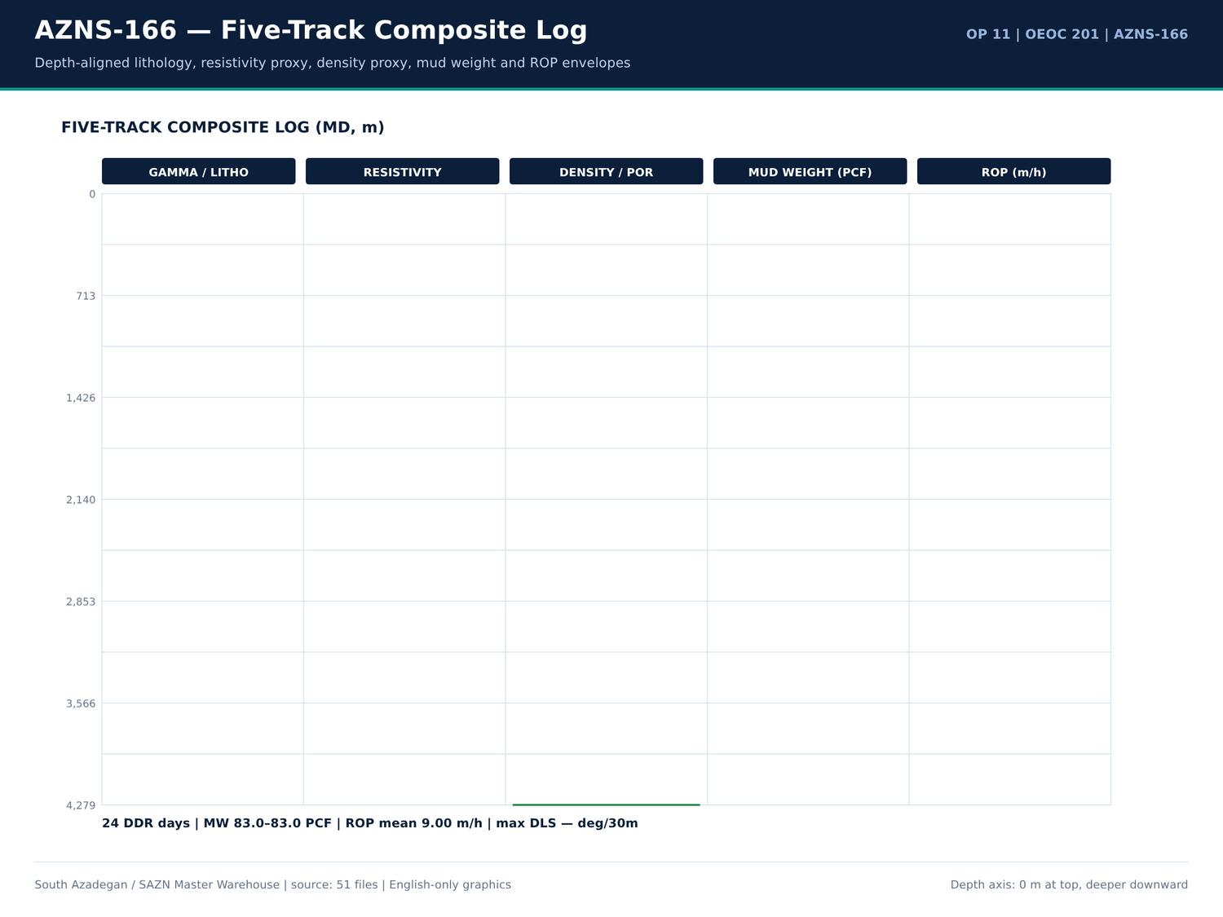
AZNS-166 05 composite log — منبع: انبار داده جامع سازن
ردیفهای قیمتی رشته ابزار
شیت | شرح | واحد | مقدار | مبلغ (دلار)
AZNS-166 WO | RIH with 8 1⁄2" bit and clean out BHA (P/U DP's JT by JT) to 7" L.LAP (1608.2m), CBU, POOH. | — | — | —
AZNS-166 WO | RIH with 5-7/8 Mill and clean out BHA to 4-1/2" Slotted Liner Lap @ 4132.8 m, CBU,POOH to Surface. | — | — | —
AZNS-166 WO | RIH with 3-1/2" Mill and clean out BHA to BTM, take care inside Slotted interval (4008m – 4068m) CBU shakers clean, POOH. Note:for Corrosion Logging Inside 7" Liner follow contingency plan#8 | — | — | —
AZNS-166 WO | M/U Tandem scraper BHA, RIH with tandem scrapers including 9-5/8" casing scraper & 7" liner scraper to 4130m. Scrap 9-5/8” casing and 7” liner and L/D same. | — | — | —

توضیحات مرتبط با BHA در DDR
شماره گزارش | شیت | دسته | Text
No source rows for this query | — | — | —

گزییده نشانی سلولهای عددی — فصل 09
سند | شیت | سلول | مقدار
CBS/11.AZNS_166_CBS.xlsx | Total Cost-EPD & Rigless | R5C3 | 9,087,998.52
CBS/11.AZNS_166_CBS.xlsx | Total Cost-EPD | R19C7 | 8,275,165.08
CBS/11.AZNS_166_CBS.xlsx | Total Cost-EPD & Rigless | R3C3 | 8,275,165.08
CBS/11.AZNS_166_CBS.xlsx | Total Cost-EPD | R3C6 | 2,118,462.01
CBS/11.AZNS_166_CBS.xlsx | Total Cost-EPD | R3C7 | 2,118,462.01
CBS/11.AZNS_166_CBS.xlsx | Cost Breakdown-166 | R197C6 | 2,118,462.01
CBS/11.AZNS_166_CBS.xlsx | Total Cost-EPD | R7C6 | 1,214,816.28
CBS/11.AZNS_166_CBS.xlsx | Total Cost-EPD | R7C7 | 1,214,816.28
CBS/11.AZNS_166_CBS.xlsx | Cost Breakdown-166 Contingecy | R183C16 | 1,214,816.28
CBS/11.AZNS_166_CBS.xlsx | Total Cost-EPD | R12C6 | 1,173,960.00
CBS/11.AZNS_166_CBS.xlsx | Total Cost-EPD | R12C7 | 1,173,960.00
CBS/11.AZNS_166_CBS.xlsx | Cost Breakdown-Material-166 | R249C6 | 1,173,960.00
CBS/11.AZNS_166_CBS.xlsx | Total Cost-EPD | R13C6 | 1,092,550.00
CBS/11.AZNS_166_CBS.xlsx | Cost Breakdown-166 | R5C6 | 1,017,455.31

Chapter 10 — Stick-Slip، Balling و Whirl
نشانههای ارتعاش، Balling مته و Whirl در توضیحات DDR، شرح فعالیتها و یادداشتها جستوجو شد. جداول هر ردیف منطبق را با شماره گزارش و متن آن میآورند؛ اگر متنی یافت نشود فصل صریحاً نبود آن را اعلام میکند و هیچ شاخص ارتعاشی از منبع خاموش ساخته نمیشود.
ردیفهای ارتعاش و Balling
شماره گزارش | شیت | دسته | Text
No source rows for this query | — | — | —

فعالیتهای دارای واژگان ارتعاش
شماره گزارش | فاز | ساعت | شرح
No source rows for this query | — | — | —

پنجرههای پارامتری دینامیک
پارامتر | تعداد | کمینه | میانگین | بیشینه
Torque / RPM / WOB rows retained in well profile | 461 | — | — | —

گزییده نشانی سلولهای عددی — فصل 10
سند | شیت | سلول | مقدار
CBS/11.AZNS_166_CBS.xlsx | Total Cost-EPD & Rigless | R5C3 | 9,087,998.52
CBS/11.AZNS_166_CBS.xlsx | Total Cost-EPD | R19C7 | 8,275,165.08
CBS/11.AZNS_166_CBS.xlsx | Total Cost-EPD & Rigless | R3C3 | 8,275,165.08
CBS/11.AZNS_166_CBS.xlsx | Total Cost-EPD | R3C6 | 2,118,462.01
CBS/11.AZNS_166_CBS.xlsx | Total Cost-EPD | R3C7 | 2,118,462.01
CBS/11.AZNS_166_CBS.xlsx | Cost Breakdown-166 | R197C6 | 2,118,462.01
CBS/11.AZNS_166_CBS.xlsx | Total Cost-EPD | R7C6 | 1,214,816.28
CBS/11.AZNS_166_CBS.xlsx | Total Cost-EPD | R7C7 | 1,214,816.28
CBS/11.AZNS_166_CBS.xlsx | Cost Breakdown-166 Contingecy | R183C16 | 1,214,816.28
CBS/11.AZNS_166_CBS.xlsx | Total Cost-EPD | R12C6 | 1,173,960.00
CBS/11.AZNS_166_CBS.xlsx | Total Cost-EPD | R12C7 | 1,173,960.00
CBS/11.AZNS_166_CBS.xlsx | Cost Breakdown-Material-166 | R249C6 | 1,173,960.00
CBS/11.AZNS_166_CBS.xlsx | Total Cost-EPD | R13C6 | 1,092,550.00
CBS/11.AZNS_166_CBS.xlsx | Cost Breakdown-166 | R5C6 | 1,017,455.31

Chapter 11 — رئولوژی، سرعت آنالوس، ECD و HSI
وزن گل، معادلهای FIT/LOT، نمایههای سرعت آنالوس و پارامترهای هیدرولیکی از ستونهای روزانه DDR، ردیفهای مواد CBS و فصول سیال EOWR جدولبندی شدهاند. باند 83.0 تا 83.0 PCF باند اندازهگیری است، نه فرض طراحی؛ ردیفهای تراز حجمی و کنترل جامدات عیناً Received / Used / Back-load / Stock را نگهداری میکنند.
پارامترهای روزانه گل و سیال
شماره گزارش | تاریخ | گل (PCF) | FIT EMW | اندازه چاله | سازند
1 | 2025-Oct-27 | 83 | — | Estimated Final Depth MD (m): | 4-1/2" Non-Slotted LNR
2 | 2025-Oct-28 | 83 | — | Estimated Final Depth MD (m): | 4-1/2" Non-Slotted LNR
3 | 2025-Oct-29 | 83 | — | Estimated Final Depth MD (m): | 4-1/2" Non-Slotted LNR
4 | 2025-Oct-30 | 83 | — | Estimated Final Depth MD (m): | 4-1/2" Non-Slotted LNR
5 | 2025-Oct-31 | 83 | — | Estimated Final Depth MD (m): | 4-1/2" Non-Slotted LNR
6 | 2025-Nov-1 | 83 | — | Estimated Final Depth MD (m): | 4-1/2" Non-Slotted LNR
7 | 2025-Nov-2 | 83 | — | Estimated Final Depth MD (m): | 4-1/2" Non-Slotted LNR
8 | 2025-Nov-3 | 83 | — | Estimated Final Depth MD (m): | 4-1/2" Non-Slotted LNR
9 | 2025-Nov-4 | 83 | — | Estimated Final Depth MD (m): | 4-1/2" Non-Slotted LNR
10 | 2025-Nov-5 | 83 | — | Estimated Final Depth MD (m): | 4-1/2" Non-Slotted LNR
11 | 2025-Nov-6 | 83 | — | Estimated Final Depth MD (m): | 4-1/2" Non-Slotted LNR
12 | 2025-Nov-7 | 83 | — | Estimated Final Depth MD (m): | 4-1/2" Non-Slotted LNR
13 | 2025-Nov-8 | 83 | — | Estimated Final Depth MD (m): | 4-1/2" Non-Slotted LNR
14 | 2025-Nov-9 | 83 | — | Estimated Final Depth MD (m): | 4-1/2" Non-Slotted LNR
15 | 2025-Nov-10 | 83 | — | Estimated Final Depth MD (m): | 4-1/2" Non-Slotted LNR
16 | 2025-Nov-11 | 83 | — | Estimated Final Depth MD (m): | 4-1/2" Non-Slotted LNR
17 | 2025-Nov-12 | 83 | — | Estimated Final Depth MD (m): | 4-1/2" Non-Slotted LNR
18 | 2025-Nov-13 | 83 | — | Estimated Final Depth MD (m): | 4-1/2" Non-Slotted LNR
19 | 2025-Nov-14 | 83 | — | Estimated Final Depth MD (m): | 4-1/2" Non-Slotted LNR
20 | 2025-Nov-15 | 83 | — | Estimated Final Depth MD (m): | 4-1/2" Non-Slotted LNR
21 | 2025-Nov-16 | 83 | — | Estimated Final Depth MD (m): | 4-1/2" Non-Slotted LNR
22 | 2025-Nov-17 | 83 | — | Estimated Final Depth MD (m): | 4-1/2" Non-Slotted LNR

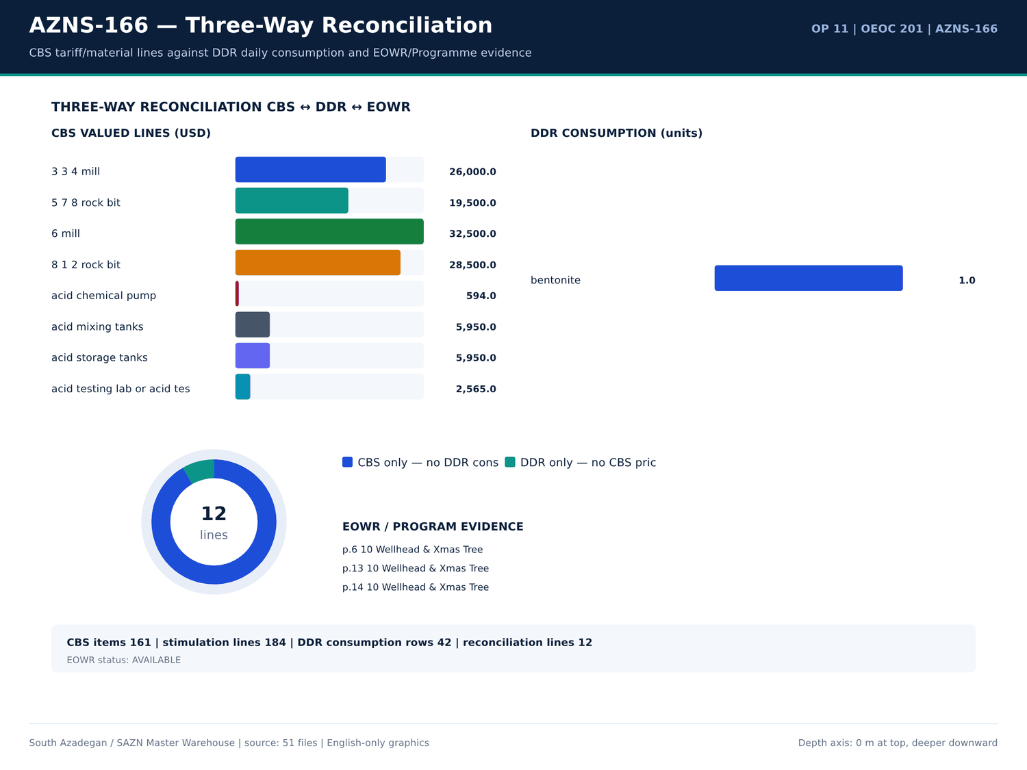
AZNS-166 06 reconciliation — منبع: انبار داده جامع سازن
مصرف گل، سیمان و مواد شیمیایی
شماره گزارش | ماده | واحد | دریافتی | مصرف | موجودی | سلول
1 | Bentonite | — | — | — | 1 | N8
1 | Barite | — | — | — | 1.5 | N9
1 | Limestone | — | 44 | — | 1 | N10
1 | Salt | — | 41 | — | 1 | N11
1 | Lime | — | — | — | 25 | N12
1 | Starch LV | — | 62 | — | 25 | N13
1 | Caustic Soda | — | 6 | — | 25 | N14
1 | Soda Ash | — | 6 | — | 25 | N15
1 | Xanthan Gum | — | — | — | 25 | N16
1 | Wall.Nut Plug (C) | — | — | — | 1 | N17
1 | Wall.Nut Plug (M) | — | — | — | 1 | N18
1 | Wall.Nut Plug (F) | — | — | — | 1 | N19
1 | Oyster Shell (C) | — | — | — | 25 | N20
1 | Oyster Shell (M) | — | — | — | 25 | N21
1 | Oyster Shell (F) | — | — | — | 25 | N22
1 | Limestone chips(M) | — | — | — | 25 | N23
1 | Limestone chips(C) | — | — | — | 1 | N24
1 | Limestone chips(F) | — | — | — | 25 | N25
1 | Mica (F) | — | — | — | 25 | N26
1 | Mica (M) | — | — | — | 25 | N27
1 | Mica (C) | — | — | — | 25 | N28
1 | Sodium Bicarbonate | — | — | — | 25 | N29

واقعهمندیهای سیال EOWR/Programme
کلید | مقدار | واحد | صفحه | سند
MUD_WEIGHT | 124 | pcf | 11 | 04.EOWR/11.AZNS_166_EOWR.pdf
MUD_WEIGHT | 112 | PCF | 11 | 04.EOWR/11.AZNS_166_EOWR.pdf
MUD_WEIGHT | 130 | PCF | 11 | 04.EOWR/11.AZNS_166_EOWR.pdf
MUD_WEIGHT | 82 | PCF | 11 | 04.EOWR/11.AZNS_166_EOWR.pdf
MUD_WEIGHT | 71 | pcf | 15 | 04.EOWR/11.AZNS_166_EOWR.pdf
MUD_WEIGHT | 83 | pcf | 16 | 04.EOWR/11.AZNS_166_EOWR.pdf
MUD_WEIGHT | 124 | pcf | 16 | Well Program/11.AZNS_166_Workover-1_Program.pdf
MUD_WEIGHT | 112 | PCF | 16 | Well Program/11.AZNS_166_Workover-1_Program.pdf
MUD_WEIGHT | 130 | PCF | 16 | Well Program/11.AZNS_166_Workover-1_Program.pdf
MUD_WEIGHT | 82 | PCF | 16 | Well Program/11.AZNS_166_Workover-1_Program.pdf
MUD_WEIGHT | 78 | PCF | 17 | 04.EOWR/11.AZNS_166_EOWR.pdf
MUD_WEIGHT | 83 | pcf | 18 | 04.EOWR/11.AZNS_166_EOWR.pdf
MUD_WEIGHT | 75 | pcf | 52 | Well Program/11.AZNS_166_Workover-1_Program.pdf
MUD_WEIGHT | 83 | PCF | 85 | 04.EOWR/11.AZNS_166_EOWR.pdf
MUD_WEIGHT | 83 | pcf | 136 | 04.EOWR/11.AZNS_166_EOWR.pdf

گزییده نشانی سلولهای عددی — فصل 11
سند | شیت | سلول | مقدار
CBS/11.AZNS_166_CBS.xlsx | Total Cost-EPD & Rigless | R5C3 | 9,087,998.52
CBS/11.AZNS_166_CBS.xlsx | Total Cost-EPD | R19C7 | 8,275,165.08
CBS/11.AZNS_166_CBS.xlsx | Total Cost-EPD & Rigless | R3C3 | 8,275,165.08
CBS/11.AZNS_166_CBS.xlsx | Total Cost-EPD | R3C6 | 2,118,462.01
CBS/11.AZNS_166_CBS.xlsx | Total Cost-EPD | R3C7 | 2,118,462.01
CBS/11.AZNS_166_CBS.xlsx | Cost Breakdown-166 | R197C6 | 2,118,462.01
CBS/11.AZNS_166_CBS.xlsx | Total Cost-EPD | R7C6 | 1,214,816.28
CBS/11.AZNS_166_CBS.xlsx | Total Cost-EPD | R7C7 | 1,214,816.28
CBS/11.AZNS_166_CBS.xlsx | Cost Breakdown-166 Contingecy | R183C16 | 1,214,816.28
CBS/11.AZNS_166_CBS.xlsx | Total Cost-EPD | R12C6 | 1,173,960.00
CBS/11.AZNS_166_CBS.xlsx | Total Cost-EPD | R12C7 | 1,173,960.00
CBS/11.AZNS_166_CBS.xlsx | Cost Breakdown-Material-166 | R249C6 | 1,173,960.00
CBS/11.AZNS_166_CBS.xlsx | Total Cost-EPD | R13C6 | 1,092,550.00
CBS/11.AZNS_166_CBS.xlsx | Cost Breakdown-166 | R5C6 | 1,017,455.31

Chapter 12 — ترپینگ، هوکلواد و Swab-Surge
فعالیتهای ترپینگ، ریمینگ، هوکلواد PU/SO/ROT و Swab-Surge بر پایه کد و کلیدواژه از 461 ردیف فعالیت جدا شدهاند. ساعات، فاز و شرح عیناً آمده است؛ آمار هوکلواد فقط از ردیفهای پارامتری برچسبخورده DDR گرفته میشود و پارامتر غایب با «—» نمایش داده میشود.
ساعات ترپینگ و ریمینگ
شماره گزارش | فاز | کد | ساعت | شرح
1 | — | — | — | Conn. Lubricator to Slick line BOP; Press. Test Slick Line BOP & Lubricator W/ 4000psi / 15min, Ok; RIH W/ 2.75" Ring Gauge Tool Strg To
1 | — | — | — | not received from the client), Confirm Protection Sleeve is in TR3SV; POOH Slick Line Tool Strg To Surface, Flush Solid Block,
1 | — | — | — | L/D 2.75" Ring Gauge Tool String; P/U & Assemble 2.2" Ring Gauge Tool Strg and RIH To 3056m (No-Go Depth: 2770m),
1 | — | — | — | Obs. Slick Line Tension Drop due to Well Deviation, Decide To POOH Slick line Tool String To Surface; Flush Solid Block;
2 | — | — | — | Conn. Lubricator to Slick line BOP; Press. Test Slick Line BOP & Lubricator W/ 4000psi / 15min, Ok; RIH W/ 2.75" Ring Gauge Tool Strg To
2 | — | — | — | not received from the client), Confirm Protection Sleeve is in TR3SV; POOH Slick Line Tool Strg To Surface, Flush Solid Block,
2 | — | — | — | L/D 2.75" Ring Gauge Tool String; P/U & Assemble 2.2" Ring Gauge Tool Strg and RIH To 3056m (No-Go Depth: 2770m),
2 | — | — | — | Obs. Slick Line Tension Drop due to Well Deviation, Decide To POOH Slick line Tool String To Surface; Flush Solid Block;
2 | — | — | — | Cont. RIH W/ 1-3/4" C.T BHA, While Circ. Thru. Choke Manifold @ 0.2BPH F.R & 1100psi Back Pressure, and Take Return in Storage Tank.
3 | REE | 23 | 7 | POOH 1-3/4" C.T BHA To Surface, While Circ. Thru. C.T BHA, NL-NG; Flush C.T; Static Flow Check & Obs. The Well for 1 Hr. , Well Static;
6 | — | — | — | POOH & L/D 4-1/2" TBG HGR ( 18.9PPF, TPCQ-EX Box * Box ) + 4-1/2" Double pin ( 18.9PPF, TPCQ-EX P*P ) + 1 Jts X.O.S TPG2 + 4-1/2" Cross
6 | REE | 23 | 6 | Cont. POOH with 2 Jts 4-1/2" TBG ( 18.9PPF, TPG2 BOX * PIN ), OBS 15-30klb over pull @ 2759-2758.3m
6 | — | — | — | Try to Cont POOH with max 30Klb over pull step by step and several times, No Succ. Perform Circ Mud Thru String, No Return Mud and
6 | — | — | — | Hold Pressure in String, try again Cont POOH with max 60klb over pull step by step and several times, No Succ & Perform Circ.
6 | — | — | — | Mud Thru String, No Return Mud and Hold Pressure in String, try again Cont POOH with max 100klb over pull step by step and
6 | — | — | — | Cont. POOH W/Normal Drag to 2750m While f/u well continuously, NL-NG.
7 | REE | 23 | 23 | As Client Request ( P.P.L ), Cont. POOH with 2 Jts 4-1/2" TBG ( 18.9PPF, TPG2 BOX * PIN ), OBS 15-30klb over pull @ 2759-2758.3m
7 | — | — | — | Try to Cont. POOH with max 30Klb over pull step by step and several times, No Succ. Perform Circ Mud Thru String, No Return Mud and
7 | — | — | — | Hold Pressure in String, try again Cont POOH with max 60klb over pull step by step and several times, No Succ & Perform Circ.
7 | — | — | — | Mud Thru String, No Return Mud and Hold Pressure in String, try again Cont POOH with max 100klb over pull step by step and
7 | — | — | — | Cont. POOH & L/D with Normal Drag to 1530m While f/u well continuously, NL-NG.
7 | REE | 20 | 1 | Meanwhile POOH, 1 Hrs waiting for Rig 201 OEOC Due to shortage has been identified within the Drilling Fluid crew.

یادداشتهای هوکلواد و PU/SO/ROT
شماره گزارش | شیت | دسته | Text
No source rows for this query | — | — | —

کدهای زمان ترپینگ و ریمینگ
کد | دسته | ساعت | شماره گزارش
6 | Trips | 24 | 13
6 | Trips | 24 | 14
6 | Trips | 23 | 17
6 | Trips | 22 | 15
6 | Trips | 21.5 | 11
6 | Trips | 21.5 | 12
6 | Trips | 21 | 10
6 | Trips | 18.5 | 18
6 | Trips | 15.5 | 16
3 | Reaming | — | 1
6 | Trips | — | 1
3 | Reaming | — | 2
6 | Trips | — | 2
3 | Reaming | — | 3
6 | Trips | — | 3
3 | Reaming | — | 4
6 | Trips | — | 4
3 | Reaming | — | 5
6 | Trips | — | 5
3 | Reaming | — | 6
6 | Trips | — | 6
3 | Reaming | — | 7

گزییده نشانی سلولهای عددی — فصل 12
سند | شیت | سلول | مقدار
CBS/11.AZNS_166_CBS.xlsx | Total Cost-EPD & Rigless | R5C3 | 9,087,998.52
CBS/11.AZNS_166_CBS.xlsx | Total Cost-EPD | R19C7 | 8,275,165.08
CBS/11.AZNS_166_CBS.xlsx | Total Cost-EPD & Rigless | R3C3 | 8,275,165.08
CBS/11.AZNS_166_CBS.xlsx | Total Cost-EPD | R3C6 | 2,118,462.01
CBS/11.AZNS_166_CBS.xlsx | Total Cost-EPD | R3C7 | 2,118,462.01
CBS/11.AZNS_166_CBS.xlsx | Cost Breakdown-166 | R197C6 | 2,118,462.01
CBS/11.AZNS_166_CBS.xlsx | Total Cost-EPD | R7C6 | 1,214,816.28
CBS/11.AZNS_166_CBS.xlsx | Total Cost-EPD | R7C7 | 1,214,816.28
CBS/11.AZNS_166_CBS.xlsx | Cost Breakdown-166 Contingecy | R183C16 | 1,214,816.28
CBS/11.AZNS_166_CBS.xlsx | Total Cost-EPD | R12C6 | 1,173,960.00
CBS/11.AZNS_166_CBS.xlsx | Total Cost-EPD | R12C7 | 1,173,960.00
CBS/11.AZNS_166_CBS.xlsx | Cost Breakdown-Material-166 | R249C6 | 1,173,960.00
CBS/11.AZNS_166_CBS.xlsx | Total Cost-EPD | R13C6 | 1,092,550.00
CBS/11.AZNS_166_CBS.xlsx | Cost Breakdown-166 | R5C6 | 1,017,455.31

Chapter 13 — زمان اتصالات و زمان پنهان ازدسترفته
کدهای اتصال، نگرشی، گردش و انتظار از زمان حفاری مولد جدا شدهاند. جداول کد، دسته، ساعات و شماره_reportno را میدهند تا زمان پنهان ازدسترفته قابل محاسبه مجدد باشد؛ هرجا خود DDR ناقص است، مجموع بر ۲۴ ساعت تحمیل نمیشود.
کدهای اتصال، گردش و انتظار
کد | دسته | ساعت | شماره گزارش
5 | Circulate & Condition | — | 1
10 | Deviation Survey | — | 1
14 | Wait on Cement | — | 1
20 | Operation Status (Waiting) | — | 1
5 | Circulate & Condition | — | 2
10 | Deviation Survey | — | 2
14 | Wait on Cement | — | 2
20 | Operation Status (Waiting) | — | 2
5 | Circulate & Condition | — | 3
10 | Deviation Survey | — | 3
14 | Wait on Cement | — | 3
20 | Operation Status (Waiting) | — | 3
5 | Circulate & Condition | — | 4
10 | Deviation Survey | — | 4
14 | Wait on Cement | — | 4
20 | Operation Status (Waiting) | — | 4
5 | Circulate & Condition | — | 5
10 | Deviation Survey | — | 5
14 | Wait on Cement | — | 5
20 | Operation Status (Waiting) | 24 | 5
5 | Circulate & Condition | — | 6
10 | Deviation Survey | — | 6

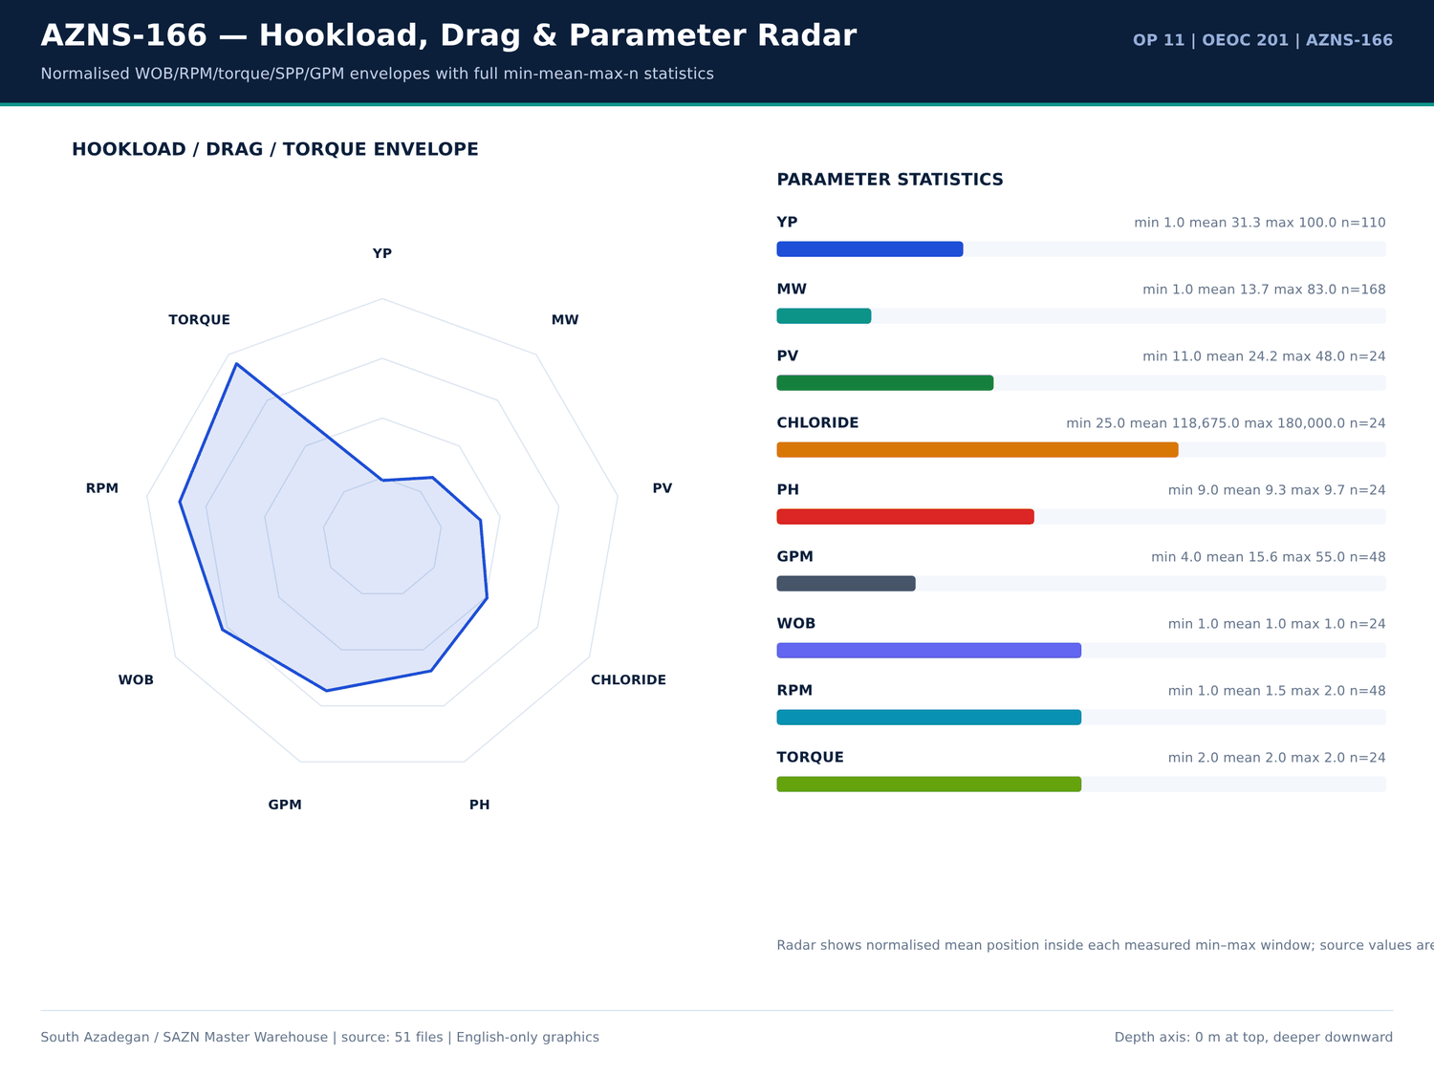
AZNS-166 07 hookload — منبع: انبار داده جامع سازن
فعالیتهای دارای واژه اتصال
شماره گزارش | فاز | ساعت | شرح
2 | — | — | P/U C.T Injector Head & M/U on C.T BOP, Press. Test C.T Riser, BOP Rams, and Injector Head Connections Thru. C.T BHA W/ 4000psi – OK;
4 | REE | 6 | Wait on OEOC to Cont. Test 13-5/8" 10k BOP Stack While Work on fixing BOP leakages as Below:
4 | — | — | Work on leakages between BTM Rams & Spacer Spool Connection @ several times No. Succ Till R.T.
5 | REE | 23 | Wait on OEOC to Cont. Test 13-5/8" 10k BOP Stack While Work on fixing BOP leakages as Below:
5 | — | — | Work on leakages between BTM Rams & Spacer Spool Connection after several times and Test W/ 4500Psi, OK.
5 | REE | 1 | 1 HRS Waiting for Mud Logging Unit ( Pars Geo Data ) Due to Failure weight indicator Sensor.
7 | REE | 1 | Meanwhile POOH, 1 Hrs waiting for Rig 201 OEOC Due to shortage has been identified within the Drilling Fluid crew.
9 | REE | 7 | Cont RIH While Waiting Noted for OEOC Rig 201.
9 | — | — | Waiting Causes / Notes: Air Tongs Malfunction. Rig Tongs Without Proper Latch. Insufficient Drawworks Air Supply.
10 | REE | 2 | Waiting For Rig 201 OEOC Due to Delay in operation.
10 | REE | 1 | Waiting For Rig 201 OEOC Due to Delay in operation.
13 | — | — | Circulate each 15 STD, NL.NG.
13 | REE | 6 | Cont. Run in hole by 5" D.Pipe from 2800m to 3530m while break Circulate each 15 STD, NL.NG. Till R.T. Internet Installation – MSA Completion Test Tools Completion String
14 | REE | 20 | Cont. Run in hole by 5" D.Pipe from 2800m to 3100m while F/U string & break Circulate each 15 STD, NL.NG.
18 | — | — | w/ 2 Jt 3-1/2" TBG To 72m; Run 2.8" Gauge Ring to SSD Depth, Ok; While Clean & Wash all Connections; Use Thread Seal
19 | — | — | w/ 2 Jt 3-1/2" TBG To 72m; Run 2.8" Gauge Ring to SSD Depth, Ok; While Clean & Wash all Connections; Use Thread Seal
19 | REE | 9 | Cont. RIH W/ 3-1/2" * 4-1/2" 7.5k Comp. Strg F/ 72 To 676m, While Clean & Wash all Connections; Use Thread Seal Compound, and
19 | — | — | While Clean & Wash all Connections; Use Thread Seal Compound, and JAM System, and Circ. C.W.H by Trip Tank & Monitor
19 | REE | 0.5 | Cont. RIH W/ 3-1/2" * 4-1/2" 7.5k Comp. Strg F/ 676 To 695m, While Clean & Wash all Connections; Use Thread Seal Compound, and
20 | — | — | While Clean & Wash all Connections; Use Thread Seal Compound, and JAM System, and Circ. C.W.H by Trip Tank & Monitor
20 | REE | 9 | Cont. RIH W/ 3-1/2" * 4-1/2" 7.5k Comp. Strg F/ 676 To 1223m, While Clean & Wash all Connections; Use Thread Seal Compound, and
20 | REE | 5.5 | Cont. RIH W/ 3-1/2" * 4-1/2" 7.5k Comp. Strg F/ 1223 To 1671m, While Pass 7" LNR gently, Clean & Wash all Connections;

تراز ساعانه روزانه PT/NPT
شماره گزارش | تاریخ | NPT (ساعت) | PT (ساعت) | هزینه تجمعی (دلار)
1 | 2025-Oct-27 | 12 | 18 | 23,000.00
2 | 2025-Oct-28 | 0 | 30 | 46,000.00
3 | 2025-Oct-29 | 0 | 30 | 69,000.00
4 | 2025-Oct-30 | 6 | 24 | 92,000.00
5 | 2025-Oct-31 | 29 | 1 | 115,000.00
6 | 2025-Nov-1 | 14 | 16 | 138,000.00
7 | 2025-Nov-2 | 1 | 29 | 161,000.00
8 | 2025-Nov-3 | 0 | 30 | 184,000.00
9 | 2025-Nov-4 | 7 | 23 | 207,000.00
10 | 2025-Nov-5 | 3 | 27 | 230,000.00
11 | 2025-Nov-6 | 2 | 28 | 253,000.00
12 | 2025-Nov-7 | 0 | 30 | 276,000.00
13 | 2025-Nov-8 | 0 | 30 | 299,000.00
14 | 2025-Nov-9 | 0 | 30 | 322,000.00
15 | 2025-Nov-10 | 0 | 30 | 345,000.00
16 | 2025-Nov-11 | 0 | 30 | 368,000.00
17 | 2025-Nov-12 | 0 | 30 | 391,000.00
18 | 2025-Nov-13 | 0 | 30 | 414,000.00
19 | 2025-Nov-14 | 15.5 | 14.5 | 437,000.00
20 | 2025-Nov-15 | 7 | 23 | 460,000.00
21 | 2025-Nov-16 | 3.5 | 26.5 | 483,000.00
22 | 2025-Nov-17 | 0 | 30 | 506,000.00

گزییده نشانی سلولهای عددی — فصل 13
سند | شیت | سلول | مقدار
CBS/11.AZNS_166_CBS.xlsx | Total Cost-EPD & Rigless | R5C3 | 9,087,998.52
CBS/11.AZNS_166_CBS.xlsx | Total Cost-EPD | R19C7 | 8,275,165.08
CBS/11.AZNS_166_CBS.xlsx | Total Cost-EPD & Rigless | R3C3 | 8,275,165.08
CBS/11.AZNS_166_CBS.xlsx | Total Cost-EPD | R3C6 | 2,118,462.01
CBS/11.AZNS_166_CBS.xlsx | Total Cost-EPD | R3C7 | 2,118,462.01
CBS/11.AZNS_166_CBS.xlsx | Cost Breakdown-166 | R197C6 | 2,118,462.01
CBS/11.AZNS_166_CBS.xlsx | Total Cost-EPD | R7C6 | 1,214,816.28
CBS/11.AZNS_166_CBS.xlsx | Total Cost-EPD | R7C7 | 1,214,816.28
CBS/11.AZNS_166_CBS.xlsx | Cost Breakdown-166 Contingecy | R183C16 | 1,214,816.28
CBS/11.AZNS_166_CBS.xlsx | Total Cost-EPD | R12C6 | 1,173,960.00
CBS/11.AZNS_166_CBS.xlsx | Total Cost-EPD | R12C7 | 1,173,960.00
CBS/11.AZNS_166_CBS.xlsx | Cost Breakdown-Material-166 | R249C6 | 1,173,960.00
CBS/11.AZNS_166_CBS.xlsx | Total Cost-EPD | R13C6 | 1,092,550.00
CBS/11.AZNS_166_CBS.xlsx | Cost Breakdown-166 | R5C6 | 1,017,455.31

Chapter 14 — جهتداری، DLS و پیچخوردگی مسیر
ایستگاههای نگرشی، انحراف، آزیموت، TVD و DLS انحنای کمینه بهتفکیک ایستگاه بازتولید شدهاند. بیشینه DLS برابر — درجه بر ۳۰ متر است. پنجرههای پارامتر جهتدار (WOB، RPM، گشتاور، SPP، GPM) از ردیفهای برچسبخورده DDR همراه تعداد، کمینه، میانگین و بیشینه آمدهاند.
ایستگاههای نگرشی جهتداری
شماره گزارش | عمق اندازهگیری (متر) | انحراف (درجه) | آزیموت (درجه) | عمق قائم (متر) | DLS (درجه/30 متر) | ابزار
No source rows for this query | — | — | — | — | — | —

توضیحات جهتداری
شماره گزارش | شیت | دسته | Text
No source rows for this query | — | — | —

مقادیر سرنگرشی KOP
شماره گزارش | تاریخ | KOP1 | KOP2 | اندازه چاله | سازند
1 | 2025-Oct-27 | — | — | Estimated Final Depth MD (m): | 4-1/2" Non-Slotted LNR
2 | 2025-Oct-28 | — | — | Estimated Final Depth MD (m): | 4-1/2" Non-Slotted LNR
3 | 2025-Oct-29 | — | — | Estimated Final Depth MD (m): | 4-1/2" Non-Slotted LNR
4 | 2025-Oct-30 | — | — | Estimated Final Depth MD (m): | 4-1/2" Non-Slotted LNR
5 | 2025-Oct-31 | — | — | Estimated Final Depth MD (m): | 4-1/2" Non-Slotted LNR
6 | 2025-Nov-1 | — | — | Estimated Final Depth MD (m): | 4-1/2" Non-Slotted LNR
7 | 2025-Nov-2 | — | — | Estimated Final Depth MD (m): | 4-1/2" Non-Slotted LNR
8 | 2025-Nov-3 | — | — | Estimated Final Depth MD (m): | 4-1/2" Non-Slotted LNR
9 | 2025-Nov-4 | — | — | Estimated Final Depth MD (m): | 4-1/2" Non-Slotted LNR
10 | 2025-Nov-5 | — | — | Estimated Final Depth MD (m): | 4-1/2" Non-Slotted LNR
11 | 2025-Nov-6 | — | — | Estimated Final Depth MD (m): | 4-1/2" Non-Slotted LNR
12 | 2025-Nov-7 | — | — | Estimated Final Depth MD (m): | 4-1/2" Non-Slotted LNR
13 | 2025-Nov-8 | — | — | Estimated Final Depth MD (m): | 4-1/2" Non-Slotted LNR
14 | 2025-Nov-9 | — | — | Estimated Final Depth MD (m): | 4-1/2" Non-Slotted LNR
15 | 2025-Nov-10 | — | — | Estimated Final Depth MD (m): | 4-1/2" Non-Slotted LNR
16 | 2025-Nov-11 | — | — | Estimated Final Depth MD (m): | 4-1/2" Non-Slotted LNR
17 | 2025-Nov-12 | — | — | Estimated Final Depth MD (m): | 4-1/2" Non-Slotted LNR
18 | 2025-Nov-13 | — | — | Estimated Final Depth MD (m): | 4-1/2" Non-Slotted LNR
19 | 2025-Nov-14 | — | — | Estimated Final Depth MD (m): | 4-1/2" Non-Slotted LNR
20 | 2025-Nov-15 | — | — | Estimated Final Depth MD (m): | 4-1/2" Non-Slotted LNR
21 | 2025-Nov-16 | — | — | Estimated Final Depth MD (m): | 4-1/2" Non-Slotted LNR
22 | 2025-Nov-17 | — | — | Estimated Final Depth MD (m): | 4-1/2" Non-Slotted LNR

گزییده نشانی سلولهای عددی — فصل 14
سند | شیت | سلول | مقدار
CBS/11.AZNS_166_CBS.xlsx | Total Cost-EPD & Rigless | R5C3 | 9,087,998.52
CBS/11.AZNS_166_CBS.xlsx | Total Cost-EPD | R19C7 | 8,275,165.08
CBS/11.AZNS_166_CBS.xlsx | Total Cost-EPD & Rigless | R3C3 | 8,275,165.08
CBS/11.AZNS_166_CBS.xlsx | Total Cost-EPD | R3C6 | 2,118,462.01
CBS/11.AZNS_166_CBS.xlsx | Total Cost-EPD | R3C7 | 2,118,462.01
CBS/11.AZNS_166_CBS.xlsx | Cost Breakdown-166 | R197C6 | 2,118,462.01
CBS/11.AZNS_166_CBS.xlsx | Total Cost-EPD | R7C6 | 1,214,816.28
CBS/11.AZNS_166_CBS.xlsx | Total Cost-EPD | R7C7 | 1,214,816.28
CBS/11.AZNS_166_CBS.xlsx | Cost Breakdown-166 Contingecy | R183C16 | 1,214,816.28
CBS/11.AZNS_166_CBS.xlsx | Total Cost-EPD | R12C6 | 1,173,960.00
CBS/11.AZNS_166_CBS.xlsx | Total Cost-EPD | R12C7 | 1,173,960.00
CBS/11.AZNS_166_CBS.xlsx | Cost Breakdown-Material-166 | R249C6 | 1,173,960.00
CBS/11.AZNS_166_CBS.xlsx | Total Cost-EPD | R13C6 | 1,092,550.00
CBS/11.AZNS_166_CBS.xlsx | Cost Breakdown-166 | R5C6 | 1,017,455.31

Chapter 15 — کنترل چاه، هرزروی، LCM، Dry Test و MAASP
هرزروی، پیلهای LCM، تست خشک، تست باند، FIT/LOT و واقعهمندیهای مرتبط با MAASP از توضیحات DDR و لایه متن EOWR / Programme استخراج شدهاند. 3 خانواده مسئله شواهد کنترل هرزروی را دارند و هر رقم شماره صفحه خود را همراه دارد. مقداری که در لایه متن چاپ نشده تخمین زده نمیشود.
توضیحات هرزروی، LCM و کنترل چاه
شماره گزارش | شیت | دسته | Text
No source rows for this query | — | — | —

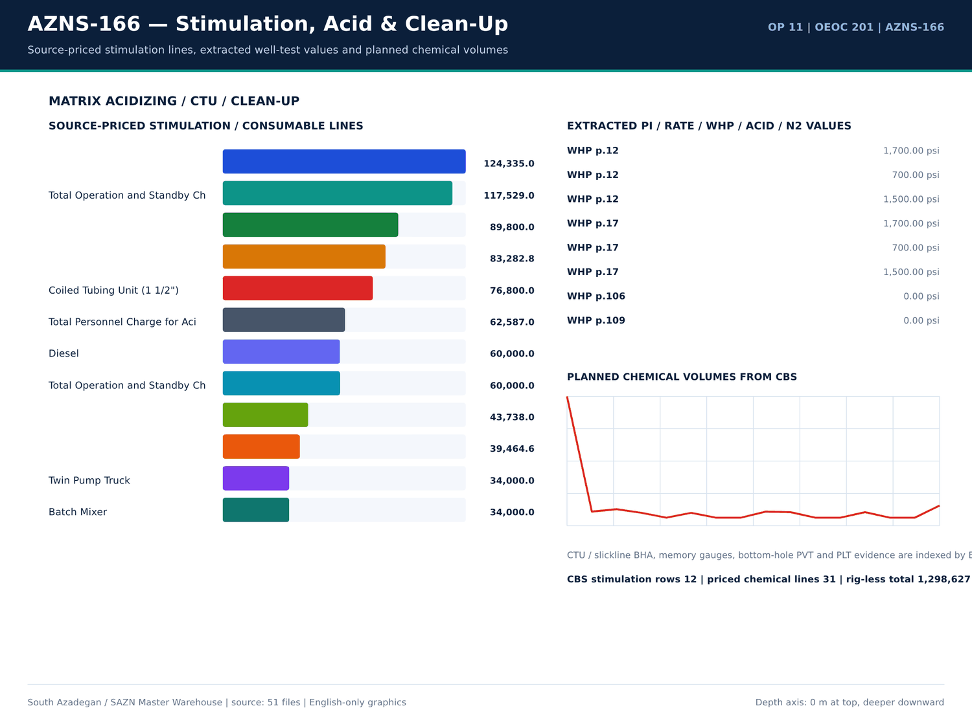
AZNS-166 08 acid — منبع: انبار داده جامع سازن
واقعهمندیهای فشار و FIT/LOT
کلید | مقدار | واحد | صفحه | سند | زمینه
WHP | 1,700.00 | psi | 12 | 04.EOWR/11.AZNS_166_EOWR.pdf | of 3SV flapper observed on neck of plug. SIWHP = 1700psi, flow the well (FWHP = 700psi), close 3SV fl
WHP | 700 | psi | 12 | 04.EOWR/11.AZNS_166_EOWR.pdf | k of plug. SIWHP = 1700psi, flow the well (FWHP = 700psi), close 3SV flowing continued, RIH SL with L
WHP | 1,500.00 | psi | 12 | 04.EOWR/11.AZNS_166_EOWR.pdf | dropped & remained constant. (600 – 800psi) WHP = 1500psi, RIH SL with special protection sleeve (prof
PRESSURE_TEST | 4,500.00 | psi | 16 | Well Program/11.AZNS_166_Workover-1_Program.pdf | lling & Plug to 2770.1m Set Prong in NO-GO. Pressure test Comp. String W/4500psi for 15MIN, Ok. Close 3SV, laydown41/2''L. J
WHP | 1,700.00 | psi | 17 | Well Program/11.AZNS_166_Workover-1_Program.pdf | 3SV flapper observed on neck of plug. • SIWHP = 1700psi, flow the well (FWHP = 700psi), close 3SV fl
WHP | 700 | psi | 17 | Well Program/11.AZNS_166_Workover-1_Program.pdf | plug. • SIWHP = 1700psi, flow the well (FWHP = 700psi), close 3SV flowing continued, RIH SL with
WHP | 1,500.00 | psi | 17 | Well Program/11.AZNS_166_Workover-1_Program.pdf | pped & remained constant. (600 – 800psi) • WHP = 1500psi, RIH SL with special protection sleeve (prof
PRESSURE_TEST | 4,500.00 | psi | 43 | Well Program/11.AZNS_166_Workover-1_Program.pdf | lling & Plug to 2770.1m Set Prong in NO-GO. Pressure test Comp. String W/4500psi for 15MIN, Ok. Close 3SV, laydown 41/2''L.
PRESSURE_TEST | 6,000.00 | psi | 58 | 04.EOWR/11.AZNS_166_EOWR.pdf | Tubing String With check valve Inside. √ Pressure Test Tubing String 6000psi/15min Every 100 JTs. √ RIH Completion Stri
PRESSURE_TEST | 6,000.00 | psi | 58 | 04.EOWR/11.AZNS_166_EOWR.pdf | RSSSV √ Install control line to TRSSSV and pressure test control line 6000psi x 15mins. And then keep 3000psi pressure wh
PRESSURE_TEST | 4,500.00 | psi | 59 | 04.EOWR/11.AZNS_166_EOWR.pdf | bonnet. √ Check hanger for any damage and pressure test control line to 4500psi √ Pressure test chemical injection line &
PRESSURE_TEST | 6,000.00 | Psi | 78 | 04.EOWR/11.AZNS_166_EOWR.pdf | all) Item Test Check Mark and Result 1 Pressure test for the kill Valve W/ 1000 & 6000 Psi / 15 min OK 2 Pressure test for the SSV
PRESSURE_TEST | 6,000.00 | Psi | 78 | 04.EOWR/11.AZNS_166_EOWR.pdf | Valve W/ 1000 & 6000 Psi / 15 min OK 2 Pressure test for the SSV W/ 1000 & 6000 Psi / 15 min OK 3 Pressure test for the top
PRESSURE_TEST | 6,000.00 | Psi | 78 | 04.EOWR/11.AZNS_166_EOWR.pdf | valve W/ 1000 & 6000 Psi / 15 min OK 4 Pressure test for Swab valve W/ 1000 & 6000 Psi / 15 min OK 5 Pressure test for the Prod
PRESSURE_TEST | 6,000.00 | Psi | 79 | 04.EOWR/11.AZNS_166_EOWR.pdf | section W/1000 &6000 psi for 15min OK 2 Pressure test for the SSV Exit block W/ 6000 Psi / 15 min OK 3 Pressure test neck of tubi
PRESSURE_TEST | 6,000.00 | Psi | 79 | 04.EOWR/11.AZNS_166_EOWR.pdf | al seal W/1000 &6000 psi for 15min OK 4 Pressure test for Swab valve W/ 6000 Psi / 15 min - 5 Pressure test for Productio
PRESSURE_TEST | 6,000.00 | Psi | 79 | 04.EOWR/11.AZNS_166_EOWR.pdf | for Swab valve W/ 6000 Psi / 15 min - 5 Pressure test for Production valve W/6000 Psi / 15 min - 6 Pressure test cavity of FS.
WHP | 0 | psi | 106 | 04.EOWR/11.AZNS_166_EOWR.pdf | ng pressure recorded at 32/64 choke setting, wellhead pressure at 0psi and no observable returns at surface. In o
WHP | 0 | psi | 109 | 04.EOWR/11.AZNS_166_EOWR.pdf | st on coiled tubing equipment C/S: 32/64 - WHP: 0 psi - outlet from the well: no return Retrieve
WHP | 0 | psi | 111 | 04.EOWR/11.AZNS_166_EOWR.pdf | uipment (S/L), set P.S at 63.7m, Open TMV, SIWHP: 0psi, RIH S/L to Max accessible TD (2950m) 24 –
WHP | 0 | psi | 111 | 04.EOWR/11.AZNS_166_EOWR.pdf | head pressure monitoring ( C/S: closed - WHP: 0 psi - outlet from the well: no return) 26 – Jan
WHP | 800 | psi | 111 | 04.EOWR/11.AZNS_166_EOWR.pdf | S, flow the well & monitor well condition, SIWHP: 800psi. 30 – Jan – 2026 flowing the well & monito

خانوادههای مسئله با شاهد هرزروی
دسته | ساعت | عمق (متر) | سازند | هزینه (دلار) | جزئیات
Other operational delay | 53 | 4,279.00 | 4-1/2" Non-Slotted LNR | 50,791.67 | Cont. R/U, While Set & Install TDS; Spud Rig 201 as per Prespud Check List @ 1404.08.05 - 12:00 | Try to perform Circ Mud Thru String No Succ Due to Observe Failure TDS Kelly Hose . | Try to perform Circ Mud Thru String No Succ Due to Ob…
Rig equipment failure | 29 | 4,279.00 | 4-1/2" Non-Slotted LNR | 27,791.67 | Wait on OEOC to Cont. Test 13-5/8" 10k BOP Stack While Work on fixing BOP leakages as Below: | Wait on OEOC to Cont. Test 13-5/8" 10k BOP Stack While Work on fixing BOP leakages as Below:
Waiting on services / material | 18 | 4,279.00 | 4-1/2" Non-Slotted LNR | 17,250.00 | 1 HRS Waiting for Mud Logging Unit ( Pars Geo Data ) Due to Failure weight indicator Sensor. | Meanwhile POOH, 1 Hrs waiting for Rig 201 OEOC Due to shortage has been identified within the Drilling Fluid crew. | Cont RIH While Waiting No…

گزییده نشانی سلولهای عددی — فصل 15
سند | شیت | سلول | مقدار
CBS/11.AZNS_166_CBS.xlsx | Total Cost-EPD & Rigless | R5C3 | 9,087,998.52
CBS/11.AZNS_166_CBS.xlsx | Total Cost-EPD | R19C7 | 8,275,165.08
CBS/11.AZNS_166_CBS.xlsx | Total Cost-EPD & Rigless | R3C3 | 8,275,165.08
CBS/11.AZNS_166_CBS.xlsx | Total Cost-EPD | R3C6 | 2,118,462.01
CBS/11.AZNS_166_CBS.xlsx | Total Cost-EPD | R3C7 | 2,118,462.01
CBS/11.AZNS_166_CBS.xlsx | Cost Breakdown-166 | R197C6 | 2,118,462.01
CBS/11.AZNS_166_CBS.xlsx | Total Cost-EPD | R7C6 | 1,214,816.28
CBS/11.AZNS_166_CBS.xlsx | Total Cost-EPD | R7C7 | 1,214,816.28
CBS/11.AZNS_166_CBS.xlsx | Cost Breakdown-166 Contingecy | R183C16 | 1,214,816.28
CBS/11.AZNS_166_CBS.xlsx | Total Cost-EPD | R12C6 | 1,173,960.00
CBS/11.AZNS_166_CBS.xlsx | Total Cost-EPD | R12C7 | 1,173,960.00
CBS/11.AZNS_166_CBS.xlsx | Cost Breakdown-Material-166 | R249C6 | 1,173,960.00
CBS/11.AZNS_166_CBS.xlsx | Total Cost-EPD | R13C6 | 1,092,550.00
CBS/11.AZNS_166_CBS.xlsx | Cost Breakdown-166 | R5C6 | 1,017,455.31

Chapter 16 — لولهگذاری، سیمان و CBL-VDL-USIT
تالی لولهگذاری شامل اندازه، گرید، وزن، رزوه، عمق از/تا، ترکیدگی و لهیدگی از شیتهای DDR است. صفحات طراحی، آزمایشگاه و اجرای سیمان، TOC و واقعهمندیهای باند CBL-VDL-USIT بر پایه صفحه EOWR/Programme نمایه شدهاند. تجهیزات تکمیل از ردیفهای قیمتی CBS با تستهای فشار همان چاه تطبیق داده شده است.
تالی لولهگذاری
شماره گزارش | اندازه (اینچ) | گرید | وزن | Thread | از (متر) | تا (متر) | ترکیدگی | لهیدگی
1 | 20" | K-55 | 94 | BTC | — | 147 | 2,110.00 | —
1 | 13-3/8" | N-80 | 68 | BTC | — | 1,338.00 | 5,020.00 | —
1 | 9-5/8" | L-80 | 47 | PJE | — | 1,765.00 | 15,110.00 | —
1 | 7" LNR | L-80 | 29 | TPCQ | 1,608.20 | 4,193.00 | 11,220.00 | —
1 | 4-1/2" Non-Slotted LNR | L-80 | 13.5 | BTC | 4,132.80 | 4,199.27 | 8,160.00 | —
1 | 4-1/2" Slotted LNR | L-80 | 13.5 | BTC | 4,199.30 | 4,269.54 | 10,131.00 | —
2 | 20" | K-55 | 94 | BTC | — | 147 | 2,110.00 | —
2 | 13-3/8" | N-80 | 68 | BTC | — | 1,338.00 | 5,020.00 | —
2 | 9-5/8" | L-80 | 47 | PJE | — | 1,765.00 | 15,110.00 | —
2 | 7" LNR | L-80 | 29 | TPCQ | 1,608.20 | 4,193.00 | 11,220.00 | —
2 | 4-1/2" Non-Slotted LNR | L-80 | 13.5 | BTC | 4,132.80 | 4,199.27 | 8,160.00 | —
2 | 4-1/2" Slotted LNR | L-80 | 13.5 | BTC | 4,199.30 | 4,269.54 | 10,131.00 | —
3 | 20" | K-55 | 94 | BTC | — | 147 | 2,110.00 | —
3 | 13-3/8" | N-80 | 68 | BTC | — | 1,338.00 | 5,020.00 | —
3 | 9-5/8" | L-80 | 47 | PJE | — | 1,765.00 | 15,110.00 | —
3 | 7" LNR | L-80 | 29 | TPCQ | 1,608.20 | 4,193.00 | 11,220.00 | —
3 | 4-1/2" Non-Slotted LNR | L-80 | 13.5 | BTC | 4,132.80 | 4,199.27 | 8,160.00 | —
3 | 4-1/2" Slotted LNR | L-80 | 13.5 | BTC | 4,199.30 | 4,269.54 | 10,131.00 | —
4 | 20" | K-55 | 94 | BTC | — | 147 | 2,110.00 | —
4 | 13-3/8" | N-80 | 68 | BTC | — | 1,338.00 | 5,020.00 | —
4 | 9-5/8" | L-80 | 47 | PJE | — | 1,765.00 | 15,110.00 | —
4 | 7" LNR | L-80 | 29 | TPCQ | 1,608.20 | 4,193.00 | 11,220.00 | —

واقعهمندیهای سیمان و باند
کلید | مقدار | واحد | صفحه | سند | زمینه
No source rows for this query | — | — | — | — | —

جداول شمارهدار سیمان و لولهگذاری
سند | صفحه | شماره جدول | عنوان | دسته
04.EOWR/11.AZNS_166_EOWR.pdf | 5 | 2-2 | AZNS-166 CASING HISTORY............................................................................................................ 13 | EOWR
04.EOWR/11.AZNS_166_EOWR.pdf | 5 | 5-1 | AZNS-166 FINAL CASING DATA ...................................................................................................... 39 | EOWR
04.EOWR/11.AZNS_166_EOWR.pdf | 13 | 2-2 | AZNS-166 Casing History | EOWR
Well Program/11.AZNS_166_Workover-1_Program.pdf | 21 | 7 | Casing & Liner Data | PROGRAM
04.EOWR/11.AZNS_166_EOWR.pdf | 39 | 5-1 | AZNS-166 Final Casing Data | EOWR

گزییده نشانی سلولهای عددی — فصل 16
سند | شیت | سلول | مقدار
CBS/11.AZNS_166_CBS.xlsx | Total Cost-EPD & Rigless | R5C3 | 9,087,998.52
CBS/11.AZNS_166_CBS.xlsx | Total Cost-EPD | R19C7 | 8,275,165.08
CBS/11.AZNS_166_CBS.xlsx | Total Cost-EPD & Rigless | R3C3 | 8,275,165.08
CBS/11.AZNS_166_CBS.xlsx | Total Cost-EPD | R3C6 | 2,118,462.01
CBS/11.AZNS_166_CBS.xlsx | Total Cost-EPD | R3C7 | 2,118,462.01
CBS/11.AZNS_166_CBS.xlsx | Cost Breakdown-166 | R197C6 | 2,118,462.01
CBS/11.AZNS_166_CBS.xlsx | Total Cost-EPD | R7C6 | 1,214,816.28
CBS/11.AZNS_166_CBS.xlsx | Total Cost-EPD | R7C7 | 1,214,816.28
CBS/11.AZNS_166_CBS.xlsx | Cost Breakdown-166 Contingecy | R183C16 | 1,214,816.28
CBS/11.AZNS_166_CBS.xlsx | Total Cost-EPD | R12C6 | 1,173,960.00
CBS/11.AZNS_166_CBS.xlsx | Total Cost-EPD | R12C7 | 1,173,960.00
CBS/11.AZNS_166_CBS.xlsx | Cost Breakdown-Material-166 | R249C6 | 1,173,960.00
CBS/11.AZNS_166_CBS.xlsx | Total Cost-EPD | R13C6 | 1,092,550.00
CBS/11.AZNS_166_CBS.xlsx | Cost Breakdown-166 | R5C6 | 1,017,455.31

Chapter 17 — Workover، ماهیگیری و میلینگ
فعالیتهای ماهیگیری، میلینگ، ویپاستاک، پنجره سایدترک و ورود مجدد از لاگ ۲۴ ساعته جدا شدهاند. برای AZNS-166 کلاس عملیات در پرونده ثبت شده است؛ جداول ردیفهای منطبق، یادداشتها و صفحات بخش Workover EOWR را بازتولید میکنند. عملیات ۴ فاقد EOWR است و تنها از DDR + CBS + Programme تحلیل میشود.
فعالیتهای ماهیگیری، میلینگ و سایدترک
شماره گزارش | فاز | کد | ساعت | شرح
8 | REE | 23 | 4 | P/U & M/U new 8-3/8" M.M.J.mill ( TSK , SN: 408 , 5*15/32 ) + Bit Sub + 9-5/8" Scraper + 1 Std 6-1/2" D.C + 6 Jts 5" H.W.D.P ( Jts by Jts ) + 1 Jts 5"
9 | REE | 23 | 4 | P/U & M/U New 8-3/8" M.M.J.mill (TSK, SN: 408, 5*15/32) + Bit Sub (F.Valve in) + 9-5/8" Scraper + 1 Std 6-1/2" D.C + 6 Jts 5" H.W.D.P (Jts by Jts)
9 | REE | 23 | 6 | Cont. RIH W/ 8-3/8" M.M.J.mill (TSK, SN: 408, 5*15/32) + Bit Sub (F.Valve in) + 9-5/8" Scraper + 1 Std 6-1/2" D.C + 6 Jts 5" H.W.D.P (Jts by Jts)
10 | REE | 6 | 6 | Cont. RIH W/ 8-3/8" M.M.J.mill (TSK, SN: 408, 5*15/32) + Bit Sub (F.Valve in) + 9-5/8" Scraper + 1 Std 6-1/2" D.C + 6 Jts 5" H.W.D.P (Jts by Jts)
10 | REE | 6 | 5 | POOH From 1609.6m to Surface and L/D 9-5/8" Scraper & 8-3/8" Junk Mill While C.W.H, NL.NG.
10 | REE | 6 | 8 | M/U New 6" Junk Mill ( T.S.E.KH ) & RIH W/ 27 jts 3-1/2" HWDP (Jt by Jt ) & Follow by 3-1/2" D.Pipe ( Jt by Jt ) to 540m for Cleaning
10 | REE | 6 | 6 | Cont RIH with 6" Junk Mill ( T.S.E.KH ) + 27 jts 3-1/2" HWDP (Jt by Jt ) & Follow by 3-1/2" D.Pipe ( Jt by Jt ) from 540m to 1040m for Cleaning
11 | REE | 6 | 8.5 | Cont RIH with 6" Junk Mill ( T.S.E.KH ) + 27 jts 3-1/2" HWDP (Jt by Jt ) & Follow by 3-1/2" D.Pipe ( Jt by Jt ) from 540m to 1153m for Cleaning
11 | REE | 6 | 13 | Cont RIH with 6" Junk Mill ( T.S.E.KH ) + 27 jts 3-1/2" HWDP (Jt by Jt ) & Follow by 3-1/2" D.Pipe ( Jt by Jt ) from 1153m to 2540m for Cleaning
11 | REE | 6 | 6 | Cont RIH with 6" Junk Mill ( T.S.E.KH ) + 27 jts 3-1/2" HWDP (Jt by Jt ) + 3-1/2" D.Pipe ( Jt by Jt ) + 4.3/4" D.PIN + 4 3/4" Bit Sub ( Float In ) +
12 | REE | 6 | 13.5 | Cont RIH with 6" Junk Mill ( T.S.E.KH ) + 27 jts 3-1/2" HWDP (Jt by Jt ) + 3-1/2" D.Pipe ( Jt by Jt ) + 4.3/4" D.PIN + 4 3/4" Bit Sub ( Float In ) +
13 | REE | 6 | 8 | Cont. POOH from 2820m to surface & L/D 6" J. Mill ( T.S.E.KH, 5% Used ) while Circ mud Cross well head, NL.NG.
13 | REE | 6 | 16 | P/U & Run in hole W/ NEW 3-1/2" M.M.J.Mill ( T.S.E.KH, SN : 084 ) + 15 Jts 3-1/8" D.C ( Jt by Jt ) + R/U 2-7/8 "D.Pipe handling tools and RIH
15 | — | — | — | Check and L/D 3-1/2" J.mill ( 10%used ). R/D 2-7/8" D.Pipe handling tools and release all the 4-1/2" LNR clean out BHA.
15 | REE | 6 | 7 | M/up 6" M.M.J.mill ( 5% Used / T.S.E.KH) + 4 3/4" Bit Sub ( F. In ) + HWDP 3 1/2" & Follow by 3 1/2 DP "G" to 1350m W/ F/U String Each
15 | REE | 6 | 6 | Cont RIH with 6" M.M.J.mill ( 5% Used / T.S.E.KH ) + 4 3/4" Bit Sub ( F. In ) + HWDP 3 1/2" & Follow by 3 1/2" DP "G" to 1608m ( 7" L.Lap )
16 | REE | 6 | 13 | Cont RIH with 6" M.M.J.mill ( 5% Used / T.S.E.KH ) + 4 3/4" Bit Sub ( F. In ) + HWDP 3 1/2" & Follow by 3 1/2" DP to 1608m ( 7" L.Lap )
16 | — | — | — | Obs. Drag @ 7" L.Lap during pass 6" Mill; Smooth this interval, several times & Check w/o Rot, Ok. Cont RIH to 3925m .
16 | REE | 6 | 2.5 | Cont. RIH W/ 6" M.M J.Mill and 7" Scraper to 4132m ( 4-1/2" L.Lap ) and Pass 7" L.Lap W/ 7" Scraper Without any Drag and
18 | REE | 6 | 18.5 | Cont. POOH 6" Clean out BHA F/ 1376m To surface On Elevator, While L/D All Tubular ( Jt by Jt ) & 6" Mill (10% Used, same as RIH

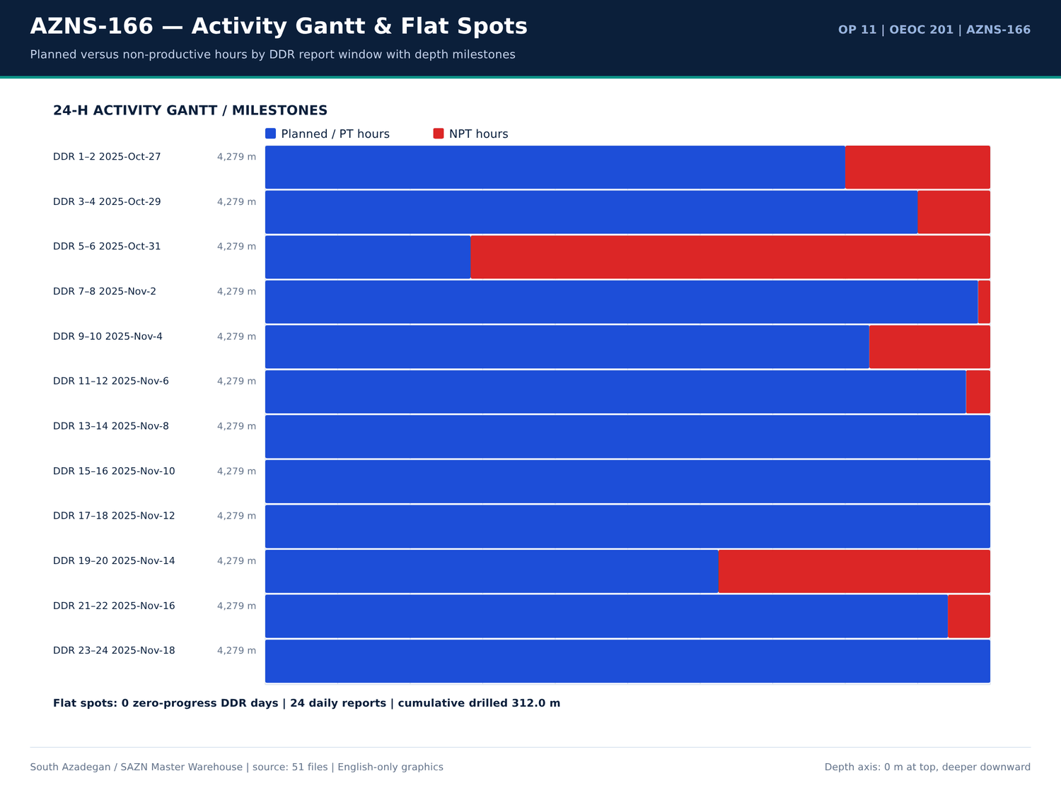
AZNS-166 09 gantt — منبع: انبار داده جامع سازن
یادداشتهای Workover و ماهیگیری
شماره گزارش | شیت | دسته | Text
No source rows for this query | — | — | —

صفحات Workover در EOWR/Programme
سند | صفحه | فصل | کاراکتر | تصویر | کلیدواژه
Well Program/11.AZNS_166_Workover-1_Program.pdf | 3 | 01 Well History & Summary | 7607 | 4 | bha,casing,cement,formation,milling,mud,waste
04.EOWR/11.AZNS_166_EOWR.pdf | 13 | 10 Wellhead & Xmas Tree | 1754 | 6 | casing,fish
Well Program/11.AZNS_166_Workover-1_Program.pdf | 18 | 10 Wellhead & Xmas Tree | 1337 | 4 | fish
04.EOWR/11.AZNS_166_EOWR.pdf | 26 | 09 Completion Tally & Tools | 2726 | 10 | casing,cement,contractor,fish,formation,mud,packer
Well Program/11.AZNS_166_Workover-1_Program.pdf | 29 | 09 Completion Tally & Tools | 3221 | 6 | casing,cement,fish,formation,mud,packer
Well Program/11.AZNS_166_Workover-1_Program.pdf | 32 | 12 Well Stimulation & Clean-Up | 2578 | 4 | acid,casing,cement,contractor,fish,mud,packer
Well Program/11.AZNS_166_Workover-1_Program.pdf | 33 | 06 BHA Record | 720 | 5 | bha,bit,milling,mud
Well Program/11.AZNS_166_Workover-1_Program.pdf | 46 | 02 Hole History & Dry Test | 3918 | 8 | casing,contractor,packer
Well Program/11.AZNS_166_Workover-1_Program.pdf | 60 | 02 Hole History & Dry Test | 461 | 4 | mud
04.EOWR/11.AZNS_166_EOWR.pdf | 63 | 02 Hole History & Dry Test | 3821 | 10 | contractor,packer

گزییده نشانی سلولهای عددی — فصل 17
سند | شیت | سلول | مقدار
CBS/11.AZNS_166_CBS.xlsx | Total Cost-EPD & Rigless | R5C3 | 9,087,998.52
CBS/11.AZNS_166_CBS.xlsx | Total Cost-EPD | R19C7 | 8,275,165.08
CBS/11.AZNS_166_CBS.xlsx | Total Cost-EPD & Rigless | R3C3 | 8,275,165.08
CBS/11.AZNS_166_CBS.xlsx | Total Cost-EPD | R3C6 | 2,118,462.01
CBS/11.AZNS_166_CBS.xlsx | Total Cost-EPD | R3C7 | 2,118,462.01
CBS/11.AZNS_166_CBS.xlsx | Cost Breakdown-166 | R197C6 | 2,118,462.01
CBS/11.AZNS_166_CBS.xlsx | Total Cost-EPD | R7C6 | 1,214,816.28
CBS/11.AZNS_166_CBS.xlsx | Total Cost-EPD | R7C7 | 1,214,816.28
CBS/11.AZNS_166_CBS.xlsx | Cost Breakdown-166 Contingecy | R183C16 | 1,214,816.28
CBS/11.AZNS_166_CBS.xlsx | Total Cost-EPD | R12C6 | 1,173,960.00
CBS/11.AZNS_166_CBS.xlsx | Total Cost-EPD | R12C7 | 1,173,960.00
CBS/11.AZNS_166_CBS.xlsx | Cost Breakdown-Material-166 | R249C6 | 1,173,960.00
CBS/11.AZNS_166_CBS.xlsx | Total Cost-EPD | R13C6 | 1,092,550.00
CBS/11.AZNS_166_CBS.xlsx | Cost Breakdown-166 | R5C6 | 1,017,455.31

Chapter 18 — تالی تکمیل و تستهای فشار
ردیفهای تالی تکمیل از شیتهای مواد 20.1/20.2/20.3 در CBS و رکوردهای لولهگذاری DDR گرفته شدهاند؛ خطوط TRSSSV، پکر، انکر، SSD، درز انبساط، نیپل و CIV/CIM با مقادیر قیمتی آمدهاند. واقعهمندیهای تست فشار از لایه متن EOWR / Programme با مقدار، واحد و صفحه جدولبندی شدهاند.
ردیفهای مواد تکمیل 20.x
شیت | شرح | واحد | مقدار | قیمت واحد (دلار) | مبلغ (دلار)
Cost Breakdown-Material-166 | Wellhead & Xmas tree Equipment | — | — | — | 483,360.00
Cost Breakdown-Material-166 | Tubing, 4 1/2", L80, 18.9 ppf, Premium Conn., Seamless, R2, PSL3. | m | 3,100.00 | 151 | 468,100.00
Cost Breakdown-Material-166 | Tubing, 3 1/2", L80, 10.2 ppf, Premium Conn., seamless, R2, PSL3. | m | 700 | 120 | 84,000.00
Coil Tubing Service-166 | Coiled Tubing Unit (1 1/2") | 1 EA | — | — | 76,800.00
Cost Breakdown-166 | Casing/tubing Running 4 1⁄2" | M | 8,000.00 | 6.5 | 52,000.00
Cost Breakdown-166 Contingecy | Coiled tubing equipment and personnel | DAY | 5.5 | 5,400.00 | 29,700.00
Mob.& Demob for Stim.-166 | Coiled Tubing Unit and Personnel | 1set | 2 | — | 16,200.00
Cost Breakdown-Material-166 | Tubing pup joint, 3 1/2", L080 type 1, 10.2 PPF, Gas Tight Conn, seamless, 1.5m long, PSL3. | ea. | 15 | 300 | 4,500.00
Cost Breakdown-Material-166 | Tubing pup joint, 3 1/2", L080,premium Connection 10.2 ppf,13CR01 MO, seamless,3 m long , PSL3 | ea. | 15 | 300 | 4,500.00
Cost Breakdown-166 | Tubing Running 3 1⁄2" | M | 558 | 6.5 | 3,627.00
Cost Breakdown-Material-166 | Drift Gauge, API, for 3 1/2" 10.2# tubing | ea. | 2 | 900 | 1,800.00
Cost Breakdown-Material-166 | Drift Gauge, API, for 4 1/2" 18.9# tubing | ea. | 2 | 900 | 1,800.00
Cost Breakdown-Material-166 | Tubing pup joint, 4 1/2", L080 type 1, 18.9 PPF, Gas Tight Conn, seamless, 1.5m, PSL3. | ea. | 5 | 350 | 1,750.00
Cost Breakdown-Material-166 | Tubing pup joint, 4 1/2", L080,premium Connection 18.9 ppf,13CR01 MO, seamless,3 m long , PSL3 | ea. | 5 | 350 | 1,750.00
Cost Breakdown-166 | Cementing 7" Liner | JOB | — | — | 0
Cost Breakdown-166 | Corrosion Log for 7" Liner and 9 5/8” casing (MTT or MTD or EMDS) CCL/GR (after perforation) | JOB | 0 | — | 0
Cost Breakdown-166 | Casing Running 7" Liner | M | 0 | 0 | 0
Cost Breakdown-166 | Casing Running 5" Liner | M | — | — | 0
Cost Breakdown-166 | Coiled tubing equipment and personnel | DAY | — | — | 0
Cost Breakdown-166 | Liner hanger running (lump Sum as Complete package) | — | — | — | 0
Cost Breakdown-166 | 7" liner hanger running equipment and personnel (lump Sum as Complete package) | JOB | — | — | 0
Cost Breakdown-166 | 5 1⁄2" liner hanger running equipment and personnel (lump Sum as Complete package) | JOB | — | — | 0

واقعهمندیهای تست فشار
کلید | مقدار | واحد | صفحه | سند | زمینه
PRESSURE_TEST | 4,500.00 | psi | 16 | Well Program/11.AZNS_166_Workover-1_Program.pdf | lling & Plug to 2770.1m Set Prong in NO-GO. Pressure test Comp. String W/4500psi for 15MIN, Ok. Close 3SV, laydown41/2''L. J
PRESSURE_TEST | 4,500.00 | psi | 43 | Well Program/11.AZNS_166_Workover-1_Program.pdf | lling & Plug to 2770.1m Set Prong in NO-GO. Pressure test Comp. String W/4500psi for 15MIN, Ok. Close 3SV, laydown 41/2''L.
PRESSURE_TEST | 6,000.00 | psi | 58 | 04.EOWR/11.AZNS_166_EOWR.pdf | Tubing String With check valve Inside. √ Pressure Test Tubing String 6000psi/15min Every 100 JTs. √ RIH Completion Stri
PRESSURE_TEST | 6,000.00 | psi | 58 | 04.EOWR/11.AZNS_166_EOWR.pdf | RSSSV √ Install control line to TRSSSV and pressure test control line 6000psi x 15mins. And then keep 3000psi pressure wh
PRESSURE_TEST | 4,500.00 | psi | 59 | 04.EOWR/11.AZNS_166_EOWR.pdf | bonnet. √ Check hanger for any damage and pressure test control line to 4500psi √ Pressure test chemical injection line &
PRESSURE_TEST | 6,000.00 | Psi | 78 | 04.EOWR/11.AZNS_166_EOWR.pdf | all) Item Test Check Mark and Result 1 Pressure test for the kill Valve W/ 1000 & 6000 Psi / 15 min OK 2 Pressure test for the SSV
PRESSURE_TEST | 6,000.00 | Psi | 78 | 04.EOWR/11.AZNS_166_EOWR.pdf | Valve W/ 1000 & 6000 Psi / 15 min OK 2 Pressure test for the SSV W/ 1000 & 6000 Psi / 15 min OK 3 Pressure test for the top
PRESSURE_TEST | 6,000.00 | Psi | 78 | 04.EOWR/11.AZNS_166_EOWR.pdf | valve W/ 1000 & 6000 Psi / 15 min OK 4 Pressure test for Swab valve W/ 1000 & 6000 Psi / 15 min OK 5 Pressure test for the Prod
PRESSURE_TEST | 6,000.00 | Psi | 79 | 04.EOWR/11.AZNS_166_EOWR.pdf | section W/1000 &6000 psi for 15min OK 2 Pressure test for the SSV Exit block W/ 6000 Psi / 15 min OK 3 Pressure test neck of tubi
PRESSURE_TEST | 6,000.00 | Psi | 79 | 04.EOWR/11.AZNS_166_EOWR.pdf | al seal W/1000 &6000 psi for 15min OK 4 Pressure test for Swab valve W/ 6000 Psi / 15 min - 5 Pressure test for Productio
PRESSURE_TEST | 6,000.00 | Psi | 79 | 04.EOWR/11.AZNS_166_EOWR.pdf | for Swab valve W/ 6000 Psi / 15 min - 5 Pressure test for Production valve W/6000 Psi / 15 min - 6 Pressure test cavity of FS.
PRESSURE_TEST | 5,500.00 | psi | 113 | 04.EOWR/11.AZNS_166_EOWR.pdf | jector CTU 27 – Jan – 2026 14:50 perform pressure test the rubber striper and injector and BOP with( 5500 psi )(ok) 28 – Jan – 2026 05:15 displacement
PRESSURE_TEST | 5,000.00 | psi | 114 | 04.EOWR/11.AZNS_166_EOWR.pdf | e (SIWHP: 800 psi). 29 – Jan – 2026 16:30 Pressure test up to 5000 psi, ok 29 – Jan – 2026 16:45 Start RIH slick

جداول شمارهدار تکمیل و سرچاه
سند | صفحه | شماره جدول | عنوان | دسته
04.EOWR/11.AZNS_166_EOWR.pdf | 5 | 7-5 | AZNS-166 COMPLETION TALLY ...................................................................................................... 70 | EOWR
04.EOWR/11.AZNS_166_EOWR.pdf | 5 | 10-2 | AZNS-166 WATER ANALYSIS DE-COMPLETION SECTION ............................................................. 105 | EOWR
04.EOWR/11.AZNS_166_EOWR.pdf | 70 | 7-5 | AZNS-166 Completion Tally | EOWR
04.EOWR/11.AZNS_166_EOWR.pdf | 105 | 10-2 | AZNS-166 Water Analysis De-Completion section | EOWR

گزییده نشانی سلولهای عددی — فصل 18
سند | شیت | سلول | مقدار
CBS/11.AZNS_166_CBS.xlsx | Total Cost-EPD & Rigless | R5C3 | 9,087,998.52
CBS/11.AZNS_166_CBS.xlsx | Total Cost-EPD | R19C7 | 8,275,165.08
CBS/11.AZNS_166_CBS.xlsx | Total Cost-EPD & Rigless | R3C3 | 8,275,165.08
CBS/11.AZNS_166_CBS.xlsx | Total Cost-EPD | R3C6 | 2,118,462.01
CBS/11.AZNS_166_CBS.xlsx | Total Cost-EPD | R3C7 | 2,118,462.01
CBS/11.AZNS_166_CBS.xlsx | Cost Breakdown-166 | R197C6 | 2,118,462.01
CBS/11.AZNS_166_CBS.xlsx | Total Cost-EPD | R7C6 | 1,214,816.28
CBS/11.AZNS_166_CBS.xlsx | Total Cost-EPD | R7C7 | 1,214,816.28
CBS/11.AZNS_166_CBS.xlsx | Cost Breakdown-166 Contingecy | R183C16 | 1,214,816.28
CBS/11.AZNS_166_CBS.xlsx | Total Cost-EPD | R12C6 | 1,173,960.00
CBS/11.AZNS_166_CBS.xlsx | Total Cost-EPD | R12C7 | 1,173,960.00
CBS/11.AZNS_166_CBS.xlsx | Cost Breakdown-Material-166 | R249C6 | 1,173,960.00
CBS/11.AZNS_166_CBS.xlsx | Total Cost-EPD | R13C6 | 1,092,550.00
CBS/11.AZNS_166_CBS.xlsx | Cost Breakdown-166 | R5C6 | 1,017,455.31

Chapter 19 — اسیدکاری ماتریس، CTU و شاخص بهرهدهی
خانوادههای تحریک بدون دکل، حجمهای برنامهریزشده مواد، قیمت واحد و واقعهمندیهای اسید / N2 / WHP / PI / نرخ با نشانی صفحه آمدهاند. مقایسه بهرهدهی پیش/پس اسید تنها وقتی انجام میشود که هر دو مقدار در متن منبع موجود باشند؛ 66 ردیف تطبیق، مواد قیمتی CBS را به مصرف DDR پیوند میدهد.
خانوادههای قیمتی تحریک بدون دکل
شیت | شرح | واحد | حجم | قیمت واحد (دلار) | روز آمادهباش | روز عملیات | مبلغ (دلار)
Cost breakdown R-less Stim.-166 | Mobilization, Demobilization | 43738 | — | — | — | — | —
Cost breakdown R-less Stim.-166 | Materials and Consumables | 124335 | — | — | — | — | —
Cost breakdown R-less Stim.-166 | Acidizing and N2 services | 117529 | — | — | — | — | —
Cost breakdown R-less Stim.-166 | Coiled Tubing Services | 89800 | — | — | — | — | —
Cost breakdown R-less Stim.-166 | Oil Transportation Services | 60000 | — | — | — | — | —
Cost breakdown R-less Stim.-166 | Well Testing and Production Services | 83282.84 | — | — | — | — | —
Cost breakdown R-less Stim.-166 | Wireline Production Logging Services | 76170 | — | — | — | — | —
Cost breakdown R-less Stim.-166 | Slickline Services | 39464.6 | — | — | — | — | —
Cost breakdown R-less Stim.-166 | Memory Gauge Service | 2927 | — | — | — | — | —
Cost breakdown R-less Stim.-166 | Bottomhole PVT Sampling | 0 | — | — | — | — | —
Cost breakdown R-less Stim.-166 | Personnel Rates | 62587 | — | — | — | — | —
Cost breakdown R-less Stim.-166 | Design, Interpretation, Reporting | 13000 | — | — | — | — | —
Cost breakdown R-less Stim.-166 | Accommodation | 100000 | — | — | — | — | —
Mob.& Demob for Stim.-166 | Liquid Pumping Unit, and Personnel | 1 set | 1 | — | — | — | 3,038.00
Mob.& Demob for Stim.-166 | Fracturing Unit and Personnel | 1set | 0 | — | — | — | 0
Mob.& Demob for Stim.-166 | Storage/Mixing Tank (water,acid, diesel) 500BBL Minimum | 1x500 BBL tank | 1 | — | — | — | 300
Mob.& Demob for Stim.-166 | Batch mixer | 1 set | 1 | — | — | — | 2,500.00
Mob.& Demob for Stim.-166 | Blender | 1 set | 1 | — | — | — | 2,500.00
Mob.& Demob for Stim.-166 | Liquid N2 Pump Unit and Personnel | 1set | 1 | — | — | — | 2,500.00
Mob.& Demob for Stim.-166 | Liquid Nitrogen Storage Tank | 1set | 1 | — | — | — | 1,000.00
Mob.& Demob for Stim.-166 | Coiled Tubing Unit and Personnel | 1set | 2 | — | — | — | 16,200.00
Mob.& Demob for Stim.-166 | Test Choke Manifold | 1set | 1 | — | — | — | 1,500.00

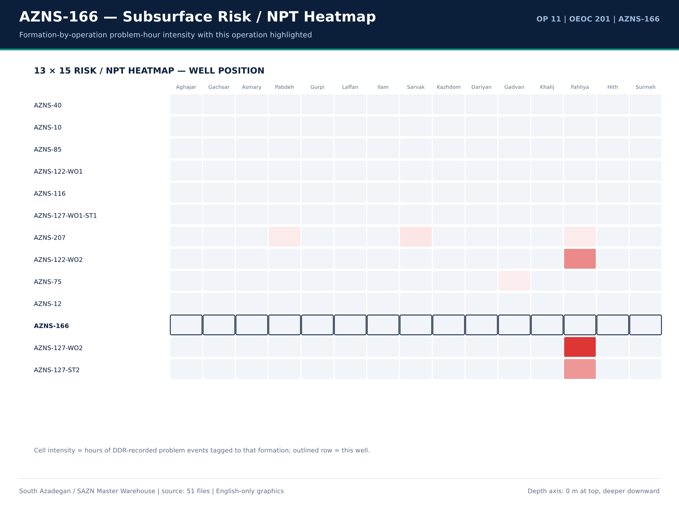
AZNS-166 10 risk — منبع: انبار داده جامع سازن
واقعهمندیهای اسید، N2، WHP، PI و نرخ
کلید | مقدار | واحد | صفحه | سند | زمینه
WHP | 1,700.00 | psi | 12 | 04.EOWR/11.AZNS_166_EOWR.pdf | of 3SV flapper observed on neck of plug. SIWHP = 1700psi, flow the well (FWHP = 700psi), close 3SV fl
WHP | 700 | psi | 12 | 04.EOWR/11.AZNS_166_EOWR.pdf | k of plug. SIWHP = 1700psi, flow the well (FWHP = 700psi), close 3SV flowing continued, RIH SL with L
WHP | 1,500.00 | psi | 12 | 04.EOWR/11.AZNS_166_EOWR.pdf | dropped & remained constant. (600 – 800psi) WHP = 1500psi, RIH SL with special protection sleeve (prof
WHP | 1,700.00 | psi | 17 | Well Program/11.AZNS_166_Workover-1_Program.pdf | 3SV flapper observed on neck of plug. • SIWHP = 1700psi, flow the well (FWHP = 700psi), close 3SV fl
WHP | 700 | psi | 17 | Well Program/11.AZNS_166_Workover-1_Program.pdf | plug. • SIWHP = 1700psi, flow the well (FWHP = 700psi), close 3SV flowing continued, RIH SL with
WHP | 1,500.00 | psi | 17 | Well Program/11.AZNS_166_Workover-1_Program.pdf | pped & remained constant. (600 – 800psi) • WHP = 1500psi, RIH SL with special protection sleeve (prof
WHP | 0 | psi | 106 | 04.EOWR/11.AZNS_166_EOWR.pdf | ng pressure recorded at 32/64 choke setting, wellhead pressure at 0psi and no observable returns at surface. In o
WHP | 0 | psi | 109 | 04.EOWR/11.AZNS_166_EOWR.pdf | st on coiled tubing equipment C/S: 32/64 - WHP: 0 psi - outlet from the well: no return Retrieve
WHP | 0 | psi | 111 | 04.EOWR/11.AZNS_166_EOWR.pdf | uipment (S/L), set P.S at 63.7m, Open TMV, SIWHP: 0psi, RIH S/L to Max accessible TD (2950m) 24 –
WHP | 0 | psi | 111 | 04.EOWR/11.AZNS_166_EOWR.pdf | head pressure monitoring ( C/S: closed - WHP: 0 psi - outlet from the well: no return) 26 – Jan
WHP | 800 | psi | 111 | 04.EOWR/11.AZNS_166_EOWR.pdf | S, flow the well & monitor well condition, SIWHP: 800psi. 30 – Jan – 2026 flowing the well & monito
N2_VOL | 2,430.00 | gal | 111 | 04.EOWR/11.AZNS_166_EOWR.pdf | le TD (2950m) 24 – Jan – 2026 Line Up CT & N2 Track, Perform N2 lifting (T.V: 2430 gal ) 25 – Jan – 2026 Well head pressure monit
WHP | 0 | psi | 112 | 04.EOWR/11.AZNS_166_EOWR.pdf | V, OK 23 – Jan – 2026 21:45 Open TMV ( SIWHP:0 psi) 23 – Jan – 2026 21:50 Start RIH S/L to s
WHP | 0 | psi | 112 | 04.EOWR/11.AZNS_166_EOWR.pdf | /5500psi ,5/15min Against TMV. Open TMV ( SIWHP:0 psi)@ Start RIH S/L to Max acceseble TD 23 – Ja
WHP | 0 | psi | 113 | 04.EOWR/11.AZNS_166_EOWR.pdf | e monitoring @ 16:50 to 23:55 ( C/S: 32/64 - WHP: 0 psi - outlet from the well: no return) 24 – Ja
WHP | 0 | psi | 113 | 04.EOWR/11.AZNS_166_EOWR.pdf | head pressure monitoring ( C/S: closed - WHP: 0 psi - outlet from the well: no return) 25 – Ja
WHP | 0 | psi | 113 | 04.EOWR/11.AZNS_166_EOWR.pdf | head pressure monitoring ( C/S: closed - WHP: 0 psi - outlet from the well: no return) R/D th
WHP | 800 | psi | 114 | 04.EOWR/11.AZNS_166_EOWR.pdf | T 29 – Jan – 2026 16:00 R/U slick line (SIWHP: 800 psi). 29 – Jan – 2026 16:30 Pressure test up

ردیفهای شیمیایی تحریک از CBS
شیت | شرح | واحد | مقدار | مبلغ (دلار)
Acidizing &N2 service-166 | Total Operation and Standby Charges for Acidizing and Nitrogen Services (USD) | — | — | 117,529.00
Personnel rate-166 | Total Personnel Charge for Acidizing, Testing and Related Services (USD) | — | — | 62,587.00
Material & Consumable-166 | Liquid Nitrogen (N2) | Gal | 7,000.00 | 28,000.00
Cost Breakdown-166 Contingecy | Xylene | Gal | 2,100.00 | 18,900.00
Material & Consumable-166 | Xylene | Gal | 2,000.00 | 18,000.00
Acidizing &N2 service-166 | Liquid Nitrogen Unit | 1 EA | — | 9,900.00
Acidizing &N2 service-166 | Acid Storage Tanks | 1 EA | — | 5,950.00
Acidizing &N2 service-166 | Acid Mixing Tanks | 1 EA | — | 5,950.00
Material & Consumable-166 | Mutual Solvent | Gal | 100 | 3,000.00
Acidizing &N2 service-166 | Liquid Nitrogen Tank | 1 EA | — | 2,800.00
Acidizing &N2 service-166 | Acid Testing Lab (or Acid Testing costs in accredited lab | 1 EA | — | 2,565.00
Material & Consumable-166 | HCL (≥28%) | Gal | 1,000.00 | 2,000.00
Design,Interp.,Reporting-166 | Acid Labaratory Experiments | Test of Acidizing Fluid | 1 | 2,000.00
Mob.& Demob for Stim.-166 | Liquid Nitrogen Storage Tank | 1set | 1 | 1,000.00
Material & Consumable-166 | Surfactant | Gal | 45 | 675
Acidizing &N2 service-166 | Acid and Chemical Pump | 1 EA | — | 594
Mob.& Demob for Stim.-166 | Storage/Mixing Tank (water,acid, diesel) 500BBL Minimum | 1x500 BBL tank | 1 | 300
Cost Breakdown-166 | Lifting with 400bbl Liquid Nitrogen | BBL | — | 0
Cost Breakdown-166 | Nitrogen Unit Full Package | Day | — | 0
Material & Consumable-166 | Acetic Acid (98%) | Gal | 0 | 0
Material & Consumable-166 | Self Diverting Viscoelastic Surfactant (SDVES) | Gal | 0 | 0
Material & Consumable-166 | Benzoic Acid | lb | 0 | 0

گزییده نشانی سلولهای عددی — فصل 19
سند | شیت | سلول | مقدار
CBS/11.AZNS_166_CBS.xlsx | Total Cost-EPD & Rigless | R5C3 | 9,087,998.52
CBS/11.AZNS_166_CBS.xlsx | Total Cost-EPD | R19C7 | 8,275,165.08
CBS/11.AZNS_166_CBS.xlsx | Total Cost-EPD & Rigless | R3C3 | 8,275,165.08
CBS/11.AZNS_166_CBS.xlsx | Total Cost-EPD | R3C6 | 2,118,462.01
CBS/11.AZNS_166_CBS.xlsx | Total Cost-EPD | R3C7 | 2,118,462.01
CBS/11.AZNS_166_CBS.xlsx | Cost Breakdown-166 | R197C6 | 2,118,462.01
CBS/11.AZNS_166_CBS.xlsx | Total Cost-EPD | R7C6 | 1,214,816.28
CBS/11.AZNS_166_CBS.xlsx | Total Cost-EPD | R7C7 | 1,214,816.28
CBS/11.AZNS_166_CBS.xlsx | Cost Breakdown-166 Contingecy | R183C16 | 1,214,816.28
CBS/11.AZNS_166_CBS.xlsx | Total Cost-EPD | R12C6 | 1,173,960.00
CBS/11.AZNS_166_CBS.xlsx | Total Cost-EPD | R12C7 | 1,173,960.00
CBS/11.AZNS_166_CBS.xlsx | Cost Breakdown-Material-166 | R249C6 | 1,173,960.00
CBS/11.AZNS_166_CBS.xlsx | Total Cost-EPD | R13C6 | 1,092,550.00
CBS/11.AZNS_166_CBS.xlsx | Cost Breakdown-166 | R5C6 | 1,017,455.31

Chapter 20 — HSE، MTBF، پسماند و پیمانکاران جزء
سری POB، مصرف سوخت/آب، ردیفهای پسماند، صفحات فصل HSE و نام پیمانکاران/شرکتهای خدماتی از DDR و EOWR بازتولید شدهاند. ردیفهای اسکان و پذیرایی CBS بر جمع POB ثبتشده در DDR تطبیق داده میشوند، نه بر سرنفر فرضی.
سری افراد حاضر
شماره گزارش | دسته | تعداد | جمع
1 | OEOC Rig | 79 | —
1 | Client (TEC) | 3 | —
1 | MSA | 7 | —
1 | Service company | 18 | —
1 | Catering + Guard | 12 | —
1 | Labour | 0 | —
1 | Other | 0 | —
1 | TOTAL POB | 119 | 119
2 | OEOC Rig | 79 | —
2 | Client (TEC) | 3 | —
2 | MSA | 7 | —
2 | Service company | 18 | —
2 | Catering + Guard | 12 | —
2 | Labour | 0 | —
2 | Other | 0 | —
2 | TOTAL POB | 119 | 119
3 | OEOC Rig | 79 | —
3 | Client (TEC) | 3 | —
3 | MSA | 7 | —
3 | Service company | 18 | —
3 | Catering + Guard | 12 | —
3 | Labour | 0 | —

ردیفهای سوخت، آب و پسماند
شماره گزارش | ماده | واحد | دریافتی | مصرف | موجودی | سلول
1 | BULK Fuel Rig | Lit | — | — | 46,000.00 | F72
1 | BULK Fuel Camp | Lit | — | — | 3,600.00 | G72
1 | BULK Fuel Rig | Lit | — | 4,500.00 | — | F73
1 | BULK Fuel Camp | Lit | — | 600 | — | G73
2 | BULK Fuel Rig | Lit | — | — | 38,000.00 | F72
2 | BULK Fuel Camp | Lit | — | — | 7,000.00 | G72
2 | BULK Fuel Rig | Lit | — | 4,000.00 | — | F73
2 | BULK Fuel Camp | Lit | — | 600 | — | G73
2 | BULK Fuel Camp | Lit | 4,000.00 | — | — | G74
3 | BULK Fuel Rig | Lit | — | — | 34,000.00 | F72
3 | BULK Fuel Camp | Lit | — | — | 6,400.00 | G72
3 | BULK Fuel Rig | Lit | — | 4,000.00 | — | F73
3 | BULK Fuel Camp | Lit | — | 600 | — | G73
4 | BULK Fuel Rig | Lit | — | — | 34,000.00 | F72
4 | BULK Fuel Camp | Lit | — | — | 6,400.00 | G72
4 | BULK Fuel Rig | Lit | — | 4,000.00 | — | F73
4 | BULK Fuel Camp | Lit | — | 600 | — | G73
5 | BULK Fuel Rig | Lit | — | — | 56,000.00 | F72
5 | BULK Fuel Camp | Lit | — | — | 5,200.00 | G72
5 | BULK Fuel Rig | Lit | — | 3,000.00 | — | F73
5 | BULK Fuel Camp | Lit | — | 600 | — | G73
5 | BULK Fuel Rig | Lit | 29,000.00 | — | — | F74

ردیفهای اسکان و پذیرایی CBS
شیت | شرح | مقدار | واحد | Rate | مبلغ (دلار)
Rig Move | Rig move between well pads | 1 | — | 247,000.00 | 247,000.00
Rig Move | Rig move between Cellar-to-Cellar within the same pad | 0 | — | 0 | 0
Catering & Accommodation | Full board catering and accommodation | — | 30 | — | —
Catering & Accommodation | Breakfast | — | 10 | — | —
Catering & Accommodation | Lunch | — | 15 | — | —
Catering & Accommodation | Dinner | — | 15 | — | —
Catering & Accommodation | Night Meals | — | 10 | — | —
Catering & Accommodation | Accommodation | — | 15 | — | —
Full package Accomm-AZNS166 | Full package Accommodation | 20 | Day | 5,000.00 | 100,000.00
Full package Accomm-AZNS166 | — | — | — | — | 100,000.00

گزییده نشانی سلولهای عددی — فصل 20
سند | شیت | سلول | مقدار
CBS/11.AZNS_166_CBS.xlsx | Total Cost-EPD & Rigless | R5C3 | 9,087,998.52
CBS/11.AZNS_166_CBS.xlsx | Total Cost-EPD | R19C7 | 8,275,165.08
CBS/11.AZNS_166_CBS.xlsx | Total Cost-EPD & Rigless | R3C3 | 8,275,165.08
CBS/11.AZNS_166_CBS.xlsx | Total Cost-EPD | R3C6 | 2,118,462.01
CBS/11.AZNS_166_CBS.xlsx | Total Cost-EPD | R3C7 | 2,118,462.01
CBS/11.AZNS_166_CBS.xlsx | Cost Breakdown-166 | R197C6 | 2,118,462.01
CBS/11.AZNS_166_CBS.xlsx | Total Cost-EPD | R7C6 | 1,214,816.28
CBS/11.AZNS_166_CBS.xlsx | Total Cost-EPD | R7C7 | 1,214,816.28
CBS/11.AZNS_166_CBS.xlsx | Cost Breakdown-166 Contingecy | R183C16 | 1,214,816.28
CBS/11.AZNS_166_CBS.xlsx | Total Cost-EPD | R12C6 | 1,173,960.00
CBS/11.AZNS_166_CBS.xlsx | Total Cost-EPD | R12C7 | 1,173,960.00
CBS/11.AZNS_166_CBS.xlsx | Cost Breakdown-Material-166 | R249C6 | 1,173,960.00
CBS/11.AZNS_166_CBS.xlsx | Total Cost-EPD | R13C6 | 1,092,550.00
CBS/11.AZNS_166_CBS.xlsx | Cost Breakdown-166 | R5C6 | 1,017,455.31

Chapter 21 — زمینشناسی عمیق و همبستگی میدانی
تعداد 11 سر سازند همبسته، ستونهای پیشبینی/واقعی DDR، سرهای EOWR و جداول پیشبینی Programme را بههم پیوند میدهد. اختلاف ساختمانی، عمق واقعی منهای پیشبینی بر حسب متر است؛ سنگشناسی، نشانههای گاز، H2S/CO2، فلورسانس و شواهد CBL-VDL-USIT بر پایه صفحه نمایه شدهاند. همبستگی تاقدیس South Azadegan با ۱۲ عملیات دیگر برقرار شده است.
سر سازندها: پیشبینی در برابر واقعی
شماره گزارش | سازند | عمق اندازهگیری (متر) | عمق قائم (متر) | عمق پیشبینی (متر) | Prognosis TVD (m) | سنگشناسی
No source rows for this query | — | — | — | — | — | —

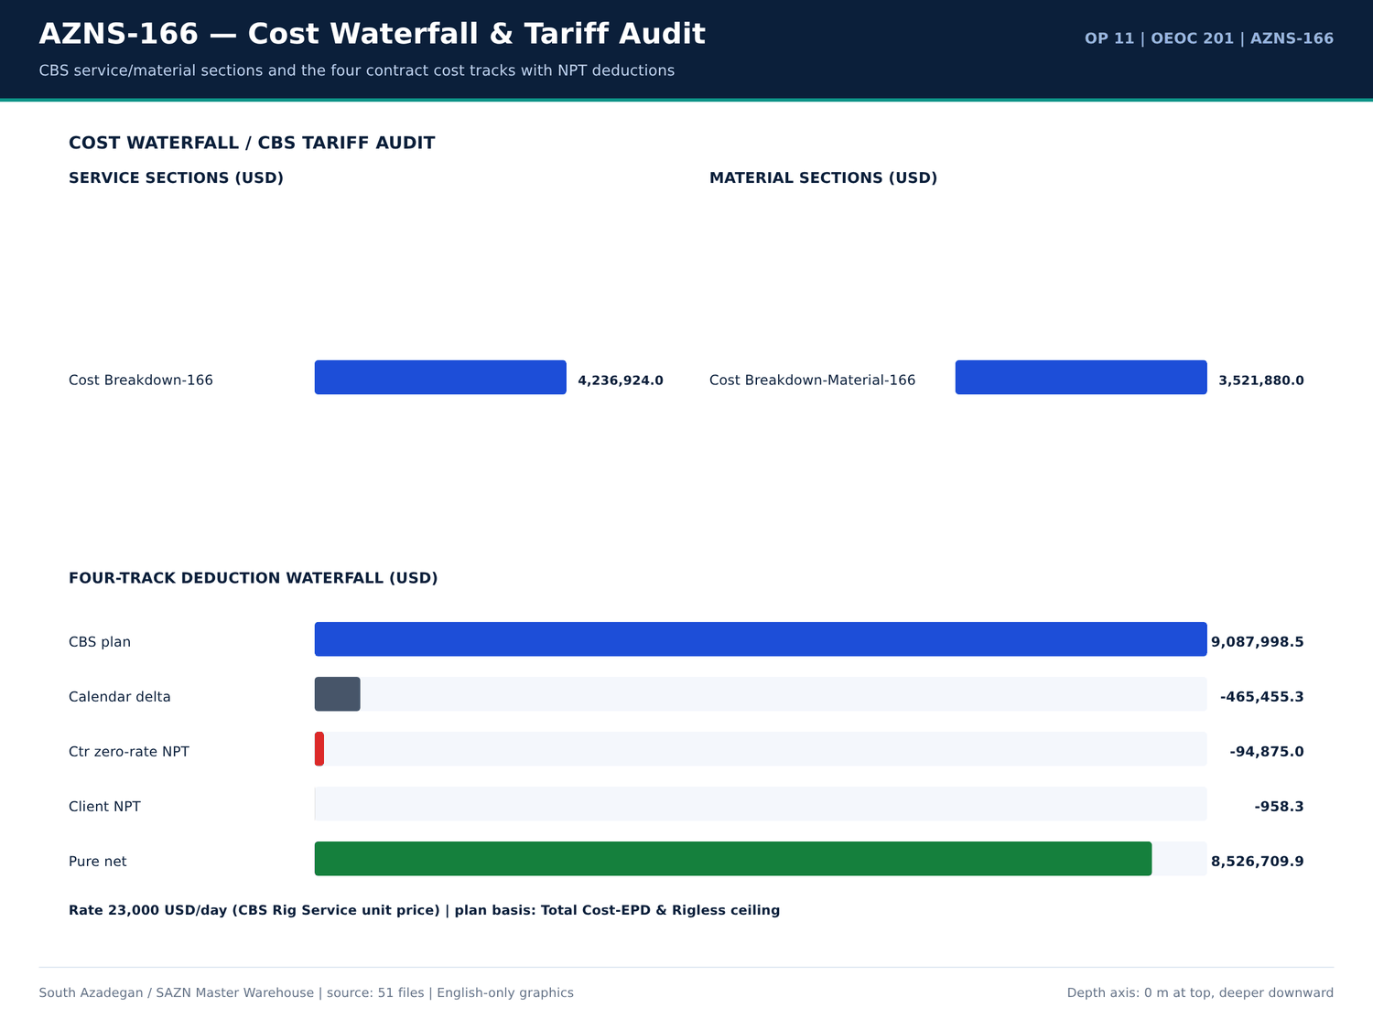
AZNS-166 11 cost — منبع: انبار داده جامع سازن
واقعهمندیهای سر سازند
کلید | مقدار | واحد | صفحه | سند | زمینه
Fahliyan MD | 643 | m | 5 | Well Program/11.AZNS_166_Workover-1_Program.pdf | vertically down to the Cretaceous Fahliyan Formation with total depth of 4,643m. The results of this well, revealed th
Fahliyan MD | 2,008.00 | m | 5 | Well Program/11.AZNS_166_Workover-1_Program.pdf | parts of this huge field down to Fahliyan Formation. In the later stage the well No.10 assumed as exploration well for
Total Depth MD | 4,280.00 | m | 22 | Well Program/11.AZNS_166_Workover-1_Program.pdf | rkover#1 Well Sketch & Completion Total Depth @ 4280 mMD Formation Formation Tops Depth (mMD) 0 1000 m 2000 m 3000 m 40
Aghajari MD | 1,262.00 | m | 22 | Well Program/11.AZNS_166_Workover-1_Program.pdf | mMD) 0 1000 m 2000 m 3000 m 4000 m Aghajari 1262 m 1773 m Gachsaran Asmari 2119 m 2353 m Gurpi 2724 m Ilam Sarvak 3847 m
Gachsaran MD | 2,119.00 | m | 22 | Well Program/11.AZNS_166_Workover-1_Program.pdf | 00 m 4000 m Aghajari 1262 m 1773 m Gachsaran Asmari 2119 m 2353 m Gurpi 2724 m Ilam Sarvak 3847 m Kazhdumi 4183 m Dariya
Asmary MD | 2,353.00 | m | 22 | Well Program/11.AZNS_166_Workover-1_Program.pdf | m Aghajari 1262 m 1773 m Gachsaran Asmari 2119 m 2353 m Gurpi 2724 m Ilam Sarvak 3847 m Kazhdumi 4183 m Dariyan 20" CSG
Gurpi MD | 2,724.00 | m | 22 | Well Program/11.AZNS_166_Workover-1_Program.pdf | 3 m Gachsaran Asmari 2119 m 2353 m Gurpi 2724 m Ilam Sarvak 3847 m Kazhdumi 4183 m Dariyan 20" CSG @ 147 mMD 13 3/8" CSG
Ilam MD | 3,847.00 | m | 22 | Well Program/11.AZNS_166_Workover-1_Program.pdf | Asmari 2119 m 2353 m Gurpi 2724 m Ilam Sarvak 3847 m Kazhdumi 4183 m Dariyan 20" CSG @ 147 mMD 13 3/8" CSG @ 1338 mMD 9
Sarvak MD | 4,183.00 | m | 22 | Well Program/11.AZNS_166_Workover-1_Program.pdf | ri 2119 m 2353 m Gurpi 2724 m Ilam Sarvak 3847 m Kazhdumi 4183 m Dariyan 20" CSG @ 147 mMD 13 3/8" CSG @ 1338 mMD 9 5/8"
Kazhdomi MD | 1,338.00 | m | 22 | Well Program/11.AZNS_166_Workover-1_Program.pdf | m Gurpi 2724 m Ilam Sarvak 3847 m Kazhdumi 4183 m Dariyan 20" CSG @ 147 mMD 13 3/8" CSG @ 1338 mMD 9 5/8" CSG @ 1764.6
Dariyan MD | 1,764.60 | m | 22 | Well Program/11.AZNS_166_Workover-1_Program.pdf | Ilam Sarvak 3847 m Kazhdumi 4183 m Dariyan 20" CSG @ 147 mMD 13 3/8" CSG @ 1338 mMD 9 5/8" CSG @ 1764.6 mMD 7" L.lap @ 1
Pabdeh MD | 2,616.00 | m | 22 | Well Program/11.AZNS_166_Workover-1_Program.pdf | 132.8 mMD 4-1/2" S.Liner 4279 mMD Pabdeh 2616 m KOP @ 2735 m MD Packer depth @ 2754 mMD Figure 4: Well Schematic Befo
Total Depth MD | 4,280.00 | m | 23 | Well Program/11.AZNS_166_Workover-1_Program.pdf | ll Sketch & Completion Depth (mMD) Total Depth @ 4280 mMD 0 1000 m 2000 m 3000 m 4000 m Aghajari 1262 m 1773 m Gachsaran
Aghajari MD | 1,262.00 | m | 23 | Well Program/11.AZNS_166_Workover-1_Program.pdf | mMD 0 1000 m 2000 m 3000 m 4000 m Aghajari 1262 m 1773 m Gachsaran Asmari 2119 m 2353 m Gurpi 2724 m Ilam Sarvak 3847 m
Gachsaran MD | 2,119.00 | m | 23 | Well Program/11.AZNS_166_Workover-1_Program.pdf | 00 m 4000 m Aghajari 1262 m 1773 m Gachsaran Asmari 2119 m 2353 m Gurpi 2724 m Ilam Sarvak 3847 m Kazhdumi 4183 m Dariya
Asmary MD | 2,353.00 | m | 23 | Well Program/11.AZNS_166_Workover-1_Program.pdf | m Aghajari 1262 m 1773 m Gachsaran Asmari 2119 m 2353 m Gurpi 2724 m Ilam Sarvak 3847 m Kazhdumi 4183 m Dariyan 20" CSG
Gurpi MD | 2,724.00 | m | 23 | Well Program/11.AZNS_166_Workover-1_Program.pdf | 3 m Gachsaran Asmari 2119 m 2353 m Gurpi 2724 m Ilam Sarvak 3847 m Kazhdumi 4183 m Dariyan 20" CSG @ 147 mMD 13 3/8" CSG
Ilam MD | 3,847.00 | m | 23 | Well Program/11.AZNS_166_Workover-1_Program.pdf | Asmari 2119 m 2353 m Gurpi 2724 m Ilam Sarvak 3847 m Kazhdumi 4183 m Dariyan 20" CSG @ 147 mMD 13 3/8" CSG @ 1338 mMD 9
Sarvak MD | 4,183.00 | m | 23 | Well Program/11.AZNS_166_Workover-1_Program.pdf | ri 2119 m 2353 m Gurpi 2724 m Ilam Sarvak 3847 m Kazhdumi 4183 m Dariyan 20" CSG @ 147 mMD 13 3/8" CSG @ 1338 mMD 9 5/8"
Kazhdomi MD | 1,338.00 | m | 23 | Well Program/11.AZNS_166_Workover-1_Program.pdf | m Gurpi 2724 m Ilam Sarvak 3847 m Kazhdumi 4183 m Dariyan 20" CSG @ 147 mMD 13 3/8" CSG @ 1338 mMD 9 5/8" CSG @ 1764.6
Dariyan MD | 1,764.60 | m | 23 | Well Program/11.AZNS_166_Workover-1_Program.pdf | Ilam Sarvak 3847 m Kazhdumi 4183 m Dariyan 20" CSG @ 147 mMD 13 3/8" CSG @ 1338 mMD 9 5/8" CSG @ 1764.6 mMD 7" L.lap @ 1
Pabdeh MD | 2,616.00 | m | 23 | Well Program/11.AZNS_166_Workover-1_Program.pdf | 132.8 mMD 4-1/2" S.Liner 4279 mMD Pabdeh 2616 m KOP @ 2735 m MD Packer depth @ 2706 mMD Figure 5: Well Schematic Afte

شواهد گاز، H2S، CO2 و CBL
کلید | مقدار | واحد | صفحه | سند | زمینه
H2S | 58 | — | 4 | Well Program/11.AZNS_166_Workover-1_Program.pdf | H2S MONITORING & PREVENTION MEASURE ........................................................ 58
H2S | 6 | — | 17 | 04.EOWR/11.AZNS_166_EOWR.pdf | H2S Drill. Cont RIH with 6
H2S | 2 | — | 55 | Well Program/11.AZNS_166_Workover-1_Program.pdf | H2S in Sarvak, Kazhdumi and Gadvan reservoirs, Make detail H2
H2S | 10 | — | 58 | Well Program/11.AZNS_166_Workover-1_Program.pdf | H2S warning indicator: the first warning level is 10
H2S | 20 | — | 58 | Well Program/11.AZNS_166_Workover-1_Program.pdf | H2S content to operators. The second warning level is 20
H2S | 20 | — | 58 | Well Program/11.AZNS_166_Workover-1_Program.pdf | H2S content in air exceed 20
H2S | 2 | — | 58 | Well Program/11.AZNS_166_Workover-1_Program.pdf | H2S area shall be furnished with H2
H2S | 9.5 | — | 58 | Well Program/11.AZNS_166_Workover-1_Program.pdf | H2S area shall be kept over 9.5
H2S | 2 | — | 58 | Well Program/11.AZNS_166_Workover-1_Program.pdf | H2S concentration in drilling fluid. The H2
H2S | 2 | — | 59 | Well Program/11.AZNS_166_Workover-1_Program.pdf | H2S concentration should be measured in the places where H2

گزییده نشانی سلولهای عددی — فصل 21
سند | شیت | سلول | مقدار
CBS/11.AZNS_166_CBS.xlsx | Total Cost-EPD & Rigless | R5C3 | 9,087,998.52
CBS/11.AZNS_166_CBS.xlsx | Total Cost-EPD | R19C7 | 8,275,165.08
CBS/11.AZNS_166_CBS.xlsx | Total Cost-EPD & Rigless | R3C3 | 8,275,165.08
CBS/11.AZNS_166_CBS.xlsx | Total Cost-EPD | R3C6 | 2,118,462.01
CBS/11.AZNS_166_CBS.xlsx | Total Cost-EPD | R3C7 | 2,118,462.01
CBS/11.AZNS_166_CBS.xlsx | Cost Breakdown-166 | R197C6 | 2,118,462.01
CBS/11.AZNS_166_CBS.xlsx | Total Cost-EPD | R7C6 | 1,214,816.28
CBS/11.AZNS_166_CBS.xlsx | Total Cost-EPD | R7C7 | 1,214,816.28
CBS/11.AZNS_166_CBS.xlsx | Cost Breakdown-166 Contingecy | R183C16 | 1,214,816.28
CBS/11.AZNS_166_CBS.xlsx | Total Cost-EPD | R12C6 | 1,173,960.00
CBS/11.AZNS_166_CBS.xlsx | Total Cost-EPD | R12C7 | 1,173,960.00
CBS/11.AZNS_166_CBS.xlsx | Cost Breakdown-Material-166 | R249C6 | 1,173,960.00
CBS/11.AZNS_166_CBS.xlsx | Total Cost-EPD | R13C6 | 1,092,550.00
CBS/11.AZNS_166_CBS.xlsx | Cost Breakdown-166 | R5C6 | 1,017,455.31

Chapter 22 — کالبدشکافی مسائل و Playbook شصتثانیهای
هر یک از 3 خانواده مسئله واقعی با روز، عمق، سازند، دو یا چند فرضیه، اثربخشی اقدام، ساعات و مواجهه هزینهای بر پایه 23,000 دلار در روز کالبدشکافی شده است. دستورالعملهای ۶۰ ثانیهای سکوی دکل عیناً در جدول جداگانهای آمدهاند؛ اینها دستور عملیاتیاند، نه توصیه کلی.
دفتر کالبدشکافی مسائل
دسته | Occurrences | ساعت | عمق (متر) | سازند | منتسب به | هزینه (دلار) | شاهد عددی
Other operational delay | 1,5,6,14,19,20,21 | 4,279.00 | 4-1/2" Non-Slotted LNR | Other operational delay — 18 occurrences | 53 | 50,791.67 | DDR 24-h log / remarks
Rig equipment failure | 4,5 | 4,279.00 | 4-1/2" Non-Slotted LNR | Rig equipment failure — 2 occurrences | 29 | 27,791.67 | DDR 24-h log / remarks
Waiting on services / material | 3,4,5,6,7,9,10,11 | 4,279.00 | 4-1/2" Non-Slotted LNR | Waiting on services / material — 18 occurrences | 18 | 17,250.00 | DDR 24-h log / remarks

دستورالعملهای ۶۰ ثانیهای سکوی دکل
دسته | دستورالعمل ۶۰ ثانیهای | ساعت | سازند
Other operational delay | Cont. R/U, While Set & Install TDS; Spud Rig 201 as per Prespud Check List @ 1404.08.05 - 12:00 | Try to perform Circ Mud Thru String No Succ Due to Observe Failure TDS Kelly Hose . | Try to perform Circ Mud Thru String No Succ Due to Ob… | 53 | 4-1/2" Non-Slotted LNR
Rig equipment failure | Wait on OEOC to Cont. Test 13-5/8" 10k BOP Stack While Work on fixing BOP leakages as Below: | Wait on OEOC to Cont. Test 13-5/8" 10k BOP Stack While Work on fixing BOP leakages as Below: | 29 | 4-1/2" Non-Slotted LNR
Waiting on services / material | 1 HRS Waiting for Mud Logging Unit ( Pars Geo Data ) Due to Failure weight indicator Sensor. | Meanwhile POOH, 1 Hrs waiting for Rig 201 OEOC Due to shortage has been identified within the Drilling Fluid crew. | Cont RIH While Waiting No… | 18 | 4-1/2" Non-Slotted LNR

فرضیهها و شواهد اقدام
دسته | ساعت | شاهد عددی | ساعت | هزینه (دلار)
Other operational delay | 53 | Cont. R/U, While Set & Install TDS; Spud Rig 201 as per Prespud Check List @ 1404.08.05 - 12:00 | Try to perform Circ Mud Thru String No Succ Due to Observe Failure TDS Kelly Hose . | Try to perform Circ Mud Thru String No Succ Due to Ob… | 53 | 50,791.67
Rig equipment failure | 29 | Wait on OEOC to Cont. Test 13-5/8" 10k BOP Stack While Work on fixing BOP leakages as Below: | Wait on OEOC to Cont. Test 13-5/8" 10k BOP Stack While Work on fixing BOP leakages as Below: | 29 | 27,791.67
Waiting on services / material | 18 | 1 HRS Waiting for Mud Logging Unit ( Pars Geo Data ) Due to Failure weight indicator Sensor. | Meanwhile POOH, 1 Hrs waiting for Rig 201 OEOC Due to shortage has been identified within the Drilling Fluid crew. | Cont RIH While Waiting No… | 18 | 17,250.00

گزییده نشانی سلولهای عددی — فصل 22
سند | شیت | سلول | مقدار
CBS/11.AZNS_166_CBS.xlsx | Total Cost-EPD & Rigless | R5C3 | 9,087,998.52
CBS/11.AZNS_166_CBS.xlsx | Total Cost-EPD | R19C7 | 8,275,165.08
CBS/11.AZNS_166_CBS.xlsx | Total Cost-EPD & Rigless | R3C3 | 8,275,165.08
CBS/11.AZNS_166_CBS.xlsx | Total Cost-EPD | R3C6 | 2,118,462.01
CBS/11.AZNS_166_CBS.xlsx | Total Cost-EPD | R3C7 | 2,118,462.01
CBS/11.AZNS_166_CBS.xlsx | Cost Breakdown-166 | R197C6 | 2,118,462.01
CBS/11.AZNS_166_CBS.xlsx | Total Cost-EPD | R7C6 | 1,214,816.28
CBS/11.AZNS_166_CBS.xlsx | Total Cost-EPD | R7C7 | 1,214,816.28
CBS/11.AZNS_166_CBS.xlsx | Cost Breakdown-166 Contingecy | R183C16 | 1,214,816.28
CBS/11.AZNS_166_CBS.xlsx | Total Cost-EPD | R12C6 | 1,173,960.00
CBS/11.AZNS_166_CBS.xlsx | Total Cost-EPD | R12C7 | 1,173,960.00
CBS/11.AZNS_166_CBS.xlsx | Cost Breakdown-Material-166 | R249C6 | 1,173,960.00
CBS/11.AZNS_166_CBS.xlsx | Total Cost-EPD | R13C6 | 1,092,550.00
CBS/11.AZNS_166_CBS.xlsx | Cost Breakdown-166 | R5C6 | 1,017,455.31

Chapter 23 — درسهای آموخته LL-01 تا LL-12
دوازده کارت LL غیرتکراری از 12 اندازهگیری ویژه چاه مشتق شدهاند: اوج فوتیج، پوشش کدها، توزیع ROP، کنترل سر سازندها، ریزدانهبودن CBS، تراز مواد و بزرگترین خانوادههای مسئله واقعی. جهت «بهترین رویه» یا «دام» هر کارت با شاهد عددی و اقدام مشخص اعلام میشود.
درسهای آموخته LL-01 تا LL-12
چاه | کد | جهت | عنوان | شاهد عددی | اقدام | ساعت | هزینه (دلار)
AZNS-166 | LL-01 | Best Practice | Peak 24-h footage of 13.0 m on report 1 | Report 1 (2025-Oct-27) drilled 13.0 m to MD 4,279 m with MW 83 PCF and ROP 9.00 m/h. | Freeze the WOB / RPM / hydraulic window of this interval as the baseline for the next well in the same formation. | — | —
AZNS-166 | LL-02 | Best Practice | Time-code coverage of 461 discrete 24-hour activity lines | 24 days, 100.0 h explicitly flagged NPT and attributed to a responsible party. | Keep the PLN / NPT / attributed-party columns mandatory — they make the four-track reconciliation auditable. | — | —
AZNS-166 | LL-03 | Best Practice | ROP distribution peaked at 9.00 m/h | 24 daily ROP entries, band 9.00–9.00 m/h (median 9.00 m/h). | Use the upper-quartile ROP as the AFE / time–depth assumption for this formation and rig pair. | — | —
AZNS-166 | LL-04 | Best Practice | Formation-top control at 11 mapped horizons | Aghajari — m; Kazhdomi — m; Dariyan — m; Fahliyan — m; Gachsaran — m; Asmary — m | Carry the measured tops into the structural grid before setting the next casing shoe. | — | —
AZNS-166 | LL-05 | Best Practice | CBS granularity: 161 material rows, 184 rig-less stimulation rows | Base commitment 7,758,804 USD + contingency 509,257 USD, rig day rate 23,000 USD/day. | Preserve unit-price × quantity visibility so zero-rate NPT deductions are computable per line. | — | —
AZNS-166 | LL-06 | Best Practice | Daily material balance on 42 distinct consumables | Received / used / stock maintained; 0 CBS↔DDR matched lines. | Keep the received–used–backload–stock four-column balance mandatory on every DDR. | — | —
AZNS-166 | LL-07 | Pitfall | Other operational delay — 53.0 h across 18 occurrences | Cont. R/U, While Set & Install TDS; Spud Rig 201 as per Prespud Check List @ 1404.08.05 - 12:00 | depth 4,279 m, formation 4-1/2" Non-Slotted LNR, attributed Unattributed, exposure 50,792 USD. | 0–60 s: secure the well, freeze the operation clock, document exact time / depth / responsible party, notify the supervisor, re-sequence the 24-hour plan to the highest-value off-critical activity. | 53 | 50,791.67
AZNS-166 | LL-08 | Pitfall | Waiting on services / material — 18.0 h across 18 occurrences | 1 HRS Waiting for Mud Logging Unit ( Pars Geo Data ) Due to Failure weight indicator Sensor. | depth 4,279 m, formation 4-1/2" Non-Slotted LNR, attributed OEOC, exposure 17,250 USD. | 0–60 s: confirm the exact missing item and quantity against the CBS line, raise a written request with the certificate list, re-sequence the 24-hour plan to off-critical-path work, start the NPT attribution clock. | 18 | 17,250.00
AZNS-166 | LL-09 | Pitfall | Rig equipment failure — 29.0 h across 2 occurrences | Wait on OEOC to Cont. Test 13-5/8" 10k BOP Stack While Work on fixing BOP leakages as Below: | depth 4,279 m, formation 4-1/2" Non-Slotted LNR, attributed OEOC, exposure 27,792 USD. | 0–60 s: secure the well, isolate the failed circuit, switch to the redundant pump / SCR / top-drive channel, log the failure time for the zero-rate NPT claim, dispatch the PM kit from the on-site store. | 29 | 27,791.67
AZNS-166 | LL-10 | Pitfall | Unattributed waiting time in the daily log | 38.0 h of NPT carries no responsible-party code. | Require an attributed-party code on every NPT row before DDR sign-off. | — | —
AZNS-166 | LL-11 | Pitfall | Unattributed waiting time in the daily log | 38.0 h of NPT carries no responsible-party code. | Require an attributed-party code on every NPT row before DDR sign-off. | — | —
AZNS-166 | LL-12 | Pitfall | Unattributed waiting time in the daily log | 38.0 h of NPT carries no responsible-party code. | Require an attributed-party code on every NPT row before DDR sign-off. | — | —

درسهای دارای مواجهه کمّی
کد | جهت | ساعت | هزینه (دلار) | عنوان
LL-07 | Pitfall | 53 | 50,791.67 | Other operational delay — 53.0 h across 18 occurrences
LL-09 | Pitfall | 29 | 27,791.67 | Rig equipment failure — 29.0 h across 2 occurrences
LL-08 | Pitfall | 18 | 17,250.00 | Waiting on services / material — 18.0 h across 18 occurrences

مقایسه منحنی یادگیری میدانی
چاه | عملیات | Days | NPT (ساعت) | CBS (دلار) | دکل
AZNS-166 | 11 | 24 | 100.0 | 9,087,999 | OEOC 201

گزییده نشانی سلولهای عددی — فصل 23
سند | شیت | سلول | مقدار
CBS/11.AZNS_166_CBS.xlsx | Total Cost-EPD & Rigless | R5C3 | 9,087,998.52
CBS/11.AZNS_166_CBS.xlsx | Total Cost-EPD | R19C7 | 8,275,165.08
CBS/11.AZNS_166_CBS.xlsx | Total Cost-EPD & Rigless | R3C3 | 8,275,165.08
CBS/11.AZNS_166_CBS.xlsx | Total Cost-EPD | R3C6 | 2,118,462.01
CBS/11.AZNS_166_CBS.xlsx | Total Cost-EPD | R3C7 | 2,118,462.01
CBS/11.AZNS_166_CBS.xlsx | Cost Breakdown-166 | R197C6 | 2,118,462.01
CBS/11.AZNS_166_CBS.xlsx | Total Cost-EPD | R7C6 | 1,214,816.28
CBS/11.AZNS_166_CBS.xlsx | Total Cost-EPD | R7C7 | 1,214,816.28
CBS/11.AZNS_166_CBS.xlsx | Cost Breakdown-166 Contingecy | R183C16 | 1,214,816.28
CBS/11.AZNS_166_CBS.xlsx | Total Cost-EPD | R12C6 | 1,173,960.00
CBS/11.AZNS_166_CBS.xlsx | Total Cost-EPD | R12C7 | 1,173,960.00
CBS/11.AZNS_166_CBS.xlsx | Cost Breakdown-Material-166 | R249C6 | 1,173,960.00
CBS/11.AZNS_166_CBS.xlsx | Total Cost-EPD | R13C6 | 1,092,550.00
CBS/11.AZNS_166_CBS.xlsx | Cost Breakdown-166 | R5C6 | 1,017,455.31

Chapter 24 — ماتریس بهینهمسازی و کارتهای REC-01 تا REC-12
چهار شاخه بهینهمسازی (زمینشناسی/کفشکها، پارامترها و کنترل هرزروی، workover/ماهیگیری/نگهداری دکل، تکمیل/سیمان/اسید/CBS) دوازده کارت نهبعدی REC را حمل میکنند. هر کارت فاز، شاهد عددی، علت ریشهای، پروتکل، پنجره کنترل بهتفکیک چاله، KPI، مسئول، اولویت و صرفهجویی کمّی روز/دلار محاسبهشده از ساعات و نرخ منبع را ثبت میکند.
کارتهای نهبعدی REC-01 تا REC-12
چاه | کد | شاخه | عنوان | علت ریشهای | پروتکل | پنجره کنترل | شاخص | مسئول | اولویت | روز صرفهجویی | دلار صرفهجویی
AZNS-166 | REC-01 | Geoscience / casing shoes / KOP | Re-set the next casing shoe and KOP from the measured tops | Prognosis tops came from a coarse structural grid; measured tops shift the pressure ramps. | Update grid → recompute pore-pressure / fracture-gradient curves → move the 9-5/8 in shoe to competent carbonate → re-run kick / loss tolerance → freeze KOP above the salt. | Shoe tolerance ±15 m around — m | Structural delta < 15 m; zero shoe-in-shale events. | Sr. Well-site Geologist / Reservoir | P1 | 1.2 | 27,600.00
AZNS-166 | REC-02 | Drilling parameters, fluids & loss control | Lock the high-ROP parameter window and ECD envelope | Parameter scatter between day and night crews diluted mechanical specific energy efficiency. | Issue a one-page parameter card per hole section → enforce the band at the driller console → log torque / MSE hourly → flag stick-slip → review at the morning meeting. | WOB 1 ±20% klb; RPM 2 ±10%; MW 83–83 PCF; AV / HSI inside the recorded hydraulic envelope. | ≥10% ROP uplift with no extra bit / BHA NPT hours. | Sr. Drilling Engineer | P1 | 0.8 | 18,400.00
AZNS-166 | REC-03 | Drilling parameters, fluids & loss control | Pre-blend graded LCM and enforce the mud-weight ramp | Transition from high-MW Gachsaran to depleted Asmari / Sarvak narrows the pore–fracture window. | Stage MW in 2 PCF steps → keep graded LCM on location → monitor pits every 15 min → trigger the 60-second loss playbook at the first 2 bph deviation. | MW 83–83 PCF; LCM pill 20–40 ppb graded; ECD margin ≥0.5 PCF below recorded FIT/LOT. | Seepage <5 bph; zero full losses. | Drilling Fluids / Rig Sup. | P1 | 0.6 | 13,800.00
AZNS-166 | REC-04 | Workover, fishing, milling & rig PM | Pre-mobilise the packer-milling / fishing spread | Legacy permanent packers and corroded tubing generate metal debris that stalls the milling BHA. | Run a pre-job drift / caliper → stage junk basket, magnet and cable spear → cap milling WOB → circulate a high-vis sweep each stand → log iron at the shaker. | Milling WOB 2–5 klb, RPM 60–90, circulation ≥ hole-cleaning AV; magnet run every 3 stands. | Milling rate ≥1.5 m/h; zero secondary fishing runs. | Workover / Completion Sup. | P2 | 0.5 | 11,500.00
AZNS-166 | REC-05 | Workover, fishing, milling & rig PM | Preventive maintenance on the rig power train | Single-point pump / SCR / top-drive failures consume zero-rate day-rate exposure. | Add daily vibration / temperature / insulation checks → hold critical spares at the pad → schedule PM during wait-on-cement → log MTBF per subsystem. | PM interval ≤250 operating hours; critical spares ≥1 each; MTBF target +20%. | Rig-equipment NPT ≤8 h per 30 operating days. | Rig Manager / OEOC | P1 | 0.7 | 16,100.00
AZNS-166 | REC-06 | Completion, liner-lap cement, acid & CBS | Close the CBS↔DDR↔EOWR variance before invoice approval | Unit-price lines and physical consumption are booked in different documents without a shared key. | Build a shared material key → match CBS qty to DDR used and EOWR consumption → require a signed variance sheet → release payment per matched line. | Variance tolerance ±5% per line; unmatched value <1% of 7,758,804 USD. | 100% of priced lines reconciled. | CBS / Cost Control Auditor | P1 | 0.2 | 15,277.71
AZNS-166 | REC-07 | Completion, liner-lap cement, acid & CBS | Qualify liner-lap cement with CBL-VDL / USIT before completion | A micro-annulus or poor lap bond is revealed only during the dry test, after the completion string is committed. | Run CBL-VDL / USIT after cementing → compute bond index by interval → squeeze before RIH with completion string → repeat dry test. | Bond index ≥0.8 over shoe track and lap; dry test 30 min with <2% pressure decline. | Zero remedial squeezes after completion RIH. | Completion / Cementing | P1 | 0.9 | 20,700.00
AZNS-166 | REC-08 | Completion, liner-lap cement, acid & CBS | Anti-sludge acid package and CTU contingency for heavy AZNS crude | HCl contacting asphaltenic heavy oil forms acid sludge and stable emulsions that cut the post-acid PI uplift. | Run crude–acid compatibility test → dose anti-sludge + de-emulsifier + iron control → pump pre-flush / main acid / over-flush by CTU with N2 lift → record WHP, choke and PI. | HCl ≥28% at CBS volume; anti-sludge / Fe-control at CBS unit rate; N2 lift staged to the CBS operating-day schedule. | Post-acid PI uplift ≥25% with no emulsion in returns. | Stimulation / Production | P1 | 0.4 | 9,200.00
AZNS-166 | REC-09 | Geoscience / casing shoes / KOP | Zero-rate NPT attribution gate on the daily report | Uncoded NPT is invoiced at full day rate instead of being deducted at zero rate. | Code every NPT row at the rig floor → supervisor signs the attribution → cost control applies the zero-rate rule → weekly four-track reconciliation. | Attribution completeness 100%; deduction 94,875 USD. | Zero unattributed NPT hours; four-track variance <1%. | Cost Control / Contract Audit | P1 | 0.1 | 14,231.25
AZNS-166 | REC-10 | Drilling parameters, fluids & loss control | Directional survey QC with minimum-curvature DLS monitoring | Isolated survey stations and high local dogleg increase torque, drag and liner hang-up risk. | Expand pipe-separated survey strings → compute DLS by minimum curvature at every station → compare with plan → trigger a wiper trip above the limit. | DLS ≤3.0 deg/30 m in the build; tortuosity index <1.2; survey spacing ≤30 m. | Zero liner hang-ups at the sidetrack window. | Directional Drilling | P2 | 0.3 | 6,900.00
AZNS-166 | REC-11 | Workover, fishing, milling & rig PM | POB and catering baseline aligned to the CBS full-package headcount | Actual POB drifts above the CBS accommodation baseline without transparent invoicing. | Set the CBS headcount baseline → record daily POB by contractor → reconcile catering cost per man-day → flag exceedances weekly. | POB within ±10% of the CBS full-package baseline; weekly variance report. | Catering variance <3% of the accommodation line. | Contracts / Camp Admin | P3 | 0.1 | 2,300.00
AZNS-166 | REC-12 | Completion, liner-lap cement, acid & CBS | Wellhead Section A–D and subsurface tool pressure-test dossier | Test charts scattered across appendices delay completion acceptance. | Digitise every test chart → index by Section A–D and tool → apply the acceptance envelope → sign off one completion dossier. | Section D test to rated working pressure with 30-min hold; TRSSSV / CIV / CIM to documented test pressure. | 100% test charts indexed before handover; zero re-tests. | Completion / Wellhead | P2 | 0.2 | 4,600.00

ماتریس چهارشاخه بهینهمسازی
شاخه | تعداد | Min saving (USD) | Max saving (USD)
Completion, liner-lap cement, acid & CBS | 4 | 4,600.00 | 20,700.00
Drilling parameters, fluids & loss control | 3 | 6,900.00 | 18,400.00
Geoscience / casing shoes / KOP | 2 | 14,231.25 | 27,600.00
Workover, fishing, milling & rig PM | 3 | 2,300.00 | 16,100.00

یافتههای ممیزی و دسترسپذیری داده
یافته | جزئیات | عنوان
AF-01 | Operation 4 is analysed in full from 112 DDR sheets, its CBS workbook and its 66-page Workover-1 Programme; no End-of-Well Report exists in the repository. | AZNS-122 WO1 has no EOWR in 04.EOWR/
AF-02 | The 238-page file is a consolidated ST#2 End-of-Well Report (header contract CCA/C/1405/3). WO#2 appears as carried-forward well history and as the WorkOver Section rows of the time-analysis and mud-volume chapters; WO2 is separately evi… | Operations 12 and 13 share one EOWR file
AF-03 | 8.AZNS_122_WO2_EOWR.pdf is headed CCA/C/1401/27 although booked under the second bundle (CCA/C/1403/31); 9.AZNS_75_EOWR.pdf is titled AZNS-075-ST1; the ST#2 EOWR carries CCA/C/1405/3. Recorded verbatim for contract close-out. | Contract-code discrepancies in source headers
AF-04 | CBS/10 CBS matrial.xlsx holds ten material sheets; wells 29 and 38 are outside the 13-operation campaign and are retained as contract-1 rate benchmarks, not attributed to any campaign well. | Benchmark material sheets for wells 29 and 38
AF-05 | Pages with very low extractable text (scanned logs, charts, certificates) are archived page-by-page; numeric content is indexed where a text layer exists. No value is invented where the source is silent. | Image-only pages and text-layer limits

گزییده نشانی سلولهای عددی — فصل 24
سند | شیت | سلول | مقدار
CBS/11.AZNS_166_CBS.xlsx | Total Cost-EPD & Rigless | R5C3 | 9,087,998.52
CBS/11.AZNS_166_CBS.xlsx | Total Cost-EPD | R19C7 | 8,275,165.08
CBS/11.AZNS_166_CBS.xlsx | Total Cost-EPD & Rigless | R3C3 | 8,275,165.08
CBS/11.AZNS_166_CBS.xlsx | Total Cost-EPD | R3C6 | 2,118,462.01
CBS/11.AZNS_166_CBS.xlsx | Total Cost-EPD | R3C7 | 2,118,462.01
CBS/11.AZNS_166_CBS.xlsx | Cost Breakdown-166 | R197C6 | 2,118,462.01
CBS/11.AZNS_166_CBS.xlsx | Total Cost-EPD | R7C6 | 1,214,816.28
CBS/11.AZNS_166_CBS.xlsx | Total Cost-EPD | R7C7 | 1,214,816.28
CBS/11.AZNS_166_CBS.xlsx | Cost Breakdown-166 Contingecy | R183C16 | 1,214,816.28
CBS/11.AZNS_166_CBS.xlsx | Total Cost-EPD | R12C6 | 1,173,960.00
CBS/11.AZNS_166_CBS.xlsx | Total Cost-EPD | R12C7 | 1,173,960.00
CBS/11.AZNS_166_CBS.xlsx | Cost Breakdown-Material-166 | R249C6 | 1,173,960.00
CBS/11.AZNS_166_CBS.xlsx | Total Cost-EPD | R13C6 | 1,092,550.00
CBS/11.AZNS_166_CBS.xlsx | Cost Breakdown-166 | R5C6 | 1,017,455.31

