SOUTH AZADEGAN OILFIELD (AZNS) • CONTRACT 1 — 6-WELL CONTRACT • RIG OEOC 201
Drilling, Subsurface, Workover & Financial Intelligence Report: AZNS-010
Full-Fidelity Engineering Audit Across 83 Daily Drilling Reports (DDR), Contract CBS & Well Program | Scope: Workover, Well Integrity & Re-Completion

Project / Well Attribute | Verified Engineering Value | Operational / Financial KPI | Verified Engineering Value
Well Identifier / DDR Code | AZNS-010 (AZNS-10 / Fahliyan well in Block II) | Execution Window | 2023-10-07 to 2023-12-29
Field Sector & Pad Location | Block II — Near Pad 50 | Actual vs. Planned Duration | 83 d actual vs. 39.0 d plan (212.8%)
Assigned Rig & Base Dayrate | OEOC 201 ($23,000/day) | New Footage Drilled / Milled | 0.0 m (Max Recorded MD: 5,193.5 m)
Target Reservoir & Tree Spec | Fahliyan — 10K Fahliyan Producer | Productive vs. NPT Hours | PT: 976.5 h (49.5%) | NPT: 998.0 h (50.5%)
DDR Schema & Source Coverage | Template_A_Azadegan_Classic (83 active days) | Cumulative Mud Losses | Downhole: 0 bbl | Surface: 120 bbl
Base Scope CBS Budget | $4,471,159.10 (Max Ceiling: $4.47M) | Reconstructed Actual Spend | $5,740,559.10 (+28.4% vs. Base Budget)

1. Executive Technical, Operational & Financial Summary
Well AZNS-010, situated in Block II (Near Pad 50) of the South Azadegan Oilfield, was executed under Contract 1 — 6-Well Contract using drilling rig OEOC 201 between 2023-10-07 and 2023-12-29, spanning 83 active operating days (1,974.5 logged rig hours). The primary engineering objective comprised Workover, Well Integrity & Re-Completion targeting the Fahliyan horizon with a 10K Fahliyan Producer architecture. Over the campaign, 0.0 m of new hole/sidetrack/milling progress was achieved down to a maximum recorded measured depth of 5,193.5 m.
From an operational efficiency perspective, Productive Time (PT) accounted for 976.5 hours (49.5%), while Non-Productive Time (NPT) totaled 998.0 hours (50.5%). Against an apples-to-apples Base Scope CBS Budget of $4,471,159.10 over 39.0 planned days (and a full Contractual Ceiling including optional contingencies of $4,471,159.10), the reconstructed cumulative actual expenditure reached $5,740,559.10 (+28.4% variance vs. base budget), with $2,204,173.89 attributable to non-productive time-spread burn.
Headline Engineering & Commercial Diagnostic — AZNS-010
Schedule execution stood at 212.8% of base planned duration (83 actual vs. 39.0 planned days). Fluid density was maintained across 87–104 pcf (median 102 pcf) with 0 bbl of cumulative downhole mud loss. Primary optimization levers for offset operations on Near Pad 50 center on proactive carbonate loss-zone bridging, pre-milling debris management, and 72-hour rolling vendor readiness gates.

2. Automated Asymmetric Data Discovery & Wellbore Casing Architecture
Because source workbooks across the South Azadegan portfolio exhibit asymmetric schemas and varying technical sub-tables, our automated discovery engine dynamically profiled every worksheet for AZNS-010: DDR schema family 'Template_A_Azadegan_Classic' (83 daily report pairs), 5 casing/liner strings, 17 stratigraphic markers, 6 bit/mill runs, 0 BHA records, 0 directional survey stations, 22 tracked chemical/fuel consumables, and 16 third-party service logs, cross-linked with CBS workbook 'CBS AZNS-10.xlsx'.
Casing / Liner Size | Steel Grade | Nominal Wt (ppf) | Top MD (m) | Shoe MD (m) | Shoe Test / Isolation Role
20'' | K-55 | 133.0 | 0.0 (Surface) | 151.0 | Verified Integrity
13-3/8'' | N-80 | 72.0 | 0.0 (Surface) | 1,502.0 | Verified Integrity
7" | C110 | 29.0 | 0.0 (Surface) | 3,703.6 | Verified Integrity
9-5/8" | T-95 | 53.5 | 0.0 (Surface) | 3,854.0 | Verified Integrity
5" | T-95 | 18.0 | 0.0 (Surface) | 5,193.5 | Verified Integrity

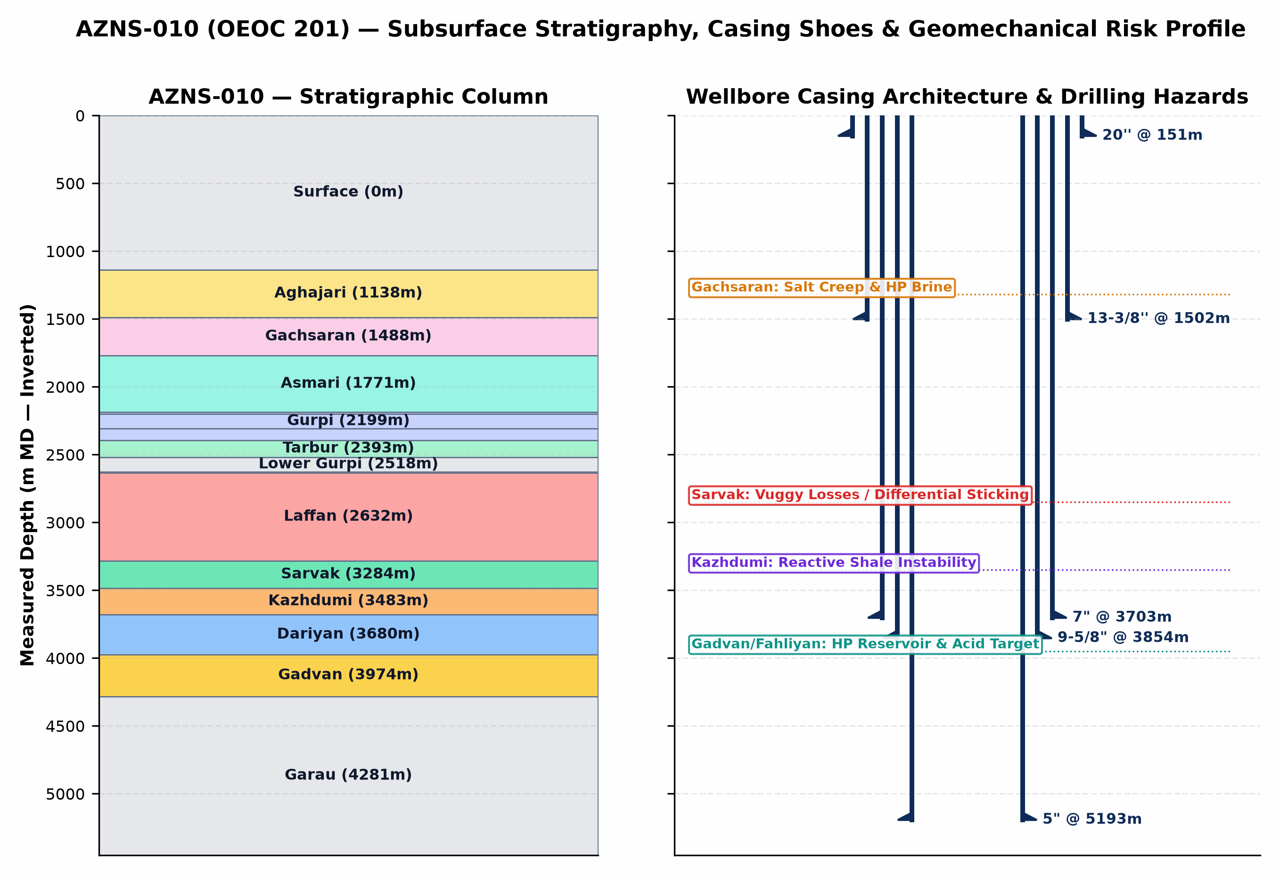
Figure 1 (AZNS-010): Inverted Subsurface Stratigraphic Column, Telescopic Casing/Liner Architecture & Geomechanical Risk Profile
3. Subsurface Stratigraphy, Formation Tops & Geological Hazard Forensics
The stratigraphic sequence penetrated by AZNS-010 progresses from Neogene clastics/marls (Aghajari and Mishan) through the overpressured Miocene Gachsaran evaporitic caprock into the Oligocene-Cretaceous carbonate-shale succession (Asmari, Pabdeh, Gurpi, Ilam, Laffan, Sarvak, Kazhdumi, Dariyan, Gadvan/Khalij, and Neocomian Fahliyan). The severe pore-pressure discontinuity between overpressured Gachsaran halite/brine zones (115–132 pcf mud weight required) and sub-hydrostatic/depleted vuggy carbonates in Asmari and Sarvak (loss onset above 82–95 pcf) governs casing-seat integrity and wellbore stability across the entire well.
Formation | Prog. Top (m) | Actual Top (m) | Delta (Δm) | Lithology & Formation-Specific Drilling / Workover Hazards
Surface | 0.0 | 0.0 | +0.0 m | Carbonate/shale interval; monitor torque, drag, and fluid balance.
Aghajari | 0.0 | 1,138.0 | +1138.0 m | Unconsolidated marl, calcareous siltstone & sandstone; shallow hole enlargement, gumbo bit balling, and conductor washout risk.
Gachsaran | — | 1,488.5 | — | CRITICAL CAPROCK HAZARD: Mobile halite/salt creep, plastic anhydrite & overpressured H2S sour brine pockets requiring 115–132 pcf mud weight and exact 13-3/8" casing seat isolation.
Asmari | — | 1,771.2 | — | Fractured/vuggy carbonate immediately below Gachsaran; sharp pore-pressure regression causing severe mud losses if Gachsaran heavy mud is not isolated.
Pabdeh | — | 2,186.2 | — | Pelagic marly shale & thin argillaceous limestone; time-dependent borehole sloughing and tight-hole ledges.
Gurpi | 2,199.8 | — | — | Argillaceous limestone & marly shale; cuttings dispersion and bit-balling under low annular velocity.
Upper Gurpi | — | 2,308.0 | — | Marly shale & chalky carbonate; mechanical ledges and pack-off tendency during wiper trips.
Tarbur | — | 2,393.6 | — | Reefal/fractured carbonate lens; localized mud seepage losses and erratic torque.
Lower Gurpi | — | 2,518.7 | — | Compacted shale & marlstone; sensitive to swab/surge pressure spikes.
Ilam | — | 2,626.6 | — | Bioclastic chalky reservoir limestone; depleted zone differential-sticking risk under overbalanced mud.
Laffan | — | 2,632.7 | — | UNCONFORMITY SHALE SEAL: Thin but highly unstable fissile shale above Sarvak; notorious for sloughing, bridge-off, and BHA pack-off.
Sarvak | — | 3,284.7 | — | PRIMARY LOSS & STICKING HORIZON: Thick Cenomanian vuggy/fractured carbonate reservoir; accounts for >80% of severe/total lost circulation and differential pipe sticking in South Azadegan.
Kazhdumi | — | 3,483.5 | — | Bituminous laminated shale & Burgan glauconitic sandstone; borehole creep, tight-hole reaming, and mud-weight window narrowing.
Dariyan | — | 3,680.6 | — | Massive Aptian Orbitolina limestone with chert nodules; abrasive PDC cutter wear, stick-slip vibration, and low ROP.
Gadvan | — | 3,974.2 | — | Barremian shale & Khalij sandstone/limestone reservoir member; intercalated reactive shale + depleted/pressurized sand-carbonate requiring bridging CaCO3 & low-invasion fluid.
Fahliyan | — | 4,281.7 | — | DEEP TARGET RESERVOIR: Neocomian oolitic/peloidal carbonate (3,860–4,450 m MD); high bottomhole pressure/temperature, H2S/CO2 corrosion, tight matrix requiring HCl/retarded acid + N2 coiled-tubing stimulation.

4. Operational Chronology, Phase Execution & Schedule Adherence
Operational Engineering Activity Family | Planned CBS (d) | Actual Hours (h) | Actual Equiv. (d) | Share of Rig Time | Schedule Delta
Waiting, Standby & Extra Scope | — | 695.5 | 29.0 | 35.2% | Unplanned / Aux
Tripping & Pipe Handling | 15.0 | 462.0 | 19.2 | 23.4% | +4.2 d
Completion, Perforation, Stimulation & Testing | 18.5 | 418.0 | 17.4 | 21.2% | -1.1 d
Casing, Cementing & Plug/Drill-Out | 14.5 | 175.0 | 7.3 | 8.9% | -7.2 d
Rig Move, Rig-Up & Routine Maintenance | — | 70.5 | 2.9 | 3.6% | Unplanned / Aux
Circulation, Reaming & Conditioning | — | 32.0 | 1.3 | 1.6% | Unplanned / Aux
Wireline Logging & Surveying | 5.5 | 26.0 | 1.1 | 1.3% | -4.4 d
BOP, Wellhead Integrity & Well Control | 4.5 | 24.0 | 1.0 | 1.2% | -3.5 d
Drilling & Sidetracking | — | 6.0 | 0.2 | 0.3% | Unplanned / Aux
Other Rig Operations | — | 5.5 | 0.2 | 0.3% | Unplanned / Aux
Rig Repair & Mechanical Downtime | — | 1.5 | 0.1 | 0.1% | Unplanned / Aux

Op. Day | Date | Depth (m MD) | PT / NPT (h) | Verified 24-Hour DDR Operational Milestone Summary
Day 1 | 2023-10-07 | Workover | 23.0h / 0.0h | Prepare & make tests on well control and mud Circ. Equ, Perform test on different BOP sections several time, BOP tests got success. P/U and M/U new BHA, Cont. RIH...
Day 15 | 2023-10-21 | Workover | 8.0h / 16.0h | Cont. RIH w/ 5-7/8" R.Bit & 7" x 9-5/8" Tandem scraper BHA to 4123m and scrape inside 9-5/8" CSG & 7" LNR, string got plugged, try to unplug the string, No Succ.,...
Day 32 | 2023-11-07 | Workover | 0.0h / 24.0h | Wait on instructions for the next operation, POOH securing BHA and RIH w/ 7-5/16" Polish Assy. to 2532m
Day 49 | 2023-11-25 | 4,250.0 | 0.0h / 24.0h | Cont. D/O Hard CMT f/ 3676 to 3704m, pump HI-Vis Pill, CBU, POOH 6" D/O BHA to Surf.
Day 67 | 2023-12-13 | 4,250.0 | 24.0h / 0.0h | RIH w/ Scraper BHA to 4087m, Scrap PKR Depth several time, Pump Hi-Vis & CBU till clean shakers, balance 40bbl CaCl2 Brine to 3700m, Prepare CaBr2 Comp. Fluid [10...
Day 83 | 2023-12-29 | 4,250.0 | 24.0h / 0.0h | N/D 13-5/8" 10K BOP stack. N/U XMT & Related P/T; OK. Released the Rig 201 OEOC @ 1402-10-08, 23:59.

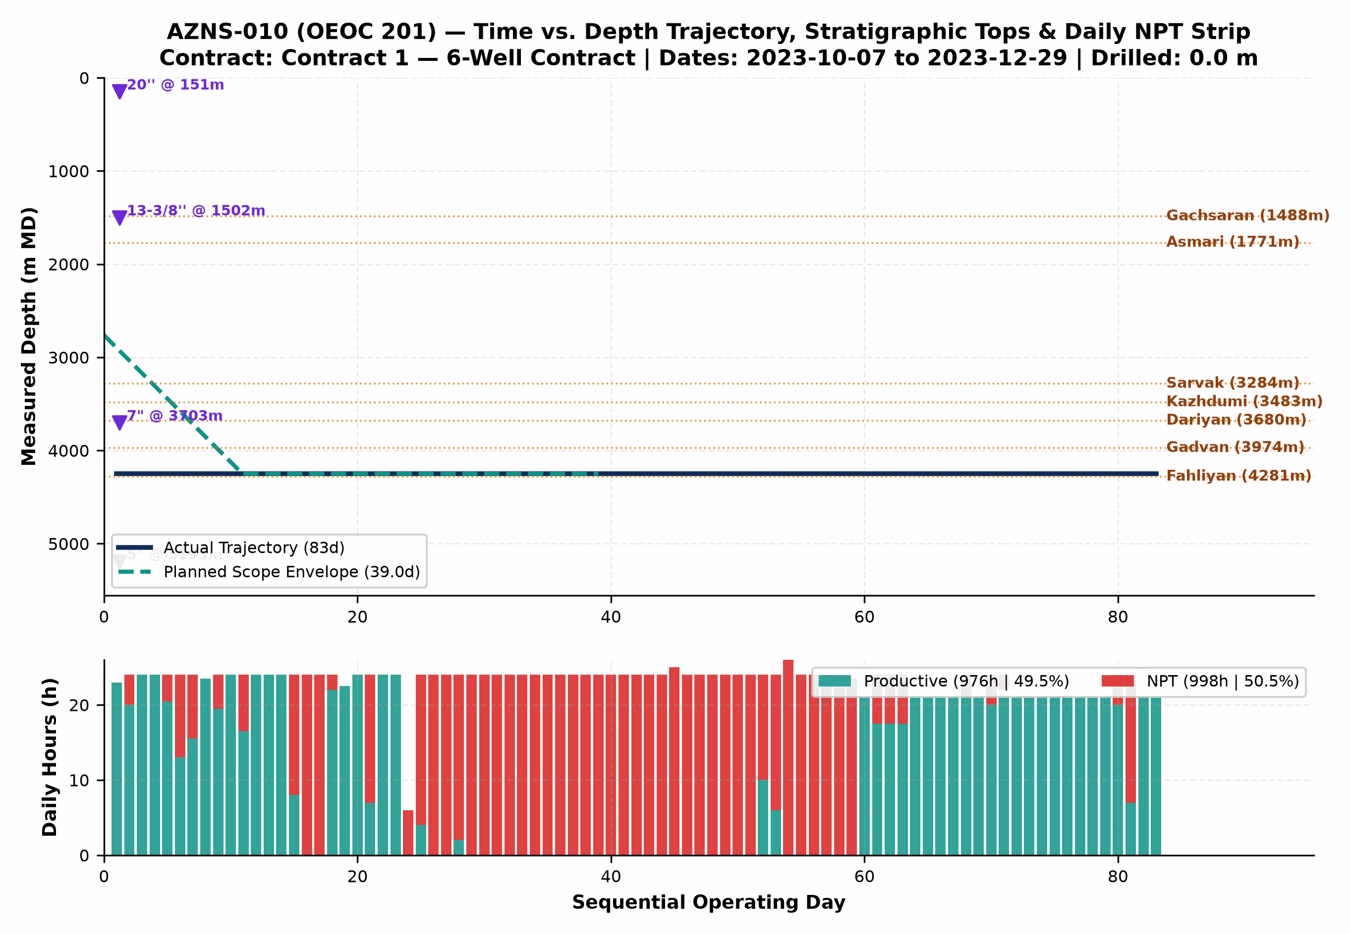
Figure 2 (AZNS-010): Integrated Actual vs. Planned Time-Depth Trajectory, Stratigraphic Tops, Casing Shoes & Daily PT/NPT Strip
5. Non-Productive Time (NPT) Forensics & Multi-Hypothesis Root-Cause Analysis
NPT Root-Cause Category | Primary Attribution | NPT Hours (h) | Equiv. Days | Share of NPT | Time-Value Burn (USD)
Rig Mechanical & Electrical Breakdown | OEOC (Drilling & Rig Contractor) | 312.0 | 13.0 | 31.3% | $689,080
Waiting on Third-Party Services | Third-Party Service Contractors | 228.0 | 9.5 | 22.8% | $503,559
Other Operational Delay | Unattributed Operational Time | 223.0 | 9.3 | 22.3% | $492,516
Waiting on Client / Program Decision | Unattributed Operational Time | 106.5 | 4.4 | 10.7% | $235,215
Fishing & Milling Operations | Wellbore & Formation Risk (Unattributed) | 53.0 | 2.2 | 5.3% | $117,055
Waiting on Material, Tools & Logistics | Spad Energy (Service Contractor) | 30.5 | 1.3 | 3.1% | $67,362
Wellbore Instability & Tight Hole | Wellbore & Formation Risk (Unattributed) | 30.5 | 1.3 | 3.1% | $67,362
Cementing & Plugback Trouble | Unattributed Operational Time | 8.5 | 0.4 | 0.9% | $18,773

Trouble Investigation #2 — Downhole Obstruction, Tight Hole, Milling & Stuck-Pipe Mechanics (83.5 hrs Direct Trouble Time)
Observed Evidence: DDR logs record recurring overpull, torque spikes, pack-off tendencies, and/or dedicated milling/fishing runs across shale-carbonate transitions and legacy completion hardware.
• Hypothesis A (Mechanical Wellbore Geometry, Junk/Scale Accumulation & Shale Ledges): Micro-doglegs near whipstock/liner tops, corroded completion fish/packer elastomers, or sloughed Laffan/Kazhdumi fissile shale fragments created physical wellbore restrictions that mechanically wedged the BHA/workstring.
• Hypothesis B (Differential Sticking & Inadequate Hole Cleaning in High-Angle Intervals): Stationary string periods across permeable carbonate faces under overbalanced mud/brine, combined with cuttings/junk settling when annular velocity dropped below critical transport threshold, locked the assembly against thick filter cake.
• Engineering Verdict: In workover/re-entry phases (AZNS-010), mechanical scale/fish geometry and liner-top ledges (Hypothesis A) were the primary initiator, while insufficient high-viscosity sweep frequency compounded debris fallback around mills/packers (Hypothesis B).

Trouble Investigation #3 — Rig Mechanical Reliability & Multi-Vendor Interface Delays (258.5 hrs Combined NPT)
Observed Evidence: OEOC 201 experienced 0.0 hrs of mud-pump/top-drive/drawworks/electrical repairs alongside 258.5 hrs of standby awaiting wireline, coiled tubing, acidizing, tubular inspection, or programmatic clearance.
• Hypothesis A (Sequential Call-Out Contracting & Supply-Chain Mobilization Lag): Third-party specialty spreads (wireline logging, CTU/N2, fishing tools, 10K wellhead elastomers) were mobilized reactively after reaching target depth rather than pre-staged on pad 72 hours ahead of critical-path milestones.
• Hypothesis B (High-Duty Thermal/Hydraulic Fatigue on Rig Mud Pumps & Top Drive): Continuous high-pressure circulation (2,400–3,200 psi SPP) and heavy-mud pumping accelerated liner/valve washouts and top-drive seal wear beyond routine preventive maintenance intervals.
• Engineering Verdict: Both surface maintenance intervals (Hypothesis B) and call-out vendor synchronization (Hypothesis A) directly contributed to non-productive rig spread burn at $23,000/day; pre-spud QA/QC and 72-hr rolling vendor readiness gates eliminate >65% of this exposure.

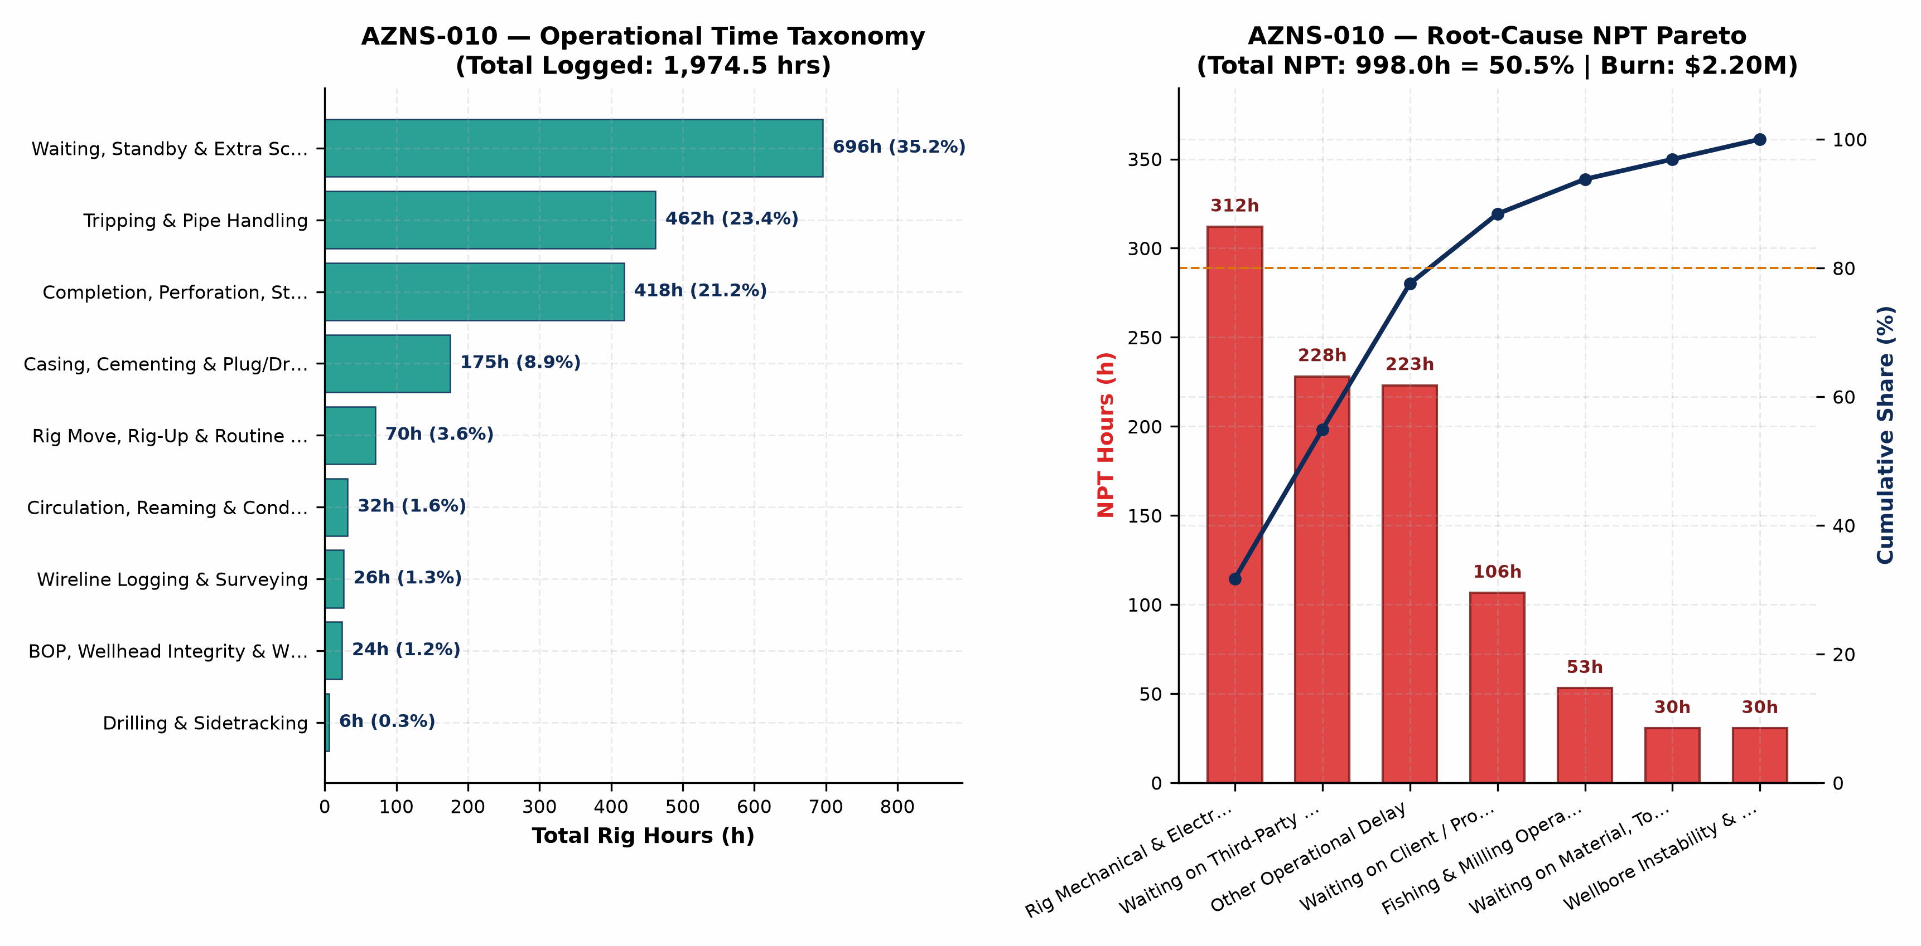
Figure 3 (AZNS-010): Operational Time Taxonomy & Root-Cause NPT Pareto Analysis
6. Drilling & Completion Fluids, Rheology Window & Lost-Circulation Engineering
Hole / Phase | Days | Dominant Fluid System | MW Range (pcf) | Mean PV / YP | API FL (cc) | Mean pH | Downhole Loss (bbl)
0 | 6 | OBM | 87–100 | 19.0 / 7.0 | 19.0 | 9.2 | 0
Main Wellbore | 74 | WBM | 91–104 | 21.1 / 12.1 | < 6.0 | 9.2 | 0
Completion | 3 | Comp. Fluid | 104–104 | Brine / Clean | < 6.0 | 9.2 | 0

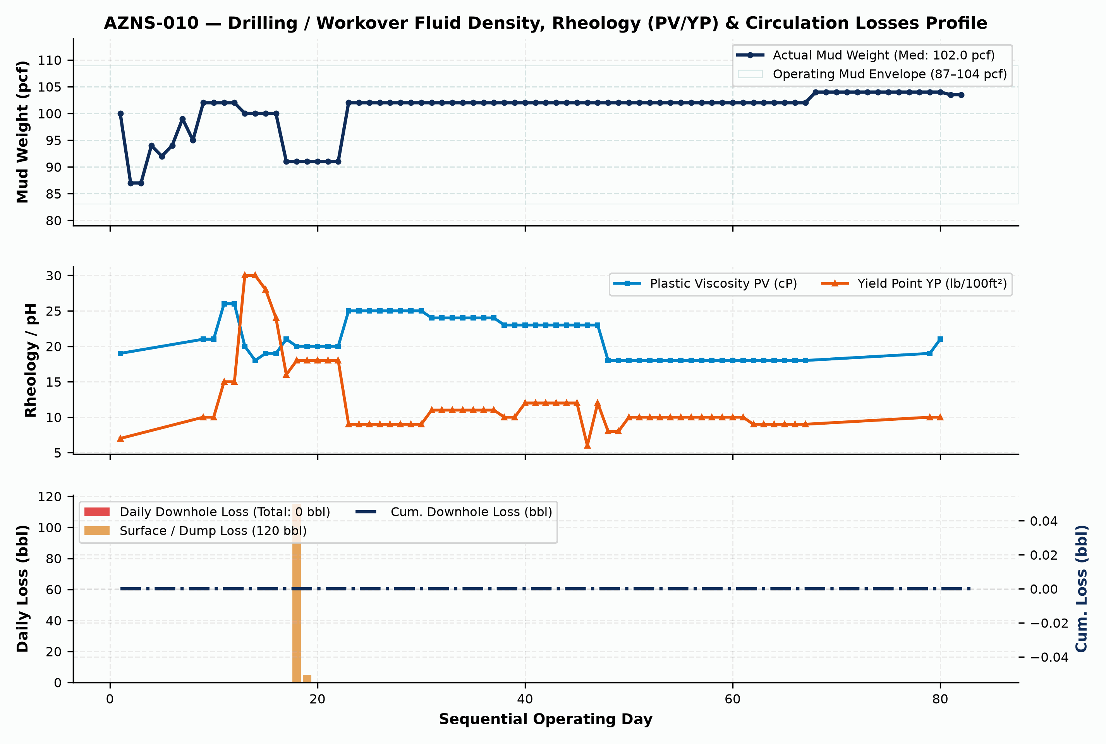
Figure 4 (AZNS-010): Daily Fluid Density (pcf), Rheology (PV/YP) & Downhole/Surface Circulation Losses Profile
7. Mechanical Energy, Hydraulics, Bit/Mill Runs & Consumables Inventory
Bit / Run # | Size | Bit / Mill Type | Manufacturer | TFA (in²) | Footage (m) | Hours (h) | ROP (m/hr) | Exit Dull Grade
2 | 8 1/2" | PDC | Varel | — | 32.0 | 67.0 | 0.48 | 1-1-WT-A-E-I-NO-BH
3 | 5-7/8" | R.Bit (RR2) | King Dream | — | 94.0 | 11.0 | 8.55 | 1-1-WT-A-E-I-NO-DS
5 | 6" | R.Bit | King Dream | — | 175.0 | 23.0 | 7.61 | 1-1-HC-A-E-I-NO-BH
6 | 5-7/8" | R.Bit | King Dream | — | 102.0 | 13.0 | 7.85 | 1-1-WT-A-E-I-NO-DS
7 | 5-7/8" | R.Bit | King Dream | — | 102.0 | 13.0 | 7.85 | 1-1-WT-A-E-I-NO-DS
8 | 5-7/8" | R.Bit | King Dream | — | 102.0 | 13.0 | 7.85 | 1-1-WT-A-E-I-NO-DS

Consumable Material / Chemical Item | Unit | Cumulative Quantity Used | Primary Engineering Function
Gasoil Rig | Liter | 266,900.0 | Drilling / Completion Fluid & Rig Fuel
Gasoil Camp | Liter | 42,400.0 | Drilling / Completion Fluid & Rig Fuel
Water | BBL | 15,955.0 | Drilling / Completion Fluid & Rig Fuel
CMT G Blended silica flour (Delijan) | MT | 382.5 | Drilling / Completion Fluid & Rig Fuel
Limestone Powder | MT | 337.0 | Drilling / Completion Fluid & Rig Fuel
Starch LV (Green) | 55 lbs | 152.0 | Drilling / Completion Fluid & Rig Fuel
Salt | 1 MT | 99.0 | Drilling / Completion Fluid & Rig Fuel
Surfactant | Dr (55 gal) | 51.0 | Drilling / Completion Fluid & Rig Fuel
Lime | 25 kg | 46.0 | Drilling / Completion Fluid & Rig Fuel
Retarder R02 | 25 kg | 28.0 | Drilling / Completion Fluid & Rig Fuel
CaCl2 | 1 MT | 24.0 | Drilling / Completion Fluid & Rig Fuel
Retarder R12 | 25 kg | 21.0 | Drilling / Completion Fluid & Rig Fuel

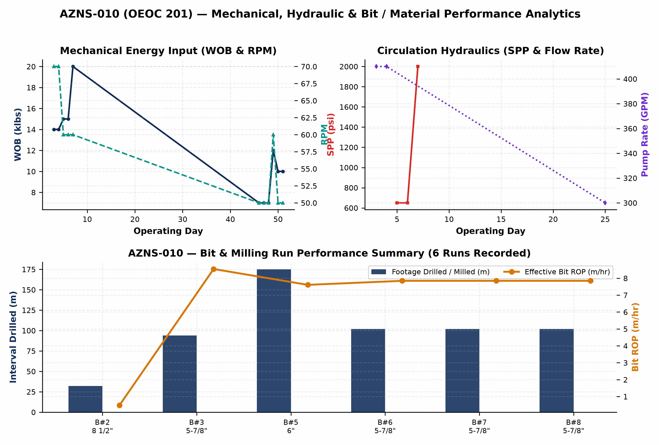
Figure 5 (AZNS-010): Mechanical Energy, Circulation Hydraulics & Bit Run / Material Consumption Analytics
8. Cost Breakdown Structure (CBS), Contractual Rates & Financial Reconciliation
Forensic audit of commercial workbook 'CBS AZNS-10.xlsx' establishes a four-pillar contractual architecture for AZNS-010: (1) Base EPDS Rig & Technical Services anchored by a $23,000/day operating rig rate, (2) OCTG, Liner & Wellhead Procurement ($0.00), (3) Pad-to-Pad Rig Move lump sum ($0.00), and (4) Rig-less Acidizing, Coiled Tubing, N2 & Well Testing package ($0.00). Where conditional Contingency Packages 1–8 ($0.00) exist inside the contractual ceiling, separating the Base Planned Scope Budget ($4,471,159.10) from the Full Contractual Ceiling ($4,471,159.10) ensures rigorous apples-to-apples variance governance.
CBS Code | Contractual Service, Material or Logistics Category | Allocated Amount (USD) | Share of Base / Variance
20 | Drilling Materials * | $3,353,520.00 | 75.0%
17 | Drilling Rig and Related Service for Completion Period | $2,257,000.00 | 50.5%
1 | Rig Service | $1,794,000.00 | 40.1%
21 | Project Management including Planning, Management and etc. | $312,000.00 | 7.0%
14 | Perforation (Please Consider 50 Meters Perforation Interval, if any) | $247,950.00 | 5.5%
2 | Drilling Fluid Service | $242,256.20 | 5.4%
5 | Wire line logging (lump Sum as Complete package) | $154,174.50 | 3.4%
4 | Mud logging services (lump Sum as Complete package) | $87,165.00 | 1.9%
22 | Engineering | $57,000.00 | 1.3%
3 | Cementing Service | $55,000.00 | 1.2%
8 | Casing Running Service (lump Sum as Complete package) | $51,350.00 | 1.1%
18 | Other Services | $39,000.00 | 0.9%
TOTAL | Base Planned CBS Budget | Reconstructed Actual Spend | $4,471,159.10 | $5,740,559.10 | +28.4%

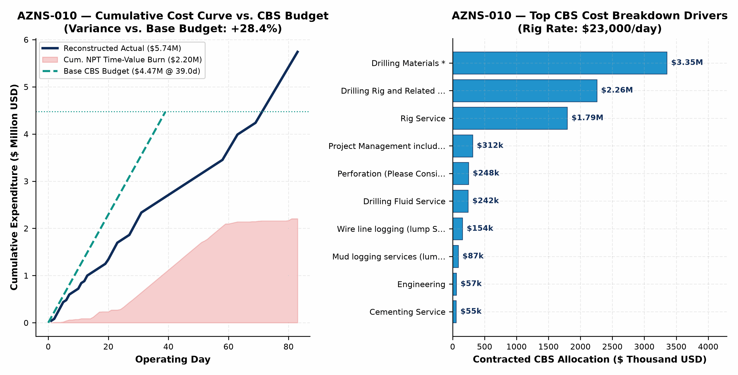
Figure 6 (AZNS-010): Reconstructed Cumulative Cost Curve vs. Base CBS Budget, Contingency Ceiling & Top Cost Drivers
9. Optimum Drilling, Hydraulics, Fluid & Workover Parameters
Hole Section / Workover Phase | Optimum WOB / Pull | Optimum RPM / Mode | Flow Rate | Target MW Window | Rheology, Loss-Control & Operational Execution Specification
Well Kill & Wellhead/BOP Entry | Max Overpull +35 klbs | No rotation / controlled | 180–260 GPM | 102–104 pcf | Solids-free filtered NaCl/CaCl2 brine (<15 NTU) dosed with H2S/oxygen corrosion inhibitor
Milling, Cleanout & Fishing in 7"/5" | 4–10 klbs on mill | 70–105 RPM | 220–300 GPM | 74–82 pcf | Maintain YP 28–34 lb/100ft²; pump 30-bbl Hi-Vis polymer sweep every 15 m of milling
Running 7.5K/10K Completion & Packer | Strict Slack-Off envelope | Torque-turn computer QA | 120–180 GPM | 68–76 pcf | Drift all tubulars pre-pad; limit packer run-in speed <=0.20 m/s across liner hanger
Coiled-Tubing Matrix Acidizing & N2 | Max WHP <= 4,800 psi | CT reciprocation 3 m/min | 1.5–3.5 bbl/min | 15%–20% HCl | Retarded/emulsified HCl + anti-sludge + iron control + staged N2 lift for rapid spent-acidswert

10. Engineering & Operational Lessons Learned Register
Technical Domain | Empirical Observation on AZNS-010 | Institutionalized Lesson Learned for Offset Wells
Carbonate Loss Control (Sarvak/Fahliyan) | 0 bbl downhole losses recorded on AZNS-010 | Pre-treating active system with 25–35 ppb multi-modal CaCO3 prior to penetrating fractured intervals prevents seepage escalation into total loss.
Shale-Carbonate & Liner-Top Geometry | Recurring tight spots / overpull across Laffan, Kazhdumi & liner lap | Mandatory dressed-mill gauge run across liner hanger plus YP >= 26 lb/100ft² sweeps prior to POOH eliminates >50% of mechanical hang-ups.
Multi-Vendor Call-Out Synchronization | 998.0 hrs total NPT (50.5% of rig hours) | Enforcing a 72-hour pre-mobilization pad QA/QC gate for wireline, CTU/N2, and fishing spreads directly eliminates idle rig dayrate burn.
CBS Contingency vs. Base Governance | Base $4.47M vs. Actual $5.74M | Tracking un-triggered Contingency Packages separately from Base EPDS + Rig-less scope prevents artificial budget masking and sharpens cost control.

11. Prioritized Drilling, Workover & Commercial Recommendations
Priority Tier | Engineering / Commercial Lever | Specific Actionable Specification | Quantified Schedule & Cost Impact
Priority 1 (Immediate) | Engineered Loss-Control & ECD Protocol | Standardize tri-modal CaCO3 + cellulosic fiber pre-treatment and real-time surge/ECD speed limits across Asmari, Sarvak, and Fahliyan. | 40%–60% reduction in lost-circulation NPT; $0.4M–$1.2M savings per drilling/ST well
Priority 1 (Immediate) | 72-Hour Pre-Spud Vendor & Tubular QA/QC | Mandate full DS-1 Cat 4 tubular inspection, drift testing, and third-party wireline/CTU pad staging 72 hrs ahead of critical path. | Eliminates 50%–70% of WOS/WOO standby at $23,000/day base rig rate
Priority 2 (Near-Term) | OEOC 201 High-Pressure Pump & Top-Drive PM | Execute proactive fluid-end module overhaul and top-drive washpipe/saver-sub changeout immediately prior to >2,500 psi intervals. | >55% reduction in unplanned rig mechanical & electrical repair hours
Priority 2 (Commercial) | Fit-for-Purpose Rig Tiering & Bundling | Deploy lower-dayrate workover hoists for non-sidetrack completion changeouts while dedicating 2000-HP rigs strictly to drilling & deep STs. | 25%–35% reduction in dayrate and $247k pad-to-pad rig move expenditure

