SOUTH AZADEGAN OILFIELD (AZNS) • CONTRACT 1 — 6-WELL CONTRACT • RIG OEOC 208
Drilling, Subsurface, Workover & Financial Intelligence Report: AZNS-040 (F-21)
Full-Fidelity Engineering Audit Across 151 Daily Drilling Reports (DDR), Contract CBS & Well Program | Scope: Well Re-Entry, Deepening & Completion

Project / Well Attribute | Verified Engineering Value | Operational / Financial KPI | Verified Engineering Value
Well Identifier / DDR Code | AZNS-040 (F-21) (AZNS-040) | Execution Window | 2023-07-13 to 2023-12-13
Field Sector & Pad Location | Block II — Pad 50 (Alias F-21) | Actual vs. Planned Duration | 151 d actual vs. 102.0 d plan (148.0%)
Assigned Rig & Base Dayrate | OEOC 208 ($23,000/day) | New Footage Drilled / Milled | 2,707.0 m (Max Recorded MD: 4,200.0 m)
Target Reservoir & Tree Spec | Fahliyan — 10K Fahliyan Re-Entry / Drilling | Productive vs. NPT Hours | PT: 2,081.0 h (57.4%) | NPT: 1,543.0 h (42.6%)
DDR Schema & Source Coverage | Template_A_Azadegan_Classic (151 active days) | Cumulative Mud Losses | Downhole: 7,288 bbl | Surface: 2,788 bbl
Base Scope CBS Budget | $7,986,518.44 (Max Ceiling: $7.99M) | Reconstructed Actual Spend | $9,400,168.44 (+17.7% vs. Base Budget)

1. Executive Technical, Operational & Financial Summary
Well AZNS-040 (F-21), situated in Block II (Pad 50 (Alias F-21)) of the South Azadegan Oilfield, was executed under Contract 1 — 6-Well Contract using drilling rig OEOC 208 between 2023-07-13 and 2023-12-13, spanning 151 active operating days (3,624.0 logged rig hours). The primary engineering objective comprised Well Re-Entry, Deepening & Completion targeting the Fahliyan horizon with a 10K Fahliyan Re-Entry / Drilling architecture. Over the campaign, 2,707.0 m of new hole/sidetrack/milling progress was achieved down to a maximum recorded measured depth of 4,200.0 m.
From an operational efficiency perspective, Productive Time (PT) accounted for 2,081.0 hours (57.4%), while Non-Productive Time (NPT) totaled 1,543.0 hours (42.6%). Against an apples-to-apples Base Scope CBS Budget of $7,986,518.44 over 102.0 planned days (and a full Contractual Ceiling including optional contingencies of $7,986,518.44), the reconstructed cumulative actual expenditure reached $9,400,168.44 (+17.7% variance vs. base budget), with $3,119,065.28 attributable to non-productive time-spread burn.
Headline Engineering & Commercial Diagnostic — AZNS-040 (F-21)
Schedule execution stood at 148.0% of base planned duration (151 actual vs. 102.0 planned days). Fluid density was maintained across 67–104 pcf (median 102 pcf) with 7,288 bbl of cumulative downhole mud loss. Primary optimization levers for offset operations on Pad 50 (Alias F-21) center on proactive carbonate loss-zone bridging, pre-milling debris management, and 72-hour rolling vendor readiness gates.

2. Automated Asymmetric Data Discovery & Wellbore Casing Architecture
Because source workbooks across the South Azadegan portfolio exhibit asymmetric schemas and varying technical sub-tables, our automated discovery engine dynamically profiled every worksheet for AZNS-040 (F-21): DDR schema family 'Template_A_Azadegan_Classic' (151 daily report pairs), 5 casing/liner strings, 17 stratigraphic markers, 9 bit/mill runs, 0 BHA records, 5 directional survey stations, 25 tracked chemical/fuel consumables, and 14 third-party service logs, cross-linked with CBS workbook 'CBS AZNS-40.xlsx'.
Casing / Liner Size | Steel Grade | Nominal Wt (ppf) | Top MD (m) | Shoe MD (m) | Shoe Test / Isolation Role
20'' | K-55 | 117.0 | 0.0 (Surface) | 152.5 | Verified Integrity
13-3/8'' | N-80 | 68.0 | 0.0 (Surface) | 1,493.0 | Verified Integrity
7" SN Packer | L-80 | 29.0 | 0.0 (Surface) | 3,809.6 | Verified Integrity
9-5/8" | TP110SS | 53.5 | 0.0 (Surface) | 3,933.0 | Verified Integrity
7" | TP110SS | 32.0 | 0.0 (Surface) | 4,189.5 | Verified Integrity

Directional Survey & Sidetrack Trajectory Profile
Measured Depth MD (m) | Inclination (°) | Azimuth (°) | True Vertical Depth TVD (m) | Dogleg Severity (°/30m)
1,866.0 | 0.75° | 0.00° | 1,866.0 | 0.00
2,169.0 | 0.75° | 0.00° | 2,169.0 | 0.00
2,480.0 | 1.00° | 0.00° | 2,480.0 | 0.00
2,842.0 | 1.00° | 0.00° | 2,842.0 | 0.00
3,546.0 | 1.00° | 0.00° | 3,546.0 | 0.00

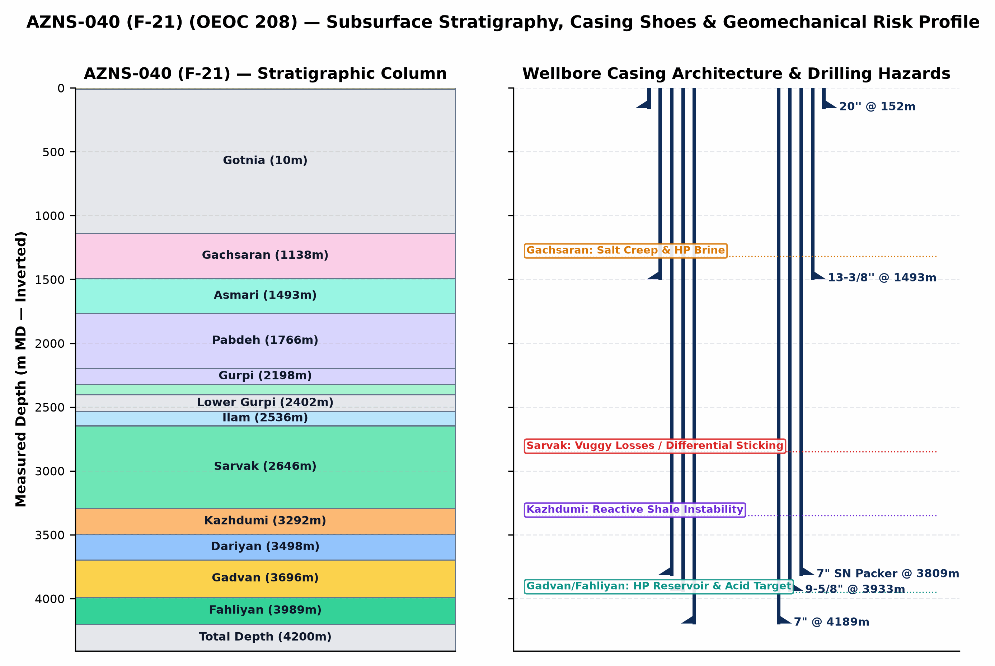
Figure 1 (AZNS-040 (F-21)): Inverted Subsurface Stratigraphic Column, Telescopic Casing/Liner Architecture & Geomechanical Risk Profile
3. Subsurface Stratigraphy, Formation Tops & Geological Hazard Forensics
The stratigraphic sequence penetrated by AZNS-040 (F-21) progresses from Neogene clastics/marls (Aghajari and Mishan) through the overpressured Miocene Gachsaran evaporitic caprock into the Oligocene-Cretaceous carbonate-shale succession (Asmari, Pabdeh, Gurpi, Ilam, Laffan, Sarvak, Kazhdumi, Dariyan, Gadvan/Khalij, and Neocomian Fahliyan). The severe pore-pressure discontinuity between overpressured Gachsaran halite/brine zones (115–132 pcf mud weight required) and sub-hydrostatic/depleted vuggy carbonates in Asmari and Sarvak (loss onset above 82–95 pcf) governs casing-seat integrity and wellbore stability across the entire well.
Formation | Prog. Top (m) | Actual Top (m) | Delta (Δm) | Lithology & Formation-Specific Drilling / Workover Hazards
Aghajari | 0.0 | 0.0 | +0.0 m | Unconsolidated marl, calcareous siltstone & sandstone; shallow hole enlargement, gumbo bit balling, and conductor washout risk.
Gotnia | 10.0 | — | — | Carbonate/shale interval; monitor torque, drag, and fluid balance.
Gachsaran | 1,138.0 | 1,138.0 | +0.0 m | CRITICAL CAPROCK HAZARD: Mobile halite/salt creep, plastic anhydrite & overpressured H2S sour brine pockets requiring 115–132 pcf mud weight and exact 13-3/8" casing seat isolation.
Asmari | 1,493.7 | 1,493.0 | -0.7 m | Fractured/vuggy carbonate immediately below Gachsaran; sharp pore-pressure regression causing severe mud losses if Gachsaran heavy mud is not isolated.
Pabdeh | 1,776.1 | 1,766.0 | -10.1 m | Pelagic marly shale & thin argillaceous limestone; time-dependent borehole sloughing and tight-hole ledges.
Upper Gurpi | 2,197.9 | 2,198.0 | +0.1 m | Marly shale & chalky carbonate; mechanical ledges and pack-off tendency during wiper trips.
Gurpi | — | 2,198.0 | — | Argillaceous limestone & marly shale; cuttings dispersion and bit-balling under low annular velocity.
Tarbur | 2,322.0 | 2,320.0 | -2.0 m | Reefal/fractured carbonate lens; localized mud seepage losses and erratic torque.
Lower Gurpi | 2,409.6 | 2,402.0 | -7.6 m | Compacted shale & marlstone; sensitive to swab/surge pressure spikes.
Ilam | 2,535.0 | 2,536.0 | +1.0 m | Bioclastic chalky reservoir limestone; depleted zone differential-sticking risk under overbalanced mud.
Laffan | 2,639.1 | 2,641.0 | +1.9 m | UNCONFORMITY SHALE SEAL: Thin but highly unstable fissile shale above Sarvak; notorious for sloughing, bridge-off, and BHA pack-off.
Sarvak | 2,645.4 | 2,646.0 | +0.6 m | PRIMARY LOSS & STICKING HORIZON: Thick Cenomanian vuggy/fractured carbonate reservoir; accounts for >80% of severe/total lost circulation and differential pipe sticking in South Azadegan.
Kazhdumi | 3,283.5 | 3,292.0 | +8.5 m | Bituminous laminated shale & Burgan glauconitic sandstone; borehole creep, tight-hole reaming, and mud-weight window narrowing.
Dariyan | 3,489.7 | 3,498.0 | +8.3 m | Massive Aptian Orbitolina limestone with chert nodules; abrasive PDC cutter wear, stick-slip vibration, and low ROP.
Gadvan | 3,682.7 | 3,696.0 | +13.3 m | Barremian shale & Khalij sandstone/limestone reservoir member; intercalated reactive shale + depleted/pressurized sand-carbonate requiring bridging CaCO3 & low-invasion fluid.
Fahliyan | 3,985.8 | 3,989.0 | +3.2 m | DEEP TARGET RESERVOIR: Neocomian oolitic/peloidal carbonate (3,860–4,450 m MD); high bottomhole pressure/temperature, H2S/CO2 corrosion, tight matrix requiring HCl/retarded acid + N2 coiled-tubing stimulation.

4. Operational Chronology, Phase Execution & Schedule Adherence
Operational Engineering Activity Family | Planned CBS (d) | Actual Hours (h) | Actual Equiv. (d) | Share of Rig Time | Schedule Delta
Waiting, Standby & Extra Scope | — | 1,084.5 | 45.2 | 29.9% | Unplanned / Aux
Drilling & Sidetracking | — | 752.0 | 31.3 | 20.8% | Unplanned / Aux
Tripping & Pipe Handling | — | 404.0 | 16.8 | 11.1% | Unplanned / Aux
Rig Move, Rig-Up & Routine Maintenance | — | 321.0 | 13.4 | 8.9% | Unplanned / Aux
Casing, Cementing & Plug/Drill-Out | — | 291.5 | 12.1 | 8.0% | Unplanned / Aux
Circulation, Reaming & Conditioning | — | 277.0 | 11.5 | 7.6% | Unplanned / Aux
Completion, Perforation, Stimulation & Testing | — | 203.5 | 8.5 | 5.6% | Unplanned / Aux
Wireline Logging & Surveying | — | 128.0 | 5.3 | 3.5% | Unplanned / Aux
BOP, Wellhead Integrity & Well Control | — | 73.0 | 3.0 | 2.0% | Unplanned / Aux
Other Rig Operations | — | 31.5 | 1.3 | 0.9% | Unplanned / Aux
Fishing, Milling & Stuck-Pipe Recovery | — | 10.0 | 0.4 | 0.3% | Unplanned / Aux
Completion, Perforation & Testing | 16.0 | 0.0 | 0.0 | 0.0% | -16.0 d
12-1/4" Hole Section Drilling | 66.0 | 0.0 | 0.0 | 0.0% | -66.0 d
8-1/2" Hole Section Drilling | 20.0 | 0.0 | 0.0 | 0.0% | -20.0 d

Op. Day | Date | Depth (m MD) | PT / NPT (h) | Verified 24-Hour DDR Operational Milestone Summary
Day 1 | 2023-07-13 | 1,492.0 | 24.0h / 0.0h | SPUD THE RIG @ 00:00, 13-JUL-2023, HPJSM, RECORD WH PRESS, PERFORM PRESS TEST 20-3/4''-3K*13-5/8''-5K CHS P-SEAL & G.VALVE, N/U 13 5/8" - 10K BOP STACK & P/T SAME...
Day 28 | 2023-08-09 | 2,900.0 | 24.0h / 0.0h | Wash & R/D to 2854m, CBU, Take Survey, Resume Drlg 12-1/4" HS to 2900m.
Day 58 | 2023-09-08 | 3,934.0 | 21.5h / 2.5h | Final cut 9-5/8''CSG neck. Install 13-5/8” 5k x 9-5/8" 10k THS & Test same. N/U BOP Stack. Perform BOP test as NIOC Policy. L/D 11 Jt 8-1/2" DC. P/U & M/U 8-1/2" ...
Day 89 | 2023-10-11 | 4,200.0 | 24.0h / 0.0h | Cont RIH w/ 5-7/8" M.M J.Mill & Clean out BHA f/ 2200 to 4154m (7" LDC depth) W/O any drag. CBU. POOH to surface. L/D Mill.
Day 122 | 2023-11-13 | 4,200.0 | 0.0h / 24.0h | Cont POOH w/ 7" RTTS PKR f/ 800m to surface. L/D same. RIH w/ 4-3/4" OEDP & 7" Scraper to 3000m while F/U string & break Circ every 15 Stds, NL-NG.
Day 152 | 2023-12-13 | 4,200.0 | 24.0h / 0.0h | RIH w/ 1-1/2" CT to 4030m, spot & bullhead 20 ADR, displace the well w/ 274 bbl diesel while POOH CT to surface, bullhead 20 diesel by kill line. Retrieve protect...

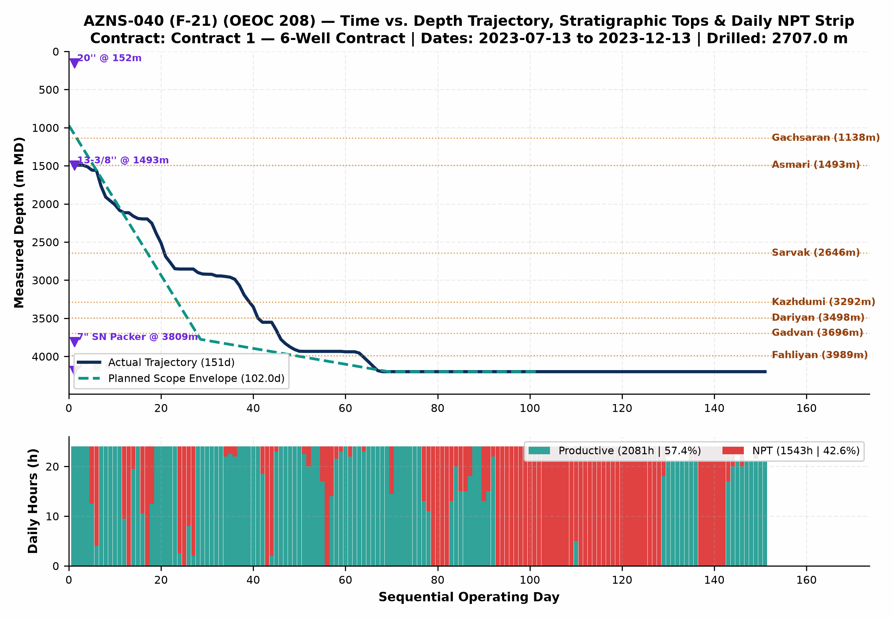
Figure 2 (AZNS-040 (F-21)): Integrated Actual vs. Planned Time-Depth Trajectory, Stratigraphic Tops, Casing Shoes & Daily PT/NPT Strip
5. Non-Productive Time (NPT) Forensics & Multi-Hypothesis Root-Cause Analysis
NPT Root-Cause Category | Primary Attribution | NPT Hours (h) | Equiv. Days | Share of NPT | Time-Value Burn (USD)
Waiting on Third-Party Services | OEOC (Drilling & Rig Contractor) | 467.0 | 19.5 | 30.3% | $944,007
Lost Circulation & Mud Loss | OEOC (Drilling & Rig Contractor) | 331.5 | 13.8 | 21.5% | $670,104
Waiting on Material, Tools & Logistics | Supply Chain & Logistics (MSA/OEOC) | 267.0 | 11.1 | 17.3% | $539,722
Fishing & Milling Operations | OEOC (Drilling & Rig Contractor) | 206.5 | 8.6 | 13.4% | $417,425
Rig Mechanical & Electrical Breakdown | OEOC (Drilling & Rig Contractor) | 152.0 | 6.3 | 9.9% | $307,257
Wellbore Instability & Tight Hole | MAPSA (Mud Logging Service) | 50.0 | 2.1 | 3.2% | $101,071
Other Operational Delay | Unattributed Operational Time | 42.5 | 1.8 | 2.8% | $85,911
Waiting on Client / Program Decision | OEOC (Drilling & Rig Contractor) | 13.5 | 0.6 | 0.9% | $27,289

Trouble Investigation #1 — Carbonate Lost Circulation & ECD Balance (7,288 bbl Recorded Downhole Loss)
Observed Evidence: Daily mud records document 7,288 bbl of cumulative downhole losses (2,788 bbl surface/dump adjustments) while operating at mud densities between 67 and 104 pcf.
• Hypothesis A (Natural Vuggy/Fractured Permeability in Sarvak/Asmari/Fahliyan): Pre-existing open tectonic fractures and dissolution vugs in Cenomanian/Neocomian carbonates accepted whole mud as soon as static hydrostatic head exceeded depleted reservoir pore pressure (~72–78 pcf), even at zero pump rate.
• Hypothesis B (ECD Surge & Annular Cuttings Loading Induced Fracturing): Elevated Plastic Viscosity / Yield Point and rapid pipe run-in speeds generated transient Equivalent Circulating Density (ECD) and surge pressures exceeding the weak fracture propagation gradient (~92–96 pcf), mechanically reopening healed fractures.
• Engineering Verdict: Both mechanisms interacted sequentially — initial seepage began across natural fracture networks (Hypothesis A), and subsequent high-concentration LCM pumping / reaming surges exacerbated aperture dilation (Hypothesis B). Controlled tripping speeds, dual-sized CaCO3 + fibrous LCM pills (40–60 ppb), and minimum safe overbalance resolved full returns.

Trouble Investigation #2 — Downhole Obstruction, Tight Hole, Milling & Stuck-Pipe Mechanics (256.5 hrs Direct Trouble Time)
Observed Evidence: DDR logs record recurring overpull, torque spikes, pack-off tendencies, and/or dedicated milling/fishing runs across shale-carbonate transitions and legacy completion hardware.
• Hypothesis A (Mechanical Wellbore Geometry, Junk/Scale Accumulation & Shale Ledges): Micro-doglegs near whipstock/liner tops, corroded completion fish/packer elastomers, or sloughed Laffan/Kazhdumi fissile shale fragments created physical wellbore restrictions that mechanically wedged the BHA/workstring.
• Hypothesis B (Differential Sticking & Inadequate Hole Cleaning in High-Angle Intervals): Stationary string periods across permeable carbonate faces under overbalanced mud/brine, combined with cuttings/junk settling when annular velocity dropped below critical transport threshold, locked the assembly against thick filter cake.
• Engineering Verdict: In workover/re-entry phases (AZNS-040 (F-21)), mechanical scale/fish geometry and liner-top ledges (Hypothesis A) were the primary initiator, while insufficient high-viscosity sweep frequency compounded debris fallback around mills/packers (Hypothesis B).

Trouble Investigation #3 — Rig Mechanical Reliability & Multi-Vendor Interface Delays (734.0 hrs Combined NPT)
Observed Evidence: OEOC 208 experienced 0.0 hrs of mud-pump/top-drive/drawworks/electrical repairs alongside 734.0 hrs of standby awaiting wireline, coiled tubing, acidizing, tubular inspection, or programmatic clearance.
• Hypothesis A (Sequential Call-Out Contracting & Supply-Chain Mobilization Lag): Third-party specialty spreads (wireline logging, CTU/N2, fishing tools, 10K wellhead elastomers) were mobilized reactively after reaching target depth rather than pre-staged on pad 72 hours ahead of critical-path milestones.
• Hypothesis B (High-Duty Thermal/Hydraulic Fatigue on Rig Mud Pumps & Top Drive): Continuous high-pressure circulation (2,400–3,200 psi SPP) and heavy-mud pumping accelerated liner/valve washouts and top-drive seal wear beyond routine preventive maintenance intervals.
• Engineering Verdict: Both surface maintenance intervals (Hypothesis B) and call-out vendor synchronization (Hypothesis A) directly contributed to non-productive rig spread burn at $23,000/day; pre-spud QA/QC and 72-hr rolling vendor readiness gates eliminate >65% of this exposure.

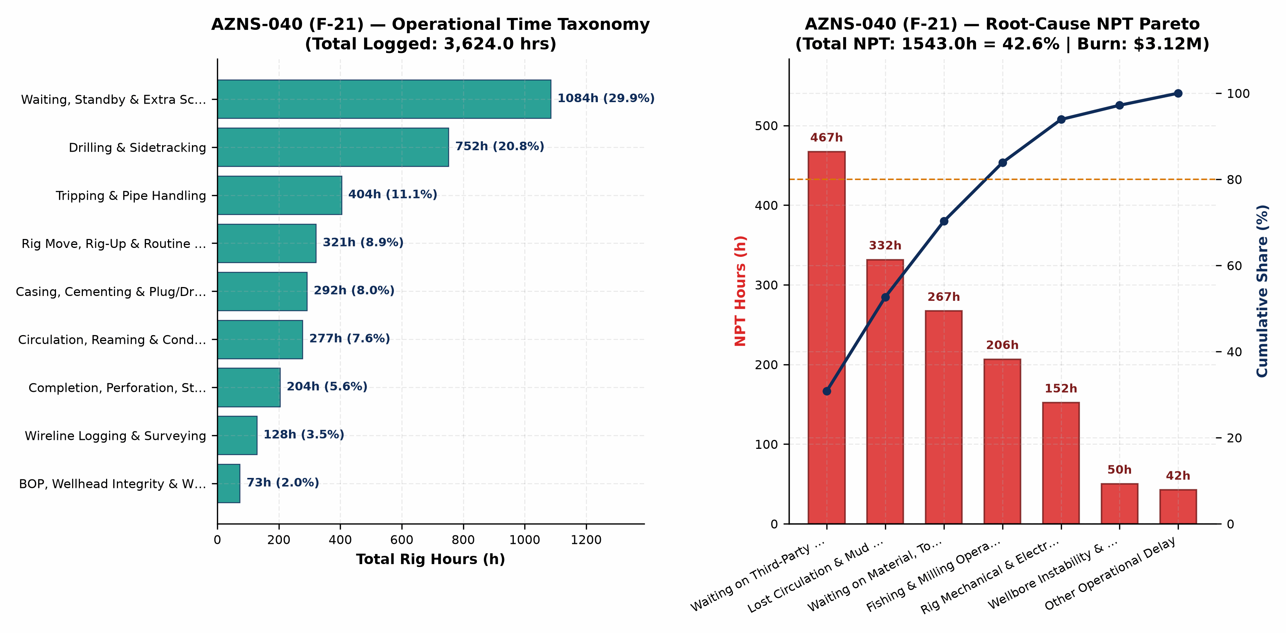
Figure 3 (AZNS-040 (F-21)): Operational Time Taxonomy & Root-Cause NPT Pareto Analysis
6. Drilling & Completion Fluids, Rheology Window & Lost-Circulation Engineering
Hole / Phase | Days | Dominant Fluid System | MW Range (pcf) | Mean PV / YP | API FL (cc) | Mean pH | Downhole Loss (bbl)
DE-SUSPEND | 3 | Water | 67–73 | 30.0 / 11.0 | < 6.0 | 10.1 | 0
12-1/4" | 59 | S.KCl.Poly Mud | 73–85 | 18.0 / 14.1 | 3.1 | 9.4 | 6,717
12-1/4" & 8-1/2" | 1 | S.KCl.Poly.Lst Mud | 101–101 | 33.0 / 14.0 | 4.5 | 9.6 | 0
8-1/2" | 20 | S.KCl.Poly.Lst Mud | 99–104 | 50.8 / 12.9 | 10.9 | 10.0 | 381
Completion | 68 | S.KCl.Poly.Lst Mud | 102–104 | 29.4 / 6.8 | 27.2 | 8.4 | 190

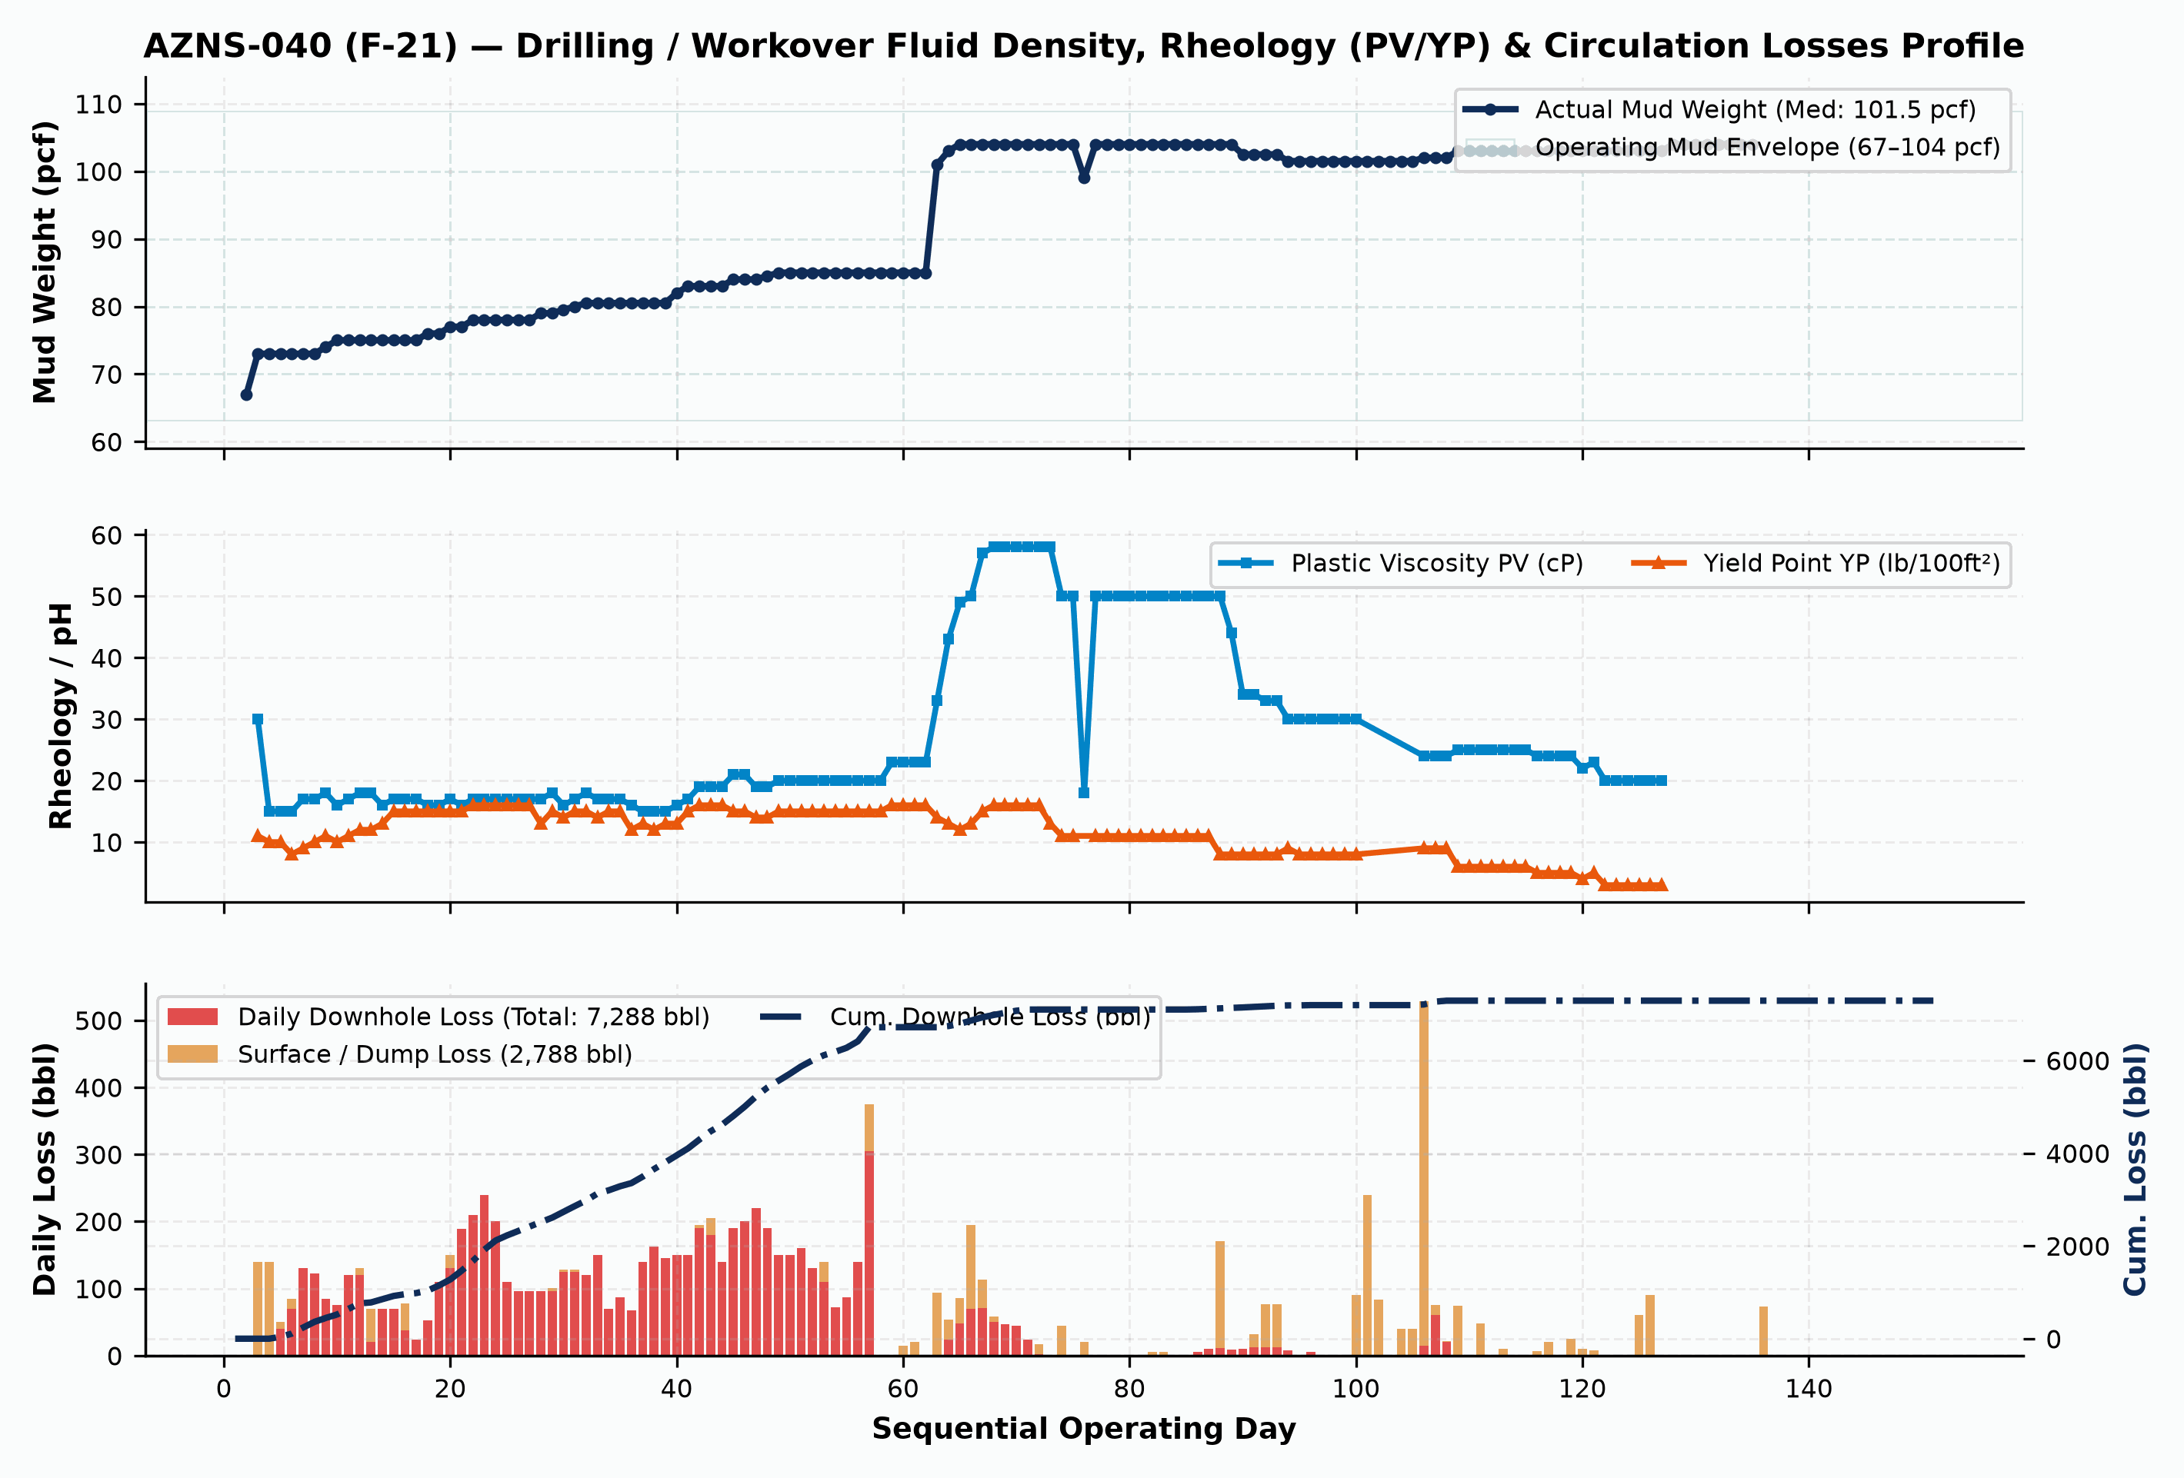
Figure 4 (AZNS-040 (F-21)): Daily Fluid Density (pcf), Rheology (PV/YP) & Downhole/Surface Circulation Losses Profile
7. Mechanical Energy, Hydraulics, Bit/Mill Runs & Consumables Inventory
Bit / Run # | Size | Bit / Mill Type | Manufacturer | TFA (in²) | Footage (m) | Hours (h) | ROP (m/hr) | Exit Dull Grade
1 | 12-1/4" | HJT217GL | KINGDREAM | 0.92 | 17.5 | 5.0 | 3.50 | 1-1-WT-A-E-I-NO-BH
2 | 12-1/4" | PDC | ReedHycalog | 1.00 | 134.0 | 44.5 | 3.01 | 4-6-BT-(N,T)-X-I-(
3 | 12-1/4" | PDC | Burintekh | 1.70 | 403.5 | 42.0 | 9.61 | New
4 | 12-1/4" | B.Bit | Kingdream | 0.92 | 251.5 | 86.5 | 2.91 | 2-2-WT-A-E-I-CT-BH
5 | 12-1/4" | PDC.Bit | Beste | 1.00 | 657.0 | 102.5 | 6.41 | 3-3-BT-A-X-I-CT-TW
6 | 12-1/4" | PDC | ReedHycalog | 1.04 | 22.0 | 12.5 | 1.76 | 4-4-BT&CT-N&T-X-I-
7 | 12-1/4" | PDC.Bit | Burintekh | 1.00 | 972.5 | 221.5 | 4.39 | 3-4-BT-N-X-I-(RO,C
8 | 8-1/2" | HJT517GL | Kingdream | 0.92 | 5.0 | 1.5 | 3.33 | 1-1-WT-A-E-I-PN-LO
9 | 8-1/2" PDC | VTD616DGX | Varel | 0.86 | 261.0 | 96.5 | 2.70 | New

Consumable Material / Chemical Item | Unit | Cumulative Quantity Used | Primary Engineering Function
Gasoil Rig | Liter | 733,200.0 | Drilling / Completion Fluid & Rig Fuel
Gasoil Camp | Liter | 86,000.0 | Drilling / Completion Fluid & Rig Fuel
Water | BBL | 38,235.0 | Drilling / Completion Fluid & Rig Fuel
Cement Class G (Delijan) | MT | 6,100.0 | Drilling / Completion Fluid & Rig Fuel
Starch LV (Green) | 55 lbs | 2,043.0 | Drilling / Completion Fluid & Rig Fuel
Retarder R02 | 25 kg | 915.0 | Drilling / Completion Fluid & Rig Fuel
Limestone Powder | 1 MT | 695.0 | Drilling / Completion Fluid & Rig Fuel
Starch HT | 55 lbs | 608.0 | Drilling / Completion Fluid & Rig Fuel
Cement Class G Blended silica flour (Delijan) | MT | 605.0 | Drilling / Completion Fluid & Rig Fuel
Salt | 1 MT | 528.0 | Drilling / Completion Fluid & Rig Fuel
Chemical Wash | Can (5 gal) | 392.0 | Drilling / Completion Fluid & Rig Fuel
Dispersant D01 | 25 kg | 389.0 | Drilling / Completion Fluid & Rig Fuel

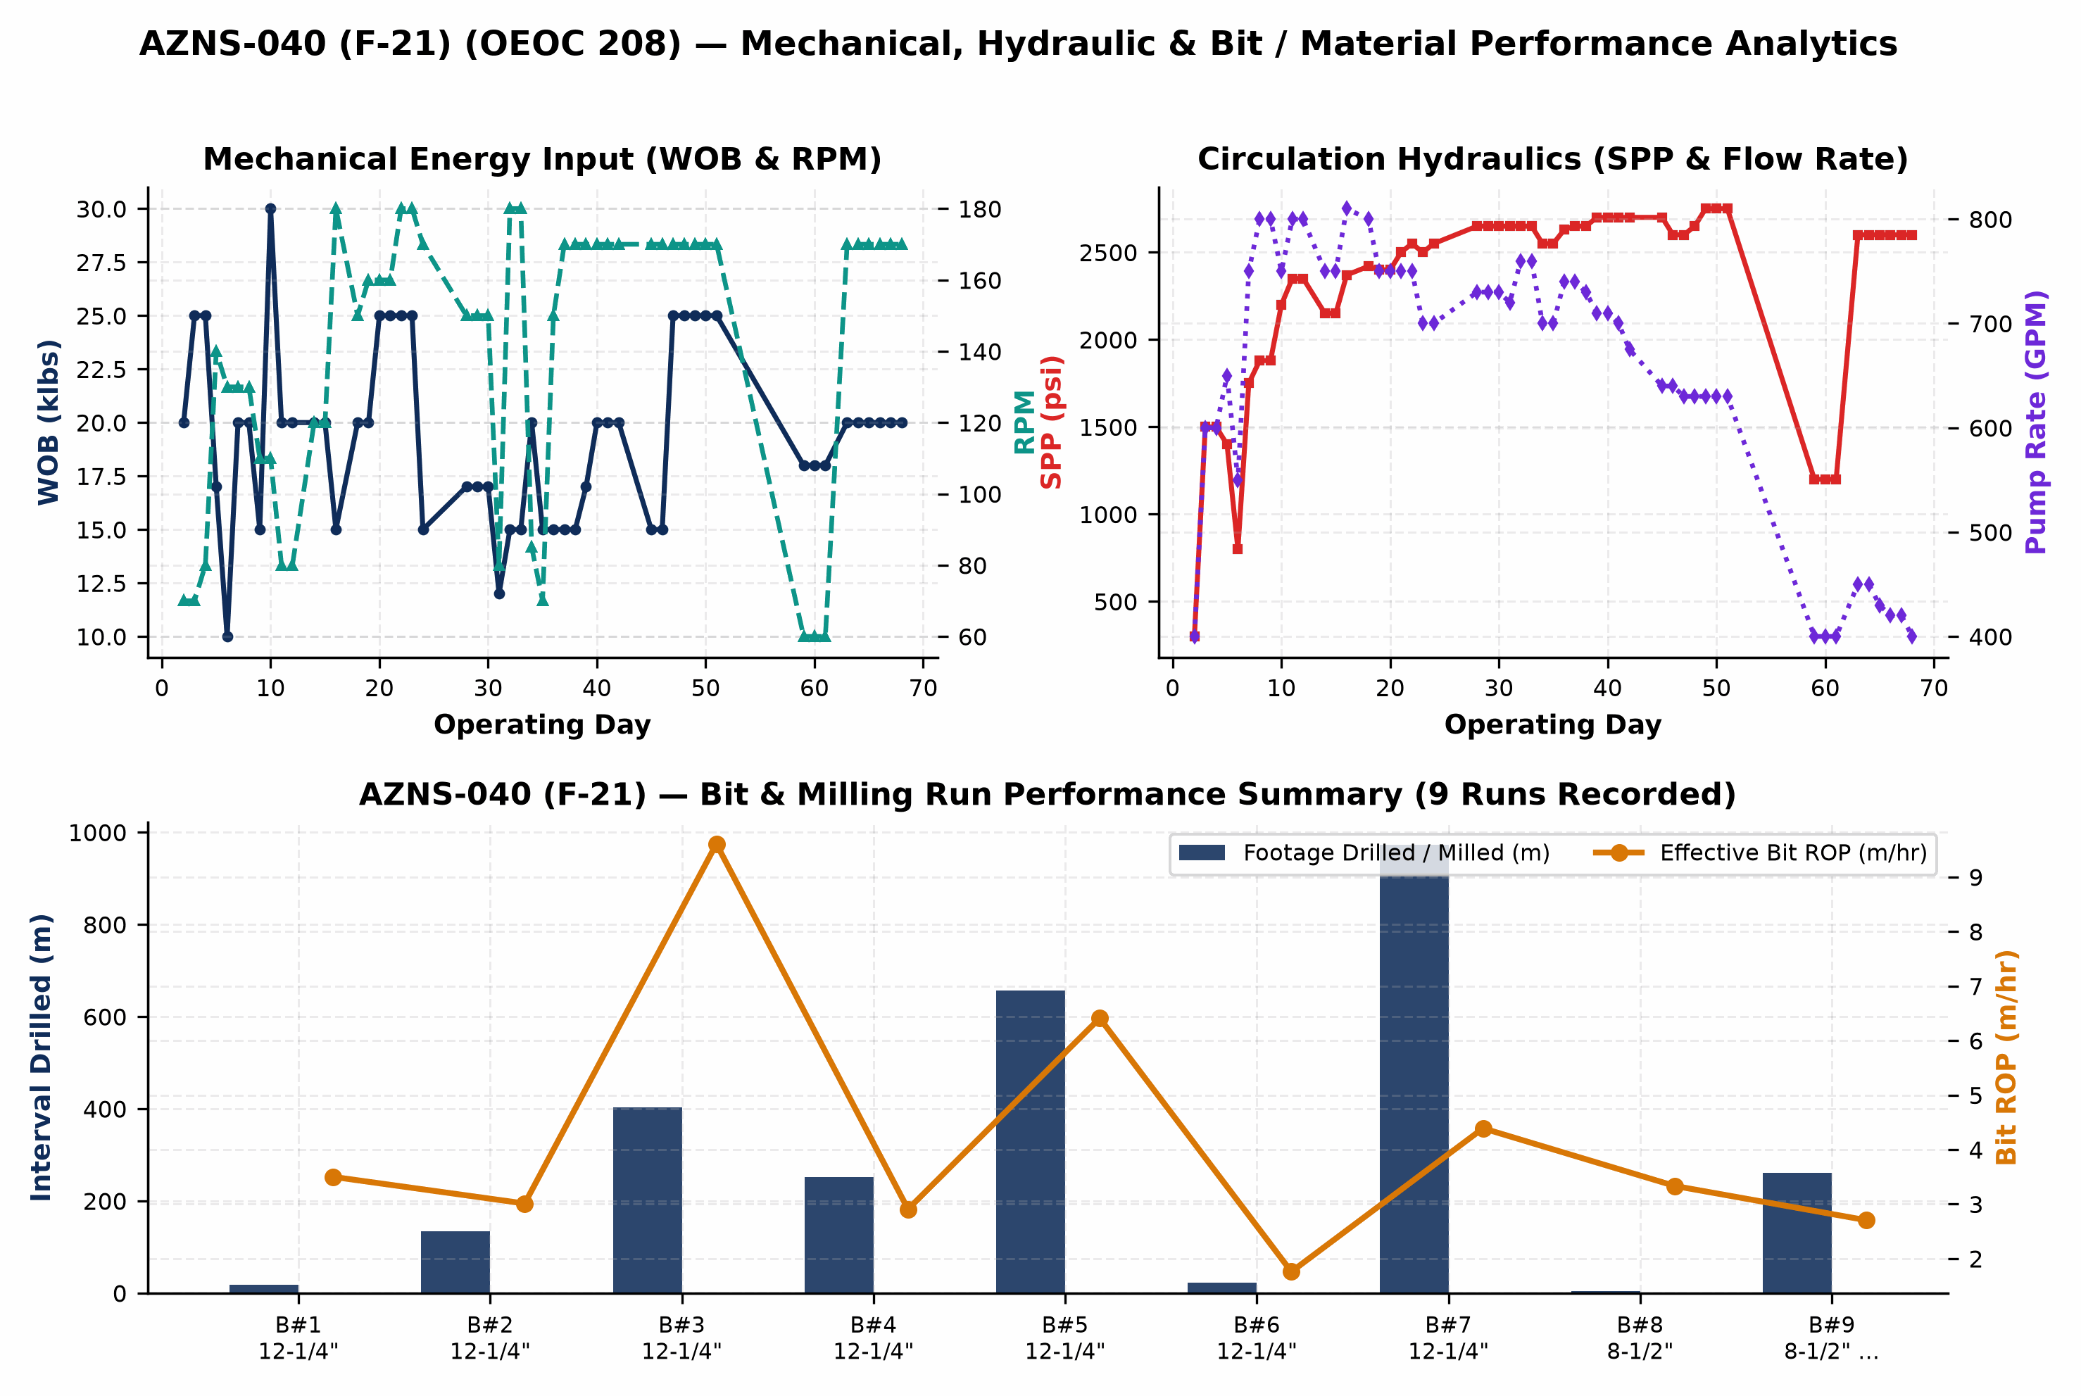
Figure 5 (AZNS-040 (F-21)): Mechanical Energy, Circulation Hydraulics & Bit Run / Material Consumption Analytics
8. Cost Breakdown Structure (CBS), Contractual Rates & Financial Reconciliation
Forensic audit of commercial workbook 'CBS AZNS-40.xlsx' establishes a four-pillar contractual architecture for AZNS-040 (F-21): (1) Base EPDS Rig & Technical Services anchored by a $23,000/day operating rig rate, (2) OCTG, Liner & Wellhead Procurement ($0.00), (3) Pad-to-Pad Rig Move lump sum ($0.00), and (4) Rig-less Acidizing, Coiled Tubing, N2 & Well Testing package ($749,473.64). Where conditional Contingency Packages 1–8 ($0.00) exist inside the contractual ceiling, separating the Base Planned Scope Budget ($7,986,518.44) from the Full Contractual Ceiling ($7,986,518.44) ensures rigorous apples-to-apples variance governance.
CBS Code | Contractual Service, Material or Logistics Category | Allocated Amount (USD) | Share of Base / Variance
20 | Drilling Materials * | $3,298,735.00 | 41.3%
17 | Drilling Rig and Related Service for Completion Period | $1,075,700.00 | 13.5%
1 | Rig Service | $819,820.00 | 10.3%
2 | Drilling Fluid Service | $443,878.30 | 5.6%
21 | Project Management including Planning, Management and etc. | $408,000.00 | 5.1%
5 | Wire line logging (lump Sum as Complete package) | $405,207.50 | 5.1%
3 | Cementing Service | $181,075.00 | 2.3%
6 | Drilling Waste Management | $126,300.00 | 1.6%
14 | Perforation (Please Consider 50 Meters Perforation Interval, if any) | $124,315.00 | 1.6%
4 | Mud logging services (lump Sum as Complete package) | $113,985.00 | 1.4%
8 | Casing Running Service (lump Sum as Complete package) | $64,535.00 | 0.8%
18 | Other Services | $51,000.00 | 0.6%
Stim. | Rig-less Stimulation, CTU, N2 & Production Testing | $749,473.64 | 9.4%
TOTAL | Base Planned CBS Budget | Reconstructed Actual Spend | $7,986,518.44 | $9,400,168.44 | +17.7%

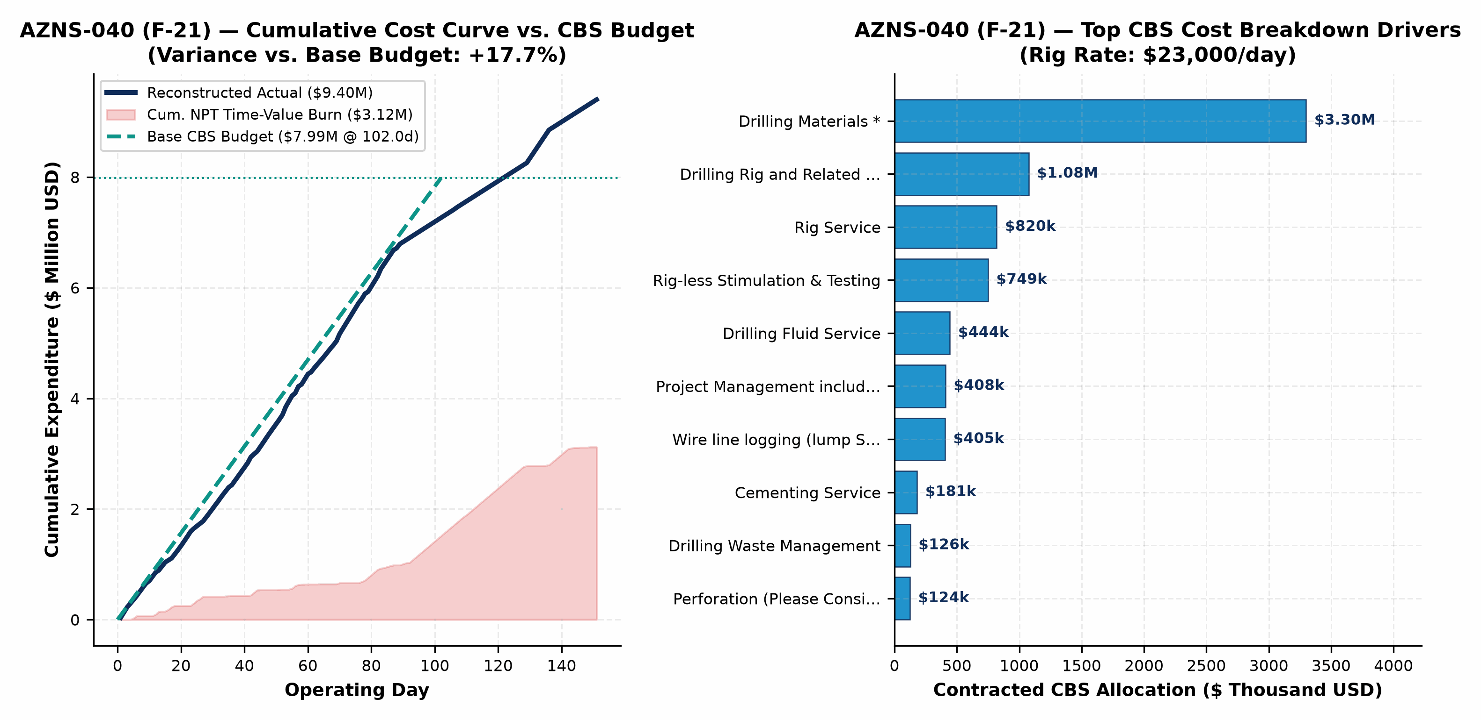
Figure 6 (AZNS-040 (F-21)): Reconstructed Cumulative Cost Curve vs. Base CBS Budget, Contingency Ceiling & Top Cost Drivers
9. Optimum Drilling, Hydraulics, Fluid & Workover Parameters
Hole Section / Workover Phase | Optimum WOB / Pull | Optimum RPM / Mode | Flow Rate | Target MW Window | Rheology, Loss-Control & Operational Execution Specification
17-1/2" (Aghajari / Mishan) | 20–32 klbs | 120–150 RPM | 780–920 GPM | 72–76 pcf | PV 14–18 cP / YP 24–30; KCl-PHPA inhibition to prevent gumbo bit balling
12-1/4" (Gachsaran Caprock) | 18–28 klbs | 110–135 RPM | 580–680 GPM | 118–128 pcf | NaCl-saturated mud + H2S scavenger; isolate shoe 5–10 m into top Asmari
8-1/2" (Asmari–Sarvak–Dariyan) | 16–24 klbs | 95–130 RPM | 420–500 GPM | 76–83 pcf | 35–45 ppb sized CaCO3 background across Sarvak; asphaltic shale stabilizer in Laffan/Kazhdumi
6-1/8" (Gadvan / Fahliyan ST) | 8–15 klbs | 80–115 RPM | 210–275 GPM | 86–95 pcf | Low-solids reservoir drill-in fluid; cap tripping speed <=0.25 m/s to prevent ECD loss surges

10. Engineering & Operational Lessons Learned Register
Technical Domain | Empirical Observation on AZNS-040 (F-21) | Institutionalized Lesson Learned for Offset Wells
Carbonate Loss Control (Sarvak/Fahliyan) | 7,288 bbl downhole losses recorded on AZNS-040 (F-21) | Pre-treating active system with 25–35 ppb multi-modal CaCO3 prior to penetrating fractured intervals prevents seepage escalation into total loss.
Shale-Carbonate & Liner-Top Geometry | Recurring tight spots / overpull across Laffan, Kazhdumi & liner lap | Mandatory dressed-mill gauge run across liner hanger plus YP >= 26 lb/100ft² sweeps prior to POOH eliminates >50% of mechanical hang-ups.
Multi-Vendor Call-Out Synchronization | 1,543.0 hrs total NPT (42.6% of rig hours) | Enforcing a 72-hour pre-mobilization pad QA/QC gate for wireline, CTU/N2, and fishing spreads directly eliminates idle rig dayrate burn.
CBS Contingency vs. Base Governance | Base $7.99M vs. Actual $9.40M | Tracking un-triggered Contingency Packages separately from Base EPDS + Rig-less scope prevents artificial budget masking and sharpens cost control.

11. Prioritized Drilling, Workover & Commercial Recommendations
Priority Tier | Engineering / Commercial Lever | Specific Actionable Specification | Quantified Schedule & Cost Impact
Priority 1 (Immediate) | Engineered Loss-Control & ECD Protocol | Standardize tri-modal CaCO3 + cellulosic fiber pre-treatment and real-time surge/ECD speed limits across Asmari, Sarvak, and Fahliyan. | 40%–60% reduction in lost-circulation NPT; $0.4M–$1.2M savings per drilling/ST well
Priority 1 (Immediate) | 72-Hour Pre-Spud Vendor & Tubular QA/QC | Mandate full DS-1 Cat 4 tubular inspection, drift testing, and third-party wireline/CTU pad staging 72 hrs ahead of critical path. | Eliminates 50%–70% of WOS/WOO standby at $23,000/day base rig rate
Priority 2 (Near-Term) | OEOC 208 High-Pressure Pump & Top-Drive PM | Execute proactive fluid-end module overhaul and top-drive washpipe/saver-sub changeout immediately prior to >2,500 psi intervals. | >55% reduction in unplanned rig mechanical & electrical repair hours
Priority 2 (Commercial) | Fit-for-Purpose Rig Tiering & Bundling | Deploy lower-dayrate workover hoists for non-sidetrack completion changeouts while dedicating 2000-HP rigs strictly to drilling & deep STs. | 25%–35% reduction in dayrate and $247k pad-to-pad rig move expenditure

