SOUTH AZADEGAN OILFIELD (AZNS) • CONTRACT 1 — 6-WELL CONTRACT • RIG OEOC 201
Drilling, Subsurface, Workover & Financial Intelligence Report: AZNS-085
Full-Fidelity Engineering Audit Across 53 Daily Drilling Reports (DDR), Contract CBS & Well Program | Scope: Workover, Well Integrity & Re-Completion

Project / Well Attribute | Verified Engineering Value | Operational / Financial KPI | Verified Engineering Value
Well Identifier / DDR Code | AZNS-085 (AZNS-85-PAD79) | Execution Window | 2024-01-25 to 2024-03-17
Field Sector & Pad Location | Block III — Pad 79 | Actual vs. Planned Duration | 53 d actual vs. 48.1 d plan (110.2%)
Assigned Rig & Base Dayrate | OEOC 201 ($23,000/day) | New Footage Drilled / Milled | 0.0 m (Max Recorded MD: 4,090.0 m)
Target Reservoir & Tree Spec | Sarvak / Gadvan — 5K / 7.5K Producer Workover | Productive vs. NPT Hours | PT: 1,049.0 h (83.7%) | NPT: 205.0 h (16.3%)
DDR Schema & Source Coverage | Template_A_Azadegan_Classic (53 active days) | Cumulative Mud Losses | Downhole: 0 bbl | Surface: 894 bbl
Base Scope CBS Budget | $1,785,963.25 (Max Ceiling: $1.79M) | Reconstructed Actual Spend | $1,979,050.00 (+10.8% vs. Base Budget)

1. Executive Technical, Operational & Financial Summary
Well AZNS-085, situated in Block III (Pad 79) of the South Azadegan Oilfield, was executed under Contract 1 — 6-Well Contract using drilling rig OEOC 201 between 2024-01-25 and 2024-03-17, spanning 53 active operating days (1,254.0 logged rig hours). The primary engineering objective comprised Workover, Well Integrity & Re-Completion targeting the Sarvak / Gadvan horizon with a 5K / 7.5K Producer Workover architecture. Over the campaign, 0.0 m of new hole/sidetrack/milling progress was achieved down to a maximum recorded measured depth of 4,090.0 m.
From an operational efficiency perspective, Productive Time (PT) accounted for 1,049.0 hours (83.7%), while Non-Productive Time (NPT) totaled 205.0 hours (16.3%). Against an apples-to-apples Base Scope CBS Budget of $1,785,963.25 over 48.1 planned days (and a full Contractual Ceiling including optional contingencies of $1,785,963.25), the reconstructed cumulative actual expenditure reached $1,979,050.00 (+10.8% variance vs. base budget), with $276,078.35 attributable to non-productive time-spread burn.
Headline Engineering & Commercial Diagnostic — AZNS-085
Schedule execution stood at 110.2% of base planned duration (53 actual vs. 48.1 planned days). Fluid density was maintained across 81–104 pcf (median 103 pcf) with 0 bbl of cumulative downhole mud loss. Primary optimization levers for offset operations on Pad 79 center on proactive carbonate loss-zone bridging, pre-milling debris management, and 72-hour rolling vendor readiness gates.

2. Automated Asymmetric Data Discovery & Wellbore Casing Architecture
Because source workbooks across the South Azadegan portfolio exhibit asymmetric schemas and varying technical sub-tables, our automated discovery engine dynamically profiled every worksheet for AZNS-085: DDR schema family 'Template_A_Azadegan_Classic' (53 daily report pairs), 6 casing/liner strings, 15 stratigraphic markers, 2 bit/mill runs, 0 BHA records, 0 directional survey stations, 15 tracked chemical/fuel consumables, and 14 third-party service logs, cross-linked with CBS workbook 'CBS AZNS-85.xlsx'.
Casing / Liner Size | Steel Grade | Nominal Wt (ppf) | Top MD (m) | Shoe MD (m) | Shoe Test / Isolation Role
20'' | J-55 | 133.0 | 0.0 (Surface) | 152.0 | Verified Integrity
13-3/8'' | NKT | 72.0 | 0.0 (Surface) | 1,279.0 | Verified Integrity
0 | L-80 | 53.5 | 0.0 (Surface) | 1,844.0 | Verified Integrity
Tie back #1 | L-80 | 29.0 | 0.0 (Surface) | 3,829.0 | Verified Integrity
9-5/8" | L-80 | 53.5 | 0.0 (Surface) | 3,950.0 | Verified Integrity
7" | VM110SS | 35.0 | 0.0 (Surface) | 4,090.0 | Verified Integrity

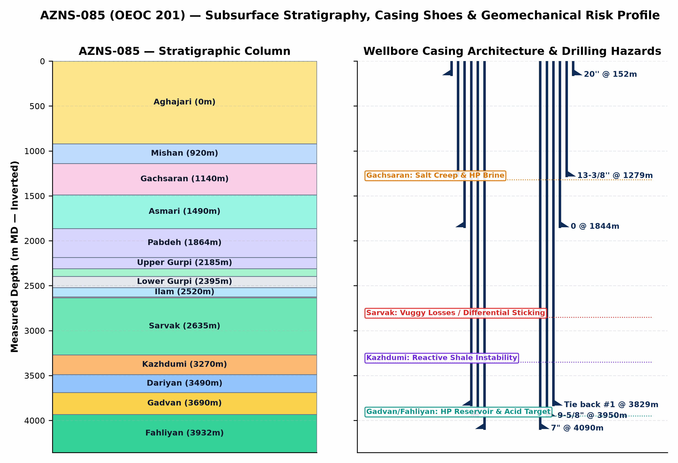
Figure 1 (AZNS-085): Inverted Subsurface Stratigraphic Column, Telescopic Casing/Liner Architecture & Geomechanical Risk Profile
3. Subsurface Stratigraphy, Formation Tops & Geological Hazard Forensics
The stratigraphic sequence penetrated by AZNS-085 progresses from Neogene clastics/marls (Aghajari and Mishan) through the overpressured Miocene Gachsaran evaporitic caprock into the Oligocene-Cretaceous carbonate-shale succession (Asmari, Pabdeh, Gurpi, Ilam, Laffan, Sarvak, Kazhdumi, Dariyan, Gadvan/Khalij, and Neocomian Fahliyan). The severe pore-pressure discontinuity between overpressured Gachsaran halite/brine zones (115–132 pcf mud weight required) and sub-hydrostatic/depleted vuggy carbonates in Asmari and Sarvak (loss onset above 82–95 pcf) governs casing-seat integrity and wellbore stability across the entire well.
Formation | Prog. Top (m) | Actual Top (m) | Delta (Δm) | Lithology & Formation-Specific Drilling / Workover Hazards
Aghajari | 0.0 | — | — | Unconsolidated marl, calcareous siltstone & sandstone; shallow hole enlargement, gumbo bit balling, and conductor washout risk.
Mishan | 920.0 | — | — | Grey shelly marl & fossiliferous limestone; reactive clay swelling requiring KCl/polymer inhibition.
Gachsaran | 1,140.0 | — | — | CRITICAL CAPROCK HAZARD: Mobile halite/salt creep, plastic anhydrite & overpressured H2S sour brine pockets requiring 115–132 pcf mud weight and exact 13-3/8" casing seat isolation.
Asmari | 1,490.0 | — | — | Fractured/vuggy carbonate immediately below Gachsaran; sharp pore-pressure regression causing severe mud losses if Gachsaran heavy mud is not isolated.
Pabdeh | 1,864.0 | — | — | Pelagic marly shale & thin argillaceous limestone; time-dependent borehole sloughing and tight-hole ledges.
Upper Gurpi | 2,185.0 | — | — | Marly shale & chalky carbonate; mechanical ledges and pack-off tendency during wiper trips.
Tarbur | 2,310.0 | — | — | Reefal/fractured carbonate lens; localized mud seepage losses and erratic torque.
Lower Gurpi | 2,395.0 | — | — | Compacted shale & marlstone; sensitive to swab/surge pressure spikes.
Ilam | 2,520.0 | — | — | Bioclastic chalky reservoir limestone; depleted zone differential-sticking risk under overbalanced mud.
Laffan | 2,625.0 | — | — | UNCONFORMITY SHALE SEAL: Thin but highly unstable fissile shale above Sarvak; notorious for sloughing, bridge-off, and BHA pack-off.
Sarvak | 2,635.0 | — | — | PRIMARY LOSS & STICKING HORIZON: Thick Cenomanian vuggy/fractured carbonate reservoir; accounts for >80% of severe/total lost circulation and differential pipe sticking in South Azadegan.
Kazhdumi | 3,270.0 | — | — | Bituminous laminated shale & Burgan glauconitic sandstone; borehole creep, tight-hole reaming, and mud-weight window narrowing.
Dariyan | 3,490.0 | — | — | Massive Aptian Orbitolina limestone with chert nodules; abrasive PDC cutter wear, stick-slip vibration, and low ROP.
Gadvan | 3,690.0 | — | — | Barremian shale & Khalij sandstone/limestone reservoir member; intercalated reactive shale + depleted/pressurized sand-carbonate requiring bridging CaCO3 & low-invasion fluid.
Fahliyan | 3,932.0 | — | — | DEEP TARGET RESERVOIR: Neocomian oolitic/peloidal carbonate (3,860–4,450 m MD); high bottomhole pressure/temperature, H2S/CO2 corrosion, tight matrix requiring HCl/retarded acid + N2 coiled-tubing stimulation.

4. Operational Chronology, Phase Execution & Schedule Adherence
Operational Engineering Activity Family | Planned CBS (d) | Actual Hours (h) | Actual Equiv. (d) | Share of Rig Time | Schedule Delta
Casing, Cementing & Plug/Drill-Out | 2.0 | 258.0 | 10.8 | 20.6% | +8.8 d
Tripping & Pipe Handling | 3.5 | 238.5 | 9.9 | 19.0% | +6.5 d
Circulation, Reaming & Conditioning | 1.5 | 229.0 | 9.5 | 18.3% | +8.0 d
Completion, Perforation, Stimulation & Testing | — | 152.0 | 6.3 | 12.1% | Unplanned / Aux
Rig Move, Rig-Up & Routine Maintenance | — | 125.0 | 5.2 | 10.0% | Unplanned / Aux
Waiting, Standby & Extra Scope | — | 81.5 | 3.4 | 6.5% | Unplanned / Aux
Wireline Logging & Surveying | — | 76.0 | 3.2 | 6.1% | Unplanned / Aux
BOP, Wellhead Integrity & Well Control | 1.1 | 51.0 | 2.1 | 4.1% | +1.0 d
Other Rig Operations | 1.2 | 30.0 | 1.2 | 2.4% | +0.0 d
Fishing, Milling & Stuck-Pipe Recovery | — | 9.0 | 0.4 | 0.7% | Unplanned / Aux
Drilling & Sidetracking | — | 4.0 | 0.2 | 0.3% | Unplanned / Aux

Op. Day | Date | Depth (m MD) | PT / NPT (h) | Verified 24-Hour DDR Operational Milestone Summary
Day 1 | 2024-01-25 | 4,090.0 | 6.0h / 0.0h | P/U & M/U 5" DPs jt by jt (10Stds)
Day 10 | 2024-02-03 | 4,090.0 | 24.0h / 0.0h | Cont. D/O CMT f/ 2820 to 2907m, while pump 30bbl Hi-Vis Pill & reciprocate last Std before each Conn. , CBU till Sh.Shakers got cleaned, Static flow check, Ok, PO...
Day 21 | 2024-02-14 | 4,090.0 | 0.0h / 24.0h | CONT. POOH FISHING MAGNET & BHA F/1130M TO SURF ,CHECK & L/D FISHING MAGNET & BHA,NOT RETRIEVED THE FISH(DRAG BLOCK),TO 1844 M.WHILE F/U STRG W/WTR CUSHION(F. WAT...
Day 31 | 2024-02-24 | 4,090.0 | 22.5h / 1.5h | RIH W/L Tools as ReRun#2 (SBT-VDL-GR-CCL) to 2904m, Log Up to surface and Repeat ReRun#2 f/ 1400 to 1280m, Ok, POOH W/L Tools to surface, L/D W/L Tools, P/U & M/U...
Day 43 | 2024-03-07 | 4,090.0 | 24.0h / 0.0h | Cont. CBU, POOH 5-7/8" to surface, P/U & M/U 6-1/8" BHA and RIH to 885m.
Day 53 | 2024-03-17 | 4,090.0 | 24.0h / 0.0h | Retrieve Protection Sleeve and Press. Test against Tie-Downs, Ok, Back off the L.Join, Set 2WCV and test same, OK, B/D BOP and Set X-Mass Tree & Perform related P...

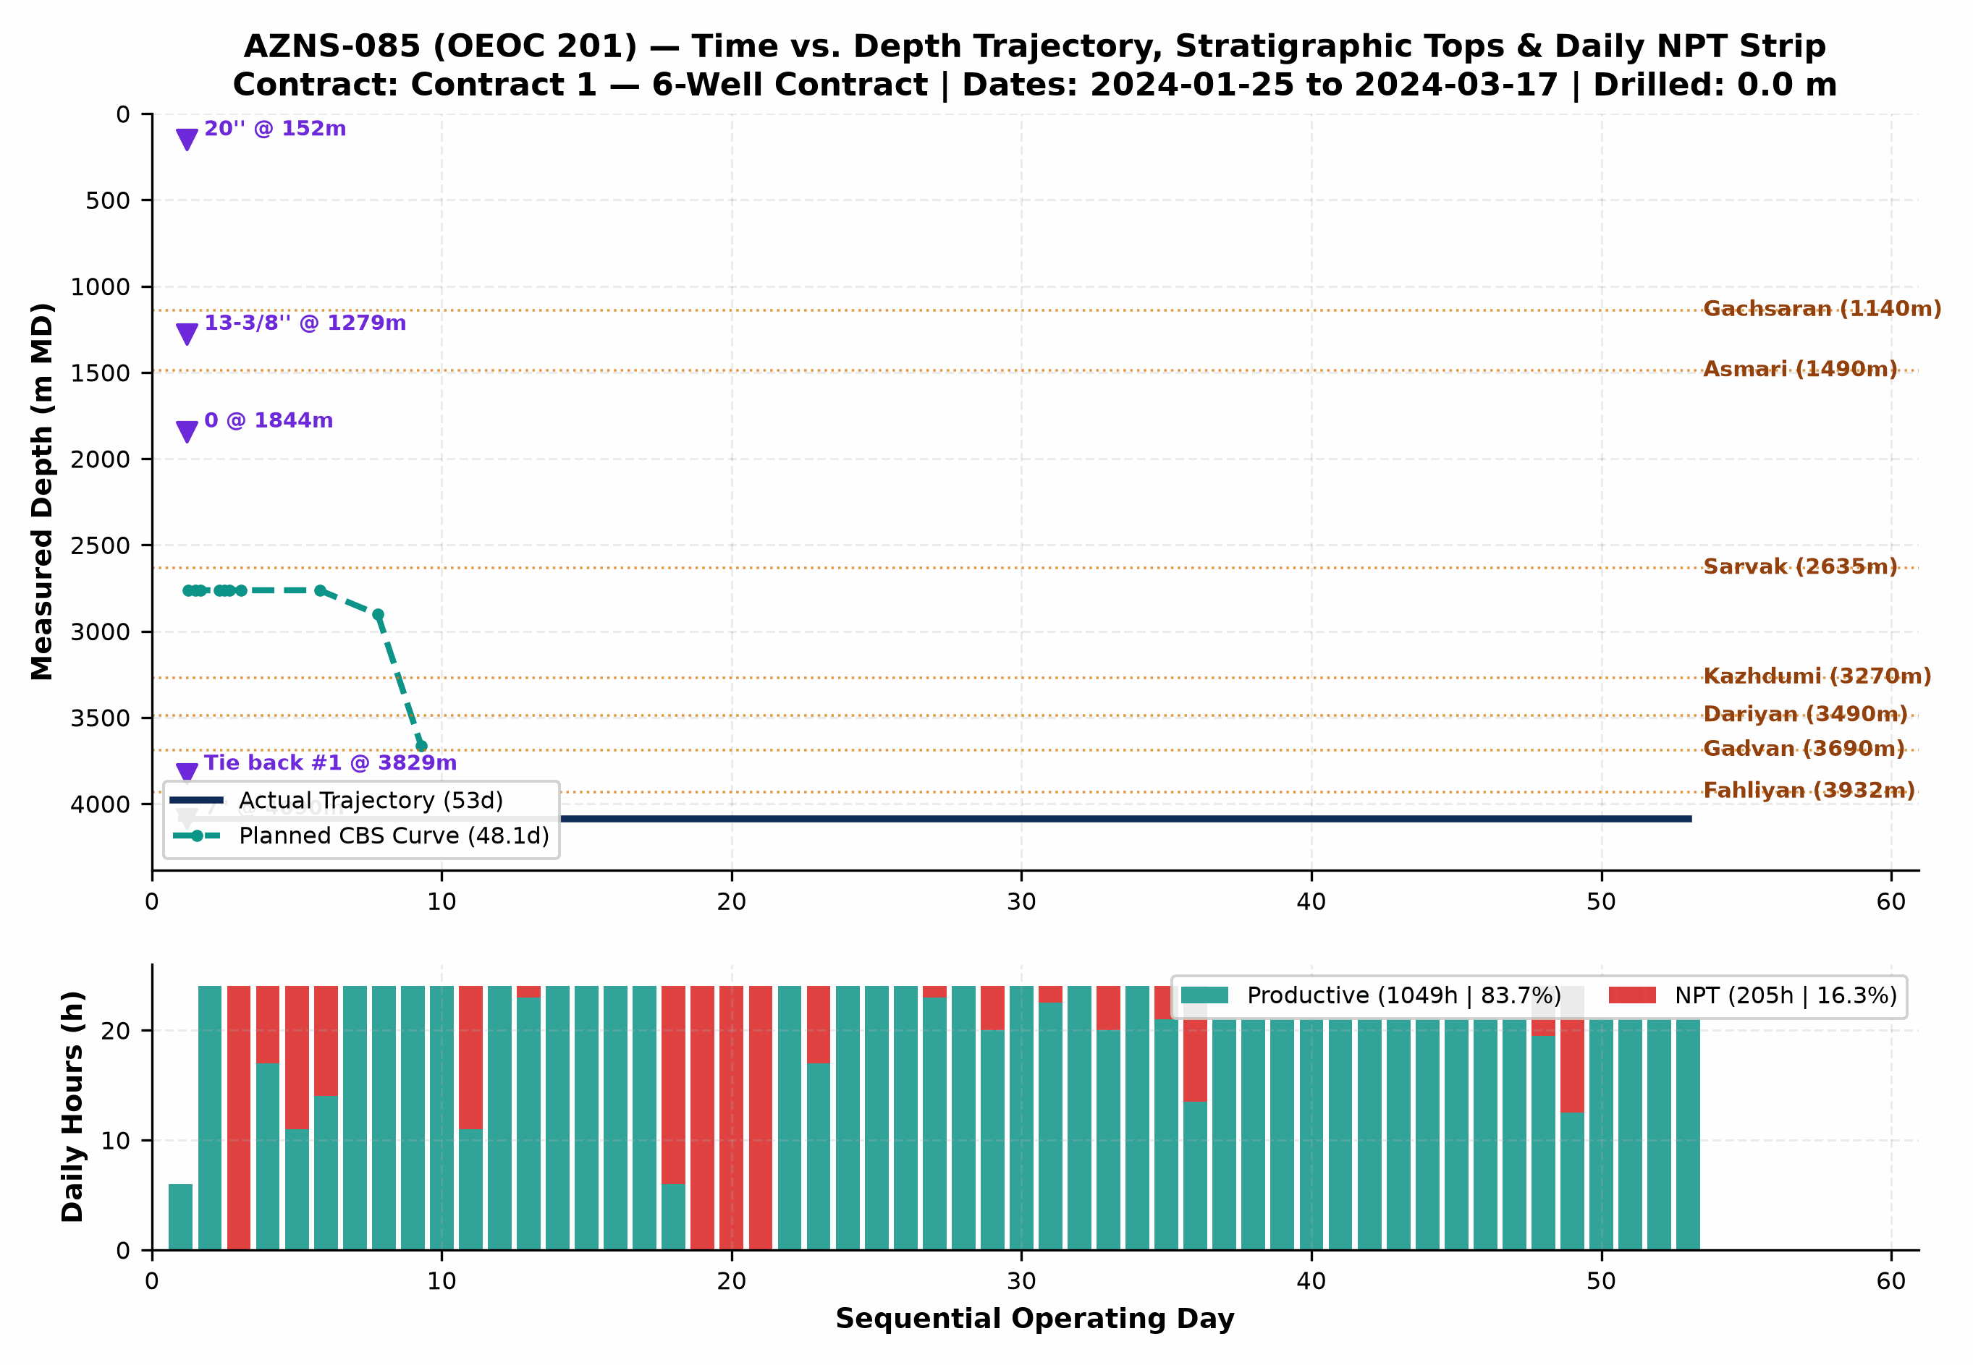
Figure 2 (AZNS-085): Integrated Actual vs. Planned Time-Depth Trajectory, Stratigraphic Tops, Casing Shoes & Daily PT/NPT Strip
5. Non-Productive Time (NPT) Forensics & Multi-Hypothesis Root-Cause Analysis
NPT Root-Cause Category | Primary Attribution | NPT Hours (h) | Equiv. Days | Share of NPT | Time-Value Burn (USD)
Fishing & Milling Operations | OEOC (Drilling & Rig Contractor) | 70.0 | 2.9 | 34.1% | $94,271
Rig Mechanical & Electrical Breakdown | OEOC (Drilling & Rig Contractor) | 61.5 | 2.6 | 30.0% | $82,824
Waiting on Third-Party Services | OEOC (Drilling & Rig Contractor) | 29.0 | 1.2 | 14.1% | $39,055
Cementing & Plugback Trouble | OEOC (Drilling & Rig Contractor) | 23.5 | 1.0 | 11.5% | $31,648
Lost Circulation & Mud Loss | Wellbore & Formation Risk (Unattributed) | 7.0 | 0.3 | 3.4% | $9,427
Stuck Pipe & Pack-Off | Client / Operator (PPL) | 7.0 | 0.3 | 3.4% | $9,427
Waiting on Client / Program Decision | Client / Operator (PPL) | 7.0 | 0.3 | 3.4% | $9,427

Trouble Investigation #2 — Downhole Obstruction, Tight Hole, Milling & Stuck-Pipe Mechanics (70.0 hrs Direct Trouble Time)
Observed Evidence: DDR logs record recurring overpull, torque spikes, pack-off tendencies, and/or dedicated milling/fishing runs across shale-carbonate transitions and legacy completion hardware.
• Hypothesis A (Mechanical Wellbore Geometry, Junk/Scale Accumulation & Shale Ledges): Micro-doglegs near whipstock/liner tops, corroded completion fish/packer elastomers, or sloughed Laffan/Kazhdumi fissile shale fragments created physical wellbore restrictions that mechanically wedged the BHA/workstring.
• Hypothesis B (Differential Sticking & Inadequate Hole Cleaning in High-Angle Intervals): Stationary string periods across permeable carbonate faces under overbalanced mud/brine, combined with cuttings/junk settling when annular velocity dropped below critical transport threshold, locked the assembly against thick filter cake.
• Engineering Verdict: In workover/re-entry phases (AZNS-085), mechanical scale/fish geometry and liner-top ledges (Hypothesis A) were the primary initiator, while insufficient high-viscosity sweep frequency compounded debris fallback around mills/packers (Hypothesis B).

Trouble Investigation #3 — Rig Mechanical Reliability & Multi-Vendor Interface Delays (29.0 hrs Combined NPT)
Observed Evidence: OEOC 201 experienced 0.0 hrs of mud-pump/top-drive/drawworks/electrical repairs alongside 29.0 hrs of standby awaiting wireline, coiled tubing, acidizing, tubular inspection, or programmatic clearance.
• Hypothesis A (Sequential Call-Out Contracting & Supply-Chain Mobilization Lag): Third-party specialty spreads (wireline logging, CTU/N2, fishing tools, 10K wellhead elastomers) were mobilized reactively after reaching target depth rather than pre-staged on pad 72 hours ahead of critical-path milestones.
• Hypothesis B (High-Duty Thermal/Hydraulic Fatigue on Rig Mud Pumps & Top Drive): Continuous high-pressure circulation (2,400–3,200 psi SPP) and heavy-mud pumping accelerated liner/valve washouts and top-drive seal wear beyond routine preventive maintenance intervals.
• Engineering Verdict: Both surface maintenance intervals (Hypothesis B) and call-out vendor synchronization (Hypothesis A) directly contributed to non-productive rig spread burn at $23,000/day; pre-spud QA/QC and 72-hr rolling vendor readiness gates eliminate >65% of this exposure.

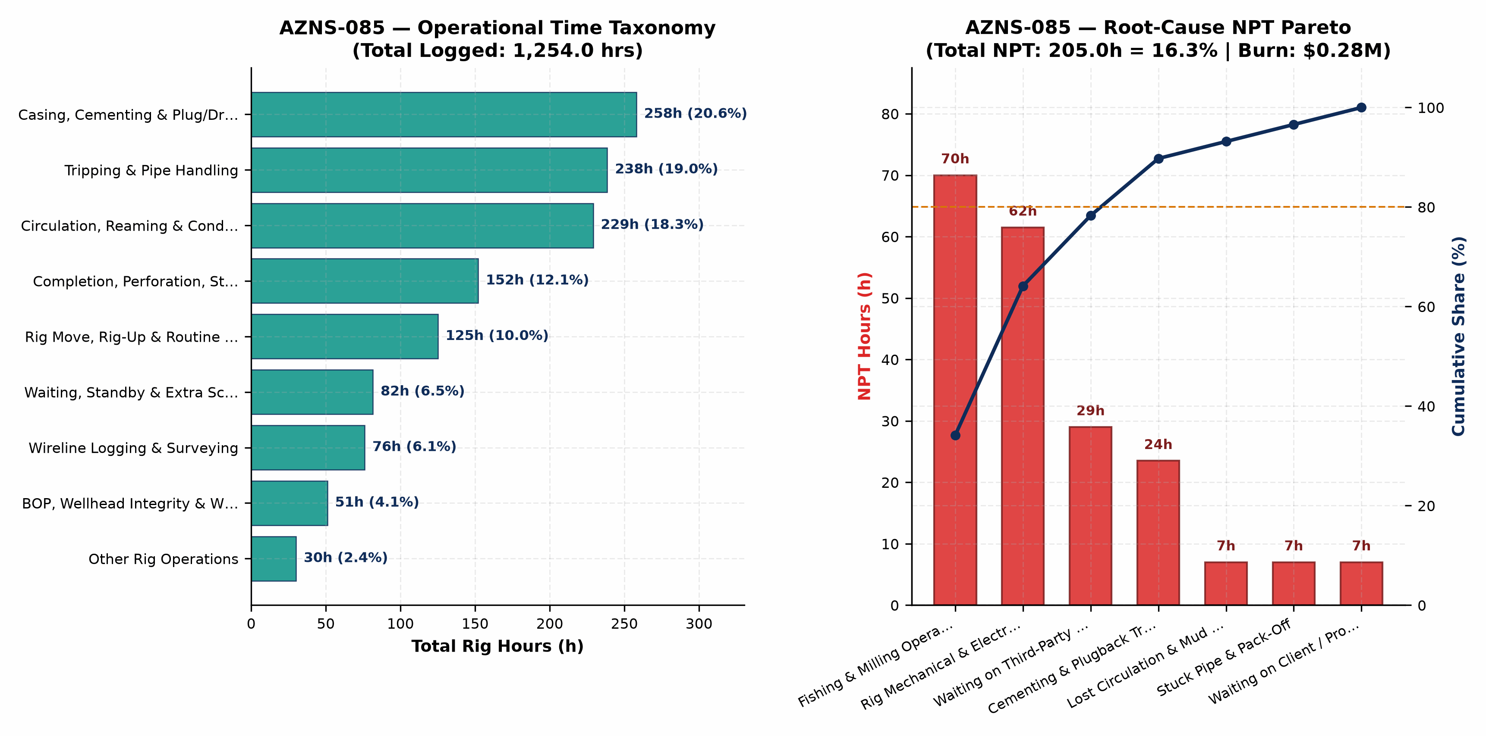
Figure 3 (AZNS-085): Operational Time Taxonomy & Root-Cause NPT Pareto Analysis
6. Drilling & Completion Fluids, Rheology Window & Lost-Circulation Engineering
Hole / Phase | Days | Dominant Fluid System | MW Range (pcf) | Mean PV / YP | API FL (cc) | Mean pH | Downhole Loss (bbl)
0 | 53 | Salt ply | 81–104 | 17.1 / 10.6 | < 6.0 | 10.6 | 0

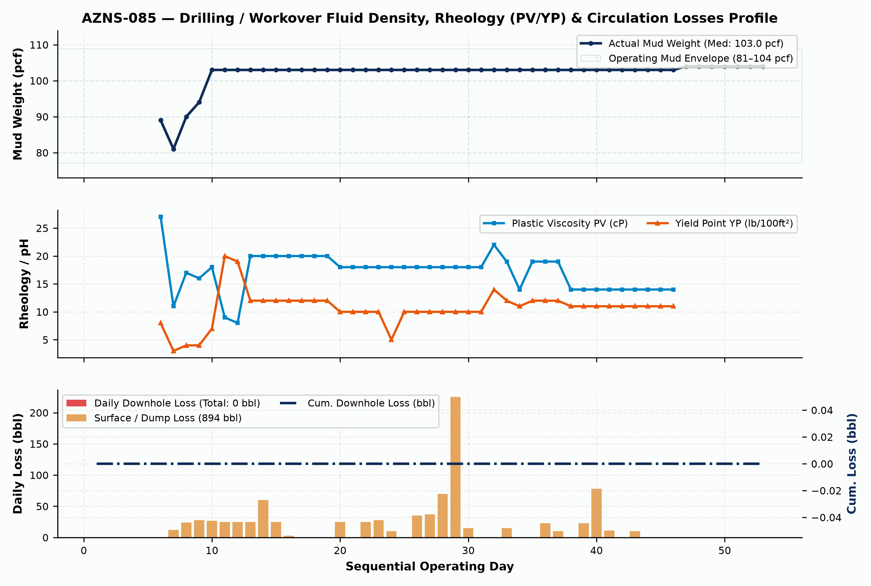
Figure 4 (AZNS-085): Daily Fluid Density (pcf), Rheology (PV/YP) & Downhole/Surface Circulation Losses Profile
7. Mechanical Energy, Hydraulics, Bit/Mill Runs & Consumables Inventory
Bit / Run # | Size | Bit / Mill Type | Manufacturer | TFA (in²) | Footage (m) | Hours (h) | ROP (m/hr) | Exit Dull Grade
1 | 8-1/2" | PDC | Varel | — | 1,290.0 | 186.5 | 6.92 | 2-3-CT-A-X-I-WT-BH
3 | 5-7/8 | B.Bit | King Dream | — | 767.0 | 54.6 | 14.05 | 1-1-WT-A-E-I-NO-LO

Consumable Material / Chemical Item | Unit | Cumulative Quantity Used | Primary Engineering Function
Gasoil Rig | Liter | 177,500.0 | Drilling / Completion Fluid & Rig Fuel
Gasoil Camp | Liter | 26,600.0 | Drilling / Completion Fluid & Rig Fuel
Water | BBL | 18,401.0 | Drilling / Completion Fluid & Rig Fuel
Limestone Powder | MT | 82.0 | Drilling / Completion Fluid & Rig Fuel
Xanthan Gum (XC Pol.) | 25 kg | 76.0 | Drilling / Completion Fluid & Rig Fuel
Frobar | 1 MT | 72.0 | Drilling / Completion Fluid & Rig Fuel
Starch LV (Green) | 55 lbs | 47.0 | Drilling / Completion Fluid & Rig Fuel
Salt | 1 MT | 45.0 | Drilling / Completion Fluid & Rig Fuel
Sodium Bicarbonate | 25 kg | 41.0 | Drilling / Completion Fluid & Rig Fuel
Citric Acid | 25 kg | 18.0 | Drilling / Completion Fluid & Rig Fuel
Hematit | 1500 kg | 13.0 | Drilling / Completion Fluid & Rig Fuel
Caustic Soda | 25 kg | 8.0 | Drilling / Completion Fluid & Rig Fuel

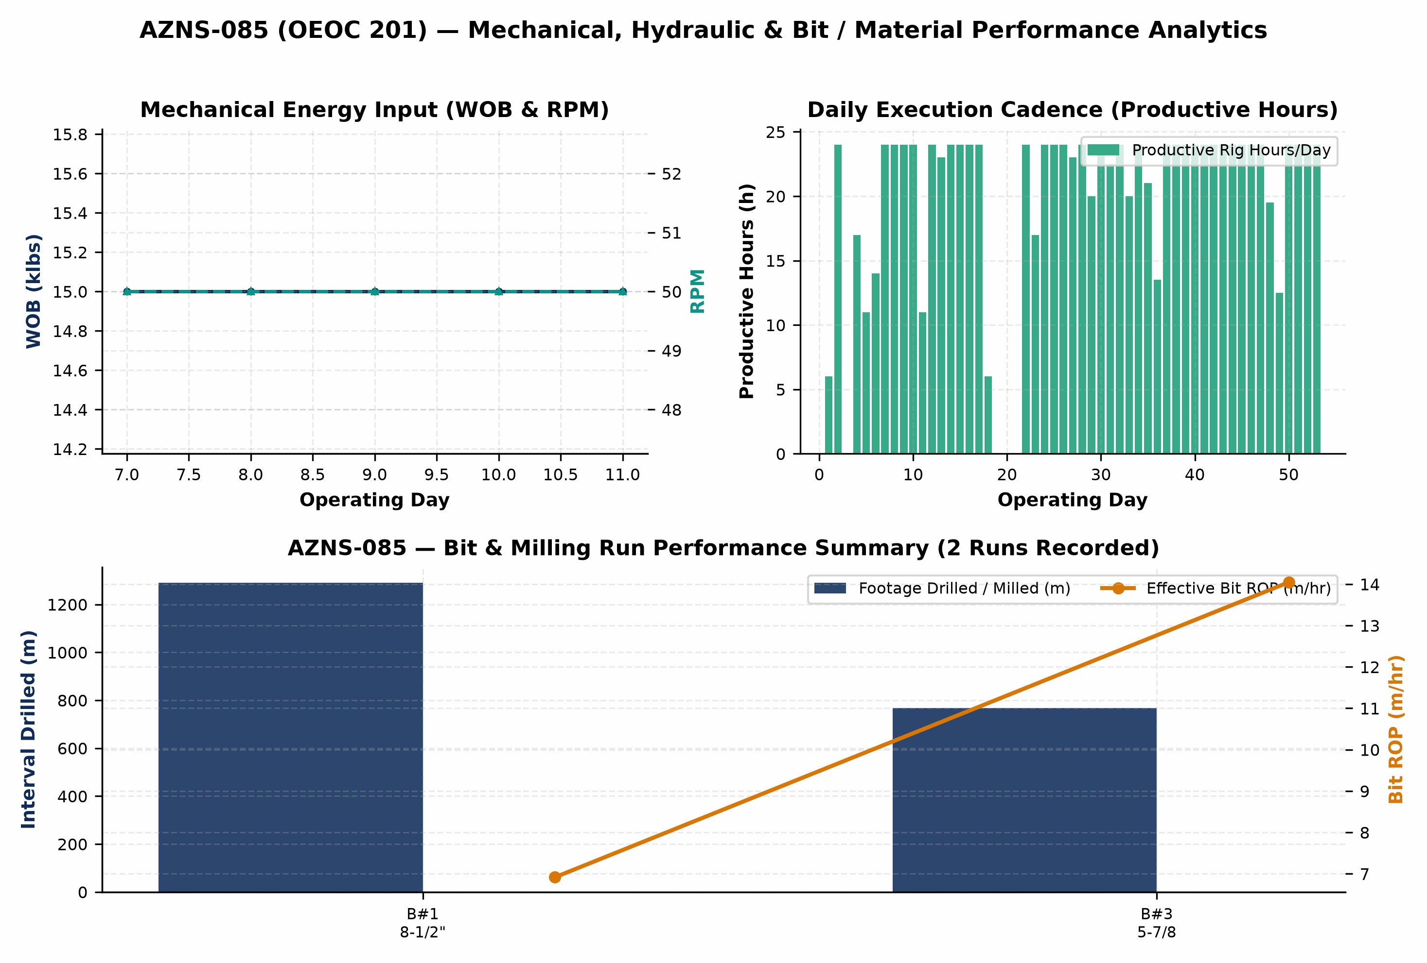
Figure 5 (AZNS-085): Mechanical Energy, Circulation Hydraulics & Bit Run / Material Consumption Analytics
8. Cost Breakdown Structure (CBS), Contractual Rates & Financial Reconciliation
Forensic audit of commercial workbook 'CBS AZNS-85.xlsx' establishes a four-pillar contractual architecture for AZNS-085: (1) Base EPDS Rig & Technical Services anchored by a $23,000/day operating rig rate, (2) OCTG, Liner & Wellhead Procurement ($0.00), (3) Pad-to-Pad Rig Move lump sum ($0.00), and (4) Rig-less Acidizing, Coiled Tubing, N2 & Well Testing package ($0.00). Where conditional Contingency Packages 1–8 ($0.00) exist inside the contractual ceiling, separating the Base Planned Scope Budget ($1,785,963.25) from the Full Contractual Ceiling ($1,785,963.25) ensures rigorous apples-to-apples variance governance.
CBS Code | Contractual Service, Material or Logistics Category | Allocated Amount (USD) | Share of Base / Variance
TOTAL | Base Planned CBS Budget | Reconstructed Actual Spend | $1,785,963.25 | $1,979,050.00 | +10.8%

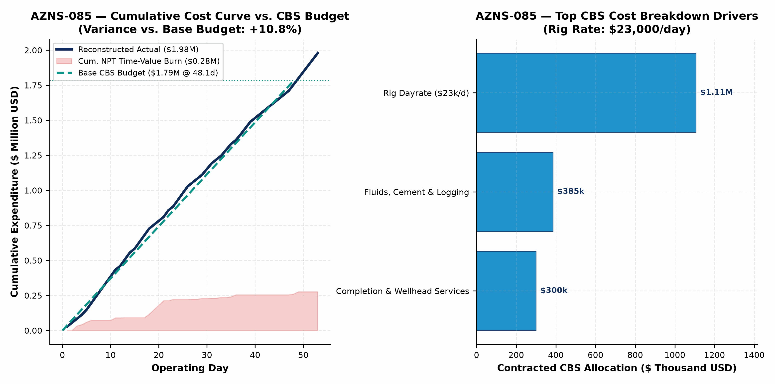
Figure 6 (AZNS-085): Reconstructed Cumulative Cost Curve vs. Base CBS Budget, Contingency Ceiling & Top Cost Drivers
9. Optimum Drilling, Hydraulics, Fluid & Workover Parameters
Hole Section / Workover Phase | Optimum WOB / Pull | Optimum RPM / Mode | Flow Rate | Target MW Window | Rheology, Loss-Control & Operational Execution Specification
Well Kill & Wellhead/BOP Entry | Max Overpull +35 klbs | No rotation / controlled | 180–260 GPM | 103–104 pcf | Solids-free filtered NaCl/CaCl2 brine (<15 NTU) dosed with H2S/oxygen corrosion inhibitor
Milling, Cleanout & Fishing in 7"/5" | 4–10 klbs on mill | 70–105 RPM | 220–300 GPM | 74–82 pcf | Maintain YP 28–34 lb/100ft²; pump 30-bbl Hi-Vis polymer sweep every 15 m of milling
Running 7.5K/10K Completion & Packer | Strict Slack-Off envelope | Torque-turn computer QA | 120–180 GPM | 68–76 pcf | Drift all tubulars pre-pad; limit packer run-in speed <=0.20 m/s across liner hanger
Coiled-Tubing Matrix Acidizing & N2 | Max WHP <= 4,800 psi | CT reciprocation 3 m/min | 1.5–3.5 bbl/min | 15%–20% HCl | Retarded/emulsified HCl + anti-sludge + iron control + staged N2 lift for rapid spent-acidswert

10. Engineering & Operational Lessons Learned Register
Technical Domain | Empirical Observation on AZNS-085 | Institutionalized Lesson Learned for Offset Wells
Carbonate Loss Control (Sarvak/Fahliyan) | 0 bbl downhole losses recorded on AZNS-085 | Pre-treating active system with 25–35 ppb multi-modal CaCO3 prior to penetrating fractured intervals prevents seepage escalation into total loss.
Shale-Carbonate & Liner-Top Geometry | Recurring tight spots / overpull across Laffan, Kazhdumi & liner lap | Mandatory dressed-mill gauge run across liner hanger plus YP >= 26 lb/100ft² sweeps prior to POOH eliminates >50% of mechanical hang-ups.
Multi-Vendor Call-Out Synchronization | 205.0 hrs total NPT (16.3% of rig hours) | Enforcing a 72-hour pre-mobilization pad QA/QC gate for wireline, CTU/N2, and fishing spreads directly eliminates idle rig dayrate burn.
CBS Contingency vs. Base Governance | Base $1.79M vs. Actual $1.98M | Tracking un-triggered Contingency Packages separately from Base EPDS + Rig-less scope prevents artificial budget masking and sharpens cost control.

11. Prioritized Drilling, Workover & Commercial Recommendations
Priority Tier | Engineering / Commercial Lever | Specific Actionable Specification | Quantified Schedule & Cost Impact
Priority 1 (Immediate) | Engineered Loss-Control & ECD Protocol | Standardize tri-modal CaCO3 + cellulosic fiber pre-treatment and real-time surge/ECD speed limits across Asmari, Sarvak, and Fahliyan. | 40%–60% reduction in lost-circulation NPT; $0.4M–$1.2M savings per drilling/ST well
Priority 1 (Immediate) | 72-Hour Pre-Spud Vendor & Tubular QA/QC | Mandate full DS-1 Cat 4 tubular inspection, drift testing, and third-party wireline/CTU pad staging 72 hrs ahead of critical path. | Eliminates 50%–70% of WOS/WOO standby at $23,000/day base rig rate
Priority 2 (Near-Term) | OEOC 201 High-Pressure Pump & Top-Drive PM | Execute proactive fluid-end module overhaul and top-drive washpipe/saver-sub changeout immediately prior to >2,500 psi intervals. | >55% reduction in unplanned rig mechanical & electrical repair hours
Priority 2 (Commercial) | Fit-for-Purpose Rig Tiering & Bundling | Deploy lower-dayrate workover hoists for non-sidetrack completion changeouts while dedicating 2000-HP rigs strictly to drilling & deep STs. | 25%–35% reduction in dayrate and $247k pad-to-pad rig move expenditure

