SOUTH AZADEGAN OILFIELD (AZNS) • CONTRACT 2 — 4+1 WELL CONTRACT • RIG OEOC 201
Drilling, Subsurface, Workover & Financial Intelligence Report: AZNS-127 WO2
Full-Fidelity Engineering Audit Across 68 Daily Drilling Reports (DDR), Contract CBS & Well Program | Scope: Workover, Well Integrity & Re-Completion

Project / Well Attribute | Verified Engineering Value | Operational / Financial KPI | Verified Engineering Value
Well Identifier / DDR Code | AZNS-127 WO2 (Work over # 2, AZNS-127) | Execution Window | 2025-12-29 to 2026-03-06
Field Sector & Pad Location | Block II — Pad 54 | Actual vs. Planned Duration | 68 d actual vs. 45.9 d plan (148.1%)
Assigned Rig & Base Dayrate | OEOC 201 ($23,000/day) | New Footage Drilled / Milled | 0.0 m (Max Recorded MD: 4,140.0 m)
Target Reservoir & Tree Spec | Fahliyan — 10K Workover Campaign #2 & Integrity | Productive vs. NPT Hours | PT: 1,261.0 h (77.3%) | NPT: 371.0 h (22.7%)
DDR Schema & Source Coverage | Template_B_OEOC_Modern (68 active days) | Cumulative Mud Losses | Downhole: 0 bbl | Surface: 980 bbl
Base Scope CBS Budget | $3,196,797.95 (Max Ceiling: $8.54M) | Reconstructed Actual Spend | $3,833,517.45 (+19.9% vs. Base Budget)

1. Executive Technical, Operational & Financial Summary
Well AZNS-127 WO2, situated in Block II (Pad 54) of the South Azadegan Oilfield, was executed under Contract 2 — 4+1 Well Contract using drilling rig OEOC 201 between 2025-12-29 and 2026-03-06, spanning 68 active operating days (1,632.0 logged rig hours). The primary engineering objective comprised Workover, Well Integrity & Re-Completion targeting the Fahliyan horizon with a 10K Workover Campaign #2 & Integrity architecture. Over the campaign, 0.0 m of new hole/sidetrack/milling progress was achieved down to a maximum recorded measured depth of 4,140.0 m.
From an operational efficiency perspective, Productive Time (PT) accounted for 1,261.0 hours (77.3%), while Non-Productive Time (NPT) totaled 371.0 hours (22.7%). Against an apples-to-apples Base Scope CBS Budget of $3,196,797.95 over 45.9 planned days (and a full Contractual Ceiling including optional contingencies of $8,542,717.05), the reconstructed cumulative actual expenditure reached $3,833,517.45 (+19.9% variance vs. base budget), with $690,893.46 attributable to non-productive time-spread burn.
Headline Engineering & Commercial Diagnostic — AZNS-127 WO2
Schedule execution stood at 148.1% of base planned duration (68 actual vs. 45.9 planned days). Fluid density was maintained across 104–112 pcf (median 112 pcf) with 0 bbl of cumulative downhole mud loss. Primary optimization levers for offset operations on Pad 54 center on proactive carbonate loss-zone bridging, pre-milling debris management, and 72-hour rolling vendor readiness gates.

2. Automated Asymmetric Data Discovery & Wellbore Casing Architecture
Because source workbooks across the South Azadegan portfolio exhibit asymmetric schemas and varying technical sub-tables, our automated discovery engine dynamically profiled every worksheet for AZNS-127 WO2: DDR schema family 'Template_B_OEOC_Modern' (68 daily report pairs), 5 casing/liner strings, 16 stratigraphic markers, 0 bit/mill runs, 0 BHA records, 0 directional survey stations, 13 tracked chemical/fuel consumables, and 3 third-party service logs, cross-linked with CBS workbook 'CBS AZNS-127WO2.xlsx'.
Casing / Liner Size | Steel Grade | Nominal Wt (ppf) | Top MD (m) | Shoe MD (m) | Shoe Test / Isolation Role
20" | K-55 | 94.0 | 0.0 (Surface) | 146.0 | Verified Integrity
13-3/8" | N-80 | 68.0 | 0.0 (Surface) | 1,441.0 | Verified Integrity
7" Liner | 110 SS | 29.0 | 0.0 (Surface) | 3,891.0 | Verified Integrity
9-5/8" | T-95 | 53.5 | 0.0 (Surface) | 3,909.0 | Verified Integrity
4-1/2" Liner | 110 S | 13.5 | 0.0 (Surface) | 4,139.5 | Verified Integrity

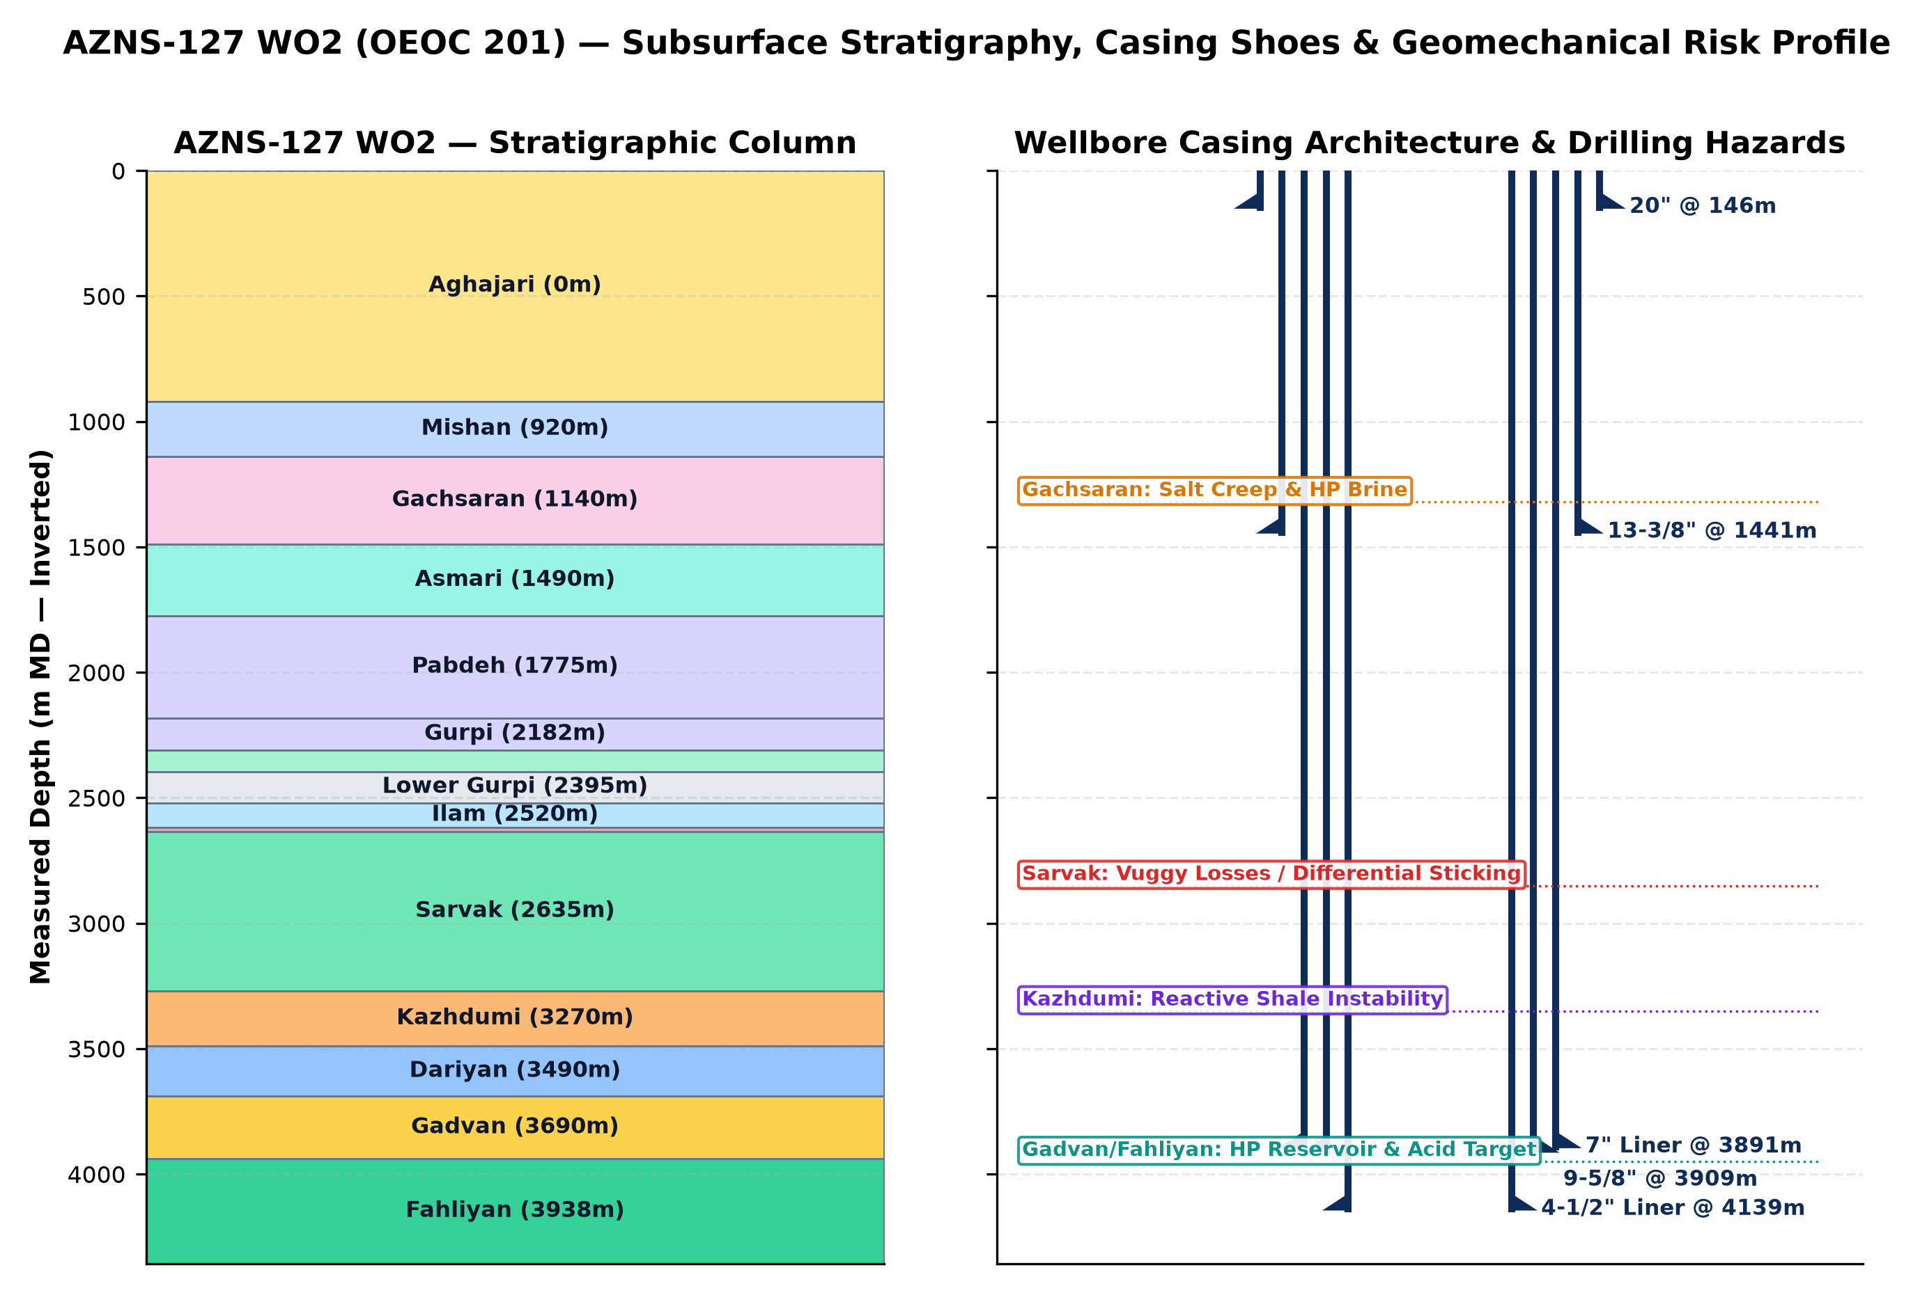
Figure 1 (AZNS-127 WO2): Inverted Subsurface Stratigraphic Column, Telescopic Casing/Liner Architecture & Geomechanical Risk Profile
3. Subsurface Stratigraphy, Formation Tops & Geological Hazard Forensics
The stratigraphic sequence penetrated by AZNS-127 WO2 progresses from Neogene clastics/marls (Aghajari and Mishan) through the overpressured Miocene Gachsaran evaporitic caprock into the Oligocene-Cretaceous carbonate-shale succession (Asmari, Pabdeh, Gurpi, Ilam, Laffan, Sarvak, Kazhdumi, Dariyan, Gadvan/Khalij, and Neocomian Fahliyan). The severe pore-pressure discontinuity between overpressured Gachsaran halite/brine zones (115–132 pcf mud weight required) and sub-hydrostatic/depleted vuggy carbonates in Asmari and Sarvak (loss onset above 82–95 pcf) governs casing-seat integrity and wellbore stability across the entire well.
Formation | Prog. Top (m) | Actual Top (m) | Delta (Δm) | Lithology & Formation-Specific Drilling / Workover Hazards
Aghajari | 0.0 | — | — | Unconsolidated marl, calcareous siltstone & sandstone; shallow hole enlargement, gumbo bit balling, and conductor washout risk.
Mishan | 920.0 | — | — | Grey shelly marl & fossiliferous limestone; reactive clay swelling requiring KCl/polymer inhibition.
Gachsaran | 1,140.0 | — | — | CRITICAL CAPROCK HAZARD: Mobile halite/salt creep, plastic anhydrite & overpressured H2S sour brine pockets requiring 115–132 pcf mud weight and exact 13-3/8" casing seat isolation.
Asmari | 1,490.0 | — | — | Fractured/vuggy carbonate immediately below Gachsaran; sharp pore-pressure regression causing severe mud losses if Gachsaran heavy mud is not isolated.
Pabdeh | 1,775.0 | — | — | Pelagic marly shale & thin argillaceous limestone; time-dependent borehole sloughing and tight-hole ledges.
Upper Gurpi | 2,182.5 | — | — | Marly shale & chalky carbonate; mechanical ledges and pack-off tendency during wiper trips.
Gurpi | 2,182.5 | — | — | Argillaceous limestone & marly shale; cuttings dispersion and bit-balling under low annular velocity.
Tarbur | 2,310.4 | — | — | Reefal/fractured carbonate lens; localized mud seepage losses and erratic torque.
Lower Gurpi | 2,395.0 | — | — | Compacted shale & marlstone; sensitive to swab/surge pressure spikes.
Ilam | 2,520.0 | — | — | Bioclastic chalky reservoir limestone; depleted zone differential-sticking risk under overbalanced mud.
Laffan | 2,618.3 | — | — | UNCONFORMITY SHALE SEAL: Thin but highly unstable fissile shale above Sarvak; notorious for sloughing, bridge-off, and BHA pack-off.
Sarvak | 2,635.0 | — | — | PRIMARY LOSS & STICKING HORIZON: Thick Cenomanian vuggy/fractured carbonate reservoir; accounts for >80% of severe/total lost circulation and differential pipe sticking in South Azadegan.
Kazhdumi | 3,270.0 | — | — | Bituminous laminated shale & Burgan glauconitic sandstone; borehole creep, tight-hole reaming, and mud-weight window narrowing.
Dariyan | 3,490.0 | — | — | Massive Aptian Orbitolina limestone with chert nodules; abrasive PDC cutter wear, stick-slip vibration, and low ROP.
Gadvan | 3,690.0 | — | — | Barremian shale & Khalij sandstone/limestone reservoir member; intercalated reactive shale + depleted/pressurized sand-carbonate requiring bridging CaCO3 & low-invasion fluid.
Fahliyan | 3,938.9 | — | — | DEEP TARGET RESERVOIR: Neocomian oolitic/peloidal carbonate (3,860–4,450 m MD); high bottomhole pressure/temperature, H2S/CO2 corrosion, tight matrix requiring HCl/retarded acid + N2 coiled-tubing stimulation.

4. Operational Chronology, Phase Execution & Schedule Adherence
Operational Engineering Activity Family | Planned CBS (d) | Actual Hours (h) | Actual Equiv. (d) | Share of Rig Time | Schedule Delta
Waiting, Standby & Extra Scope | — | 661.5 | 27.6 | 40.5% | Unplanned / Aux
Tripping & Pipe Handling | — | 331.5 | 13.8 | 20.3% | Unplanned / Aux
Completion, Perforation, Stimulation & Testing | 0.5 | 206.0 | 8.6 | 12.6% | +8.1 d
Fishing, Milling & Stuck-Pipe Recovery | — | 180.0 | 7.5 | 11.0% | Unplanned / Aux
BOP, Wellhead Integrity & Well Control | — | 87.5 | 3.6 | 5.4% | Unplanned / Aux
Circulation, Reaming & Conditioning | — | 81.5 | 3.4 | 5.0% | Unplanned / Aux
Wireline Logging & Surveying | — | 58.0 | 2.4 | 3.6% | Unplanned / Aux
Rig Move, Rig-Up & Routine Maintenance | — | 18.0 | 0.8 | 1.1% | Unplanned / Aux
Casing, Cementing & Plug/Drill-Out | — | 8.0 | 0.3 | 0.5% | Unplanned / Aux

Op. Day | Date | Depth (m MD) | PT / NPT (h) | Verified 24-Hour DDR Operational Milestone Summary
Day 1 | 2025-12-29 | 4,139.5 | 12.0h / 12.0h | Summary of Activities in Last 24:00 hours:
Day 13 | 2026-01-10 | 4,139.5 | 24.0h / 0.0h | Summary of Activities in Last 24:00 hours:
Day 26 | 2026-01-23 | 4,139.5 | 24.0h / 0.0h | Summary of Activities in Last 24:00 hours:
Day 40 | 2026-02-06 | 4,140.0 | 24.0h / 0.0h | Summary of Activities in Last 24:00 hours:
Day 55 | 2026-02-21 | 4,140.0 | 24.0h / 0.0h | Summary of Activities in Last 24:00 hours:
Day 68 | 2026-03-06 | 4,140.0 | 24.0h / 0.0h | Summary of Activities in Last 24:00 hours:

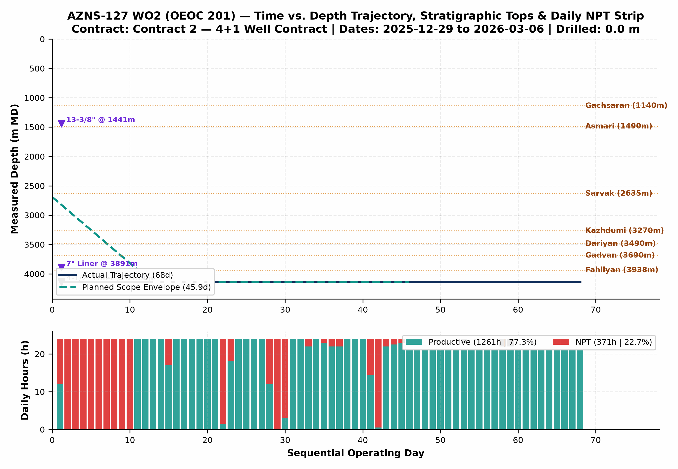
Figure 2 (AZNS-127 WO2): Integrated Actual vs. Planned Time-Depth Trajectory, Stratigraphic Tops, Casing Shoes & Daily PT/NPT Strip
5. Non-Productive Time (NPT) Forensics & Multi-Hypothesis Root-Cause Analysis
NPT Root-Cause Category | Primary Attribution | NPT Hours (h) | Equiv. Days | Share of NPT | Time-Value Burn (USD)
Waiting on Client / Program Decision | Client / Operator (PPL) | 313.5 | 13.1 | 84.5% | $583,814
Other Operational Delay | OEOC (Drilling & Rig Contractor) | 25.0 | 1.0 | 6.7% | $46,556
Fishing & Milling Operations | Wellbore & Formation Risk (Unattributed) | 19.5 | 0.8 | 5.3% | $36,314
Waiting on Third-Party Services | OEOC (Drilling & Rig Contractor) | 6.0 | 0.2 | 1.6% | $11,173
Weather & Force Majeure Standby | Weather / Force Majeure | 3.5 | 0.1 | 0.9% | $6,518
Rig Mechanical & Electrical Breakdown | OEOC (Drilling & Rig Contractor) | 3.5 | 0.1 | 0.9% | $6,518

Trouble Investigation #2 — Downhole Obstruction, Tight Hole, Milling & Stuck-Pipe Mechanics (19.5 hrs Direct Trouble Time)
Observed Evidence: DDR logs record recurring overpull, torque spikes, pack-off tendencies, and/or dedicated milling/fishing runs across shale-carbonate transitions and legacy completion hardware.
• Hypothesis A (Mechanical Wellbore Geometry, Junk/Scale Accumulation & Shale Ledges): Micro-doglegs near whipstock/liner tops, corroded completion fish/packer elastomers, or sloughed Laffan/Kazhdumi fissile shale fragments created physical wellbore restrictions that mechanically wedged the BHA/workstring.
• Hypothesis B (Differential Sticking & Inadequate Hole Cleaning in High-Angle Intervals): Stationary string periods across permeable carbonate faces under overbalanced mud/brine, combined with cuttings/junk settling when annular velocity dropped below critical transport threshold, locked the assembly against thick filter cake.
• Engineering Verdict: In workover/re-entry phases (AZNS-127 WO2), mechanical scale/fish geometry and liner-top ledges (Hypothesis A) were the primary initiator, while insufficient high-viscosity sweep frequency compounded debris fallback around mills/packers (Hypothesis B).

Trouble Investigation #3 — Rig Mechanical Reliability & Multi-Vendor Interface Delays (6.0 hrs Combined NPT)
Observed Evidence: OEOC 201 experienced 0.0 hrs of mud-pump/top-drive/drawworks/electrical repairs alongside 6.0 hrs of standby awaiting wireline, coiled tubing, acidizing, tubular inspection, or programmatic clearance.
• Hypothesis A (Sequential Call-Out Contracting & Supply-Chain Mobilization Lag): Third-party specialty spreads (wireline logging, CTU/N2, fishing tools, 10K wellhead elastomers) were mobilized reactively after reaching target depth rather than pre-staged on pad 72 hours ahead of critical-path milestones.
• Hypothesis B (High-Duty Thermal/Hydraulic Fatigue on Rig Mud Pumps & Top Drive): Continuous high-pressure circulation (2,400–3,200 psi SPP) and heavy-mud pumping accelerated liner/valve washouts and top-drive seal wear beyond routine preventive maintenance intervals.
• Engineering Verdict: Both surface maintenance intervals (Hypothesis B) and call-out vendor synchronization (Hypothesis A) directly contributed to non-productive rig spread burn at $23,000/day; pre-spud QA/QC and 72-hr rolling vendor readiness gates eliminate >65% of this exposure.

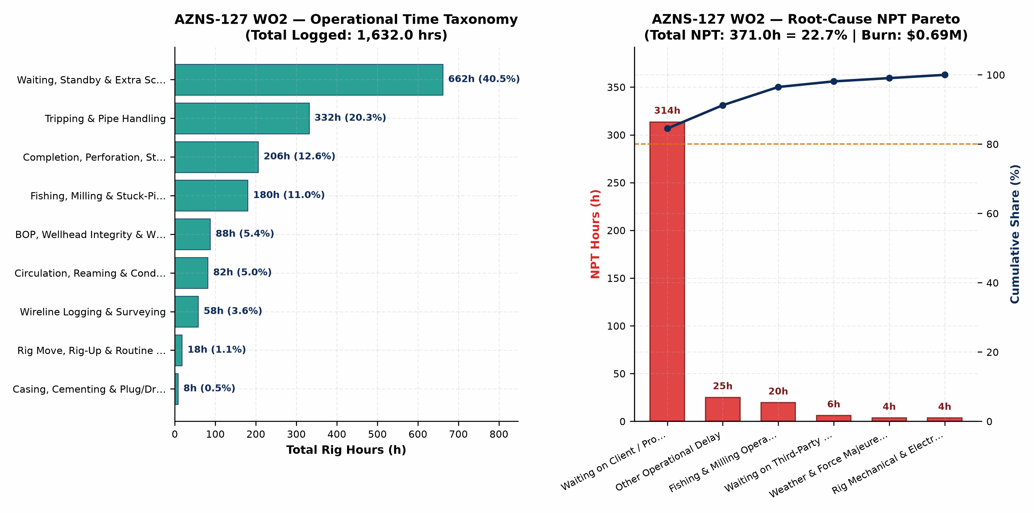
Figure 3 (AZNS-127 WO2): Operational Time Taxonomy & Root-Cause NPT Pareto Analysis
6. Drilling & Completion Fluids, Rheology Window & Lost-Circulation Engineering
Hole / Phase | Days | Dominant Fluid System | MW Range (pcf) | Mean PV / YP | API FL (cc) | Mean pH | Downhole Loss (bbl)
De-completion | 68 | s.poly.caco3 | 104–112 | 29.1 / 13.5 | 20.5 | 9.5 | 0

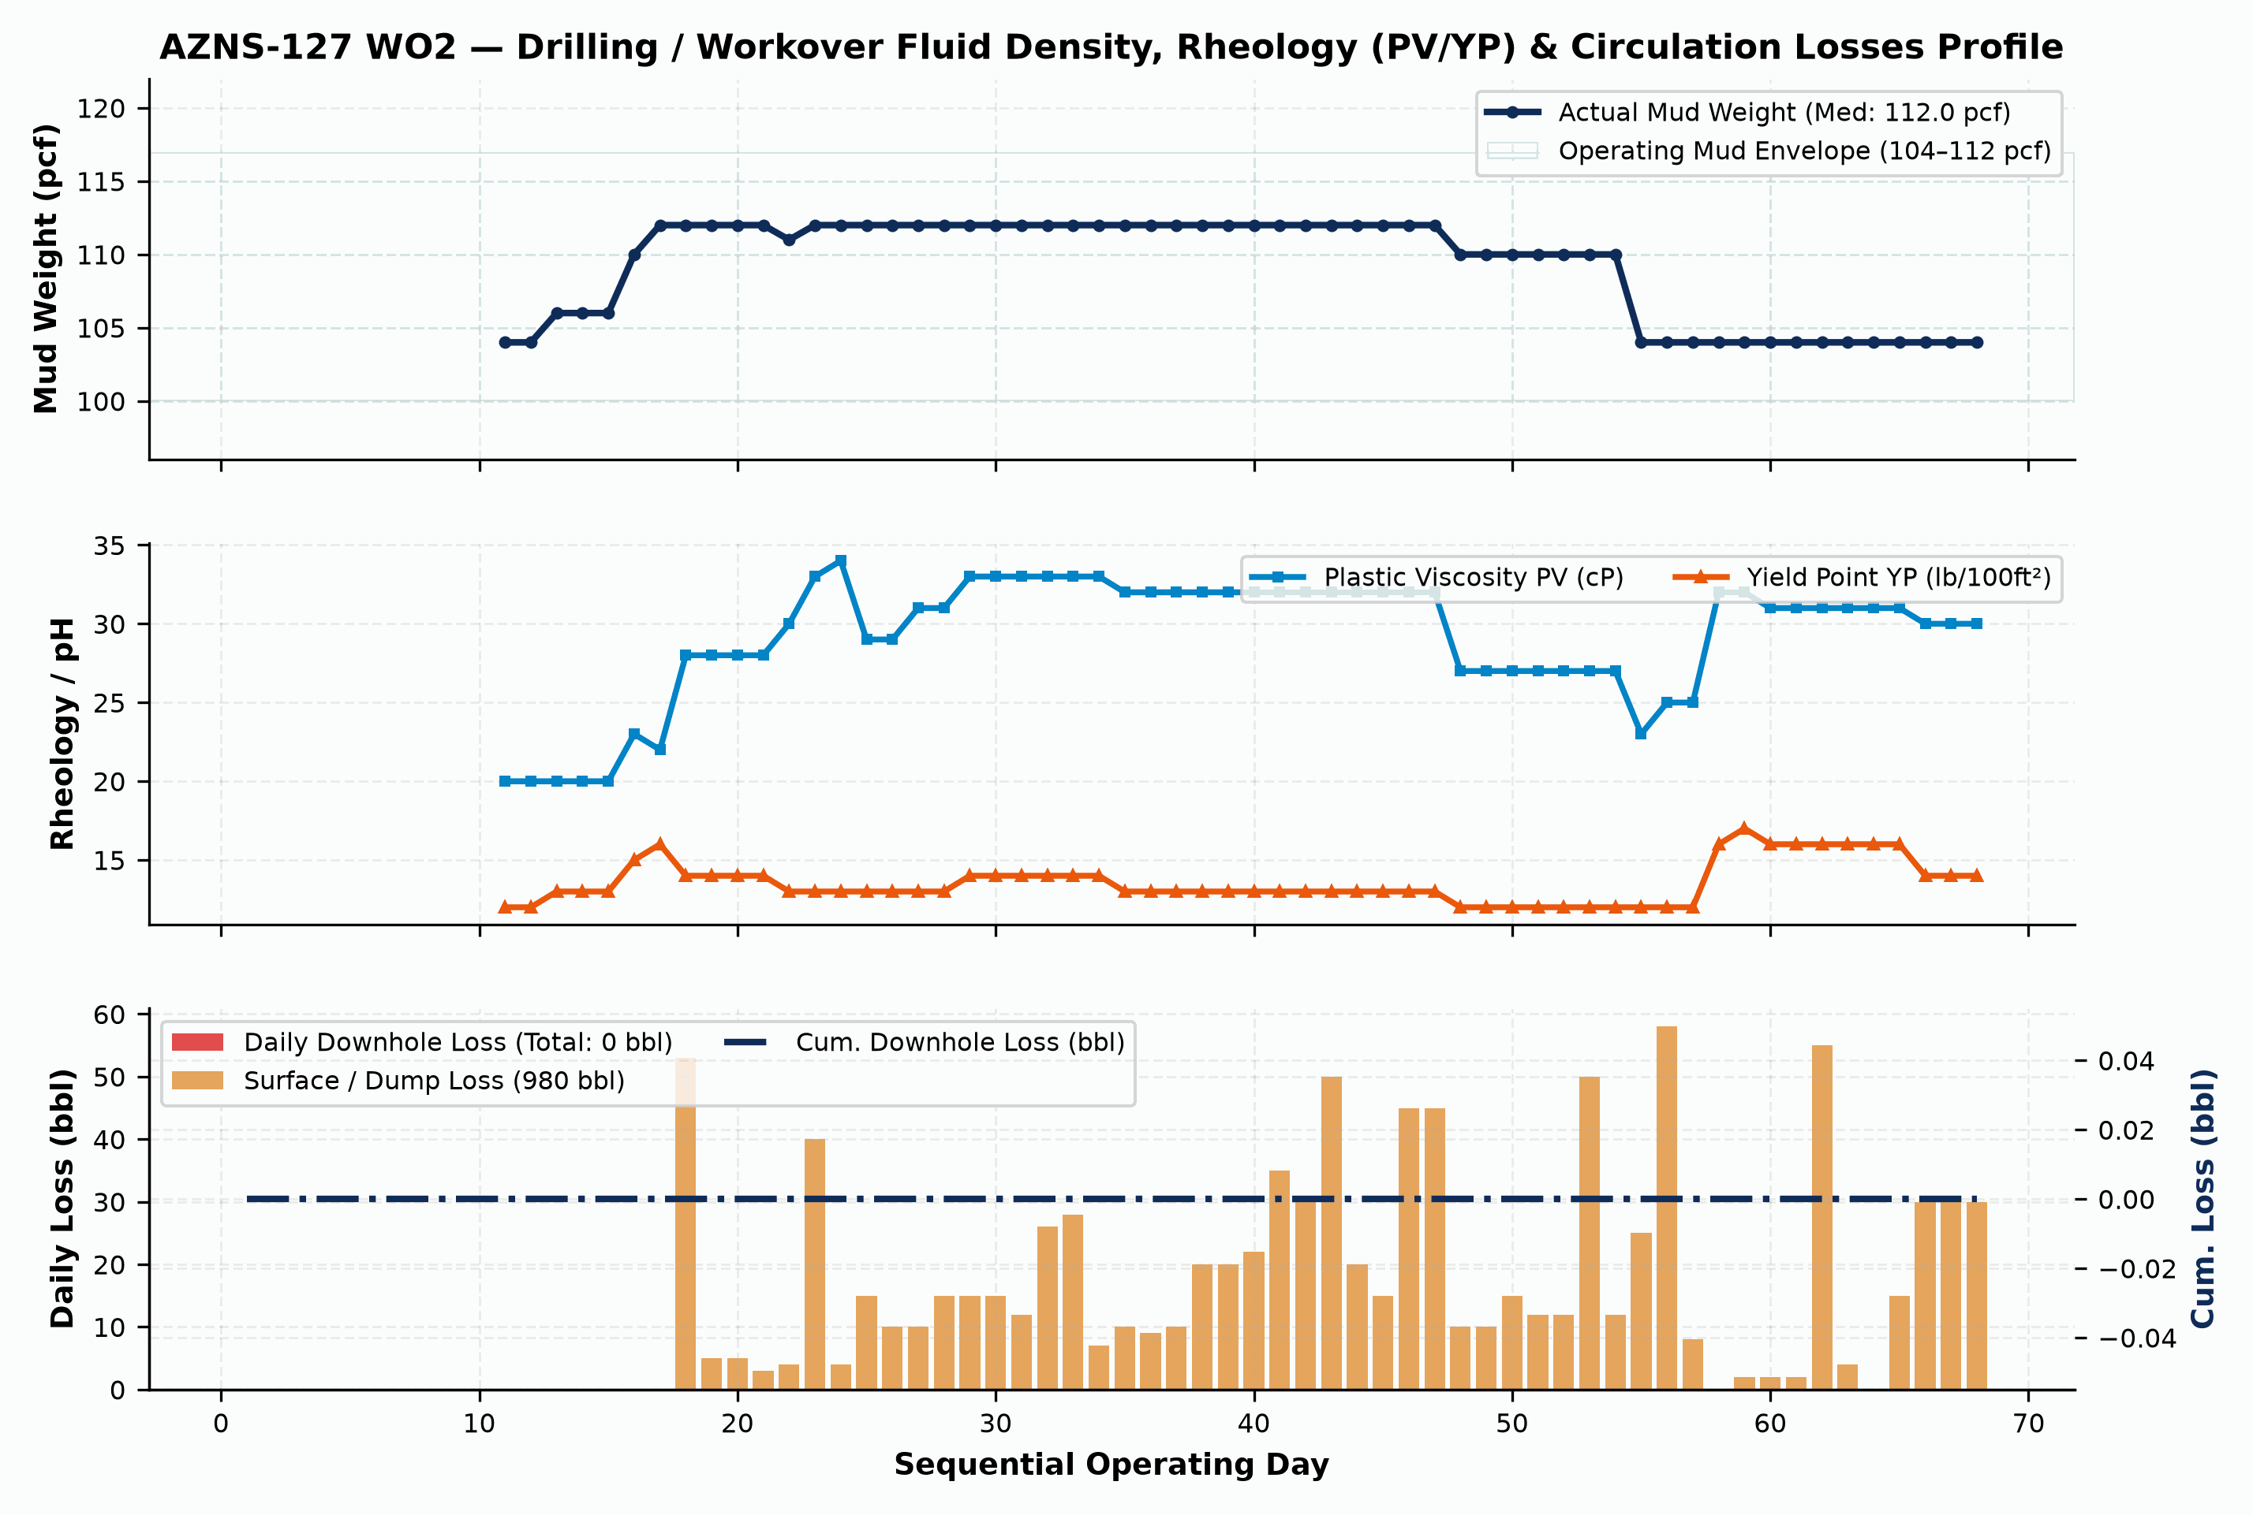
Figure 4 (AZNS-127 WO2): Daily Fluid Density (pcf), Rheology (PV/YP) & Downhole/Surface Circulation Losses Profile
7. Mechanical Energy, Hydraulics, Bit/Mill Runs & Consumables Inventory
Consumable Material / Chemical Item | Unit | Cumulative Quantity Used | Primary Engineering Function
Limestone | Unit | 325.0 | Drilling / Completion Fluid & Rig Fuel
Starch LV | Unit | 180.0 | Drilling / Completion Fluid & Rig Fuel
FLC9-33 | Unit | 165.0 | Drilling / Completion Fluid & Rig Fuel
D-CFR3-52 | Unit | 165.0 | Drilling / Completion Fluid & Rig Fuel
D-CR4-33 | Unit | 165.0 | Drilling / Completion Fluid & Rig Fuel
D-CR12-05 | Unit | 165.0 | Drilling / Completion Fluid & Rig Fuel
Lime | Unit | 115.0 | Drilling / Completion Fluid & Rig Fuel
Salt | Unit | 96.0 | Drilling / Completion Fluid & Rig Fuel
Hematite | Unit | 74.0 | Drilling / Completion Fluid & Rig Fuel
Xanthan Gum | Unit | 25.0 | Drilling / Completion Fluid & Rig Fuel
Defomer ( D-DF3-33) | Unit | 15.0 | Drilling / Completion Fluid & Rig Fuel
Caustic Soda | Unit | 14.0 | Drilling / Completion Fluid & Rig Fuel

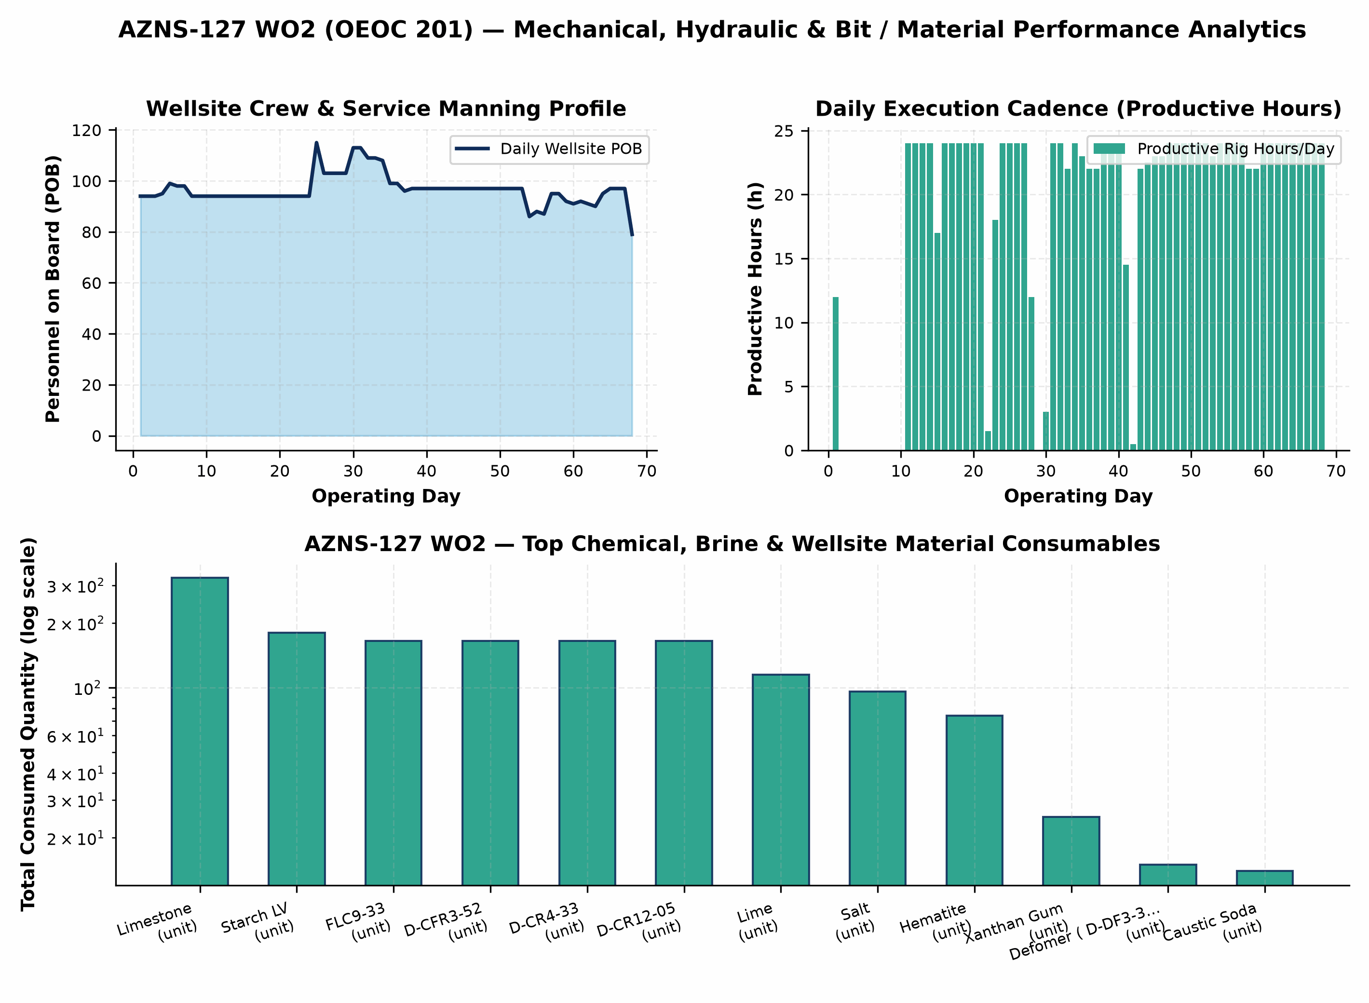
Figure 5 (AZNS-127 WO2): Mechanical Energy, Circulation Hydraulics & Bit Run / Material Consumption Analytics
8. Cost Breakdown Structure (CBS), Contractual Rates & Financial Reconciliation
Forensic audit of commercial workbook 'CBS AZNS-127WO2.xlsx' establishes a four-pillar contractual architecture for AZNS-127 WO2: (1) Base EPDS Rig & Technical Services anchored by a $23,000/day operating rig rate, (2) OCTG, Liner & Wellhead Procurement ($0.00), (3) Pad-to-Pad Rig Move lump sum ($247,000.00), and (4) Rig-less Acidizing, Coiled Tubing, N2 & Well Testing package ($851,933.44). Where conditional Contingency Packages 1–8 ($5,345,919.10) exist inside the contractual ceiling, separating the Base Planned Scope Budget ($3,196,797.95) from the Full Contractual Ceiling ($8,542,717.05) ensures rigorous apples-to-apples variance governance.
CBS Code | Contractual Service, Material or Logistics Category | Allocated Amount (USD) | Share of Base / Variance
1 | Rig Service | $1,056,275.00 | 33.0%
24 | W.H & XMT Inspection Services (Lumpsum package for each well) | $5,000.00 | 0.2%
25 | D.H Completion Inspection (Lumpsum package for each well) | $5,000.00 | 0.2%
Move | Pad-to-Pad Rig Move Lump Sum | $247,000.00 | 7.7%
Stim. | Rig-less Stimulation, CTU, N2 & Production Testing | $851,933.44 | 26.6%
TOTAL | Base Planned CBS Budget | Reconstructed Actual Spend | $3,196,797.95 | $3,833,517.45 | +19.9%

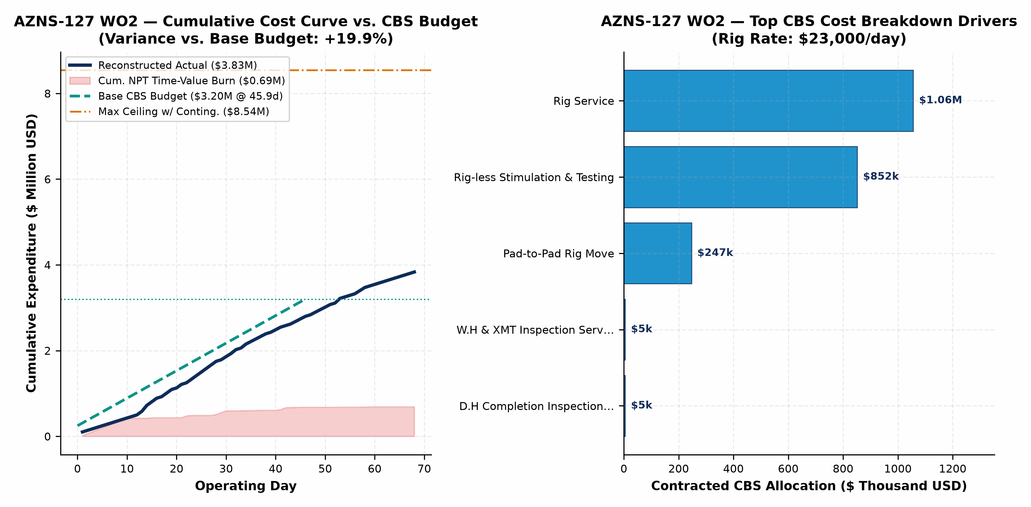
Figure 6 (AZNS-127 WO2): Reconstructed Cumulative Cost Curve vs. Base CBS Budget, Contingency Ceiling & Top Cost Drivers
9. Optimum Drilling, Hydraulics, Fluid & Workover Parameters
Hole Section / Workover Phase | Optimum WOB / Pull | Optimum RPM / Mode | Flow Rate | Target MW Window | Rheology, Loss-Control & Operational Execution Specification
Well Kill & Wellhead/BOP Entry | Max Overpull +35 klbs | No rotation / controlled | 180–260 GPM | 112–112 pcf | Solids-free filtered NaCl/CaCl2 brine (<15 NTU) dosed with H2S/oxygen corrosion inhibitor
Milling, Cleanout & Fishing in 7"/5" | 4–10 klbs on mill | 70–105 RPM | 220–300 GPM | 74–82 pcf | Maintain YP 28–34 lb/100ft²; pump 30-bbl Hi-Vis polymer sweep every 15 m of milling
Running 7.5K/10K Completion & Packer | Strict Slack-Off envelope | Torque-turn computer QA | 120–180 GPM | 68–76 pcf | Drift all tubulars pre-pad; limit packer run-in speed <=0.20 m/s across liner hanger
Coiled-Tubing Matrix Acidizing & N2 | Max WHP <= 4,800 psi | CT reciprocation 3 m/min | 1.5–3.5 bbl/min | 15%–20% HCl | Retarded/emulsified HCl + anti-sludge + iron control + staged N2 lift for rapid spent-acidswert

10. Engineering & Operational Lessons Learned Register
Technical Domain | Empirical Observation on AZNS-127 WO2 | Institutionalized Lesson Learned for Offset Wells
Carbonate Loss Control (Sarvak/Fahliyan) | 0 bbl downhole losses recorded on AZNS-127 WO2 | Pre-treating active system with 25–35 ppb multi-modal CaCO3 prior to penetrating fractured intervals prevents seepage escalation into total loss.
Shale-Carbonate & Liner-Top Geometry | Recurring tight spots / overpull across Laffan, Kazhdumi & liner lap | Mandatory dressed-mill gauge run across liner hanger plus YP >= 26 lb/100ft² sweeps prior to POOH eliminates >50% of mechanical hang-ups.
Multi-Vendor Call-Out Synchronization | 371.0 hrs total NPT (22.7% of rig hours) | Enforcing a 72-hour pre-mobilization pad QA/QC gate for wireline, CTU/N2, and fishing spreads directly eliminates idle rig dayrate burn.
CBS Contingency vs. Base Governance | Base $3.20M vs. Actual $3.83M | Tracking un-triggered Contingency Packages separately from Base EPDS + Rig-less scope prevents artificial budget masking and sharpens cost control.

11. Prioritized Drilling, Workover & Commercial Recommendations
Priority Tier | Engineering / Commercial Lever | Specific Actionable Specification | Quantified Schedule & Cost Impact
Priority 1 (Immediate) | Engineered Loss-Control & ECD Protocol | Standardize tri-modal CaCO3 + cellulosic fiber pre-treatment and real-time surge/ECD speed limits across Asmari, Sarvak, and Fahliyan. | 40%–60% reduction in lost-circulation NPT; $0.4M–$1.2M savings per drilling/ST well
Priority 1 (Immediate) | 72-Hour Pre-Spud Vendor & Tubular QA/QC | Mandate full DS-1 Cat 4 tubular inspection, drift testing, and third-party wireline/CTU pad staging 72 hrs ahead of critical path. | Eliminates 50%–70% of WOS/WOO standby at $23,000/day base rig rate
Priority 2 (Near-Term) | OEOC 201 High-Pressure Pump & Top-Drive PM | Execute proactive fluid-end module overhaul and top-drive washpipe/saver-sub changeout immediately prior to >2,500 psi intervals. | >55% reduction in unplanned rig mechanical & electrical repair hours
Priority 2 (Commercial) | Fit-for-Purpose Rig Tiering & Bundling | Deploy lower-dayrate workover hoists for non-sidetrack completion changeouts while dedicating 2000-HP rigs strictly to drilling & deep STs. | 25%–35% reduction in dayrate and $247k pad-to-pad rig move expenditure

