**Data Analysis Report**

Table of Contents

**Project Overview** 2

**Dataset Information** 2

**Data Loading** 2

**Data Information** 2

**Data Cleaning** 3

**Data Analysis and Visualizations** 4

**Conclusion** 7

# **Project Overview**

This project aims to analyze YouTube statistics using a dataset obtained from Kaggle. The analysis includes cleaning the data, exploring relationships between various features, and generating visualizations to provide insights.

## **Dataset Information**

* **Source**: Kaggle
* **File**: Global YouTube Statistics.csv

## **Data Loading**

The dataset was loaded using the pandas library. The first few rows of the dataset were inspected to understand its structure and content.

import pandas as pd

import Loading_file as ld

data = ld.load_file()

print(data.head())

## **Data Information**

**Data Types**

The data types of each column were reviewed to ensure proper handling of data.

print(infoFile.data_types(data))

**Data Description**

Descriptive statistics of the dataset were obtained to understand the distribution and summary of each column.

print(infoFile.describe_data(data))

## **Data Cleaning**

**Removing Duplicate Values**

Duplicate values in the rank column were removed to ensure data integrity.

cleaned_data = cf.clean_duplicates_col(data, "rank")

**Dropping Zero Values**

Rows where the video views column had zero values were removed as they are considered useless.

Cleaned_data = cf.clean_col_null(data, 'video views')

**Removing Null Values**

Rows with null or empty values in the category column were removed.

cleaned_data = data[~data['category'].isna() & (data['category'].str.strip() != '')]

**Dropping Unnecessary Columns**

Columns that are not needed for the analysis were dropped to simplify the dataset.

cleaned_data = cf.drop_column(data, ["Longitude", "Latitude", "Urban_population", "Population",

"Gross tertiary education enrollment (%)", "created_date", "created_month",

"lowest_monthly_earnings", "highest_monthly_earnings",

"video_views_for_the_last_30_days", "channel_type_rank",

"Unemployment rate", "subscribers_for_last_30_days"])

## **Data Analysis and Visualizations**

Several visualizations were created to explore the relationships in the data.

**Bar Plot**

A bar plot was created to show the total uploads by country, separated by channel type.

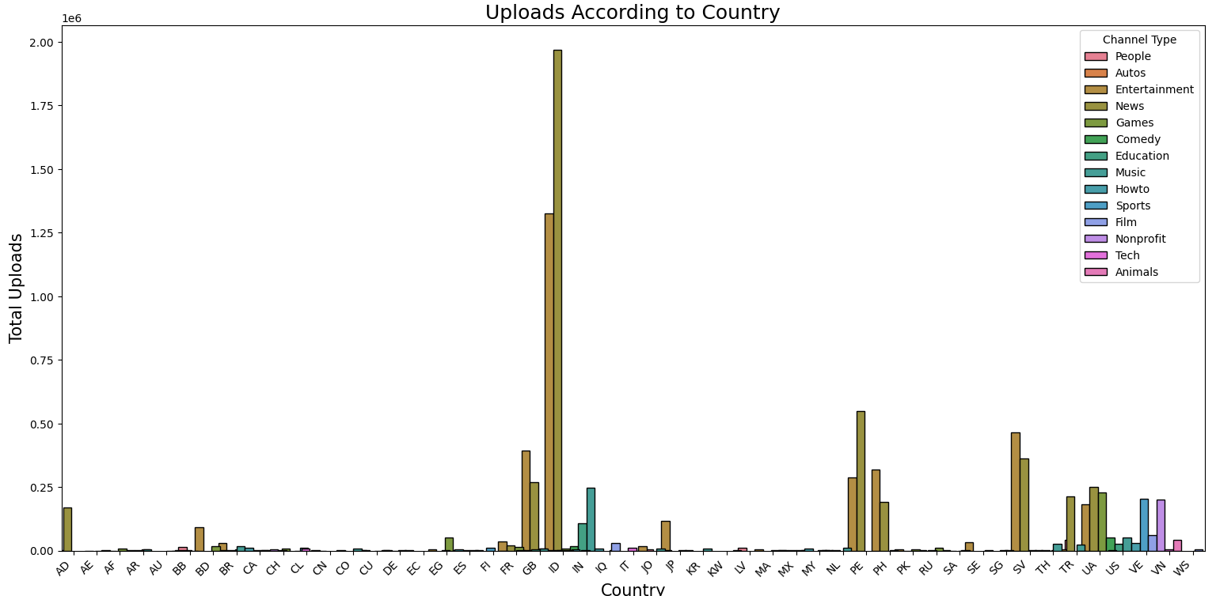

**Scatter Plot**

A scatter plot was created to explore the relationship between different numeric features.

**Count Plot**

A count plot was created to show the distribution of a categorical feature.

**Category Views Bar Plot**

A bar plot was created to show the total views for each category.

**Scatter Plot with Regression**

A scatter plot with a regression line was created to show the relationship between the created year and rank.

**Saving the Cleaned Data**

The cleaned dataset was saved to a new Excel file for future use.

cleaned_data.to_excel("Data_sets/cleaned_data.xlsx", index=False, engine="openpyxl")

## **Conclusion**

This project involved cleaning and analyzing a YouTube statistics dataset to uncover insights and patterns. The visualizations provided a clear understanding of how different features are related. The cleaned dataset is now ready for further analysis or machine learning tasks.