Design document

High Level Requirement Analysis

- This will be a simple webapp allowing users to take exams, and determine the grade right after the submission.
- Sample user details, test details, questions, choices will already be populated with the SQL Scripts provided herewith. Dynamic creation of (or updates to) these details within the app is out of scope.
- The user's exam attempt details will be recorded in the database when the exams are submitted.

Project Outline

1. Enter credentials in the Login Page to land on the Home Page.
2. Home Page shows the test description of the latest assigned to the user. Button is available to start the test.
3. This page shows all questions in the same page.
4. When user finishes the test, a check is made to see if all questions are answered. If not, a confirmation is displayed whether to really proceed with submission.
5. After all questions are submitted, result will be displayed on the next page.

Data Model

- Following tables are created to establish the relationship with the user and the exam details (in no particular order).
  - Users
  - Tests
  - Questions
  - Choices
  - Question_Choices
  - Test_Questions
  - Test_Attempts (Unused. Please ignore)
  - User_Tests
  - Grades
- DB normalization is followed wherever possible to reduce data redundancy and to support clear separation of concerns.

Tables Overview

S.No | Table Name | Columns | Constraints | Description
1 | users | user_id, name, password | user_id is the PK | Stores the user's credentials who can use this webapp.
2 | tests | test_id, name, description | test_id is the PK | Stores the different tests/exams that can be assigned to the users.
3 | questions | question_id, question, answer | question_id is the PK | Stores the various questions that can be assigned to the tests.
4 | choices | choice_id, choice | choice_id is the PK | Stores the different choices that can be assigned to the questions.
5 | grades | grade, threshold, result | grade is the PK | Contains the grade for a threshold (which is usually the percentage or the score) and the final result (which is success/failure).
6 | question_choices | question_id, choice_id | Both are PK (composite). They are FKs to the corresponding tables above. | Mapping of the choices for a particular question.
7 | user_tests | user_id, test_id, creation_date | user_id and test_id are the PK (composite). They are also FKs to the corresponding tables above. | Contains the list of tests that are assigned to a user. The test with the latest creation_date is what will appear on their homepage upon logging in.
8 | test_questions | test_id, question_id | Both are PK (composite). They are also FKs to the corresponding tables above. | Mapping of what questions are available as part of a test.
9 | test_attempts | attempt_id, test_id, user_id, grade, attempt_date | attempt_id is the PK. test_id and user_id are the FKs to the corresponding tables above. | This table is unused. This was initially designed for the purposes of showing the history of the tests attempted by the user. Not implemented in the code since it's out of scope.

Architecture (or High level Component Diagram)

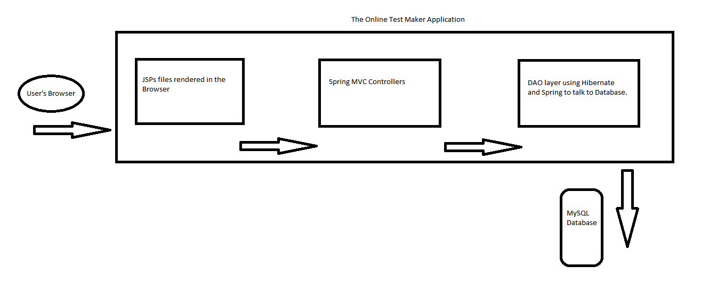

Component Breakdown

- The UI layer is built using the JSP templates. A little bit of plain CSS and JS are added to achieve functionality.
- Spring MVC is used to front-end the requests/responses from the UI side.
- Spring DI is used to manage all the Objects (or beans).
- Spring-ORM is used to manage the lifecycle of Hibernate objects (SessionFactory, etc.,)
- Hibernate is the ORM framework doing all the DB heavy lifiting.

UI Flow

- login.jsp → User enters their credentials and submits the page. Upon error, message is displayed on the same page.
- Upon successful authentication, user lands on the home.jsp. User sees the test details and clicks on the Start Test Now! button.
- User lands on the testquestions.jsp. Answers the questions and submits the test.
- User is taken to the testresult.jsp where the result of the test is displayed.

