**Arnab Sengupta**

**Mobile:** 8017494412

**Email:** [arnabsengupta.pcmt@gmail.com](mailto:arnabsengupta.pcmt@gmail.com)

**Address:** 256/C Prince Anwar Shah Road, Kolkata-700045

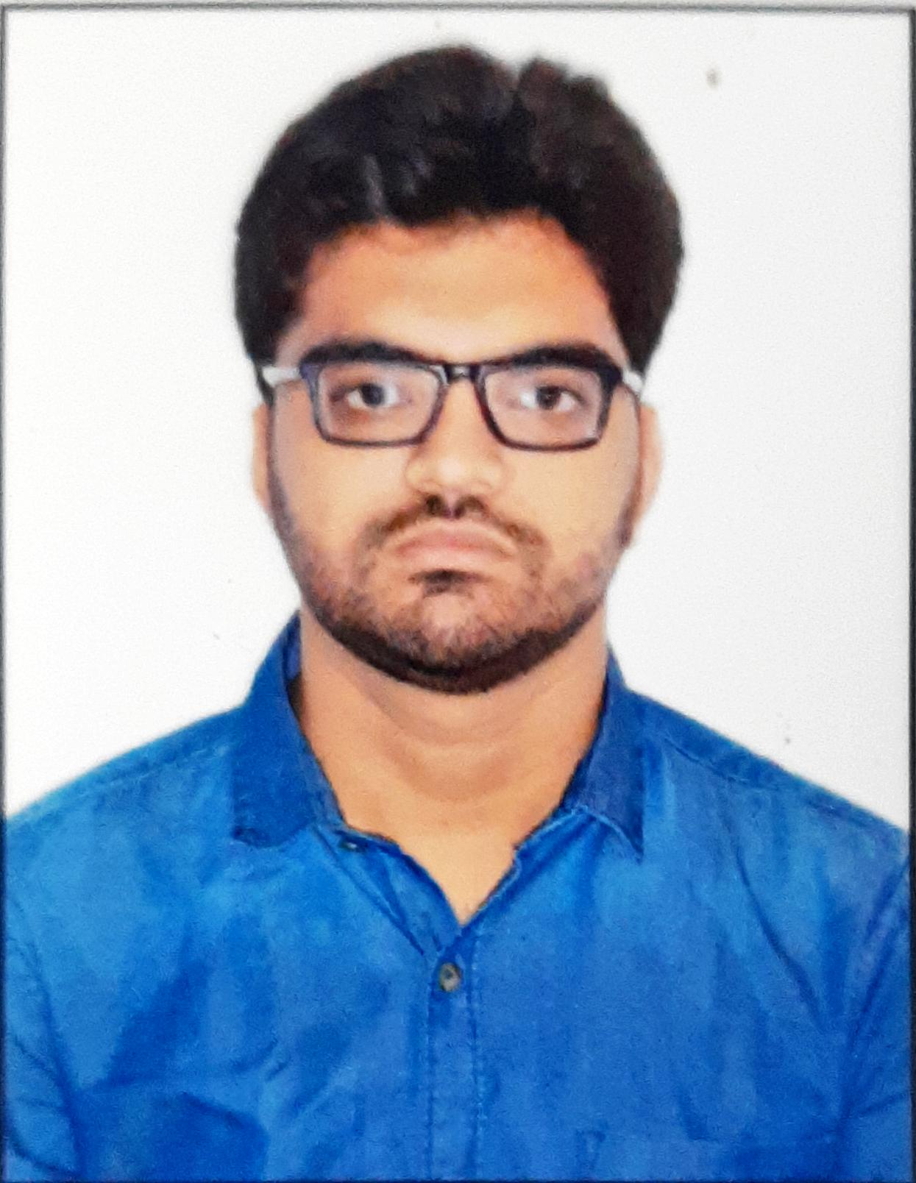

|  |  |
| --- | --- |
| **Title:** | Analyst/ Software Engineer |
| **Location:** | Kolkata, India |
| **Languages:** | Bengali (Native),  English (Fluent),  Hindi (Fluent) |

# Experience Summary

Specialization in UI development. Worked as a UI developer in healthcare domain and implemented innovating, seamless UI. Experienced in providing a compelling user experience and boosting customer retention. Special skills include React JS and Material UI.

**KEY SKILLS:**

* **Functional:** Team Player, Communication and Interpretation skills.
* **Technical:** React JS, Material UI, HTML, CSS, Javascript, Java Spring & Springboot.

# Experience

* Analyst at Capgemini (November 2021 – Present)

UI Developer

|  |  |  |
| --- | --- | --- |
| **01** | **Type of Industry:** | Healthcare/Life Sciences |
|  | **Project:** | Temperature Excursion Management |
|  | **Role/Title:** | UI Developer |
|  | **Project Duration:** | 8 months |
|  | **Responsibilities:** | * Developed UI Architectures * Developed Interface designs * Implemented UI Functionalities |
|  | **Operating Systems:** | Windows 10 |
|  | **Software / Languages:** | ReactJS, Material UI, HTML, CSS, Javascript. |
|  | **Special Tools:** | Sourcetree |
|  |  |  |

##### 

# Training, Certifications & Affiliations

* Java Full Stack with React JS.
* AWS Certified Cloud Practitioner.

# Published & Presented / Awards

* Awarded for securing Rank 1 in the Capgemini Fresher Training program conducted by L&D.

# Higher Education

* RCC Institute of Information Technology, Kolkata- Masters of Computer Application.
* Pailan College of Management & Technology- Bachelors of Computer Application.