Brief Report

2025-04-05

## [[1]]

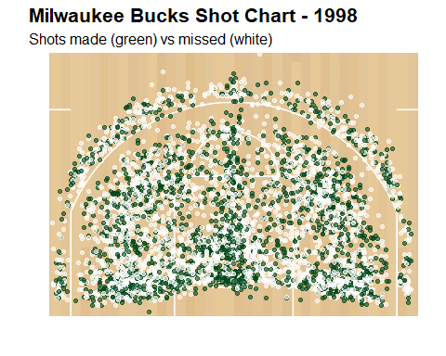

##   
## [[2]]

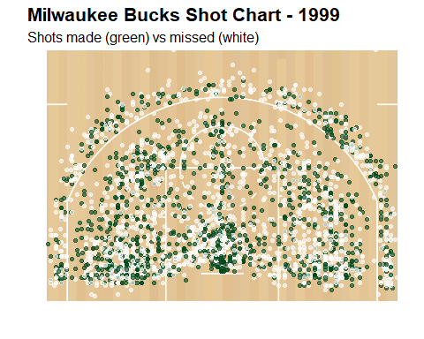

##   
## [[3]]

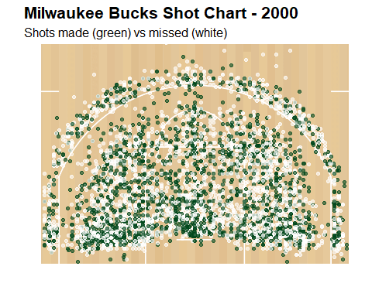

##   
## [[4]]

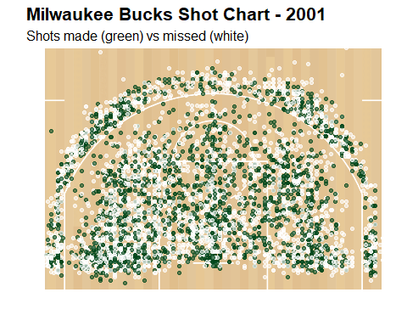

##   
## [[5]]

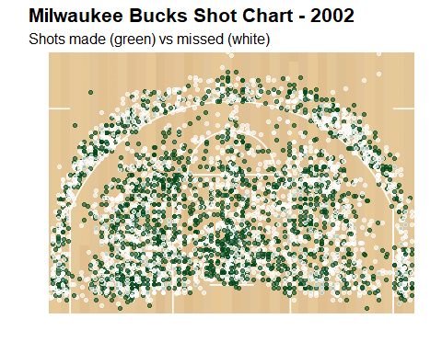

##   
## [[6]]

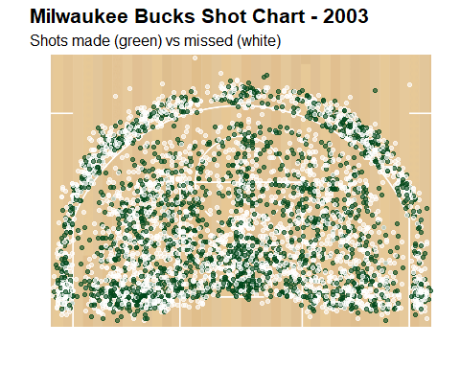

##   
## [[7]]

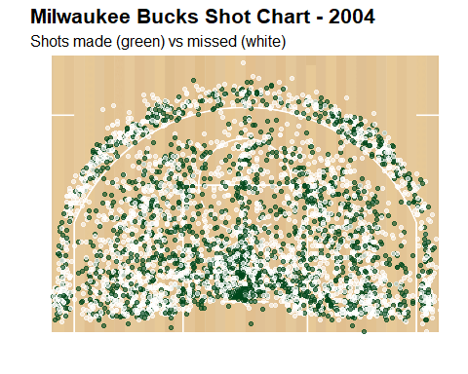

##   
## [[8]]

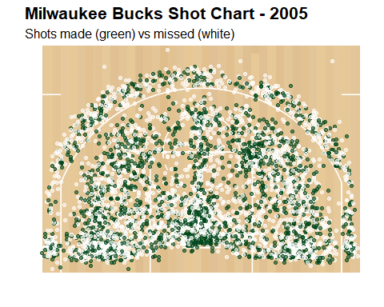

##   
## [[9]]

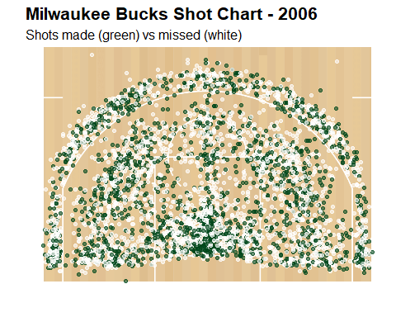

##   
## [[10]]

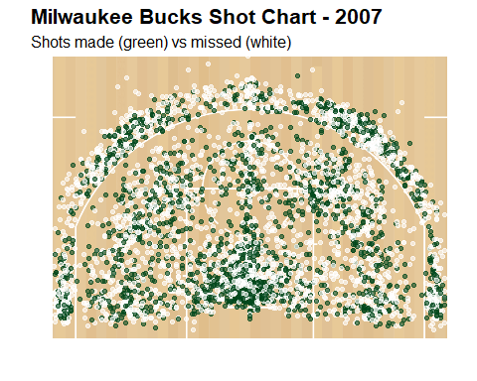

##   
## [[11]]

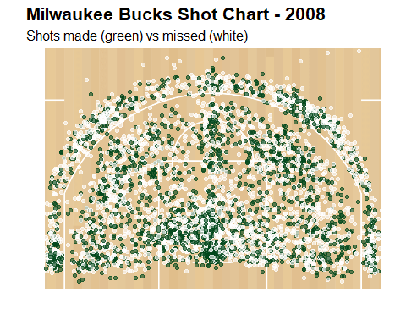

##   
## [[12]]

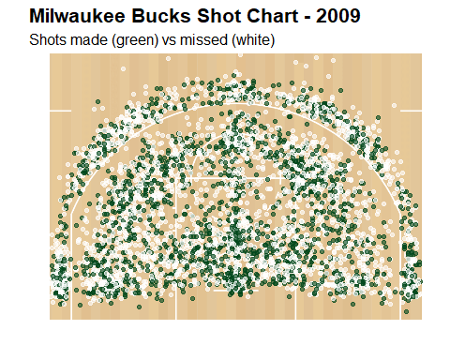

##   
## [[13]]

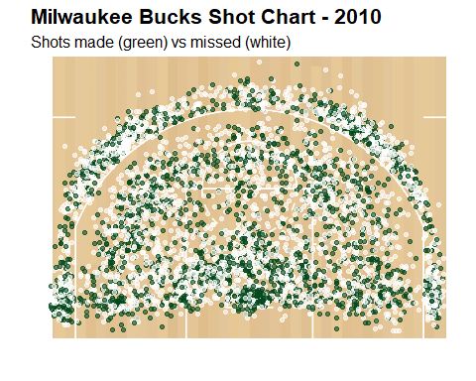

##   
## [[14]]

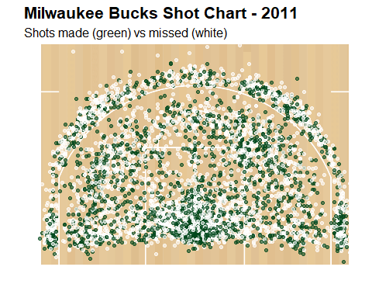

##   
## [[15]]

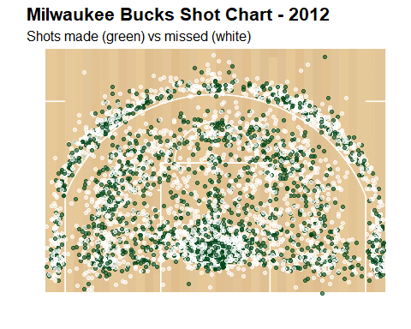

##   
## [[16]]

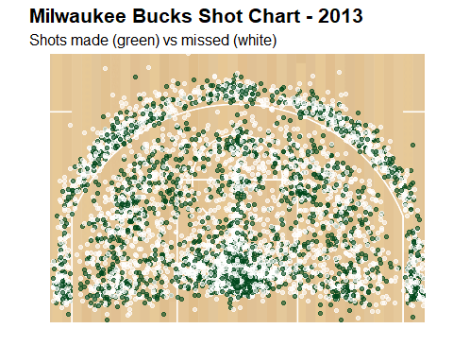

##   
## [[17]]

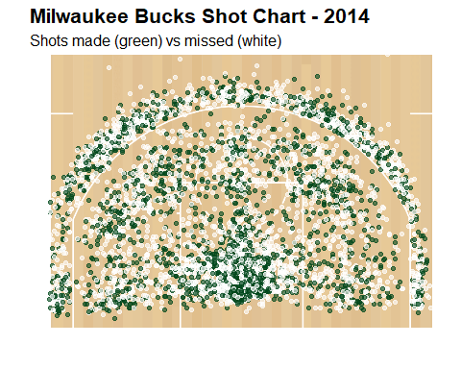

##   
## [[18]]

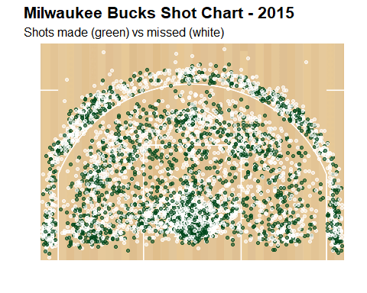

##   
## [[19]]

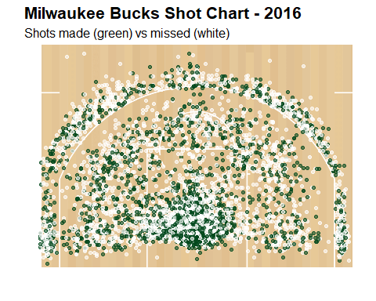

##   
## [[20]]

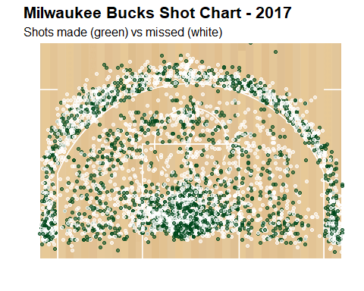

##   
## [[21]]

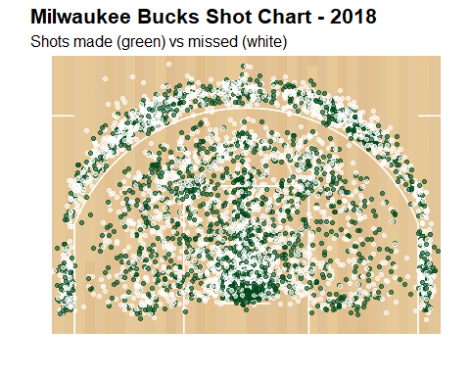

List of Findings:

* Shot density is highest in the paint.
* There is a clear upward trend in three-point shot attempts over time.
* The paint area shows a high frequency of missed shots.

Details:

* High Shot Density: The majority of shots are concentrated in the paint, reflecting an emphasis on high-percentage opportunities near the rim.
* Trend Over Time: From 1998 to 2003, there was a noticeable increase in three-point shots, particularly from behind the three-point line, which aligns with evolving offensive strategies.
* Missed Shots: A high ratio of missed to made shots within the restricted area suggests challenges in making a shot at the rim, highlighting a potential area for strategic improvement.