Logistic Regression and XGBoost on Support Ticket Dataset
Ashley Barone
Western Governors University
May 14, 2026

Table of Contents
Table of Contents 2
A. Research Question 3
Research Question 3
Context and Justification 3
Hypothesis 4
B. Data Collection 4
Data Description 4
Advantage of Methodology 5
Disadvantage of Methodology 5
Challenges and Resolutions 5
C. Data Extraction and Preparation 6
Extraction Process 6
Preparation Process 6
Tools and Techniques Justification 11
Advantage and Disadvantage 11
D. Analysis 12
Analysis Techniques 12
Calculations and Outputs 13
Justification of Techniques 19
Advantage and Disadvantage 20
E. Data Summary and Implications 20
Results in Context 20
Limitations 22
Recommended Course of Action 22
Directions for Future Study 22
F. References 22

A. Research Question

Research Question
The research question for this analysis is: Can a logistic regression model be constructed using an IT support ticket dataset? This study explores whether a logistic regression model can be built using an IT support ticket dataset. The hope is that the logistic regression model will accurately identify statistically significant predictors of Service Level Agreement (SLA) breach.

Context and Justification
Service Level Agreements (SLAs) are standards set by organizations for how business will be conducted and services will be delivered. In the context of support tickets, companies can define resolution timeframes appropriate for different account types, event priorities, or issue complexity. They may also require certain types of tickets to undergo more robust review, such as support tickets concerning major account contracts or services, support tickets that create legal liability, or support tickets surrounding new features or services. The purpose of this study is to create a tool for support teams to use to identify support tickets at risk of SLA breach. By identifying high-risk tickets, support teams are better equipped to effectively assist with complex and urgent issues without relying on manual flagging or agent risk estimation.
The contribution of this study to the field of Data Analytics and the MSDA program is to create a predictive logistic regression model that predicts whether a company’s SLA targets will be met or breached during support ticket resolution. This study constructs a logistic regression model to analyze predictor variables and their significance in predicting SLA outcomes. Logistic regression is a type of linear model that examines relationships between independent variables and a dependent variable with a categorical outcome (IBM, 2025). Swain and Garza (2023) used logistic regression to identify factors influencing SLA outcomes with IT incident event data. The study found that incident priority, knowledge base article usage, and the number of times a ticket event log was updated were statistically significant predictors of SLA targets being met (Swain & Garza, 2023).

Hypothesis
This analysis hypothesizes that a logistic regression model can be constructed using an IT support ticket dataset.
- H₀: A logistic regression model cannot be constructed using an IT support ticket dataset.
- H₁: A logistic regression model can be constructed using an IT support ticket dataset at a model accuracy >70%.
To determine whether the null hypothesis can be rejected, a binary logistic regression and an XGBoost model will be constructed and evaluated. If the logistic regression model achieves an accuracy >70%, the null hypothesis will be rejected.

B. Data Collection

Data Description
The dataset used in this study is publicly available on Kaggle at: https://www.kaggle.com/datasets/williamsewell/support-tickets-study-dataset. The dataset contains 10,000 rows of support ticket data. The independent variables selected for this analysis are shown in the chart below. The dependent variable in this study is sla_breached. Sla_breached uses a binary value to indicate whether the SLA was met (0) or breached (1). Of the 10,000 tickets, 3,656 (36.6%) did not meet the company’s SLA targets. The distribution of sla_breached is reasonable and balanced. The dataset has no missing values, with overall data sparsity <1%.
Independent Variable Name | Data Type
customer_segment | Categorical
product_area | Categorical
priority | Categorical
channel | Categorical
agent_tenure_months | Continuous
sentiment_score | Continuous

Advantage of Methodology
One advantage of the dataset is its lack of missing values. The dataset has no missing values. No imputation or row/column dropping is required. The low data sparsity makes the focus of this study data preparation, modeling, and interpretation of results.

Disadvantage of Methodology
One disadvantage of this dataset is the lack of documentation. No data dictionary or context document was included with the data set. This lack of context leads to questions about what exactly some variables represent and when certain variables are captured or generated.
Another disadvantage is that the dataset has little customer demographic data. The only customer demographic data included is customer_segment. Knowing more about the customer for whom a support ticket was submitted, such as age group, account age, income range, region, etc., could provide more complete insight.

Challenges and Resolutions
A challenge during data collection was the lack of provided documentation. This dataset did not have an attached data dictionary or any organizational context. That lack of information raised questions about variable definitions and when certain variables were captured or generated.
An example of this challenge is the interpretation of sentiment_score. The dataset does not make clear when the sentiment_score is calculated. It could have been calculated at the time of ticket creation or post-ticket resolution. The goal is to build a model that predicts the SLA outcome of a support ticket. So, training the model on data where sentiment_score is calculated post-resolution could lead to inaccuracy when sentiment_score is calculated at ticket creation. This study examines the significance of sentiment_score and conducts a robustness test to identify potential data leakage. Another example of a challenge is the interpretation of the dependent variable, sla_breached. There is no documentation about SLA targets, so assumptions must be made. This study will explore resolution_min for potential SLA target thresholds that may provide insight into predictor context.
Beyond minor interpretational challenges, the data collection process was straightforward and without issue.

C. Data Extraction and Preparation

Extraction Process
The dataset was extracted by first downloading the support_tickets_10000.csv file from Kaggle. Next, the file was loaded into the Jupyter Notebook using pandas' read_csv. The dataset structure and contents were verified by inspecting the shape, data types, and missing values. The dataset contains 10,000 rows and 14 columns with no missing values.
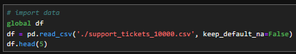
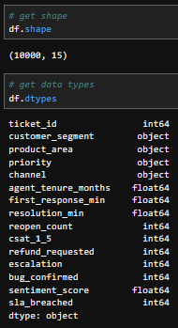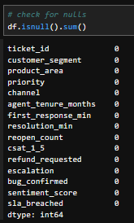

Preparation Process
The data was prepared for analysis in several ways:
- Feature selection: The dataset contains 13 total independent variables. Some of those variables are likely to be available only after ticket resolution or along the way. Post-resolution or mid-resolution variables could introduce data leakage if used as predictors in a model meant to be used shortly after ticket creation. As such, the following variables were excluded from the model: resolution_min, first_response_min, reopen_count, csat_1_5, refund_requested, escalation, bug_confirmed. The six remaining variables were kept as they are likely to be available at ticket creation: customer_segment, product_area, priority, channel, agent_tenure_months, and sentiment_score.
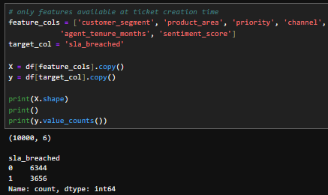
- Normality testing and log transformation: Continuous variables (agent_tenure_months and sentiment_score) were normality tested using the Shapiro-Wilk test. Agent_tenure_months showed a skew of 1.36, indicating a high right skew. A log transformation was applied using np.log1p to stabilize variance and reduce skewness (MetricGate, 2025). Sentiment_score had a skew of -0.39, indicating mild left skew. No log transformations were required for sentiment_score.
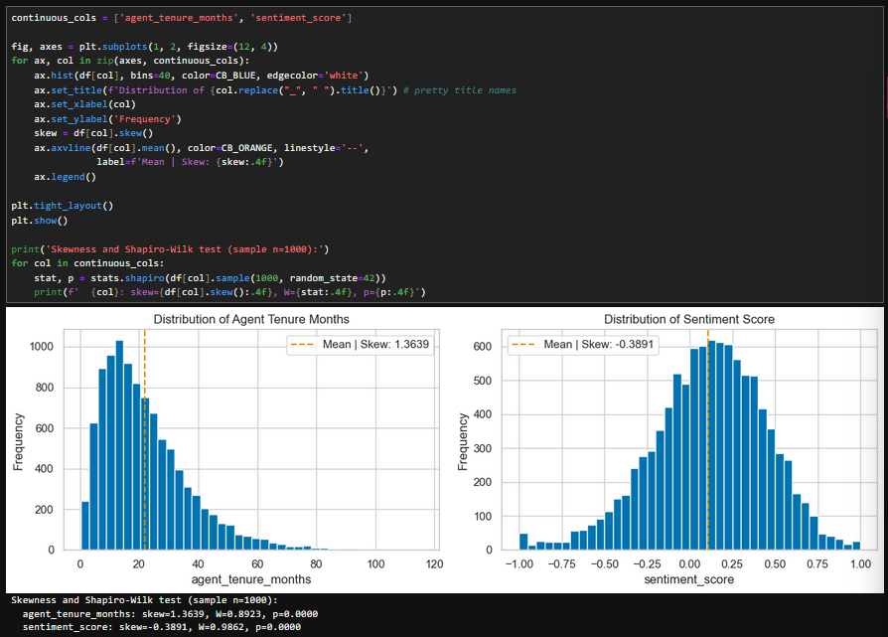
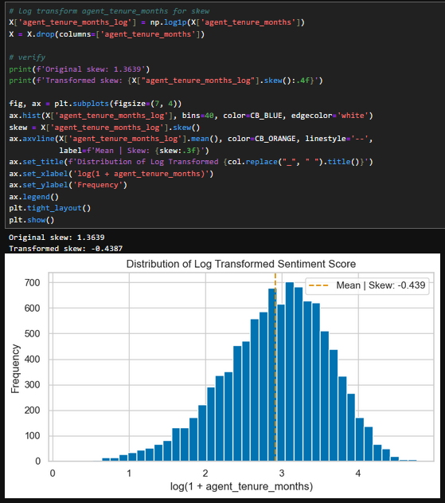

- One-hot encoding: Categorical variables (customer_segment, product_area, priority, and channel) were one-hot encoded using pandas’ get_dummies with drop_first=True. One-hot encoding converts categorical variables into separate binary columns indicating which category value is present (Brownlee, 2020). The drop_first parameter drops one category from each variable, treating it as the reference category and preventing multicollinearity.
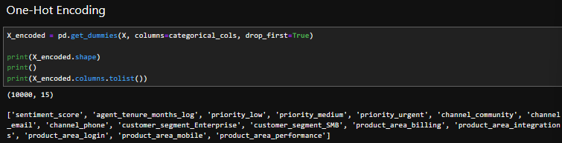
- Multicollinearity: Variance Inflation Factors (VIFs) were calculated for all encoded predictor variables to assess multicollinearity. All variables returned VIF values <10. The highest VIF value was 8.59 for agent_tenure_months. All other VIF values were <3.
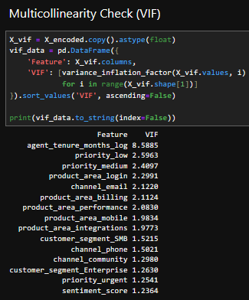
- Train/test split: The data was split into a training set of 80% and a test set of 20% using scikit-learn’s train_test_split with stratification on the dependent variable, sla_breached.
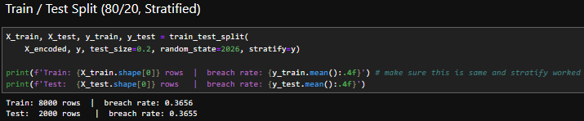

Tools and Techniques Justification
Python is the primary tool used for data extraction and preparation alongside Jupyter Notebook. Pandas is used for data loading and preparation. Scikit-learn is used for the train/test split. Statsmodels is used for VIF calculations. SciPy is used for the Shapiro-Wilk normality test. Matplotlib and Seaborn are used for plotting and visualizations.
Python offers machine learning capabilities through libraries such as scikit-learn and XGBoost, whereas SAS has limited machine learning capabilities without the additional SAS/STAT package (GeeksforGeeks, 2025). Python includes frameworks such as scikit-learn and XGBoost, written into the language, while similar or the same R implementations often serve as wrappers around the same Python libraries, which can lead to lag in availability (Anaconda, 2025). Those advantages, plus the streamlining of tools and libraries within the same Python environment, make Python the right choice for this study.

Advantage and Disadvantage
One advantage of using Python, Jupyter Notebook, and pandas/scikit-learn together is the integration between them. All the above steps from data loading to train/test split are performed easily and intuitively in the same notebook environment. That integration of tools reduces errors, supports reproducibility, and streamlines the process.
One disadvantage of using Python and multiple libraries (pandas, scikit-learn, statsmodels, SciPy) is that those libraries may release updates that deprecate or change features. This can affect reproducibility by requiring adjustments to the code and methods used throughout the notebook when a library releases a major update. Although dependency management is outside the scope of this study, it is worth noting as a disadvantage, as a company using this model in the future may need to make small updates to correct dependency errors.

D. Analysis

Analysis Techniques
Two analysis techniques were used in this study: binary logistic regression and XGBoost. Logistic regression establishes relationships between independent variables and a dependent variable with a categorical outcome, making it an effective technique for predicting SLA outcomes (Selvi et al., 2025). For each ticket, the model predicts the probability of the outcome of the dependent variable, sla_breached. That probability is then converted to a class label (breached or not breached) using a default threshold of 0.5, with values >0.5 representing breached and values <0.5 representing not breached. XGBoost is a machine learning algorithm under the Gradient Boosting framework that can be used to predict and classify data (NVIDIA, n.d.). XGBoost combines predictions from multiple, iteratively trained decision trees, with each new tree correcting the errors of the previous tree, making it well-suited for comparison or validation alongside logistic regression. Both models were trained on the same stratified 80/20 train/test split and evaluated using the same metrics for direct performance comparison.

Calculations and Outputs
The logistic regression model was constructed using scikit-learn’s LogisticRegressionCV using 10 regularization parameters, 5-fold cross-validation, and accuracy as the scoring metric to select the best regularization (C) parameter. Regularization parameters increase or reduce penalties on coefficients to prevent overfitting.
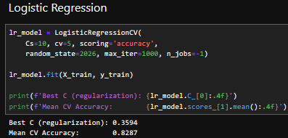
The XGBoost model was built using the base classifier and scikit-learn’s GridSearchCV with 16 hyperparameter combinations, 5-fold cross-validation, and accuracy as the scoring metric. GridSearchCV runs XGBoost repeatedly to find the best parameters. N_estimators is the number of decision trees built, with max_depth being the maximum depth of each tree. The learning_rate is how much each new tree contributes to correcting errors from the previous tree. Subsample refers to the amount of training data that is sampled for each tree.
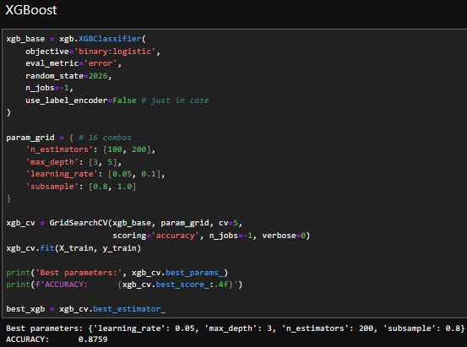
Both models were assessed for feature importance. For the logistic regression model, feature importance was assessed using the model’s coefficients and their odds ratios. Priority level was the strongest predictor of breach, with urgent priority level tickets having 19.7 times odds of breach compared to the reference priority level (high). Other strong positive predictors include customer_segment_Enterprise and customer_segment_SMB, with 2 times odds and 1.4 times odds, respectively. Strong negative predictors include priority_low and priority_medium, with negative coefficients of -5.7 and -3, respectively. Sentiment_score was also a strong negative predictor, with a coefficient of -4.2. Product_area_login and product_area_billing showed a moderate to strong negative effect on SLA breach, with coefficients of -3 and -1.9, respectively.
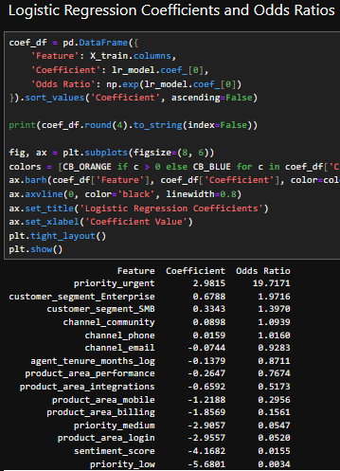
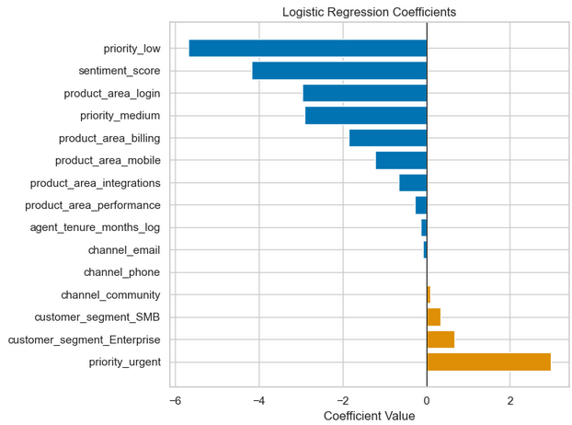

XGBoost’s feature importance was assessed using the model’s built-in feature importances metric. Priority levels were once again the strongest predictors, accounting for ~72% of total feature importance. Unlike logistic regression, XGBoost only provides a score for how much a feature affects the target variable without direction or magnitude. As such, it is less clear how each priority level affects the probability of SLA compliance, but certain levels may affect it more. Priority_low carries the most weight at 36%. Priority_medium accounts for 30%, and priority_urgent accounts for 6% of feature importance. Sentiment_score and product_area_login each account for about 6% of total feature importance. Product_area_billing accounts for roughly 4%, while product_area_performance accounts for roughly 3%. All other features account for less than 2% each with little effect on SLA compliance.
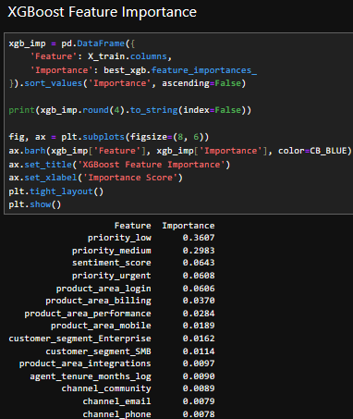
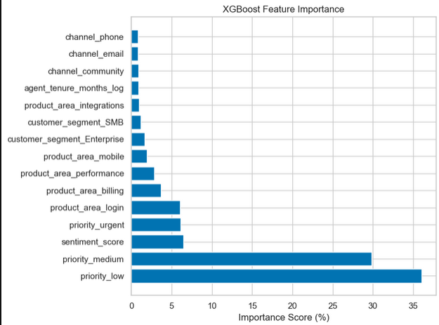

A robustness check was performed with both models to investigate if sentiment_score was, in fact, a strong predictor. Questions about whether sentiment_score represents a ticket's sentiment at creation time or post-resolution justify checking the effect of removing sentiment_score from the analysis. After retraining both models with sentiment_score removed, they still retained an accuracy of >70%, with logistic regression dropping by 4 points to 83% and XGBoost dropping by 4 points to 83%.
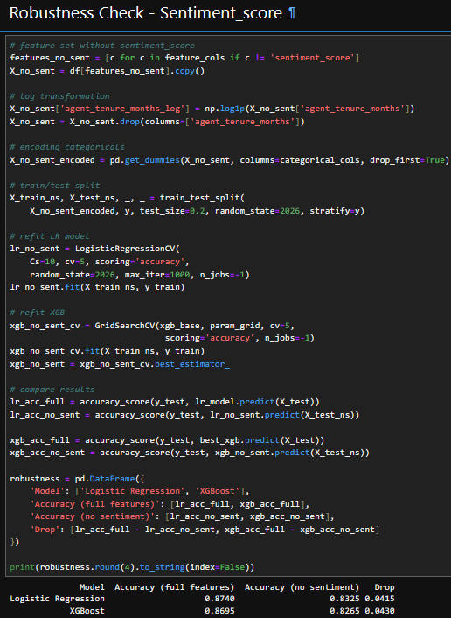

One additional comparison was made by encoding the priority variable differently. Instead of one-hot encoding priority, the variable was ordinally encoded (1-4). Overall, it made no meaningful difference which encoding method was used for priority, as ordinal encoding only reduced accuracy by 0.2%.
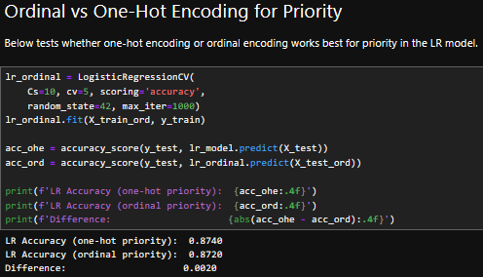

Justification of Techniques
Logistic regression is an appropriate analytical method because the dependent variable is categorical, specifically binary. Swain and Garza (2023) used logistic regression to identify key predictors of SLA outcome using IT incident event data. That study found that incident priority and the number of times an incident event was updated in the system were statistically significant predictors of whether an SLA was met. Selvi et al. (2025) used logistic regression on customer support ticket data and reported that it achieved the best macro-averaged F1-score among the several classification methods they tested. Together, these two studies support the choice of a logistic regression model for use with the support ticket data set.
XGBoost was selected as a comparison model to validate the logistic regression model’s performance and findings. XGBoost has been successfully used to classify IT incident data using priority and urgency variables, supporting its relevance to this study (Akhlaq, 2024). Comparing two different modeling techniques strengthens the validity of any shared results and findings.

Advantage and Disadvantage
One advantage of these analysis techniques is the interpretability of results. Logistic regression provides coefficients and odds ratios that indicate the direction and magnitude of the independent variables’ effects on the dependent variable’s outcome. XGBoost provides feature importance scores that represent the weights of independent variables’ effects on the dependent variable’s outcome. Using both easy-to-interpret methods provides a more in-depth understanding of the data than using only one method.
One disadvantage of these analysis techniques is that logistic regression assumes a linear relationship between independent variables and the log-odds of the outcome (University of Illinois Department of Statistics, n.d.). This assumption of the model could lead to issues capturing non-linear patterns. XGBoost is used as a validation model to help offset this specific limitation.

E. Data Summary and Implications

Results in Context
The research question for this analysis is: Can a logistic regression model be constructed using an IT support ticket dataset? The above results provide strong support for the claim that a predictive logistic regression model can be constructed using an IT support ticket dataset with high accuracy. The logistic regression model achieved accuracy of 87.3% on a test set, well above the 70% threshold. The XGBoost model achieved a similarly high accuracy of 86.7%, further supporting the logistic regression model’s results. The robustness check on sentiment_score confirmed that the models were not relying heavily on it as a single variable, with both accuracy scores dropping by only ~4% when sentiment_score was removed.
Based on those results, the null hypothesis can be rejected. A predictive logistic regression model can be constructed using an IT support ticket dataset at a model accuracy >70%.
Feature importance scores from both models highlighted priority as the dominant predictor of SLA breach, aligning with prior research by Swain and Garza (2023). This study and prior research findings strengthen the role of support ticket priority as a key driver of SLA breach. This study also uncovered sentiment scores and product areas as moderate predictors of SLA compliance.
Both models revealed that priority was both a positive and a negative predictor of SLA outcomes. Since the dataset lacked documented SLA targets, an exploration of resolution_min by priority level revealed possible resolution-time targets. For each priority category, the maximum resolution_min for tickets that met SLA was compared to the minimum resolution_min for tickets that did not meet SLA. By comparing those values, possible thresholds for each priority level were revealed. The resolution time targets appear to be:
- Low priority: 1440 minutes, or 24 hours
- Medium priority: 720 minutes, or 12 hours
- High priority: 360 minutes, or 6 hours
- Urgent priority: 180 minutes, or 3 hours
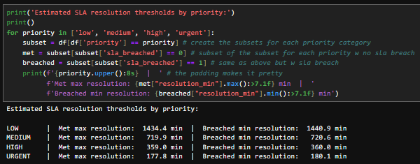
Understanding these possible thresholds can help provide context for priority as a strong predictor in both models. It makes sense that a support ticket with urgent priority is more likely to fail SLA compliance when the resolution target is only 3 hours, versus a low-priority support ticket with a 24-hour resolution target. Any high- or urgent-priority tickets that require escalation or complex problem-solving could easily have resolution delayed by hardware or software issues, staffing shortages, or agent inexperience. Tools like the predictive logistic regression model can assist support teams by flagging support tickets at high risk of SLA breach, enabling organizations to mitigate such issues more effectively.

Limitations
One limitation of this analysis is the limited context in the dataset. A wider variety of variables to study could help uncover more patterns and drivers of SLA outcomes. This dataset provides limited information about the customers associated with each support ticket. Customer demographics, such as age group, account age, region, and more, could be added to determine whether certain demographic factors contribute to the likelihood of SLA targets being met or breached.

Recommended Course of Action
It is recommended that IT support teams use the logistic regression model to identify high-risk SLA breach support tickets. Since the model was trained only on variables assumed to be available at ticket creation, teams can apply it as soon as the required input variables (customer_segment, product_area, priority, channel, agent_tenure_months, and sentiment_score) are available. Tickets flagged as high-risk can then be prioritized by teams for additional review and support. Since priority is the strongest driver of SLA breaches, teams should ensure tickets are assigned the correct priority so the model can flag them appropriately.

Directions for Future Study
Future studies should first expand the dataset to include customer demographic data such as age group, account age, region, income level, occupation, and more. The addition of these types of variables enables further exploration and analysis, potentially creating a more complete picture of what really drives SLA outcomes. Second, future studies should include testing threshold tuning. Since the default classification threshold of 0.5 was used in this study, further studies could explore different thresholds to either prevent false alarms or prevent missed at-risk tickets. The current model recalled ~78% of the breached class. Lowering the threshold would catch more at-risk tickets but lead to more false alarms. Raising the threshold would reduce false alarms but miss more at-risk tickets. Organizations could choose either approach depending on their specific business and client goals.

F. References
Akhlaq, S. U. (2024). AI/ML-driven service management for enhancing organizational overall KPIs and security. Journal of Computational Analysis and Applications, 33(8), 4442–4463. Retrieved May 11, 2026, from https://eudoxuspress.com/index.php/pub/article/view/2854

Anaconda. (2025, December 15). Why Python is a better choice than R for data science and AI workflows. Retrieved May 11, 2026, from https://www.anaconda.com/blog/python-vs-r-data-science-ai-workflows

Brownlee, J. (2020, August 17). Ordinal and one-hot encodings for categorical data. Machine Learning Mastery. Retrieved May 11, 2026, from https://machinelearningmastery.com/one-hot-encoding-for-categorical-data/

Count.co. (n.d.). Customer support ticket analysis: Methods & best practices. Retrieved May 11, 2026, from https://count.co/metric/customer-support-ticket-analysis

GeeksforGeeks. (2025, July 23). SAS vs R vs Python. Retrieved May 11, 2026, from https://www.geeksforgeeks.org/blogs/sas-vs-r-vs-python/

Grace-Martin, K. (2024, May 13). Effect size statistics in logistic regression. The Analysis Factor. Retrieved May 11, 2026, from https://www.theanalysisfactor.com/effect-size-statistics-logistic-regression/

IBM. (2025, November 17). What is logistic regression? Retrieved May 11, 2026, from https://www.ibm.com/think/topics/logistic-regression

MetricGate. (2025). Log transformations for skewed data. Retrieved May 11, 2026, from https://metricgate.com/blogs/log-transformations-skewed-data/

Selvi, C. S. K., Shri, S. J., Prasshanthini, R., Neelamegan, & Sanjay, R. (2025). Customer support ticket categorization and prioritization using natural language processing. Proceedings of the 3rd International Conference on Futuristic Technology (INCOFT 2025), 3, 690–698. Retrieved May 11, 2026, from https://www.scitepress.org/Papers/2025/136404/136404.pdf

Swain, A. K., & Garza, V. R. (2023). Key factors in achieving service level agreements (SLA) for information technology (IT) incident resolution. Information Systems Frontiers, 25(2), 819–834. Retrieved May 11, 2026, from https://pmc.ncbi.nlm.nih.gov/articles/PMC8942060/

University of Illinois Department of Statistics. (n.d.). Evaluating your logistic regression model. Data Science Exploration. Retrieved May 11, 2026, from https://exploration.stat.illinois.edu/learn/Logistic-Regression/Evaluating-your-Logistic-Regression-Model/

