Logistic Regression and XGBoost on Support Ticket Dataset
Executive Summary
Ashley Barone
Western Governors University
May 20, 2026

Problem and Hypothesis
Service Level Agreements (SLAs) include targets and standards set by organizations for how services will be delivered. Missing SLA targets can cause support teams to struggle and customer satisfaction to suffer. Without a way to identify tickets at risk of SLA breach, support teams must rely solely on internal priority flagging and ticket queueing. Such a broad approach can quickly lead to missed targets, unresolved tickets, and overworked agents. A predictive tool that identifies high-risk tickets early would allow teams to allocate resources effectively and improve SLA compliance.
Understanding factors that lead to SLA breaches can help support teams to flag high-risk support tickets early, resulting in better SLA compliance and more effective ticket resolution. This study hypothesizes that a logistic regression model can be constructed using an IT support ticket dataset at a model accuracy >70%. Support teams could then use the model to identify high-risk support tickets better.
Data Analysis Process
The dataset used in this analysis is from Kaggle and contains 10,000 rows of IT support ticket data. There are 14 variables in total, with no missing values. The target variable in this study is sla_breached, a binary variable indicating whether the SLA was met for each ticket. Six independent variables were selected as possible drivers of SLA breach: customer_segment, product_area, priority, channel, agent_tenure_months, and sentiment_score. These six were selected because they are most likely to be available at ticket creation, when it is most advantageous to assess a ticket's risk of SLA breach. The remaining seven variables (resolution_min, first_response_min, reopen_count, csat_1_5, refund_requested, escalation, and bug_confirmed) were excluded because they are likely to be available only after a support ticket is resolved.
Independent Variable Name | Data Type
customer_segment | Categorical
product_area | Categorical
priority | Categorical
channel | Categorical
agent_tenure_months | Continuous
sentiment_score | Continuous

Data preparation included log transformation of agent_tenure_months to address a right-skew of 1.36 (MetricGate, 2025), one-hot encoding of categorical features using drop_first=True (Brownlee, 2020), a VIF check to confirm the absence of severe multicollinearity, and a stratified 80/20 train/test split. The logistic regression model was built with scikit-learn's LogisticRegressionCV, using 10 regularization parameters, 5-fold cross-validation, and accuracy as the scoring metric. XGBoost was built using the base classifier and scikit-learn's GridSearchCV with 16 hyperparameter combinations, 5-fold cross-validation, and accuracy as the scoring metric, serving as a comparison model for the logistic regression model. Both models were trained using the 80% training set. Then, both models were tested using the 20% testing set of unseen support tickets. Metrics for each model were gathered and compared.

Findings
Both models greatly exceeded the hypothesized 70% accuracy threshold. Logistic regression achieved a test accuracy of 87.3%, and XGBoost achieved 86.7%. The null hypothesis was rejected.
Priority was the strongest predictor in both models. The logistic regression model reported that urgent priority tickets had roughly 20 times the odds of breach compared to high-priority tickets (the reference category). XGBoost feature importances indicated that roughly 72% of total feature importance could be attributed to priority: low priority accounting for 36%, medium priority accounting for 30%, and urgent priority accounting for 6%.
The logistic regression model identified both positive (orange) and negative (blue) predictors, as shown in the figure below.
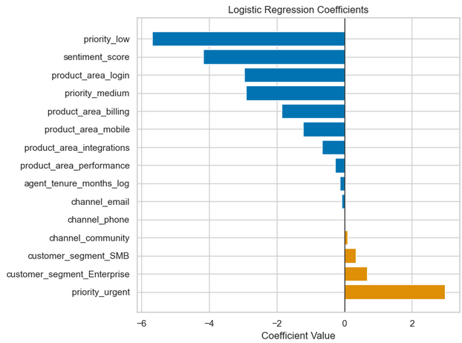
Low-priority tickets had the strongest negative effect on SLA outcomes, meaning that a low-priority ticket was much less likely to breach SLA. Alternatively, urgent-priority tickets were more likely to breach SLA. Other factors, like sentiment_score and product_area, also decreased the chance of an SLA breach, while customer_segment increased the chance by a small amount.
In the XGBoost model, features were scored by their importance, or their contribution to SLA outcomes, as shown in the figure below.
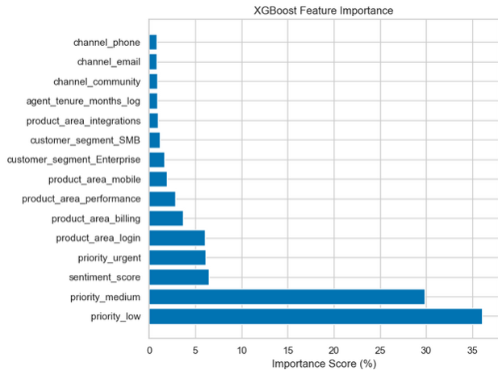
With the priority features carrying the majority of feature importance weight at 72%, only a few other features made meaningful contributions to SLA outcomes. Sentiment score and product_area_login each account for 6% of feature importance. Product_area_billing accounts for 4%, while product_area_performance accounts for 3%. All other features account for less than 2% each with little effect on SLA outcomes.
Since the dataset lacked documentation on when sentiment_score is calculated, a robustness check was performed to confirm that the models' performance was not overly dependent on sentiment_score as a single feature. When sentiment_score was removed, and both models were retrained, accuracy dropped by only ~4 percentage points (to 83% for both models), confirming sentiment_score as a moderate predictor rather than a source of data leakage.
Overall, both models performed comparably well and provided helpful insight into what drives SLA outcomes. The table below summarizes each model’s performance metrics.
Metric | Logistic Regression | XGBoost
Accuracy | 87.3% | 86.7%
ROC-AUC | 0.94 | 0.94
Precision (Breached) | 85% | 85%
Recall (Breached) | 80% | 79%
F1-Score (Breached) | 82% | 82%

Limitations
The primary technical limitation of logistic regression is that it assumes a linear relationship between predictors and the log-odds of the outcome, which can limit the model's ability to capture non-linear patterns (University of Illinois Department of Statistics, n.d.). XGBoost was used to help offset this limitation. The nearly identical performance and findings of the models suggest that the technical limitations of logistic regression did not meaningfully impact results.
Another limitation is the dataset's lack of customer demographic data. Minimal customer demographics limit the insight each model can provide. With more detailed data, support teams could potentially more accurately detect high-risk support tickets and provide quicker, better support ticket resolution.

Proposed Actions
It is recommended that IT support teams use the logistic regression model to identify tickets at high risk of SLA breach. Having been trained only on variables assumed to be available at ticket creation, teams can apply the tool as soon as the required input variables (customer_segment, product_area, priority, channel, agent_tenure_months, and sentiment_score) are available. Tickets flagged as high-risk can be prioritized for additional review and support. Given that priority is the strongest predictor of breaches, teams should ensure that internal priority flagging is consistent and accurate during ticket intake, as inconsistencies in priority assignment would directly affect the reliability of the model's predictions.

Expected Benefits
The logistic regression model correctly identifies 80% of tickets that will result in SLA breach. The model performs with a precision of 85%. For support teams, this translates to 85 of every 100 model-flagged tickets resulting in SLA breach. That precision will allow support teams to focus their efforts on tickets that need additional support rather than spreading resources thinly across all tickets. A model that successfully identifies 80% of all tickets that will miss SLA targets allows for accurate, early intervention. The expected benefit is more consistent SLA compliance, fewer escalations, and better resource allocation across support teams.

References
Brownlee, J. (2020, August 17). Ordinal and one-hot encodings for categorical data. Machine Learning Mastery. Retrieved May 20, 2026, from https://machinelearningmastery.com/one-hot-encoding-for-categorical-data/

MetricGate. (2025). Log transformations for skewed data. Retrieved May 20, 2026, from https://metricgate.com/blogs/log-transformations-skewed-data/

University of Illinois Department of Statistics. (n.d.). Evaluating your logistic regression model. Data Science Exploration. Retrieved May 20, 2026, from https://exploration.stat.illinois.edu/learn/Logistic-Regression/Evaluating-your-Logistic-Regression-Model/

