Proteomics signature of whole-brain microstructural integrity of white matter using LatentSNA
Ash Sharma1, Connor Lee Cornelison1, Luling Zou1, Krishnendu Chandra1, Qiuting Wen3,5, Kwangsik Nho3,5, Andrew J. Saykin3,5, Yu-Chien Wu3,5, and Selena Wang1,5
1Department of Biostatistics and Health Data Science, Indiana University School of Medicine, Indianapolis, IN, USA
3Department of Radiology and Imaging Sciences, Indiana University School of Medicine, Indianapolis, IN, USA
5Indiana Alzheimer’s Disease Research Center, Indiana University School of Medicine, Indianapolis, IN, USA

April 10, 2026

Background
Alzheimer’s disease (AD) is a progressive neurodegenerative disorder for which early identification and intervention are critical to reducing the overall public health burden and alleviating individual impact. The development of plasma-based proteomic biomarkers offers a more cost-effective and less invasive alternative to cerebrospinal fluid (CSF) and positron emission tomography (PET)-based biomarkers. Although early evidence suggests that plasma proteomic biomarkers are associated with AD risk, limited research has examined their ability to assess microstructural integrity of white matter (WM), as measured by diffusion tensor imaging (DTI). In this project, we aim to fill this gap by identifying plasma proteomics associates of WM variations.
Method
To identify plasma-based protein biomarkers of white matter microstructures, we applied latent-space based statistical network analysis (LatentSNA, Wang et al., 2026) to 139 participants with both plasma proteomics and fractional anisotropy (FA)-based structural connectomes from the Indiana Alzheimer’s Disease Research Center (IADRC). Plasma proteins were quantified using the SomaScan 7k v4.1 assay, a high-throughput proteomics platform using modified aptamer technology that measures over 7000 protein analytes across a broad range of endogenous concentrations.

Results
In Figure 1, we show the plasma proteins that are most associated with microstructural changes of white matter (WM) identified in the IADRC cohort. Our results show that acyl-CoA oxidase 1 (ACOX1), which regulates peroxisomal fatty acid oxidation neuroinflammation [Chung et al., 2020], platelet-derived growth factor subunit B (PDGFB), which maintains the blood-brain barrier (BBB) integrity by regulating pericytes [Smyth et al., 2022]; and pyruvate kinase M1/2 (PKM) that promotes toxic amyloid-beta production [Gojani et al., 2026] are some of the strongest associations of WM changes.

Discussion/Conclusion
Plasma based biomarkers have promise as predictors of microstructural integrity of white matter, which has been proposed as an early change associated with AD.

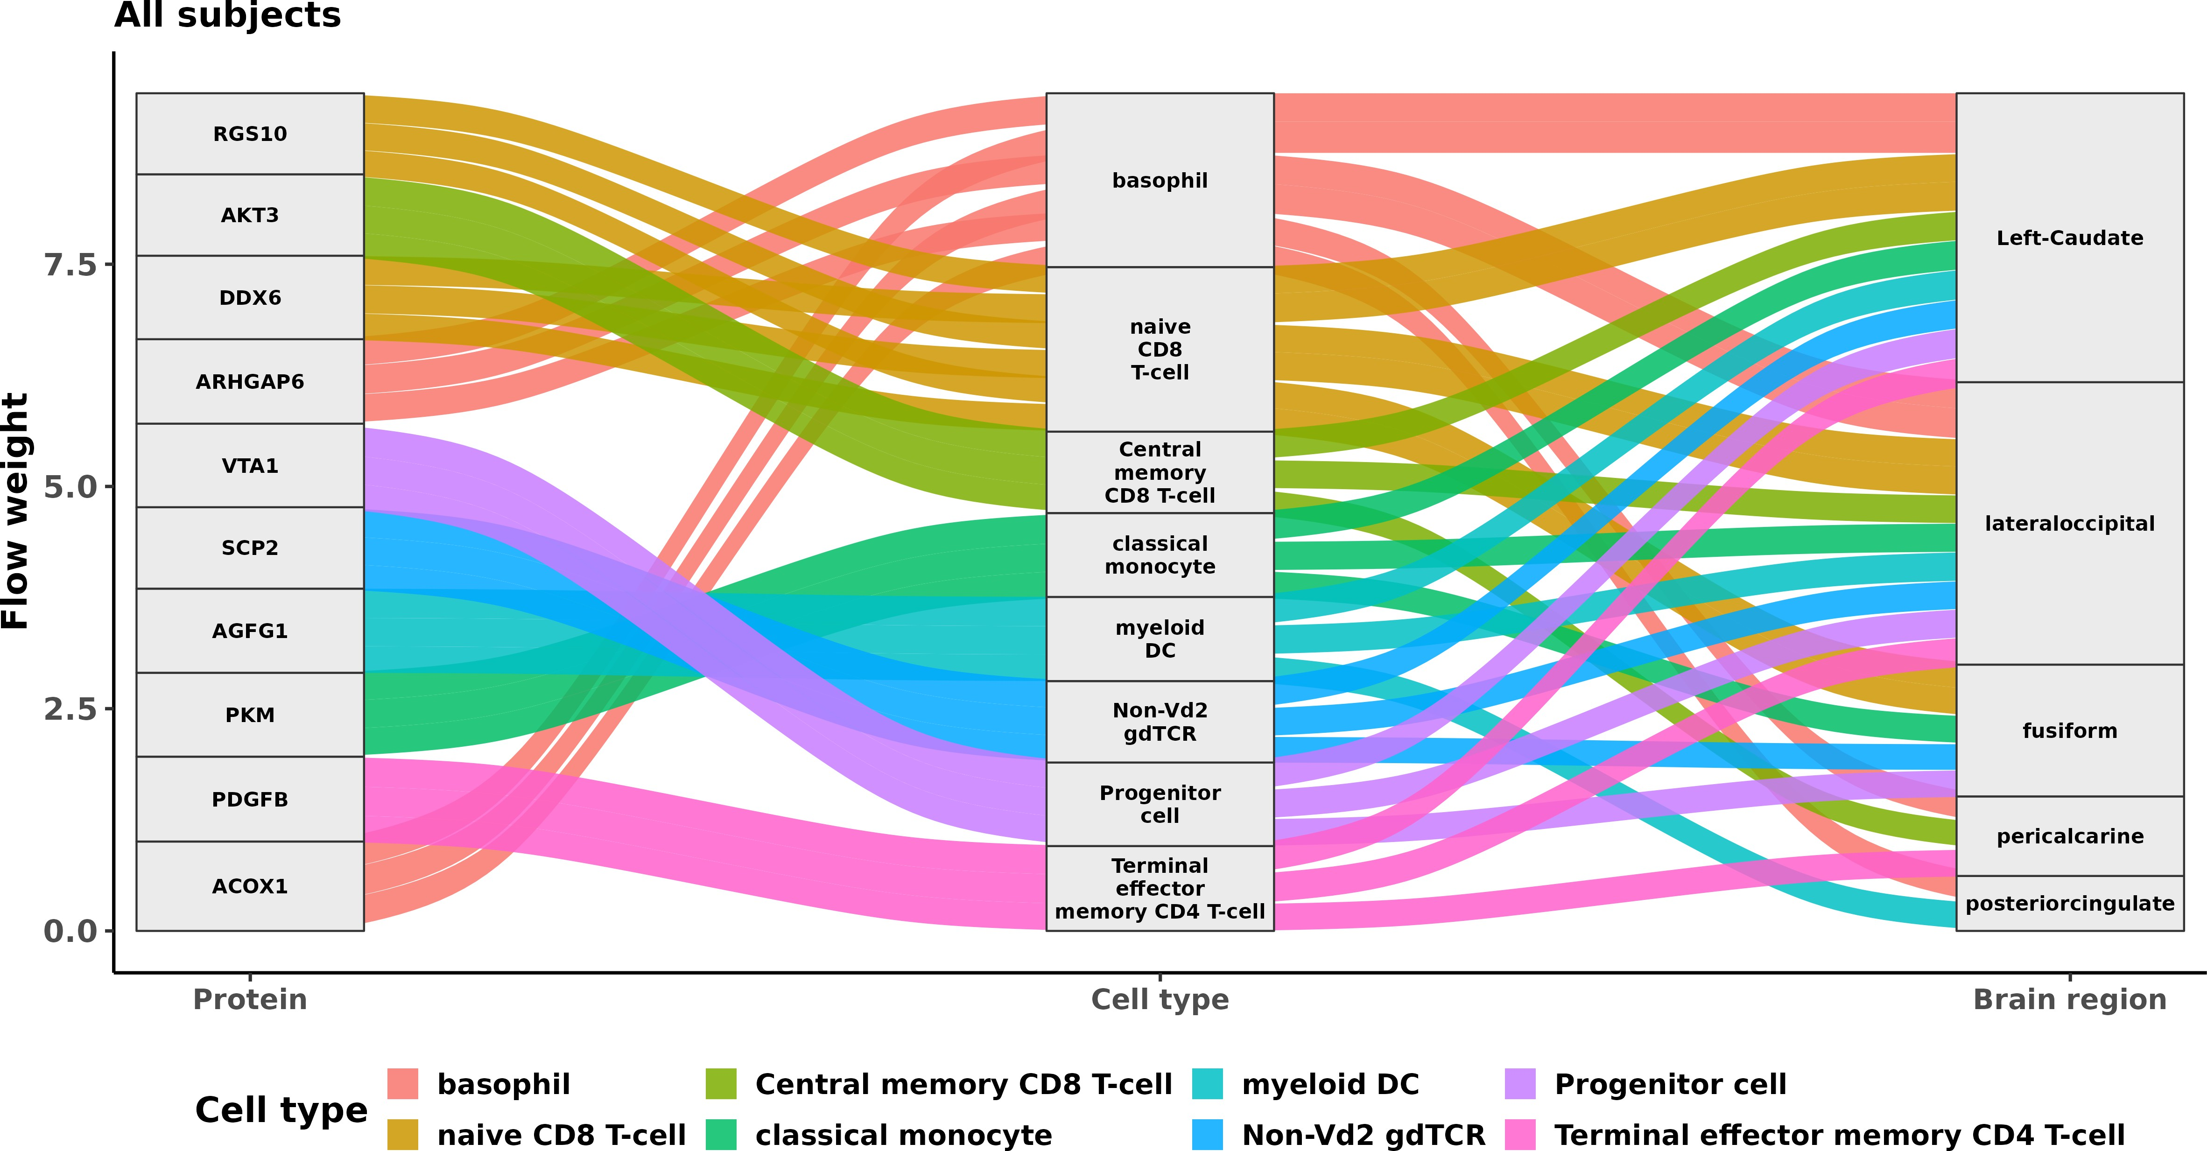

Figure 1: Alluvial plot of cell-type specific protein pathways to region specific white matter degeneration. Top proteins were selected based on the strength of their association with region specific white matter integrity. Flow width reflects association strength.

References
Chung, H.-l., Wangler, M. F., Marcogliese, P. C., Jo, J., Ravenscroft, T. A., Zuo, Z., Duraine, L., Sadeghzadeh, S., Li-Kroeger, D., Schmidt, R. E., Pestronk, A., Rosenfeld, J. A., Burrage, L., Herndon, M. J., Chen, S., et al. (2020). Loss- or gain-of-function mutations in ACOX1 cause axonal loss via different mechanisms. Neuron, 106(4), 589–606.e6. https://doi.org/10.1016/j.neuron.2020.02.021
Gojani, E. G., Sutherland, R. J., & Mohajerani, M. H. (2026). Pyruvate kinase m2 in alzheimer’s disease: From dysregulation to therapeutic inhibition. Brain Communications, 8(2), fcag054. https : / / doi . org/ 10.1093/ braincomms/fcag054
Smyth, L. C. D., Highet, B., Jansson, D., Wu, J., Rustenhoven, J., Aalderink, M., Tan, A., Li, S., Johnson, R., Coppieters, N., Handley, R., Narayan, P., Singh-Bains, M. K., Schweder, P., Turner, C., Mee, E. W., Heppner, P., Correia, J., Park, T. I.-H., . . . Dragunow, M. (2022). Characterisation of pdgf-bb:pdgfr𝛽 signalling pathways in human brain pericytes: Evidence of disruption in alzheimer’s disease. Communications Biology, 5, 235. https://doi.org/10.1038/s42003-022-03180-8
Wang, S., Zhang, X., Liu, Y., Xu, W., Tian, X., & Zhao, Y. (2026). Latent space-based network analysis for brain-behavior linking in neuroimaging. Nature Methods, 23(1), 225–235. https://doi.org/10.1038/s41592-025-02896-9

