1. **How to compare two JSON have the same properties without order?**
   1. var obj1 = { name: "Person 1", age:5 };
   2. var obj2 = { age:5, name: "Person 1" };

**Ans**: Using lodash we can compare the object.

console.log( _.isEqual(obj1, obj2) );

output:



1. **Use the rest countries API url ->** [**https://restcountries.eu/rest/v2/all**](https://restcountries.eu/rest/v2/all) **and display all the country flags in console**

**Ans:**

const rest_country_url="https://raw.githubusercontent.com/rvsp/restcountries-json-data/master/res-countries.json";

    let xhr=new XMLHttpRequest();

    xhr.open('GET',rest_country_url);

    xhr.onload=(()=>{

       let response= xhr.responseText;

       let data=JSON.parse(response);

       Displaymsg(data);

    });

    xhr.send();

    let Displaymsg=((objData)=>{

        objData.forEach(function(obj){

            console.log(`${obj.name} ${obj.region}`);

        });

    })

Output:

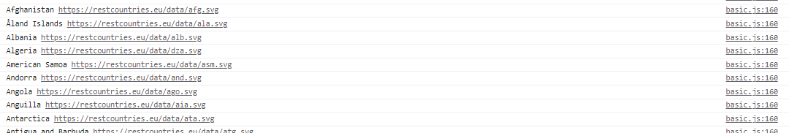

1. **Use the same rest countries and print all countries name, region, sub region and population**

 const rest_country_url="https://raw.githubusercontent.com/rvsp/restcountries-json-data/master/res-countries.json";

    let xhr=new XMLHttpRequest();

    xhr.open('GET',rest_country_url);

    xhr.onload=(()=>{

       let response= xhr.responseText;

       let data=JSON.parse(response);

       Displaymsg(data);

    });

    xhr.send();

    let Displaymsg=((objData)=>{

        objData.forEach(function(obj){

            console.log(`

                         Name: ${obj.name}

                         Region: ${obj.region}

                         Subregion: ${obj.subregion}

                         Population: ${obj.population}`);

        });

    })

**Output:**

