**Q.1 ) For the given JSON iterate over all for loops (for, for in, for of, forEach):**

**Ans:**

let arrobj=[

{

"id": "1",

"name": "Lura Senger",

"email": "Xander_Collier@yahoo.com"

},

{

"id": "2",

"name": "Wilburn Weber",

"email": "Bennett_Kreiger11@yahoo.com"

},

{

"id": "3",

"name": "Tyrique Hahn",

"email": "Juston.Altenwerth@yahoo.com"

},

{

"id": "4",

"name": "Lenny Bailey",

"email": "Guiseppe_Hegmann@yahoo.com"

},

{

"id": "5",

"name": "Vladimir Keeling",

"email": "Louisa_Walsh18@hotmail.com"

}

];

**For Loop:**

//For Loop

for(i=0;i<arrobj.length;i++){

console.log(arrobj[i].id,arrobj[i].name,arrobj[i].email);

}

**//For In Loop**

for(let j in arrobj){

console.log(arrobj[j].id,arrobj[j].name,arrobj[j].email);

}

**//For OfLoop**

for(let k of arrobj){

console.log(k.id,k.name,k.email);

}

**//ForEach Loop**

arrobj.forEach(function(obj){

console.log(`

id: ${obj.id}

name: ${obj.name}

email: ${obj.email}

`);

})

Output:

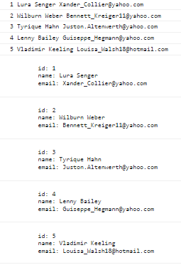

**Q.2 ) For** Create your own resume data in JSON format

**Ans:**

let my_resume={

personal_information:{

name:"Aishwarya Gandhi",

email:"ash.gandhi19@gmail.com",

contact:8983662057,

alternate_contact:8999746558,

address:"birwadi",

city:"mahad",

pincode:402302,

},

education_details:[

{

education_name:"Graduate",

passout_year: 2016,

location: "Pune",

},

{

education_name:"Diploma",

passout_year:2013,

location:"Lonere"

},

{

education_name:"SSC",

passout_year:2010,

location:"Birwadi"

}

],

experiance:[

{

company_name:"Softebizz Technology",

years_of_exp:"5 months",

location:"Pune"

},

{

company_name:"Saraswat Webtech",

years_of_exp:"1 Year 7 months",

location:"Mumbai"

},

{

company_name:"Fyntune Solution",

years_of_exp:"2 years",

location:"Mumbai"

},

],

keyskills:{

languages:["php","javascript","html","css","jquery","ajax"],

framework:["codeigniter","laravel"],

}

};