LAB 7.2 LOG
11/7
12AM: Added BRAM block into HDMI text controller toplevel. Connected to logic signals inside of toplevel, but have not connected to the AXI module. Simulation still runs as expected
2AM: Successfully tested just BRAM through forced signals in the testbench. Found that for a write operation, the write data must be consistent for a little over one clock cycle (it cannot change RIGHT before the write strobe signal goes low again). If this happens, no data is written.
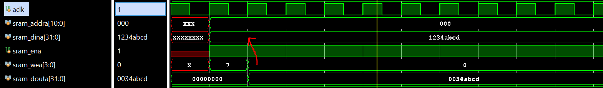
Confirmed that when doing a read from BRAM, the read data is guaranteed to be correct on the rising edge of the clock one cycle after asserting the address and enable.
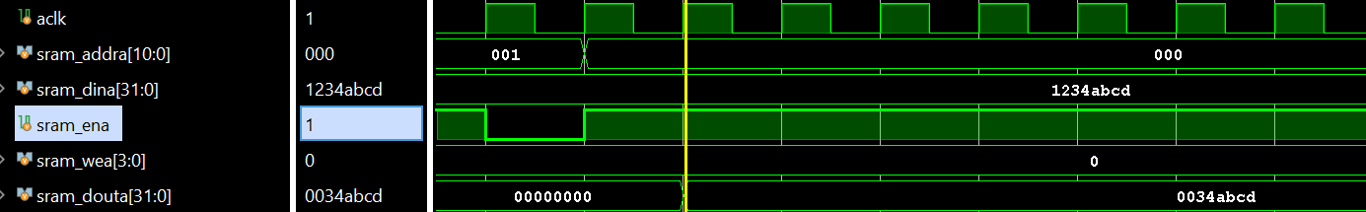
6AM: Successfully ran old AXI test code with new BRAM memory implemented. The address width is still 12 bits, and this will need to be increased to 13 bits to support the 1200 word addresses.

