Assignment - 4

ECN-619: Introduction To Compressed Sensing

Name: Ashwani Kumar

Roll: 23531002

Course: MTech CNSP Yr-1

Q1: QCBP

After alpha = 0.99, the optimization problem is becoming feasible and CVX can solve the problem.

For values of alpha = 1 and close to 1, the estimate was not smooth for zero values of x, although the reconstruction of non-zero values of x were good.

As we increase alpha, zero values of x are being estimated smoothly but the solver struggles to estimate a very small non-zero value of x.

Found best reconstruction of x at alpha = 1.45

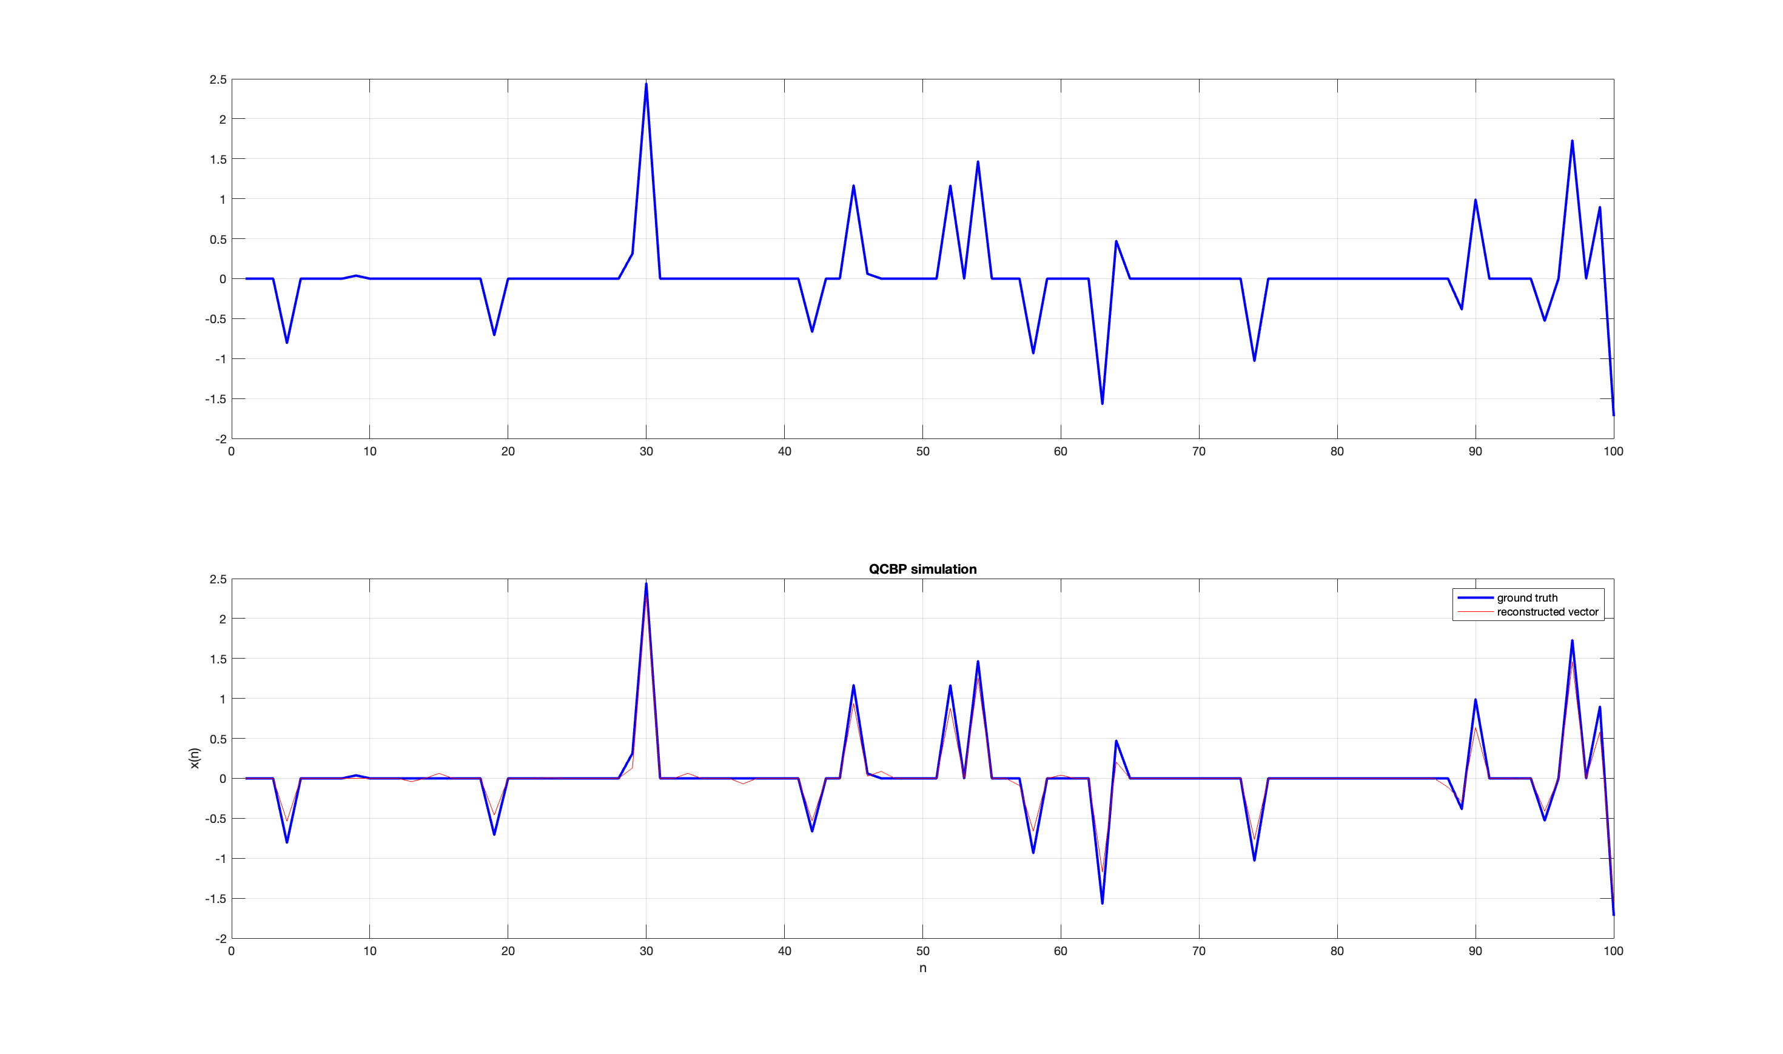

Q2: BPDN: Optimal regularization bias term = 0.25

Output:

Q3: LASSO optimization: Tau values near k value gives good estimate, Tau = 16

Output:

