FLUTTER TASK

TASK TITLE : Flutter Project with integration of Node.js and MongoDB

Submitted By :

Ashwin Nirmalraj K S,

A.ID – 901477,

GE-25 Batch – 2

1. HOME SCREEN

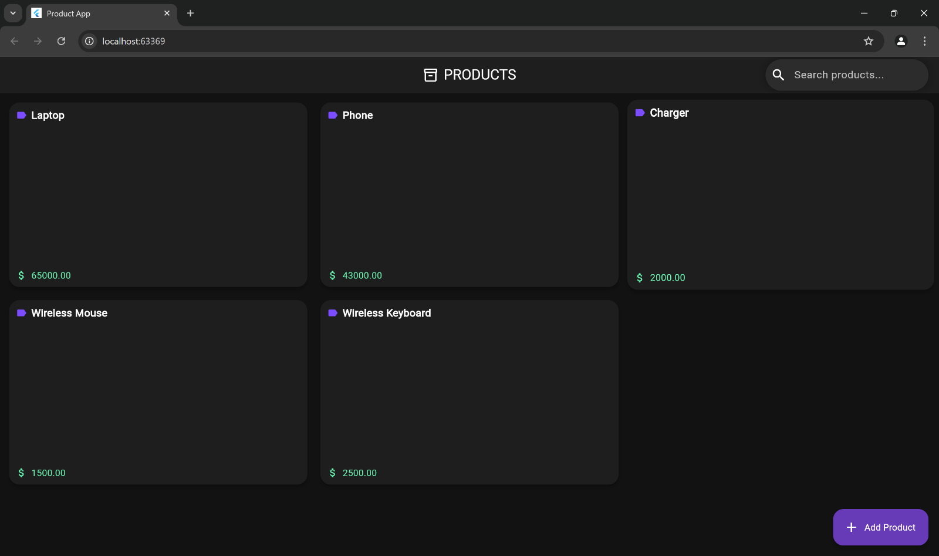

1. PRODUCT DETAIL SCREEN :

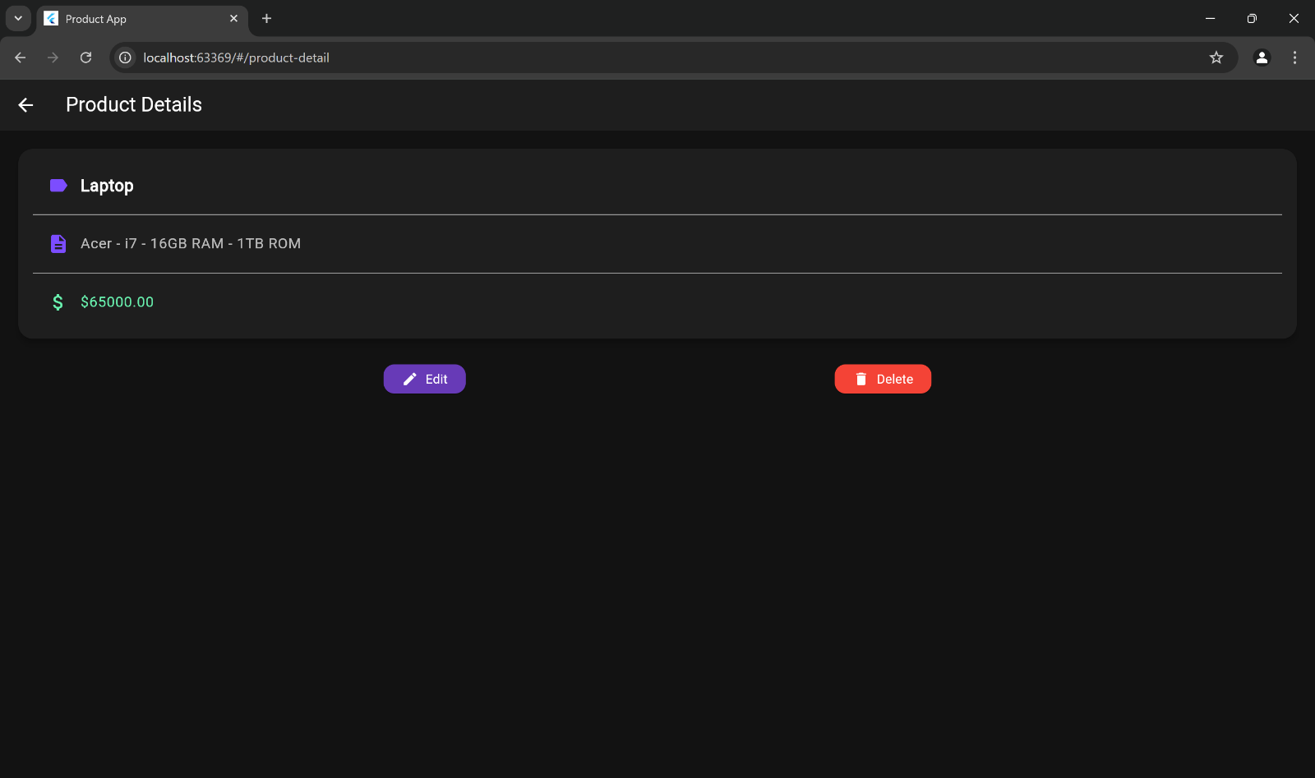

1. PRODUCT UPDATION SCREEN:

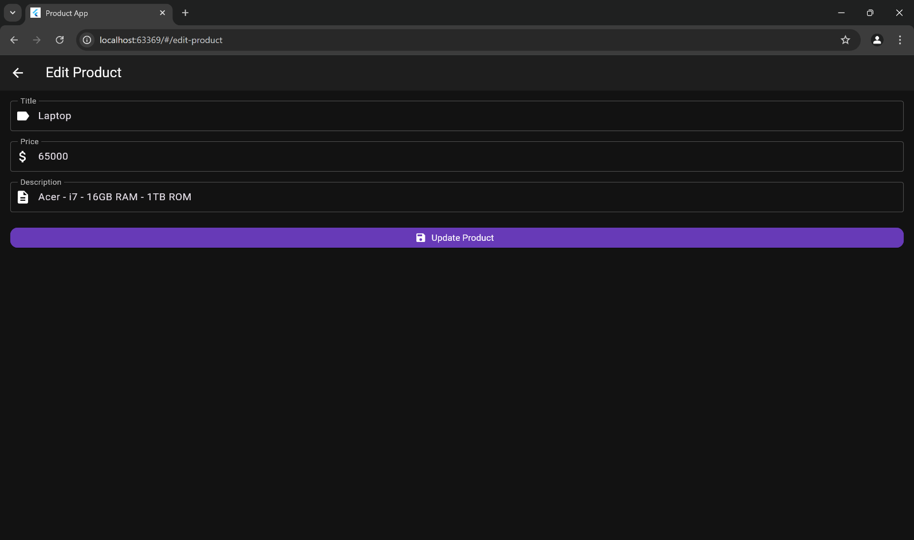

1. PRODUCT DELETION PROMPT :

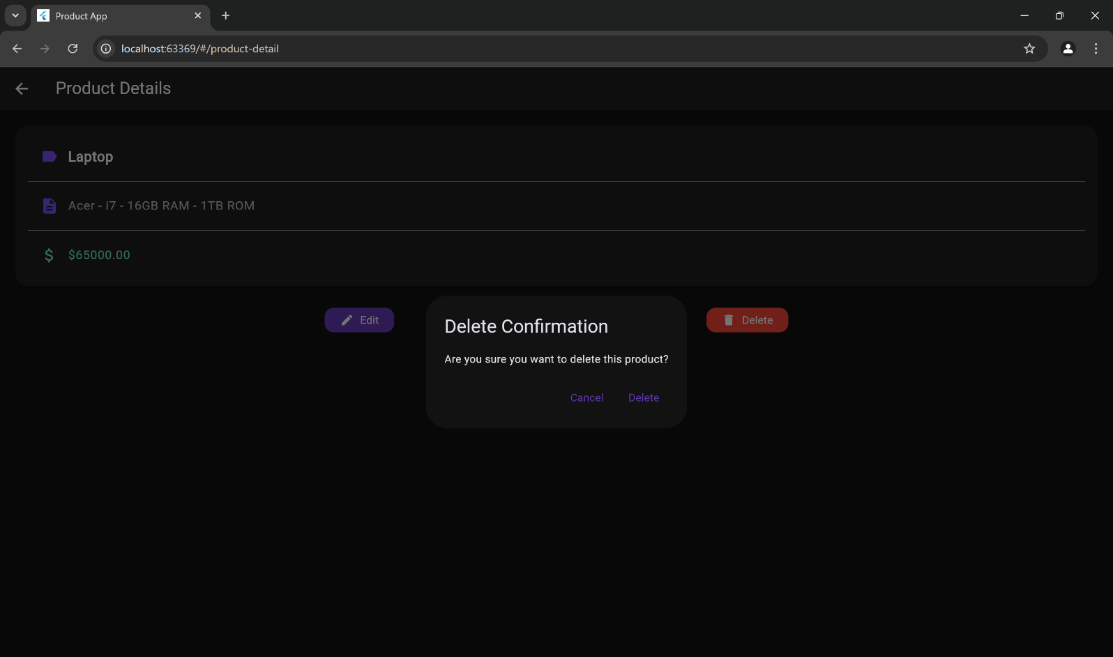

1. ADD PRODUCT SCREEN :

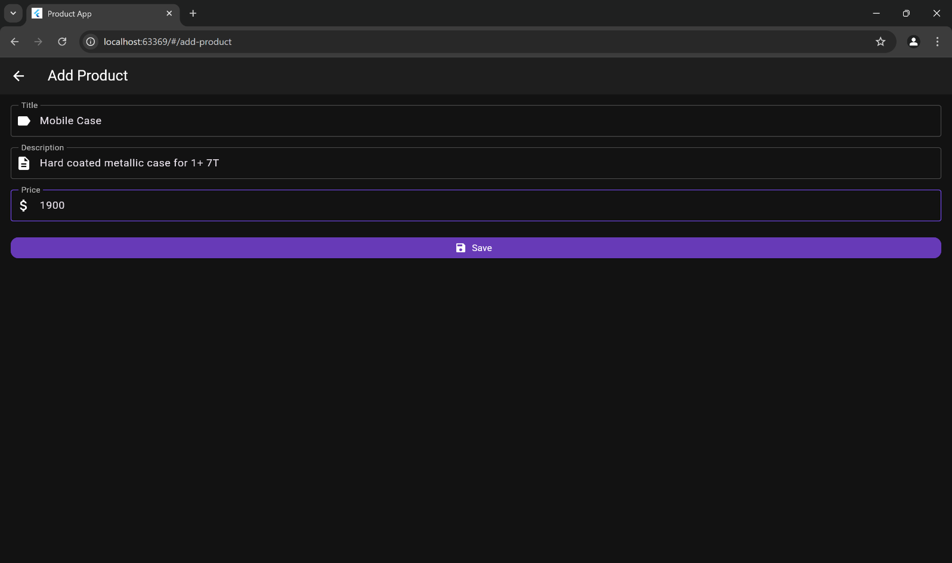

1. MONGODB CLUSTER :

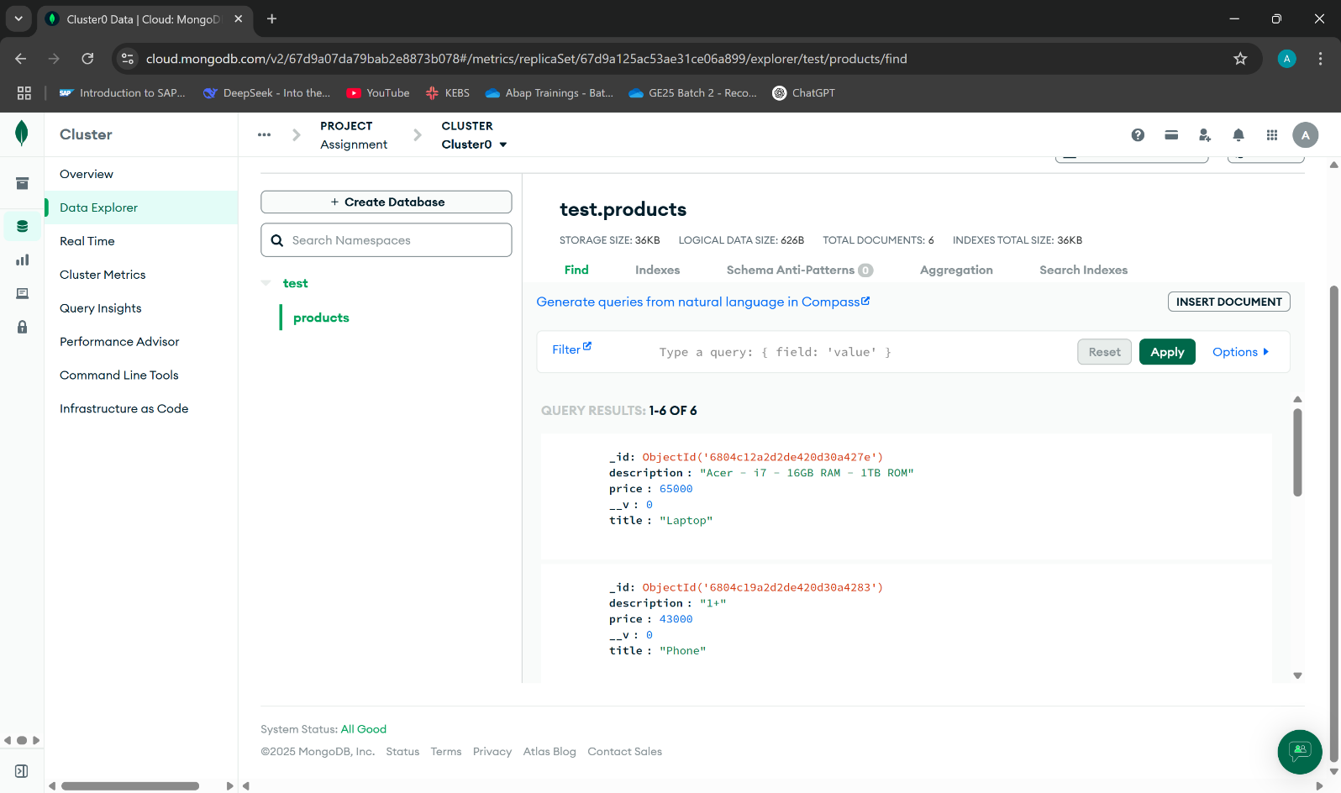

1. GIT REPOSITORY :

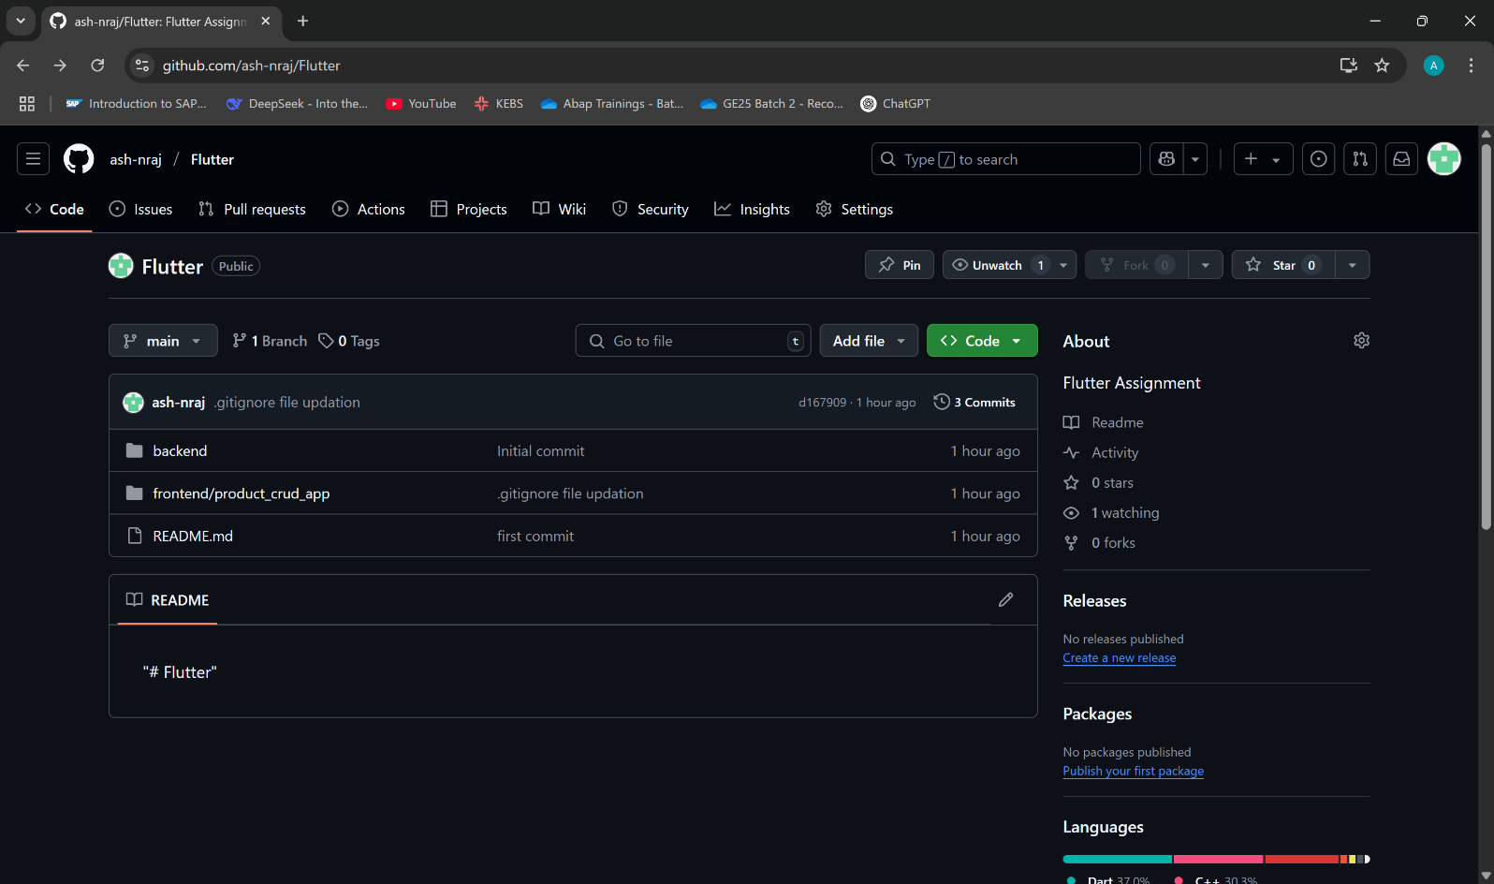

1. Repo Link :

<https://github.com/ash-nraj/Flutter>