**Investment Prediction: A paper on Stock**

**market price analysis methods**

*Market Hypothesis is a well-known belief in stock speculation. With failure, much research has been done on the stock forecasting area. Previously accurate predictions of the market have been a tedious task. This project considering capturing huge data such as an economic information article regarding a particular sector association and foretelling its coming stock trends by mood categories. If you think that news or any information articles have a change on the market, this is an analysis to examine the connection between stock price plus market news. For the examination of this, we have created few models for different categories that show the magnitude of the news articles whether they are good or bad. A look shows that SVM and RF work well for all types different types of tests. The Naive provides genuine output although the unlike additional two. Tests were performed to test the certain features of the implemented model and the encouraging results are available for tests. The efficiency of the prediction model is nearly more than 79% and compared to the random label recording with less accuracy which is about 50%; the accuracy of the model is increased by 31%.*

*The proposed strategy helps to get higher clarity in market Analysis by merging Sensex, and Simple Syndication (RSS), and Tweets feeds. The algorithm mainly covers the integration between stock market values, sentimental sentiments, and Really simple syndication feeds over a while. In that algorithm, a fully instruct design is applied for market Analysis standards. The practical study focused on stock prices, RSS news feeds, and tweets inculcated by NSE and BSE. The paper considers two kinds of hypotheses. Null Hypothesis: The level indicator predicts stock price trends with a valid minimum value of 80% or more. Another Hypothesis Ha: Stock indicators and psychology analysis of tweets as stock and RSS feeds improves predictive efficiency. The experimental research has confirmed the correlation between RSS feeds and Stock indicators and Tweets from Twitter and has given a notable change in the accuracy of 20%.*

**1. Introduction**

Stock price estimates are an important area of ​​study, as more accurate forecasts are more closely connected to give higher returns. Therefore, in past years, major changes are done in developing models that can give upcoming trends in a particular stock or the market. Most existing strategies use technical indicators. Some investigators have indicated that there is a strong association between its share price and a news article about a company. The comprehending is a review of previous research on the emotional study of text data and various analysis techniques. These days, stock investigators can share their ideas through knowledge articles and common media sites such as Twitter, WhatsApp, etc. Investor reaction is strongly influenced by the sentiments of these major issues. Freshly Twitter has been used to identify and prognosticate trading and investments to quickly end economic crisis issues. Twitter holds a very large quantity of texts and is growing each day. The collected corpus can be illegal. So if the sentiment is well-balanced and its size is well determined it can help improve the firm's review also make its investors happy. Here study paper studies common sentiments, as reflected in large groups of regular Twitter columns and paper studies common sentiments, as reflected in large groups of regular Twitter columns and RSS feeds accumulated on websites that are related to stocks that can be practiced to foretell the stock market.

Emotional metrics, called News Sentiment, which uses direct and negative polarity word counts are intended as an act of the general feeling of corpus news. Use a variety of open-source packages and instruments to improve news acquisition with integration engine and emotion testing engine. They also claim that the time variation in the News Sentiment indicates the strongest correlation with real stock price movements.

This study follows a basic analysis process to determine future stock trends by looking at news reports about the corporation as key knowledge moreover attempts to analyze news as positive and negative. Whether a particular media outlook is positive, so there is a good chance that the price of the stock will show an advance and whether the media opinion is not positive, the stock price may decline.

Here study is an try to build a design that foretells media cohesion that could influence variations in trends of stocks. In other terms, compare the outcome from news headlines upon stocks and their costs. We have selected supervised machine reading because of segregation and different archaeology methods to test the duality of media. Also being ready to distinguish anonymous, unused stories to create distinctions.

The below-mentioned system model was built in that research to identify knowledge for forming stock trends.

This research introduces an efficient and proper market prediction process via coupling social media with stock prices [16]. The analysis does related to our process of analyzing emotions. containing many features collected on Twitter for emotional interpretation. It is free to all and anyone can use and any Twitter tweet can be retweeted without privacy limitations. Twitter uses an absolute API and well-document that allows developers to inquire about particular collections of tweets applying specific keywords or over time. In this suggested activity, the sensitivity of stock-related tweets is examined and based on sensitivity duality with 1 to -1 emotional points. If the average value of the senses is 0.0 to 1.0 the judgment is satisfying. If this average value of the emotion is -1.0 to 0.0 the negative sentence is not positive which means negative. If this average value of the emotion is 0.0 then the sentence is neither positive nor negative which means neutral. The level of emotion is related to differences in stock prices over a while. 2. Emotional analysis of the media with the automatic detection of media, we follow a dictionary-based procedure that practices the Pack of Word process to extract lines. This strategy is typically based on the study of J. Bean in their Twitter emotional study(analysis) work at airlines. Create a contradiction dictionary, we require two kinds of word collections; i.e. negative and positive words. Later we can match the words in both articles with a list of count and the words in the dictionary and then count that points in the text. We have built a dictionary of polarity words using common words with good and bad polarity. And on top of that, we've used some financial terms for its polarity we use

McDonald's study. In this dictionary, we have handled 2360 words and 7383 antonyms. In a news story, we consider a thread that contains the title and body of the story, both. The algorithm for determining the emotional record of a document is given below mentioned Algorithm:

1. Mark each docket with the word vector.

2. Provide a dictionary comprising high-quality words (good or bad)

3. Check each weather term to see if it is the same as the one word from the constructive word vocabulary or gloss dictionary.

4. Calculate the number of words for good and bad cooling.

5. Count Document Points = count (similar to similar) - count (unequal.

6. If the Count is 0 or higher, we check that this report is valid or otherwise, it is denying. Here, we look at one thought as if it were 0 document points, and then put it as positive as we consider the problem of the two classes of this implementation. Because of this, we find a collection of stories about its emotional values ​​and polarity as good or bad.

**2.1 Classifier learning**

Looking at most of the studies show that Random Forest, Support Vector Machine, and Naïve analysis algorithms function well in word i.e. text categorization. Therefore, we continue acknowledging every three methods i.e. Algorithms to analyze the words and review various algorithm’s efficiency. We could examine all the effects such as correctness, recall, and different standard evaluation approaches.

**2.2 System evaluation**

We have taken the data of the last three years of Apple as news feeds and stock costs. We split the data into test and train sets. Moreover, we designed different datasets for the classifier to verify the precision of the classifier upon new data which we are going to analyze next. We assessed all mentioned three classifiers' reviews by examining each one’s efficiency, correctness, ROC curve are and recall.

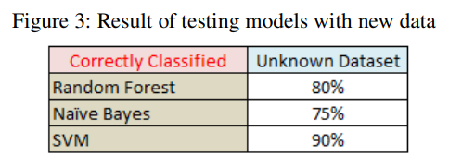

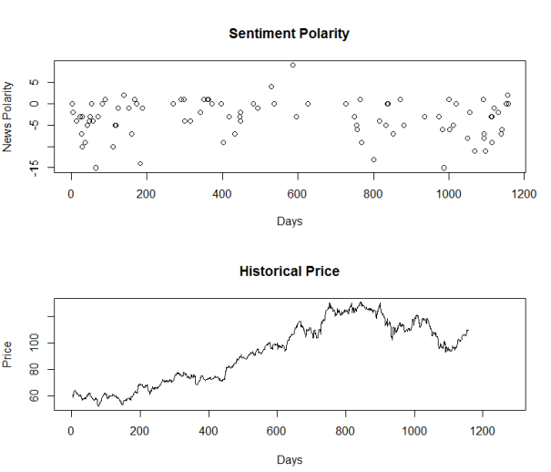

**3. RSS news feeds and Twitter**

**3.1 Twitter and its relation on stock market prediction**

Twitter is a real-time social media stage that provides the public to interact with SMS facilities. A single post is known as a tweet which can have up to 140 characters. Users can update posts which can be any kind of media to express their intrusiveness, to express themselves, or merely to update status to companions and relatives to know about their posts. To foretell market upcoming trend, an exceptional data source comprises many features that are collected from Twitter for doing sentiment study. It is free for all and either tweet can be resent without any isolation restrictions. Sentiment number is associated with the differences in the Sensex points of stock for a certain time.

**3.2 RSS news feeds and its effect on stock**

RSS is a setup as presenting frequently evolving content. On numerous news-providing sites, online publicizers make the content in such a way that it seems to be RSS Supplies to whoever requires it. The XML report helps content syndication. Really simple syndication is a safe approach to produce the web content presented to the Internet since the information is short and fast-loading, it can be practiced with facilities like smartphones, voicemails, and electronic mail. Unlike electronic mail and RSS news is zero support, the information will never become filtered or blacklisted. Including RSS, users can filter desired knowledge from undesired knowledge. Really simple syndication texts use very simple syntax and self-explaining. Frequently, an RSS feeds holds the caption, author, and date knowledge in extension to description and links. If regular and big news on current events is released then that has an actual influence on the market values. This is captured by analyses of the RSS news feeds. It accepts stock RSS news feeds and tweets automatically retrieved from the Twitter website. It also retrieves historical prices from the respective stock market site. One of the parallel tasks is performing sentiment mining on the contents of RSS news feeds and tweets retrieved from the Twitter site. . All collected feeds are small sentences and stored in the document. In the same way, tweets from Twitter contain an enormous number of text posts and it grows every day. Twitter aggregates users into communities and links users in a variety of ways, ranging from short dialogues to interest graphs. Short tweets are gathered and stored in a document. The collected data from RSS news feeds and tweets are noted as input sentences which are not parsed as sentences. They are in the form of a document. These sentences are passed to the pre-processing steps where only document cleaning is performed. Undesired contents such as semicolons, numbers, symbols, comma date and time, etc. are termed as unwanted content and are eliminated in this very first step. After giving the cleaning operation, the text splitting module will classify the document into an individual sentence and stored them in a separate file. 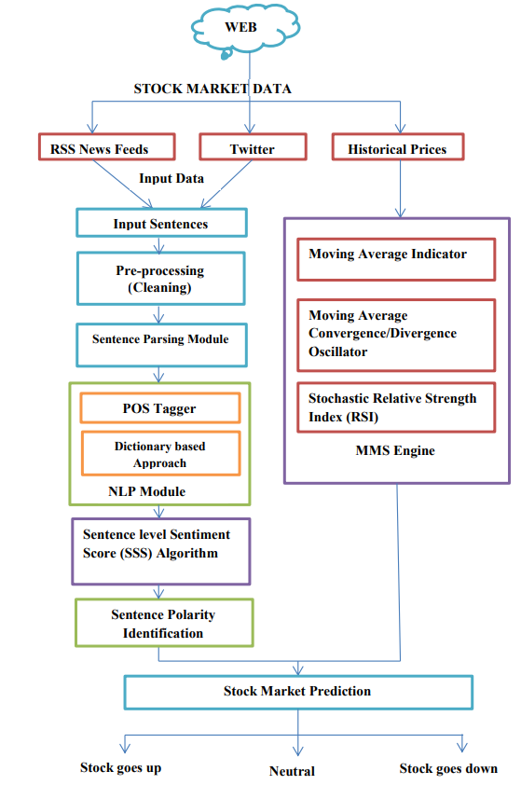

**Conclusion**

Determining future stock trends is an important responsibility because trends of stocks depend on several factors. We seized that news items and stock prices were correlated. Also, news can have the potential for stock volatility. Therefore, we examined this association and decided that stock trends could be divined using news feeds and past price history. As feeds headlines fascinate the sentiments of the modern market, we make that discovery of the views, and based on the text in the news feeds, we can find the general polarity of the news. Whether the news feeds are good, next we could say that here news influence is great in the stock market, so many opportunities of the stock going up and if the news feeds are not good, then it could affect the price of the stock to decline. We used polarity detection methods originally to label the news and get the trained set. In this approach, a dictionary-based strategy has been adopted. References of direct and indirect speech are developed using common and monetary terms. Subsequently processing text data was also a tough job. We have developed our reference of terminology for the elimination of words, including specific punctuation marks. Depend on this, we used three interpretation models and were tested under various test circumstances. Next analyzing their outputs, RF performed very well in every test case covering 88% to 92% efficiency. The correctness succeeded by SVM is also seen at about 86%. The review of the Naive's algorithm is about 83%. Given any news feeds, it is likely that the model will come with a polarity that will continue to predict stock trends.

In a general market examination, indicators such as MA, EMA, or DMA, stock RSI stock indicators are used to predict the market. Earlier, we introduced the fact that RSS news sensor mines help improve stock market predictions and indicators. Here in this work, the influence of emotions of tweets and RSS feeds are analyzed. This is observed that every sentiment of stock indicators and social media improves that property of forecasts. Because our method is an integrated strategy, an empirical analysis was performed to test hypotheses H0 and HA. And HA has shown notable improvement in accuracy and accuracy compared to H0. You have ample evidence to refuse the vain hypotheses and accept other hypotheses. Here function can also be increased to predict customer purchasing patterns by including emotional mines from numerous social platforms such as RSS news feeds, Facebook, WhatsApp, and Tweets.

**References**

[1] Anurag Nagar, Michael Hahsler, Using Text and Data Mining Techniques to extract Stock Market Sentiment from Live News Streams, IPCSIT vol. XX (2012) IACSIT Press, Singapore

[2] W.B. Yu, B.R. Lea, and B. Guruswamy, A Theoretic Framework Integrating Text Mining and Energy Demand Forecasting, International Journal of Electronic Business Management. 2011, 5(3): 211-224 [3] J. Bean, R by example: Mining Twitter for consumer attitudes towards airlines, In Boston Predictive Analytics Meetup Presentation, 2011

[4] Yauheniya Shynkevich, T.M. McGinnity, Sonya Coleman, Ammar Belatreche, Predicting Stock Price Movements Based on Different Categories of News Articles, 2015 IEEE Symposium Series on Computational Intelligence

[5] P. Hofmarcher, S. Theussl, and K. Hornik, Do Media Sentiments Reflect Economic Indices? Chinese Business Review. 2011, 10(7): 487-492

[6] Q. Li, Y. Chen, L. L. Jiang, P.Li, and H. Chen, “A Tensor Based Information Framework For Predicting The Stock Market”, ACM Transactions on Information Systems, Vol.34,No.2, pp.1-30, 2016.

[7] Y. Kim, S.R. Jeong, and I. Ghani, “Text Opinion Mining To Analyze News For Stock Market Prediction”, International Journal of Advances in Soft Computing and its Applications, Vol. 6, No. 1, pp. 1-13, 2014.

[8] S. Bharathi and A. Geetha, “Sentiment Analysis for Effective Stock Market Prediction”, International Journal of Intelligent Engineering and Systems, Vol.10, No.3, pp. 146- 153, 2017.

[9] L. Yu, L. Hu and L.Tang, “Stock Selection With A Novel Sigmoid-Based Mixed Discrete Continuous Differential Evolution Algorithm”, IEEE Transactions on Knowledge and Data Engineering, Vol.28, No.7, pp.1891- 1904, 2016.

[10] Z. Z. Alp and S. G.Oguduc, “Extracting Topical Information of Tweets Using Hash Tags”, In: Proc. of the IEEE International Conf. on Machine Learning and Applications, Vol.1, No.1, pp. 644-648, 2015.

[11] M. Kanakaraj and R. M. R. Guddeti, “Performance Analysis of Ensemble Methods on Twitter Sentiment Analysis Using NLP Techniques”, In: Proc. of the IEEE International Conf. on Semantic Computing, Vol.1, No.1, pp. 169-170, 2015.