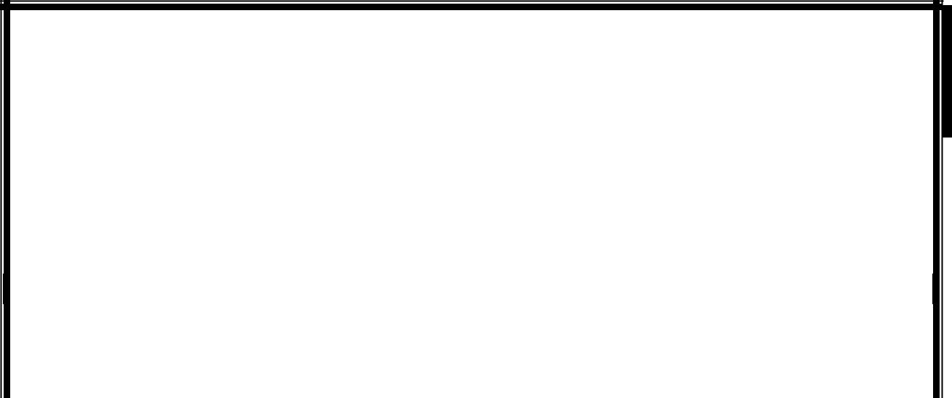

INVESTMENT PREDICTION

A Project Report submitted in partial fulfilment of the requirements for the award of the degree of

Bachelor of Technology


in
Computer Science and Engineering

by

Aditi Gupta (171510007)
Ashree Verma (171520007)
Hemant Kumar (171520013)

Under the Guidance of

Mr. Rahul Pradhan

Department of Computer Engineering & Applications

Institute of Engineering & Technology

GLA University

Mathura- 281406, INDIA

May, 2020


Department of Computer Engineering and Applications

GLA University, 17 km. Stone NH#2, Mathura-Delhi Road, Chaumuha, Mathura – 281406 U.P (India)

Declaration

I hereby declare that the work which is being presented in the B.Tech. Project “Investment Prediction”, in partial fulfillment of the requirements for the award of the Bachelor of Technology in Computer Science and Engineering and submitted to the Department of Computer Engineering and Applications of GLA University, Mathura, is an authentic record of my own work carried under the supervision of Mr. Rahul Pradhan, Assistant Professor, GLA University.
The contents of this project report, in full or in parts, have not been submitted to any other Institute or University for the award of any degree.

Sign ______________________ Sign ______________________
Name of Candidate: Aditi Gupta Name of Candidate: Ashree Verma
University Roll No.: 171510007 University Roll No.: 171520007

Sign ______________________
Name of Candidate: Hemant Kumar
University Roll No.: 171520013

Certificate

This is to certify that the above statements made by the candidate are correct to the best of my/our knowledge and belief.

_______________________

Supervisor
Mr. Rahul Pradhan
Assistant Professor, Dept of CEA

____________________ ____________________________

Project Coordinator Program Co-ordinator

(Mr. Mayank Srivastava) (Dr Anant Ram)

Date:

ACKNOWLEDGEMENT

It gives us a great sense of pleasure to present the report of the B. Tech Major Project undertaken during B. Tech Fourth Year. This project in itself is an acknowledgement to the inspiration, drive and technical assistance contributed to it by many individuals. This project would never have seen the light of the day without the help and guidance that we have received.
Our heartiest thanks to Prof. (Dr.) Anand Singh Jalal, Head of Dept., Department of CEA for providing us with an encouraging platform to develop this project, which thus helped us in shaping our abilities towards a constructive goal.

We owe special debt of gratitude to Mr. Rahul Pradhan, Assistant Professor Department of CEA, for his constant support and guidance throughout the course of our work. His sincerity, thoroughness and perseverance have been a constant source of inspiration for us. He has showered us with all his extensively experienced ideas and insightful comments at virtually all stages of the project & has also taught us about the latest industry-oriented technologies.
We also do not like to miss the opportunity to acknowledge the contribution of all faculty members of the department for their kind guidance and cooperation during the development of our project. Last but not the least, we acknowledge our friends for their contribution in the completion of the project.
Sign ______________________ Sign ______________________
Name of Candidate: Aditi Gupta Name of Candidate: Ashree Verma
University Roll No.: 171510007 University Roll No.: 171520007

Sign ______________________
Name of Candidate: Hemant Kumar
University Roll No.: 171520013

ABSTRACT

In the recent, past accurate forecasting of stock market has become a challenging task. The proposed approach helps to achieve high precision in stock market prediction by combining the Sensex points, with sentimental analysis on Tweets. The project focuses on the correlation between the stock market values, sentiments of tweets for a particular period of time. In this, a trained model is used for stock market prediction rates. Experimental study focuses on the stock prices and tweets which are collected for the company Tesla from Yahoo Finance. This project uses stock level indicators to predict the trend of stock rates and the sentiment analysis of tweets as stock enhances the accuracy of prediction. The LSTM model for technical analysis has shown a mean square error of 0.00679847 while the accuracy for best model for fundamental analysis was around 80%.

List of Figures

3.1 Prediction model Diagram for sentimental analysis

3.2 Flow of technical analysis

    - Importing Libraries

4.2.2 Importing dataset

    - Describing the dataset

    - Creating data frame

4.3.1 Removing special characters from tweet column of dataset

4.3.2 Removing Stop words

4.3.3 Performing stemming, bringing words to their base form

4.4.1 Importing libraries for sentimental analysis

4.4.2 Adding four columns compound, positive, negative and neutral to our data frame

4.4.3 Code for performing sentimental analysis in each tweet

4.4.4 Creating dataset to combine tweets with historical stock prices

4.4.5 Sorting data on basis of date

4.4.6 Combining multiple tweets of each day

4.5.1 Applying sentimental analyzer

4.5.2 Adding price column to our dataset

4.5.3 Printing the missing values

4.5.4 Replacing blank values with mean prices

4.5.5 Changing the datatype of price as integer to perform mathematical operations

4.5.6 Pie chart depicting the ratio of positive and negative tweets

4.5.7 Setting date as the index of dataframe

4.5.8 Splitting data frame into test and train
4.5.9 Calculating the sentiment score of each tweet

4.5.10 Training the decision tree model

4.5.11 Actual price vs price predicted by decision tree model

4.5.12 Applying linear regressor

4.5.13 Applying random forest

4.5.14 Actual price vs price predicted by random forest model

4.6.1 Splitting dataset for technical analysis by linear regression

4.6.2 Using linear regressor model from sckit learn library

4.6.3 Predicting prices

4.6.4 Plotting predicted value against actual

4.6.5 Test score of linear model

4.7.1 Splitting dataset for basic LSTM model

4.7.2 Building the basic LSTM model

4.7.3 Training the basic LSTM model and train dataset

4.7.4 Predicting prices using basic LSTM model

4.7.5 Plot of actual and predicted value

4.7.6 Test scores for improved LSTM model

4.8.1 Splitting dataset for improved LSTM model

4.8.2 Building the improved LSTM model

4.8.3 Training the improved LSTM model and train dataset

4.8.4 Predicting prices using improved LSTM model

4.8.5 Plotting actual and predicted value

4.8.6 Curve of basic LSTM model

4.8.7 Curve of improved LSTM model

List of Tables

3.1 Calculation of final result based on both fundamental and technical analysis

CONTENTS

Declaration ii
Certificate ii
Acknowledge iii
Abstract iv
List of figures v
List of Tables vii

CHAPTER 1 Introduction 1
1.1 Overview and Motivation 1
1.2 Objective 3
1.3 Issues and Challenges 5
1.4 Organization of the Project 5

CHAPTER 2 Literature Review 6
CHAPTER 3 Proposed Work 9
CHAPTER 4 Implementation and Result Analysis 17
CHAPTER 6 Conclusion 42

APPENDICES
Appendix 1. References

Chapter 1
Introduction

  - Overview and Motivation
Stock prices are considered as a basic measure in the prediction of stock market. Well defined strategies are used for earning high profit. The main aim of this work is to minimize the inaccurate forecasting of stock prices along with the help of sentiment analysis. Mathematically different indicators are there. However, their level of accuracy in prediction is not very satisfactory. One way of improving this prediction process is by incorporating the sentiments and moods of public along with news events at that period of time. For capturing the sentiments of people, social media mining can be made use of. In our case we consider the tweets related to company.
In general stock market is volatile and needs accurate forecast model. It is very difficult for an individual to consider all the current and past information for predicting future trend of a stock because it provides large amount of data every day. These high fluctuations affect the investor’s belief. Financial stock market movements mainly depend on news, social networking sites like twitter, Facebook etc.
There are two standard measures used for predicting market trends. One is technical analysis and another one is fundamental analysis. Technical analysis considers daily ups and downs, trend indicators, highest and lowest values of a day, indices past price and volume to predict the future trend whereas Fundamental analysis involves reports and analyzing its financial data to get some insights.
Nowadays, stock analysts can share their views through news document and social networking sites like twitter, Facebook etc. The behavior of investors is greatly affected by the sentiment of these mass media. Twitter contains an enormous number of text posts and it grows every day. The collected corpus can be arbitrarily large. Thus, if sentiments are correctly categorized and their polarity are correctly determined they can be helpful in enhancing a company’s performance and making its investors happy.

Modern data mining techniques have led to the development of sentiment analysis, an algorithmic approach for detecting the predominant sentiment about a product or company using social media data. A prominent field for the use f sentiment analysis has been stock market forecasting, a subject undeniably undergoing intense studies. Nowadays, a great volume of data, which contains information about numerous topics, is being transmitted online through various social media. An excellent example is Twitter, where over 400 million tweets are sent daily. Though each tweet may not be significant as a unit, a large collection of them can provide data with valuable insight about the common opinion on a particular subject. Gauging the public’s sentiment by retrieving online information from Twitter, can be valuable in forming trading strategies. The correct prediction about the fluctuation of stock prices depends on many factors, and public sentiment is arguably included. Well defined strategies are used for earning high profit. The main aim of this work is to minimize the inaccurate forecasting of stock prices along with the help of sentiment analysis. Mathematically different indicators are there. However, their level of accuracy in prediction is not very satisfactory. One way of improving this prediction process is by incorporating the sentiments and moods of public along with news events at that period of time. For capturing the sentiments of people, social media mining can be made use of There are two standard measures used for predicting market trends. One is technical analysis and another one is fundamental analysis. Technical analysis considers daily ups and downs, trend indicators, highest and lowest values of a day, indices past price and volume to predict the future trend whereas Fundamental analysis involves reports and analysing its financial data to get some insights. The ability of both technical and fundamental analysis is discovered by the efficientmarket hypothesis which states that stock market prices are essentially unpredictable.

  - Objective
Stock market prediction is the act of trying to determine the future value of a company stock or other financial instrument traded on an exchange. The successful prediction of a stock's future price could yield significant profit. The efficient market hypothesis suggests that stock prices reflect all currently available information and any price changes that are not based on newly revealed information thus are inherently unpredictable. Others disagree and those with this viewpoint possess myriad methods and technologies which purportedly allow them to gain future price information.
In Stock Market Prediction, the aim is to predict the future value of the financial stocks of a company. The recent trend in stock market prediction technologies is the use of machine learning which makes predictions based on the values of current stock market indices by training on their previous values. Machine learning itself employs different models to make prediction easier and authentic Nowadays, stock analysts can share their views through news document and social networking sites like twitter, Facebook etc. The behavior of investors is greatly affected by the sentiment of these mass media. Twitter contains an enormous number of text posts and it grows every day. The collected corpus can be arbitrarily large. Thus, if sentiments are correctly categorized and their polarity are correctly determined they can be helpful in enhancing a company’s performance and making its investors happy.
There are two standard measures used for predicting market trends. One is technical analysis and another one is fundamental analysis. Technical analysis considers daily ups and downs, trend indicators, highest and lowest values of a day, indices past price and volume to predict the future trend whereas Fundamental analysis involves reports and analyzing its financial data to get some insights. The ability of both technical and fundamental analysis is discovered by the efficientmarket hypothesis which states that stock market prices are essentially unpredictable. Nowadays, stock analysts can share their views through news document and social networking sites like twitter, Facebook etc. The behavior of investors is greatly affected by the sentiment of these mass media. Recently twitter has been used to detect and forecast trading and investing to break critical financial news faster. Twitter contains an enormous number of text posts and it grows every day. The collected corpus can be arbitrarily large. Thus, if sentiments are correctly categorized and their polarity are correctly determined they can be helpful in enhancing a company’s performance and making its investors happy. This research paper investigates the public sentiment, as expressed in large scale collections of daily twitter posts and RSS news feeds collected from stock related websites can indeed be used to predict the stock market. A new novel approach is proposed to predict buy or sell signal to the investors in the stock market. This paper proposed a forecasting method by combining the stock related tweets and RSS news feeds with Sensex points. Based on the combined result of opinion of sentences collected from tweets, feeds and Sensex points of various stock related indicators the investors buy or sell their products
Investment firms, hedge funds and even individuals have been using financial models to better understand market behavior and make profitable investments and trades. A wealth of information is available in the form of historical stock prices and company performance data, suitable for machine learning algorithms to process. Can we actually predict stock prices with machine learning? Investors make educated guesses by analyzing data. They'll read the news, study the company history, industry trends and other lots of data points that go into making a prediction. The prevailing theories is that stock prices are totally random and unpredictable but that raises the question why top firms like Morgan Stanley and Citigroup hire quantitative analysts to build predictive models. We have this idea of a trading floor being filled with adrenaline infuse men with loose ties running around yelling something into a phone but these days they're more likely to see rows of machine learning experts quietly sitting in front of computer screens. In fact, about 70% of all orders on Wall Street are now placed by software, we're now living in the age of the algorithm. This project seeks to utilize Deep Learning models, Long-Short Term Memory (LSTM) Neural Network algorithm, to predict stock prices. For data with timeframes recurrent neural networks (RNNs) come in handy but recent researches have shown that LSTM, networks are the most popular and useful variants of RNNs. We have used Keras to build a LSTM to predict stock prices using historical closing price and trading volume and visualize both the predicted price values over time and the optimal parameters for the model. We also have used Sentimental Analyzer to calculate the future price of stock using twitter data.

  - Issues and Challenges
Prediction of stock market trends is considered as an important task and is of great attention as predicting stock prices successfully may lead to attractive profits by making proper decisions. Stock market prediction is a major challenge owing to non-stationary, blaring, and chaotic data, and thus, the prediction becomes challenging among the investors to invest the money for making profits. Several techniques are devised in the existing techniques to predict the stock market trends. The commonly used technique for attaining effective stock market prediction is ANN and the fuzzy-based technique. Even though a lot of research efforts, the current stock market prediction technique still has many limits.

  - Organization of project report
Firstly, the literature review has been done which is the previous work done under the similar problem statement. A detailed study of the existing models and accuracy achieved from them. After reviewing we have proposed our model. We have included the algorithm, use case and pseudo code. We further included the implementation details and the accuracy achieved by us. After implementation and result analysis we have concluded.

Chapter 2
Literature Review

Alongside the rising number of blogs and social media, opinion mining and sentiment analysis became very popular and began to spread. An extensive synopsis of the existing work was presented in [7]. Wysoki’s research project had as a goal to study stock market message boards for over 3,000 stocks to determine if a correlation between discussion board message volume and message quality had any effect on the volume or price for a stock. A key contribution of this research showed a strong positive correlation between the volume of messages posted on the discussion boards during the hours that the stock market was not open and the next trading day’s volume and stock returns. The researchers stated that a tenfold increase in message postings in the overnight hours led to an average increase in the next day’s stock volume of approximately 15.6 percent and a 0.7 percent increase in next day stock returns [7]. Along the same lines, [1] took into account messages posted on stock-related message boards and calculated their ability to affect the movements of stock prices. The researchers examined around 1.5 million messages posted on two message boards for 45 companies and performed text classification and sentiment analysis to define the sentiment of each message. With their work they were able to show a positive correlation between message board posts and stock price fluctuations on the day after [1]. While both of the above projects involved stock message discussion boards, attempts have been made in order for modern media to be included. In particular, many have used Facebook, Twitter and other social media platforms in order to predict the movement of stock prices or of the market in general. For example, [5] proposed the use of Twitter specifically as a corpus for sentiment analysis and referred to the methods of tweet gathering and processing. The researchers used specific emoticons to form a training set for sentiment classification, a method that curtailed the need to tag tweets by hand. Their training set was divided into positive and negative samples based on happy and sad emoticons [5]. Undeniably, the work of [2] is amongst the most popular on the field. In their publication, the researchers described the use of sentiment analysis of a large corpus of Twitter messages in order to understand the average mood of Twitter users on a specific day. Afterwards, these results became the input into a neural network prediction engine in order to forecast the movement of stock prices on the very next day, with a reported 87.6 percent accuracy of prediction of the Dow Jones Industrial Average.
Even though this project did indeed show a correlation between sentiment scores and stock price movements, the authors also proceeded in examining a vast number of tweets derived from all Twitter users and not just from users directed toward the stock market. Their effort was made in order to grasp the overall sentiment of the Twitter population
Furthermore, the paper of [3] achieves a 75 percent accurate prediction mechanism using Self Organizing Fuzzy Neural Networks on Twitter and DJIA feeds. In their research, they created a custom questionnaire with words to analyze tweets for their sentiment. Last but not least, another important publication is that of [6]. They decided to follow a more straightforward path by focusing on the “Standard and Poor’s” (S&P) top 100 stocks, collecting only related tweets. These were then analyzed in order to determine if the sentiment of a company on Twitter has any correlation to the movement in price or volume. [6] decided to follow the dollar symbol preceding the stock market symbol, nomenclature popularized by the stocktwitstook.com website and its users, in order to reduce the large amount of “noise” on Twitter. This nomenclature allowed them to collect only tweets that had been created and shared by users with an interest in the stock market. Their results indicate that the sentiment of a company on Twitter closely follows market movements and that message volume on Twitter is positively correlated to the trading volume for that stock [6]. The techniques proposed by these papers provide an interesting overview of sentiment analysis and how it can relate to the stock market. However, the results seem varied and may depend on the accuracy of a twitter sentiment classifier, as well as the preprocessing and filtering of tweets, including the process of choosing which tweets to use for analysis. In this work, we emulate some of these previous works to build a sentiment analyzer, but specifically for the Twitter domain.
The most well-known publication in this area is by Bollen [10]. They investigated whether the collective mood states of public (Happy, calm, Anxiety) derived from twitter feeds are correlated to the value of the Dow Jones Industrial Index. They used a Fuzzy neural network for their prediction. Their results show that public mood states in twitter are strongly correlated with Dow Jones Industrial Index. Chen and Lazer [12] derived investment strategies by observing and classifying the twitter feeds. Bing et al. [15] studied the tweets and concluded the predictability of stock prices based on the type of industry like Finance, IT etc. Zhang [13] found out a high negative correlation between mood states like hope, fear and worry in tweets with the Dow Jones Average Index. Recently, Brian et al. [14] investigated the correlation of sentiments of public with stock increase and decreases using Pearson correlation coefficient for stocks. In this paper, we took a novel approach of predicting rise and fall in stock prices based on the sentiments extracted from twitter to find the correlation.
The core contribution of our work is the development of a sentiment analyzer which works better than the one in Brian’s work and a novel approach to find the correlation.
Sentiment analyzer is used to classify the sentiments in tweets extracted. The human annotated dataset in our work is also exhaustive. We have shown that a strong correlation exists between twitter sentiments and the next day stock prices in the results section. We did so by considering the tweets and stock opening and closing prices of Microsoft over a year.
In order to predict rises and falls on the Korea Composite Stock Price Index (KOSPI), compile a stock domain specific sentimental word dictionary from the news as big data and predict ‘sentiment’ for that Korean language news. Needs further improvement in attributes such as market prospects, overseas news, and corporate performance This research explores the opinion mining on stock market by combining the Sensex points of moving average stock level indicator with RSS news feeds which obtained the high accuracy rather than individual Sensex calculation . This paper needs to focus on more than one stock level indicator with sentiment analysis

Chapter 3
Proposed Work

We collected tweets for Tesla from Kaggle and subsequently processed them for further analysis, which included Natural Language Processing (NLP) and Sentiment Analysis. Thereafter, we applied Naive Bayes, Decision Tree, Linear Regression and Random Forest to predict each tweet’s sentiment. By evaluating each model for its proper sentiment classification, we discovered that Random Forest give higher accuracy through cross validation. Despite this fact, we continued to take into consideration all techniques and compare every time their accuracy. After predicting every tweet’s sentiment, we mined historical stock data using Yahoo finance API. We then created a respective feature matrix for stock market prediction using sentiment score and stock price’s change for each day and at the end we proposed our own trading strategy.
After calculating the stock prices from the twitter sentiments, we utilized Deep Learning models, Long-Short Term Memory (LSTM) Neural Network algorithm, to predict stock prices. For data with timeframes recurrent neural networks (RNNs) come in handy but recent researches have shown that LSTM, networks are the most popular and useful variants of RNNs. We used Keras to build a LSTM to predict stock prices using historical closing price and trading volume and visualize both the predicted price values over time and the optimal parameters for the model. Results of both have been used to predict the final up or down.
So, in order to produce the final result, we are using two methods:
- Fundamental Analysis of twitter data
- Technical Analysis of previous five-year stock prices
After getting results from individual models we will be using table no 3.1 to conclude whether the prices will go up, down or neutral.
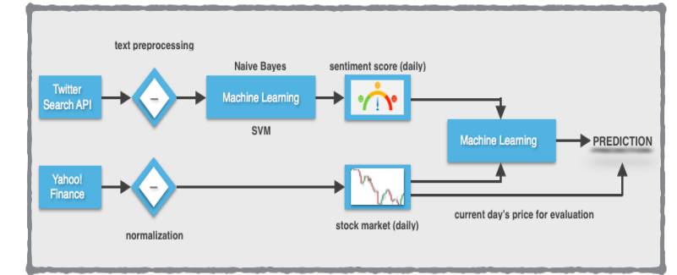
Kaggle
data
Yahoo!
Finance
Fig 3.1
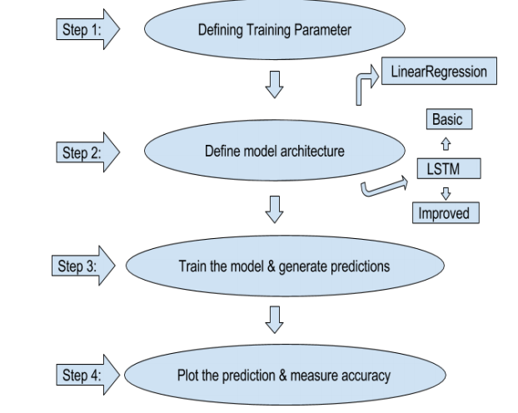
Fig 3.2

Sentiment Analysis of Twitter | Stock Level Indicators | Final Result Prediction
Positive | Positive | Positive
Positive | Neutral | Positive
Positive | Negative | Positive
Neutral | Negative | Neutral
Negative | Neutral | Negative
Neutral | Positive | Positive
Negative | Negative | Negative
Neutral | Neutral | Neutral
Table 3.1

Fundamental Analysis
Datasets:
We used Kaggle dataset:
• The dataset used is of tweets of top five companies
• For each tweet these records provide a tweet id, the timestamp and tweet text, which is by design limited to 140 characters and needs to be filtered from noise. Since we perform our prediction and analysis on a daily basis, we split the tweets by days using the timestamp as the main index of the data frame.

Twitter Data Preprocessing
The main problem we faced was that while the Twitter data were available for each day of the week, including weekends, the stock values were absent for weekends and other holidays when the market is closed. In order to fill the missing values, we overcame this problem by using a simple statistical function. If the value that is missing is y, the previous known value is xprevious and the next known value is xnext, then the value y will be: y = (xprevious + xnext)/2. This approximation works most of the time very well except in cases of unexpected rapidly rise and fall.

Sentiment Analysis
Text Processing The text of each tweet includes a lot of words that are irrelevant to its sentiment. For example, some tweets contain URLS, tags to other users, or symbols that have no meaning. In order to better determine a tweet’s sentiment score, before anything else we had to exclude the “noise” that occurred because of these words.
For this to happen, we relied on a variety of techniques using the Natural Language ToolKit (NLTK) for Python. Sentiment analysis task is very much field specific. There is lot of research on sentiment analysis of movie reviews and news articles and many sentiment analyzers are available as an open source. The main problem with these analyzers is that they are trained with a different corpus. For instance, Movie corpus and stock corpus are not equivalent. So, we developed our own sentiment analyzer. Tweets are classified as positive, negative and neutral based on the sentiment present. 3,216 tweets out of the total tweets are examined by humans and annotated as 1 for Positive, 0 for Neutral and 2 for Negative emotions. For classification of nonhuman annotated tweets, a machine learning model is trained whose features are extracted from the human annotated tweets.

- Tokenization Firstly, we divided the text by spaces, thus forming a list of individual words per tweet. We then used each word in the tweet as features to train our classifier.
- Removing Stopwords Next, we removed stopwords from the list of words. Python’s Natural Language ToolKit library contains a stopword dictionary, which is a list of words that have neutral meaning and are inappropriate for sentiment analysis. To remove the stopwords from each text, we simply checked each word in the list of words against the dictionary. If a word was in the list, we excluded it from the tweet’s text. The list of stopwords contains articles, some prepositions, and other words that add no sentiment value (able, also, or, etc.)
- Twitter Symbols It is not uncommon that tweets may contain extra symbols such as “@” or “#” as well as URLs. On Twitter, the word following an “@” (mentions) symbol is always a username, which we also exclude because it adds no value at all to the text. Words following “#” (hashtags) are not filtered out because they may contain crucial information about the tweet’s sentiment. They are also particularly useful for categorization since Twitter creates new databases that are collections of similar tweets, by using hashtags. URLs are filtered out entirely, as they add no sentiment meaning to the text and could also be spams. Training Set Collection To train a sentiment analyzer and obtain data, we were in need of a system that could gather tweets. Therefore, we first collected a large number of tweets that would serve as training data for our sentiment analyzer. In the beginning, we considered manually tagging tweets with a “positive” or “negative” label. Thus, we created a list of 1000 hand-classified tweets but because it was hard and time-consuming, we decided to look for a database with already sentiment-classified tweets.

Surprisingly, we found that our search for other tweet corpuses returned no results, as Twitter had recently modified its terms of service to disallow public hosting of old tweets. Under these circumstances, we turned to alternative methods in order to form a training set. Specifically, we had two main ideas on how to classify tweets as training data. According to the first idea we created a “positive” and a “negative” dataset for training, by using Twitter’s Search API. Each dataset was created programmatically and was based on positive and negative queries on emoticons and keywords:
• Positive sentiment query: “:) :-) =) :D love like”
• Negative sentiment query: “:( =( hate, dislike”

Training the classifiers

Once we had collected a large tweet corpus as training data, we were able to construct and train a classifier. Within this project we used two types of classifiers: Linear Regression, decision tree, Support Vector Machine and Random Forest. We chose to focus on these algorithms because they are the state of the art for Sentiment Analysis. For both classifiers, we extracted the same features from the tweets to classify on

MACHINE LEARNING TECHNIQUES

Accurate classification continues to be an engaging problem in machine learning and data mining. It is more than often that we need to create a model with a set of training data and labels. In our case, we want to build a classifier that is trained on our “positive” and “negative” labelled tweet corpus. This way, the classifier will be able to label future tweets as either ”positive” or ”negative”, according to each tweet’s characteristics and features. In this project, we examine different classifiers used for text sentiment score evaluation like linear regression,

Decision tree, random forest etc.

Linear Regression

Linear Regression is a machine learning algorithm based on supervised learning. It performs a regression task. Regression models a target prediction value based on independent variables. It is mostly used for finding out the relationship between variables and forecasting. Different regression models differ based on – the kind of relationship between dependent and independent variables, they are considering and the number of independent variables being used.

Linear regression performs the task to predict a dependent variable value (y) based on a given independent variable (x). So, this regression technique finds out a linear relationship between x (input) and y(output). Hence, the name is Linear Regression.
In the figure above, X (input) is the work experience and Y (output) is the salary of a person. The regression line is the best fit line for our model. Y=θ₁ ₊ θ₂.X

Decision Tree

A decision tree is a flowchart-like structure in which each internal node represents a test on a feature (e.g. whether a coin flip comes up heads or tails) , each leaf node represents a class label (decision taken after computing all features) and branches represent conjunctions of features that lead to those class labels. The paths from root to leaf represent classification rules

Decision trees are constructed via an algorithmic approach that identifies ways to split a data set based on different conditions. It is one of the most widely used and practical methods for supervised learning. Decision Trees are a non-parametric supervised learning method used for both classification and regression tasks.

Tree models where the target variable can take a discrete set of values are called classification trees. Decision trees where the target variable can take continuous values (typically real numbers) are called regression trees. Classification and Regression Tree (CART) is general term for this.

Random Forest
Random Forest is a popular machine learning algorithm that belongs to the supervised learning technique. It can be used for both Classification and Regression problems in ML. It is based on the concept of ensemble learning, which is a process of combining multiple classifiers to solve a complex problem and to improve the performance of the model.
As the name suggests, "Random Forest is a classifier that contains a number of decision trees on various subsets of the given dataset and takes the average to improve the predictive accuracy of that dataset." Instead of relying on one decision tree, the random forest takes the prediction from each tree and based on the majority votes of predictions, and it predicts the final output.
The greater number of trees in the forest leads to higher accuracy and prevents the problem of overfitting.
Since the random forest combines multiple trees to predict the class of the dataset, it is possible that some decision trees may predict the correct output, while others may not. But together, all the trees predict the correct output. Therefore, below are two assumptions for a better Random forest classifier:
- There should be some actual values in the feature variable of the dataset so that the classifier can predict accurate results rather than a guessed result.
- The predictions from each tree must have very low correlations.

Neural Networks
An artificial neural network is a layered structure of connected neurons, inspired by biological neural networks. It is not one algorithm but combinations of various algorithms which allows us to do complex operations on data.

Recurrent Neural Networks
It is a class of neural networks tailored to deal with temporal data. The neurons of RNN have a cell state/memory, and input is processed according to this internal state, which is achieved with the help of loops with in the neural network. There are recurring module(s) of ‘tanh’ layers in RNNs that allow them to retain information. However, not for a long time, which is why we need LSTM models.
Technical Analysis
The goal of this project was to study time-series data and explore as many options as possible to accurately predict the Stock Price. Through research we came to know about Recurrent Neural Nets (RNN) which are used specifically for sequence and pattern 8 learning. As they are networks with loops in them, allowing information to persist and thus ability to memorizes the data accurately. But Recurrent Neural Nets have vanishing Gradient descent problem which does not allow it to learn from past data as was expected. The remedy of this problem was solved in Long-Short Term Memory Networks, usually referred as LSTMs. These are a special kind of RNN, capable of 9 learning long-term dependencies. In addition to adjusting the architecture of the Neural Network, the following full set of parameters can be tuned to optimize the prediction model:
- Input Parameters
- Preprocessing and Normalization (see Data Preprocessing Section)
- Neural Network Architecture
- Number of Layers (how many layers of nodes in the model; used 3)
- Number of Nodes (how many nodes per layer; tested 1,3,8, 16, 32, 64, 100,128)
- Training Parameters
- Training / Test Split (how much of dataset to train versus test model on; kept constant at 82.95% and 17.05% for benchmarks and lstm model)
- Validation Sets (kept constant at 0.05% of training sets)
- Batch Size (how many time steps to include during a single training step; kept at 1 for basic lstm model and at 512 for improved lstm model)
• Optimizer Function (which function to optimize by minimizing error; used “Adam” throughout)
• Epochs (how many times to run through the training process; kept at 1 for base model and at 20 for improved LSTM)
Data Preprocessing
Acquiring and preprocessing the data for this project occurs in following sequence, much of which has been modularized into the preprocess.py​ file for importing and use across all notebooks:
- Request the data from the Yahoo Finance and save it in TESLA.csv​ file in the following format.
- Remove unimportant features (date, high and low) from the acquired data and reversed the order of data, i.e., from January 03, 2005 to June 30, 2005.
- Normalized the data using MinMaxScaler ​ helper function from Scikit-Learn.
- Stored the normalized data in google_preprocessed.csv ​ file for future reusability.
- Splitted the dataset into the training and test datasets for linear regression model.
- Splitted the dataset into the training and test datasets for LSTM model.

Chapter 4

Implementation

FUNDAMENTAL ANALYSIS

4.1 IMPORT LIBRARIES

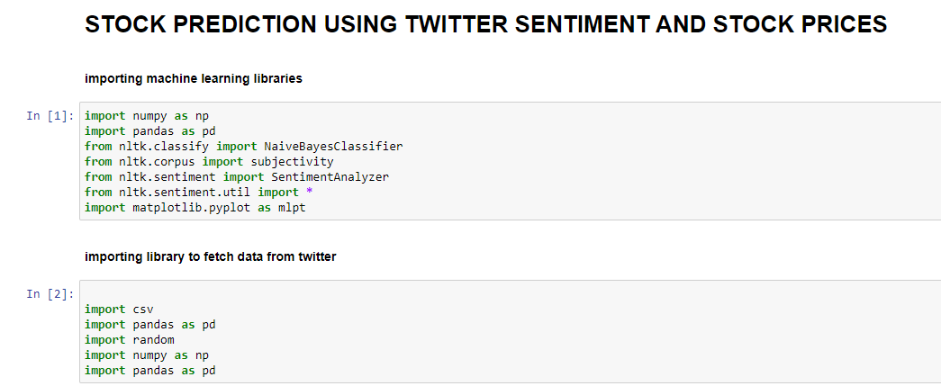

Fig: 4.1.1

4.2 DATA PREPRATION

Dataset has been collected from Kaggle https://www.kaggle.com/omermetinn/tweets-about-the-top-companies-from-2015-to-2020
This dataset is a part of the paper published in 2020 IEEE International Conference on Big Data Special Session 2, is created to determine possible speculators and influencers in a stock market. This dataset has tweets that are written about Amazon, Apple, Google, Microsoft, and Tesla by using their appropriate share tickers.
Since the dataset contains the information about all five companies we separated the data each company hence made our dataset for company “TESLA”.

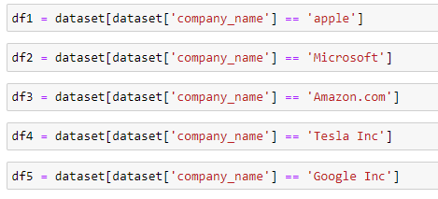

Fig: 4.2.1

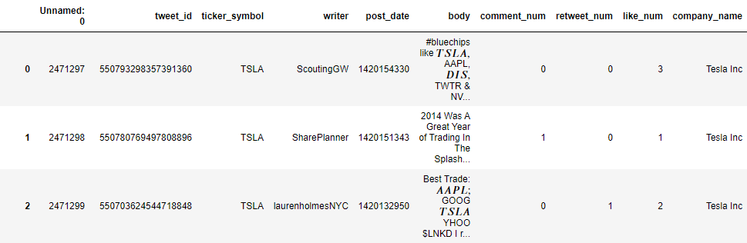

Fig: 4.2.2

The dataset for TESLA have 1096868 rows and 10 columns the column are labelled as:
- Company Name: The company to which the tweet belongs
- Post_Date: the epoch time of the tweet posted
- Tweet_id: the unique id of each tweet
- Writer: the author of the tweet
- Body: The text contained in the tweet
- Comment_num: the number of replies to the tweet
- Retweet_num: The number of retweets of the tweets

Creating the new data frame using the date and body of the tweet
The dataset has too many columns which are not necessary for the model hence we will only consider the columns which are usefull to us in predicting the value which are tweet text and date it was tweeted

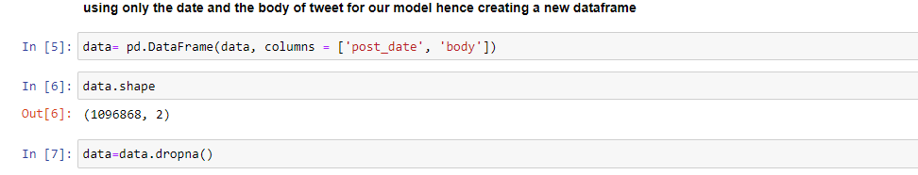

Fig: 4.2.3

Converting epoch time to normal time

The time given in dataset is epoch time format and we to understand it we need to convert it to human readable format so that we can have indexing based on date as well as some useful information

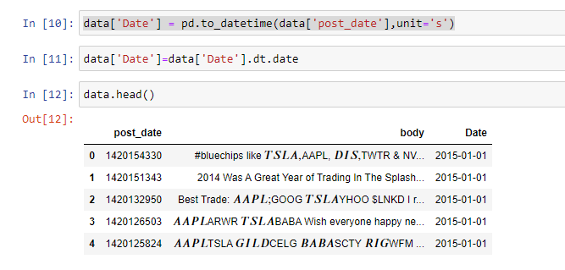
Fig: 4.2.4

4.3 DATA CLEANING

Removing of special characters from each tweet since it has no meaning in sentiment analysis
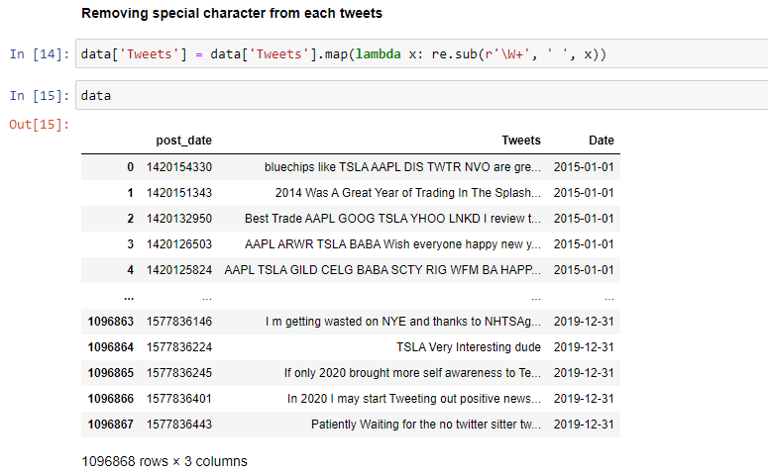

Fig: 4.3.1
Removing Stopwords: A stop word is a commonly used word (such as “the”, “a”, “an”, “in”) that a search engine has been programmed to ignore, both when indexing entries for searching and when retrieving them as the result of a search query.We would not want these words to take up space in our database, or taking up valuable processing time.

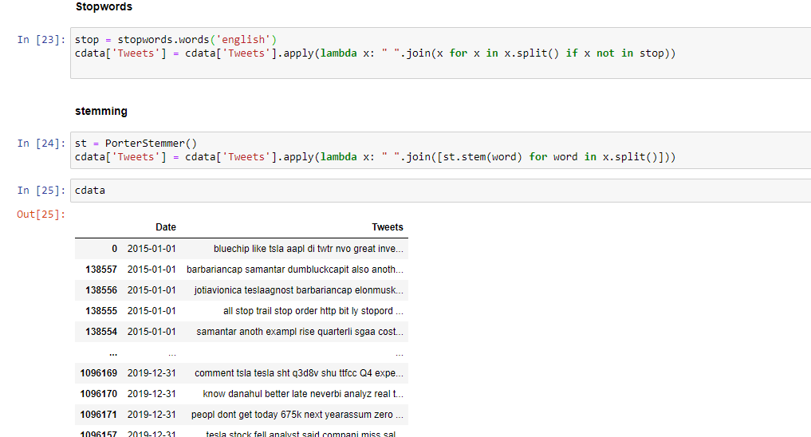

Fig: 4.3.2

Stemming: Stemming is the process of reducing inflected (or sometimes derived) words to their word stem, base or root form.
Fig: 4.3.3

4.4 SENTIMENTAL ANALYSIS

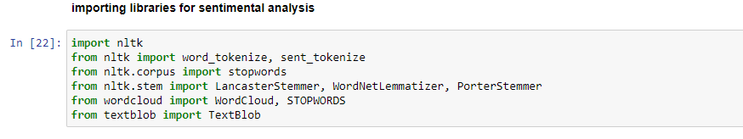

Fig: 4.4.1

We will be using lexicon sentiment analyzer which gives us four aspects compound, positive, negative, neutral so for that we add four columns to our dataset.

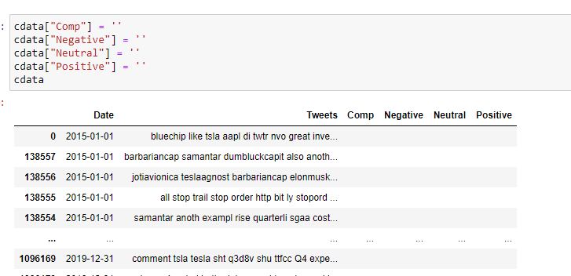
Fig: 4.4.2

Now we will perform sentiment analysis on each tweet of our dataset

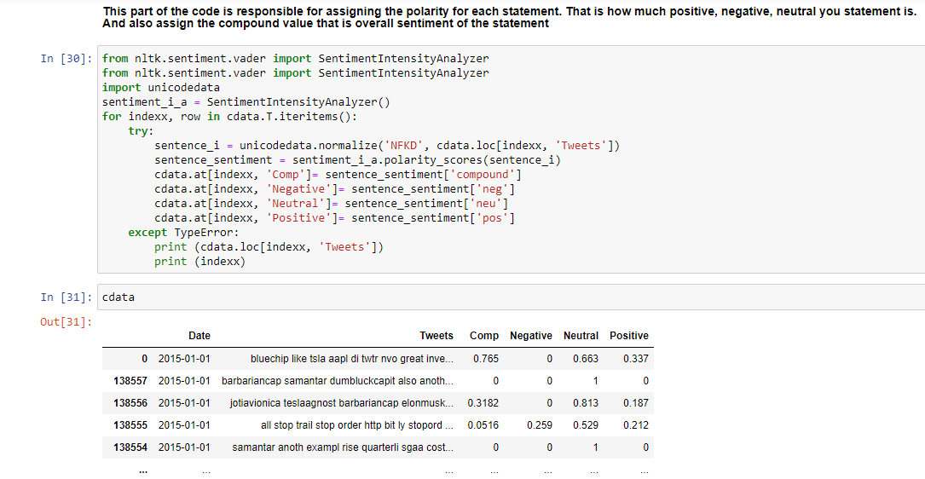

Fig: 4.4.3

Creating the dataframe where we will combine the tweets and store in it.

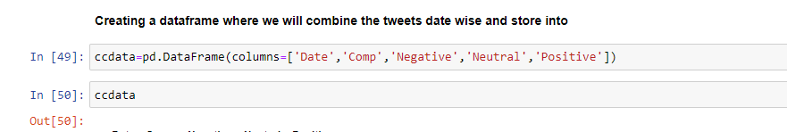

Fig: 4.4.4

Sorting the dataframe on the basis of date so that the tweet for the same date can be merged.
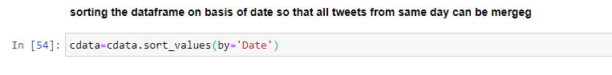
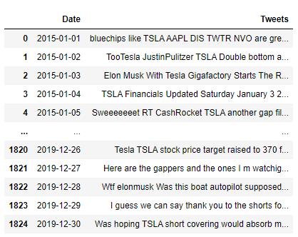

Fig: 4.4.5

We can see that there are multiple tweets for a single day and hence we need to put them all together for that we will combine the text of the tweet and use aggregate of positive, negative, compound and neutral for each day

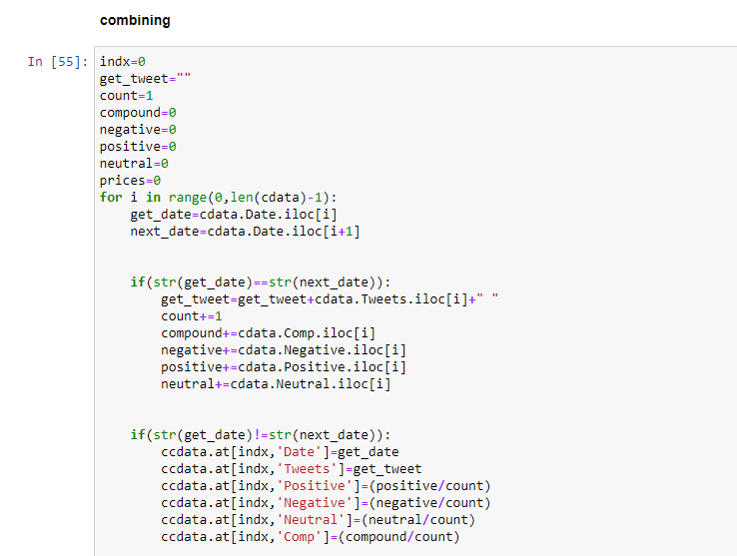
Fig: 4.4.6

4.5 MODEL APPLICATION
For application of model and to know the accuracy we need to know the actual stock prices of tesla for each day therefore importing the stock price data that we acquired form yahoo finance. Here will only consider the close price
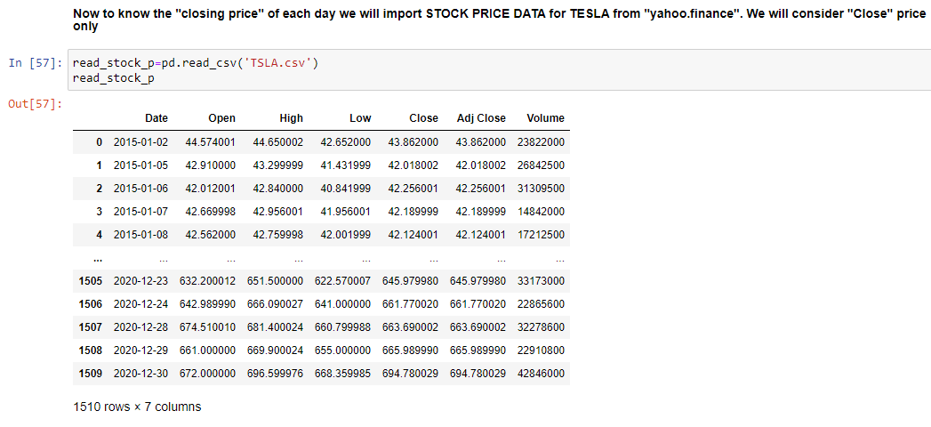

Fig: 4.5.1

Adding a “Price” Column in our existing data frame and fetching the stock price as per the date in our data frame

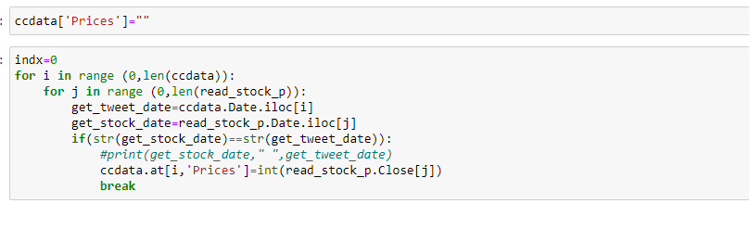

Fig: 4.5.2

Prices are fetched but some entries are blank as close price might not available for the day due to some reasons like holidays etc.

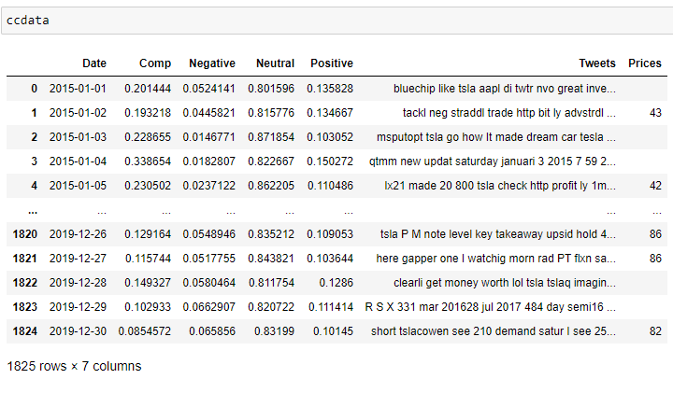

Fig: 4.5.3

So we will calculate the mean for the close price and put it in the blank value.

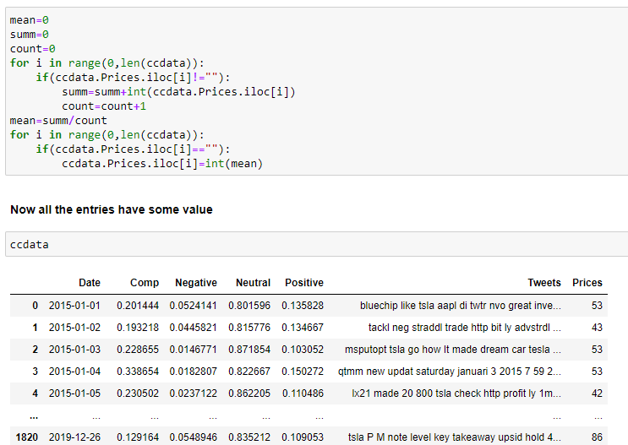

Fig: 4.5.4

Making “Prices” column as integer so mathematical operation can be performed easily.

Fig: 4.5.5

Calculating the percentage of Negative, Neutral and Positive tweets and displaying in the form of Pie-chart.

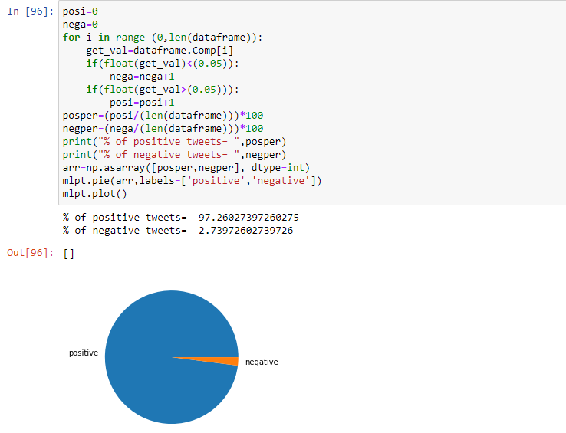

Fig: 4.5.6

Setting the date using index function in dataframe

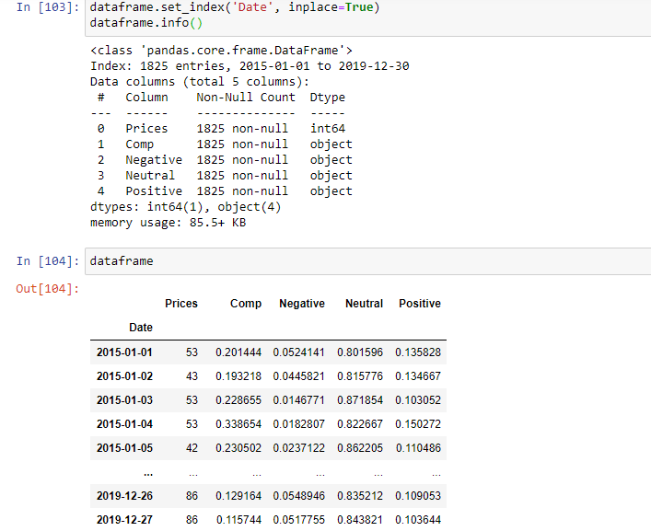

Fig: 4.5.7

Now we will split the dataframe.

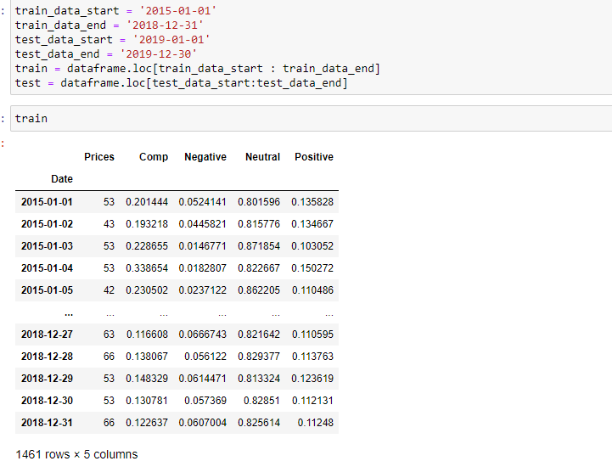

Fig: 4.5.8

Now we will calculate the sentiment score of train and test data

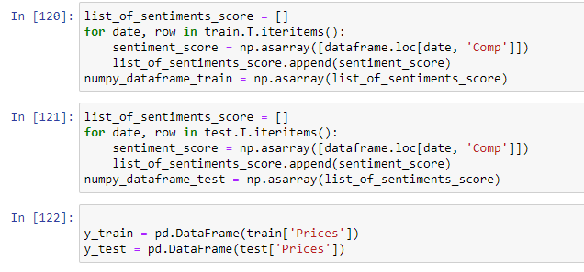

Fig: 4.5.9

Now by using the Decision Tree we will predict the price using actual price.

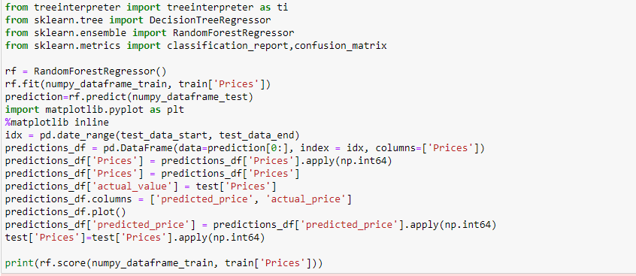

Fig: 4.5.10

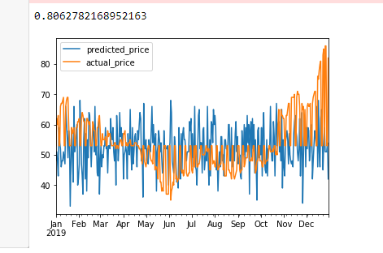

Fig: 4.5.11

Now we use Neural Network to predict the price

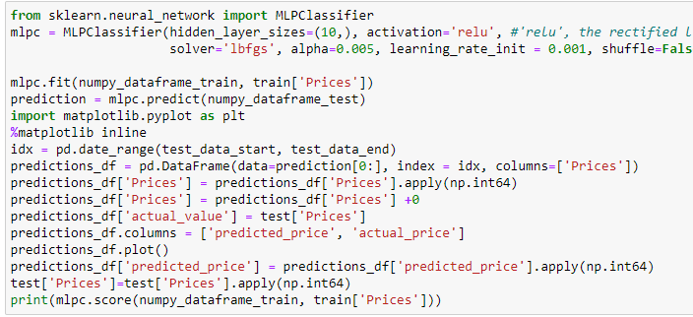

Fig: 4.5.11

Now we use linear regressor to predict the price

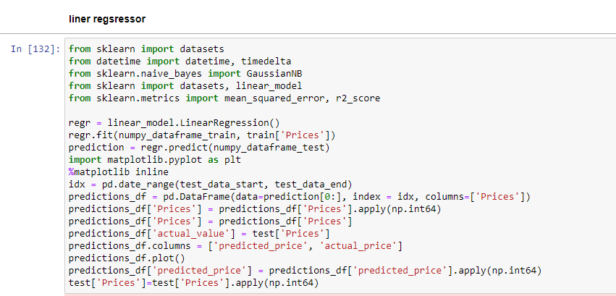

Fig: 4.5.12

Now we will use random forest to predict the value
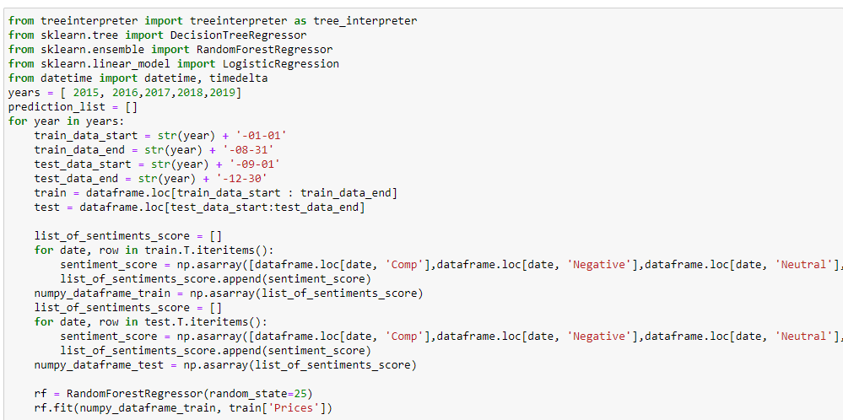

Fig: 4.5.13

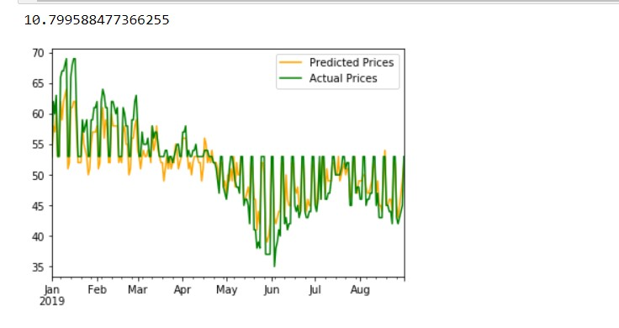

Fig: 4.5.14

TECHNICAL ANALYSIS

4.6 Benchmark Model

Step 1-Splitting into test and train set

Fig: 4.6.1

Here a function “train_test_split_linear_regression” is called which splits the data for linear regression model. The function is as follows:

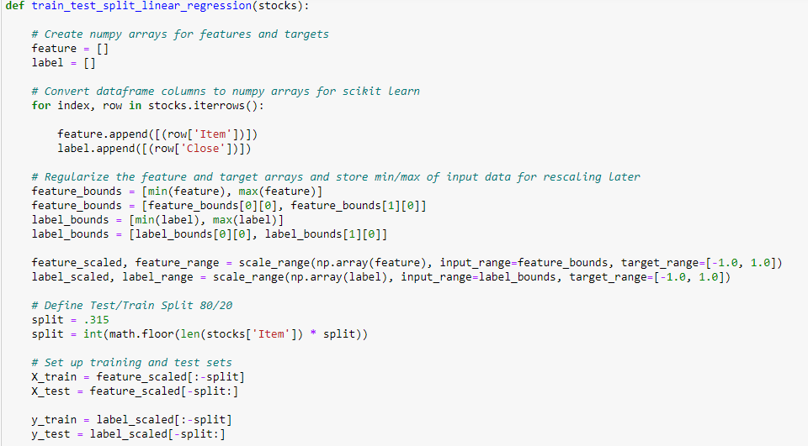

Step 2: In this step model is built using scikit-learn linear_model library.

Fig: 4.6.2

Step 3: Predicting the prices for given test datasets.

Fig: 4.6.3

Step4: Plot the predicted value against actual value

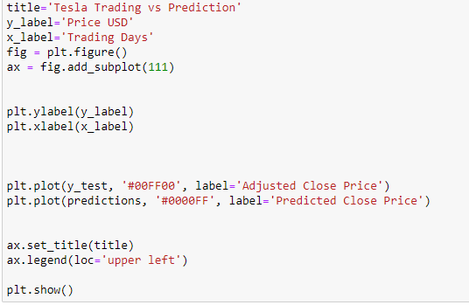

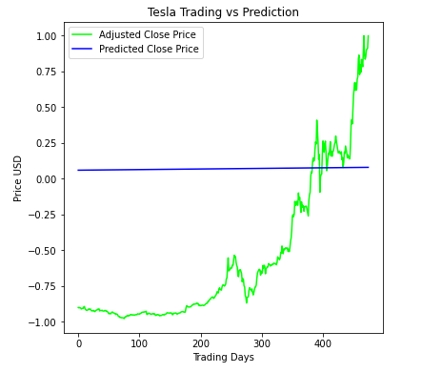

Fig: 4.6.4

Step 5: Finally calculate the test score

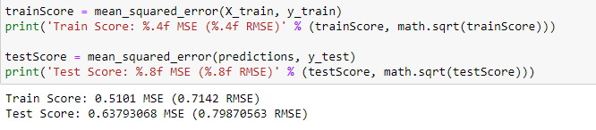

Fig: 4.6.5

4.7 Basic LSTM

Step 1-Splitting into test and train set

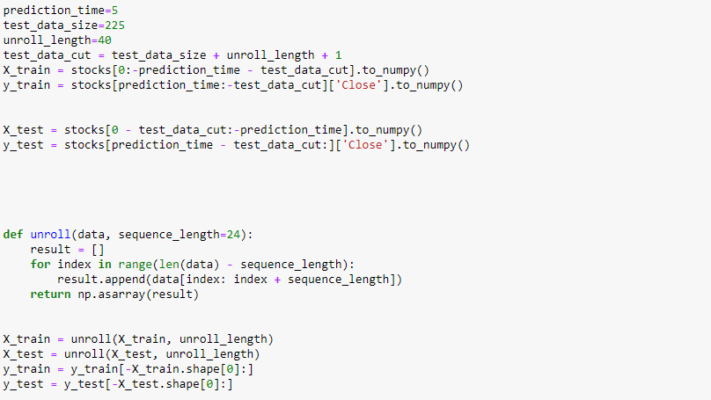

Fig: 4.7.1

Step 2: Build a basic LSTM model

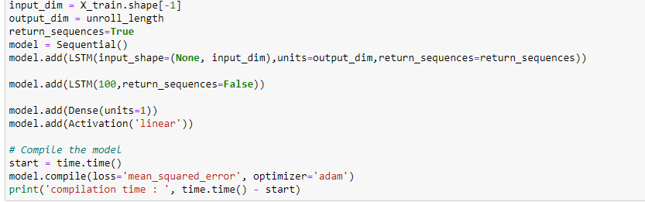

Fig: 4.7.2

Step 3: We now need to train our model

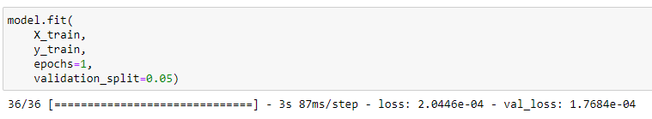

Fig: 4.7.3

Step 4: predicting the prices for given test datasets.

Fig: 4.7.4

Step5: Plot the predicted value against actual value

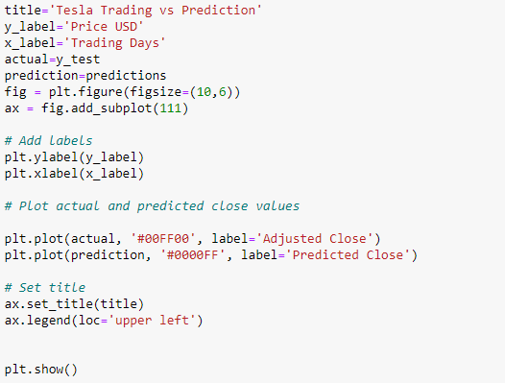

Fig: 4.7.5

Step 6: Finally calculate the test score

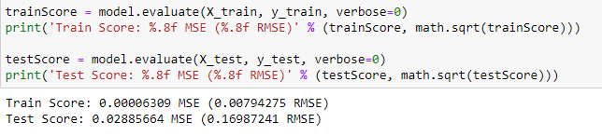

Fig: 4.7.6

4.8 Improved LSTM model

Step 1-Splitting into test and train set

Fig: 4.8.1

Step 2: Build an improved LSTM model

Fig: 4.8.2

Step 3: We now need to train our model

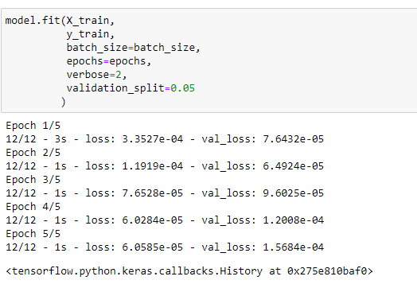

Fig: 4.8.3

Step 4: predicting the prices for given test datasets.

Fig: 4.8.4

Step 5: Finally calculate the test score and plot the results of benchmark model

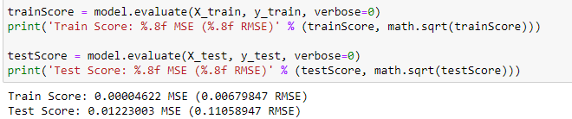

Fig: 4.8.5

Fig: 4.8.6

The linear model is represented in the above figure which shows how inaccurately it has predicted.

To increase the accuracy, we use the two lstm models. One basic and one improved both represented in the figure below.

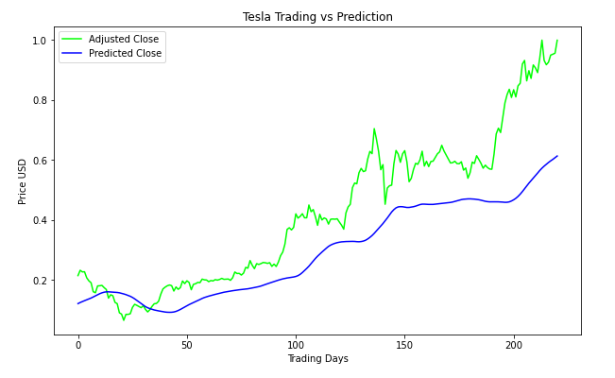

Fig: 4.8.7

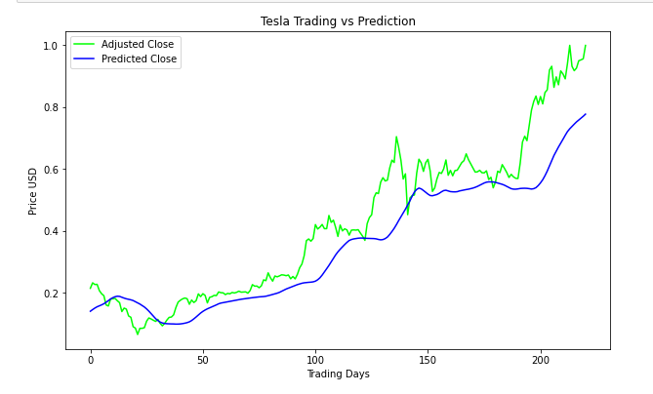

Fig: 4.8.8

Chapter 5

Conclusion

The sentiment analysis on the twitter data is used to predict the stock prices. Lexicon Vader has been used to extract the effect of tweet whether it has positive, negative or neutral effect. For fundamental analysis, We used different models to predict the stock prices and all of them differed in accuracy. The liner regressor gave us the accuracy of 35% while the decision tree gave us the accuracy of 80% whereas random forest was the best with an accuracy of around 85%.
For technical analysis we created two models and mean square error reduced significantly with each
The first linear regression model,
- Train Score: 0.5101 MSE (0.7142 RMSE)
- Test Score: 0.6379 MSE (0.7987056 RMSE)
The Second LSTM model,
- Train Score: 0.00012533 MSE (0.1119506 RMSE)
- Test Score: 0.049343434 MSE (0.22213381 RMSE)
The third improved LSTM model,
- Train Score: 0.00004622 MSE (0.00679847 RMSE)
- Test Score: 0.01223003 MSE (0.11058947 RMSE)

.

Chapter 6

References

[1] W. Antweiler and M. Frank. Do US stock markets typically overreact to corporate news stories? Working Paper, (1998):1–22, 2006.

[2] J. Bollen and H. Mao. Twitter mood as a stock market predictor. Computer, 44(10):91–94, 2011.

[3] a. Mittal and a. Goel. Stock Prediction Using Twitter Sentiment Analysis. Tomx.Inf.Elte.Hu, (June), 2012.

[4] F. ˚A. Nielsen. A new ANEW: evaluation of a word list for sentiment analysis in microblogs. In M. Rowe, M. Stankovic, A.-S. Dadzie, and M. Hardey, editors, Proceedings of the ESWC2011 Workshop on ’Making Sense of Microposts’: Big things come in small packages, volume 718 of CEUR Workshop Proceedings, pages 93–98, May 2011.

[5] A. Pak and P. Paroubek. Twitter as a Corpus for Sentiment Analysis and Opinion Mining. Lrec, pages 1320–1326, 2010.

[6] T. O. Sprenger, A. Tumasjan, P. G. Sandner, and I. M. Welpe. Tweets and trades: The information content of stock microblogs. European Financial Management, 20(5):926–957, 2014.

[7] P. D. Wysocki. Cheap talk on the web The determinants of postings on stock message boards. 1998

[8] Bordino, I., Battiston, S., Caldarelli, G., Cristelli, M., Ukkonen, A., Weber, I.: Web search queries can predict stock market volumes. PLoS ONE 7(7), e40014 (2011)

[9] Gilbert, E., Karahalios, K.: Widespread Worry and the Stock Market. In: Proceedings of the Fourth International AAAI Conference on Weblogs and Social Media, pp.58-65 (2010)
[10] Bollen, J., Mao, H., Zeng, X.: Twitter mood predicts the stock market. Journal of Compu-tational Science, 2(1), 1-8 (2011)
[11] Aramaki, Eiji, Sachiko Maskawa, and Mizuki Morita. “Twitter catches the flu: detecting influenza epidemics using Twitter.” Proceedings of the conference on empirical methods in natural language processing. Association for Computational Linguistics, 2011
[12] R. Chen and M. Lazer, Sentiment Analysis of Twitter Feeds for the Prediction of Stock Market Movement, Cs 229, pp. 15, 2011.
[13] L. Zhang, Sentiment Analysis on Twitter with Stock Price and Significant Keyword Correlation, pp. 130, 2013.
[14] Dickinson, Brian, and Wei Hu. ”Sentiment analysis of investor opinions on twitter.” Social Networking 4.03 (2015): 62.
[15] Bing, Li, Keith CC Chan, and Carol Ou. ”Public sentiment analysis in Twitter data for prediction of a company’s stock price movements.” eBusiness Engineering (ICEBE), 2014 IEEE 11th International Conference on. IEEE, 2014.

