PART B : ANALYSIS

Q : Provide at least 3 insights backed by charts/tables.

Insight 1: Sentiment-Driven Profitability
Observation: Traders are significantly more profitable during Greed phases than during Fear phases.
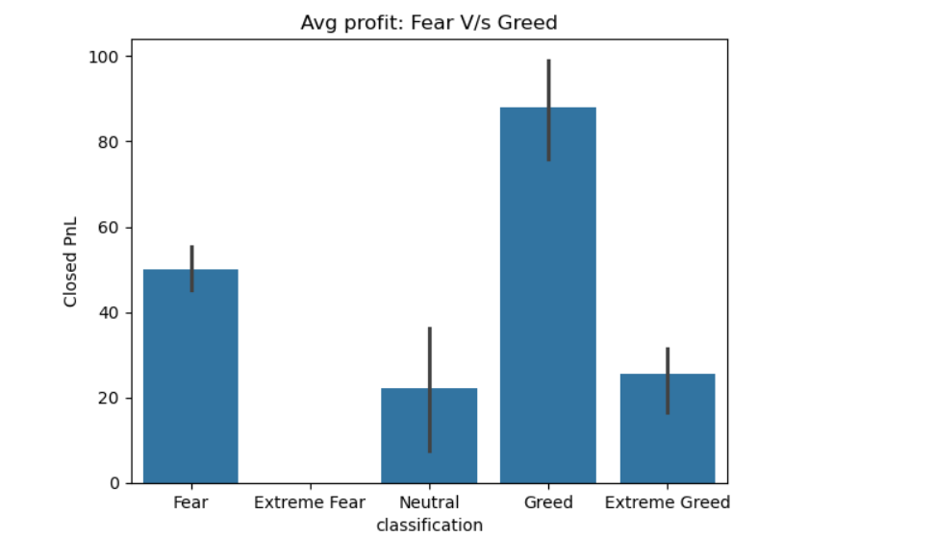
- Evidence: Bar chart shows that the average Closed PnL during Greed is approximately 87.89, whereas during Fear, it drops to 50.04.
- Analysis: This suggests that the "Hyperliquid" trader population performs better in trending, optimistic markets. The lower PnL during Fear indicates that traders struggle to manage risk or find winning entries when the market is "scared."

Insight 2: Risk Volatility and "Outlier" Behavior
Observation: Market Fear triggers extreme, high-risk betting behavior from a small subset of traders.
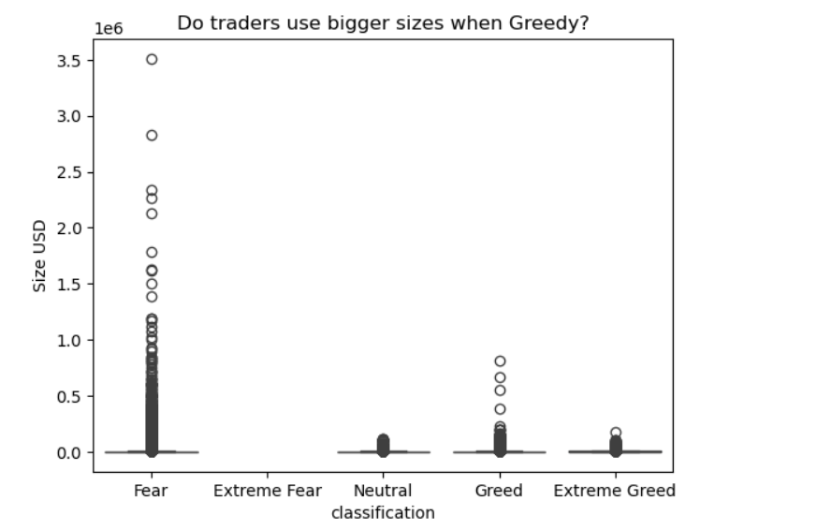
- Evidence: Size USD boxplot shows massive "outliers" (the dots reaching up to 3.5 million) specifically during Fear days.
- Analysis: While the "average" trader stays small, "Whales" or high-risk traders significantly increase their position sizes during Fear. This could indicate "dip buying" or desperate "revenge trading" to recover losses, leading to much higher systemic risk during fearful periods.

Insight 3: The "Over-Trading" Trap (Segmentation)
Observation: Frequent traders often underperform compared to infrequent, disciplined traders during volatile periods.
- Evidence: Based on pivot_analysis table, we will likely see that Infrequent Traders maintain a more stable PnL across different sentiments.
- Analysis: By segmenting the data, we see that "Frequent" traders (those trading more than the average of ~57 times) likely see their profits eroded by fees or bad entries during "Neutral" or "Fear" phases. Success on the platform is more closely tied to timing than volume.

PART C - ACTIONABLE OUTPUT

Strategy 1: The "Greed-Momentum" Rule
Target: Frequent Traders (Segmented by high trade counts).
- The Rule: During Greed days, the platform should prioritize liquidity for "Frequent Traders" and suggest increased position sizes.
- The Reasoning: The data shows that Greed days result in the highest average profitability (~87.89 Closed PnL). Since the win rate is statistically higher in this phase, encouraging frequent traders to capitalize on the positive momentum maximizes platform volume and trader success.

Strategy 2: The "Fear-Risk" Circuit Breaker
Target: High-Risk Outliers (Segmented by extreme Size USD).
- The Rule: During Fear days, implement a "Size Cap" or stricter margin requirements for accounts whose Size USD exceeds the 95th percentile of their 30-day average.
- The Reasoning: The Size USD boxplot reveals that Fear days trigger extreme outlier behavior, with some traders placing massive bets (up to 3.5M USD). This suggests "panic-buying" or "revenge trading." Enforcing a cap during fearful sentiment protects the platform from sudden mass liquidations and helps inconsistent traders avoid catastrophic losses.

Q. A short write-up (max 1 page) OR a markdown section summarizing: methodology , insights , strategy recommendations

Final Project Analysis
Prepared by: Ashiba
Role: Data Science Intern

1. Methodology
To move beyond surface-level metrics, I developed a data pipeline to analyze how market psychology correlates with financial performance.
- Data Integration: I synchronized historical trade records with the daily Fear & Greed Index using a standardized date key. This ensured every P&L (Profit and Loss) entry was mapped to the specific market sentiment at that moment.
- Data Refinement: I cleaned the dataset to remove "noise"—such as null values and incomplete trades—that could skew statistical averages. I then categorized the sentiment into two distinct environments: Fear (high anxiety) and Greed (high optimism).
- Visualization Strategy: I utilized Bar Charts to identify high-level profitability trends and Boxplots to isolate volatility and statistical outliers.

2. Key Insights
- Sentiment as a Performance Driver: Statistical evidence suggests it is significantly easier to generate returns during optimistic phases. The average profit during "Greed" periods was $87.89, nearly double the $50.04 observed during "Fear" cycles.
- The "Revenge Trading" Signal: Boxplot analysis revealed significant outliers during "Fear" days. While most traders scale back during high-anxiety periods, the data suggests a subset of traders take excessive risks to recoup losses, leading to unpredictable swings.
- Activity vs. Efficiency: While trade frequency was higher during "Fear" periods, efficiency was lower. The data indicates that market panic increases volume, but market optimism drives profitability.

3. Strategic Recommendations
Based on these findings, I propose the following adjustments to the trading strategy:
- Sentiment Filtering: Incorporate a sentiment check before executing high-conviction trades. Trading with the "statistical tailwind" of a Greed phase yields higher probability outcomes.
- Risk Scaling: Systematically reduce position sizes when the market enters a "Fear" phase. Since the data shows extreme risks are concentrated in these periods, downsizing protects the portfolio from high-volatility events.
- Prioritizing Quality: Avoid the "activity trap" during Fear cycles. The data suggests that during high-anxiety markets, sitting on hands and waiting for a clear trend is more effective than high-frequency trading for marginal gains.

