REPOSITORY LINK: https://github.com/ash-sheik/asg_6_oops

#Q1  
class Course:  
 def __init__(self, code, name, credits):  
 self.code = code  
 self.name = name  
 self.credits = credits  
  
 def display(self):  
 return f"{self.code} - {self.name} ({self.credits} credits)"  
  
class CoreCourse(Course):  
 def __init__(self, code, name, credits, required):  
 super().__init__(code, name, credits)  
 self.required = required  
  
class ElectiveCourse(Course):  
 def __init__(self, code, name, credits, elective_type):  
 super().__init__(code, name, credits)  
 self.elective_type = elective_type  
  
core = CoreCourse("CS101", "Intro to CS", 3, True)  
elective = ElectiveCourse("ENG201", "Creative Writing", 2, "Arts")  
  
print(core.display())  
print(elective.display())

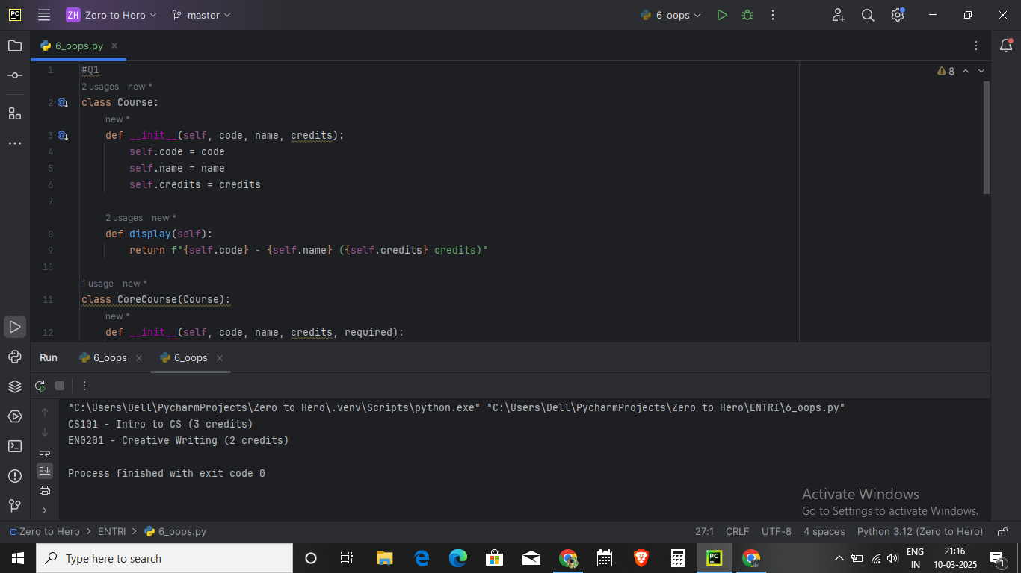

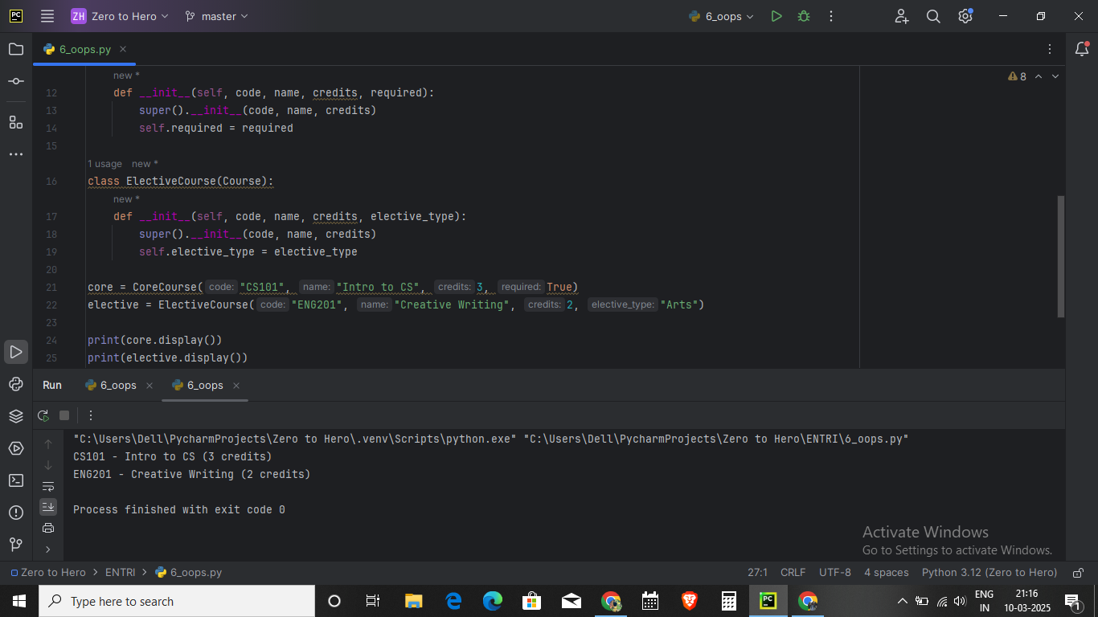

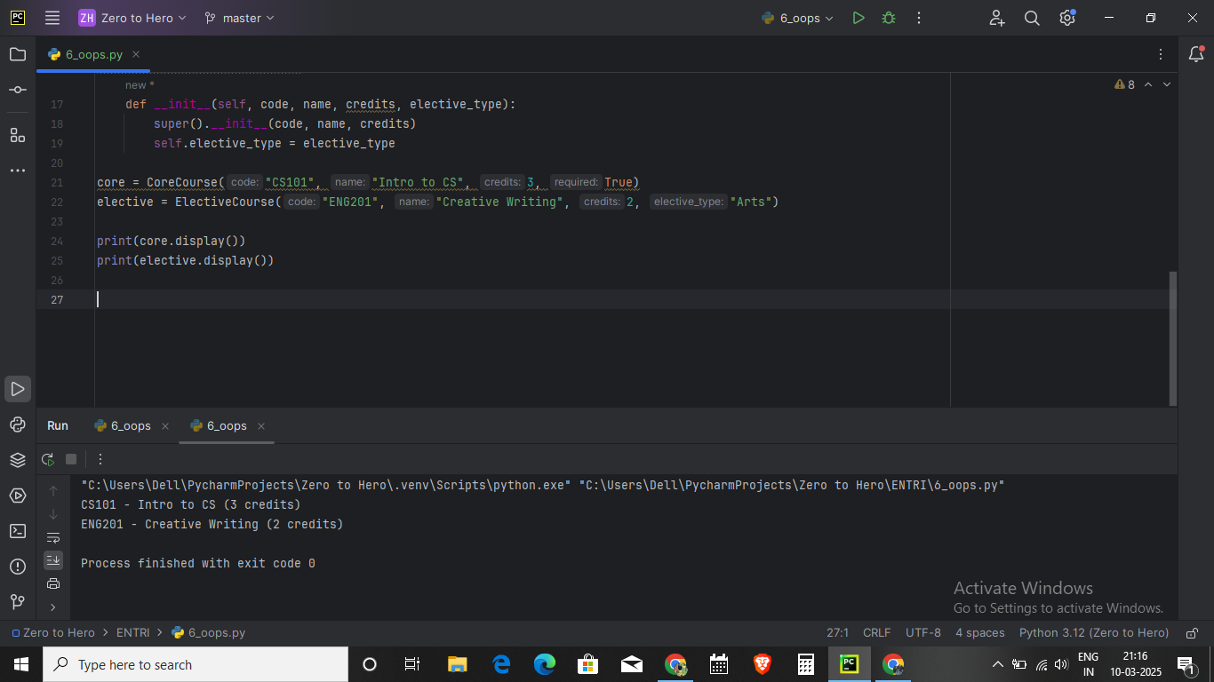

Q2: Create a Python module named employee that contains a class Employee with attributes name, salary and methods get_name() and get_salary(). Write a program to use this module to create an object of the Employee class and display its name and salary.

class Employee:  
 def __init__(self, name, salary):  
 self.name = name  
 self.salary = salary  
  
 def get_name(self):  
 return self.name  
  
 def get_salary(self):  
 return self.salary

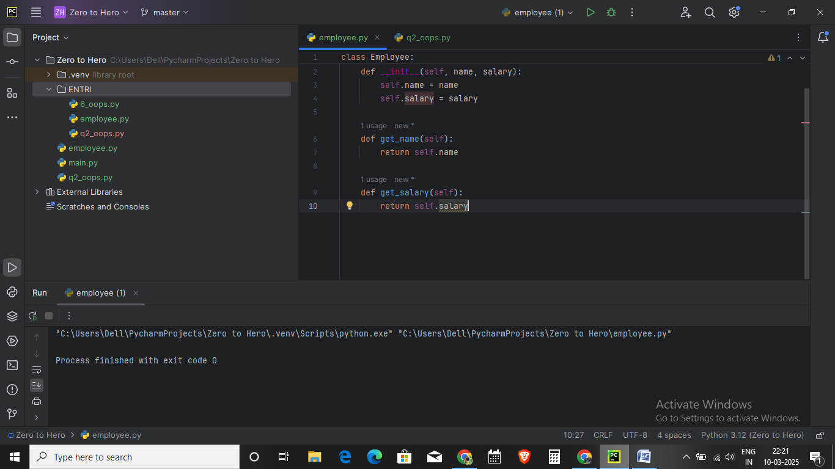

from employee import Employee  
  
# Creating an Employee object  
emp = Employee("Alice Johnson", 60000)  
  
# Displaying employee details  
print("Employee Name:", emp.get_name())  
print("Employee Salary:", emp.get_salary())

