**Journals:**

Before Entering Journals, we must make sure that the accounting period is opened on the system

**Steps of Open/Close Period:**

Path: Set Up 🡪 Open/Close

Then this Screen will appear:

In find Periods screen, The Name of the Ledger of the company must appear in **Ledger** field

**Status** field indicates:

* **Open**: The period is open for posting transactions.
* **Closed**: The period is closed, and no further transactions can be posted.
* **Future**: The period is in the future and not yet available for posting.
* **Permanently Closed**: The period is permanently closed, and no changes can be made

**Periods** contain all the periods that have been created in the calendar of the ledger

**Period Numbers** Refers to the numerical identifiers for accounting periods (e.g., Period 1 for January, Period 2 for February). This helps with organizing and referencing periods.

You can choose the period you want then click on **Find,** This screen will appear:

After choosing the period you want to open or close, click on it to choose your choice and save

**Type of Journals:**

**A. Standard Journal**

* The most common type of journal entry is used for recording day-to-day financial transactions.
* Includes manual and system-generated entries, such as expenses, revenue, and adjustments.

**B. Reversing Journal**

* A journal that is automatically or manually reversed in a future period.
* Used to correct accruals and temporary adjustments.
* Types of reversals:
  + Switch Dr/Cr – Debits and credits are swapped.
  + Change Sign – The same amounts are reversed (e.g., +100 becomes -100).
* Helps prevent double counting of expenses or revenues.

**C. Recurring Journal**

* A journal that is created once and repeated periodically.
* Used for regular, consistent transactions like depreciation, rent, and payroll allocations.
* Types of recurring journals:
  + Skeleton – Has fixed accounts but variable amounts.
  + Formula – Uses calculations based on predefined formulas (e.g., Mass allocations).
  + Standard – Same amounts and accounts every period

**Steps of Entering Basic Journal**

Path: General Leger (Responsibility) 🡪 Journal 🡪 Enter 🡪 New Journal.

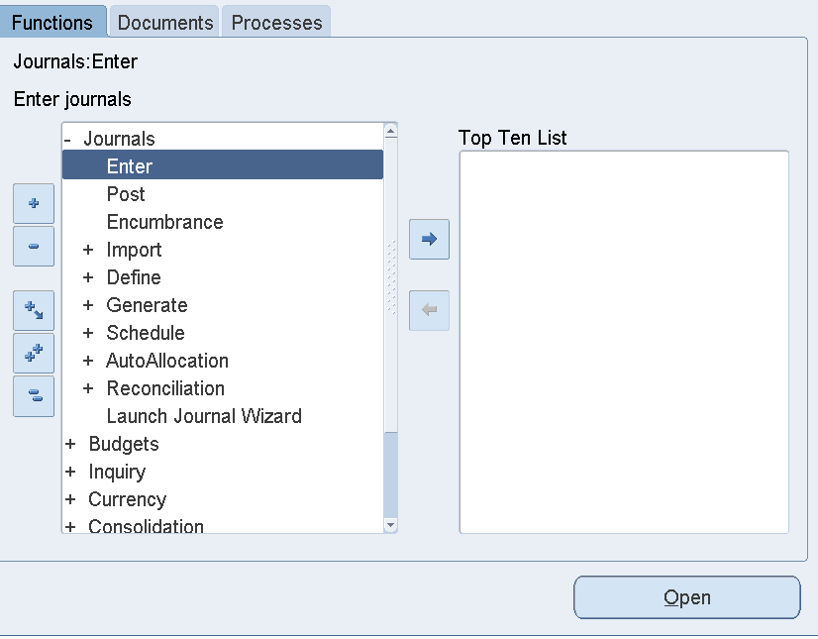

The **Top Ten List** in Oracle ERP is a handy feature that lets users quickly access their most frequently used tasks. Here’s what it does:

1. **Quick Access**: Provides shortcuts to the tasks you use most often.
2. **Customizable**: You can add, remove, or rearrange items to fit your needs.
3. **Saves Time**: Reduces the need to navigate through menus, making work faster.
4. **Personalized**: Each user’s list is tailored to their specific role and tasks

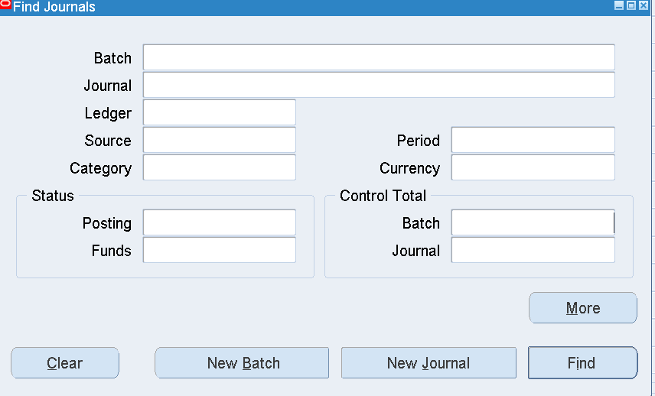

Functions in Find Journal Screen:

* **Batch:** to find batch name that contains all related journals with in specific period
* **Journal**: This likely refers to the journal entries within a batch. Journals are records of financial transactions in chronological order.
* **Ledger**: This is the main book or computer file for recording and totaling economic transactions. It provides a complete record of financial transactions over the life of the company.
* **Source**: This could refer to the origin of the transaction, such as a specific department or type of transaction.
* **Category**: This might be used to classify transactions into different categories for easier tracking and reporting
* **Period:** This could refer to the time in which the transactions are recorded
* **Currency**: This likely refers to the currency in which the transactions are recorded
* **Posting:** This indicates whether the transactions have been posted to the ledger. the process of transferring entries from the journal to the ledger.
* **Funds**: This could refer to the availability or status of funds related to the transactions

After Entering New Journal, the following Screen will appear:

**Header Section (Journal Details)**

1. **Journal** – The name or identifier for the journal entry. This is a required field.
2. **Description** – A brief description of the journal entry for reference.
3. **Ledger** – Specifies the ledger where the journal will be posted.
4. **Period** – The accounting period in which this journal will be posted.
5. **Balance Type** – Indicates the type of balance (e.g., Actual, Encumbrance, Budget).
6. **Clearing Company** – Used if the journal entry involves intercompany transactions.
7. **Journal Type** – Defines the type of journal, such as Standard, Reversal, or Adjusting

**Conversion Section (Foreign Currency Transactions)**

1. **Currency** – Specifies the currency used for this journal entry.
2. **Date** – The date when the currency conversion rate applies.
3. **Type** – Defines the source of the conversion rate (e.g., User, Corporate, Spot).
4. **Rate** – The exchange rate applied if the journal entry is in a foreign currency.

**Reversal Section (Journal Reversal Settings)**

1. **Date** – Specifies the reversal date if the journal is set for automatic reversal.
2. **Period** – The accounting period for the reversal entry.
3. **Method** – The method of reversal:
   * **Switch Dr/Cr** (Debit and Credit will be swapped)
   * **Change Sign** (The amount will be negated)
4. **Status** – Displays whether the journal has been reversed.
5. **Reverse Button** – Enables reversal of the journal if applicable.