**Industrial Internship Report on**

**Python**

**Prepared by**

**ASHWINI I**

|  |
| --- |
| *Executive Summary* |
| This report provides details of the Industrial Internship provided by upskill Campus and The IoT Academy in collaboration with Industrial Partner UniConverge Technologies Pvt Ltd (UCT).  This internship was focused on a project/problem statement provided by UCT. We had to finish the project including the report in 6 weeks’ time.  **Project Title**: Python Application Suite  **Description**: Created a suite of Python applications encompassing various utilities, including:   * **Password Manager**: Developed a secure password management tool allowing users to store and retrieve their credentials safely. * **URL Shortener**: Implemented a URL shortening service to generate short URLs from long ones, facilitating easy sharing and tracking of links. * **File Organiser**: Designed a file organization tool to automatically sort and manage files based on predefined criteria, enhancing file management efficiency.   This internship gave me a very good opportunity to get exposure to Industrial problems and design/implement solution for that. It was an overall great experience to have this internship. |

**TABLE OF CONTENTS**

1 Preface 3

2 Introduction 4

2.1 About UniConverge Technologies Pvt Ltd 4

2.2 About upskill Campus 8

2.3 Objective 9

2.4 Reference 9

2.5 Glossary 10

3 Performance Test 14

3.1 Test Plan/ Test Cases 14

3.2 Test Procedure 14

3.3 Performance Outcome 14

4 My learnings 15

5 Future work scope 16

# Preface

During the six-week internship program, I had the invaluable opportunity to immerse myself in practical learning and skill development, which has significantly contributed to my career growth. This internship experience underscored the importance of relevant internships in shaping one's professional journey, providing hands-on experience and exposure to real-world challenges.  
  
The primary focus of my internship was to develop a suite of Python applications addressing various utility needs. The projects included a Password Manager for secure credential management, a URL Shortener for easy link sharing, and a File Organiser for efficient file management. These projects were conceived to address practical needs in everyday computing tasks, and their development highlighted the power and versatility of Python programming.  
  
I am immensely grateful to upSkill Campus (USC) and UniConverge Technologies (UCT) for providing this invaluable opportunity. Their support and guidance throughout the internship program have been instrumental in my learning journey. The well-structured program provided a conducive environment for learning, with a blend of theoretical knowledge and hands-on practical exercises.

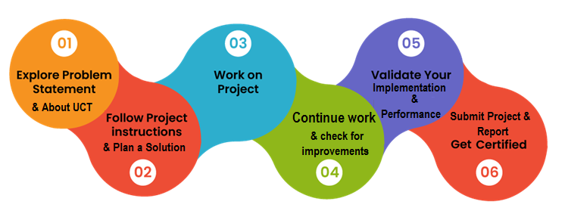

My learning experience during the internship was multifaceted. Beyond honing my technical skills in Python programming, I gained insights into project planning, problem-solving, and collaboration. The structured approach to learning, coupled with mentorship and peer interactions, fostered a conducive learning environment conducive to growth and development.  
  
I extend my heartfelt thanks to Sir Ankit kumar who have replied to all my queries in the official group and regularly reviewed all my reports.  
  
To my juniors and peers, I encourage you to seize every opportunity for experiential learning and skill development. Embrace challenges as opportunities for growth, and never stop exploring and expanding your horizons. Remember that every experience, whether successful or challenging, contributes to your journey of continuous learning and improvement.  
  
In conclusion, I am grateful for the enriching experience and look forward to applying the knowledge and skills gained during the internship in my future endeavors.

# Introduction

## About UniConverge Technologies Pvt Ltd

A company established in 2013 and working in Digital Transformation domain and providing Industrial solutions with prime focus on sustainability and RoI.

For developing its products and solutions it is leveraging various**Cutting Edge Technologies e.g. Internet of Things (IoT), Cyber Security, Cloud computing (AWS, Azure), Machine Learning, Communication Technologies (4G/5G/LoRaWAN), Java Full Stack, Python, Front end**etc.



1. UCT IoT Platform **(****)**

**UCT Insight** is an IOT platform designed for quick deployment of IOT applications on the same time providing valuable “insight” for your process/business. It has been built in Java for backend and ReactJS for Front end. It has support for MySQL and various NoSql Databases.

* It enables device connectivity via industry standard IoT protocols - MQTT, CoAP, HTTP, Modbus TCP, OPC UA
* It supports both cloud and on-premises deployments.

It has features to  
• Build Your own dashboard  
• Analytics and Reporting  
• Alert and Notification  
• Integration with third party application(Power BI, SAP, ERP)  
• Rule Engine

 

1. **Smart Factory Platform (****)**

Factory watch is a platform for smart factory needs.

It provides Users/ Factory

* with a scalable solution for their Production and asset monitoring
* OEE and predictive maintenance solution scaling up to digital twin for your assets.
* to unleased the true potential of the data that their machines are generating and helps to identify the KPIs and also improve them.
* A modular architecture that allows users to choose the service that they what to start and then can scale to more complex solutions as per their demands.

Its unique SaaS model helps users to save time, cost and money.

 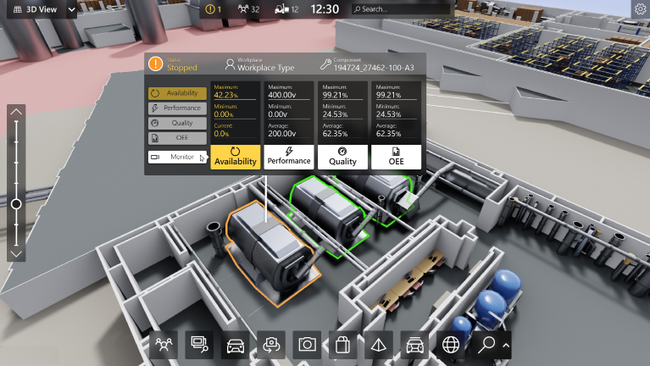

1.  based Solution

UCT is one of the early adopters of LoRAWAN teschnology and providing solution in Agritech, Smart cities, Industrial Monitoring, Smart Street Light, Smart Water/ Gas/ Electricity metering solutions etc.

1. Predictive Maintenance

UCT is providing Industrial Machine health monitoring and Predictive maintenance solution leveraging Embedded system, Industrial IoT and Machine Learning Technologies by finding Remaining useful life time of various Machines used in production process.



## About upskill Campus (USC)

upskill Campus along with The IoT Academy and in association with Uniconverge technologies has facilitated the smooth execution of the complete internship process.

USC is a career development platform that delivers **personalized executive coaching** in a more affordable, scalable and measurable way.



Seeing need of upskilling in self paced manner along-with additional support services e.g. Internship, projects, interaction with Industry experts, Career growth Services

<https://www.upskillcampus.com/>

upSkill Campus aiming to upskill 1 million learners in next 5 year

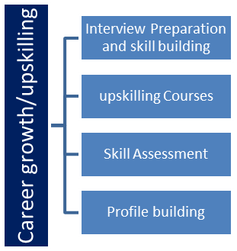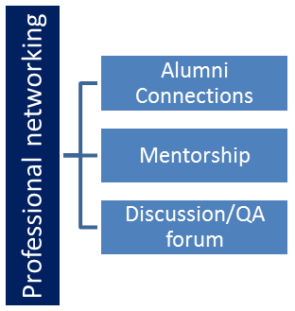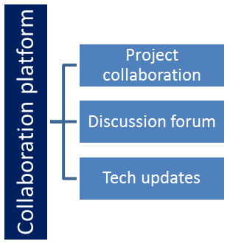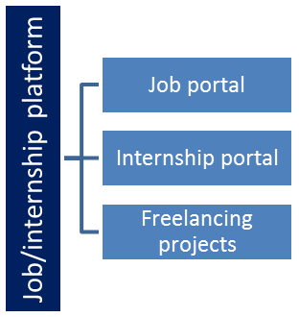

## The IoT Academy

The IoT academy is EdTech Division of UCT that is running long executive certification programs in collaboration with EICT Academy, IITK, IITR and IITG in multiple domains.

## Objectives of this Internship program

The objective for this internship program was to

 ☛ get practical experience of working in the industry.

 ☛ to solve real world problems.

 ☛ to have improved job prospects.

 ☛ to have Improved understanding of our field and its applications.

 ☛ to have Personal growth like better communication and problem solving.

# 

## Code submission (Github link)

https://github.com/ash1877/upskillCampus.git

## Report submission (Github link) :

# Performance Test

During the development of my Python projects, I recognized the importance of addressing constraints that are prevalent in real-world industries. Here, I'll outline the constraints identified, how they were addressed in my design, and the proposed test plan and procedure, along with potential performance outcomes:

1.Memory Constraint:

Identified Constraint: Limited memory availability, especially when dealing with large datasets or complex algorithms.

Addressing the Constraint: Implemented memory-efficient data structures and optimized algorithms to minimize memory usage. Utilized generators and lazy evaluation techniques where applicable to reduce memory footprint.

Potential Impact: Excessive memory usage could lead to performance degradation, system crashes, or inefficient resource utilization.

Recommendatios: Regularly monitor memory usage during development and testing phases. Implement memory profiling tools to identify and address memory leaks or inefficiencies.

2.Speed Constraint (MIPS):  
Identified Constraint: Speed limitations, particularly when processing large volumes of data or executing computationally intensive operations.

Addressing the Constraint: Employed algorithmic optimizations, parallel processing techniques, and utilized built-in libraries optimized for speed, such as NumPy and Pandas.  
Potential Impact: Slow execution times could lead to delays in processing, affecting overall system performance and user experience.  
Recommendations: Conduct benchmarking tests to measure processing speed under various conditions. Explore hardware acceleration options, such as utilizing GPUs or distributed computing frameworks, to improve performance.

3.Accuracy Constraint:

Identified Constraint: Requirement for precise and reliable results, especially in data analysis and decision-making processes.

Addressing the Constraint: Implemented robust error handling mechanisms, conducted thorough testing/validation of algorithms and models, and incorporated feedback loops for continuous improvement.

Potential Impact: Inaccurate results could lead to erroneous conclusions, impacting business decisions or system reliability.

Recommendations: Perform extensive testing using diverse datasets and scenarios to validate algorithmic accuracy. Implement monitoring and alerting systems to detect and address deviations from expected accuracy levels.

5.Durability Constraint:

Identified Constraint: Need for data persistence and resilience against failures or disruptions.

Addressing the Constraint: Implemented robust error handling, data backup, and recovery mechanisms. Utilized transactional processing and ensured data integrity through proper error logging and auditing.

Potential Impact: Data loss or corruption could lead to business disruptions, loss of valuable information, or compromised system reliability.

Recommendations: Conduct stress testing and fault tolerance simulations to evaluate system resilience under adverse conditions. Implement automated backup and disaster recovery procedures to mitigate risks associated with data durability.

6.Power Consumption Constraint:

Identified Constraint: Requirement for energy-efficient operation, particularly in resource-constrained environments or battery-powered devices.

Addressing the Constraint: Optimized code for energy efficiency, minimized unnecessary computations or idle time, and leveraged power management features of underlying hardware platforms.

Potential Impact: Excessive power consumption could lead to increased operational costs, reduced battery life, or environmental impact.

Recommendations: Conduct power consumption profiling to identify energy-intensive operations. Implement dynamic power management strategies, such as sleep modes or adaptive voltage scaling, to optimize energy usage without sacrificing performance.

## Test Plan/ Test Cases

* Define specific test cases for each identified constraint, covering various scenarios and edge cases.
* Develop test procedures to simulate real-world conditions and validate system behavior under different constraints.
* Execute test cases systematically, capturing performance metrics and identifying any deviations from expected outcomes.
* Document test results, including any issues encountered, performance bottlenecks, or areas for improvement.

## Test Procedure

1. Identify Test Cases: Define specific test cases for each constraint, covering different aspects of system functionality and performance. Test cases should encompass a range of scenarios, including typical usage, edge cases, and stress tests.
2. Prepare Test Environment: Set up a controlled testing environment that closely mirrors real-world conditions. This may involve configuring hardware resources, software dependencies, and input data sets according to the requirements of each test case.
3. Execute Test Cases: Systematically execute the predefined test cases, following a predefined sequence to ensure consistency and repeatability. Record relevant metrics, such as execution time, memory usage, accuracy rates, and power consumption, for each test case.
4. Measure Performance: Capture performance metrics using appropriate monitoring tools and instrumentation techniques. Monitor system behavior in real-time to identify any deviations from expected outcomes and potential performance bottlenecks.
5. Analyze Results: Analyze test results to evaluate system performance under different constraints. Compare measured metrics against predefined thresholds or industry standards to assess compliance and identify areas for improvement.
6. Document Findings: Document test findings, including observed performance metrics, any issues encountered during testing, and recommendations for optimization or refinement. Provide clear and concise descriptions of test procedures, results, and conclusions for future reference.
7. Iterate and Refine: Iterate on the test procedure as needed, incorporating feedback and insights gained from initial test runs. Refine test cases, adjust testing parameters, or introduce new constraints to further explore system behavior and performance characteristics.
8. Report and Present Results: Compile test results into a comprehensive report summarizing the performance evaluation process, key findings, and recommendations for improvement. Present findings to stakeholders, project team members, or relevant parties to facilitate decision-making and action planning.

## Performance Outcome

Performance Outcome:

* Evaluate performance metrics, such as execution time, memory usage, accuracy rates, and energy consumption, against predefined thresholds or industry standards.
* Identify areas of improvement based on test results and refine the design or implementation accordingly.
* Provide recommendations for optimizing performance, addressing any identified constraints, and enhancing overall system efficiency and reliability.

# My learnings

Completing my Python internship at upSkill Campus was a significant milestone for me. Throughout this experience, I had the opportunity to work on several projects, including a URL shortener, file organiser, quiz game, and password manager. These projects not only deepened my understanding of Python programming but also allowed me to explore various built-in libraries extensively.

Reflecting on my overall learning journey, I can confidently say that it has been incredibly rewarding. Each project challenged me to apply Python fundamentals and problem-solving techniques in real-world scenarios. For instance, developing the URL shortener and file organiser sharpened my skills in web development and file manipulation. Similarly, working on the quiz game and password manager enhanced my knowledge of data management and security measures.

Looking ahead, I am excited about the career growth opportunities that stem from this internship experience. The skills and knowledge I've gained, coupled with my hands-on project experience, will undoubtedly serve me well in my future endeavors. Whether I pursue a career in software development, web development, or any other field, I feel confident in my ability to contribute effectively and tackle new challenges head-on.

In conclusion, my Python internship journey has laid a solid foundation for my professional growth. I am grateful for the opportunity to learn, grow, and expand my skill set. As I continue on my career path, I am eager to apply what I've learned and continue exploring the vast possibilities that Python and technology have to offer.

# Future work scope

During my Python internship at upSkill Campus, I encountered several ideas that sparked my interest but couldn't be pursued due to time limitations. However, these ideas hold great potential for future exploration and development. Some of these include:

Implementing advanced features in the URL shortener, such as custom aliases, expiration dates for links, and analytics tracking to monitor link usage.

1.Implementing advanced features in the URL shortener, such as custom aliases, expiration dates for links, and analytics tracking to monitor link usage.

2.Expanding the functionality of the file organiser to include automated file tagging based on content analysis or file metadata.

3.Enhancing the quiz game with multiplayer functionality, interactive leaderboards, and a wider range of question types, including multimedia questions.

4.Adding additional security features to the password manager, such as two-factor authentication and integration with password strength analysis tools.

These ideas represent exciting avenues for future projects and could further deepen my understanding of Python programming and its applications. I look forward to exploring these opportunities and continuing my learning journey beyond the scope of the internship.